Name of Journal: World Journal of Clinical Cases
Manuscript NO: 88120
Manuscript Type: CASE REPORT

Lung ultrasound for the early diagnosis of acute lung injury: A case report

Zheng X et al. LUS for the early diagnosis of ALI

Xin Zheng, Na Liu

Xin Zheng, Na Liu, Department of Anesthesiology, The Second Hospital of Dalian Medical University, Dalian 116027, Liaoning Province, China

Author contributions: Zheng X performed the data collection and drafted the article; Liu N revised the article.

Corresponding author: Na Liu, MD, Doctor, Department of Anesthesiology, The Second Hospital of Dalian Medical University, No. 467 Zhongshan Road, Dalian 116027, Liaoning Province, China. 18640964469@163.com

Received: September 11, 2023
Revised: October 4, 2023
Accepted: November 3, 2023
Published online: November 16, 2023

Abstract
BACKGROUND
The extensive availability of ultrasound (US) technology has increased its use for point-of-care applications in many health care settings. During anaesthesia and surgery, acute respiratory failure or pulmonary oedema are common life-threatening events that, if not recognized and treated appropriately, result in a high mortality rate.

CASE SUMMARY
We report a patient under anaesthesia whose lung US examination showed multiple vertical artefacts (B-lines) in the lung tissue, indicating pulmonary oedema. The respiratory state improved with the resolution of the pulmonary oedema after our treatment.

CONCLUSION
We believe that US of the lungs may be a useful tool for dynamic respiratory monitoring at the bedside during anaesthesia.

Key Words: Lung ultrasound; Acute respiratory failure; Ultrasound; Lung; Case report

©The Author(s) 2023. Published by Baishideng Publishing Group Inc. All rights reserved.

Citation: Zheng X, Liu N. Lung ultrasound for the early diagnosis of acute lung injury: A case report. World J Clin Cases 2023; 11(32): 7900-7904
URL: https://www.wjgnet.com/2307-8960/full/v11/i32/7900.htm
DOI: https://dx.doi.org/10.12998/wjcc.v11.i32.7900

Core Tip: The extensive availability of ultrasound (US) technology has increased its use for points of care applications in many health care settings. During anesthesia and surgery, acute respiratory failure or pulmonary edema are common life-threatening events that, if not recognized and treated appropriately, result in a high mortality rate. We report on a patient under anesthesia whose lung US examination showed multiple vertical artifacts (B-lines) in the lung tissue, indicating pulmonary edema. The respiratory state was improved with the resolution of pulmonary edema after our treatment. We believe that US of the lungs may be a useful tool for dynamic respiratory monitoring at the bedside during anesthesia.

INTRODUCTION
Lung ultrasound (US) (LUS) is now a standard tool for the diagnosis of acute lung injury (ALI), which refers to a clinical syndrome characterized by bilateral lung injury, severe diffuse failure of the lung, and even hypoxemia^{[1]}. Perioperative lung injury is the main cause of excess health care use, avoidable mortality, and postoperative morbidity^{[2]}. If not recognized and treated appropriately, cases of mild pulmonary injury with nonspecific signs and symptoms would increase the morbidity and mortality rate^{[3]}. Focused US (point-of-care US) is defined as an ultrasonic evaluation at the bedside, where an ultrasonic evaluation is conducted in real time^{[4]}. These images are collected by the anaesthesiologist perioperatively, and they can immediately be integrated into the medical decision-making process. The reported case shows the importance of performing LUS to evaluate respiratory function in the operating room.

CASE PRESENTATION
Chief complaints
On arrival at the operating room, the patient presented with increased respiratory effort.

History of present illness
An 89-year-old man diagnosed with acute intestinal obstruction was scheduled to undergo laparoscopic exploration.

History of past illness
No basic past illness.

Personal and family history
His personal history shows no abnormalities.

Physical examination
His heart rate was 103 beats per minute, his blood pressure was 120/74 mmHg, and his respiratory rate was 22 breaths per minute.

Laboratory examinations
An arterial blood gas analysis was taken immediately, which showed a PH value of 7.25, partial oxygen pressure of 59 mmHg, partial carbon dioxide pressure of 48 mmHg.

Imaging examinations
His chest X-ray on the first day of admission showed no abnormal findings except for mild right pleural effusion (Figure 1). Bedside ultrasonography was performed and displayed the disappearance of lung sliding and the presence of multiple B-lines in both lungs (Figure 2).

FINAL DIAGNOSIS
We diagnosed pulmonary oedema using sonography.

TREATMENT
Intubation and ventilation were initiated immediately. Controlled ventilation was chosen using FiO₂ 100% oxygen and 10-15 cm H₂O positive end-expiratory pressure (PEEP). While the patient was undergoing the lung recruitment manoeuvre with US, we observed that the area of collapsed alveoli reaerated as the PEEP reached 15 cm H₂O. Dobutamine and epinephrine were given after the valve preload, and his haemodynamics gradually stabilized.

OUTCOME AND FOLLOW-UP
After surgery, the patient was sent to the intensive care unit. His respiratory symptoms resolved on the second day (Figure 3), and 100% oxygen was gradually removed. The patient was successfully extubated and discharged after 12 d of hospitalization.

DISCUSSION
The current observational case showed that LUS is an important tool to monitor lung involvement in many different situations. Perioperative lung injury complicates postoperative recovery for many patients. The rate of postoperative pulmonary complications is between 11% and 59%, which has led to a significant increase in mortality and morbidity and an increase in the use of hospital resources^{[5]}.Perioperative lung injury includes respiratory insufficiency, gas exchange disorders and pneumonia. Mild lung injury is generally not a threat to life; however, a delayed diagnosis may be harmful because it is associated with compromised circulation and respiration in unstable patients^{[6]}.
LUS can be performed at the bedside by an anaesthesiologist in the operating room and can provide accurate images of the lung state with diagnostic and therapeutic relevance^{[7]}. A high sensitivity and specificity of LUS were shown in the diagnosis of pneumothorax and interstitial syndrome^{[4,8]}. Although chest computed tomography (CT) is the gold standard to assess lung involvement^{[9]}, it necessitates the transfer of a ventilated patient out of the operating room. CT cannot always be performed promptly. Any delay in the provision of radiological evidence may be deleterious in some instances. LUS examination may be a valid alternative to CT scans^{[10]}. It is not intrusive and is easily repeatable at the bedside, enabling the assessment of lung recruitment following PEEP or any other manoeuvres requiring direct visualization of the lungs.
Lung ultrasonography is useful for the diagnosis and estimation of lung recruitment by PEEP^{[11]}. Several randomised controlled trials reported that patients undergoing laparoscopic surgery receiving 5 cm of H₂O PEEP experienced significantly better oxygenation and less postoperative atelectasis than patients with zero PEEP^{[2]}. Tsubo et al^{[12]} used transoesophageal ultrasonography to evaluate the reaeration induced by PEEP of a hyperdense left lower lobe. Researchers noticed that the ultrasonic densities “disappeared” using 15 cm H₂O PEEP for ALI patients. LUS examinations can be used to monitor the responsiveness of each 3- to 4-cm H₂O increase in PEEP until moderate or severe aeration loss becomes normal.

CONCLUSION
As shown by this case report, lung ultrasonography may be a valuable tool to evaluate lung recruitment in real time at the bedside. Intraoperative point-of-care US performed by the anaesthesiologist provides the possibility of assessing lung reaeration in surgical patients. LUS may be an important alternative to chest CT scans in the perioperative setting.

REFERENCES
1 Abraham E, Matthay MA, Dinarello CA, Vincent JL, Cohen J, Opal SM, Glauser M, Parsons P, Fisher CJ Jr, Repine JE. Consensus conference definitions for sepsis, septic shock, acute lung injury, and acute respiratory distress syndrome: time for a reevaluation. Crit Care Med 2000; 28: 232-235 [PMID: 10667529 DOI: 10.1097/00003246-200001000-00039]
2 O'Gara B, Talmor D. Perioperative lung protective ventilation. BMJ 2018; 362: k3030 [PMID: 30201797 DOI: 10.1136/bmj.k3030]
3 Fernandez-Bustamante A, Frendl G, Sprung J, Kor DJ, Subramaniam B, Martinez Ruiz R, Lee JW, Henderson WG, Moss A, Mehdiratta N, Colwell MM, Bartels K, Kolodzie K, Giquel J, Vidal Melo MF. Postoperative Pulmonary Complications, Early Mortality, and Hospital Stay Following Noncardiothoracic Surgery: A Multicenter Study by the Perioperative Research Network Investigators. JAMA Surg 2017; 152: 157-166 [PMID: 27829093 DOI: 10.1001/jamasurg.2016.4065]
4 Shrestha GS, Weeratunga D, Baker K. Point-of-Care Lung Ultrasound in Critically ill Patients. Rev Recent Clin Trials 2018; 13: 15-26 [PMID: 28901850 DOI: 10.2174/1574887112666170911125750]
5 Shander A, Fleisher LA, Barie PS, Bigatello LM, Sladen RN, Watson CB. Clinical and economic burden of postoperative pulmonary complications: patient safety summit on definition, risk-reducing interventions, and preventive strategies. Crit Care Med 2011; 39: 2163-2172 [PMID: 21572323 DOI: 10.1097/CCM.0b013e31821f0522]
6 Ding W, Shen Y, Yang J, He X, Zhang M. Diagnosis of pneumothorax by radiography and ultrasonography: a meta-analysis. Chest 2011; 140: 859-866 [PMID: 21546439 DOI: 10.1378/chest.10-2946]
7 Soldati G, Sher S. Bedside lung ultrasound in critical care practice. Minerva Anestesiol 2009; 75: 509-517 [PMID: 19644435]
8 Volpicelli G, Elbarbary M, Blaivas M, Lichtenstein DA, Mathis G, Kirkpatrick AW, Melniker L, Gargani L, Noble VE, Via G, Dean A, Tsung JW, Soldati G, Copetti R, Bouhemad B, Reissig A, Agricola E, Rouby JJ, Arbelot C, Liteplo A, Sargsyan A, Silva F, Hoppmann R, Breitkreutz R, Seibel A, Neri L, Storti E, Petrovic T; International Liaison Committee on Lung Ultrasound (ILC-LUS) for International Consensus Conference on Lung Ultrasound (ICC-LUS). International evidence-based recommendations for point-of-care lung ultrasound. Intensive Care Med 2012; 38: 577-591 [PMID: 22392031 DOI: 10.1007/s00134-012-2513-4]
9 Lichtenstein D, Goldstein I, Mourgeon E, Cluzel P, Grenier P, Rouby JJ. Comparative diagnostic performances of auscultation, chest radiography, and lung ultrasonography in acute respiratory distress syndrome. Anesthesiology 2004; 100: 9-15 [PMID: 14695718 DOI: 10.1097/00000542-200401000-00006]
10 Llamas-Álvarez AM, Tenza-Lozano EM, Latour-Pérez J. Accuracy of Lung Ultrasonography in the Diagnosis of Pneumonia in Adults: Systematic Review and Meta-Analysis. Chest 2017; 151: 374-382 [PMID: 27818332 DOI: 10.1016/j.chest.2016.10.039]
11 Stefanidis K, Dimopoulos S, Tripodaki ES, Vitzilaios K, Politis P, Piperopoulos P, Nanas S. Lung sonography and recruitment in patients with early acute respiratory distress syndrome: a pilot study. Crit Care 2011; 15: R185 [PMID: 21816054 DOI: 10.1186/cc10338]
12 Tsubo T, Sakai I, Suzuki A, Okawa H, Ishihara H, Matsuki A. Density detection in dependent left lung region using transesophageal echocardiography. Anesthesiology 2001; 94: 793-798 [PMID: 11388530 DOI: 10.1097/00000542-200105000-00017]

Footnotes
Informed consent statement: Informed written consent was obtained from the patient for publication of this report and any accompanying images.

Conflict-of-interest statement: The authors declare that they have no conflict of interest.

CARE Checklist (2016) statement: The authors have read the CARE Checklist (2016), and the manuscript was prepared and revised according to the CARE Checklist (2016).

Open-Access: This article is an open-access article that was selected by an in-house editor and fully peer-reviewed by external reviewers. It is distributed in accordance with the Creative Commons Attribution NonCommercial (CC BY-NC 4.0) license, which permits others to distribute, remix, adapt, build upon this work non-commercially, and license their derivative works on different terms, provided the original work is properly cited and the use is non-commercial. See: https://creativecommons.org/Licenses/by-nc/4.0/

Provenance and peer review: Unsolicited article; Externally peer reviewed.

Peer-review model: Single blind

Peer-review started: September 11, 2023
First decision: September 28, 2023
Article in press: November 3, 2023

Specialty type: Medicine, research and experimental
Country/Territory of origin: China
Peer-review report’s scientific quality classification
Grade A (Excellent): 0
Grade B (Very good): 0
Grade C (Good): C
Grade D (Fair): 0
Grade E (Poor): 0

P-Reviewer: Sunder T, India S-Editor: Qu XL L-Editor: A P-Editor: Qu XL
Figure Legends
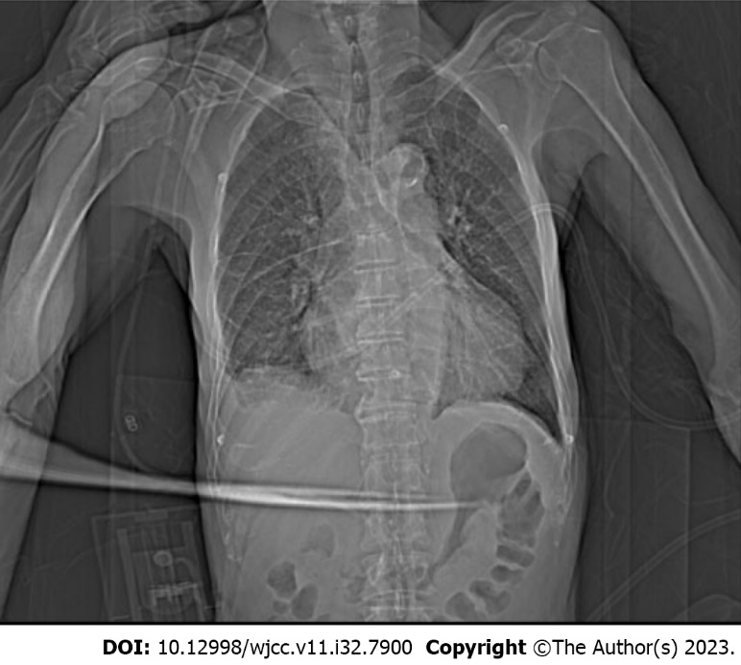
Figure 1 Chest X-ray on the first day of admission.

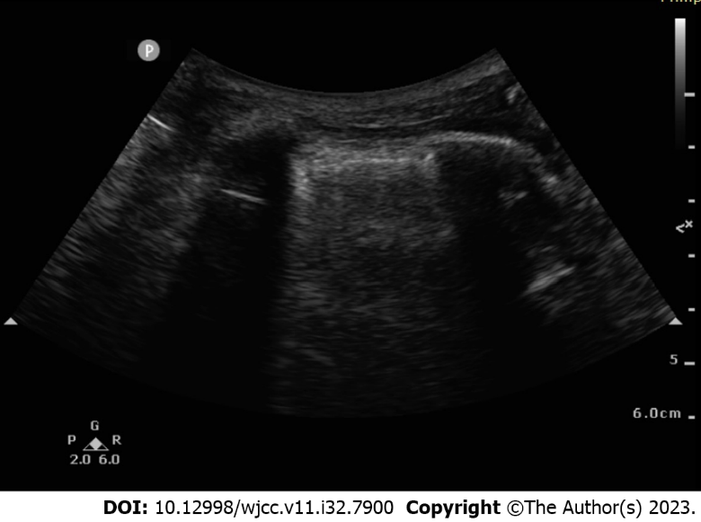
Figure 2 Ultrasonography shows the presence of B lines.

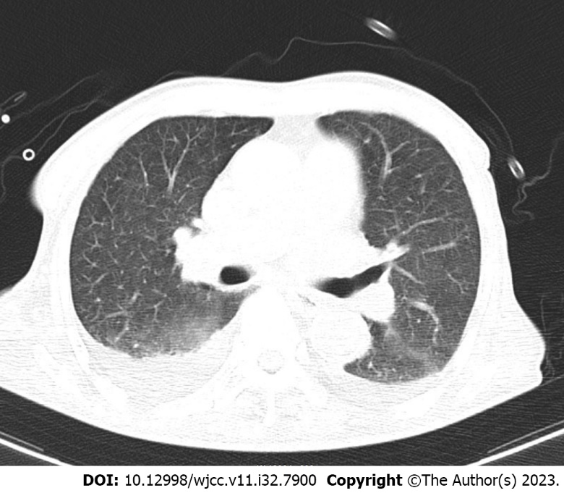
Figure 3 A chest computed tomography scan shows the minimal presence of pulmonary oedema on the second day of intensive care unit admission.

Published by Baishideng Publishing Group Inc
7041 Koll Center Parkway, Suite 160, Pleasanton, CA 94566, USA
Telephone: +1-925-3991568
E-mail: bpgoffice@wjgnet.com
Help Desk: https://www.f6publishing.com/helpdesk
https://www.wjgnet.com

© 2023 Baishideng Publishing Group Inc. All rights reserved.

