Name of Journal: World Journal of Clinical Cases
Manuscript NO: 58221
Manuscript Type: CASE REPORT

Bouveret syndrome masquerading as a gastric mass-unmasked with endoscopic luminal laser lithotripsy: A case report

Parvataneni S et al. Bouveret syndrome masquerading

Swetha Parvataneni, Harshit S Khara, David L Diehl

Swetha Parvataneni, Department of Internal Medicine, Geisinger Lewistown Hospital, Lewistown, PA 17044, United States

Harshit S Khara, Department of Gastroenterology and Hepatology, Advanced Endoscopy，Geisinger Health system, Danville, PA 17822, United States

David L Diehl, Department of Gastroenterology and Nutrition, Geisinger Medical Center, Danville, PA 17822, United States

Author contributions: Parvataneni S guaranted the article, researched literature and preparated manuscript; Khara HS and Diehl DL did the case management, manuscript editing, manuscript revision/review and final version approval.

Corresponding author: Swetha Parvataneni, MD, Attending Doctor, Department of Internal Medicine, Geisinger Lewistown Hospital, 400 Highland Ave, Lewistown, PA 17044, United States. swethaparvataneni88@gmail.com

Received: August 2, 2020
Revised: October 8, 2020
Accepted: October 26, 2020
Published online:

Abstract
BACKGROUND
Bouveret syndrome, also known as gallstone ileus, is a rare form of gastric outlet obstruction accounting for 1%-3% of cases. This condition is most often reported in females. The diagnosis can be challenging and is often missed due to atypical presentations, which occasionally mimic gastric outlet obstruction symptoms such as nausea, vomiting, loss of appetite and hematemesis. The symptoms vary with stone size. Larger stones are managed with a surgical approach, but this carries increased morbidity and mortality. Over the past decade, the endoscopic approach has emerged as an alternative mode of treatment, but it is generally unsuccessful in the management of larger-sized stones. A literature review revealed cases of successful endoscopic treatment requiring multiple sessions for stone sizes measuring up to about 4.5 cm. Here we present a unique case of an elderly patient with Bouveret syndrome with a 5 cm stone mimicking a gastric mass and causing gastric outlet obstruction, who was successfully managed in a single session using a complete endoscopic approach with laser lithotripsy.

CASE SUMMARY
An 85-year-old female patient presented with 1-month history of intermittent abdominal pain, vomiting, decreased appetite and weight loss. An abdominal computed tomography showed a 4.5 cm × 4.7 cm partially calcified mass at the gastric pylorus causing gastric outlet obstruction. Endoscopy showed an ulcerated fistulous opening and a large 5 cm impacted gallstone in the duodenal bulb. Endoscopic nets and baskets were used in an attempt to remove the stone, but this approach was unsuccessful. Given her advanced age, poor physical condition and underlying comorbidities, she was deemed to be high-risk for surgery. Thus, a minimally invasive approach using endoscopic laser lithotripsy was attempted and successfully treated the stone. Post-procedure, the patient experienced complete resolution of her symptoms with no complications and was able to tolerate her diet. She was subsequently discharged home at 48 h, with an uneventful recovery.

CONCLUSION
In our paper we describe Bouveret syndrome and highlight its management with a novel endoscopic approach of laser lithotripsy in addition to various other endoscopic approaches available to date and its success rates.

Key Words: Gastric outlet obstruction; Bouveret syndrome; Laser lithotripsy; Holmium laser lithotripsy; Holmium and neodymium yttrium aluminum garnet lasers; Case report

Parvataneni S, Khara HS, Diehl DL. Bouveret syndrome masquerading as a gastric mass-unmasked with endoscopic luminal laser lithotripsy: A case report. World J Clin Cases 2020; In press

Core Tip: An elderly female presented with features of gastric outlet obstruction found to have a large gall stone of 5 cm on endoscopy, successfully treated with complete endoscopic approach with laser lithotripsy.
INTRODUCTION
Gastric outlet obstruction is a condition characterized by mechanical impedance of gastric contents emptying into the proximal duodenum. Bouveret syndrome is a rare form of gastric outlet obstruction caused by gallstone impaction in the duodenum via a fistulous tract. First described by Beaussier in 1770, the syndrome was described again in two case reports published by Bouveret^{[1]} in 1896, after which the syndrome was given his name^{[1]}. This condition is most commonly seen in elderly patients, with a reported median age of 74 year, and occurs predominantly in females, with a female-to-male ratio of 1.82^{[2]}. The diagnosis can be challenging and is often missed due to its nonspecific and atypical presentation that mimics the symptoms of gastric outlet obstruction, such as nausea, vomiting, weight loss, decreased appetite, and hematemesis, as seen with the present case^{[3]}. We present a rare case of a patient who presented with signs of malignancy and was discovered to have a stone on endoscopy. The stone was treated successfully with a complete endoscopic resolution using laser lithotripsy.

CASE PRESENTATION
Chief complaints
An 85-year-old female presented to emergency room with vomiting and abdominal pain.

History of present illness
An elderly female patient presented with symptoms of intermittent abdominal pain around epigastric and umbilical area. The pain was dull aching 5/10 intensity that had been present for 1 mo and gradually worsened over the last 2 wk. The abdominal pain was non-radiating, exacerbated by food intake and had no associated relieving factors. Vomiting intermittently for the last 2 wk and increased in intensity over the past 48 h; it was non-blood stained and non-foul smelling. The patient had a history of loss of appetite and weight loss of about 15 Lbs. over the 1-mo duration. Her last bowel movement was 2 d prior to admission, with a normal consistency but black tarry in color. Review of systems unremarkable.

History of past illness
Past medical history included hypertension, cerebrovascular accident, diabetes, and chronic kidney disease stage 3. Family history did not reveal anything of significance to her present illness.

Personal and family history
Family history did not reveal anything of significance to her present illness.

Physical examination
Heart rate of 110 beats per minute, blood pressure of systolic 80’s, temperature 36.4 °C, respiratory rate of 18. The patient abdomen was mildly distended, with tenderness in the mid epigastric region, no organomegaly, and normal bowel sounds.

Laboratory examinations
Blood tests revealed elevated troponin of 86, electrocardiogram showed ST segment depressions likely demand ischemia from the acute illness. Basic metabolic panel showed creatinine of 3.1 (baseline was 1.4), potassium of 3.2, alkaline phosphatase of 177, Alanine transaminase of 53, aspartate transaminase of 53, and lactic acid of 2.3. On complete blood count, her white cell count of 20.78 neutrophilic leukocytosis, and hemoglobin of 9.8.

Imaging examinations
An abdominal computed tomography (CT) scan showed a 4.5 cm × 4.7 cm partially calcified mass at the gastric pylorus causing gastric outlet obstruction (Figure 1).

Further diagnostic works up
Endoscopy showed an ulcerated fistulous opening and a large 5 cm impacted gallstone in the duodenal bulb (Figure 2). Endoscopic nets and baskets were used in an attempt to remove the stone, but this approach was unsuccessful.

FINAL DIAGNOSIS
Given the endoscopic picture patient was diagnosed to have gastric outlet obstruction secondary to a large impacted gall stone which defines Bouveret syndrome, with a large duodenal ulcer.

TREATMENT
Given her advanced age, poor physical condition and underlying comorbidities, she was deemed to be high-risk for surgery. Thus, a minimally invasive approach using endoscopic laser lithotripsy was attempted. Holmium laser therapy was performed using an upper endoscope in the duodenal bulb with 9 Watts, 1000 pulses and 10 Joules; and after an extensive session of lithotripsy, the stone was eventually fragmented and removed piecemeal (Figure 3).

OUTCOME AND FOLLOW-UP
Post-procedure, the patient experienced complete resolution of her symptoms with no complications and was able to tolerate her diet. She was subsequently discharged home at 48 h, with an uneventful recovery.

DISCUSSION
Bouveret syndrome is a rare form of gallstone ileus accounting for approximately 1%-3% of cases^{[4]}. In approximately 85% of these patients, gallstones are eliminated either by vomiting or in the feces; in the remaining 15% gallstones measuring more than 2.5 cm become impacted in the descending order in terminal ileum, proximal ileum, jejunum, colon, and rarely in the duodenum and stomach^{[5-7]} . Imaging such as X-ray, CT scan, and ultrasound are used for diagnosis. X-ray is diagnostic in only 21% of cases, whereas CT scan has higher sensitivity for diagnosis. The classic sign seen on radiograph is the Riggler triad of bowel obstruction, pneumobilia and ectopic gallstone^{[8-10]}.
Treatment includes non-surgical and surgical options. In the past, surgical approaches using open enterolithotomy and cholecystectomy with fistula closure were considered first-line treatment, but surgery was associated with a morbidity and mortality of 37.5% and 11%, respectively^{[11]}. The first successful reports describing endoscopic visualization and extraction of gallstones were published in three cases by Bedogni et al^{[12]} in 1985. Later, endoscopic nets and lithotripsy techniques were developed for gallstone extraction. Endoscopic nets are a good alternative to the surgical approach in elderly patients in order to decrease the mortality risk, though nets are reported to be more effective for treating smaller-sized stones rather than larger ones^{[13]}. This is evident in our case, in which the endoscopic net approach failed and lithotripsy was ultimately used for stone extraction.
Lithotripsy is a procedure used for stone destruction to facilitate easy passage and removal. It includes the use of mechanical, electrohydraulic, laser and extracorporeal shock wave techniques. Given the large stone size in our patient, we opted for laser lithotripsy. Laser lithotripsy was introduced in the mid-1980’s for the treatment of bile duct stones^{[14,15]}. Holmium and neodymium yttrium aluminum garnet lasers are the Food and Drug Administration-approved laser treatments available in the market^{[16]}. Laser lithotripsy has proven to be safe and effective in the treatment of complicated and refractory bile duct stones^{[17,18]}. A literature review revealed case discussions in which laser lithotripsy was successfully used in the treatment of Bouveret syndrome. This approach was successful in patients with a maximal median size stone size of 4 cm (Interquartile range: 1.5) and was performed in a median of 1.5 sessions (Interquartile range: 1.5)^{[19]}.
To date, the present report is unique in describing a tailored endoscopic laser lithotripsy approach used to successfully treat a large stone with only one treatment session in an elderly patient with comorbidities. Bouveret syndrome is rare and should be considered in elderly patients with atypical presentations, and endoscopic approaches to fragmentation are a viable option that represent an alternative to surgery as first-line therapy.

CONCLUSION
Bouveret syndrome is a rare form of gastric outlet obstruction. Given the high incidence of morbidity and mortality associated with misdiagnosis and delayed treatment, it is important to keep Bouveret syndrome in the differential diagnosis of gastric outlet obstruction in elderly patients with atypical presentation. This case is unique because of its atypical presentation mimicking a malignant gastric outlet obstruction, which was successfully treated with advanced endoscopic intervention.

REFERENCES
1 Bouveret L. Stenose du pylore adherent a la vesicle. Rev Med 1896; 16: 1
2 Al-Habbal Y, Ng M, Bird D, McQuillan T, Al-Khaffaf H. Uncommon presentation of a common disease - Bouveret's syndrome: A case report and systematic literature review. World J Gastrointest Surg 2017; 9: 25-36 [PMID: 28138366 DOI: 10.4240/wjgs.v9.i1.25]
3 Cappell MS, Davis M. Characterization of Bouveret's syndrome: a comprehensive review of 128 cases. Am J Gastroenterol 2006; 101: 2139-2146 [PMID: 16817848 DOI: 10.1111/j.1572-0241.2006.00645.x]
4 Heneghan HM, Martin ST, Ryan RS, Waldron R. Bouveret's syndrome--a rare presentation of gallstone ileus. Ir Med J 2007; 100: 504-505 [PMID: 17668686]
5 Iñíguez A, Butte JM, Zúñiga JM, Crovari F, Llanos O. Bouveret syndrome: report of four cases. Rev Med Chil 2008; 136: 163-168 [PMID: 18483669]
6 Brennan GB, Rosenberg RD, Arora S. Bouveret syndrome. Radiographics 2004; 24: 1171-1175 [PMID: 15256636 DOI: 10.1148/rg.244035222]
7 Mavroeidis VK, Matthioudakis DI, Economou NK, Karanikas ID. Bouveret syndrome-the rarest variant of gallstone ileus: a case report and literature review. Case Rep Surg 2013; 2013: 839370 [PMID: 23864977 DOI: 10.1155/2013/839370]
8 Trubek S, Bhama J K, Lamki N. Radiological findings in Bouveret's syndrome. Emerg Radiol 2001; 8: 335-337 [DOI: 10.1007/PL00011935]
9 Pickhardt PJ, Friedland JA, Hruza DS, Fisher AJ. Case report. CT, MR cholangiopancreatography, and endoscopy findings in Bouveret's syndrome. AJR Am J Roentgenol 2003; 180: 1033-1035 [PMID: 12646450 DOI: 10.2214/ajr.180.4.1801033]
10 Yu CY, Lin CC, Shyu RY, Hsieh CB, Wu HS, Tyan YS, Hwang JI, Liou CH, Chang WC, Chen CY. Value of CT in the diagnosis and management of gallstone ileus. World J Gastroenterol 2005; 11: 2142-2147 [PMID: 15810081 DOI: 10.3748/wjg.v11.i14.2142]
11 Pavlidis TE, Atmatzidis KS, Papaziogas BT, Papaziogas TB. Management of gallstone ileus. J Hepatobiliary Pancreat Surg 2003; 10: 299-302 [PMID: 14598150 DOI: 10.1007/s00534-002-0806-7]
12 Bedogni G, Contini S, Meinero M, Pedrazzoli C, Piccinini GC. Pyloroduodenal obstruction due to a biliary stone (Bouveret's syndrome) managed by endoscopic extraction. Gastrointest Endosc 1985; 31: 36-38 [PMID: 3979766 DOI: 10.1016/s0016-5107(85)71965-7]
13 Jindal A, Philips CA, Jamwal K, Sarin SK. Use of a Roth Net Platinum Universal Retriever for the endoscopic management of a large symptomatic gallstone causing Bouveret's syndrome. Endoscopy 2016; 48: E308 [PMID: 27669536 DOI: 10.1055/s-0042-116430]
14 Kozarek RA, Low DE, Ball TJ. Tunable dye laser lithotripsy: in vitro studies and in vivo treatment of choledocholithiasis. Gastrointest Endosc 1988; 34: 418-421 [PMID: 2903114 DOI: 10.1016/s0016-5107(88)71408-x]
15 Cotton PB, Kozarek RA, Schapiro RH, Nishioka NS, Kelsey PB, Ball TJ, Putnam WS, Barkun A, Weinerth J. Endoscopic laser lithotripsy of large bile duct stones. Gastroenterology 1990; 99: 1128-1133 [PMID: 1975549 DOI: 10.1016/0016-5085(90)90634-d]
16 ASGE Technology Committee., Watson RR, Parsi MA, Aslanian HR, Goodman AJ, Lichtenstein DR, Melson J, Navaneethan U, Pannala R, Sethi A, Sullivan SA, Thosani NC, Trikudanathan G, Trindade AJ, Maple JT. Biliary and pancreatic lithotripsy devices. VideoGIE 2018; 3: 329-338 [PMID: 30402576 DOI: 10.1016/j.vgie.2018.07.010]
17 Lv S, Fang Z, Wang A, Yang J, Zhang W. Choledochoscopic Holmium Laser Lithotripsy for Difficult Bile Duct Stones. J Laparoendosc Adv Surg Tech A 2017; 27: 24-27 [PMID: 28048950 DOI: 10.1089/lap.2016.0289]
18 Schatloff O, Rimon U, Garniek A, Lindner U, Morag R, Mor Y, Ramon J, Winkler H. Percutaneous transhepatic lithotripsy with the holmium: YAG laser for the treatment of refractory biliary lithiasis. Surg Laparosc Endosc Percutan Tech 2009; 19: 106-109 [PMID: 19390274 DOI: 10.1097/SLE.0b013e31819fa5d5]
19 Dumonceau JM, Devière J. Novel treatment options for Bouveret's syndrome: a comprehensive review of 61 cases of successful endoscopic treatment. Expert Rev Gastroenterol Hepatol 2016; 10: 1245-1255 [PMID: 27677937 DOI: 10.1080/17474124.2016.1241142]

Footnotes
Informed consent statement: Verbal and written consent was obtained from the patient(s) for their anonymized information to be published in this article.

Conflict-of-interest statement: The author(s) declared no potential conflicts of interest with respect to the research, authorship, and/or publication of this article.

CARE Checklist (2016) statement: The authors have read the CARE Checklist (2016), and the manuscript was prepared and revised according to the CARE Checklist (2016).

Open-Access: This article is an open-access article that was selected by an in-house editor and fully peer-reviewed by external reviewers. It is distributed in accordance with the Creative Commons Attribution NonCommercial (CC BY-NC 4.0) license, which permits others to distribute, remix, adapt, build upon this work non-commercially, and license their derivative works on different terms, provided the original work is properly cited and the use is non-commercial. See: http://creativecommons.org/Licenses/by-nc/4.0/

Manuscript source: Unsolicited manuscript

Peer-review started: August 2, 2020
First decision: September 24, 2020
Article in press:

Specialty type: Medicine, research and experimental
Country/Territory of origin: United States
Peer-review report’s scientific quality classification
Grade A (Excellent): 0
Grade B (Very good): 0
Grade C (Good): C
Grade D (Fair): 0
Grade E (Poor): 0

P-Reviewer: Goral V S-Editor: Zhang L L-Editor: P-Editor:

Figure Legends
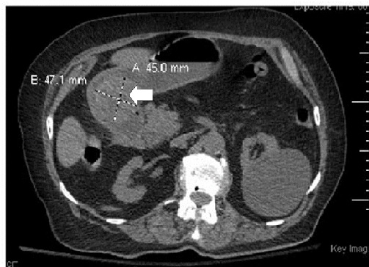
Figure 1 Computed tomography scan showing calcified mass at the gastric pylorus (shown by arrow).
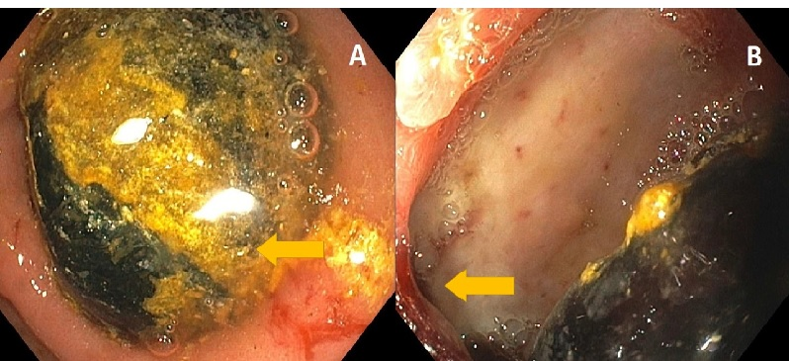
Figure 2 Esophagogastroduodenoscopy showing large impacted gall stone. A: In the duodenal bulb; B: With an ulcerated cholecystoduodenal fistula (shown by arrows).
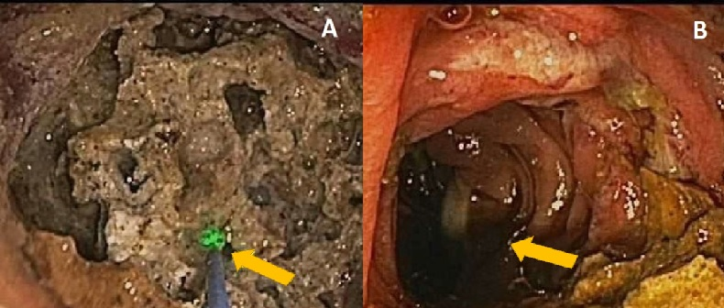
Figure 3 Holmium laser therapy was performed using an upper endoscope in the duodenal bulb with 9 Watts, 1000 pulses and 10 Joules; and after an extensive session of lithotripsy, the stone was eventually fragmented and removed piecemeal. A: Endoscopic laser lithotripsy; B: With complete stone clearance (shown by arrows).

