Name of journal: World Journal of Gastrointestinal Endoscopy

ESPS Manuscript NO: 12399

Columns: CASE REPORT

Esophageal papilloma: Flexible endoscopic ablation by radiofrequency

del Genio G et al. Esophageal papilloma: Flexible endoscopic ablation by radiofrequency

Gianmattia del Genio, Federica del Genio, Pietro Schettino, Paolo Limongelli, Salvatore Tolone, Luigi Brusciano, Manuela Avellino, Chiara Vitiello, Giovanni Docimo, Angelo Pezzullo, Ludovico Docimo

Gianmattia del Genio, Paolo Limongelli, Salvatore Tolone, Luigi Brusciano, Chiara Vitiello, Giovanni Docimo, Ludovico Docimo, XI Division of General and Bariatric Surgery, Department of Surgery, Second University of Naples, 80131 Naples, Italy

Federica del Genio, Center of Esophago-gastric and Bariatric Surgery (E.G.O.), Clinica C.G. Ruesch, 80122 Naples, Italy

Pietro Schettino, Manuela Avellino, Angelo Pezzullo, Surgical Endoscopy, Department of Surgery, Second University of Naples, 80131 Naples, Italy

Author contributions: All authors contributed to this work.

Ethics approval: The study was reviewed and approved.

Informed consent: All study participants, or their legal guardian, provided informed written consent prior to study enrollment

Conflict-of-interest: Drs. Gianmattia del Genio et al have no conflict of interest, financial ties or funding source to disclose.

Open-Access: This article is an open-access article which was selected by an in-house editor and fully peer-reviewed by external reviewers. It is distributed in accordance with the Creative Commons Attribution Non Commercial (CC BY-NC 4.0) license, which permits others to distribute, remix, adapt, build upon this work non-commercially, and license their derivative works on different terms, provided the original work is properly cited and the use is non-commercial. See: http://creativecommons.org/licenses/by-nc/4.0/

Correspondence to: Gianmattia del Genio, MD, PhD, Professor, FACS, Surgical Endoscopy Unit, Università Degli Studi di Napoli, Second University of Naples, XI Division of General and Bariatric Surgery, Department of Surgery, Second University of Naples, Via Pansini, 5, Padiglione 17, 80131 Naples, Italy. gianmattia.delgenio@unina2.it

Telephone: +39-081-5666773
Fax: +39-081-5666237
Received: July 6, 2014

Peer-review started: July 6, 2014

First decision: August 28, 2014
Revised: January 5, 2014
Accepted: Janurary 15, 2015

Article in press:

Published online:

Abstract
Squamous papilloma of the esophagus is a rare benign lesion of the esophagus. Radiofrequency ablation is an established endoscopic technique for the eradication of Barrett esophagus. No cases of endoscopic ablation of esophageal papilloma by radiofrequency ablation (RFA) have been reported. We report a case of esophageal papilloma successfully treated with a single session of radiofrequency ablation. Endoscopic ablation of the lesion was achieved by radiofrequency using a new catheter inserted through the working channel of endoscope. The esophageal ablated tissue was removed by a specifically designed cup. Complete ablation was confirmed at 3 mo by endoscopy with biopsies. This case supports feasibility and safety of as a new potential indication for BarrxTM RFA in patients with esophageal papilloma.

Key words: Esophageal papilloma; Endoscopic ablation; Radiofrequency; Minimally invasive; Natural orifice transluminal endoscopic surgery (NOTES)

© The Author(s) 2015. Published by Baishideng Publishing Group Inc. All rights reserved.

Core tip: This paper reports for the first time a flexible endoscopic treatment of esophageal papilloma by a new radiofrequency system that goes into the working channel of the endoscope. This allows the endoscopist to see what he is doing along the procedure and to complete the procedure in few minutes. The procedure was performed without particular difficulties and did not required elevated skills.

del Genio G, del Genio F, Schettino P, Limongelli P, Tolone S, Brusciano L, Avellino M, Vitiello C, Docimo G, Pezzullo A, Docimo L. Esophageal papilloma: Flexible endoscopic ablation by radiofrequency. World J Gastrointest Endosc 2015; In press

INTRODUCTION
Esophageal benign lesion is often a major concern due to need of an effective and low risk procedure combined to unmodified physiology^{[1]}. Radiofrequency ablation (RFA) is an established endoscopic technique for the eradication of Barrett esophagus, which has been investigated in a variety of study designs and settings^{[2-6]}.
Radiofrequency ablation is associated with an acceptable safety profile, high rates of complete eradication of dysplasia and intestinal metaplasia, durability of effect, and a significant relative risk reduction for neoplastic progression, thus it is considered a standard of care for patients with high-grade dysplasia^{[7]}.
Squamous papilloma (SP) of the esophagus is a rare benign lesion of the esophagus. The prevalence ranges from 0.01 % to 0.45 %^{[8]}. SP of the esophagus is usually asymptomatic and rarely causes dysphagia. Esophageal squamous papillomatosis is typically reported as a wart-like and fleshy-pink single lesion, most commonly in the middle or distal esophagus; the typical endoscopic appearance is a single, round sessile lesion^{[9]}. The underlying etiology is unclear, but chronic reflux disease, mucosal trauma, and human papillomavirus (HPV) infection have been implicated, although most lesions are found in absence of HPV^{[10]}. The malignant potential of the lesion is unknown, and no guidelines exist regarding follow-up of these lesions^{[11]}. Some authors have recently reported the possibility of an endoscopic removal^{[12,13]}. To the best of our knowledge, no cases of endoscopic ablation of esophageal papilloma by RFA has been reported. We report a case of esophageal papilloma successfully treated with a single session of RFA.

CASE REPORT
This case was conducted according to the Declaration of Helsinki and approved by the local institutional review board. In February 2014, a 52-year-old white asymptomatic woman was referred to our unit in the preoperative assessment of intragastric baloon placement for obesity. Upper gastrointestinal endoscopy (UGIE) revealed the presence of a single whitish wart-like area of about 0.5 cm in diameter which was located 37 cm from the incisors, above the Z-line (Figure 1). Narrow band imaging (NBI) confirmed the presence of an unstained area. Histologic examination showed the presence of micropapilloma of the esophagus surrounded by cilindric epithelium with congestion and flogosis (Figure 2). In April 2014 a session of RFA (BarrxTM, Covidien, CA, United States) on the dysmorfic esophageal area was performed. Total length of the procedure was 10 min. No complications occurred during the procedure. Postoperative course was uneventful.

Endoscopic technique
The patient was positioned in the left lateral decubitus position under monitoring of vital signs. Intravenous sedation was administered. An UGIE allowed identification of the esophageal papilloma. The total length of the area was calculated. Esophageal lumen was pre-treated with N-acetycysteine 1% (MucomystTM). A new designed catheter (Channel RFA Endoscopic Catheter, Barrx™, Covidien) was inserted through the working channel of a standard flexible gastroscope (Figure 3). The electric pad of the catheter was placed under direct visualization so that the entire suspected area was covered. Radiofrequency was applied at 300 W and 12 J/cm². The wound along the ablation zone was cleaned from debris using Barrx™ RFA Cleaning cup mounted on distal end of endoscope. The ablation was repeated using the same procedure (Figure 4). The patient was discharged the same day. An UGIE was repeated after one months, showing a whitish area suggestive of scarring at the site of ablation without macroscopical evidence of residual papilloma. A second UGIE with biopsies, at 3 months, excluded the presence of recurrent disease.

DISCUSSION
RFA has been recently reported to be more effective and less costly than photodynamic therapy in the treatment of Barrett’s related dysplasia^{[14]}. On the other hand, an important advantage of RFA lays on simplicity and safety of the procedure suggesting the treatment can be effective with potential lower complications rates than more invasive techniques such as endoscopic resection. In this case an asymptomatic patient was discovered to have an esophageal papilloma in course of preoperative EGDS before bariatric treatment.
In this case, the efficacy was reached by a single session of RFA, with a minimal discomfort for the patient and a relatively low impact on the endoscopic center. Our initial experience supports the feasibility and safety of a new potential indication for BarrxTM RFA in patients with esophageal papilloma. Further cases and a longer follow up will be needed to drive a definitive conclusion.

ACKNOWLEDGMENTS
“Considerate la vostra semenza: Fatti non foste a viver come bruti, ma per seguir virtute e canoscenza.” (Consider well the seed that gave you birth: you were not made to live as brutes, but to follow virtue and knowledge). Ulysses in The Divine Comedy. Dante Alighieri, Canto XXVI, 1308-21.

COMMENTS

Case characteristics

A 52-year-old female with esophageal papilloma.

Clinical diagnosis
The tumor was diagnosed during routine gastroscopy for preoperative assessment before placing intragastric baloon.

Differential diagnosis
Esophageal high grade dysplasia, metaplasia, early adenocarcimona or squamous cell carcinoma.

Laboratory diagnosis

All blood test were within normal limits.

Imaging diagnosis

Upper endoscopy showed the lesion, byopsies were taken.

Pathological diagnosis
Histologic examination showed the presence of micropapilloma of the esophagus surrounded by cilindric epithelium with congestion and flogosis

Treatment

Single treatment of endoscopic ablation by radiofrequency.

Related reports
Endoscopic curative treatment is becoming more popular. This is the first report of squamous esophageal papilome treated by a new catheter radiofrequency technology.

Term explanation
RFA: Radiofrequency ablation is a relatively new technique generally used to treat Barrett’s esophagus related high grade dysplasia. This technology uses bipolar energy associated to impedance to automatically controll the energy output.

Experiences and lessons
The new technical possibility allows a less invasive approach with a reduced risks of potentially serious complication and a faster return to normal life.

Peer review

The manuscript is very well.

REFERENCES
1 Del Genio G, Tolone S, Del Genio F, D'Alessandro A, Brusciano L, Aggarwal R, Conzo G, Orditura M, Docimo L, Del Genio A. Impact of total fundoplication on esophageal transit: analysis by combined multichannel intraluminal impedance and manometry. J Clin Gastroenterol 2012; 46: e1-e5 [PMID: 22157223 DOI: 10.1097/MCG.0b013e31822f3735]
2 Phoa KN, Pouw RE, van Vilsteren FG, Sondermeijer CM, Ten Kate FJ, Visser M, Meijer SL, van Berge Henegouwen MI, Weusten BL, Schoon EJ, Mallant-Hent RC, Bergman JJ. Remission of Barrett's esophagus with early neoplasia 5 years after radiofrequency ablation with endoscopic resection: a Netherlands cohort study. Gastroenterology 2013; 145: 96-104 [PMID: 23542068 DOI: 10.1053/j.gastro.2013.03.046]
3 van Vilsteren FG, Pouw RE, Seewald S, Alvarez Herrero L, Sondermeijer CM, Visser M, Ten Kate FJ, Yu Kim Teng KC, Soehendra N, Rösch T, Weusten BL, Bergman JJ. Stepwise radical endoscopic resection versus radiofrequency ablation for Barrett's oesophagus with high-grade dysplasia or early cancer: a multicentre randomised trial. Gut 2011; 60: 765-773 [PMID: 21209124 DOI: 10.1136/gut.2010.229310]
4 Pouw RE, Wirths K, Eisendrath P, Sondermeijer CM, Ten Kate FJ, Fockens P, Devière J, Neuhaus H, Bergman JJ. Efficacy of radiofrequency ablation combined with endoscopic resection for barrett's esophagus with early neoplasia. Clin Gastroenterol Hepatol 2010; 8: 23-29 [PMID: 19602454 DOI: 10.1016/j.cgh.2009.07.003]
5 Shaheen NJ, Sharma P, Overholt BF, Wolfsen HC, Sampliner RE, Wang KK, Galanko JA, Bronner MP, Goldblum JR, Bennett AE, Jobe BA, Eisen GM, Fennerty MB, Hunter JG, Fleischer DE, Sharma VK, Hawes RH, Hoffman BJ, Rothstein RI, Gordon SR, Mashimo H, Chang KJ, Muthusamy VR, Edmundowicz SA, Spechler SJ, Siddiqui AA, Souza RF, Infantolino A, Falk GW, Kimmey MB, Madanick RD, Chak A, Lightdale CJ. Radiofrequency ablation in Barrett's esophagus with dysplasia. N Engl J Med 2009; 360: 2277-2288 [PMID: 19474425 DOI: 10.1056/NEJMoa0808145]
6 Fleischer DE, Overholt BF, Sharma VK, Reymunde A, Kimmey MB, Chuttani R, Chang KJ, Muthasamy R, Lightdale CJ, Santiago N, Pleskow DK, Dean PJ, Wang KK. Endoscopic radiofrequency ablation for Barrett's esophagus: 5-year outcomes from a prospective multicenter trial. Endoscopy 2010; 42: 781-789 [PMID: 20857372 DOI: 10.1055/s-0030-1255779]
7 Phoa KN, van Vilsteren FG, Weusten BL, Bisschops R, Schoon EJ, Ragunath K, Fullarton G, Di Pietro M, Ravi N, Visser M, Offerhaus GJ, Seldenrijk CA, Meijer SL, ten Kate FJ, Tijssen JG, Bergman JJ. Radiofrequency ablation vs endoscopic surveillance for patients with Barrett esophagus and low-grade dysplasia: a randomized clinical trial. JAMA 2014; 311: 1209-1217 [PMID: 24668102 DOI: 10.1001/jama.2014.2511]
8 Takeshita K, Murata S, Mitsufuji S, Wakabayashi N, Kataoka K, Tsuchihashi Y, Okanoue T. Clinicopathological characteristics of esophageal squamous papillomas in Japanese patients--with comparison of findings from Western countries. Acta Histochem Cytochem 2006; 39: 23-30 [PMID: 17460769]
9 Lewin KJ, Appelman HD. Tumors of the esophagus & stomach: atlas of tumor pathology. 3rd Series, Vol. 18. American Registry of Pathology. Washington, DC: Armed forced Institute of Pathology, 1995: 31-32
10 Del Genio G, Tolone S, Limongelli P, Brusciano L, D'Alessandro A, Docimo G, Rossetti G, Silecchia G, Iannelli A, del Genio A, del Genio F, Docimo L. Sleeve gastrectomy and development of "de novo" gastroesophageal reflux. Obes Surg 2014; 24: 71-77 [PMID: 24249251 DOI: 10.1007/s11695-013-1046-4.]
11 Odze R, Antonioli D, Shocket D, Noble-Topham S, Goldman H, Upton M. Esophageal squamous papillomas. A clinicopathologic study of 38 lesions and analysis for human papillomavirus by the polymerase chain reaction. Am J Surg Pathol 1993; 17: 803-812 [PMID: 8393303]
12 Kim E, Byrne MF, Donnellan F. Endoscopic mucosal resection of esophageal squamous papillomatosis. Can J Gastroenterol 2012; 26: 780-781 [PMID: 23166898]
13 del Genio G, Rossetti G, Brusciano L, Limongelli P, Pizza F, Tolone S, Fei L, Maffettone V, Napolitano V, del Genio A. Laparoscopic Nissen-Rossetti fundoplication with routine use of intraoperative endoscopy and manometry: technical aspects of a standardized technique. World J Surg 2007; 31: 1099-1106 [PMID: 17426906]
14 Ertan A, Zaheer I, Correa AM, Thosani N, Blackmon SH. Photodynamic therapy vs radiofrequency ablation for Barrett's dysplasia: efficacy, safety and cost-comparison. World J Gastroenterol 2013; 19: 7106-7113 [PMID: 24222954 DOI: 10.3748/wjg.v19.i41.7106]

P-Reviewer: de Mello RA S-Editor: Ji FF L-Editor: E-Editor:

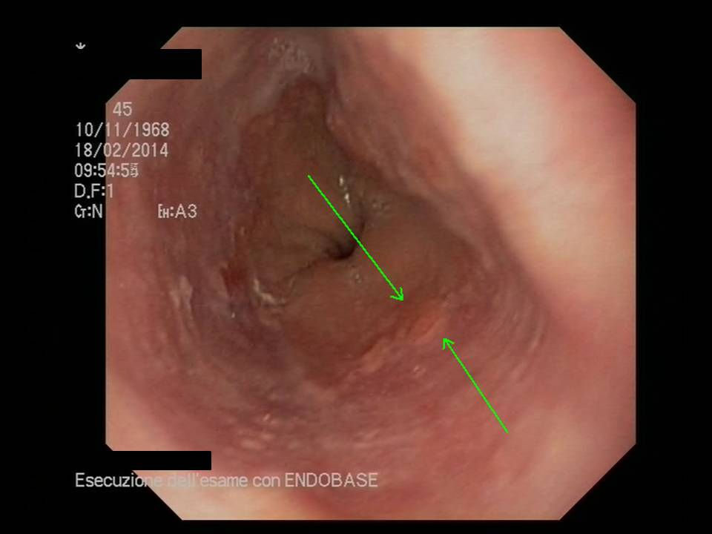

Figure 1 Endoscopic view of esophageal papilloma.
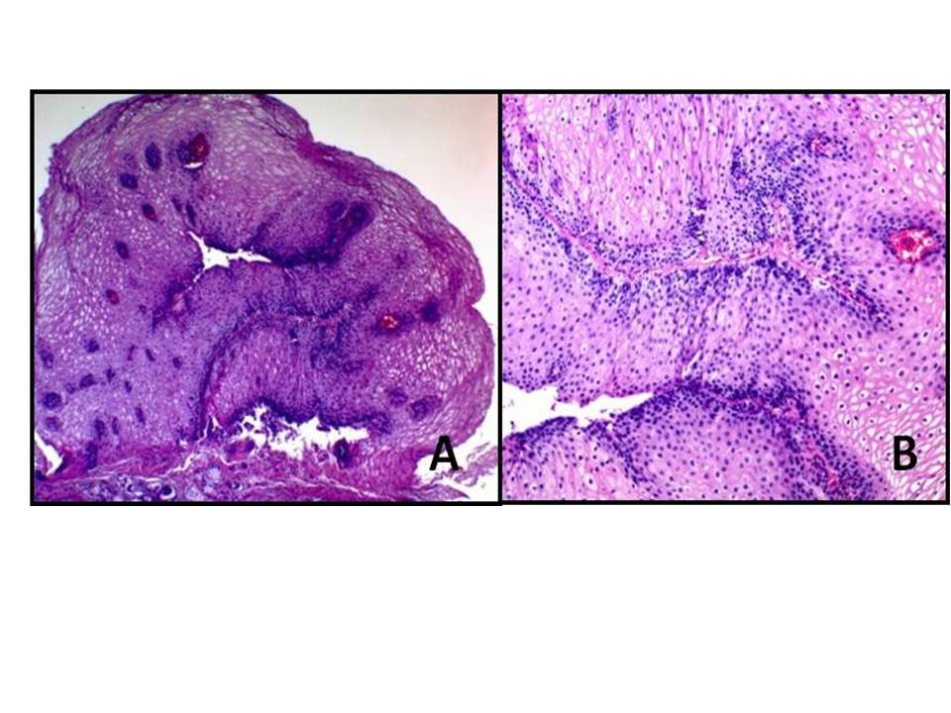
Figure 2 Esophageal biopsy showing papillary projections lined with acanthotic squamous epithelium (A: HE 4 ×; B: HE 10 ×).
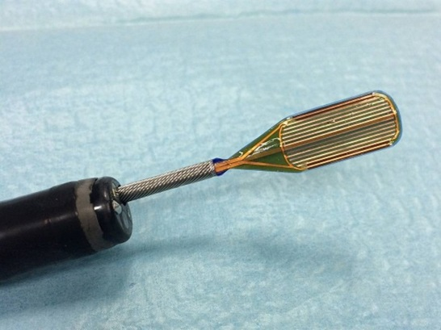
Figure 3 Radiofrequency catheter inserted into standard flexible gastroscope operative channel (Barrx™, Covidien).
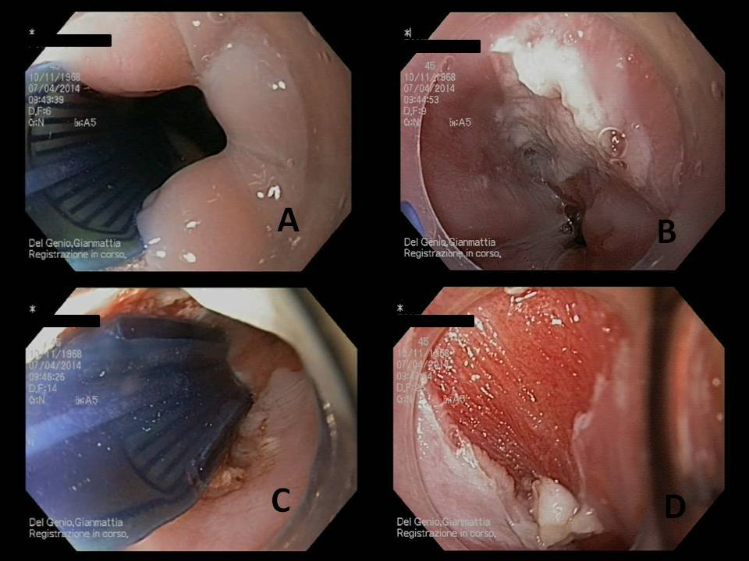
Figure 4 (A) Radiofrequency pad is placed over the lesion under direct visualization; (B) Ablation area after the first application of energy; (C) Second application of the pad to include all the area of esophageal papilloma; (D) Esophageal wound cleaned from debris by cleaning cup.

