Name of Journal: World Journal of Clinical Cases
Manuscript NO: 50535
Manuscript Type: CASE REPORT

Unilateral congenital scrotal agenesis with ipsilateral cryptorchidism: A case report

Fang Y et al. Congenital scrotal agenesis with ipsilateral cryptorchidism

Yong Fang, Juan Lin, Wen-Wei Wang, Jun Qiu, Yi Xie, Li-Ping Sang, Jia-Cong Mo, Jun-Hang Luo, Jin-Huan Wei

Yong Fang, Wen-Wei Wang, Jun Qiu, Yi Xie, Li-Ping Sang, Jia-Cong Mo, Jun-Hang Luo, Jin-Huan Wei, Department of Urology, First Affiliated Hospital of Sun Yat-sen University, Guangzhou 510080, Guangdong Province, China

Juan Lin, Department of Pediatrics, Third Affiliated Hospital of Sun Yat-sen University, Guangzhou 510630, Guangdong Province, China

ORCID number: Yong Fang (0000-0002-2445-8441); Juan Lin (0000-0002-9193-8285); Wen-Wei Wang (0000-0002-6916-5503); Jun Qiu (0000-0001-9827-631X); Yi Xie (0000-0002-9226-4438; Li-Ping Sang (0000-0002-4127-1355); Jia-Cong Mo (0000-0002-7920-7447); Jun-Hang Luo (0000-0001-5449-5131); Jin-Huan Wei (0000-0003-0179-6250).

Author contributions: Wei JH designed the case report; Lin J, Wang WW, Qiu J, Xie Y, Sang LP, Mo JC, and Luo JH collected the case data; Fang Y wrote the manuscript; Wei JH revised the manuscript. All authors read and approved the final manuscript.
Supported by the National Natural Science Foundation of China, No. 81602219.

Informed consent statement: Written informed consent was obtained from the patient.

Conflict-of-interest statement: The authors declare that they have no conflict of interest.

CARE Checklist (2016) statement: The manuscript was prepared and revised according to the CARE Checklist (2016).

Open-Access: This article is an open-access article which was selected by an in-house editor and fully peer-reviewed by external reviewers. It is distributed in accordance with the Creative Commons Attribution Non Commercial (CC BY-NC 4.0) license, which permits others to distribute, remix, adapt, build upon this work non-commercially, and license their derivative works on different terms, provided the original work is properly cited and the use is non-commercial. See: http://creativecommons.org/licenses/by-nc/4.0/

Manuscript source: Unsolicited manuscript

Corresponding author: Jin-Huan Wei, PhD, Research Fellow, Department of Urology, First Affiliated Hospital of Sun Yat-sen University, No. 58, Zhongshan Er Road, Guangzhou 510080, Guangdong Province, China. wei_jhurol@sina.com
Telephone: +86-20-87755776
Fax: +86-20-87333300

Received: July 27, 2019
Peer-review started: July 27, 2019
First decision: September 9, 2019
Revised: September 19, 2019
Accepted: September 25, 2019
Article in press: September 25, 2019
Published online: November 26, 2019

Abstract
BACKGROUND
Congenital scrotal agenesis (CSA) is very rare. There are 11 cases of congenital scrotal agenesis or absence reported in the literature, most of which are bilateral and accompanied by cryptorchidism. Only two cases of which are unilateral scrotal agenesis and not accompanied by cryptorchidism. This is the first reported case of unilateral scrotal agenesis with cryptorchidism and scrotoplasty.

CASE SUMMARY
A 2-year-old boy was admitted to our hospital with left cryptorchidism and ipsilateral CSA. An innovative method was used in the patient where a scrotal skin pedicle from the right part of scrotal skin was transplanted to the left side. At the same time, descent orchiopexy was performed. At the 4-mo follow-up, the left testicle was located in the scrotum and the size and shape were normal.

CONCLUSION
For unilateral CSA with ipsilateral cryptorchidism, contralateral scrotal pedicle transplantation and descent orchiopexy appear to be a successful surgical option.

Key word: Unilateral congenital scrotal agenesis; Contralateral scrotal pedicle transplantation; Cryptorchidism; Case report

© The Author(s) 2019. Published by Baishideng Publishing Group Inc. All rights reserved.

Core tip: Congenital scrotal agenesis is very uncommon. More specially, this is the first reported case of unilateral scrotal agenesis with cryptorchidism. We innovatively transplanted the contralateral scrotal skin flap to the affected side and achieved satisfactory results.

Citation: Fang Y, Lin J, Wang WW, Qiu J, Xie Y, Sang LP, Mo JC, Luo JH, Wei JH. Unilateral congenital scrotal agenesis with ipsilateral cryptorchidism: A case report. World J Clin Cases 2019; 7(22): 3807-3811
URL: https://www.wjgnet.com/2307-8960/full/v7/i22/3807.htm
DOI: https://dx.doi.org/10.12998/wjcc.v7.i22.3807
INTRODUCTION
Cryptorchidism is a common disease in children, but congenital scrotal agenesis (CSA) is very rare. At present, there are 11 cases of CSA reported in the literature^{[1-5]}. Two of these cases are unilateral, while the rest are bilateral, most of which are accompanied by cryptorchidism. Recently, a boy with left cryptorchidism and ipsilateral congenital scrotal agenesis was treated in our hospital. Our innovative method involved performing descent orchiopexy and then transplanting a scrotal skin pedicle from the right part of scrotal skin to the left side. Through this method, we were able to achieve satisfactory results, as detailed in this report.

CASE PRESENTATION
Chief complaints
The patient was a 2-year-old boy born with abnormal skin of the left scrotum. It was later found that the left testicle was not in the scrotum.

History of present illness
When the patient was 2 years old, he went to the local hospital for descent orchiopexy. However, after the doctors discovered skin agenesis of his scrotum, he was transferred to our hospital for treatment because this disease had never been seen in their hospital and local physicians were worried about the effect of surgical treatment.

History of past illness
The patient’s parents denied any past surgical interventions.

Personal and family history
The patient was born in normal childbirth and his parents were healthy.

Physical examination upon admission
The left testicle was located in the inguinal region and was about 1.2 cm × 1 cm in size. The right testicle and scrotum developed normally, however, the skin of the left scrotum was significantly less wrinkled and was pale compared to the right side (Figure 1).

Laboratory examinations
The karyotype was normal (46XY), and high-throughput sequencing results indicated that the child carried the SRY gene without any pathogenic variations of sex development disorder genes (WNT4, NR5A1, SOX9, and NROB1).

Imaging examinations
Ultrasonography determined that there were no abnormalities in the kidneys, bladder, or prostate; the left testicle was located in the inguinal region, which was 1.2 cm × 1 cm in size; the right testicle was located in the right scrotum, which was 1.5 cm × 1.2 cm in size.

FINAL DIAGNOSIS
Unilateral CSA with ipsilateral cryptorchidism.

TREATMENT
Treatment at our hospital occurred in February 2019. First, we recovered the testis by making an incision in the left lower abdomen and freed the testis from the surrounding tissue until it would be able to descend to the scrotum and ligate the unclosed sheath process at a high position. Then we cut a pedicle of skin tissue from the right scrotum (size of pedicle = 2 cm × 2 cm), cut open the left agenesis scrotum skin (3 cm), placed the left testis into the incision, and fixed the testis with cotton balls. Lastly, the pedicled scrotal skin was sewed into the incision (Figure 2).

OUTCOME AND FOLLOW-UP
Follow-up at 4 mo after the surgery showed that there were no complications and the wound had healed well. The left testicle was located in the scrotum and the size and shape were normal (Figure 3).

DISCUSSION
CSA or congenital scrotal absence is a very rare disease and most of the time occurs in a bilateral manner. According to the available literature, there are two cases of unilateral scrotal agenesis without cryptorchidism^{[1,2]}. This is the first reported case of unilateral scrotal agenesis with cryptorchidism and scrotoplasty. The pathogenesis of scrotal agenesis is not clear. The patient in this study carries SRY gene and we did not detect pathogenic variations of related sex development genes. There was no androgen insensitivity or 5-reductase deficiency overall, but local androgen insensitivity or 5-reductase deficiency specifically in the scrotum may exist. There is a hypothesis that descending testicles contribute to the formation of scrotal skin, but one case of unilateral scrotal agenesis did have normal testicles^{[1]}, so this hypothesis may not be valid. Additionally, previous reports have shown that complete scrotal agenesis patients can carry heterozygous genomic variation in exon 17 of the MAP3K1 gene^{[3]}, suggesting that this mutation may play a role in the pathogenesis of scrotal agenesis.
Therapeutic measures for CSA or congenital scrotal absence mainly include drug treatment, surgical treatment, and regular observation. Mohan et al^{[4]} reported two cases of scrotal agenesis treated with testosterone and found that the scrotum gradually developed into skin wrinkles. Currently, operation options include prepuce flap transplantation; testicular descent and fixation after testicular prostheses expanding the skin^{[3,5]}. Some patients also chose not to undergo surgery and instead opt for regular observation as their preferred course of action^{[1]}. Although the prepuce skin and scrotal skin were used almost interchangeable for a long time^{[6]}, for this patient, we did not use prepuce transplantation because of the postoperative risk of small area necrosis and infection in prepuce transplantation flaps^{[5]}. Additionally, the appearance of scrotal skin is quite different from prepuce skin, so a scrotal skin pedicle was the preferred option. There are also other several reasons to consider scrotal skin transplantation. First, the nearby pedicled skin flap is more likely to survive after transplantation. Second, compared with prepuce skin and dilated perineal skin, scrotal skin wrinkles are more conducive to testicular heat dissipation, allowing the pedicled scrotal skin to serve a functional purpose. Finally, a scrotal skin graft is closer to the shape of the natural scrotum and may positively contribute to his psychological stability in adulthood.

CONCLUSION
In summary, contralateral scrotal pedicle transplantation and descent orchiopexy are a feasible surgical method for unilateral CSA with ipsilateral cryptorchidism. Compare with other surgical methods, it is more conducive to retain the inherent function of scrotal skin itself, and will reduce the psychological shadow brought by the disease to the growth of children. But further follow-up is necessary in order to determine its long-term efficacy.

References
1 Flum AS, Chaviano AH, Kaplan WE. Hemiscrotal agenesis: new variation in a rare anomaly. Urology 2012; 79: 210-211 [PMID: 21820704 DOI: 10.1016/j.urology.2011.05.022]
2 Yilmaz E, Afşarlar CE, Karaman I, Özgüner IF, Karaman A, Hızli F. Congenital hemiscrotal agenesis: report of a rare entity. J Pediatr Urol 2013; 9: e76-e77 [PMID: 23044375 DOI: 10.1016/j.jpurol.2012.09.005]
3 Spagnoli A, Borsellino A, Crucianelli S, Bizzarri C, Mucciolo M, Trucchi A, Ferro F. Complete Scrotal Agenesis: New Surgical Approach Using Self-inflating Tissue Expander. Urology 2018; 112: 169-171 [PMID: 29080783 DOI: 10.1016/j.urology.2017.10.015]
4 Mohan PP, Woodward MN, Chandran H, Parashar K. Topical testosterone in scrotal agenesis. Pediatr Surg Int 2006; 22: 565-566 [PMID: 16518594 DOI: 10.1007/s00383-006-1659-y]
5 Wright JE. Congenital absence of the scrotum: case report and description of an original technique of construction of a scrotum. J Pediatr Surg 1993; 28: 264-266 [PMID: 8094748 DOI: 10.1016/s0022-3468(05)80291-x]
6 Fam MM, Hanna MK. Resurfacing the Penis of Complex Hypospadias Repair ("Hypospadias Cripples"). J Urol 2017; 197: 859-864 [PMID: 28131500 DOI: 10.1016/j.juro.2016.09.075]
P-Reviewer: Salvi PF S-Editor: Zhang L L-Editor: Wang TQ E-Editor:

Specialty type: Medicine, Research and Experimental
Country of origin: China
Peer-review report classification
Grade A (Excellent): 0
Grade B (Very good): 0
Grade C (Good): C
Grade D (Fair): 0
Grade E (Poor): 0

Figure 1 The wrinkles of the left scrotum were markedly reduced and the skin was pale in color. The left testicle was located in the left groin.

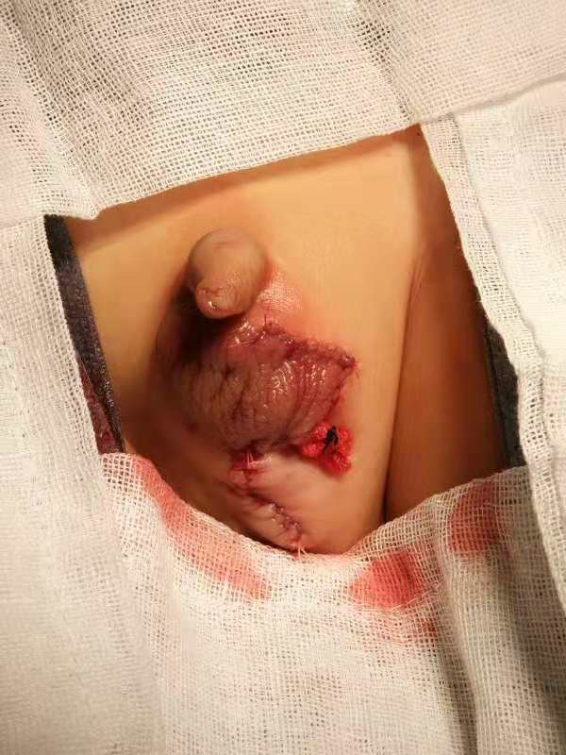
Figure 2 The right scrotal skin was transplanted to the left side using a pedicle, and the left testicle was relocated and fixed in the scrotum.

Figure 3 After 4 mo, the wound has healed well and the left testicle was located in the scrotum.

