Name of Journal: World Journal of Cardiology
ESPS Manuscript NO: 19955
Manuscript Type: Letter to the editor

Imaging of pannus formation in patients with mechanical heart valves

Gündüz S et al. Imaging of periprosthetic pannus

Sabahattin Gündüz, Mehmet Özkan, Mahmut Yesin

Sabahattin Gündüz, Mehmet Özkan, Mahmut Yesin, Department of Cardiology, Kosuyolu Kartal Heart Training and Research Hospital, 34846 İstanbul, Turkey

Author contributions: All the authors equally contributed to this work.

Conflict-of-interest statement: None of the authors have any conflict of interest to be disclosed.

Open-Access: This article is an open-access article which was selected by an in-house editor and fully peer-reviewed by external reviewers. It is distributed in accordance with the Creative Commons Attribution Non Commercial (CC BY-NC 4.0) license, which permits others to distribute, remix, adapt, build upon this work non-commercially, and license their derivative works on different terms, provided the original work is properly cited and the use is non-commercial. See: http://creativecommons.org/licenses/by-nc/4.0/

Correspondence to: Sabahattin Gündüz, MD, Cardiologist, Department of Cardiology, Kosuyolu Kartal Heart Training and Research Hospital, Denizer Cad. No: 2, Cevizli kavşağı, 34846 İstanbul, Turkey. sabahattingunduz@yahoo.com
Telephone: +90-505-5379809
Fax: +90-216-3682527

Received: May 26, 2015
Peer-review started: May 28, 2015
First decision: July 3, 2015
Revised: July 24, 2015
Accepted: September 16, 2015
Article in press:
Published online:

Abstract
Patient-prosthesis mismatch (PPM) should be recognized in patients with elevated transprosthetic gradients but without leaflet immobility, since the treatment strategy may differ in either etiology. However, thrombus and/or pannus formation should be excluded before a diagnosis of PPM is made. Particularly, pannus formation may not be diagnosed with 2-dimensional transesophageal echocardiography. Electrocardiographically gated 64-section multidetector computed tomography (MDCT) may be a promising tool in diagnosing or excluding pannus formation. Our report underlines the utility of MDCT in this regard and also emphasizes the importance of recognition of PPM as a differential diagnosis in such patients.

Key words: Multidetector computed tomography; Pannus formation; Patient prosthesis mismatch; Prosthetic heart valves; Transesophageal echocardiography

© The Author(s) 2015. Published by Baishideng Publishing Group Inc. All rights reserved.

Core tip: Elevated transprosthetic gradients may be caused by pannus and/or thrombus formation or patient prosthesis mismatch (PPM). The differentiation between these three diagnoses is essential since the treatment strategy may differ in either etiology. Our report emphasizes the usefulness of cardiac multidetector computerized tomography in cases with suspected pannus formation which may not be diagnosed without surgical confirmation. Moreover, we underline the importance of recognizing PPM which may easily be overlooked in patients with elevated transprosthetic gradients. Indeed, pannus, trombus or any other masses as the cause of prosthetic dysfunction should be ruled out for a diagnosis of PPM.

Gündüz S, Özkan M, Yesin M. Imaging of pannus formation in patients with mechanical heart valves. World J Cardiol 2015; In press

TO THE EDITOR
We would like to comment on the recent article by Soumolou et al^{[1]} which reports a case of obstructed prosthetic aortic valve caused by pannus formation, in which a preoperative definitive diagnosis could not be made by multiple imaging methods. We appreciate the authors since they emphasize the importance of clinical suspicion along with using multimodality imaging in recognizing this infrequent but serious complication of valve replacement surgery. However, two major issues remain to be addressed.
The differential diagnosis of a patient with elevated transprosthetic gradients should include not only pannus formation and thrombosis, but also patient prosthesis mismatch (PPM), since the treatment strategy may differ in either etiology. In the reported case, since there was no identifiable mass on transesophageal echocardiography (TEE) and no limited excursion of prosthetic leaflets, PPM had to be recognized before the decision of re-operation. Because, if the patient had had PPM, improvement of transprosthetic gradients after re-operation woud have been unlikely. Although the prosthetic valve size (#23 St. Jude) is not small and there is no information regarding the patient’s body surface area, PPM can not be excluded unless the presence of a periprosthetic mass (pannus or thrombus) is precisely excluded. Real-time 3-dimensional TEE may be a promising tool as previously reported^{[2]}. Although thrombus can be excluded by TEE, pannus may not be diagnosed in most of the cases. We have previously demonstrated that pannus formation may be visualized as a high-attenuated periprosthetic mass (Figure 1) and thrombus can be demonstrated as a low attenuated periprosthetic mass on electrocardiographically gated 64-section multidetector cardiac computed tomography (MDCT)^{[3-6]}. Although the authors mention the use of cardiac computed tomography pre-operatively, there is no information regarding the slice number of the MDCT, use of intravenous contrast agent, electrocardiographic gating during the scan. Hence, without appropriate use of cardiac MDCT, pannus or thrombus may not be visualized. Fortunately, pannus formation was diagnosed peri-operatively in the current case, and the patient was succesfully re-replaced with another mechanical prosthesis.
Clinicians should be cognizant of PPM, when evaluating a patient with elevated transprosthetic gradients but without leaflet blockade. Thrombus can readliy be excluded with TEE but, pannus visualization may require more sophisticated imaging with MDCT in addition to TEE.

REFERENCES
1 Soumoulou JB, Cianciulli TF, Zappi A, Cozzarin A, Saccheri MC, Lax JA, Guidoin R, Zhang Z. Limitations of multimodality imaging in the diagnosis of pannus formation in prosthetic aortic valve and review of the literature. World J Cardiol 2015; 7: 224-229 [PMID: 25914791 DOI: 10.4330/wjc.v7.i4.224]
2 Ozkan M, Gündüz S, Yildiz M, Duran NE. Diagnosis of the prosthetic heart valve pannus formation with real-time three-dimensional transoesophageal echocardiography. Eur J Echocardiogr 2010; 11: E17 [PMID: 20022870 DOI: 10.1093/ejechocard/jep206]
3 Gündüz S, Ozkan M, Biteker M, Güneysu T. Imaging of the mechanical heart valve pannus formation with multidetector computerised tomography. Eur J Cardiothorac Surg 2010; 37: 1472 [PMID: 20172736 DOI: 10.1016/j.ejcts.2010.01.013]
4 Özkan M, Gündüz S, Biteker M, Duran NE, Güneysu T. Letter to the Editor re: Correctness of multi-detector-row computed tomography for diagnosing mechanical prosthetic heart valve disorders using operative findings as a gold standard. Eur Radiol 2009; 19: 2950-2952; author reply 2953-2954 [PMID: 19547985 DOI: 10.1007/s00330-009-1478-3]
5 Biteker M, Gündüz S, Ozkan M. Role of MDCT in the evaluation of prosthetic heart valves. AJR Am J Roentgenol 2009; 192: W77; author reply W78 [PMID: 19155385 DOI: 10.2214/AJR.08.1553]
6 Gündüz S, Ozkan M, Biteker M, Güneysu T. Mechanical mitral valve thrombosis and giant left atrial thrombus: comparison of transesophageal echocardiography and 64-slice multidetector computed tomography. Turk Kardiyol Dern Ars 2009; 37: 483-487 [PMID: 20098043]
P-Reviewer: Peteiro J, Petix NR, Takano M, Teragawa H S-Editor: Tian YL
L-Editor: E-Editor:

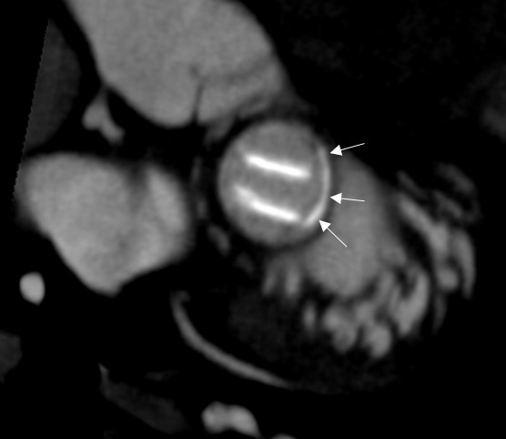
Figure 1 Pannus formation visualized as a high-attenuated periprosthetic mass.

