Name of Journal: World Journal of Gastroenterology
Manuscript NO: 82388
Manuscript Type: ORIGINAL ARTICLE

Basic Study
Effect and mechanism of reactive oxygen species-mediated NOD-like receptor family pyrin domain-containing 3 inflammasome activation in hepatic alveolar echinococcosis

Chen CS et al. ROS-Mediated NLRP3 Activation in the liver

Cai-Song Chen, Yao-Gang Zhang, Hai-Jiu Wang, Hai-Ning Fan

Cai-Song Chen, Research Center for High Altitude Medicine of Qinghai University, Affiliated Hospital of Qinghai University, Xining 810001, Qinghai Province, China

Yao-Gang Zhang, Hai-Jiu Wang, Qinghai Province Research Key Laboratory for Echinococcosis, Affiliated Hospital of Qinghai University, Xining 810001, Qinghai Province, China

Hai-Ning Fan, Department of Hepatobiliary and Pancreatic Surgery, Qinghai Province Research Key Laboratory for Echinococcosis, Affiliated Hospital of Qinghai University, Xining 810001, Qinghai Province, China

Author contributions: Chen CS and Fan HN conceived and designed the experiments; Chen CS, Zhang YG, and Wang HJ collected the samples; Chen CS and Zhang YG performed the experiments and data analyses; Chen CS wrote the first draft of the manuscript; Zhang YG and Fan HN provided comments for the revisions; all authors read and approved the final manuscript.

Supported by the National Major Research and Development Project of “Precision Medicine Research”, No. 2017YFC0909900; Qinghai Province Science and Technology Department Programme, No. 2019-SF-131; and the Qinghai Province Health and Family Planning Commission Programme, No. 2016-wjzd-04.

Corresponding author: Hai-Ning Fan, MD, Doctor, Professor, Department of Hepatobiliary and Pancreatic Surgery, Qinghai Province Research Key Laboratory for Echinococcosis, Affiliated Hospital of Qinghai University, No. 29 Tongren Road, Xining 810001, Qinghai Province, China. fanhaining6@yeah.net

Received: December 17, 2022
Revised: February 1, 2023
Accepted: March 15, 2023
Published online: April 14, 2023

Abstract
BACKGROUND
The NOD-like receptor family pyrin domain-containing 3 (NLRP3) inflammasome is a significant component of the innate immune system that plays a vital role in the development of various parasitic diseases. However, its role in hepatic alveolar echinococcosis (HAE) remains unclear.

AIM
To investigate the NLRP3 inflammasome and its mechanism of activation in HAE.

METHODS
We assessed the expression of NLRP3, caspase-1, interleukin (IL)-1β, and IL-18 in the marginal zone and corresponding normal liver of 60 patients with HAE. A rat model of HAE was employed to investigate the role of the NLRP3 inflammasome in the marginal zone of HAE. Transwell experiments were conducted to investigate the effect of Echinococcus multilocularis (E. multilocularis) in stimulating Kupffer cells and hepatocytes. Furthermore, immunohistochemistry, Western blotting, and enzyme-linked immunosorbent assay were used to evaluate NLRP3, caspase-1, IL-1β, and IL-18 expression; flow cytometry was used to detect apoptosis and reactive oxygen species (ROS).

RESULTS
NLRP3 inflammasome activation was significantly associated with ROS. Inhibition of ROS production decreased NLRP3-caspase-1-IL-1β pathway activation and mitigated hepatocyte damage and inflammation.

CONCLUSION
E. multilocularis induces hepatocyte damage and inflammation by activating the ROS-mediated NLRP3-caspase-1-IL-1β pathway in Kupffer cells, indicating that ROS may serve as a potential target for the treatment of HAE.

Key Words: Hepatic alveolar echinococcosis; Inflammasome; Inflammation; Kupffer cell; NLR family pyrin domain-containing 3 protein; Reactive oxygen species

©The Author(s) 2023. Published by Baishideng Publishing Group Inc. All rights reserved.

Citation: Chen CS, Zhang YG, Wang HJ, Fan HN. Effect and mechanism of reactive oxygen species-mediated NOD-like receptor family pyrin domain-containing 3 inflammasome activation in hepatic alveolar echinococcosis. World J Gastroenterol 2023; 29(14): 2153-2171
URL: https://www.wjgnet.com/1007-9327/full/v29/i14/2153.htm
DOI: https://dx.doi.org/10.3748/wjg.v29.i14.2153

Core Tip: In recent years, the role of the NOD-like receptor family pyrin domain-containing 3 (NLRP3) inflammasome in parasitic diseases has attracted widespread attention. However, the role and clinical significance of the NLRP3 inflammasome in Hepatic alveolar echinococcosis (HAE) remain unclear. Herein, we explored the mode of NLRP3 inflammasome activation in the tissues of patients with HAE, a rat model of HAE, rat Kupffer cells, and hepatocytes. Our experiments showed that inhibiting reactive oxygen species (ROS) production reduces NLRP3-caspase-1-IL-1β pathway activation. Decreased IL-1β expression alleviated inflammation and apoptosis rates in hepatocytes in HAE. We conclude that ROS-mediated NLRP3 inflammasome activation was a key factor leading to hepatocyte injury and triggering a cascade of inflammatory reactions. Therefore, ROS production may be a promising target for the treatment of HAE.

INTRODUCTION
Echinococcosis is a global zoonotic parasitic disease categorised into two main subtypes, namely cystic echinococcosis and alveolar echinococcosis, which are caused by the larvae of Echinococcus granulosus and Echinococcus multilocularis (E. multilocularis), respectively. Alveolar echinococcosis, also termed “parasite cancer”^{[1]}, is a helminthiasis that progresses slowly and mainly invades the liver. However, if left untreated, it can lead to high morbidity and mortality^{[2]}. It is estimated that nearly 600000 people worldwide have been infected^{[3,4]}. Cases of hepatic alveolar echinococcosis (HAE) have risen sharply in recent years. Qinghai Province in China is a region with a high and increasing incidence of echinococcosis^{[5]}. Moreover, epidemiological evidence suggests that the medical and economic burden of HAE will increase significantly in the next decade^{[6]}.
Inflammasomes were first proposed by Martinon et al^{[7]} in 2002 as multimeric complexes that form in response to various physiological and pathological stimuli. Inflammasomes are important components of the innate immune system, and inflammasome activation is essential for pathogen clearance^{[8]}. The main components include nucleotide-binding oligomerization domain-like receptors (NLRs), leucine-rich repeats, and a protein-protein interaction domain, which could be a pyrin domain, a caspase recruitment domain, or a baculovirus inhibitor of an apoptosis protein repeat domain. NLRs are cytosolic pattern-recognition receptors that act as sensors of the innate immune system. They can recognize microbial structures or pathogenic components, called pathogen-associated molecular patterns or damage-associated molecular patterns, which are generated by endogenous stress, and trigger downstream inflammatory pathways, to eliminate infection and repair damaged tissues^{[9]}. An inflammasome is defined by its sensor protein. Five pattern-recognition receptors have been shown to form inflammasomes: Absent in melanoma 2 (AIM2), NLR family caspase recruitment domain-containing 4 (NLRC4), NOD-like receptor family pyrin domain-containing 1 (NLRP1), NLRP3, and pyrin^{[10]}. Among them, the NLRP3 inflammasome is the most studied.
The NLRP3 inflammasome, a signaling molecule in the innate immune system, can convert inactive cysteine aspartate proteolytic enzyme 1 precursor (pro-caspase-1) into active caspase-1, which in turn converts inactive pro-interleukin (IL)-1β and pro-IL-18 into mature IL-1β and IL-18, respectively. NLRP3 inflammasome expression is transcriptionally regulated by nuclear factor kappa B (NF-κB), and is very low in non-activated macrophages^{[11]}. NLRP3-caspase-1-IL-1β pathway activation exerts effects on processes, such as stress, inflammation, and injury repair^{[12]}, which have been extensively studied in tumour development^{[13-15]} and metastasis^{[16]}. In recent years, the role of the NLRP3 inflammasome in parasitic diseases has attracted widespread attention. The NLRP3 inflammasome is upregulated in malaria^{[17]}. Furthermore, in amoebic diseases, macrophage α5β1 integrin expression is associated with NLRP3 inflammasome activation^{[18]}. The NLRP3 inflammasome and caspase-1/11 pathway protect against acute Trypanosoma cruzi (T. cruzi) infection^{[19]}. The NLRP3 inflammasome controls T. cruzi infection via a caspase-1-dependent, IL-1R-independent, nitric oxide mechanism^{[20]}. Inflammasome-derived IL-1β production induces nitric oxide-mediated resistance to Leishmania^{[21]}. The development of Leishmaniasis occurs via NLRP3 inflammasome-mediated IL-1β production^{[22]}. Schistosoma mansoni activates the NLRP3 inflammasome and alters adaptive immune responses through Dectin-2^{[23]}. NLRP3 inflammasome activation in mice results in fibrosis of hepatic stellate cells in schistosomiasis^{[24]}. Although the NLRP3 inflammasome is activated differently in different parasitic diseases, it plays an important role in these diseases. Assessing inflammasomes may aid in the rapid identification and elimination of these pathogenic factors, and provide potential means for the treatment and prevention of infection.
NLRP3 inflammasome activation is related to mitochondrial autophagy and reactive oxygen species (ROS) production^{[25,26]}. The mechanism of ROS-mediated NLRP3 inflammasome activation is closely related to Kupffer cells^{[27,28]}. Inhibiting ROS production or using nicotinamide adenine dinucleotide phosphate, an oxidase inhibitor, can block NLRP3 inflammasome activation^{[29,30]}. As an important mediator of oxidative stress, ROS is closely related to inflammation. T. cruzi infection promotes the synthesis and release of ROS, with NF-κB pathway activation and decreased expression of inflammatory cytokines in NLRP3 knock-out mice, while alleviating acute-phase symptoms^{[31]}. Protein kinase C/ROS-mediated NLRP3 inflammasome activation correlates with pathological changes in leishmaniasis^{[32]}. ROS inhibition and prevention of potassium channel opening inhibits NLRP3 inflammasome expression, implying that ROS production and potassium channel opening are pivotal for NLRP3 inflammasome activation in human prostate epithelial cells^{[33]}.
The occurrence and development of parasitic diseases is often accompanied by inflammation^{[34,35]}. In a previous study, we determined that HAE has a clear marginal zone^{[36]}. However, the role and clinical significance of the NLRP3 inflammasome in HAE remain unclear. Herein, we explored NLRP3 inflammasome activation in the tissues of patients with HAE, a rat model of HAE, rat Kupffer cells, and hepatocytes. We investigated the mechanism of NLRP3 inflammasome activation in HAE and the effect of its downstream products. We hypothesised that E. multilocularis aggravates hepatic damage and inflammation by activating the NLRP3 inflammasome in HAE.

MATERIALS AND METHODS
Patient tissues
Tissue specimens were collected from 60 patients with HAE who underwent surgery at the Department of Hepatobiliary and Pancreatic Surgery of the Affiliated Hospital of Qinghai University from January to December 2020. Patients did not receive adjuvant therapy before surgery. HAE was confirmed by pathological examination. The pathological stage and degree of differentiation of the lesions were based on the PNM classification, where P refers to a parasitic mass in the liver, N refers to the involvement of neighbouring organs, and M refers to metastasis^{[37]}. The marginal zone of the lesion (< 0.5 cm away from the lesion) and the tissue adjacent to the lesion (> 3 cm away from the lesion) were rapidly frozen in liquid nitrogen, within 15 min of surgical resection, and stored at -80 °C.

Parasites and animal experiments
E. multilocularis specimens were obtained from the Key Laboratory of Echinococcosis, Qinghai Province, China, and cultured in Dulbecco’s Modified Eagle’s Medium (DMEM) (Gibco, Burlington, Ontario, Canada) supplemented with 10% foetal bovine serum (FBS) (Gibco) at 37 °C in 5% carbon dioxide. Sprague-Dawley rats were purchased from the Nanjing Qinglongshan Laboratory Animal Breeding Centre, China. Feeding and housing were performed under specific pathogen-free conditions. Eight- to 10-wk-old male Sprague-Dawley rats were used as hosts. Rats were fixed in the dorsal position and anaesthetised with 1%-3% isoflurane. The abdominal cavity was opened, and the skin, superficial fascia, deep fascia, muscle, and peritoneum were dissected to expose the liver. A syringe needle was inserted into the liver obliquely at a 45-degree angle (penetration depth, 0.5 cm). Each rat was injected with a suspension of approximately 1200-1500 E. multilocularis. The method of counting the number of E. multilocularis was similar to the cell counting plate method. After injecting the suspension, the liver was covered with absorbable hemostat gauze to stop bleeding, and the abdominal incision was closed. For in vivo experiments, N-tert-Butyl-α-phenylnitrone (PBN; Sigma, Saint Louis, MO, United States) was used as a ROS scavenger. Nine 6-mo-old HAE rats were divided into three groups (three rats per group), to test the efficacy of PBN^{[38,39]}. The three groups were treated with different concentrations-20, 50, and 100 mg/kg/d-intraperitoneally for 30 d. ROS production in the three groups was used to determine the relative efficient concentration of PBN in HAE rats. Subsequently, 30 HAE rats were randomly divided into three groups (10 rats per group), namely the 50 mg/kg/d PBN group, normal saline group, and no-treatment group (control). Intraperitoneal injection was performed at the same time and the same dose (50 mg/kg/d) in the PBN and normal saline groups for 30 d.

Immunohistochemistry and haematoxylin eosin staining
Paraffin sections were incubated in 3% hydrogen peroxide at 25 °C for 5-10 min to inhibit endogenous peroxidase activity. Primary antibodies (NLRP3: Abcam, Shanghai, China; caspase-1: Thermo Scientific, Waltham, MA, United States; and IL-1β and IL-18: Boster Biotechnology, Wuhan, China) were added and incubated at 4 °C overnight, washed with phosphate-buffered saline (PBS), and incubated with the appropriate secondary antibody at 20-37 °C for 10-30 min. Haematoxylin and eosin staining was performed, as described previously^{[40]}. The optical density and area of each image were measured using an Image-Pro Plus 6.0 Image Analysis System (Media Cybernetics Inc., Bethesda, MD, United States), and the mean density was calculated.

Immunofluorescence staining for cell localisation
Normal goat serum blocking solution was added to reduce background staining. Primary antibodies (CD68: Proteintech, Wuhan, China; NLRP3: Abcam; and caspase-1: Thermo Scientific) were added. The sections were incubated at 4 °C overnight, washed with PBS, and incubated with fluorescent secondary antibodies for 2 h, followed by a 30-min incubation in the dark with 4’,6-diamidino-2-phenylindole (DAPI; Beyotime Biotechnology, Shanghai, China). Cells were observed and images captured under a fluorescence microscope (Olympus BX33; Olympus Corp., Tokyo, Japan).

Analysis of ROS production and apoptosis by flow cytometry
To detect ROS, Kupffer cells were resuspended in 2’-7’-dichlorofluorescin diacetate from a ROS Assay Kit (Nanjin Jiancheng Bioengineering Institute, Nanjing, China) and incubated at 25 °C for 30 min. The liver was cut into 2-3 mm³ sections with scissors and single-cell suspensions were harvested for ROS detection. Cells were washed twice with PBS. Relative ROS production was detected through the fluorescein isothiocyanate (FITC) channel (500 nm). For the apoptosis assay, cells were stained with Annexin V-FITC (MultiSciences, Hangzhou, China) and propidium iodide, according to the manufacturer’s instructions. Briefly, 1-10 × 10⁵ cells were washed with PBS and resuspended in 500 μL of 1 × binding buffer. Next, 5 μL Annexin V-FITC and 10 μL propidium iodide were added to each tube. The cells were incubated at 25 °C in the dark for 5 min. Flow cytometry was performed on a FACSCalibur (Becton and Dickinson, Rutherford, NJ, United States). FlowJo software version 10.5 (Becton and Dickinson) was used to analyse the data.

Co-cultivation experiments
For the co-cultivation experiments, normal Buffalo rat liver cells were purchased from the Institute of Cell Biology of the Chinese Academy of Sciences, Shanghai, China. Buffalo rat liver cells (3 × 10⁵) were plated in the top chamber of a 6-well plate (0.4-µm Pore Polycarbonate Membrane Insert; Corning Life Sciences, Shanghai, China). E. multilocularis (1 × 10³) and rat liver macrophages (1 × 10⁶) were cultured in the lower chamber. Buffalo rat liver hepatocytes, liver macrophages, and E. multilocularis were cultured in DMEM (Gibco) supplemented with 10% FBS (Gibco). N-acetyl-L-cysteine (NAC; Macklin Biochemical, Shanghai, China) was chosen as a ROS scavenger^{[41]} in a co-culture system, by treating cells with 5, 10, or 20 mmol/L NAC and detecting ROS production in Kupffer cells at 24, 48, and 72 h, to test its efficacy. The supernatant was collected and stored at -80 °C. IL-1β and IL-18 were detected, along with NLRP3, caspase-1, and ROS.

Western blotting
Protein samples were quantified using a BCA Protein Assay Kit (Bio-Rad, Mississauga, Ontario, Canada). Western blotting was performed, as described previously^{[42]}. Briefly, samples were subjected to polyacrylamide gel electrophoresis under reducing conditions, transferred to polyvinylidene fluoride membranes, incubated with primary antibodies (NLRP3: Abcam; and caspase-1: Thermo Scientific) overnight at 4 °C, washed, and blotted with the Goat Anti-Rabbit IgG H&L (HRP) secondary antibody (Abcam). The blots were developed with ECL reagent (Sangon Biotech, Shanghai, China) using an Image Quant LAS 4000 Imaging System (GE Healthcare, Chicago, IL, United States) and analysed using Image-Pro Plus 6.0 (Media Cybernetics Inc.). Band intensity was normalised to the intensity of b-actin (Abcam).

Enzyme-linked immunosorbent assay
The Rat IL-1b ELISA Kit (Abcam) and Rat IL-18 enzyme-linked immunosorbent assay (ELISA) Kit (MultiSciences) were used, according to the manufacturers’ instructions, to determine IL-1b and IL-18 levels in serum and the co-cultured cell supernatant. Each sample was assayed in duplicate and the optical density of each well was measured immediately using a microplate reader (iMark; Bio-Rad, Hercules, CA, United States).

Extraction and identification of Sprague-Dawley rat Kupffer cells
Kupffer cells were isolated from Sprague-Dawley rats by collagenase perfusion and density gradient centrifugation^{[43,44]}. Briefly, Sprague-Dawley rat liver tissue was perfused with type IV collagenase (Beyotime Biotechnology) and cut into 2-3 mm³. The cell suspension was separated by centrifugation at 500 × g for 5 min, followed by the addition of 30% Percoll density gradient separation solution (Macklin Biochemical) and centrifugation at 900 × g for 15 min. Kupffer cells were collected from the interface between the PBS and 30% Percoll layers and cultured in DMEM (Gibco) supplemented with 10% FBS (Gibco) and 1% penicillin-streptomycin at 37 °C in 5% carbon dioxide. For identification, cells were adhered to a glass coverslip, fixed with 4% paraformaldehyde for 15 min, and blocked with normal goat serum. Diluted (1:100) primary antibody (CD68: Proteintech) was added and incubated at 4 °C overnight, followed by incubation with fluorescent secondary antibody at 20-37 °C for 1 h. DAPI (Beyotime Biotechnology) was added, with a further incubation in the dark for 5 min. Cells were observed and images captured under a fluorescence microscope (Olympus BX33; Olympus Corp.) at 200 × and 400 × magnification.

Statistical analysis
All statistical analyses were performed using GraphPad Prism 6 (GraphPad Software, United States). The Pearson test was used for correlation analysis and the chi-squared test was applied to analyze the relationship between NLRP3 expression and the clinicopathological characteristics of patients with HAE. Quantitative data are presented as the mean ± SD. Data were analyzed using Student’s t-test or one-way analysis of variance, as appropriate. All P values were two-sided; as P < 0.05 was considered statistically significant.

RESULTS
NLRP3, Caspase-1, and IL-1β were upregulated in the marginal zone and NLRP3 expression was associated with HAE
Hematoxylin and eosin-stained tissues from patients with HAE exhibited a clear marginal zone with inflammation (Figure 1A). Immunohistochemical staining of NLRP3, caspase-1, IL-1β, and IL-18 in the marginal zone and corresponding normal liver of 60 patients with HAE (Figure 1B) showed that the expression of NLRP3, caspase-1, and IL-1β was higher in the marginal zone than in the corresponding normal liver, with no significant difference in IL-18 expression (Figure 1C). Using the median expression level of NLRP3 (0.45) as the cut-off, the 60 patients with HAE were divided into a high expression group (n = 30) and a low expression group (n = 30). Clinicopathological analysis showed that NLRP3 expression in the marginal zone of patients with HAE was associated with jaundice symptoms and Child-Pugh class, but not age, sex, alpha-fetoprotein, or primary lesion (Table 1).
Western blotting (Figure 1D and E) also showed that the expression of NLRP3 (Figure 1F) and caspase-1 (Figure 1G) was higher in the marginal zone than in the corresponding normal liver. These results suggest that the NLRP3-caspase-1-IL-1β pathway may be activated in HAE and that this activation may play a role in the marginal zone.

ROS production increased in the marginal zone and was associated with NLRP3 activation
Lesion growth in HAE rats is shown in Figure 2A. Higher ROS production was observed in the marginal zone compared to the corresponding normal liver. Similarly, cells in the marginal zone of HAE liver showed higher ROS production (Figure 2B and C). ROS production correlated with the relative levels of NLRP3 (linear correlation co-efficient, r = 0.9489) (Figure 2D). Thus, we speculated that ROS production may play a role in NLRP3-caspase-1-IL-1β pathway activation in the marginal zone of HAE.

ROS-mediated NLRP3 inflammasome activation in HAE rats
PBN (50 mg/kg/d) significantly reduced ROS production (Figure 3A) and was used in subsequent experiments. After 30 d of intervention, ROS production was detected in the marginal zone of HAE rats in each group (Figure 3B). The relative values of the marginal zone are shown in Figure 3C. Immunohistochemical staining of NLRP3, caspase-1, IL-1β, and IL-18 in the HAE rat marginal zone and corresponding normal liver, after 30-days of treatment, is shown in Figure 3D. The expression of NLRP3, caspase-1), and IL-1β was higher in the marginal zone than in the corresponding normal liver, with no significant difference in IL-18 expression (Figure 3E). NLRP3 and caspase-1 protein expression in the marginal zone and corresponding normal liver is shown in Figure 3F; their relative protein levels are shown in Figure 3G and H, respectively. The Pearson test showed a correlation between ROS production and NLRP3 expression (Figure 3I), and between NLRP3 expression and inflammation in the marginal zone (Figure 3J).

E. multilocularis activated the NLRP3-caspase-1-IL-1β pathway in Kupffer cells
Cells expressing NLRP3 and caspase-1 were localized in the marginal zone of HAE rats (Figure 4A and B). This suggests that NLRP3 and caspase-1 are highly expressed in macrophages (Kupffer cells), with no obvious expression in hepatocytes. To test whether E. multilocularis activates the NLRP3-caspase-1-IL-1β pathway in rat Kupffer cells by enhancing ROS production, which promotes IL-1β synthesis and release, leading to hepatocyte damage and triggering an acute inflammatory response, Kupffer cells were isolated (Figure 4C and D). E. multilocularis was also isolated from HAE lesions (Figure 4E). In 24-h co-cultures of E. multilocularis and Kupffer cells, ROS production was significantly increased in Kupffer cells (Figure 4F).

ROS-mediated NLRP3-Caspase-1-IL-1β pathway activation in Kupffer cells
NAC (5 mmol/L) effectively abrogated ROS production in co-cultured cells (Figure 5A). Co-cultures of E. multilocularis, Kupffer cells, and hepatocytes were prepared (Figure 5B). ROS production in Kupffer cells at 24 h, 48 h, and 72 h with or without NAC is shown in Figure 5C. Significant suppression of ROS production was evident in NAC-treated co-cultures (Figure 5D). The effects on IL-1β and IL-18 expression are shown in Figure 5E and F. Hepatocyte apoptosis at 24 h, 48 h, and 72 h is shown in Figure 5G, with relative levels shown in Figure 5H. Western blotting analysis of NLRP3 and caspase-1 is shown in Figure 5I, NLRP3 IntDen/β-actin IntDen protein expression in Figure 5J, and caspase-1 IntDen/β-actin IntDen protein expression in Figure 5K. The apoptosis rate and expression of NLRP3 and caspase-1 were significantly reduced after inhibiting ROS production.

DISCUSSION
As a global zoonotic parasitic disease, the occurrence of HAE is rare; however, if left untreated, it can lead to high morbidity and mortality, with significant economic burden. Inflammation is crucial in the pathogenesis and progression of serious liver diseases^{[45-47]}. Activation of the inflammatory response is inextricably linked to the activation of innate immunity^{[12]}. The NLRP3 inflammasome is a critical component of the innate immune system that mediates the secretion of pro-inflammatory cytokines in response to infection and cellular damage. Multiple cellular events, including ionic flux, mitochondrial dysfunction, and ROS production, trigger its activation^{[48]}. The aberrant activation of the NLRP3 inflammasome is closely related to various liver diseases, including liver cancer^{[45,46]}, viral hepatitis^{[49]}, non-alcoholic fatty liver disease^{[47,50]}, and parasitic diseases, such as schistosomiasis^{[51,52]}, leishmaniasis^{[53]}, malaria^{[54]}, and trypanosomiasis^{[55]}. Our study confirms that the NLRP3 inflammasome plays a pivotal role in HAE via the NLRP3-caspase-1-IL-1β pathway involving inflammation in the marginal zone.
As important participants in oxidative stress, ROS are also closely related to inflammation^{[56]}. The balance of ROS can regulate apoptosis and cell proliferation, activating a series of signal transduction pathways. Excessive ROS production damages cell integrity, resulting in tissue dysfunction^{[57]}. ROS inhibitors significantly reduce this damage and alleviate acute liver injury. Consistent with a previous study^{[45]}, our results showed that decreased ROS production in HAE inhibits NLRP3-caspase-1-IL-1β pathway activation and alleviates hepatocyte damage. ROS act as a critical regulator of various inflammatory processes and have received much attention^{[58]}. In inflammatory liver disease, ROS induce fatty liver and ischemia/reperfusion injury by promoting inflammation and cell death^{[59]}. In kidney disease, ROS is closely related to acute kidney injury in rats via ROS-mediated NLRP3 inflammasome activation^{[60]}. In cardiovascular disease, ROS mediate several aspects of the stress-response signalling network^{[61]}. In parasitic diseases, Neospora caninum evades immunity by inducing mitophagy and inhibiting pro-inflammatory cytokine production in a ROS-dependent manner^{[62]}. Studies on parasitic diseases, inflammatory liver disease, cardiovascular disease, kidney disease, intestinal disease, and ischaemia/reperfusion injury also suggest that ROS production contributes to the activation of the NLRP3 inflammasome^{[63,64]}. Although the specific mechanism of ROS-mediated NLRP3 inflammasome activation is unknown, the effect of ROS-mediated NLRP3 inflammasome activation under disease conditions has been confirmed^{[65]}. Consistent with previous studies^{[61,64]}, our results indicated that NLRP3 inflammasome activation is intimately associated with ROS production. In addition, ROS-mediated NLRP3 inflammasome activation plays a vital role in the progression of inflammation in HAE. If the balance of ROS can be maintained by internal ROS scavengers and external antioxidants, ROS-mediated progression of inflammation and pathological processes can be alleviated or inhibited.
As NLRP3 inflammasome expression is transcriptionally regulated by NF-κB, it is very low in non-activated macrophages^{[11]}. We localised cells expressing NLRP3 and caspase-1 in the marginal zone of HAE rats. The results showed that NLRP3 and caspase-1 were highly expressed in Kupffer cells (resident macrophages of the liver that play a leading role in the regulation of liver homeostasis). The marginal zone in HAE is a consequence of self-healing caused by continuous stimulation of E. multilocularis, and the inflammatory response is important in the progression of HAE. In the early stages of HAE, there are few abnormalities in liver function and liver enzyme levels. As the disease progresses, the imbalance of the internal environment of the liver and severe liver injury manifest in patients with mid-to-late-stage HAE as jaundice, abdominal pain, and even liver failure. Kupffer cells are associated with acute liver injury and secrete various cytokines under continuous stimulation by E. multilocularis^{[66]}. IL-1β secreted by Kupffer cells is an important factor causing liver damage^{[64]}. In a previous study^{[36]}, we observed typical chronic granulomatous changes around the lesion, accompanied by lymphocyte infiltration, hepatocyte degeneration and necrosis, and Kupffer cell proliferation and differentiation in tissues from patients with HAE. In this study, we used CD68 to identify Kupffer cells, and confirmed that they play an important role in the marginal zone. Kupffer cells are activated in response to liver injury. Activated Kupffer cells express markers of M1-like or M2-like macrophages, depending on external signals. Liver inflammation is regulated by the balance between pro-inflammatory M1 Kupffer cells and anti-inflammatory M2 Kupffer cells, which are partially self-renewal in a stable state^{[67]}. We observed chronic granulomatous changes in the marginal zone of lesions in patients with HAE. Therefore, pro-inflammatory M1 Kupffer cells may be more mobile than anti-inflammatory M2 Kupffer cells in HAE. Activated Kupffer cells secrete IL-1β, a common pro-inflammatory cytokine, suggesting that pro-inflammatory M1 Kupffer cells play a key role in liver inflammation, although further research is needed.
Among the members of the inflammasome family, NLRP3 is the most well-characterised. The NLRP3 inflammasome is associated with several autoimmune and inflammatory diseases^{[68]}. NLRP3 inflammasome activation leads to pro-inflammatory programmed cell death, known as pyroptosis^{[69]}. NLRP3 inflammasome activation results in caspase-1 activation, which triggers the release of pro-inflammatory cytokines, IL-1β and IL-18. NLRP3 inflammasome activation has received widespread attention, and significant progress has been made in understanding the molecular mechanisms underlying the priming step of NLRP3 inflammasome activation. NLRP3 inflammasome activation is triggered by several cellular signals: Mitochondrial dysfunction, ROS production, potassium and calcium ion signalling, and lysosomal rupture^{[48]}. As HAE is a parasitic disease that mainly affects the liver, we considered the modes of NLRP3 inflammasome activation in liver and parasitic diseases. In non-alcoholic fatty liver disease, free fatty acids induce ROS production, which has been proposed as a common mechanism of NLRP3 inflammasome activation, resulting in hepatocyte injury and steatosis^{[68,69]}. In viral hepatitis, NLRP3 inflammasome activation is mediated by elevated ROS production, resulting in liver inflammation and hepatocellular pyroptosis under hydrogen peroxide stress^{[70]}. Wei et al^{[46]} showed that 17β-estradiol-induced NLRP3 inflammasome activation inhibited liver cancer by triggering apoptosis and inhibiting protective autophagy. Additionally, Ma et al^{[71]} showed that NLRP3 inflammasomes play an important role in host defence against Talaromyces marneffei (T. marneffei) infection via the Dectin-1/Syk signalling pathway, T. marneffei yeast triggers NLRP3-ASC-caspase-1 inflammasome assembly to facilitate IL-1β maturation. While NLRP3 inflammasome activation plays different roles at various stages of leishmaniasis, ROS-mediated NLRP3 inflammasome activation has been confirmed^{[32]}. Schistosomiasis attracted our attention as a parasitic disease that mainly affects the liver. In a study of Schistosoma japonicum (S. japonicum), Zhang et al^{[72]} showed that S. japonicum induces liver fibrosis via NF-κB signaling and NLRP3 inflammasome activation in Kupffer cells, promoting cytokine production and the mechanism of NLRP3 inflammasome activation during S. japonicum infection was found to be dependent on ROS production and lysosomal activity. NLRP3 expression is closely related to an increase in ROS production and the degree of inflammation in the marginal zone. Therefore, we hypothesised that E. multilocularis activates the ROS-mediated NLRP3-caspase-1-IL-1β pathway in Kupffer cells, promoting IL-1β synthesis and release, leading to hepatocyte damage. We showed that E. multilocularis alone triggers ROS production in Kupffer cells, and reduces the impact of ROS production in a co-culture system, effectively inhibiting IL-1β production and reducing the apoptosis of rat hepatocytes.
IL-1β, mainly synthesised by macrophages, is an important pro-inflammatory cytokine that activates lymphocytes, macrophages, and natural killer cells, and is involved in various pathological processes^{[73]}. IL-1β is activated in neurological diseases (especially Parkinson’s disease and Alzheimer’s disease), intestinal diseases, and cancer^{[74,75]}. Previous studies have led to the development of IL-1β-targeted therapies, which have achieved considerable success^{[76]}. IL-1β is also associated with parasitic infections^{[20,21]}. IL-1β may eliminate parasites by associating with other components of the immune system^{[77]}. IL-1β can also co-ordinate innate and adaptive immune responses to eliminate pathogens. However, excess IL-1β leads to inflammatory diseases^{[78]}. As mentioned above, IL-1β expression may be critical in inflammatory diseases, and blocking IL-1β may be a useful strategy for treating inflammatory diseases. We confirmed that IL-1β levels were increased in HAE and may be responsible for the development of HAE infection. We did not observe a corresponding increase in IL-18 Levels, possibly because the ROS-mediated NLRP3-caspase-1-IL-18 pathway was not activated in HAE.
Patients do not show obvious clinical symptoms in the early stages of HAE. Patients begin treatment in the mid-to-late stages of the disease, which are often accompanied by jaundice, abdominal pain, abnormal liver function, and declining immune system function. Radical surgery is the first choice for the treatment of alveolar echinococcosis. There is no doubt that choosing the correct treatment is key to improving the outcome of HAE. From previous studies^{[79,80]}, we have accumulated experience in the surgical treatment of HAE, and patients with blood vessel invasion (hepatic vein, portal vein, or inferior abdominal vein) and lymph node metastasis were still given the opportunity to undergo surgery. Similar to liver cancer lesions, HAE lesions are usually characterised by milky white surfaces. However, the specimens are harder and denser than cancer. Most lesions have clear boundaries. Some small lesions are distributed around the large lesions. Liquefaction necrosis is observed in the center of the larger lesions, with a distinct marginal zone around the lesion. However, unlike patients with liver cancer who often benefit from immunotherapeutic drugs, few drugs are available for the treatment of HAE. Drugs that protect the liver, maintain stable liver function, and inhibit parasites (e.g., albendazole) are routine choices, owing to the lack of evidence from pathophysiological research on the occurrence and development of HAE. An obvious pathological change in the development of HAE is inflammation. We begin with the NLRP3 inflammasome, an important factor in the inflammatory signaling pathway. We explored the mode of activation and the effect of downstream products on HAE. ROS-mediated NLRP3 inflammasome activation was a key factor leading to hepatocyte injury and triggering a cascade of inflammatory reactions. There are a number of challenges in translating findings into the clinic. However, the use of dietary antioxidants to inhibit oxidative stress and reduce ROS production may be a possible treatment option. Therefore, ROS production may be a promising target for the treatment of HAE.
Herein, the expression of NLRP3, caspase-1, and IL-1β was significantly elevated in the marginal zone in patients with HAE. To the best of our knowledge, this is the first study to explore the effect and mechanism of ROS-mediated NLRP3 inflammasome activation in HAE. In vivo experiments showed that inhibiting ROS production reduces NLRP3-caspase-1-IL-1β pathway activation. Decreased IL-1β expression alleviated inflammation in the HAE marginal zone. In vitro data revealed significantly decreased apoptosis rates in hepatocytes, corresponding to reduced ROS-mediated NLRP3-caspase-1-IL-1β pathway activation in Kupffer cells. However, our study has a few limitations. We did not verify whether M1 Kupffer cells or M2 Kupffer cells were more mobile in the regulation of inflammatory response, nor did we further explore the activation modes of NLRP3 inflammasome. Additionally, although NLRP3 inflammasome is the most well-characterised inflammasome, further studies are warranted to determine whether other inflammasomes are activated in the HAE marginal zone. We conclude that E. multilocularis induces hepatocyte damage and inflammation by activating the ROS-mediated NLRP3-caspase-1-IL-1β pathway in Kupffer cells. The increase in ROS production caused by E. multilocularis may be a potential mechanism of NLRP3 inflammasome activation. In addition, crosstalk between signaling pathways may be involved in the regulatory network in the marginal zone. Future studies should clarify the function and mechanisms of the immune responses in the progression of HAE. This will enhance our understanding of the occurrence and development of infection and facilitate the development of diagnostics and therapy.

CONCLUSION
Our in vivo experiments showed that inhibiting ROS production reduces NLRP3-caspase-1-IL-1β pathway activation. Decreased IL-1β expression alleviated inflammation in the HAE marginal zone. In vitro data revealed significantly decreased apoptosis rates in hepatocytes, corresponding to reduced ROS-mediated NLRP3-caspase-1-IL-1β pathway activation in Kupffer cells. We conclude that E. multilocularis induces hepatocyte damage and inflammation by activating the ROS-mediated NLRP3-caspase-1-IL-1β pathway in Kupffer cells.

ARTICLE HIGHLIGHTS
Research background
In recent years, the role of the NOD-like receptor family pyrin domain-containing 3 (NLRP3) inflammasome in parasitic diseases has attracted widespread attention. However, the role and clinical significance of the NLRP3 inflammasome in Hepatic alveolar echinococcosis (HAE) remain unclear.

Research motivation
To investigate the mechanism of NLRP3 inflammasome activation in HAE and the effect of its downstream products may enhance our understanding of the occurrence and development of infection.

Research objectives
To investigate the NLRP3 inflammasome and its mechanism of activation in HAE.

Research methods
We assessed the expression of NLRP3, caspase-1, interleukin (IL)-1β, and IL-18 in the marginal zone and corresponding normal liver of 60 patients with HAE. A rat model of HAE was employed to investigate the role of the NLRP3 inflammasome in the marginal zone of HAE. Transwell experiments were conducted to investigate the effect of Echinococcus multilocularis (E. multilocularis) in stimulating Kupffer cells and hepatocytes. Furthermore, immunohistochemistry, Western blotting, and enzyme-linked immunosorbent assay were used to evaluate NLRP3, caspase-1, IL-1β, and IL-18 expression; flow cytometry was used to detect apoptosis and reactive oxygen species (ROS).

Research results
NLRP3 inflammasome activation was significantly associated with ROS. Inhibition of ROS production decreased NLRP3-caspase-1-IL-1β pathway activation and mitigated hepatocyte damage and inflammation.

Research conclusion
E. multilocularis induces hepatocyte damage and inflammation by activating the ROS-mediated NLRP3-caspase-1-IL-1β pathway in Kupffer cells, indicating that ROS may serve as a potential target for the treatment of HAE.

Research perspectives
Although NLRP3 inflammasome is the most well-characterised inflammasome, further studies are warranted to determine whether other inflammasomes are activated in the HAE marginal zone and clarify the function and mechanisms of the immune responses in the progression of HAE.

REFERENCES
1 Xu K, Ahan A. A new dawn in the late stage of alveolar echinococcosis "parasite cancer". Med Hypotheses 2020; 142: 109735 [PMID: 32344283 DOI: 10.1016/j.mehy.2020.109735]
2 Aji T, Dong JH, Shao YM, Zhao JM, Li T, Tuxun T, Shalayiadang P, Ran B, Jiang TM, Zhang RQ, He YB, Huang JF, Wen H. Ex vivo liver resection and autotransplantation as alternative to allotransplantation for end-stage hepatic alveolar echinococcosis. J Hepatol 2018; 69: 1037-1046 [PMID: 30031886 DOI: 10.1016/j.jhep.2018.07.006]
3 Deplazes P, Rinaldi L, Alvarez Rojas CA, Torgerson PR, Harandi MF, Romig T, Antolova D, Schurer JM, Lahmar S, Cringoli G, Magambo J, Thompson RC, Jenkins EJ. Global Distribution of Alveolar and Cystic Echinococcosis. Adv Parasitol 2017; 95: 315-493 [PMID: 28131365 DOI: 10.1016/bs.apar.2016.11.001]
4 Baumann S, Shi R, Liu W, Bao H, Schmidberger J, Kratzer W, Li W; interdisciplinary Echinococcosis Working Group Ulm. Worldwide literature on epidemiology of human alveolar echinococcosis: a systematic review of research published in the twenty-first century. Infection 2019; 47: 703-727 [PMID: 31147846 DOI: 10.1007/s15010-019-01325-2]
5 Xiu-Min H, Xue-Yong Z, Qi-Gang C, Jing-Ni Z, Yong-Shun W, Qiang Z. [Epidemic status of alveolar echinococcosis in Tibetan children in south Qinghai Province]. Zhongguo Xue Xi Chong Bing Fang Zhi Za Zhi 2017; 29: 53-58 [PMID: 29469387 DOI: 10.16250/j.32.1374.2016235]
6 Qingling M, Guanglei W, Jun Q, Xinquan Z, Tianli L, Xuemei S, Jinsheng Z, Huisheng W, Kuojun C, Chuangfu C. Prevalence of hydatid cysts in livestock animals in Xinjiang, China. Korean J Parasitol 2014; 52: 331-334 [PMID: 25031478 DOI: 10.3347/kjp.2014.52.3.331]
7 Martinon F, Burns K, Tschopp J. The inflammasome: a molecular platform triggering activation of inflammatory caspases and processing of proIL-beta. Mol Cell 2002; 10: 417-426 [PMID: 12191486 DOI: 10.1016/s1097-2765(02)00599-3]
8 Platnich JM, Muruve DA. NOD-like receptors and inflammasomes: A review of their canonical and non-canonical signaling pathways. Arch Biochem Biophys 2019; 670: 4-14 [PMID: 30772258 DOI: 10.1016/j.abb.2019.02.008]
9 Takeuchi O, Akira S. Pattern recognition receptors and inflammation. Cell 2010; 140: 805-820 [PMID: 20303872 DOI: 10.1016/j.cell.2010.01.022]
10 Sharma D, Kanneganti TD. The cell biology of inflammasomes: Mechanisms of inflammasome activation and regulation. J Cell Biol 2016; 213: 617-629 [PMID: 27325789 DOI: 10.1083/jcb.201602089]
11 Bauernfeind FG, Horvath G, Stutz A, Alnemri ES, MacDonald K, Speert D, Fernandes-Alnemri T, Wu J, Monks BG, Fitzgerald KA, Hornung V, Latz E. Cutting edge: NF-kappaB activating pattern recognition and cytokine receptors license NLRP3 inflammasome activation by regulating NLRP3 expression. J Immunol 2009; 183: 787-791 [PMID: 19570822 DOI: 10.4049/jimmunol.0901363]
12 Jo EK, Kim JK, Shin DM, Sasakawa C. Molecular mechanisms regulating NLRP3 inflammasome activation. Cell Mol Immunol 2016; 13: 148-159 [PMID: 26549800 DOI: 10.1038/cmi.2015.95]
13 Wei Q, Guo P, Mu K, Zhang Y, Zhao W, Huai W, Qiu Y, Li T, Ma X, Liu Y, Chen X, Han L. Estrogen suppresses hepatocellular carcinoma cells through ERβ-mediated upregulation of the NLRP3 inflammasome. Lab Invest 2015; 95: 804-816 [PMID: 26006022 DOI: 10.1038/labinvest.2015.63]
14 Martínez-Cardona C, Lozano-Ruiz B, Bachiller V, Peiró G, Algaba-Chueca F, Gómez-Hurtado I, Such J, Zapater P, Francés R, González-Navajas JM. AIM2 deficiency reduces the development of hepatocellular carcinoma in mice. Int J Cancer 2018; 143: 2997-3007 [PMID: 30133699 DOI: 10.1002/ijc.31827]
15 Moossavi M, Parsamanesh N, Bahrami A, Atkin SL, Sahebkar A. Role of the NLRP3 inflammasome in cancer. Mol Cancer 2018; 17: 158 [PMID: 30447690 DOI: 10.1186/s12943-018-0900-3]
16 Dupaul-Chicoine J, Arabzadeh A, Dagenais M, Douglas T, Champagne C, Morizot A, Rodrigue-Gervais IG, Breton V, Colpitts SL, Beauchemin N, Saleh M. The Nlrp3 Inflammasome Suppresses Colorectal Cancer Metastatic Growth in the Liver by Promoting Natural Killer Cell Tumoricidal Activity. Immunity 2015; 43: 751-763 [PMID: 26384545 DOI: 10.1016/j.immuni.2015.08.013]
17 Santos MLS, Reis EC, Bricher PN, Sousa TN, Brito CFA, Lacerda MVG, Fontes CJF, Carvalho LH, Pontillo A. Contribution of inflammasome genetics in Plasmodium vivax malaria. Infect Genet Evol 2016; 40: 162-166 [PMID: 26946405 DOI: 10.1016/j.meegid.2016.02.038]
18 Mortimer L, Moreau F, Cornick S, Chadee K. The NLRP3 Inflammasome Is a Pathogen Sensor for Invasive Entamoeba histolytica via Activation of α5β1 Integrin at the Macrophage-Amebae Intercellular Junction. PLoS Pathog 2015; 11: e1004887 [PMID: 25955828 DOI: 10.1371/journal.ppat.1004887]
19 Paroli AF, Gonzalez PV, Díaz-Luján C, Onofrio LI, Arocena A, Cano RC, Carrera-Silva EA, Gea S. NLRP3 Inflammasome and Caspase-1/11 Pathway Orchestrate Different Outcomes in the Host Protection Against Trypanosoma cruzi Acute Infection. Front Immunol 2018; 9: 913 [PMID: 29774028 DOI: 10.3389/fimmu.2018.00913]
20 Gonçalves VM, Matteucci KC, Buzzo CL, Miollo BH, Ferrante D, Torrecilhas AC, Rodrigues MM, Alvarez JM, Bortoluci KR. NLRP3 controls Trypanosoma cruzi infection through a caspase-1-dependent IL-1R-independent NO production. PLoS Negl Trop Dis 2013; 7: e2469 [PMID: 24098823 DOI: 10.1371/journal.pntd.0002469]
21 Lima-Junior DS, Costa DL, Carregaro V, Cunha LD, Silva AL, Mineo TW, Gutierrez FR, Bellio M, Bortoluci KR, Flavell RA, Bozza MT, Silva JS, Zamboni DS. Inflammasome-derived IL-1β production induces nitric oxide-mediated resistance to Leishmania. Nat Med 2013; 19: 909-915 [PMID: 23749230 DOI: 10.1038/nm.3221]
22 Dey R, Joshi AB, Oliveira F, Pereira L, Guimarães-Costa AB, Serafim TD, de Castro W, Coutinho-Abreu IV, Bhattacharya P, Townsend S, Aslan H, Perkins A, Karmakar S, Ismail N, Karetnick M, Meneses C, Duncan R, Nakhasi HL, Valenzuela JG, Kamhawi S. Gut Microbes Egested during Bites of Infected Sand Flies Augment Severity of Leishmaniasis via Inflammasome-Derived IL-1β. Cell Host Microbe 2018; 23: 134-143.e6 [PMID: 29290574 DOI: 10.1016/j.chom.2017.12.002]
23 Ritter M, Gross O, Kays S, Ruland J, Nimmerjahn F, Saijo S, Tschopp J, Layland LE, Prazeres da Costa C. Schistosoma mansoni triggers Dectin-2, which activates the Nlrp3 inflammasome and alters adaptive immune responses. Proc Natl Acad Sci U S A 2010; 107: 20459-20464 [PMID: 21059925 DOI: 10.1073/pnas.1010337107]
24 Meng N, Xia M, Lu YQ, Wang M, Boini KM, Li PL, Tang WX. Activation of NLRP3 inflammasomes in mouse hepatic stellate cells during Schistosoma J. infection. Oncotarget 2016; 7: 39316-39331 [PMID: 27322427 DOI: 10.18632/oncotarget.10044]
25 Afonina IS, Zhong Z, Karin M, Beyaert R. Limiting inflammation-the negative regulation of NF-κB and the NLRP3 inflammasome. Nat Immunol 2017; 18: 861-869 [PMID: 28722711 DOI: 10.1038/ni.3772]
26 Lin Q, Li S, Jiang N, Shao X, Zhang M, Jin H, Zhang Z, Shen J, Zhou Y, Zhou W, Gu L, Lu R, Ni Z. PINK1-parkin pathway of mitophagy protects against contrast-induced acute kidney injury via decreasing mitochondrial ROS and NLRP3 inflammasome activation. Redox Biol 2019; 26: 101254 [PMID: 31229841 DOI: 10.1016/j.redox.2019.101254]
27 Kojima S, Negishi Y, Tsukimoto M, Takenouchi T, Kitani H, Takeda K. Purinergic signaling via P2X7 receptor mediates IL-1β production in Kupffer cells exposed to silica nanoparticle. Toxicology 2014; 321: 13-20 [PMID: 24685903 DOI: 10.1016/j.tox.2014.03.008]
28 Nan B, Yang C, Li L, Ye H, Yan H, Wang M, Yuan Y. Allicin alleviated acrylamide-induced NLRP3 inflammasome activation via oxidative stress and endoplasmic reticulum stress in Kupffer cells and SD rats liver. Food Chem Toxicol 2021; 148: 111937 [PMID: 33348049 DOI: 10.1016/j.fct.2020.111937]
29 Gong Z, Pan J, Shen Q, Li M, Peng Y. Mitochondrial dysfunction induces NLRP3 inflammasome activation during cerebral ischemia/reperfusion injury. J Neuroinflammation 2018; 15: 242 [PMID: 30153825 DOI: 10.1186/s12974-018-1282-6]
30 Wree A, McGeough MD, Inzaugarat ME, Eguchi A, Schuster S, Johnson CD, Peña CA, Geisler LJ, Papouchado BG, Hoffman HM, Feldstein AE. NLRP3 inflammasome driven liver injury and fibrosis: Roles of IL-17 and TNF in mice. Hepatology 2018; 67: 736-749 [PMID: 28902427 DOI: 10.1002/hep.29523]
31 Dey N, Sinha M, Gupta S, Gonzalez MN, Fang R, Endsley JJ, Luxon BA, Garg NJ. Caspase-1/ASC inflammasome-mediated activation of IL-1β-ROS-NF-κB pathway for control of Trypanosoma cruzi replication and survival is dispensable in NLRP3-/- macrophages. PLoS One 2014; 9: e111539 [PMID: 25372293 DOI: 10.1371/journal.pone.0111539]
32 Shio MT, Christian JG, Jung JY, Chang KP, Olivier M. PKC/ROS-Mediated NLRP3 Inflammasome Activation Is Attenuated by Leishmania Zinc-Metalloprotease during Infection. PLoS Negl Trop Dis 2015; 9: e0003868 [PMID: 26114647 DOI: 10.1371/journal.pntd.0003868]
33 Gu NY, Kim JH, Han IH, Im SJ, Seo MY, Chung YH, Ryu JS. Trichomonas vaginalis induces IL-1β production in a human prostate epithelial cell line by activating the NLRP3 inflammasome via reactive oxygen species and potassium ion efflux. Prostate 2016; 76: 885-896 [PMID: 26959386 DOI: 10.1002/pros.23178]
34 Zaccone P, Fehervari Z, Phillips JM, Dunne DW, Cooke A. Parasitic worms and inflammatory diseases. Parasite Immunol 2006; 28: 515-523 [PMID: 16965287 DOI: 10.1111/j.1365-3024.2006.00879.x]
35 Solaymani-Mohammadi S, Eckmann L, Singer SM. Interleukin (IL)-21 in Inflammation and Immunity During Parasitic Diseases. Front Cell Infect Microbiol 2019; 9: 401 [PMID: 31867283 DOI: 10.3389/fcimb.2019.00401]
36 Du Q, Zhou Y, Fan H. Treatment of hepatic alveolar echinococcosis infringing the inferior vena cava. Rev Soc Bras Med Trop 2019; 52: e20180342 [PMID: 31141046 DOI: 10.1590/0037-8682-0342-2018]
37 Kern P, Wen H, Sato N, Vuitton DA, Gruener B, Shao Y, Delabrousse E, Kratzer W, Bresson-Hadni S. WHO classification of alveolar echinococcosis: principles and application. Parasitol Int 2006; 55 Suppl: S283-S287 [PMID: 16343985 DOI: 10.1016/j.parint.2005.11.041]
38 Kim HK, Park SK, Zhou JL, Taglialatela G, Chung K, Coggeshall RE, Chung JM. Reactive oxygen species (ROS) play an important role in a rat model of neuropathic pain. Pain 2004; 111: 116-124 [PMID: 15327815 DOI: 10.1016/j.pain.2004.06.008]
39 Wang J, Cochran V, Abdi S, Chung JM, Chung K, Kim HK. Phenyl N-t-butylnitrone, a reactive oxygen species scavenger, reduces zymosan-induced visceral pain in rats. Neurosci Lett 2008; 439: 216-219 [PMID: 18514415 DOI: 10.1016/j.neulet.2008.05.018]
40 Fischer AH, Jacobson KA, Rose J, Zeller R. Hematoxylin and eosin staining of tissue and cell sections. CSH Protoc 2008; 2008: pdb.prot4986 [PMID: 21356829 DOI: 10.1101/pdb.prot4986]
41 Halasi M, Wang M, Chavan TS, Gaponenko V, Hay N, Gartel AL. ROS inhibitor N-acetyl-L-cysteine antagonizes the activity of proteasome inhibitors. Biochem J 2013; 454: 201-208 [PMID: 23772801 DOI: 10.1042/BJ20130282]
42 Kurien BT, Scofield RH. Western blotting. Methods 2006; 38: 283-293 [PMID: 16483794 DOI: 10.1016/j.ymeth.2005.11.007]
43 Smedsrød B, Pertoft H. Preparation of pure hepatocytes and reticuloendothelial cells in high yield from a single rat liver by means of Percoll centrifugation and selective adherence. J Leukoc Biol 1985; 38: 213-230 [PMID: 2993459 DOI: 10.1002/jlb.38.2.213]
44 Bourgognon M, Klippstein R, Al-Jamal KT. Kupffer Cell Isolation for Nanoparticle Toxicity Testing. J Vis Exp 2015: e52989 [PMID: 26327223 DOI: 10.3791/52989]
45 Wei Q, Mu K, Li T, Zhang Y, Yang Z, Jia X, Zhao W, Huai W, Guo P, Han L. Deregulation of the NLRP3 inflammasome in hepatic parenchymal cells during liver cancer progression. Lab Invest 2014; 94: 52-62 [PMID: 24166187 DOI: 10.1038/labinvest.2013.126]
46 Wei Q, Zhu R, Zhu J, Zhao R, Li M. E2-Induced Activation of the NLRP3 Inflammasome Triggers Pyroptosis and Inhibits Autophagy in HCC Cells. Oncol Res 2019; 27: 827-834 [PMID: 30940293 DOI: 10.3727/096504018X15462920753012]
47 Sun CC, Zhang CY, Duan JX, Guan XX, Yang HH, Jiang HL, Hammock BD, Hwang SH, Zhou Y, Guan CX, Liu SK, Zhang J. PTUPB ameliorates high-fat diet-induced non-alcoholic fatty liver disease via inhibiting NLRP3 inflammasome activation in mice. Biochem Biophys Res Commun 2020; 523: 1020-1026 [PMID: 31973813 DOI: 10.1016/j.bbrc.2019.12.131]
48 Elliott EI, Sutterwala FS. Initiation and perpetuation of NLRP3 inflammasome activation and assembly. Immunol Rev 2015; 265: 35-52 [PMID: 25879282 DOI: 10.1111/imr.12286]
49 Ding X, Lei Q, Li T, Li L, Qin B. Hepatitis B core antigen can regulate NLRP3 inflammasome pathway in HepG2 cells. J Med Virol 2019; 91: 1528-1536 [PMID: 31017673 DOI: 10.1002/jmv.25490]
50 Dwivedi DK, Jena GB. NLRP3 inhibitor glibenclamide attenuates high-fat diet and streptozotocin-induced non-alcoholic fatty liver disease in rat: studies on oxidative stress, inflammation, DNA damage and insulin signalling pathway. Naunyn Schmiedebergs Arch Pharmacol 2020; 393: 705-716 [PMID: 31834465 DOI: 10.1007/s00210-019-01773-5]
51 Chen TTW, Cheng PC, Chang KC, Cao JP, Feng JL, Chen CC, Lam HYP, Peng SY. Activation of the NLRP3 and AIM2 inflammasomes in a mouse model of Schistosoma mansoni infection. J Helminthol 2019; 94: e72 [PMID: 31412958 DOI: 10.1017/S0022149X19000622]
52 Liu X, Zhang YR, Cai C, Ni XQ, Zhu Q, Ren JL, Chen Y, Zhang LS, Xue CD, Zhao J, Qi YF, Yu YR. Taurine Alleviates Schistosoma-Induced Liver Injury by Inhibiting the TXNIP/NLRP3 Inflammasome Signal Pathway and Pyroptosis. Infect Immun 2019; 87 [PMID: 31570558 DOI: 10.1128/IAI.00732-19]
53 de Carvalho RVH, Silva ALN, Santos LL, Andrade WA, de Sá KSG, Zamboni DS. Macrophage priming is dispensable for NLRP3 inflammasome activation and restriction of Leishmania amazonensis replication. J Leukoc Biol 2019; 106: 631-640 [PMID: 31063608 DOI: 10.1002/JLB.MA1118-471R]
54 Ataide MA, Andrade WA, Zamboni DS, Wang D, Souza Mdo C, Franklin BS, Elian S, Martins FS, Pereira D, Reed G, Fitzgerald KA, Golenbock DT, Gazzinelli RT. Malaria-induced NLRP12/NLRP3-dependent caspase-1 activation mediates inflammation and hypersensitivity to bacterial superinfection. PLoS Pathog 2014; 10: e1003885 [PMID: 24453977 DOI: 10.1371/journal.ppat.1003885]
55 Matteucci KC, Pereira GJS, Weinlich R, Bortoluci KR. Frontline Science: Autophagy is a cell autonomous effector mechanism mediated by NLRP3 to control Trypanosoma cruzi infection. J Leukoc Biol 2019; 106: 531-540 [PMID: 31071239 DOI: 10.1002/JLB.HI1118-461R]
56 El-Kenawi A, Ruffell B. Inflammation, ROS, and Mutagenesis. Cancer Cell 2017; 32: 727-729 [PMID: 29232551 DOI: 10.1016/j.ccell.2017.11.015]
57 Kellner M, Noonepalle S, Lu Q, Srivastava A, Zemskov E, Black SM. ROS Signaling in the Pathogenesis of Acute Lung Injury (ALI) and Acute Respiratory Distress Syndrome (ARDS). Adv Exp Med Biol 2017; 967: 105-137 [PMID: 29047084 DOI: 10.1007/978-3-319-63245-2_8]
58 Zhao Y, Yang Y, Liu M, Qin X, Yu X, Zhao H, Li X, Li W. COX-2 is required to mediate crosstalk of ROS-dependent activation of MAPK/NF-κB signaling with pro-inflammatory response and defense-related NO enhancement during challenge of macrophage-like cell line with Giardia duodenalis. PLoS Negl Trop Dis 2022; 16: e0010402 [PMID: 35482821 DOI: 10.1371/journal.pntd.0010402]
59 Tang SP, Mao XL, Chen YH, Yan LL, Ye LP, Li SW. Reactive Oxygen Species Induce Fatty Liver and Ischemia-Reperfusion Injury by Promoting Inflammation and Cell Death. Front Immunol 2022; 13: 870239 [PMID: 35572532 DOI: 10.3389/fimmu.2022.870239]
60 Song L, Yao S, Zheng D, Xuan Y, Li W. Astaxanthin attenuates contrast-induced acute kidney injury in rats via ROS/NLRP3 inflammasome. Int Urol Nephrol 2022; 54: 1355-1364 [PMID: 34652584 DOI: 10.1007/s11255-021-03015-1]
61 Zhang H, Chen X, Zong B, Yuan H, Wang Z, Wei Y, Wang X, Liu G, Zhang J, Li S, Cheng G, Wang Y, Ma Y. Gypenosides improve diabetic cardiomyopathy by inhibiting ROS-mediated NLRP3 inflammasome activation. J Cell Mol Med 2018; 22: 4437-4448 [PMID: 29993180 DOI: 10.1111/jcmm.13743]
62 Zhang X, Wang Y, Gong P, Wang X, Zhang N, Chen M, Wei R, Zhang X, Li X, Li J. Neospora caninum Evades Immunity via Inducing Host Cell Mitophagy to Inhibit Production of Proinflammatory Cytokines in a ROS-Dependent Manner. Front Immunol 2022; 13: 827004 [PMID: 35355995 DOI: 10.3389/fimmu.2022.827004]
63 Minutoli L, Puzzolo D, Rinaldi M, Irrera N, Marini H, Arcoraci V, Bitto A, Crea G, Pisani A, Squadrito F, Trichilo V, Bruschetta D, Micali A, Altavilla D. ROS-Mediated NLRP3 Inflammasome Activation in Brain, Heart, Kidney, and Testis Ischemia/Reperfusion Injury. Oxid Med Cell Longev 2016; 2016: 2183026 [PMID: 27127546 DOI: 10.1155/2016/2183026]
64 Yu X, Lan P, Hou X, Han Q, Lu N, Li T, Jiao C, Zhang J, Zhang C, Tian Z. HBV inhibits LPS-induced NLRP3 inflammasome activation and IL-1β production via suppressing the NF-κB pathway and ROS production. J Hepatol 2017; 66: 693-702 [PMID: 28027970 DOI: 10.1016/j.jhep.2016.12.018]
65 Jiang C, Jiang L, Li Q, Liu X, Zhang T, Dong L, Liu T, Liu L, Hu G, Sun X, Jiang L. Acrolein induces NLRP3 inflammasome-mediated pyroptosis and suppresses migration via ROS-dependent autophagy in vascular endothelial cells. Toxicology 2018; 410: 26-40 [PMID: 30205151 DOI: 10.1016/j.tox.2018.09.002]
66 Liu Y, Tian F, Shan J, Gao J, Li B, Lv J, Zhou X, Cai X, Wen H, Ma X. Kupffer Cells: Important Participant of Hepatic Alveolar Echinococcosis. Front Cell Infect Microbiol 2020; 10: 8 [PMID: 32064239 DOI: 10.3389/fcimb.2020.00008]
67 Hashimoto D, Chow A, Noizat C, Teo P, Beasley MB, Leboeuf M, Becker CD, See P, Price J, Lucas D, Greter M, Mortha A, Boyer SW, Forsberg EC, Tanaka M, van Rooijen N, García-Sastre A, Stanley ER, Ginhoux F, Frenette PS, Merad M. Tissue-resident macrophages self-maintain locally throughout adult life with minimal contribution from circulating monocytes. Immunity 2013; 38: 792-804 [PMID: 23601688 DOI: 10.1016/j.immuni.2013.04.004]
68 Yu Z, Xie X, Su X, Lv H, Song S, Liu C, You Y, Tian M, Zhu L, Wang L, Qi J, Zhu Q. ATRA-mediated-crosstalk between stellate cells and Kupffer cells inhibits autophagy and promotes NLRP3 activation in acute liver injury. Cell Signal 2022; 93: 110304 [PMID: 35278669 DOI: 10.1016/j.cellsig.2022.110304]
69 Hamarsheh S, Zeiser R. NLRP3 Inflammasome Activation in Cancer: A Double-Edged Sword. Front Immunol 2020; 11: 1444 [PMID: 32733479 DOI: 10.3389/fimmu.2020.01444]
70 Xie WH, Ding J, Xie XX, Yang XH, Wu XF, Chen ZX, Guo QL, Gao WY, Wang XZ, Li D. Hepatitis B virus X protein promotes liver cell pyroptosis under oxidative stress through NLRP3 inflammasome activation. Inflamm Res 2020; 69: 683-696 [PMID: 32347316 DOI: 10.1007/s00011-020-01351-z]
71 Ma H, Chan JFW, Tan YP, Kui L, Tsang CC, Pei SLC, Lau YL, Woo PCY, Lee PP. NLRP3 Inflammasome Contributes to Host Defense Against Talaromyces marneffei Infection. Front Immunol 2021; 12: 760095 [PMID: 34912336 DOI: 10.3389/fimmu.2021.760095]
72 Zhang WJ, Fang ZM, Liu WQ. NLRP3 inflammasome activation from Kupffer cells is involved in liver fibrosis of Schistosoma japonicum-infected mice via NF-κB. Parasit Vectors 2019; 12: 29 [PMID: 30635040 DOI: 10.1186/s13071-018-3223-8]
73 Yazdi AS, Ghoreschi K. The Interleukin-1 Family. Adv Exp Med Biol 2016; 941: 21-29 [PMID: 27734407 DOI: 10.1007/978-94-024-0921-5_2]
74 Kaminsky LW, Al-Sadi R, Ma TY. IL-1β and the Intestinal Epithelial Tight Junction Barrier. Front Immunol 2021; 12: 767456 [PMID: 34759934 DOI: 10.3389/fimmu.2021.767456]
75 Voet S, Srinivasan S, Lamkanfi M, van Loo G. Inflammasomes in neuroinflammatory and neurodegenerative diseases. EMBO Mol Med 2019; 11 [PMID: 31015277 DOI: 10.15252/emmm.201810248]
76 Dinarello CA, Simon A, van der Meer JW. Treating inflammation by blocking interleukin-1 in a broad spectrum of diseases. Nat Rev Drug Discov 2012; 11: 633-652 [PMID: 22850787 DOI: 10.1038/nrd3800]
77 Patil T, More V, Rane D, Mukherjee A, Suresh R, Patidar A, Bodhale N, Mosser D, Dandapat J, Sarkar A. Pro-inflammatory cytokine Interleukin-1β (IL-1β) controls Leishmania infection. Cytokine 2018; 112: 27-31 [PMID: 30145061 DOI: 10.1016/j.cyto.2018.06.033]
78 Vijayaraj SL, Feltham R, Rashidi M, Frank D, Liu Z, Simpson DS, Ebert G, Vince A, Herold MJ, Kueh A, Pearson JS, Dagley LF, Murphy JM, Webb AI, Lawlor KE, Vince JE. The ubiquitylation of IL-1β limits its cleavage by caspase-1 and targets it for proteasomal degradation. Nat Commun 2021; 12: 2713 [PMID: 33976225 DOI: 10.1038/s41467-021-22979-3]
79 Xu X, Gao C, Ye H, Wang Z, Wang Z, Zhou Y, Wang H, Zhang B, Pang M, Zhou H, Pan S, Zhao M, Fan H. Diagnosis and treatment of a case of hepatic mixed echinococcosis infection combined with distant organ metastasis. J Int Med Res 2020; 48: 300060519851651 [PMID: 31156003 DOI: 10.1177/0300060519851651]
80 Xu X, Gao C, Qian X, Liu H, Wang Z, Zhou H, Zhou Y, Wang H, Hou L, He S, Feng X, Fan H. Treatment of Complicated Hepatic Alveolar Echinococcosis Disease With Suspicious Lymph Node Remote Metastasis Near the Inferior Vena Cava-Abdominal Aorta: A Case Report and Literature Review. Front Oncol 2022; 12: 849047 [PMID: 35402272 DOI: 10.3389/fonc.2022.849047]

Footnotes
Institutional review board statement: The study was reviewed and approved by the Institutional Review Board at Affiliated Hospital of Qinghai University (approval No. P-SL-2019054).

Informed consent statement: All study participants, or their legal guardian, provided informed written consent prior to study enrollment.

Institutional animal care and use committee statement: All procedures involving animals were reviewed and approved by the Ethics Committee of the Affiliated Hospital of Qinghai University (approval No. 2019-SF-131).

Conflict-of-interest statement: The authors declare that they have no conflict of interest.

Data sharing statement: No additional data are available.

ARRIVE guidelines statement: The authors have read the ARRIVE guidelines, and the manuscript was prepared and revised according to the ARRIVE guidelines.

Open-Access: This article is an open-access article that was selected by an in-house editor and fully peer-reviewed by external reviewers. It is distributed in accordance with the Creative Commons Attribution NonCommercial (CC BY-NC 4.0) license, which permits others to distribute, remix, adapt, build upon this work non-commercially, and license their derivative works on different terms, provided the original work is properly cited and the use is non-commercial. See: https://creativecommons.org/Licenses/by-nc/4.0/

Provenance and peer review: Unsolicited article; Externally peer reviewed.
Peer-review model: Single blind

Peer-review started: December 17, 2022
First decision: January 22, 2023
Article in press: March 15, 2023

Specialty type: Parasitology
Country/Territory of origin: China
Peer-review report’s scientific quality classification
Grade A (Excellent): A
Grade B (Very good): B, B
Grade C (Good): 0
Grade D (Fair): 0
Grade E (Poor): 0

P-Reviewer: Aydin S, Turkey; Kotlyarov S, Russia; Mohammadi S, Iran S-Editor: Chen YL L-Editor: A P-Editor: Guo X

Figure Legends
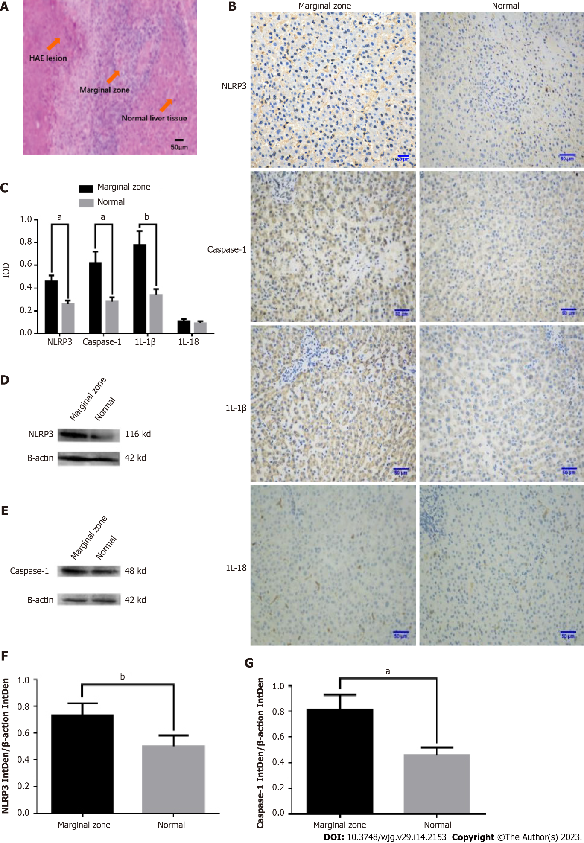
Figure 1 NOD-like receptor family pyrin domain-containing 3, caspase-1, and interleukin-1β were upregulated in the marginal zone and NOD-like receptor family pyrin domain-containing 3 expression was associated with hepatic alveolar echinococcosis. A: Hematoxylin and eosin staining of the lesion, marginal zone, and corresponding normal liver in hepatic alveolar echinococcosis; B: Immunohistochemical staining of NOD-like receptor family pyrin domain-containing 3 (NLRP3), caspase-1, interleukin (IL)-1β, and IL-18 in the marginal zone and corresponding normal liver; C: Relative expression of NLRP3, caspase-1, IL-1β, and IL-18; D: NLRP3 protein expression evaluated by western blotting; E: Caspase-1 protein expression evaluated by Western blotting; F: Relative protein expression levels of NLRP3 IntDen/β-actin IntDen; G: Relative protein expression levels of caspase-1 IntDen/β-actin IntDen. C, n = 60. Scale bar: 50 μm. Western blotting was performed in triplicate (mean ± SD). ªP < 0.05; ^{b}P < 0.01. HAE: Hepatic alveolar echinococcosis; IOD: Integral Optical Density; NLRP3: NOD-like receptor family pyrin domain-containing 3. IL-1β: Interleukin-1β; IL-18: Interleukin-18.

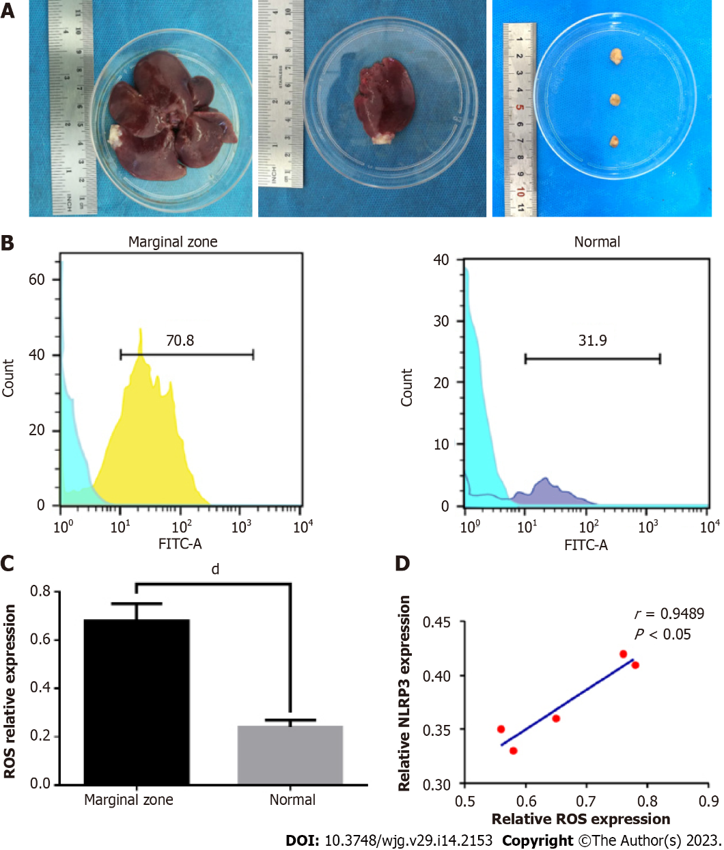
Figure 2 Reactive oxygen species were highly produced in the hepatic alveolar echinococcosis marginal zone and were intimately associated with the activation of NOD-like receptor family pyrin domain-containing 3. A: Lesion growth in hepatic alveolar echinococcosis rats; B: Reactive oxygen species (ROS) production in the marginal zone and corresponding normal liver; C: Relative levels of ROS production; D: Relationship between ROS and NLRP3. C and D, n = 5 rats per group. ^{d}P < 0.0001. NLRP3: NOD-like receptor family pyrin domain-containing 3; ROS: Reactive oxygen species; FITC-A: Fluorescein isothiocyanate isomer I-A.

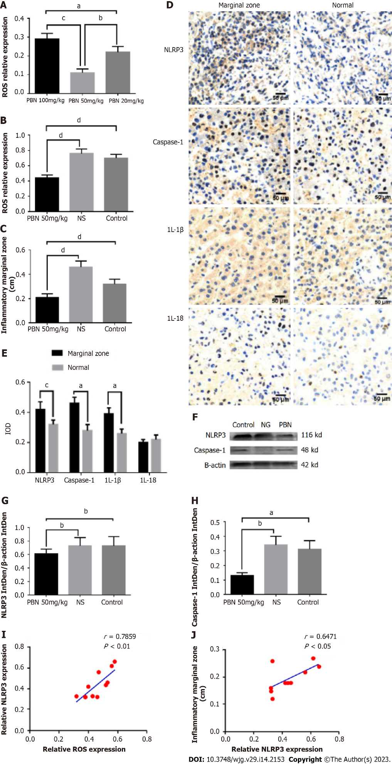
Figure 3 Reactive oxygen species-mediated NOD-like receptor family pyrin domain-containing 3 inflammasome activation in hepatic alveolar echinococcosis rats. A: Reactive oxygen species (ROS) production in the 20, 50, and 100 mg/kg/d N-tert-Butyl-α-phenylnitrone (PBN) groups; B: ROS production in the 50 mg/kg/d PBN, normal saline (NS), and control groups; C: Analysis of inflammation; D: Immunohistochemical staining of NLRP3, caspase-1, interleukin (IL)-1β, and IL-18; E: Relative expression of NLRP3, caspase-1, IL-1β, and IL-18 in the marginal zone compared with the corresponding normal liver; F: Western blotting analysis of the PBN, NS, and control groups; G: NLRP3 IntDen/β-actin IntDen protein expression; H: Caspase-1 IntDen/β-actin IntDen protein expression; I: Relationship between ROS production and the relative expression of NLRP3; J: The relative expression of NLRP3 and inflammation observed in the marginal zone. Western blotting was performed in triplicate (mean ± SD). Scale bar, 50 μm. A, n = 3 rats per group; B, C, and E, n = 10 rats per group; I and J, n = 10. ªP < 0.05; ^{b}P < 0.01; ^{c}P < 0.001; ^{d}P < 0.0001. NLRP3: NOD-like receptor family pyrin domain-containing 3; ROS: Reactive oxygen species; PBN: N-tert-Butyl-α-phenylnitrone; NS: Normal saline; IOD: Integral optical density; IL-1β: Interleukin-1β; IL-18: Interleukin-18.

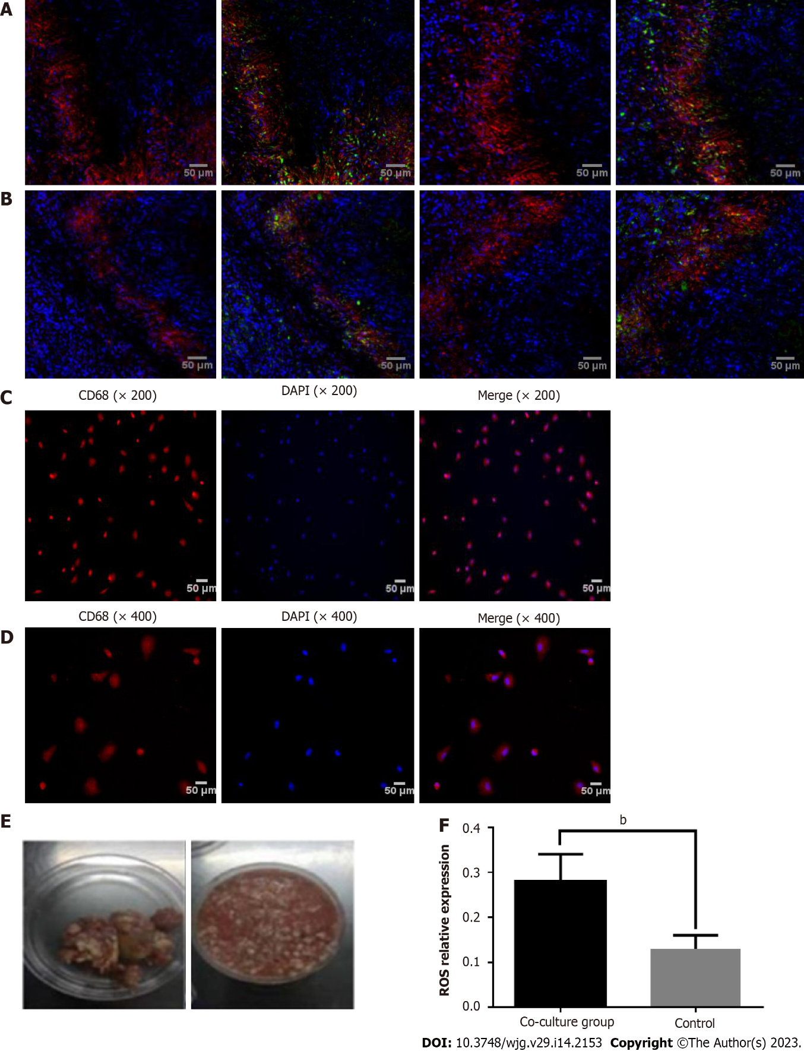
Figure 4 Echinococcus multilocularis activation of the NOD-like receptor family pyrin domain-containing 3-caspase-1-interleukin-1β pathways in Kupffer cells. A: Cellular localisation of NOD-like receptor family pyrin domain-containing 3 (NLRP3) in the marginal zone (red denotes NLRP3 inflammasomes, blue denotes 4’,6-diamidino-2-phenylindole (DAPI) stained nuclei, and green denotes the macrophage marker, CD68); B: Cellular localisation of caspase-1 in the marginal zone (red denotes caspase-1, blue denotes DAPI stained nuclei, and green denotes CD68); C: The identification of Kupffer cells at 200 × magnification and; D: The identification of Kupffer cells at 400× magnification (red denotes CD68 and blue denotes DAPI stained nuclei; the final image is a fusion image); E: Isolation of E. multilocularis; F: Relative expression in the co-culture and control groups. Scale bar, 50 μm. F, n = 3. ^{b}P < 0.01. NLRP3: NOD-like receptor family pyrin domain-containing 3; DAPI: 4’,6-diamidino-2-phenylindole.

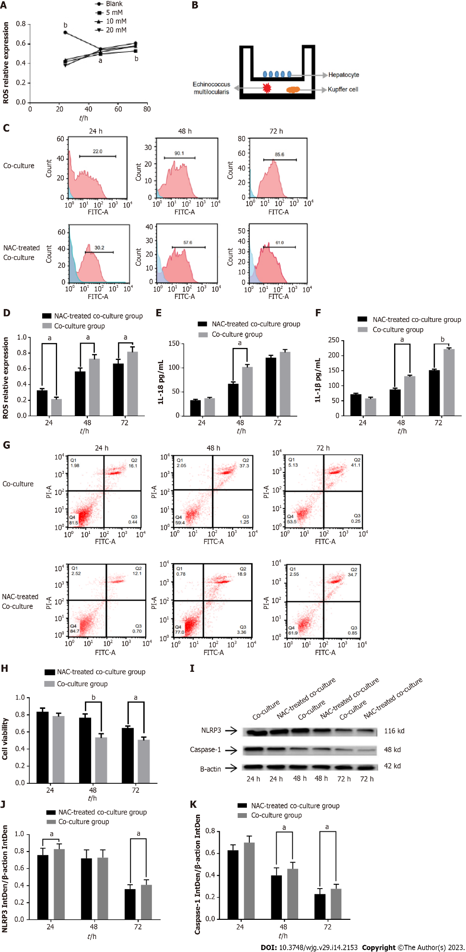
Figure 5 Reactive oxygen species-mediated NOD-like receptor family pyrin domain-containing 3-caspase-1-interleukin-18 pathway activation in Kupffer cells. A: Reactive oxygen species (ROS) production with the indicated N-acetyl-L-cysteine (NAC) dose at the specified time points. ^{b}P < 0.01, blank vs 5 mmol/L; ªP < 0.05, 10 mmol/L vs 5 mM. ^{b}P < 0.0120 mmol/L vs 5 mM; B: Representation of the Transwell model used in this study; C: ROS production in the co-culture groups treated with or without NAC at the indicated time points; D: Relative production of ROS; E: Interleukin (IL)-18 expression; F: IL-1β expression; G: Apoptosis of hepatocytes in the co-culture groups treated with or without NAC at 24, 48, and 72 h; H: Cell viability; I: Western blotting analysis of the indicated proteins; J: NLRP3 IntDen/β-actin IntDen protein expression; K: Caspase-1 IntDen/β-actin IntDen protein expression. ªP < 0.05; ^{b}P < 0.01. NLRP3: NOD-like receptor family pyrin domain-containing 3; ROS: Reactive oxygen species; FITC-A: Fluorescein isothiocyanate isomer I-A; PI: Propidium Iodide; NAC: N-acetyl-L-cysteine; IL-1β: Interleukin-1β; IL-18: Interleukin-18.

Table 1 Correlation between NOD-like receptor family pyrin domain-containing 3 expression and clinicopathological parameters
Characteristics | n | NLRP3 |  | P value
 |  | Low expression, n = 30 | High expression, n = 30
Age (yr) |  |  |  | 0.787
≥ 50 | 21 | 11 | 10
< 50 | 39 | 19 | 20
Sex |  |  |  | 0.195
Male | 33 | 14 | 19
Female | 27 | 16 | 11
Serum AFP (ng/mL) |  |  |  | 0.796
< 20 | 32 | 16 | 15
≥ 20 | 28 | 14 | 15
Jaundice symptoms |  |  |  | < 0.001
Yes | 34 | 8 | 26
No | 26 | 22 | 4
Primary lesion size (cm) |  |  |  | 0.071
≥ 5 | 51 | 23 | 28
< 5 | 9 | 7 | 2
Child-Pugh class |  |  |  | 0.012
A | 42 | 26 | 16
B | 18 | 4 | 12
AFP: Alpha-fetoprotein; NLRP3: NOD-like receptor family pyrin domain-containing 3.

Published by Baishideng Publishing Group Inc
7041 Koll Center Parkway, Suite 160, Pleasanton, CA 94566, USA
Telephone: +1-925-3991568
E-mail: bpgoffice@wjgnet.com
Help Desk: https://www.f6publishing.com/helpdesk
https://www.wjgnet.com

© 2023 Baishideng Publishing Group Inc. All rights reserved.

