Name of journal: World Journal of Dermatology
ESPS Manuscript NO: 14386
Columns: Review

Review of the cutaneous manifestations of autoimmune connective tissue diseases in pediatric patients

Yun D et al. Pediatric connective tissue disease review

Duri Yun, Sarah L Stein

Duri Yun, Sarah L Stein, Division of Dermatology, the University of Chicago Medicine, Chicago, IL 60637, United States

Author contributions: Yun D and Stein SL solely contributed to this paper.

Conflict-of-interest: The authors have no conflicts of interest to disclose.

Open-Access: This article is an open-access article which was selected by an in-house editor and fully peer-reviewed by external reviewers. It is distributed in accordance with the Creative Commons Attribution Non Commercial (CC BY-NC 4.0) license, which permits others to distribute, remix, adapt, build upon this work non-commercially, and license their derivative works on different terms, provided the original work is properly cited and the use is non-commercial. See: http://creativecommons.org/licenses/by-nc/4.0/

Correspondence to: Sarah L Stein, MD, Division of Dermatology, the University of Chicago Medicine, 5841 S. Maryland Avenue, MC 5067, Chicago, IL 60637, United States. sstein@medicine.bsd.uchicago.edu
Telephone: +1-773-8342004
Fax: +1-773-7028398

Received: September 30, 2014
Peer-review started: September 30, 2014
First decision: October 28, 2014
Revised: February 25, 2015
Accepted: April 1, 2015
Article in press:

Published online:

Abstract

Autoimmune connective tissue diseases are chronic inflammatory disorders associated with complex genetic and environmental interplay resulting in a variety of cutaneous and systemic manifestations. Pediatric onset of these disorders carries a unique diagnostic pressure for the clinician due to the potential years of disease burden and complications. Mortality and morbidity from these disorders has fallen dramatically over the past fifty years due to increasing awareness of these disease sequelae and utilization of systemic treatment modalities when necessary. This review highlights the clinical features that are unique to pediatric presentations of lupus erythematosus, juvenile idiopathic arthritis, juvenile dermatomyositis, juvenile onset systemic sclerosis and morphea. Each of these disorders has a distinct appearance corresponding to a particular cutaneous and systemic clinical course and prognosis. Awareness of the associated potential systemic complications can also alert the clinician to make astute management decisions when confronted with a probable rheumatologic case. Cutaneous symptoms may predate onset of systemic symptoms and by keeping the rheumatologic differential diagnoses in mind, the dermatologist can play a key role in potentially offsetting autoimmune disease burden in children.

Key words: Lupus erythematosus; Juvenile idiopathic arthritis; Juvenile dermatomyositis; Systemic sclerosis; Morphea

© The Author(s) 2015. Published by Baishideng Publishing Group Inc. All rights reserved.

Core tip: Early recognition of cutaneous manifestation of connective tissue disease can positively impact disease course. This review summarizes key cutaneous findings of some of the more common pediatric autoimmune connective tissue disorders, including lupus erythematosus, neonatal lupus, juvenile idiopathic arthritis, juvenile dermatomyositis, systemic sclerosis, and morphea.

Yun D, Stein SL. Review of the cutaneous manifestations of autoimmune connective tissue diseases in pediatric patients. World J Dermatol 2015; In press

INTRODUCTION
Autoimmune connective tissue diseases are complex multisystem disorders. These disorders are associated with genetic and environmental factors, triggering intricate interactions between inflammatory cell responses and mediators, ultimately resulting in clinical manifestations. Dermatologists have the unique opportunity to diagnose some of these autoimmune disorders based on cutaneous findings which may predate systemic symptoms. The patient then benefits from close surveillance for complications and related conditions. Early recognition is of particular importance in the pediatric population as prompt intervention can often positively impact disease course.
The purpose of this review is to highlight the cutaneous manifestations of several of the more common pediatric autoimmune connective tissue diseases, including lupus erythematosus, juvenile idiopathic arthritis (JIA), juvenile dermatomyositis, systemic sclerosis, and morphea. We describe the disease course, highlighting the unique aspects of the pediatric presentation, potential complications seen in these disorders, key dermatologic and serologic findings, and offer a brief review of management options.

LUPUS ERYTHEMATOSUS
Lupus erythematosus (LE) was initially described as a disorder limited to the skin by Cazenave in 1851^{[1]} Subsequently, Kaposi clarified the skin findings as one component of a disease that can potentially affect multiple organs, hence coining the term systemic lupus erythematosus (SLE)^{[2]}. Today, cutaneous lupus erythematous (CLE) is considered a subset of SLE and is further sub-characterized based on the various cutaneous morphologies that are observed. Cutaneous LE is 2-4 times more common than SLE in the pediatric and adult populations^{[3,4]}. Recognition of CLE is essential as a subset of patients, particularly pediatric patients, may have or develop systemic involvement.
SLE is a chronic autoimmune disorder that can affect multiple systems including the skin, joints, kidneys, heart and central nervous system and therefore can incur significant morbidity. More recently, it has been reported that patients are also at increased risk for atherosclerosis^{[5]}. The pathogenesis is complex, involving genetic predisposition as well as environmental triggers, particularly medications and ultraviolet (UV) radiation exposure. Furthermore, UV radiation has been implicated in triggering and exacerbating cutaneous LE^{[6,7]}. About 80% of patients with SLE will display cutaneous involvement at some time during the disease course, with up to 60% for whom it is the presenting symptom^{[8,9]}. Although the majority of patients are adult women within their childbearing years, approximately 20% of patients are diagnosed prior to the age of 16 years of age^{[10]}. Pediatric onset SLE is a special subset of this disease and portends a more severe and aggressive disease course, particularly among non-Caucasian patients^{[11-13]} Approximately 50 years ago, pediatric onset SLE was associated with a 100% mortality rate. However, with the utilization of more aggressive therapy, pediatric patients currently have been able to achieve survival rates > 90% with systemic anti-inflammatory medications to restrain and manage immune dysregulation^{[14]}. Underscoring the severity seen in the pediatric population, systemic medications are used almost 4 times more frequently than in the adult populations^{[9,15,16]}.
Diagnosis of SLE was recently updated in 2012 by the Systemic Lupus International Collaborating clinics^{[17]}. Eleven clinical and 6 immunologic criteria were identified and currently the diagnosis of SLE requires fulfillment of at least 4 criteria, with at least 1 from either category (Table 1). These criteria would allow for a diagnosis of SLE based on skin findings alone (acute cutaneous lupus, chronic cutaneous lupus, oral or nasal ulcers and non-scarring alopecia) in the setting of positive serologic markers. Early diagnosis is imperative to minimize potential end organ damage^{[18]}. This is particularly critical for pediatric patients as this group is more likely to have associated renal and neurologic disease^{[9]}. Serology can be helpful in predicting disease course. In pediatric patients, anti-dsDNA, anti-ribosomal P and anti-histone antibodies are more frequently seen. Anti-dsDNA autoantibodies are associated with significant renal disease while the presence of anti-ribosomal P autoantibodies appears to be inversely correlated with kidney involvement^{[19]}. The presence of antiphospholipid antibodies is generally associated with a poorer prognosis^{[20]}.

Cutaneous lupus erythematosus can be categorized into three major forms which are described as acute, subacute (SCLE) and chronic cutaneous lupus^{[21]}. Within the chronic category, several subtypes are included: discoid lupus (DLE), lupus erythematosus tumidus (tumid lupus), lupus panniculitis, and chilblain lupus erythematosus. Importantly, the three major types of cutaneous lupus are not mutually exclusive and more than one subtype of cutaneous disease may occur in the same person^{[22]}.

Acute cutaneous lupus is commonly associated with active SLE and can be further categorized into localized and generalized forms^{[3]}. The classic localized form manifests as what is known as the “malar rash” extending over the nasal bridge with sparing of the nasolabial folds. This finding can be as subtle as mild erythema, or more pronounced with features of intense edema and scaling (Figure 1). This finding may last from a few hours to several weeks. A malar rash is associated with the onset of SLE in 61% of pediatric cases^{[8]}. The malar rash may be misdiagnosed as seborrheic dermatitis, rosacea, parvovirus B19 infection, sunburn or other facial dermatoses^{[23]}. The generalized form of acute cutaneous lupus is rare and appears as widespread symmetric erythematous macules and papules on the torso and extremities, sometimes associated with pruritus^{[3]} (Figure 2). Involvement of the dorsal hands can provide diagnostic clues. Erythematous plaques characteristically involve the skin between the joints more than the skin overlying the knuckles. Cuticle overgrowth and dilated cutaneous blood vessels may be seen underlying the proximal nail fold (Figure 3). Mucosal involvement in acute cutaneous lupus manifests as mucosal ulcerations, gingivitis, or silvery white changes on the vermilion border, gingiva, buccal and nasal mucosa. These findings may be seen in 3% of patients with cutaneous LE and up to 30% of pediatric patients with SLE^{[24]}. Mucosal findings may be severe in acute SLE flares and have even been mistaken for drug-induced toxic epidermal necrolysis (TEN)^{[25]}. A rare, but distinctive, variant of acute CLE is bullous lupus erythematosus. This condition is characterized by localized or generalized tense subepidermal vesicles and bullae arising on normal or erythematous skin. The bullae herald the presence of circulating auto-antibodies to collagen VII^{[26]}. Sun-exposed sites of the trunk, limbs and face are particularly affected; small blisters along the vermillion border of the lips can be seen in up to 30% of cases^{[27,28]}.

SCLE is typically limited to sun-exposed skin. This form of cutaneous lupus is the least common type presenting in the pediatric population, however when present, is more frequently associated with systemic disease as compared to the adult population^{[22,29]}. The lesions of SCLE tend to demonstrate an annular configuration, often with raised red borders, and manifesting eczematous to psoriasiform epidermal features. Due to the superficial location of the inflammation, these lesions rarely result in scarring. Interestingly, the midface skin is usually spared, with more frequent involvement of the sides of the face, upper trunk and extensor aspects of the arms; lip involvement has also been described^{[25]}. The differential diagnosis of SCLE in children includes urticaria, eczematous dermatitis and erythema multiforme. Anti-Ro and La autoantibodies are often associated with SCLE, and subsequently patients may also have dry eye and dry mouth symptoms and organ involvement consistent with Sjogren’s syndrome^{[22]}.

Chronic cutaneous lupus is the most common subtype of cutaneous LE among pediatric patients, specifically the morphology known as discoid lupus erythematosus (DLE). Children with DLE have an increased risk of developing SLE as compared to adults, with approximately 23%-26% developing SLE, versus 5%-20% of adults^{[30,31]}. Discoid LE is most often localized to the face, scalp and ears as it preferentially appears on sun-exposed areas and is found to be exacerbated by UV radiation^{[4,24]}. A generalized form of DLE has been described where there is widespread distribution including mucosal surfaces. The latter presentation is associated with a higher rate of progression to SLE^{[4,6]}. The lesions are typically round to annular, slightly indurated, erythematous to violaceous plaques with adherent scale, often with follicular plugging which is described as “carpet tack-like.” Older lesions will demonstrate atrophy, dyspigmentation resulting in scarring, and alopecia in hair bearing areas (Figure 4). Lip involvement can be present with lesions blurring the sharp vermillion border^{[25]}. Linear presentations following the lines of Blaschko have also been described in children^{[32,33]}. Squamous cell carcinoma has been reported in longstanding lesions of DLE^{[34]}.

Other subtypes of chronic cutaneous lupus include lupus panniculitis, chilblain lupus erythematosus and tumid lupus, all of which are rare in children. Lupus panniculitis results in firm subcutaneous nodules and can present in association with DLE. Lesions tend to involve areas of increased fat deposition such as the chest, upper arms and thighs and sometimes in areas where patients report a history of trauma^{[3,28]}. Lupus panniculitis can last for many years, and due to the deep nature of the inflammation, the lesions can leave disfiguring atrophic scars. Chilblain lupus appears as painful, itchy, violaceous papules, plaques, or erosions on cold-exposed surfaces such as the tips of the digits (Figure 5). This finding represents cold-induced vasospasm of the hands and feet and may even resemble frostbite. Twenty percent of adult patients with chilblain lupus are reported to evolve into SLE^{[35]}. A dominantly inherited familial form of chilblain lupus erythematosus has been described due to a mutation in TREX1^{[36]}. Tumid lupus presents as red to purple edematous plaques without epidermal change that remain fixed in shape, often in a polycyclic pattern, on sun exposed sites. These lesions tend to heal without scarring.

The major histologic findings associated with most forms of cutaneous lupus erythematosus include basement membrane thickening in the setting of an interface lymphohistiocytic infiltrate and increased dermal mucin deposition^{[37]}. In acute cutaneous lupus the dermal infiltrate can be subtle, while in SCLE there can be significantly more superficial dermal involvement. In DLE lesions, liquefactive degeneration of the basal layer with lymphohistiocytic involvement of periadnexal structures, follicular plugging and fibrosis is notable. Lupus panniculitis exhibits lobular infiltrates within the subcutaneous fat. In contrast, lupus tumidus will not exhibit the epidermal changes, but demonstrates notably increased dermal mucin deposition. Direct immunofluorescence of lesional and nonlesional skin in the setting of LE will typically exhibit a granular deposition of IgG and/or IgM along the dermal epidermal junction and around hair follicles^{[37]}.

Special mention needs to be made of non-specific skin findings observed in LE patients. These findings may be suggestive of SLE and when they coincide with systemic symptoms suggestive of SLE, such as joint pain, the physician must be alert for additional signs of lupus (Table 2). The most common non-specific findings are those representing cutaneous vascular disease such as Raynaud phenomenon, livedo reticularis, and cutaneous vasculitis. Other nonspecific findings which may be associated with SLE include urticaria, erythema multiforme, and nonscarring alopecia.

The management of pediatric cutaneous LE is dependent on extent of disease. In general, patients should be advised to avoid the sun as much as possible and to employ UV protection at all times. If the disease is localized, treatment with topical corticosteroids or calcineurin inhibitors may be adequate; however, the routine use of hydroxychloroquine in all LE patients, including those with skin-limited disease, is becoming more strongly favored. Hydroxychloroquine has been shown to increase survival and lengthen remission in adults and to specifically reduce the prevalence of renal disease^{[3,38,39]}. Refractory cutaneous disease may require additional antimalarial agents, systemic corticosteroids, and steroid sparing agents such as methotrexate and mycophenolate mofetil^{[3]}.

NEONATAL LUPUS
Neonatal lupus is a passively acquired autoimmune disorder of neonates born to mothers with circulating connective tissue autoantibodies Ro, La, and less commonly, U1-ribonucleoprotein^{[40]}. Approximately 50% of mothers are asymptomatic at the time of the infant’s diagnosis, therefore diagnosis in the child can alert the clinician to recommend connective tissue disease evaluation for the mother^{[40]}. The data suggests that approximately 50% of mothers who are asymptomatic at the time of their child’s diagnosis will develop symptoms of connective tissue disease within 3 years^{[41,42]}. Only 10% of these women will meet full criteria for SLE within 6 years of follow up^{[42]}. Cutaneous lesions of neonatal LE are transient. Cutaneous manifestations typically resolve within 6-8 mo after birth, as maternal autoantibodies disappear from the infant’s circulation^{[42,43]}. The gravest complication of neonatal lupus is cardiac conduction abnormalities which are typically permanent. Conduction abnormalities occur in 15%-30% of cases^{[42]}. The developing fetal heart undergoes a complex pattern of growth, programmed apoptosis and folding, during which Ro and La antigens are expressed on fetal myocytes. These myocytes are targeted by the maternal autoantibodies causing scarring within the fetal conduction pathway and resulting in dysrhythmias and/or complete heart blocks without structural anomalies. Almost all patients with this complication will require a pacemaker at some point in their life^{[42]}. Other potential complications of neonatal lupus include liver involvement with conjugated hyperbilirubinemia, splenomegaly, hematologic abnormalities, hydrocephalus, hemorrhagic strokes and seizures^{[42,44,45]}.
Cutaneous features of neonatal lupus typically appear at a mean of 6 wk after birth, though it can be present at the time of delivery in some cases^{[46,47]}. The classic facial lesions are erythematous annular and polycyclic plaques with or without scale located on the scalp and periocular region of the face. Confluent erythematous papules or even pustules are also seen^{[44]}. The pattern noted on the face is often referred to as “owl like” or “raccoon like” (Figure 6). Annular plaques may also be found on the trunk and extremities and in the groin region, thus involving non-sun-exposed sites^{[47,48]}. Many lesions resolve without sequelae over a mean duration of 17 wk, however approximately 25% can leave residual dyspigmentation, persistent telangiectasia and atrophic scarring of the affected areas. It is unclear if treatment with topical steroids prevents lingering skin findings. Strict UV protection is recommended as it is in all forms of CLE^{[47]}. All patients with neonatal lupus should be followed regularly as long term follow up studies have reported cases of autoimmune thyroiditis, type 1 diabetes mellitus and JIA. To date, there have been no reports of cases of SLE, dermatomyositis (DMS), or systemic sclerosis in patients with a history of neonatal lupus^{[47,49]}.

SYSTEMIC JIA
JIA is a term that refers to a group of six chronic arthritides in children less than 16 years of age. Of these six subtypes, only two are associated with cutaneous findings, systemic onset arthritis and psoriatic arthritis. Due to the connective tissue disease focus of this review, skin manifestations of psoriatic arthritis will not be discussed here. Systemic JIA is considered a subset of JIA and is a diagnosis of exclusion defined as arthritis with, or preceded by, daily fevers of at least 2 wk duration in the setting of specific systemic signs of inflammation (Table 1). Cutaneous findings are found in 25%-50% of patients and may precede fevers, arthritis or organ involvement by several years^{[24]}. Pathophysiology of this disease remains obscure, and current theories point to an autoinflammatory etiology. A genetic component has been identified as subgroups of patients have been identified to have mutations in MEFV and LACC1^{[50,51]}.
Joint involvement will result in severe, recalcitrant and destructive progressive polyarticular disease in 50% of patients. Other complications of systemic JIA include serositis, uveitis, hepatosplenomegaly, pleuritis, and pericarditis. A particularly severe complication is the macrophage activation syndrome which can be life threatening.
The classic evanescent cutaneous eruption associated with systemic JIA is described as 2-5 mm salmon-pink macules and edematous papules that arise with fevers and typically resolve within hours of defervescence. This eruption is not usually pruritic and can involve the chest, proximal extremities and pressure points^{[52]} (Figure 7). These cutaneous findings will coincide with an elevation in acute phase reactants such as erythrocyte sedimentation rate (ESR), C-reactive protein (CRP), ferritin and platelets. Biopsy findings are variable and non-specific^{[37]}. Adult-onset Still’s disease is typically considered the adult version of systemic onset JIA. An eruption of persistent pruritic papules and plaques variably associated with a flagellate erythema has been described in adult-onset Still’s disease. The histologic findings in these cases are notable for a characteristic pattern of dyskeratotic keratinocytes in the upper layer of the epidermis and extending into the stratum corneum^{[53-58]}. A similar eruption with consistent histologic findings has been observed in a child with systemic onset JIA (authors’ experience) (Figure 8).
Management of the cutaneous features of systemic onset JIA is contingent on treatment of the systemic disease. First line treatment includes non-steroidal anti-inflammatory medications in association with physical therapy. For severe cases, systemic corticosteroids, methotrexate, other steroid-sparing medications or biologic agents may be necessary. Recently, genetic variations in patients with systemic onset JIA has helped to elucidate treatment response patterns^{[59,60]} Earlier aggressive therapy is associated with longer remission^{[61,62]}.

JUVENILE DMS
DMS is an immune-mediated process triggered by exposure to various exogenous factors in genetically predisposed individuals. The skin, striated muscles and internal organs may be affected. It is the most common inflammatory cause of myopathy in children^{[63]}. Traditional diagnostic criteria for juvenile DMS include cutaneous findings in conjunction with serologic findings and signs and markers of myopathic disease, including muscle electromyographic changes and histopathologic features (Table 1). Radiographic studies to document muscle involvement are often substituted for the more invasive diagnostic procedures^{[64,65]}. A subtype known as amyopathic DMS is diagnosed when cutaneous findings are present in the absence of muscle symptoms for at least 6 mo. Amyopathic disease is thought to represent an estimated 20% of all dermatomyositis cases^{[66]}. In children, it has been suggested that a quarter of patients with amyopathic DMS will progress to classic DMS in a mean follow up period of 4 years^{[67]}. Dermatomyositis is rarely associated with malignancy in children, whereas in adults associated malignancy is present in 14%-30% of cases^{[66-68]}. Females are at higher risk for DMS overall. A bimodal pattern of onset is seen in childhood with peak ages of onset between 2-5 years of age and 12-13 years of age^{[63]}. Recent literature suggests that patients who present at the younger age peak may have a milder disease course^{[69]}.
Onset of DMS can be insidious in up to 43% of the cases and by the time the diagnosis is made, the patients may have experienced subtle weakness, anorexia, malaise, and abdominal pain in addition to cutaneous findings for over 2-6 mo^{[63,67,70]}. Male gender and proximal muscle weakness evidenced by a positive Gower’s sign is associated with poor prognosis for complete clinical remission^{[71]}. Complications of DMS include hypertriglyceridemia with insulin resistance, calcinosis cutis, muscle weakness and atrophy, lipodystrophy, and infections, particularly from gram negative organisms. Lipodystrophy and small vessel vasculitis affects an estimated 10% of the pediatric disease population and these patients demonstrate an increased incidence of concomitant insulin resistance and hyperlipidemia^{[72]}.
Most patients will present with proximal muscle weakness and the hallmark dermatologic findings of Gottron’s papules and heliotrope rash around the eyes. Gottron’s papules are small purple or pink lichenoid papules on the dorsum of the hands, overlying the metacarpophalangeal, proximal interphalangeal and distal interphalangeal joints (Figure 9). These papules may resolve with atrophy, telangiectasia and dyspigmentation. Similar small pink to purple papules, almost psoriasiform in nature, can be found on bony prominences over the knees, elbows and ankles (Figure 10). The heliotrope rash is a purplish red discoloration that involves the eyelids most commonly. The notable purple red patches are sometimes accompanied by edema. Temples, forehead, cheeks and ears can be similarly affected^{[24]} (Figure 11). Erythema with scaling may involve the scalp and can be mistaken for seborrheic dermatitis, psoriasis or even CLE^{[73]}. The histologic findings that correlate with most of these clinical features demonstrate vacuolar changes of basal keratinocytes, dermal mucin accumulation and a mild to moderate dermal lymphocytic infiltrate, sometimes with features of dermal sclerosis^{[37]}.
In the setting of chronic DMS, poikiloderma (dyspigmentation, telangiectasia and epidermal atrophy overlapping in the same region) is often present. Poikilodermatous change involving the upper back and anterior chest in a photodistributed manner is classically referred to as the “shawl sign”. Ragged cuticles and nail fold telangiectasia can be appreciated in up to 68% of patients. “Mechanic’s hand” is a phrase that describes hyperkeratosis and fissuring at the fingertips with associated palmar erythema. Mucosal findings include mouth ulcers, gingival telangiectasia and gingival bleeding.
Calcinosis cutis is a complication associated with significant morbidity and is more prevalent in juvenile DMS as compared to adult counterparts, affecting 18%-25% of pediatric patients. This finding correlates with disease chronicity. Fortunately, with newer management regimens focusing on early aggressive therapy, the incidence is steadily decreasing^{[63,70,72]}. Lesions of calcinosis cutis are hard nodules in areas that are prone to trauma such as the buttocks, elbows, knees, fingers and shoulders. The nodules are occasionally deeply seated into the fascia and intramuscular connective tissue. These lesions may connect to the skin surface and result in chalky drainage. Complications such as cellulitis and ulceration may ensue^{[24]}.
Prior to the use of corticosteroids in the treatment of juvenile DMS, the disease had a mortality rate of 30%. Standardized treatment protocols have resulted in lowered mortality rates of 0.7%-3.1%. The mainstay of treatment is systemic corticosteroids, methotrexate and IVIG. Other treatments include hydroxychloroquine and cyclosporine^{[64]}. Studies using biologic therapies including etanercept and rituximab have demonstrated mixed results^{[64,74,75]}. Patients with amyopathic DMS can be treated with hydroxychloroquine, topical corticosteroids and photoprotection^{[76]}. Treatment of calcinosis cutis can be unsatisfying. The most promising treatments in children include bisphosphonates, calcium channel blockers and surgical excision of larger lesions^{[77]}.

JUVENILE ONSET SYSTEMIC SCLEROSIS
Juvenile onset systemic sclerosis (jSSc) is a rare disorder of unclear etiology that causes vascular dysfunction, immune dysregulation and finally tissue fibrosis due to deposition of collagen and other extracellular matrix proteins. The organs prominently affected are skin, blood vessels and internal organs. Of the organs, the lungs are of particular concern as almost all patients will exhibit pulmonary function test abnormalities resulting in significant morbidity and mortality^{[78]}. The onset of this disease is insidious and it can take 1-4 years on average until the diagnosis is made, highlighting the importance of disease awareness. Ten percent of all patients with this disease will present in childhood^{[79]}. Diagnostic criteria set forth by the Pediatric Rheumatology European Society and American College of Rheumatology require the presence of cutaneous sclerosis proximal to the metacarpophalangeal joints in addition to 2 minor criteria involving extracutaneous organs^{[80,81]} (Table 1). There are two known types of jSSc, limited and diffuse. The limited type is characterized by distal extremity disease and facial involvement. These patients may also fulfill criteria for CREST syndrome (calcinosis, Raynaud’s phenomenon, esophageal dysmotility, sclerodactyly and telangiectasia). The diffuse type involves both the distal and proximal portions of the extremities including the hands and face. The limited subtype appears to have a more benign course. In both subtypes, the diseases will often affect the fingers and hands first, with subsequent spread to the proximal extremities and trunk in symmetric fashion. Compared to adults, juvenile onset systemic sclerosis has a higher survival rate (98% vs 75%), is more likely to be involved in rheumatologic overlap syndromes, and is less likely to be complicated by pulmonary artery hypertension and renal crisis^{[82]}.
The cutaneous manifestations of jSSc underscore the vascular dysfunction central to this entity. The most common initial presentation of jSSc is Raynaud’s phenomenon, present in approximately 75% of cases, followed by proximal skin induration (66%), sclerodactyly (55%), and digital tip ulcers (35%)^{[79]}. Raynaud’s phenomenon is characterized by vasospasms causing pallor, cyanosis, pain, numbness, tingling, swelling, and hyperhidrosis of acral surfaces, most typically affecting the hands and feet and occasionally the nose, lips, cheeks and ears^{[24]}. Episodes can be precipitated by cold and emotional stress. Sclerodactyly in children tends to appear edematous at first, with progression to shiny skin overlying tapered fingertips associated with decreased range of movement. In addition to the sclerotic changes, calcifications, ulcerations, and matted telangiectasias will develop^{[79,83]}. Dyspigmentation of the overlying skin has been described to have a “salt and pepper” appearance due to retained pigment in a perifollicular pattern within areas of hypopigmentation^{[24]}. Ichthyotic skin changes of the proximal extremities have been reported as a prodromal presentation of jSSc^{[84]}. Histologically, skin biopsy reveals compact or hyalinized collagen in the dermis with atrophic adnexal structures and thinning of the overlying epidermis. The different subtypes of systemic sclerosis cannot be differentiated on microscopic exam^{[1]}.
Lifestyle recommendations are critical to the management of the cutaneous symptoms in this disorder. Patients must be advised to avoid vasospasm triggers such as stress, cold and smoking. Currently most treatment modalities are based on adult studies. In adults, there have been randomized controlled trials that support methotrexate in managing and treating the early stages of disease^{[85,86]}. For patients with recalcitrant disease, human autologous stem cell transplants have been reported to improve symptoms in a limited number of cases^{[87]}. Due to the risk of contractures with jSSc, physiotherapy is critical.

MORPHEA

Morphea is a distinct inflammatory disease affecting the skin and underlying tissues leading to localized sclerosis. For this reason, another term for morphea is “localized scleroderma.” However, morphea displays a clinical course distinct from that of systemic sclerosis and thus “morphea” is the preferred term to prevent confusion. The Childhood Arthritis and Rheumatology Research Alliance (CARRA) recently reported baseline data of 259 patients within their registry. The majority of patients were female (71%) and were more likely to be Caucasian (81%). Here they reported that the mean age of onset was 9.5 years, however almost 40% had at least a 5 year delay in diagnosis^{[88]}. Approximately half of all cases of morphea present in childhood. In children, disability due to the disease and associated extracutaneous complications is more severe than it is in adult patients^{[89]}.

When a patient presents with morphea, the differential diagnosis of systemic sclerosis may be entertained. The distinction between morphea and systemic sclerosis is a clinical one with the latter characteristically exhibiting Raynaud’s phenomenon and sclerodactyly as mentioned in the previous section (Table 1). Morphea is non-life-threatening, but can be significantly debilitating and disfiguring. Limb involvement, particularly when overlying a joint, can cause permanent limb asymmetry, contractures, ulcerations and joint immobility. Ocular and central nervous systemic manifestations have been reported underlying disease focused on the face or scalp. Esophageal involvement is not uncommon in children^{[90]}. Restrictive lung disease can result from generalized morphea subtypes^{[91,92]}. Other potential complications include calcinosis cutis and rarely squamous cell carcinoma in lesions of morphea, particularly of the pansclerotic type^{[93,94]}.

Morphea is classified into 5 groups: Linear, circumscribed, generalized, pansclerotic and mixed. Mixed type refers to presentations where 2 or more different types of morphea present on the same patient^{[92]}. In children, linear morphea is most common; in adults the circumscribed type is more common. Approximately 51%-65% of pediatric cases are of the linear subtype, followed by circumscribed morphea (26%), generalized morphea (7%) and pansclerotic morphea (2%). Histologically, the hallmark of well-developed lesions of morphea is thickened dense bundles of collagen in the dermis. Additionally, vascular changes of endothelial swelling and edema with a perivascular lymphocytic infiltrate and plasma cells may be appreciated^{[1,37]}. Slightly over 10% of pediatric patients will report an inciting event that is attributed to the onset of the morphea, such as trauma, infection, vaccination or insect bite^{[91,92]}.
Linear morphea is the most common subtype in children and is divided into 2 subtypes by area of involvement: trunk/limbs and head^{[95]}. Linear morphea presents as a linear, erythematous strip that extends longitudinally in a series of indurated plaques, ultimately joining into a scar-like band. When linear morphea involves skin overlying a joint, there is risk of involvement of the underlying fascia, muscle and tendons (Figure 12). The inherent stiffness of the skin, as well as any deeper manifestations, can ultimately impact the joint mobility. Linear lesions can also extend circumferentially and produce significant limb size discrepancies^{[24]}. When linear morphea affects the head, various presentations, including en coup de sabre and Parry-Romberg syndrome, are described. En coup de sabre is a term used for linear morphea affecting the forehead and scalp (Figure 13). Underlying findings on brain MRI/CT scans, including T2 hyperintensities, calcifications and ipsilateral cerebral atrophy, can be found in up to 73% of patients and can be associated with neurologic symptoms including seizures^{[96]}. Parry-Romberg syndrome (progressive hemifacial atrophy) describes a subset of facial morphea cases involving the lower half the face with associated ipsilateral atrophy (Figure 14). In this particular presentation, the entire distribution of the trigeminal nerve, including the eye and tongue, may be affected. Associated symptoms can include alopecia, seizures and headaches^{[24,95]}.
Circumscribed morphea is characterized by slightly elevated, flesh colored or erythematous edematous plaques with an advancing border. The active border classically appears “lilac”, or violaceous, in color leaving a trail of central sclerotic, scar-like tissue (Figure 15). There can be associated hair and sweat gland loss. The lesions can be asymptomatic or slightly pruritic and are often initially not noticed by the patient. The trunk is the most common location, affected by one or multiple asymmetric lesions. Clinical activity correlates with the presence of the lilac border. The active period of disease is felt to be on average 3-5 years. Once the lilac hue at the border disappears, the progression also seems to arrest^{[1]}. Residual atrophy and dyspigmentation are commonly observed. The term generalized morphea is used when there are 4 or more circumscribed plaques of morphea that are larger than 3cm in diameter and involve at least 2 out of 7 anatomic sites: head-neck, right upper extremity, left upper extremity, right lower extremity, left lower extremity, anterior trunk, and posterior trunk^{[95]}.
Pansclerotic morphea is a rare disabling variant more commonly seen in children than in adults. Diffuse involvement of the limbs, trunk, face and scalp occurs. In contrast to systemic sclerosis, pansclerotic morphea notably spares the fingertips and toes (Figure 16). Superficial and deep involvement by the sclerotic process leads to fixation of underlying structures. Internal organ involvement is notably absent, differentiating this entity from systemic sclerosis. Onset is usually before 14 years of age. Severe disability may result due to persistent atrophy of the underlying musculature^{[24 95]}.
Treatment of morphea depends on the site of involvement, extent of disease and level of disease activity. Aggressive treatment is indicated for linear morphea overlying joints or near joints, facial disease, generalized and pansclerotic morphea. The standard treatment protocols involve use of systemic corticosteroids initially while bridging to longer term management with methotrexate. Randomized controlled studies have demonstrated response rates to be as high as 75% with this protocol^{[97]}. Increased relapse rates have been associated with shorter methotrexate courses (< 2 years) and shorter tapering regimens^{[98]}. Milder presentations of morphea may be managed with topical regimens including calcipotriene and corticosteroids. UVA1 phototherapy has recently been shown to have efficacy in morphea^{[99,100]}. Any consideration of surgical reconstructive procedures must be delayed until evidence of active disease has been thoroughly ruled out^{[101]}.

CONCLUSION
In summary, there is a wide array of cutaneous findings observed in the setting of autoimmune connective tissue diseases affecting pediatric patients. Timely diagnosis of these entities can be challenging as many symptoms are of gradual onset. Dermatologists have the opportunity to provide critical assistance by early recognition of suggestive findings, allowing for prompt treatment of disease and improved clinical outcome.

REFERENCES
1 Lee LA, Werth VP. Lupus erythematosus. In: Bolognia JL, Jorizzo JL, Schaffer JV. Dermatology. Vol One. 3rd ed. Philadelphia; London: Elsevier Saunders, 2012: 615-629
2 Scofield RH, Oates J. The place of William Osler in the description of systemic lupus erythematosus. Am J Med Sci 2009; 338: 409-412 [PMID: 19826244 DOI: 10.1097/MAJ.0b013e3181acbd71]
3 Okon LG, Werth VP. Cutaneous lupus erythematosus: diagnosis and treatment. Best Pract Res Clin Rheumatol 2013; 27: 391-404 [PMID: 24238695 DOI: 10.1016/j.berh.2013.07.008]
4 Moises-Alfaro C, Berrón-Pérez R, Carrasco-Daza D, Gutiérrez-Castrellón P, Ruiz-Maldonado R. Discoid lupus erythematosus in children: clinical, histopathologic, and follow-up features in 27 cases. Pediatr Dermatol 2003; 20: 103-107 [PMID: 12657003 DOI: 10.1046/j.1525-1470.2003.20201.x]
5 von Scheven E, Bakkaloglu A. What's new in paediatric SLE? Best Pract Res Clin Rheumatol 2009; 23: 699-708 [PMID: 19853834 DOI: 10.1016/j.berh.2009.07.008]
6 Bano S, Bombardieri S, Doria A, Iaccarino L, Lehmann P, Mosca M. Lupus erythematosus and the skin. Clin Exp Rheumatol 2006; 24: S26-S35 [PMID: 16466622]
7 Kochevar IE. Action spectrum and mechanisms of UV radiation-induced injury in lupus erythematosus. J Invest Dermatol 1985; 85: 140s-143s [PMID: 2409182 DOI: 10.1111/1523-1747.ep12275658]
8 Hiraki LT, Benseler SM, Tyrrell PN, Hebert D, Harvey E, Silverman ED. Clinical and laboratory characteristics and long-term outcome of pediatric systemic lupus erythematosus: a longitudinal study. J Pediatr 2008; 152: 550-556 [PMID: 18346514 DOI: 10.1016/j.jpeds.2007.09.019]
9 Malattia C, Martini A. Paediatric-onset systemic lupus erythematosus. Best Pract Res Clin Rheumatol 2013; 27: 351-362 [PMID: 24238692 DOI: 10.1016/j.berh.2013.07.007]
10 Albrecht J, Berlin JA, Braverman IM, Callen JP, Connolly MK, Costner MI, Dutz J, Fivenson D, Franks AG, Jorizzo JL, Lee LA, McCauliffe DP, Sontheimer RD, Werth VP. Dermatology position paper on the revision of the 1982 ACR criteria for systemic lupus erythematosus. Lupus 2004; 13: 839-849 [PMID: 15580979 DOI: 10.1191/0961203304lu2020oa]
11 Klein-Gitelman M, Reiff A, Silverman ED. Systemic lupus erythematosus in childhood. Rheum Dis Clin North Am 2002; 28: 561-77, vi-vii [PMID: 12380370 DOI: 10.1016/S0889-857X(02)00015-7]
12 Hiraki LT, Benseler SM, Tyrrell PN, Harvey E, Hebert D, Silverman ED. Ethnic differences in pediatric systemic lupus erythematosus. J Rheumatol 2009; 36: 2539-2546 [PMID: 19833755 DOI: 10.3899/jrheum.081141]
13 Tucker LB, Menon S, Schaller JG, Isenberg DA. Adult- and childhood-onset systemic lupus erythematosus: a comparison of onset, clinical features, serology, and outcome. Br J Rheumatol 1995; 34: 866-872 [PMID: 7582729]
14 Aggarwal A, Srivastava P. Childhood onset systemic lupus erythematosus: how is it different from adult SLE? Int J Rheum Dis 2014 [PMID: 24965742 DOI: 10.1111/1756-185x.12419]
15 Ginzler EM, Diamond HS, Weiner M, Schlesinger M, Fries JF, Wasner C, Medsger TA, Ziegler G, Klippel JH, Hadler NM, Albert DA, Hess EV, Spencer-Green G, Grayzel A, Worth D, Hahn BH, Barnett EV. A multicenter study of outcome in systemic lupus erythematosus. I. Entry variables as predictors of prognosis. Arthritis Rheum 1982; 25: 601-611 [PMID: 7092960 DOI: 10.1002/art.1780250601]
16 Brunner HI, Gladman DD, Ibañez D, Urowitz MD, Silverman ED. Difference in disease features between childhood-onset and adult-onset systemic lupus erythematosus. Arthritis Rheum 2008; 58: 556-562 [PMID: 18240232 DOI: 10.1002/art.23204]
17 Petri M, Orbai AM, Alarcón GS, Gordon C, Merrill JT, Fortin PR, Bruce IN, Isenberg D, Wallace DJ, Nived O, Sturfelt G, Ramsey-Goldman R, Bae SC, Hanly JG, Sánchez-Guerrero J, Clarke A, Aranow C, Manzi S, Urowitz M, Gladman D, Kalunian K, Costner M, Werth VP, Zoma A, Bernatsky S, Ruiz-Irastorza G, Khamashta MA, Jacobsen S, Buyon JP, Maddison P, Dooley MA, van Vollenhoven RF, Ginzler E, Stoll T, Peschken C, Jorizzo JL, Callen JP, Lim SS, Fessler BJ, Inanc M, Kamen DL, Rahman A, Steinsson K, Franks AG, Sigler L, Hameed S, Fang H, Pham N, Brey R, Weisman MH, McGwin G, Magder LS. Derivation and validation of the Systemic Lupus International Collaborating Clinics classification criteria for systemic lupus erythematosus. Arthritis Rheum 2012; 64: 2677-2686 [PMID: 22553077 DOI: 10.1002/art.34473]
18 Lee PY, Yeh KW, Yao TC, Lee WI, Lin YJ, Huang JL. The outcome of patients with renal involvement in pediatric-onset systemic lupus erythematosus--a 20-year experience in Asia. Lupus 2013; 22: 1534-1540 [PMID: 23966304 DOI: 10.1177/0961203313502110]
19 Hoffman IE, Lauwerys BR, De Keyser F, Huizinga TW, Isenberg D, Cebecauer L, Dehoorne J, Joos R, Hendrickx G, Houssiau F, Elewaut D. Juvenile-onset systemic lupus erythematosus: different clinical and serological pattern than adult-onset systemic lupus erythematosus. Ann Rheum Dis 2009; 68: 412-415 [PMID: 18930995 DOI: 10.1136/ard.2008.094813]
20 Descloux E, Durieu I, Cochat P, Vital Durand D, Ninet J, Fabien N, Cimaz R. Paediatric systemic lupus erythematosus: prognostic impact of antiphospholipid antibodies. Rheumatology (Oxford) 2008; 47: 183-187 [PMID: 18160418 DOI: 10.1093/rheumatology/kem335]
21 Kuhn A, Landmann A. The classification and diagnosis of cutaneous lupus erythematosus. J Autoimmun 2014; 48-49: 14-19 [PMID: 24486120 DOI: 10.1016/j.jaut.2014.01.021]
22 Dickey BZ, Holland KE, Drolet BA, Galbraith SS, Lyon VB, Siegel DH, Chiu YE. Demographic and clinical characteristics of cutaneous lupus erythematosus at a paediatric dermatology referral centre. Br J Dermatol 2013; 169: 428-433 [PMID: 23601021 DOI: 10.1111/bjd.12383]
23 Cooray M, Manolakos JJ, Wright DS, Haider S, Patel A. Parvovirus infection mimicking systemic lupus erythematosus. CMAJ 2013; 185: 1342-1344 [PMID: 23979870 DOI: 10.1503/cmaj.121565]
24 Paller A, Mancini AJ. Collagen vascular disordersHurwitz clinical pediatric dermatology. 4th ed. Philadelphia, PA; Toronto: Elsevier Saunders, 2011: 497-527
25 Nico MM, Bologna SB, Lourenço SV. The lip in lupus erythematosus. Clin Exp Dermatol 2014; 39: 563-569 [PMID: 24934909 DOI: 10.1111/ced.12368]
26 Contestable JJ, Edhegard KD, Meyerle JH. Bullous systemic lupus erythematosus: a review and update to diagnosis and treatment. Am J Clin Dermatol 2014; 15: 517-524 [PMID: 25358414 DOI: 10.1007/s40257-014-0098-0]
27 Lourenço DM, Gomes RC, Aikawa NE, Campos LM, Romiti R, Silva CA. Childhood-onset bullous systemic lupus erythematosus. Lupus 2014; 23: 1422-1425 [PMID: 25074872 DOI: 10.1177/0961203314544187]
28 Obermoser G, Sontheimer RD, Zelger B. Overview of common, rare and atypical manifestations of cutaneous lupus erythematosus and histopathological correlates. Lupus 2010; 19: 1050-1070 [PMID: 20693199 DOI: 10.1177/0961203310370048]
29 Berry T, Walsh E, Berry R, DeSantis E, Smidt AC. Subacute cutaneous lupus erythematosus presenting in childhood: a case report and review of the literature. Pediatr Dermatol 2014; 31: 368-372 [PMID: 23106790 DOI: 10.1111/pde.12007]
30 Sampaio MC, de Oliveira ZN, Machado MC, dos Reis VM, Vilela MA. Discoid lupus erythematosus in children--a retrospective study of 34 patients. Pediatr Dermatol 2008; 25: 163-167 [PMID: 18429771 DOI: 10.1111/j.1525-1470.2008.00625.x]
31 Wieczorek IT, Propert KJ, Okawa J, Werth VP. Systemic symptoms in the progression of cutaneous to systemic lupus erythematosus. JAMA Dermatol 2014; 150: 291-296 [PMID: 24477339 DOI: 10.1001/jamadermatol.2013.9026]
32 Abe M, Ishikawa O, Miyachi Y. Linear cutaneous lupus erythematosus following the lines of Blaschko. Br J Dermatol 1998; 139: 307-310 [PMID: 9767250 DOI: 10.1046/j.1365-2133.1998.02373.x]
33 Requena C, Torrelo A, de Prada I, Zambrano A. Linear childhood cutaneous lupus erythematosus following Blaschko lines. J Eur Acad Dermatol Venereol 2002; 16: 618-620 [PMID: 12482048 DOI: 10.1046/j.1468-3083.2002.00588.x]
34 Flower C, Gaskin D, Bhamjee S, Bynoe Z. High-risk variants of cutaneous squamous cell carcinoma in patients with discoid lupus erythematosus: a case series. Lupus 2013; 22: 736-739 [PMID: 23698016 DOI: 10.1177/0961203313490243]
35 Hedrich CM, Fiebig B, Hauck FH, Sallmann S, Hahn G, Pfeiffer C, Heubner G, Lee-Kirsch MA, Gahr M. Chilblain lupus erythematosus-a review of literature. Clin Rheumatol 2008; 27: 1341 [PMID: 19125230 DOI: 10.1007/s10067-008-0975-0]
36 Lee-Kirsch MA, Gong M, Schulz H, Rüschendorf F, Stein A, Pfeiffer C, Ballarini A, Gahr M, Hubner N, Linné M. Familial chilblain lupus, a monogenic form of cutaneous lupus erythematosus, maps to chromosome 3p. Am J Hum Genet 2006; 79: 731-737 [PMID: 16960810 DOI: 10.1086/507848]
37 Luzar B, Calonje E. Idiopathic connective tissue disorders. In: Calonje E, Brenn T, Lazar A, McKee PH. McKee's pathology of the skin: with clinical correlations. Fourth ed. Edinburgh: Elsevier Saunders, 2012: 711-759
38 Lee SJ, Silverman E, Bargman JM. The role of antimalarial agents in the treatment of SLE and lupus nephritis. Nat Rev Nephrol 2011; 7: 718-729 [PMID: 22009248 DOI: 10.1038/nrneph.2011.150]
39 Chang AY, Piette EW, Foering KP, Tenhave TR, Okawa J, Werth VP. Response to antimalarial agents in cutaneous lupus erythematosus: a prospective analysis. Arch Dermatol 2011; 147: 1261-1267 [PMID: 21768444 DOI: 10.1001/archdermatol.2011.191]
40 Hon KL, Leung AK. Neonatal lupus erythematosus. Autoimmune Dis 2012; 2012: 301274 [PMID: 22973504 DOI: 10.1155/2012/301274]
41 Barcelos A, Fernandes B. Cutaneous manifestations of neonatal lupus: a case report. Acta Reumatol Port 2012; 37: 352-354 [PMID: 24126428]
42 Izmirly PM, Rivera TL, Buyon JP. Neonatal lupus syndromes. Rheum Dis Clin North Am 2007; 33: 267-85, vi [PMID: 17499707 DOI: 10.1016/j.rdc.2007.02.005]
43 Korkij W, Soltani K. Neonatal lupus erythematosus: a review. Pediatr Dermatol 1984; 1: 189-195 [PMID: 6387665 DOI: 10.1111/j.1525-1470.1984.tb01114.x]
44 Döring M, Rohrer KM, Tsiflikas I, Buchenau W, Wilke M, Handgretinger R, Poets CF, Goelz R. A newborn with grouped facial skin lesions and subsequent seizures. BMC Pediatr 2014; 14: 126 [PMID: 24884686 DOI: 10.1186/1471-2431-14-126]
45 Chen CC, Huang JL, Hsu JF, Chung CY, Lin KL. Neonatal lupus complicated by hemorrhagic stroke. Lupus 2012; 21: 1582-1585 [PMID: 23161579 DOI: 10.1177/0961203312463981]
46 Weston WL, Morelli JG, Lee LA. The clinical spectrum of anti-Ro-positive cutaneous neonatal lupus erythematosus. J Am Acad Dermatol 1999; 40: 675-681 [PMID: 10321592 DOI: 10.1016/S0190-9622(99)70146-5]
47 Neiman AR, Lee LA, Weston WL, Buyon JP. Cutaneous manifestations of neonatal lupus without heart block: characteristics of mothers and children enrolled in a national registry. J Pediatr 2000; 137: 674-680 [PMID: 11060534 DOI: 10.1067/mpd.2000.109108]
48 Wisuthsarewong W, Soongswang J, Chantorn R. Neonatal lupus erythematosus: clinical character, investigation, and outcome. Pediatr Dermatol 2011; 28: 115-121 [PMID: 21362029 DOI: 10.1111/j.1525-1470.2011.01300.x]
49 Martin V, Lee LA, Askanase AD, Katholi M, Buyon JP. Long-term followup of children with neonatal lupus and their unaffected siblings. Arthritis Rheum 2002; 46: 2377-2383 [PMID: 12355485 DOI: 10.1002/art.10638]
50 Wakil SM, Monies DM, Abouelhoda M, Al-Tassan N, Al-Dusery H, Naim EA, Al-Younes B, Shinwari J, Al-Mohanna FA, Meyer BF, Al-Mayouf S. Association of a mutation in LACC1 with a monogenic form of systemic juvenile idiopathic arthritis. Arthritis Rheumatol 2015; 67: 288-295 [PMID: 25220867 DOI: 10.1002/art.38877]
51 Ayaz NA, Ozen S, Bilginer Y, Ergüven M, Taşkiran E, Yilmaz E, Beşbaş N, Topaloğlu R, Bakkaloğlu A. MEFV mutations in systemic onset juvenile idiopathic arthritis. Rheumatology (Oxford) 2009; 48: 23-25 [PMID: 18984609 DOI: 10.1093/rheumatology/ken409]
52 Dop D, Niculescu CE, Stănescu L, Niculescu D, Stepan A. Atypical debut manifestations in juvenile idiopathic arthritis. Rom J Morphol Embryol 2013; 54: 669-673 [PMID: 24068423]
53 Ciliberto H, Kumar MG, Musiek A. Flagellate erythema in a patient with fever. JAMA Dermatol 2013; 149: 1425-1426 [PMID: 24080790 DOI: 10.1001/jamadermatol.2013.4457]
54 Kaur S, Bambery P, Dhar S. Persistent dermal plaque lesions in adult onset Still's disease. Dermatology 1994; 188: 241-242 [PMID: 8186519 DOI: 10.1159/000247150]
55 Kikuchi N, Satoh M, Ohtsuka M, Yamamoto T. Persistent pruritic papules and plaques associated with adult-onset Still's disease: report of six cases. J Dermatol 2014; 41: 407-410 [PMID: 24628100 DOI: 10.1111/1346-8138.12426]
56 Lübbe J, Hofer M, Chavaz P, Saurat JH, Borradori L. Adult-onset Still's disease with persistent plaques. Br J Dermatol 1999; 141: 710-713 [PMID: 10583122 DOI: 10.1046/j.1365-2133.1999.03115.x]
57 Suzuki K, Kimura Y, Aoki M, Takezaki S, Tuchida T, Takano T, Kawana S. Persistent plaques and linear pigmentation in adult-onset Still's disease. Dermatology 2001; 202: 333-335 [PMID: 11455148 DOI: 10.1159/000051669]
58 Yamamoto T, Nishioka K. Flagellate erythema. Int J Dermatol 2006; 45: 627-631 [PMID: 16700810 DOI: 10.1111/j.1365-4632.2005.02647.x]
59 Pastore S, Stocco G, Moressa V, Zandona L, Favretto D, Malusa N, Decorti G, Lepore L, Ventura A. 5-Aminoimidazole-4-carboxamide ribonucleotide-transformylase and inosine-triphosphate-pyrophosphatase genes variants predict remission rate during methotrexate therapy in patients with juvenile idiopathic arthritis. Rheumatol Int 2014 [PMID: 25240429 DOI: 10.1007/s00296-014-3131-y]
60 Covone AE, Solari N, Malattia C, Pop V, Martini A, Ravelli A, Ravazzolo R. Periostin gene variants are associated with disease course and severity in juvenile idiopathic arthritis. Clin Exp Rheumatol 2014; 32: 747-753 [PMID: 25236364]
61 Wallace CA, Ringold S, Bohnsack J, Spalding SJ, Brunner HI, Milojevic D, Schanberg LE, Higgins GC, O'Neil KM, Gottlieb BS, Hsu J, Punaro MG, Kimura Y, Hendrickson A. Extension study of participants from the trial of early aggressive therapy in juvenile idiopathic arthritis. J Rheumatol 2014; 41: 2459-2465 [PMID: 25179849 DOI: 10.3899/jrheum.140347]
62 Kessler EA, Becker ML. Therapeutic advancements in juvenile idiopathic arthritis. Best Pract Res Clin Rheumatol 2014; 28: 293-313 [PMID: 24974064 DOI: 10.1016/j.berh.2014.03.005]
63 Gowdie PJ, Allen RC, Kornberg AJ, Akikusa JD. Clinical features and disease course of patients with juvenile dermatomyositis. Int J Rheum Dis 2013; 16: 561-567 [PMID: 24164844 DOI: 10.1111/1756-185x.12107]
64 Ernste FC, Reed AM. Recent advances in juvenile idiopathic inflammatory myopathies. Curr Opin Rheumatol 2014; 26: 671-678 [PMID: 25160931 DOI: 10.1097/bor.0000000000000103]
65 Iaccarino L, Ghirardello A, Bettio S, Zen M, Gatto M, Punzi L, Doria A. The clinical features, diagnosis and classification of dermatomyositis. J Autoimmun 2014; 48-49: 122-127 [PMID: 24467910 DOI: 10.1016/j.jaut.2013.11.005]
66 Bendewald MJ, Wetter DA, Li X, Davis MD. Incidence of dermatomyositis and clinically amyopathic dermatomyositis: a population-based study in Olmsted County, Minnesota. Arch Dermatol 2010; 146: 26-30 [PMID: 20083689 DOI: 10.1001/archdermatol.2009.328]
67 Gerami P, Walling HW, Lewis J, Doughty L, Sontheimer RD. A systematic review of juvenile-onset clinically amyopathic dermatomyositis. Br J Dermatol 2007; 157: 637-644 [PMID: 17596148 DOI: 10.1111/j.1365-2133.2007.08055.x]
68 McCann LJ, Juggins AD, Maillard SM, Wedderburn LR, Davidson JE, Murray KJ, Pilkington CA. The Juvenile Dermatomyositis National Registry and Repository (UK and Ireland)--clinical characteristics of children recruited within the first 5 yr. Rheumatology (Oxford) 2006; 45: 1255-1260 [PMID: 16567354 DOI: 10.1093/rheumatology/kel099]
69 Patwardhan A, Rennebohm R, Dvorchik I, Spencer CH. Is juvenile dermatomyositis a different disease in children up to three years of age at onset than in children above three years at onset? A retrospective review of 23 years of a single center's experience. Pediatr Rheumatol Online J 2012; 10: 34 [PMID: 22995763 DOI: 10.1186/1546-0096-10-34]
70 Sato JO, Sallum AM, Ferriani VP, Marini R, Sacchetti SB, Okuda EM, Carvalho JF, Pereira RM, Len CA, Terreri MT, Lotufo SA, Romanelli PR, Ramos VC, Hilario MO, Silva CA, Corrente JE, Saad-Magalhães C. A Brazilian registry of juvenile dermatomyositis: onset features and classification of 189 cases. Clin Exp Rheumatol 2009; 27: 1031-1038 [PMID: 20149327]
71 Sun C, Lee JH, Yang YH, Yu HH, Wang LC, Lin YT, Chiang BL. Juvenile Dermatomyositis: A 20-year Retrospective Analysis of Treatment and Clinical Outcomes. Pediatr Neonatol 2015; 56: 31-39 [PMID: 24985888 DOI: 10.1016/j.pedneo.2014.02.006]
72 Ravelli A, Trail L, Ferrari C, Ruperto N, Pistorio A, Pilkington C, Maillard S, Oliveira SK, Sztajnbok F, Cuttica R, Beltramelli M, Corona F, Katsicas MM, Russo R, Ferriani V, Burgos-Vargas R, Magni-Manzoni S, Solis-Valleoj E, Bandeira M, Zulian F, Baca V, Cortis E, Falcini F, Alessio M, Alpigiani MG, Gerloni V, Saad-Magalhaes C, Podda R, Silva CA, Lepore L, Felici E, Rossi F, Sala E, Martini A. Long-term outcome and prognostic factors of juvenile dermatomyositis: a multinational, multicenter study of 490 patients. Arthritis Care Res (Hoboken) 2010; 62: 63-72 [PMID: 20191492 DOI: 10.1002/acr.20015]
73 Kasteler JS, Callen JP. Scalp involvement in dermatomyositis. Often overlooked or misdiagnosed. JAMA 1994; 272: 1939-1941 [PMID: 7990247 DOI: 10.1001/jama.1994.03520240067043]
74 Rouster-Stevens KA, Ferguson L, Morgan G, Huang CC, Pachman LM. Pilot study of etanercept in patients with refractory juvenile dermatomyositis. Arthritis Care Res (Hoboken) 2014; 66: 783-787 [PMID: 24127327 DOI: 10.1002/acr.22198]
75 Oddis CV, Reed AM, Aggarwal R, Rider LG, Ascherman DP, Levesque MC, Barohn RJ, Feldman BM, Harris-Love MO, Koontz DC, Fertig N, Kelley SS, Pryber SL, Miller FW, Rockette HE. Rituximab in the treatment of refractory adult and juvenile dermatomyositis and adult polymyositis: a randomized, placebo-phase trial. Arthritis Rheum 2013; 65: 314-324 [PMID: 23124935 DOI: 10.1002/art.37754]
76 Walling HW, Gerami P, Sontheimer RD. Juvenile-onset clinically amyopathic dermatomyositis: an overview of recent progress in diagnosis and management. Paediatr Drugs 2010; 12: 23-34 [PMID: 20034339 DOI: 10.2165/10899380-000000000-00000]
77 Gutierrez A, Wetter DA. Calcinosis cutis in autoimmune connective tissue diseases. Dermatol Ther 2012; 25: 195-206 [PMID: 22741938 DOI: 10.1111/j.1529-8019.2012.01492.x]
78 Murray KJ, Laxer RM. Scleroderma in children and adolescents. Rheum Dis Clin North Am 2002; 28: 603-624 [PMID: 12380372 DOI: 10.1016/S0889-857X(02)00010-8]
79 Martini G, Foeldvari I, Russo R, Cuttica R, Eberhard A, Ravelli A, Lehman TJ, de Oliveira SK, Susic G, Lyskina G, Nemcova D, Sundel R, Falcini F, Girschick H, Lotito AP, Buoncompagni A, Sztajnbok F, Al-Mayouf SM, Orbàn I, Ferri C, Athreya BH, Woo P, Zulian F. Systemic sclerosis in childhood: clinical and immunologic features of 153 patients in an international database. Arthritis Rheum 2006; 54: 3971-3978 [PMID: 17133611 DOI: 10.1002/art.22207]
80 Foeldvari I. New developments in juvenile systemic and localized scleroderma. Rheum Dis Clin North Am 2013; 39: 905-920 [PMID: 24182860 DOI: 10.1016/j.rdc.2013.05.003]
81 Zulian F, Woo P, Athreya BH, Laxer RM, Medsger TA, Lehman TJ, Cerinic MM, Martini G, Ravelli A, Russo R, Cuttica R, de Oliveira SK, Denton CP, Cozzi F, Foeldvari I, Ruperto N. The Pediatric Rheumatology European Society/American College of Rheumatology/European League against Rheumatism provisional classification criteria for juvenile systemic sclerosis. Arthritis Rheum 2007; 57: 203-212 [PMID: 17330294 DOI: 10.1002/art.22551]
82 Foeldvari I, Nihtyanova SI, Wierk A, Denton CP. Characteristics of patients with juvenile onset systemic sclerosis in an adult single-center cohort. J Rheumatol 2010; 37: 2422-2426 [PMID: 20843905 DOI: 10.3899/jrheum.100001]
83 Shah AA, Wigley FM, Hummers LK. Telangiectases in scleroderma: a potential clinical marker of pulmonary arterial hypertension. J Rheumatol 2010; 37: 98-104 [PMID: 19955048 DOI: 10.3899/jrheum.090697]
84 Williams CM, Storm CA, Burns C, Rigby W, Dinulos JG. Ichthyotic-appearing skin changes associated with childhood morphea, systemic sclerosis, and systemic lupus erythematosus/scleroderma overlap. Pediatr Dermatol 2010; 27: 170-173 [PMID: 20537069 DOI: 10.1111/j.1525-1470.2010.01108.x]
85 Nagaraja V, Denton CP, Khanna D. Old medications and new targeted therapies in systemic sclerosis. Rheumatology (Oxford) 2014 [PMID: 25065013 DOI: 10.1093/rheumatology/keu285]
86 Zulian F, Cuffaro G, Sperotto F. Scleroderma in children: an update. Curr Opin Rheumatol 2013; 25: 643-650 [PMID: 23912318 DOI: 10.1097/BOR.0b013e3283641f61]
87 Burt RK, Shah SJ, Dill K, Grant T, Gheorghiade M, Schroeder J, Craig R, Hirano I, Marshall K, Ruderman E, Jovanovic B, Milanetti F, Jain S, Boyce K, Morgan A, Carr J, Barr W. Autologous non-myeloablative haemopoietic stem-cell transplantation compared with pulse cyclophosphamide once per month for systemic sclerosis (ASSIST): an open-label, randomised phase 2 trial. Lancet 2011; 378: 498-506 [PMID: 21777972 DOI: 10.1016/s0140-6736(11)60982-3]
88 Wu EY, Li SC, Torok KS, Virkud Y, Fuhlbrigge R, Rabinovich CE. A28: Description of the Juvenile Localized Scleroderma Subgroup of the CARRA Registry. Arthritis Rheumatol 2014; 66 Suppl 3: S43-44 [PMID: 24677956 DOI: 10.1002/art.38444]
89 Condie D, Grabell D, Jacobe H. Comparison of outcomes in adults with pediatric-onset morphea and those with adult-onset morphea: a cross-sectional study from the morphea in adults and children cohort. Arthritis Rheumatol 2014; 66: 3496-3504 [PMID: 25156342 DOI: 10.1002/art.38853]
90 Guariso G, Conte S, Galeazzi F, Vettorato MG, Martini G, Zulian F. Esophageal involvement in juvenile localized scleroderma: a pilot study. Clin Exp Rheumatol 2007; 25: 786-789 [PMID: 18078634]
91 Christen-Zaech S, Hakim MD, Afsar FS, Paller AS. Pediatric morphea (localized scleroderma): review of 136 patients. J Am Acad Dermatol 2008; 59: 385-396 [PMID: 18571769 DOI: 10.1016/j.jaad.2008.05.005]
92 Zulian F, Athreya BH, Laxer R, Nelson AM, Feitosa de Oliveira SK, Punaro MG, Cuttica R, Higgins GC, Van Suijlekom-Smit LW, Moore TL, Lindsley C, Garcia-Consuegra J, Esteves Hilário MO, Lepore L, Silva CA, Machado C, Garay SM, Uziel Y, Martini G, Foeldvari I, Peserico A, Woo P, Harper J. Juvenile localized scleroderma: clinical and epidemiological features in 750 children. An international study. Rheumatology (Oxford) 2006; 45: 614-620 [PMID: 16368732 DOI: 10.1093/rheumatology/kei251]
93 Michalowski R. Diffuse morphoea with calcinosis cutis and squamous-cell carcinoma. Br J Dermatol 1967; 79: 453-455 [PMID: 6039630 DOI: 10.1111/j.1365-2133.1967.tb11532.x]
94 Saleh DB, Williams AM, Smith IM. Cutaneous squamous cell carcinoma arising within generalised morphea. JPRAS 2011; 64: e149-e152 [DOI: 10.1016/j.bjps.2011.01.019]
95 Laxer RM, Zulian F. Localized scleroderma. Curr Opin Rheumatol 2006; 18: 606-613 [PMID: 17053506 DOI: 10.1097/01.bor.0000245727.40630.c3]
96 Chiu YE, Vora S, Kwon EK, Maheshwari M. A significant proportion of children with morphea en coup de sabre and Parry-Romberg syndrome have neuroimaging findings. Pediatr Dermatol 2012; 29: 738-748 [PMID: 23106674 DOI: 10.1111/pde.12001]
97 Zulian F, Martini G, Vallongo C, Vittadello F, Falcini F, Patrizi A, Alessio M, La Torre F, Podda RA, Gerloni V, Cutrone M, Belloni-Fortina A, Paradisi M, Martino S, Perilongo G. Methotrexate treatment in juvenile localized scleroderma: a randomized, double-blind, placebo-controlled trial. Arthritis Rheum 2011; 63: 1998-2006 [PMID: 21305525 DOI: 10.1002/art.30264]
98 Zulian F, Vallongo C, Patrizi A, Belloni-Fortina A, Cutrone M, Alessio M, Martino S, Gerloni V, Vittadello F, Martini G. A long-term follow-up study of methotrexate in juvenile localized scleroderma (morphea). J Am Acad Dermatol 2012; 67: 1151-1156 [PMID: 22657157 DOI: 10.1016/j.jaad.2012.03.036]
99 Lim D, Johnston S, Novakovic L, Fearfield L. Radiation-induced morphoea treated with UVA-1 phototherapy. Clin Exp Dermatol 2014; 39: 612-615 [PMID: 24890985 DOI: 10.1111/ced.12345]
100 Nisar MF, Parsons KS, Bian CX, Zhong JL. UVA irradiation induced heme oxygenase-1: a novel phototherapy for morphea. Photochem Photobiol 2014; 91: 210-220 [PMID: 25207998 DOI: 10.1111/php.12342]
101 You KH, Baik HS. Orthopedic and orthodontic treatment of Parry-Romberg syndrome. J Craniofac Surg 2011; 22: 970-973 [PMID: 21558909 DOI: 10.1097/SCS.0b013e31820fe339]

P- Reviewer: La Montagna G, Palmirotta R, Vasconcellos C
S- Editor: Song XX L- Editor: E- Editor:

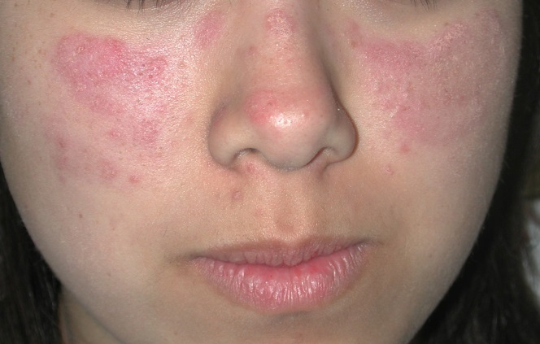
Figure 1 Acute cutaneous lupus erythematosus. The facial erythema on the malar cheeks appears as erythematous plaques with scale. There is distinct sparing of the nasolabial folds.

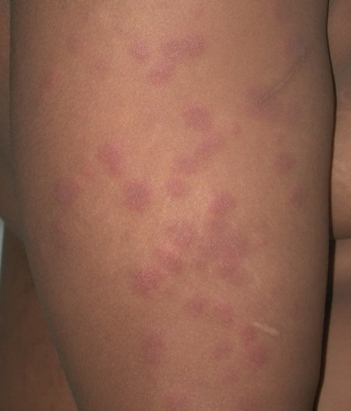
Figure 2 Acute cutaneous lupus erythematosus. Pink edematous papules on the extremities.

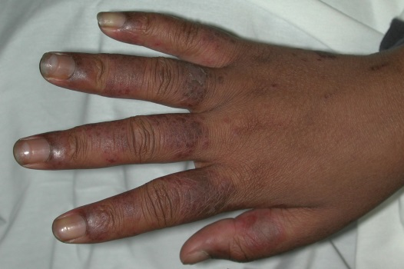
Figure 3 Acute cutaneous lupus erythematosus on the dorsal hands. Note the erythematous edematous papules coalescing into plaques on the dorsal fingers with sparing of the phalangeal joints. Note the dilated cutaneous vessels under the proximal nail fold particularly of the index finger.

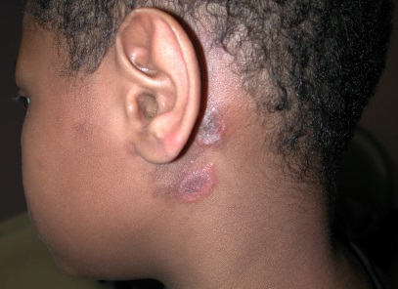
A
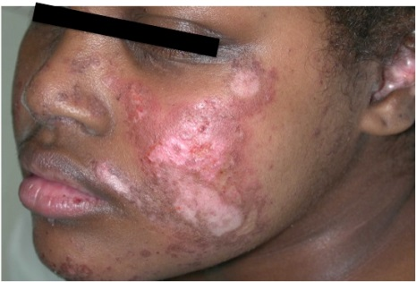
B

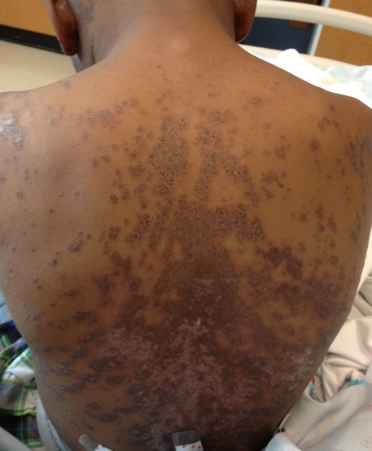
C
Figure 4 Discoid lupus erythematosus. These lesions will typically favor the head and neck. A: Earlier lesions can present as erythematous papules and annular plaques with scaling; B: This patient had more chronic lesions involving her cheek, nose, chin and conchal bowl with significant dyspigmentation; C: Widespread symmetric involvement can be seen in generalized discoid lupus

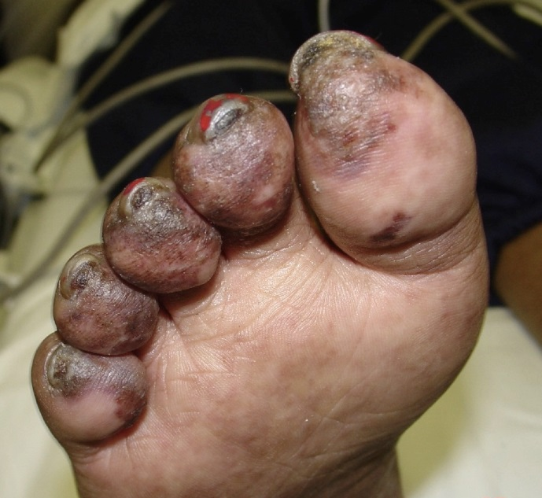
Figure 5 Chilblain lupus erythematosus. Violaceous plaques with overlying scale on the distal toes.

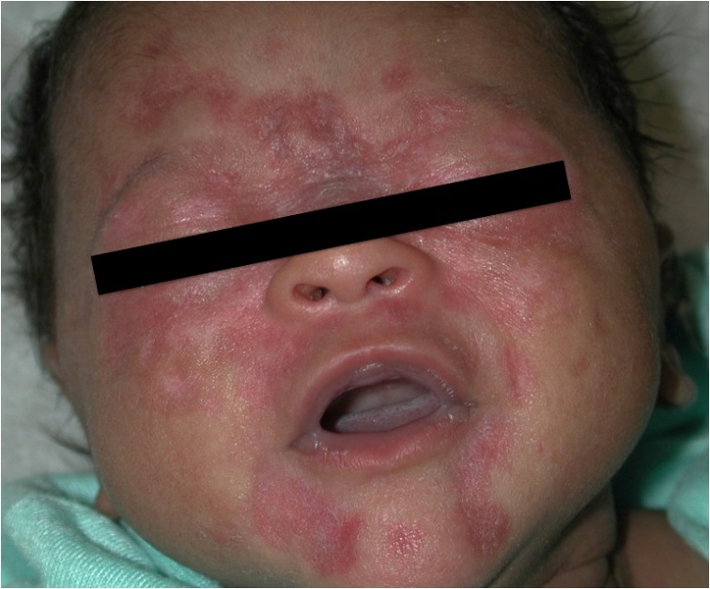
Figure 6 Neonatal lupus. Annular lesions with central atrophy particularly concentrated around the eyes.

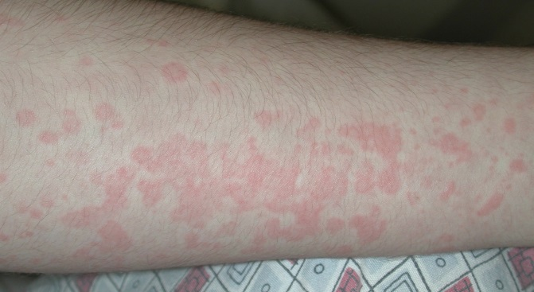
Figure 7 Juvenile idiopathic arthritis. Erythematous papules coalescing into plaques with surrounding pallor, typically evanescent in nature.

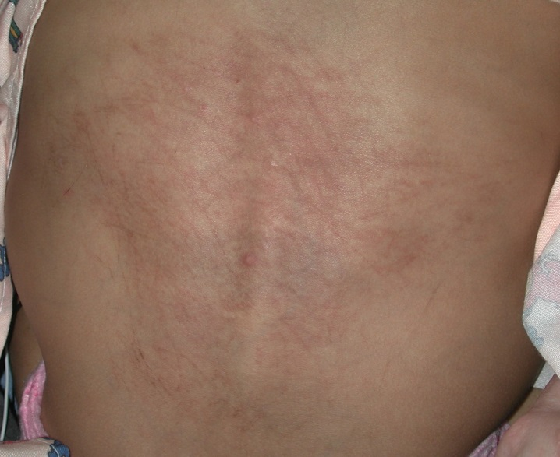
Figure 8 Juvenile idiopathic arthritis presenting as flagellate erythema. Erythematous and hyperpigmented persistent plaques in a flagellate pattern.

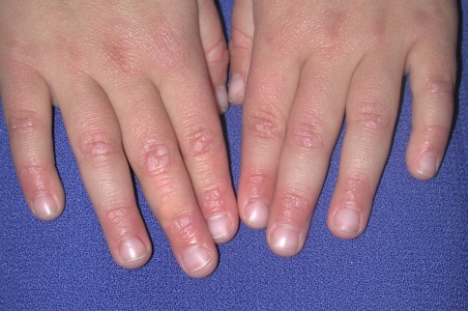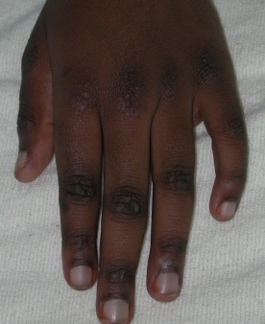
A B
Figure 9 Dermatomyositis. Gottron’s papules with (A) pink to (B) violaceous flat-topped papules overlying the dorsal joints of the fingers with sparing of the skin in between the joints, a finding occasionally mistaken for flat warts. Also note the erythema noted around the proximal nail folds.

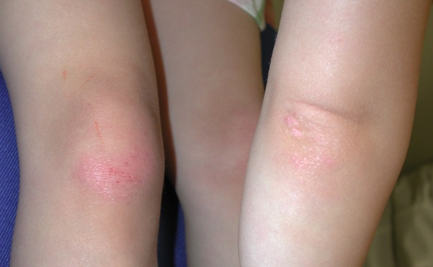
Figure 10 Dermatomyositis. Lichenoid papules and plaques over bony prominences of the knees and elbows.

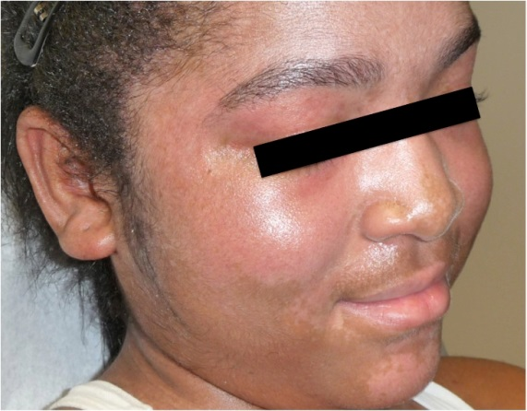
Figure 11 Dermatomyositis. Heliotrope sign with prominent capillary vasculature around the eyelids and characteristic pink-purple patches involving the cheeks, chin and temples.

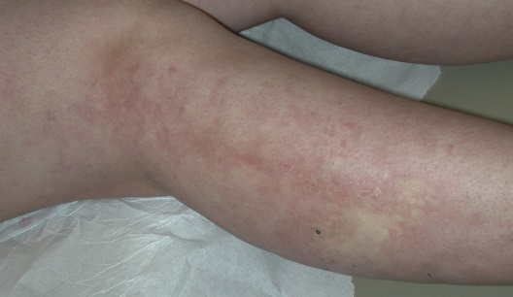
A

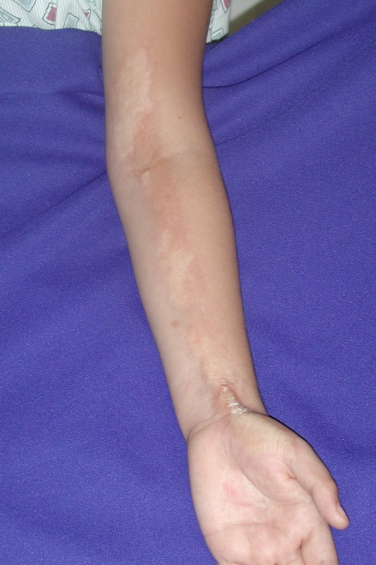
B

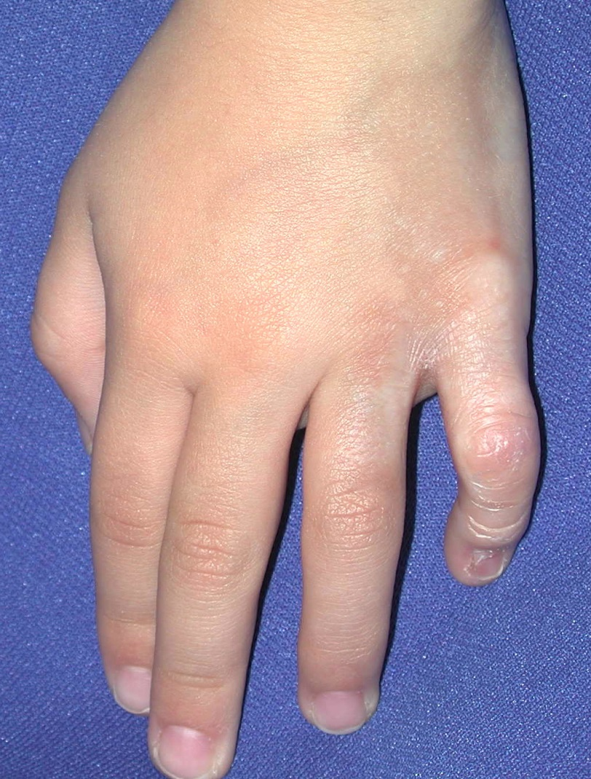
C

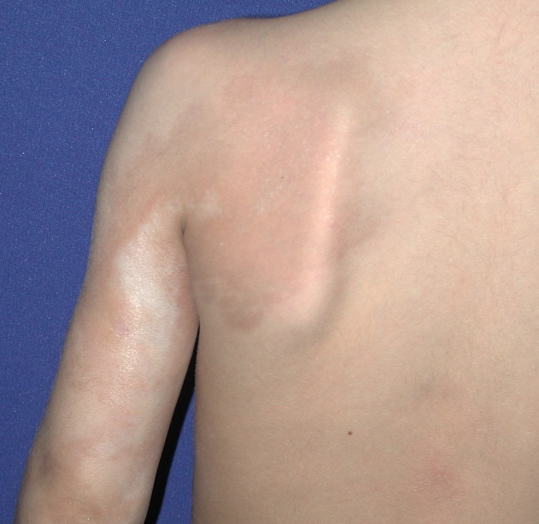
D
Figure 12 Linear morphea overlying joints. Early indurated plaques with lilac-colored border (A); (B) Advanced sclerotic and hypopigmented plaques on the left arm (C) with flexion contraction of the left fifth finger (D) and residual hyperpigmentation on the left shoulder.

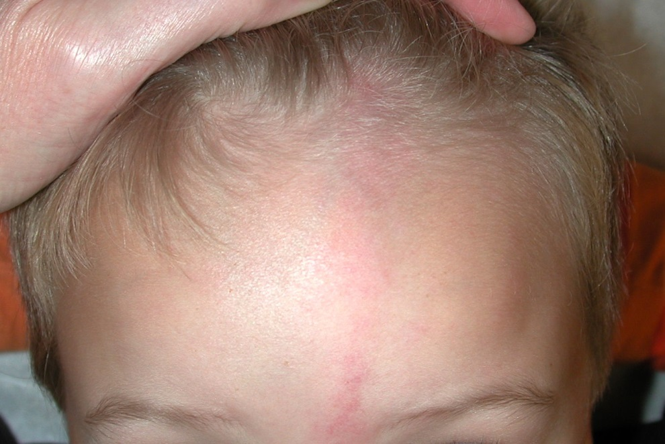
Figure 13 En coup de sabre morphea. Early presentation with an erythematous patch in paramedian forehead location extending into the scalp with hair loss.

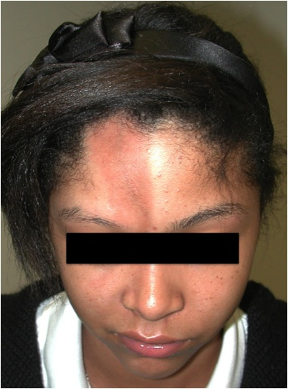
Figure 14 Parry-Romberg syndrome. Note the resulting asymmetry of the right lower face due to loss of subcutaneous fat.

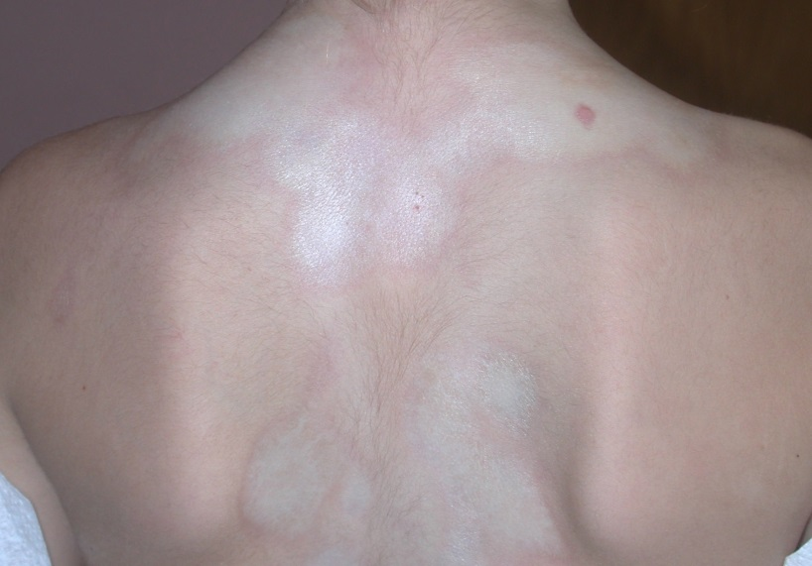
Figure 15 Circumscribed morphea. Inflamed lilac border around indurated sclerotic plaques.

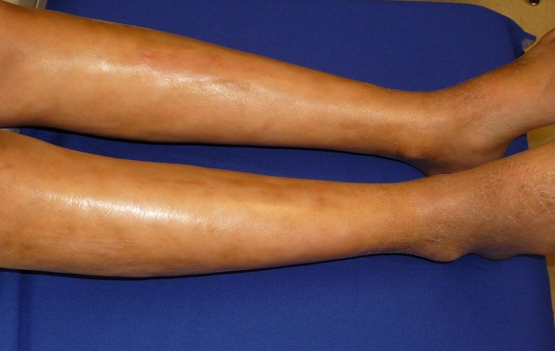
A

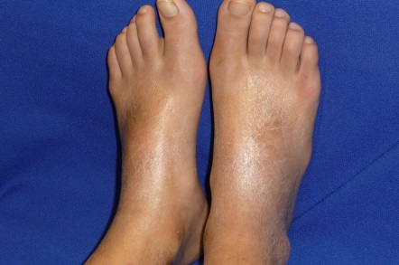
B
Figure 16 Pansclerotic morphea. A: Sclerosis of the skin bound down to underlying skin making the skin appear wooden with an uneven, taut shiny texture to the skin; B: Note the sparing of the toes which differentiates pansclerotic morphea from systemic sclerosis.

Table 1 Cutaneous findings, diagnostic criteria, and treatments for juvenile systemic connective tissue disease

Disease | Cutaneous findings | Diagnostic criteria |  |  | Treatment
Lupus erythematosus | Acute cutaneous lupus  Malar rash  Generalized erythematous macules and papules, sparing the knuckles on dorsal hands  Mucosal ulcerations  Bullous lupus  Subacute cutaneous lupus  Photodistributed annular eczematous or psoriasiform plaques  Chronic cutaneous lupus  Discoid lupus  Lupus panniculitis  Chilblain lupus  Tumid lupus | Systemic lupus erythematous requires fulfillment of ≥ 4 criteria with at least 1 criterion from either category: |  |  | Mild skin-limited disease  Photoprotection  Topical corticosteroids  Calcineurin inhibitors  Hydroxychloroquine  Refractory skin disease and systemic disease  Hydroxychloroquine  Systemic corticosteroids  Methotrexate  Dapsone (bullous lupus)  Other steroid sparing immune modulators
 |  | Clinical criteria  Acute cutaneous lupus  Chronic cutaneous lupus  Oral ulcers  Nonscarring alopecia  Synovitis  Serositis  Renal disease  Neurologic disease  Hemolytic anemia  Leukopenia  Thrombocytopenia |  | Immunologic criteria  ANA  Anti-dsDNA  Anti-Smith  Anti-phospholipid antibody  Low complement  Direct Coombs’ test
Systemic juvenile idiopathic arthritis | Transient salmon-pink macules and edematous papules  Flagellate erythema | Onset before 16 yr of age, ≥ 6 wk of arthritis, ≥ 2 wk of fever  At least one of the following:  evanescent eruption  generalized lymphadenopathy  splenomegaly  serositis |  |  | Systemic corticosteroids  Methotrexate  Biologic agents  Supportive symptomatic measures for skin manifestations
Juvenile dermatomyositis | Gottron’s papules–lichenoid papules overlying phalangeal joints, elbows, knees  Heliotrope rash of eyelids  Poikiloderma of upper back and chest  Hyperkeratosis and fissuring of fingertips  Mucosal ulcers  Gingival telangiectasia  Calcinosis cutis | Fulfillment of all five criteria:  Symmetric proximal muscle weakness  Elevated skeletal muscle enzymes  Electromyography changes¹  Muscle biopsy abnormalities¹  Characteristic skin findings |  |  | Photoprotection  Hydroxychloroquine  Systemic corticosteroids  Methotrexate  IVIG  Other steroid sparing immune modulators
Juvenile onset systemic sclerosis | Limited  Sclerosis limited to distal extremities and face  CREST (calcinosis, Raynaud’s phenomenon, esophageal dysmotility, sclerodactyly and telangiectasias)  Diffuse  Diffuse sclerosis | Skin sclerosis and ≥ 2 of the following: |  |  | Avoidance of vasospasm triggers  Methotrexate  Physiotherapy  Other immune modulators
 |  | Sclerodactyly  Raynaud’s phenomenon  Nailfold capillary abnormalities  Digital tip ulcers  Dysphagia  Gastroesophageal reflux  Neuropathy  Carpal tunnel syndrome  Tendon friction rubs  Arthritis  Myositis | Arrhythmias  Heart failure  Renal crisis  New-onset arterial hypertension  Pulmonary fibrosis  Decreased DLCO  Pulmonary arterial hypertension  Antinuclear antibodies  SSc-selective autoantibodies
Morphea | Linear  Linear erythematous indurated plaques  En coup de sabre–indurates plaques affecting forehead and scalp  Parry Romberg–indurated plaques of the face with ipsilateral facial atrophy  Circumscribed  Isolated indurated plaques  Generalized  4 or more circumscribed type plaques that are larger than 3 cm in diameter  Involving at least 2/7 anatomic sites: head-neck, right upper extremity, left upper extremity, right lower extremity, left lower extremity, anterior trunk or posterior trunk  Pansclerotic  Diffuse involvement of the limbs, trunk, face and scalp with fixation of underlying structures  Mixed  2 or more different types of morphea present | No sclerosis of internal organs, except for rare involvement of underlying fascia, muscle and bone |  |  | Topical corticosteroids  Calcipotriene  UVA1 phototherapy  Severe or critical location of lesions  Systemic corticosteroids  Methotrexate
¹These tests are typically not done in children and have been clinically replaced with MRI evidence of muscle inflammation and autoantibodies compatible with juvenile dermatomyositis.

Table 2 Nonspecific cutaneous findings suggestive of systemic lupus erythematosus (Modified from Bolognia)^{[1]}
Nonspecific cutaneous findings suggestive of systemic lupus erythematosus
Diffuse non-scarring alopecia
Raynaud’s phenomenon
Nailfold telangiectasia and erythema
Vasculitis
Urticarial vasculitis
Small vessel vasculitis (e.g., palpable purpura)
Polyarteritis nodosa-like lesions
Ulcerations
Cutaneous signs of antiphospholipid syndrome
Livedo reticularis
Ulcerations
Acrocyanosis
Atrophie blanche-like lesions
Degos’-like lesions
Livedoid vasculopathy
Palmar erythema
Papular and nodular mucinosis

