Name of Journal: World Journal of Gastroenterology
Manuscript NO: 56086
Manuscript Type: ORIGINAL ARTICLE

Retrospective Study
Current status of Helicobacter pylori eradication and risk factors for eradication failure

Yan TL et al. Status of H. pylori eradication

Tian-Lian Yan, Jian-Guo Gao, Jing-hua Wang, Dan Chen, Chao Lu, Cheng-Fu Xu

Tian-Lian Yan, Jian-Guo Gao, Jing-hua Wang, Dan Chen, Chao Lu, Cheng-Fu Xu, Department of Gastroenterology, The First Affiliated Hospital, Zhejiang University School of Medicine, Hangzhou 310003, Zhejiang Province, China

Author contributions: Yan TL and Gao JG contributed equally to this work; Xu CF, Yan TL, and Lu C designed the research; Yan TL, Gao JG, and Chen D performed the research; Wang JH analyzed the data; Yan TL and Xu CF drafted and revised the manuscript. All authors approved the final draft of this manuscript for submission.

Supported by the National Natural Science Foundation of China, No. 81600447.

Corresponding author: Cheng-Fu Xu, MD, Doctor, Department of Gastroenterology, The First Affiliated Hospital, Zhejiang University School of Medicine, No. 79 Qingchun Road, Hangzhou 310003, Zhejiang Province, China. xiaofu@zju.edu.cn

Received: April 24, 2020
Revised: July 18, 2020
Accepted: July 30, 2020
Published online: August 28, 2020

Abstract
BACKGROUND
The Helicobacter pylori (H. pylori) eradication rate is decreasing in the general population of China.

AIM
To evaluate the H. pylori eradication status in real-world clinical practice and to explore factors related to eradication failure.

METHODS
Patients with H. pylori infection who were treated with standard 14-d quadruple therapy and received a test of cure at a provincial medical institution between June 2018 and May 2019 were enrolled. Demographic and clinical data were recorded. Eradication rates were calculated and compared between regimens and subgroups. Multivariate analysis was performed to identify predictors of eradication failure.

RESULTS
Of 2610 patients enrolled, eradication was successful in 1999 (76.6%) patients. Amoxicillin-containing quadruple regimens showed a higher eradication rate than other quadruple therapy regimens (83.0% vs 69.0%, P < 0.001). The quadruple therapy containing amoxicillin plus clarithromycin achieved the highest eradication rate (83.5%). Primary therapy had a higher eradication rate than rescue therapy (78.3% vs 66.5%, P < 0.001). In rescue therapy, the amoxicillin- and furazolidone-containing regimens achieved the highest eradication rate (80.8%). Esomeprazole-containing regimens showed a higher eradication rate than those containing other proton pump inhibitors (81.8% vs 74.9%, P = 0.001). Multivariate regression analysis found that older age, prior therapy, and use of omeprazole or pantoprazole were associated with an increased risk of eradication failure.

CONCLUSION
The total eradication rate is 76.6%. Amoxicillin-containing regimens are superior to other regimens. Age, prior therapy, and use of omeprazole or pantoprazole are independent risk factors for eradication failure.

Key words: Helicobacter pylori; Eradication; Quadruple therapy; Proton pump inhibitor; Retrospective study

Yan TL, Gao JG, Wang JH, Chen D, Lu C, Xu CF. Current status of Helicobacter pylori eradication and risk factors for eradication failure. World J Gastroenterol 2020; 26(32): 4846-4856
URL: https://www.wjgnet.com/1007-9327/full/v26/i32/4846.htm
DOI: https://dx.doi.org/10.3748/wjg.v26.i32.4846

Core tip: The Helicobacter pylori eradication rate is decreasing worldwide, and there is a lack of recent data from China. The current study of 14-d quadruple regimens in Eastern China revealed an eradication rate of 76.6%. Amoxicillin-containing regimens had the highest eradication rate in primary therapy, and amoxicillin- and furazolidone-containing regimens showed superiority in rescue therapy. Age, prior therapy, and use of omeprazole or pantoprazole were independent risk factors for eradication failure. This study can improve the choice of antibiotics and proton pump inhibitors and indicates that in clinical practice, attention should be paid to elderly patients and rescue therapy.

INTRODUCTION
Helicobacter pylori (H. pylori) is a widespread bacterium that typically infects the human gastric mucosa. The infection may induce numerous gastrointestinal diseases, including gastritis, peptic ulcer, gastric carcinoma, and gastric lymphoma^{[1-3]}, and it is also associated with significant extragastric diseases, such as idiopathic thrombocytopenic purpura, idiopathic iron deficiency anemia, and vitamin B12 deficiency^{[4]}. Epidemical studies reported that H. pylori affects 24%-50% of people in industrialized nations and up to 79% of those in less-developed countries. H. pylori infection is a worldwide threat to public health^{[5]}.
Currently, H. pylori infection is considered the most important (yet controllable) risk factor for intestinal gastric cancer, as it accounts for the vast majority of cases of gastric cancer, which generally develops from a normal gastric mucosa to superficial gastritis and pre-neoplastic lesions^{[6]}. A large number of studies have confirmed that H. pylori screening and treatment strategies could prevent gastric cancer in a cost-effective way, especially before the appearance of pre-neoplastic lesions and in high-risk areas^{[7-9]}. In recent decades, the urea breath test has been widely used to detect H. pylori infection not only in specialized hospitals but also in physical examination centers and community hospitals in China. This has led to large numbers of asymptomatic patients being referred to specialized clinics for treatment^{[10]}.
However, H. pylori eradication therapies are facing decreasing eradication rates, mainly owing to antimicrobial resistance, and are partially influenced by the efficacy of acid-suppressive drugs^{[11]}. Recent guidelines recommend 14-d combination therapies with two types of antibiotics, a proton pump inhibitor (PPI) and bismuth^{[12,13]}. Studies using susceptibility tests based on H. pylori strains cultured in vitro and prospective studies with relatively small sample sizes reported increasing resistance rates to clarithromycin, metronidazole, and levofloxacin, while resistance rates to amoxicillin, tetracycline, and furazolidone were low^{[14,15]}. However, there is a scarcity of eradication data from large-sample size studies of real-world practice, which are important for formulating future guidelines and conducting clinical work in China. Moreover, it remains uncertain whether the acidic environment in the stomach during therapy, prior therapy, and demographic characteristics are related to eradication failure.
In this study, we reviewed the medical records of a large series of H. pylori-positive patients from the First Affiliated Hospital, Zhejiang University School of Medicine. We evaluated the H. pylori eradication status in the local population of Eastern China in real clinical practice and explored factors related to therapy failure.

MATERIALS AND METHODS
Study design and research subjects
All of the patients diagnosed with H. pylori infection in the electronic medical records obtained from the First Affiliated Hospital, Zhejiang University School of Medicine (Hangzhou, China) between June 2018 and May 2019 were included. In addition, separate databases of laboratory test, endoscopy, and pathology results were searched. Anonymized information of each patient was linked to a unique identification number. Two clinicians checked the therapy regimens independently.
The inclusion criteria were the following: (1) The general and clinical information and the prescription records were complete and available; (2) the H. pylori infection status before treatment was directly determined by one or more of the standard detection methods (urea breath test, histologic staining, and/or bacterial culture); (3) patients received quadruple therapy for H. pylori infection according to the standard antibiotic combinations and dosages of the “Fifth Chinese National Consensus Report on the management of H. pylori infection,” which highlights bismuth-containing quadruple therapy (PPI, bismuth, and two antibiotics) as the main empirical therapy for H. pylori eradication^{[12]}; (4) the treatment lasted 14 d; and (5) test of cure: The H. pylori status was confirmed by urea breath test 4-8 wk after the end of treatment.
The exclusion criteria were the following: (1) Patients who were lost to follow-up or changed the therapy regimen; and (2) therapies that included other drugs, such as probiotics and/or Chinese traditional medicines.
The study protocol was approved by the Clinical Research Ethics Committee of the First Affiliated Hospital, Zhejiang University School of Medicine.

Statistical analysis
Statistical analyses were performed using SPSS version 22.0 (IBM SPSS Statistics, IBM Corporation, Armonk, NY, USA). Categorical variables are displayed as frequencies and proportions (%). Continuous variables are presented as the mean and standard deviation (SD) unless otherwise stated. Continuous variables were compared by Student’s t-test or one-way ANOVA. Categorical variables were compared using the χ² test. The Cochran-Armitage trend test was used to analyze H. pylori eradication rates in the different age groups. A stepwise logistic regression analysis was performed to examine the relationship between H. pylori eradication failure and risk factors (probability to enter = 0.05 and probability to remove = 0.10). Two-tailed P values < 0.05 were considered to indicate statistical significance.

RESULTS
Patient selection and clinical characteristics
A total of 2652 H. pylori-positive patients received 14-d quadruple therapy between June 2018 and May 2019 and took the urea breath test 4-8 wk later. We excluded 34 patients because the therapy regimens were changed due to drug intolerance. We also excluded another five patients who received amoxicillin plus metronidazole-based therapy and three patients who received levofloxacin plus metronidazole-based therapy owing to the small sample sizes. Finally, 2610 patients (1088 men and 1522 women) with a mean age of 44.53 ± 14.43 years were included in the analyses (Figure 1).
Of the 2610 patients, 373 (14.3%) had a prior history of H. pylori treatment, and 2237 (85.7%) did not (Table 1). One or more symptoms were observed in 1301 (49.8%) patients, including upper abdominal pain (15.6%), abdominal distension (24.6%), nausea (5.3%), acid regurgitation or heartburn (9.6%), bitter taste in the mouth (6.0%), belching (8.6%), increased stool frequency (5.5%), and others (5.8%). A total of 1390 (53.3%) patients underwent gastroscopy before or after therapy, 244 had at least one peptic ulcer, 416 had atrophy, intestinal metaplasia, or dysplasia, as determined by biopsy histology, and 17 were diagnosed with MALT lymphoma or gastric cancer (Table 1).

Helicobacter pylori eradication rates
Of the 2610 patients, eradication was successful in 1999 (76.6%) patients. The eradication rate of each antibiotic combination is illustrated in Figure 2. Amoxicillin-based therapy showed a significantly higher eradication rate than other regimens (83.0% vs 69.0%, P < 0.001). Therapy consisting of amoxicillin plus clarithromycin achieved the highest eradication rate (83.5%; 95%CI: 81.4%-85.5%), followed by therapy that consisted of amoxicillin plus furazolidone (79.4%; 95%CI: 69.4%-89.4%), amoxicillin plus levofloxacin (78.9%; 95% CI: 69.8%-88.1%), clarithromycin plus levofloxacin (72.1%; 95%CI: 69.3%-74.9%), levofloxacin plus furazolidone (63.2%; 95%CI: 41.5%-84.8%), clarithromycin plus metronidazole (54.7%; 95%CI: 46.7%-62.7%), and clarithromycin plus furazolidone (44.1%; 95%CI: 27.4%-60.8%). The eradication rate was not significantly different among the three different amoxicillin-based therapies (Figure 2).
We also found that the choice of PPI is a factor that influenced the eradication rate (Table 2). Therapy with esomeprazole achieved the highest eradication rate (81.8%; 95%CI: 78.2%-84.0%), followed by therapies with rabeprazole (78.6%; 95%CI: 75.8%-81.4%), lansoprazole (78.2%; 95%CI: 67.3%-89.1%), pantoprazole (74.0%; 95%CI: 70.5%-77.5%), and omeprazole (68.6%; 95%CI: 64.1%-73.1%). Eradication rates of therapies with omeprazole and pantoprazole were significantly lower than that of therapy with esomeprazole (P < 0.005). Eradication rates of therapies with rabeprazole and lansoprazole were lower than that of therapy with esomeprazole, but the difference was not statistically significant. Therapies with esomeprazole showed a significantly higher overall eradication rate than those with other PPIs (81.8% vs 74.9%, χ² = 10.755, P = 0.001).
In addition, we found that the eradication rate showed a significant decreasing trend with increase in age (Figure 3). The eradication rates were 84.0%, 79.3%, 74.5%, 70.8%, and 72.4% in patients aged < 30, 30-39, 40-49, 50-59, and ≥ 60 years, respectively (P for trend < 0.001).

Subgroup analysis
The eradication rates for primary and rescue therapies were 78.3% (95%CI: 76.6%-80.0%) and 66.5% (95% CI: 61.7%-71.3%), respectively. Primary therapy showed a higher eradication rate than rescue therapy (P < 0.001). The amoxicillin-containing regimens showed superiority in primary therapy, and amoxicillin- and furazolidone-containing regimens achieved the highest eradication rate (80.8%; 95%CI: 70.1%-91.5%) in rescue therapy, followed by amoxicillin- and clarithromycin-containing regimens (77.1%; 95%CI: 69.1%-85.2%).
The regimens containing amoxicillin plus levofloxacin, clarithromycin plus levofloxacin, and clarithromycin plus metronidazole showed lower eradication rates in rescue therapy than in primary therapy (P < 0.05). The regimens containing amoxicillin plus clarithromycin, amoxicillin plus furazolidone, clarithromycin plus furazolidone, and levofloxacin plus furazolidone showed no significant difference in eradication rates between primary and rescue therapy (Table 3).

Risk factors for eradication failure
We performed stepwise logistic regression analyses to explore factors associated with eradication failure. The univariate analysis showed that age, prior therapy, antibiotic regimen, and choice of PPI were significantly associated with the risk of eradication failure, while gender and chief complaint were not. The multivariate logistic regression analysis confirmed that older age and prior therapy were significantly associated with an increased risk of eradication failure (P < 0.001). Setting the regimen containing amoxicillin plus clarithromycin as the reference group, regimens containing clarithromycin plus levofloxacin, clarithromycin plus metronidazole, and clarithromycin plus furazolidone all showed a higher odds of eradication failure (P < 0.001). Other regimens were not significantly associated with eradication failure. Setting regimens containing esomeprazole as the reference group, the regimens containing omeprazole and pantoprazole showed a significantly higher risk of eradication failure (P < 0.05), whereas rabeprazole and lansoprazole were not significantly associated with eradication failure (Table 4).

DISCUSSION
In this large-sized retrospective study, we evaluated the efficiency of various standard 14-d quadruple regimens recommended for H. pylori treatment. We found that amoxicillin-based quadruple therapy was superior, and amoxicillin- and furazolidone-based therapy showed a high eradication rate in rescue therapy. Our multivariate analysis showed that older age, prior therapy, and application of omeprazole or pantoprazole increased the risk of eradication failure.
This study reports an unsatisfactory eradication rate of 76.6%, even though prescription was in strict accordance with guidelines. In a single-center retrospective study performed by another hospital in Eastern China, 992 patients received 10 to 14 d of quadruple therapy for H. pylori infection based on furazolidone and amoxicillin between January and December 2015. The eradication rate of rescue therapy was 91.3%^{[16]}. However, in our study, the eradication rate of 14-d quadruple rescue therapy based on amoxicillin and furazolidone was only 80.8%. One possible reason for this discrepancy is that H. pylori resistance rates to antibiotics have increased during the past years. However, antibiotic resistance of H. pylori cultures was not investigated for all of the enrolled patients. Because of its cost and relatively low sensitivity, H. pylori culture is not recommended for routine diagnosis of H. pylori infection^{[17]}. Another reason might be the lack of tetracycline-containing regimens and the low proportion of furazolidone-containing regimens, the resistance rates of which are relatively low in China^{[18]}. Unfortunately, most hospitals in China are facing shortages of tetracycline, which yielded effective anti-H. pylori results in the USA^{[19]}. Moreover, the potentially severe side effects of furazolidone limit its widespread application in initial empiric therapy. Therefore, furazolidone-containing regimens are more frequently used for patients with refractory H. pylori infection^{[20]}.
In this study, we also observed that only half of the patients had symptoms, and the other half were asymptomatic. As more asymptomatic patients are referred to the hospital for H. pylori therapy, we predict that antibiotic resistance of H. pylori will increase in the near future. It is, therefore, worthwhile to explore methods to improve the eradication rate. A previous study reported that patient compliance is an indispensable factor influencing treatment results^{[21]}. In addition, high-dose PPI and amoxicillin dual therapy could decrease the use of unnecessary antibiotics, which is a promising alternative approach^{[22,23]}. Adjuvant therapy, including specific probiotics or vitamins, also showed good results, although more evidence will be needed^{[24]}.
Consistent with previous studies, our results also suggest that acid-suppressive drugs play an important role in eradication therapy. A previous meta-analysis reported that regimens containing new-generation PPIs (esomeprazole or rabeprazole) showed a significantly higher eradication rate than those containing first-generation PPIs (omeprazole, lansoprazole, or pantoprazole)^{[25]}. In this study, we also found a significantly lower eradication rate for omeprazole- or pantoprazole-containing regimens than for those containing new-generation PPIs. However, the difference in eradication rates between regimens containing lansoprazole and new-generation PPIs was not significant. Due to the relatively small size of the lansoprazole group, this result needs to be confirmed in future studies. The main role of PPIs in the treatment of H. pylori infections is to elevate the gastric pH, leading to an increase in the population of dividing H. pylori. Subsequently, the bacteria become more susceptible to antibiotics, such as amoxicillin and clarithromycin^{[26]}. Selecting a PPI with a stable effect and high efficacy that is weakly influenced by CYP2C19 genotypes can improve the eradication rate^{[12]}. In addition to the modification of dual therapy by high-dose PPI mentioned above, vonoprazan, a first-in-class potassium-competitive acid blocker, was recently reported to be an independent factor for successful H. pylori eradication in both primary and rescue therapy^{[27]}.
In this study, a significant trend of decreasing eradication rates was observed with increasing age, which is consistent with previous reports^{[27,28]}. Possible reasons include lower tolerance to and compliance with therapy, more potential complications, increased risks of drug side effects, and increased antibiotic resistance because of higher accumulated antibiotic consumption^{[29]}. In contrast, no significant difference in the eradication rate or frequency of adverse effects between the elderly group and the younger group was found in other studies^{[30,31]}.
Several limitations should be considered when explaining the results of this study. First, because of its retrospective nature, the classification of primary or rescue therapy was completely dependent on the electronic medical records. The percentage of rescue therapy might be underestimated if the patients’ medical histories were not fully recorded, and some rescue therapy cases might be misclassified as primary therapy, resulting in a relatively low eradication rate in the primary therapy group. Second, patient compliance was not analyzed in this study. However, all of the patients enrolled in this study completed the urea breath test 4-8 wk after finishing treatment, indicating a relatively high compliance. Third, similar to previous reports of H. pylori eradication, the data used in this study were extracted from a single center. The results may not be extrapolated to other areas, especially if resistance rates vary geographically. In addition, the small sample sizes of some regimens, such as the furazolidone-containing regimens in subgroup analysis of primary therapy and lansoprazole-containing regimens, limit the reliability of the corresponding results.
In conclusion, this study revealed an unsatisfactory H. pylori eradication rate of 76.6% in Eastern China. Amoxicillin-containing 14-d quadruple regimens have the highest eradication rate in primary therapy, and amoxicillin- and furazolidone-containing regimens show superiority in rescue therapy. An inferiority of omeprazole and pantoprazole is also observed. These findings may be helpful to improve the eradication rate of anti-H. pylori therapy.

ARTICLE HIGHLIGHTS
Research background
Helicobacter pylori (H. pylori) is a widespread bacterium that affects approximately 50% of the world’s population and induces numerous gastrointestinal and extragastric diseases. Currently, H. pylori infection is considered the most important (yet controllable) risk factor for gastric cancer. To date, there are limited data in clinical practice regarding eradication rate and factors related to therapy failure.

Research motivation
In recent years, H. pylori eradication therapies are facing decreasing eradication rates. However, risk factors related to therapy failure are still uncertain. In addition, there is a lack of recent eradication rate from China. Study in this aspect will certainly be helpful to improve the effectiveness of anti-H. pylori therapy in the future.

Research objectives
This study aimed to evaluate the H. pylori eradication status in the local population of Eastern China and to explore factors related to eradication failure.

Research methods
Medical records for patients with H. pylori infection who underwent standard 14-d quadruple therapy and received urea breath test after treatment were retrospectively reviewed. Eradication rates were calculated and compared between regimens and subgroups. Multivariate analysis was performed to identify predictors of eradication failure.

Research results
Of 2610 patients enrolled, eradication was successful in 1999 (76.6%) patients. Amoxicillin-containing quadruple regimens showed a higher eradication rate than other quadruple therapy regimens (83.0% vs 69.0%, P < 0.001). The quadruple therapy containing amoxicillin plus clarithromycin achieved the highest eradication rate (83.5%). Primary therapy had a higher eradication rate than rescue therapy (78.3% vs 66.5%, P < 0.001). In rescue therapy, amoxicillin- and furazolidone-containing regimens achieved the highest eradication rate (80.8%). Esomeprazole-containing regimens showed a higher eradication rate than those containing other proton pump inhibitors (81.8% vs 74.9%, P = 0.001). Multivariate regression analysis found that older age, prior therapy, and use of omeprazole or pantoprazole were associated with an increased risk of eradication failure.

Research conclusions
This study confirmed that the total eradication rate is 76.6% in eastern China. Amoxicillin-containing regimens are superior to other regimens. Age, prior therapy, and use of omeprazole or pantoprazole are independent risk factors for eradication failure.

Research perspectives
This study can improve the choice of antibiotics and proton pump inhibitors and indicates that in clinical practice, attention should be paid to elderly patients and rescue therapy. Further prospective research focusing on optimizing the treatment strategies considering these factors is required.

REFERENCES
1 Boltin D, Niv Y, Schütte K, Schulz C. Review: Helicobacter pylori and non-malignant upper gastrointestinal diseases. Helicobacter 2019; 24 Suppl 1: e12637 [PMID: 31486237 DOI: 10.1111/hel.12637]
2 Sugano K. Effect of Helicobacter pylori eradication on the incidence of gastric cancer: a systematic review and meta-analysis. Gastric Cancer 2019; 22: 435-445 [PMID: 30206731 DOI: 10.1007/s10120-018-0876-0]
3 Venerito M, Vasapolli R, Rokkas T, Delchier JC, Malfertheiner P. Helicobacter pylori, gastric cancer and other gastrointestinal malignancies. Helicobacter 2017; 22 Suppl 1: [PMID: 28891127 DOI: 10.1111/hel.12413]
4 Franceschi F, Covino M, Roubaud Baudron C. Review: Helicobacter pylori and extragastric diseases. Helicobacter 2019; 24 Suppl 1: e12636 [PMID: 31486239 DOI: 10.1111/hel.12636]
5 Sjomina O, Pavlova J, Niv Y, Leja M. Epidemiology of Helicobacter pylori infection. Helicobacter 2018; 23 Suppl 1: e12514 [PMID: 30203587 DOI: 10.1111/hel.12514]
6 Rugge M, Genta RM, Di Mario F, El-Omar EM, El-Serag HB, Fassan M, Hunt RH, Kuipers EJ, Malfertheiner P, Sugano K, Graham DY. Gastric Cancer as Preventable Disease. Clin Gastroenterol Hepatol 2017; 15: 1833-1843 [PMID: 28532700 DOI: 10.1016/j.cgh.2017.05.023]
7 Lansdorp-Vogelaar I, Sharp L. Cost-effectiveness of screening and treating Helicobacter pylori for gastric cancer prevention. Best Pract Res Clin Gastroenterol 2013; 27: 933-947 [PMID: 24182612 DOI: 10.1016/j.bpg.2013.09.005]
8 Han Y, Yan T, Ma H, Yao X, Lu C, Li Y, Li L. Cost-Effectiveness Analysis of Helicobacter pylori Eradication Therapy for Prevention of Gastric Cancer: A Markov Model. Dig Dis Sci 2020; 65: 1679-1688 [PMID: 31673902 DOI: 10.1007/s10620-019-05910-1]
9 Bae SE, Choi KD, Choe J, Kim SO, Na HK, Choi JY, Ahn JY, Jung KW, Lee J, Kim DH, Chang HS, Song HJ, Lee GH, Jung HY. The effect of eradication of Helicobacter pylori on gastric cancer prevention in healthy asymptomatic populations. Helicobacter 2018; 23: e12464 [PMID: 29345408 DOI: 10.1111/hel.12464]
10 Du Y, Zhu H, Liu J, Li J, Chang X, Zhou L, Chen M, Lu N, Li Z. Consensus on eradication of Helicobacter pylori and prevention and control of gastric cancer in China (2019, Shanghai). J Gastroenterol Hepatol 2020; 35: 624-629 [PMID: 31788864 DOI: 10.1111/jgh.14947]
11 Suzuki S, Gotoda T, Kusano C, Ikehara H, Ichijima R, Ohyauchi M, Ito H, Kawamura M, Ogata Y, Ohtaka M, Nakahara M, Kawabe K. Seven-day vonoprazan and low-dose amoxicillin dual therapy as first-line Helicobacter pylori treatment: a multicentre randomised trial in Japan. Gut 2020; 69: 1019-1026 [PMID: 31915235 DOI: 10.1136/gutjnl-2019-319954]
12 Liu WZ, Xie Y, Lu H, Cheng H, Zeng ZR, Zhou LY, Chen Y, Wang JB, Du YQ, Lu NH; Chinese Society of Gastroenterology, Chinese Study Group on Helicobacter pylori and Peptic Ulcer. Fifth Chinese National Consensus Report on the management of Helicobacter pylori infection. Helicobacter 2018; 23: e12475 [PMID: 29512258 DOI: 10.1111/hel.12475]
13 Malfertheiner P, Megraud F, O'Morain CA, Gisbert JP, Kuipers EJ, Axon AT, Bazzoli F, Gasbarrini A, Atherton J, Graham DY, Hunt R, Moayyedi P, Rokkas T, Rugge M, Selgrad M, Suerbaum S, Sugano K, El-Omar EM; European Helicobacter and Microbiota Study Group and Consensus panel. Management of Helicobacter pylori infection-the Maastricht V/Florence Consensus Report. Gut 2017; 66: 6-30 [PMID: 27707777 DOI: 10.1136/gutjnl-2016-312288]
14 Hu Y, Zhu Y, Lu NH. Primary Antibiotic Resistance of Helicobacter pylori in China. Dig Dis Sci 2017; 62: 1146-1154 [PMID: 28315035 DOI: 10.1007/s10620-017-4536-8]
15 Zhang W, Chen Q, Liang X, Liu W, Xiao S, Graham DY, Lu H. Bismuth, lansoprazole, amoxicillin and metronidazole or clarithromycin as first-line Helicobacter pylori therapy. Gut 2015; 64: 1715-1720 [PMID: 26338726 DOI: 10.1136/gutjnl-2015-309900]
16 Zhang YW, Hu WL, Cai Y, Zheng WF, Du Q, Kim JJ, Kao JY, Dai N, Si JM. Outcomes of furazolidone- and amoxicillin-based quadruple therapy for Helicobacter pylori infection and predictors of failed eradication. World J Gastroenterol 2018; 24: 4596-4605 [PMID: 30386109 DOI: 10.3748/wjg.v24.i40.4596]
17 Atkinson NS, Braden B. Helicobacter Pylori Infection: Diagnostic Strategies in Primary Diagnosis and After Therapy. Dig Dis Sci 2016; 61: 19-24 [PMID: 26391269 DOI: 10.1007/s10620-015-3877-4]
18 Zhang YX, Zhou LY, Song ZQ, Zhang JZ, He LH, Ding Y. Primary antibiotic resistance of Helicobacter pylori strains isolated from patients with dyspeptic symptoms in Beijing: a prospective serial study. World J Gastroenterol 2015; 21: 2786-2792 [PMID: 25759550 DOI: 10.3748/wjg.v21.i9.2786]
19 Alsamman MA, Vecchio EC, Shawwa K, Acosta-Gonzales G, Resnick MB, Moss SF. Retrospective Analysis Confirms Tetracycline Quadruple as Best Helicobacter pylori Regimen in the USA. Dig Dis Sci 2019; 64: 2893-2898 [PMID: 31187323 DOI: 10.1007/s10620-019-05694-4]
20 Nijevitch AA, Shcherbakov PL, Sataev VU, Khasanov RSh, Al Khashash R, Tuygunov MM. Helicobacter pylori eradication in childhood after failure of initial treatment: advantage of quadruple therapy with nifuratel to furazolidone. Aliment Pharmacol Ther 2005; 22: 881-887 [PMID: 16225499 DOI: 10.1111/j.1365-2036.2005.02656.x]
21 Wang T, Yang X, Li Y, Li L, Liu J, Ji C, Sun Y, Li Y, Zuo X. Twice daily short-message-based re-education could improve Helicobacter pylori eradication rate in young population: A prospective randomized controlled study. Helicobacter 2019; 24: e12569 [PMID: 30848868 DOI: 10.1111/hel.12569]
22 Yang J, Zhang Y, Fan L, Zhu YJ, Wang TY, Wang XW, Chen DF, Lan CH. Eradication Efficacy of Modified Dual Therapy Compared with Bismuth-Containing Quadruple Therapy as a First-Line Treatment of Helicobacter pylori. Am J Gastroenterol 2019; 114: 437-445 [PMID: 30807294 DOI: 10.14309/ajg.0000000000000132]
23 Tai WC, Liang CM, Kuo CM, Huang PY, Wu CK, Yang SC, Kuo YH, Lin MT, Lee CH, Hsu CN, Wu KL, Hu TH, Chuah SK. A 14 day esomeprazole- and amoxicillin-containing high-dose dual therapy regimen achieves a high eradication rate as first-line anti-Helicobacter pylori treatment in Taiwan: a prospective randomized trial. J Antimicrob Chemother 2019; 74: 1718-1724 [PMID: 30768161 DOI: 10.1093/jac/dkz046]
24 Hu Y, Zhu Y, Lu NH. Recent progress in Helicobacter pylori treatment. Chin Med J (Engl) 2020; 133: 335-343 [PMID: 31929363 DOI: 10.1097/CM9.0000000000000618]
25 McNicholl AG, Linares PM, Nyssen OP, Calvet X, Gisbert JP. Meta-analysis: esomeprazole or rabeprazole vs. first-generation pump inhibitors in the treatment of Helicobacter pylori infection. Aliment Pharmacol Ther 2012; 36: 414-425 [PMID: 22803691 DOI: 10.1111/j.1365-2036.2012.05211.x]
26 Hu Y, Zhu Y, Lu NH. Novel and Effective Therapeutic Regimens for Helicobacter pylori in an Era of Increasing Antibiotic Resistance. Front Cell Infect Microbiol 2017; 7: 168 [PMID: 28529929 DOI: 10.3389/Fcimb.2017.00168]
27 Mori H, Suzuki H, Omata F, Masaoka T, Asaoka D, Kawakami K, Mizuno S, Kurihara N, Nagahara A, Sakaki N, Ito M, Kawamura Y, Suzuki M, Shimada Y, Sasaki H, Matsuhisa T, Torii A, Nishizawa T, Mine T, Ohkusa T, Kawai T, Tokunaga K, Takahashi S. Current status of first- and second-line Helicobacter pylori eradication therapy in the metropolitan area: a multicenter study with a large number of patients. Therap Adv Gastroenterol 2019; 12: 1756284819858511 [PMID: 31320930 DOI: 10.1177/1756284819858511]
28 Kim BJ, Yang CH, Song HJ, Jeon SW, Kim GH, Kim HS, Kim TH, Shim KN, Chung IK, Park MI, Choi IJ, Kim JH, Kim BW, Baik GH, Han SW, Seo HE, Jung WT, Hwan Oh J, Kim SG, Lee JH, Park SK, Park BJ, Yang BR, Lee J, Kim JG. Online registry for nationwide database of Helicobacter pylori eradication in Korea: Correlation of antibiotic use density with eradication success. Helicobacter 2019; 24: e12646 [PMID: 31368629 DOI: 10.1111/hel.12646]
29 Boyanova L, Gergova G, Markovska R, Kandilarov N, Davidkov L, Spassova Z, Mitov I. Primary Helicobacter pylori resistance in elderly patients over 20 years: A Bulgarian study. Diagn Microbiol Infect Dis 2017; 88: 264-267 [PMID: 28506722 DOI: 10.1016/j.diagmicrobio.2017.05.001]
30 Kobayashi S, Joshita S, Yamamoto C, Yanagisawa T, Miyazawa T, Miyazawa M, Kubota D, Sato J, Umemura T, Tanaka E. Efficacy and safety of eradication therapy for elderly patients with helicobacter pylori infection. Medicine (Baltimore) 2019; 98: e16619 [PMID: 31348311 DOI: 10.1097/MD.0000000000016619]
31 Nishizawa T, Suzuki H, Fujimoto A, Kinoshita H, Yoshida S, Isomura Y, Toyoshima A, Kanai T, Yahagi N, Toyoshima O. Effects of patient age and choice of antisecretory agent on success of eradication therapy for Helicobacter pylori infection. J Clin Biochem Nutr 2017; 60: 208-210 [PMID: 28584402 DOI: 10.3164/jcbn.16-86]
Footnotes
Institutional review board statement: This study was reviewed and approved by the Clinical Research Ethics Committee of the First Affiliated Hospital, Zhejiang University School of Medicine.

Informed consent statement: Because of the retrospective and anonymous nature of this study, the need for informed consent was exempted by the institutional review board.

Conflict-of-interest statement: All of the authors declare that they have no conflicts of interest to disclose.

Data sharing statement: No additional data are available.

Open-Access: This article is an open-access article that was selected by an in-house editor and fully peer-reviewed by external reviewers. It is distributed in accordance with the Creative Commons Attribution NonCommercial (CC BY-NC 4.0) license, which permits others to distribute, remix, adapt, build upon this work non-commercially, and license their derivative works on different terms, provided the original work is properly cited and the use is non-commercial. See: http://creativecommons.org/licenses/by-nc/4.0/

Manuscript source: Unsolicited Manuscript

Peer-review started: April 24, 2020
First decision: June 13, 2020
Article in press: July 30, 2020

Specialty type: Gastroenterology and hepatology
Country/Territory of origin: China
Peer-review report’s scientific quality classification
Grade A (Excellent): 0
Grade B (Very good): 0
Grade C (Good): C, C
Grade D (Fair): 0
Grade E (Poor): 0

P-Reviewer: Gavriilidis P, Sezgin O S-Editor: Wang DM L-Editor: Wang TQ E-Editor: Zhang YL

Figure Legends
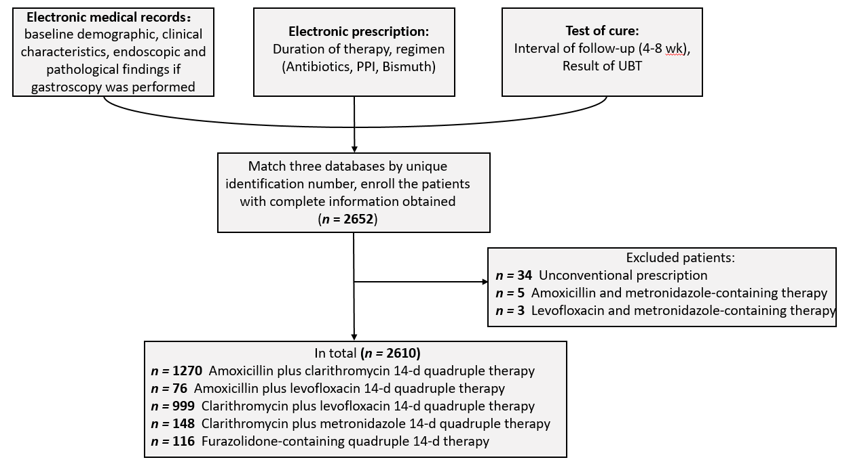
Figure 1 Study flowchart.

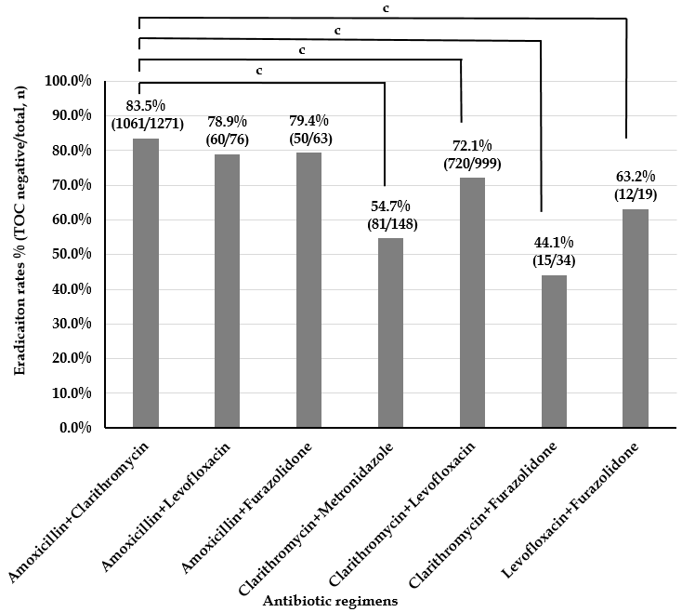
Figure 2 Eradication rates of Helicobacter pylori treatment regimens classified by antibiotic combination. ^{c}P < 0.001 compared with the regimen containing amoxicillin plus clarithromycin.
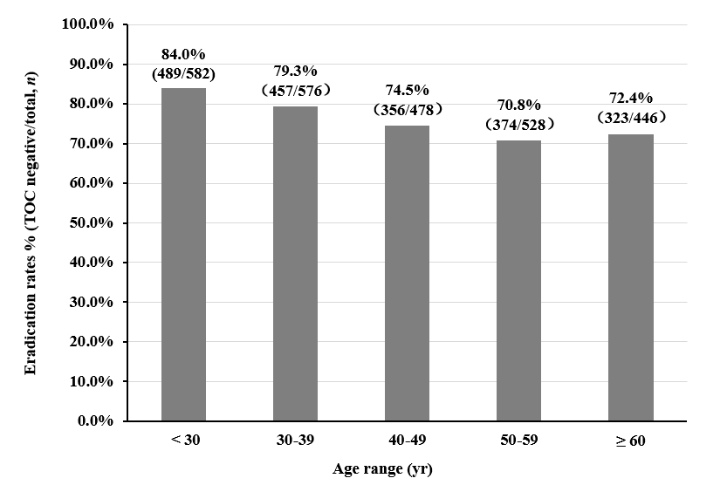
Figure 3 Eradication rates in specific patient age ranges.

Table 1 Demographic and clinical characteristics of patients with Helicobacter pylori infection
Variable | Cases (n) | Percentage
Overall cases | 2610
Gender
Male | 1088 | 41.7%
Female | 1522 | 58.3%
Age, range (yr)
< 30 | 582 | 22.3%
30-40 | 576 | 22.1%
40-50 | 478 | 18.3%
50-60 | 528 | 20.2%
> 60 | 446 | 17.1%
Chief complaint
Upper abdominal pain | 406 | 15.6%
Abdominal distension | 643 | 24.6%
Nausea | 138 | 5.3%
Acid regurgitation or heartburn | 250 | 9.6%
Bitter taste in mouth | 157 | 6.0%
Belching | 224 | 8.6%
Increased stool frequency | 143 | 5.5%
Others | 152 | 5.8%
No symptoms | 1309 | 50.2%
Received gastroscopy | 1390 | 53.3%
Endoscopic and pathological findings
Peptic ulcer | 244 | 9.3%
Pre-neoplastic lesions | 416 | 15.9%
MALT lymphoma or gastric cancer | 17 | 0.7%
Eradication attempts
Primary | 2237 | 85.7%
Rescue | 373 | 14.3%

Table 2 Eradication rates of specific Helicobacter pylori regimens classified by proton pump inhibitor
PPI | Successful eradication (n) |  | Total (n) | Eradication rate (%) | 95%CI (%)
Esomeprazole | 566 | 698 |  | 81.1 | 78.2-84.0
Non-esomeprazole PPIs | 1433 | 1912 |  | 74.9 | 73.0-76.8
Rabeprazole | 657 | 836 |  | 78.6 | 75.8-81.4
Lansoprazole | 43 | 55 |  | 78.2 | 67.3-89.1
Pantoprazole | 449 | 607 |  | 74.0 | 70.5-77.5
Omeprazole | 284 | 414 |  | 68.6 | 64.1-73.1
The following PPI dosages were prescribed: Esomeprazole, 20 mg bid; rabeprazole, 20 mg bid; omeprazole, 20 mg bid; lansoprazole, 30 mg bid; pantoprazole, 40 mg bid. PPI: Proton pump inhibitor.

Table 3 Subgroup comparison of eradication rates
 | Antibiotic regimen | Successful eradication (n) | Total (n) | Eradication rate (%) | 95% CI (%)
Primary | Total | 1751 | 2237 | 78.3 | 76.6-80.0
 | Amoxicillin plus clarithromycin | 980 | 1166 | 84.0 | 81.9-86.1
 | Amoxicillin plus levofloxacin | 47 | 54 | 87.0 | 78.1-96.0
 | Amoxicillin plus furazolidone | 8 | 11 | 72.7 | 46.4-99.0
 | Clarithromycin plus metronidazole | 61 | 112 | 54.5 | 45.2-63.7
 | Clarithromycin plus levofloxacin | 647 | 871 | 74.3 | 71.4-77.2
 | Clarithromycin plus furazolidone | 7 | 20 | 35.0 | 14.1-55.9
 | Levofloxacin plus furazolidone | 1 | 3 | 33.3 | 0.0-86.7
Rescue | Total | 248 | 373 | 66.5 | 61.7-71.3
 | Amoxicillin plus clarithromycin | 81 | 105 | 77.1 | 69.1-85.2
 | Amoxicillin plus levofloxacin | 13 | 22 | 59.1 | 38.5-79.6
 | Amoxicillin plus furazolidone | 42 | 52 | 80.8 | 70.1-91.5
 | Clarithromycin plus metronidazole | 20 | 36 | 55.6 | 39.3-71.8
 | Clarithromycin plus levofloxacin | 73 | 128 | 57.0 | 48.5-65.6
 | Clarithromycin plus furazolidone | 8 | 14 | 57.1 | 31.2-83.1
 | Levofloxacin plus furazolidone | 11 | 16 | 68.8 | 46.0-91.5
The following antibiotic dosages were prescribed: Amoxicillin, 1000 mg bid; clarithromycin, 500 mg bid; levoflaxacin, 500 mg qd or 200 mg bid; furazolidone, 100 mg bid; metronidazole, 200 mg bid, 400 mg bid, or 200 mg tid.

Table 4 Univariate and multivariate analyses of risk factors for eradication failure
Variable |  | Univariate analysis |  |  |  | Multivariate analysis
 |  | OR | 95%CI | P value |  | OR | 95%CI | P value
Gender | Male | 1 (Reference)
 | Female | 1.202 | 0.998-1.447 | 0.052
Age |  | 1.018 | 1.011-1.024 | < 0.001 |  | 1.014 | 1.008-1.021 | < 0.001
Eradication attempts | Primary | 1 (Reference) |  |  |  | 1 (Reference)
 | Rescue | 1.816 | 1.432-2.302 | < 0.001 |  | 1.538 | 1.179-2.007 | 0.002
Antibiotic regimens | Amoxicillin plus clarithromycin | 1 (Reference) |  |  |  | 1 (Reference)
 | Amoxicillin plus levofloxacin | 1.347 | 0.761-2.385 | 0.306 |  | 1.167 | 0.654-2.084 | 0.601
 | Amoxicillin plus furazolidone | 1.314 | 0.701-2.461 | 0.394 |  | 0.982 | 0.505-1.911 | 0.958
 | Clarithromycin plus metronidazole | 4.179 | 2.928-5.966 | < 0.001 |  | 3.139 | 2.125-4.637 | < 0.001
 | Clarithromycin plus levofloxacin | 1.958 | 1.599-2.397 | < 0.001 |  | 1.863 | 1.517-2.287 | < 0.001
 | Clarithromycin plus furazolidone | 6.400 | 3.200-12.797 | < 0.001 |  | 5.748 | 2.834-11.655 | < 0.001
 | Levofloxacin plus furazolidone | 2.947 | 1.147-7.574 | 0.025 |  | 2.115 | 0.798-5.605 | 0.132
PPIs | Esomeprazole | 1 (Reference) |  |  |  | 1 (Reference)
 | Rabeprazole | 1.168 | 0.909-1.502 | 0.225 |  | 1.138 | 0.879-1.473 | 0.327
 | Lansoprazole | 1.197 | 0.614-2.332 | 0.598 |  | 1.262 | 0.638-2.496 | 0.504
 | Pantoprazole | 1.509 | 1.161-1.961 | 0.002 |  | 1.398 | 1.067-1.831 | 0.015
 | Omeprazole | 1.963 | 1.482-2.600 | < 0.001 |  | 1.513 | 1.113-2.056 | 0.008

