We declare that for the present manuscript no grant or fund has been given and used
Maurizio Salvadori MD
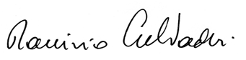
December 10th, 2017

