Name of Journal: World Journal of Gastroenterology

Manuscript NO: 36331
Manuscript Type: ORIGINAL ARTICLE

Basic Study
Fructo-oligosaccharide intensifies stress-induced visceral hypersensitivity and intestinal inflammation in irritable bowel syndrome mouse model

Chen BR et al. Fructo-oligosaccharide in IBS mice

Bin-Rui Chen, Li-Jun Du, Hui-Qin He, John J Kim, Yan Zhao, Ya-Wen Zhang, Liang Luo, Ning Dai

Bin-Rui Chen, Li-Jun Du, Hui-Qin He, Ya-Wen Zhang, Liang Luo, Ning Dai, Department of Gastroenterology, Sir Run Run Shaw Hospital, School of Medicine, Zhejiang University, Hangzhou 310016, Zhejiang Province, China

John J Kim, Yan Zhao, Division of Gastroenterology, Loma Linda University Medical Center, Loma Linda, Ca 92354, United States

ORCID number: Bin-Rui Chen (0000-0002-4535-6516); Li-Jun Du (0000-0002-7783-1959); Hui-Qin He (0000-0002-0333-4933); John J Kim(0000-0003-4341-8661); Yan Zhao(0000-0003-4278-2592); Ya-Wen Zhang (0000-0003-2191-3346); Liang Luo(0000-0002-2630-5828); Ning Dai(0000-0003-0749-9230).

Author contributions: All authors contributed to the design of the study; Chen BR, Du LJ, He HQ, Zhang YW and Luo L performed the experiments; Chen BR and Du LJ analyzed the data; Chen BR, Kim JJ and Zhao Y wrote the paper; Kim JJ and Dai N critically revised the manuscript; All authors have reviewed the manuscript and given advices.

Institutional review board statement: The study was review and approved by Zhejiang University, Animal Institutional Review Board.

Institutional animal care and use committee statement: All procedures involving animals were reviewed and approved by the Institutional Animal Care and Use Committee of Zhejiang University.

Conflict-of-interest statement: The authors declare no conflict of interest related to this study.

Open-Access: This article is an open-access article which was selected by an in-house editor and fully peer-reviewed by external reviewers. It is distributed in accordance with the Creative Commons Attribution Non Commercial (CC BY-NC 4.0) license, which permits others to distribute, remix, adapt, build upon this work non-commercially, and license their derivative works on different terms, provided the original work is properly cited and the use is non-commercial. See: http://creativecommons.org/licenses/by-nc/4.0

Manuscript source: Unsolicited manuscript

Correspondence to: Ning Dai, PhD, Chief Doctor, Full Professor, Department of Gastroenterology, Sir Run Run Shaw Hospital, School of Medicine, Zhejiang University, No. 3 East Qingchun Road, Hangzhou 310016, Zhejiang Province, China. ndaicn@zju.edu.cn

Telephone: +86-571-86044817

Fax: +86-571-86044817

Received: September 28, 2017
Peer-review started: September 28, 2017
First decision: October 17, 2017
Revised: November 14, 2017
Accepted: November 22, 2017
Article in press:
Published online:

Abstract
AIM
To determine whether fructo-oligosaccharide (FOS) affect visceral sensitivity, inflammation, and intestinal short-chain fatty acids (SCFA) production in irritable bowel syndrome (IBS) mouse model.

METHODS
Mice were randomly assigned to daily oral gavage of saline solution with or without FOS (8 g/kg of body weight) for 14 d. Mice were further assigned to receive either daily one-hour water avoidance stress (WAS) or sham-WAS for the first 10 d. After 2 wk, visceral sensitivity was measured by abdominal withdrawal reflex in response to colorectal distension and mucosal inflammation was evaluated. Gas chromatography, reverse transcription, and immunohistochemistry assays were used to quantify cecal concentrations of SCFA, intestinal cytokine expression, and number of intestinal mast cells per high-power field (HPF), respectively.

RESULTS
Mice subjected to WAS exhibited visceral hypersensitivity and low-grade inflammation. Among mice subjected to WAS, FOS increased visceral hypersensitivity and led to higher cecal concentrations of acetic acid (2.49 ± 0.63 mmol/L vs 1.49 ± 0.72 mmol/L, P < 0.05), propionic acid (0.48 ± 0.09 mmol/L vs 0.36 ± 0.05 mmol/L, P < 0.01), butyric acid (0.28 ± 0.09 mmol/L vs 0.19 ± 0.003 mmol/L, P < 0.05), as well as total SCFA (3.62 ± 0.87 mmol/L vs 2.27 ± 0.75 mmol/L, P < 0.01) compared to saline administration. FOS also increased ileal interleukin (IL)-23 mRNA (4.71 ± 4.16 vs 1.00 ± 0.99, P < 0.05) and colonic IL-1β mRNA (2.15 ± 1.68 vs 0.88 ± 0.53, P < 0.05) expressions as well as increased mean mast cell counts in the ileum (12.3 ± 2.6 per HPF vs 8.3 ± 3.6 per HPF, P < 0.05) and colon (6.3 ± 3.2 per HPF vs 3.4 ± 1.2 per HPF, P < 0.05) compared to saline administration in mice subjected to WAS. No difference in visceral sensitivity, intestinal inflammation, and cecal SCFA levels were detected with or without FOS administration in mice subjected to sham-WAS.

CONCUSION
FOS administration intensifies visceral hypersensitivity and gut inflammation in stress induced-IBS mice, but not in the control mice, and is also associated with increased intestinal SCFA production.

Key words: Fructo-oligosaccharide; Stress; Irritable bowel syndrome; Visceral hypersensitivity; Intestinal inflammation; Short chain fatty acids

© The Author(s) 2017. Published by Baishideng Publishing Group Inc. All rights reserved.

Core tip: Fructo-oligosaccharide is a component of fermentable oligosaccharide, disaccharide, monosaccharide, and polyols (FODMAP) which has been associated with triggering symptoms in patients with irritable bowel syndrome (IBS). In a stress-induced IBS mice model, daily fructo-oligosaccharide (FOS) administration further intensified visceral hypersensitivity and low-grade intestinal inflammation compared to saline. FOS administration also led to increased intestinal production of individual and total short-chain fatty acids (SCFA) in mice subjected to stress. However, no difference in visceral sensitivity, intestinal inflammation, and cecal concentrations of SCFA were observed among sham-stressed mice receiving FOS or saline. Our findings suggest a mechanism of FODMAP-induced gastrointestinal symptoms associated with increased production of SCFA specific to IBS.

Chen BR, Du LJ, He HQ, Kim JJ, Zhao Y, Zhang YW, Luo L, Dai N. Fructo-oligosaccharide intensifies stress-induced visceral hypersensitivity and intestinal inflammation in irritable bowel syndrome mouse model. World J Gastroenterol 2017; In press

INTRODUCTION
Irritable bowel syndrome (IBS) is a functional gastrointestinal disorder characterized by chronic abdominal pain associated with changes in bowel habit and frequency affecting more than tenth of the general population^{[1,2]}. Many factors contribute to the development of IBS including altered visceral pain perception, low-grade intestinal inflammation, change in microbiota, and psychosocial factors^{[3]}. The complex pathophysiology of IBS has posed challenges to developing effective interventions, and therapeutic gains with conventional pharmacologic therapies have been marginal at less than 15%^{[4]}.
Importance of dietary factors in triggering symptoms is increasingly being recognized in patients with IBS. Specifically, poorly absorbed, fermentable carbohydrates categorized as Fermentable Oligosaccharide, Disaccharide, Monosaccharide, and Polyols (FODMAP) have been studied closely^{[5]}. Consumption of food content high in FODMAP triggers abdominal pain, bloating, and flatulence in patients with IBS. Furthermore several randomized trials have demonstrated that low FODMAP diet reduces gastrointestinal symptoms in patients with IBS^{[6-9]}. Although largely unexplored, the accumulation of intestinal fluid from osmotic load of poorly digested carbohydrates and excessive colonic gas production associated with ingestion of FODMAP have been proposed as a mechanism for development of gastrointestinal symptoms^{[10,11]}. Intestinal dysmotility, visceral hypersensitivity, altered microbiota, and change in metabolic output also likely contribute to the pathophysiology of gastrointestinal symptoms associated with ingestion of FODMAP in IBS patients^{[11-13]}. In addition, the production of short-chain fatty acids (SCFA), such as acetic, propionic, and butyric acids, may also be important in the development of symptoms in IBS^{[14]}.
Fructo-oligosaccharide (FOS) is one of the most frequently consumed FODMAP components in the general diet. The aim of our study was to investigate the effects of FOS on visceral sensitivity, intestinal SCFA production, and intestinal inflammation in stress-induced IBS mouse model. Water avoidance stress (WAS) was utilized to simulate psychological stress in IBS, and WAS mouse model was used to evaluate the effects of FOS administration on visceral hypersensitivity and intestinal immune activation^{[15]}. Individual (acetic, propionic, and butyric acids) as well as total SCFA concentrations were also quantified in the cecum to determine the effects of FOS administration in stress-induced IBS mouse model.

MATERIALS AND METHODS
Animal
Three week-old female C57BL/6 mice (Slac Laboratory Animal Co. Ltd. Shanghai, China) were used as described in previous studies using WAS to develop stress-induced IBS mouse model^{[16]}. Mice were housed in pathogen-free conditions with temperature (21 ± 1 ˚C) and light/dark cycle (12/12 h) regulation. Purified rodent diet (AIN-76A) without any FODMAP content and demineralized water were supplied freely on demand.

Animal care and use statement
All animal experiment protocol was reviewed and approved by the Animal Care and Use Committee of Zhejiang University prior to initiating this study. All animals received humane care in compliance with the criterions in “The Guide for the Care and Use of Laboratory Animals.”

Experimental design
To evaluate the effects of FOS on WAS induced-visceral hypersensitivity and intestinal inflammation, thirty-two mice were randomly divided into four groups of eight mice (sham-WAS+saline administration, sham-WAS+FOS administration, WAS+saline administration, and WAS+FOS administration). Mice were administered daily with oral gavage of saline solution with or without FOS (8 g/kg body weight) for 14 d. FOS dose was derived according to Meeh-Rubner formula^{[8]}. Mice were subjected to either WAS or sham-WAS during the first 10 d. For WAS, mice were placed on a glass platform (3 cm length×3 cm width×9 cm height) surrounded by water (25 °C) in the middle of a plastic container (45 cm×30 cm×25 cm) as previously described^{[15]}. Control mice assigned to sham-WAS were placed in the same container without water. Food consumption quantity, body weight, and index were recorded daily prior to subjecting mice to daily WAS or sham-WAS.

Assessment of visceral sensitivity
Abdominal withdrawal reflex in response to colorectal distension was evaluated to assess visceral sensitivity as described previously^{[17]}. Semi-quantitative abdominal withdrawal reflex score (0-4) was utilized to evaluate pain responses at different magnitudes of colorectal distention (20, 40, 60, and 80 mmHg)^{[18]}. With gradual colorectal distention to 100 mmHg, the pressure that eliciting abdomen lifting was recorded as pain thresholds and eliciting body arching was recorded as volume thresholds. To achieve accuracy, each pressure and threshold measurements were repeated three times and recorded by two independent operators blinded to WAS or FOS assignment.

Histological evaluation of inflammation
Mice were sacrificed by cervical dislocation, and intestines were harvested for histological evaluation. Intestinal issue was fixed in formalin and processed with hematoxylin and eosin stains. The absence or presence of neutrophil infiltration in the lamina propria and the degree of interstitial edema in the intestines were graded based on previously description^{[18]}. Stained slides were examined by two independent observers blinded to WAS or FOS assignment.

Quantification of SCFA production
SCFA production was quantified by using gas chromatography as previously described^{[19]}. 50 mg of cecal contents was homogenized in 0.5 mL of distilled water and 0.1 mL of 25% (w/v) metaphosphoric acid was added to the suspension. The samples were subsequently centrifuged at 14000g for 20 min, and the supernatant was filtered through a membrane filter (pore size 0.22 μm). SCFA in the samples were then separated with InertCap FFAP columns (0.25 mm×30 mm×0.25 mm), and the peaks were integrated with GC Solution software (Shimadzu, GC-2010 Plus, Japan). Single-point internal standard method was used to quantify SCFA.

Intestinal cytokine mRNA detection
Intestinal cytokines expression such as TNF-α, interleukin (IL)-6, IL-23, IL-10 and IL-1β were detected. Total RNA was isolated from 100mg sample of ileal and colonic tissues by using RNA Extraction Kit (Takara, Japan) and processed with PrimeScript™RT reagent Kit (Takara, Japan) to synthesize cDNA. Primers are listed in Table 1. Quantitative real-time PCR was performed in triplicate for each sample with Lightcycler 480 instrument (Roche Applied Science, Penzberg, Germany). Reaction conditions for amplification of DNA were as follows: 95 °C for 30 s, 40 cycles at 95 °C for 5 s, and 60 °C for 30 s. Cytokine transcript levels were normalized with β-actin, and relative gene expression was expressed as the fold change (2^{-ΔΔCt}) relative to the expression in the control samples.

Immunohistochemistry
Intestinal mucosal mast cells were estimated by immunohistochemistry. After incubating in xylene to dewax and in ethanol to rehydrate, tissue section was incubated with 0.3% hydrogen peroxide in methanol to block endogenous peroxidase activity followed by visualizing antigen with heat-mediation. After blocking slides with 3% goat serum at room temperature for 20 min to prevent nonspecific staining, the section was treated with mouse anti-mast cell tryptase antibody (1:20000, Abcam, Cambridge, United Kingdom) for one hour at room temperature. After washing, the section was treated with HRP-labeled goat anti-mouse IgG (Zhongshan Gold Bridge, Beijing, China) for 30 min. Diaminobenzidine (DAB kit, Zhongshan Gold Bridge, Beijing, China) and hematoxylin staining were used to visualize the reaction. Four to five non-overlapping fields were randomly selected. The number of mucosal mast cell were counted under a light microscope (400X magnification, Leica Company, Wetzlal, Germany) by two independent observers and expressed as cells per high power field.

Statistical analysis
Data were presented as mean ± SD or median with 5th and 95th percentiles. Differences between two groups were determined by Students’ t-test for normal distribution or Wilcoxon two-sample otherwise. Comparisons among three or more groups were performed by one-way ANOVA for normal distribution or Kruskal–Wallis one-way ANOVA for abnormality distribution. Rate of weight gain was analyzed using repeated measures analysis of variance (ANOVA) using the factors of WAS administration and time. Statistical analysis was conducted by using SPSS (IBM, Armonk, NY, United States; version 22 ) and Graphpad Prism (GraphPad Sofware, San Diego, CA, United States; version 6.0) Two-tailed value of P < 0.05 was considered statistically significant. The statistical methods of this study were reviewed by Professor Yunxian Yu from Department of Epidemiology and Health Statistics of Zhejiang University.

RESULTS
WAS-induced visceral hypersensitivity in IBS mouse model
Of the 32 randomized mice, five (sham-WAS+saline group in one, sham-WAS+FOS group in one, WAS+saline group in two, WAS+FOS group in one) died due to gavage trauma and were excluded from the outcome analysis.
During the first 10 d, mice receiving WAS had lower rate of weight gain compared to mice receiving sham-WAS (Figure 1A). No difference in quantity of consumed feed were observed between mice receiving WAS or sham-WAS. Mice subjected to WAS had higher mean abdominal withdrawal reflex scores at 20, 40, 60, and 80 mmHg pressure of colorectal distention compared to mice subjected to sham-WAS (Figure 1B). Furthermore, mice subjected to WAS had lower pain and volume thresholds compared to mice subjected to sham-WAS (Figure 1C, 1D).

FOS intensified WAS-induced visceral hypersensitivity
Among mice subjected to WAS, mice that received FOS administration for 14 d had higher mean abdominal withdrawal reflex scores at 20 mmHg pressure of colorectal distention compared to those that received saline administration (Figure 2A). Furthermore, mice that received FOS administration had lower pain and volume thresholds compared with those that received saline administration following WAS (Figure 2B, 2C). However, no difference in mean abdominal withdrawal reflex scores, pain thresholds, and volume thresholds were observed between mice administered with FOS or saline following sham-WAS.

FOS had no effect on intestinal histological scores
No difference in neutrophil counts or degree of interstitial edema in the lamina propria were observed between WAS and sham-WAS groups (Figure 3A, 3C). Furthermore, no difference in histologic score was observed among all four groups (sham-WAS+saline, sham-WAS+FOS, WAS+saline, WAS+FOS) at 14 d of the experiment (Figure 3B, 3D).

FOS increased cecal SCFA concentrations following WAS
No difference in levels of SCFA in the cecum was found between mice subjected to WAS and sham-WAS receiving saline administration. Among mice subjected to WAS, mice administered with FOS had higher mean concentrations of acetic acid (2.49 ± 0.63 mmol/L vs 1.49 ± 0.72 mmol/L, P < 0.01, one-way ANOVA), propionic acid (0.48 ± 0.09 mmol/L vs 0.36 ± 0.05 mmol/L, P < 0.01, one-way ANOVA), butyric acid (0.28 ± 0.09 mmol/L vs 0.19 ± 0.003 mmol/L, P < 0.05, one-way ANOVA) and total SCFA (3.62 ± 0.87 mmol/L vs 2.27 ± 0.75 mmol/L, P < 0.01, one-way ANOVA) measured in the cecum compared to the mice administered with saline for 14 d (Figure 4). However, among mice subjected to sham-WAS, no difference in concentrations of individual or total SCFA were found between those administered with FOS or saline for 14 d.

FOS-mediated intestinal cytokine expression following WAS
Mice subjected to WAS had higher expressions of IL-6 (8.25 ± 3.95 vs 1.86 ± 1.66, P < 0.01, one-way ANOVA) and TNF-α (2.05 ± 1.73 vs 0.56 ± 0.28, P < 0.05, one-way ANOVA) mRNA in the ileal specimen, as well as, higher IL-6 (1.60 ± 1.10 vs 0.46 ± 0.29, P < 0.05, one-way ANOVA) and IL-1β (0.88 ± 0.53 vs 0.34 ± 0.35, P < 0.05, one-way ANOVA) mRNA expression in the colonic specimen compared to those that received sham-WAS (Figure 5). Among mice subjected to WAS, mice administered with FOS for 14 days had higher expressions of IL-23 mRNA (4.71 ± 4.16 vs 1.00 ± 0.99, P < 0.05, one-way ANOVA) in the ileum and IL-1β mRNA (2.15 ± 1.68 vs 0.88 ± 0.53, P < 0.05, one-way ANOVA) in the colon compared to the mice administered with saline. However, among mice subjected to sham-WAS, no difference in IL-6, IL-23, TNF-α, IL-10, or IL-1β mRNA expression in the ileum or colon were found between mice administered with FOS or saline for 14 days.

FOS increased the mucosal mast cell counts following WAS
Mice subjected to WAS had higher mean mast cell counts in the ileum (8.3 ± 3.6 per HPF vs 4.9 ± 1.4 per HPF, P < 0.05, one-way ANOVA) and colon (3.4 ± 1.2 per HPF vs 1.8 ± 1.5 per HPF, P < 0.05, one-way ANOVA) compared to those subjected to sham-WAS (Figure 6). Among mice subjected to WAS, mice administered with FOS for 14 d had greater mast cell infiltration in the ileum (12.3 ± 2.6 per HPF vs 8.3 ± 3.6 per HPF, P < 0.05, one-way ANOVA) and colon (6.3 ± 3.2 per HPF vs 3.4 ± 1.2 per HPF, P < 0.05, one-way ANOVA) compared to mice administered with saline. However, among mice subjected to sham-WAS, no difference in mast cell infiltration in the ileum or colon was observed between mice administered with FOS or saline for 14 d.

DISCUSSION
We evaluated the effects of high-dose FOS administration, a component of FODMAP, on visceral sensitivity and gut inflammation using a stress-induced IBS mouse model. Mice subjected to WAS exhibited visceral hypersensitivity and low-grade inflammation demonstrated by higher mucosal expressions of pro-inflammatory cytokines and increased number of intestinal mast cells. Among mice subjected to WAS, FOS administration further intensified visceral hypersensitivity and also led to a higher intestinal expression of IL-23 and IL-1β with increasing mucosal mast cell counts. Furthermore, FOS administration in mice subjected to WAS led to higher intestinal production of individual (acetic, propionic, and butyric acids) as well as total SCFA. However, FOS administration did not affect visceral sensitivity, intestinal inflammation, or intestinal SCFA production in control mice.
The role of psychological stress on altered brain-gut axis as inciting and/or exacerbating factor is central to the pathophysiology of IBS. In our study, mice subjected to WAS demonstrated visceral hypersensitivity and low-grade immune activation, characterized by increased expression of pro-inflammatory cytokines and mucosal mast cells infiltration yet without overt difference in intestinal histological scores compared to the control mice. These findings are consistent with prior studies that demonstrated the effects of stress on visceral hypersensitivity and intestinal immune activation in rodents^{[15,20]}. Therefore, WAS IBS-mouse model was used to study the effects on FOS administration on visceral sensitivity and mucosal inflammation typical in IBS.
Although the role of food intolerance-induced IBS symptoms has been long recognized, correlations with a specific food group have been difficult to demonstrate^{[21,22]}. A key observation in our study is that FOS consumption further intensified visceral hypersensitivity already present in mice subjected to WAS. These results are consistent with the clinical studies that demonstrate adverse effects of high FODMAP diet as an individual component or as an aggregate on exacerbating gastrointestinal symptoms in IBS^{[6,8,23,24]}. Along the same vein, our findings are concordant with studies that demonstrate the efficacy of dietary restriction of FODMAP on improving gastrointestinal symptoms, such as abdominal pain, diarrhea, bloating, flatulence, and quality of life in IBS patients^{[7,9,25]}. Interestingly, FOS had no effect on visceral sensation on mice exposed to sham-WAS. Prior studies also demonstrated that high FODAMP diet induced gastrointestinal symptoms in IBS patients but not in health volunteers except increased flatus^{[6,8]}. Our findings highlight the direct effects of FODMAP on visceral hypersensitivity as a mechanism of FODMAP-induced IBS symptoms other than proposed mechanisms such as osmotic effects of poorly absorbed carbohydrates and increased colonic gas production from intestinal fermentation. A recent study indicated that hypersensitivity to colorectal distension, rather than excessive gas fermented by FODMAP, was the primarily factor contributing to IBS symptoms^{[26]}. Our findings that FOS consumption increased visceral hypersensitivity in IBS-mouse model, but not in control mice, suggests that stress-induced visceral hyperalgesia is a prerequisite for FODMAP-induced visceral hypersensitivity. Similarly, anxiety was a robust predictor of inducing abdominal symptoms after lactose ingestion, another FODMAP component, in a previous study among patients with IBS^{[27]}.
SCFA are byproducts of FODMAP fermentation. For example, IBS patients on low FODMAP diet have altered fecal fermentation producing lower levels of stool SCFA including acetic acid and butyric acid^{[28-30]}. Our study showed that high-dose FOS administration increased production of individual (acetic, propionic, and butyric acids) and total SCFA which was also associated with increased visceral hypersensitivity and intestinal inflammation already present in IBS-mouse model. Although inconsistent effects, SCFA clearly play a role in the regulation of visceral pain and intestinal immune activation. For example, butyric acid reduced visceral pain in humans, but induced visceral hypersensitivity in rats^{[31]}. Intracolonic infusion of 0.5% acetic acid developed visceral hypersensitivity in rats^{[32]}. In addition, SCFA also as pro-inflammatory substrates may induce immune responses^{[33]}, but in others cases, exert anti-inflammatory properties^{[34]}. SCFA inhibited regulatory T cell differentiation and suppressed IL-10 expression in IBS^{[35]}. However, butyric acid exacerbated dextran sodium sulfate (DSS)-induced colitis in a murine model and increased IL-23 production by stimulating dendritic cells^{[36]}.
Interestingly, administration of FOS in control mice did not increase the levels of individual or total SCFA production, highlighting the difference in fermentation of FOS between stressed and sham-stressed conditions. Stress-induced alteration in microbiota may lead to the change of fermentation products^{[16]}. Alternatively, stress-induced release of corticotropin-releasing hormone may accelerate intestinal transit, reducing absorption of SCFA^{[37]}. However, SCFA production was comparable between mice subjected to WAS or sham-WAS in the absence of FOS administration. Although studies have generally reported higher stool concentrations of SCFA in IBS patients, some have demonstrated similar SCFA levels in IBS and non-IBS patients, likely explained by lack of rigorous control of dietary factors^{[14,38,39]}. In our study, feed void of FODMAP content as an essential substrate for SCFA may account for the lack of difference in SCFA production between WAS and sham-WAS group despite possible difference in fermentation capacity of the two groups.
In our study, FOS administration in mice subjected to WAS was associated with low-grade inflammation, consist with prior studies in IBS. FOS administration increased expression of pro-inflammatory cytokines, such as IL-23 in the ileum and IL-1β in the colon, following WAS. Specifically, IL-23 is important in regulating intestinal inflammation by activating lymphocytes, as well as, inducing and promoting release of other inflammatory mediators. Although FOS administration exerted anti-inflammatory effects in some studies^{[40]}, others have also demonstrated that FOS administration induced pro-inflammatory cytokine profile, including elevated IL-10 and a reduction in IL-6, typically observed in active Crohn's disease^{[41]}. Given the pivotal role of low-grade mucosal inflammation as a trigger of IBS symptom^{[42-44]}, the increased pro-inflammatory cytokines may have played a role in worsening visceral hypersensitivity in FOS administered mice following WAS. In addition to increased production of pro-inflammatory cytokines, mice subjected to WAS had further increased mucosal mast infiltration with FOS. Our findings are in line with a study that demonstrated an eight-fold reduction of urinary histamine, a measure of mast cells activation, among IBS patients receiving low compared to high FODMAP diet^{[45]}. Mast cells play an important role in mucosal immune activation in IBS by releasing a variety of pro-inflammatory mediators^{[46]}. For example, mast cells released-tryptase can activate protease-activated receptor-2 which is important in inducing visceral hypersensitivity^{[47]}. In addition to mucosal mast cell activation by WAS, FOS-induced SCFA production may also contribute to further recruitment of mucosal mast cells and secretion of histamine^{[48,49]}.
Our study has limitations. First, FOS is only one component of FODMAP that was studied, and effects of the other FODMAP components on visceral hypersensitivity and immune activation are unknown. Second, although our studies demonstrate the effects of FOS on stress-induced visceral hypersensitivity and intestinal inflammation, detailed mechanism was beyond the scope of the study and will be invaluable in future studies. Finally, although the WAS-induced mouse model exhibited visceral hypersensitivity and low-grade inflammation, experimental models are not able to fully encompass the complex biopsychosocial components of IBS, and our findings should be interpreted with caution.
In conclusion, administration of FOS, a component of FODMAP, intensified visceral hypersensitivity and gut inflammation in stressed induced-IBS mice, but not in control mice. A parallel increased production of intestinal SCFA was also observed with FOS administration in IBS mice but not in control mice. Our findings suggest a mechanism of FODMAP-induced gastrointestinal symptoms specific to IBS.

ARTICLE HIGHLIGHTS
Research background
The impact of dietary factors on exacerbating symptoms of irritable bowel syndrome (IBS) is being increasingly recognized. Specifically, abdominal pain following the consumption of fermentable oligosaccharides, disaccharides, monosaccharides and polyols (FODMAP) diet is common, and dietary restriction of FODMAP improves symptoms of IBS.

Research motivation
Although osmotic effects of poorly absorbed carbohydrates and increased colonic gas production from intestinal fermentation are proposed, evidence providing specific mechanism of FODMAP-induced IBS symptoms is sparse. With wide acceptance of low-FODMAP diet as treatment for IBS, clarifying the specific mechanism is important for optimal application in clinical practice.

Research objectives
The aim of the study was to explore the effects of high-dose fructo-oligosaccharides (FOS), a component of FODMAP, on visceral sensitivity, inflammation, and intestinal short-chain fatty acids (SCFA) production using an IBS mouse model. FOS administration intensified visceral hypersensitivity and gut inflammation already present in the stress induced-IBS mice, but not in the control mice, and was also associated with increased cecal SCFA production. The results provide a biologic framework for FODMAP-induced IBS symptoms that supports the application of low FODMAP therapy in clinical practice.

Research methods
The effects of FOS on visceral sensitivity, SCFA production, and intestinal inflammation were examined by using a water avoidance stress (WAS)-induced IBS mouse model. Mice were randomly assigned to receive daily WAS or sham-WAS for 10 d while receiving daily oral gavage of saline solution with or without high-dose FOS. After 2 wk, visceral sensitivity was measured by abdominal withdrawal reflex in response to colorectal distension and mucosal inflammation was measure by histologic analyses. Furthermore, intestinal SCFA production, cytokine expression, and mast cell counts were evaluated.

Research results
FOS administration intensified visceral hypersensitivity, increased mucosal mast cell counts, and mediated intestinal cytokine expression in stressed induced-IBS mice, but not in the control mice. A parallel increase in cecal SCFA levels was also observed with FOS administration in IBS mice but not in the control mice. These findings suggest that visceral hypersensitivity and gut inflammation intensified by FODMAP diet may lead to worsening IBS symptoms. Examining the effects of other FODMAP components other than FOS on visceral hypersensitivity and immune activation, as well as, detailed molecular mechanism may be invaluable in future studies.

Research conclusions
Administration of high-dose FOS, a component of FODMAP, intensified visceral sensitivity and intestinal inflammation in stress-induced IBS mouse model which was also associated with increased production of SCFA. These findings suggest a mechanism of FODMAP-induced gastrointestinal symptoms specific to IBS and are consistent with clinical studies that demonstrate efficacy of low-FODMAP diet in treatment of individuals with IBS.

Research perspectives
The importance of dietary factors in triggering symptoms is increasingly being recognized in patients with IBS. FOS administration intensifies visceral hypersensitivity and gut inflammation in stress induced-IBS mice, and is also associated with increased intestinal SCFA production.

ACKNOWLEDGMENTS
We are grateful to Xin Wang, Ye-Shi Yin, Zheng-peng Li, Jing-gang Chen from Zhejiang Academy of Agricultural Sciences Institute for their guidance on the experiments. We would also like to thank Professor Yun-xian Yu from Zhejiang University for reviewing the statistical methods of this study.

REFERENCES
1 Rodríguez-Fandiño O, Hernández-Ruiz J, Schmulson M. From cytokines to toll-like receptors and beyond - current knowledge and future research needs in irritable bowel syndrome. J Neurogastroenterol Motil 2010; 16: 363-373 [PMID: 21103418 DOI: 10.5056/jnm.2010.16.4.363]
2 Lovell RM, Ford AC. Global prevalence of and risk factors for irritable bowel syndrome: a meta-analysis. Clin Gastroenterol Hepatol 2012; 10: 712-721.e4 [PMID: 22426087 DOI: 10.1016/j.cgh.2012.02.029]
3 Takahashi T, Nakade Y, Fukuda H, Tsukamoto K, Mantyh C, Pappas TN. Daily intake of high dietary fiber slows accelerated colonic transit induced by restrain stress in rats. Dig Dis Sci 2008; 53: 1271-1277 [PMID: 18335315 DOI: 10.1007/s10620-008-0228-8]
4 Jailwala J, Imperiale TF, Kroenke K. Pharmacologic treatment of the irritable bowel syndrome: a systematic review of randomized, controlled trials. Ann Intern Med 2000; 133: 136-147 [PMID: 10896640]
5 Tuck CJ, Muir JG, Barrett JS, Gibson PR. Fermentable oligosaccharides, disaccharides, monosaccharides and polyols: role in irritable bowel syndrome. Expert Rev Gastroenterol Hepatol 2014; 8: 819-834 [PMID: 24830318 DOI: 10.1586/17474124.2014.917956]
6 Shepherd SJ, Parker FC, Muir JG, Gibson PR. Dietary triggers of abdominal symptoms in patients with irritable bowel syndrome: randomized placebo-controlled evidence. Clin Gastroenterol Hepatol 2008; 6: 765-771 [PMID: 18456565 DOI: 10.1016/j.cgh.2008.02.058]
7 Böhn L, Störsrud S, Liljebo T, Collin L, Lindfors P, Törnblom H, Simrén M. Diet low in FODMAPs reduces symptoms of irritable bowel syndrome as well as traditional dietary advice: a randomized controlled trial. Gastroenterology 2015; 149: 1399-1407.e2 [PMID: 26255043 DOI: 10.1053/j.gastro.2015.07.054]
8 Ong DK, Mitchell SB, Barrett JS, Shepherd SJ, Irving PM, Biesiekierski JR, Smith S, Gibson PR, Muir JG. Manipulation of dietary short chain carbohydrates alters the pattern of gas production and genesis of symptoms in irritable bowel syndrome. J Gastroenterol Hepatol 2010; 25: 1366-1373 [PMID: 20659225 DOI: 10.1111/j.1440-1746.2010.06370.x]
9 Halmos EP, Power VA, Shepherd SJ, Gibson PR, Muir JG. A diet low in FODMAPs reduces symptoms of irritable bowel syndrome. Gastroenterology 2014; 146: 67-75.e5 [PMID: 24076059 DOI: 10.1053/j.gastro.2013.09.046]
10 Barrett JS, Gearry RB, Muir JG, Irving PM, Rose R, Rosella O, Haines ML, Shepherd SJ, Gibson PR. Dietary poorly absorbed, short-chain carbohydrates increase delivery of water and fermentable substrates to the proximal colon. Aliment Pharmacol Ther 2010; 31: 874-882 [PMID: 20102355 DOI: 10.1111/j.1365-2036.2010.04237.x]
11 Staudacher HM, Whelan K. The low FODMAP diet: recent advances in understanding its mechanisms and efficacy in IBS. Gut 2017; 66: 1517-1527 [PMID: 28592442 DOI: 10.1136/gutjnl-2017-313750]
12 Salvioli B, Serra J, Azpiroz F, Malagelada JR. Impaired small bowel gas propulsion in patients with bloating during intestinal lipid infusion. Am J Gastroenterol 2006; 101: 1853-1857 [PMID: 16817837 DOI: 10.1111/j.1572-0241.2006.00702.x]
13 Serra J, Villoria A, Azpiroz F, Lobo B, Santos J, Accarino A, Malagelada JR. Impaired intestinal gas propulsion in manometrically proven dysmotility and in irritable bowel syndrome. Neurogastroenterol Motil 2010; 22: 401-406, e91-e92 [PMID: 20047636 DOI: 10.1111/j.1365-2982.2009.01447.x]
14 Tana C, Umesaki Y, Imaoka A, Handa T, Kanazawa M, Fukudo S. Altered profiles of intestinal microbiota and organic acids may be the origin of symptoms in irritable bowel syndrome. Neurogastroenterol Motil 2010; 22: 512-519, e114-e115 [PMID: 19903265 DOI: 10.1111/j.1365-2982.2009.01427.x]
15 Bradesi S, Schwetz I, Ennes HS, Lamy CM, Ohning G, Fanselow M, Pothoulakis C, McRoberts JA, Mayer EA. Repeated exposure to water avoidance stress in rats: a new model for sustained visceral hyperalgesia. Am J Physiol Gastrointest Liver Physiol 2005; 289: G42-G53 [PMID: 15746211 DOI: 10.1152/ajpgi.00500.2004]
16 Sun Y, Zhang M, Chen CC, Gillilland M 3rd, Sun X, El-Zaatari M, Huffnagle GB, Young VB, Zhang J, Hong SC, Chang YM, Gumucio DL, Owyang C, Kao JY. Stress-induced corticotropin-releasing hormone-mediated NLRP6 inflammasome inhibition and transmissible enteritis in mice. Gastroenterology 2013; 144: 1478-1487, 1487.e1-1487.e8 [PMID: 23470617 DOI: 10.1053/j.gastro.2013.02.038]
17 Jones RC 3rd, Otsuka E, Wagstrom E, Jensen CS, Price MP, Gebhart GF. Short-term sensitization of colon mechanoreceptors is associated with long-term hypersensitivity to colon distention in the mouse. Gastroenterology 2007; 133: 184-194 [PMID: 17553498 DOI: 10.1053/j.gastro.2007.04.042]
18 Al–Chaer ED, Kawasaki M, Pasricha PJ. A new model of chronic visceral hypersensitivity in adult rats induced by colon irritation during postnatal development. Gastroenterology 2000; 119: 1276-1285 [DOI: 10.1053/gast.2000.19576]
19 Bai S, Chen H, Zhu L, Liu W, Yu HD, Wang X, Yin Y. Comparative study on the in vitro effects of Pseudomonas aeruginosa and seaweed alginates on human gut microbiota. PLoS One 2017; 12: e0171576 [PMID: 28170428 DOI: 10.1371/journal.pone.0171576]
20 Xu D, Gao J, Gillilland M 3rd, Wu X, Song I, Kao JY, Owyang C. Rifaximin alters intestinal bacteria and prevents stress-induced gut inflammation and visceral hyperalgesia in rats. Gastroenterology 2014; 146: 484-96.e4 [PMID: 24161699 DOI: 10.1053/j.gastro.2013.10.026]
21 Soares RL, Figueiredo HN, Santos JM, Oliveira RF, Godoy RL, Mendonca FA. Discrepancies between the responses to skin prick test to food and respiratory antigens in two subtypes of patients with irritable bowel syndrome. World J Gastroenterol 2008; 14: 3044-3048 [PMID: 18494056 doi: 10.3748/wjg.14.3044]
22 Soares RL, Figueiredo HN, Maneschy CP, Rocha VR, Santos JM. Correlation between symptoms of the irritable bowel syndrome and the response to the food extract skin prick test. Braz J Med Biol Res 2004; 37: 659-662 [PMID: 15107926]
23 Evans PR, Piesse C, Bak YT, Kellow JE. Fructose-sorbitol malabsorption and symptom provocation in irritable bowel syndrome: relationship to enteric hypersensitivity and dysmotility. Scand J Gastroenterol 1998; 33: 1158-1163 [PMID: 9867093]
24 Goldstein R, Braverman D, Stankiewicz H. Carbohydrate malabsorption and the effect of dietary restriction on symptoms of irritable bowel syndrome and functional bowel complaints. Isr Med Assoc J 2000; 2: 583-587 [PMID: 10979349]
25 Eswaran SL, Chey WD, Han-Markey T, Ball S, Jackson K. A Randomized Controlled Trial Comparing the Low FODMAP Diet vs. Modified NICE Guidelines in US Adults with IBS-D. Am J Gastroenterol 2016; 111: 1824-1832 [PMID: 27725652 DOI: 10.1038/ajg.2016.434]
26 Major G, Pritchard S, Murray K, Alappadan JP, Hoad CL, Marciani L, Gowland P, Spiller R. Colon Hypersensitivity to Distension, Rather Than Excessive Gas Production, Produces Carbohydrate-Related Symptoms in Individuals With Irritable Bowel Syndrome. Gastroenterology 2017; 152: 124-133.e2 [PMID: 27746233 DOI: 10.1053/j.gastro.2016.09.062]
27 Yang J, Fox M, Cong Y, Chu H, Zheng X, Long Y, Fried M, Dai N. Lactose intolerance in irritable bowel syndrome patients with diarrhoea: the roles of anxiety, activation of the innate mucosal immune system and visceral sensitivity. Aliment Pharmacol Ther 2014; 39: 302-311 [PMID: 24308871 DOI: 10.1111/apt.12582]
28 Hustoft TN, Hausken T, Ystad SO, Valeur J, Brokstad K, Hatlebakk JG, Lied GA. Effects of varying dietary content of fermentable short-chain carbohydrates on symptoms, fecal microenvironment, and cytokine profiles in patients with irritable bowel syndrome. Neurogastroenterol Motil 2017; 29: [PMID: 27747984 DOI: 10.1111/nmo.12969]
29 Staudacher H, Lomer MC, Lindsay JO, Irving PM, Whelan K. The impact of low FODMAP dietary advice and probiotics on symptoms in irritable bowel syndrome: A randomised, placebo-controlled, 2 × 2 factorial trial. Gut 2015; 64: A51
30 Valeur J, Røseth AG, Knudsen T, Malmstrøm GH, Fiennes JT, Midtvedt T, Berstad A. Fecal Fermentation in Irritable Bowel Syndrome: Influence of Dietary Restriction of Fermentable Oligosaccharides, Disaccharides, Monosaccharides and Polyols. Digestion 2016; 94: 50-56 [PMID: 27487397 DOI: 10.1159/000448280]
31 Kannampalli P, Shaker R, Sengupta JN. Colonic butyrate- algesic or analgesic? Neurogastroenterol Motil 2011; 23: 975-979 [PMID: 21981302 DOI: 10.1111/j.1365-2982.2011.01775.x]
32 Winston J, Shenoy M, Medley D, Naniwadekar A, Pasricha PJ. The vanilloid receptor initiates and maintains colonic hypersensitivity induced by neonatal colon irritation in rats. Gastroenterology 2007; 132: 615-627 [PMID: 17258716 DOI: 10.1053/j.gastro.2006.11.014]
33 Kim MH, Kang SG, Park JH, Yanagisawa M, Kim CH. Short-chain fatty acids activate GPR41 and GPR43 on intestinal epithelial cells to promote inflammatory responses in mice. Gastroenterology 2013; 145: 396-406.e1-10 [PMID: 23665276 DOI: 10.1053/j.gastro.2013.04.056]
34 Singh N, Gurav A, Sivaprakasam S, Brady E, Padia R, Shi H, Thangaraju M, Prasad PD, Manicassamy S, Munn DH, Lee JR, Offermanns S, Ganapathy V. Activation of Gpr109a, receptor for niacin and the commensal metabolite butyrate, suppresses colonic inflammation and carcinogenesis. Immunity 2014; 40: 128-139 [PMID: 24412617 DOI: 10.1016/j.immuni.2013.12.007]
35 Xu WL, Lu G, Liang SJ, Wu XL, Pei LX, Geng H, Ning HX, Sun JH. Short chain fatty acids mediated flora-host interaction and irritable bowel syndrome. Shijie Huaren Xiaohua Zazhi 2015; 23: 5815 [DOI: 10.11569/wcjd.v23.i36.5815]
36 Berndt BE, Zhang M, Owyang SY, Cole TS, Wang TW, Luther J, Veniaminova NA, Merchant JL, Chen CC, Huffnagle GB, Kao JY. Butyrate increases IL-23 production by stimulated dendritic cells. Am J Physiol Gastrointest Liver Physiol 2012; 303: G1384-G1392 [PMID: 23086919 DOI: 10.1152/ajpgi.00540.2011]
37 Murray KA, Lam C, Rehman S, Marciani L, Costigan C, Hoad CL, Lingaya MR, Banwait R, Bawden SJ, Gowland PA, Spiller RC. Corticotropin-releasing factor increases ascending colon volume after a fructose test meal in healthy humans: a randomized controlled trial. Am J Clin Nutr 2016; 103: 1318-1326 [PMID: 27099247 DOI: 10.3945/ajcn.115.125047]
38 Ringel-Kulka T, Choi CH, Temas D, Kim A, Maier DM, Scott K, Galanko JA, Ringel Y. Altered Colonic Bacterial Fermentation as a Potential Pathophysiological Factor in Irritable Bowel Syndrome. Am J Gastroenterol 2015; 110: 1339-1346 [PMID: 26303129 DOI: 10.1038/ajg.2015.220]
39 Farup PG, Rudi K, Hestad K. Faecal short-chain fatty acids - a diagnostic biomarker for irritable bowel syndrome? BMC Gastroenterol 2016; 16: 51 [PMID: 27121286 DOI: 10.1186/s12876-016-0446-z]
40 Lindsay JO, Whelan K, Stagg AJ, Gobin P, Al-Hassi HO, Rayment N, Kamm MA, Knight SC, Forbes A. Clinical, microbiological, and immunological effects of fructo-oligosaccharide in patients with Crohn's disease. Gut 2006; 55: 348-355 [PMID: 16162680 DOI: 10.1136/gut.2005.074971]
41 Benjamin JL, Hedin CR, Koutsoumpas A, Ng SC, McCarthy NE, Hart AL, Kamm MA, Sanderson JD, Knight SC, Forbes A, Stagg AJ, Whelan K, Lindsay JO. Randomised, double-blind, placebo-controlled trial of fructo-oligosaccharides in active Crohn's disease. Gut 2011; 60: 923-929 [PMID: 21262918 DOI: 10.1136/gut.2010.232025]
42 Vázquez-Frias R, Gutiérrez-Reyes G, Urbán-Reyes M, Velázquez-Guadarrama N, Fortoul-van der Goes TI, Reyes-López A, Consuelo-Sánchez A. Proinflammatory and anti-inflammatory cytokine profile in pediatric patients with irritable bowel syndrome. Rev Gastroenterol Mex 2015; 80: 6-12 [PMID: 25697785 DOI: 10.1016/j.rgmx.2014.11.001]
43 Liebregts T, Adam B, Bredack C, Röth A, Heinzel S, Lester S, Downie-Doyle S, Smith E, Drew P, Talley NJ, Holtmann G. Immune activation in patients with irritable bowel syndrome. Gastroenterology 2007; 132: 913-920 [PMID: 17383420 DOI: 10.1053/j.gastro.2007.01.046]
44 Ohman L, Isaksson S, Lindmark AC, Posserud I, Stotzer PO, Strid H, Sjövall H, Simrén M. T-cell activation in patients with irritable bowel syndrome. Am J Gastroenterol 2009; 104: 1205-1212 [PMID: 19367268 DOI: 10.1038/ajg.2009.116]
45 McIntosh K, Reed DE, Schneider T, Dang F, Keshteli AH, De Palma G, Madsen K, Bercik P, Vanner S. FODMAPs alter symptoms and the metabolome of patients with IBS: a randomised controlled trial. Gut 2017; 66: 1241-1251 [PMID: 26976734 DOI: 10.1136/gutjnl-2015-311339]
46 Lee KN, Lee OY. The Role of Mast Cells in Irritable Bowel Syndrome. Gastroenterol Res Pract 2016; 2016: 2031480 [PMID: 28115927 DOI: 10.1155/2016/2031480]
47 Coelho AM, Vergnolle N, Guiard B, Fioramonti J, Bueno L. Proteinases and proteinase-activated receptor 2: a possible role to promote visceral hyperalgesia in rats. Gastroenterology 2002; 122: 1035-1047 [PMID: 11910355]
48 Yamada K, Mori M, Matsuo N, Shoji K, Ueyama T, Sugano M. Effects of fatty acids on accumulation and secretion of histamine in RBL-2H3 cells and leukotriene release from peritoneal exudate cells isolated from Wistar rats. J Nutr Sci Vitaminol (Tokyo) 1996; 42: 301-311 [PMID: 8906631]
49 Karaki S, Mitsui R, Hayashi H, Kato I, Sugiya H, Iwanaga T, Furness JB, Kuwahara A. Short-chain fatty acid receptor, GPR43, is expressed by enteroendocrine cells and mucosal mast cells in rat intestine. Cell Tissue Res 2006; 324: 353-360 [PMID: 16453106 DOI: 10.1007/s00441-005-0140-x]
P-Reviewer: Chiba T, Soares RLS S-Editor: Ma YJ L-Editor: E-Editor:

Specialty type: Gastroenterology and hepatology
Country of origin: China
Peer-review report classification
Grade A (Excellent): 0
Grade B (Very good): B, B
Grade C (Good): 0
Grade D (Fair): 0
Grade E (Poor): 0

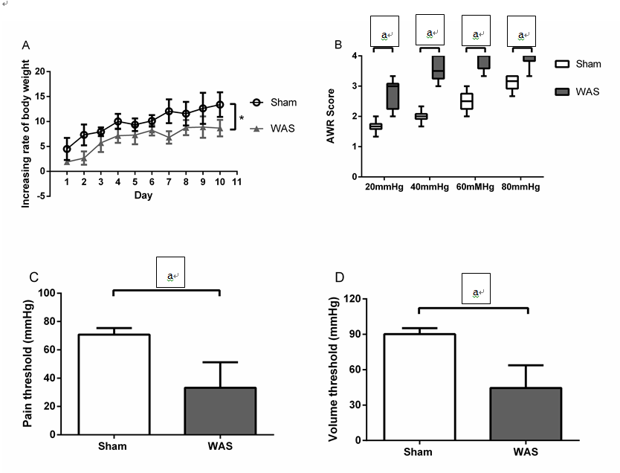
Figure 1 Effects of water avoidance stress on rate of weight gain and visceral sensitivity. A: Rate of weight gain (g) was lower in water avoidance stress (WAS) (n = 13) compared to the sham-WAS (n = 14) group. Values represent mean weight gain ± SD, repeated analysis of variance (ANOVA); B: Abdominal withdrawal reflex (AWR) scores in response to colorectal distension were increased in WAS compared to the sham-WAS group. Lines within the box represent the median value, end of the box represent 25th and 75th percentiles, and the error bars represent 5th and 95th percentiles. Wilcoxon two-sample test; C: Pain thresholds were decreased in WAS compared to the sham-WAS group. Values represent mean ± SD, Student’s t-test; D: Volume thresholds were decreased in WAS compared to the sham-WAS group. Values represent means values ± SD, Student’s t-test. ªP < 0.05, Sham vs WAS.

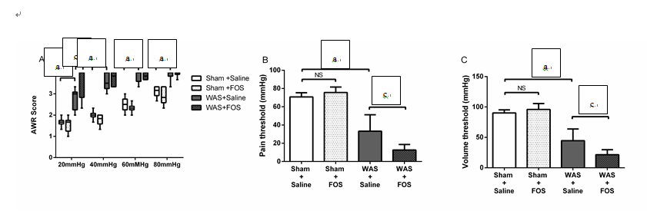Figure 2 Effects of oral gavage of fructo-oligosaccharide on visceral sensitivity. A: fructo-oligosaccharide (FOS) increased abdominal withdrawal reflex (AWR) scores at 20 mmHg pressure in response to colorectal distension compared to saline administration following water avoidance stress (WAS). Values represent median, 25th, 75th, 5th, and 95th percentiles. sham+saline (n = 7), sham+FOS (n = 7), WAS+saline (n = 6), WAS+FOS (n = 7). Kruskal–Wallis one-way ANOVA; B: Pain thresholds decreased in FOS-administered compared to saline administered mice following WAS. Values represent mean ± SD, one-way ANOVA; C: Volume thresholds decreased in FOS compared to saline administered mice following WAS. Values represent mean ± SD, one-way ANOVA. ªP < 0.05, sham+saline vs WAS+saline; ^{c}P < 0.05, WAS+saline vs WAS+FOS.

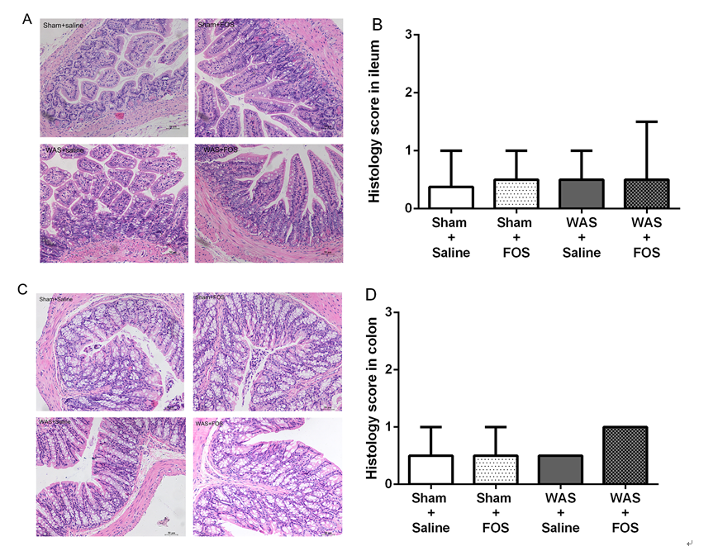
Figure 3 Effects of oral gavage of fructo-oligosaccharide on intestinal histological scores. A: Ileum stained with Hematoxylin–eosin (HE) for inflammation score (magnification 200x); B: No difference in structural histology among four groups; C: Colon stained with H&E for inflammation score (magnification 200x); D: No difference in structural histology among four groups. Values represent median with 5th and 95th percentiles; sham+saline (n = 7), sham+FOS (n = 7), WAS+saline (n = 6), WAS+FOS (n = 7); Kruskal–Wallis one-way ANOVA. FOS: fructo-oligosaccharide; WAS: water avoidance stress.

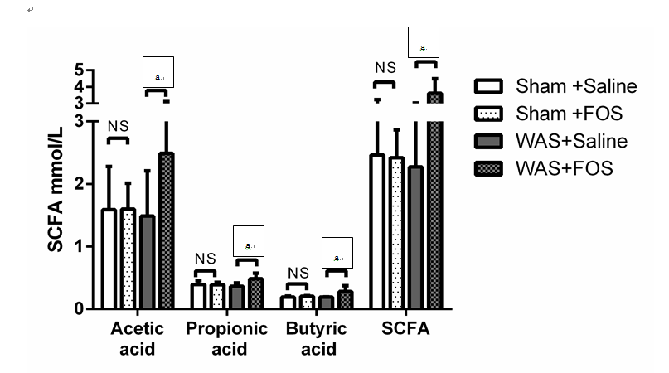Figure 4 Effects of oral gavage of fructo-oligosaccharide on short chain fatty acids concentrations. The average concentrations of total SCFA, acetic, propionic, and butyric acids increased in FOS-administered mice compared to saline-administered mice following WAS intervention. No difference in total SCFA, acetic, propionic and butyric acids levels with FOS or saline administration in mice following sham-WAS. Values represent mean ± SD; sham+saline (n = 7), sham+FOS (n = 7), WAS+saline (n = 6), WAS+FOS (n = 7); one-way ANOVA. ªP < 0.05, WAS+saline vs WAS+FOS. SCFA: short chain fatty acids; FOS: fructo-oligosaccharide; WAS: water avoidance stress.

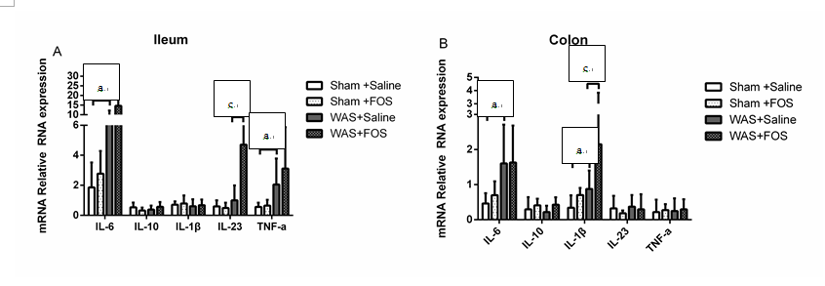Figure 5 Effects of oral gavage of fructo-oligosaccharide on intestinal cytokine expression. A: Among saline administered mice, IL-6 and TNF-α expression increased in ileum in WAS compared to the sham-WAS group. IL-23 increased in FOS compared to saline administered mice following WAS; B: In saline administered mice, colonic IL-6 and IL-1β increased in WAS compared to the sham-WAS group. IL-1β increased in FOS compared to saline administered mice in WAS group. Values represent mean ± SD; sham+saline (n = 7), sham+FOS (n = 7), WAS+saline (n = 6), WAS+FOS (n = 7); one-way ANOVA. ªP < 0.05, sham+saline vs WAS+saline; ^{c}P < 0.05, WAS+saline vs WAS+FOS. FOS: fructo-oligosaccharide; WAS: water avoidance stress; IL: interleukin; tnf: tumor necrosis factor.
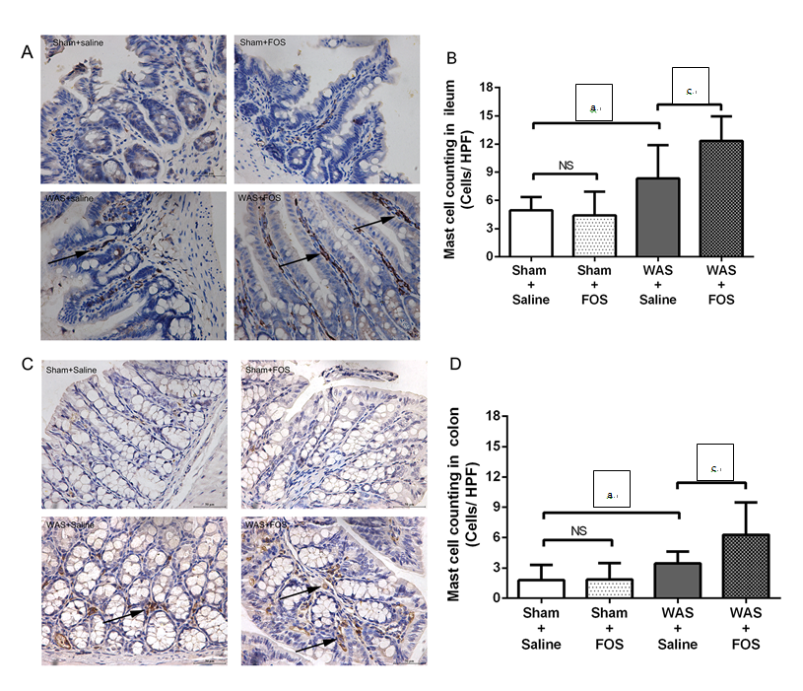Figure 6 Effects of oral gavage of fructo-oligosaccharide on mucosal mast cell numbers (arrows). A: Ileum stained with mast cell tryptase (magnification 400x); B: In saline administered mice, mast cell counts increased in WAS compared to the sham-WAS group. Mast cell counts increased in FOS compared to saline administered mice following WAS; C: Colon stained with mast cell tryptase (magnification 400 ×); D: In saline administered mice, mast cell counts increased in WAS compared to sham-WAS. Mast cell counts increased in FOS compared to saline administered mice following WAS. Values represent mean ± SD; sham+saline (n = 7), sham+FOS (n = 7), WAS+saline (n = 6), WAS+FOS (n = 7); one-way ANOVA. ªP < 0.05, sham+saline vs WAS+saline; ^{c}P < 0.05, WAS+saline vs WAS+FOS. FOS: fructo-oligosaccharide; WAS: water avoidance stress.

Table 1 Primer sequences
Gene | Forward primer | Reverse primer
TNF-α | GGCTTTCCGAATTCACTGGAG | CCCCGCCCTTCCAAATAAA
β-actin | GCAGGAGTACGATGAGTCCG | ACGCAGCTCAGTAACAGTCC
IL-6 | GTATGAACAACGATGATGCACTTG | ATGGTACTCCAGAAGACCAGAGGA
IL-23 | AATAATGCTATGGCTGTTGC | CCTTGAGTCCTTGTGGGT
IL-10 | ACTGCACCCACTTCCCAGT | ATGTTGTCCAGCTGGTCCTT
IL-1β | TTGACGGACCCCAAAAGATG | AGAAGGTGCTCATGTCCTCA
IL: interleukin; tnf: tumor necrosis factor.

