Name of Journal: World Journal of Clinical Cases
Manuscript NO: 59827
Manuscript Type: CASE REPORT

Innovative chest wall reconstruction with a locking plate and cement spacer after radical resection of chondrosarcoma in the sternum: A case report

Lin CW et al. Chest wall reconstruction after chondrosarcoma resection

Chung-Wei Lin, Tsung-Yu Ho, Chen-Wei Yeh, Hsien-Te Chen, I-Ping Chiang, Yi-Chin Fong

Chung-Wei Lin, Tsung-Yu Ho, Hsien-Te Chen, Yi-Chin Fong, Department of Orthopedic Surgery, China Medical University Hospital, China Medical University, Taichung City 40454, Taiwan

Chen-Wei Yeh, Department of Education, China Medical University Hospital, China Medical University, Taichung City 40447, Taiwan

Hsien-Te Chen, Yi-Chin Fong, Department of Sports Medicine, College of Health Care, China Medical University, Taichung City 40402, Taiwan

Hsien-Te Chen, Spine Center, China Medical University Hospital, China Medical University, Taichung City 40454, Taiwan

I-Ping Chiang, Department of Pathology, China Medical University Hospital, China Medical University, Taichung 40454, Taiwan

Yi-Chin Fong, Department of Orthopedic Surgery, China Medical University Beigang Hospital, Yunlin County 65152, Taiwan

Author contributions: Chen HT designed the concept; Fong YC was the attending doctor and treated the patient; Lin CW and Ho TY contributed to literature review and manuscript drafting; Lin CW and Yeh CW revised the manuscript; Chiang IP performed histopathological analysis.

Corresponding author: Yi-Chin Fong, MD, Chief Doctor, Professor, Department of Orthopedic Surgery, China Medical University Hospital, China Medical University, No. 2 Xueshi Road, North District, Taichung City 40454, Taiwan. d1762@mail.cmuh.org.tw

Received: October 1, 2020
Revised: January 10, 2021
Accepted: January 25, 2021
Published online:

Abstract
BACKGROUND
Chondrosarcoma, a cartilage matrix producing tumor, is the second most commonly observed primary bone tumor after osteosarcoma, accounting for 15% of all chest wall malignancies. We herein report the case of a patient with chondrosarcoma of the sternum and our management of the chest wall defects that presented following radical tumor resection.

CASE SUMMARY
A 31-year-old patient presented to our hospital with dull pain and a protruding mass overlying the chest for 3 mo. The presence of nocturnal pain and mass size progression was reported, as were overhead arm elevation-related limitations. Computed tomography showed a focal osteoblastic mass in the sternum with bony exostosis and adjacent soft tissue calcification. Positron emission tomography-computed tomography revealed hypermetabolic activity with a mass located over the upper sternum. Magnetic resonance imaging showed a focal ill-defined bony mass of the sternum with cortical destruction and periosteal reaction. Preoperative biopsy showed a consistent result with chondrosarcoma with immunohistochemical positivity for S100 and focal positivity for IDH-1. The grade II chondrosarcoma diagnosis was confirmed by postoperative pathology. The patient underwent radical tumor resection and chest wall reconstruction with a locking plate and cement spacer. The patient was discharged 1 wk after surgery without any complications. At the 1-year follow-up, there was no local recurrence on imaging. The functional scores, including Constant Score, Nottingham Clavicle Score, and Oxford Shoulder Score, showed the absence of pain in the performance of daily activities or substantial functional disabilities.

CONCLUSION
The diagnosis of chondrosarcoma must be considered when chest wall tumors are encountered. The surgical reconstructive materials, with a locking plate and cement spacer, used in our study are cost-effective and readily-available for the sternum defect.

Key Words: Chondrosarcoma; Sternum; Chest wall; Cement; Reconstruction; Case report

Lin CW, Ho TY, Yeh CW, Chen HT, Chiang IP, Fong YC. Innovative chest wall reconstruction with a locking plate and cement spacer after radical resection of chondrosarcoma in the sternum: A case report. World J Clin Cases 2021; In press

Core Tip: Chondrosarcoma is the second most commonly observed primary bone tumor after osteosarcoma, accounting for 15% of all chest wall malignancies. Radical tumor excision is deemed the gold standard treatment. However, reconstruction of chest wall defect following tumor resection remains challenging. Our clinical case presents an innovative surgical procedure in managing chest wall defect. The surgical reconstructive materials including a locking plate and cement spacer are cost-effective and readily-available. We believe this technique, which yielded promising results, may serve as an alternative in cases such as ours.
INTRODUCTION
Chondrosarcomas are the second most commonly observed primary bone tumors after osteosarcoma, and the majority of these are observed in middle-aged populations^{[1,2]}. The characteristics of chondrosarcoma include slow tumor growth, low-grade disease, extremely low rates of metastasis, and slight male predominance. Primary bone tumors located over the chest wall are rarely observed, and account for less than 1% of all primary bone neoplasms^{[3,4]}. However, 15% of chondrosarcomas are located over the chest wall, with an annual incidence of 0.5 million/year^{[5,6]}. Since chondrosarcomas are resistant to radiotherapy and chemotherapy, wide tumor excision followed by anterior chest wall reconstruction is deemed the gold standard for treatment^{[7]}.
Generally, chest wall defects larger than 5 cm require surgical reconstruction for functional and cosmetic purposes^{[8-10]}. Reconstructive procedures are performed with the aim of restoring the stability and rigidity of the thoracic cage, eliminating thoracic dead space, preserving pulmonary function, protecting the major intra-thoracic organs, providing adequate soft tissue coverage, and optimizing the patient’s cosmetic appearance. The reconstruction is considered challenging regarding the proximity of major vital organs and difficulties in finding suitable materials. Previous studies with variable tumors located on the sternum reported various methods of sternal reconstruction, including those performed using a methyl methacrylate Marlex mesh sandwich plate, titanium mesh, titanium plate and stainless steel plate, allograft transplantation, and three-dimensional custom-made prosthesis^{[4,11-15]}. Ideally, the materials used for these purposes must be readily-available, durable, and cost-effective. The lack of flexibility of metal prosthesis could lead to unexpected breakage or potential dislocation if malpositioned. Other issues include inaccurate sizing or restriction of movement after surgery^{[4]}. Allograft transplantation takes the major advantage in the ability to incorporate into native tissue and revascularization. However, bone allograft comes in limited source and bears the risk of disease transmission^{[10]}. Three-dimensional custom-made prosthesis achieves a perfect shape in chest wall reconstruction process but is deemed time-consuming and costly^{[4]}.
The advantages of using cement spacer for chest wall reconstruction include low cost and being durable, readily-available, and most importantly moldable based on individual body size. Accordingly, we sought to present the case of a patient who underwent bilateral sternoclavicular joint fixation and cement spacer augmentation following radical tumor resection.

CASE PRESENTATION
Chief complaints
A 31-year-old man presented to our hospital with dull and nocturnal pain. A protruding mass overlying the left side chest wall with progressive growing was noted.

History of present illness
According to the patient’s statement, the mass gradually increased in size over these 3 mo. The pain interfered with the patient’s performance of daily activities. There were no symptoms related to airway compression or respiratory disturbance.

History of past illness
The patient had a past history of left lower lobe lung adenocarcinoma in situ and underwent wedge resection 3 mo ago.

Personal and family history
The patient had no family history.

Physical examination
Physical examination revealed tenderness on palpation and the presence of a firm, non-movable, well-defined 5 cm mass. The motion of the left shoulder and overhead arm elevation was interfered by this mass. There was no other palpable mass over the head, neck, or axillary lymph nodes.

Laboratory examinations
The results of the laboratory tests, including those for complete blood count, biochemical proﬁling, and coagulation function, were all within the normal range.

Imaging examinations
Computed tomography (CT) with contrast showed a focal osteoblastic mass in sternum manubrium region with bony exostosis and adjacent soft tissue calcification (Figure 1). Positron emission tomography-computed tomography (PET-CT) revealed the presence of hypermetabolic activity with a mass located over the upper sternum (Figure 2). Bone scintigraphy also revealed increased focal uptake in the area, indicating a strong suspicion of a primary sternal tumor (Figure 3). Magnetic resonance imaging (MRI) showed a focal ill-defined bony mass of the sternum with cortical destruction and periosteal reaction. The tumor size was approximately 5.0 cm × 4.2 cm × 5.2 cm, with an edge abutting the aortic arch (Figure 4). The presence of malignancies including chondrosarcoma was suspected in the differential diagnosis.

Preoperative biopsy
Section through the tumor at the sternum showed hypercellularity and contained groups of neoplastic chondrocytes with extensive chondroid matrix component. The tumor cells had enlarged, hyperchromatic nuclei and occasional binucleation. Some bony fragments were also present. The immunostaining of the tumor cell revealed positivity for S100 and focal positivity for IDH-1. It was consistent with grade II chondrosarcoma.

Pathological findings
The gross specimen showed a 6.5 cm × 6.0 cm × 5.0 cm gelatinous and elastic to firm tumor mass composed of hyaline cartilage (Figure 5). Pathology suggested grade II moderately differentiated chondrosarcoma with clear and uninvolved margins. Hematoxylin and eosin (HE) staining indicated less cellularity without atypia and a lobulated architecture with abundant cartilaginous matrix separated by the fibrovascular bands. The spread trabecular bone filled the lacunar space, which was surrounded by the hyaline cartilaginous matrix (Figure 6).

MULTIDISCIPLINARY EXPERT CONSULTATION
Preoperative evaluation and preparation were performed over the first few days following admission. A multidisciplinary tumor board, comprising chest surgeons, orthopedic surgeons, anesthesiologists, and radiologists, was established. After a detailed discussion, the performance of radical resection and chest wall reconstruction, with a goal of complete tumor eradication, was decided on. The advantages and disadvantages associated with the procedure, surgical morbidities, and surgical-related risks were explained clearly to the patient and his family members.

FINAL DIAGNOSIS
The final diagnosis was grade II moderately differentiated chondrosarcoma.

TREATMENT
The patient was kept in a supine position and surgery was performed under general anesthesia. After a routine disinfection procedure, a T-shaped incision was made so as to expose the sternum and bilateral sternoclavicular joint. Radical en bloc resection of the medial part of the left clavicle, manubrium, and medial part of the left first and second ribs were performed. Safe margins were confirmed by intraoperative frozen section. Reconstruction began with bilateral clavicle fixation, which was performed using a J-shaped locking plate (DePuy Synthes Comp., Zuchwil, Switzerland) with three screws placed on either side of the clavicle. Then, polymethyl methacrylate (PMMA) medium viscosity bone cement (DePuy Inc., Warsaw, IN, United States) was introduced for sternum reconstruction. The cement curing process was divided into four stages: Mixing, sticky/waiting, working, and hardening^{[16]}. After the defect size was carefully measured, the PMMA was remodeled to meet the shape of the manubrium during the working stage. Kirschner wires (K wires) were inserted into the cement spacer, creating holes for further suture anchoring (Figure 7), following which 1-0 Ethibond sutures (Ethicon, Somerville, NJ, United States) were passed through the pectoralis major fascia, medial portion of the clavicle, the J-shaped locking plate, and sternum body (Figure 7). The polypropylene mesh (Marlex, Bard Cardiosurgery, Billerica, MA, United States) was first placed over the mediastinum for protection, and the cement spacer was then introduced into the desire location. The Ethibond sutures passing through the spacer were tightened, ensuring the stability of the thoracic cage. Eventually, the soft tissue and skin were sutured layer by layer. The estimated blood loss was 150 mL.

OUTCOME AND FOLLOW-UP
The postoperative course was uneventful, and the patient was discharged 1 wk after surgery without any skin-related or respiratory complications. At the 1-year follow-up, chest radiography showed a solid chest with a good shape. CT revealed the absence of local tumor recurrence and stable fixation of the sternoclavicular joint (Figure 8). There was no evidence of infection, peri-implant fracture, screw loosening, or foreign body rejection. The patient’s functional scores, including the Constant Score (CS), Nottingham Clavicle Score (NCS), and Oxford Shoulder Score (OSS), were well-documented^{[17]}. The CS was 66 before surgery and 85 at the 1-year postoperative follow-up. The NCS improved from 74 to 94, and the OSS showed some advancement, from 44 to 46. The clinical results demonstrated improvements in the patient’s quality of life, with the absence of pain or substantial functional disabilities. Table 1 summarizes the treatment timeline of the patient.

DISCUSSION
To the best of our knowledge, our report presents a rare case of chondrosarcoma invading the manubrium and bilateral sternoclavicular joint. The patient underwent tumor resection and chest wall reconstruction using a cement spacer with improved clinical and radiological results.
Chondrosarcomas are hyaline-producing tumors that commonly arise in the axial and proximal appendicular skeleton. They are commonly found in the pelvis, proximal femur, proximal humerus and proximal tibia, but rare cases of chondrosarcoma in the patella and scapula have also been reported^{[1,18]}. The disease’s clinical presentation may vary depending on the tumor grade. Patients with low-grade chondrosarcoma may present with large tumors before medical assistance is sought, while those with high-grade chondrosarcoma tend to experience worsening pain or pathologic fractures in association with scalloping and cortical destruction^{[19]}.
As chondrosarcomas are resistant to chemotherapy and radiotherapy, wide surgical resection is the gold standard for treatment. Local recurrence is more commonly observed than distant metastasis in such settings, while inadequate excision margins are important risk factors for local recurrence development. Tumor histological grade, extracompartmental spread, and local recurrence are important factors that affect the survival associated with chondrosarcoma. The 10-year survival rates were reported to be 89% for grade 1, 53% for grade 2, and 38% for grade 3 chondrosarcoma^{[20]}. Another population-based Scandinavian Sarcoma Group study revealed a 10-year survival rate of 67% for treated patients (92% after wide resection and 47% following intralesional resection)^{[6]}.
Chondrosarcoma of the sternum is rarely encountered by orthopedic surgeons. The performance of complete tumor resection without damage to the surrounding major organs and vessels, and reconstruction following tumor resection is challenging. Our study sought to report the preliminary clinical results associated with reconstruction performed using familiar, easily-available, and durable materials. PMMA bone cement is known for its strength against compression and bending, which is vital in the construction of a solid and stable thoracic cage.
Currently, there is no guideline regarding the absolute indication for chest wall reconstruction. However, most previous studies indicated that a chest wall defect larger than 5 cm in size or containing four or more ribs would benefit from chest wall reconstruction^{[8-10,21]}. Several studies have demonstrated various chest wall reconstruction methods in the fields of cardiac and thoracic surgery. Gao et al^{[13]} reported on the use of titanium sternal fixation systems for reconstruction, while Ma et al^{[4]} performed sternal reconstruction with 3-dimensional (3D) custom-made prostheses. Metal prosthesis carries the advantage of establishing adequate chest wall stability, but there are some limitations regarding the use of metal prosthesis including prosthesis dislocation, infection, or inappropriate sizing. The 3D custom made prosthesis provides a reliable option for reconstruction with perfect shape matching but is time consuming, expensive, and not readily-available in every institution. Allograft transplantation is also discussed in the literature with better biological effect in reconstruction but the source is limited and the risk of disease transmission should also be taken into consideration^{[10]}.
Some reports also advocate the performance of biological reconstruction using the rectus abdominus flap, omental flap, latissimus dorsi flap, or free flap for soft tissue coverage^{[22-25]}. The advantage of using flap coverage is its ability to incorporate into a patient’s native tissue by revascularization and tissue regeneration. However, there are some surgery-related complications that need to be addressed. Ventral herniation and prolonged ileus were previously found after abdominus flap or omental flap surgery^{[22]}. Shoulder extension endurance and adduction deficits and short-term reductions in the arm strength following latissimus dorsi flap transfer have been noted^{[23]}. Free flap reconstruction, which is associated with a relatively low rate of donor site complications, is technically demanding and requires frequent inspections and anticoagulation therapy administration after surgery^{[24,25]}.
The strengths of our reconstruction technique are as follows. It is reliable and provides adequate chest wall stability. In addition, the low cost is better tolerated by the patient. Furthermore, the procedure is not time-consuming and most orthopedic surgeons are familiar with. Finally, cement is readily-available and the moldability also offers the advantage of better size-matching, providing personalized treatment. We believe the technique, which yielded promising results, may serve as an alternative in cases such as ours.
Our study has some limitations. First, the shape of handmade cement spacer may not be superior to 3D custom-made prostheses and this is not a biological reconstruction. Second, the maximal strength of PMMA bone cement against chest wall trauma requires further biomechanical study. Moreover, it is a case report with a 1-year follow-up period. Longer follow-up durations, for the monitoring of possible local recurrence or distal metastasis, are still required. Finally, there is a need for large series with control groups to ensure the reproducibility of our findings, and to confirm the radiological and functional outcomes associated with the technique that we used as well.

CONCLUSION
Bilateral sternoclavicular joint fixation with a locking plate along with PMMA cement reconstruction of the sternum is a safe and cost-effective method through which chest cavity stabilization can be achieved. The study provides a surgical alternative, from the orthopedic perspective, in the management of chest wall chondrosarcoma, with good clinical functional scores and the absence of local recurrence on imaging.

REFERENCES
1 Qiang S, Ma XN, Wang HW, Lv SC. Scapula chondrosarcoma: A case report. Medicine (Baltimore) 2019; 98: e15388 [PMID: 31027132 DOI: 10.1097/MD.0000000000015388]
2 Liu S, Zhou X, Song A, Huo Z, Wang Y, Liu Y. Surgical treatment of metastatic mesenchymal chondrosarcoma to the spine: A case report. Medicine (Baltimore) 2020; 99: e18643 [PMID: 32000368 DOI: 10.1097/MD.0000000000018643]
3 Liu ZC, Zhao H. Titanium internal fixation system used for sternum reconstruction after resection of chondrosarcoma. Chin Med J (Engl) 2010; 123: 2621-2622 [PMID: 21034640]
4 Ma XL, Wang DB, Ma JX, Wang Y, Sun L, Lu B, Wang Y, Zhao XW, Li F, Fan ZR, Han B, Bai HH, Yang BC, Jiang X, Tian AX, Dong BC, Du YR. Custom-made Prosthesis for Reconstruction after Radical Resection for Chondrosarcoma of Manubrium. Orthop Surg 2018; 10: 272-275 [PMID: 30152608 DOI: 10.1111/os.12388]
5 Burt M, Fulton M, Wessner-Dunlap S, Karpeh M, Huvos AG, Bains MS, Martini N, McCormack PM, Rusch VW, Ginsberg RJ. Primary bony and cartilaginous sarcomas of chest wall: results of therapy. Ann Thorac Surg 1992; 54: 226-232 [PMID: 1637209 DOI: 10.1016/0003-4975(92)91374-i]
6 Widhe B, Bauer HC; Scandinavian Sarcoma Group. Surgical treatment is decisive for outcome in chondrosarcoma of the chest wall: a population-based Scandinavian Sarcoma Group study of 106 patients. J Thorac Cardiovasc Surg 2009; 137: 610-614 [PMID: 19258076 DOI: 10.1016/j.jtcvs.2008.07.024]
7 Lequaglie C, Massone PB, Giudice G, Conti B. Gold standard for sternectomies and plastic reconstructions after resections for primary or secondary sternal neoplasms. Ann Surg Oncol 2002; 9: 472-479 [PMID: 12052759 DOI: 10.1007/BF02557271]
8 Chapelier AR, Missana MC, Couturaud B, Fadel E, Fabre D, Mussot S, Pouillart P, Dartevelle PG. Sternal resection and reconstruction for primary malignant tumors. Ann Thorac Surg 2004; 77: 1001-1006; discussion 1006-1007 [PMID: 14992915 DOI: 10.1016/j.athoracsur.2003.08.053]
9 Girotti P, Leo F, Bravi F, Tavecchio L, Spano A, Cortinovis U, Nava M, Pastorino U. The "rib-like" technique for surgical treatment of sternal tumors: lessons learned from 101 consecutive cases. Ann Thorac Surg 2011; 92: 1208-1215; discussion 1215-1216 [PMID: 21958766 DOI: 10.1016/j.athoracsur.2011.05.016]
10 Seder CW, Rocco G. Chest wall reconstruction after extended resection. J Thorac Dis 2016; 8: S863-S871 [PMID: 27942408 DOI: 10.21037/jtd.2016.11.07]
11 Chaudhry Iu, Alhajji Z, Aldulaijan F, Mutairi H, Amr SS. Manubrioclavicular and Manubriosternal Reconstruction After Radical Resection for Chondrosarcoma of Manubriosternum: A Modified Surgical Technique. Ann Thorac Surg 2015; 99: e137-e139 [PMID: 26046904 DOI: 10.1016/j.athoracsur.2015.02.119]
12 Aprile V, Korasidis S, Crisci R, Ambrogi MC. Chest wall reconstruction with a novel titanium mesh after partial sternectomy for chondrosarcoma. Interact Cardiovasc Thorac Surg 2020; 30: 149-150 [PMID: 31873742 DOI: 10.1093/icvts/ivz214]
13 Gao E, Li Y, Zhao T, Guo X, He W, Wu W, Zhao Y, Yang Y. Reconstruction of anterior chest wall: a clinical analysis. J Cardiothorac Surg 2018; 13: 124 [PMID: 30526640 DOI: 10.1186/s13019-018-0810-x]
14 Chen C, Huang X, Chen M, Yu F, Yin B, Yuan Y. Surgical management of a giant sternal chondromyxoid fibroma: a case report. J Cardiothorac Surg 2015; 10: 178 [PMID: 26615403 DOI: 10.1186/s13019-015-0370-2]
15 Dell'Amore A, Cassanelli N, Dolci G, Stella F. An alternative technique for anterior chest wall reconstruction: the sternal allograft transplantation. Interact Cardiovasc Thorac Surg 2012; 15: 944-947 [PMID: 22990634 DOI: 10.1093/icvts/ivs411]
16 Vaishya R, Chauhan M, Vaish A. Bone cement. J Clin Orthop Trauma 2013; 4: 157-163 [PMID: 26403875 DOI: 10.1016/j.jcot.2013.11.005]
17 Charles ER, Kumar V, Blacknall J, Edwards K, Geoghegan JM, Manning PA, Wallace WA. A validation of the Nottingham Clavicle Score: a clavicle, acromioclavicular joint and sternoclavicular joint-specific patient-reported outcome measure. J Shoulder Elbow Surg 2017; 26: 1732-1739 [PMID: 28601491 DOI: 10.1016/j.jse.2017.03.036]
18 Ye C, Luo Z, Zeng J, Dai M. Chondrosarcoma of the patella: A case report. Medicine (Baltimore) 2017; 96: e8049 [PMID: 28906396 DOI: 10.1097/MD.0000000000008049]
19 Riedel RF, Larrier N, Dodd L, Kirsch D, Martinez S, Brigman BE. The clinical management of chondrosarcoma. Curr Treat Options Oncol 2009; 10: 94-106 [PMID: 19238552 DOI: 10.1007/s11864-009-0088-2]
20 Fiorenza F, Abudu A, Grimer RJ, Carter SR, Tillman RM, Ayoub K, Mangham DC, Davies AM. Risk factors for survival and local control in chondrosarcoma of bone. J Bone Joint Surg Br 2002; 84: 93-99 [PMID: 11837841 DOI: 10.1302/0301-620x.84b1.11942]
21 Mahabir RC, Butler CE. Stabilization of the chest wall: autologous and alloplastic reconstructions. Semin Plast Surg 2011; 25: 34-42 [PMID: 22294941 DOI: 10.1055/s-0031-1275169]
22 Daigeler A, Simidjiiska-Belyaeva M, Drücke D, Goertz O, Hirsch T, Soimaru C, Lehnhardt M, Steinau HU. The versatility of the pedicled vertical rectus abdominis myocutaneous flap in oncologic patients. Langenbecks Arch Surg 2011; 396: 1271-1279 [PMID: 21779830 DOI: 10.1007/s00423-011-0823-6]
23 Glassey N, Perks GB, McCulley SJ. A prospective assessment of shoulder morbidity and recovery time scales following latissimus dorsi breast reconstruction. Plast Reconstr Surg 2008; 122: 1334-1340 [PMID: 18971716 DOI: 10.1097/PRS.0b013e3181881ffe]
24 Fischer S, Klinkenberg M, Behr B, Hirsch T, Kremer T, Hernekamp F, Kolbenschlag J, Lehnhardt M, Kneser U, Daigeler A. Comparison of donor-site morbidity and satisfaction between anterolateral thigh and parascapular free flaps in the same patient. J Reconstr Microsurg 2013; 29: 537-544 [PMID: 23982858 DOI: 10.1055/s-0033-1351394]
25 Klinkenberg M, Fischer S, Kremer T, Hernekamp F, Lehnhardt M, Daigeler A. Comparison of anterolateral thigh, lateral arm, and parascapular free flaps with regard to donor-site morbidity and aesthetic and functional outcomes. Plast Reconstr Surg 2013; 131: 293-302 [PMID: 23357991 DOI: 10.1097/PRS.0b013e31827786bc]

Footnotes
Informed consent statement: The patient provided consent for the treatment and the use of his medical documentation and information for the present article.

Conflict-of-interest statement: The authors declare that they have no conflict of interest to disclose.

CARE Checklist (2016) statement: The authors have read the CARE Checklist (2016), and the manuscript was prepared and revised according to the CARE Checklist (2016).

Open-Access: This article is an open-access article that was selected by an in-house editor and fully peer-reviewed by external reviewers. It is distributed in accordance with the Creative Commons Attribution NonCommercial (CC BY-NC 4.0) license, which permits others to distribute, remix, adapt, build upon this work non-commercially, and license their derivative works on different terms, provided the original work is properly cited and the use is non-commercial. See: http://creativecommons.org/Licenses/by-nc/4.0/

Manuscript source: Unsolicited manuscript

Peer-review started: October 1, 2020
First decision: December 28, 2020
Article in press:

Specialty type: Medicine, research and experimental
Country/Territory of origin: Taiwan
Peer-review report’s scientific quality classification
Grade A (Excellent): A
Grade B (Very good): 0
Grade C (Good): C
Grade D (Fair): D
Grade E (Poor): 0

P-Reviewer: Grignani G, Shimada S, Zhu Y S-Editor: Gao CC L-Editor: Wang TQ P-Editor:
Figure Legends
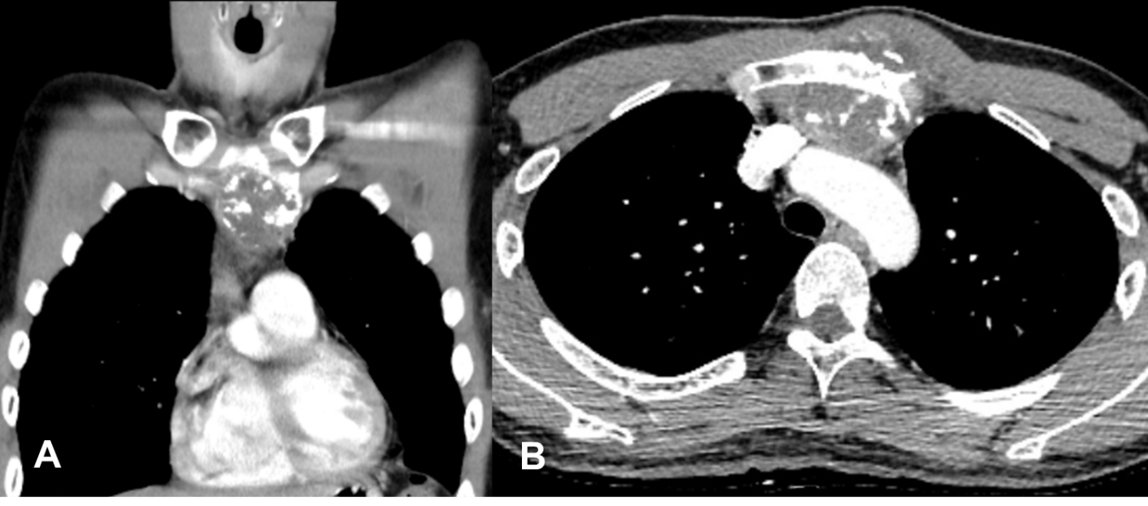
Figure 1 Focal osteoblastic mass in the sternum with bony exostosis and adjacent soft tissue calcification. A and B: Coronal (A) and axial (B) views of contrast computed tomography.
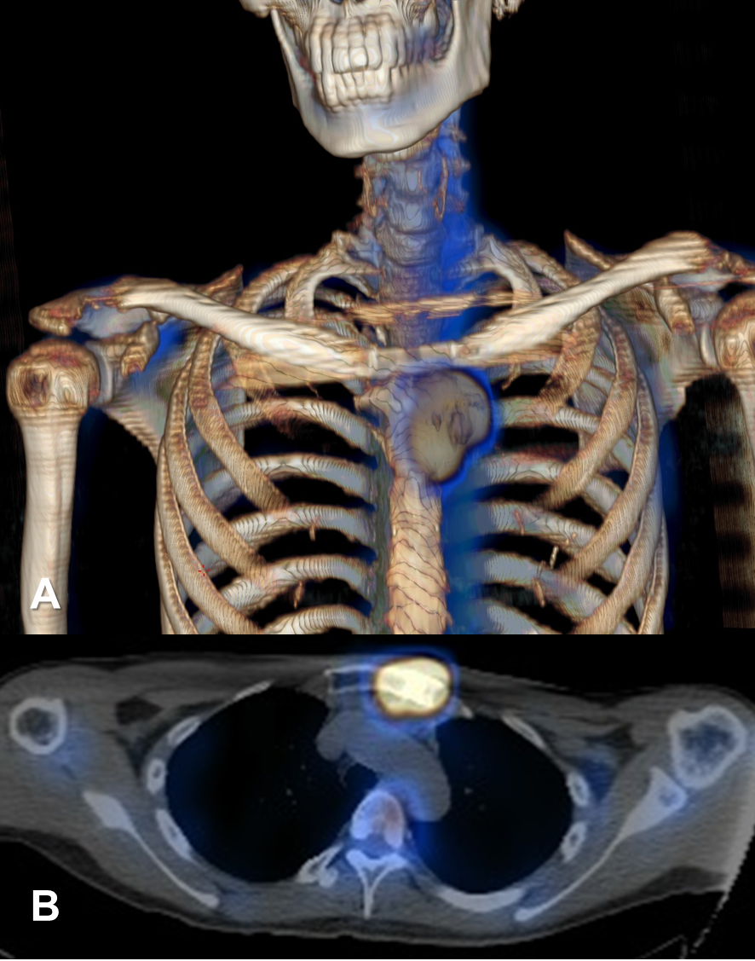
Figure 2 Hypermetabolic mass overlying the upper sternum. A and B: Three-dimensional reconstruction and axial view of positron emission tomography-computed tomography image.
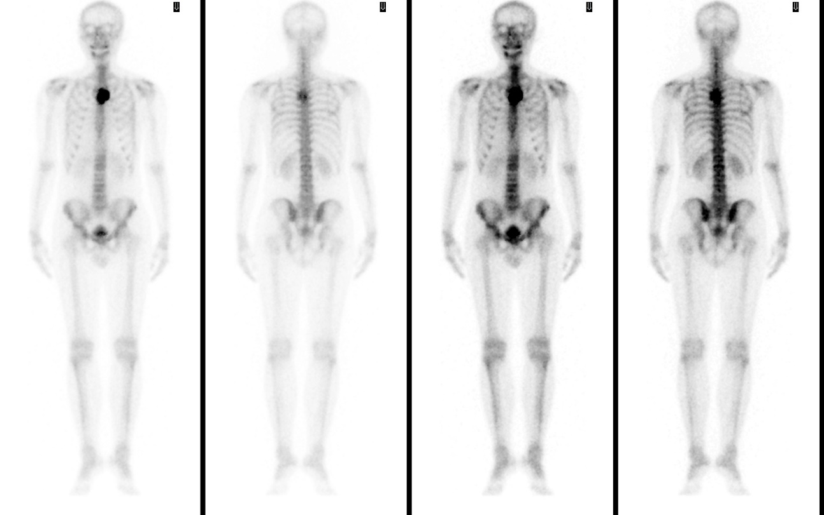
Figure 3 Bone scintigraphy revealing increased focal uptake in the sternum, showing a strong suspicion of a primary sternal tumor.
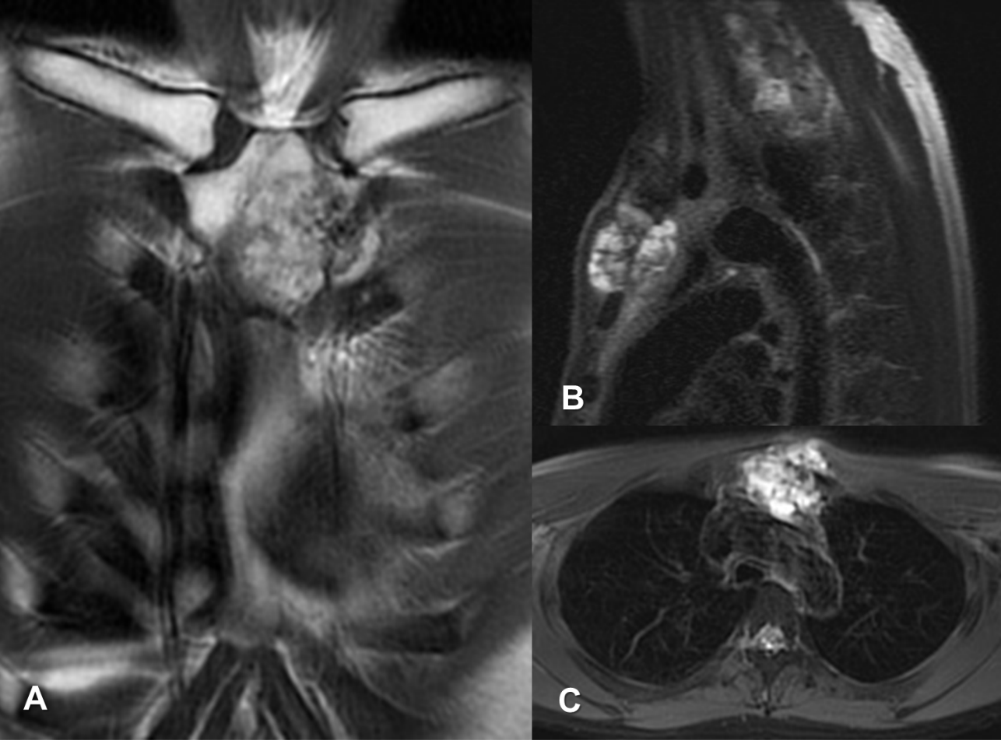
Figure 4 Focal ill-defined bony mass of the sternum with cortical destruction and periosteal reaction. A-C: Magnetic resonance imaging with (A) coronal T2-weighted scan, (B) sagittal fat-suppressed T2-weighted scan, and (C) axial fat-suppressed T2-weighted scan.
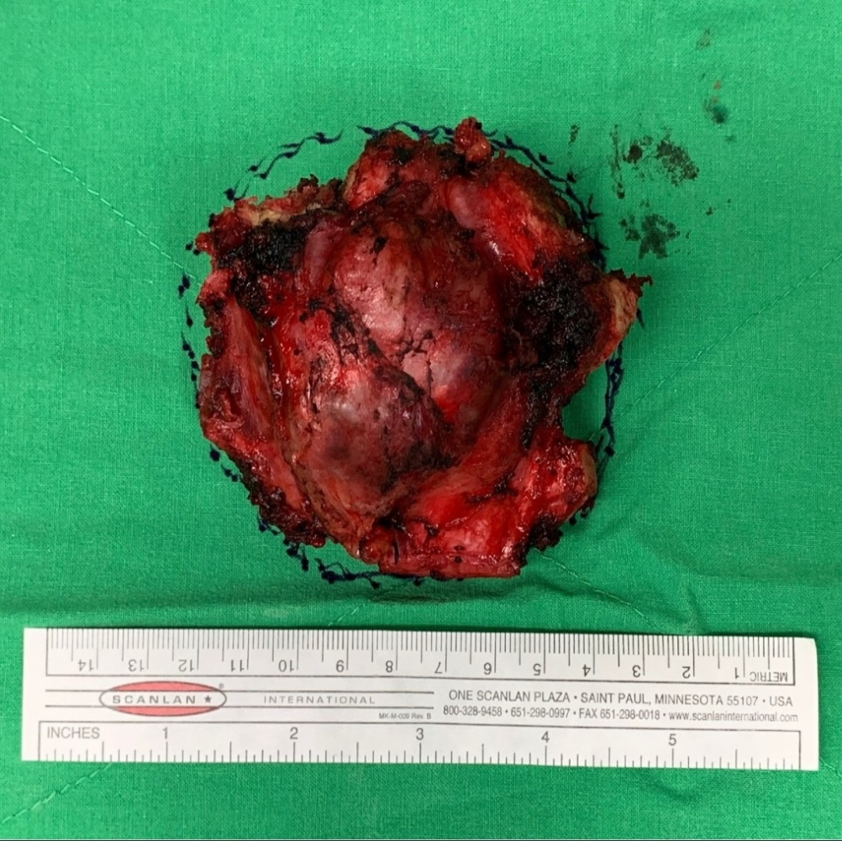
Figure 5 Gross specimen of the resected tumor showing a 6.5 cm × 6.0 cm × 5.0 cm mass with a clean resected margin as confirmed by frozen section. The tumor comprised hyaline cartilage.
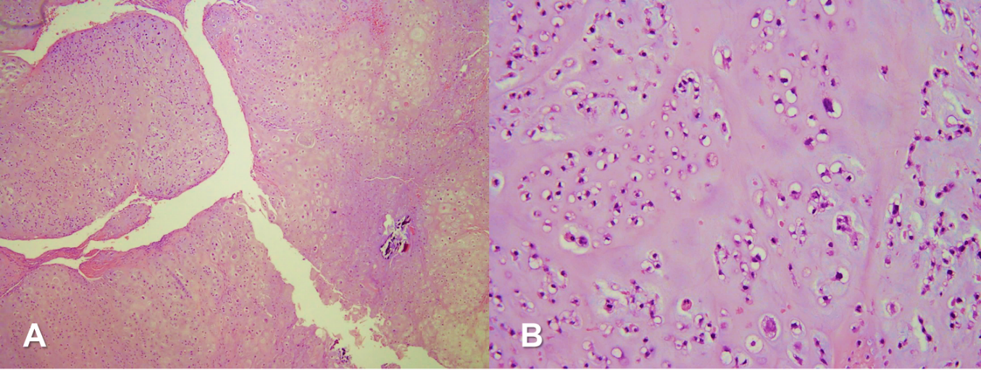
Figure 6 Pathological images. A and B: Low power (A, 40 ×) and high power (B, 200 ×) histopathology pictures of chondrosarcoma showing hyaline cartilage matrix and chondrocytes in lacunae.
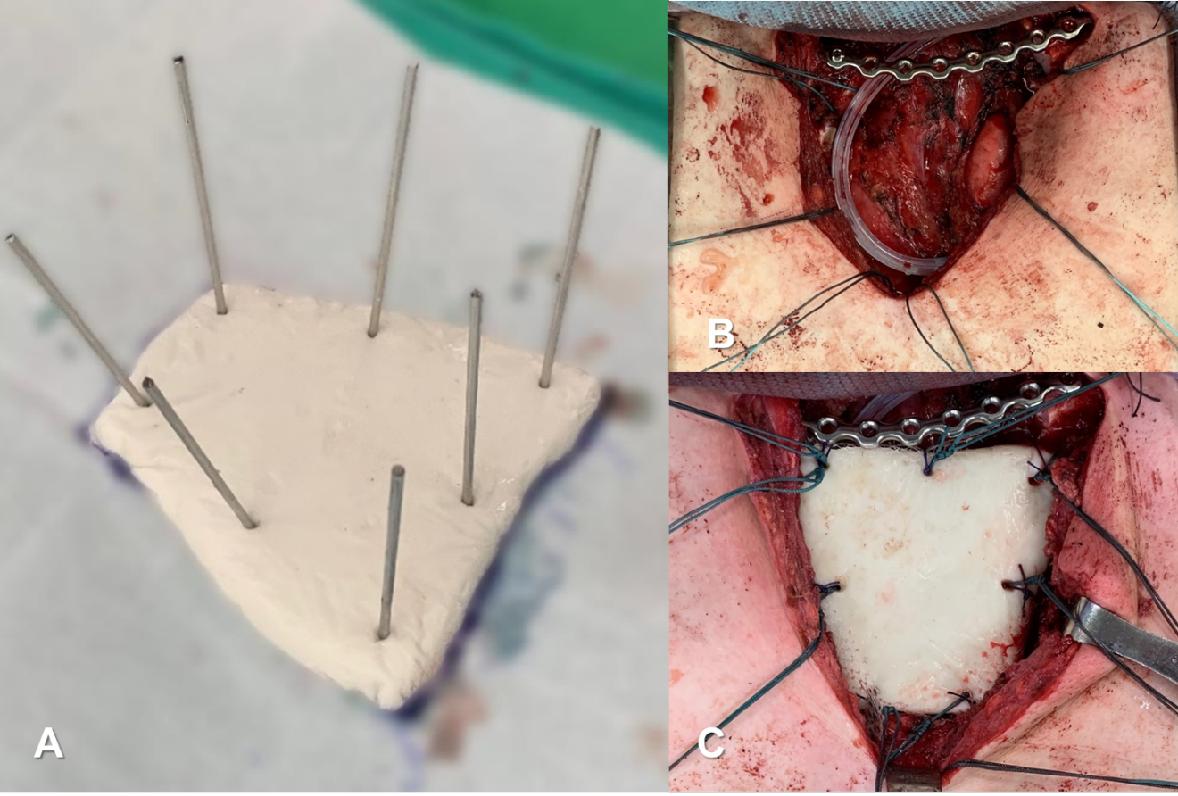
Figure 7 Intraoperative photos demonstrating the shaping of bone cement spacer for the sternum. A: We measured the defect size carefully, remodeled the polymethyl methacrylate to meet the shape of manubrium, and inserted Kirschner wire creating holes for anchoring sutures; B: Mesh placement over the mediastinum to prevent cement spacer from direct contact with the surrounding musculature and major blood vessels; C: Ethibond sutures passing through the spacer anchoring surrounding bony structures, muscles, and the J-shaped locking plate.
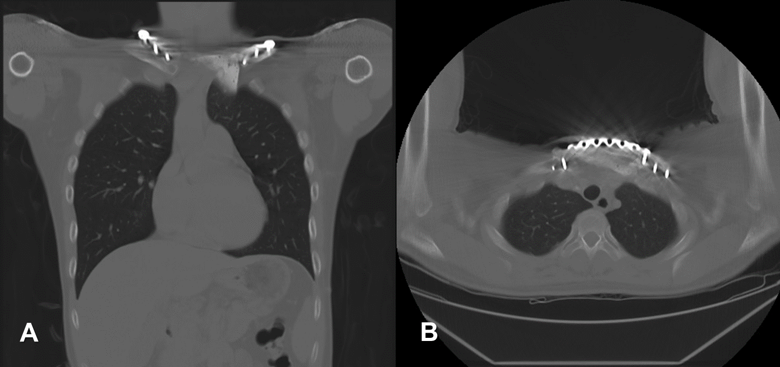
Figure 8 Coronal and axial views of computed tomography at 1-year follow-up revealing absence of local tumor recurrence. A: Coronal; B: Axial.
Table 1 Case report timeline
Complaint/investigations | Details
Presenting symptoms | Dull pain and protruding mass for 3 mo; Nocturnal pain; Mass gradually increased in size; Overhead arm elevation limitation
CT | Focal osteoblastic change in sternum manubrium region with bony exostosis with adjacent soft tissue calcification mass
PET-CT | Mass with hypermetabolic activity over the upper sternum
Bone scintigraphy | Focal increased uptake over the upper sternum
MRI | Focal ill-defined bony mass of the sternum with cortical destruction and periosteal reaction
Biopsy | Hypercellular mass with groups of neoplastic chondrocytes and extensive chondroid matrix component; Tumor cells with enlarged hyperchromatic nuclei and occasional binucleation; Some bony fragments are also present; Immunohistochemical positivity for S100 positive and focal positivity for IDH-1
Surgical intervention | Radical tumor resection followed by chest wall reconstruction with a locking plate and cement spacer; Pathology suggested grade II chondrosarcoma
Admission course | The patient was discharged 1 wk after the surgery without complication
Postoperative 1-year follow-up | 1-yr follow-up: Improved CS, NSS and OSS; No evidence of local recurrence; Further consecutive follow-up needed
CT: Computed tomography; PET-CT: Positron emission tomography-computed tomography; MRI: Magnetic resonance imaging; CS: Constant Score; NCS: Nottingham Clavicle Score; OSS: Oxford Shoulder Score.

