Name of Journal: World Journal of Gastroenterology
Manuscript NO: 35974
Manuscript Type: CASE REPORT

HHV-8 positive iatrogenic Kaposi's sarcoma in the setting of refractory ulcerative colitis

Duh E et al. Kaposi sarcoma in UC

Erica Duh, Sean Fine

Erica Duh, Warren Alpert Medical School of Brown University, 222 Richmond Street, Providence, RI 02903, United States

Sean Fine, Department of Inflammatory Bowel Disease, Warren Alpert Medical School, 222 Richmond Street, Providence, RI 02903, United States

ORCID number: Erica Duh (0000-0002-0473-1324); Sean Fine (0000-0002-8289-4890).

Author contributions: Duh E drafted manuscript; Fine S collected and interpreted data, proofread manuscript.

Institutional review board statement: Case report written with initial intention only to treat and not for research.

Informed consent statement: Verbal consent was obtained from all patients included in this submission.

Conflict-of-interest statement: We have no potential conflict of interest, real or perceived, and no additional disclosures.

Open-Access: This article is an open-access article which was selected by an in-house editor and fully peer-reviewed by external reviewers. It is distributed in accordance with the Creative Commons Attribution Non Commercial (CC BY-NC 4.0) license, which permits others to distribute, remix, adapt, build upon this work non-commercially, and license their derivative works on different terms, provided the original work is properly cited and the use is non-commercial. See: http://creativecommons.org/licenses/by-nc/4.0/

Manuscript source: Unsolicited manuscript

Correspondence to: Erica Duh, BS, Warren Alpert Medical School of Brown University, 222 Richmond Street Providence, RI 02903, United States. erica_duh@brown.edu
Telephone: +1-301-7583862
Fax: +1-401-8635711

Received: August 24, 2017
Peer-review started: August 25, 2017
First decision: September 6, 2017
Revised: September 22, 2017
Accepted: September 29, 2017
Article in press:
Published online:

Abstract
Although Kaposi Sarcoma (KS) has been more traditionally considered an AIDS-defining illness, it may also be seen in individuals on immunosuppresive therapy. We report a case of a patient who presented to the hospital in the setting of increasingly refractory ulcerative colitis. Computed tomography scan of the abdomen was consistent with sigmoid diverticulititis and blood cultures were positive for Klebsiella. After a course of antibiotics with resolution of infection, a colonoscopy was performed to evaluate his diverticulitis and incidentally revealed a new rectal tumor. Immunohistochemistry showed the tumor was consistent with KS, with cells staining strongly positive for Human Herpesvirus-8. This case not only illustrates a rare case of KS found in an HIV-negative individual, but it also highlights the importance of considering an alternative diagnosis in a patient refractory to medical treatment. We discuss the management and care of an Ulcerative Colitis patient diagnosed with KS on immunosuppressive therapy.

Key words: Kaposi Sarcoma; Ulcerative colitis; Inflammatory bowel disease; Human herpesvirus-8; Colorectal cancer; HIV/AIDS

© The Author(s) 2017. Published by Baishideng Publishing Group Inc. All rights reserved.

Core tip: Kaposi sarcoma (KS) is associated with human herpes 8 virus infection and is typically an acquired immune deficiency syndrome defining illness. However, KS may also be seen in patients who are on long-term immunosuppression. Review of the literature suggests that isolated gastrointestinal KS is a very rare complication, as there are less than 20 reported cases in the English language literature in ulcerative colitis HIV negative host. Our findings contribute to a small body of literature illustrating the manifestation of primary gastrointestinal KS without skin manifestations in a patient with refractory colitis to medical management.

Duh E, Fine S. HHV-8 positive iatrogenic Kaposi's sarcoma in the setting of refractory ulcerative colitis. World J Gastroenterol 2017; In press

INTRODUCTION
Kaposi Sarcoma is a vascular neoplasm caused by human herpesvirus-8 infection in an immunocompromised host. There are four settings in which KS occurs: the classic form (in elderly men of Mediterranean or Eastern European background), the endemic form (in individuals of African background), the HIV-associated form, and the iatrogenic form^{[1]}. The latter form is most commonly seen after solid organ transplantation. There are, however, several case reports of colonic KS associated with ulcerative colitis, typically in refractory cases requiring either intermittent or continuous corticosteroids. Interestingly, no association has been noted between the development of KS and duration of ulcerative colitis (UC) disease activity^{[2]}. The relationship between KS and corticosteroid dose or duration of therapy has not been deeply explored, though there have been case-control studies that suggest oral corticosteroid use is independently associated with increased risk of classical Kaposi Sarcoma^{[3]}. Clinical manifestations may include characteristic skin lesions (not present in this case) or intraluminal vascular-appearing colonic tumors. The lack of skin lesions in primary gastrointestinal KS makes the diagnosis challenging. We report a case of a HIV-negative patient with refractory ulcerative colitis who was diagnosed with KS on histopathological examination of rectal tissue.

CASE REPORT
A 48-year-old man with a long-standing history of left-sided Ulcerative Colitis for 25 years presented to the hospital with fever, nausea, diarrhea and hematochezia for four days. His UC had become increasingly refractory the year prior to presentation with numerous flares that were managed with steroids. Attempts to taper and withdraw steroids had led to multiple relapses. He was started on azathioprine just eight months prior to his presentation and the remainder of his medication at the time of admission included prednisone and pantoprazole.
His exam at the time of presentation was largely unremarkable with a soft, non-tender abdomen without rebound or guarding and no evidence of skin rashes. Vital signs included a temperature of 98.6 °F, a heart rate of 62 bpm, and a blood pressure of 143/84 mmHg. Labs were notable for a hemoglobin of 12.3 g/dL (13.5-16), WBC of 10.1 × 10⁹/L (3.5-11) and a negative HIV antibody. A CT scan of the abdomen showed sigmoid wall-thickening, luminal narrowing and surrounding inflammatory stranding with a small fluid collection. He was diagnosed with sigmoid diverticulitis complicated by a 3 cm abscess that was felt to not be amenable to drainage. Blood cultures were positive for Klebsiella and he was treated with a fourteen-day course of antibiotics. A colonoscopy was performed following resolution of acute diverticulitis and revealed a tumor in the rectum (Figure 1A and B). Biopsies of the distal colon revealed focal active colitis and proximal biopsies of the left colon demonstrated crypt architectural irregularities and paneth cell metaplasia consistent with quiescent colitis. Histologic sections of the rectal tumor demonstrated a cytologically bland spindle cell proliferation interspersed by irregular vascular spaces containing extravasated erythrocytes (Figures 1C, D and E). By immunohistochemistry, the lesional cells were strongly positive for Human Herpesvirus-8 (Figures 1F and G) and consistent with Kaposi’s sarcoma. Esophagogastroduodenoscopy and capsule endoscopy demonstrated that tumor involvement was limited to the rectum. In consultation with a sarcoma specialist, the treatment plan involved an attempt at immune reconstitution by withdrawal of steroids. Over the period of a year, attempts to taper the patient off of steroids by introducing alternative agents (including aloe vera, probiotics, phostatidylcholine and Epigallocatechin-3-gallate) were unsuccessful and led to repeated relapses. Surveillance colonoscopies completed four and seven months following diagnosis revealed persistent Kaposi rectal tumor. The patient went on to have a definitive laparoscopic assisted subtotal colectomy with end ileostomy and since has done well.

DISCUSSION
Kaposi Sarcoma is a rare diagnosis and is typically diagnosed when the classic skin manifestations are present. Isolated gastrointestinal Kaposi sarcoma may occur in patients with ulcerative colitis as a result of the dysregulated immune response seen in IBD or in combination with medications causing immune suppression. Symptoms and signs of gastrointestinal KS may include diarrhea, bleeding, obstruction, and rarely perforation. A misdiagnosis of refractory ulcerative colitis may occur in part because the initial presentation may mimic a IBD flare with diarrhea and rectal bleeding and may be severe to the point requiring blood transfusions^{[4]}. The reason KS lesions are predisposed to bleeding is that they are angioproliferative tumors. Typically, KS lesions in the intestinal tract tend to localize more to the upper intestinal tract and are less frequently encountered in the large bowel^{[5]}.
This is one of the few reported cases in the English language literature of large bowel Kaposi Sarcoma associated with ulcerative colitis in an HIV-negative host with positive HHV-8 immunohistochemistry. Infection with HHV-8 is a known precedent to the development of all types of Kaposi sarcoma and has been found in over 95% of cases^{[5]}. The literature shows that only a small proportion of HHV-8 infected people develop Kaposi Sarcoma, suggesting that additional iatrogenic causes such as immunosuppressive drugs could cause viral reactivation, and contribute to the development of KS^{[6]}.
Corticosteroid use was first implemented in the 1950’s for the management of Ulcerative colitis and has played a pivotal role in decreasing mortality^{[7]}. However, over the years evidence has demonstrated poor outcomes for patients who remain on longterm steroids, notably an increased risk for infections and mortality^{[8]}. In the first population-based field study of classical Kaposi sarcoma, use of oral corticosteroids showed a increased risk for the development of KS (OR = 2.34, 95%CI: 1.23-4.45)^{[3]}. KS has also been reported to be higher in illnesses that are commonly treated with corticosteroids including asthma and rheumatic diseases^{[9,10]}. Studies have shown that glucocorticoids can induce Kaposi Sarcoma and drive progression in multiple different clinical settings through interactions with the gene Transforming growth factor- β (TGF- β). This gene has several effects, one of which is inhibition of cell growth. While glucocorticoids have no effect on the actual transcription of TGF- β, the medication does decrease activation of the TGF- β gene by downregulating plasminogen activator and plasminogen activator receptor, which are known to drive the TGF- β activation pathway^{[13]}. Thus, glucocorticoids reduce levels of plasmin, which prevents activation of TGF- β, and in turn decreases its inhibitory effects on Kaposi Sarcoma cells^{[11]}.
Diagnosis of KS in the absence of characteristic skin lesions can be difficult as colonic KS development starts in the submucosa and standard biopsies may not prove diagnostic. Therefore if there is a high suspicion, ”bite on bite” biopsies should be taken with large forceps, which may improve the diagnostic yield^{[6]}. When the mucosa is involved, tumors may appear similar to pseudopolyps. Cross sectional imaging may only demonstrate colonic wall thickening. Serum PCR for HHV-8 is an available test that may be useful in the diagnosis and in guiding decision for early surgical management^{[12]}. Treatment consists of immune reconstitution and should be pursued to prevent systemic dissemination of disease^{[5]}. Withdrawal of immunosuppressive agents, which often requires surgical colonic resection, can lead to regression or cure of KS lesions. Lastly, involvement of a multidisciplinary treatment team is vital to coordination of care and ensuring resolution of the disease.

COMMENTS
Case characteristics
Patient’s symptoms included fever, nausea, diarrhea, and hematochezia.

Clinical diagnosis
Patient was found to have a rectal tumor consistent with Kaposi Sarcoma after having had surveillance colonoscopies completeded.

Differential diagnosis
Ulcerative colitis flare, vascular transformation of lymph nodes, CMV colitis, infectious colitis.

Laboratory diagnosis
Labs were notable for a hemoglobin of 12.3 g/dL (13.5-16), WBC of 10.1 × 10⁹/L (3.5-11) and a negative HIV antibody.

Imaging diagnosis
Esophagogastroduodenoscopy and capsule endoscopy demonstrated that tumor involvement was limited to the rectum.

Pathological diagnosis
Histologic sections of the rectal tumor demonstrated a cytologically bland spindle cell proliferation interspersed by irregular vascular spaces containing extravasated erythrocytes, which on immunohistochemistry were positive for Human Herpesvirus-8 and consistent with Kaposi’s sarcoma.

Treatment
The patient underwent multiple failed attempts to withdraw his regimen of oral corticosteroids, and ultimately received a laparoscopic assisted subtotal colectomy with end ileostomy and since has done well.

Term explanation
Refractory: resistant to a process or stimulus, in the context of medicine this term often refers to being resistant to treatment. Immunosuppression: reduction of the activation or efficacy of the immune system

Experiences and lessons
This particular patient’s case highlights the importance in considering the diagnosis of Kaposi Sarcoma in the setting of ulcerative colitis patients, as failure to do so delay treatment.

Peer-review
This patient case illustrates the manifestation of primary gastrointestinal KS in a patient with refractory colitis to medical management.

REFERENCES
1 Kumar V, Soni P, Garg M, Abduraimova M, Harris J. Kaposi Sarcoma Mimicking Acute Flare of Ulcerative Colitis. J Investig Med High Impact Case Rep 2017; 5: 2324709617713510 [PMID: 28638838 DOI: 10.1177/2324709617713510]
2 Rodríguez-Peláez M, Fernández-García MS, Gutiérrez-Corral N, de Francisco R, Riestra S, García-Pravia C, Rodríguez JI, Rodrigo L. Kaposi's sarcoma: an opportunistic infection by human herpesvirus-8 in ulcerative colitis. J Crohns Colitis 2010; 4: 586-590 [PMID: 21122564 DOI: 10.1016/j.crohns.2010.03.006]
3 Anderson LA, Lauria C, Romano N, Brown EE, Whitby D, Graubard BI, Li Y, Messina A, Gafà L, Vitale F, Goedert JJ. Risk factors for classical Kaposi sarcoma in a population-based case-control study in Sicily. Cancer Epidemiol Biomarkers Prev 2008; 17: 3435-3443 [PMID: 19064559 DOI: 10.1158/1055-9965.EPI-08-0671]
4 Querido S, Sousa HS, Pereira TA, Birne R, Matias P, Jorge C, Weigert A, Adragão T, Bruges M, Machado D. Gastrointestinal Bleeding and Diffuse Skin Thickening as Kaposi Sarcoma Clinical Presentation. Case Rep Transplant 2015; 1-4 [MID: 26783491 DOI: 10.1155/2015/424508]
5 Saltz RK, Kurtz RC, Lightdale CJ, Myskowski P, Cunningham-Rundles S, Urmacher C, Safai B. Kaposi's sarcoma. Gastrointestinal involvement correlation with skin findings and immunologic function. Dig Dis Sci 1984; 29: 817-823 [PMID: 6468212 DOI: 10.1007/bf01318424]
6 Gao SJ, Kingsley L, Hoover DR, Spira TJ, Rinaldo CR, Saah A, Phair J, Detels R, Parry P, Chang Y, Moore PS. Seroconversion to antibodies against Kaposi's sarcoma-associated herpesvirus-related latent nuclear antigens before the development of Kaposi's sarcoma. N Engl J Med 1996; 335: 233-241 [PMID: 8657239 DOI: 10.1056/NEJM199607253350403]
7 Truelove SC, Witts LJ. Cortisone in ulcerative colitis; preliminary report on a therapeutic trial. Br Med J 1954; 2: 375-378 [PMID: 13182220]
8 Lichtenstein GR, Feagan BG, Cohen RD, Salzberg BA, Diamond RH, Chen DM, Pritchard ML, Sandborn WJ. Serious infections and mortality in association with therapies for Crohn's disease: TREAT registry. Clin Gastroenterol Hepatol 2006; 4: 621-630 [PMID: 16678077 DOI: 10.1016/j.cgh.2006.03.002]
9 Svrcek M, Tiret E, Bennis M, Guyot P, Fléjou JF. KSHV/HHV8-associated intestinal Kaposi's sarcoma in patient with ulcerative colitis receiving immunosuppressive drugs: report of a case. Dis Colon Rectum 2009; 52: 154-158 [PMID: 19273971 DOI: 10.1007/DCR.0b013e318197217f]
10 Louthrenoo W, Kasitanon N, Mahanuphab P, Bhoopat L, Thongprasert S. Kaposi's sarcoma in rheumatic diseases. Semin Arthritis Rheum 2003; 32: 326-333 [PMID: 12701043 DOI: 10.1053/sarh.2002.50000]
11 Goedert JJ, Vitale F, Lauria C, Serraino D, Tamburini M, Montella M, Messina A, Brown EE, Rezza G, Gafà L, Romano N; Classical Kaposi's Sarcoma Working Group. Risk factors for classical Kaposi's sarcoma. J Natl Cancer Inst 2002; 94: 1712-1718 [PMID: 12441327 DOI: 10.1186/1750-9378-5-18]
12 Cai J, Zheng T, Lotz M, Zhang Y, Masood R, Gill P. Glucocorticoids induce Kaposi's sarcoma cell proliferation through the regulation of transforming growth factor-beta. Blood 1997; 89: 1491-1500 [PMID: 9057628]
13 Pioche M, Boschetti G, Cotte E, Graber I, Moussata D, François Y, Berger F, Nancey S, Flourie B. Human herpesvirus 8-associated colorectal Kaposi's sarcoma occurring in a drug-induced immunocompromised patient with refractory ulcerative colitis: report of a new case and review of the literature. Inflamm Bowel Dis 2013; 19: E12-E15 [PMID: 22344863 DOI: 10.1002/ibd.21921]

P-Reviewer: M’Koma A, Saniabadi AR, S-Editor: Qi Y L-Editor: E-Editor:
Specialty type: Gastroenterology and hepatology
Country of origin: United States
Peer-review report classification
Grade A (Excellent): 0
Grade B (Very good): B, B
Grade C (Good): 0
Grade D (Fair): 0
Grade E (Poor): 0

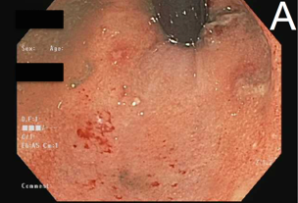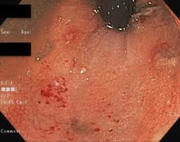

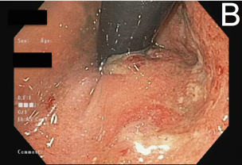
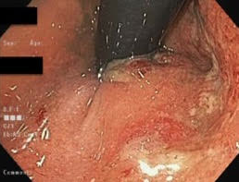

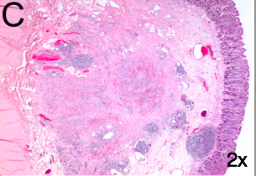
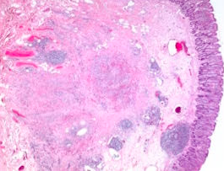

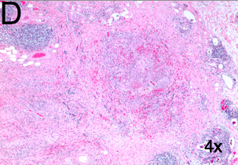
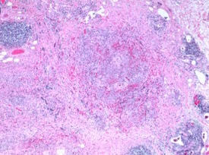

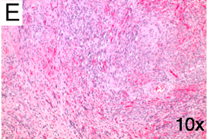
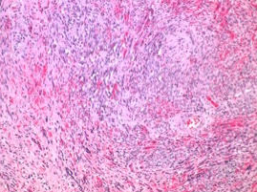

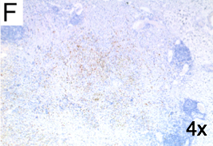
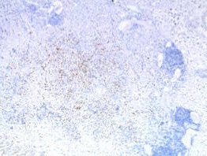

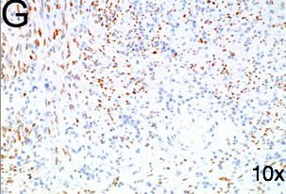
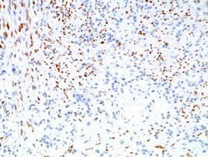

Figure 1 Colonoscopy, histologic and immunohistochemistry. A: A colonoscopy was performed following resolution of acute diverticulitis, revealing a tumor in the rectum. Biopsies of the colon revealed distal focal active colitis as well as more proximal crypt architectural irregularities and paneth cell metaplasia consistent with quiescent colitis. B: A colonoscopy was performed following resolution of acute diverticulitis, revealing a tumor in the rectum. Biopsies of the colon revealed distal focal active colitis as well as more proximal crypt architectural irregularities and paneth cell metaplasia consistent with quiescent colitis. C: Histologic sections of the rectal tumor demonstrated a cytologically bland spindle cell proliferation interspersed by irregular vascular spaces containing extravasated erythrocytes. D: Histologic sections of the rectal tumor demonstrated a cytologically bland spindle cell proliferation interspersed by irregular vascular spaces containing extravasated erythrocytes. E: Histologic sections of the rectal tumor demonstrated a cytologically bland spindle cell proliferation interspersed by irregular vascular spaces containing extravasated erythrocytes. F: By immunohistochemistry, the lesional cells were strongly positive for Human Herpesvirus-8 and consistent with Kaposi’s sarcoma. G: By immunohistochemistry, the lesional cells were strongly positive for Human Herpesvirus-8 and consistent with Kaposi’s sarcoma.

