Name of Journal: World Journal of Clinical Cases
Manuscript NO: 70437
Manuscript Type: CASE REPORT

Tracheal tube misplacement in the thoracic cavity: A case report

Li KX et al. Tracheal tube malposition into thoracic cavity

Ke-Xin Li, Yu-Ting Luo, Leng Zhou, Jia-Peng Huang, Peng Liang

Ke-Xin Li, Yu-Ting Luo, Leng Zhou, Department of Anesthesiology, West China Hospital, Chengdu 610041, Sichuan Province, China

Jia-Peng Huang, Department of Anesthesiology, University of Louisville, Louisville, KY 40202, United States

Peng Liang, Day Surgery Center, Department of Anesthesiology, West China Hospital, Chengdu 610041, Sichuan Province, China

Author contributions: Li KX, Luo YT, and Zhou L collected medical records of the patient; all authors were involved in the drafting and revision of this manuscript and approved the final version to be published.

Corresponding author: Peng Liang, MD, Associate Professor, Day Surgery Center, Department of Anesthesiology, West China Hospital, No. 37 Guoxue Alley, Wuhou District, Chengdu 610041, Sichuan Province, China. liangpengwch@scu.edu.cn

Received: August 2, 2021
Revised: September 9, 2021
Accepted: October 18, 2021
Published online:

Abstract
BACKGROUND
Penetrating neck injuries require prompt recognition, diagnosis and management of critical airways. This case demonstrates an emergent situation that a “medical negligence” was avoided with the aid of end-tidal carbon dioxide (ETCO₂) waveform.

CASE SUMMARY
We report a case of malposition of the endotracheal tube into the right hemithoracic cavity for cervical knife trauma, resulting in pneumothorax. Tube placement was not confirmed during emergency airway management, and the patient was directly transferred to the emergency operation room. Assisted by ETCO₂ and imaging examinations, the anesthetist timely noticed the absence of ETCO₂ waveform and resolved this urgent situation before anesthesia induction.

CONCLUSION
This case emphasizes the necessity of ETCO₂ waveform and/or X-ray confirmation of endotracheal intubation even in emergent situations.

Key Words: Penetrating neck injury; Tracheal injury; Endotracheal intubation; Malposition; Pneumothorax; Case report

Li KX, Luo YT, Zhou L, Huang JP, Liang P. Tracheal tube misplacement in the thoracic cavity: A case report. World J Clin Cases 2021; In press

Core Tip: We report a case of malposition of the endotracheal tube into the right hemithoracic cavity for cervical knife trauma, resulting in pneumothorax. Fortunately, the anesthetist timely noticed the absence of end-tidal carbon dioxide (ETCO₂) waveform and reviewed the thoracic computed tomography scanning just before anesthesia induction. This case highlights the role of ETCO₂ waveform and/or chest radiography in confirmation of emergency endotracheal intubation, especially for junior doctors and emergency physicians.

INTRODUCTION
Penetrating neck injuries (PNI) are neck injuries penetrating the platysma and represent 5% to 10% of all traumatic events with a high mortality rate due to unprotected airway and proximity to vital vascular structures and trachea^{[1,2]}. PNI requires anesthesiologists and surgeons to maintain vigilance on timely recognition, diagnosis, and management^{[2-4]}. Challenging airway management is inevitable^{[5]}. End-tidal carbon dioxide (ETCO₂) monitoring non-invasively detects the concentration of CO₂ at the end of expiration^{[6]}. And the appearance of ETCO₂ waveform is regarded as the golden standard for proper intubations. However, intubation without confirmation tends to happen, especially in urgent situations, such as PNI. Here we report a rare case of misplaced endotracheal tube into the thoracic cavity.

CASE PRESENTATION
Chief complaints
A 28-year-old female patient was admitted to the emergency department with knife injury to the neck for 12 h.

History of present illness
The patient was found to have tracheal injury 1cm below the thyroid cartilage with severe pain, active bleeding (the specific amount of blood loss was unknown) dyspnea, chest distress, shortness of breath and dysphonia. She was managed with compression packing at a local hospital and was transferred to our hospital for further management.

History of past illness
The patient had a disease-free personal and family history.

Personal and family history
The patient had not the special personal or family history.

Physical examination
On admission, the patient was awake with stable vital signs: temperature 36.6 ℃, pulse rate 98 bpm, respiratory rate 22/min and blood pressure 118/70 mmHg. Tissue deficits were identified on the left sternocleidomastoid muscles. Breath sounds were slightly diminished, and dry and moist rales were noticed on both upper lobes.

Laboratory examinations
Leucocyte count was 12.79 × 10⁹/L, where neutrophils accounted for 86.8%. And other examinations were all normal, such as hematocrit and hemoglobin count. Urine analysis was also normal. Prothrombin, partial thromboplastin times, and d-dimers were within normal ranges. Electrocardiogram showed a sinus rhythm.

Imaging examinations
After the endotracheal tube was inserted, the patient underwent urgent imaging examinations for operation preparation. Computed tomographic angiography (CTA) showed that there was no leakage, occlusion or expansion of cervical blood vessels and branches. Emergent cervical computed tomography (CT) scan revealed extensive gas accumulation in the mediastinum and underneath the cervical tissue, and continuous interruption in the anterior part of trachea. Chest CT scan demonstrated that the right hemithoracic cavity with limited pleural effusion was collapsed by 70% approximately. The patchy lesions and shadows suggested slight infection in the right hemithorax.

FINAL DIAGNOSIS
The patient was diagnosed with cervical knife trauma and tracheal injuries, which should be managed by emergency operation.

TREATMENT
The emergency medicine physician inserted a 6.5# endotracheal tube into the wound, and inflated the cuff to prevent bleeding from the lumen into the ruptured trachea. Right chest tube was placed for preventing suspected pneumothorax. The patient was immediately transferred to the operating room for exploration after CT scan was performed, but without final reading and confirmation.

OUTCOME AND FOLLOW-UP
The anesthetist was informed that the airway was secured without aspiration risks. However, the patient was agitated and in respiratory distress with 85% pulse oxygenation on room air. After the tracheal tube was connected with anesthesia circuit, the breathing bag of the anesthesia machine was expanding and shrinking during patient’s spontaneous breathing (25/min). However, ETCO₂ waveform was absent. CT scan was reviewed immediately and revealed that the endotracheal tube entered into the right hemithoracic cavity and the right lung was collapsed by 70% approximately due to extensive pneumothorax (Figure 1).
The anesthesiologist and otolaryngologist immediately reinserted the tracheal tube, connecting it to the ETCO₂ monitor. The tube placement was confirmed carefully before final fixation. Next, the patient underwent open neck exploration, tracheal end-to-end anastomosis, recurrent laryngeal nerve reconstruction and tracheotomy thereafter. The subsequent clinical course was uneventful, the patient was transferred into intensive care unit and discharged after two-week hospitalization.

DISCUSSION
We presented a case of tracheal tube misplacement into the thoracic cavity for neck injury. Although the emergency medicine physicians promptly evaluated and attempted to manage the airway with an awake endotracheal intubation, the tube was inserted into the thoracic cavity and produced pneumothorax. Because the patient was on spontaneous breathing and a chest tube was placed on the same side, breath sounds were heard bilaterally. The patient was sent immediately to the operating room assuming successful airway establishment. Successful airway management should have been confirmed with clinical evaluation, chest radiography, and ETCO₂ detection^{[4]}.
Iatrogenic tracheobronchial injuries by intubation have been reported^{[6-8]}, including tracheal laceration^{[9,10]} and subcutaneous emphysema^{[11-13]}. Incorrect tube sizes and reintubation may contribute to iatrogenic injuries with direct laryngoscopy after endotracheal intubation^{[14]}. Therefore, some studies recommended awake intubation, flexible fiberoptic bronchoscopy, or direct ultrasound visualization to avoid false passage and tracheal injury^{[15-18]}. When dealing with tracheal trauma from PNI, confirmation of the endotracheal tube placement by ETCO₂ waveform and/or X-ray/CT scan is mandatory.

CONCLUSION
Airway establishment is the priority option for tracheal injuries, which was an extremely urgent situation for PNI. Emergent evaluation and treatment are challenging. Negligence is inevitable, especially in emergency situations. This case highlights the role of ETCO₂ waveform and/or chest radiography in confirmation of emergent endotracheal intubation after emergent intubation, especially for junior doctors and emergent physicians.

REFERENCES
1 Shiroff AM, Gale SC, Martin ND, Marchalik D, Petrov D, Ahmed HM, Rotondo MF, Gracias VH. Penetrating neck trauma: a review of management strategies and discussion of the 'No Zone' approach. Am Surg 2013; 79: 23-29 [PMID: 23317595 DOI: 10.1177/000313481307900113]
2 Sgardello SD, Christodoulou M, Abbassi Z. Anatomy of a Suicide: A Case Report. Am J Case Rep 2019; 20: 1801-1804 [PMID: 31794545 DOI: 10.12659/AJCR.917993]
3 Triggiani E, Belsey R. Oesophageal trauma: incidence, diagnosis, and management. Thorax 1977; 32: 241-249 [PMID: 882938 DOI: 10.1136/thx.32.3.241]
4 Mandavia DP, Qualls S, Rokos I. Emergency airway management in penetrating neck injury. Ann Emerg Med 2000; 35: 221-225 [PMID: 10692187 DOI: 10.1016/s0196-0644(00)70071-0]
5 Hiraoka C, Ikuta Y, Yamamoto T. [A Case of Penetrating Injury of the Neck in Which It Was Difficult to Secure the Airway]. Masui 2015; 64: 1052-1055 [PMID: 26742407]
6 Siobal MS. Monitoring Exhaled Carbon Dioxide. Respir Care 2016; 61: 1397-1416 [PMID: 27601718 DOI: 10.4187/respcare.04919]
7 Schneider T, Storz K, Dienemann H, Hoffmann H. Management of iatrogenic tracheobronchial injuries: a retrospective analysis of 29 cases. Ann Thorac Surg 2007; 83: 1960-1964 [PMID: 17532378 DOI: 10.1016/j.athoracsur.2007.01.042]
8 Regragui IA, Fagan AM, Natrajan KM. Tracheal rupture after tracheal intubation. Br J Anaesth 1994; 72: 705-706 [PMID: 8024923 DOI: 10.1093/bja/72.6.705]
9 Borasio P, Ardissone F, Chiampo G. Post-intubation tracheal rupture. A report on ten cases. Eur J Cardiothorac Surg 1997; 12: 98-100 [PMID: 9262088 DOI: 10.1016/s1010-7940(97)00111-5]
10 Ross HM, Grant FJ, Wilson RS, Burt ME. Nonoperative management of tracheal laceration during endotracheal intubation. Ann Thorac Surg 1997; 63: 240-242 [PMID: 8993280 DOI: 10.1016/s0003-4975(96)01077-6]
11 Cunningham LC, Jatana KR, Grischkan JM. Conservative management of iatrogenic membranous tracheal wall injury: a discussion of 2 successful pediatric cases. JAMA Otolaryngol Head Neck Surg 2013; 139: 405-410 [PMID: 23599077 DOI: 10.1001/jamaoto.2013.75]
12 Watters KF, Lacy PD, Walsh RM. Massive subcutaneous emphysema following routine endotracheal intubation. J Laryngol Otol 2003; 117: 899-901 [PMID: 14670155 DOI: 10.1258/002221503322542953]
13 Harris R, Joseph A. Acute tracheal rupture related to endotracheal intubation: case report. J Emerg Med 2000; 18: 35-39 [PMID: 10645834 DOI: 10.1016/s0736-4679(99)00159-6]
14 Doherty KM, Tabaee A, Castillo M, Cherukupally SR. Neonatal tracheal rupture complicating endotracheal intubation: a case report and indications for conservative management. Int J Pediatr Otorhinolaryngol 2005; 69: 111-116 [PMID: 15627458 DOI: 10.1016/j.ijporl.2004.07.020]
15 Wood JW, Thornton B, Brown CS, McLevy JD, Thompson JW. Traumatic tracheal injury in children: a case series supporting conservative management. Int J Pediatr Otorhinolaryngol 2015; 79: 716-720 [PMID: 25792031 DOI: 10.1016/j.ijporl.2015.02.025]
16 Mercer SJ, Jones CP, Bridge M, Clitheroe E, Morton B, Groom P. Systematic review of the anaesthetic management of non-iatrogenic acute adult airway trauma. Br J Anaesth 2016; 117 Suppl 1: i49-i59 [PMID: 27566791 DOI: 10.1093/bja/aew193]
17 Turbitt L, Nawaz Y, Sharpe E. Mediastinal intubation following complete tracheal transection secondary to blunt trauma. Anaesth Intensive Care 2011; 39: 137-138 [PMID: 21375110 DOI: 10.1164/rccm.201009-1505IM]
18 Horton CL, Brown CA 3rd, Raja AS. Trauma airway management. J Emerg Med 2014; 46: 814-820 [PMID: 24582643 DOI: 10.1016/j.jemermed.2013.11.085]

Footnotes
Informed consent statement: Informed written consent was obtained from the patient for publication of this report and any accompanying images.

Conflict-of-interest statement: The authors declare that they have no conflict of interest.

CARE Checklist (2016) statement: The authors have read the CARE Checklist (2016), and the manuscript was prepared and revised according to the CARE Checklist (2016).

Open-Access: This article is an open-access article that was selected by an in-house editor and fully peer-reviewed by external reviewers. It is distributed in accordance with the Creative Commons Attribution NonCommercial (CC BY-NC 4.0) license, which permits others to distribute, remix, adapt, build upon this work non-commercially, and license their derivative works on different terms, provided the original work is properly cited and the use is non-commercial. See: https://creativecommons.org/Licenses/by-nc/4.0/

Manuscript source: Unsolicited manuscript

Peer-review started: August 2, 2021
First decision: September 1, 2021
Article in press:

Specialty type: Anesthesiology
Country/Territory of origin: China
Peer-review report’s scientific quality classification
Grade A (Excellent): 0
Grade B (Very good): B
Grade C (Good): C
Grade D (Fair): 0
Grade E (Poor): 0

P-Reviewer: Beşler MS, Masaki S S-Editor: Yan JP L-Editor: A P-Editor: Yan JP

Figure Legends
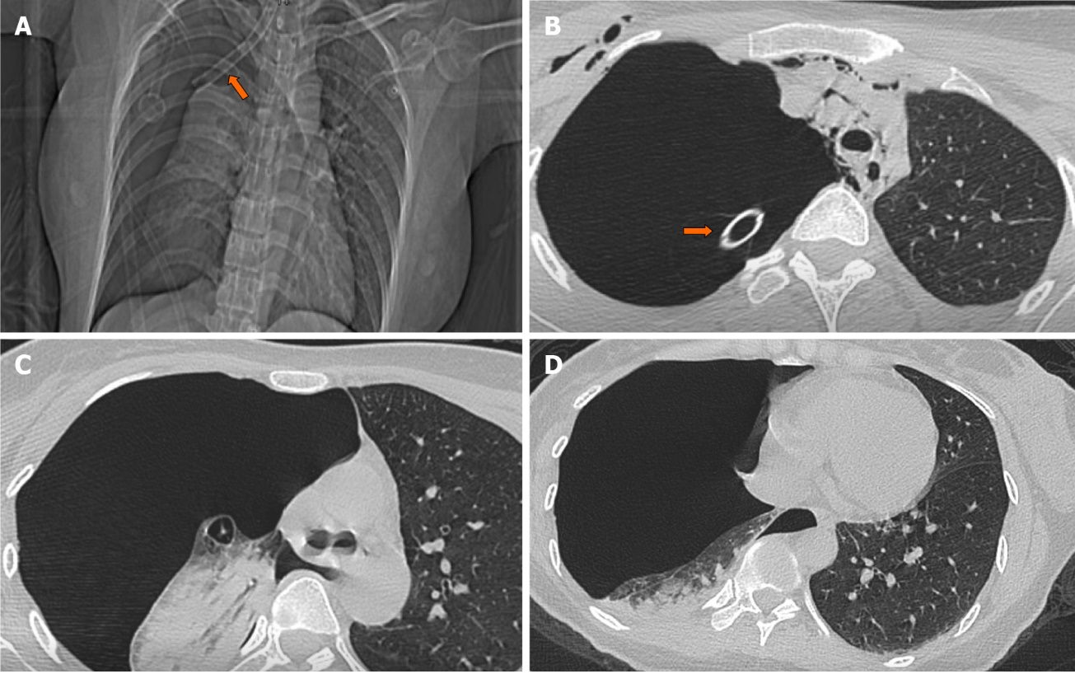
Figure 1 X-ray and computed tomography findings after insertion of endotracheal tube and right chest tube. A and B: X ray (A) and computed tomography (CT, B) scan images revealed that there was a tracheal tube inserted into the right hemithorax (orange arrow); C and D: CT scan images showed that right pulmonary markings were absent, and right lung was condensed. The right lung was condensed by 70% and the mediastinum shifted to the right side.

