Name of Journal: World Journal of Clinical Cases
Manuscript NO: 85057
Manuscript Type: CASE REPORT

Poststroke rehabilitation using repetitive transcranial magnetic stimulation during pregnancy: A case report

Joong Ho Jo et al. Safety and effectiveness of TMS during pregnancy

Joongho JO, Hyojong KIM

Joongho JO, Department of Rehabilitation Medicine, Chungbuk National University Hospital, Cheongju-si 28644, Chungbuk, South Korea

Hyojong KIM, Department of Rehabilitation Medicine, Chungbuk National University Hospital, Cheongjusi 28644, Chungbuk, South Korea

Author contributions: Jo JH contributed to manuscript writing and editing and case selection; Kim HJ contributed to manuscript supervision; all authors have read and approved the final manuscript.

Corresponding author: Hyojong KIM, MD, PhD, Professor, Department of Rehabilitation Medicine, Chungbuk National University Hospital, Department of Rehabilitation Medicine, Chungbuk National University Hospital, 776, Sunhwan-ro, Seowon-gu, Cheongju 28644, Korea, Cheongjusi 28644, Chungbuk, South Korea. hyojong80@gmail.com

Received: April 10, 2023
Revised: May 22, 2023
Accepted: June 9, 2023
Published online:

Abstract
BACKGROUND
Repetitive transcranial magnetic stimulation (rTMS) is a form of magnetic stimulation therapy used to treat depression, migraine, and motor function impairment in patients with stroke. As there is little research on the effects of rTMS in pregnant women, it is not widely used in these patients. This case report aimed to demonstrate the safety of rTMS in pregnant patients.

CASE SUMMARY
After much consideration, we applied rTMS to treat recent stroke and hemiplegia in a 34-year-old pregnant woman. The patient received 45 sessions of low-frequency treatment over the course of 10 wk. We closely monitored the mother and fetus for potential side effects; the results showed significant improvement in the patient's motor function, with no harmful effects on the mother or fetus during pregnancy or after delivery. The patient’s fine motor and walking functions improved after treatment. This case is the first instance of a stroke patient treated with rTMS during pregnancy.

CONCLUSION
This case demonstrates that rTMS could be used to improve motor function recovery in stroke patients during pregnancy.

Key Words: Health; Pregnancy; Rehabilitation; Stroke; Transcranial magnetic stimulation; Case report

JO J, KIM H. Poststroke rehabilitation using repetitive transcranial magnetic stimulation during pregnancy: A case report. World J Clin Cases 2023; In press

Core Tip: This case report describes the use of repetitive transcranial magnetic stimulation (rTMS) to improve the motor function of a patient after stroke. The patient was pregnant, but low-frequency rTMS was deemed to be safe and was administered for 10 wk. After treatment, the patient regained function in her hands and was able to walk without a cane, and no side effects were observed in the patient or her baby. This case demonstrates that rTMS can be used safely in pregnant patients.

INTRODUCTION
As society ages, the incidence and mortality rates of stroke remain high, and interest in active rehabilitation therapy has grown^{[1]}. Repetitive transcranial magnetic stimulation (rTMS) is a noninvasive therapy that uses magnetic fields to modulate the activity of specific cortical areas, and it is widely used to aid motor function recovery in stroke patients, as well as to alleviate depression and migraines^{[2-4]}. In cases of severe motor deficits in affected limbs after stroke, early and aggressive treatment is necessary to prevent long-term impairment^{[5]}. Therefore, in clinical settings, rTMS is actively utilized as an early rehabilitation option for patients with hemiplegia^{[6]}. A combination of rTMS and physical therapy was found to be more effective than physical therapy alone in stroke patients^{[7]}.
Caution is advised regarding the use of rTMS in patients with severe cerebral hemorrhage or in pregnant women, owing to the potential risks involved. However, a recent study reported a positive outcome when rTMS was applied to patients with perinatal depression. No side effects were observed in patients who underwent rTMS, and no issues were found in their newborns, indicating that rTMS could be a safe alternative for new mothers with depression^{[8]}.
Based on this previous study, we considered the use of rTMS as an early and active treatment option for a pregnant stroke patient with severe hemiplegia. After careful consideration, we decided to apply rTMS in combination with conventional rehabilitation therapy to improve the prognosis of a young mother who suffered a stroke during pregnancy.

CASE PRESENTATION
Chief complaints
A 34-year-old pregnant woman at 24+0 wk of gestation presented to the emergency room with dysarthria and right-sided weakness.

History of present illness
A pregnant women at 24 wk gestation (para 0) presented to our emergency department on 28 November 2022 at approximately 1:50 am with decreased consciousness. In the emergency room, the patient complained of dysarthria and right hemiparesis, with an initial National Institutes of Health Stroke Scale (NIHSS) score of 14.

History of past illness
The patient had no underlying medical conditions, and all routine prenatal checks since conception were normal, including the screening for chromosomal abnormalities (at 11-14 wk and 16-18 wk gestation), nuchal translucency measurement (at 11-14 wk gestation), and fetal ultrasound (at 20-24 wk gestation).

Personal and family history
The patient reported a history of two intrauterine insemination cycles and five in vitro fertilization cycles with embryo transfer. She had experienced no complications (such as preeclampsia) during the current pregnancy.

Physical examination
The initial evaluation performed by the Department of Rehabilitation Medicine demonstrated that the patient had completely flaccid upper and lower extremity muscles on the right side; she was unable to walk and had an NIHSS score of 14.

Laboratory examinations
All of the following tests conducted to check for complications in the mother and fetus were normal: Blood pressure tests, blood glucose tests, other blood tests, echocardiography, 24-hour Holter monitoring, Doppler ultrasound of the leg, pulse wave velocity and ankle-brachial index measurements, transcranial Doppler ultrasound, and duplex Doppler ultrasound of the carotid arteries. In addition, all blood tests related to autoimmune diseases were normal.

Imaging examinations
Imaging tests conducted upon admission revealed acute infarction in the left side of the corpus callosum, thalamus, occipital lobe, pons, and midbrain (Figure 1).

FINAL DIAGNOSIS
Based on the patient’s medical history, the final diagnosis was acute infarction in the left side of the corpus callosum, thalamus, occipital lobe, pons, and midbrain.

TREATMENT
The patient received enoxaparin at a dose of 1 mg/kg twice daily as medical treatment for suspected hypercoagulability. In addition, she received functional electrical stimulation for right ankle dorsiflexor and mat activity as well as gait training for 20 minutes twice a day, five days a week. She received occupational therapy for the recovery of fine motor function and activities of daily living for 30 min per day, 5 d a week. She also received speech therapy for dysarthria once a week for 30 min. After much consideration, we decided to use rTMS therapy in combination with conventional rehabilitation therapy to promote the patient's motor recovery. We used the rTMS protocol reported by Kim et al^{[9]} and administered 45 sessions of rTMS over 10 wk.

OUTCOME AND FOLLOW-UP
After three weeks of combined therapy, the patient was able to walk with a cane and showed significant improvement in upper extremity muscle strength and hand function (Table 1) (Video 1). At the time of delivery, she was able to raise her right hand above her head, use both hands to type on a laptop, and walk with a cane under supervision (Figure 2). During the 10 wk of rTMS therapy, the patient did not report any significant side effects, and detailed fetal monitoring did not reveal any fetal dysfunction. Intensive rehabilitation therapy and rTMS therapy continued until three days before delivery. The delivery was performed by cesarean section at 37+3 wk of gestation, and the newborn weighed 2900 g with Apgar scores of 10 at 1 and 5 minutes. Both the mother and newborn had normal vital signs and postpartum examinations. After an additional four days of monitoring and testing, they were discharged to a postpartum care center with no reported complications.

DISCUSSION
Neuroplasticity-induced cortical reorganization is a crucial mechanism for motor recovery in patients with stroke, and rTMS is commonly used as a treatment to enhance neuroplasticity^{[10,11]}. In this case, the patient was a pregnant woman with only three months left until delivery. In addition, due to cerebral infarction, she was almost completely paralyzed on one side and was unable to walk. If this patient had not received appropriate rehabilitation treatment in a timely manner, her motor disabilities could have persisted, and the risk of fetal growth restriction or even miscarriage could have increased. Conventional rehabilitation activities; therefore, additional therapies are needed. Although no previous studies have reported the use of rTMS in pregnant patients after stroke, there have been reports in which rTMS was used safely for the treatment of perinatal depression. Therefore, based on this evidence and with the consent of the patient and her family, we decided to perform rTMS. Currently, there is no standard rTMS procedure to improve motor function recovery in patients with early stroke. However, according to a study by Du et al^{[12]}, both high-frequency (HF; > 10 Hz) rTMS over the ipsilesional primary motor cortex and low-frequency (LF; 1 Hz) rTMS over the contralesional primary motor cortex are effective in improving motor function. To minimize any potential negative effects on the mother or fetus caused by HF rTMS, we used LF rTMS, and treatment was stopped three days before delivery. The mother underwent a total of 45 treatments over 10 wk using inhibitory mode rTMS, and we actively monitored vital signs and side effects during each treatment session. We also ensured that all periodic obstetric examinations were performed, and all examinations demonstrated normal results. The patient's motor function gradually improved during treatment, and at the time of delivery, she was able to use both hands to type on a laptop, and her ability to walk with a cane (under supervision) had significantly improved. With no previously published cases, there were concerns about the safety of using rTMS in a poststroke pregnant patient; however, this case demonstrates that rTMS can be safely used in such patients and can greatly aid in motor recovery when combined with conventional rehabilitation therapy. This case has significant implications for the treatment of poststroke pregnant patients with motor deficits.

CONCLUSION
Stroke during pregnancy is a rare but serious condition that can cause neurological deficits. Active rehabilitation therapy is necessary for functional recovery. In this patient with severely impaired motor function, the combination of rTMS and rehabilitation therapy was effective in improving function, and there was no harm to the fetus or mother. Therefore, rTMS may be a good therapeutic tool for perinatal stroke treatment.

REFERENCES
1 Jung SH. Stroke Rehabilitation Fact Sheet in Korea. Ann Rehabil Med 2022; 46: 1-8 [PMID: 35272435 DOI: 10.5535/arm.22001]
2 Medical Advisory Secretariat. Repetitive transcranial magnetic stimulation for the treatment of major depressive disorder: an evidence-based analysis. Ont Health Technol Assess Ser 2004; 4: 1-98 [PMID: 23074457]
3 Lan L, Zhang X, Li X, Rong X, Peng Y. The efficacy of transcranial magnetic stimulation on migraine: a meta-analysis of randomized controlled trails. J Headache Pain 2017; 18: 86 [PMID: 28831756 DOI: 10.1186/s10194-017-0792-4]
4 Málly J, Dinya E. Recovery of motor disability and spasticity in post-stroke after repetitive transcranial magnetic stimulation (rTMS). Brain Res Bull 2008; 76: 388-395 [PMID: 18502315 DOI: 10.1016/j.brainresbull.2007.11.019]
5 Gao C, Pu SX, Zhu DY. [Effects of early rehabilitation on motor function of upper and lower extremities and activities of daily, living in patients with hemiplegia after stroke]. Zhongguo Kangfu Yixue Zazhi 2001; 1: 27-29
6 Dionísio A, Duarte IC, Patrício M, Castelo-Branco M. The Use of Repetitive Transcranial Magnetic Stimulation for Stroke Rehabilitation: A Systematic Review. J Stroke Cerebrovasc Dis 2018; 27: 1-31 [PMID: 29111342 DOI: 10.1016/j.jstrokecerebrovasdis.2017.09.008]
7 Barros Galvão SC, Borba Costa dos Santos R, Borba dos Santos P, Cabral ME, Monte-Silva K. Efficacy of coupling repetitive transcranial magnetic stimulation and physical therapy to reduce upper-limb spasticity in patients with stroke: a randomized controlled trial. Arch Phys Med Rehabil 2014; 95: 222-229 [PMID: 24239881 DOI: 10.1016/j.apmr.2013.10.023]
8 Zhang D, Hu Z. RTMS may be a good choice for pregnant women with depression. Arch Womens Ment Health 2009; 12: 189-190 [PMID: 19238519 DOI: 10.1007/s00737-009-0058-5]
9 Kim JS, Kim DH, Kim HJ, Jung KJ, Hong J, Kim DY. Effect of Repetitive Transcranial Magnetic Stimulation in Post-stroke Patients with Severe Upper-Limb Motor Impairment. Brain Neurorehabil 2020; 13: e3 [PMID: 36744269 DOI: 10.12786/bn.2020.13.e3]
10 Buma F, Kwakkel G, Ramsey N. Understanding upper limb recovery after stroke. Restor Neurol Neurosci 2013; 31: 707-722 [PMID: 23963341 DOI: 10.3233/RNN-130332]
11 Adeyemo BO, Simis M, Macea DD, Fregni F. Systematic review of parameters of stimulation, clinical trial design characteristics, and motor outcomes in non-invasive brain stimulation in stroke. Front Psychiatry 2012; 3: 88 [PMID: 23162477 DOI: 10.3389/fpsyt.2012.00088]
12 Du J, Yang F, Hu J, Hu J, Xu Q, Cong N, Zhang Q, Liu L, Mantini D, Zhang Z, Lu G, Liu X. Effects of high- and low-frequency repetitive transcranial magnetic stimulation on motor recovery in early stroke patients: Evidence from a randomized controlled trial with clinical, neurophysiological and functional imaging assessments. Neuroimage Clin 2019; 21: 101620 [PMID: 30527907 DOI: 10.1016/j.nicl.2018.101620]

Footnotes
Informed consent statement: Informed written consent was obtained from the patient for publication of this report and accompanying images.

Conflict-of-interest statement: No potential conflicts of interest relevant to this article were reported.

CARE Checklist (2016) statement: The authors have read the CARE Checklist (2016), and the manuscript was prepared and revised according to the CARE Checklist (2016).

Open-Access: This article is an open-access article that was selected by an in-house editor and fully peer-reviewed by external reviewers. It is distributed in accordance with the Creative Commons Attribution NonCommercial (CC BY-NC 4.0) license, which permits others to distribute, remix, adapt, build upon this work non-commercially, and license their derivative works on different terms, provided the original work is properly cited and the use is non-commercial. See: https://creativecommons.org/Licenses/by-nc/4.0/

Provenance and peer review: Unsolicited article; Externally peer reviewed.
Peer-review model: Single blind

Peer-review started: April 10, 2023
First decision: May 12, 2023
Article in press:

Specialty type: Rehabilitation
Country/Territory of origin: South Korea
Peer-review report’s scientific quality classification
Grade A (Excellent): 0
Grade B (Very good): 0
Grade C (Good): C, C
Grade D (Fair): 0
Grade E (Poor): 0

P-Reviewer: luo W, China; Shao A, China S-Editor: Ma YJ L-Editor: A P-Editor: Ma YJ
Figure Legends
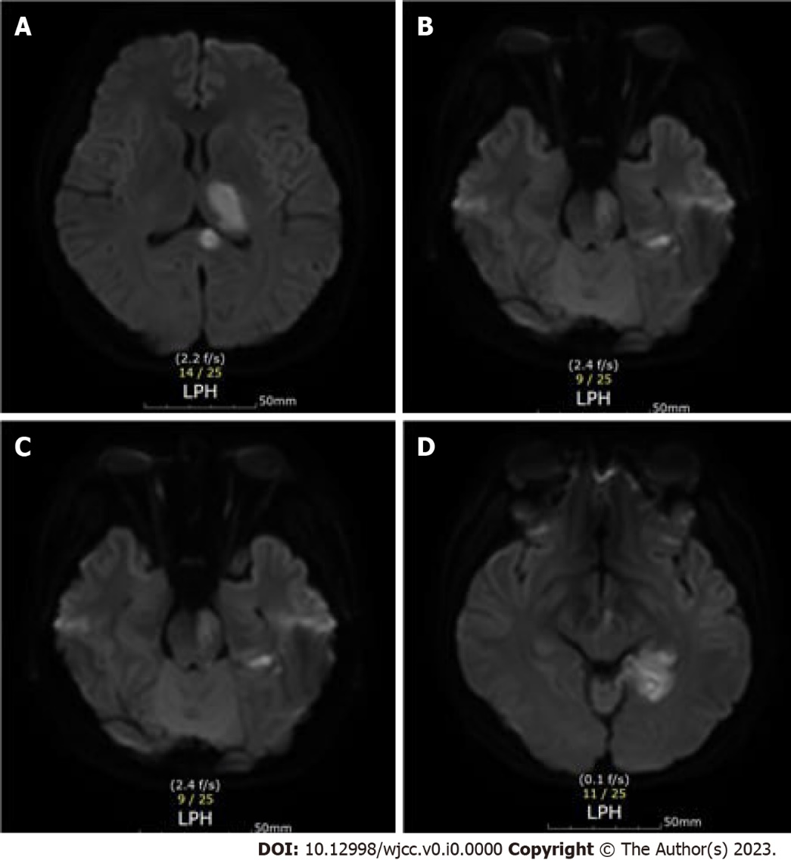
Figure 1 Cerebral infarction lesion shown on a brain magnetic resonance imaging image. A: Left corpus callosum and thalamus; B: Left occipital lobe; C: Left pons; D: Left midbrain.

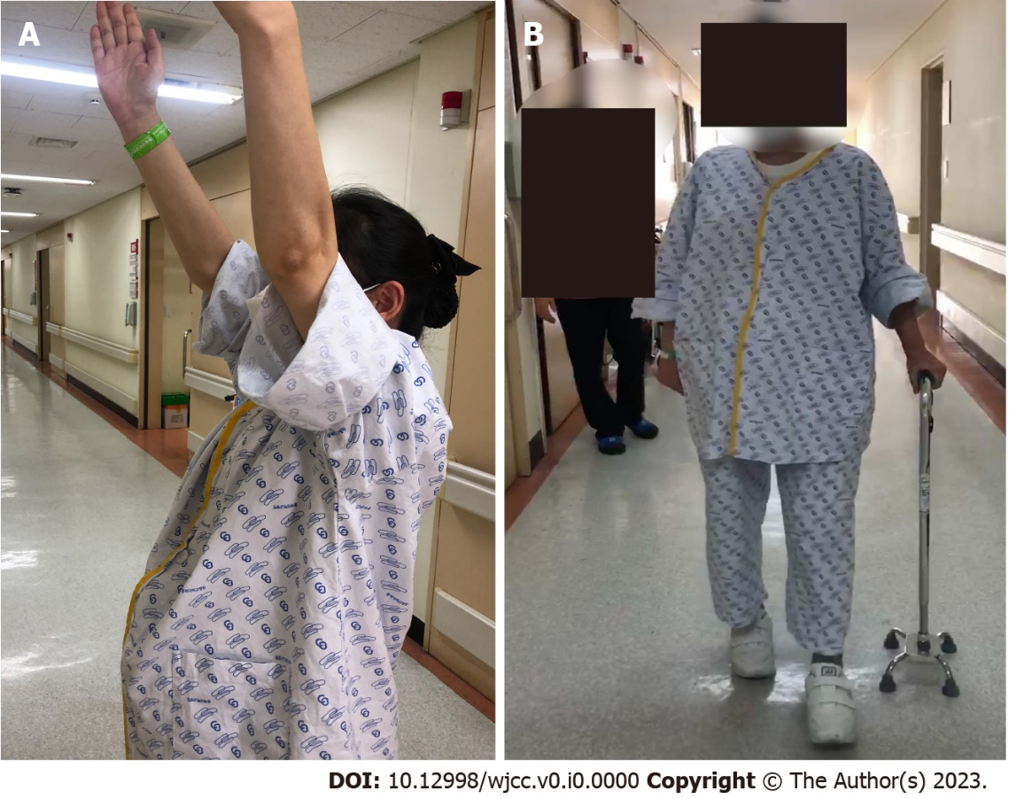
Figure 2 Images of the patient after completing repetitive transcranial magnetic stimulation sessions. A: Hand elevation; B: Walking with a cane under supervision.
Table 1 Timecourse of motor recovery as determined at 3, 6 and 10 weeks after the combination of repetitive transcranial magnetic stimulation and rehabilitation therapy
Assessment | Baseline | 3 wk | 6 wk | 10 wk
Purdue test | 0/8 | 0/10 | 1/13 | 4/15
Grip power(kg) | 0/12 | 6/14 | 12/16 | 12/16
JHFT | 0/80 | 2/85 | 14/85 | 17/85
FAC | 0 | 2 | 3 | 4
MBI | 10 | 40 | 64 | 75
MRS | 5 | 4 | 4 | 3
RTMS: Repetitive transcranial magnetic stimulation; JHFT: Jebsen hand function test; FAC: Functional ambulatory category; MBI: Modified barthel index; MRS: Modified rankin scale.

