Name of Journal: World Journal of Orthopedics
Manuscript NO: 76080
Manuscript Type: ORIGINAL ARTICLE

Retrospective Cohort Study
Association between tourniquet use and intraoperative blood loss during below-knee amputation

Wyland AE et al. Tourniquet use in below knee amputation

Alden E Wyland, Erik Woelber, Liam H Wong, Jordan Arakawa, Zachary M Working, James Meeker

Alden E Wyland, Liam H Wong, School of Medicine, Oregon Health and Sciences University, Portland, OR 97239, United States

Erik Woelber, Jordan Arakawa, Zachary M Working, James Meeker, Department of Orthopaedics and Rehabilitation, Oregon Health and Sciences University, Portland, OR 97239, United States

Author contributions: Woelber E, Meeker J and Working Z contributed the study conception and design; Wyland AE, Wong LH and Arakawa J contributed the generation, collection of the data; Wyland AE and Woelber E contributed the assembly, analysis and/or interpretation of the data; Wyland A, Woelber E, Meeker J and Working Z contributed to drafting and revising the manuscript.

Corresponding author: James Meeker, MD, Assistant Professor, Department of Orthopaedics and Rehabilitation, Oregon Health and Sciences University, 3181 SW Sam Jackson Road, Portland, OR 97239, United States. meekerj@ohsu.edu

Received: February 28, 2022
Revised: May 27, 2022
Accepted: July 6, 2022
Published online:

Abstract
BACKGROUND
Despite over 150000 amputations of lower limbs annually, there remains a wide variation in tourniquet practice patterns and no consensus on their necessity, especially among orthopedic patient populations. The purpose of this study was to determine whether tourniquet use in orthopedic patients undergoing below knee amputation (BKA) was associated with a difference in calculated blood loss relative to no tourniquet use.

AIM
To determine if tourniquet use in orthopedic patients undergoing BKA was associated with a difference in calculated blood loss relative to no tourniquet use.

METHODS
We performed a retrospective review of consecutive patients undergoing BKA by orthopedic surgeons at a tertiary care hospital from 2008 through 2018. Blood loss was calculated using a combination of the Nadler equation for preoperative blood volume and a novel formula utilizing preoperative and postoperative hemoglobin levels and transfusions. Univariate and forwards step-wise multivariate linear regressions were performed to determine the association between tourniquet use and blood loss. A Wilcoxon was used to determine the univariate relationship between tourniquet use and blood loss for in the restricted subgroups of patients who underwent BKA for trauma, tumor, and infection.

RESULTS
Of 97 eligible patients identified, 67 underwent surgery with a tourniquet and 30 did not. In multivariate regression, tourniquet use was associated with a 488 mL decrease in calculated blood loss (CI 119-857, P = 0.01). In subgroup analysis, no individual group showed a statistically significant decrease in blood loss with tourniquet use. There was no significant association between tourniquet use and either postoperative transfusions or reoperation at one year.

CONCLUSION
We found that tourniquet use during BKA is associated with decreased calculated intraoperative blood loss. We recommend that surgeons performing this procedure use a tourniquet to minimize blood loss.

Key Words: Amputation; Tourniquet; Blood loss; Hemostasis

Wyland AE, Woelber E, Wong LH, Arakawa J, Working ZM, Meeker J. Association between tourniquet use and intraoperative blood loss during below-knee amputation. World J Orthop 2022; In press

Core Tip: We retrospectively evaluated 138 patients who underwent a below knee amputation by an orthopedic surgeon and compared the calculated intraoperative blood loss between patients who received or did not receive a tourniquet. We found that patients who did receive a tourniquet had significantly lower blood loss than those who did not.
INTRODUCTION
Since its 2nd century introduction to amputation surgery by Heliodorus, the tourniquet has been nearly as enduring as the knife itself^{[1,2]}. Yet despite the amputation of over 150000 Lower limbs annually in the United States, there are wide variations in tourniquet practice patterns and no consensus on their necessity during limb removal^{[3]}.
Tourniquet application during limb amputation is controversial. Historically, the high rate of mortality associated with early amputations was attributed to both delayed septicemia and immediate blood loss, leading surgeons such as Esmarch, Lister, and Cushing to improve upon early designs during the 19th and 20th centuries^{[2]}. Today, tourniquet use is associated with decreased intraoperative blood loss and fewer transfusions in below knee amputations performed primarily in vascular surgery settings^{[4,5]}. However, this has hardly settled the question of whether they should be used routinely for hemorrhage control during orthopedic limb removal. Throughout the dissection, use of a tourniquet may provide a drier surgical field by slowing intraoperative bleeding, but at the same time may limit the palpation of neurovascular structures^{[6-8]}. Additionally, blood loss continues beyond the intraoperative period, and application of a tourniquet may prevent the surgeon from identifying damage to small vessels that continue to ooze postoperatively. There is also a theoretical risk of damaging fragile atherosclerotic vessels as pneumatic pressure increases, leading to swelling and blood loss in the perioperative period after the tourniquet has been removed^{[9]}. This may explain studies finding no difference in total blood loss or transfusions with tourniquet use in studies of both below knee amputation and total knee arthroplasty^{[9-12]}.
There is a paucity of literature describing the association between tourniquet use and blood loss during below knee amputation in orthopedic populations, which include patients undergoing surgery for neoplastic disease, trauma, and infection^{[11]}. Furthermore, blood loss in prior studies has typically been recorded using surgeon estimation, which is subjective, imprecise, and does not account for perioperative “hidden” blood loss that continues after closure of the wound^{[10,13,14]}.
The primary purpose of this study was to determine whether tourniquet use in orthopedic patients undergoing below knee amputation was associated with a difference in calculated blood loss relative to no tourniquet use. Secondarily, we assessed whether tourniquet application was associated with postoperative transfusions during the inpatient stay or reoperation within one year. We hypothesized that tourniquet use would not be associated with decreased blood loss, postoperative transfusions, or reoperation within one year.

MATERIALS AND METHODS
With Institutional Review of Board approval, we retrospectively reviewed consecutive patients undergoing below knee amputation by orthopedic surgeons at a single academic institution over a ten-year period from January 1, 2008 to December 31, 2018. The hospital is a tertiary referral center for soft tissue sarcomas and a Level 1 trauma center. This study was conducted following STROBE guidelines^{[15]}.
Patients were identified by CPT code for below-knee amputation. To prevent confounding by other sources of bleeding, patients were excluded if the indication for below-knee amputation was a trauma that had occurred within one week, if they had active gastrointestinal bleeding, or if they had a diagnosed bleeding disorder. We excluded patients with through-knee amputations.
Data for identified patients was collected from chart review including demographic characteristics (e.g., age, sex), known or potential modifiers of blood loss (e.g., kidney dysfunction, platelet count), and surgical data (e.g., indication for surgery, intraoperative transfusions). A full list of variables that were collected can be found in Supplemental Table 1. Tourniquet use and tourniquet time were taken from surgeon operative reports. Post-operative hemoglobin and hematocrit results were taken within 72 h of the operation. We used the first post-operative hemoglobin in blood loss calculations.
Blood loss was determined using a series of calculations. Preoperative blood volume was calculated using patient height, weight, and gender by the Nadler formula^{[16]}:
Blood volume (Male) = 0.3669 × H³ + 0.03219 × W + 0.6041.
Blood volume (Female) = 0.3561 × H³ + 0.03308 × W + 0.1833.
Total blood loss was then determined using calculated blood volume, change in hemoglobin concentration, and the mass of hemoglobin transfused intraoperatively, based on modification of the formula by Wied et al^{[10]}: Total mass of Hgb lost = Blood volume (L) ×(Hgb preop - Hgb postop) × 10 + mass of transfused Hgb. Where mass of transfused Hgb = 61.25g × intraoperative units transfused^{[16]}. Blood loss (L)= total mass of Hgb lost/ (Hgb preop × 10).
We excluded five variables with > 5% data missingness (functional capacity, erythrocyte sedimentation rate, C-reactive protein, A1c, and albumin). The only remaining variable with missing data (creatinine, 2%) was included in regression analysis. Characteristics of patients undergoing below knee amputation with and without tourniquet were compared using t tests or chi square tests as appropriate.
For our primary outcome, we performed a univariate linear regression to determine the association between tourniquet use and blood loss. We also ran subgroup analyses by indication for surgery, using a Wilcoxon due to the non-parametric distribution of blood loss and the low number of observations in each subgroup. We then performed a forward stepwise regression with potential modifiers of the association between tourniquet use and blood loss, sequentially retaining variables that changed the estimation of the association by greater than 10 percent. We excluded the surgeon as a variable from this analysis as it was thought to lie on a causal pathway between indication and blood loss and was not generalizable. We also excluded operative time due to the directionality of its association with tourniquet use and because it likely lies along the causal pathway between tourniquet use and blood loss^{[11]}. To avoid spurious associations, we only included variables that were logically associated tourniquet use and blood loss, and limited the variables tested to 10% of the number of observations. We included interaction terms for variables of interest.
We then performed two logistic regressions in a similar fashion using postoperative transfusion and reoperation in one year as outcomes. Postoperative transfusions were only included if administered during the immediate inpatient stay. Reoperations included stump revisions, revision to a higher-level amputation (e.g., above-the-knee), and irrigation and debridement.
All statistical analysis was performed using R version 3.6.3 including the packages tableone, dplyr, ggplot2, and chest. Statistical significance was determined at 0.05. The study was reviewed by our statistician Dr. Erik Woelber.

RESULTS
138 patients undergoing below knee amputation were identified by chart review. 41 patients were excluded because they sustained a trauma within the prior week, leaving 97 patients for analysis. Of the patients identified, 67 underwent surgery with a tourniquet and 30 did not. Indications included infection (69%, n = 67), trauma (11%, n = 11), and tumor (20%, n = 19). Demographic characteristics are shown in Table 1. The tourniquet group was older (56 vs 43 years, P < 0.001) and had categorical differences in indication for surgery (P < 0.001).
In simple linear regression, tourniquet use was associated with significantly decreased blood loss (-0.41 Liters, SE 0.17, P = 0.01) (Figure 1). The calculation allowed for negative blood loss values to occur for 6 patients (6%). The plots reveal a right-skewed distribution of calculated blood loss for both tourniquet and non-tourniquet patients. In the analysis of restricted subgroups, no individual group showed a statistically significant decrease in blood loss with tourniquet use (Figure 2).
Results of multivariate regression are shown in Table 2. Of the tested variables, only the indication for surgery modified the association between tourniquet use and blood loss above the 10% threshold for inclusion. Though it differed significantly between tourniquet and non-tourniquet groups, age did not significantly modify the association between tourniquet use and blood loss. Two patients with missing data for creatinine were excluded from stepwise regression modelling but were included in the final multivariate model. The interaction term between tourniquet use and indication for surgery was not significant (P = 0.84 for trauma and P = 0.99 for tumor, relative to infection).
Thirteen patients in the tourniquet group (19%) and six patients in the non-tourniquet group (20%) received a postoperative transfusion. Twenty patients in the tourniquet group (30%) and 13 patients in the non-tourniquet group (43%) underwent an unplanned reoperation within one year of the index surgery. Adjusted secondary analyses showed no statistically significant association between tourniquet use and either inpatient blood transfusion after the first postoperative lab draw (OR 0.83, CI 0.25-2.72, P = 0.75) or reoperation at one year (OR 0.84, CI 0.26-2.79, P = 0.78).

DISCUSSION
We found that tourniquet use during below knee amputation is associated with decreased calculated intraoperative blood loss. The decision to use a tourniquet depends on multiple factors related to the individual patient, the underlying pathology being treated, and surgeon preferences. However, based on these results, we recommend that surgeons performing this procedure use a tourniquet if they wish to minimize blood loss. Analysis of a larger database may provide supporting evidence for tourniquet use in specific patient subgroups including patients with malignant tumors and those who sustained acute traumatic injury.

CONCLUSION
We found that tourniquet use during below knee amputation is associated with decreased calculated intraoperative blood loss. The decision to use a tourniquet depends on multiple factors related to the individual patient, the underlying pathology being treated, and surgeon preferences. However, based on these results, we recommend that surgeons performing this procedure use a tourniquet if they wish to minimize blood loss. Analysis of a larger database may provide supporting evidence for tourniquet use in specific patient subgroups including patients with malignant tumors and those who sustained acute traumatic injury.

ARTICLE HIGHLIGHTS
Research background
Below-knee amputation (BKA) is common procedure in the orthopedic population. Etiology for patients requiring this surgery are primarily trauma, infection, and neoplastic disease. There is currently no consensus among orthopedic surgeons regarding the use of a tourniquet in these patients.

Research motivation
The motivation behind this study is to determine a possible method to minimize blood loss in BKA operations.

Research objectives
To compare blood loss between patients who received a tourniquet during their BKA procedure and those who did not.

Research methods
We performed a retrospective cohort study on consecutive patients who underwent BKA over a ten-year period at a tertiary care hospital. Blood loss was estimated using the Nadler equation for preoperative blood volume and a novel formula that utilizes preoperative and postoperative hemoglobin levels and transfusions. Univariate and forwards stepwise multivariate linear regression were utilized to determine an association between tourniquet use and blood loss.

Research results
We found that patients undergoing a BKA operation with tourniquet use were associated with a 488 mL decrease in calculated blood loss. This is significant for orthopedic surgeons wanting to minimize blood loss in BKA operations.

Research conclusions
This study utilized a calculated blood loss rather than the commonly utilized estimated blood loss, and proposes that a tourniquet should be used if orthopedic surgeons wish to minimize blood loss in BKA operation.

Research perspectives
Research should be conducted on a larger population across multiple centers to determine a stronger association and increase external validity.

REFERENCES
1 Kirkup J. A History of Limb Amputation. London: Springer, 2007: 1-12 [DOI: 10.1002/bjs.6331]
2 Bowker JH, Pritham CH. The history of amputation surgery and prosthetics. In: Smith DG, editor. Atlas of Amputation and Limb Deficiencies: Surgical, Prosthetic and Rehabilitation Principles, 3rd edition. Rosemont, IL: AAOS, 2004: 3-21 [DOI: 10.1007/s10016-006-9117-9]
3 Dillingham TR, Pezzin LE, MacKenzie EJ. Limb amputation and limb deficiency: epidemiology and recent trends in the United States. South Med J 2002; 95: 875-883 [PMID: 12190225 DOI: 10.1097/00007611-200208000-00018]
4 Wolthuis AM, Whitehead E, Ridler BM, Cowan AR, Campbell WB, Thompson JF. Use of a pneumatic tourniquet improves outcome following trans-tibial amputation. Eur J Vasc Endovasc Surg 2006; 31: 642-645 [PMID: 16427337 DOI: 10.1016/j.ejvs.2005.11.018]
5 Choksy SA, Lee Chong P, Smith C, Ireland M, Beard J. A randomised controlled trial of the use of a tourniquet to reduce blood loss during transtibial amputation for peripheral arterial disease. Eur J Vasc Endovasc Surg 2006; 31: 646-650 [PMID: 16750790 DOI: 10.1016/j.ejvs.2006.03.008]
6 Jarolem KL, Scott DF, Jaffe WL, Stein KS, Jaffe FF, Atik T. A comparison of blood loss and transfusion requirements in total knee arthroplasty with and without arterial tourniquet. Am J Orthop (Belle Mead NJ) 1995; 24: 906-909 [PMID: 8776080]
7 Aglietti P, Baldini A, Vena LM, Abbate R, Fedi S, Falciani M. Effect of tourniquet use on activation of coagulation in total knee replacement. Clin Orthop Relat Res 2000: 169-177 [DOI: 10.1097/00003086-200002000-00021]
8 Streichenberger R, Barjoud H, Konieczny M, Elias W. Surgical management of major varicose veins of the lower limb using a pneumatic tourniquet. Ann Vasc Surg 1991; 5: 559-560 [PMID: 1772766 DOI: 10.1007/BF02015285]
9 Silver R, de la Garza J, Rang M, Koreska J. Limb swelling after release of a tourniquet. Clin Orthop Relat Res 1986: 86-89 [DOI: 10.1097/00003086-198605000-00017]
10 Wied C, Tengberg PT, Kristensen MT, Holm G, Kallemose T, Troelsen A, Foss NB. Total Blood Loss After Transfemoral Amputations Is Twice the Intraoperative Loss: An Observational Cohort Study of 81 Nontraumatic Amputations. Geriatr Orthop Surg Rehabil 2017; 8: 123-127 [PMID: 28835867 DOI: 10.1177/2151458517706595]
11 Wied C, Tengberg PT, Holm G, Kallemose T, Foss NB, Troelsen A, Kristensen MT. Tourniquets do not increase the total blood loss or re-amputation risk in transtibial amputations. World J Orthop 2017; 8: 62-67 [PMID: 28144581 DOI: 10.5312/wjo.v8.i1.62]
12 Smith TO, Hing CB. Is a tourniquet beneficial in total knee replacement surgery? A meta-analysis and systematic review. Knee 2010; 17: 141-147 [PMID: 19616954 DOI: 10.1016/j.knee.2009.06.007]
13 Wied C, Foss NB, Kristensen MT, Holm G, Kallemose T, Troelsen A. Surgical apgar score predicts early complication in transfemoral amputees: Retrospective study of 170 major amputations. World J Orthop 2016; 7: 832-838 [PMID: 28032037 DOI: 10.5312/wjo.v7.i12.832]
14 Rothermel LD, Lipman JM. Estimation of blood loss is inaccurate and unreliable. Surgery 2016; 160: 946-953 [PMID: 27544540 DOI: 10.1016/j.surg.2016.06.006]
15 von Elm E, Altman DG, Egger M, Pocock SJ, Gøtzsche PC, Vandenbroucke JP; STROBE Initiative. The Strengthening the Reporting of Observational Studies in Epidemiology (STROBE) statement: guidelines for reporting observational studies. PLoS Med 2007; 4: e296 [PMID: 17941714 DOI: 10.1371/journal.pmed.0040296]
16 Nadler SB, Hidalgo JH, Bloch T. Prediction of blood volume in normal human adults. Surgery 1962; 51: 224-232 [PMID: 21936146]

Footnotes
Institutional review board statement: This study was approved by the Institutional Review Board (STUDY00020406).

Informed consent statement: All study participants or their legal guardian provided informed written consent about personal and medical data collection prior to study enrolment.

Conflict-of-interest statement: Each author certifies that he or she has no commercial associations (e.g., consultancies, stock ownership, equity interest, patent/Licensing arrangements, etc.) that might pose a conflict of interest in connection with the submitted article.

Data sharing statement: Data and study materials are available upon reasonable request from the corresponding author at meekerj@ohsu.edu. Consent was not obtained, but the data are anonymous and the risk of identification is low.

STROBE statement: The authors have read the STROBE Statement—checklist of items, and the manuscript was prepared and revised according to the STROBE Statement—checklist of items.

Open-Access: This article is an open-access article that was selected by an in-house editor and fully peer-reviewed by external reviewers. It is distributed in accordance with the Creative Commons Attribution NonCommercial (CC BY-NC 4.0) license, which permits others to distribute, remix, adapt, build upon this work non-commercially, and license their derivative works on different terms, provided the original work is properly cited and the use is non-commercial. See: https://creativecommons.org/Licenses/by-nc/4.0/

Provenance and peer review: Unsolicited article; Externally peer reviewed.
Peer-review model: Single blind

Peer-review started: February 28, 2022
First decision: April 13, 2022
Article in press:

Specialty type: Orthopedics
Country/Territory of origin: United States
Peer-review report’s scientific quality classification
Grade A (Excellent): 0
Grade B (Very good): B
Grade C (Good): C
Grade D (Fair): D
Grade E (Poor): 0

P-Reviewer: Liu C, China; Skok P, Slovenia; Vitiello R, Italy S-Editor: Wang LL L-Editor: A P-Editor: Wang LL

Figure Legends
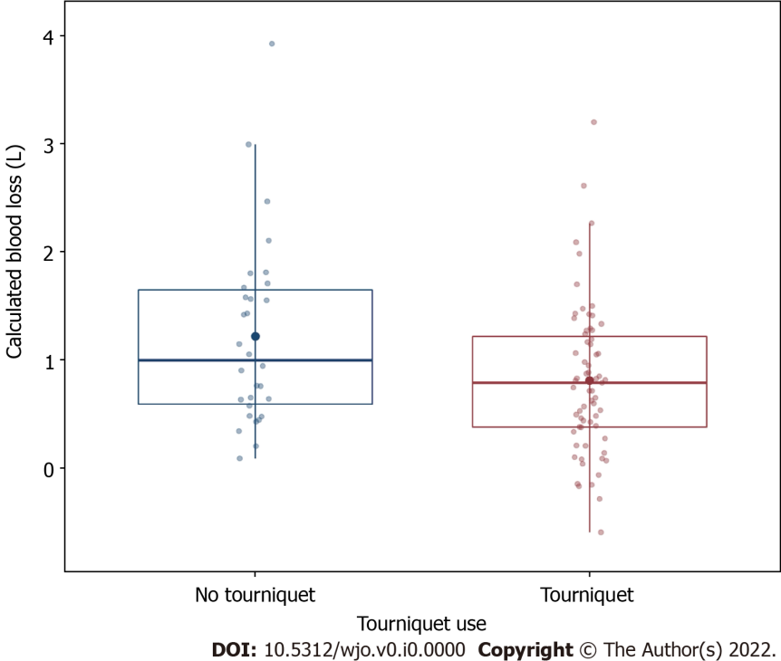
Figure 1 Tourniquet use was associated with significantly decreased blood loss.
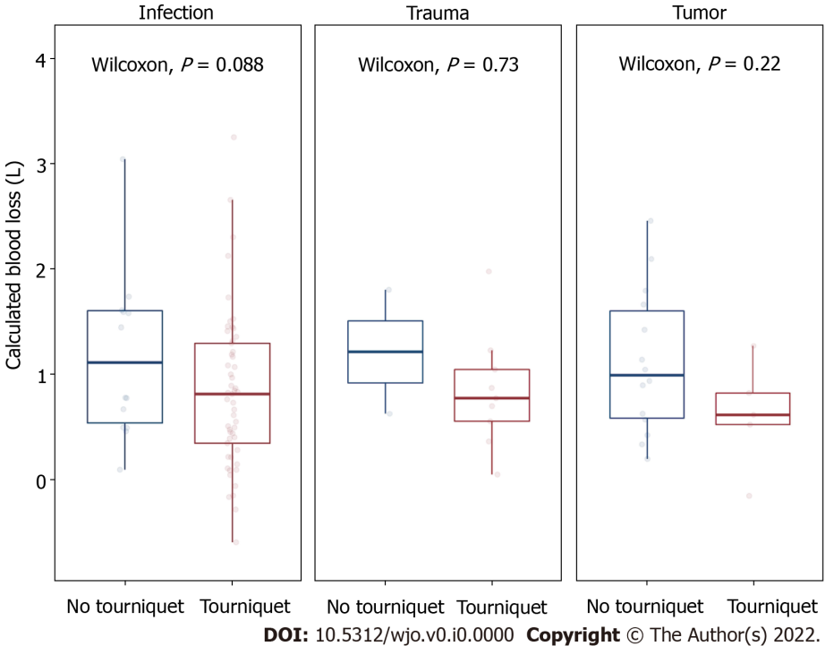
Figure 2 No individual group showed a statistically significant decrease in blood loss with tourniquet use.
Table 1 Demographic characteristics of patients undergoing below knee amputation with and without tourniquet
 | No tourniquet | Tourniquet | P value
n | 30 | 67
Age, mean (SD) | 43.31 (18.53) | 56.05 (14.02) | < 0.001
Gender = M (%) | 19 (63.3) | 43 (64.2) | 1
Height (mean (SD)) | 1.73 (0.10) | 1.75 (0.10) | 0.423
Weight (mean (SD)) | 90.63 (31.57) | 98.78 (32.46) | 0.252
BMI (mean (SD)) | 29.96 (9.62) | 32.12 (9.81) | 0.315
Diabetes (%) | 7 (23.3) | 27 (40.3) | 0.165
Hepatitis C (%) | 0 (0.0) | 4 (6.0) | 0.415
Smoking (%) | 6 (20.0) | 26 (38.8) | 0.112
IV drug use (%) | 1 (3.3) | 5 (7.5) | 0.746
Alcoholism (%) | 2 (6.7) | 10 (14.9) | 0.419
Outside hospital transfer (%) | 3 (10.0) | 13 (19.4) | 0.391
ASA score (%) |  |  | 0.433
1 | 1 (3.3) | 0 (0.0)
2 | 12 (40.0) | 20 (29.9)
3 | 15 (50.0) | 40 (59.7)
4 | 2 (6.7) | 6 (9.0)
5 | 0 (0.0) | 1 (1.5)
Homeless (%) | 0 (0.0) | 1 (1.5) | 1
Preoperative hemoglobin (mean (SD)) | 11.91 (2.64) | 11.78 (2.74) | 0.82
Platelets (mean (SD)) | 270.83 (153.50) | 315.09 (114.02) | 0.117
Indication for surgery (%) |  |  | < 0.001
Infection | 14 (46.7) | 53 (79.1)
Trauma | 2 (6.7) | 9 (13.4)
Tumor | 14 (46.7) | 5 (7.5)
BMI: Body mass index.
Table 2 Results of multivariate regression modeling
Variable | Estimate (95%CI) | P value
Tourniquet use | -488 mL (-857, -119) | 0.01
Indication (vs infection)
Trauma | 12 mL (-474, 498) | 0.96
Tumor | -190 mL (-624, 245) | 0.39
CI: Confidence interval.

