Name of journal: World Journal of Gastroenterology
ESPS Manuscript NO: 31023
Manuscript Type: CASE REPORT

Supraclavicular lymph node metastases from malignant gastrointestinal stromal tumor of the jejunum: A case report with review of the literature

Ma C et al. Supraclavicular LN metastases from GIST

Chi Ma, Shao-Long Hao, Xin-Cheng Liu, Jin-Yao Nin, Guo-Chang Wu, Li-Xin Jiang, Alessandro Fancellu, Alberto Porcu, Hai-Tao Zheng

Chi Ma, Jin-Yao Nin, Guo-Chang Wu, Li-Xin Jiang, Hai-Tao Zheng, Department of Gastrointestinal and Thyroid Surgery, Yuhuangding Hospital Affiliated to Qingdao University, Yantai 264000, Shandong Province, China

Shao-Long Hao, Xin-Cheng Liu, Qingdao University Medical College, Qingdao 266021, Shandong Province, China

Alessandro Fancellu, Alberto Porcu, Unit of General Surgery, Department of Clinical and Experimental Medicine, University of Sassari, 07100 Sassari, Italy

Author contributions: Ma C drafting of the manuscript, acquisition of material; Hao SL and Liu XC collected of material; Ning JY collected of patient’s information; Wu GC revised of the manuscript, collected of patient’s information; Jiang LX revised of the manuscript; Fancellu A and Porcu A revised of the manuscript and modification of language; Zheng HT drafting of the manuscript, acquisition of patient’s information.

Institutional review board statement: Approved by the Yuhuangding Hospital Affiliated to Qingdao University Institutional Review Board.

Informed consent statement: All study participants, or their legal guardian, provided informed written consent prior to study enrollment.

Conflict-of-interest statement: There is no conflict of interest.

Open-Access: This article is an open-access article which was selected by an in-house editor and fully peer-reviewed by external reviewers. It is distributed in accordance with the Creative Commons Attribution Non Commercial (CC BY-NC 4.0) license, which permits others to distribute, remix, adapt, build upon this work non-commercially, and license their derivative works on different terms, provided the original work is properly cited and the use is non-commercial. See: http://creativecommons.org/licenses/by-nc/4.0/

Manuscript source: Unsolicited manuscript

Correspondence to: Hai-Tao Zheng, PhD, Department of Gastrointestinal and Thyroid Surgery, Yuhuangding Hospital Affiliated to Qingdao University, No. 20 Yuhuangdingdong Road, Zhifu District, Yantai 264000, Shandong Province, China. machi_sdu@163.com
Telephone: +86- 535-6691999

Received: October 26, 2016
Peer-review started: October 28, 2016
First decision: December 19, 2017
Revised: January 5, 2017
Accepted: January 18, 2017
Article in press:
Published online:

Abstract
Gastrointestinal stromal tumors (GISTs) represent the most common mesenchymal tumors of the alimentary tract. These tumors may have different clinical and biological behavior. Malignant forms usually spread via hematogenous route, and lymph nodes metastases rarely occur. Herein, we report a case history of a patient with jejunal GIST who developed supraclavicular lymph nodes metastasis. This observation suggests that lymphatic diffusion viamediastinal lymphatic station to the supraclavicular lymph nodes can be a potential metastatic way of GISTs.

Key words: Gastrointestinal stromal tumor; Metastasis; Lymph nodes

© The Author(s) 2017. Published by Baishideng Publishing Group Inc. All rights reserved.

Core tip: As we know, unlike gastrointestinal carcinomas, lymph node metastases rarely develop in patients with malignant gastrointestinal stromal tumors (GISTs). We report a case with history of jejunal GIST who developed supraclavicular lymph nodes metastasis and review the related literatures. This observation suggests that lymphatic diffusion via mediastinal lymphatic station to the supraclavicular lymph nodes can be a potential metastatic way of GISTs.

Ma C, Hao SL, Liu XC, Nin JY, Wu GC, Jiang LX, Fancellu A, Porcu A, Zheng HT. Supraclavicular lymph node metastases from malignant gastrointestinal stromal tumor of the jejunum: A case report with review of the literature. World J Gastroenterol 2017; In press

INTRODUCTION
Gastrointestinal stromal tumors (GISTs) represent the most common mesenchymal tumors of the alimentary tract. These tumors may have different clinical and biological behavior. Malignant forms usually spread via hematogenous route, and lymph nodes metastases rarely occur. Herein, we report a case history of a patient with jejunal GIST who developed supraclavicular lymph nodes metastasis.

CASE REPORT
A 56-year-old man with a 24-hour history of melena was admitted to the gastrointestinal department of the Yuhuangding Hospital affiliated with Qingdao University, China. Laboratory assessment revealed a hemoglobin level of 8 g/dL. Urgent gastroduodenoscopy, colonoscopy, and enhanced computed tomography (CT) did not reveal any source of bleeding. During the next 24 h, the patient had further episodes of melena and became hemodynamically unstable despite receiving a transfusion of 5 units of packed red blood cells and hemostatic agents. Therefore, emergency laparotomy was performed. Upon surgical exploration, a bleeding solid mass was found in the jejunum. Then, resection of a small bowel loop measuring 20 centimeters in length was performed. Upon gross examination, a nodular well-encapsulated tumor, measuring 2 cm, was found. Upon microscopic examination, histologic sections showed a GIST infiltrating through all bowel layers, and it had features of mixed spindle and epithelioid types of cells. The mitotic index was > 5/50 high-power ﬁelds (HPFs). There was no infiltration of the surgical margins, and two harvested lymph nodes were free of metastases (Figure 1). Immunohistochemical studies showed positivity for CD117, CD34, and Dog-1; the Ki67 index was 20%. Therefore, the diagnosis was GIST of the small intestine with high-grade malignancy based on the modified NIH GIST criteria^{[1]}. Postoperative total body CT scan and positron emission tomography-computed tomography (PET-CT) were negative for metastatic disease. The patient was offered adjuvant imatinib therapy, but he declined due tofamily and economic reasons.
One year later, the patient was admitted to the thyroid department at same hospitalcomplaining of a left cervical massthat had been gradually enlarging over one month. Ultrasound revealed a hypoechoicmass above the left clavicle, measuring 3.1 cm × 4.6 cm; this mass was unenhanced in a contrast-enhanced CT scan (Figure 2 and 3). Interestingly, there were noalterations of the thyroid in imaging studies. Core needle biopsy was performed, and histopathological examination with hematoxylin-eosin stainingrevealed lymph node metastasis from a GIST. Immunohistochemistry studies demonstrated positivity for CD117, CD34, and vim, whereas calponin, estrogen, progesterone, and thyroglobulin were negative. A PET-CT scan showed uneven FDG uptake in the cervical mass and multiple lymph nodes in the mediastinum (Figure 4). The patient underwent surgical removal of the cervical mass. Gross examination of the excised lymph node demonstrated that it measured 5 cm × 6 cm × 8 cm and appeared irregular, smooth, and well encapsulated. Histopathologic examination again confirmed a metastasis from a GIST (Figure 5). Immunohistochemical studies of the resected lymph node showed positivity for CD117 and CD34and negativity for Dog-1 and S-100. The Ki67 index was 30%. Insertion of GCC TAT in exon 9 of the c-KIT gene was identified with mutation analysis. Exons 11, 13, and 17 and the PDGFRα gene were wild type. After the second operation, the patient was regularly given imatinib at a dose of 400 mg per day. At 1 year following the surgery, the patient was asymptomatic, and there wereno signs of tumor recurrence or progression (Table 1).

DISCUSSION
GISTs represent the most common neoplasms of mesenchymal origin of the gastrointestinal tract. GISTs may have different clinical and biological behavior, ranging from small benign tumors to aggressive forms that have a dismal prognosis. Approximately 20%-25% of GISTs are located in the stomach, and 40%-50% of those located in the small intestine can be considered as malignant neoplasms with features such as local recurrence after surgical removal, intraperitoneal dissemination and distant metastases^{[2]}. However, unlike gastrointestinal carcinomas, lymph node metastases (LNMs) rarely develop in patients with malignant GISTs. In fact, the mainstay of treatment for GISTs is complete surgical resection without a regional lymphadenectomy^{[3,4]}.
In the literature, the rates of lymph node metastases from GISTs range from 0 to 5%^{[3,5,6]}. The few studies reporting on this subject are summarized in Table 1^{[5,7-19]}. Most of the reported cases are peritumoral lymph nodes metastases, which have occasionally been discovered with histopathological examination of surgical specimens. We found only 3 cases that could be defined as distant LNMs^{[14,18]}，including 2 inguinal lymph nodes and 1 axillary lymph node. In the case described herein, LNMs developed in left supraclavicular and mediastinal basins. This behavior is similar to that observed in malignant gastrointestinal tumors that have an epithelial origin. To the best of our knowledge, this is the first caseof the lymphatic spread of a gastric GISTto supraclavicular and mediastinum lymph nodes. This might indicate that a particular subgroup of GISTs has biological characteristics similar to carcinomas.
According to the modified NIH GIST criteria, the case was a high-grade GIST malignancy^{[1]}. Ki67 expression changed from 20% in the primary tumor to 30% in the supraclavicular metastasis. Interestingly, Dog-1 was negative in the LNM, whereas it was positive in primary tumor. It could be speculated that the Ki67 and Dog-1 levels may be markers of the primary tumor de-differentiation tendency.
Activating mutations of the c-kit gene (especially exons 11 and 9) are present in most GISTs and probably play a fundamental role in the development of these tumors. Among the reported cases of LNMs from GISTs, few gene detection results have been described, most of which are exon 11 mutations^{[5,7,13,14]}. In the study by Kong et al^{[13]}, the exon 11 mutation was linked to the likelihood of LNMs. However, in the case described herein, we found an exon 9 mutation. This genetic mutation in the LNMs from GISTs has not been reported to date. The relationship between gene mutations and LNMs is still not clear, but many authors have stated that KIT exon 9-mutant tumors demonstrates imatinib resistance more frequently than exon 11-mutant tumors^{[20,21]}. Cases with exon 9-mutant tumors should be treated with increased imatinib doses. Because the patient declined imatinib treatment after the first surgery, he was treated with 400 mg of imatinib per day after the second operation.
In conclusion, complete surgical resection remains the mainstay of treatment for resectable GISTs. Imatinib is currently indicated for the first-line treatment of patients with metastatic or unresectable KIT-positive GISTs. Adjuvant therapy with imatinib was deemed necessary for this patient following complete resection of a primary jejunual tumor because it was an aggressive, high-risk form of GIST. Unfortunately, he did not take imatinib after his first operation, and distant lymph node metastases occurred after 12 months. Following the second operation, the patient received imatinib treatment and had survived without disease progression atthe 1-yearfollow up.
This case confirms that LNMs in the mediastinum and supraclavicular lymph nodes is a potential metastatic route for malignant GISTs. Further studies are needed to clarify the mechanism of lymph node metastases in patients with GISTs.

COMMENTS
Case characteristics
The patient was admitted to hospital with complaining of a left cervical mass, which had been diagnosed as jejunum gastrointestinal stromal tumors (GISTs) and cured by operation 1 year before.

Clinical diagnosis
To identify the differential diagnoses of thyroid tumor, lymphoma, metastatic carcinoma, the patient was carried on computed tomography (CT), ultrasound (US), positron emission tomography-computed tomography (PET-CT) and biopsy. US, CT and PET-CT revealed a hypoechoic, unenhanced and uneven FDG uptake mass above the left clavicle measuring 3.1 cm × 4.6 cm.

Laboratory diagnosis
After a biopsy of the cervical mass, this patient was diagnosed as supraclavicular lymph node metastases from GISTs.

Pathological diagnosis
Core needle biopsy was carried out, and the histopathological examination on hematoxylin-eosin stain showed lymph node metastasis from GIST.

Treatment
The patient underwent surgical removal of the cervical mass and was regularly given imatinib 400 mg per day

Experiences and lessons
This case confirms that LNM in the mediastinum and supraclavicular lymph nodes are a potential metastatic way of malignant GISTs, so they should attach importance to this during operation and chemotherapy. Due to the first case repot, we try to give some but not sufficient evidence of the possible mechanisms of spread of the supraclavicular lymph node metastasis.

Peer-review
This case report is well organized and had much information including genetic analysis data on primary GIST and metastatic lesion.
REFERENCES
1 Joensuu H. Risk stratification of patients diagnosed with gastrointestinal stromal tumor. Hum Pathol 2008; 39: 1411-1419 [PMID: 18774375 DOI: 10.1016/j.humpath.2008.06.025]
2 Miettinen M, Lasota J. Gastrointestinal stromal tumors: review on morphology, molecular pathology, prognosis, and differential diagnosis. Arch Pathol Lab Med 2006; 130: 1466-1478 [PMID: 17090188 DOI: 10.1043/1543-2165(2006)130]
3 DeMatteo RP, Lewis JJ, Leung D, Mudan SS, Woodruff JM, Brennan MF. Two hundred gastrointestinal stromal tumors: recurrence patterns and prognostic factors for survival. Ann Surg 2000; 231: 51-58 [PMID: 10636102]
4 Pierie JP, Choudry U, Muzikansky A, Yeap BY, Souba WW, Ott MJ. The effect of surgery and grade on outcome of gastrointestinal stromal tumors. Arch Surg 2001; 136: 383-389 [PMID: 11296107]
5 Tashiro T, Hasegawa T, Omatsu M, Sekine S, Shimoda T, Katai H. Gastrointestinal stromal tumour of the stomach showing lymph node metastases. Histopathology 2005; 47: 438-439 [PMID: 16178904 DOI: 10.1111/j.1365-2559.2005.02133.x]
6 Aparicio T, Boige V, Sabourin JC, Crenn P, Ducreux M, Le Cesne A, Bonvalot S. Prognostic factors after surgery of primary resectable gastrointestinal stromal tumours. Eur J Surg Oncol 2004; 30: 1098-1103 [PMID: 15522557 DOI: 10.1016/j.ejso.2004.06.016]
7 Sato T, Kanda T, Nishikura K, Hirota S, Hashimoto K, Nahagawa S, Ohashi M, Hatakeyama K. Two cases of gastrointestinal stromal tumor of the stomach with lymph node metastasis. Hepatogastroenterology 2007; 54: 1057-1060 [PMID: 17629038]
8 El Demellawy D, Shokry P, Ing A, Khalifa M. Polypoid gastrointestinal stromal tumor of small bowel metastasizing to mesenteric lymph nodes: a case report. Pathol Res Pract 2008; 204: 197-201 [PMID: 18096326 DOI: 10.1016/j.prp.2007.10.007]
9 Hu X, Forster J, Damjanov I. Primary malignant gastrointestinal stromal tumor of the liver. Arch Pathol Lab Med 2003; 127: 1606-1608 [PMID: 14632569 DOI: 10.1043/1543-2165(2003)127<1606: pmgsto>2.0.co; 2]
10 Sakurai N, Yamauchi J, Shibuma H, Ikeda E, Sasou S. [A case of recurrent GIST of the esophagus which completely responded to imatinib mesilate]. Gan To Kagaku Ryoho 2007; 34: 237-240 [PMID: 17301535]
11 Asakage N, Kobayashi S, Gotou T, Sasaki M, Tsukada K, Suzuki T, Yamamoto T, Sekine M, Miyazaki E, Hirai S, Yamasaki S. [Two cases of gastrointestinal stromal tumor (GIST) of the stomach and a consideration of its malignancy potential and treatment strategy - report of two cases]. Gan To Kagaku Ryoho 2007; 34: 919-923 [PMID: 17565257]
12 Canda AE, Ozsoy Y, Nalbant OA, Sagol O. Gastrointestinal stromal tumor of the stomach with lymph node metastasis. World J Surg Oncol 2008; 6: 97 [PMID: 18775061 DOI: 10.1186/1477-7819-6-97]
13 Kong M, Wang YL, Xu LJ, Teng XD. [Gastrointestinal stromal tumor of small intestine associated with lymph node metastasis: a report of 2 cases with review of literatures]. Zhonghua Bing Li Xue Za Zhi 2009; 38: 617-620 [PMID: 20079191]
14 Zhang Q, Yu JW, Yang WL, Liu XS, Yu JR. Gastrointestinal stromal tumor of stomach with inguinal lymph nodes metastasis: a case report. World J Gastroenterol 2010; 16: 1808-1810 [PMID: 20380018]
15 Yamada E, Oyaizu T, Miyashita T. [A case of gastrointestinal stromal tumor of the stomach with lymph node metastasis followed up for 7 years without evidence of recurrence after surgery]. Nihon Shokakibyo Gakkai Zasshi 2010; 107: 743-749 [PMID: 20460848]
16 Masuda T, Toh Y, Kabashima A, Aoki Y, Harimoto N, Ito S, Taomoto J, Ikeda O, Ohga T, Adachi E, Sakaguchi Y, Hirahashi M, Nishiyama K, Okamura T. Overt lymph node metastases from a gastrointestinal stromal tumor of the esophagus. J Thorac Cardiovasc Surg 2007; 134: 810-811 [PMID: 17723845 DOI: 10.1016/j.jtcvs.2007.06.002]
17 Shafizad A, Mohammadianpanah M, Nasrolahi H, Mokhtari M, Mousavi SA. Lymph Node Metastasis in Gastrointestinal Stromal Tumor (GIST): to Report a Case. Iran J Cancer Prev 2014; 7: 171-174 [PMID: 25250169]
18 Vassos N, Agaimy A, Hohenberger W, Croner RS. Extraabdominal lymph node metastasis in gastrointestinal stromal tumors (GIST). J Gastrointest Surg 2011; 15: 1232-1236 [PMID: 21336495 DOI: 10.1007/s11605-011-1464-3]
19 Catani M, De Milito R, Simi M. [New orientations in the management of advanced, metastatic gastrointestinal stromal tumors (GIST): combination of surgery and systemic therapy with imatinib in a case of primary gastric location]. Chir Ital 2005; 57: 127-133 [PMID: 15832750]
20 Heinrich MC, Owzar K, Corless CL, Hollis D, Borden EC, Fletcher CD, Ryan CW, von Mehren M, Blanke CD, Rankin C, Benjamin RS, Bramwell VH, Demetri GD, Bertagnolli MM, Fletcher JA. Correlation of kinase genotype and clinical outcome in the North American Intergroup Phase III Trial of imatinib mesylate for treatment of advanced gastrointestinal stromal tumor: CALGB 150105 Study by Cancer and Leukemia Group B and Southwest Oncology Group. J Clin Oncol 2008; 26: 5360-5367 [PMID: 18955451 DOI: 10.1200/jco.2008.17.4284]
21 Lee JH, Kim Y, Choi JW, Kim YS. Correlation of imatinib resistance with the mutational status of KIT and PDGFRA genes in gastrointestinal stromal tumors: a meta-analysis. J Gastrointestin Liver Dis 2013; 22: 413-418 [PMID: 24369323]

P-Reviewer: Alimehmeti RH, Kim ST S-Editor: Qi Y L-Editor: E-Editor:
Specialty type: Gastroenterology and hepatology
Country of origin: China
Peer-review report classification
Grade A (Excellent): 0
Grade B (Very good): B
Grade C (Good): C
Grade D (Fair): 0
Grade E (Poor): 0

Table 1 Clinical characteristics of cases reported

Author | Primary site | HPF | T size (cm) | Treatment | LNM site | LNM time | Gene mutation
Sato T | gastric |  | 4 | Proximal gastrectomy | right cardia | Pre | deletion mutation in exon 11
Sato T | gastric |  | 2.5 | Wedge resection +partial hepatectomy | adjacent to the tumor | Pre | No mutation
El Demellawy D | small bowel |  |  |  | mesenteric | Pre
Hu X | Hepatic | 4/10 | 15 × 10 | Right hepatic lobectomy | hilar | Post
Canda AE | gastric | 25/50 | 8 × 8 × 4 | distal gastrectomy +perigastric LN dissection | perigastirc | Pre | No mutation
Kong M | Small intestinal | 2/50 | 6 × 7 | Partial resection of the ileum | periintestine | Pre | deletion 559-569 in exon 11
Kong M | Small intestinal | 2/50 | 5 × 5 | Partial resection of the ileum | periintestine | Pre | Deletion 559-565 in exon 11
Qin Zhang | Gastric |  |  | distal gastrectomy, perigastriclymphadenectomy and hepatectomy | Inguinal LN | Post | deletion 557/558 in exon 11
Yamada E | Gastric | > 5 / 50 | 4.5 × 3.5 | Gastrectomy+lymph node dissection | perigastirc | Pre
Catani M | Gastric |  |  | Gastrectomy+ resection of the tail of the pancreas, the spleen, and the transverse colo | perigastirc | Pre
Masuda T | Esophagus | 15/50 | 9.5 | subtotal esophagectomy | Periesophagus | Pre
Amin Shafizad | Gastric |  | 8 | total gastrectomy and omentectomy | perigastirc | Pre
Vassos N | Ileum |  |  | Partial resection of the ileum | Inguinal | Pre
Vassos N | Gastric |  |  | extended gastrectomy, atypical liver resection, splenectomy | Axillary | Post
Sakurai N | Esophagus |  |  | Middle and lower esophagectomy | multiple | Post
Asakage N | Gastric |  |  | total gastrectomy with distal pancreatosplenectomy and segmental liver resection | perigastirc | Pre
T Tashiro | Gastric |  | 1-5 |  |  |  | No mutation
T Tashiro | Gastric | Ki67 10% | 2.5 | proximal gastrectomy with sampling of the regional LNs |  |  | Exon 11
HPF: High-power ﬁelds; LNM: Lymph node metastases.
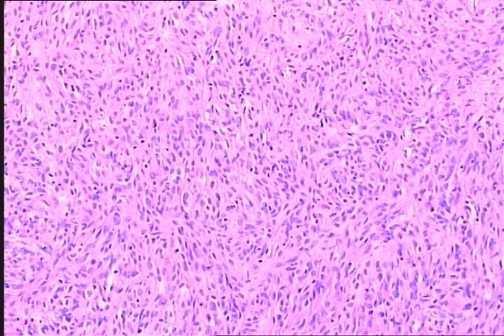
Figure 1 Histopathologic section of the primary tumour. The tumor was composed of spindle and epithelioid cells, which were predominantly arranged in spiral and lace-like shape (H&E stain: × 400).

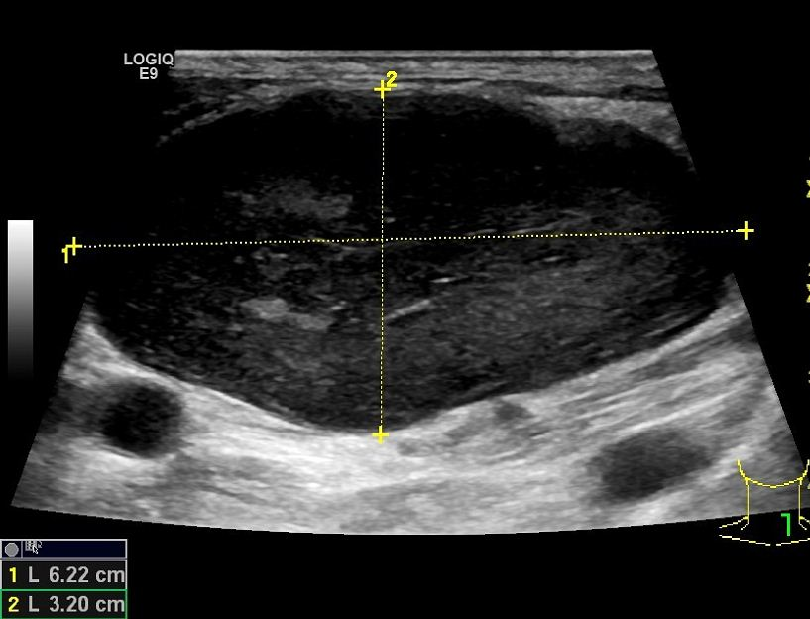
Figure 2 Ultrasonography of cervical mass: The mass was hypoechoic, with a smooth border and un-even internal echo.

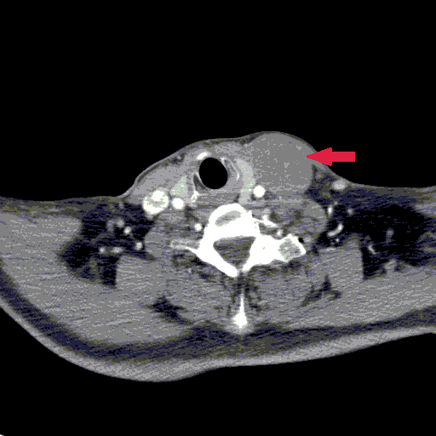
Figure 3 Computed tomography: The mass appeared as a low density cyst with clear edge without contrast enhancement.

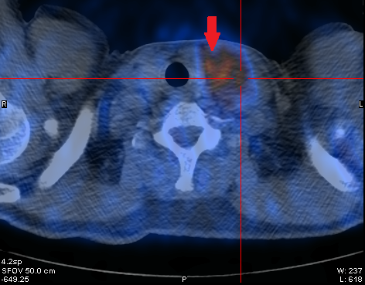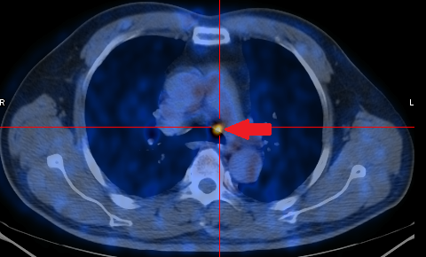
Figure 4 Positron emission tomography-computed tomography: FDG accumulated unevenly in the cervical mass and multiple lymph nodes in mediastinum.

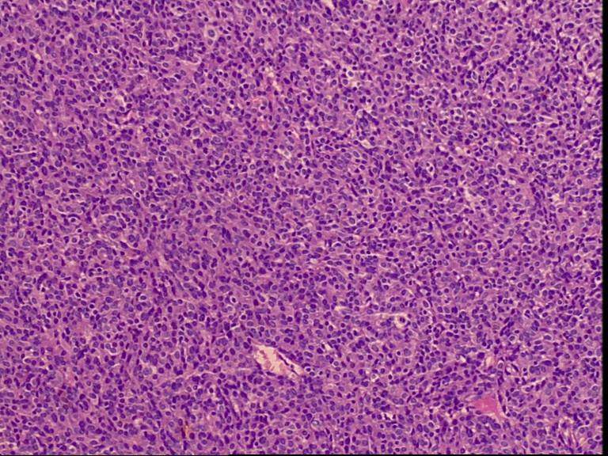
Figure 5 Histopathologic section of the cervical tumour (HE staining). The epithelioid cells were sheet arranged, with abundant eosinophilic cytoplasm and prominent nuclei (HE staining × 400).

