Name of Journal: World Journal of Clinical Cases
Manuscript NO: 46325
Manuscript Type: CASE REPORT

Primary hepatoid adenocarcinoma of the lung in Yungui Plateau, China: a case report

Shi YF et al. Primary hepatoid adenocarcinoma of the lung

Yun-Fei Shi, Jia-Gui Lu, Qing-Mei Yang, Jin Duan, You-Ming Lei, Wei Zhao, Yin-Qiang Liu

Yun-Fei Shi, Jia-Gui Lu, Qing-Mei Yang, Jin Duan, You-Ming Lei, Wei Zhao, Yin-Qiang Liu, Department of Thoracic Surgery in the Elderly, the First Affiliated Hospital of Kunming Medical University, Kunming 650032, Yunnan Province, China

ORCID number: Yun-Fei Shi (0000-0002-4089-5828); Jia-Gui Lu (0000-0002-9301-8917); Qing-Mei Yang (0000-0002-2988-3367); Jin Duan (0000-0001-7006-4702); You-Ming Lei (0000-0002-7738-0019); Wei Zhao (0000-0001-6830-6514); Yin-Qiang Liu (0000-0003-3043-6123).

Author contributions: Shi YF, Lu JG, Yang QM, Duan J, Lei YM, Zhao W and Liu YQ were involved in diagnostic flow and patient follow-up; Liu YQ contributed to interpretation of published data and drafting the manuscript; All the authors read and gave their final approval of the version to be published.

Supported by the Yunnan Health Science and Technology Plan Project Task Book, No. 2017NS020; Yunnan Provincial Health and Family Planning Commission Reserve Talent Project, No. H-2017013; Yunnan Provincial Science and Technology Project, No. 2017FE467(-142); 2018 CSCO-Qilu Tumor Project, No. Y-Q201802-011; the Educational Reform Project of Kunming Medical University, No. 2018-JY-Y-046.

Informed consent statement: Written informed consent was obtained from the patient for the publication of this case report.

Conflict-of-interest statement: The authors declare no conflict of interest.

CARE Checklist (2016) statement: The authors have read the CARE Checklist (2016), and the manuscript was prepared and revised according to the CARE Checklist (2016).

Open-Access: This article is an open-access article that was selected by an in-house editor and fully peer-reviewed by external reviewers. It is distributed in accordance with the Creative Commons Attribution Non Commercial (CC BY-NC 4.0) license, which permits others to distribute, remix, adapt, build upon this work non-commercially, and license their derivative works on different terms, provided the original work is properly cited and the use is non-commercial. See: http://creativecommons.org/licenses/by-nc/4.0/

Manuscript source: Unsolicited manuscript

Corresponding author: Yin-Qiang Liu, MD, Doctor, Surgeon, Department of Thoracic Surgery in the Elderly, the First Affiliated Hospital of Kunming Medical University, No. 295 Xichang Road, Kunming 650032, Yunnan Province, China. 823039079@qq.com
Telephone: +86-0871-65324888
Fax: +86-0871-65324888

Received: February 17, 2019
Peer-review started: February 18, 2019
First decision: March 14, 2019
Revised: March 29, 2019
Accepted: May 2, 2019
Article in press: May 3, 2019
Published online: July 6, 2019

Abstract
BACKGROUND
Hepatoid adenocarcinoma (HAC) occurs in extrahepatic organs such as the gastrointestinal tract, testes, ovaries, lungs, mediastinum and pancreas, and frequently produces α-fetoprotein (AFP). HAC of the lung (HAL) is rare, characterized by difficult treatment and poor prognosis. There are no reports of HAL in Yunnan-Guizhou Plateau, China.

CASE SUMMARY
A 60-year-old male patient was clinically diagnosed with HAL pT3N0M0, stage IIB. Chest computed tomography revealed a 7.5 cm × 7.2 cm soft tissue mass located in the right lung upper lobe and the adjacent superior mediastinum. Right upper lobectomy was performed. The diagnosis of HAL was confirmed by pathological examination, and the patient received paclitaxel and carboplatin as adjuvant chemotherapy after surgery.

CONCLUSION
Clinical manifestations, pathological features, imaging findings, auxiliary examination, and treatment planning of HAL are presented to help clinicians improve their diagnosis and treatment.

Key words: Hepatic adenocarcinoma; Lung cancer; Immunohistochemistry; α-Fetoprotein; Case report

© The Author(s) 2019. Published by Baishideng Publishing Group Inc. All rights reserved.

Core tip: We present a patient with primary hepatoid adenocarcinoma of the lung (HAL) in Yungui Plateau, China. HAL is a rare tumor involving difficult treatment and poor prognosis. We discussed the clinical manifestations, pathological features, imaging findings, auxiliary examination performance and treatment planning of HAL in order to help clinicians improve their diagnosis and treatment.

Citation: Shi YF, Lu JG, Yang QM, Duan J, Lei YM, Zhao W, Liu YQ. Primary hepatoid adenocarcinoma of the lung in Yungui Plateau, China: a case report. World J Clin Cases 2019; 7(13): 1711-1716
URL: https://www.wjgnet.com/2307-8960/full/v7/i13/1711.htm
DOI: https://dx.doi.org/10.12998/wjcc.v7.i13.1711
INTRODUCTION
Hepatoid adenocarcinoma (HAC) is a rare neoplasm with aberrant hepatocellular differentiation, and morphological features similar to hepatocellular carcinoma^{[1]}. HAC occurs in extrahepatic organs, and the most common site of origin is the stomach^{[2-4]}. There have been a few reports of HAC in extrahepatic organs such as the ovaries, mediastinum and pancreas^{[1]}. Primary HAC of the lung (HAL) is rare.
HAL was first formally described by Ishikura et al^{[3]} in 1990. Compared with the other more common types of lung tumors, HAL has a poorer prognosis^{[5-7]} and its invasiveness may explain its high mortality rate^{[3,7]}. The clinical symptoms of HAL are uncertain, and its biological significance remains to be elucidated^{[4]}. Computed tomography (CT) images, combined with morphology and immunohistochemistry, may provide some indications for confirmation of this diagnosis. The following two points about diagnostic criteria of HAL were proposed by Ishikura^{[3]}: (1) Typical acinar or papillary adenocarcinoma; and (2) α‑fetoprotein (AFP). AFP expression is positive and/or the level of AFP is elevated in most HAL cases^{[8]}. The present literature review found no relevant cases of HAL in Yunnan-Guizhou Plateau, China. The limited literature regarding HAL is summarized in Table 1. Here, we present a case that was diagnosed as HAL, and the postoperative pathological stage was pT3N0M0, stage IIB.

CASE PRESENTATION
Chief complaints
A 60-year-old man was hospitalized with repeated coughing and expectoration for > 4 years, and the symptoms worsened for 1 mo.

History of present illness
The patient had no history of the present illness.

History of past illness
He had undergone esophageal polypectomy, and suffered from gastric ulcers for > 20 years.

Personal and family history
No specific personal and family history of disease.

Physical examination upon admission
Physical examination showed that thick breathing sounds could be heard in the upper right lung, along with moist rales.

Laboratory examinations
No obvious abnormalities were found in liver and kidney function. Serum AFP (1210.0 ng/mL), cancer antigen (CA) 125 (38.43 U/mL), carcinoembryonic antigen, CA15-3 and CA72-4 were normal. C antibodies, E antibodies and surface antibodies were all positive for six items of hepatitis B, and the rest were negative.

Imaging examinations
A 7.5 cm × 7.2 cm soft tissue mass in the right lung upper lobe and adjacent superior mediastinum was observed by CT. The boundary of the soft tissue was clear, and there was significant inhomogeneous enhancement after enhanced CT (Figures 1 and 2). Numbers of enlarged lymph nodes were found in the mediastinum. The largest lymph node diameter was 1.4 cm. There were calcified nodules in the right middle lobe, and subpleural nodules in the left upper lobe. Abdominal magnetic resonance imaging, including the liver, gallbladder, pancreas and spleen, and double kidney B ultrasound did not show any occupying lesions.

FINAL DIAGNOSIS
The specimen was sent for pathological examination after surgery. The diagnosis of HAL was confirmed by pathological examination.

TREATMENT
The patient had no surgical contraindications after examination. Resection of the right upper lung was performed. The tumor was located in the upper right lobe of the right lung, and measured about 7 cm × 7 cm × 5 cm. The 1st, 2nd, 3rd, 4th, 7th and 11th groups of mediastinal lymph nodes were resected. The specimens were sent for pathological examination after surgery

OUTCOME AND FOLLOW-UP
Right upper lobectomy was performed. The diagnosis of HAL was confirmed by pathological examination, and the patient received paclitaxel and carboplatin as adjuvant chemotherapy after surgery. For economic reasons, we did not carry out detection of tumor histogenetics and immune-related indicators. Chemotherapy was given once in the first month after surgery. Paclitaxel and carboplatin were added. Because of a serious adverse reaction to chemotherapy, the patient did not continue with the chemotherapy and other treatment. He died 15 mo after surgery.

DISCUSSION
HAC is a rare tumor that was first recognized as a gastric tumor in 1985 by Ishikura et al^{[3]}, and its etiology is still unclear. It has hepatocellular carcinoma-like differentiation and cytological characteristics. It is an aggressive tumor that most commonly arises from the gastrointestinal tract, and there are also a few reports in the ovaries, mediastinum, pancreas and other organs. Primary HAL is very rare. Ishikura et al^{[3]} showed that the pharynx, esophagus, upper gastroduodenal region, liver, gallbladder, pancreas and respiratory system below the throat all develop in the anterior intestine of the embryonic primitive digestive tract. Due to abnormalities in the differentiation process, certain adenocarcinomas of the lungs and other tissues may differentiate into hepatocytes. However, a small number of HACs are also seen in organs such as sweat glands, ovaries, endometrium, frontal sweat glands, and adrenal glands. In terms of embryonic histology, the above organs do not develop from the original digestive tract, or even from the endoderm. Therefore, further research and discussion are needed to explain the origin of extrahepatic HAC in relation to embryonic development.
HAL commonly occurs in older male patients aged > 50 years. It frequently occurs in the upper lobe, and metastasis of the adrenal gland and spine has been reported^{[9]}. The prognosis is closely related to the pathological stage, and the clinical manifestations are nonspecific. According to existing reports^{[9]}, there may be symptoms in common with those of other lung tumors, such as cough, expectoration and hemoptysis, and other clinical manifestations of lumbar and back pain. The patient reported in this article only showed symptoms of repeated cough and expectoration. Most of the tumors were located near the hilar area, and the margins were more regular based on clinicopathological and radiographic findings. Tumor marker AFP was often elevated, but cases with normal AFP have also been reported. Postoperative pathological specimens were often grayish white, with a tough, well-defined mass, and internal necrosis. The lung mass was biopsied via bronchoscopy, revealing histopathological findings of carcinoma with hepatoid features. Tumor cells were large and irregular in shape. Circles and polygons were also visible. The cytoplasm was rich, acidophilic or transparent, with obvious heteromorphism. The nuclear mitotic figures were easy to see, and the nucleus was large and irregular. Positive corpuscle was seen in the cytoplasm by periodic acid–Schiff (PAS) staining. Immunohistochemical staining showed that tumor cells were positive for AFP, hepatocytes and cytokeratin (CK) 18. Compared with the reported cases, the clinical manifestations of this case were nonspecific, AFP level was abnormal, the mass was large, but there was no distant metastasis. Bronchoscopy features and immunohistochemical results were similarly to those reported previously.
The clinical manifestations of HAC are nonspecific, and the imaging features are often larger than those of typical lung cancer, but the boundaries are relatively neat. Bronchoscopy often shows dense, small blood vessels in tumor cells, and PAS-positive homogeneous transparent bodies. Elevated AFP is a useful index for the diagnosis of HAL, but lung metastasis of hepatocellular carcinoma must be excluded^{[10]}. However, there are still reports of AFP-negative HAC. Hou et al^{[11]} showed that preoperative patients have the following conditions that can be considered as HAL: (1) Symptoms in common with those of lung cancer, such as cough, expectoration, hemoptysis and other lung cancers; (2) elderly men; (3) AFP positivity; and (4) liver without space-occupying lesions. Preoperative diagnosis of HAL is difficult because there are no obvious clinical manifestations, nor clinicopathological or radiographic features.
Although serum AFP levels are not high (Table 1), HAL can be considered when high levels occur before surgery and there is no space-occupying lesion in the liver. It is generally recognized that the diagnosis of HAL depends on the cytopathological characteristics of hepatocellular carcinoma, and immunohistochemical staining for AFP, hepatocytes and CK18. Simultaneously, we can exclude lung metastasis of hepatocellular carcinoma. However, there are also reports of HAL with negative immunohistochemical staining for AFP and hepatocytes (Table 1). Therefore, HAL is still diagnosed based on comprehensive evaluation, and there are no highly specific indicators. HAL is essentially a special type of lung adenocarcinoma, and guidelines for diagnosis and treatment of lung cancer should be followed. The general principle is that if there is distant metastasis, systemic chemotherapy and local radiotherapy should be performed after a clear diagnosis. If there is no distant metastasis, surgical treatment or local radiotherapy should be performed. Chemotherapy should be considered according to the postoperative stage of HAL. We strongly recommend that patients undergo genetic and immunological tests. However, there are different chemotherapy regimens at present, and the prognosis of patients varies. Therefore, the optimal chemotherapy scheme still requires further research. In the present case, right upper lobectomy was performed. The diagnosis of HAL was confirmed by pathological examination, and the patient received paclitaxel and carboplatin as adjuvant chemotherapy after surgery. For economic reasons, we did not carry out detection of tumor genetics and immune-related indicators. Chemotherapy with paclitaxel and carboplatin was given once in the first month after surgery. Due to a serious adverse reaction to chemotherapy, the patient did not continue with chemotherapy and other treatments, and he died 15 mo after surgery in December 2018. The prognosis of HAL is not clear, and there is no specific retrospective study at present, which may be related to the reported number of cases. Preliminary research has found that vascular endothelial growth factor is highly expressed in HAL, which may be associated with early vascular invasion. The expression of Ki-67 may be directly related to prognosis. It is difficult to review and evaluate the results because of the small number of reported cases and lack of data on the above indicators. It is suggested that Ki-67 is expressed in HAL at levels between 20%-40% (Table 1)^{[9-22]}. We could not perform statistical analysis due to incomplete follow-up data. Early vascular invasion may be the direct cause of early HAL metastasis and high degree of malignancy. However, this patient has a large primary mass, and postoperative pathology confirmed vascular invasion, although distant metastasis was undetected. Therefore, the above speculation needs further confirmation with retrospective studies.

CONCLUSION
Pathological examination revealed a lump of 7 cm × 7 cm × 7 cm in the upper lobe of the right lung. The patient was considered to have HAC because of the immunohistochemistry results and elevated AFP. Abdominal magnetic resonance imaging, including the liver, gallbladder, pancreas and spleen, and double kidney B ultrasound did not show occupying lesions. Investigation also found that there was no pleural or bronchial invasion, but vascular tumor thrombus was seen. Immunohistochemical staining showed that tumor cells were positive for epidermal growth factor receptor, pan-CK, CK18, Napsin A (small focus), CK8 (weak), CD117 (small), Ki-67 (50%), and hepatocytes (weak). In contrast, TTF-1, Syn, CgA, PD-1, PAS, Villin, VIM and CK7 were negative. Finally, no lymph node metastasis was seen.

REFERENCES
1 Su JS, Chen YT, Wang RC, Wu CY, Lee SW, Lee TY. Clinicopathological characteristics in the differential diagnosis of hepatoid adenocarcinoma: a literature review. World J Gastroenterol 2013; 19: 321-327 [PMID: 23372352 DOI: 10.3748/wjg.v19.i3.321]
2 Wu Z, Upadhyaya M, Zhu H, Qiao Z, Chen K, Miao F. Hepatoid adenocarcinoma: computed tomographic imaging findings with histopathologic correlation in 6 cases. J Comput Assist Tomogr 2007; 31: 846-852 [PMID: 18043368 DOI: 10.1097/RCT.0b013e318038f6dd]
3 Ishikura H, Kanda M, Ito M, Nosaka K, Mizuno K. Hepatoid adenocarcinoma: a distinctive histological subtype of alpha-fetoprotein-producing lung carcinoma. Virchows Arch A Pathol Anat Histopathol 1990; 417: 73-80 [PMID: 1694332 DOI: 10.1007/BF01600112]
4 Nagai E, Ueyama T, Yao T, Tsuneyoshi M. Hepatoid adenocarcinoma of the stomach. A clinicopathologic and immunohistochemical analysis. Cancer 1993; 72: 1827-1835 [PMID: 7689918]
5 Arnould L, Drouot F, Fargeot P, Bernard A, Foucher P, Collin F, Petrella T. Hepatoid adenocarcinoma of the lung: report of a case of an unusual alpha-fetoprotein-producing lung tumor. Am J Surg Pathol 1997; 21: 1113-1118 [PMID: 9298890 DOI: 10.1097/00000478-199709000-00018]
6 Hiroshima K, Iyoda A, Toyozaki T, Haga Y, Baba M, Fujisawa T, Ishikura H, Ohwada H. Alpha-fetoprotein-producing lung carcinoma: report of three cases. Pathol Int 2002; 52: 46-53 [PMID: 11940206 DOI: 10.1046/j.1440-1827.2002.01311.x]
7 Terracciano LM, Glatz K, Mhawech P, Vasei M, Lehmann FS, Vecchione R, Tornillo L. Hepatoid adenocarcinoma with liver metastasis mimicking hepatocellular carcinoma: an immunohistochemical and molecular study of eight cases. Am J Surg Pathol 2003; 27: 1302-1312 [PMID: 14508391 DOI: 10.1097/00000478-200310000-00002]
8 Kishimoto T, Yano T, Hiroshima K, Inayama Y, Kawachi K, Nakatani Y. A case of *-fetoprotein-producing pulmonary carcinoma with restricted expression of hepatocyte nuclear factor-4* in hepatoid foci: a case report with studies of previous cases. Hum Pathol 2008; 39: 1115-1120 [PMID: 18570977 DOI: 10.1016/j.humpath.2007.12.013]
9 Bai CG, Liu XH, Yu YW, Zhang SM, Ma DL. A case of pulmonary hepatic adenocarcinoma and literature review. J Clin Exper Pathol 2006; 22: 246-248 [DOI: 10.3969/j.issn.1001-7399.2006.02.037]
10 Poulakis V, Witzsch U, de Vries R, Becht E, Altmannsberger HM, Störkel S. Alpha-fetoprotein-producing renal cell carcinoma. Urol Int 2001; 67: 181-183 [PMID: 11490220 DOI: 10.1159/000050982]
11 Hou Q, Zhang X, Zhang Y, Li W. Primary hepatic adenocarcinoma of the lung: a case report. J Diagn Pathol 2017; 24: 473-475 [DOI: 10.3969/j.issn.1007-8096.2017.06.020]
12 Cao YA, Long NZ, Peng CS, Lu P, Xia Q，Wang W, Xie WX. Pulmonary hepatic adenocarcinoma with elevated alpha-fetoprotein 1 case. Diagn Theor and Prac 2008; 35: 420-420 [DOI: 10.3969/j.issn.1000-8179.2008.07.019]
13 Feng GW, Hu JJ, Li B. 18F-FDGPET/CT detected pulmonary hepatic adenocarcinoma with elevated alpha-fetoprotein 1 case. Diagn Theor and Prac 2013; 231-233 [DOI: 10.3969/j.issn.1671-2870.2013.02.026]
14 Haninger DM, Kloecker GH, Bousamra Ii M, Nowacki MR, Slone SP. Hepatoid adenocarcinoma of the lung: report of five cases and review of the literature. Mod Pathol 2014; 27: 535-542 [PMID: 24030743 DOI: 10.1038/modpathol.2013.170]
15 Shaib W, Sharma R, Mosunjac M, Farris AB 3rd, El Rayes B. Hepatoid adenocarcinoma of the lung: a case report and review of the literature. J Gastrointest Cancer 2014; 45 Suppl 1: 99-102 [PMID: 24408270 DOI: 10.1007/s12029-013-9558-7]
16 Gavrancic T, Park YH. A novel approach using sorafenib in alpha fetoprotein-producing hepatoid adenocarcinoma of the lung. J Natl Compr Canc Netw 2015; 13: 387-391; quiz 391 [PMID: 25870375 DOI: 10.6004/jnccn.2015.0054]
17 Che YQ, Wang S, Luo Y, Wang JB, Wang LH. Hepatoid adenocarcinoma of the lung: Presenting mediastinal metastasis without transfer to the liver. Oncol Lett 2014; 8: 105-110 [PMID: 24959228 DOI: 10.3892/ol.2014.2064]
18 Liu HY, Wang XM, Cheng ZQ, Peng QZ, Sun XF, Hu JT, Jin HT, He LS. Clinicopathological observation of primary hepatic adenocarcinoma of the lung. Doc dissert 2014 [DOI: 10.3877/cma.j.issn.1674-0785.2014.14.010]
19 Zhong MY, Liu B. A case report of pulmonary hepatic adenocarcinoma and literature review. J Cap Med Univ 2015; 36: 515-516 [DOI: 10.3969/j.issn.1006-7795.2015.03.037]
20 Motooka Y, Yoshimoto K, Semba T, Ikeda K, Mori T, Honda Y, Iyama K, Suzuki M. Pulmonary hepatoid adenocarcinoma: report of a case. Surg Case Rep 2016; 2: 1 [PMID: 26943677 DOI: 10.1186/s40792-016-0129-6]
21 Sun JN, Zhang BL, Li LK, Yu HY, Wang B. Hepatoid adenocarcinoma of the lung without production of α-fetoprotein: A case report and review of the literature. Oncol Lett 2016; 12: 189-194 [PMID: 27347123 DOI: 10.3892/ol.2016.4559]
22 Grossman K, Beasley MB, Braman SS. Hepatoid adenocarcinoma of the lung: Review of a rare form of lung cancer. Respir Med 2016; 119: 175-179 [PMID: 27692141 DOI: 10.1016/j.rmed.2016.09.003]

P-Reviewer: Turner AM S-Editor: Cui LJ L-Editor: Filipodia E-Editor: Wu YXJ

Specialty type: Medicine, research and experimental
Country of origin: China
Peer-review report classification
Grade A (Excellent): 0
Grade B (Very good): 0
Grade C (Good): C
Grade D (Fair): 0
Grade E (Poor): 0

Table 1 Clinicopathologic characteristics of patient with hepatoid adenocarcinoma of the lung
Ref. | Year | Region | Age/Sex | Maximum diameter in cm | Ki-67 | VEGF | Immunohistochemical AFP | Serum AFP as μg/L | Hepatocyte | Survival time
Bai et al^{[9]} | 2006 | Shanghai | 48/M | 7 | Low-medium level | no data | - | - | + | 9 mo
Cao et al^{[ 12]} | 2008 | Beijing | 64/M | 3 | no data | no data | no data | 2037 | no data | 12 mo
Feng et al^{[13]} | 2013 | Shanghai | 46/M | 2.4 | no data | no data | little + | 586 | little + | 6 mo
Haninger et al^{[14]} | 2013 | Louisville | 51/M |  | lowly proliferative | no data |  |  |  | 14 mo
Shaib et al^{[15]} | 2014 | Atlanta | 53/F |  | no data | no data |  |  |  | 4 yr
Gavrancic et al ^{[16]} | 2014 | New York | 64/M |  | no data | no data |  |  |  | 2 mo
Che et al^{[17]} | 2014 | Beijing | 48/M |  | no data | no data
Liu et al^{[18]} | 2014 | Guangzhou | 64/M |  | no data | no data
Zhong et al^{[19]} | 2015 | Jiangxi | 61/M | 5.7 | 40% + | no data | ++ | 943 | - | 2 wk
Motooka et al^{[20]} | 2016 | Kumamoto | 69/M | 4.3 | no data | no data | + | 4497 | + | 51 mo
Sun et al^{[21]} | 2016 | Shandong | 59/M |  | 20% | no data |  |  |  | 23 mo
Grossman et al^{[22]} | 2016 | New York | 54/M |  | no data | no data |  |  |  | 3 mo
Hou et al^{[ 11]} | 2017 | Shandong | 59/M | 4 | 20% | no data | - | - | no data | 12 mo
YF Shi | 2018 | Yunnan | 60/M | 7 | 50% + | no data | no data | 1210 | weak+ | 15 mo
VEGF: Vascular endothelial growth factor; AFP: α-Fetoprotein; Ki-67: Nuclear-associated antigen 67.

A
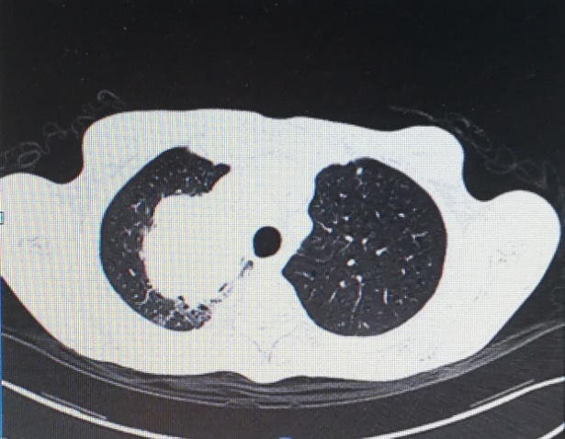

B
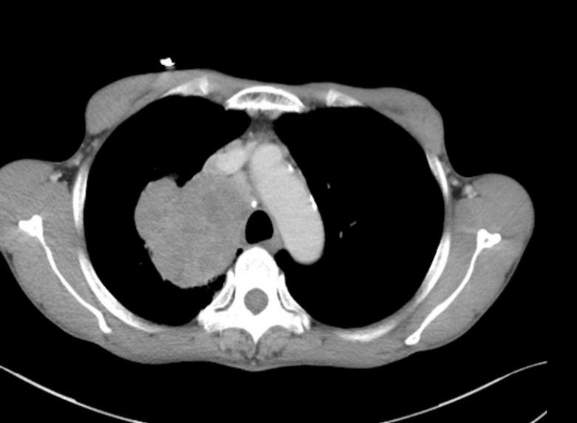

Figure 1 Computed tomography scan. A: Space-occupying lesion of the upper lobe of the right lung; B: Mediastinal window of the upper lobe of the right lung.

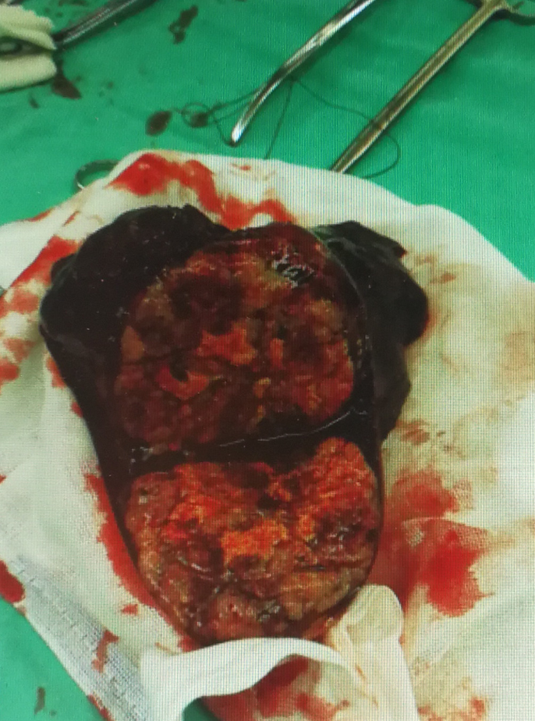
Figure 2 Pictures of hepatoid adenocarcinoma of the lung.

