Name of journal: World Journal of Gastroenterology
ESPS Manuscript NO: 9854
Columns: TOPIC HIGHLIGHTS

WJG 20th Anniversary Special Issues (18): Pancreatitis

Magnetic resonance imaging of pancreatitis: An update

Manikkavasakar S et al. Magnetic resonance imaging of pancreatitis

Sriluxayini Manikkavasakar, Mamdoh AlObaidy, Kiran K Busireddy, Miguel Ramalho, Viragi Nilmini, Madhavi Alagiyawanna, Richard C Semelka

Sriluxayini Manikkavasakar, Mamdoh AlObaidy, Kiran K Busireddy, Miguel Ramalho, Viragi Nilmini, Madhavi Alagiyawanna, Department of Radiology, University of North Carolina at Chapel Hill, Chapel Hill, NC 27599-7510, United States

Richard C Semelka, Department of Radiology, University of North Carolina at Chapel Hill, Chapel Hill, NC 27599-7510, United States

Authors contributions: Manikkavasakar S, AlObaidy M, Busireddy KK, Ramalho M, Nilmini V, Alagiyawanna M, and Semelka RC contributed equally to this work, including literature review, manuscript writing, manuscript editing, figures collection, writing figures captions, and figures annotations.

Correspondence to: Richard C Semelka, MD, Department of Radiology, University of North Carolina at Chapel Hill, 2001 Old Clinic Bldg., CB 7510, Chapel Hill, NC 27599-7510, United States. richsem@med.unc.edu
Telephone: +1-919-9669676 Fax: +1-919-8437147

Received: March 1, 2014 Revised: June 2, 2014
Accepted: June 14, 2014

Published online:

Abstract
Magnetic resonance (MR) imaging plays an important role in the diagnosis and staging of acute and chronic pancreatitis and may represent the best imaging techniques in the setting of pancreatitis due to its unmatched soft tissue contrast resolution as well as non-ionizing nature and higher safety profile of intravascular contrast media, making it particularly valuable in radiosensitive populations such as pregnant patients, and patients with recurrent pancreatitis requiring multiple follow-up examinations. Additional advantages include the ability to detect early form of chronic pancreatitis and to better differentiate adenocarcinoma from focal chronic pancreatitis. This review addresses new trends in clinical pancreatic MR imaging emphasizing its role in imaging all types of acute and chronic pancreatitis, pancreatitis complications and other important differential diagnoses that mimic pancreatitis.

© 2014 Baishideng Publishing Group Inc. All rights reserved.
Key words: Magnetic resonance imaging; Acute pancreatitis; Chronic pancreatitis; Autoimmune pancreatitis; Chronic pancreatitis; Revised Atlanta classification; Motion-resistant imaging.
Core tip: Magnetic resonance (MR) imaging is widely used in the diagnosis and staging of pancreatitis, and may represent the best imaging techniques due to its unmatched soft tissue contrast resolution, non-ionizing nature, higher safety profile of intravascular contrast media. This review addresses new trends in clinical pancreatic MR imaging emphasizing its role in imaging all types of acute and chronic pancreatitis, autoimmune pancreatitis, pancreatitis complications, and other important differential diagnoses that mimic pancreatitis.

Manikkavasakar S, AlObaidy M, Busireddy KK, Ramalho M, Nilmini V, Alagiyawanna M, and Semelka RC. Magnetic resonance imaging of pancreatitis: An update. World J Gastroenterol 2014; In press

INTRODUCTION
Pancreatitis is a major cause for abdominal pain and hospitalization in the United States and worldwide. Incidence of pancreatitis is increasing in the recent decades^{[1,2]}. Imaging plays a central role in the management and complications of pancreatitis^{[3]}. The recent development of new respiratory gating techniques, motion resistant pulse sequences, and additive advantages of magnetic resonance cholangiopancreatography (MRCP) imaging protocols make magnetic resonance imaging (MRI) a very accurate investigation modality for assessing patients with pancreatitis^{[4,5]}, particularly acutely ill patients unable to breath hold^{[6]}. This review addresses new trends in clinical pancreatic MR imaging emphasizing its role in imaging all types of acute and chronic pancreatitis, pancreatitis complications and other important differential diagnoses that mimic pancreatitis.
MRI and MRCP are the most safe, effective, and noninvasive imaging method for evaluation of the pancreas and ductal system^{[7]}. Technical innovations in MRI such as the use of phased-array coils and parallel imaging allow for improved spatial resolution and faster acquisition times. The use of triggering techniques^{[8]} or motion resistant sequences such as free-breathing three-dimensional gradient-echo with radial data sampling (Radial 3D-GRE), make routine MRI of the pancreas more feasible^{[6]}. MRI has the unique capability of allowing noninvasive evaluation of the, pancreatic parenchyma, pancreatic ductal system, peripancreatic soft tissue, and vascular network in a single examination. The concurrent use of Secretin improved the diagnostic yield of MRCP in the evaluation of the pancreatic duct integrity and pancreatic exocrine function in cases of early pancreatitis^{[9-11]}.
Normal pancreatic parenchyma has high aqueous protein content that results in high signal intensity on T1-weighted fat-suppressed breath-hold gradient-echo sequences^{[12]} and shows uniform enhancement on the hepatic arterial-dominant phase, also known as late hepatic arterial phase (Figure 1). The standard MR protocol includes a fat-suppressed 3D-GRE T1-weighted pre- and post-gadolinium imaging in the capillary phase (hepatic arterial-dominant phase), portal, and interstitial phase (1-10 min post-Gadolinium)^{[13]}. The main advantages of these sequences are being able to acquire thinner sections (3 mm) and acquire multiplanar imaging. On gadolinium-enhanced images, the pancreas demonstrates a uniform capillary blush on immediate post-Gadolinium images, which renders it markedly higher in signal intensity than liver, neighboring bowel, and adjacent fat^{[14]}. By 1-min post-Gadolinium, the pancreas shows approximately isointense signal to fat on non fat-suppressed T1-weighted GRE, and moderately higher signal than background fat in fat-suppressed SGE or 3D-GE sequences.
Echo-train spin-echo sequences such as T2-weighted half-Fourier acquisition snapshot turbo spin-echo (HASTE) are motion robust sequences that provide a sharp anatomic delineation of the common bile duct (CBD) on coronal plane images and of the main pancreatic duct on transverse plane images. Also, T2-weighted images provide information on the complexity of the fluid within pancreatic pseudocysts, which may reflect the presence of complications such as necrotic debris or infection.
MRI combining T1, T2, early and late post-gadolinium images, MRCP, and MRA generate comprehensive information on the pancreas^{[13,15]}.
Three-dimensional MRCP images are acquired in the plane of the pancreatic duct in an oblique coronal projection with the additive advantage of yielding multiplanar maximal projection (MIP) and volume rendering (VR) imaging (Figure 2). It delineates longer segments of the pancreatic duct in continuity^{[13,16]}.

PANCREATITIS
Pancreatitis is defined as the inflammation of the pancreas and considered the most common pancreatic disease in children and adults. It can be acute; representing an acute inflammatory process of the pancreas, or chronic; progressing slowly with continued, permanent inflammatory injury to the pancreas.

Acute pancreatitis
Acute pancreatitis is an acute inflammatory process of the pancreas, which may spread to adjacent tissues and organs^{[17,18]}. It can be triggered by several factors, of which alcoholism and choledocholithiasis are responsible for 90% of cases in the United States^{[17]}. The diagnosis of non-complicated acute pancreatitis mainly depends on elevated serum amylase or lipase level of more than three time of its upper limit with characteristic clinical findings^{[18,19]}. In severe forms of the disease, imaging is performed to assess pancreatic parenchyma perfusion, the extent of necrosis as well as the presence and extent of fluid collections and other complications.
The revised Atlanta classification for acute pancreatitis in 2012^{[20]} was aimed to establish international standards of definitions of acute pancreatitis and its complications and to ensure the proper communication between multidisciplinary team working in these patients^{[20]}. According to this classification early imaging will only be required when patient is suspected to have pancreatitis without elevated serum amylase or lipase.

Classification of acute pancreatitis
According to the revised Atlanta classification, acute pancreatitis can be divided into interstitial edematous and necrotizing pancreatitis^{[20]}.

Interstitial edematous pancreatitis
It is commonly present as a generalized enlargement of pancreas, or in some cases, as focal swelling due to inflammatory edema of the pancreas and surrounding peripancreatic fat (Figure 3) and relatively homogenous enhancement with contrast (Figure 4). Some peripancreatic fluid may also be present (Figure 5). The clinical symptoms of interstitial edematous pancreatitis usually resolve within first week of onset of disease^{[21]}.

Necrotizing pancreatitis
About 5%-10% of cases develop necrosis of pancreatic tissue, peripancreatic fat, or both (Figure 6).
Development of pancreatic and peripancreatic necrosis due to the impaired perfusion in acute pancreatitis takes several days^{[22,23]}; explaining why initial imaging may underestimate disease progression. Initial images may show patchy non-enhancing areas that become more confluent or diffuse with the time^{[22,23]} (Figure 7). Non-enhancing areas after 7 d of the disease are diagnosed as parenchymal necrosis^{[24]}. Normal enhancement of pancreatic parenchyma may be seen in peripancreatic necrosis, and is associated with increased rate of morbidity than in patients with interstitial edematous pancreatitis^{[21,22,25]}. Pancreatic and peripancreatic necrosis can be infected, liquefied, remain solid, sterile or in some cases persist or disappear with time.

Complications of acute pancreatitis
According to the revised Atlanta classification^{[20]} for pancreatitis, the following are the complications noted on imaging.

Acute peripancreatic fluid collections (APFCs): They occur early in the course of the disease^{[20,26]}. They present between the facial planes surrounding the pancreas and do not have clear wall around them. They can be single or multiple, but their contents are typically homogenous and sterile. Patients with APFC are asymptomatic and treatment is unnecessary. Most of these collections resolve on their own^{[26,27]}. If they do not resolve within a month, they may become pancreatic pseudocysts (Figure 8).

Pancreatic pseudocysts: Cystic lesions with homogenous internal fluid content, but without any solid materials, demarcated by a clear wall and located in the pancreatic or peripancreatic regions are called pseudocysts (Figures 9 and 10). High amylase levels are seen in aspirated fluid from these cysts^{[20]}.
Pancreatic pseudocysts develop due to the leakage of pancreatic juice from the ruptured main pancreatic duct or its side branches of more than 4 wk, with no obvious pancreatic necrosis. T2-weighted images confirm the absence of solid content in the collection. Pseudocysts may also arise in the setting of acute necrotizing pancreatitis as a result of a “disconnected duct syndrome” where proximal pancreatic parenchymal necrosis isolates a still viable distal pancreatic parenchymal remnant^{[28]}.
Pseudocysts may be evident many weeks following operative necrosectomy secondary to localized leakage of the disconnected duct into the necrosectomy cavity.

Acute necrotic collections (ANCs): Well-defined collections of variable amount of necrotic materials and fluid within a month of disease occurrence are referred to as ANCs (Figure 11). They can be single or multiple, and are sometimes multi-loculated. The main differences between ANCs and APFCs are that ANCs contain necrotic materials, and also develop from necrotizing pancreatitis, sometimes associated with pancreatic ducts disruption, and occasionally they can get infected^{[20]}. Because of CT’s low contrast resolution, MRI may be indicated in the early course of the disease to differentiate ANCs from APFCs. With time, parenchymal necrosis becomes more obvious, which aids in the distinction of ANCs from APFCs. MRI is more sensitive in depicting solid tissue within ANCs.

Walled-off necrosis (WONs): Well-defined necrotic tissues surrounded by enhancing viable inflammatory walls are referred to as WONs. They can be confined to the pancreatic parenchyma, involve the peripancreatic tissue (Figure 12), or even at times be away from the pancreas. The whole process may take about a month after the onset of necrotizing pancreatitis. WONs can be sterile or infected as well as solitary or multiple^{[20]}. Contrast-enhanced CT may under misdiagnose WONs as pseudocysts. MRI may be useful to differentiate solid from liquid contents within the lesion. Identification of ductal disruptions is necessary for further management.

Infected pancreatic necrosis: The diagnosis of infected pancreatic necrosis suspected in the presence of extra-luminal gas or gas-fluid level in the areas of pancreatic or peripancreatic necrosis on imaging^{[20]} (Figure 13). The amount of gas-fluid level depends on the stage of the disease. Confirmation of diagnosis is made by microscopy and culture of fine needle aspiration^{[29,30]}. Infected necrosis is associated with high morbidity and mortality and requires drainage and antibiotic therapy.

Disconnected pancreatic duct syndrome (DPDS): It is characterized by disruption of the main pancreatic duct with loss of continuity between the pancreatic duct and the gastrointestinal tract caused by ductal necrosis after severe acute necrotizing pancreatitis treated by percutaneous drainage or necrosectomy^{[20,28]}.
Diagnosis of disconnected pancreatic duct syndrome is important in the determination of the optimal approach (surgical, endoscopic, and percutaneous) for patients with organizing pancreatic necrosis or fluid collections^{[31]}. The treatment of the disconnected pancreatic duct is surgical and requires either internal drainage or distal pancreatic resection for complete resolution. The exact incidence of this syndrome remains unknown; however, pancreatic duct disruption has been observed in as many as 50% of patients after an episode of severe acute necrotizing pancreatitis^{[9,31]}.
The morbidity associated with ERCP in the setting of recent acute pancreatitis is high, and the procedure is often technically challenging because of ongoing edema that involves the duodenum or complete disruption of the main pancreatic duct. MRCP is a non-invasive way of assessing the DPDS, where discrete intra pancreatic fluid collection along the expected course of the main pancreatic duct, with viable upstream pancreatic parenchyma, is suggestive of the diagnosis of the disconnected pancreatic duct syndrome^{[9]}.
ERCP findings of ductal obstruction at the level of this fluid collection, with or without extravasation of contrast material, help in confirming this diagnosis. Although ERCP is still considered the reference standard for the evaluation of disconnected pancreatic duct syndrome, secretin-enhanced MRCP can be useful in determining whether the main pancreatic duct is disrupted or disconnected in patients with necrotizing pancreatitis^{[9,11,32-34]} (Figure 13).

Other complication: Other local complications of acute pancreatitis are gastric outlet dysfunction, splenic or portal veins thrombosis, and large bowel necrosis. Clinical features of local complications includes recurrent abdominal pain, secondary increase in serum amylase, impaired renal and liver function, fever, and, leukocytosis.

MRI and MRCP in acute pancreatitis
A variety of pulse sequences are routinely used in pancreatic imaging including T1- and T2-weighted sequences with or without fat-suppression and 3D-GRE T1-weighted pre- and post-gadolinium administration. MRCP is routinely added to the standard imaging protocol to assess ductal obstruction, dilation, anatomical variation (Figure 14), or complication such as disconnected pancreatic duct syndrome. In selected cases, secretin-enhanced MRCP further increases the diagnostic value of MRCP^{[9,11,32-34]}. T2-weighted fat-suppressed images are extremely sensitive in detecting subtle, early pancreatitis in patients who have negative CT scan findings^{[19]}. It has been reported that MR severity index (MRSI) assessed by using 0.5 Tesla (T) MR systems without contrast significantly correlated with CT severity index (CTSI), Ranson score, C-reactive protein levels, appearance of systemic complications, duration of hospitalization, and clinical outcome^{[35,36]}.

CHRONIC PANCREATITIS
Chronic pancreatitis is defined as continuing inflammatory destruction of pancreatic tissue that results in irreversible structural changes of pancreas including parenchymal tissue and ductal system. The incidence of chronic pancreatitis is 5-12 per 100000 persons per year; accounting for more than 120000 outpatient visits and 50000 hospitalizations annually^{[37]}. Alcohol consumption is a major cause in adults (80%) in developed countries, whereas malnutrition is the most common cause worldwide^{[38]}. Other causes of chronic pancreatitis includes genetic mutations, pancreatic ductal obstruction or anatomical variation, hypercalcemia, nutritional factors, hyperparathyroidism, and hyperlipidemia.
Diagnosis is made by clinical history, testing of pancreatic exocrine function, and imaging^{[39]}. MRI is more reliable in diagnosing chronic pancreatitis than CT or ultrasonography^{[40]}. MRI will identify parenchymal atrophy, duct dilation, and pancreatic ductal and parenchymal changes after hormonal stimulation^{[40,41]}. Chronic pancreatitis damages the acinar cells, main pancreatic duct, and side branches. Microscopic finding includes sclerosis and fibrosis of pancreatic duct and side branches, acinar cell atrophy and ductal dilatation stricture or stenosis. Eosinophilic protein plugs or intraductal calcification may be seen with the ducts. All these changes will lead to focal, segmental or generalized atrophy or loss of pancreatic tissue, main and/or side pancreatic ducts stenosis, stricture or dilatation^{[40-44]}.

Early chronic pancreatitis
Parenchymal changes might be preceded by ductal changes in chronic pancreatitis^{[45]}; this makes MRCP alone more advantageous in suspected early chronic pancreatitis. MRI detects not only morphological characteristics, but also early fibrotic changes. Fibrosis is shown by diminished signal intensity on fat-suppressed T1-weighted images and diminished parenchymal enhancement on immediate post-Gadolinium images^{[46]} (Figure 15). Low signal intensity on fat-suppressed T1-weighted images reflects loss of the aqueous protein within the pancreatic acini. Diminished pancreatic parenchymal enhancement on the capillary phase images reflects disruption of the normal capillary bed and increased chronic inflammation and fibrosis. MRCP findings in early chronic pancreatitis often demonstrate normal main pancreatic duct with dilated and irregular side duct branches (Figure 16). The limiting factor is the underestimation of ductal size. Some investigators reported that patients with abnormal MR imaging findings but normal MRCP might benefit from dynamic secretin-MRCP (S-MRCP), which may reveal ductal abnormalities due to improved visualization otherwise not detected on MRCP alone^{[45]}. Secretin-MRCP has been reported to show ductal changes, like dilatations and strictures in early chronic pancreatitis.

Late chronic pancreatitis
All patients with late or advanced chronic pancreatitis show diminished signal intensity of the pancreas on T1-weighted fat-suppressed images, an abnormally low percentage of contrast enhancement on arterial phase images, and progressive parenchymal enhancement on the 5-min delayed post-Gadolinium images; reflecting the pattern of enhancement of ﬁbrous tissue^{[47,48]}. MRCP in advanced phase demonstrate dilatation of the main pancreatic duct with ectasia of the side branches; giving chain of lakes appearance (Figure 17) manifested as pancreatic ductal strictures, irregularities and intra ductal calculi, appearing as hypointense filling defects. Other findings include intra ductal calcifications, which are the most specific finding, seen in nearly half of the patients with chronic pancreatitis and parenchymal atrophy (Figure 18), though it is neither specific nor sensitive as it seen normally with aging. Intraductal or parenchymal calcifications are usually seen with alcohol related chronic pancreatitis but not on chronic pancreatitis resultant from other causes.

Pancreatic inflammatory mass versus pancreatic cancer
Chronic inflammatory process in chronic pancreatitis can produce a focal mass lesion, especially in the head of the pancreas that can mimic more sinister pathologies i.e., pancreatic adenocarcinoma^{[49]} (Figure 19).
Both chronic pancreatitis and adenocarcinoma show similar imaging characteristics on MRI due to abundant fibrosis and ductal obstruction; therefore, making the differentiation between these two entities very difficult. Both are generally seen as mildly hypointense on T1-weighted images and heterogeneously mildly hyperintense signal on T2-weighted images. Other possible similar findings in both conditions include common bile duct and main pancreatic duct dilation (double duct sign), stricture of ducts, peripancreatic fat stranding due to infiltration, vascular encasement of superior mesenteric artery, and splenic vein thrombosis^{[50,51]}. T1- and T2-weighted images alone cannot differentiate both conditions. The following supporting feature may favor inflammatory origin: part of the duct seen through the mass is not dilated and shows smooth tapering (duct penetrating sign)^{[52]}. Features favoring carcinoma include abrupt cut off of pancreatic duct just proximal to the ampulla, pancreatic atrophy distal to the mass, and increased duct caliber-to-gland ratio (ductal diameter is out of proportion to pancreatic parenchymal thickness). Pancreatic adenocarcinoma can develop in patients with chronic pancreatitis, which further limits the diagnostic capability of imaging necessitate histological confirmation^{[51,53]}. Excessive fibrosis seen in both conditions explains the similarities on imaging. Because of the similarities between these conditions on clinical and imaging evaluations, histology is mandatory for final diagnosis^{[50]}.

Complications of chronic pancreatitis
The most common non-neoplastic complications of chronic pancreatitis include pseudocysts, pseudo aneurysms (due to erosion of the arterial wall), splenic vein thrombosis with subsequent development of collaterals, biliary obstruction (due to pseudocysts), and gastrointestinal complications; such as gastric outlet obstruction or bowel ischemia^{[19,54]}. These complications are well depicted with MRI. MRI with MRCP may be superior to CT in detecting specific complications like pseudocysts, fistula formation, and distal common biliary dilatation. Vascular complications associated with higher morbidity and mortality.

MRI and MRCP in chronic pancreatitis
MRI, combined with MRCP, is an excellent modality to assess patients with clinically suspected chronic pancreatitis^{[40]}, MRI evaluates ductal alterations and obstructive causes of chronic pancreatitis like ductal calculi. MRI also assesses signal changes of gland, glandular volume depletion or atrophy, and pancreatic perfusion on contrast-enhanced images. Volume depletion manifests as reduction of anterior posterior diameter of pancreas in the entire gland or in specific segments. Pancreatic fibrosis causes reduction of pancreatic signal intensity on MRI. Loss of acinar cell aqueous protein causes reduction of signal on fat suppressed T1-weighted images. Signal intensity will be assessed by comparison of signals between pancreas and spleen or paravertebral muscle. The normal pancreas have same signal as spleen or paravertebral muscles. Normal pancreatic enhancement will be maximal during late arterial phase and washed out at venous phase. In patients with chronic pancreatitis, pancreas shows progressive enhancement that peaks on the portal venous or interstitial phase. This finding is the result of pancreatic fibrosis that causes impairment of capillary blood flow to the gland. A time-related perfusion model can assess pattern of enhancement of the pancreas, where normal pancreas shows high upslope in contrast. In cases of chronic pancreatitis, a plateau-like pattern is observed. Periductal fibrosis causes dilated main and side pancreatic ducts due to traction^{[40,41,43,55,56]}. Several classification systems are used to define and characterize the severity of chronic pancreatitis. The Cambridge classification, which is the most commonly used grading system for chronic pancreatitis, was established in 1984 for ERCP^{[57]}. This system classifies pancreatograms into normal or equivocal, mild, moderate, and severe changes of chronic pancreatitis on the basis of the main pancreatic duct dilatation, side-branch dilatation, and additional features (Table 1). The new MR techniques with addition of secretin make it possible to use Cambridge classification for MRCP as well by increasing ductal filling to improve the depiction of the pancreatic ductal system^{[9,11,56,58-60]}.

Secretin-enhanced MRCP
Secretin-enhanced MRCP is an imaging modality that not only helps identify the characteristic ductal changes of acute or chronic pancreatitis but also provides an estimate of pancreatic excretory volume. It is important to remember that the presence of normal duodenal filling does not exclude impairment of pancreatic exocrine function, which is measured by determining the fluid bicarbonate level^{[11,61]}. Secretin is a polypeptide hormone made by 27 amino acids, secreted by the duodenum. After meals, acid secretion increases in duodenum stimulating the secretion of secretin. Secretin stimulates the pancreas; which secretes bicarbonate rich fluid and increases the tone of sphincter of Oddi. The main pancreatic duct distends by the accumulation of the pancreatic juice due to the effect of secretin. The distention will be maximal in about four to ten minutes. Ductal anatomy can be clearly studied after secretin stimulation. Other advantages of secretin are ease of administration and safety of use with low incidence of major side effects^{[9,11,61-63]}. Excretory function of the pancreas is graded in secretin-enhanced MRCP according to the duodenal anatomic imaging findings: grade 1, when pancreatic fluid is confined to the duodenal bulb; grade 2, when fluid is seen as far as the second part of the duodenum; and grade 3, when duodenal filling reaches the third part of the duodenum. Diminished estimated pancreatic exocrine function is suspected in the absence of duodenal fluid accumulation, or with grade 1 duodenal filling^{[11,61]}. This grading does not differentiate between early and established pancreatitis. To adequately assess the exocrine response to secretin, patients should be fasting for at least 4 h before the MR imaging examination. It is recommend that the administration of a negative oral contrast agent to remove high signal intensity from the fluid within the stomach and duodenum on MRCP images. Ferumoxsil suspension (300 mL) can be used as an oral contrast agent. Other oral contrast agent is diluted gadolinium-DTPA (5 mL gadolinium DTPA diluted with 75 mL of distilled water). Oral contrast agents shorten the T2 time and act like a negative T2 agent^{[55,64-67]}. If a commercial product is not available, pineapple juice or blueberry juice can be used as alternative negative MR contrast material. Oral contrast agent should be given 30 minutes before the procedure to counteract signals from preexisting duodenal secretions. Secretin bolus injection can cause abdominal cramps; to avoid this, slow intravenous infusion over a minute is indicated. Following negative oral contrast administration and intravenous infusion of 0.2 µg secretin, serial coronal single-shot fast spin echo images are obtained every 30 s for 15 min from the time of injection^{[44,45,67,68]}.

Diffusion weighted imaging and chronic pancreatitis
Diffusion weighted imaging (DWI) sequence may be used to assess pancreatic parenchymal atrophy in patients with chronic pancreatitis, where atrophy and ductal pathology are subtle, and has shown results comparable to MRI and MRCP^{[48,69]}. DWI assesses the random microscopic motion of water protons to obtain the apparent diffusion coefficient (ADC). This is reflected by reduction in ADC values in case of chronic pancreatitis as loss of exocrine functional tissue of pancreas increases the amount of fibrosis, leading to reduction in water diffusibility^{[40,60]}. Furthermore, when DWI is used in combination with secretin stimulation, the diffusion coefficients have either delayed or lower peak values in chronic pancreatitis, indicating reduced exocrine function^{[48,70,71]}.

Special types of chronic pancreatitis
Autoimmune pancreatitis: Continuous inflammatory process of the pancreas due to an autoimmune pathogenesis leading to chronic pancreatitis called autoimmune pancreatitis. Other autoimmune diseases associated with autoimmune pancreatitis include ulcerative colitis, primary sclerosing cholangitis, primary biliary cirrhosis, retroperitoneal fibrosis, Sjogren's syndrome, and systemic lupus erythematosus^{[72]}. It is accounts for 2%-6% of chronic pancreatitis^{[73,74]}. It is characterized, clinically, by obstructive jaundice (with or without pancreatic mass); histologically, by a lymphoplasmacytic inﬁltrate and ﬁbrosis; and, therapeutically, by a dramatic response to steroids^{[75]}. Early diagnosis of autoimmune pancreatitis is critical as it often responds well to steroid therapy; thus avoiding complications.
There are three types based on morphological patterns: diffuse, focal, and multifocal. Diffuse disease is the most common type. MRI commonly shows a swollen, sausage-like pancreas (Figure 20) with poorly demonstrated borders, moderately decreased T1 signal intensity, mildly high T2 signal intensity, and delayed gadolinium enhancement of the pancreatic parenchyma on post-gadolinium images. Additional ﬁndings that may be observed in autoimmune pancreatitis include low signal capsule-like rim surrounding the diseased parenchyma on T2-weighted images, delayed post-gadolinium enhancement^{[76]}, absence of parenchymal atrophy, ductal dilatation proximal to the site of stenosis, absence of peripancreatic ﬂuid, and clear demarcation of the abnormality^{[77]}. The diffuse form of autoimmune pancreatitis (AIP) may mimic diffuse disorders like lymphoma, metastases or other diffuse infiltrative processes however, in most of these disorders, the parenchyma is heterogeneous and shows irregular contour.
Focal disease is less common and manifests as a well-defined T2 hyperintense mass with a T2 hypointense capsule-like rim surrounding the diseased parenchyma which may show delayed post-gadolinium enhancement, often involving the head and mimicking pancreatic adenocarcinoma but most often without associated pancreatic ductal cutoff. The characteristic imaging finding in MRCP is focal, segmental or diffuse stenosis or irregularity of main pancreatic duct.
The most commonly involved segment is the intra pancreatic common bile duct, accompanied by a lesser degree of upstream dilatation of the main pancreatic duct. Less frequently, multifocal intrahepatic biliary strictures are also noted in AIP^{[78]}.

Groove/paraduodenal pancreatitis: Groove or paraduodenal pancreatitis is an uncommon type of focal chronic pancreatitis; which may affect the groove between the head of the pancreas, the duodenum, and the common bile duct. The rest of the pancreatic parenchyma is slightly compromised or spared^{[79,80]}. Groove pancreatitis is categorized into 2 forms: pure, involving exclusively the groove; or segmental (Figure 21), involving the groove and extending in to the pancreatic head^{[80]}. Pathogenesis remains controversial but may result from obstruction of the accessory pancreatic duct as it drains into the second portion of the duodenum through the minor papilla^{[81]}. It may be due the previous biliary diseases, gastric resections, peptic ulcer disease, true duodenal wall or pancreatic head cysts, or pancreatic head heterotopias in the duodenum^{[80,82]}. Both pure and segmental form can cause progressive stenosis of the pancreatic duct, leading subsequently to diffuse chronic pancreatitis. The histopathologic hallmark of groove pancreatitis is the presence of fibrosis and scar tissue within the pancreaticoduodenal groove, in the pure form; or within the groove and superior portion of the pancreatic head, in the pure form of the disease. The most relevant differential diagnosis of groove pancreatitis, particularly in its segmental form, is pancreatic head adenocarcinoma.
The most characteristic finding on MRI is a sheet like mass between the head of pancreas and duodenal C-loop. The mass demonstrates low signal on T1-weighted images compared to the rest of the pancreatic parenchymal tissue, and variable signal on T2-weighted images. This variation in the T2 signal can be attributed to the time of onset of the disease; as subacute form of the disease shows brighter signal on T2-weighted images due to edema, while chronic form of the disease has a lower T2 signal due to fibrosis^{[82]}. Gadolinium-enhanced dynamic images show delayed and progressive heterogeneous enhancement, reflecting the fibrous nature of the tissue. Cystic lesions can also be well seen on T2-weighted images in the groove or duodenal wall^{[80]}.
It may be challenging to differentiate groove pancreatitis from pancreatic head duct adenocarcinoma. Recently, it was shown that by using three strict diagnostic criteria for groove pancreatitis: (1) focal thickening of the second part of the duodenum; (2) abnormal increased enhancement of the second part of the duodenum; and (3) cystic changes in the region of the pancreatic accessory duct, With these features distinction from pancreatic duct adenocarcinoma could be achieved with high diagnostic accuracy (87.2% of patients), and a diagnosis of cancer could be excluded with a negative predictive value of 92.9%^{[83]}.

Hereditary pancreatitis: Hereditary pancreatitis is an autosomal dominant disease presenting as multiple episodes of pancreatitis in the absence of any predisposing factors and is consider as a premalignant disease^{[84]}. Imaging findings include parenchymal and intraductal calcifications and parenchymal atrophy. However, in hereditary pancreatitis, imaging plays an important role to rule out structural causes of pancreatitis and to closely monitor the development of pancreatic cancer, the risk of which is increased by many folds in these patients.

NEW TECHNIQUES
Continuous development in MRI technologies have resulted in new techniques with increased signal-to-noise ratio, shorter breath-hold scan time and respiratory triggering techniques to produce improved image quality and diagnostic performances. Edelman et al^{[85]} reported that there is a marked improvement in SNR at 3 T compared with 1.5 T (by a factor of 2 in some cases) when using identical imaging parameters to image the pancreas. A recent study showed that respiratory-triggered 3D-MRCP using a navigator technique was feasible in routine clinical practice. The navigator technique improved the image quality and lesion visualization of free-breathing 3D-MRCP compared with conventional respiratory triggering techniques using bellows (bellows technique)^{[86]}.
Imaging patients unable to hold their breath is challenging. Elderly or very sick patients, who are often part of the pancreatitis population, cannot adequately hold their breath for the required time to acquire T1-weighted images. Radial 3D-GRE delivers robust contrast-enhanced imaging for these patients by being resistant to motion artifacts. A previous study by Bamrungchart et al^{[6]} has shown that free-breathing radial 3D-GRE is of value for pancreatic MR imaging in patients who are unable to suspend respiration.
MR spectroscopy with non-invasive in-vivo assessment of metabolite concentrations has been applied in a variety of different tissues (brain, prostate, breast, and liver). Hence, spectroscopy of the pancreas has the potential to offer a more accurate tissue characterization^{[48]}. Despite this, Su et al^{[87]} characterized the normal pancreas at 3.0 T and identified metabolites such as lipid, choline and cholesterol. Cho et al^{[88]} used MR spectroscopy to distinguish between patients with chronic focal pancreatitis and patients with pancreatic carcinoma and found fewer lipids in pancreatitis than in pancreatic carcinoma. Furthermore, other studies also detected differences between normal pancreatic tissue and carcinoma tissue with alterations in lipid, choline and fatty acids^{[89,90]}. However, to the best of our knowledge, this technique has not yet been applied in the characterization of patients with pancreatitis.

CONCLUSION
In this review we emphasized the role of MRI in imaging all types of acute and chronic pancreatitis, pancreatitis complications, and other important differential diagnoses that mimic pancreatitis. MRI is a valuable alternative modality, with at least equal diagnostic performance to CT for the diagnosis and follow-up of acute and chronic pancreatitis. The recent development of new respiratory gating techniques, motion resistant pulse sequences, and additive advantages of MRCP imaging protocols make MRI a very accurate investigation modality for assessing patients with pancreatitis; particularly acutely ill patients unable to breath hold. MRI is a non-ionizing cross sectional imaging method with a safer intravenous contrast profile. This is particularly important in patients with acute pancreatitis, who often have a concomitant renal impairment of some degree and often require repeated follow-up imaging. Additionally, MRI offers higher sensitivity for the diagnosis of subtle early changes of acute pancreatitis (i.e., interstitial pancreatitis and peripancreatic edema) and early manifestations of chronic pancreatitis.

REFERENCES
1 Goldacre MJ, Roberts SE. Hospital admission for acute pancreatitis in an English population, 1963-98: database study of incidence and mortality. BMJ 2004; 328: 1466-1469 [PMID: 15205290]
2 O'Sullivan JN, Nobrega FT, Morlock CG, Brown AL, Bartholomew LG. Acute and chronic pancreatitis in Rochester, Minnesota, 1940 to 1969. Gastroenterology 1972; 62: 373-379 [PMID: 5011528]
3 Turkvatan A, Erden A, Turkoglu MA, Secil M, Yener O. Imaging of acute pancreatitis and its complications. Part 1: Acute pancreatitis. Diagn Interv Imaging 2014 [PMID: 24512896 DOI: 10.1016/j.diii.2013.12.017]
4 Shanmugam V, Beattie GC, Yule SR, Reid W, Loudon MA. Is magnetic resonance cholangiopancreatography the new gold standard in biliary imaging? Br J Radiol 2005; 78: 888-893 [PMID: 16177010 DOI: 10.1259/bjr/51075444]
5 Maurea S, Caleo O, Mollica C, Imbriaco M, Mainenti PP, Palumbo C, Mancini M, Camera L, Salvatore M. Comparative diagnostic evaluation with MR cholangiopancreatography, ultrasonography and CT in patients with pancreatobiliary disease. Radiol Med 2009; 114: 390-402 [PMID: 19266258 DOI: 10.1007/s11547-009-0374-x]
6 Bamrungchart S, Tantaway EM, Midia EC, Hernandes MA, Srirattanapong S, Dale BM, Semelka RC. Free breathing three-dimensional gradient echo-sequence with radial data sampling (radial 3D-GRE) examination of the pancreas: Comparison with standard 3D-GRE volumetric interpolated breathhold examination (VIBE). J Magn Reson Imaging 2013; 38: 1572-1577 [PMID: 23417838 DOI: 10.1002/jmri.24064]
7 Drake LM, Anis M, Lawrence C. Accuracy of magnetic resonance cholangiopancreatography in identifying pancreatic duct disruption. J Clin Gastroenterol 2012; 46: 696-699 [PMID: 22565603 DOI: 10.1097/MCG.0b013e31825003b3]
8 Tkacz JN, Anderson SA, Soto J. MR imaging in gastrointestinal emergencies. Radiographics 2009; 29: 1767-1780 [PMID: 19959520 DOI: 10.1148/rg.296095509]
9 Tirkes T, Sandrasegaran K, Sanyal R, Sherman S, Schmidt CM, Cote GA, Akisik F. Secretin-enhanced MR cholangiopancreatography: spectrum of findings. Radiographics 2013; 33: 1889-1906 [PMID: 24224585 DOI: 10.1148/rg.337125014]
10 Carbognin G, Pinali L, Girardi V, Casarin A, Mansueto G, Mucelli RP. Collateral branches IPMTs: secretin-enhanced MRCP. Abdom Imaging 2007; 32: 374-380 [PMID: 16967247 DOI: 10.1007/s00261-006-9056-5]
11 Bian Y, Wang L, Chen C, Lu JP, Fan JB, Chen SY, Zhao BH. Quantification of pancreatic exocrine function of chronic pancreatitis with secretin-enhanced MRCP. World J Gastroenterol 2013; 19: 7177-7182 [PMID: 24222963 DOI: 10.3748/wjg.v19.i41.7177]
12 Pamuklar E, Semelka RC. MR imaging of the pancreas. Magn Reson Imaging Clin N Am 2005; 13: 313-330 [PMID: 15935314 DOI: 10.1016/j.mric.2005.03.012]
13Altun E, Elias J Jr., Armao D, Vachiranubhap B, Semelka RC,. Pancreas. In: Semelka RC. Abdominal-Pelvic MRI. Hoboken, NJ: Wiley-Blackwell; 2010: 535-676
14 Hamed MM, Hamm B, Ibrahim ME, Taupitz M, Mahfouz AE. Dynamic MR imaging of the abdomen with gadopentetate dimeglumine: normal enhancement patterns of the liver, spleen, stomach, and pancreas. AJR Am J Roentgenol 1992; 158: 303-307 [PMID: 1729787 DOI: 10.2214/ajr.158.2.1729787]
15 Catalano C, Pavone P, Laghi A, Panebianco V, Scipioni A, Fanelli F, Brillo R, Passariello R. Pancreatic adenocarcinoma: combination of MR imaging, MR angiography and MR cholangiopancreatography for the diagnosis and assessment of resectability. Eur Radiol 1998; 8: 428-434 [PMID: 9510578]
16 Herédia V, Altun E, Bilaj F, Ramalho M, Hyslop BW, Semelka RC. Gadolinium- and superparamagnetic-iron-oxide-enhanced MR findings of intrapancreatic accessory spleen in five patients. Magn Reson Imaging 2008; 26: 1273-1278 [PMID: 18440173 DOI: 10.1016/j.mri.2008.02.008]
17 O'Connor OJ, McWilliams S, Maher MM. Imaging of acute pancreatitis. AJR Am J Roentgenol 2011; 197: W221-W225 [PMID: 21785045 DOI: 10.2214/AJR.10.4338]
18 Bradley EL. A clinically based classification system for acute pancreatitis. Summary of the International Symposium on Acute Pancreatitis, Atlanta, Ga, September 11 through 13, 1992. Arch Surg 1993; 128: 586-590 [PMID: 8489394]
19 Bollen TL. Imaging of acute pancreatitis: update of the revised Atlanta classification. Radiol Clin North Am 2012; 50: 429-445 [PMID: 22560690 DOI: 10.1016/j.rcl.2012.03.015]
20 Banks PA, Bollen TL, Dervenis C, Gooszen HG, Johnson CD, Sarr MG, Tsiotos GG, Vege SS. Classification of acute pancreatitis--2012: revision of the Atlanta classification and definitions by international consensus. Gut 2013; 62: 102-111 [PMID: 23100216 DOI: 10.1136/gutjnl-2012-302779]
21 Singh VK, Bollen TL, Wu BU, Repas K, Maurer R, Yu S, Mortele KJ, Conwell DL, Banks PA. An assessment of the severity of interstitial pancreatitis. Clin Gastroenterol Hepatol 2011; 9: 1098-1103 [PMID: 21893128 DOI: 10.1016/j.cgh.2011.08.026]
22 Bollen TL, Singh VK, Maurer R, Repas K, van Es HW, Banks PA, Mortele KJ. A comparative evaluation of radiologic and clinical scoring systems in the early prediction of severity in acute pancreatitis. Am J Gastroenterol 2012; 107: 612-619 [PMID: 22186977 DOI: 10.1038/ajg.2011.438]
23 Spanier BW, Nio Y, van der Hulst RW, Tuynman HA, Dijkgraaf MG, Bruno MJ. Practice and yield of early CT scan in acute pancreatitis: a Dutch Observational Multicenter Study. Pancreatology 2010; 10: 222-228 [PMID: 20484959 DOI: 10.1159/000243731]
24 Thai TC, Riherd DM, Rust KR. MRI manifestations of pancreatic disease, especially pancreatitis, in the pediatric population. AJR Am J Roentgenol 2013; 201: W877-W892 [PMID: 24261395 DOI: 10.2214/AJR.13.10834]
25 Sakorafas GH, Tsiotos GG, Sarr MG. Extrapancreatic necrotizing pancreatitis with viable pancreas: a previously under-appreciated entity. J Am Coll Surg 1999; 188: 643-648 [PMID: 10359357]
26 Lenhart DK, Balthazar EJ. MDCT of acute mild (nonnecrotizing) pancreatitis: abdominal complications and fate of fluid collections. AJR Am J Roentgenol 2008; 190: 643-649 [PMID: 18287434 DOI: 10.2214/AJR.07.2761]
27 Balthazar EJ, Robinson DL, Megibow AJ, Ranson JH. Acute pancreatitis: value of CT in establishing prognosis. Radiology 1990; 174: 331-336 [PMID: 2296641 DOI: 10.1148/radiology.174.2.2296641]
28 Pelaez-Luna M, Vege SS, Petersen BT, Chari ST, Clain JE, Levy MJ, Pearson RK, Topazian MD, Farnell MB, Kendrick ML, Baron TH. Disconnected pancreatic duct syndrome in severe acute pancreatitis: clinical and imaging characteristics and outcomes in a cohort of 31 cases. Gastrointest Endosc 2008; 68: 91-97 [PMID: 18378234 DOI: 10.1016/j.gie.2007.11.041]
29 van Santvoort HC, Bakker OJ, Bollen TL, Besselink MG, Ahmed Ali U, Schrijver AM, Boermeester MA, van Goor H, Dejong CH, van Eijck CH, van Ramshorst B, Schaapherder AF, van der Harst E, Hofker S, Nieuwenhuijs VB, Brink MA, Kruyt PM, Manusama ER, van der Schelling GP, Karsten T, Hesselink EJ, van Laarhoven CJ, Rosman C, Bosscha K, de Wit RJ, Houdijk AP, Cuesta MA, Wahab PJ, Gooszen HG. A conservative and minimally invasive approach to necrotizing pancreatitis improves outcome. Gastroenterology 2011; 141: 1254-1263 [PMID: 21741922 DOI: 10.1053/j.gastro.2011.06.073]
30 Banks PA, Gerzof SG, Langevin RE, Silverman SG, Sica GT, Hughes MD. CT-guided aspiration of suspected pancreatic infection: bacteriology and clinical outcome. Int J Pancreatol 1995; 18: 265-270 [PMID: 8708399 DOI: 10.1007/BF02784951]
31 Neoptolemos JP, London NJ, Carr-Locke DL. Assessment of main pancreatic duct integrity by endoscopic retrograde pancreatography in patients with acute pancreatitis. Br J Surg 1993; 80: 94-99 [PMID: 8428306]
32 Akisik MF, Sandrasegaran K, Aisen AA, Maglinte DD, Sherman S, Lehman GA. Dynamic secretin-enhanced MR cholangiopancreatography. Radiographics 2006; 26: 665-677 [PMID: 16702446 DOI: 10.1148/rg.263055077]
33 Gillams AR, Kurzawinski T, Lees WR. Diagnosis of duct disruption and assessment of pancreatic leak with dynamic secretin-stimulated MR cholangiopancreatography. AJR Am J Roentgenol 2006; 186: 499-506 [PMID: 16423959 DOI: 10.2214/AJR.04.1775]
34 Arvanitakis M, Le Moine O. ERCP. Endoscopy 2013; 45: 296-299 [PMID: 23440584 DOI: 10.1055/s-0032-1326285]
35 Arvanitakis M, Koustiani G, Gantzarou A, Grollios G, Tsitouridis I, Haritandi-Kouridou A, Dimitriadis A, Arvanitakis C. Staging of severity and prognosis of acute pancreatitis by computed tomography and magnetic resonance imaging-a comparative study. Dig Liver Dis 2007; 39: 473-482 [PMID: 17363349 DOI: 10.1016/j.dld.2007.01.015]
36 Stimac D, Miletić D, Radić M, Krznarić I, Mazur-Grbac M, Perković D, Milić S, Golubović V. The role of nonenhanced magnetic resonance imaging in the early assessment of acute pancreatitis. Am J Gastroenterol 2007; 102: 997-1004 [PMID: 17378903 DOI: 10.1111/j.1572-0241.2007.01164.x]
37 Etemad B, Whitcomb DC. Chronic pancreatitis: diagnosis, classification, and new genetic developments. Gastroenterology 2001; 120: 682-707 [PMID: 11179244]
38 Shanbhogue AK, Fasih N, Surabhi VR, Doherty GP, Shanbhogue DK, Sethi SK. A clinical and radiologic review of uncommon types and causes of pancreatitis. Radiographics 2009; 29: 1003-1026 [PMID: 19605653 DOI: 10.1148/rg.294085748]
39 Forsmark CE. The early diagnosis of chronic pancreatitis. Clin Gastroenterol Hepatol 2008; 6: 1291-1293 [PMID: 18986847 DOI: 10.1016/j.cgh.2008.08.008]
40 Balcı C. MRI assessment of chronic pancreatitis. Diagn Interv Radiol 2011; 17: 249-254 [PMID: 20945291 DOI: 10.4261/1305-3825.DIR.3889-10.0]
41 Choueiri NE, Balci NC, Alkaade S, Burton FR. Advanced imaging of chronic pancreatitis. Curr Gastroenterol Rep 2010; 12: 114-120 [PMID: 20424983 DOI: 10.1007/s11894-010-0093-4]
42 Brock C, Nielsen LM, Lelic D, Drewes AM. Pathophysiology of chronic pancreatitis. World J Gastroenterol 2013; 19: 7231-7240 [PMID: 24259953 DOI: 10.3748/wjg.v19.i42.7231]
43 Ahmed SA, Wray C, Rilo HL, Choe KA, Gelrud A, Howington JA, Lowy AM, Matthews JB. Chronic pancreatitis: recent advances and ongoing challenges. Curr Probl Surg 2006; 43: 127-238 [PMID: 16530053 DOI: 10.1067/j.cpsurg.2005.12.005]
44 Balci NC, Bieneman BK, Bilgin M, Akduman IE, Fattahi R, Burton FR. Magnetic resonance imaging in pancreatitis. Top Magn Reson Imaging 2009; 20: 25-30 [PMID: 19687723]
45 Balci NC, Alkaade S, Magas L, Momtahen AJ, Burton FR. Suspected chronic pancreatitis with normal MRCP: findings on MRI in correlation with secretin MRCP. J Magn Reson Imaging 2008; 27: 125-131 [PMID: 18058927 DOI: 10.1002/jmri.21241]
46 Semelka RC, Shoenut JP, Kroeker MA, Micflikier AB. Chronic pancreatitis: MR imaging features before and after administration of gadopentetate dimeglumine. J Magn Reson Imaging 1993; 3: 79-82 [PMID: 8428105]
47 Ly JN, Miller FH. MR imaging of the pancreas: a practical approach. Radiol Clin North Am 2002; 40: 1289-1306 [PMID: 12479712]
48 Hansen TM, Nilsson M, Gram M, Frøkjær JB. Morphological and functional evaluation of chronic pancreatitis with magnetic resonance imaging. World J Gastroenterol 2013; 19: 7241-7246 [PMID: 24259954 DOI: 10.3748/wjg.v19.i42.7241]
49 Ito K, Koike S, Matsunaga N. MR imaging of pancreatic diseases. Eur J Radiol 2001; 38: 78-93 [PMID: 11335090]
50 Jenkins JP, Braganza JM, Hickey DS, Isherwood I, Machin M. Quantitative tissue characterisation in pancreatic disease using magnetic resonance imaging. Br J Radiol 1987; 60: 333-341 [PMID: 3580737]
51 Balthazar EJ. Pancreatitis associated with pancreatic carcinoma. Preoperative diagnosis: role of CT imaging in detection and evaluation. Pancreatology 2005; 5: 330-344 [PMID: 16015017 DOI: 10.1159/000086868]
52 Ichikawa T, Sou H, Araki T, Arbab AS, Yoshikawa T, Ishigame K, Haradome H, Hachiya J. Duct-penetrating sign at MRCP: usefulness for differentiating inflammatory pancreatic mass from pancreatic carcinomas. Radiology 2001; 221: 107-116 [PMID: 11568327 DOI: 10.1148/radiol.2211001157]
53 Baker ME. Pancreatic adenocarcinoma: are there pathognomonic changes in the fat surrounding the superior mesenteric artery? Radiology 1991; 180: 613-614 [PMID: 1871269 DOI: 10.1148/radiology.180.3.1871269]
54 Remer EM, Baker ME. Imaging of chronic pancreatitis. Radiol Clin North Am 2002; 40: 1229-142, v [PMID: 12479708]
55 Coenegrachts K, Van Steenbergen W, De Keyzer F, Vanbeckevoort D, Bielen D, Chen F, Dockx S, Maes F, Bosmans H. Dynamic contrast-enhanced MRI of the pancreas: initial results in healthy volunteers and patients with chronic pancreatitis. J Magn Reson Imaging 2004; 20: 990-997 [PMID: 15558558 DOI: 10.1002/jmri.20212]
56 Sai JK, Suyama M, Kubokawa Y, Watanabe S. Diagnosis of mild chronic pancreatitis (Cambridge classification): comparative study using secretin injection-magnetic resonance cholangiopancreatography and endoscopic retrograde pancreatography. World J Gastroenterol 2008; 14: 1218-1221 [PMID: 18300347]
57 Sarner M, Cotton PB. Classification of pancreatitis. Gut 1984; 25: 756-759 [PMID: 6735257]
58 Sugiyama M, Haradome H, Atomi Y. Magnetic resonance imaging for diagnosing chronic pancreatitis. J Gastroenterol 2007; 42 Suppl 17: 108-112 [PMID: 17238038 DOI: 10.1007/s00535-006-1923-x]
59 Testoni PA, Mariani A, Curioni S, Giussani A, Masci E. Pancreatic ductal abnormalities documented by secretin-enhanced MRCP in asymptomatic subjects with chronic pancreatic hyperenzymemia. Am J Gastroenterol 2009; 104: 1780-1786 [PMID: 19436288 DOI: 10.1038/ajg.2009.158]
60 Balci NC, Momtahen AJ, Akduman EI, Alkaade S, Bilgin M, Burton FR. Diffusion-weighted MRI of the pancreas: correlation with secretin endoscopic pancreatic function test (ePFT). Acad Radiol 2008; 15: 1264-1268 [PMID: 18790398 DOI: 10.1016/j.acra.2008.05.002]
61 Cappeliez O, Delhaye M, Devière J, Le Moine O, Metens T, Nicaise N, Cremer M, Stryuven J, Matos C. Chronic pancreatitis: evaluation of pancreatic exocrine function with MR pancreatography after secretin stimulation. Radiology 2000; 215: 358-364 [PMID: 10796908 DOI: 10.1148/radiology.215.2.r00ma10358]
62 Chang TM, Chey WY. Neurohormonal control of exocrine pancreas. Curr Opin Gastroenterol 2001; 17: 416-425 [PMID: 17031194]
63 Chey WY, Chang TM. Neural control of the release and action of secretin. J Physiol Pharmacol 2003; 54 Suppl 4: 105-112 [PMID: 15075453]
64 Coppens E, Metens T, Winant C, Matos C. Pineapple juice labeled with gadolinium: a convenient oral contrast for magnetic resonance cholangiopancreatography. Eur Radiol 2005; 15: 2122-2129 [PMID: 15999215 DOI: 10.1007/s00330-005-2835-5]
65 Papanikolaou N, Karantanas A, Maris T, Gourtsoyiannis N. MR cholangiopancreatography before and after oral blueberry juice administration. J Comput Assist Tomogr 2000; 24: 229-234 [PMID: 10752883]
66 Riordan RD, Khonsari M, Jeffries J, Maskell GF, Cook PG. Pineapple juice as a negative oral contrast agent in magnetic resonance cholangiopancreatography: a preliminary evaluation. Br J Radiol 2004; 77: 991-999 [PMID: 15569640]
67 Tirkes T, Menias CO, Sandrasegaran K. MR imaging techniques for pancreas. Radiol Clin North Am 2012; 50: 379-393 [PMID: 22560687 DOI: 10.1016/j.rcl.2012.03.003]
68 Tirkes T, Akisik F, Tann M, Balci NC. Imaging of the pancreas with secretin enhancement. Top Magn Reson Imaging 2009; 20: 19-24 [PMID: 19687722]
69 Balci NC, Smith A, Momtahen AJ, Alkaade S, Fattahi R, Tariq S, Burton F. MRI and S-MRCP findings in patients with suspected chronic pancreatitis: correlation with endoscopic pancreatic function testing (ePFT). J Magn Reson Imaging 2010; 31: 601-606 [PMID: 20187202 DOI: 10.1002/jmri.22085]
70 Akisik MF, Aisen AM, Sandrasegaran K, Jennings SG, Lin C, Sherman S, Lin JA, Rydberg M. Assessment of chronic pancreatitis: utility of diffusion-weighted MR imaging with secretin enhancement. Radiology 2009; 250: 103-109 [PMID: 19001148 DOI: 10.1148/radiol.2493080160]
71 Erturk SM, Ichikawa T, Motosugi U, Sou H, Araki T. Diffusion-weighted MR imaging in the evaluation of pancreatic exocrine function before and after secretin stimulation. Am J Gastroenterol 2006; 101: 133-136 [PMID: 16405545 DOI: 10.1111/j.1572-0241.2006.00406.x]
72 Ito T, Nakano I, Koyanagi S, Miyahara T, Migita Y, Ogoshi K, Sakai H, Matsunaga S, Yasuda O, Sumii T, Nawata H. Autoimmune pancreatitis as a new clinical entity. Three cases of autoimmune pancreatitis with effective steroid therapy. Dig Dis Sci 1997; 42: 1458-1468 [PMID: 9246047]
73 Sah RP, Pannala R, Chari ST, Sugumar A, Clain JE, Levy MJ, Pearson RK, Smyrk TC, Petersen BT, Topazian MD, Takahashi N, Vege SS. Prevalence, diagnosis, and profile of autoimmune pancreatitis presenting with features of acute or chronic pancreatitis. Clin Gastroenterol Hepatol 2010; 8: 91-96 [PMID: 19800984 DOI: 10.1016/j.cgh.2009.09.024]
74 Nishimori I, Tamakoshi A, Otsuki M. Prevalence of autoimmune pancreatitis in Japan from a nationwide survey in 2002. J Gastroenterol 2007; 42 Suppl 18: 6-8 [PMID: 17520216 DOI: 10.1007/s00535-007-2043-y]
75 Shimosegawa T, Chari ST, Frulloni L, Kamisawa T, Kawa S, Mino-Kenudson M, Kim MH, Klöppel G, Lerch MM, Löhr M, Notohara K, Okazaki K, Schneider A, Zhang L. International consensus diagnostic criteria for autoimmune pancreatitis: guidelines of the International Association of Pancreatology. Pancreas 2011; 40: 352-358 [PMID: 21412117]
76 Irie H, Honda H, Baba S, Kuroiwa T, Yoshimitsu K, Tajima T, Jimi M, Sumii T, Masuda K. Autoimmune pancreatitis: CT and MR characteristics. AJR Am J Roentgenol 1998; 170: 1323-1327 [PMID: 9574610 DOI: 10.2214/ajr.170.5.9574610]
77 Van Hoe L, Gryspeerdt S, Ectors N, Van Steenbergen W, Aerts R, Baert AL, Marchal G. Nonalcoholic duct-destructive chronic pancreatitis: imaging findings. AJR Am J Roentgenol 1998; 170: 643-647 [PMID: 9490945 DOI: 10.2214/ajr.170.3.9490945]
78 Kamisawa T, Chen PY, Tu Y, Nakajima H, Egawa N, Tsuruta K, Okamoto A, Kamata N. MRCP and MRI findings in 9 patients with autoimmune pancreatitis. World J Gastroenterol 2006; 12: 2919-2922 [PMID: 16718819]
79 Irie H, Honda H, Kuroiwa T, Hanada K, Yoshimitsu K, Tajima T, Jimi M, Yamaguchi K, Masuda K. MRI of groove pancreatitis. J Comput Assist Tomogr 1998; 22: 651-655 [PMID: 9676462]
80 Blasbalg R, Baroni RH, Costa DN, Machado MC. MRI features of groove pancreatitis. AJR Am J Roentgenol 2007; 189: 73-80 [PMID: 17579155 DOI: 10.2214/AJR.06.1244]
81 Chatelain D, Vibert E, Yzet T, Geslin G, Bartoli E, Manaouil D, Delcenserie R, Brevet M, Dupas JL, Regimbeau JM. Groove pancreatitis and pancreatic heterotopia in the minor duodenal papilla. Pancreas 2005; 30: e92-e95 [PMID: 15841034]
82 Raman SP, Salaria SN, Hruban RH, Fishman EK. Groove pancreatitis: spectrum of imaging findings and radiology-pathology correlation. AJR Am J Roentgenol 2013; 201: W29-W39 [PMID: 23789694 DOI: 10.2214/AJR.12.9956]
83 Kalb B, Martin DR, Sarmiento JM, Erickson SH, Gober D, Tapper EB, Chen Z, Adsay NV. Paraduodenal pancreatitis: clinical performance of MR imaging in distinguishing from carcinoma. Radiology 2013; 269: 475-481 [PMID: 23847255 DOI: 10.1148/radiol.13112056]
84 Masamune A, Mizutamari H, Kume K, Asakura T, Satoh K, Shimosegawa T. Hereditary pancreatitis as the premalignant disease: a Japanese case of pancreatic cancer involving the SPINK1 gene mutation N34S. Pancreas 2004; 28: 305-310 [PMID: 15084977]
85 Edelman RR, Salanitri G, Brand R, Dunkle E, Ragin A, Li W, Mehta U, Berlin J, Newmark G, Gore R, Patel B, Carillo A, Vu A. Magnetic resonance imaging of the pancreas at 3.0 tesla: qualitative and quantitative comparison with 1.5 tesla. Invest Radiol 2006; 41: 175-180 [PMID: 16428989]
86 Matsunaga K, Ogasawara G, Tsukano M, Iwadate Y, Inoue Y. Usefulness of the navigator-echo triggering technique for free-breathing three-dimensional magnetic resonance cholangiopancreatography. Magn Reson Imaging 2013; 31: 396-400 [PMID: 23102944 DOI: 10.1016/j.mri.2012.08.009]
87 Su TH, Jin EH, Shen H, Zhang Y, He W. In vivo proton MRS of normal pancreas metabolites during breath-holding and free-breathing. Clin Radiol 2012; 67: 633-637 [PMID: 22316597 DOI: 10.1016/j.crad.2011.05.018]
88 Cho SG, Lee DH, Lee KY, Ji H, Lee KH, Ros PR, Suh CH. Differentiation of chronic focal pancreatitis from pancreatic carcinoma by in vivo proton magnetic resonance spectroscopy. J Comput Assist Tomogr 2005; 29: 163-169 [PMID: 15772531]
89 Yao X, Zeng M, Wang H, Fei S, Rao S, Ji Y. Metabolite detection of pancreatic carcinoma by in vivo proton MR spectroscopy at 3T: initial results. Radiol Med 2012; 117: 780-788 [PMID: 22095426 DOI: 10.1007/s11547-011-0757-7]
90 Ma X, Zhao X, Ouyang H, Sun F, Zhang H, Zhou C, Shen H. The metabolic features of normal pancreas and pancreatic adenocarcinoma: preliminary result of in vivo proton magnetic resonance spectroscopy at 3.0 T. J Comput Assist Tomogr 2011; 35: 539-543 [PMID: 21926845]

P-Reviewers: Suarez J, Tarnawski AS S-Editor: Ding Y L-Editor: E-Editor:
Figure 1 Normal pancreatic appearance on magnetic resonance imaging. A: Axial single-shot turbo spin-echo T2-weighted (HASTE) image with fat-suppression; B: Axial pre-contrast 3D-GRE T1-weighted image with fat-suppression. Axial post-Gadolinium 3D-GRE T1-weighted image with fat-suppression during the hepatic arterial-dominant (C) and hepatic-venous phases (D). The pancreas demonstrates low T2 signal intensity (A) and high T1 signal intensity on pre-contrast images (B) reflecting high protein content of the exocrine gland. The pancreas demonstrates maximal enhancement on hepatic arterial-dominant phase (C); which fades on subsequent phases; reﬂecting a normal capillary blush.

Figure 2 Normal magnetic resonance cholangiopancreatogram. Coronal oblique thick-slab magnetic resonance cholangiopancreatogram (MRCP) image. There is normal course and normal uniform diameter of the pancreatic (arrow) and extra-hepatic biliary ducts (arrowhead). This sequence requires less than 1 second to acquire and is very sensitive for detecting stones.

Figure 3 Mild acute interstitial edematous pancreatitis. A: Axial single-shot turbo spin-echo T2-weighted (HASTE) image; B: Axial pre-contrast 3D-GRE T1-weighted images with fat-suppression; C: Axial post-Gadolinium 3D-GRE T1-weighted images with fat-suppression during the hepatic arterial-dominant phases. There is mild lace-like increased T2 signal involving the pancreatic parenchyma, associated with effacement of the distal pancreatic duct (arrowhead), due to surrounding edema, and minimal amount of peripancreatic fluid around (arrows) the head and body (A). The pancreas demonstrates mildly enlarged distal body and tail (A-C); with diffuse minimally decreased T1 signal intensity (B); and mild heterogeneous enhancement of the distal body and tail on the hepatic arterial-dominant phase (C) in keeping with diffuse edematous pancreatitis.

Figure 4 Gallstone acute interstitial edematous pancreatitis. A: Axial single-shot turbo spin-echo T2-weighted (HASTE) image with fat-suppression; B: Axial in-phase T1-weighted image. C: Axial post-Gadolinium 3D-GRE T1-weighted image with fat-suppression during the hepatic arterial-dominant phase. There is mild diffuse lace-like increased T2 signal involving the pancreatic parenchyma (arrowheads), associated with a small amount of peripancreatic fluid (arrows) (A). The pancreas demonstrates diffuse minimal decreased T1 signal intensity with peripancreatic stranding (B); in addition to minimally reduced homogenous enhancement (C) in keeping in with diffuse edematous pancreatitis. There are also innumerable gallstones (asterisk) (A).

Figure 5 Acute interstitial edematous pancreatitis with acute peripancreatic fluid collection. A: Axial single-shot turbo spin-echo T2-weighted (HASTE) image with fat-suppression; B: Axial 3D-GRE T1-weighted image with fat-suppression. The pancreas shows mild lace-like increased T2 signal involving the pancreatic parenchyma (A), with minimally decreased T1 signal intensity and mild peripancreatic stranding (arrowheads) (B), associated with peripancreatic fluid collections and small proteinaceous fluid at the left anterior para- and peri-renal spaces (arrows); both associated with imperceptible wall in keeping with acute interstitial edematous pancreatitis and acute peripancreatic fluid collection (APFC). Minimal ascites is also seen (A).

Figure 6 Pancreatic and peripancreatic necrosis. A: Axial single-shot turbo spin-echo T2-weighted (HASTE) image with fat-suppression. Axial post-Gadolinium 3D-GRE T1-weighted image with fat-suppression during the B hepatic arterial-dominant and C hepatic-venous phases. The pancreas shows very heterogeneous increased T2 signal (asterisk) (A) and no appreciable enhancement on the post-Gadolinium images (arrowheads) (B-C); associated with a large peripancreatic fluid collection (arrow) (A-C) and a thick enhancing rim on delayed images (C) in keeping with pancreatic and peripancreatic necrosis.

Figure 7 Necrotizing pancreatitis. A: Axial T1-weighted fast low-angle shot (FLASH) image with fat-suppression; B: Axial post-Gadolinium 3D-GRE T1-weighted image with fat-suppression during the hepatic arterial-dominant phase. The pancreas shows diffuse decreased T1 signal intensity (A) with patchy areas of minimal enhancement (arrowheads) (B) in keeping with necrotizing pancreatitis.

Figure 8 Gallstone acute edematous pancreatitis with acute peripancreatic fluid collection. A: Axial single-shot turbo spin-echo T2-weighted (HASTE) image with fat-suppression; B: Axial post-Gadolinium 3D-GRE T1-weighted image with fat-suppression. There is diffuse lace-like increased T2 signal involving the pancreatic parenchyma (A), minimally reduced enhancement post-Gadolinium, peripancreatic stranding, and thick rim of enhancement (arrowheads) surrounding the pancreas (B), associated with peripancreatic fluid collection (arrows) in keeping with diffuse edematous pancreatitis and peripancreatic acute peripancreatic fluid collection. There are also innumerable gallstones (asterisk) (A).

Figure 9 Large pancreatic pseudocyst. A: Axial single-shot turbo spin-echo T2-weighted (HASTE) image with fat-suppression; B: Axial pre-contrast 3D-GRE T1-weighted image with fat-suppression. Axial post-Gadolinium 3D-GRE T1-weighted image with fat-suppression during © the true late hepatic arterial and (D) hepatic-venous phases. There is a large oval shaped thin walled cyst (asterisks) with homogenously increased T2 (A) and decreased T1 signal intensities (B) at the left subdiaphragmatic region, with dependent non-enhancing (C) layering material (arrows) (A-B). The cyst demonstrates mild wall enhancement (C, D) in keeping with a large pancreatic pseudocyst. There is also diffuse pancreatic parenchyma thinning, irregular diffuse main pancreatic ducal dilatation (arrowhead), and pancreatic side-branches ductal prominence in keeping with chronic pancreatitis (D).

Figure 10 Multiple intrapancreatic pseudocysts. Coronal (A) and axial (B) single-shot turbo spin-echo T2-weighted (HASTE) image with fat-suppression; C: Axial post-Gadolinium 3D-GRE T1-weighted image with fat-suppression during the hepatic arterial-dominant phase. There are multiple thin walled cysts, some of which show multi-loculation (asterisks) (A) within the pancreatic parenchyma extending into the lesser sac and porta hepatis (A-C) and demonstrate mild uniform wall enhancement (arrowheads) (C) in keeping with multiple pseudocysts.

Figure 11 Acute necrotic collection. A, B: Axial single-shot turbo spin-echo T2-weighted (HASTE) image; C: Axial fast low-angle shot (FLASH) in-phase T1-weighted image; D: Axial FLASH in-phase T1-weighted image with fat-suppression; E: Axial post-Gadolinium 3D-GRE T1-weighted image with fat-suppression during the hepatic arterial-dominant phase. There is a well-defined fluid collection (arrows) replacing a great portion of the pancreatic parenchyma and extending into the peripancreatic tissue, associated with few internal areas of decreased T2 signal intensity (arrowheads) (A); which do not show any appreciable enhancement (B, C) in keeping with acute necrotic collection.

Figure 12 Necrotizing pancreatitis with peripancreatic walled-off necrosis. A: Axial single-shot turbo spin-echo T2-weighted (HASTE) image. Axial (B) pre- and post-Gadolinium 3D-GRE T1-weighted images with fat-suppression during the (C) hepatic arterial-dominant and (D) hepatic-venous phases. There is a well-defined fluid collection (arrows) at the region of the pancreatic body/tail (A, B); which demonstrates a uniform mildly enhancing thickened rim (arrowheads) (C,D) and contains a dependent non-enhancing debris (asterisk) (C, D) in keeping with necrotizing pancreatitis and walled-off necrosis.

Figure 13 Infected peripancreatic fluid and interrupted duct syndrome in a patient with acute pancreatitis. A: Axial single-shot turbo spin-echo T2-weighted (HASTE) image with fat-suppression. Axial (B) pre- and (C) post-Gadolinium 3D-GRE T1-weighted images with fat-suppression during the hepatic arterial-dominant phase. D: Axial post-Gadolinium radial 3D-GRE T1-weighted images with fat-suppression during the interstitial phase. There is a large irregular multiloculated (partially visualized) peripancreatic collection. It demonstrates decreased T2 (A) and T1 (B) signal with a thick rim of increased T2 signal (arrows) (A) that shows enhancement on delayed images (arrows) (C, D) in keeping with infected necrotic collection (proven by fine needle aspiration). There is also a well-defined fluid collection in the lesser sac (asterisk) (A) with an enhancing thin wall and minimal ascites (arrowheads) (A-D). Of note is the motion robustness of the radial 3D-GRE (D) compared to convention 3D-GRE (C) sequence, facilitating imaging of sick uncooperative patients.

Figure 14 Mild pancreatitis complicated by pancreatic divisum and santorinocele. A: Axial single-shot turbo spin-echo T2-weighted (HASTE) image with fat-suppression. Axial (B) pre- and (C) post-Gadolinium radial 3D-GRE T1-weighted image with fat-suppression during the hepatic-venous phase. D: Coronal oblique thick-slab magnetic resoncance cholangiopancreatogram (MRCP) image. There is mild lace-like increased T2 signal involving the pancreatic parenchyma, associated with a minimal amount of peripancreatic fluid (A) and pachy pancreatic enhancement on post-Gadolinium images (B-C) in keeping with mild acute pancreatitis. There is also abnormal course and insertion of the main pancreatic duct into the minor papilla (D) terminating in a small cystic structure (arrow) in keeping with pancreatic divisum and a small Santorinicele (D).

Figure 15 Chronic pancreatitis. A: Axial post-Gadolinium 3D-GRE T1-weighted image with fat-suppression during the hepatic arterial-dominant phase; B: Axial post-Gadolinium FLASH in-phase T1-weighted image with fat-suppression during the hepatic-venous phases. The pancreatic body and tail show poor early contrast enhancement (A) and mild enhancement on the delayed images related to fibrosis (B) in keeping with chronic pancreatitis.

Figure 16 Mild chronic pancreatitis. A: Coronal oblique thick-slab magnetic cholangiopancreatogram (MRCP) image; B: Coronal single-shot turbo spin-echo T2-weighted (HASTE) image with fat-suppression. There is uniform dilatation of the pancreatic duct (arrows) and prominence of the pancreatic duct side-branches (arrowheads), without significant diffuse thinning of the pancreatic parenchyma (A, B) in keeping with mild chronic pancreatitis. MRCP: Magnetic resonance cholangiopancreatography.

Figure 17 Chronic pancreatitis. Coronal oblique maximal intensity projection image (MIP) of a 3D magnetic cholangiopancreatogram (MRCP) image. There is mild pancreatic main ductal (arrow) and side branches (arrowheads) dilatation in keeping with chronic pancreatitis.

Figure 18 Chronic pancreatitis. A: Axial single-shot turbo spin-echo T2-weighted (HASTE) image. Axial (B) pre- and (C) post-Gadolinium 3D-GRE T1-weighted image with fat-suppression during the hepatic arterial-dominant phase. There is evidence of diffuse atrophy of the pancreatic parenchyma with mild uniform pancreatic ductal dilatation (arrow) and pancreatic side-branches prominence (arrowheads) (A), associated with diminished T1 signal intensity (B) and minimal arterial enhancement (C) in keeping with chronic pancreatitis. There are also few prominent lymph nodes in the peripancreatic and porta hepatis lymph nodes (asterisks) (A-C).

Figure 19 Chronic inflammatory mass simulating pancreatic adenocarcinoma. A: Axial T2-weighted image with fat-suppression; B: Axial pre-contrast 3D-GRE T1-weighted image with fat-suppression; C: Axial post-Gadolinium 3D-GRE T1-weighted image with fat-suppression during the hepatic arterial-dominant phase. There is a complex lobulated pancreatic head mass (arrowheads) with multiple foci of increased T2 signal throughout (arrows) (A), associated with decreased pancreatic parenchymal T1 signal (B), proximal pancreatic ductal dilation (not shown), and diminished enhancement on post-Gadolinium images (C) in keeping the diagnosis of focal chronic pancreatitis.

Figure 20 Autoimmune pancreatitis. A: Axial single-shot turbo spin-echo T2-weighted (HASTE) image with fat-suppression; B: Axial T1–weighted image. Post-Gadolinium 3D-GRE T1-weighted images with fat-suppression during the © hepatic arterial-dominant (D) and hepatic-venous phases. There is evidence of diffuse pancreatic swelling with patchy mildly increased T2 signal (arrowheads) (A), decreased T1 signal (B), loss of the normal pancreatic lobulations, and diffuse obliteration of the pancreatic duct (arrow) (A); associated with patchy decreased early enhancement (C) and progression of enhancement on subsequent phases (D) in keeping with autoimmune pancreatitis.

Figure 21 Segmental form groove pancreatitis. Coronal (A) and axial (B) single-shot turbo spin-echo T2-weighted (HASTE) images with fat-suppression. Axial post-Gadolinium 3D-GRE T1-weighted images with fat-suppression during the (C) hepatic arterial-dominant and (D) interstitial phases. There is mild duodenal thickening and edema (arrowheads) (A, B) associated with a sheet-like mass in the pancreaticoduodenal groove that extends to the pancreatic head and demonstrates decreased T1 signal pre-contrast (not shown), slightly decreased T2 signal with tiny cystic changes (white arrows) (A, B), early arterial hypo-enhancement (black arrow) (C) and progressive enhancement on the subsequent delayed images (D) due to fibrosis, in keeping with segmental form groove pancreatitis.

Figures
- Fig. 1A

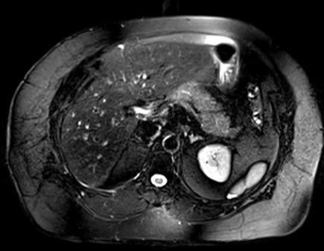

- Fig. 1B
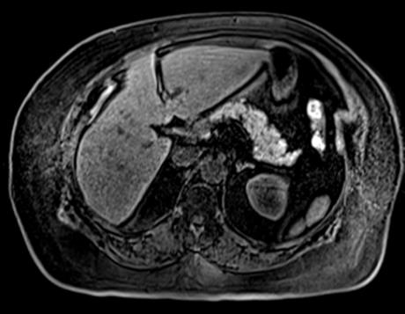

- Fig. 1C
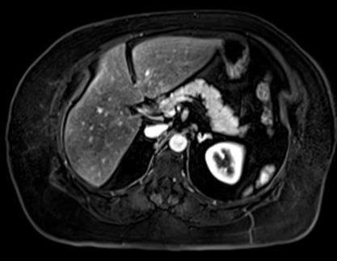

- Fig. 1D

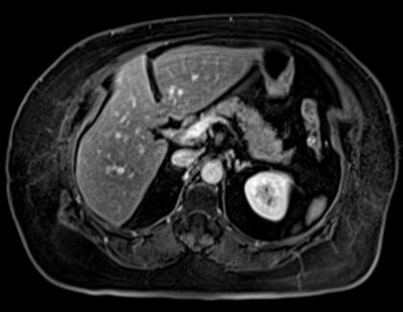

- Fig. 2

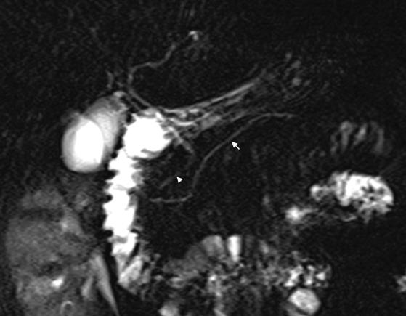

- Fig. 3A

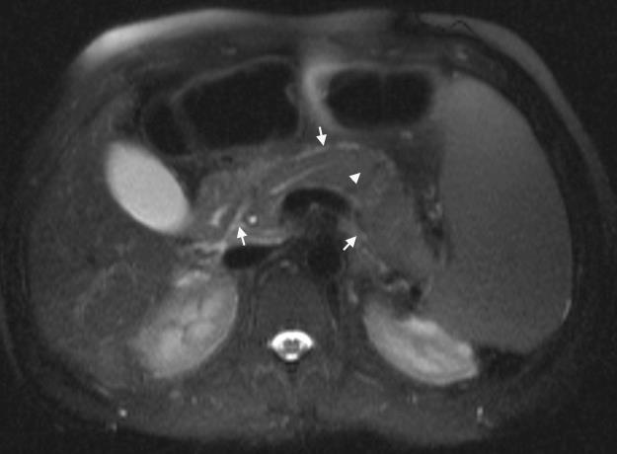

- Fig. 3B

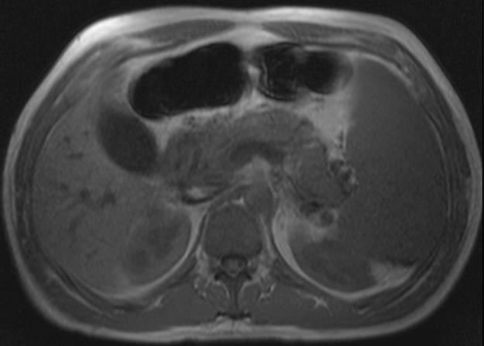

- Fig. 3C

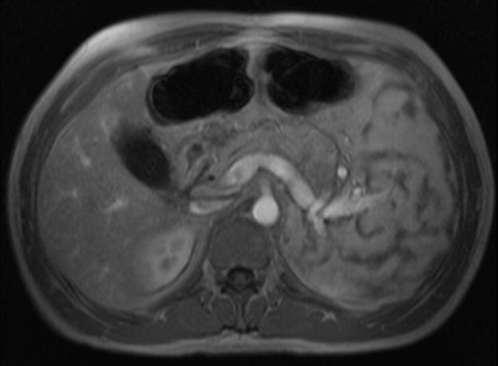

- Fig. 4A
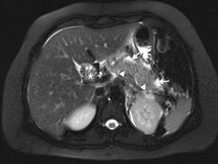

- Fig. 4B
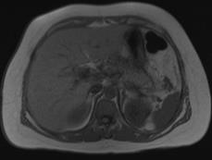

- Fig. 4C
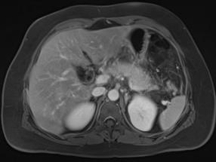

- Fig. 5A

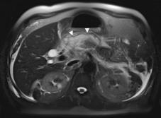

- Fig. 5B
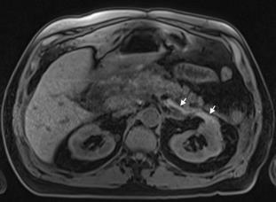

- Fig. 6A
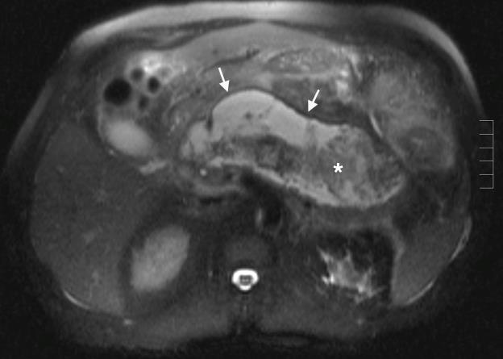

- Fig. 6B

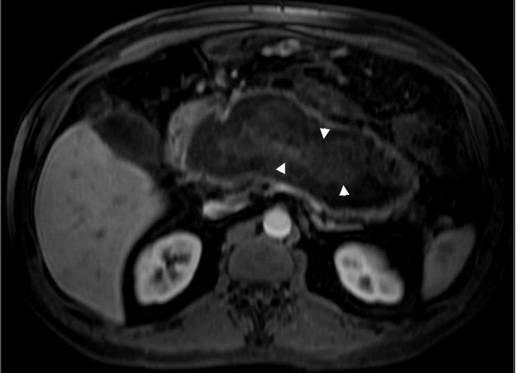

- Fig. 6C

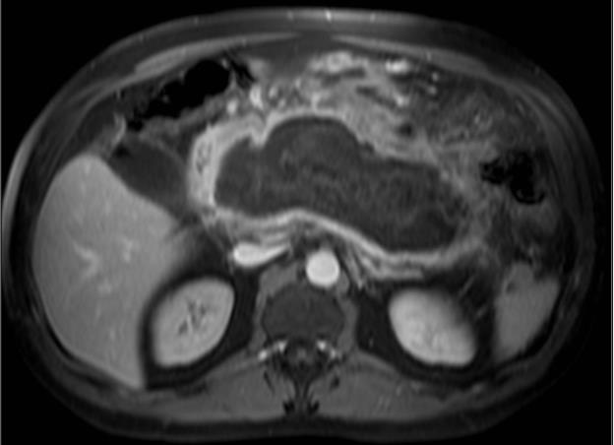

- Fig. 7A

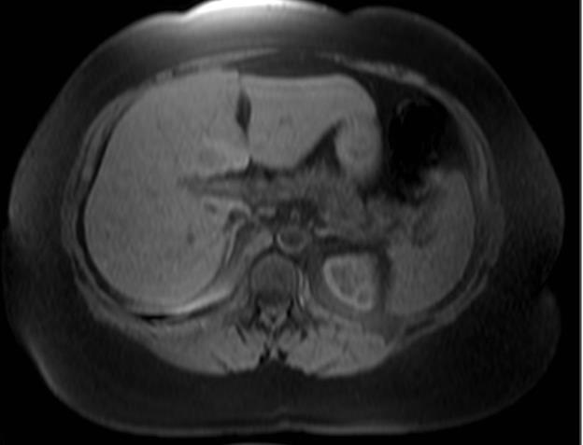

- Fig. 7B

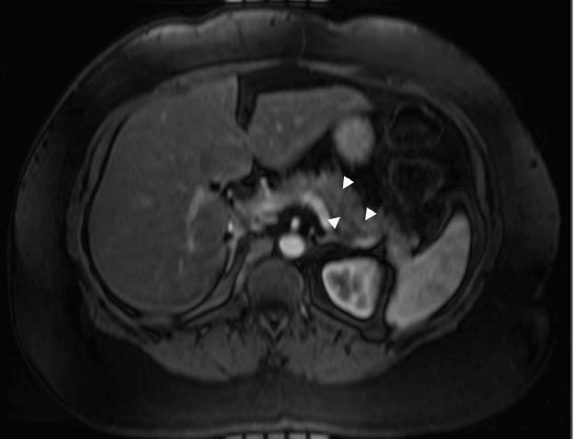

- Fig. 8A

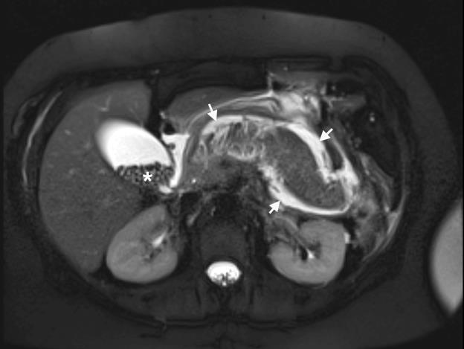

- Fig. 8B

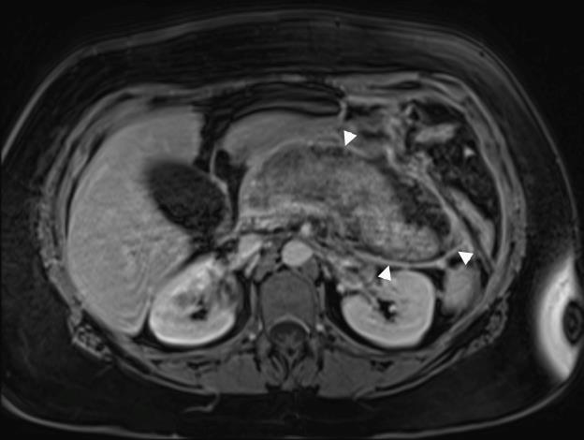

- Fig. 9A
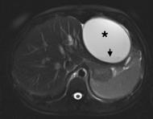

- Fig. 9B
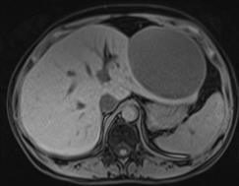

- Fig. 9C
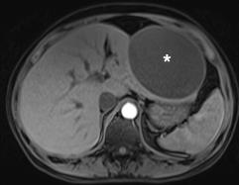

- Fig. 9D

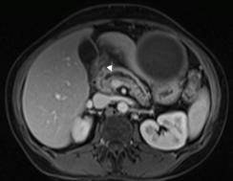

- Fig. 10A
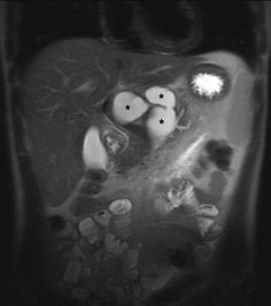

- Fig. 10B

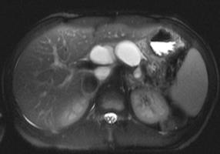

- Fig. 10C

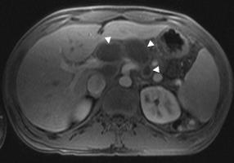

- Fig. 11A

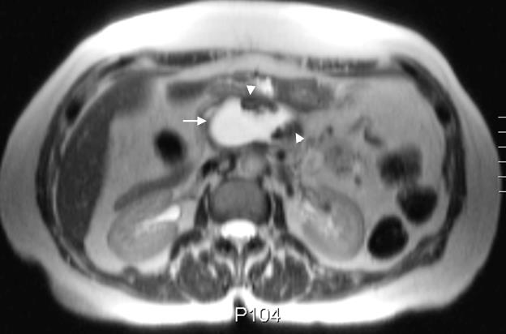

- Fig. 11B
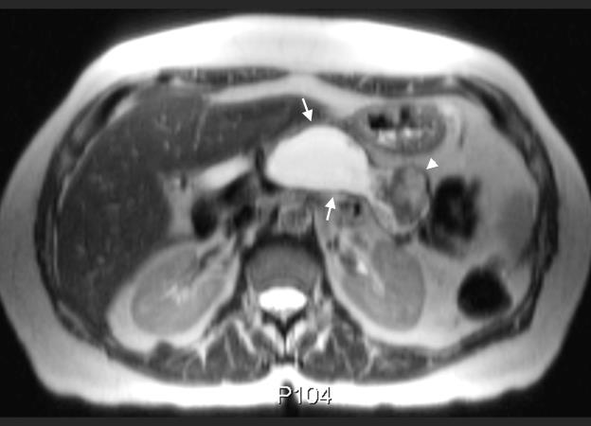

- Fig. 11C
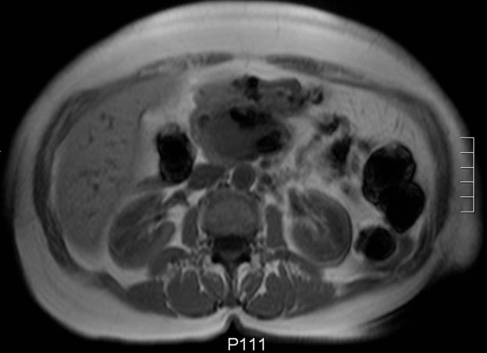

- Fig. 11D

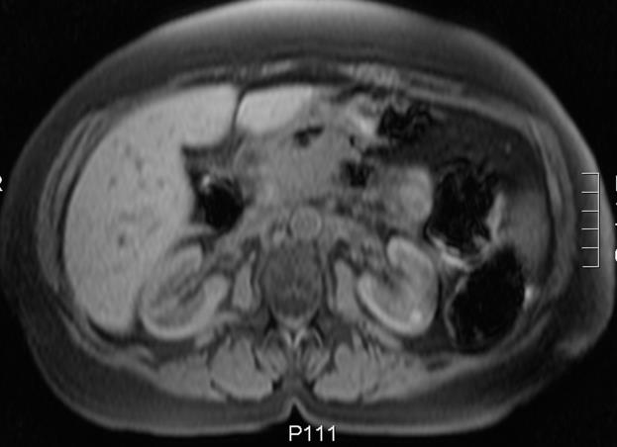

- Fig. 11E

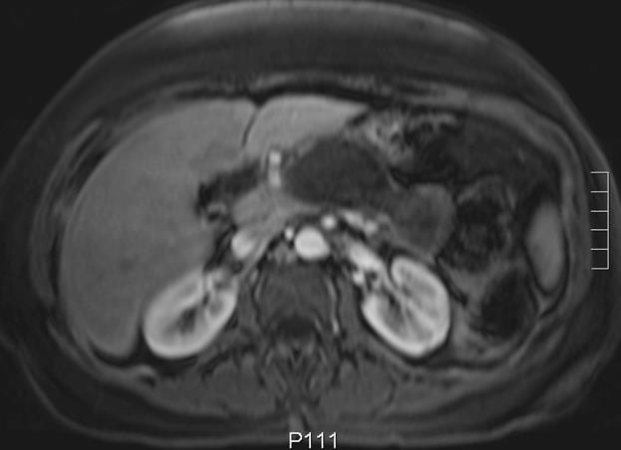

- Fig. 12A
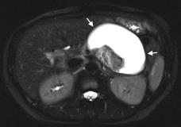

- Fig. 12B
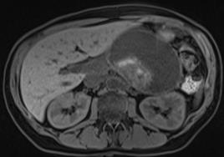

- Fig. 12C
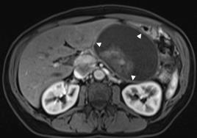

- Fig. 12D
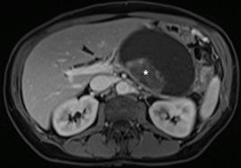

- Fig. 13A

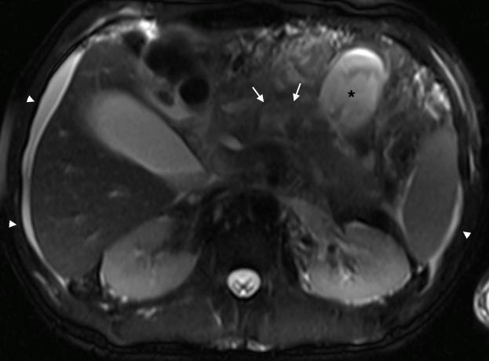

- Fig. 13B

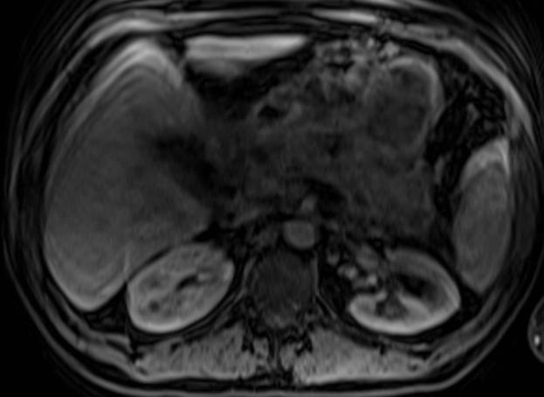

- Fig. 13C
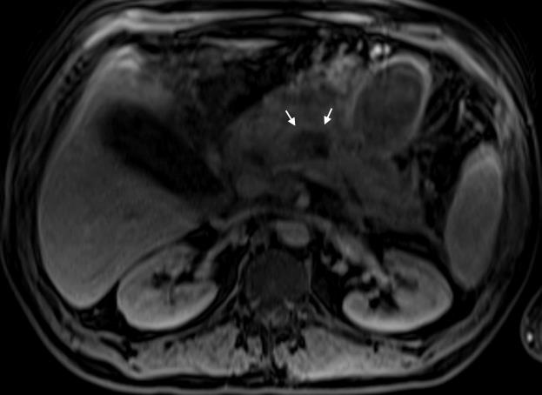

- Fig. 13D

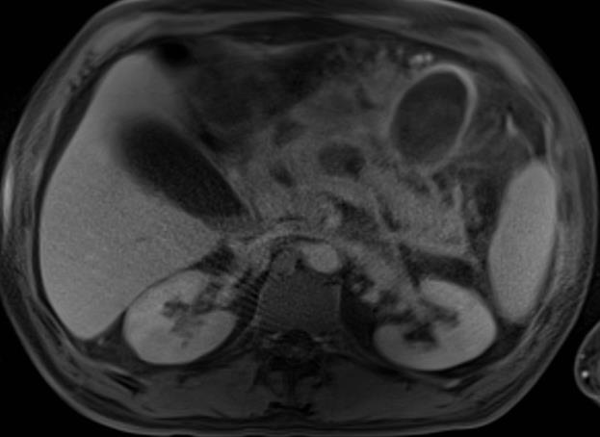

- Fig. 14A

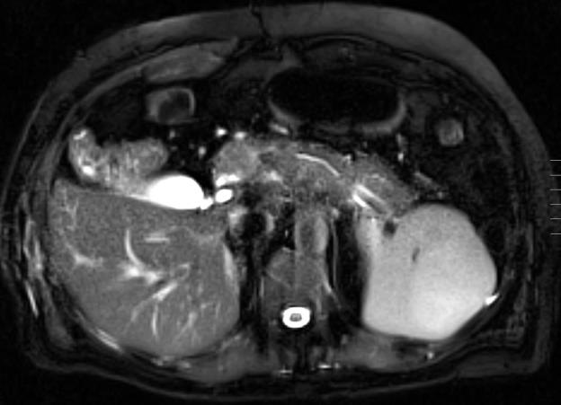

- Fig. 14B

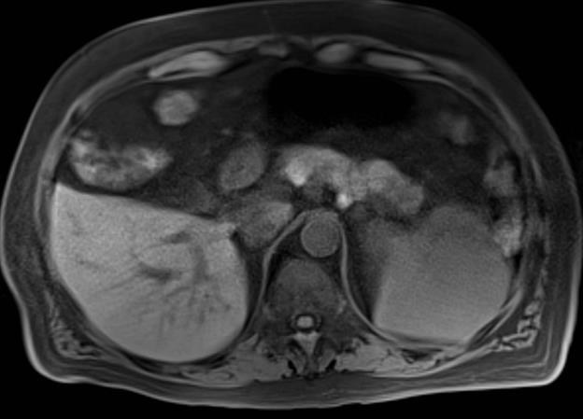

- Fig. 14C

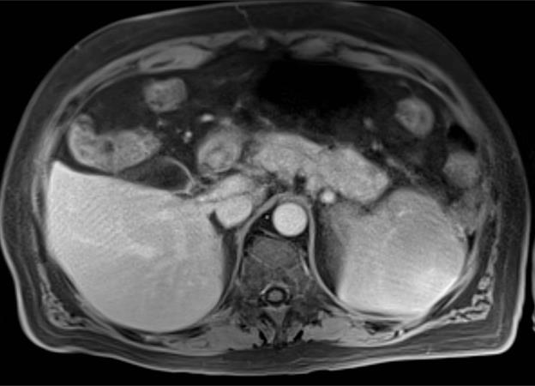

- Fig. 14D
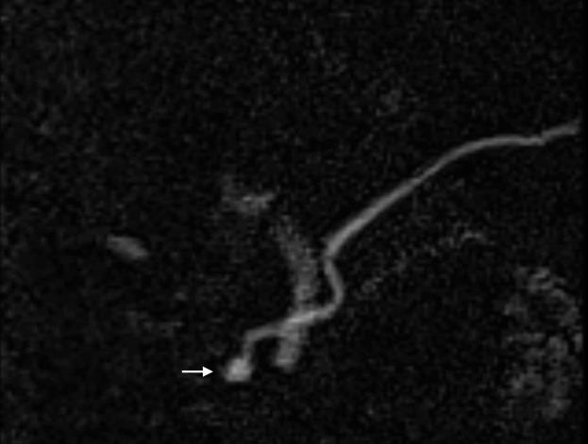

- Fig. 15A

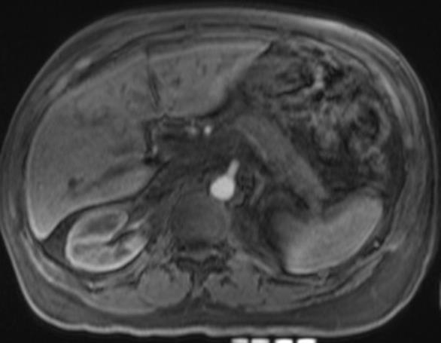

- Fig. 15B

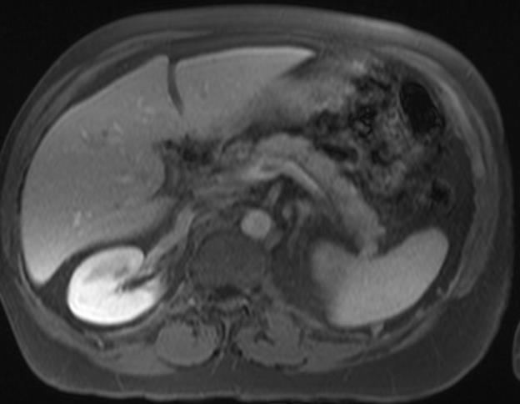

- Fig. 16A

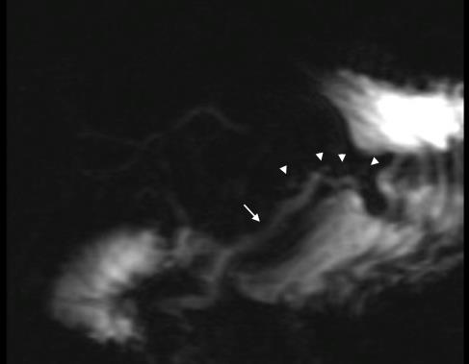

- Fig. 16B

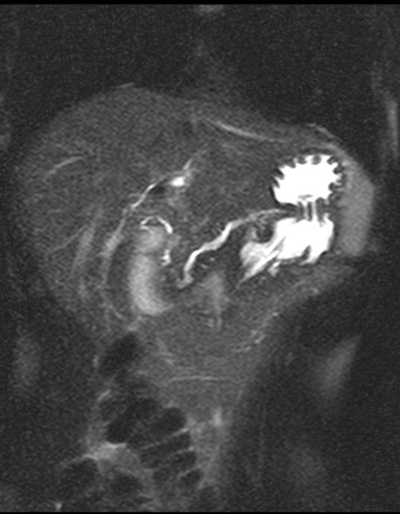

- Fig. 17

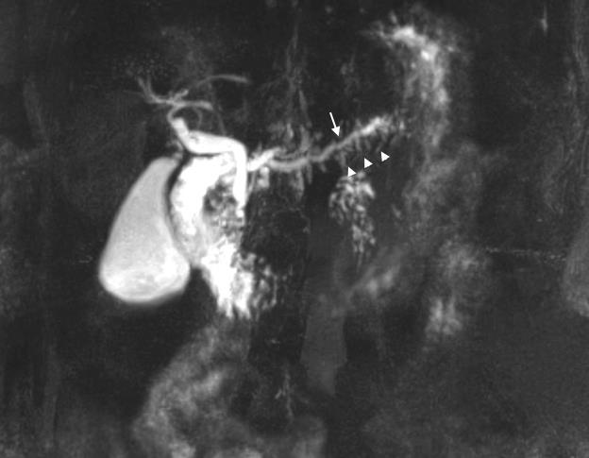

- Fig. 18A

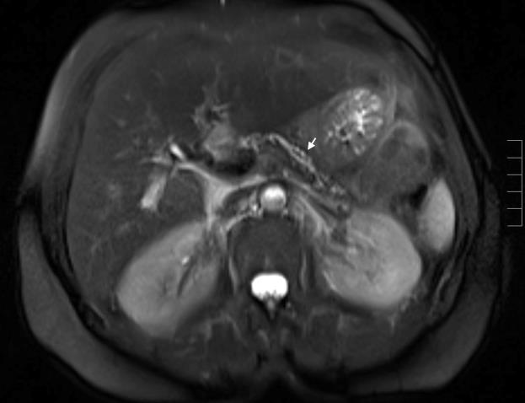

- Fig. 18B

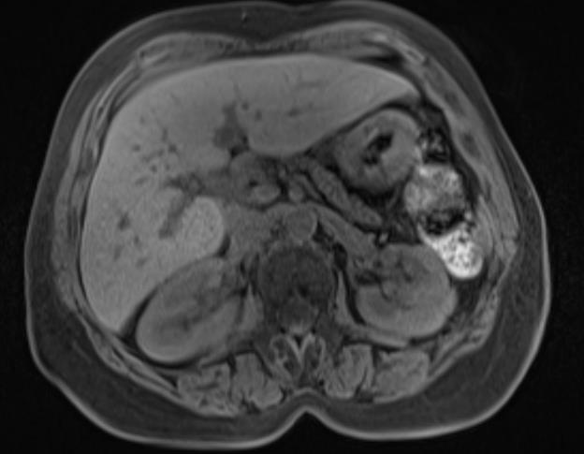

- Fig. 18C

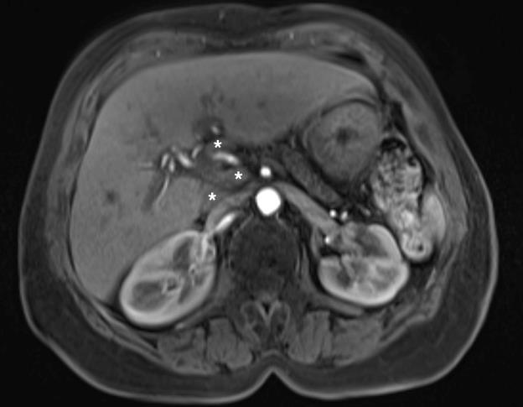

- Fig. 19A
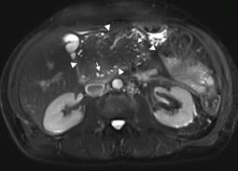

- Fig. 19B
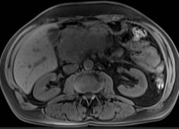

- Fig. 19C
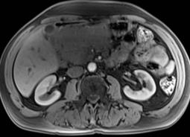

- Fig. 20A

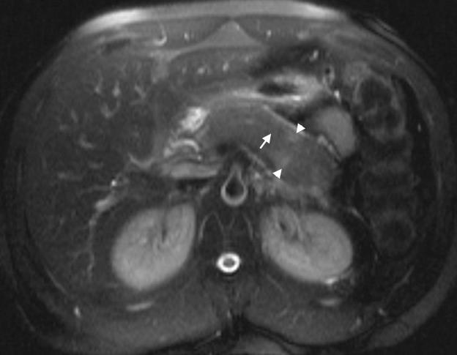

- Fig. 20B

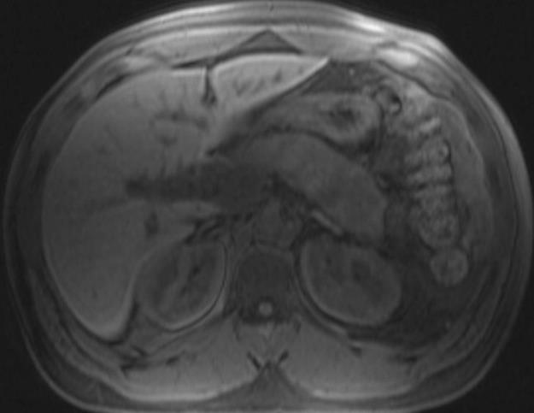

- Fig. 20C
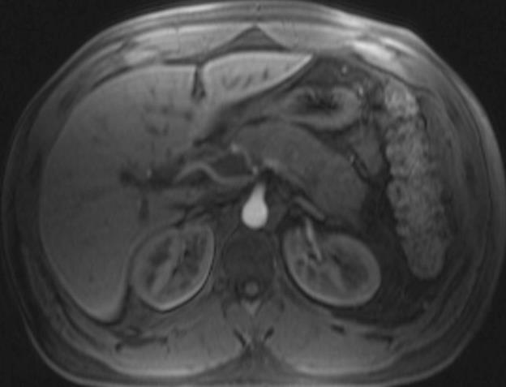

- Fig. 20D
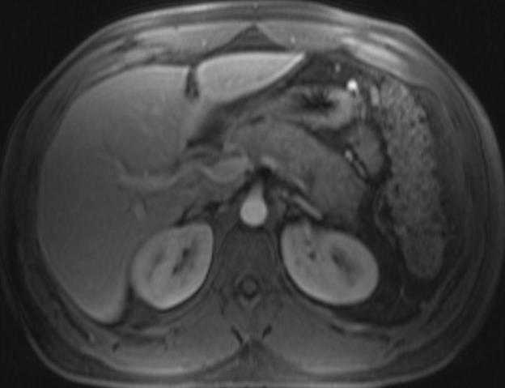

Fig. 21A
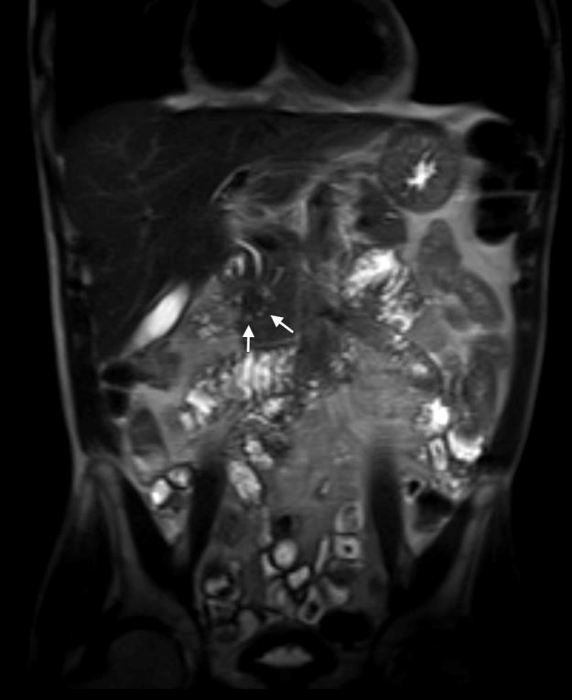

- Fig 21B

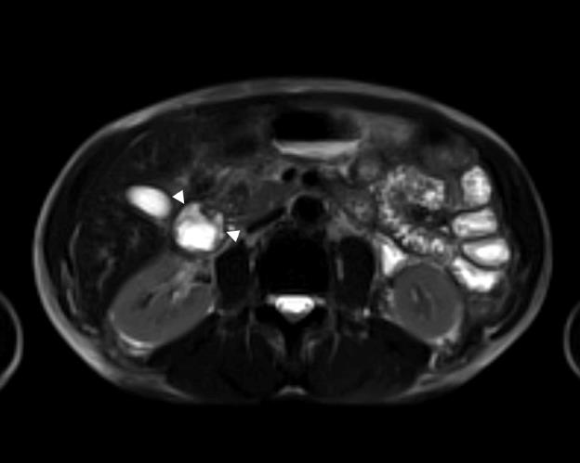

- Fig. 21C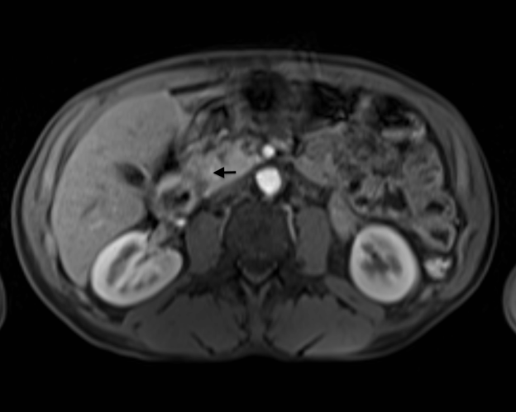

- Fig. 21D

