Name of Journal: World Journal of Clinical Cases
Manuscript NO: 76972
Manuscript Type: CASE REPORT

Acute cytomegalovirus hepatitis in an immunocompetent patient: A case report

Wang JP et al. Acute CMV hepatitis in an immunocompetent patient

Jack P Wang, Bou-Zenn Lin, Chih-Lin Lin, Kuan-Yang Chen, Tsung-Jung Lin

Jack P Wang, Bou-Zenn Lin, Chih-Lin Lin, Kuan-Yang Chen, Tsung-Jung Lin, Department of Gastroenterology, Taipei City Hospital, Taipei City 10629, Taiwan

Tsung-Jung Lin, University of Taipei, Taipei City 10066, Taiwan

Author contributions: Lin TJ designed the research study; Lin BZ, Lin CL, and Chen KY performed the research; Wang JP analyzed the data and wrote the manuscript; All authors have read and approve the final manuscript.

Corresponding author: Tsung-Jung Lin, MD, Attending Doctor, Department of Gastroenterology, Taipei City Hospital, No. 10 Section 4, Ren’ai Road, Da’an District, Taipei 10629, Taiwan. dab70@tpech.gov.tw

Received: August 15, 2022
Revised: October 20, 2022
Accepted: November 4, 2022
Published online: December 6, 2022

Abstract
BACKGROUND
Cytomegalovirus (CMV) infection is usually subclinical and asymptomatic in the healthy population, whereas severe complications occur in immunocompromised patients.

CASE SUMMARY
In this case report, we described a rare case of acute CMV hepatitis in a 35-year-old male immunocompetent patient who presented with a history of week-long intermittent fever with nonspecific constitutional symptoms. Acute hepatitis was suspected according to the initial serological tests. After ruling out other etiologies, including viral hepatitis A, B, C, drug, alcohol, autoimmune, and Wilson disease, acute CMV hepatitis was diagnosed based on positive CMV IgM and DNA quantitative tests. Because there was no any local acute hepatitis E reported in Taiwan, so hepatitis E was not checked. The patient recovered both clinically and serologically with symptomatic management and without antiviral therapy within 12 days from the onset of symptom.

CONCLUSION
In conclusion, a diagnosis of CMV infection should be considered when nonspecific prodromal symptoms occur in acute hepatitis with an uncertain etiology. Antiviral therapy should not be used in immunocompetent patient who had no decompensation of the liver, such as this patient. Widely available noninvasive tests for CMV can facilitate early diagnosis if used appropriately. Harm–benefit analysis is essential before using antiviral therapy in immunocompetent patients.

Key Words: Cytomegalovirus; Acute hepatitis; Immunocompetent; Case report

©The Author(s) 2022. Published by Baishideng Publishing Group Inc. All rights reserved.

Citation: Wang JP, Lin BZ, Lin CL, Chen KY, Lin TJ. Acute cytomegalovirus hepatitis in an immunocompetent patient: A case report. World J Clin Cases 2022; 10(34):12605-12609
URL: https://www.wjgnet.com/2307-8960/full/v10/i34/12605.htm
DOI: https://dx.doi.org/10.12998/wjcc.v10.i34.12605

Core Tip: Cytomegalovirus (CMV) infection is usually subclinical and asymptomatic in the healthy population, whereas severe complications occur in immunocompromised patients. In this case report, we described a rare case of acute CMV hepatitis in a 35-year-old male immunocompetent patient who presented with a history of week-long intermittent fever with nonspecific constitutional symptoms. Acute hepatitis was suspected according to the initial serological tests. After ruling out other etiologies, acute CMV hepatitis was diagnosed based on positive CMV IgM and DNA quantitative tests. The patient recovered both clinically and serologically with symptomatic management and without antiviral therapy within 12 d from the onset of symptom.

INTRODUCTION
Cytomegalovirus (CMV), a member of the Herpesviridae family, is a double-stranded DNA virus^{[1]}. Adult infection is transmitted through multiple routes, including oropharyngeal secretions, genital fluids, urine, blood, breast milk, perinatal and occupational exposure^{[2,3]}. While CMV infection is associated with both significant morbidity and mortality in immunocompromised hosts, usually, it causes a mild subclinical infection in most nonimmunosuppressed patients^{[2,3]}. CMV disease is defined as evidence of CMV infection with attributable symptoms, categorized as a viral syndrome with fever, malaise, leukopenia and thrombocytopenia or as a tissue-invasive disease^{[2]}. However, CMV infection in immunocompetent patients can seldom lead to acute hepatitis, acute liver failure requiring liver transplantation, acute pancreatitis, portal vein thrombosis, or splenic infarction^{[2]}. Here, we report the case of a young healthy male who presented with acute hepatitis due to CMV infection.

CASE PRESENTATION
Chief complaints
Intermittent fever with constitutional symptoms for 1 wk.

History of present illness
A 35-year-old male without any pre-existing comorbidity presented with a week-long history of intermittent fever with associated symptoms including chills, malaise, myalgia, headache, mild sore throat, and diarrhea. No features of altered consciousness, poor appetite, cough, dyspnea, abdominal pain, nausea or vomiting, dysuria, or urinary frequency were reported. The patient lived with his wife in a monogamous relationship and without any pets.

History of past illness
He denied any past illness.

Personal and family history
He denied any sick contacts at work or home and a traveling history outside of Taipei city. Additionally, he did not have a history of smoking, alcohol, drug, and Chinese herbal medicine use.

Physical examination
On admission, his vitals were stable – temperature: 37.8 °C, pulse rate: 90 beats per minute, respiratory rate: 20 breaths per min, and normal blood pressure.

Laboratory examinations
Initial complete blood count (CBC) showed a leukocyte count: 6590/µL [lymphocytes: 63.7% (21.2%-51.0%); monocytes: 18.2% (3.1%-8.0%); neutrophils: 12.7% (41.2%-74.7%)], normal hemoglobin, and platelet count. The liver function tests revealed normal bilirubin and prothrombin time levels; however, the serum levels of aspartate aminotransferase: 396 U/L (10-42 U/L), alanine aminotransferase: 505 U/L (7-42 U/L), alkaline phosphatase: 204 U/L (35-129 U/L), and gamma-glutamyl transferase: 174 U/L (5-61 U/L), were significantly raised. The urinalysis was negative for glucose, protein, blood, nitrite, and leukocytes.

Imaging examinations
The abdominal ultrasonography showed the length of splenic long –axis was 11.4 cm, so splenomegaly was impressed (Figure 1).

FINAL DIAGNOSIS
The patient was admitted to our ward with a probable diagnosis of acute viral hepatitis. The reason of admission is not only intractable symptoms but also the risk of acute hepatitis in progress[t1]. Serological tests for viral hepatitis A, B, C, herpes simplex, and Epstein–Barr virus (EBV) were all negative; however, CMV serology was positive with an IgM titer of 2.42 index (< 1.0) but the level of IgG was not checked[t2]. Antinuclear antibody, antismooth muscle antibody, and antimitochondrial antibody levels were negative, and IgG and ceruloplasmin levels were unremarkable. CMV–DNA polymerase chain reaction (PCR) revealed 486 copies/mL (1 copy = 0.91 IU), and the antihuman immunodeficiency virus (HIV) rapid test was also negative. Follow-up (on day 4) CBC revealed a leukocyte count of 14120/µL (lymphocytes: 70.8%, monocytes: 8.5%, neutrophils: 10.4%, and atypical lymphocyte: 0.9%), normal hemoglobin, and platelet counts. Accordingly, a diagnosis of acute CMV hepatitis was made. However, a decision to not go for antiviral therapy was made due to its associated toxicity and no hepatic decompensation.

TREATMENT
Following admission, he continued to have temperature spikes up to 39 °C in the first three days (Figure 2). Antibiotics—piperacillin/tazobactam—were given since a superimposed bacterial infection could not be ruled out. Additionally, he was managed with an antipyretic, intravenous fluid supply, and monitoring the fever pattern and liver function. The blood culture turned out to be negative for any microbial growth.

OUTCOME AND FOLLOW-UP
The fever subsided by day 7; the liver enzyme profiles also trended down gradually. With symptomatic and clinical recovery, the patient was discharged after 12 d of hospitalization. He was then followed up at our outpatient department until his liver enzyme profiles had resolved to within the normal limits 1 mo later.

DISCUSSION
Notably, only about 10% of CMV infections lead to clinical symptoms in immunocompetent patients^{[4]}, which have a mononucleosis-like presentation, consisting of prolonged fever, malaise, myalgia, and headache^{[2,5]}. The CBC may show leukopenia, neutropenia, thrombocytopenia, or atypical lymphocytes. Furthermore, the liver is frequently involved and hepatosplenomegaly is seen in 10%-38% of patients^{[3]}. About 70% of acute CMV infections result in abnormalities in hepatic enzyme tests in both immunocompetent and immunosuppressed patients^{[6]}; however, these levels are rarely elevated by more than five times the upper limit^{[3]}. Our patient’s clinical profile mimicked a mononucleosis-like syndrome, including significantly constitutional symptoms, monocytosis, lymphocytosis, atypical lymphocytes, and splenomegaly. Therefore, acute viral hepatitis was primarily suspected on the first day of admission. EBV infection had been excluded, and a simultaneously positive anti-CMV IgM test, coupled with detectable CMV-DNA levels and a negative anti-HIV rapid test confirmed our diagnosis of acute CMV hepatitis in an immunocompetent patient. Other differential diagnoses – acute drug hepatitis, alcoholic hepatitis, autoimmune hepatitis, Wilson’s disease, viral hepatitis A, B, C, and herpes simplex, were excluded based on his medical history and serological tests. No any local acute hepatitis E had been reported in Taiwan in the past, so hepatitis E was not checked. Therefore, a liver biopsy was not needed for diagnosis in this patient.
Ideally, a diagnosis of acute CMV hepatitis is based on clinical suspicion, a positive anti-CMV IgM or elevated IgG titers, or a qualitative or quantitative CMV–DNA PCR assay^{[7,8]}. Quantitative PCR for CMV-DNA is the standard method for the early detection of CMV infections^{[7]}, so CMV antigen pp65 and IgG levels were not checked in our patient[t1]. Although a liver biopsy is not mandatory, it may be used in cases when the diagnosis is uncertain^{[2,5]}. Histological findings of the specimen include sinusoidal infiltration of predominantly mononuclear cells and mild hepatocellular necrosis^{[5]}. Although nonspecific, the most important pathological finding is the intranuclear inclusion of body formations in the infected liver cells. Immunohistochemical staining of the CMV antigen can also help confirm the diagnosis of CMV hepatitis^{[2]}.
Currently, there are four licensed antiviral drugs for the treatment of CMV infections – ganciclovir, valganciclovir, foscarnet, and cidofovir^{[9]}. Mostly, acute CMV hepatitis in immunocompetent patients is self-limiting, so antiviral therapy is not necessary. Because of their potential side effects, including myelosuppression, hepatotoxicity, teratogenicity, and infertility, they are reserved for severe infection or immunocompromised patients^{[10]}. Therefore, antiviral therapy should not be used in immunocompetent patient who had no decompensation of the liver, such as this patient.

CONCLUSION
In conclusion, a diagnosis of CMV infection should be considered when nonspecific prodromal symptoms occur in acute hepatitis with an uncertain etiology. Widely available noninvasive tests for CMV can facilitate early diagnosis if used appropriately. However, harm–benefit analysis is essential before using antiviral therapy in immunocompetent patients.

REFERENCES
1 Crough T, Khanna R. Immunobiology of human cytomegalovirus: from bench to bedside. Clin Microbiol Rev 2009; 22: 76-98, Table of Contents [PMID: 19136435 DOI: 10.1128/CMR.00034-08]
2 Bunchorntavakul C, Reddy KR. Epstein-Barr Virus and Cytomegalovirus Infections of the Liver. Gastroenterol Clin North Am 2020; 49: 331-346 [PMID: 32389366 DOI: 10.1016/j.gtc.2020.01.008]
3 Fakhreddine AY, Frenette CT, Konijeti GG. A Practical Review of Cytomegalovirus in Gastroenterology and Hepatology. Gastroenterol Res Pract 2019; 2019: 6156581 [PMID: 30984257 DOI: 10.1155/2019/6156581]
4 Eddleston M, Peacock S, Juniper M, Warrell DA. Severe cytomegalovirus infection in immunocompetent patients. Clin Infect Dis 1997; 24: 52-56 [PMID: 8994755 DOI: 10.1093/clinids/24.1.52]
5 Noor A, Panwala A, Forouhar F, Wu GY. Hepatitis caused by herpes viruses: A review. J Dig Dis 2018; 19: 446-455 [PMID: 29923691 DOI: 10.1111/1751-2980.12640]
6 Leonardsson H, Hreinsson JP, Löve A, Björnsson ES. Hepatitis due to Epstein-Barr virus and cytomegalovirus: clinical features and outcomes. Scand J Gastroenterol 2017; 52: 893-897 [PMID: 28446048 DOI: 10.1080/00365521.2017.1319972]
7 Kotton CN, Kumar D, Caliendo AM, Huprikar S, Chou S, Danziger-Isakov L, Humar A; The Transplantation Society International CMV Consensus Group. The Third International Consensus Guidelines on the Management of Cytomegalovirus in Solid-organ Transplantation. Transplantation 2018; 102: 900-931 [PMID: 29596116 DOI: 10.1097/TP.0000000000002191]
8 Ross SA, Novak Z, Pati S, Boppana SB. Overview of the diagnosis of cytomegalovirus infection. Infect Disord Drug Targets 2011; 11: 466-474 [PMID: 21827433 DOI: 10.2174/187152611797636703]
9 Schleiss MR. Antiviral therapy of congenital cytomegalovirus infection. Semin Pediatr Infect Dis 2005; 16: 50-59 [PMID: 15685150 DOI: 10.1053/j.spid.2004.09.012]
10 Rafailidis PI, Mourtzoukou EG, Varbobitis IC, Falagas ME. Severe cytomegalovirus infection in apparently immunocompetent patients: a systematic review. Virol J 2008; 5: 47 [PMID: 18371229 DOI: 10.1186/1743-422X-5-47]

Footnotes
Informed consent statement: Informed consent was obtained from the patient.

Conflict-of-interest statement: All the authors declare no conflict of interest.

CARE Checklist (2016) statement: The authors have read the CARE Checklist (2016), and the manuscript was prepared and revised according to the CARE Checklist (2016).

Open-Access: This article is an open-access article that was selected by an in-house editor and fully peer-reviewed by external reviewers. It is distributed in accordance with the Creative Commons Attribution NonCommercial (CC BY-NC 4.0) license, which permits others to distribute, remix, adapt, build upon this work non-commercially, and license their derivative works on different terms, provided the original work is properly cited and the use is non-commercial. See: https://creativecommons.org/Licenses/by-nc/4.0/

Provenance and peer review: Unsolicited article; Externally peer reviewed.
Peer-review model: Single blind

Peer-review started: August 15, 2022
First decision: October 12, 2022
Article in press: November 4, 2022

Specialty type: Gastroenterology and hepatology
Country/Territory of origin: Taiwan
Peer-review report’s scientific quality classification
Grade A (Excellent): 0
Grade B (Very good): 0
Grade C (Good): C, C
Grade D (Fair): 0
Grade E (Poor): E

P-Reviewer: Bessone F, Argentina; Inoue K, Japan; Kurtcehajic A, Bosnia and Herzegovina S-Editor: Liu JH L-Editor: A P-Editor: Liu JH

Figure Legends
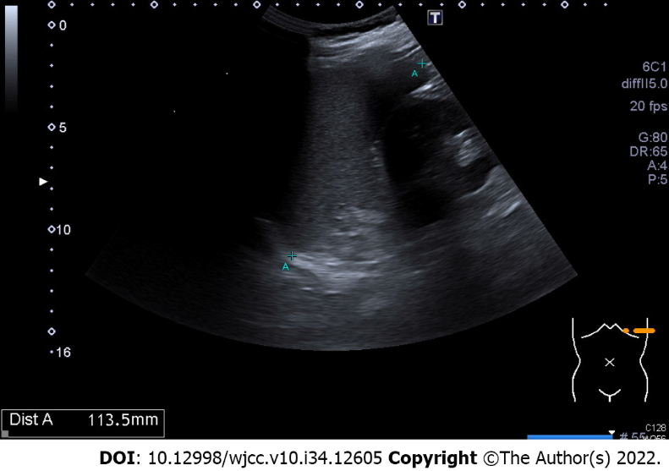
Figure 1 The length of splenic long-axis was 11.4 cm on sonography.

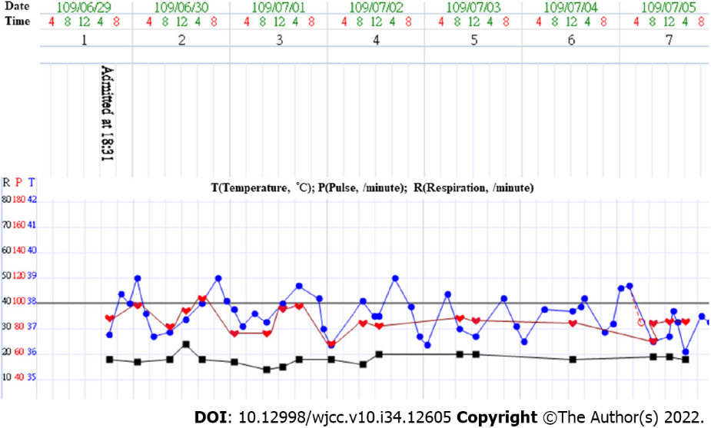
Figure 2 Fever pattern in the initial 7 d of admission.

Published by Baishideng Publishing Group Inc
7041 Koll Center Parkway, Suite 160, Pleasanton, CA 94566, USA
Telephone: +1-925-3991568
E-mail: bpgoffice@wjgnet.com
Help Desk: https://www.f6publishing.com/helpdesk
https://www.wjgnet.com

© 2022 Baishideng Publishing Group Inc. All rights reserved.

