Format for ANSWERING REVIEWERS

December 30, 2014

Dear Editor,

Please find enclosed the edited manuscript in Word format (file name: 14894- The endoscopic papillectomy- ESPS Manuscript NO 14894. doc).

Title: Endoscopic papillectomy: The limits of the indication, technique and results

Author: José Celso Ardengh, Rafael Kemp, Éder Rios Lima-Filho, José Sebastião dos Santos

Name of Journal: World Journal of Gastroenterology

ESPS Manuscript NO: 00182188

The manuscript has been improved according to the suggestions of reviewers:
1 Format has been updated

2 Revision has been made according to the suggestions of the all reviewers

3 References and typesetting were corrected

Thank you again for publishing our manuscript in the World Journal of Gastroenterology.

Sincerely yours,

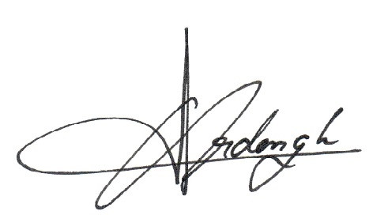
José Celso Ardengh, MD, PhD

