Name of Journal: World Journal of Clinical Cases
Manuscript NO: 63820
Manuscript Type: CASE REPORT

Effective treatment of polyneuropathy, organomegaly, endocrinopathy, M-protein, and skin changes syndrome with congestive heart failure: A case report

Fu LY et al. POEMS syndrome with CHF

Ling-Yao Fu, Hong-Bin Zhang

Ling-Yao Fu, Hong-Bin Zhang, Department of Hematology, The First Affiliated Hospital of Chongqing Medical University, Chongqing 400016, China

Author contributions: Fu LY prepared and reviewed the manuscript; Zhang HB supervised the work; all authors read and approved the final manuscript.

Corresponding author: Hong-Bin Zhang, MD, Chief Physician, Department of Hematology, The First Affiliated Hospital of Chongqing Medical University, No. 1 Youyi Road, Yuanjiagang, Yuzhong District, Chongqing 400016, China. usamake@163.com

Received: March 8, 2021
Revised: April 5, 2021
Accepted: July 14, 2021
Published online:

Abstract
BACKGROUND
Polyneuropathy, organomegaly, endocrinopathy, M-protein, and skin changes (POEMS) syndrome is a rare paraneoplastic syndrome caused by a plasma cell proliferative disorder. The syndrome is characterized by elevated plasma cells, platelets, and vascular endothelial growth factor levels. Although heart disease rarely occurs in POEMS syndrome, the death rate increases sharply after heart failure. We report a patient who initially presented with an endocrine disease and developed congestive heart failure related to POEMS syndrome 9 years later.

CASE SUMMARY
A 23-year-old woman with no history of menstruation and a 9-year history of type I diabetes reported feeling breathless after activities. She could not lie down and rest at night. Three months prior, she experienced pain and increased tension in her left thigh accompanied by tenderness and edema in both lower extremities. The chief complaint upon hospital admission was that blood sugar has increased for more than 9 years, pain in the left thigh, and edema in both legs for more than 2 mo. After a multisystem evaluation, she was diagnosed with POEMS syndrome. Her echocardiogram showed left ventricular dilation with systolic dysfunction, and the left ventricular ejection fraction was only 38% with severely elevated brain natriuretic peptide. She received a combination of dexamethasone and thalidomide for 1 mo, but her symptoms did not improve. Therefore, we added a two-per-week bortezomib injection. After 2 wk, the patient’s heart function had improved significantly.

CONCLUSION
This case provides information about the treatment of POEMS syndrome with complications and highlights the challenges of developing a standardized treatment.

Key Words: Polyneuropathy, organomegaly, endocrinopathy, M-protein, and skin changes syndrome; Heart failure; Ejection fraction; Vascular endothelial growth factor; Bortezomib; Case report

Fu LY, Zhang HB. Effective treatment of polyneuropathy, organomegaly, endocrinopathy, M-protein, and skin changes syndrome with congestive heart failure: A case report. World J Clin Cases 2021; In press

Core Tip: The standardized treatment for multiple myeloma may become the first reference for the treatment of polyneuropathy, organomegaly, endocrinopathy, M-protein, and skin changes (POEMS) syndrome. We believe that the treatment effect for POEMS syndrome is poor once heart failure occurs. Therefore, early identification of heart disease and its cause along with timely follow-up treatment are critical to the treatment of POEMS syndrome. Whether this patient continues to undergo peripheral blood stem cell transplantation treatment after drug treatment remains to be evaluated. To date, the surgical indications and results have not been well defined, and a method for preventing heart disease has not been established for POEMS patients without heart failure.
INTRODUCTION
Polyneuropathy, organomegaly, endocrinopathy, M-protein, and skin changes (POEMS) syndrome is a rare paraneoplastic syndrome caused by a plasma cell proliferative disorder that is most commonly lambda restricted. This complex multisystem disease may involve angiogenesis and proinflammatory cytokines. For example, upregulation of various proinflammatory cytokines and growth factors [tumor necrosis factor-alpha, interleukin (IL)-1, IL-6, and above all, vascular endothelial growth factor (VEGF)] plays a crucial role in the pathogenesis of POEMS syndrome, contributing to vascular leakage and polyneuropathy. Cases of POEMS syndrome with heart failure are rare. Given the limited experiences with early diagnoses and follow-up treatments, no clinically standardized treatment is available. However, reports have described effective treatment methods^{[1]} as well as methods of observing heart disease in patients with POEMS syndrome^{[2]}. This case report describes a patient with POEMS syndrome and heart failure who has not yet received high-dose chemotherapy with peripheral blood stem cell transplantation (PBSCT), dexamethasone, or thalidomide.

CASE PRESENTATION
Chief complaints
A 23-year-old Chinese woman with overall poor physical development was admitted to the hospital because her blood sugar had increased over 9 years. In addition, her left thigh was swollen and painful, and her lower extremities showed edema.

History of present illness
The patient had been diagnosed with type I diabetes 9 years before she came to the hospital. However, she was not treated with regular insulin injections outside the hospital, and her blood sugar was not well controlled. One year ago, she felt tired after exercise and could not lie down at night; she also felt squeezing in her chest area during defecation. She felt pain in her left thigh pain and increased tension that had occurred more than 3 mo earlier accompanied by tenderness, edema in both lower extremities, paleness, swelling, and ulceration. Initially, she could walk autonomously but gradually became unstable while standing, even finding it difficult to squat during bowel movements.

History of past illness
“Cataractectomy” was performed 1 year ago.

Personal and family history
Menarche had not occurred to date, and she was diagnosed with a naive uterus outside our hospital. The family history was unremarkable.

Physical examination
The parameters of vital signs were as follows: Heart rate, 107 beats/min; BP 110/78 mmHg; height, 145 cm; and weight, 45 kg. The skin and mucous membranes of the whole body were pale. There was no pubic or axillary hair, and multiple areas of the skin were damaged and crusted. On auscultation, the breath sounds in both upper lungs were thick and weak, and moist rales were heard in both lower lungs. The abdomen was distended. The liver and spleen were unaffected and moved upon respiration. There was positive dullness and pitting edema of both lower limbs. There were no other obvious abnormalities.

Laboratory examinations
The patient’s laboratory results are listed in Table 1. Endocrine examination revealed hypothyroidism and hypogonadotropic hypogonadism. The patient’s brain natriuretic peptide (BNP) was severely elevated.

Imaging examinations
Electromyography showed that the conduction velocity of both upper limbs was slowed and accompanied by low amplitude M and F waves; edema of both lower limbs could not be detected. Computed tomography (CT) showed enlarged liver, spleen, and multiple lymph nodes with pleural effusion and ascites. We did not find monoclonal plasma cell proliferation by lymph node biopsy, bone biopsy, or flow cytometry. A 12-lead electrocardiogram showed sinus tachycardia (Figure 1). It is worth noting that echocardiography showed left ventricular dilation with systolic dysfunction, and the left ventricular ejection fraction (LVEF) was only 38% (Figure 2). Cardiac magnetic resonance imaging (MRI) showed interstitial edema of the myocardium, myocardial native T1 values globally increased, and late gadolinium enhancement could represent definite myocardial necrosis (Figure 3).

FINAL DIAGNOSIS
The patient had multiple neuropathy, organ enlargement, endocrine diseases, skin changes, and other manifestations, coupled with an increase of VEGF. She was finally diagnosed as having POEMS syndrome with congestive heart failure.

TREATMENT
We started her on an insulin pump (continuously adjusting the dose) with some oral medicines that were targeted to improve heart function. These drugs were digoxin (0.125 mg/d), sacubitril valsartan sodium tablets (50 mg/d), and furosemide (60 mg/d). To actively control blood sugar and improve heart function symptoms, 50 mg/d oral dexamethasone (4 consecutive days, repeated every 14 d) combined with 100 mg/d thalidomide (increased to 200 mg after 14 d) was administered. One month later, the patient's weight, cardiac ejection fraction, BNP, LVEF, and other indicators suggested that the patient’s lower limb edema and cardiac function had not significantly improved. Therefore, we changed the treatment plan based on the 1 mo of treatment, and the patient was administered intravenously with 20 mg/d dexamethasone (for 4 consecutive days/2 wk) and 50 mg/d oral thalidomide combined with 1.3 mg/m² bortezomib (injected twice a week for 2 consecutive weeks).

OUTCOME AND FOLLOW-UP
The patient showed significant improvement in cardiac function at the 6th week after all treatments. For example, the LVEF increased to 45%, and a 5-kg weight loss was observed. A CT scan showed reduced hepatosplenomegaly, and serum VEGF levels decreased rapidly. In the process of continuing the treatment plan, we recommended that the patient undergo autologous stem cell transplantation to obtain a better prognosis and informed the patient of the adverse consequences of the treatment. The patient refused this treatment. In the current treatment plan, thalidomide was well tolerated, and there was no neurotoxicity with bortezomib. If oral medication is necessary, we can only give long-term medication as far as possible without affecting the patient’s future stem cell collection.

DISCUSSION
In most patients diagnosed with POEMS syndrome, neuropathy is the first clinical feature and may even be the only feature at the initial diagnosis^{[3]}. However, based on all the examination results, this patient was diagnosed with multiple serous effusions with multisystem damage and multiple endocrine diseases; the cause of the heart function decline was unknown. There were no abnormally relevant immunological indicators of systemic lupus erythematosus and dermatomyositis during diagnosis and treatment; thus, rheumatic immune disease could not explain the patient's polyneuropathy. Studies have shown that monoclonal lambda sclerosing plasmacytoma or bone marrow infiltration can be detected in greater than 95% of patients^{[4]}, but we could not detect monoclonal plasma cell proliferation in this patient. A large amount of clinical data is needed to reassess whether single clonal plasma cell proliferative disease can become the main criterion for the diagnosis of POEMS syndrome^{[1]}. Case reports of POEMS and retrospective studies have indicated that although the treatment of POEMS syndrome has not yet been standardized, current treatment methods have progressed from steroid monotherapy to more effective drugs and methods, such as radiotherapy, chemotherapy, hematopoietic stem cell transplantation, and other strategies. Radiotherapy is mainly aimed at patients with POEMS syndrome without bone marrow infiltration and bone lesions. In addition, systemic therapy is the most reasonable choice^{[5]}. Available chemotherapy drugs include lenalidomide, thalidomide, bortezomib, bevacizumab, and others^{[6–11]}. The successful treatment of POEMS syndrome is related to the treatment of potential clonal plasma cell disorder^{[12]}. At present, autologous hematopoietic stem cell transplantation under high-dose chemotherapy may be the best treatment for POEMS syndrome. After this treatment, we observed hematological improvement, nervous system response recovery, good survival rates, and other improvements^{[13]}. However, for POEMS syndrome with different complications after a clear diagnosis, more case reports on how to choose treatment methods and how to judge the indications for PBSCT are needed. Pulmonary hypertension is more common in POEMS syndrome involving the cardiovascular system^{[14,15]}, but the syndrome rarely affects the heart. In addition, the performance of the heart is also different in these reported cases^{[2]}. To date, only eight cases have been reported^{[1,16–20]}. The case reported in this article represents the ninth case of POEMS syndrome with heart failure. The patient’s left ventricle was enlarged and exhibited decreased systolic function. Its pathogenesis may involve increased serum VEGF levels in POEMS syndrome. VEGF promotes vascular endothelial cell migration and increases vascular permeability. VEGF overexpression can cause extracellular edema of myocardial cells, increasing the distances between capillaries and myocardial fibers in the interstitium, affecting myocardial blood supply, and leading to contractile dysfunction^{[2]}. However, it is still necessary to accumulate many cases to clarify the pathogenesis of POEMS with concurrent heart disease. According to reports by Daichi et al^{[1,7]}, thalidomide, which has been successfully used in the treatment of multiple myeloma (MM), is effective in treating POEMS syndrome with severe congestive heart failure^{[11]}. However, chemotherapy is also effective. There are great risks, such as damage to the hematopoietic system, cardiovascular system, and nervous system, but few adverse reactions have been reported after treatment. The curative effect can be observed through various factors, such as LVEF, BNP, plasma VEGF, electromyography, and endocrine markers^{[1,12]}. However, individual differences in treatment response are possible. The patient’s response to dexamethasone and thalidomide was poor in this case. Given that no standardized treatment has been established, this poor response may be related to the dosage and method of medication administration, but some of them have not been used to treat heart failure. After using bortezomib as a basic treatment for patients with POEMS syndrome, disease activity is effectively controlled^{[21]}. In this case, the patient's heart function improved significantly after the addition of bortezomib. The current research on proteasome inhibitors for the treatment of MM is more in-depth. We believe that both diseases are caused by abnormal plasma cells. When treating POEMS syndrome-related complications, we can still refer to the standardized treatment plan for MM first, and more clinical cases are still pending. According to reports, elevated BNP levels are associated with a poor prognosis in POEMS syndrome patients with pulmonary hypertension complications^{[22]}. This finding suggests that once POEMS syndrome patients develop heart failure, the treatment effect is poor, and the mortality rate sharply increases. Therefore, early identification of heart disease and its causes and timely follow-up treatment of the heart are critical to the treatment of POEMS syndrome. In this case, it was necessary to exclude other organic heart diseases and abnormalities found by coronary angiography. For patients with POEMS syndrome and congestive heart failure caused by myocardial edema or diabetic cardiomyopathy, it is necessary to identify these conditions by cardiac MRI^{[2]}. If necessary, an endocardial myocardial biopsy is feasible. Cardiac MRI can also evaluate POEMS-related heart disease management by detecting the volume of extracellular fluid. For this patient, although no monoclonal plasma cell proliferation was noted in the bone marrow, it seems that PBSCT could still be chosen^{[1]}. In this case, this treatment may have been used to eliminate VEGF and other possible pathogenic cytokines in the body. The therapeutic effect can also be feedback through serum VEGF levels^{[7]}, but more postoperative case results are needed to support this principle. The postoperative results of the cases that have been treated with PBSCT suggest that surgical treatment may lead to high morbidity^{[4]} due to various issues, such as multiple organ failure and even possible conversion to chronic myeloid leukemia. This article reports that whether patients should continue to undergo PBSCT treatment after drug treatment remains to be evaluated. The results and indications of surgery have not been well defined, and there is no established treatment method for preventing heart disease in POEMS patients with no heart failure.

CONCLUSION
In this case, the response to treatment with dexamethasone and thalidomide was poor. Given the lack of standardized treatment, the poor response may have been related to the dosage, method, and individual differences. However, the patient's heart function improved significantly after the addition of bortezomib. Current research on proteasome inhibitors for the treatment of MM has been relatively in-depth. We believe that these two diseases are both caused by abnormal plasma cells. The standardized treatment for MM should serve as the first reference for the treatment of POEMS syndrome-related complications.

ACKNOWLEDGEMENTS
We thank Hong-Bin Zhang, MD for his expert clinical consultation and assistance in preparing this manuscript.

REFERENCES
1 Inoue D, Kato A, Tabata S, Kitai T, Takiuchi Y, Kimura T, Shimoji S, Mori M, Nagai Y, Togami K, Matsushita A, Nagai K, Maruoka H, Imai Y, Beppu M, Kawamoto M, Takahashi T. Successful treatment of POEMS syndrome complicated by severe congestive heart failure with thalidomide. Intern Med 2010; 49: 461-466 [PMID: 20190484 DOI: 10.2169/internalmedicine.49.2833]
2 Takahashi Y, Iwano H, Nakano I, Fukushima A, Naya M, Shimizu A, Matsuno Y, Oyama-Manabe N, Anzai T. POEMS Syndrome Showing Left Ventricular Dysfunction and Extracellular Edema Assessed by Cardiac Magnetic Resonance Imaging. Intern Med 2019; 58: 2539-2543 [PMID: 31118405 DOI: 10.2169/internalmedicine.2842-19]
3 Takahashi W, Ichikawa M, Okazaki A, Nakamura F, Arai H, Handa T, Nakamura Y, Nakamura Y, Seo S, Sasaki K, Mitani K. [Effective treatment of POEMS syndrome accompanied by plasmacytoma with lenalidomide, dexamethasone, and local irradiation]. Rinsho Ketsueki 2020; 61: 262-267 [PMID: 32224588 DOI: 10.11406/rinketsu.61.262]
4 Paulus WJ, Tschöpe C, Sanderson JE, Rusconi C, Flachskampf FA, Rademakers FE, Marino P, Smiseth OA, De Keulenaer G, Leite-Moreira AF, Borbély A, Edes I, Handoko ML, Heymans S, Pezzali N, Pieske B, Dickstein K, Fraser AG, Brutsaert DL. How to diagnose diastolic heart failure: a consensus statement on the diagnosis of heart failure with normal left ventricular ejection fraction by the Heart Failure and Echocardiography Associations of the European Society of Cardiology. Eur Heart J 2007; 28: 2539-2550 [PMID: 17428822 DOI: 10.1093/eurheartj/ehm037]
5 Dispenzieri A. How I treat POEMS syndrome. Blood 2012; 119: 5650-5658 [PMID: 22547581 DOI: 10.1182/blood-2012-03-378992]
6 Sinisalo M, Hietaharju A, Sauranen J, Wirta O. Thalidomide in POEMS syndrome: case report. Am J Hematol 2004; 76: 66-68 [PMID: 15114600 DOI: 10.1002/ajh.20051]
7 Kuwabara S, Misawa S, Kanai K, Sawai S, Hattori T, Nishimura M, Nakaseko C. Thalidomide reduces serum VEGF levels and improves peripheral neuropathy in POEMS syndrome. J Neurol Neurosurg Psychiatry 2008; 79: 1255-1257 [PMID: 18469028 DOI: 10.1136/jnnp.2008.150177]
8 Kim SY, Lee SA, Ryoo HM, Lee KH, Hyun MS, Bae SH. Thalidomide for POEMS syndrome. Ann Hematol 2006; 85: 545-546 [PMID: 16718498 DOI: 10.1007/s00277-006-0119-z]
9 Samaras P, Bauer S, Stenner-Liewen F, Steiner R, Zweifel M, Renner C, Knuth A. Treatment of POEMS syndrome with bevacizumab. Haematologica 2007; 92: 1438-1439 [PMID: 18024383 DOI: 10.3324/haematol.11315]
10 Dispenzieri A, Klein CJ, Mauermann ML. Lenalidomide therapy in a patient with POEMS syndrome. Blood 2007; 110: 1075-1076 [PMID: 17644745 DOI: 10.1182/blood-2007-03-082354]
11 Weber D, Rankin K, Gavino M, Delasalle K, Alexanian R. Thalidomide alone or with dexamethasone for previously untreated multiple myeloma. J Clin Oncol 2003; 21: 16-19 [PMID: 12506164 DOI: 10.1200/JCO.2003.03.139]
12 Dispenzieri A. POEMS Syndrome: 2019 Update on diagnosis, risk-stratification, and management. Am J Hematol 2019; 94: 812-827 [PMID: 31012139 DOI: 10.1002/ajh.25495]
13 Cerri F, Falzone YM, Riva N, Quattrini A. An update on the diagnosis and management of the polyneuropathy of POEMS syndrome. J Neurol 2019; 266: 258-267 [PMID: 30264176 DOI: 10.1007/s00415-018-9068-4]
14 Chandrashekaran S, Dispenzieri A, Cha SS, Kennedy CC. Pulmonary morbidity improves after autologous stem cell transplantation in POEMS syndrome. Respir Med 2015; 109: 122-130 [PMID: 25433952 DOI: 10.1016/j.rmed.2014.11.005]
15 Li J, Tian Z, Zheng HY, Zhang W, Duan MH, Liu YT, Cao XX, Zhou DB. Pulmonary hypertension in POEMS syndrome. Haematologica 2013; 98: 393-398 [PMID: 22983590 DOI: 10.3324/haematol.2012.073031]
16 Tanus T, Miller HJ. POEMS syndrome presenting with cardiomegaly and cardiomyopathy. J Intern Med 1992; 231: 445-448 [PMID: 1534113 DOI: 10.1111/j.1365-2796.1992.tb00958.x]
17 Yokokawa T, Nakazato K, Kanno Y, Mizukami H, Kobayashi A, Yoshihisa A, Takahashi H, Shichishima-Nakamura A, Ohkawara H, Noji H, Suzuki H, Saitoh S, Ogawa K, Hisa S, Takeishi Y. Pulmonary hypertension and refractory heart failure in a patient with Crow-Fukase (POEMS) syndrome. Intern Med 2013; 52: 1061-1065 [PMID: 23676591 DOI: 10.2169/internalmedicine.52.9256]
18 Shimizu N, Goya M, Akimoto H, Koike A, Nogami A, Ito H, Marumo F, Hiroe M. Cardiomyopathy in a case of Crow-Fukase syndrome. Jpn Heart J 1997; 38: 877-880 [PMID: 9486942 DOI: 10.1536/ihj.38.877]
19 Iwasaki H, Ogawa K, Yoshida H, Takashima F, Shimizu K, Lee JD, Ueda T, Nakamura T. Crow-Fukase syndrome associated with pulmonary hypertension. Intern Med 1993; 32: 556-560 [PMID: 8286834 DOI: 10.2169/internalmedicine.32.556]
20 Reitan JB, Pape E, Fosså SD, Julsrud OJ, Slettnes ON, Solheim OP. Osteosclerotic myeloma with polyneuropathy. Acta Med Scand 1980; 208: 137-144 [PMID: 6254342 DOI: 10.1111/j.0954-6820.1980.tb01167.x]
21 Ishii Y, Yamazaki E, Ishiyama Y, Yamamoto E, Hattori Y, Hagihara M, Tomita N, Ishigatsubo Y. Successful treatment of POEMS syndrome with bortezomib and dexamethasone, combined with radiotherapy, and followed by autologous stem cell transplantation. Int J Hematol 2013; 98: 723-728 [PMID: 24166587 DOI: 10.1007/s12185-013-1456-z]
22 Leuchte HH, Holzapfel M, Baumgartner RA, Neurohr C, Vogeser M, Behr J. Characterization of brain natriuretic peptide in long-term follow-up of pulmonary arterial hypertension. Chest 2005; 128: 2368-2374 [PMID: 16236896 DOI: 10.1378/chest.128.4.2368]

Footnotes
Informed consent statement: Informed written consent was obtained from the patient for publication of this report and any accompanying images.

Conflict-of-interest statement: Hong-Bin Zhang is an employee of The First Affiliated Hospital of Chongqing Medical University.

CARE Checklist (2016) statement: The authors have read the CARE Checklist (2016), and the manuscript was prepared and revised according to the CARE Checklist (2016).

Open-Access: This article is an open-access article that was selected by an in-house editor and fully peer-reviewed by external reviewers. It is distributed in accordance with the Creative Commons Attribution NonCommercial (CC BY-NC 4.0) license, which permits others to distribute, remix, adapt, build upon this work non-commercially, and license their derivative works on different terms, provided the original work is properly cited and the use is non-commercial. See: http://creativecommons.org/Licenses/by-nc/4.0/

Manuscript source: Unsolicited manuscript

Peer-review started: March 8, 2021
First decision: March 25, 2021
Article in press:

Specialty type: Medicine, research and experimental
Country/Territory of origin: China
Peer-review report’s scientific quality classification
Grade A (Excellent): 0
Grade B (Very good): B, B
Grade C (Good): 0
Grade D (Fair): D, D
Grade E (Poor): 0

P-Reviewer: Barison A, Naswhan AJ S-Editor: Fan JR L-Editor: Wang TQ P-Editor:
Figure Legends
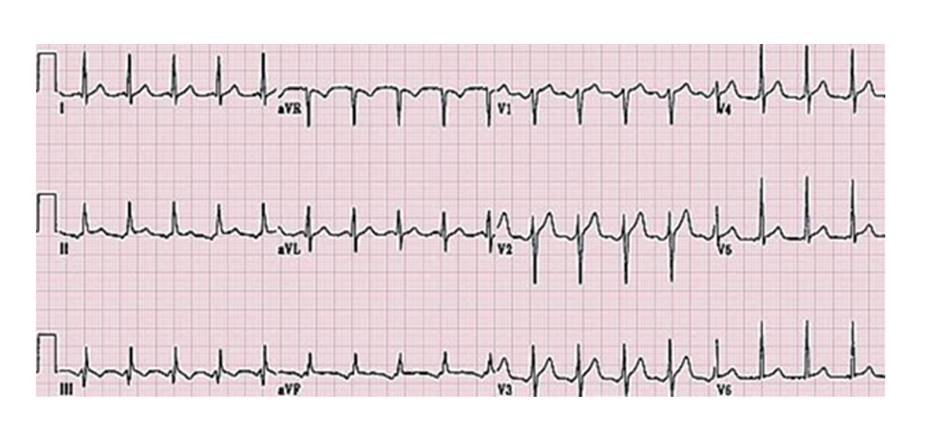
Figure 1 Electrocardiograph showing sinus tachycardia.
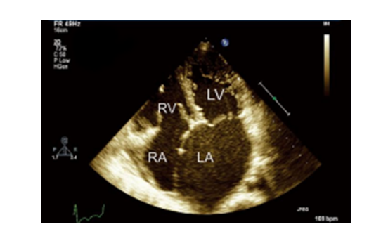
Figure 2 Echocardiography showed diffuse hypokinesis of the left ventricle with a 38% ejection fraction. LV: Left ventricle; RV: Right ventricle; RA: Right atrium; LA: Left atrium.
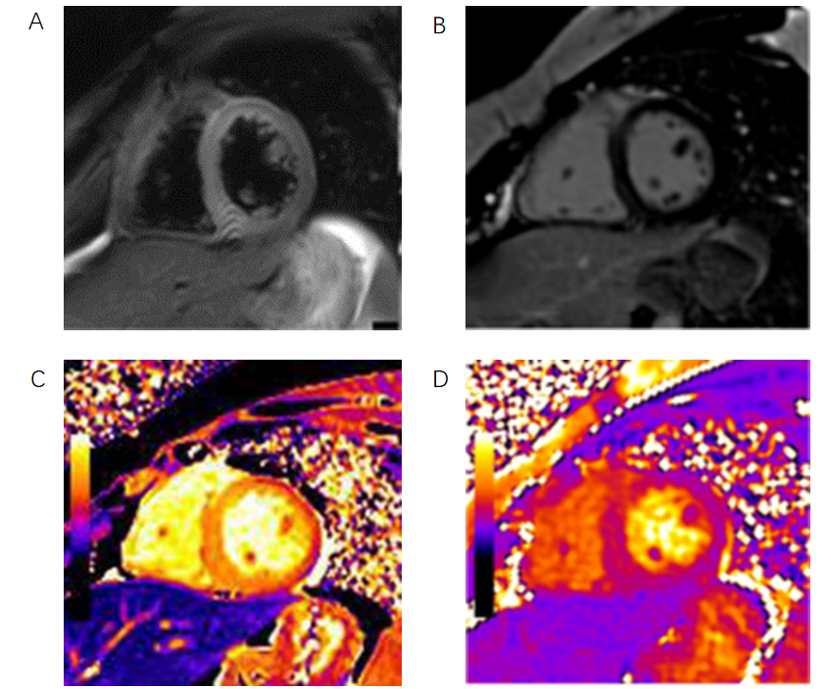
Figure 3 T2-weighted images, late gadolinium enhancement, and T1 and T2 mapping in this patient. Mapping of the native T1 values of the left ventricle showed a diffusely enhanced T1 value of approximately 1380 msec. T2 = 45 ms. A: Edema ratio; B: Late gadolinium enhancement; C: T1; D: T2.
Table 1 Laboratory findings on admission
Hematology | Serum chemistry | Endocrinology
WBC (7.71 × 10⁹/L) | α1 (8.5%) | LH (0.02 mIU/mL)
Neu (65.4%) | γ (30.9%) | FSH (0.95 mIU/mL)
RBC (2.88 × 10¹² /L) | Alb (22 g/L) | GH (11.69 ng/mL)
HB (85 g/dL) | cTnT (0.188 μg/L) | T3 (0.54 nmol/L)
Hct (28%) | Mb (272.8 ng/mL) | T4 (5.26 nmol/L)
PLT (360 × 10⁹/L) | CK-MB (12.7 U/L) | TSH (17.634 mU/L)
 | BNP (5487 pg/mL) | PTH (51.6 ng/L)
Urinalysis | PT (16.5 s) | IGF-1 (< 25.0 ng/mL)
 | PTR (1.43) | VEGF (9800 pg/mL)
Protein (1921 μmol/dL) | INR (1.45) | IgG (23.90 g/L)
M protein (0.27 g/L) | Fbg (3.95 g/L) | IgA (5.04 g/L)
KET (++) | ALB (26 g/L) | HbA1c (8.10%)
 | AST (30 U/L)
 | ALT (25 U/L)
 | BUN (7.4 mmol/L)
 | CRE (50 μmol/L)
 | UA (408 μmol/L)
 | Na (135 mmol/L)
 | K (4.8 mmol/L)
 | Cl (104 mmol/L)
WBC: White blood cells; ALB: Albumin; AST: Aspartate aminotransferase; ALT: Alanine aminotransferase; INR: International normalized ratio; VEGF: Vascular endothelial-derived growth factor; IgG: Immunoglobulin G; IgA: Immunoglobulin A; HbA1c: Hemoglobin A1c; IGF-1: Insulin-like growth factor 1; RBC: Red blood cells; CK-MB: Creatine kinase MB; BNP: Brain natriuretic peptide; FSH: Follicle-stimulating hormone; TSH: Thyroid Stimulating Hormone; PTH: Parathyroid hormone; PT: Prothrombin time.

