Name of journal: World Journal of Gastroenterology
ESPS Manuscript NO: 21055
Manuscript Type: ORIGINAL ARTICLE
Basic Study
Dietary saturated fatty acid and polyunsaturated fatty acid oppositely affect hepatic NOD-like receptor protein 3 inflammasome through regulating nuclear factor-kappa B activation

Sui YH et al. Dietary fatty acids and NLRP3 inflammasome

Yong-heng Sui, Wen-jing Luo, Qin-yu Xu, Jing Hua

Yong-heng Sui, Wen-jing Luo, Qin-yu Xu, Jing Hua, Division of Gastroenterology and Hepatology, Ren Ji Hospital, School of Medicine, Shanghai Jiao Tong University, Shanghai Institute of Digestive Disease, Shanghai 200127, China

Author contributions: Sui YH and Luo WJ contributed equally to this work, performed the experiments and analyzed the data; Xu QY coordinated the research; Hua J designed the study; Sui YH, Luo WJ and Hua J wrote the paper.

Supported by the National Natural Science Foundation of China, NO. 81170374 and NO. 81470842 to Hua J.

Institutional review board statement: The study was reviewed and approved by Ren Ji Hospital, School of Medicine, Shanghai Jiao Tong University Institutional Review Board.

Institutional animal care and use committee statement: All procedures involving animals were reviewed and approved by the Institutional Animal Care and Use Committee of Ren Ji Hospital, School of Medicine, Shanghai Jiao Tong University (IACUC protocol number: SYXK 2011-0121).

Conflict-of-interest statement: We declare that there is no conflict of interest to disclose.

Data sharing statement: No additional data are available.

Open-Access: This article is an open-access article which was selected by an in-house editor and fully peer-reviewed by external reviewers. It is distributed in accordance with the Creative Commons Attribution Non Commercial (CC BY-NC 4.0) license, which permits others to distribute, remix, adapt, build upon this work non-commercially, and license their derivative works on different terms, provided the original work is properly cited and the use is non-commercial. See: http://creativecommons.org/licenses/by-nc/4.0/

Correspondence to: Jing Hua, MD, PhD, Division of Gastroenterology and Hepatology, Ren Ji Hospital, School of Medicine, Shanghai Jiao Tong University, No. 160 Pu Jian Road, Shanghai 200127, China. hua-jing88@hotmail.com
Telephone: +86-21-68383113
Fax: +86-21-63200874

Received: June 28, 2015
Peer-review started: July 1, 2015
First decision: September 29, 2015
Revised: October 17, 2015
Accepted: December 30, 2015

Article in press:
Published online:

Abstract
Aim: To investigate the effect of different dietary fatty acids on hepatic inflammasome activation.

Methods: Wild-type C57BL/6 mice were fed either high-fat diet or polyunsaturated fatty acid (PUFA)-enriched diet. Primary hepatocytes were treated with either saturated fatty acids (SFAs) or PUFAs as well as combined with lipopolysaccharide (LPS). The expression of NOD-like receptor protein 3 (NLRP3) inflammasome, peroxisome proliferator-activated receptor-γ and nuclear factor-kappa B (NF-κB) was determined by real-time PCR and Western blot. The activity of Caspase-1 and IL-1β production were measured.

Results: High-fat diet-induced hepatic steatosis was sufficient to induce and activate hepatic NLRP3 inflammasome. SFA palmitic acid (PA) directly activated NLRP3 inflammasome and increased sensitization to LPS-induced inflammasome activation in hepatocytes. In contrast, PUFA docosahexaenoic acid (DHA) had the potential to inhibit NLRP3 inflammasome expression in hepatocytes and partly abolished LPS-induced NLRP3 inflammasome activation. Furthermore, high-fat diet increased but PUFA-enriched diet decreased sensitization to LPS-induced hepatic NLRP3 inflammasome activation in vivo. Moreover, PA increased but DHA decreased phosphorylated NF-κB p65 protein expression in hepatocytes.

Conclusion: Hepatic NLRP3 inflammasome activation played an important role in the development of non-alcoholic fatty liver disease. Dietary SFAs and PUFAs oppositely regulated the activity of NLRP3 inflammasome through direct activation or inhibition of NF-κB.

Key words: non-alcoholic fatty liver disease; NOD-like receptor protein 3 inflammasome; saturated fatty acids; polyunsaturated fatty acids; nuclear factor-kappa B

© The Author(s) 2015. Published by Baishideng Publishing Group Inc. All rights reserved.

Core tip: Our research inventively elucidated that high-fat diet-induced hepatic steatosis was sufficient to induce and activate hepatic NOD-like receptor protein 3 (NLRP3) inflammasome, playing an important role in the development of non-alcoholic fatty liver disease. Furthermore, dietary saturated fatty acids and polyunsaturated fatty acids oppositely regulated the activity of NLRP3 inflammasome in hepatocytes and transmitted different sensitization to lipopolysaccharide-induced activation of NLRP3 inflammasome in vitro and in vivo, partly through direct activation or inhibition of nuclear factor-kappa B.

Sui YH, Luo WJ, Xu QY, Hua J. Dietary saturated fatty acid and polyunsaturated fatty acid oppositely affect hepatic NOD-like receptor protein 3 inflammasome through regulating nuclear factor-kappa B activation. World J Gastroenterol 2015; In press
Introduction
Nonalcoholic fatty liver disease (NAFLD) is considered the hepatic manifestation of the metabolic syndrome. The spectrum of NAFLD includes simple steatosis, steatosis with inflammation, and non-alcoholic steatohepatitis (NASH) with fibrosis. A “two hit” mechanism is proposed to drive progression from NAFLD to NASH. The initial step involves excessive fat accumulation in the liver and the second hit includes enhanced lipid peroxidation and increased generation of reactive oxygen species (ROS). Subsequently, fat accumulation in the liver enhances sensitization to the second hits or further insults. Recently, increasing evidence has suggested chronic and systemic low-grade inflammation played an essential role in the pathogenesis of insulin resistance and NAFLD^{[1,2]}.
Inflammasome has emerged as an important regulator of inflammation^{[3,4]}. The NOD-like receptor protein 3 (NLRP3) inflammasome is a cytosolic protein complex composed of the regulatory subunit NLRP3, the adaptor apoptosis-associated speck-like protein (ASC), and the effector caspase-1. Inflammasome can be activated by both pattern associated molecular patterns (PAMPs) and danger-associated molecular patterns (DAMPs)^{[5,6]}. Two-signal hypothesis is accepted in inflammasome activation: the first signal produces and induces pro-interleukine-1 beta (pro-IL-1β) and inflammasome components expression, and the second signal assembles inflammasome components to engage in caspase-1 activation and secret bioactive IL-1β.
Recent studies suggest a critical role of NLRP3 inflammasome in obesity and its complications^{[7-9]}. Loss of NLRP3 inflammasome components protects mice against insulin resistance and metabolic dysfunction, indicating that NLRP3 inflammasome may function as a sensor to detect metabolic danger signals. Free fatty acids (FFAs), usually elevated in plasma of NASH patients^{[10,11]}, have been proposed as a major contributing factor for inflammatory response through engaging toll-like receptors (TLRs) and inducing nuclear factor-kappa B (NF-κB)-dependent production of inflammatory cytokines such as Tumor Necrosis Factor-α (TNF-α) and Interleukine-6 (IL-6)^{[12]}. Recently, several studies have demonstrated that the saturated FFA (SFA) palmitic acid triggered inflammation by activating inflammasome in macrophages and hepatocytes^{[13,14]}. However, these studies indicated SFAs alone only primed and induced the NLRP3 inflammasome expression, but failed to completely activate NLRP3 inflammasome. Furthermore, there was no inflammasome activation in liver with simple hepatic steatosis in ob/ob mice. Therefore, the effect of SFAs or high-fat diet (HFD) on activation of the NLRP3 inflammasome needs to be further confirmed. Interestingly, recent studies revealed that n-3 polyunsaturated fatty acids (n-3 PUFAs) suppressed both lipopolysaccharide (LPS)-induced priming and NLRP3 inflammasome activation in macrophages, and more importantly, n-3 PUFAs prevented HFD-induced metabolic disorder such as insulin resistance through inhibition of NLRP3 inflammasome activation^{[15,16]}. These results indicated different types of fatty acids exerted different or even opposite roles in the activation of the NLRP3 inflammasome. Currently, the mechanism involved in inflammasome regulation remains largely unknown. Elevated ROS levels, mitochondria damage, and lysosomal rupture have been proposed to participate in NLRP3 inflammasome activation^{[17-19]}, but little is known about FFAs to positively or negatively regulate NLRP3 inflammasome activation.
In the current study, we investigated whether HFD-induced hepatic steatosis had direct effect on NLRP3 inflammasome activation. Furthermore, effect of dietary SFAs and PUFAs on the NLRP3 inflammasome activation in hepatocytes was determined and the possible underlying mechanism was explored. We also determined effect of different FFAs on LPS-induced NLRP3 inflammasome activation.

Materials and Methods
Animal experiments
Adult (age 6-8 wk) male wild type C57BL/6 mice were obtained from Experimental Animal Center (Ren Ji Hospital, Shanghai Jiao Tong University). Mice were fed either a normal control diet (NCD, 12% kcal from fat, n = 10) or a high-fat diet (HFD, 59% kcal from fat，Shanghai SLACCAS Company, n = 10) for 14 wk. All mice were maintained in a temperature- and light-controlled facility and permitted to consume water and pellet chow ad libitum. All animal experiments fulfilled Shanghai Jiao Tong University criteria for the humane treatment of laboratory animals and was approved by the Ren Ji Hospital Animal Care and Use Committee (SYXK 2011-0121).
For LPS-induced liver injury, mice received intraperitoneal injection of lipopolysaccharide (LPS, 1.5 mg/kg, Sigma-Aldrich Corporation, St. Louis, MO, United States) 6h before sacrificed after feeding with either NCD (n = 5), HFD (n = 5) or PUFA-enriched diet (enriched in polyunsaturated fatty acid, 45% kcal from fish oil, Medicience Ltd, China, n = 5) for 4 wk. The serum and liver tissue were collected.

Hepatocytes isolation and treatment
Hepatocytes were isolated as previously described^{[20]} and obtained through low-speed centrifugation of the liver filtrate and cultured in DMEM solution containing 12% fetal bovine serum (FBS, Gibco, Grand Island, NY, United States), with 100 U/mL penicillin G and 100 U/mL streptomycin sulfate on collagen I-coated plates. The viability of cells was assessed by the trypan blue exclusion test. Exclusion was greater than 90% for hepatocytes.
After overnight culture, hepatocytes were treated with either palmitic acid (PA, 0.5 mmol/L, Sigma-Aldrich Corporation, St. Louis, MO, United States) or docosahexaenoic acid (DHA, 50 μmol/L, Sigma-Aldrich Corporation, St. Louis, MO, United States) for 6 h or 24 h, as well as combined with LPS (1 μg/mL, Sigma-Aldrich Corporation, St. Louis, MO, United States) treatment. Meanwhile DMEM solution or LPS treatment alone were served as control respectively in the separated experiments.

Total RNA isolation and real-time PCR
Total RNA was extracted from mice liver tissue and hepatocytes using TRIzol reagent (Invitrogen, Grand Island, NY, United States). cDNA was synthesized from 2 µg of total RNA using Primescript RT Reagent kit (TaKaRa, Japan). For real-time PCR, 10 ng template was added in a 10 μl reaction system containing each primer and SYBR Green PCR Master Mix (TaKaRa, Japan). PCR thermocycling parameters were 95 °C for 30 s, followed by 40 cycles of 95 °C for 5 s and 60 °C for 30 s performed by ABI Prism 7300 system (Applied Biosystems, Grand Island, NY, United States). All reactions were performed in triplicate. The expression levels of target genes were quantified by the double-delta method (2^{-△△Ct}). Murine primers (provided by Sangon Biotech Co., Shanghai, China) were as follows: NLRP3: GAGTTCTTCGCTGCTATGT and ACCTTCACGTCTCGGTTC; Caspase-1: TGGAGAGAAACAAGGAG and TTGAAGAGCAGAAAGCAAT; IL-1β: TCTTTGAAGTTGACGGACCC and TGAGTGATACTGCCTGCCTG; TNF-α: TCTTCTCATTCCTGCTTGTGG and GGTCTGGGCCATAGAACTGA; PPARγ: GCCCTTTACCACAGTTGATTTCT and GTGATTTGTCCGTTGTCTTTCCT; β-actin: TGTTACCAACTGGGACGACA and CTGGGTCATCTTTTCACGGT

Western blot analysis
Whole protein extracted from mice liver tissue and hepatocytes were resolved by 8% sodium dodecyl sulfate-polyacrylamide gel electrophoresis (SDS-PAGE) gels according to standard procedures. The samples were then transferred to 0.45 μm nitrocellulose membranes (Bio-Rad, Hercules, CA, United States) and incubated at 4 °C overnight with antibodies against NLRP3 (1:1000, Abcam, Cambridge, MA, United States), Caspase-1 (procaspase-1 and Caspase-1-p10, 1:1000, Abcam, Cambridge, MA, United States), peroxisome proliferator-activated receptor-γ (PPAR-γ) (1:500, Cell Signaling Technology, Danvers, MA, United States), NF-κB p65 (1:1000, Cell Signaling Technology, Danvers, MA, United States), phosphorylated NF-κB p65 (1:500, Cell Signaling Technology, Danvers, MA, United States), GAPDH (1:10000, KangChen Bio-tech, Shanghai, China). The blots were then incubated with a horseradish peroxidase (HRP)-conjugated secondary antibody (1:10000, KangChen Bio-tech, Shanghai, China) at room temperature for 1h. Immunoreactive bands were detected with ECL Western blotting kit (Thermo Scientific Pierce, Grand Island, NY, United States) and exposed to films and developed.

Caspase-1 activity Measurement
Protein from mice liver tissue and hepatocytes was extracted in the same way as above. The activity of Caspase-1 was assessed with the Caspase-1 activity assay kit (BioVision, Milpitas, CA, United States) according to the manufacturer’s instruction.

enzyme-linked immuno sorbent assay analysis
Whole cell lysates were extracted from liver tissue. Cells culture supernatants of hepatocytes were collected after 24 h treatment. These lysates and culture supernatants were assayed for IL-1β production with IL-1β ELISA kit (eBioscience, San Diego, CA, United States) according to the manufacturer’s protocol.

Liver histology and oil red O staining
Liver tissue were fixed in 10% formalin and embedded in paraffin. The sections were stained with hematoxylin-eosin and examined under Olympus light microscopy. Liver tissue and fatty acids treated hepatocytes were fixed in 10% formalin and stained with oil red O and hematoxylin for examination of lipid accumulation.

Statistical analysis
All statistical analyses were carried out with GraphPad Prism 5 and expressed as Mean ± SEM. The paired-individual means were compared by t-test. P < 0.05 was considered statistically significant.

Results
High fat diets induce and activate hepatic NLRP3 inflammasome
Chronic and systemic activation of inflammatory-immune system plays an important role in the development of NAFLD^{[1,2]}. Inflammasomes are major contributors to inflammation. Here, we study the association between high-fat diet feeding and hepatic NLRP3 inflammasome expression. As our previous report, 14-wk HFD induced significant but simple hepatic steatosis (Figure 1A) and up-regulated mRNA expression of proinflammatory cytokines TNF-α and IL-1β in liver (Figure 1B) when compared to those of NCD mice. Unlike other proinflammatory cytokines, IL-1β is cleaved from pro-IL-1β by caspase-1, which is activated by the inflammasome complex. Here we found expression of NLRP3 and caspase-1 were significantly up-regulated at mRNA level in the livers of HFD-fed mice versus NCD-fed mice (Figure 1B). Furthermore, the protein expression of NLRP3 and fountional cleavaged caspase-1 (caspase-1-p10) were also increased in HFD-fed mice (Figure 1C). In agreement with the increased fountional caspase-1 mRNA expression, caspase-1 activity (Figure 1D) and mature IL-1β protein levels (Figure 1E) in liver tissue were significantly increased in HFD-fed mice versus NC-fed mice, which indicated inflammasome activation. Taken together, these results indicated that high-fat diet induced hepatic NLRP3 inflammasome activation associated with hepatic steatosis.

Different fatty acids have opposite effect on NLRP3 inflammasome activation in hepatocytes
Hepatic steatosis was characterized with overloading of lipid droplets in hepatocytes. Next, we’d like to investigate whether lipid droplets deposition in hepatocytes can directly induce and activate NLRP3 inflammasome, and further explore the effect of different fatty acids on NLRP3 inflammasome activation. Primary hepatocytes isolated from C57BL/6 mice were incubated in either SFA (PA, 0.5 mmol/L) or PUFA (DHA, 50 μmol/L) for 24 h. Oil red O staining showed severe lipid droplets deposition in PA-treated hepatocytes when compared to those of normal controls. However, slight lipid droplets deposition was observed in DHA-treated hepatocytes (Figure 2A), which was similar to that of normal controls. As expected, PA-treated hepatocytes demonstrated markedly increased mRNA expression of NLRP3 and IL-1β than those of normal controls (Figure 2B). The protein expression of NLRP3 and fountional caspase1-p10 in hepatocytes after PA treatment was also increased (Figure 2C). Moreover, caspase-1 activity (Figure 2D) and IL-1β secretion (Figure 2E) were markedly increased in PA-treated hepatocytes culture supernatants. In contrast, DHA treatment significantly decreased mRNA expression of NLRP3 and IL-1β than those of normal controls (Figure 2B), but no significant change was detected in caspase-1 activity and IL-1β secretion in culture supernatants. Althogether, these results indicated that SFAs alone could induce and activate NLRP3 inflammasome in hepatocytes, which may be associated with lipid deposition. On the contrary, PUFAs had the potential to inhibit NLRP3 inflammasome activation.

Combined effect of fatty acids with LPS on NLRP3 inflammasome activation in hepatocytes
LPS has been proposed as an important factor in the pathogenesis of NAFLD. Recent reports have shown LPS can induce and activate NLRP3 inflammasome in the liver^{[21]}. Furthermore, TLRs and PA cooperatively activated inflammasome in the liver^{[14,22]}. Next, we’d like to investigate the effect of LPS combined with different fatty acids on NLRP3 inflammasome activation in hepatocytes. Figure 3A/B showed that PA combined with LPS significantly increased NLRP3 gene and protein expression when compared with LPS treatment alone. Simultaneously, caspase-1 activity (Figure 3C) and IL-1β secretion (Figure 3D) were also significantly increased in combined treatment group versus LPS treatment alone. In contrast, DHA combined with LPS significantly decreased NLRP3 expression at gene and protein levels when compared with LPS treatment alone (Figure 3A/B). Furthermore, IL-1β secretion in culture supernatant was decreased markedly after DHA combined with LPS treatment (Figure 3C). These results indicated that SFAs enhanced sensitization to LPS-induced NLRP3 inflammasome activation, while PUFAs had potential to decrease LPS-induced inflammsome activation.

Effect of different fatty acids diets combined with LPS on hepatic NLRP3 inflammasome in vivo
Different fatty acids oppositely regulated LPS-induced NLRP3 inflammasome activation in vitro. Next, we’d like to explore whether different fatty acids-enriched diets had different effect on LPS-induced NLRP3 inflammasome activation in vivo. Hepatic NLRP3 inflammasome expression was determined after administration of LPS and 4-wk feeding of either HFD (enriched in SFAs) or high-PUFA diet (enriched in PUFAs). Short-term feeding of HFD significantly enhanced LPS-induced up-regulation of NLRP3 and IL-1β gene expression when compared to those of NCD (Figure 4A). NLRP3 and caspase-1 protein expression were also up-regulated in mice fed with HFD combined with LPS treatment (Figure 4B). Furthermore, caspase-1 activity and IL-1β production in liver tissue were significantly increased in HFD mice (Figure 4C/D). In contrast, PUFA-enriched diet significantly decreased LPS-induced caspase-1 gene and protein expression (Figure 4A/B). Altogether, these results revealed that different fatty acids-enriched diet offered opposite sensitization to LPS-induced NLRP3 inflammasome activation.

Effect of different fatty acids on NF-κB/PPAR-γ expression
Recent study has shown that NF-κB played a critical role in priming of NLRP3 inflammasome. Furthermore, PPAR-γ inhibited proinflammatory cytokines expression partly by antagonizing activities of the transcription factors NF-κB. In the current study, we determined NF-κB/PPAR-γ expression in hepatocytes treated with different fatty acids. Figure 5A showed that DHA treatment significantly increased PPAR-γ gene expression in hepatocytes, but LPS alone as well as combined with either PA or DHA treatment decreased PPAR-γ expression. However, PPAR-γ protein expression was similar in PA and DHA-treated hepatocytes (Figure 5B). On the contrary, we found PA increased but DHA decreased NF-κB p65 protein expression in hepatocytes. Furthermore, PA combined with LPS had synthetic effect on p65 NF-κB protein expression, while DHA almost completely abolished LPS-induced NF-κB activation. Therefore, different fatty acids exerted opposite effect on the inflammatory response partly through regulating the NF-κB activity.

Discussion
Increasing evidence has suggested that inflammasome played an important role in the insulin resistance and development of NAFLD^{[7-9]}. In the current study, we confirmed that HFD-induced hepatic simple steatosis was sufficient to induce and activate hepatic NLRP3 inflammasome. Furthermore, different fatty acids had opposite effect on the NLRP3 inflammasome in hepatocytes. SFAs significantly activated the NLRP3 inflammasome, while n-3 PUFAs had potential to decrease the activity of NLRP3 inflammasome. In addition, different fatty acids transmitted different sensitization to LPS-induced activation of NLRP3 inflammasome in vitro and in vivo. The different effect of fatty acids on NLRP3 inflammasome may be dependent on the NF-κB/PPAR-γ signaling.
Previous study has shown up-regulation and activation of NLRP3 inflammasome in mice models of long-term (9 mo) HFD-induced NASH, while there was no inflammasome activation in mice models of short-term (4 weeks) HFD^{[14]}. In the current study, 14-wk HFD feeding induced significant hepatic steatosis and increased mRNA expression of TNF-α and IL-1β. Furthermore, hepatic expression of NLRP3 and caspase-1 were up-regulated at both mRNA and protein levels, and caspase-1 activity and IL-1β secretion in the liver of HFD-fed mice were significantly increased, which indicated inflammasome activation. Our previous studies showed no significant lipid accumulation in the liver of short-term (4-6 wk) HFD-fed mice, but 8-12 wk feeding of HFD induced markedly hepatic steatosis^{[23]}. Therefore, HFD-induced hepatic steatosis was prerequisite to induce and activate NLRP3 inflammasome. It has been widely acknowledged that NLRP3 inflammasome is activated by PAMPs or DAMPs^{[5,6,24]}. Excessive intracellular lipid droplet deposition has been thought as one of the endogenous DAMPs^{[12]}. Therefore, hepatic steatosis may initiate NLRP3 inflammasome gene expression through metabolic stress-induced endogenous DAMPs. Furthermore, FFAs derived from HFD could directly stimulate TLRs and activated inflammasome as a second stimuli. Altogether, HFD-induced hepatic steatosis was sufficient to induce and activate hepatic NLRP3 inflammasome, which may contribute to the development of NAFLD.
FFAs, usually elevated in plasma of NASH patients and animal models of NAFLD, have been proposed to promote inflammatory responses by directly engaging TLRs and inducing NF-κB-dependent production of inflammatory cytokines^{[10-12]}. Recently, emerging evidence demonstrated that FFAs activated the inflammasome^{[13,14,25]}. Wen et al^{[13]} demonstrated the SFA palmitate could activate the NLRP3 inflammasome-dependent IL-1β secretion from murine macrophages. Reynolds CM found palmitate induced IL-1β secretion in dendritic cells through a caspase-1/ASC/NLRP3-dependent pathway^{[25]}. These results implicated that dietary SFAs served as DAMPs to induce NLRP3 inflammasome, however, SFAs only showed a priming role on NLRP3 inflammasome. In the current study, we found exposure to dietary PA induced significant lipid deposition in hepatocytes. The lipid-loaded hepatocytes exhibited not only up-regulated NLRP3 inflammasome expression and pro-IL-1β gene transcription, but also increased caspase-1 activity and IL-1β secretion. Our results indicated that SFAs alone could directly induce and activate NLRP3 inflammasome and initiate inflammatory responses in hepatocytes. The discrepancy between ours and others was mainly due to the different cell types studied. Hepatocytes were the major place of lipid metabolism, and excessive lipid deposition in hepatocytes led to lipotoxicity. Recent study has demonstrated that SFAs enhanced endoplasmic reticulum stress and induced production of ROS, which were sufficient for the induction of IL-1β production via activation of the NF-κB and inflammasome pathways^{[26]}. Therefore, endogenous DAMPs associated with excessive intracellular lipid deposition may serve as both priming and activating signal on NLRP3 inflammasome. On the other hand, we found n-3 PUFAs had no effect on IL-1β secretion, and it even decreased NLRP3 inflammasome gene expression at some extent. Recently, Yan et al^{[16]} reported that omega-3 fatty acids inhibited the NLRP3 inflammasome activation in macrophages. L’homme et al^{[15]} found unsaturated fatty acids abolished SFA-induced NLRP3 inflammasome activation and inhibited subsequent caspase-1 activation and IL-1β secretion in human monocytes/macrophages. These results indicated different dietary fatty acids exerted opposite role in the activation of the NLRP3 inflammasome. Taken together, SFAs, the main fatty acids derived from HFD, may contribute to the development of NAFLD through activating NLRP3 inflammasome, at least partly. In contrast, PUFAs had a potential to play a protective role in NAFLD.
The level of bacterial endotoxin (or LPS) is increased in the portal and/or systemic circulation in NFALD^{[27]}. Emerging evidence supported the role of gut-derived endotoxin in the pathogenesis of NAFLD. LPS was recognized by TLRs and activated the signaling pathway to produce proinflammatory cytokines such as TNF-α which further increased lipid accumulation and decreased β-oxidation of fatty acids^{[28,29]}. Previous studies demonstrated LPS directly induced and activated the NLRP3 inflammasome in the liver^{[21,30]}. Furthermore, SFAs enhanced sensitization to LPS-induced inflammasome activation and IL-1β release in hepatocytes. In the current study, we found that SFAs increased but PUFAs decreased sensitization to LPS-induced NLRP3 inflammasome activation and subsequent IL-1β secretion in hepatocytes. The similar result was observed in vivo. HFD increased sensitization to LPS-induced hepatic NLRP3 inflammasome activation in vivo, while PUFA-enriched diet had the potential to inhibit LPS-induced hepatic NLRP3 inflammasome activation to some extent. Taken altogether, HFD or SFAs and LPS cooperatively contributed to NLRP3 inflammasome activation, which may play an important role in the progression of NAFLD to NASH. In contrast, PUFAs had inhibitory effect on NLRP3 inflammasome and decreased LPS-induced NLRP3 inflammasome activation, indicating a new protective and anti-inflammatory function of PUFAs.
We found different fatty acids or diets oppositely regulated the activity of NLRP3 inflammasome, but the underlying possible mechanism involved was not elucidated. It has been shown that SFAs were able to activate TLR4 signaling to induce gene expression of diverse proinflammatory cytokines by regulating the transcription factors, including NF-κB^{[12]}. In contrast, PUFAs were verified to reduce lipid accumulation and improve insulin sensitivity through regulating transcription factors, such as PPAR-γ, to exert anti-inflammatory responses^{[31]}. Recently, studies have shown that NF-κB signaling was necessary for proper activation of the NLRP3 inflammasome. Bauernfeind FG demonstrated that NF-κB inhibition led to reduction of NLRP3 inflammasome expression induced by LPS^{[30]}. Furthermore, some studies demonstrated that PPAR-γ inhibited proinflammatory cytokines gene expression partly by antagonizing activities of the transcription factors AP-1, STAT and NF-κB^{[32]}. In the present study, we found SFAs increased but PUFAs decreased NF-κB p65 protein expression in hepatocytes. Furthermore, SFAs combined with LPS had synthetic effect on p65 NF-κB protein expression, while PUFAs almost completely abolished LPS-induced NF-κB activation. However, PPAR-γ protein expression was similar in hepatocytes treated with SFAs or PUFAs. Our result was similar to other reports. Recently, Williams-Bey Y found that DHA suppressed macrophage inflammasome activation by inhibiting NF-κB activation, and also potently reduced LPS-induced nuclear translocation of p65 NF-κB^{[33]}. Therefore, different dietary fatty acids oppositely regulated the activity of NLRP3 inflammasome through directly regulating NF-κB activation, which may play a crucial role in the progression or improvement of NAFLD.
In conclusion, our study confirmed that HFD-induced hepatic steatosis was sufficient to induce and activate hepatic NLRP3 inflammasome, which played an important role in the development of NAFLD. Moreover, SFAs directly activated NLRP3 inflammasome and increased sensitization to LPS-induced inflammasome activation. While PUFAs had the potential to inhibit NLRP3 inflammasome expression and abolished LPS-induced NLRP3 inflammasome activation. Different fatty acids oppositely regulated NLRP3 inflammasome activity through direct activation or inhibition of NF-κB.

Comments
Background
Increasing evidence has suggested chronic and systemic low-grade inflammation plays an important role in the pathogenesis of non-alcoholic fatty liver disease (NAFLD). Free fatty acids have been proposed as a major contributing factor for inflammation. Inflammasome has emerged as an important regulator of inflammation.

Research frontiers
Recent studies suggest a critical role of the NOD-like receptor protein 3 (NLRP3) inflammasome in obesity and its complications. Elevated reactive oxygen species levels, mitochondria damage, and lysosomal rupture have been proposed to participate in NLRP3 inflammasome activation, but little is known about fatty acids to positively or negatively regulate NLRP3 inflammasome activation.

Innovations and breakthroughs
This research inventively demonstrated that hepatic NLRP3 inflammasome activation played an important role in the development of NAFLD. Dietary saturated fatty acids (SFAs) and polyunsaturated fatty acids (PUFAs) oppositely regulated the activity of NLRP3 inflammasome through direct activation or inhibition of nuclear factor-kappa B (NF-κB).

Applications
This research confirmed that dietary SFAs and PUFAs oppositely affect hepatic NLRP3 inflammasome through regulating NF-κB activation, which may provide a new therapy option on dietary-based intervention for NAFLD.

Terminology
The NLRP3 inflammasome is a cytosolic protein complex composed of the regulatory subunit NLRP3, the adaptor apoptosis-associated speck-like protein, and the effector caspase-1. Two-signal hypothesis is accepted in inflammasome activation: the first signal produces and induces pro-Interleukine-1 beta (pro-IL-1β) and inflammasome components expression, and the second signal assembles inflammasome components to engage in caspase-1 activation and secret bioactive IL-1β.

Peer-review
The authors investigated the effect of differently dietary fatty acid on hepatic inflammasome activation. The work was logically designed and nicely described.
References
1 Hotamisligil GS. Inflammation and metabolic disorders. Nature 2006; 444: 860-867 [PMID: 17167474 DOI: 10.1038/nature05485]
2 Maher JJ, Leon P, Ryan JC. Beyond insulin resistance: Innate immunity in nonalcoholic steatohepatitis. Hepatology 2008; 48: 670-678 [PMID: 18666225 DOI: 10.1002/hep.22399]
3 Strowig T, Henao-Mejia J, Elinav E, Flavell R. Inflammasomes in health and disease. Nature 2012; 481: 278-286 [PMID: 22258606 DOI: 10.1038/nature10759]
4 Szabo G, Csak T. Inflammasomes in liver diseases. J Hepatol 2012; 57: 642-654 [PMID: 22634126 DOI: 10.1016/j.jhep.2012.03.035]
5 Martinon F. Detection of immune danger signals by NALP3. J Leukoc Biol 2008; 83: 507-511 [PMID: 17982111 DOI: 10.1189/jlb.0607362]
6 Pétrilli V, Dostert C, Muruve DA, Tschopp J. The inflammasome: a danger sensing complex triggering innate immunity. Curr Opin Immunol 2007; 19: 615-622 [PMID: 17977705 DOI: 10.1016/j.coi.2007.09.002]
7 Vandanmagsar B, Youm YH, Ravussin A, Galgani JE, Stadler K, Mynatt RL, Ravussin E, Stephens JM, Dixit VD. The NLRP3 inflammasome instigates obesity-induced inflammation and insulin resistance. Nat Med 2011; 17: 179-188 [PMID: 21217695 DOI: 10.1038/nm.2279]
8 Stienstra R, van Diepen JA, Tack CJ, Zaki MH, van de Veerdonk FL, Perera D, Neale GA, Hooiveld GJ, Hijmans A, Vroegrijk I, van den Berg S, Romijn J, Rensen PC, Joosten LA, Netea MG, Kanneganti TD. Inflammasome is a central player in the induction of obesity and insulin resistance. Proc Natl Acad Sci USA 2011; 108: 15324-15329 [PMID: 21876127 DOI: 10.1073/pnas.1100255108]
9 Dixon LJ, Flask CA, Papouchado BG, Feldstein AE, Nagy LE. Caspase-1 as a central regulator of high fat diet-induced non-alcoholic steatohepatitis. PLoS One 2013; 8: e56100 [PMID: 23409132 DOI: 10.1371/journal.pone.0056100]
10 de Almeida IT, Cortez-Pinto H, Fidalgo G, Rodrigues D, Camilo ME. Plasma total and free fatty acids composition in human non-alcoholic steatohepatitis. Clin Nutr 2002; 21: 219-223 [PMID: 12127930 DOI: 10.1054/clnu.2001.0529]
11 Puri P, Wiest MM, Cheung O, Mirshahi F, Sargeant C, Min HK, Contos MJ, Sterling RK, Fuchs M, Zhou H, Watkins SM, Sanyal AJ. The plasma lipidomic signature of nonalcoholic steatohepatitis. Hepatology 2009; 50: 1827-1838 [PMID: 19937697 DOI: 10.1002/hep.23229]
12 Shi H, Kokoeva MV, Inouye K, Tzameli I, Yin H, Flier JS. TLR4 links innate immunity and fatty acid-induced insulin resistance. J Clin Invest 2006; 116: 3015-3025 [PMID: 17053832 DOI: 10.1172/JCI28898]
13 Wen H, Gris D, Lei Y, Jha S, Zhang L, Huang MT, Brickey WJ, Ting JP. Fatty acid-induced NLRP3-ASC inflammasome activation interferes with insulin signaling. Nat Immunol 2011; 12: 408-415 [PMID: 21478880 DOI: 10.1038/ni.2022]
14 Csak T, Ganz M, Pespisa J, Kodys K, Dolganiuc A, Szabo G. Fatty acid and endotoxin activate inflammasomes in mouse hepatocytes that release danger signals to stimulate immune cells. Hepatology 2011; 54: 133-144 [PMID: 21488066 DOI: 10.1002/hep.24341]
15 L'homme L, Esser N, Riva L, Scheen A, Paquot N, Piette J, Legrand-Poels S. Unsaturated fatty acids prevent activation of NLRP3 inflammasome in human monocytes/macrophages. J Lipid Res 2013; 54: 2998-3008 [PMID: 24006511 DOI: 10.1194/jlr.M037861]
16 Yan Y, Jiang W, Spinetti T, Tardivel A, Castillo R, Bourquin C, Guarda G, Tian Z, Tschopp J, Zhou R. Omega-3 fatty acids prevent inflammation and metabolic disorder through inhibition of NLRP3 inflammasome activation. Immunity 2013; 38: 1154-1163 [PMID: 23809162 DOI: 10.1016/j.immuni.2013.05.015]
17 Gross O, Thomas CJ, Guarda G, Tschopp J. The inflammasome: an integrated view. Immunol Rev 2011; 243: 136-151 [PMID: 21884173 DOI: 10.1111/j.1600-065X.2011.01046.x]
18 Zhou R, Tardivel A, Thorens B, Choi I, Tschopp J. Thioredoxin-interacting protein links oxidative stress to inflammasome activation. Nat Immunol 2010; 11: 136-140 [PMID: 20023662 DOI: 10.1038/ni.1831]
19 Zhou R, Yazdi AS, Menu P, Tschopp J. A role for mitochondria in NLRP3 inflammasome activation. Nature 2011; 469: 221-225 [PMID: 21124315 DOI: 10.1038/nature09663]
20 Hua J, Ma X, Webb T, Potter JJ, Oelke M, Li Z. Dietary fatty acids modulate antigen presentation to hepatic NKT cells in nonalcoholic fatty liver disease. J Lipid Res 2010; 51: 1696-1703 [PMID: 20185414 DOI: 10.1194/jlr.M003004]
21 Ganz M, Csak T, Nath B, Szabo G. Lipopolysaccharide induces and activates the Nalp3 inflammasome in the liver. World J Gastroenterol 2011; 17: 4772-4778 [PMID: 22147977 DOI: 10.3748/wjg.v17.i43.4772]
22 Miura K, Yang L, van Rooijen N, Brenner DA, Ohnishi H, Seki E. Toll-like receptor 2 and palmitic acid cooperatively contribute to the development of nonalcoholic steatohepatitis through inflammasome activation in mice. Hepatology 2013; 57: 577-589 [PMID: 22987396 DOI: 10.1002/hep.26081]
23 Ma X, Hua J, Li Z. Probiotics improve high fat diet-induced hepatic steatosis and insulin resistance by increasing hepatic NKT cells. J Hepatol 2008; 49: 821-830 [PMID: 18674841 DOI: 10.1016/j.jhep.2008.05.025]
24 Schroder K, Tschopp J. The inflammasomes. Cell 2010; 140: 821-832 [PMID: 20303873 DOI: 10.1016/j.cell.2010.01.040]
25 Reynolds CM, McGillicuddy FC, Harford KA, Finucane OM, Mills KH, Roche HM. Dietary saturated fatty acids prime the NLRP3 inflammasome via TLR4 in dendritic cells-implications for diet-induced insulin resistance. Mol Nutr Food Res 2012; 56: 1212-1222 [PMID: 22700321 DOI: 10.1002/mnfr.201200058]
26 Kim S, Joe Y, Jeong SO, Zheng M, Back SH, Park SW, Ryter SW, Chung HT. Endoplasmic reticulum stress is sufficient for the induction of IL-1β production via activation of the NF-κB and inflammasome pathways. Innate Immun 2014; 20: 799-815 [PMID: 24217221 DOI: 10.1177/1753425913508593]
27 Harte AL, da Silva NF, Creely SJ, McGee KC, Billyard T, Youssef-Elabd EM, Tripathi G, Ashour E, Abdalla MS, Sharada HM, Amin AI, Burt AD, Kumar S, Day CP, McTernan PG. Elevated endotoxin levels in non-alcoholic fatty liver disease. J Inflamm (Lond) 2010; 7: 15 [PMID: 20353583 DOI: 10.1186/1476-9255-7-15]
28 Kudo H, Takahara T, Yata Y, Kawai K, Zhang W, Sugiyama T. Lipopolysaccharide triggered TNF-alpha-induced hepatocyte apoptosis in a murine non-alcoholic steatohepatitis model. J Hepatol 2009; 51: 168-175 [PMID: 19446916 DOI: 10.1016/j.jhep.2009.02.032]
29 Keshavarzian A, Farhadi A, Forsyth CB, Rangan J, Jakate S, Shaikh M, Banan A, Fields JZ. Evidence that chronic alcohol exposure promotes intestinal oxidative stress, intestinal hyperpermeability and endotoxemia prior to development of alcoholic steatohepatitis in rats. J Hepatol 2009; 50: 538-547 [PMID: 19155080 DOI: 10.1016/j.jhep.2008.10.028]
30 Bauernfeind FG, Horvath G, Stutz A, Alnemri ES, MacDonald K, Speert D, Fernandes-Alnemri T, Wu J, Monks BG, Fitzgerald KA, Hornung V, Latz E. Cutting edge: NF-kappaB activating pattern recognition and cytokine receptors license NLRP3 inflammasome activation by regulating NLRP3 expression. J Immunol 2009; 183: 787-791 [PMID: 19570822 DOI: 10.4049/jimmunol.0901363]
31 Depner CM, Traber MG, Bobe G, Kensicki E, Bohren KM, Milne G, Jump DB. A metabolomic analysis of omega-3 fatty acid-mediated attenuation of western diet-induced nonalcoholic steatohepatitis in LDLR-/- mice. PLoS One 2013; 8: e83756 [PMID: 24358308 DOI: 10.1371/journal.pone.0083756]
32 Ricote M, Li AC, Willson TM, Kelly CJ, Glass CK. The peroxisome proliferator-activated receptor-gamma is a negative regulator of macrophage activation. Nature 1998; 391: 79-82 [PMID: 9422508 DOI: 10.1038/34178]
33 Williams-Bey Y, Boularan C, Vural A, Huang NN, Hwang IY, Shan-Shi C, Kehrl JH. Omega-3 free fatty acids suppress macrophage inflammasome activation by inhibiting NF-κB activation and enhancing autophagy. PLoS One 2014; 9: e97957 [PMID: 24911523 DOI: 10.1371/journal.pone.0097957]
P-Reviewer: Kucera O, Lee MK S-Editor: Gong ZM
L-Editor: E-Editor:

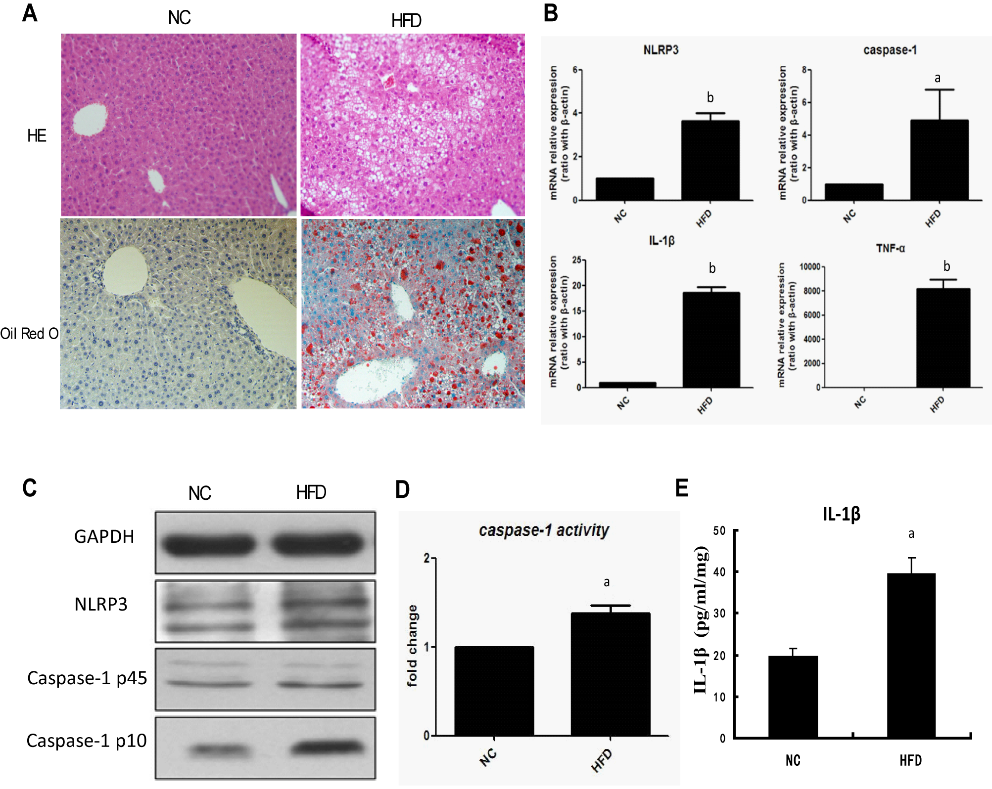
Figure 1 High fat diets induce hepatic steatosis and NOD-like receptor protein 3 inflammasome activation. Wild-type C57BL/6 mice were fed either normal control (NC) diet or high-fat diet (HFD) for 14 wk. A: Liver histology (magnification × 100); B: mRNA expression of NLRP3 inflammasome components and proinflammatory cytokines, determined by quantitative real-time PCR; C: Protein expression of NLRP3 and caspase-1 in Western blot; D: Caspase-1 activity in liver tissue; and E: mature IL-1β secretion in liver. Values are Mean ± SEM, ªP < 0.05, ^{b}P < 0.01 vs NC; n = 10 animals per group. NLRP3: NOD-like receptor protein 3; GAPDH: reduced glyceraldehyde-phosphate dehydrogenase; IL-1β: interleukine-1 beta.

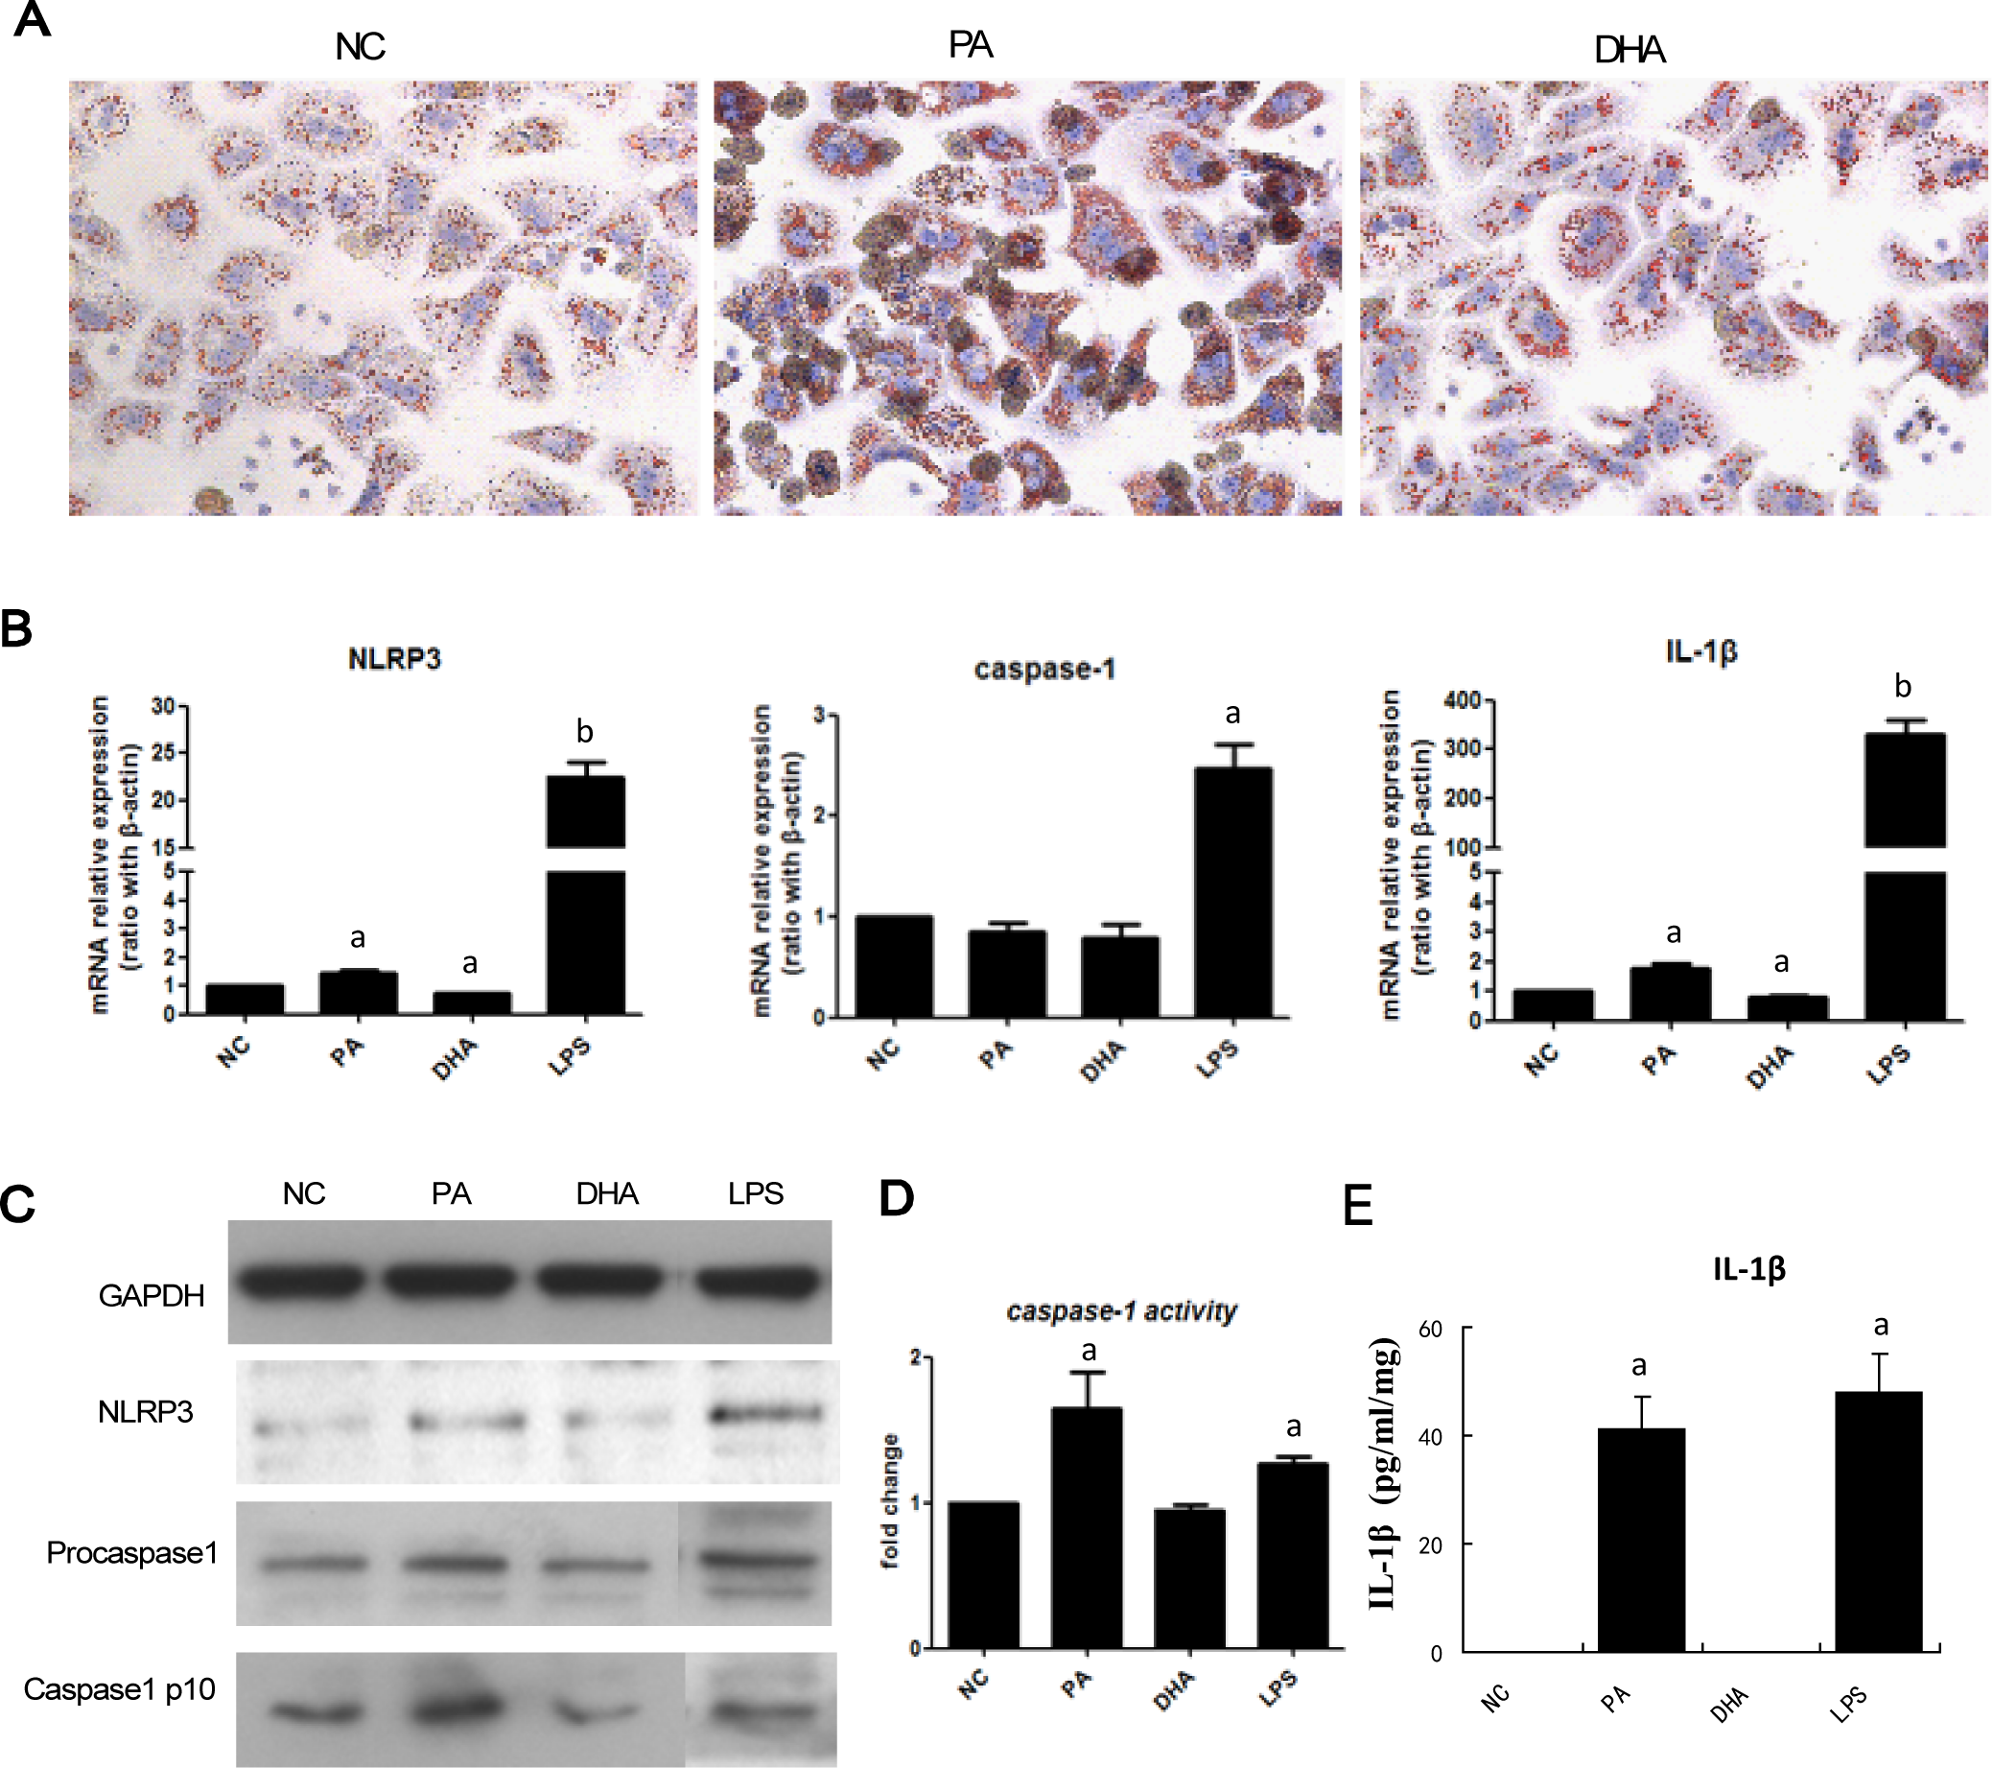
Figure 2 Effect of different fatty acids on NOD-like receptor protein 3 inflammasome activation in hepatocytes. Primary hepatocytes were isolated from wild-type C57BL/6 mice and were treated with either palmitic acid (PA, 0.5 mmol/L) or docosahexaenoic acid (DHA, 50 μmol/L). A: Lipid deposition in hepatocytes after exposure to PA or DHA for 24 h; B: mRNA expression of NLRP3 inflammasome components after FFAs treatment for 6 h; C: Protein expression of NLRP3 and caspase-1 in Western blot; D: Caspase-1 activity, and E: culture supernatant IL-1β level. Values are Mean ± SEM, ªP < 0.05, ^{b}P < 0.01 vs normal control (NC), n = 3 experiments. NLRP3: NOD-like receptor protein 3; GAPDH: reduced glyceraldehyde-phosphate dehydrogenase; LPS: lipopolysaccharide; IL-1β: interleukine-1 beta.

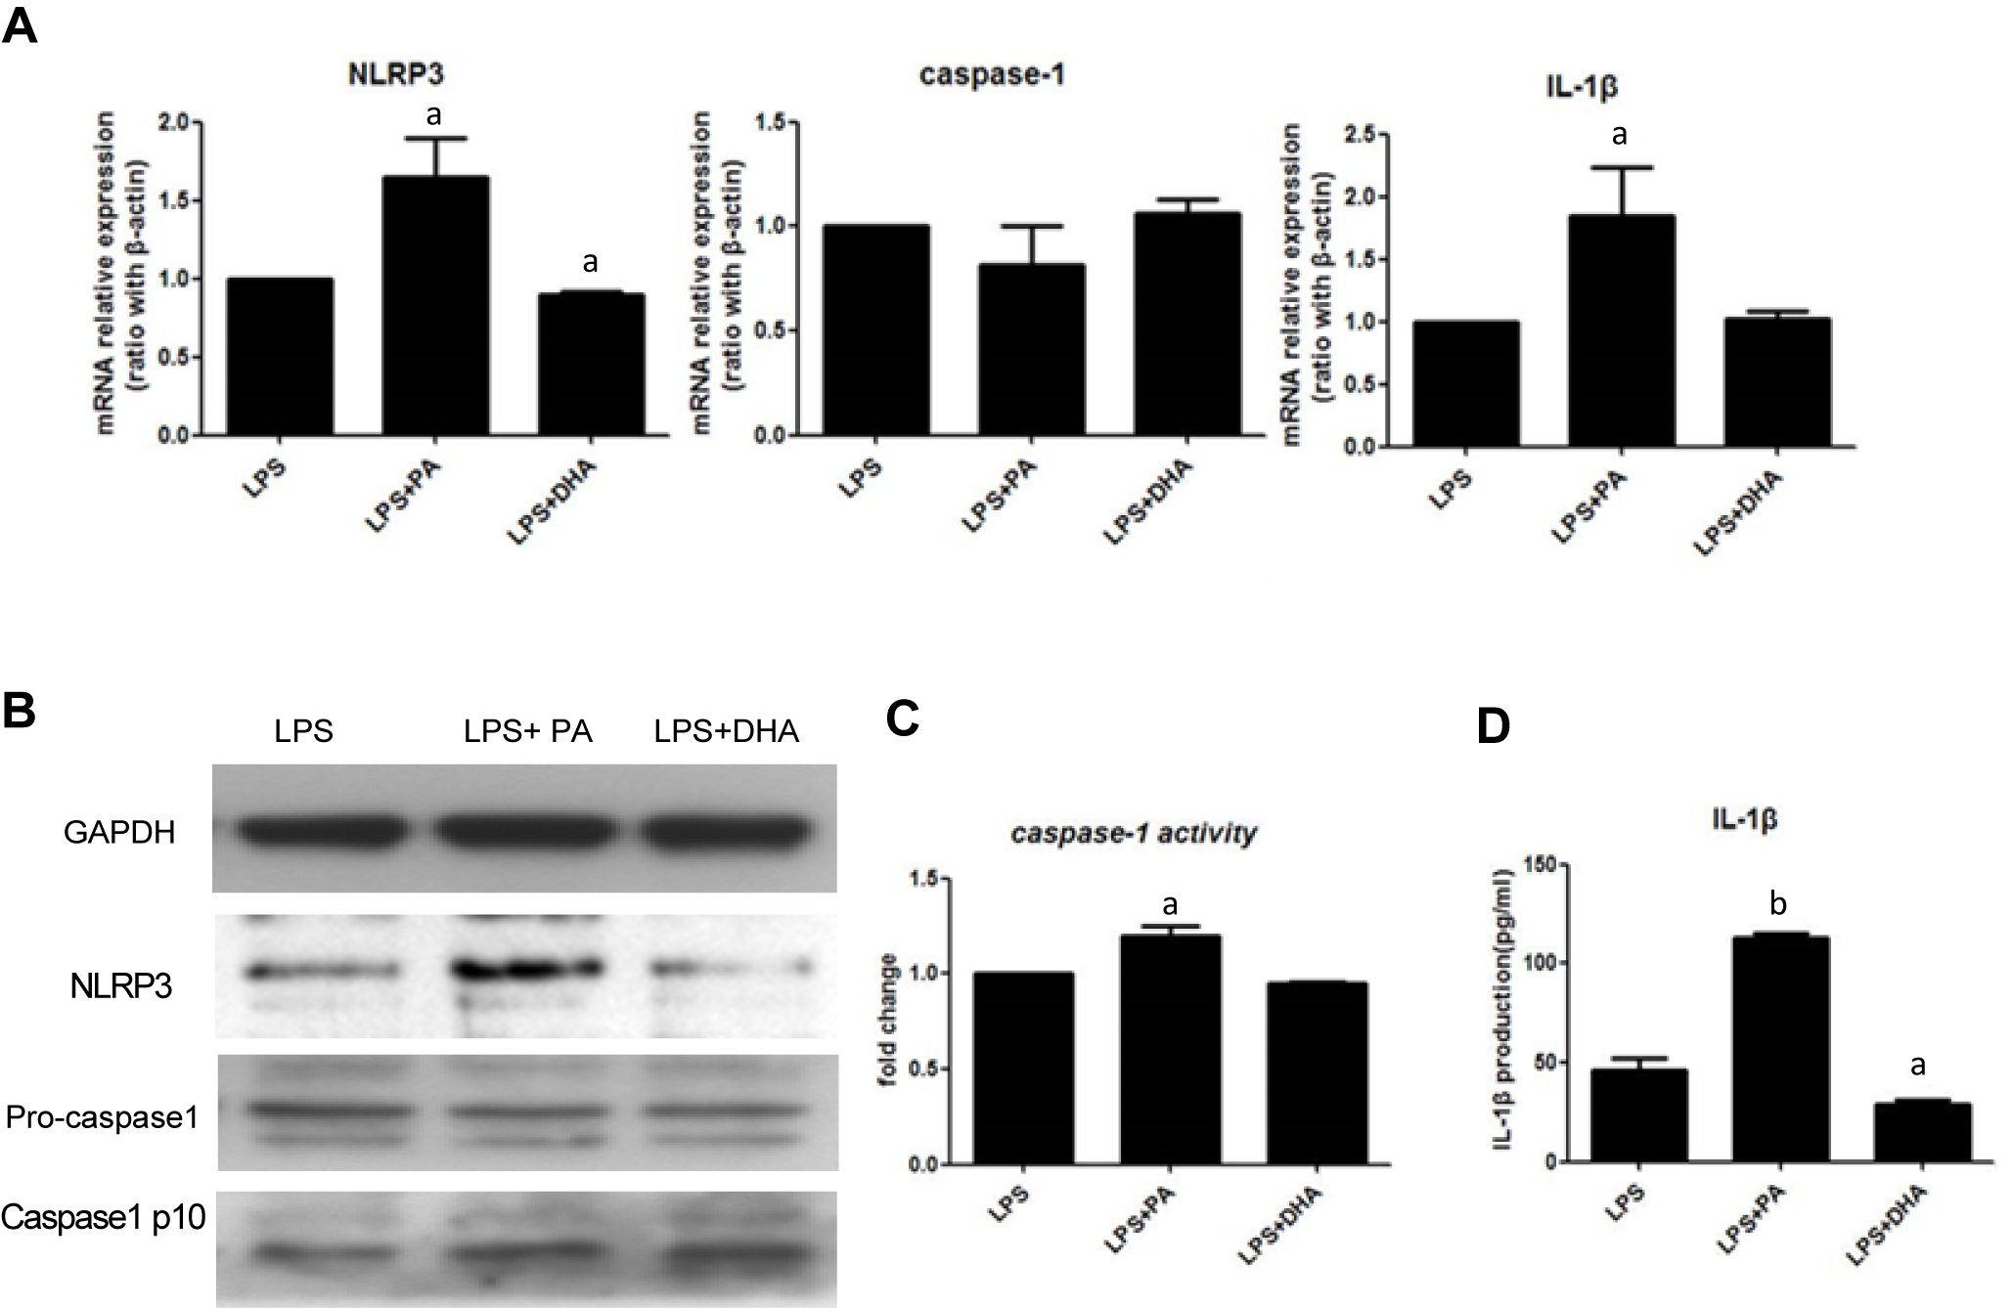
Figure 3 Combined effect of free fatty acids with lipopolysaccharide on NOD-like receptor protein 3 inflammasome activation in hepatocytes. Primary hepatocytes were isolated and treated with either PA (0.5 mmol/L) or DHA (50 μmol/L) combined with LPS (1 μg/mL). A: mRNA expression of NLRP3 inflammasome components; B: Protein expression of NLRP3 and caspase-1; C: Caspase-1 activity; and D: culture supernatant IL-1β level. Values are Mean ± SEM, ªP < 0.05, ^{b}P < 0.01 vs LPS control, n = 3 experiments. NF-κB: nuclear factor-kappa B; PA: palmitic acid; DHA: docosahexaenoic acid; LPS: lipopolysaccharide; FFAs: Free fatty acids; GAPDH: reduced glyceraldehyde-phosphate dehydrogenase. IL-1β: interleukine-1 beta; LPS: lipopolysaccharide;
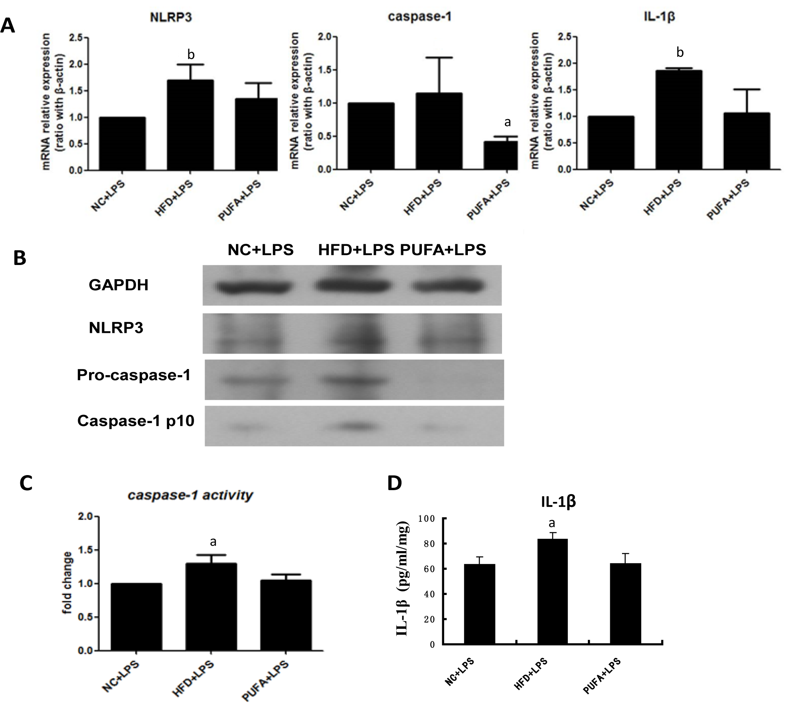
Figure 4 Effect of different fatty acids diet combined with lipopolysaccharide on hepatic NOD-like receptor protein 3 inflammasome in vivo. Wild-type C57BL/6 mice were fed either normal control (NC) diet, high-fat diet (HFD) or PUFA-enriched diet (PUFA) for 4 wk, and then injected LPS (1.5 mg/kg) before sacrificed. Liver tissues were obtained for following analysis. A: mRNA expression of NLRP3 inflammasome components; B: Protein expression of NLRP3 and caspase-1; C: Caspase-1 activity; and D: mature IL-1β secretion in liver. Values are Mean ± SEM, ªP < 0.05, ^{b}P < 0.01 vs NC + LPS, n = 5 animals per group. NLRP3: NOD-like receptor protein 3; GAPDH: reduced glyceraldehyde-phosphate dehydrogenase; LPS: lipopolysaccharide; IL-1β: interleukine-1 beta.
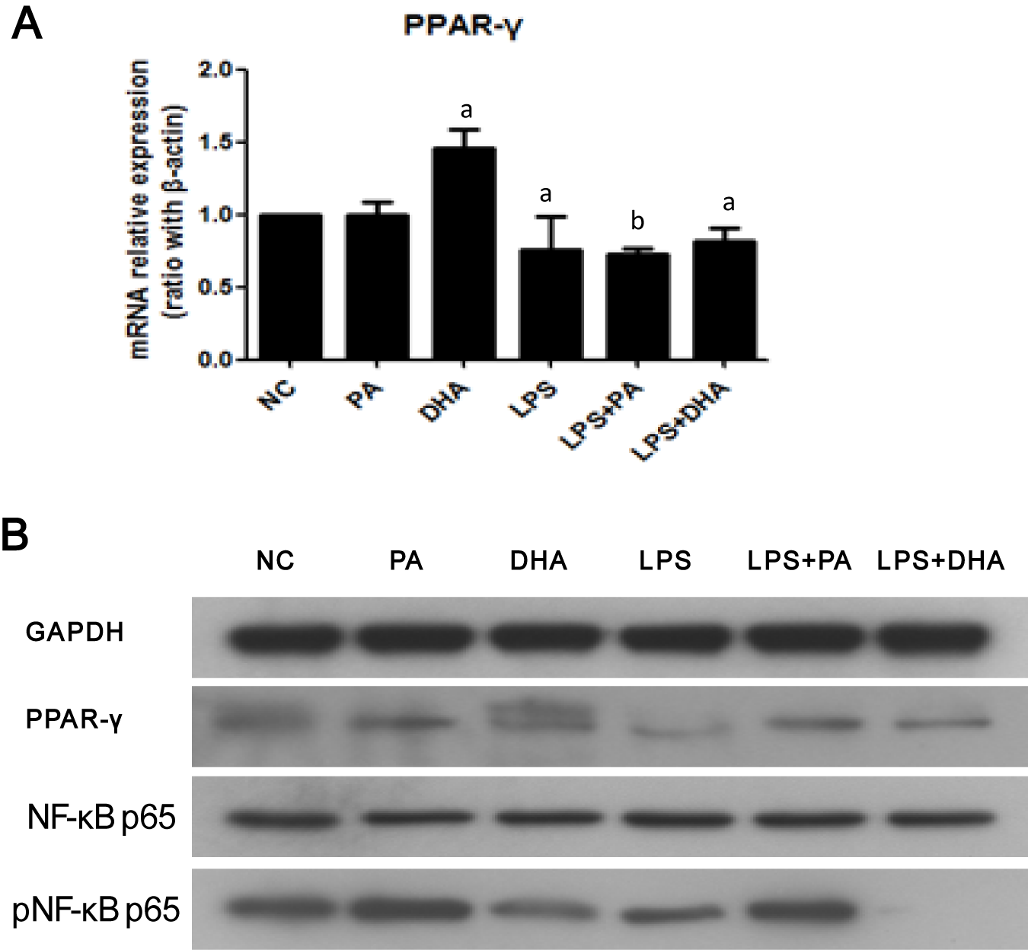
Figure 5 Effect of different fatty acids on nuclear factor-kappa B/peroxisome proliferator-activated receptor-γ expression. Primary hepatocytes were isolated and treated with PA (0.5 mmol/L), DHA (50 μmol/L) or LPS (1 μg/mL) alone or both of them. (A) mRNA expression of PPAR-γ, (B) Protein expression of NF-κB and PPAR-γ. Values are Mean ± SEM, ªP < 0.05, ^{b}P < 0.01 vs control, n = 3 experiments. PPAR-γ: peroxisome proliferator-activated receptor-γ; NF-κB: nuclear factor-kappa B; PA: palmitic acid; DHA: docosahexaenoic acid; LPS: lipopolysaccharide.

