Name of Journal: World Journal of Gastroenterology
Manuscript NO: 78894
Manuscript Type: CORRECTION

Correction to “MicroRNA-596 acts as a tumor suppressor in gastric cancer and is upregulated by promotor demethylation”

Zhang Z et al. Correction to figure 4

Zhen Zhang, Dong-Qiu Dai

Zhen Zhang, Dong-Qiu Dai, Department of Gastroenterological Surgery, The Fourth Affiliated Hospital of China Medical University, Shenyang 110032, Liaoning Province, China

Author contributions: Dai DQ and Zhang Z approved the final version of the article to be published.

Corresponding author: Dong-Qiu Dai, PhD, Chief Doctor, Professor, Surgical Oncologist, Department of Gastroenterological Surgery, The Fourth Affiliated Hospital of China Medical University, No. 4 Chongshan Road, Shenyang 110032, Liaoning Province, China. daidq63@163.com

Received: July 20, 2022
Revised: September 29, 2022
Accepted: November 4, 2022
Published online:

Abstract
Correction to “Zhang Z, Dai DQ. MicroRNA-596 acts as a tumor suppressor in gastric cancer and is upregulated by promotor demethylation. World J Gastroenterol 2019; 25: 1224-1237 [PMID: 30886505 DOI: 10.3748/wjg.v25.i10.1224]”. In this article, we found the following errors in figure 4: Three images of the NC and miR-NC groups in the MGC-803 cell wound healing assay were misapplied during the preparation of submission; the mimcs and miR-NC icons were incorrectly edited in the image of the statistical chart. According to the reviewer’s comments, we have re-analyzed the images of the wound-healing assay and revised the charts depicting the analyzed results. The corrected figure is given in this correction.

Key Words: Correction; MicroRNA-596; Gastric cancer; Figure; Errors

Zhang Z, Dai DQ. Correction to “MicroRNA-596 acts as a tumor suppressor in gastric cancer and is upregulated by promotor demethylation”. World J Gastroenterol 2022; In press

Core Tip: This manuscript is to correct the images in figure 4 of “Zhang Z, Dai DQ. MicroRNA-596 acts as a tumor suppressor in gastric cancer and is upregulated by promotor demethylation. World J Gastroenterol 2019; 25: 1224-1237 [PMID: 30886505 DOI: 10.3748/wjg.v25.i10.1224]”.

TO THE EDITOR
Correction
Correction to: Zhang Z, Dai DQ. MicroRNA-596 acts as a tumor suppressor in gastric cancer and is upregulated by promotor demethylation. World J Gastroenterol 2019; 25: 1224-1237 [PMID: 30886505 DOI: 10.3748/wjg.v25.i10.1224].
In the original publication of the article^{[1]}, we found the following errors in figures 4A and 4B (in this manuscript marked as Figure 1): Three images of the NC and miR-NC groups in the MGC-803 cell wound healing assay were misapplied during the preparation of submission; the mimcs and miR-NC icons were incorrectly edited in the image of the statistical chart. According to the reviewer’s comments, we have re-analyzed the images of the wound-healing assay and revised the charts depicting the analyzed results. The corrected figure is given in this correction. This correction will have no influence on the interpretation of the entire results and conclusion in this study. We apologize for any inconvenience this may cause.

REFERENCES
1 Zhang Z, Dai DQ. MicroRNA-596 acts as a tumor suppressor in gastric cancer and is upregulated by promotor demethylation. World J Gastroenterol 2019; 25: 1224-1237 [PMID: 30886505 DOI: 10.3748/wjg.v25.i10.1224]

Footnotes
Conflict-of-interest statement: All the authors report no relevant conflicts of interest for this article.

Open-Access: This article is an open-access article that was selected by an in-house editor and fully peer-reviewed by external reviewers. It is distributed in accordance with the Creative Commons Attribution NonCommercial (CC BY-NC 4.0) license, which permits others to distribute, remix, adapt, build upon this work non-commercially, and license their derivative works on different terms, provided the original work is properly cited and the use is non-commercial. See: https://creativecommons.org/Licenses/by-nc/4.0/

Provenance and peer review: Unsolicited article; Externally peer reviewed
Peer-review model: Single blind

Peer-review started: July 20, 2022
First decision: September 26, 2022
Article in press:

Specialty type: Gastroenterology and hepatology
Country/Territory of origin: China
Peer-review report’s scientific quality classification
Grade A (Excellent): 0
Grade B (Very good): B, B
Grade C (Good): 0
Grade D (Fair): 0
Grade E (Poor): 0

P-Reviewer: Dambrauskas Z, Lithuania; He D, China S-Editor: Wang JJ L-Editor: A P-Editor:

Figure Legends
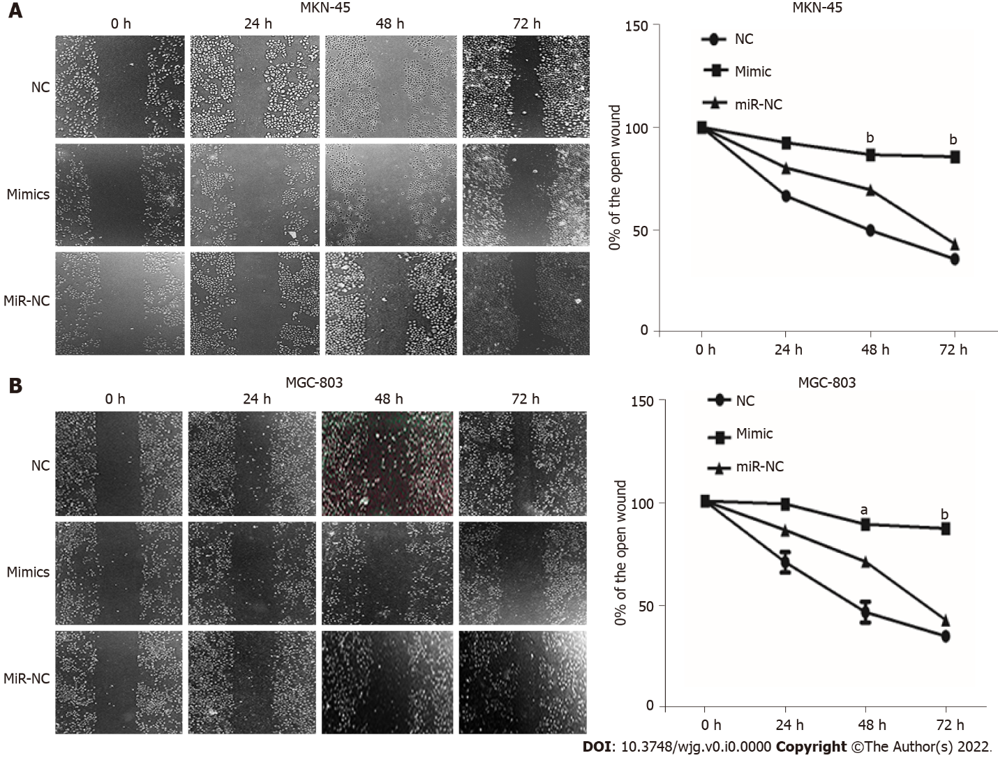
Figure 1 Wound healing assay for detecting cell migration in MKN-45 and MGC-803 cells transfected with miR-NC or microRNA-596 mimic. A: MKN-45 cells; B: MGC-803 cells. ªP < 0.05; ^{b}P < 0.01 vs miR-NC.

