Name of journal: World Journal of Gastroenterology
ESPS Manuscript NO: 16747
Columns: ORIGINAL ARTICLES

Basic Study
Linc00675 as novel marker of short survival and recurrence in patients with pancreatic ductal adenocarcinoma

Li DD et al. Linc00675 in pancreatic cancer

Dou-Dou Li, Zhi-Qiang Fu, Qing Lin, Yu Zhou, Quan-Bo Zhou, Zhi-Hua Li, Lang-Ping Tan, Ru-Fu Chen, Yi-Min Liu

Dou-Dou Li, Yi-Min Liu, Department of Radiotherapy, Sun Yat-sen Memorial Hospital, Sun Yat-sen University, Guangzhou, Guangdong Province 510120, China
Zhi-Qiang Fu, Qing Lin, Yu Zhou, Quan-Bo Zhou, Lang-Ping Tan, Ru-Fu Chen, Department of Pancreaticobiliary Surgery, Hepatobiliary Surgery, Sun Yat-sen Memorial Hospital, Sun Yat-sen University, Guangzhou 510120, Guangdong Province, China
Zhi-Hua Li, Department of Medical Oncology, Sun Yat-sen Memorial Hospital, Sun Yat-sen University, Guangzhou 510120, Guangdong Province, China

Author contributions: Li DD and Fu ZQ contributed equally to this study; Li DD and Fu ZQ performed the majority of experiments; Lin Q conducted part of the experiment, and contributed to the revision of this paper; Zhou Y and Zhou QB conceived the experiments, analyzed and interpreted data and wrote the manuscript; Li ZH and Tan LP participated in the experiments and helped to analyze the data; all authors read and approved the final manuscript.

Ethics approval: The study was reviewed and approved by the Institutional Review Board of Sun Yat-sen Memorial hospital and the Ethics Committee of Sun Yat-sen Memorial Hospital.
Informed consent: All study participants provided informed written consent prior to study enrollment.
Conflict-of-interest: The authors disclose no conflicts.
Data sharing: The technical appendix, statistical code, and dataset are available from the corresponding author at liuyimin_sysu@163.com. Consent was not obtained but the presented data are anonymized and the risk of identification is low.

Open-Access: This article is an open-access article which was selected by an in-house editor and fully peer-reviewed by external reviewers. It is distributed in accordance with the Creative Commons Attribution Non Commercial (CC BY-NC 4.0) license, which permits others to distribute, remix, adapt, build upon this work non-commercially, and license their derivative works on different terms, provided the original work is properly cited and the use is non-commercial. See: http://creativecommons.org/licenses/by-nc/4.0/

Correspondence to: Dr. Yi-Min Liu, Department of Radiotherapy, Sun Yat-sen Memorial Hospital, Sun Yat-sen University, 107 Yan-Jiang Xi Road, Guangzhou, Guangdong Province 510120, China. liuyimin_sysu@163.com
Telephone: +86-20-81332480-
Fax: +86-20-81332480

Received: January 28, 2015
Peer-review started: January 29, 2015
First decision: March 10, 2015
Revised: April 7, 2015
Accepted: June 15, 2015

Article in press:
Published online:

Abstract
AIM: To analyze linc00675 expression in pancreatic ductal adenocarcinoma (PDAC), analysis the relationship between the expression level of linc00675 and the clinical pathological characteristics; and to explore its biological functions and determine whether linc00675 has independent prognostic value in PDAC.

METHODS: We studied linc00675 expression among eight histologically confirmed PDAC tissue samples and four chronic pancreatitis tissue samples through microarray screening. RT-qPCR was conducted to further investigate linc00675 expression in PDAC cell lines as well as archived tissue from a large cohort of PDAC patients. The correlations between (1) the level of lnc00675; and (2) clinicopathological characteristics and survival in patients with pancreatic cancer were evaluated using Correlation analysis. Univariate and multivariate analysis were conducted to predict whether it is an independent prognostic and recurrence factor in patients with pancreatic cancer. Downregulate the expression of linc00675 through SiRNA, Using MTT assay, flow cytometry, transwell assay and western blot to explore related biological function of the linc00675 in proliferation, invasion, and affect the cell cycle of pancreatic cancer cells. Further explore the relative molecular expression levels of epithelial-mesenchymal transition through reverse transcription- polymerase chain reaction (RT-PCR) and Western blot.

RESULTS: The expression of Linc00675 in PDAC tissue samples was shown to be 672 times that in chronic pancreatitis tissue samples by microarray screening (P = 3.69 × 10⁻⁵). This finding was confirmed in tumor tissue from 90 patients with PDAC compared with adjacent normal tissue samples by quantitative RT-PCR. We found that linc00675 overexpression positively correlated with lymph node metastasis (P = 0.005), perineural invasion (P = 0.006), and poor survival (P < 0.001). Univariate and multivariate analyses showed that linc00675 expression served as an independent predictor for overall survival (P = 0.009). Additionally, receiver operating curve analysis showed that high linc00675 might serve as a predictor for tumor progression within 6 mo to a year after surgery. In vitro functional analysis demonstrated that knockdown of linc00675 attenuates pancreatic cancer cell proliferation and invasion as well asinduces S phase arrest. Suppression of linc00675 in pancreatic cancer cells resulted can reverse the progress of epithelial-mesenchymal transition.

CONCLUSION: Linc00675 may function as an oncogene during PDAC development, and its expression is an independent predictor of unfavorable prognosis in patients with PDAC.

Keywords: Linc00675; Long noncoding RNAs; Prognosis biomarker; Pancreatic cancer; Epithelial-mesenchymal transition

© The Author(s) 2015. Published by Baishideng Publishing Group Inc. All rights reserved.

Core tip: This is the first study to report that linc00675 is more highly expressed in pancreatic ductal adenocarcinoma (PDAC) tissues than in adjacent normal tissues. Overexpression of linc00675 in PDAC tissues positively correlated with short survival and tumor progression. The prominent findings in this study are that linc00675 is an independent prognostic marker for predicting the survival of PDAC patients after surgery.

Li DD, Fu ZQ, Lin Q, Zhou Y, Zhou QB, Li ZH, Tan LP, Chen RF, Liu YM. Linc00675 is a novel prognostic factor for poor survival and short-term recurrence in patients with pancreatic ductal adenocarcinoma. World J Gastroenterol 2015; In press

INTRODUCTION
Pancreatic ductal adenocarcinoma (PDAC) that originates in the glandular epithelium accounts for approximately 90% of all pancreatic tumors and exhibits a high grade of malignancy^{[1]}. PDAC patients have an extremely poor prognosis, with a 5-year survival rate of approximately 6%. Even in patients who undergo surgical resection, the disease commonly recurs and the 5-year survival rate remains low at 15%–25%^{[2]}. This dismal prognosis is due to the aggressive nature of this disease, and its resistance to traditional therapeutic strategies. Therefore, the development of an effective treatment for PDAC requires further research to reveal the molecular mechanisms underlying its aggressive pathogenesis.
Long noncoding RNAs (lncRNAs) are RNA molecules over 200 nucleotides in length with little protein-coding potential. Long intergenic noncoding RNAs (lincRNAs) have transcription loci that fall between two protein-coding genes and function to regulate gene expression at various levels, including transcription, epigenetic regulation and post-transcriptional processing^{[3-7]}. Accumulating evidence suggests that deregulation of lincRNAs may contribute to many types of human diseases, including cancer^{[8, 9]}. Moreover, they play critical roles in cancer initiation, progression and metastasis^{[10-12]}. LincRNA expression signatures have been associated with patient survival and may be useful in the patient management and the design of anticancer treatments^{[13]}. Several lincRNAs have been implicated in tumorigenesis. However, the biological functions and prognostic value of lincRNAs in pancreatic cancer remain largely unexplored. Thus, there is an urgent need to identify the etiology and biological function of lincRNAs that may serve as markers of diagnosis and prognosis in PDAC to improve survival in this disease.
In the present study, based on microarray analysis, we focused on a long intergenic noncoding RNA named linc00675 that showed 672-fold upregulation in PDAC compared with normal pancreatic tissues. Building on this finding, we determined the significance of linc00675 in PDAC by investigating the relationship between aberrantly expressed linc00675 and patients’ clinicopathological features, as well as performing further in vitro study of PDAC cell lines. We found that upregulation of linc00675 is associated with short survival. In addition to affecting the cell cycle, overexpression of linc00675 could therefore promote cancer cell proliferation, migration and invasion. Thus, our studies reveal that linc00675 is a promising prognostic biomarker in pancreatic cancer, and could be useful in pancreatic cancer risk assessment and future therapeutic targeting.

MATERIALS AND METHODS
Patients and tissue samples
Samples of fresh frozen cancer tissues, together with normal adjacent tissues, were obtained during surgical resection from Sun Yat-sen Memorial Hospital of Sun Yat-sen University. Informed consent was obtained from the patients before sample collection, and approved by the hospital’s ethics review committees. All samples were confirmed by pathological examination.

Cell culture
The human pancreatic cancer cell lines PANC1, Capan2, BXPC-3, Mia PaCa2, SW1990, and immortalized human pancreatic ductal epithelial cells (HPDE6) were purchased from the American Type Culture Collection and grown in complete growth medium with 10% FBS and 1% penicillin/streptomycin as recommended by the manufacturer. All the cells were cultured in a humidified 5% CO₂ incubator at 37°C.

RNA Isolation, microarrays, and quantitative reverse transcription PCR
Total mRNA was extracted, purified using the mRNA-ONLYTM Eukaryotic mRNA Isolation Kit (Epicentre, Madison, CA). Total RNA was fragmented and then labeled (One-Color, Cy3, Agilent). After purification, the labeled RNA was hybridized to probes on the Hybridization Chamber gasket slides (Agilent). After being washed, the slides were scanned using an Agilent Microarray Scanner. The raw data was extracted with the Feature Extraction software (Agilent Technology). This software utilizes the robust multiarray average algorithm to adjust the background signals. Normalized data was obtained using the quantile method of intra-microarray normalization and median method of baseline transformation between the microarrays. Differentially expressed genes with a raw expression level of over 400 in more than 4 of the 12 samples used for profiling were extracted. Then they were ordered by P value. The 10 most significantly de-regulated genes (those with the smallest P-values) were selected for validation. We also computed the maximum false discovery rate based on a single gene-probe P-value threshold of 0.05. We considered as significant signatures with a false discovery rate ≤ 0.1. The microarray platform and data were submitted to the Gene Expression Omnibus public database at the National Center for Biotechnology Information (accession number: GSE61166, http://www.ncbi.nlm.nih.gov/geo/query/acc.cgi?acc=GSE61166).
Real-time quantitative PCR (RT-qPCR) was performed for linc00675 and EMT marker (E-cadherin, N-cadherin, and Vimentin) mRNA, with β-actin as an internal control. The total RNA was then converted to cDNA by reverse-transcription using oligodT primers and SuperScript II reverse transcriptase (Invitrogen). Quantitative PCR was performed with SYBR green master mix (Roche). Relative expression values were calculated (ΔΔCT method) using β-actin as a normalizer. The primer sequences used in the study are listed in Supplementary Table 1.

RNA interference
siRNA oligos targeting linc00675 (CTGATGGAGGAGAATCAATT, GTCCGAGAATGGCT GTGATT, and GTTCCAGACTCCATCACAATT), and nontargeting siRNAs (UUCUCCGAACGUG UCACGUTT) were purchased from Sigma Aldrich. siRNA transfections were done with 80 nmol/L siRNA and Lipofectamine 2000 (Life Technologies) following the manufacturer’s instructions.

Cell growth assay, cell cycle analysis, and invasion assay
After transfection, 2 × 10³ cells (SW1990 or Mia PaCa-2) were plated in 96-well plates. A cell proliferation reagent kit (Roche) was used to assess cell proliferation. Transfected cells were assessed every 24 h according to the manufacturer’s instructions. For cell cycle analysis, transfected cells were collected, washed in PBS, and stained with propidium oxide using the Cell Cycle Analysis Kit (Beyotime, Haimen, China), and then subjected to FACS analysis. In vitro cell invasion assay was performed using the BD BioCoat™ Matrigel™ Invasion Chamber (Becton Dickinson) according to manufacturer's instructions, with 3×10⁴ cells seeded in the upper chamber. At least three biological replicates of the experiments were performed.

Western blot analysis
Cells were washed in PBS and lysed with RIPA buffer (Invitrogen, Carlsbad, CA, USA), and a bicinchoninic acid protein assay kit (Pierce) was used to calculate the protein concentration of each sample. Equivalent amounts of proteins were separated by SDS-PAGE and transferred to polyvinylidene fluoride membranes for immunoblotting. The membranes were blocked in 5% fat-free milk for 1 h at room temperature, then incubated with the following primary antibodies: anti-CyclinA, anti-CyclinE, anti-Cyclin D1, anti-CDK2 and anti- β -actin (Abcam, Cambridge, MA); anti-Vimentin, Anti-E-cadherin, anti-N-cadherin, and anti-GAPDH (Pro-teinTech Group, Chicago, IL, USA). GAPDH was used as a loading control. Horseradish peroxidase-conjugated secondary antibodies (Cell Signaling Technology) and an ECL chemiluminescence kit (Pierce) were used to detect bound antibody.

Statistical analysis
Statistical analyses were performed using SPSS Statistics 17.0 (SPSS lnc®). All in vitro experiment quantitative data are presented as the mean ± SD from at least three independent experiments, unless otherwise noted. The differences between two groups were analyzed using a Student's t test. The correlation between linc00675 and clinical and pathological characteristics was assessed using Pearson’s χ² test. Survival was evaluated using the Kaplan–Meier method. Cox proportional hazard analysis was performed to calculate the hazard ratio and the 95%CI to evaluate the association between linc00675 and other clinicopathologic factors and survival. All tests performed were two-sided. Differences were considered statistically significant if P < 0.05.

RESULTS
Linc00675 is aberrantly overexpressed in human PDAC cell lines and cancerous tissues.
We conducted microarray analysis of tissue from eight PDAC cases and four cases of chronic pancreatitis (CP) using a microarray targeting 7419 lncRNAs (Agilent). We discovered that the expression of the long intergenic noncoding RNA linc00675 (LOC100289255) in PDAC tissues was 672 times that in CP tissues (P = 3.69 × 10⁻⁵, Figure 1A). The hybridization signals of another three long noncoding RNAs, HULC, MALAT1, and HOTAIR, which have previously been reported to be upregulated in pancreatic cancer were also shown in Figure 1A, the expression of linc00675 is the most obvious differences. Next, we investigated whether linc00675 was upregulated in PDAC cell lines and large cohort of PDAC tissues. As shown in Figure 1B and 1C, RT-qPCR revealed that expression of linc00675 was significantly higher in tumor tissues compared with matched adjacent non-tumor tissues (P < 0.001). We also found that the expression of linc00675 in each PDAC cell line was significantly higher than in the HPDE6 cell line (Figure 1D).

Association between linc00675 expression and overall survival of PDAC patients
We assessed the correlation between linc00675 expression and clinical characteristics using expression levels obtained from qRT-PCR data of a cohort of 90 patients (Figure 1B). We found that linc00675 expression level was significantly associated with both lymph node metastasis (P = 0.005) and perineural invasion (P = 0.006) (Table 1). Log-rank analysis demonstrated that overall survival was significantly worse in patients with higher linc00675 expression (P < 0.001) (Figure 2A and B). Further multivariate analysis confirmed that linc00675 expression level was an independent prognostic indicator for overall survival of patients with PDAC (P = 0.009) (Table 2).

Linc00675 is a potential biomarker for predicting recurrence in PDAC patients
Because linc00675 showed significant correlation with lymph node metastasis and perineural invasion, we went on to assess the value of linc00675 in predicting tumor progression after surgery and conducted a ROC curve (Receiver Operating Characteristic) analysis. Results showed that for predicting tumor progression within one year, the area under the ROC curve was 0.893 (P < 0.0001, Figure 2C); and for predicting progression within six months, the area under the ROC curve was 0.928 (P < 0.0001, Figure 2D). These findings suggested that linc00675 has potential diagnostic value in predicting recurrence in PDAC patients after radical surgical resection.

Linc00675 regulates proliferation of pancreatic cancer cells
To further examine whether linc00675 functions in pancreatic cancer progression, in vitro studies were conducted. We knocked down linc00675 expression in SW1990 and MIA PaCa-2 cells using small interfering RNA; the most effective siRNA that showed more than 70% knockout efficiency was selected for the following test (Figure 3A). Linc00675 depletion resulted in decreased tumor cell proliferation both in the pancreatic cancer cell lines SW1990 and MIA PaCa-2, as determined by MTT assay (Figure 3B). Further flow cytometry analysis showed that linc00675 knockdown induced S phase arrest in both SW1990 and MIA PaCa-2 cells (Figure 3C and D). The expression of Cyclin E, CyclinA, Cyclin D1 and CDK2, which are markers of S phase arrest, were analyzed by western blotting. In both linc00675 knockdown-treated SW1990 and Miapaca-2 cells, Cyclin E and Cyclin A, which are responsible for G1/S transition and S phase progression, respectively, were significantly upregulated, whereas the levels of Cyclin D1, CDK2 which are suppressed in the S phase were found to be significantly reduced (Figure 3E). The latter findings are consistent with S phase arrest via reduced expression of linc00675 in PDAC cell lines.

Linc00675 regulates invasion ability and expression of epithelial-mesenchymal transition-related genes in pancreatic cancer cells
Cell invasiveness is closely correlated with cancer metastasis. We therefore examined whether linc00675 knockdown affects invasiveness of pancreatic cancer cells. A matrigel invasion assay showed that linc00675 knockdown significantly inhibited invasiveness in SW1990 and MIA PaCa-2 cells (Figure 4A). Since epithelial-mesenchymal transition (EMT) is closely related to cell invasiveness, we also examined whether the suppression of linc00675 can affect the expression of EMT-related genes. Both PCR (Figure 4B) and western blot analyses (Figure 4C) showed that suppression of linc00675 in pancreatic cells resulted in decreased expression of mesenchymal markers N-cadherin and vimentin, and upregulation of epithelial marker E-cadherin.

DISCUSSION
To our knowledge, the findings of the present study provide the first evidence of the potential clinical utility of linc00675 expression as a prognostic factor in PDAC, and support a role for this lncRNA in cancer cell behavior. We showed that linc00675 is frequently highly expressed in PDAC tissues as well as in PDAC cell lines, and its overexpression positively correlates with lymph node metastasis, perineural invasion and poor prognosis in PDAC patients, suggesting linc00675 might to be a useful biomarker. Supporting this observation, functional studies revealed a strong correlation between linc00675 level and malignant behavior of pancreatic carcinoma cells.
LncRNAs are non-protein coding transcripts longer than 200 nucleotides which can regulate gene transcription indirectly through the targeting and recruitment of chromatin-modifying complexes as well as directly at the transcriptional or posttranscriptional levels^{[14,15]}. An increasing number of studies have revealed that lncRNAs have important functions and implicated them in a wide range of diseases. Moreover, lncRNA biology is attracting great attention in cancer research because dysregulated lncRNAs occur in a variety of cancers, including pancreatic cancer^{[10,16]}. Recently, several lncRNAs have been identified as oncogenes or tumor suppressors during cancer progression. In pancreatic cancer, the lncRNA HOTAIR^{[17]}, MALAT1^{[18]} and HULC^{[19]} have been found to be associated with either clinical characteristics of PDAC patients or cancer cell behavior. Abnormally expressed lncRNAs may play a causal role in pancreatic cancer initiation, development and progression by regulating cell proliferation, migration, invasion, and epithelial-mesenchymal transition^{[20-22]}. However, research investigating functional lncRNAs in PDAC is still limited. In this study, based on microarray screening, we found that linc00675 expression in PDAC tissues was 672 times that in CP tissues. Notably, the level of linc00675 in pancreatic cancer tissues was markedly higher than other lncRNAs already found to recurrently upregulated and of potential prognostic use, further supporting the value of linc00675 as a biomarker and therapeutic target.
Identification of biomarkers that accurately predict survival, disease recurrence and response to chemotherapy would help to assess individual risk and treatment selection. Besides protein coding genes, noncoding RNAs have also been shown to possess potential diagnostic and prognostic values. Efforts have been made to identify molecular predictive factors for lymph node metastasis, perineural invasion, and the survival of cancer patients^{[23, 24]}. Here we found that linc00675 expression correlates with the prognosis of PDAC patients. PDAC patients with a high linc00675 level in tumor tissue had a very poor outcome. Importantly, this subset of patients showed a higher recurrence rate with increased linc00675 expression. By ROC curve analysis, the AUC using linc00675 as a predictor for tumor recurrence was around 0.9, which is higher than reported for most prognostic tumor markers, such as CA19-9. Linc00675 may therefore prove to be a more useful prognostic factor in PDAC patients than biomarkers reported to date.
The prognostic value of linc00675 in patients with PDAC is supported by functional experiments. We modulated its expression in SW1990 and Miacapa-2 cell lines and found that suppression of linc00675 could reduce cell proliferation and invasion ability, which was consistent with clinical findings. Interestingly, we found that knockdown of linc00675 results in S phase arrest in pancreatic cancer cells. Gemcitabine, a chemotherapy agent, exerts its cytotoxic effect mainly targeting tumor cells in S phase, which remains a standard therapy in PDAC patients. Some tumor suppressor genes and molecules were identified to increase gemcitabine sensitivity in pancreatic cancer cells through S-phase arrest^{[25]}. Because the patients analyzed in this study were receiving gemcitabine-based chemotherapy after surgery, and linc00675 showed S phase arrest in pancreatic cancer cells, it will be interesting to explore whether linc00675 contributes to increased gemcitabine sensitivity.
In summary, we found strong expression of linc00675 in patients with PDAC, and suggest that linc00675 may serve as an oncogenic lincRNA that promotes pancreatic cancer cell growth and progression. Further study is required to completely define the function of linc00675, its utility in guiding patient management and its potential as a therapeutic target.

COMMENTS
Background
Pancreatic ductal adenocarcinoma (PDAC) is a highly malignant digestive tumor with extremely poor prognosis. Long intergenic noncoding RNAs (lincRNAs) have key roles in the regulation of multiple biological processes, including development, differentiation and carcinogenesis. There is, therefore, a need to explore the potential of lincRNAs as markers of diagnosis and prognosis and to investigate their biological functions to improve the outcome of PDAC patients.

Research frontiers
Recently, lincRNAs have been found to play critical roles in cancer initiation, progression and metastasis. LincRNA expression has been associated with patient survival and may be useful in outcome prediction and the design of anticancer treatments. Several lincRNAs have been implicated in pancreatic tumorigenesis; however, the role of linc00675 in PDAC is still unknown. In this study, the authors demonstrate that linc00675 was highly expressed in PDAC tissues compared with adjacent normal tissues. Increased expression of linc00675 in PDAC tissues positively correlated with poor survival and tumor progression. These results indicate that linc00675 could be a potential prognostic factor for PDAC patients.

Innovations and breakthroughs
This is the first study to report that linc00675 is overexpressed in PDAC tissue compared with adjacent normal tissue. The overexpression of linc00675 positively correlates with poor survival and short-term recurrence in patients with PDAC and in functional experiments was shown to promote pancreatic cancer cell growth and progression.

Applications
This study showed that the linc00675 expression level may be useful as a predictor of prognosis in pancreatic cancer.

Terminology
Linc00675 serves as an oncogenic lincRNA that promotes pancreatic cancer cell growth and progression. Since linc00675 is associated with the malignancy phenotypes of pancreatic cancer, further study is required to determine the potential roles of linc00675 as a candidate therapeutic target.

Peer-review
This is an interesting study with valuable information regarding the expression and clinical impact of linc00675 in pancreatic ductal adenocarcinoma.

REFERENCES
1 Reichert M, Rustgi AK. Pancreatic ductal cells in development, regeneration, and neoplasia. J Clin Invest 2011; 121: 4572-4578 [PMID: 22133881 DOI: 10.1172/JCI57131]
2 Michl P, Gress TM. Current concepts and novel targets in advanced pancreatic cancer. Gut 2013; 62: 317-326 [PMID: 23112132 DOI: 10.1136/gutjnl-2012-303588]
3 Mercer TR, Dinger ME, Mattick JS. Long non-coding RNAs: insights into functions. Nat Rev Genet 2009; 10: 155-159 [PMID: 19188922 DOI: 10.1038/nrg2521]
4 Wilusz JE, Sunwoo H, Spector DL. Long noncoding RNAs: functional surprises from the RNA world. Genes Dev 2009; 23: 1494-1504 [PMID: 19571179 DOI: 10.1101/gad.1800909]
5 Ponting CP, Oliver PL, Reik W. Evolution and functions of long noncoding RNAs. Cell 2009; 136: 629-641 [PMID: 19239885 DOI: 10.1016/j.cell.2009.02.006]
6 Kung JT, Colognori D, Lee JT. Long noncoding RNAs: past, present, and future. Genetics 2013; 193: 651-669 [PMID: 23463798 DOI: 10.1534/genetics.112.146704]
7 Cheetham SW, Gruhl F, Mattick JS, Dinger ME. Long noncoding RNAs and the genetics of cancer. Br J Cancer 2013; 108: 2419-2425 [PMID: 23660942 DOI: 10.1038/bjc.2013.233]
8 Brunner AL, Beck AH, Edris B, Sweeney RT, Zhu SX, Li R, Montgomery K, Varma S, Gilks T, Guo X, Foley JW, Witten DM, Giacomini CP, Flynn RA, Pollack JR, Tibshirani R, Chang HY, van de Rijn M, West RB. Transcriptional profiling of long non-coding RNAs and novel transcribed regions across a diverse panel of archived human cancers. Genome Biol 2012; 13: R75 [PMID: 22929540 DOI: 10.1186/gb-2012-13-8-r75]
9 Wapinski O, Chang HY. Long noncoding RNAs and human disease. Trends Cell Biol 2011; 21: 354-361 [PMID: 21550244 DOI: 10.1016/j.tcb.2011.04.001]
10 Prensner JR, Chinnaiyan AM. The emergence of lncRNAs in cancer biology. Cancer Discov 2011; 1: 391-407 [PMID: 22096659 DOI: 10.1158/2159-8290.CD-11-0209]
11 Gutschner T, Diederichs S. The hallmarks of cancer: a long non-coding RNA point of view. RNA Biol 2012; 9: 703-719 [PMID: 22664915 DOI: 10.4161/rna.20481]
12 Gupta RA, Shah N, Wang KC, Kim J, Horlings HM, Wong DJ, Tsai MC, Hung T, Argani P, Rinn JL, Wang Y, Brzoska P, Kong B, Li R, West RB, van de Vijver MJ, Sukumar S, Chang HY. Long non-coding RNA HOTAIR reprograms chromatin state to promote cancer metastasis. Nature 2010; 464: 1071-1076 [PMID: 20393566 DOI: 10.1038/nature08975]
13 Deng Q, He B, Gao T, Pan Y, Sun H, Xu Y, Li R, Ying H, Wang F, Liu X, Chen J, Wang S. Upregulation of 91H promotes tumor metastasis and predicts poor prognosis for patients with colorectal cancer. PLoS One 2014; 9: e103022 [PMID: 25058480 DOI: 10.1371/journal.pone.0103022]
14 Mattick JS. The genetic signatures of noncoding RNAs. PLoS Genet 2009; 5: e1000459 [PMID: 19390609 DOI: 10.1371/journal.pgen.1000459]
15 Mattick JS, Makunin IV. Non-coding RNA. Hum Mol Genet 2006; 15 Spec No 1: R17-R29 [PMID: 16651366]
16 Gibb EA, Brown CJ, Lam WL. The functional role of long non-coding RNA in human carcinomas. Mol Cancer 2011; 10: 38 [PMID: 21489289 DOI: 10.1186/1476-4598-10-38]
17 Kim K, Jutooru I, Chadalapaka G, Johnson G, Frank J, Burghardt R, Kim S, Safe S. HOTAIR is a negative prognostic factor and exhibits pro-oncogenic activity in pancreatic cancer. Oncogene 2013; 32: 1616-1625 [PMID: 22614017 DOI: 10.1038/onc.2012.193]
18 Jiao F, Hu H, Yuan C, Wang L, Jiang W, Jin Z, Guo Z, Wang L. Elevated expression level of long noncoding RNA MALAT-1 facilitates cell growth, migration and invasion in pancreatic cancer. Oncol Rep 2014; 32: 2485-2492 [PMID: 25269958 DOI: 10.3892/or.2014.3518]
19 Peng W, Gao W, Feng J. Long noncoding RNA HULC is a novel biomarker of poor prognosis in patients with pancreatic cancer. Med Oncol 2014; 31: 346 [PMID: 25412939 DOI: 10.1007/s12032-014-0346-4]
20 Sun YW, Chen YF, Li J, Huo YM, Liu DJ, Hua R, Zhang JF, Liu W, Yang JY, Fu XL, Yan T, Hong J, Cao H. A novel long non-coding RNA ENST00000480739 suppresses tumour cell invasion by regulating OS-9 and HIF-1α in pancreatic ductal adenocarcinoma. Br J Cancer 2014; 111: 2131-2141 [PMID: 25314054 DOI: 10.1038/bjc.2014.520]
21 Ma C, Nong K, Zhu H, Wang W, Huang X, Yuan Z, Ai K. H19 promotes pancreatic cancer metastasis by derepressing let-7's suppression on its target HMGA2-mediated EMT. Tumour Biol 2014; 35: 9163-9169 [PMID: 24920070 DOI: 10.1007/s13277-014-2185-5]
22 Pang EJ, Yang R, Fu XB, Liu YF. Overexpression of long non-coding RNA MALAT1 is correlated with clinical progression and unfavorable prognosis in pancreatic cancer. Tumour Biol 2015; 36: 2403-2407 [PMID: 25481511 DOI: 10.1007/s13277-014-2850-8]
23 Xiao Z, Luo G, Liu C, Wu C, Liu L, Liu Z, Ni Q, Long J, Yu X. Molecular mechanism underlying lymphatic metastasis in pancreatic cancer. Biomed Res Int 2014; 2014: 925845 [PMID: 24587996 DOI: 10.1155/2014/925845]
24 Bapat AA, Hostetter G, Von Hoff DD, Han H. Perineural invasion and associated pain in pancreatic cancer. Nat Rev Cancer 2011; 11: 695-707 [PMID: 21941281 DOI: 10.1038/nrc3131]
25 Guo Y, Ziesch A, Hocke S, Kampmann E, Ochs S, De Toni EN, Göke B, Gallmeier E. Overexpression of heat shock protein 27 (HSP27) increases gemcitabine sensitivity in pancreatic cancer cells through S-phase arrest and apoptosis. J Cell Mol Med 2015; 19: 340-350 [PMID: 25331547 DOI: 10.1111/jcmm.12444]

P-Reviewer: Park JY, Ritchie S, Stanojevic GZ, Wongkham S
S-Editor: Wang JL L-Editor: E-Editor:

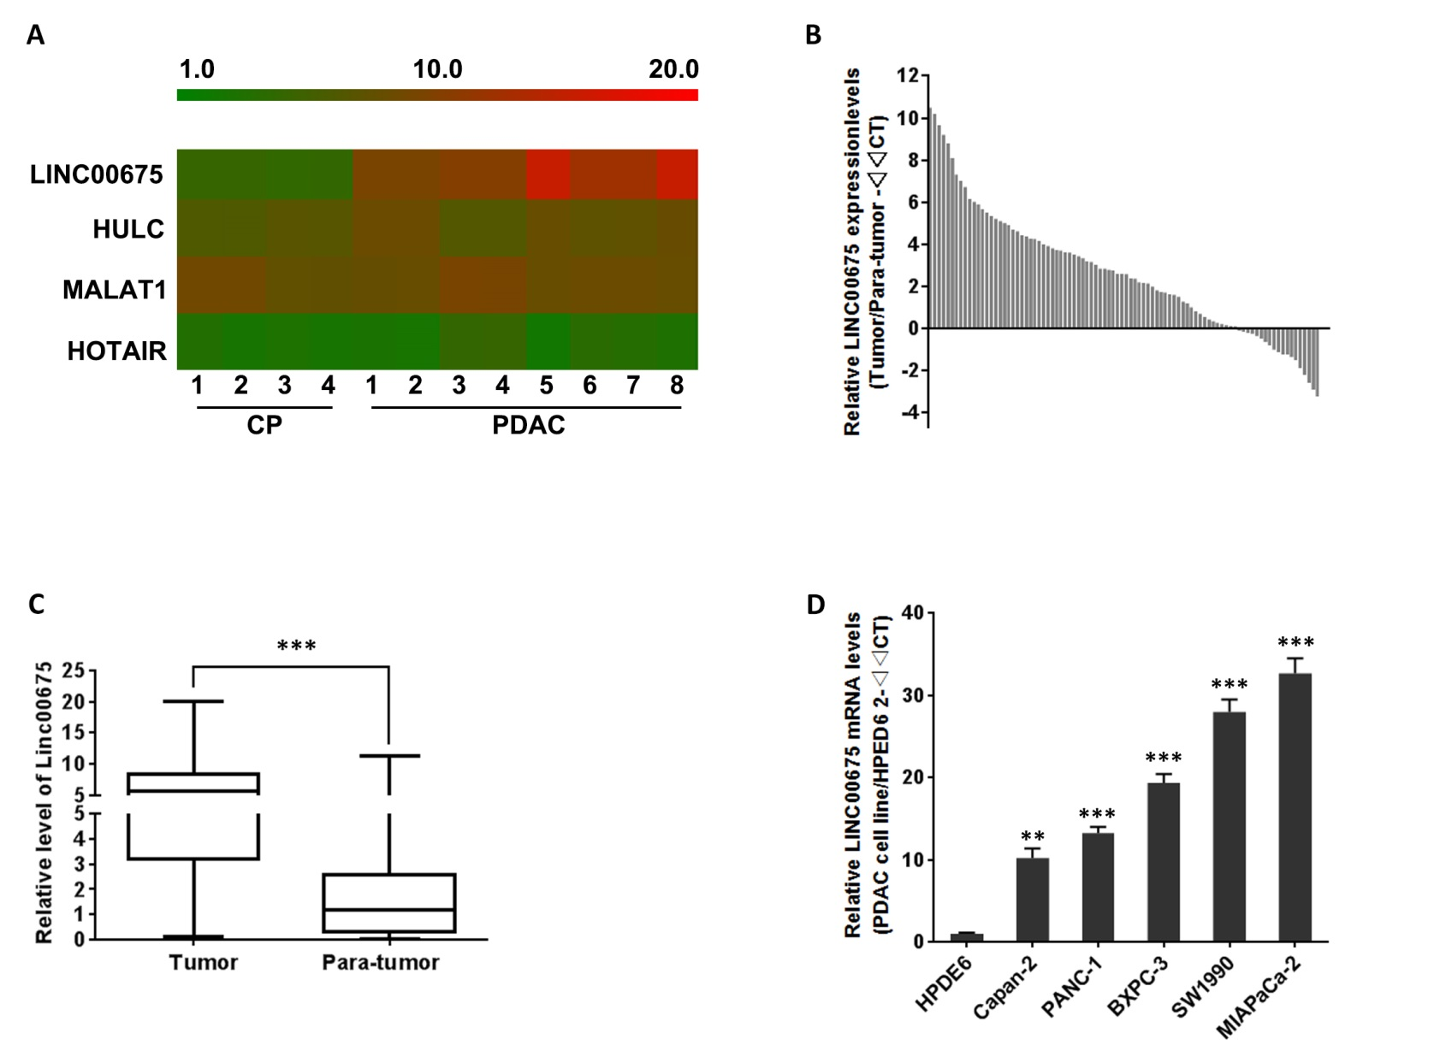Figure 1 Expression of linc00675 in human pancreatic ductal adenocarcinoma cell lines and cancerous tissues. A: Heat map showing linc00675, HULC, MALAT1, and HOTAIR expression in the microarray analysis. The rectangular indicates the hybridization signal (replicate probes) of linc00675 in pancreatic ductal adenocarcinoma (PDAC) and chronic pancreatitis (CP) tissues; B: qRT-PCR analysis of linc00675 expression level in 90 cases of PDAC tissues. GAPDH was used as internal control; C: The boxes represent the distribution of linc00675 expression from the 25th to 75th percentiles of all patient samples with the horizontal lines showing the median levels of linc00675, ^{c}P < 0.001, tumor vs para-tumor, Student’s t-test; D: Relative abundance of linc00675 in multiple pancreatic cancer cell lines. Data are represented as the mean ± SD from three independent experiments, ^{b}P < 0.01, ^{c}P < 0.001, the corresponding pancreatic cancer cell line vs HPDE6, Student’s t-test.
b
c
c
c
c
c

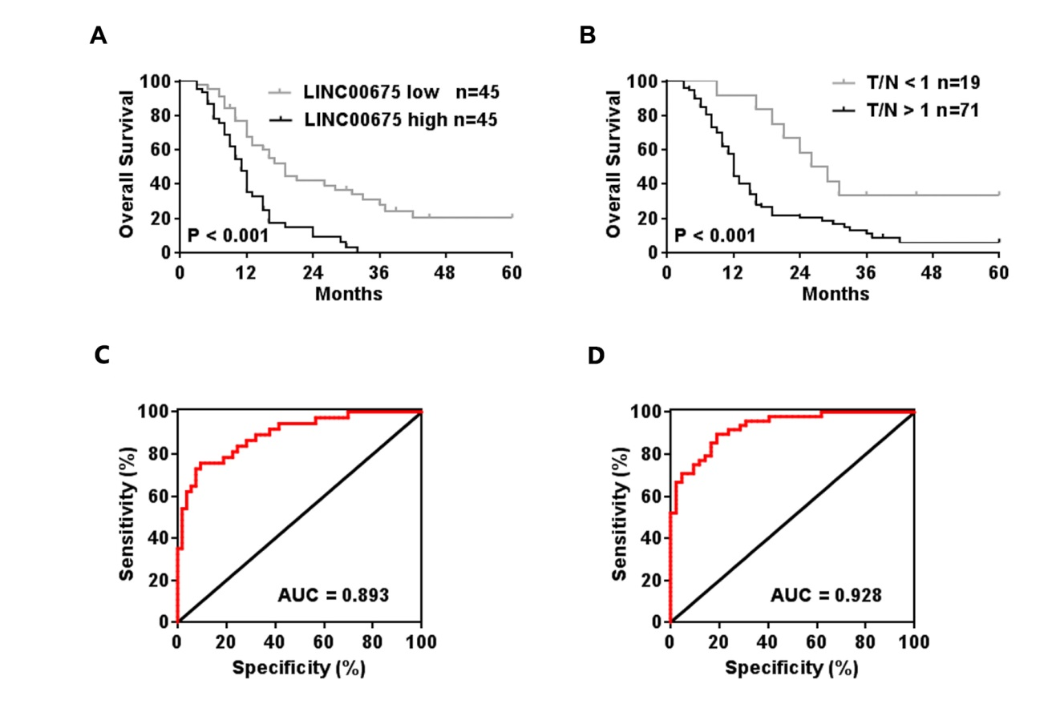
Figure 2 Overall survival of patients with pancreatic ductal adenocarcinoma based on linc00675 expression status and ROC curves of pancreatic ductal adenocarcinoma patients based on linc00675 for predicting recurrence. A: Pancreatic ductal adenocarcinoma (PDAC) patients were equally divided into two groups based on linc00675 mRNA levels, and then Kaplan–Meier survival curves were employed for comparing overall survival between two groups; B: Overall survival of patients with PDAC were evaluated via Kaplan–Meier survival curves based on whether linc00675 was increased in tumor tissues compared with paired non-cancerous tissue; C: ROC curves of PDAC patients based on linc00675 for predicting recurrence within one year; D: ROC curves of PDAC patients based on linc00675 for predicting recurrence within 6 mo.

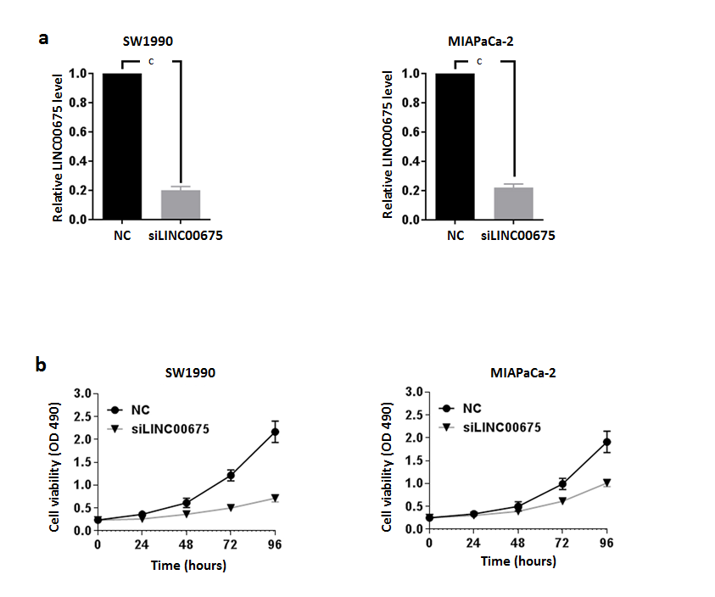
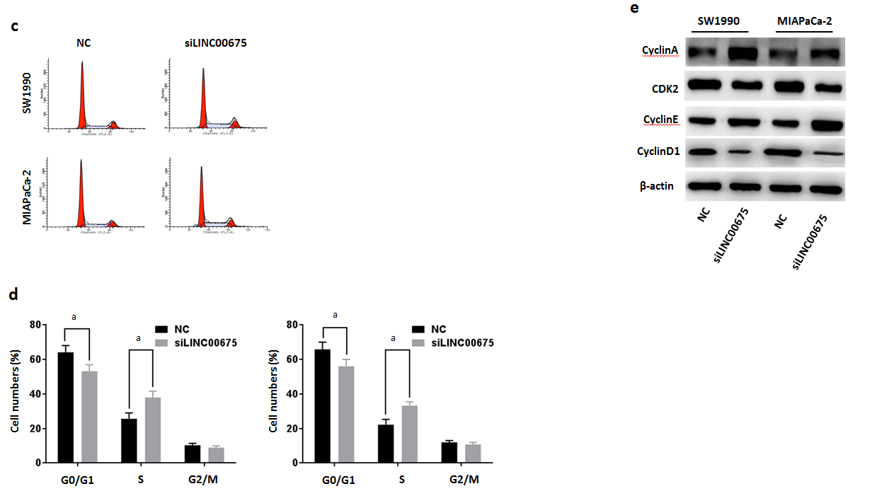

Figure 3 Effect of linc00675 knockdown on pancreatic ductal adenocarcinoma growth in vitro. A: Knockout efficiency of siRNA on Linc00675 was confirmed by qRT-PCR in SW1990 and MIA PaCa-2 cell lines, ^{c}P < 0.001, NC vs siLINC00675, Student’s t-test; B: Effects of knockdown of linc00675 on the proliferation of SW1990 and MIA PaCa-2 cells were assessed with MTT assay; C: Cell cycle of SW1990 and MIA PaCa-2 was analyzed by flow cytometry 48 hours after transfection; D: Knockdown of linc00675 on percentage of cells in G1-G0, S, and G2-M phase was examined quantitatively, ªP < 0.05, NC vs siLINC00675, Student’s t-test; E: Cells were untreated, or transfected with linc00675, then the expressions of CyclinA, CDK2,CyclinE and CyclinD1were detected by Western blot. Data are represented as the mean ± SD from three independent experiments.

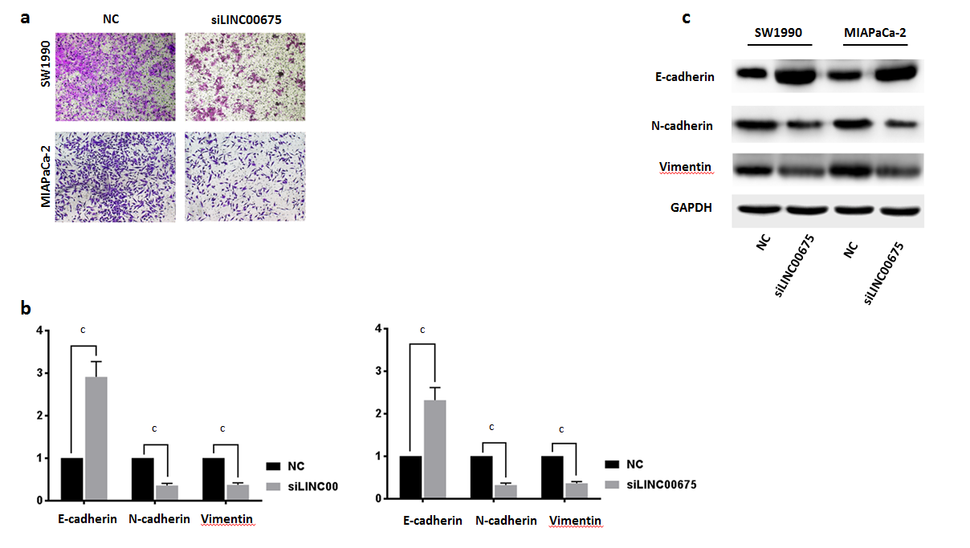
Figure 4 Effect of linc00675 knockdown on pancreatic ductal adenocarcinoma cell invasiveness in vitro. A: Representative images of transwell assay after linc00675 knockdown in pancreatic cancer cell line SW1990 and MIA PaCa-2; B: qRT-PCR analysis of E-cadherin, N-cadherin and Vimentin was performed in SW1990 and MIA PaCa-2 cells at 72 h after transfection; ^{c}P < 0.001, NC vs siLINC00675, Student’s t-test; C: Western blot analysis of E-cadherin, N-cadherin and Vimentin was performed in SW1990 and MIA PaCa-2 cells at 72 hours after transfection. Data are represented as the mean ± SD from three independent experiments.

Table 1 Correlation between linc00675 expression and clinical characteristics
Factors |  | Linc00675 expression |  | P value¹
 |  | High (n = 45) | Low (n = 45)
Age (yr) | <60 | 22 | 23 | 0.833
 | ≥60 | 23 | 22
Sex | Male | 30 | 27 | 0.512
 | Female | 15 | 18
Differentiation | Well | 16 | 17 | 0.304
 | Moderate | 15 | 20
 | Poor | 14 | 8
UICC stage | pI | 9 | 15 | 0.153
 | pII | 36 | 30
T stage | T1 | 6 | 9 | 0.697
 | T2 | 16 | 15
 | T3 | 23 | 21
N stage | N0 | 12 | 25 | 0.005
 | N1 | 33 | 20
Perineural invasion | Negative | 17 | 30 | 0.006
 | Positive | 28 | 15
¹Pearson χ² test.

Table 2 Multivariate analysis of clinicopathological factors for overall survival
Variable | Univariate |  |  | Multivariate
 | P value |  | HR | 95%CI | P value
T stage | 0.031 |  | 1.812 | 1.008 - 3.258 | 0.047
N stage | 0.026 |  | 2.016 | 1.112 - 3.657 | 0.021
Perineural invasion | 0.016 |  | 2.611 | 1.246 - 5.471 | 0.011
Linc00675 expression | 0.013 |  | 4.620 | 1.233 - 4.336 | 0.009
HR: Hazard ratio.

