Name of Journal: World Journal of Transplantation
ESPS Manuscript NO: 23818
Manuscript Type: Original Article

Retrospective Study

Proposal of new expanded selection criteria using total tumor size and ¹⁸F-fluorodeoxyglucose - positron emission tomography/computedtomography for living donor liver transplantation in patients with hepatocellular carcinoma: The national cancer center Korea criteria

Lee SD et al. LDLT criteria using tumor size and PET/CT

Seung Duk Lee, Bora Lee, Seong Hoon Kim, Jungnam Joo, Seok-Ki Kim, Young-Kyu Kim, Sang-Jae Park
Seung Duk Lee, Seong Hoon Kim, Sang-Jae Park, Center for Liver Cancer, Research Institute and Hospital, National Cancer Center, Goyang 10408, South Korea

Bora Lee, Jungnam Joo, Biometric Research Branch, Research Institute and Hospital, National Cancer Center, Goyang 10408, South Korea

Seok-Ki Kim, Department of Nuclear Medicine, Research Institute and Hospital, National Cancer Center, Goyang 10408, South Korea

Young-Kyu Kim, Department of Surgery, College of Medicine, Jeju National University, Jeju-do 63241, South Korea

Author contributions: Lee SD designed study and wrote the paper, Lee B and Joo J performed the statistical analysis. Kim SH designed the study and performed research. Kim SK, Kim YK and Park SJ performed the study.

Institutional review board statement: This study was reviewed and approved by the National Cancer Center Institutional Review Board.

Informed consent statement: This is the retrospective study and we analyzed data using only medical records. Therefore, waiver of informed consent for this study subjects might be justifiable. In our institute IRB, waiver of informed consent in this study was approved.

Conflict-of-interest statement: The authors declare no potential conflicts of interest and funding resources.

Open-Access: This article is an open-access article which was selected by an in-house editor and fully peer-reviewed by external reviewers. It is distributed in accordance with the Creative Commons Attribution Non Commercial (CC BY-NC 4.0) license, which permits others to distribute, remix, adapt, build upon this work non-commercially, and license their derivative works on different terms, provided the original work is properly cited and the use is non-commercial. See: http://creativecommons.org/licenses/by-nc/4.0/

Correspondence to: Seong Hoon Kim, MD, PhD, Center for Liver Cancer, Research Institute and Hospital, National Cancer Center, 323 Ilsan-ro, Ilsandong-gu, Goyang-si Gyeonggi-do, Goyang 10408, South Korea. kshlj@ncc.re.kr
Telephone: +82-31-9201647
Fax: +82-31-9202799

Received: December 22, 2015
Peer-review started: December 23, 2015
First decision: January 15, 2016
Revised: January 18, 2016
Accepted: March 7, 2016

Article in press:
Published online:

Abstract
AIM: To expand the living donor liver transplantation (LT) pool of eligible patients with hepatocellular carcinoma (HCC) using new morphological and biological criteria.

METHODS: Patients with HCC who underwent living donor LT (LDLT) from March 2005 to May 2013 at the National Cancer Center Korea (NCCK) were enrolled. We performed the ¹⁸F-fluorodeoxyglucose positron-emission tomography/computed tomography (PET/CT) before LDLT. Overall and disease-free survival analysis was done in patients to evaluate the usefulness of new NCCK criteria using PET/CT and total tumor size (10 cm).

RESULTS: We enrolled a total of 280 patients who pathologically confirmed to have HCC and performed the PET/CT before transplantation. Among them, 164 (58.6%) patients fulfilled the NCCK criteria and 132 patients (47.1%) met the Milan criteria. Five-year overall and disease-free survival rates for patients who fulfilled the NCCK criteria showed 85.2% and 84.0%, respectively, and were significantly higher than those beyond the NCCK criteria (60.2% and 44.4%, respectively; P < 0.001). The correlation analysis between preoperative imaging tests and pathologic reports using Cohen’s Kappa demonstrated the better results in the NCCK criteria than those in the Milan criteria (0.850 vs 0.583). The comparison of disease-free analysis among the NCCK, Milan, and University of California, San Francisco (UCSF) criteria using the receiver operating characteristics curves revealed the similar area under the curve value criteria (NCCK vs Milan, P = 0.484; NCCK vs UCSF, P = 0.189 at 5-years).

CONCLUSION: The NCCK criteria using hybrid concept of both morphological and biological parameters showed an excellent agreement between preoperative imaging and pathological results, and favorable survival outcomes. These new criteria might select the optimal patients with HCC waiting LDLT and expand the selection pool.

Key words: Hepatocellular carcinoma; Living donor; Liver transplantation; Selection criteria

© The Author(s) 2016. Published by Baishideng Publishing Group Inc. All rights reserved.

Core tip: National Cancer Center Korea criteria using positron-emission tomography/computed tomography positivity and total tumor size (cutoff 10 cm) expanded the pool of living donor liver transplantation for patients with hepatocellular carcinoma. Patient identification on the bases of the criteria showed an excellent agreement between preoperative imaging and pathological results and favorable survival outcomes.

Lee SD, Lee B, Kim SH, Joo J, Kim SK, Kim YK, Park SJ. Proposal of new expanded selection criteria using total tumor size and ¹⁸F-fluorodeoxyglucose - positron emission tomography/computedtomography for living donor liver transplantation in patients with hepatocellular carcinoma: The national cancer center Korea criteria. World J Transplant 2016; In press

INTRODUCTION
The application of selection criteria for liver transplantation (LT) in patients with hepatocellular carcinoma (HCC) has changed the HCC treatment algorithm over the past 20 years. The Milan criteria proposed by Mazzaferro et al^{[1]}. helped to increase the number of LTs in patients with HCC and demonstrated remarkably good survival outcomes for these patients. In particular, the Milan criteria, which use both tumor size and number are very useful and have been adopted as selection criteria. Based on these criteria, the patients for whom HCC was identified early had the best chance of being cured of cancer following LT. In Asian countries such as Korea and Japan, the number of deceased donors is limited and living donor LT (LDLT) has become an important option for treatment in patients with HCC^{[2,3]}. As the amount of experience and evidence on LDLT for HCC has increased in recent years, the selection criteria for LT have gradually been expanded in large-volume centers. Various expanded criteria based on tumor number and size, such as the University of California, San Francisco (UCSF) criteria, have been proposed^{[4-9]}. Some Japanese centers have demonstrated that preoperative tumor markers such as the des-gamma-carboxy prothrombin (DCP) level and tumor size were associated with higher recurrence rates^{[10,11]}. These expanded criteria revealed that selected patients who did not fulfill the Milan criteria showed good overall survival (OS) and disease-free survival (DFS) rates compared with those who fulfilled the Milan criteria. Although the Milan criteria always guarantee the best survival rates in patients with HCC, they are too restrictive and use modalities.
In HCC patients, tumor characteristics, including differentiation grade and microvascular invasion, are well-known independent prognostic factors for OS and DFS following LT^{[12]}. However, these factors cannot be evaluated by preoperative imaging studies, which reveal the morphological characteristics such as number and size. Recently, several studies using ¹⁸F-fluorodeoxyglucose positron-emission tomography/CT (¹⁸F-FDG PET/CT) demonstrated that ¹⁸F-FDG PET/CT findings were a powerful prognostic marker in patients with HCC after LT and showed good correlation with pathological tumor characteristics, such as microvascular invasion and differentiation^{[13-15]}.
In the present study, we performed a retrospective analysis to identify prognostic factors in patients with HCC who underwent ¹⁸F-FDG PET/CT before LDLT. Based on this result, we developed new and simple expanded criteria [the National Cancer Center, Korea (NCCK) criteria], incorporating a hybrid concept of biological and morphological characteristics on PET/CT images, including total tumor size, and compared these criteria with the Milan criteria, which are based on only morphological evaluation.

MATERIALS AND METHODS
Patients
Patients who underwent LDLT due to HCC at NCCK between March 2005 and May 2013 were collected using prospectively collected database. All patients were diagnosed as HCC by pathologic reports, and underwent ¹⁸F-FDG PET/CT to check biologic status of the primary tumor and the presence of metastasis within 1 mo before LDLT. Routine preoperative imaging tools for clinical staging in patients with HCC before LDLT were ultrasonography, multi-detector CT (MDCT), and/or dual contrast-enhanced magnetic resonance imaging (MRI) including PET/CT without protocol tumor biopsy. We reviewed the medical records for clinicopathological data, including age, sex, serum α-fetoprotein (AFP), viral markers, C-reactive protein (CRP), Model for End-Stage Liver Disease (MELD) score, PET/CT reports, tumor maximum standardized uptake value (SUVmax), pre-transplant therapies, and pathologic data such as Edmondson and Steiner grade; vessel, serosa, and duct invasion; capsule formation; cirrhosis; intrahepatic metastasis; and dysplastic nodules. Prognostic factors using clinicopathological data were analyzed for their effect on OS and DFS. This study was approved by the institutional review board of NCCK.
Our policy for selecting recipients with HCC for LDLT was basically based on the Milan criteria by preoperative imaging tools such as MDCT, MRI, or PET/CT. However, considering the specificity of living related donation, we performed LDLT on patients without major vascular invasion and extrahepatic metastasis on preoperative imaging tools even though they do not satisfy the Milan criteria. We do not recommend the downstaging or bridging therapy before LDLT even though the patient had advanced HCC. The operative techniques, immunosuppression, and management for hepatitis virus of donor and recipient have been described in detail in previous our reports^{[16,17]}. Patients were followed up periodically with interval 3 or 6 mo using imaging studies such as ultrasonography, abdomen, and chest MDCT with AFP and DCP level. As the tumor recurrence was suspected by imaging tools and serologic tests, additional PET/CT was performed to evaluate the recurrent tumor and distant metastasis. For one or two nodules in the liver, lung, bone, or brain, we performed the resections. However, in case of multiple metastases, we treated tumors with a multimodality approach such as radiofrequency ablation, transarterial chemoembolization (TACE), radiation therapy, or chemotherapy.

¹⁸F-FDG PET/CT
Our protocol of ¹⁸F-FDG PET/CT was described in detail previously^{[14]}. In brief, ¹⁸F-FDG PET/CT was performed using a PET/CT scanner (Biograph LSO; Siemens Medical Systems and Discovery LS; GE Healthcare, New Jersey, USA). The mean period between PET/CT and LDLT was 14.8 d. All PET/CT images were analyzed by experienced nuclear medicine physicians. SUV was calculated as (decay-corrected activity kBq/mL of tissue volume)/(injected FDG activity kBq/body mass g). SUVs of the lesions were checked by placing a region of interest (ROI) at the site of the maximum FDG uptake in the PET images. The ROI was drawn to encircle the highest activity of each tumor, by the results of the CT scans that were acquired from PET/CT or MRI scans. PET/CT positivity was defined by experienced nuclear medicine physicians by checking whether the SUVmax of the tumor by CT or MRI scans was higher than that in the surrounding noncancerous hepatic tissue. Mean SUVmax of tumors for PET/CT positivity and negativity in this study was 4.46 and 3.08, respectively (P < 0.001).

The NCCK criteria
In a multivariable analysis of our data, we identified two significant prognostic factors by evaluating pathological examination results (Table 1). These were positive findings on PET/CT (HR = 2.652, 95%CI: 1.384-50.085, P = 0.003 for OS; HR = 2.517, 95%CI: 1.481-4.279, P = 0.001 for DFS) and total tumor size of > 10 cm (HR = 2.909, 95%CI: 1.230-6.880, P = 0.015 for OS; HR = 3.003, 95%CI: 1.536-5.870, P = 0.001 for DFS). Although microvascular invasion was a significant factor only for DFS (HR = 2.148, 95%CI: 1.064-4.336, P = 0.033), it was not included because these data are typically not available before transplantation. We analyzed our data in comparison with the Milan and UCSF criteria using the NCCK criteria (negative findings on PET/CT and total tumor size < 10 cm vs others). The NCCK criteria were assessed both preoperatively and postoperatively.

Statistical analysis
Survival rates were estimated using Kaplan-Meier method, and survival curves were compared with log-rank test. Multivariable Cox proportional hazard regressions were fitted to identify factors that affected post-transplant survival. T-test and test analyses were also used in comparing the differences between groups for continuous and categorical variables, respectively. Cohen`s Kappa was used to assess classification consistency of each criteria. The prediction model of DFS using each criteria (the NCCK, Milan, and UCSF) adjusted for significant prognostic factors was developed using multivariable Cox proportional hazard regression. The receiver operating characteristic (ROC) curves and the associated area under the curves (AUC) of these models predicting 1, 3, and 5 years DFS rates were evaluated to compare the discrimination ability of different criteria. Differences in AUCs were tested using Delong`s method^{[18]}. All statistical analyses were performed using SAS software (9.2 version). P-value less than 0.05 was used to evaluate statistical significance.

RESULTS
Clinicopathological characteristics
During the study period, a total of 280 patients underwent LDLT for HCC. Among them, 116 (41.4%) patients did not fulfil the NCCK criteria. The comparisons of clinicopathological characteristics between patients who did and did not fulfill the NCCK criteria are presented in Table 2. C-reactive protein level, tumor SUVmax, total tumor size (> 10 cm), AFP (> 400 ng/mL), positive findings on PET/CT, differentiation (grade III–IV), microvascular invasion, intrahepatic metastasis, and serosal invaion were significantly greater in patients who did not fulfill the NCCK criteria compared with those who did. The mean C-reactive protein levels in two groups were 0.58 mg/dL and 1.37 mg/dL, and tumor SUVmax were 3.08 and 4.13, in patients who did and did not fulfill the NCCK criteria, respectively. On the other hand, patients who did not fulfill the NCCK criteria had significantly lower MELD scores compared to those within the NCCK criteria (12.5 vs 14.4, respectively, P = 0.029). Pre-transplant therapy type, viral hepatitis type, ductal invasion, capsule formation, dysplastic nodules, and cirrhosis were not significantly different between the two groups.

NCCK criteria: Survival rates and comparison between preoperative imaging and explant pathological reports
OS and DFS according to the NCCK criteria are presented in Figure 1. Patients fulfilling the NCCK criteria according to preoperative imaging findings revealed significantly higher OS and DFS than those who did not fulfill the NCCK criteria (five-year OS: 83.6% vs 59.8%, P < 0.001; five-year DFS: 80.7% vs 45.1%, P < 0.001). In patients who fulfilled the NCCK criteria according to explant pathological reports, five-year OS and DFS were 85.2% and 84.0%, respectively; these values were significantly higher than those among patients who did not fulfill the NCCK criteria (60.2% and 44.7%, respectively, P < 0.001).
The number of patients who fulfilled the NCCK criteria according to preoperative imaging and explant pathology reports were 178 (63.6%) and 164 (58.6%). According to the Milan criteria, these were 167 (59.6%) and 132 (47.1%) patients (Table 3). The NCCK criteria exhibited 95.0% accuracy of preoperative imaging and explant pathological reports; in contrast, the Milan criteria demonstrated only 78.9% accuracy. Compared with the Milan criteria, the NCCK criteria exhibited almost perfect agreement between preoperative imaging and explant pathological reports (Cohen’s Kappa 0.850 vs 0.583).

Comparative survival analysis among the NCCK, Milan, and UCSF criteria
In a survival analysis including all patients, five-year OS and DFS were 75.2% and 67.7% (Figure 1). The patients who fulfilled the Milan criteria according to preoperative imaging and explant pathological reports showed good five-year OS and DFS (83.4% and 82.0% according to preoperative imaging; 85.5% and 84.4% by explant pathological reports, Figure 2). These survival results are very similar to those of patients fulfilling the NCCK criteria, particularly with regard to explant pathological reports. There were 34 (12.14%) patients who did not fulfill the NCCK criteria but fulfilled the Milan criteria according to preoperative imaging findings, and 22 (7.9%) according to explant pathological reports. This group showed a trend toward low five-year OS and DFS according to both preoperative imaging and explant pathological reports, compared with those who fulfilled the NCCK criteria; however, the differences between the two groups were not statistically significant (P = 0.148 in OS and P = 0.212 in DFS according to preoperative imaging findings; P = 0.658 in OS and P = 0.376 in DFS according to explant pathological reports, Figure 3).
ROC curve and AUC of the Milan, UCSF and NCCK criteria for the prediction of one, three, and five years DFS are presented in Figure 4 and Table 4. The value of AUC by three criteria was similar in both preoperative imaging and explant pathological reports, and there were no significant differences in the area under the ROC curve at one, three, and five years by three groups (five-year DFS, Delong’s P = 0.267 for Milan vs NCCK, P = 0.213 for UCSF vs NCCK in preoperative imaging; P = 0.484 for Milan vs NCCK, P = 0.189 for UCSF vs NCCK in explant pathological reports).

DISCUSSION
In the present study, the NCCK criteria were associated with favorable survival outcomes and expanded the selection pool for LDLT among patients with HCC. Over the past 10 years, the Milan criteria have been regarded as a well-established tool for assessing the prognosis of HCC for LT. However, limited selection and inaccurate assessment using preoperative imaging modalities, such as CT, have been constantly recognized as a limitation of the criteria. Tumor biological characteristics, such as microvascular invasion and differentiation, are strong predictive factors for HCC recurrence. ¹⁸F-FDG PET/CT findings are a useful marker to predict these factors before LT, as well as to detect extrahepatic metastases. Furthermore, total tumor size itself can be simple and relatively accurate measure rather than using both tumor number and size which are used in the Milan and UCSF criteria. The proposed NCCK criteria, therefore, presented with better correlation with preoperative imaging and explant pathological reports than the Milan criteria.
There were several expanded criteria for patients with HCC beyond the Milan criteria. The main factors that were present in these criteria were tumor size and number. The UCSF, Tokyo, and “up-to-seven” criteria are based on tumor morphological characteristics using preoperative imaging or explant pathological reports^{[4,8,19]}. However, recent studies reported the expanded criteria using markers of tumor aggressiveness as well as tumor morphological characteristics. These included responses to TACE, the degree of differentiation, the gene-expression profile, the presence of microvascular invasion, and the levels of tumor markers, including AFP or DCP^{[11,20-24]}. In particular, it is well known that microvascular invasion and the degree of differentiation are associated with decreased survival and an increased risk of recurrence following LT. However, these pathological examination results are not routinely available before LT because fine-needle biopsy before surgery has not shown significant correlations with explant pathological reports^{[25]}. Some promising attempts to identify microvascular invasion before LT through ¹⁸F-FDG PET or PET/CT have been reported^{[13,14,26]}. Moreover, positive findings on PET/CT in patients with HCC predicted the prognosis and tumor recurrence after LT^{[13-15]}. In the present study, the patients beyond the NCCK criteria, including positive findings on PET/CT, showed more microvascular invasion (59.5% vs 22.6%, P < 0.001) and poor differentiation (52.6% vs 37.8%, P = 0.02). One concern regarding the use of PET/CT in patients with HCC is that the sensitivity is low for the primary detection of HCC compared with many other cancers, because glucose metabolism is high in liver tissue^{[27,28]}. On the other hand, PET/CT has been shown to differentiate between well-differentiated and poorly-differentiated HCC, and is useful in the detection of extrahepatic metastases and recurrence of HCC after transplantation^{[29]}.
The concept of the NCCK criteria began from the observation that good survival rates without recurrence could occur in patients who did not fulfill the Milan criteria. In our data, patients beyond the Milan criteria who also had negative findings on PET/CT showed significantly better survival rates than those who had positive findings on PET/CT (five-year OS, 74.6% vs 51.4%, P < 0.001; five-year DFS, 73.3% vs 37.5%, P < 0.001). When another significant factor for survival in multivariable analysis (total tumor size < 10 cm) was considered, patients who did not fulfill the Milan criteria with negative findings on PET/CT and total tumor size <10cm showed similar OS and DFS compared with those who met the Milan criteria (OS: mean 90.7 vs 83.8 mo, P = 0.235; DFS: mean 94.4 vs 84.4 mo, P = 0.076). Furthermore, positive findings on PET/CT and total tumor size were significant prognostic factors of OS and DFS for all patients (Table 1). Therefore, we applied the NCCK criteria to all patients and analyzed their usefulness and associated survival rates as new expanded criteria that could be used instead of the traditional Milan criteria.
Numerous expanded criteria based on tumor number and size have been reported, but are not used widely due to limited clinical usefulness. The major reason for this is that the risk of underestimating tumor status is considerable regardless the recent developments of new technologies in radiological assessment of liver tumors^{[30]}. Freeman et al^{[31]} studied the results from the United Network for Organ Sharing (UNOS) database on 789 LT recipients to analyze the accuracy of imaging findings compared with the explant pathological reports. In that report, radiological imaging underestimated tumor staging in 26.6% of cases, and the risk of overestimation was almost 30%. The overall preoperative accuracy was approximately 50%, regardless of the radiological technique used. In our data, among 167 patients who fulfilled the Milan criteria according to preoperative imaging modalities, 47 patients (28.1%) were found as not fulfilling the Milan criteria in explant pathological reports. Therefore, some authors proposed that total tumor volume or size was more likely to result in accurate staging before LT^{[32-34]}. We also used the total tumor size (cutoff 10 cm), which was a significant prognostic factor in multivariable analysis for the NCCK criteria. In our study, among a total of 243 patients with preoperative total tumor size < 10 cm measured with imaging modalities, only 27 patients (11.1%) were confirmed to have a total tumor size of > 10 cm according to pathological reports. Compared with the Milan criteria, the percentage of underestimation in the NCCK criteria using total tumor size (cutoff 10 cm) was lower (9.6%), and Cohen’s Kappa was high (0.850), explaining the near-perfect agreement between preoperative imaging and explant pathological reports (Table 3).
In particular, the survival rates of patients who fulfilled the NCCK criteria were quite good and showed similar outcomes compared with the Milan and UCSF criteria (five-year DFS; 80.7% according to preoperative imaging findings, 84.0% in explant pathological reports, Figure 2). Furthermore, the number of patients who fulfilled the NCCK criteria was higher than the Milan criteria [preoperative imaging findings, 178 (63.6%) vs 164 (58.6%) patients; explant pathological reports, 167 (59.6%) vs 132 (47.1%) patients]. The patients who did not fulfill the NCCK, but fulfilled the Milan criteria did not show statistically significant differences compared with those who fulfilled the NCCK criteria; however, a trend toward low five-year OS and DFS according to both preoperative imaging and explant pathological reports was observed (Figure 3). This result was likely because of the fact that the Milan criteria are too restrictive and limited. There was no significant difference observed when the values of AUC and ROC curves for predicting DFS at one, three, and five years were compared among the three criteria (NCCK, Milan, and UCSF) (Figure 4 and Table 4).
There are some limitations to the present study. First, we analyzed LDLT patients without including deceased donor LT patients; therefore, comparison with other studies that included deceased donor LT patients was not possible. However, we included a considerable proportion of patients who were beyond the Milan criteria; thus, the dilution effect on the analysis was less than that in other studies. Second, the present study was retrospective in nature, and selection bias could have influenced the survival analysis. However, we enrolled all consecutive cases and performed routine PET/CT before LDLT in patients with HCC. Therefore, exclusions during the study period were rare.
In conclusion, our data show that the NCCK criteria, utilizing total tumor size and PET/CT findings, successfully expanded the recipient pool and demonstrated better ability of tumor assessment before LT and similar survival rates compared with the well-known criteria, such as the Milan and UCSF. These criteria represent a new approach to selection for LT that incorporates both tumor biological and morphological characteristics. Therefore, the NCCK criteria are simple and useful expanded criteria for LDLT in HCC, showing excellent agreement between preoperative imaging and explant pathological reports and favorable survival outcomes.

COMMENTS
Background
Several expanded criteria based on morphological features have been proposed to identify appropriate candidates for liver transplantation (LT). However, the definitions are still complex, and the benefit of expanding the pool remains controversial. In this study, we evaluated the new criteria using positron-emission tomography/computed tomography (PET/CT) and total tumor size, called as National Cancer Center Korea criteria.

Research frontiers
The expanding criteria for living donor liver transplantation for hepatocellular carcinoma is issued recently. The results of this study contribute to clarifying exact criteria using PET/CT and tumor morphologic characteristics.

Innovation and breakthroughs
In this study, we used the PET/CT for all patients underwent living donor liver transplantation in our institute before transplantation. These results are so unique and included relatively large number of patients. PET/CT is very useful tool for selecting recipients with hepatocellular carcinoma in living donor liver transplantation.

Applications
This study suggested that PET/CT is useful for selecting recipient and total tumor size is simple for marker in preoperative imaging tests. If a patient is diagnosed with hepatocellular carcinoma and waiting the living donor liver transplantation, PET/CT can be chosen for diagnostic metastasis and prediction of prognosis.

Peer-review
The author this paper evaluated the usefulness of PET/CT and total tumor size for predicting the prognosis after living donor liver transplantation for hepatocellular carcinoma, and showed the expanded criteria using these tools. Further trials using these criteria in large population of living donor liver transplantation will be valuable.

REFERENCES
1 Mazzaferro V, Regalia E, Doci R, Andreola S, Pulvirenti A, Bozzetti F, Montalto F, Ammatuna M, Morabito A, Gennari L. Liver transplantation for the treatment of small hepatocellular carcinomas in patients with cirrhosis. N Engl J Med 1996; 334: 693-699 [PMID: 8594428 DOI: 10.1056/NEJM199603143341104]
2 Chen CL, Fan ST, Lee SG, Makuuchi M, Tanaka K. Living-donor liver transplantation: 12 years of experience in Asia. Transplantation 2003; 75: S6-11 [PMID: 12589130 DOI: 10.1097/01.TP.0000046533.93621.C7]
3 Lee SG. Asian contribution to living donor liver transplantation. J Gastroenterol Hepatol 2006; 21: 572-574 [PMID: 16638101 DOI: 10.1111/j.1440-1746.2006.04283.x]
4 Yao FY, Ferrell L, Bass NM, Watson JJ, Bacchetti P, Venook A, Ascher NL, Roberts JP. Liver transplantation for hepatocellular carcinoma: expansion of the tumor size limits does not adversely impact survival. Hepatology 2001; 33: 1394-1403 [PMID: 11391528 DOI: 10.1053/jhep.2001.24563]
5 Herrero JI, Sangro B, Quiroga J, Pardo F, Herraiz M, Cienfuegos JA, Prieto J. Influence of tumor characteristics on the outcome of liver transplantation among patients with liver cirrhosis and hepatocellular carcinoma. Liver Transpl 2001; 7: 631-636 [PMID: 11460231 DOI: 10.1053/jlts.2001.25458]
6 Roayaie S, Frischer JS, Emre SH, Fishbein TM, Sheiner PA, Sung M, Miller CM, Schwartz ME. Long-term results with multimodal adjuvant therapy and liver transplantation for the treatment of hepatocellular carcinomas larger than 5 centimeters. Ann Surg 2002; 235: 533-539 [PMID: 11923610]
7 Onaca N, Davis GL, Goldstein RM, Jennings LW, Klintmalm GB. Expanded criteria for liver transplantation in patients with hepatocellular carcinoma: a report from the International Registry of Hepatic Tumors in Liver Transplantation. Liver Transpl 2007; 13: 391-399 [PMID: 17318865 DOI: 10.1002/lt.21095]
8 Mazzaferro V, Llovet JM, Miceli R, Bhoori S, Schiavo M, Mariani L, Camerini T, Roayaie S, Schwartz ME, Grazi GL, Adam R, Neuhaus P, Salizzoni M, Bruix J, Forner A, De Carlis L, Cillo U, Burroughs AK, Troisi R, Rossi M, Gerunda GE, Lerut J, Belghiti J, Boin I, Gugenheim J, Rochling F, Van Hoek B, Majno P. Predicting survival after liver transplantation in patients with hepatocellular carcinoma beyond the Milan criteria: a retrospective, exploratory analysis. Lancet Oncol 2009; 10: 35-43 [PMID: 19058754 DOI: 10.1016/S1470-2045(08)70284-5]
9 Lee S, Ahn C, Ha T, Moon D, Choi K, Song G, Chung D, Park G, Yu Y, Choi N, Kim K, Kim K, Hwang S. Liver transplantation for hepatocellular carcinoma: Korean experience. J Hepatobiliary Pancreat Sci 2010; 17: 539-547 [PMID: 19727542 DOI: 10.1007/s00534-009-0167-6]
10 Taketomi A, Sanefuji K, Soejima Y, Yoshizumi T, Uhciyama H, Ikegami T, Harada N, Yamashita Y, Sugimachi K, Kayashima H, Iguchi T, Maehara Y. Impact of des-gamma-carboxy prothrombin and tumor size on the recurrence of hepatocellular carcinoma after living donor liver transplantation. Transplantation 2009; 87: 531-537 [PMID: 19307789 DOI: 10.1097/TP.0b013e3181943bee]
11 Takada Y, Ito T, Ueda M, Sakamoto S, Haga H, Maetani Y, Ogawa K, Ogura Y, Oike F, Egawa H, Uemoto S. Living donor liver transplantation for patients with HCC exceeding the Milan criteria: a proposal of expanded criteria. Dig Dis 2007; 25: 299-302 [PMID: 17960063 DOI: 10.1159/000106908]
12 Roayaie S, Schwartz JD, Sung MW, Emre SH, Miller CM, Gondolesi GE, Krieger NR, Schwartz ME. Recurrence of hepatocellular carcinoma after liver transplant: patterns and prognosis. Liver Transpl 2004; 10: 534-540 [PMID: 15048797 DOI: 10.1002/lt.20128]
13 Kornberg A, Freesmeyer M, Bärthel E, Jandt K, Katenkamp K, Steenbeck J, Sappler A, Habrecht O, Gottschild D, Settmacher U. 18F-FDG-uptake of hepatocellular carcinoma on PET predicts microvascular tumor invasion in liver transplant patients. Am J Transplant 2009; 9: 592-600 [PMID: 19191771 DOI: 10.1111/j.1600-6143.2008.02516.x]
14 Lee SD, Kim SH, Kim YK, Kim C, Kim SK, Han SS, Park SJ. (18)F-FDG-PET/CT predicts early tumor recurrence in living donor liver transplantation for hepatocellular carcinoma. Transpl Int 2013; 26: 50-60 [PMID: 23106431 DOI: 10.1111/j.1432-2277.2012.01572.x]
15 Kornberg A, Küpper B, Tannapfel A, Büchler P, Krause B, Witt U, Gottschild D, Friess H. Patients with non-[18 F]fludeoxyglucose-avid advanced hepatocellular carcinoma on clinical staging may achieve long-term recurrence-free survival after liver transplantation. Liver Transpl 2012; 18: 53-61 [PMID: 21850692 DOI: 10.1002/lt.22416]
16 Kim SH, Kim YK, Lee SD, Park SJ. Selection and outcomes of living donors with a remnant volume less than 30% after right hepatectomy. Liver Transpl 2013; 19: 872-878 [PMID: 23695974 DOI: 10.1002/lt.23677]
17 Lee SD, Kim SH, Kim YK, Lee SA, Park SJ. Graft-to-recipient weight ratio lower to 0.7% is safe without portal pressure modulation in right-lobe living donor liver transplantation with favorable conditions. Hepatobiliary Pancreat Dis Int 2014; 13: 18-24 [PMID: 24463075]
18 DeLong ER, DeLong DM, Clarke-Pearson DL. Comparing the areas under two or more correlated receiver operating characteristic curves: a nonparametric approach. Biometrics 1988; 44: 837-845 [PMID: 3203132]
19 Sugawara Y, Tamura S, Makuuchi M. Living donor liver transplantation for hepatocellular carcinoma: Tokyo University series. Dig Dis 2007; 25: 310-312 [PMID: 17960065 DOI: 10.1159/000106910]
20 Otto G, Herber S, Heise M, Lohse AW, Mönch C, Bittinger F, Hoppe-Lotichius M, Schuchmann M, Victor A, Pitton M. Response to transarterial chemoembolization as a biological selection criterion for liver transplantation in hepatocellular carcinoma. Liver Transpl 2006; 12: 1260-1267 [PMID: 16826556 DOI: 10.1002/lt.20837]
21 Cillo U, Vitale A, Grigoletto F, Gringeri E, D'Amico F, Valmasoni M, Brolese A, Zanus G, Srsen N, Carraro A, Burra P, Farinati F, Angeli P, D'Amico DF. Intention-to-treat analysis of liver transplantation in selected, aggressively treated HCC patients exceeding the Milan criteria. Am J Transplant 2007; 7: 972-981 [PMID: 17391137 DOI: 10.1111/j.1600-6143.2006.01719.x]
22 Schwartz M, Dvorchik I, Roayaie S, Fiel MI, Finkelstein S, Marsh JW, Martignetti JA, Llovet JM. Liver transplantation for hepatocellular carcinoma: extension of indications based on molecular markers. J Hepatol 2008; 49: 581-588 [PMID: 18602719 DOI: 10.1016/j.jhep.2008.03.032]
23 Shirabe K, Itoh S, Yoshizumi T, Soejima Y, Taketomi A, Aishima S, Maehara Y. The predictors of microvascular invasion in candidates for liver transplantation with hepatocellular carcinoma-with special reference to the serum levels of des-gamma-carboxy prothrombin. J Surg Oncol 2007; 95: 235-240 [PMID: 17323337 DOI: 10.1002/jso.20655]
24 Sotiropoulos GC, Malagó M, Bockhorn M, Schmitz KJ, Radtke A, Molmenti EP, Schaffer R, Beckebaum S, Cicinnati VR, Fouzas I, Broelsch CE, Lang H. Liver transplantation for hepatocellular carcinoma and cirrhosis in candidates with undetectable or very low alpha-fetoprotein levels: is an expansion of the listing criteria justified? Hepatogastroenterology 2008; 55: 1671-1677 [PMID: 19102367]
25 Pawlik TM, Gleisner AL, Anders RA, Assumpcao L, Maley W, Choti MA. Preoperative assessment of hepatocellular carcinoma tumor grade using needle biopsy: implications for transplant eligibility. Ann Surg 2007; 245: 435-442 [PMID: 17435551 DOI: 10.1097/01.sla.0000250420.73854.ad]
26 Sumie S, Kuromatsu R, Okuda K, Ando E, Takata A, Fukushima N, Watanabe Y, Kojiro M, Sata M. Microvascular invasion in patients with hepatocellular carcinoma and its predictable clinicopathological factors. Ann Surg Oncol 2008; 15: 1375-1382 [PMID: 18324443 DOI: 10.1245/s10434-008-9846-9]
27 Hatano E, Ikai I, Higashi T, Teramukai S, Torizuka T, Saga T, Fujii H, Shimahara Y. Preoperative positron emission tomography with fluorine-18-fluorodeoxyglucose is predictive of prognosis in patients with hepatocellular carcinoma after resection. World J Surg 2006; 30: 1736-1741 [PMID: 16850145 DOI: 10.1007/s00268-005-0791-5]
28 Okazumi S, Isono K, Enomoto K, Kikuchi T, Ozaki M, Yamamoto H, Hayashi H, Asano T, Ryu M. Evaluation of liver tumors using fluorine-18-fluorodeoxyglucose PET: characterization of tumor and assessment of effect of treatment. J Nucl Med 1992; 33: 333-339 [PMID: 1311035]
29 Kim YK, Lee KW, Cho SY, Han SS, Kim SH, Kim SK, Park SJ. Usefulness 18F-FDG positron emission tomography/computed tomography for detecting recurrence of hepatocellular carcinoma in posttransplant patients. Liver Transpl 2010; 16: 767-772 [PMID: 20517911 DOI: 10.1002/lt.22069]
30 Sherman M. The radiological diagnosis of hepatocellular carcinoma. Am J Gastroenterol 2010; 105: 610-612 [PMID: 20203642 DOI: 10.1038/ajg.2009.663]
31 Freeman RB, Mithoefer A, Ruthazer R, Nguyen K, Schore A, Harper A, Edwards E. Optimizing staging for hepatocellular carcinoma before liver transplantation: A retrospective analysis of the UNOS/OPTN database. Liver Transpl 2006; 12: 1504-1511 [PMID: 16952174 DOI: 10.1002/lt.20847]
32 Toso C, Trotter J, Wei A, Bigam DL, Shah S, Lancaster J, Grant DR, Greig PD, Shapiro AM, Kneteman NM. Total tumor volume predicts risk of recurrence following liver transplantation in patients with hepatocellular carcinoma. Liver Transpl 2008; 14: 1107-1115 [PMID: 18668667 DOI: 10.1002/lt.21484]
33 Silva M, Moya A, Berenguer M, Sanjuan F, López-Andujar R, Pareja E, Torres-Quevedo R, Aguilera V, Montalva E, De Juan M, Mattos A, Prieto M, Mir J. Expanded criteria for liver transplantation in patients with cirrhosis and hepatocellular carcinoma. Liver Transpl 2008; 14: 1449-1460 [PMID: 18825681 DOI: 10.1002/lt.21576]
34 Guiteau JJ, Cotton RT, Washburn WK, Harper A, O'Mahony CA, Sebastian A, Cheng S, Klintmalm G, Ghobrial M, Halff G, Mieles L, Goss J. An early regional experience with expansion of Milan Criteria for liver transplant recipients. Am J Transplant 2010; 10: 2092-2098 [PMID: 20883543 DOI: 10.1111/j.1600-6143.2010.03222.x]

P-Reviewer: Chiu KW, Goral V, Kabir A, Mihaila RG, Mizuguchi T
S-Editor: Qiu S L-Editor: E-Editor:

Table 1 Multivariable analysis of prognostic factors for overall and disease-free survival
Multivariable analysis |  | Overall survival |  |  |  | Disease-free survival
Variables |  | HR | 95%CI | P |  | HR | 95% CI | P
AFP¹ | > 400 ng/mL | 1.145 | 0.543-2.418 | 0.722 |  | 1.003 | 0.556-1.811 | 0.991
PET/CT | Positive | 2.652 | 1.384-5.085 | 0.003 |  | 2.517 | 1.481-4.279 | 0.001
Tumor number | > 3 | 0.647 | 0.294-1.425 | 0.28 |  | 0.814 | 0.425-1.557 | 0.534
Maximum tumor size | > 5 cm | 0.696 | 0.307-1.580 | 0.386 |  | 1.551 | 0.836-2.877 | 0.164
Total tumor size | > 10 cm | 2.909 | 1.230-6.880 | 0.015 |  | 3.003 | 1.536-5.870 | 0.001
Differentiation² | III-IV | 1.206 | 0.616-2.358 | 0.585 |  | 1.01 | 0.594-1.717 | 0.972
Microvascular invasion | Present | 1.269 | 0.522-3.084 | 0.599 |  | 2.148 | 1.064-4.336 | 0.033
Capsule formation | Present | 0.439 | 0.166-1.162 | 0.097 |  | 0.737 | 0.353- 1.542 | 0.418
Major vessel invasion | Present | 2.017 | 0.829-4.905 | 0.122 |  | 1.712 | 0.850-3.449 | 0.132
Ductal invasion | Present | 0.907 | 0.265-3.100 | 0.876 |  | 1.409 | 0.534-3.720 | 0.489
Serosal invasion | Present | 1.463 | 0.670-3.195 | 0.339 |  | 1.047 | 0.553-1.984 | 0.887
Intrahepatic metastasis | Present | 1.471 | 0.595-3.640 | 0.404 |  | 1.519 | 0.752-3.070 | 0.244
Dysplastic nodule | Present | 0.744 | 0.365-1.514 | 0.414 |  | 0.84 | 0.478-1.479 | 0.546
¹ α-fetoprotein; ² Edmondson-Steiner Grade.

Table 2 Clinicopathologic characteristics of patients according to National Cancer Center Korea criteria
Variables |  | Within NCCK  (n = 164) |  | Beyond NCCK  (n = 116) |  | P value
Sex, n (%) | Male | 138 | (84.1) | 97 | (83.6) | 1
 | Female | 26 | (15.9) | 19 | (16.4)
Age (year), mean (SD) |  | 54.2 | (7) | 54.7 | (7.7) | 0.561
MELD¹ score, mean (SD) |  | 14.4 | (7.9) | 12.5 | (6.1) | 0.029
C-reactive protein (mg/dL), mean (SD) |  | 0.58 | (1.11) | 1.37 | (2.67) | 0.004
Tumor maximum SUV, mean (SD) |  | 3.08 | (0.64) | 4.13 | (1.79) | < 0.001
Tumor total size, n (%) | ≤ 10 cm | 164 | (100) | 56 | (48.3) | < 0.001
 | > 10 cm | 0 | (0) | 60 | (51.7)
AFP², n (%) | ≤ 400 ng/mL | 151 | (92.1) | 88 | (75.9) | < 0.001
 | > 400 ng/mL | 13 | (7.9) | 28 | (24.1)
PET/CT, n (%) | Negative | 164 | (100) | 26 | (22.4) | < 0.001
 | positive | 0 | (0) | 90 | (77.6)
Pretransplant therapy, n (%) | No therapy | 39 | (23.8) | 29 | (25) | 0.77
 | Surgery only | 8 | (4.9) | 4 | (3.4)
 | TACE³ only | 71 | (43.3) | 52 | (44.8)
 | RFA⁴ only | 7 | (4.3) | 2 | (1.7)
 | Combination | 39 | (23.8) | 29 | (25)
Viral hepatitis, n (%) | HBV | 142 | (86.6) | 103 | (88.8) | 0.442
 | HCV | 9 | (5.5) | 8 | (6.9)
 | NBNC | 11 | (6.7) | 3 | (2.6)
 | HBV + HCV | 2 | (1.2) | 2 | (1.7)
Differentiation⁵, n (%) | I-II | 102 | (62.2) | 55 | (47.4) | 0.02
 | III-IV | 62 | (37.8) | 61 | (52.6)
Microvascular invasion, n (%) | Absent | 127 | (77.4) | 47 | (40.5) | < 0.001
 | Present | 37 | (22.6) | 69 | (59.5)
Capsule formation, n (%) | No complete | 134 | (81.7) | 94 | (81) | 1
 | Complete | 30 | (18.3) | 22 | (19)
Ductal invasion, n (%) | Absent | 161 | (98.2) | 109 | (94) | 0.123
 | Present | 3 | (1.8) | 7 | (6)
Serosal invasion, n (%) | Absent | 146 | (89) | 72 | (62.1) | < 0.001
 | Present | 18 | (11) | 44 | (37.9)
Intrahepatic metastasis, n (%) | Absent | 129 | (78.7) | 55 | (47.4) | < 0.001
 | Present | 35 | (21.3) | 61 | (52.6)
Cirrhosis, n (%) | Absent | 10 | (6.1) | 11 | (9.5) | 0.407
 | Present | 154 | (93.9) | 105 | (90.5)
Dysplastic nodule, n (%) | Absent | 120 | (73.2) | 81 | (69.8) | 0.633
 | Present | 44 | (26.8) | 35 | (30.2)
¹Model for End-Stage Liver Disease; ²α-fetoprotein; ³Transarterial chemoembolization; ⁴Radiofrequency ablation; ⁵Edmondson-Steiner Grade. HBV: Hepatitis B virus; HCV: Hepatitis C virus; NBNC: Non-hepatitis B and non-hepatitis C virus; B+C: Hepatitis B and C virus; NCCK: National Cancer Center Korea.

Table 3 Comparison between preoperative imaging and explant pathology by the Milan and National Cancer Center Korea criteria
Milan criteria |  | Preoperative  imaging
 |  | Within | Beyond
Explant  pathology | Within | 120 (42.86) | 12 (4.29)
 | Beyond | 47 (16.79) | 101 (36.07)

NCCK criteria |  | Preoperative  imaging
 |  | Within | Beyond
Explant  pathology | Within | 161 (57.50) | 3 (1.07)
 | Beyond | 17 (6.07) | 99 (35.36)
Cohen’s Kappa = 0.850; NCCK: National Cancer Center Korea.

Table 4 Area under the curves and 95%CI for the Milan, University of California, San Francisco, and National Cancer Center Korea criteria for the prediction of 1, 3, and 5 years disease-free survival
Diagnostic approach | Criteria | AUC (95%CI)
 |  | 1 yr | 3 yr | 5 yr
Preoperative imaging | Milan¹ | 0.814 | 0.804 | 0.799
 |  | (0.754, 0.873) | (0.750, 0.858) | (0.747, 0.851)
 | UCSF² | 0.812 | 0.800 | 0.793
 |  | (0.754, 0.871) | (0.747, 0.853) | (0.741, 0.844)
 | NCCK³ | 0.810 | 0.806 | 0.802
 |  | (0.753, 0.867) | (0.755, 0.857) | (0.753, 0.852)
Explant pathology | Milan⁴ | 0.824 | 0.815 | 0.807
 |  | (0.767, 0.880) | (0.764, 0.866) | (0.757, 0.856)
 | UCSF⁵ | 0.819 | 0.811 | 0.803
 |  | (0.761, 0.877) | (0.759, 0.863) | (0.752, 0.853)
 | NCCK⁶ | 0.823 | 0.817 | 0.810
 |  | (0.769, 0.878) | (0.767, 0.866) | (0.762, 0.857)
AUC: Area under the curves; UCSF: University of California, San Francisco; NCCK: National Cancer Center Korea; 95%CI and P value were calculated by Cox PH regression analyses adjusted by the following covariates for each criteria. ¹adjusted by PET, X, Y and Z; ²by PET, X and Y; ³by maximum tumor size, X, Y, and Z; ⁴by PET, total tumor size, X and Y; ⁵by PET, X, Y, and Z; ⁶by total tumor size, X, Y, and Z; X: Microvascular invasion; Y: Major vessel invasion; Z: Intrahepatic metastasis.
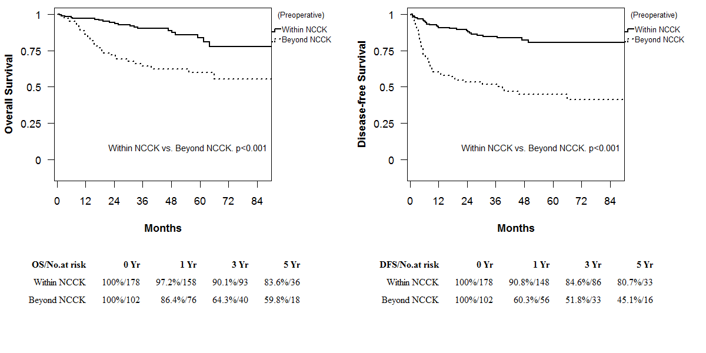
A

B

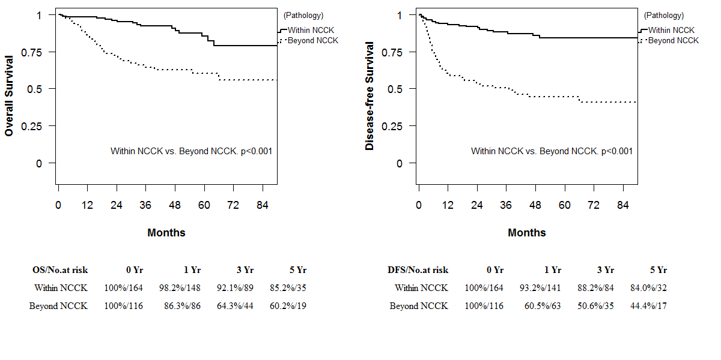

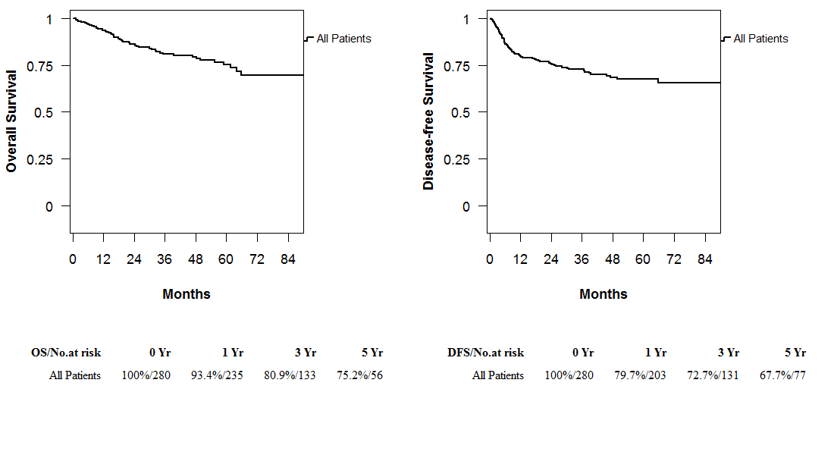
C

Figure 1 Overall and disease-free survival rates according to the National Cancer Center Korea criteria. A: By preoperative imaging; B: By explant pathology; C: Overall and disease-free survival rates for all patients.

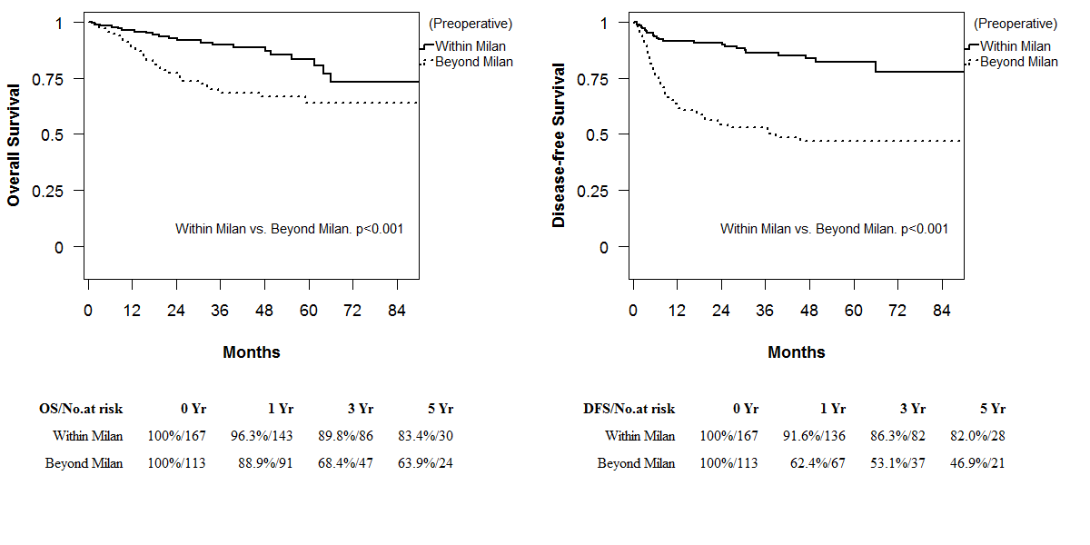
A

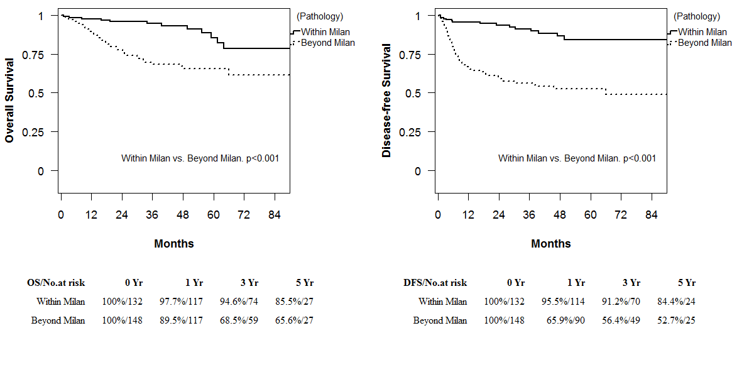
B

Figure 2 Overall and disease-free survival rates according to the Milan criteria. A: By preoperative imaging; B: By explant pathology.

A
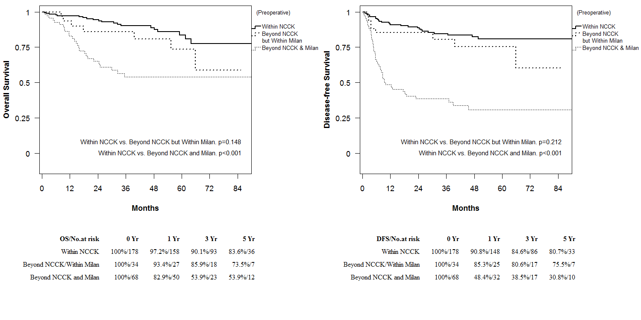
B

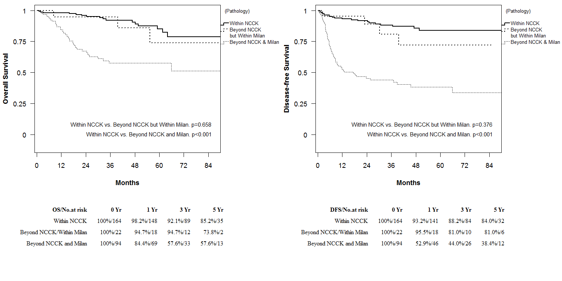
C
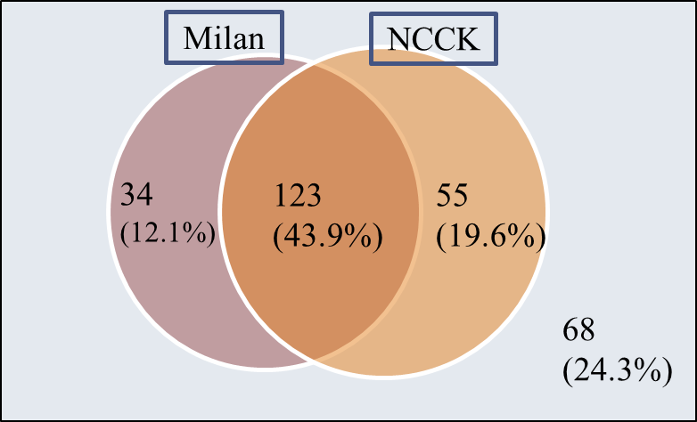

Figure 3 Overall and disease-free survival rates according to three groups (within the National Cancer Center Korea criteria, Beyond the National Cancer Center Korea but within the Milan criteria, Beyond both the National Cancer Center Korea and Milan criteria. A: By preoperative imaging; B: By explant pathology; C: the diagram of the portion of patients in Milan and NCCK criteria by preoperative imaging. NCCK: National Cancer Center Korea.

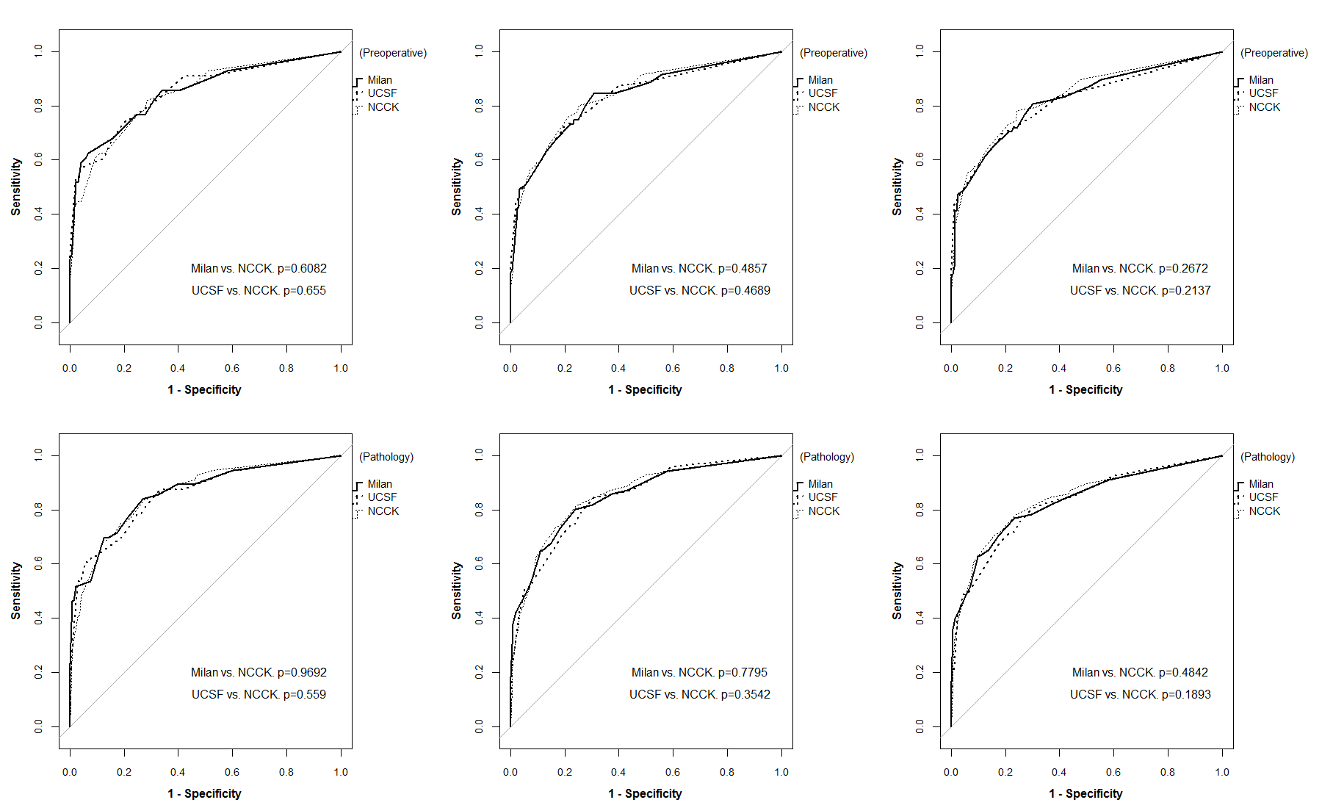
A
B

Figure 4 Receiver operating characteristic curves of three criteria (the National Cancer Center Korea, Milan and University of California, San Francisco) at 1, 3, and 5 years. A: By preoperative imaging; B: By explant pathology.

