Name of Journal: World Journal of Clinical Cases
Manuscript NO: 75712
Manuscript Type: CASE REPORT

Spinal giant cell-rich osteosarcoma-diagnostic dilemma and treatment strategy: A case report

Tseng CS et al. Spinal giant cell-rich osteosarcoma

Chen-Sheng Tseng, Chia-En Wong, Chi-Chen Huang, Hao-Hsiang Hsu, Jung-Shun Lee, Po-Hsuan Lee

Chen-Sheng Tseng, Chia-En Wong, Chi-Chen Huang, Hao-Hsiang Hsu, Jung Shun Lee, Po-Hsuan Lee, Section of Neurosurgery, Department of Surgery, National Cheng Kung University Hospital, College of Medicine, National Cheng Kung University, Tainan 704, Taiwan

Jung-Shun Lee, Department of Cell Biology and Anatomy, College of Medicine, National Cheng Kung University, Tainan 701, Taiwan

Jung-Shun Lee, Institute of Basic Medical Sciences, College of Medicine, National Cheng Kung University, Tainan 701, Taiwan

Author contributions: Lee PH and Lee JS supervised and coordinated the study; Tseng CS and Lee PH conceived and designed the study; Tseng CS, Wong CE, and Huang CC obtained, analyzed, and interpreted the data; Tseng CS, Wong CE, Lee JS, and Lee PH wrote the manuscript; All authors revised the draft for important intellectual content and agreed upon the manuscript before submission.

Corresponding author: Po-Hsuan Lee, MD, Surgeon, Section of Neurosurgery, Department of Surgery, National Cheng Kung University Hospital, College of Medicine, National Cheng Kung University, No. 138, Shengli Road, North District, Tainan 704, Taiwan. ftl053@gmail.com

Received: February 11, 2022
Revised: April 2, 2022
Accepted: May 27, 2022
Published online: July 26, 2022

Abstract
BACKGROUND
Giant cell-rich osteosarcoma (GCRO) is a rare histological variant of osteosarcoma. Spinal GCROs are extremely rare, with challenging diagnosis and management. Herein, we present a case of spinal GCRO at T2, which was not diagnosed in initial biopsy but after T2 corpectomy. We detailed the clinical course, management strategy, and outcome after a 4-year follow-up.

CASE SUMMARY
A 17-year-old female patient presented with back pain followed by ascending paresthesia. Spinal computed tomography (CT) and magnetic resonance imaging (MRI) revealed a collapsed T2 vertebra with an enhancing osteolytic mass. CT-guided biopsy showed inconclusive morphology. Pathology from T2 corpectomy revealed GCRO. The patient subsequently received neoadjuvant chemotherapy followed by salvage operation of T2 costotransversectomy with grossly-total resection adjuvant chemoradiation. Upon treatment completion, she had complete GCRO remission. The 4-year follow-up spinal MRI showed no tumor recurrence.

CONCLUSION
Spinal GCRO poses unique challenges in obtaining sufficient tissue diagnosis and complete surgical removal. However, long-term local control of spinal GCRO is possible following complete resection and adjuvant chemoradiation

Key Words: giant cell-rich osteosarcoma; giant cell tumor; osteosarcoma; spinal tumor; spinal osteosarcoma; Case report

©The Author(s) 2022. Published by Baishideng Publishing Group Inc. All rights reserved.

Citation: Tseng CS, Wong CE, Huang CC, Hsu HH, Lee JS, Lee PH. Spinal giant cell-rich osteosarcoma-diagnostic dilemma and treatment strategy: A case report. World J Clin Cases 2022; 10(21): 7565-7570
URL: https://www.wjgnet.com/2307-8960/full/v10/i21/7565.htm
DOI: https://dx.doi.org/10.12998/wjcc.v10.i21.7565

Core Tip: Giant cell-rich osteosarcoma (GCRO) is a rare variant of conventional osteosarcoma that is easily misdiagnosed as giant cell tumors. Spinal GCRO poses unique challenges in obtaining a sufficient tissue diagnosis and complete surgical removal. We report a case of spinal GCRO, which was not diagnosed in initial computed tomography-guided biopsy but after T2 corpectomy. Given the relationship between the extent of resection and prognosis, a second salvage operation was performed and gross total resection was achieved. Thus, long-term local control is achievable following complete resection of salvage surgery and adjuvant chemoradiation even in spinal GCRO with previous subtotal resection.

INTRODUCTION
Osteosarcoma is the most common primary malignant bone tumor, with high-grade histopathological features and poor prognosis, mostly arising from long bones^{[1]}. Osteosarcomas that arise from the spine are rare, accounting for 0.85%–3.0% of all osteosarcomas and 3.6%–14.5% of primary spinal tumors^{[2]}. The sacrum is the most commonly involved location, followed by the lumbar and thoracic spine^{[2]}. Giant cell tumors (GCTs) are typically benign with a low incidence of malignant transformation (< 1%) but can aggressively behave locally^{[3]}. The typical radiographic features consist of a well-defined osteolytic lesion with a non-sclerotic margin and subchondral bone extension^{[4]}.
Giant cell-rich osteosarcoma (GCRO) is a rare histological variant of osteosarcoma that was first reported by Bathurst et al^{[5]} in 1986. Based on the World Health Organization classification of soft tissue and bone in 2020, GCRO is categorized as conventional osteosarcomas, which belonged to the group of osteosarcoma not otherwise specified^{[6]}. It accounts for approximately 3% of osteosarcomas and mostly occurs in the long bones^{[5]}. Spinal GCROs are extremely rare, with challenging diagnosis and management compared with long-bone GCRO^{[7]}.
Herein, we report a case of spinal GCRO at T2 vertebrae, which was not diagnosed in the initial computed tomography (CT)-guided biopsy but after T2 corpectomy. We detailed the clinical course, management strategy, and outcome after a 4-year follow-up.

CASE PRESENTATION
Chief complaints
A 17-year-old female patient presented with back pain and leg numbness for 4 mo.

History of present illness
The patient had an unremarkable history and complained of insidious onset of intermittent back pain followed by bilateral ascending paresthesia for 4 mo. Neurological examination revealed paresthesia below the T5 level, 5/5 muscle strength in all four limbs, and bilaterally normal reflexes. Spinal CT and magnetic resonance imaging (MRI) revealed a collapsed T2 vertebra with an enhancing osteolytic mass that extended into the epidural and paraspinal region (Figure 1A-C). Bone scan showed an active bone lesion at the upper thoracic spine (Figure 1D).

History of past illness
Past illness history was not contributory.

Personal and family history
Personal and family history was not contributory.

Physical examination
Neurological examination revealed paresthesia below the T5 level, 5/5 muscle strength in four limbs, and bilaterally normal reflexes.

Laboratory examinations
Routine laboratory tests were unremarkable.

Imaging examinations
Spinal CT and MRI revealed a collapsed T2 vertebra with an enhancing osteolytic mass that extends into the epidural and paraspinal region (Figure 1A-C). Bone scan showed an active bone lesion at the upper thoracic spine (Figure 1D).

FINAL DIAGNOSIS
Pathological examination following T2 corpectomy reported GCRO of the spine (Figure 2).

TREATMENT
The patient first received CT-guided biopsy, which showed inconclusive morphology; thus, surgical resection for tissue diagnosis was offered. The patient underwent anterior T2 corpectomy with tumor excision and reconstruction with a right iliac bone graft. Intraoperatively, the T2 vertebra was replaced by hypervascular soft tissues, and the pathology showed a hypercellular tumor composed of atypical mononuclear oval to plump spindle cells with osteoid formation, permeative infiltration to the preexisting bony trabeculae, and some osteoclast-like multinucleated giant cells (Figure 2A). Immunochemical staining revealed lack of cyclin-dependent kinase 4 (CDK4) and mouse double minute-2 (MDM2) amplification, but moderate Ki67 and diffuse H3F3A mutation expression (Figure 2B). A final diagnosis of GCRO was made.
Considering the presence of residual tumor, the patient subsequently received an 8-wk course of neoadjuvant chemotherapy with cisplatin and doxorubicin, salvage operation of T2 costotransversectomy with gross total removal of the residual tumor, adjuvant radiation with 5000 cGy to the T1-T3 region, and a 30-wk course of adjuvant chemotherapy.

OUTCOME AND FOLLOW-UP
Upon treatment completion, she had complete neurologic recovery and GCRO remission. A 4-year follow-up spinal MRI showed no tumor recurrence (Figure 3).

DISCUSSION
GCRO is easily misdiagnosed as GCT due to its similarities in radiographic and histopathology features^{[8]}. Radiographically, the radiographic features of GCRO and GCT are similar in the literature. However, most GCRO has little periosteal reactions, whereas a periosteal reaction was seen in 10%-30% of GCTs. Besides, the periosteal reaction identified in GCTs usually present in long bones, and the spinal location of the present case may further hinder the identification of these radiographic findings^{[9]}. Histologically, both GCT and GCRO consist of diffuse infiltration of an abnormally increased number of giant cells^{[10]}. The abundant giant cells in GCROs could thereby almost swamp the sarcoma cells, making GCRO easily misdiagnosed as GCT in pathology^{[11]}. Moreover, the giant cells in GCRO and GCT both share a common H3F3A mutation, osteoclast-like activity, and a tendency to cause bone resorption^{[12]}. Therefore, radiolucency in X-ray images and osteolytic lesions in CT is the commonly shared radiographic feature between GCT and GCRO^{[8,10,11]}. The key diagnostic feature to distinguish CGRO from GCT is still the presence of eosinophilic and irregularly shaped osteoids, which are usually surrounded by a rim of osteoblasts. Furthermore, the key sarcomatous features of GCRO composed of atypical mononuclear oval to plump spindle cells with anaplasia and nuclear pleomorphism, invasive permeative infiltration, and formation of irregularly contoured eosinophilic osteoid, which are unlikely be present in GCT^{[8,10,13]}. Moreover, recent studies have shown that MDM2 and CDK4 are amplified in low-grade osteosarcoma, which can potentially help distinguish GCT from GCRO. It has also been reported that a high Ki67 proliferative index > 20% in GCRO is useful in differentiating it from GCT^{[13-15]}. Therefore, a generous amount of tissue sampling to prevent any sampling bias in surgical pathology is of paramount importance to make the correct diagnosis between GCRO and CGT^{[16]}.
Herein, the spinal location of the GCRO impacted its correct diagnosis in several aspects. First, the spinal location of the tumor might hinder a generous amount of surgical tissue sampling due to its proximity to the neurovascular structure. Moreover, decompression and/or separation surgery with stabilization followed by radiation is an accepted alternative treatment strategy, especially in patients with suspected spinal metastases and those unable to tolerate major operations^{[17]}. Thus, an insufficient amount of tissue sampling may pose a higher risk of sampling bias in surgical pathology and misdiagnosis^{[16,18]}. In this case, we selected anterior approach T2 corpectomy to allow a wide corpectomy with circumferential decompression and maximize the amount of tissue sampling since the initial pathology obtained from a CT-guided biopsy was inconclusive.
The survival rate of GCROs is similar to that of high-grade osteosarcoma^{[13]} ranging from 60% to 70% at 5 years and decreases to approximately 20%–30% in patients with metastatic disease^{[5,19]}; long-term local control is achievable with complete resection. The spinal location of the GCRO could impact its prognosis since complete resection with clear surgical margins is associated with better survival^{[10]}. Complete spinal GCRO resection could be more technically challenging or require more aggressive approaches given the proximity of the neural, vascular, and visceral structures to the spinal column compared to the long-bone counterparts^{[20]}. Therefore, the survival rate of primary osteosarcoma in pediatric spine is 18% at 5 years and 7% with distant metastasis^{[21]}. However, gross total tumor resection should be attempted since it directly affects the prognosis^{[2,7,8]}. A recent meta-analysis study also revealed the beneficial outcome after salvage surgery for residual primary spinal osteosarcoma^{[22]}. In the present case, given the relationship between the extent of resection and prognosis, a second salvage operation following neoadjuvant chemotherapy was performed and grossly-total resection was achieved. The present case showed that long-term local control is achievable following complete resection of salvage surgery and adjuvant chemoradiation even in spinal GCRO with previous subtotal resection.
With limited knowledge, we propose in addition to regular physical and neurological exams, a whole-body bone scan 6-mo after salvage surgery is suggested to exclude any distant metastasis. Spinal CT is indicated to evaluation the degree of bony fusion on 3-6 mo postoperatively. MRI scans every 6-mo in the first 2 years and yearly in the subsequent years are mandatory to identify any recurrent tumor locally.

CONCLUSION
GCRO is a rare variant of conventional osteosarcoma that is easily misdiagnosed as GCT. Spinal GCRO poses unique challenges in obtaining a sufficient tissue diagnosis and complete surgical removal. However, long-term local control of spinal GCRO is possible following complete resection and adjuvant chemoradiation.

REFERENCES
1 Brookes MJ, Chan CD, Baljer B, Wimalagunaratna S, Crowley TP, Ragbir M, Irwin A, Gamie Z, Beckingsale T, Ghosh KM, Rankin KS. Surgical Advances in Osteosarcoma. Cancers (Basel) 2021; 13 [PMID: 33494243 DOI: 10.3390/cancers13030388]
2 Feng D, Yang X, Liu T, Xiao J, Wu Z, Huang Q, Ma J, Huang W, Zheng W, Cui Z, Xu H, Teng Y. Osteosarcoma of the spine: surgical treatment and outcomes. World J Surg Oncol 2013; 11: 89 [PMID: 23597053 DOI: 10.1186/1477-7819-11-89]
3 van der Heijden L, Dijkstra PD, van de Sande MA, Kroep JR, Nout RA, van Rijswijk CS, Bovée JV, Hogendoorn PC, Gelderblom H. The clinical approach toward giant cell tumor of bone. Oncologist 2014; 19: 550-561 [PMID: 24718514 DOI: 10.1634/theoncologist.2013-0432]
4 Chakarun CJ, Forrester DM, Gottsegen CJ, Patel DB, White EA, Matcuk GR Jr. Giant cell tumor of bone: review, mimics, and new developments in treatment. Radiographics 2013; 33: 197-211 [PMID: 23322837 DOI: 10.1148/rg.331125089]
5 Bathurst N, Sanerkin N, Watt I. Osteoclast-rich osteosarcoma. Br J Radiol 1986; 59: 667-673 [PMID: 3460667 DOI: 10.1259/0007-1285-59-703-667]
6 Choi JH, Ro JY. The 2020 WHO Classification of Tumors of Bone: An Updated Review. Adv Anat Pathol 2021; 28: 119-138 [PMID: 33480599 DOI: 10.1097/PAP.0000000000000293]
7 Mosquera-Salas L, Salazar-Falla N, Perez B, Sangiovanni S, Sua LF, Fernández-Trujillo L. Acute respiratory failure as initial manifestation of conventional osteosarcoma rich in giant cells: a case report. J Med Case Rep 2020; 14: 228 [PMID: 33228766 DOI: 10.1186/s13256-020-02562-y]
8 Shinozaki T, Fukuda T, Watanabe H, Takagishi K. Giant Cell-Rich Osteosarcoma Simulating Giant Cell Tumor of Bone. KITAKANTO Med J 2004; 54: 147–151 [DOI: 10.2974/kmj.54.147]
9 Murphey MD, Nomikos GC, Flemming DJ, Gannon FH, Temple HT, Kransdorf MJ. From the archives of AFIP. Imaging of giant cell tumor and giant cell reparative granuloma of bone: radiologic-pathologic correlation. Radiographics 2001; 21: 1283-1309 [PMID: 11553835 DOI: 10.1148/radiographics.21.5.g01se251283]
10 Mallick A, Shah N, Mahmud SA, Das SK. Giant cell-rich osteosarcoma - A rare case. J Oral Maxillofac Pathol 2020; 24: S67-S72 [PMID: 32189908 DOI: 10.4103/jomfp.JOMFP_251_19]
11 Lee JC, Huang HY. Soft Tissue Special Issue: Giant Cell-Rich Lesions of the Head and Neck Region. Head Neck Pathol 2020; 14: 97-108 [PMID: 31950466 DOI: 10.1007/s12105-019-01086-2]
12 Presneau N, Baumhoer D, Behjati S, Pillay N, Tarpey P, Campbell PJ, Jundt G, Hamoudi R, Wedge DC, Loo PV, Hassan AB, Khatri B, Ye H, Tirabosco R, Amary MF, Flanagan AM. Diagnostic value of H3F3A mutations in giant cell tumour of bone compared to osteoclast-rich mimics. J Pathol Clin Res 2015; 1: 113-123 [PMID: 27499898 DOI: 10.1002/cjp2.13]
13 Chow LT. Giant cell rich osteosarcoma revisited-diagnostic criteria and histopathologic patterns, Ki67, CDK4, and MDM2 expression, changes in response to bisphosphonate and denosumab treatment. Virchows Arch 2016; 468: 741-755 [PMID: 27003154 DOI: 10.1007/s00428-016-1926-9]
14 Hirose K, Okura M, Sato S, Murakami S, Ikeda JI, Noda Y, Fukuda Y, Morii E, Toyosawa S. Gnathic giant-cell-rich conventional osteosarcoma with MDM2 and CDK4 gene amplification. Histopathology 2017; 70: 1171-1173 [PMID: 27926798 DOI: 10.1111/his.13141]
15 Santana LADM, Felix FA, de Arruda JAA, da Silva LP, Brito ÉAC, Takeshita WM, Trento CL. A rare case of a metastatic giant cell-rich osteosarcoma of the mandible: Update and differential diagnostic considerations. Oral Surg Oral Med Oral Pathol Oral Radiol 2021; 131: e163-e169 [PMID: 33187945 DOI: 10.1016/j.oooo.2020.10.009]
16 Thunnissen FB, Ambergen AW, Koss M, Travis WD, O'Leary TJ, Ellis IO. Mitotic counting in surgical pathology: sampling bias, heterogeneity and statistical uncertainty. Histopathology 2001; 39: 1-8 [PMID: 11454038 DOI: 10.1046/j.1365-2559.2001.01187.x]
17 Conti A, Acker G, Kluge A, Loebel F, Kreimeier A, Budach V, Vajkoczy P, Ghetti I, Germano' AF, Senger C. Decision Making in Patients With Metastatic Spine. The Role of Minimally Invasive Treatment Modalities. Front Oncol 2019; 9: 915 [PMID: 31608228 DOI: 10.3389/fonc.2019.00915]
18 Renshaw AA, Gould EW. Measuring errors in surgical pathology in real-life practice: defining what does and does not matter. Am J Clin Pathol 2007; 127: 144-152 [PMID: 17145620 DOI: 10.1309/5KF89P63F4F6EUHB]
19 Zhao X, Wu Q, Gong X, Liu J, Ma Y. Osteosarcoma: a review of current and future therapeutic approaches. Biomed Eng Online 2021; 20: 24 [PMID: 33653371 DOI: 10.1186/s12938-021-00860-0]
20 Katonis P, Datsis G, Karantanas A, Kampouroglou A, Lianoudakis S, Licoudis S, Papoutsopoulou E, Alpantaki K. Spinal osteosarcoma. Clin Med Insights Oncol 2013; 7: 199-208 [PMID: 24179411 DOI: 10.4137/CMO.S10099]
21 Kim HJ, McLawhorn AS, Goldstein MJ, Boland PJ. Malignant osseous tumors of the pediatric spine. J Am Acad Orthop Surg 2012; 20: 646-656 [PMID: 23027694 DOI: 10.5435/JAAOS-20-10-646]
22 Shankar GM, Clarke MJ, Ailon T, Rhines LD, Patel SR, Sahgal A, Laufer I, Chou D, Bilsky MH, Sciubba DM, Fehlings MG, Fisher CG, Gokaslan ZL, Shin JH. The role of revision surgery and adjuvant therapy following subtotal resection of osteosarcoma of the spine: a systematic review with meta-analysis. J Neurosurg Spine 2017; 27: 97-104 [PMID: 28452631 DOI: 10.3171/2016.12.SPINE16995]

Footnotes
Informed consent statement: Informed written consent was obtained from the patient for publication of this reporting

Conflict-of-interest statement: The authors have no conflicts of interest to declare.

CARE Checklist (2016) statement: The authors have read the CARE Checklist (2016), and the manuscript was prepared and revised according to the CARE Checklist (2016).

Open-Access: This article is an open-access article that was selected by an in-house editor and fully peer-reviewed by external reviewers. It is distributed in accordance with the Creative Commons Attribution NonCommercial (CC BY-NC 4.0) license, which permits others to distribute, remix, adapt, build upon this work non-commercially, and license their derivative works on different terms, provided the original work is properly cited and the use is non-commercial. See: https://creativecommons.org/Licenses/by-nc/4.0/

Provenance and peer review: Unsolicited article; Externally peer reviewed.
Peer-review model: Single blind

Peer-review started: February 11, 2022
First decision: March 23, 2022
Article in press: May 27, 2022

Specialty type: Surgery
Country/Territory of origin: Taiwan
Peer-review report’s scientific quality classification
Grade A (Excellent): 0
Grade B (Very good): B
Grade C (Good): C
Grade D (Fair): 0
Grade E (Poor): 0

P-Reviewer: Muthu S, India; Zhang L, China A-Editor: Liu X, China S-Editor: Ma YJ L-Editor: Filipodia P-Editor: Ma YJ

Figure Legends
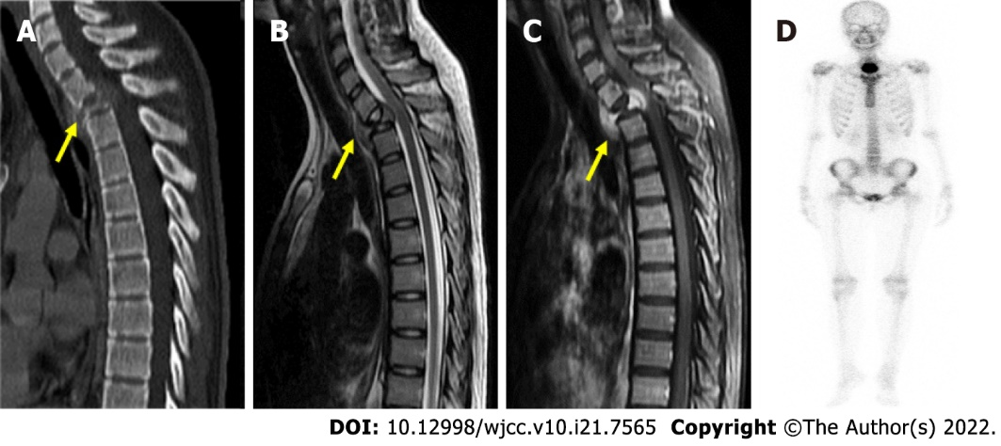
Figure 1 Preoperative radiographic evaluation. A: Preoperative computed tomography demonstrating collapsed T2 vertebra (yellow arrow); B, C: Preoperative magnetic resonance imaging revealed vertebral body mass (yellow arrow) with paraspinal and epidural paraspinal extension and gadolinium enhancement; D: Bone scan showing an active bone lesion at the upper thoracic spine.

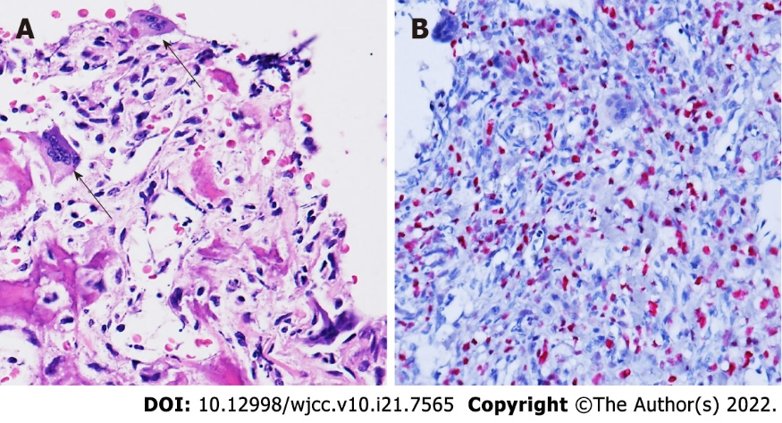
Figure 2 Histopathology of the T2 vertebral tumor. A: Hematoxylin and eosin staining revealing atypical mononuclear oval to plump spindle cells with osteoid formation infiltrating osteoclast-like multinucleated giant cells (arrow); B: Immunohistochemistry demonstrating diffuse H3F3A G34W mutation. Magnification: 400 x.

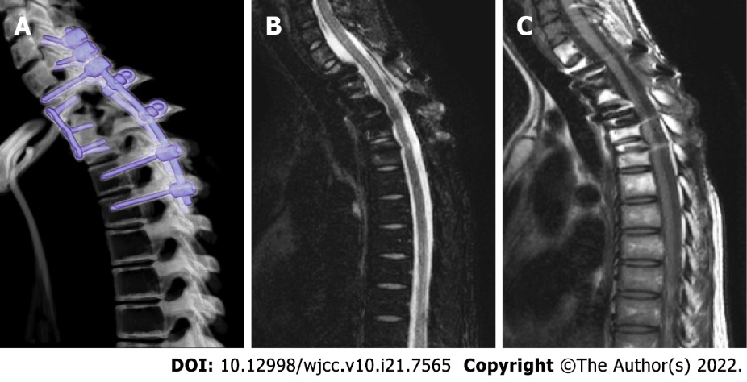
Figure 3 Postoperative radiographic evaluation. A-C: No tumor recurrence was revealed in the A: 3-mo postoperative computed tomography; B: 4-yr postoperative T2; or C: T1 gadolinium-enhanced magnetic resonance imaging.

Published by Baishideng Publishing Group Inc
7041 Koll Center Parkway, Suite 160, Pleasanton, CA 94566, USA
Telephone: +1-925-3991568
E-mail: bpgoffice@wjgnet.com
Help Desk: https://www.f6publishing.com/helpdesk
https://www.wjgnet.com

© 2022 Baishideng Publishing Group Inc. All rights reserved.

