Name of Journal: World Journal of Gastrointestinal Oncology
Manuscript NO: 75709
Manuscript Type: LETTER TO THE EDITOR

Exosomes: Promising biomarkers and targets for cancer

Fang Z et al. Roles of exosomes in cancer

Zhen Fang, Yi-Xuan Ding, Fei Li

Zhen Fang, Yi-Xuan Ding, Fei Li, Department of General Surgery, Xuanwu Hospital of Capital Medical University, Beijing 100053, China

Author contributions: Fang Z and Ding YX wrote the manuscript; Li F designed the study; and All authors have read and approve the final manuscript.

Corresponding author: Zhen Fang, PhD, Academic Research, Surgeon, Department of General Surgery, Xuanwu Hospital of Capital Medical University, No. 45 changchun street, Xicheng District, Beijing 100053, China. ifang123@163.com

Received: February 17, 2022
Revised: April 25, 2022
Accepted: July 19, 2022
Published online:

Abstract
The review article entitled "Exosomes as potential diagnosis and treatment for liver cancer " recently published in World Journal of Gastrointestinal Oncology 2022; 14: 334-347 concluded that exosomes can be used as effective biomarkers or therapeutic biotargets in liver cancer. Exosomes are a hot spot in the field of tumor diagnosis and treatment research. We had also previously published a review on exosomes and tumors. In this letter to the editor, we summarize the clinical application prospects and current challenges of exosomes.

Key Words: Exosomes; Cancer; Biomarkers; Diagnosis; Therapy

Fang Z, Ding YX, Li F. Exosomes: Promising biomarkers and targets for cancer. World J Gastrointest Oncol 2022; In press

Core Tip: Exosomes have been shown to be major transmitters of cell-to-cell communication. Several advantageous features make exosomes effective therapeutic targets for cancer and ideal vehicles for drug delivery. This letter highlights the opportunities and challenges for clinical study and application of exosomes.

TO THE EDITOR
We read with great interest the systematic review "Exosomes as potential diagnosis and treatment for liver cancer" recently published in World J Gastrointest Oncol 2022; 14: 334-347^{[1]}. The authors conducted a literature search to identify potential diagnostic and therapeutic markers of exosomes in liver cancer. Forty potential liver cancer biomarkers, 13 potential biotherapeutics and 10 potential hepatocellular carcinoma therapeutic targets were identified, providing future directions for basic research and targeted therapy of liver cancer.
Exosomes, first discovered in 1983, are small lipid bilayer vesicles with a diameter of 40-160 nm, which are found in body fluids such as blood, urine, saliva, and cerebrospinal fluid^{[2]}. Exosomes contain many biomolecules, including membrane-bound proteins, soluble proteins, lipids, DNA, microRNAs and non-coding RNAs^{[3]}. In recent years, studies have found that exosomes are involved in intercellular communication in many physiological processes in the body, and play a crucial role in mediating tumorigenesis, development and metastasis^{[4-6]}. Tumor-derived exosomes convey tumorigenic information and contribute to the tumor microenvironment for tumor proliferation and metastasis, and are a promising biomarker for cancer therapy^{[2]}. The unique characteristics of tumor cell-derived exosomes make them potential biomarkers for early cancer diagnosis, tracking cancer patient’s response to therapy, and detecting mechanisms of resistance to therapy, and making important contributions to precise and personalized cancer therapy.
A variety of cancer cell-specific proteins, lipids, DNA, RNA and metabolites can be isolated from cancer cell-derived exosomes, which can be used as cancer biomarkers^{[3]}. Studies have reported that exosome-associated glypican-1 (GPC1) is a diagnostic biomarker for early pancreatic cancer^{[7]}. Circulating exosome-derived lncRNA-GC1 can be used as a biomarker to detect early gastric cancer and monitor disease progression^{[8]}. Tumor cell-specific molecules in exosomes can be used for early diagnosis and detection of cancer recurrence.
Exosomes have natural delivery capabilities as carriers for cancer therapeutics and functional RNAs^{[9]}. Compared with traditional nanomaterial carriers, exosomes have the advantages of high bioavailability, non-cytotoxicity and non-immunogenicity. Transmembrane and membrane-anchored proteins within exosomes enhance endocytosis, thereby facilitating transfer of chemotherapeutics. Studies have found that neutrophil-derived exosomes deliver chemotherapeutics across the blood-brain barrier and effectively inhibit tumor growth^{[10]}. Exosomes have the characteristics of small size, strong penetration and high biological stability. Using exosomes to deliver drugs or adding inhibitory immune checkpoints on the surface of exosomes to further enhance the anti-cancer effect is a new direction for exosomes in cancer treatment. In the future, exosome-based drug delivery systems are expected to be widely used in cancer therapy. (Figure 1)
With the deepening of exosome research, a more comprehensive understanding of exosomes has been achieved, but there are still factors that restrict exosome research and clinical application. For example, the large-scale extraction, isolation and purification of exosomes are limited. At present, the exosome extraction method is mainly ultracentrifugation, but with low yield and high cost, thus it is difficult to achieve industrial production and large-scale clinical application.
In conclusion, much progress has been made in the field of exosome research, but the obstacles hindering the widespread clinical application of exosomes should also be highly concerned. The great prospect of exosomes for cancer diagnosis and treatment is undeniable.

REFERENCES
1 Wei XC, Liu LJ, Zhu F. Exosomes as potential diagnosis and treatment for liver cancer. World J Gastrointest Oncol 2022; 14: 334-347 [PMID: 35116120 DOI: 10.4251/wjgo.v14.i1.334]
2 Kalluri R, LeBleu VS. The biology, function, and biomedical applications of exosomes. Science 2020; 367 [PMID: 32029601 DOI: 10.1126/science.aau6977]
3 Thakur BK, Zhang H, Becker A, Matei I, Huang Y, Costa-Silva B, Zheng Y, Hoshino A, Brazier H, Xiang J, Williams C, Rodriguez-Barrueco R, Silva JM, Zhang W, Hearn S, Elemento O, Paknejad N, Manova-Todorova K, Welte K, Bromberg J, Peinado H, Lyden D. Double-stranded DNA in exosomes: a novel biomarker in cancer detection. Cell Res 2014; 24: 766-769 [PMID: 24710597 DOI: 10.1038/cr.2014.44]
4 Li W, Li C, Zhou T, Liu X, Liu X, Li X, Chen D. Role of exosomal proteins in cancer diagnosis. Mol Cancer 2017; 16: 145 [PMID: 28851367 DOI: 10.1186/s12943-017-0706-8]
5 Wu H, Fu M, Liu J, Chong W, Fang Z, Du F, Liu Y, Shang L, Li L. The role and application of small extracellular vesicles in gastric cancer. Mol Cancer 2021; 20: 71 [PMID: 33926452 DOI: 10.1186/s12943-021-01365-z]
6 Ding Y, Cao F, Sun H, Wang Y, Liu S, Wu Y, Cui Q, Mei W, Li F. Exosomes derived from human umbilical cord mesenchymal stromal cells deliver exogenous miR-145-5p to inhibit pancreatic ductal adenocarcinoma progression. Cancer Lett 2019; 442: 351-361 [PMID: 30419348 DOI: 10.1016/j.canlet.2018.10.039]
7 Melo SA, Luecke LB, Kahlert C, Fernandez AF, Gammon ST, Kaye J, LeBleu VS, Mittendorf EA, Weitz J, Rahbari N, Reissfelder C, Pilarsky C, Fraga MF, Piwnica-Worms D, Kalluri R. Glypican-1 identifies cancer exosomes and detects early pancreatic cancer. Nature 2015; 523: 177-182 [PMID: 26106858 DOI: 10.1038/nature14581]
8 Guo X, Lv X, Ru Y, Zhou F, Wang N, Xi H, Zhang K, Li J, Chang R, Xie T, Wang X, Li B, Chen Y, Yang Y, Chen L, Chen L. Circulating Exosomal Gastric Cancer-Associated Long Noncoding RNA1 as a Biomarker for Early Detection and Monitoring Progression of Gastric Cancer: A Multiphase Study. JAMA Surg 2020; 155: 572-579 [PMID: 32520332 DOI: 10.1001/jamasurg.2020.1133]
9 Dai J, Su Y, Zhong S, Cong L, Liu B, Yang J, Tao Y, He Z, Chen C, Jiang Y. Exosomes: key players in cancer and potential therapeutic strategy. Signal Transduct Target Ther 2020; 5: 145 [PMID: 32759948 DOI: 10.1038/s41392-020-00261-0]
10 Wang J, Tang W, Yang M, Yin Y, Li H, Hu F, Tang L, Ma X, Zhang Y, Wang Y. Inflammatory tumor microenvironment responsive neutrophil exosomes-based drug delivery system for targeted glioma therapy. Biomaterials 2021; 273: 120784 [PMID: 33848731 DOI: 10.1016/j.biomaterials.2021.120784]

Footnotes
Conflict-of-interest statement: All authors report no relevant conflicts of interest for this article.

Open-Access: This article is an open-access article that was selected by an in-house editor and fully peer-reviewed by external reviewers. It is distributed in accordance with the Creative Commons Attribution NonCommercial (CC BY-NC 4.0) license, which permits others to distribute, remix, adapt, build upon this work non-commercially, and license their derivative works on different terms, provided the original work is properly cited and the use is non-commercial. See: https://creativecommons.org/Licenses/by-nc/4.0/

Provenance and peer review: Invited article; Externally peer reviewed.
Peer-review model: Single blind

Peer-review started: February 17, 2022
First decision: April 17, 2022
Article in press:

Specialty type: Oncology
Country/Territory of origin: China
Peer-review report’s scientific quality classification
Grade A (Excellent): 0
Grade B (Very good): B, B
Grade C (Good): C
Grade D (Fair): 0
Grade E (Poor): 0

P-Reviewer: Habashy HO, Egypt; Manojlovic N, Serbia; Toyoshima O, Japan S-Editor: Ma YJ L-Editor: A P-Editor: Ma YJ

Figure Legends
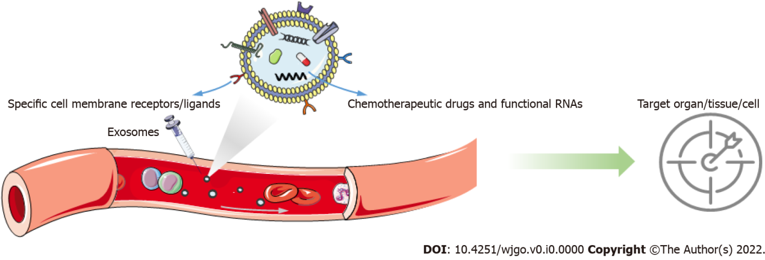
Figure 1 Schematic diagram of exosome drug delivery system.

