Name of journal: World Journal of Gastroenterology
ESPS Manuscript NO: 16271
Columns: CASE REPORT

Abnormal layering of muscularis propria, as a cause of chronic intestinal pseudo-obstruction: A case report and literature review

Angkathunyakul N et al. A cause of chronic intestinal pseudo-obstruction

Napat Angkathunyakul, Suporn Treepongkaruna, Sani Molagool, Nichanan Ruangwattanapaisarn

Napat Angkathunyakul, Department of Pathology, Ramathibodi hospital, Mahidol University, Bangkok 10400, Thailand

Suporn Treepongkaruna, Department of Pediatric, Ramathibodi hospital, Mahidol University, Bangkok 10400, Thailand

Sani Molagool, Department of Surgery, Ramathibodi hospital, Mahidol University, Bangkok 10400, Thailand

Nichanan Ruangwattanapaisarn, Department of Diagnostic and Therapeutic Radiology, Ramathibodi hospital, Mahidol University, Bangkok 10400, Thailand

Author contributions: Angkathunyakul N designed the report, interpreted histologic findings, special staining and immunohistochemistry study; Treepongkaruna S and Molagool S collected the patient's clinical data; Ruangwattanapaisarn N provided the radiographic data; Angkathunyakul N and Treepongkaruna S reviewed and analyzed the literature and wrote the paper.

Supported by Faculty of Medicine, Ramathibodi Hospital, Mahidol University, Thailand.

Ethics approval: The study was reviewed and approved by the Committee on Human Rights Related to Research Involving Human Subjects, based on the Declaration of Helsinki.

Informed consent: The legal guardian of the study participant provided informed written consent prior to study enrollment.

Conflict-of-interest: The authors have no conflicts of interest to declare.

Open-Access: This article is an open-access article which was selected by an in-house editor and fully peer-reviewed by external reviewers. It is distributed in accordance with the Creative Commons Attribution Non Commercial (CC BY-NC 4.0) license, which permits others to distribute, remix, adapt, build upon this work non-commercially, and license their derivative works on different terms, provided the original work is properly cited and the use is non-commercial. See: http://creativecommons.org/licenses/by-nc/4.0/

Correspondence to: Napat Angkathunyakul, MD, Pathologist, Department of Pathology, Ramathibodi hospital, Mahidol University, Highway 3310, Salaya, Phutthamonthon District, Bangkok 10400, Thailand. napat.ang@mahidol.ac.th
Telephone: +66-2-2011667
Fax: +66-2-3547266
Received: January 7, 2015
Peer-review started: January 8, 2015
First decision: January 22, 2015
Revised: March 9, 2015
Accepted: March 30, 2015

Article in press:
Abstract
Visceral myopathy is one of the causes of chronic intestinal pseudo-obstruction (CIPO). Most cases pathologically revealed degenerative changes of myocytes or muscularis propia atrophy and fibrosis. Abnormal layering of muscularis propria is extremely rare. We report a case of a 9-mo-old Thai male baby who presented with CIPO. Histologic findings showed abnormal layering of small intestinal muscularis propria with additional oblique layer and aberrant muscularization in serosa. The patient also had short small bowel without malrotation, brachydactyly and absence of the 2nd - 4th middle fingers of both hands. The patient was treated with cisapride and combined parenteral and enteral nutritional support. He had gradual clinical improvement and gained his body weight. Subsequently the parenteral nutrition could be discontinued. The previously reported cases were reviewed and discussed.

Key words: Abnormal layering of muscularis propria; Serosal muscularization; Chronic intestinal pseudo-obstruction; Short small bowel; Brachydactyly; Visceral myopathy

© The Author(s) 2015. Published by Baishideng Publishing Group Inc. All rights reserved.

Core tip: We report a case of 9-mo-old boy, who presented with chronic intestinal pseudo-obstruction. Full-thickness small bowel biopsy showed abnormal layering of muscularis propria (additional oblique layer) and serosal aberrant muscularization. There have been only 8 previously reported abnormal layering cases and only 1 case with additional oblique layer. The patient also had short small bowel without malrotation, brachydactyly and absence of the 2nd - 4th middle fingers of both hands. He had clinical improvement with medical treatment and nutritional support.

Angkathunyakul N, Treepongkaruna S, Molagool S, Ruangwattanapaisarn N. Abnormal layering of muscularis propria, as a cause of chronic intestinal pseudo-obstruction: A case report and literature review. World J Gastroenterol 2015; In press

INTRODUCTION
Chronic intestinal pseudo-obstruction (CIPO) was first described by Dudley in 1958^{[1]}. It is a rare, severe gastrointestinal disorder in which intestinal motility is impaired. CIPO could be congenital or acquired, primary or secondary^{[2]} and is characterized by recurrent signs and symptoms of intestinal obstruction in the absence of true mechanical obstruction^{[3]}. It can affect both adults and children. Most pediatric patients manifest since birth or early infancy^{[4]}. The two main pathophysiologic types of this motility disorder are myopathic and neuropathic^{[5]}. In this article, we report a pediatric case of CIPO due to visceral myopathy with rare histology (abnormal layering muscularis propria and serosal aberrant muscularization) and review literatures.

CASE REPORT
A 9-mo-old Thai male baby presented with abdominal distention and bilious vomiting since 2 wk of age. He could take oral feed and defecate daily. He was the first child with an uneventful history of prenatal, perinatal and neonatal periods and his birth weight was 3065 G. No family member had similar symptoms. He had visited another hospital at age of 3 mo and upper gastrointestinal (GI) studies were done and revealed no intestinal malrotation nor other GI obstruction. His abdominal distention and bilious vomiting progressed and he had poor weight gain. He then visited our hospital. Physical examination revealed BW 5500 G (below the 3rd percentile), length 64 cm (the 10th percentile), no dysmorphic features, marked abdominal distention, hyperactive bowel sound, visible peristalsis and bilateral indirect inguinal hernia. He also had brachydactyly on both hands. X-ray film demonstrated an absence of middle phalanges of the 2nd - 4th fingers. The other systems were unremarkable. The plain abdominal radiographys showed diffuse small bowel dilatation (Figure 1). Barium enema showed no transitional zone nor signs of Hirschsprung disease, but irregular mucosa of nearly his entire colon was noted. Small bowel follow-through showed dilatation with thickening fold of almost entire small bowel from duodenum to ileum with hyperperistalsis, suspicious of partial distal small bowel obstruction (Figure 1). A bilateral inguinal hernia was suspected as the cause of partial GI obstruction and bilateral herniorrhaphy was performed. Unfortunately, his symptoms did not improve. Upper endoscopy and colonoscopy were performed for excluding mucosal diseases and were unremarkable. The histology of biopsies from esophageal, duodenal, gastric and colonic mucosa showed no significant pathologic finding nor tissue eosinophilia. His clinical symptoms were worse with progressive bilious vomiting, abdominal distension and poor weight gain. Since intestinal obstruction could not be excluded, exploratory laparotomy was performed at the age of 9 mo. Intraoperative findings showed normal size of colon, but thickening short small bowel which was 86 cm long from his duodenojejunal junction to ileocecal valve. A pale thickened and inflamed "Taenia coli"-like line was noted at his antimesenteric side from his duodenojejunal junction to 15 cm above ileocecal valve (Figure 2). Appendectomy and full-thickness biopsy of distal ileum were performed and sent for intraoperative consultation. The specimen was fixed in formalin afterward.

Histopathology
Full-thickness biopsy of terminal ileum revealed unremarkable mucosa with no significant tissue eosinophilia. Submucosa showed hyalinization and fibrosis. Unremarkable ganglion cells in submucosa (Henle's) and deep submucosa (Meissner's) were identified. Muscularis propria was markedly thickened and revealed abnormal layering into 3 layers; (1) inner circular; (2) additional oblique; and (3) outer longitudinal layer (Figure 3A). No degenerative change of myocyte (e.g., cytoplasmic vacuolation, variation in muscle fiber size, nuclear pleomorphism) or increased mitosis was observed. Periodic acid schiff (PAS) stain revealed no intracytoplasmic inclusion. Diffuse delicate interstitial fibrosis in all muscular layers highlighted by Masson trichrome was noted (Figure 3B). Meissner's plexuses were located between his inner circular and additional oblique layer. There was no inflammation in muscular layers, around ganglion cells or neural plexuses. Serosa showed 3 bizarre layers of aberrant muscularization diffuse interstitial fibrosis into of smooth muscles, forming grossly "Taenia coli"-like line. Congo red stain excluded amyloidosis (Figure 4).
Sections of vermiform appendix showed unremarkable mucosal, mural and serosal layers.

Immunohistochemistry study
Muscularis mucosae, all muscular layers in muscularis propria and serosa showed diffusely strong expression of smooth muscle actin, desmin, and muscle actin. (Figure 5) S100 highlighted normal distribution of Henle's, Meissner's and Auerbach's neural plexuses with unremarkable ganglion cells. Normal expression of Bcl-2 was observed in all plexuses. Immunohistochemistry study of CD117 revealed normal interstitial cells of Cajal (ICC) networks around Auerbach's plexus and extending to inner circular and outer longitudinal muscular layer. Thus, we could exclude neuropathic and ICC abnormalities.

DISCUSSION
This report a pediatric case of primary CIPO due to visceral myopathy from abnormal layering of muscularis propria. Clinical presentations were similar to most cases of CIPO. The symptoms begin at birth in 50% of patients and by age one year in 75%. Bilious vomiting, abdominal distension, and obstipation are almost universal presentations^{[6]}. The majority of the pediatric cases are primary or idiopathic CIPO. Antonucci et al^{[7]} demonstrated that secondary causes such as organic, systemic or metabolic causes were identified in only 4 patients of 77 CIPO patients in their study. Antroduodenal manometry is useful for differentiation between the neuropathy and myopathy type^{[8]}. Unfortunately, this investigation is not available in our institute. Definite diagnosis of CIPO requires full thickness biopsies for histopathology.
Visceral myopathy can be divided into two groups. The first group is intrinsic myocyte defect with characteristic findings of vacuolar degeneration and fibrosis in inner circular and/or outer longitudinal muscular layers^{[9-12]}. The other changes include nuclear atypia, increased mitotic activity and PAS-positive intracytoplasmic inclusions^{[13]}, and absence or decreased smooth muscle α-actin immunostaining in the circular muscle layer^{[14]}. The second group is abnormalities of morphogenesis of muscularis propria. Most cases are of atrophic pattern^{[8,15,16]}. A few cases of hypertrophic pattern with hypertrophy of one or both layers have been reported^{[8,17-19]}. The abnormal layering of muscularis propria is exceedingly rare and only 8 cases have been reported (Table 1).
Most cases with abnormally layered muscularis propria are male. The clinical symptoms appear at early life and depend on the site of involvement. Patients with colonic involvement present with constipation while small intestine involvement manifests with vomiting and abdominal distension. Additional circular muscle coat in various locations is the most common feature. Only one case with additional oblique layer similar to our case has been reported by Yamagiwa et al^{[20]} To our knowledge, serosal "Taenia-coli like" aberrant muscularization has never been described in the literatures.
Common associated abnormalities are short small intestine (mostly with malrotation)^{[4,21]}, urinary involvement including megacystis and megaureter^{[22]}, and skeletal deformity (spine and extremities). To our knowledge, there has been no report of association with brachydactyly and absence of the middle phalangeal bones in visceral myopathy cases. Smith et al^{[9]} suggested X-linked mode of inheritance in three related boys with abnormal layered muscularis propria of small and large intestine with megacystic. DNA analysis was not performed in our case due to unavailability in our institute.
The impact of abnormal layering of muscularis propria on the natural history or prognosis remains unknown since the numbers of cases are small. Among the 8 reported cases, clinical outcome could be identified in only two cases. The first case had clinical improvement of constipation and grew into a healthy young man after partial resection of dilated sigmoid colon and rectum. However, the second case died due to multiple organ anomalies^{[23]}.
There is no specific treatment for CIPO from visceral myopathy, and nutritional support is the mainstay of management in these children. Pharmacotherapy, including cisapride, erythromycin and octreotide, to stimulate intestinal contractions, may be useful in some selected cases^{[24,25]}. Small bowel transplantation has a potential role for those who have irreversible intestinal failure and permanent dependence on parenteral nutrition^{[26,27]}. Prognosis is fair to poor and long-term parenteral nutrition requirement is common in these patients^{[28]}. A mortality rate of 25% has been reported in a large cohort study and common causes of death are parenteral-related complications^{[22]}. Our patient also had short bowel accompanying with his CIPO. Management modalities of short bowel syndrome include enteral and parenteral nutritional support, treating small bowel bacterial overgrowth and fish-oil-based lipid emulsions^{[29]}. Currently, teduglutide, a recombinant analog of human glucagon-like peptide-2, is an emerging treatment for those with intestinal failure^{[30]}. Our patient was treated with cisapride and combined parenteral and enteral nutritional support. He had gradual clinical improvement and gained his body weight and subsequently parenteral nutrition could be discontinued. At the time of writing, he is 3-year-old and he has normal growth with body weight of 15 KG (the 65th percentile) and height of 95 cm (the 55th percentile).
COMMENTS
Case characteristics
A 9-mo-old Thai male baby presented with abdominal distention since birth and bilious vomiting since 2 wk of age.

Clinical diagnosis
Chronic intestinal pseudo-obstruction.

Differential diagnosis
Hirschsprung’s disease.

Laboratory diagnosis
Unremarkable findings for the laboratory tests.

Imaging diagnosis
Abdominal X-ray showed diffused dilatation of small bowel loops. Small bowel follow-through showed generalized bowel dilatation with thickening fold of entire small bowel loops from duodenum to ileum.

Pathological diagnosis
Full-thickness biopsy of ileum revealed abnormal layering of muscularis propria (additional oblique layer between inner circular and outer longitudinal layer) and serosal aberrant muscularization.
Treatment
Medication (cisapride) and combined parenteral and enteral nutritional support.

Related reports
There have been only 8 previously reported abnormal layering cases and only 1 case showed additional oblique layer. The patient also had aberrant serosal muscularization, brachydactyly and absence of 2nd - 4th middle fingers in both hands which have never been reported.

Term explanation
Abnormal layering of muscularis propria is an exceedingly rare condition of abnormal morphogenesis of muscularis propria (visceral myopathy) which causes chronic intestinal pseudo-obstruction.

Experiences and lessons
The case report presents the unique abnormal layering of muscularis propria and aberrant serosal muscularization in a case of chronic intestinal pseudo-obstruction and also different associated anomaly from previously reported cases. We learnt that medical treatment and combined parenteral and enteral nutritional support improved clinical outcome.

Peer-review
The authors have reported an interesting case of a very rare situation presenting with intestinal pseudo-obstruction linked to short, small bowel and brachydactyly. In the gut it was associated with an additional oblique muscle layer and with muscularization of the serosa. Although descriptive, this study also reviews the few cases described in the literature exhibiting visceral myopathy due to abnormal layering of the muscularis propria. It shows that the current case corresponds to a situation never previously reported.

REFERENCES
1 Dudley HA, Sinclair IS, Mclaren IF, Mcnair TJ, Newsam JE. Intestinal pseudo-obstruction. J R Coll Surg Edinb 1958; 3: 206-217 [PMID: 13514744]
2 Rudolph CD, Hyman PE, Altschuler SM, Christensen J, Colletti RB, Cucchiara S, Di Lorenzo C, Flores AF, Hillemeier AC, McCallum RW, Vanderhoof JA. Diagnosis and treatment of chronic intestinal pseudo-obstruction in children: report of consensus workshop. J Pediatr Gastroenterol Nutr 1997; 24: 102-112 [PMID: 9093995 DOI: 10.1097/00005176-199701000-00021]
3 Cucchiara S, Borrelli O, Salvia G, Iula VD, Fecarotta S, Gaudiello G, Boccia G, Annese V. A normal gastrointestinal motility excludes chronic intestinal pseudoobstruction in children. Dig Dis Sci 2000; 45: 258-264 [PMID: 10711435 DOI: 10.1023/A: 1005491921972]
4 Heneyke S, Smith VV, Spitz L, Milla PJ. Chronic intestinal pseudo-obstruction: treatment and long term follow up of 44 patients. Arch Dis Child 1999; 81: 21-27 [PMID: 10373127 DOI: 10.1136/adc.81.1.21]
5 Georgescu EF, Vasile I, Ionescu R. Intestinal pseudo-obstruction: an uncommon condition with heterogeneous etiology and unpredictable outcome. World J Gastroenterol 2008; 14: 954-959 [PMID: 18240359 DOI: 10.3748/wjg.14.954]
6 Kocoshis SA, Reyes J, Todo S, Starzl TE. Small intestinal transplantation for irreversible intestinal failure in children. Dig Dis Sci 1997; 42: 1997-2008 [PMID: 9365126]
7 Antonucci A, Fronzoni L, Cogliandro L, Cogliandro RF, Caputo C, De Giorgio R, Pallotti F, Barbara G, Corinaldesi R, Stanghellini V. Chronic intestinal pseudo-obstruction. World J Gastroenterol 2008; 14: 2953-2961 [PMID: 18494042 DOI: 10.3748/wjg.14.2953]
8 Connor FL, Di Lorenzo C. Chronic intestinal pseudo-obstruction: assessment and management. Gastroenterology 2006; 130: S29-S36 [PMID: 16473068 DOI: 10.1053/j.gastro.2005.06.081]
9 Smith VV, Milla PJ. Histological phenotypes of enteric smooth muscle disease causing functional intestinal obstruction in childhood. Histopathology 1997; 31: 112-122 [PMID: 9279561 DOI: 10.1046/j.1365-2559.1997.2250839.x]
10 Moore SW, Schneider JW, Kaschula RD. Non-familial visceral myopathy: clinical and pathologic features of degenerative leiomyopathy. Pediatr Surg Int 2002; 18: 6-12 [PMID: 11793055 DOI: 10.1007/s003830200002]
11 Smith VV, Gregson N, Foggensteiner L, Neale G, Milla PJ. Acquired intestinal aganglionosis and circulating autoantibodies without neoplasia or other neural involvement. Gastroenterology 1997; 112: 1366-1371 [PMID: 9098023 DOI: 10.1016/S0016-5085(97)70151-3]
12 De Giorgio R, Guerrini S, Barbara G, Stanghellini V, De Ponti F, Corinaldesi R, Moses PL, Sharkey KA, Mawe GM. Inflammatory neuropathies of the enteric nervous system. Gastroenterology 2004; 126: 1872-1883 [PMID: 15188182 DOI: 10.1053/j.gastro.2004.02.024]
13 Fogel SP, DeTar MW, Shimada H, Chandrasoma PT. Sporadic visceral myopathy with inclusion bodies. A light-microscopic and ultrastructural study. Am J Surg Pathol 1993; 17: 473-481 [PMID: 8385883 DOI: 10.1097/00000478-199305000-00006]
14 Knowles CH, Silk DB, Darzi A, Veress B, Feakins R, Raimundo AH, Crompton T, Browning EC, Lindberg G, Martin JE. Deranged smooth muscle alpha-actin as a biomarker of intestinal pseudo-obstruction: a controlled multinational case series. Gut 2004; 53: 1583-1589 [PMID: 15479676 DOI: 10.1136/gut.2003.037275]
16 De Giorgio R, Sarnelli G, Corinaldesi R, Stanghellini V. Advances in our understanding of the pathology of chronic intestinal pseudo-obstruction. Gut 2004; 53: 1549-1552 [PMID: 15479666 DOI: 10.1136/gut.2004.043968]
17 McClelland HA, Lewis MJ, Naish JM. Idiopathic steatorrhoea with intestinal pseudo-obstruction. Gut 1962; 3: 142-145 [PMID: 18668747 DOI: 10.1136/gut.3.2.142]
18 Naish JM, Capper WM, Brown NJ. Intestinal pseudoobstruction with steatorrhoea. Gut 1960; 1: 62-66 [PMID: 14425851 DOI: 10.1136/gut.1.1.62]
19 Koh S, Bradley RF, French SW, Farmer DG, Cortina G. Congenital visceral myopathy with a predominantly hypertrophic pattern treated by multivisceral transplantation. Hum Pathol 2008; 39: 970-974 [PMID: 18329691 DOI: 10.1016/j.humpath.2007.10.016]
20 Yamagiwa I, Ohta M, Obata K, Washio M. Intestinal pseudoobstruction in a neonate caused by idiopathic muscular hypertrophy of the entire small intestine. J Pediatr Surg 1988; 23: 866-869 [PMID: 3183906]
21 Tanner MS, Smith B, Lloyd JK. Functional intestinal obstruction due to deficiency of argyrophil neurones in the myenteric plexus. Familial syndrome presenting with short small bowel, malrotation, and pyloric hypertrophy. Arch Dis Child 1976; 51: 837-841 [PMID: 1008589 DOI: 10.1136/adc.51.11.837]
22 Mousa H, Hyman PE, Cocjin J, Flores AF, Di Lorenzo C. Long-term outcome of congenital intestinal pseudoobstruction. Dig Dis Sci 2002; 47: 2298-2305 [PMID: 12395903 DOI: 10.1023/A: 1020199614102]
23 Kapur RP, Correa H. Architectural malformation of the muscularis propria as a cause for intestinal pseudo-obstruction: two cases and a review of the literature. Pediatr Dev Pathol 2009; 12: 156-164 [PMID: 18788889 DOI: 10.2350/08-07-0495.1]
24 Di Lorenzo C, Reddy SN, Villanueva-Meyer J, Mena I, Martin S, Hyman PE. Cisapride in children with chronic intestinal pseudoobstruction. An acute, double-blind, crossover, placebo-controlled trial. Gastroenterology 1991; 101: 1564-1570 [PMID: 1955122]
25 Di Lorenzo C, Lucanto C, Flores AF, Idries S, Hyman PE. Effect of sequential erythromycin and octreotide on antroduodenal manometry. J Pediatr Gastroenterol Nutr 1999; 29: 293-296 [PMID: 10467994 DOI: 10.1097/00005176-199909000-00010]
26 Bond GJ, Reyes JD. Intestinal transplantation for total/near-total aganglionosis and intestinal pseudo-obstruction. Semin Pediatr Surg 2004; 13: 286-292 [PMID: 15660322 DOI: 10.1053/j.sempedsurg.2004.10.016]
27 Gambarara M, Ferretti F, Diamanti A, Papadatou B, D'Orio F, Sabbi T, Castro M. Parenteral nutrition dependence in pediatric patients: an indication for small bowel transplantation. Transplant Proc 2002; 34: 882-883 [PMID: 12034220 DOI: 10.1016/S0041-1345(02)02684-2]
28 Ueno T, Wada M, Hoshino K, Sakamoto S, Furukawa H, Fukuzawa M. A national survey of patients with intestinal motility disorders who are potential candidates for intestinal transplantation in Japan. Transplant Proc 2013; 45: 2029-2031 [PMID: 23769101 DOI: 10.1016/j.transproceed.2013.01.092]
29 Uko V, Radhakrishnan K, Alkhouri N. Short bowel syndrome in children: current and potential therapies. Paediatr Drugs 2012; 14: 179-188 [PMID: 22452596 DOI: 10.2165/11594880-000000000-00000]
30 Wilhelm SM, Lipari M, Kulik JK, Kale-Pradhan PB. Teduglutide for the Treatment of Short Bowel Syndrome. Ann Pharmacother 2014; 48: 1209-1213 [PMID: 24871569 DOI: 10.1177/1060028014537468]

P-Reviewer: Alsolaiman MM, Conzo G, Freund JN S-Editor: Qi Y
L-Editor: E-Editor:

Figure 1 Plain abdominal radiographs showed diffused dilatation of small bowel loops. A: Supine; B: Upright; C: Small bowel follow-through showed dilatation with thickening fold of almost entire small bowel from duodenum to ileum.
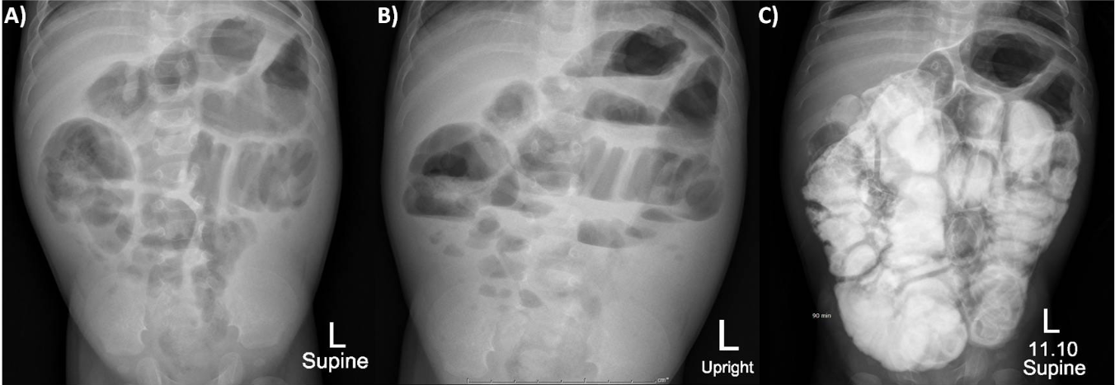

Figure 2 Explore laparotomy revealed thickening short small bowel, pale thickened and inflamed "Taenia coli"-like line was noted at antimesenteric side from duodenojejunal junction to 15 cm above ileocecal valve.
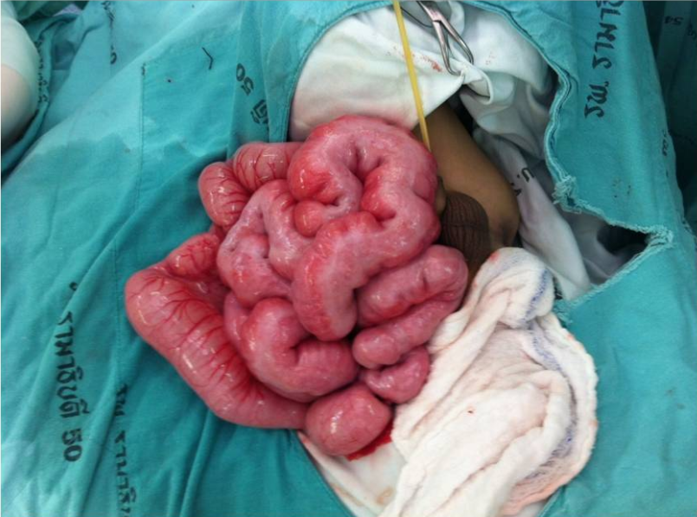

Figure 3 Full-thickness biopsy from distal ileum. A: (HE, × 20) Hypertrophic muscularis propria with abnormal layering into 3 layers (IC: Inner circular; OB: Additional oblique; OL: Outer longitudinal). B: Delicate interstitial fibrosis is highlighted by Masson trichrome (× 20) as well as serosal muscularization (SE).
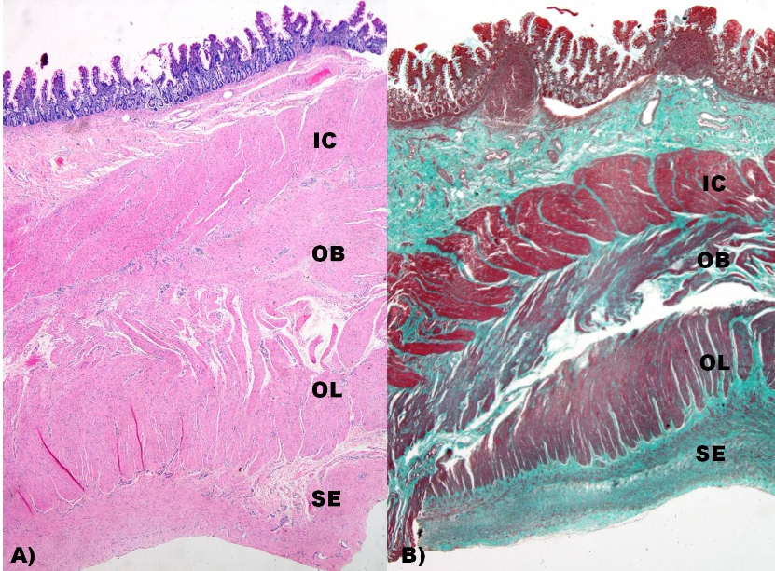

Figure 4 Serosal aberrant muscularization into 3 bizarre layers of smooth muscles (Masson trichrome, × 100).
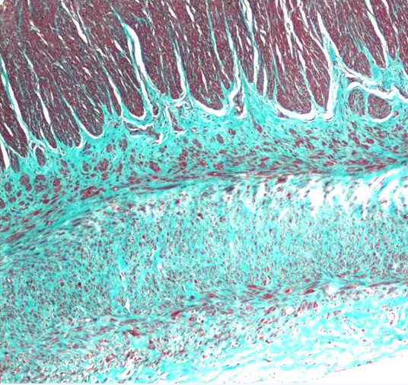

Figure 5 Immunohistochemistrystudy (× 20). A: Smooth muscle α-actin; B: Desmin were strongly expressed in all layers of smooth muscle; C: CD117 showed ICC network; D: S100 highlighted Auerbach's neural plexuses.
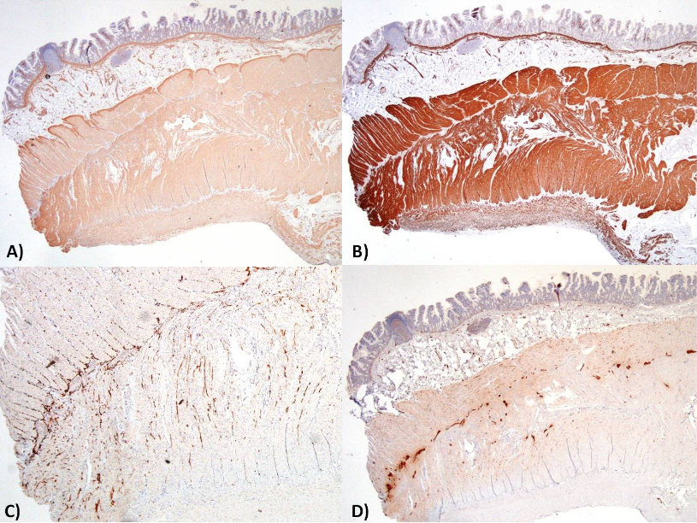

Table 1 Previously reported cases of visceral myopathy due to abnormal layering of muscularis propria
Case | Sex / Age | Presenting symptom | Site | Muscularis propria pathology |  | Other GI abnormality | Other system  Findings | Remark | Ref.
 |  |  |  | Additional layer | Location
1 | M / 11 days | CIPO | S | Oblique | External to OL | Short small intestine  + malrotation | Sclerocornea, Cryptorchidism, Scoliosis, Deformity of extremities |  | [20]
2 | M | CIPO | S and L | Circular | Between IC and OL | Short intestine + malrotation | Megacystic | X-linked | [9]
3 | M | CIPO | S and L | Circular | Between IC and OL | Short intestine + malrotation | Megacystic | X-linked | [9]
4 | M | CIPO | S and L | Circular | Between IC and OL | Short intestine + malrotation | Megacystic | X-linked | [9]
5 | F | Constipation | L | Circular | Internal to IC |  |  |  | [9]
6 | F | Constipation | L | Circular | Internal to IC |  | Megaureter |  | [9]
7 | M / 16 years | Constipation | L | Circular | Internal to IC |  | Dysmorphic facies & toes, Seizures,  Leukoencephalopathy, Cataract | Clinically improved after surgery | [23]
8 | M / birth | Respiratory problem | S | Circular | External to OL | Short small intestine  + malrotation | Diaphragmatic defect, High-arched palate, ASD, Ventriculomegaly, Subependymal heterotopias,  Arachnoid cyst, Spina bifida,  Proximally placed thumbs | Dead | [23]
9 | M / 9 months | CIPO | S | Oblique | Between IC and OL | Short small intestine | Brachydactyly, Absent 2nd - 4th middle fingers of both hands | Clinically improved by medication | Our case
M: Male; F: Female; S: Small intestine; L: Large intestine; IC: Inner circular layer; OL: Outer longitudinal layer.

