Name of journal: World Journal of Gastroenterology
ESPS Manuscript NO: 6357
Columns: CASE REPORT

Concomitant pancreatic adenocarcinoma in a patient with branch-duct intraductal papillary mucinous neoplasm

Law JK et al. Concomitant pancreatic adenocarcinoma

Joanna K Law, Christopher L Wolfgang, Matthew J Weiss, Anne Marie Lennon

Joanna K Law, Christopher L Wolfgang, Matthew J Weiss, Anne Marie Lennon, Division of Gastroenterology, Johns Hopkins Hospital, Baltimore, MD 21287, United States

Author contributions: Law JK was involved in the concept, data acquisition and writing of this manuscript, and approval of the final manuscript; Wolfgang CL and Weiss MJ were involved in the editing of the manuscript and final approval of the submitted version; and Lennon AM developed the concept, wrote, and edited the manuscript.

Correspondence to: Anne Marie Lennon, MB, PhD, Division of Gastroenterology, Johns Hopkins Hospital, Sheikh Zayed Tower, Suite 7125J, Baltimore, MD 21287, United States. amlennon@jhmi.edu

Telephone: +1-410-9555800 Fax: +1-410-6148337
Received: October 14, 2013 Revised: December 31, 2013
Accepted: February 26, 2014

Published online:

Abstract
Branch duct intraductal papillary mucinous neoplasms (BD-IPMN) are pre-malignant pancreatic cystic lesions which carry a small risk of malignant transformation within the cyst. Guidelines exist with respect to surveillance of the cysts using computed tomography, magnetic resonance imaging, and/or endoscopic ultrasound (EUS). There are reports that patients with intraductal papillary mucinous neoplasms (IPMNs) are at increased risk of developing pancreatic adenocarcinoma, which arises in an area separate to the IPMNs. We present two cases of pancreatic adenocarcinoma arising within the parenchyma, distinct from the IPMN-associated cyst, identified with EUS. This case report highlights that patients with BD-IPMN are at increased risk for pancreatic adenocarcinoma separate from the cyst and also the importance for endosonographers to carefully survey the rest of the pancreatic parenchyma separate from the cyst in order to identify small pancreatic adenocarcinomas.

© 2014 Baishideng Publishing Group Co., Limited. All rights reserved.

Key words: Pancreatic adenocarcinoma; Intraductal papillary mucinous neoplasm; Endoscopic ultrasound; Surveillance

Core tip: Patients with intraductal papillary mucinous neoplasm are not only at risk for malignant degeneration within the cyst, but some reports have indicated an increased risk for the development of pancreatic adenocarcinoma separate from the cyst. The current international guidelines emphasize surveillance of the cyst but this case report highlights the importance for endosonographers to carefully evaluate parenchyma not involved with the cyst to identify small pancreatic adenocarcinomas.

Law JK, Wolfgang CL, Weiss MJ, Lennon AM. Concomitant pancreatic adenocarcinoma in a patient with branch-duct intraductal papillary mucinous neoplasm.
Available from:
DOI:

INTRODUCTION
Incidental pancreatic cysts are detected frequently due to the widespread availability and use of cross-sectional imaging. Over the past decade, 2.6% of patients undergoing multidetector computed tomography (CT) scans and up to 13.5% of patients undergoing magnetic resonance imaging (MRI) were found to have incidentally detected pancreatic cysts^{[[1,2]}.
Intraductal papillary mucinous neoplasm (IPMN) account for almost 50% of surgically resected cystic pancreatic neoplasms^{[3]} and can progress from benign neoplastic epithelium to invasive carcinoma through increasing severity of dysplasia. The risk of malignant transformation is dependent on whether or not there is involvement of the main pancreatic duct. Main, or mixed duct IPMN is associated with a risk of high-grade dysplasia or invasive adenocarcinoma of 44% to 62% in surgical series^{[4]}. In contrast, only 16% to 25% of surgically resected branch-duct IPMN contain either high-grade dysplasia or invasive adenocarcinoma^{[4]}.
We present two cases of patients with BD-IPMN who had no high-risk or worrisome features within their cysts but were found to have a pancreatic adenocarcinoma unrelated to a cyst while undergoing routine surveillance with EUS.

CASE REPORT
Case 1
A 67-year-old man with a history of resected prostate cancer and no significant family history underwent an abdominal CT scan for surveillance of his prostate cancer. An incidental 1.4cm cyst in the uncinate process of the pancreas was found. EUS with fine needle aspiration (EUS-FNA) was performed at an outside hospital. The findings were consistent with a branch duct IPMN (BD-IPMN), with no worrisome features. He underwent surveillance with a pancreatic protocol CT scan six months later, which revealed a 2 cm cystic lesion in the uncinate process (Figures 1A and 1B) with multiple smaller cysts in the body, none of which had any worrisome or high-risk features. Six months later the patient was seen in our multidisciplinary pancreatic cyst clinic; he underwent a routine EUS and was found to have a 2.2 cm cyst (Figure 1C). In addition, a 2.6 cm x 1.9 cm mass was identified within the head of the pancreas, separate from the cyst (Figure 1D). EUS-FNA of the lesion was performed, which confirmed as a well-differentiated adenocarcinoma on cytopathology. The patient underwent a pancreaticoduodenectomy and was found to have a moderately differentiated adenocarcinoma, with invasion through the muscularis propria and into the submucosa of the small intestine, with 1 of 34 lymph nodes involved by metastatic adenocarcinoma. In addition, an IPMN with low to intermediate grade dysplasia was found.

Case 2
A 55-year-old man had an incidental finding of a 3 cm x 3 cm multi-lobulated cyst in the uncinate process and a 2 cm x 2 cm cyst in the distal tail of the pancreas, when he underwent an abdominal CT scan for evaluation of flank pain. He was found to have markedly atypical cells worrisome for malignancy, and underwent a pylorus-preserving pancreaticoduodenectomy. The pathology demonstrated an IPMN with high-grade dysplasia with no evidence of involvement of the surgical resection margin. He underwent routine transabdominal surveillance of the remnant pancreas with a combination of CT and MR imaging at 6-monthly intervals. Five years after initial detection, the lesion in the tail was noted to have increased minimally in size to 2.4 cm on a MRI scan. In addition, multiple sub-centimeter cystic lesions were present throughout the remnant body and tail (Figure 2A), none of which contained any suspicious features. The patient underwent a routine EUS which demonstrating a 2.9 cm cystic lesion in the tail of the pancreas (Figure 2B), with additional smaller cysts in the body and tail of the pancreas none of which contained any worrisome features. However in the body of the pancreas, separate to any cyst, a 1.4 cm mass was visualized (Figure 2C). EUS-FNA was performed, and cytopathology confirmed a pancreatic adenocarcinoma. The patient underwent a staging CT scan, which found multiple spiculated nodules in the lung, which were confirmed as metastatic pancreatic adenocarcinoma on biopsy.

DISCUSSION
Patients with IPMN are known to be at increased risk of developing pancreatic ductal adenocarcinoma, the majority of which arise from an IPMN related cyst. Patients with IPMN are followed using the International Consensus Criteria guidelines, which recommend surveillance of patients with BD-IPMN and no worrisome features at 3-6 mo intervals alternating with MRI and EUS for cysts > 2 cm and for patients with smaller cysts, annual to every 2-3 yearly CT and/or MRI is recommended^{[4]}. Both the EUS literature^{[5,6]}, and these guidelines, stress the importance of looking for high-risk or worrisome features in the IPMN related cysts (Table 1). However, there have been a number of retrospective studies reporting cases of patients with IPMN developing adenocarcinoma in areas unrelated to pancreatic cysts with incidences of between 4% to 11%^{[7-14]}. In a single prospective study, which followed 89 patients with IPMN over a 17 year period, 4 developed concomitant pancreatic adenocarcinoma^{[15]}.
The current guidelines recommend that BD-IPMN measuring < 2 cm are followed with MRI or CT, with EUS being used for larger cysts or those with worrisome features^{[4]}. However, very few studies have compared the sensitivity and specificity of these three imaging modalities. One prospective, multicenter study by Canto et al^{[16]}, compared CT, MRI and EUS in high-risk patients, and found that EUS was the most sensitive test for identifying cysts. Several studies have shown that EUS is superior to CT for identifying small solid pancreatic neoplasms, but there are no studies to date examining its role in detecting concomitant pancreatic adenocarcinoma in patients with IPMN. In this series, both patients underwent high quality imaging with either CT or MRI with a mass only detected on EUS. A recent study by He et al^{[17]}, found that up to 17% of patients who underwent resection of IPMN, will develop lesions in the remnant pancreas which fulfill the criteria for surgical resection. It may be that high risk groups such as this may benefit from increased use of EUS. Large, prospective studies are necessary to compare these three imaging modalities and determine their optimum combination and timing.
In conclusion, concomitant pancreatic adenocarcinoma may arise in patients undergoing surveillance for IPMN with and without previous pancreatic resection. Endosonographers should examine not only the cysts, but also the entire pancreatic parenchyma carefully.

COMMENTS
Case characteristics
Two patients undergoing surveillance for branch duct intraductal papillary mucinous neoplasm are found to have concomitant adenocarcinoma (i.e., separate from the cystic lesion) found on endoscopic ultrasound.

Clinical diagnosis
Pancreatic adenocarcinoma separate and distinct from branch duct intraductal papillary mucinous neoplasm (BD-IPMN) was detected in two patients undergoing surveillance by endoscopic ultrasound (EUS).

Differential diagnosis
In both cases, the adenocarcinoma was an incidental finding that was not detected on cross sectional imaging; the differential for a solid-appearing lesion in the pancreas includes pancreatic neuroendocrine tumor, lymphoma, and metastases.

Imaging diagnosis
Both patients were undergoing surveillance of BD-IPMN with cross-sectional imaging as recommended by the international consensus guidelines and included either computed tomography (CT), magnetic resonance imaging (MRI), and/or EUS.

Pathological diagnosis
Through EUS-guided fine needle aspiration, a cytopathologic diagnosis confirmed pancreatic adenocarcinoma.

Treatment
In the first case, the patient underwent surgical resection in the form of a pancreaticoduodenectomy; the second patient presented with lung metastases and was treated with palliative chemotherapy

Term explanation
Concomitant pancreatic adenocarcinoma is the term used to describe a lesion that is unrelated to the cystic lesion.

Experiences and lessons
These two cases are meant to emphasize the need for endosonographers to survey the pancreatic parenchyma not involved with cyst in the evaluation of patients with BD-IPMN.

Peer review
In the two cases, endosonographers were preferable to CT and MRI in surveillance of pancreatic adenocarcinoma from BD-IPMN. However, it is still hard for us to choose which cyst to take a FNA if EUS finds some cysts which are < 2 cm with no worrisome features in clinical practice.

REFERENCES
1 Laffan TA, Horton KM, Klein AP, Berlanstein B, Siegelman SS, Kawamoto S, Johnson PT, Fishman EK, Hruban RH. Prevalence of unsuspected pancreatic cysts on MDCT. AJR Am J Roentgenol 2008; 191: 802-807 [PMID: 18716113 DOI: 10.2214/AJR.07.3340]
2 Lee KS, Sekhar A, Rofsky NM, Pedrosa I. Prevalence of incidental pancreatic cysts in the adult population on MR imaging. Am J Gastroenterol 2010; 105: 2079-2084 [PMID: 203545070 DOI: 10.1038/ajg.2010.122]
3 Valsangkar NP, Morales-Oyarvide V, Thayer SP, Ferrone CR, Wargo JA, Warshaw AL, Fernández-del Castillo C. 851 resected cystic tumors of the pancreas: a 33-year experience at the Massachusetts General Hospital. Surgery 2012; 152: S4-S12 [PMID: 22770958 DOI: 10.1016/j.surg.2012.05.033]
4 Tanaka M, Fernández-del Castillo C, Adsay V, Chari S, Falconi M, Jang JY, Kimura W, Levy P, Pitman MB, Schmidt CM, Shimizu M, Wolfgang CL, Yamaguchi K, Yamao K. International consensus guidelines 2012 for the management of IPMN and MCN of the pancreas. Pancreatology 2010; 12: 183-197 [PMID: 22687371 DOI: 10.1016/j.pan.2012.04.004]
5 Ohno E, Hirooka Y, Itoh A, Ishigami M, Katano Y, Ohmiya N, Niwa Y, Goto H. Intraductal papillary mucinous neoplasms of the pancreas: differentiation of malignant and benign tumors by endoscopic ultrasound findings of mural nodules. Ann Surg 2009; 249: 628-634 [PMID: 19300203 DOI: 10.1097/SLA.0b013e31819edle5]
6 Zhong N, Zhang L, Takahashi N, Shalmiyev V, Canto MI, Clain JE, Deutsch JC, DeWitt J, Eloubeidi MA, Gleeson FC, Levy MJ, Mallery S, Raimondo M, Rajan E, Stevens T, Topazian M. Histologic and imaging features of mural nodules in mucinous pancreatic cysts. Clin Gastroenterol Hepatol 2012; 10: 192-198, 198.e1-2 [PMID: 21982970 doi: 10.1016/j.cgh.2011.09.029]
7 Kamisawa T, Tu Y, Egawa N, Nakajima H, Tsuruta K, Okamoto A. Malignancies associated with intraductal papillary mucinous neoplasm of the pancreas. World J Gastroenterol 2005; 11: 5688-5690 [PMID: 16237766]
8 Yamaguchi K, Kanemitsu S, Hatori T, Maguchi H, Shimizu Y, Tada M, Nakagohri T, Hanada K, Osanai M, Noda Y, Nakaizumi A, Furukawa T, Ban S, Nobukawa B, Kato Y, Tanaka M. Pancreatic ductal adenocarcinoma derived from IPMN and pancreatic ductal adenocarcinoma concomitant with IPMN. Pancreas 2011; 40: 571-580 [PMID: 21499212 DOI: 10.1097/MPA.0b013e318215010c]
9 Yamaguchi K, Ohuchida J, Ohtsuka T, Nakano K, Tanaka M. Intraductal papillary-mucinous tumor of the pancreas concomitant with ductal carcinoma of the pancreas. Pancreatology 2002; 2: 484-490 [PMID: 12378117 DOI: 10.1159/000064716]
10 Tamura K, Ohtsuka T, Ideno N, Aso T, Kono H, Nagayoshi Y, Shindo K, Ushijima Y, Ueda J, Takahata S, Ito T, Oda Y, Mizumoto K, Tanaka M. Unresectable pancreatic ductal adenocarcinoma in the remnant pancreas diagnosed during every-6-month surveillance after resection of branch duct intraductal papillary mucinous neoplasm: a case report. JOP 2013; 14: 450-453 [PMID: 23846946 DOI: 10.6092/1590-8577/1494]
11 Sawai Y, Yamao K, Bhatia V, Chiba T, Mizuno N, Sawaki A, Takahashi K, Tajika M, Shimizu Y, Yatabe Y, Yanagisawa A. Development of pancreatic cancers during long-term follow-up of side-branch intraductal papillary mucinous neoplasms. Endoscopy 2010; 42: 1077-1084 [PMID: 21120776 DOI: 10.1055/s-0030-1255971]
12 Tada M, Kawabe T, Arizumi M, Togawa O, Matsubara S, Yamamoto N, Nakai Y, Sasahira N, Hirano K, Tsujino T, Tateishi K, Isayama H, Toda N, Yoshida H, Omata M. Pancreatic cancer in patients with pancreatic cystic lesions: a prospective study in 197 patients. Clin Gastroenterol Hepatol 2006; 4: 1265-1270 [PMID: 16979953 DOI: 10.1016/j.cgh.2006.07.013]
13 Yamaguchi K, Nakamura K, Yokohata K, Shimizu S, Chijiiwa K, Tanaka M. Pancreatic cyst as a sentinel of in situ carcinoma of the pancreas. Report of two cases. Int J Pancreatol 1997; 22: 227-231 [PMID: 9444555 DOI: 10.1007/BF02788389]
14 Uehara H, Nakaizumi A, Ishikawa O, Iishi H, Tatsumi K, Takakura R, Ishida T, Takano Y, Tanaka S, Takenaka A. Development of ductal carcinoma of the pancreas during follow-up of branch duct intraductal papillary mucinous neoplasm of the pancreas. Gut 2008; 57: 1561-1565 [PMID: 18477671 DOI: 10.1136/gut.2007.145631]
15 Tanno S, Nakano Y, Koizumi K, Sugiyama Y, Nakamura K, Sasajima J, Nishikawa T, Mizukami Y, Yanagawa N, Fujii T, Okumura T, Obara T, Kohgo Y. Pancreatic ductal adenocarcinomas in long-term follow-up patients with branch duct intraductal papillary mucinous neoplasms. Pancreas 2010; 39: 36-40 [PMID: 19745777 DOI: 10.1097/MPA.0b013e3181b91cd0]
16 Canto MI, Hruban RH, Fishman EK, Kamel IR, Schulick R, Zhang Z, Topazian M, Takahashi N, Fletcher J, Petersen G, Klein AP, Axilbund J, Griffin C, Syngal S, Saltzman JR, Mortele KJ, Lee J, Tamm E, Vikram R, Bhosale P, Margolis D, Farrell J, Goggins M. Frequent detection of pancreatic lesions in asymptomatic high-risk individuals. Gastroenterology 2012; 142: 796-804; quiz e14-5 [PMID: 22245846 DOI: 10.1053/j.gastro.2012.01.005]
17 He J, Cameron JL, Ahuja N, Makary MA, Hirose K, Choti MA, Schulick RD, Hruban RH, Pawlik TM, Wolfgang CL. Is it necessary to follow patients after resection of a benign pancreatic intraductal papillary mucinous neoplasm? J Am Coll Surg 2013; 216: 657-65; discussion 665-7 [PMID: 23395158 DOI: 10.1016/j.jamcollsurg.2012.12.026]
P-Reviewers: Chen JQ, Liang H S-Editor: Ma YJ L-Editor: E-Editor:

Table 1 High-risk and worrisome criteria
High-risk stigmata | Worrisome stigmata
- Jaundice in the patient with a cyst in the head of the pancreas  Enhancing solid component within the cyst on cross-sectional imaging  Main pancreatic duct ≥10 mm | Clinical pancreatitis  Cyst ≥ 3 cm  Thickened or enhancing cyst walls on cross-sectional imaging  Main pancreatic duct 5-9 mm  Non-enhancing mural nodule  Abrupt change in the pancreatic duct with distal pancreatic atrophy

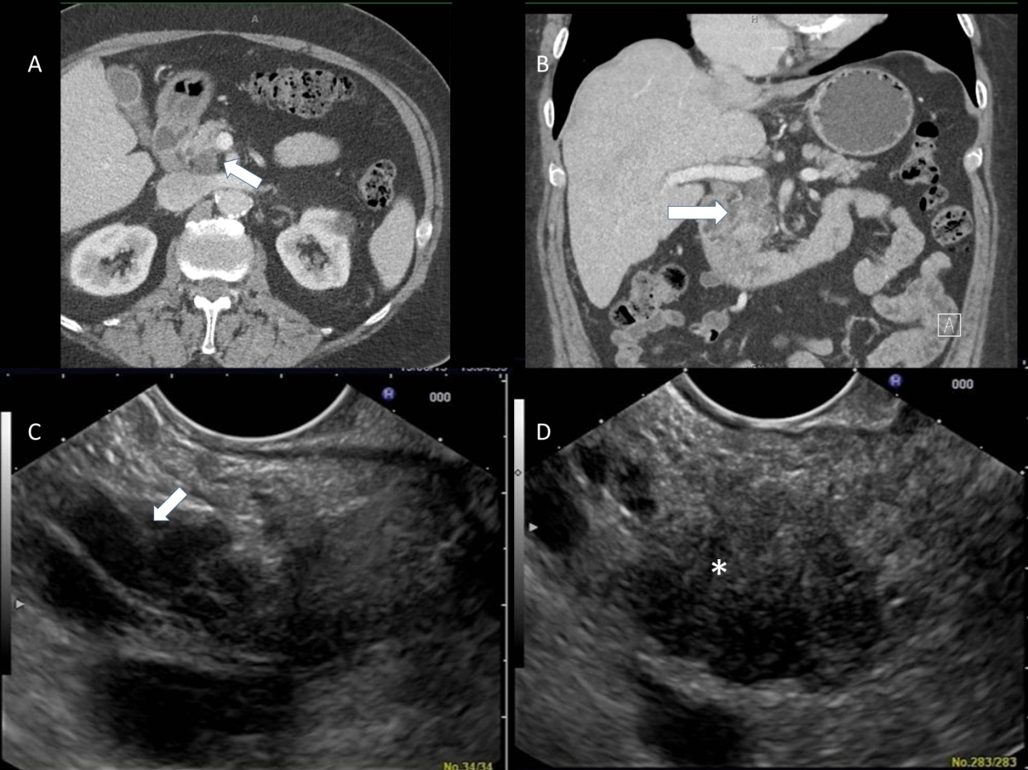

Figure 1 Abdominal imaging and endoscopic ultrasound of a patient 1 undergoing routine surveillance for a pancreatic cyst. (A) and (B) demonstrate the cystic lesion in the head/uncinate process of the pancreas as seen on computed tomography scan (arrow); and seen on endoscopic ultrasound (C). Image (D) shows a mass¹ within the head of the pancreas which was separate to the cyst.
(Note: *-1)
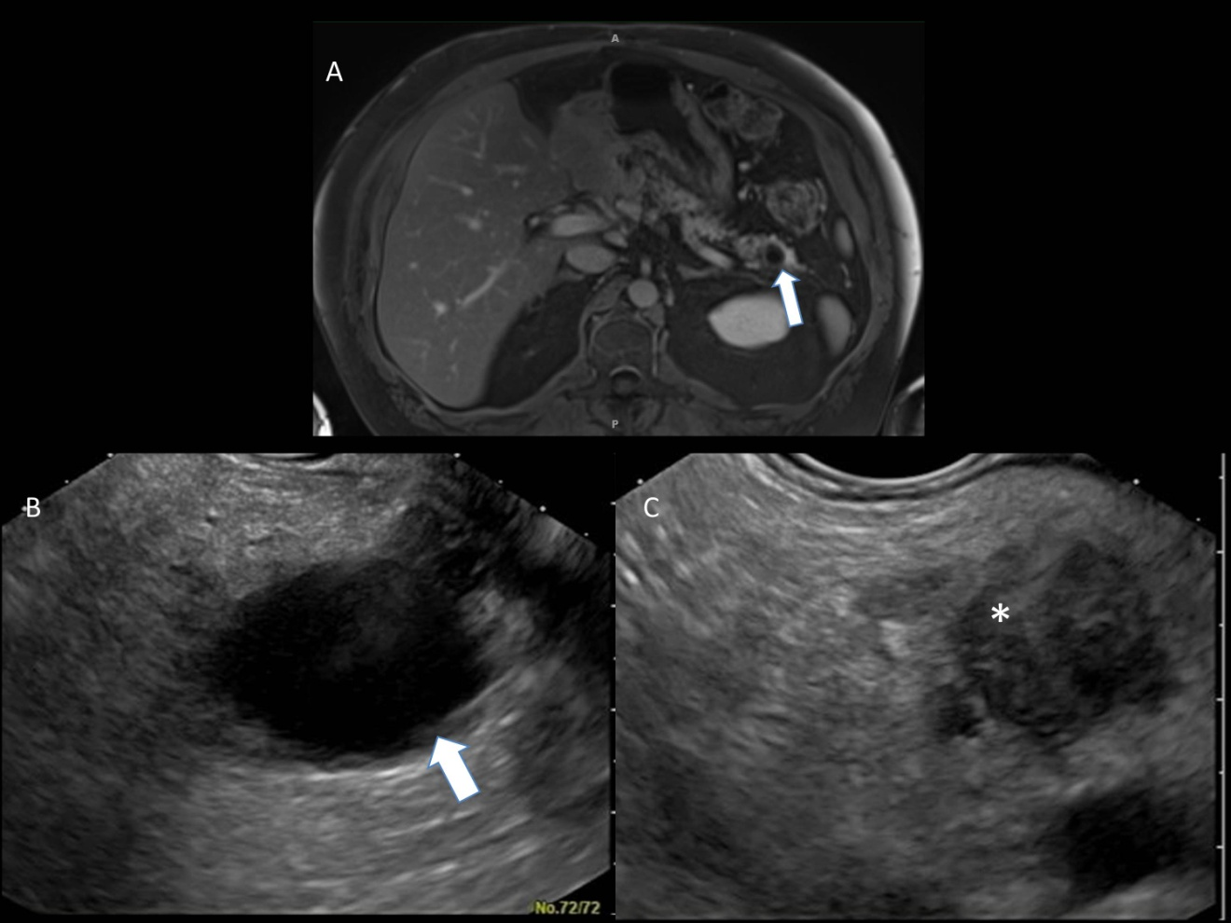
Figure 2 Abdominal imaging and endoscopic ultrasound of the pancreatic remnant in patient 2 who was status post pancreaticoduodenctomy for intraductal papillary mucinous neoplasm. A: magnetic resonance imaging (MRI) of the remnant pancreas performed 6 mo before the endoscopic ultrasound (EUS). The arrow demonstrates the cyst in the tail of the pancreas; B: EUS image of the cyst in the tail of the pancreas (arrow) corresponding to the MRI image seen in (A); C: demonstrates an ill-defined hypoechoic area¹ in the body of the pancreas.
(Note: *-1)

