Name of Journal: World Journal of Clinical Cases
Manuscript NO: 66601
Manuscript Type: ORIGINAL ARTICLE

Clinical Trials Study
Association between plasma dipeptidyl peptidase-4 levels and cognitive function in perinatal pregnant women with gestational diabetes mellitus

Sana SRGL et al. DPP4 causes cognitive impairment in GDM

Si-Ri-Gu-Leng Sana, En-You Li, Xi-Jin Deng, Lei Guo

Si-Ri-Gu-Leng Sana, En-You Li, Lei Guo, Department of Anesthesiology, the First Affiliated Hospital of Harbin Medical University, Harbin 150001, Heilongjiang Province, China

Xi-Jin Deng, Department of Anesthesiology, the Second Affiliated Hospital of Harbin Medical University, Harbin 150001, Heilongjiang Province, China

Author contributions: LI EY designed the study; Sana SRGL designed the study, collected data, and wrote and revised the manuscript; Deng XJ interpreted and analyzed the data; Guo L collected the data.

Corresponding author: En-You Li, PhD, Doctor, Professor, Department of Anesthesiology, the First Affiliated Hospital of Harbin Medical University, No. 23 Youzheng Street, Nangang District, Harbin 150001, Heilongjiang Province, China. lienyou_1111@163.com

Received: April 2, 2021
Revised: July 13, 2021
Accepted: September 6, 2021
Published online:

Abstract
BACKGROUND
Dipeptidyl peptidase-4 (DPP4) is associated with cognitive dysfunction in patients with type 2 diabetes.

AIM
To assess a possible relationship between serum DPP4 and cognitive function in perinatal pregnant women with gestational diabetes mellitus (GDM).

METHODS
The study subjects were divided into three groups: GDM group (n = 81), healthy pregnant (HP) group (n = 85), and control group (n = 51). The Montreal Cognitive Assessment (MoCA) was used to assess the cognitive status of each group. Venous blood samples were collected to measure blood lipids, glycated hemoglobin, and glucose levels. For each participant, a 3-mL blood sample was collected and centrifuged, and the serum was collected. Blood samples were stored at −80°C, and DPP4, interleukin-6 (IL-6), and 8-iso-prostaglandin F2α (8-iso-PGF2α), and brain-derived neurotrophic factor (BDNF) were detected using ELISA.

RESULTS
The MoCA scores in the GDM and HP groups were significantly different from those in the control group in terms of visuospatial/executive function and attention (P < 0.05); however, the scores were not significantly different between the GDM and HP groups (P > 0.05). In terms of language, the GDM group had significantly different scores from those in the other two groups (P < 0.05). In terms of memory, a significant difference was found between the HP and control groups (P < 0.05), as well as between the GDM and HP groups. The levels of DPP4, IL-6, and 8-iso-PGF2α in the GDM group were significantly higher than those in the HP and control groups (P < 0.05); however, the differences between these levels in the HP and control groups were not significant (P > 0.05). The level of BDNF in the GDM group was significantly lower than that in the HP and control groups (P < 0.05), although the difference in this level between the HP and control groups was not significant (P > 0.05).

CONCLUSION
Cognitive dysfunction in perinatal pregnant women with GDM mainly manifested as memory loss, which might be associated with elevated DPP4 levels.

Key Words: Gestational diabetes mellitus; Dipeptidyl peptidase-4; Cognitive function; Oxidative stress; Perinatal pregnant women; Montreal cognitive assessment

Sana SRGL, Li EY, Deng XJ, Guo L. Association between plasma dipeptidyl peptidase-4 levels and cognitive function in perinatal pregnant women with gestational diabetes mellitus. World J Clin Cases 2021; In press

Core Tip: It is generally believed that diabetes can cause cognitive impairment, and even is an important cause of Alzheimer’s disease. This study investigated whether gestational diabetes mellitus (GDM) induced cognitive decline in perinatal pregnant women and assessed a possible relationship between serum dipeptidyl peptidase-4 (DPP4) levels and maternal cognitive function in perinatal pregnant women with GDM, and detected DPP4 levels in cord blood. DPP4 may cause cognitive impairment by aggravating inflammatory response and oxidative stress response.

INTRODUCTION
With the advent of the two-child policy in China, the number of elderly parturient women is increasing, which has led to a rise in many pregnancy-related complications, the most common of which is gestational diabetes mellitus (GDM). The global incidence of DM during pregnancy is 15%, of which, GDM comprises 87.5% of cases^{[1]}. GDM causes serious adverse effects to the mother and fetus, and increases the risk of eclampsia, maternal metabolic disorders, miscarriage, premature birth, obstructed labor, macrosomia, fetal distress, neonatal pulmonary immaturity, and neonatal hypoglycemia^{[2]}. Although the pathogenesis of GDM is poorly understood, it might be associated with insulin resistance, and may share similarities with the pathogenesis of type 2 DM (T2DM). Most of the women with GDM regain normal glucose metabolism after delivery but face a significantly higher risk of developing DM than healthy pregnancy women in the future^{[3]}.
Several recent studies have found that T2DM can lead to cognitive dysfunction^{[3]}, which mostly manifests as impairments in various abilities such as memory and orientation. Zheng et al^{[4]} confirmed the correlation between cognitive dysfunction and serum dipeptidyl peptidase-4 (DPP4) activity in patients with T2DM; they also found that the underlying mechanism was related to DPP4-mediated activation of inflammatory responses and oxidative stress. Thus, they suggested that altered DPP4 activity could be a risk factor for cognitive dysfunction in T2DM. Other studies have also reported a decline in verbal memory, associative learning, reaction time, and verbal recall in healthy pregnant (HP) women^{[5-7]}. However, only a few studies have examined the presence of altered cognitive function in patients with GDM. Therefore, this study aimed to determine whether having GDM for nearly 6 mo during the perinatal period, combined with the stress of anxiety during pregnancy, could cause mild cognitive impairment (MCI), and whether there are subsequent changes in serum DPP4 levels.

MATERIALS AND METHODS
Subjects and protocols
Patients aged 18–35 years, with American Society of Anesthesiologists physical status I/II, were included in this study. A total of 100 consecutive perinatal pregnant women with GDM who were diagnosed, followed up, and treated at the First Affiliated Hospital of Harbin Medical University were included in the study (GDM group). One hundred age-matched perinatal pregnant women without DM comprised the HP group. The healthy control group included 51 nonpregnant female volunteers of similar age with normal blood glucose levels. All patients and volunteers read and signed informed consent forms before enrolment in the study. The study protocol was approved by the Ethics Committee of the First Affiliated Hospital of Harbin Medical University, and was registered with the Chinese Clinical Trial Register (registration number: ChiCTR2000038703).
GDM was diagnosed with at least one abnormal result during the oral glucose tolerance test: plasma glucose during fasting, ≥ 92 mg/dL (5.1 mmol/L); at 1 h, ≥ 180 mg/dL (10.0 mmol/L); or at 2 h, ≥ 153 mg/dL (8.5 mmol/L). Women with fasting plasma glucose ≥ 126 mg/dL (7.0 mmol/L), glycated hemoglobin (HbA1c) ≥ 6.5%, or random plasma glucose ≥ 200 mg/dL (11.1 mmol/L) were diagnosed with overt diabetes and excluded. Subjects on medications that affect cognitive function, including corticosteroids, antidepressants, and antiepileptics, were also excluded. In addition, all patients with other chronic diseases were excluded^{[8]}. The Hamilton Depression Rating Scale was used to assess the psychological status of pregnant women; those with a score > 7, who might have depression, were excluded^{[9]}.
On the survey date, all enrolled patients underwent routine medical history inquiries, physical examinations, and laboratory measurements. Clinical research coordinators used a standard questionnaire to collect information on demographic characteristics and medical history. All pregnant women were instructed to maintain their usual physical activity and diet for at least 3 d before the survey. After an overnight fast of ≥ 10 h, venous blood samples were collected to measure blood lipid, HbA1c and glucose levels. For each participant, a 3-mL blood sample was collected and centrifuged, and the serum was collected. Blood samples were stored at −80°C, and DPP4, interleukin-6 (IL-6), 8-iso-prostaglandinF2α (8-iso-PGF2α), and brain-derived neurotrophic factor (BDNF) were detected using ELISA (Mlbio, Shanghai, China). All measurements were performed within 6 mo of sample collection.
Umbilical cord blood was collected at the time of delivery from participants in the GDM and HP groups. Serum DPP4 level was measured using ELISA in these groups as well.

Assessment of cognitive function
To assess cognitive function, the Montreal Cognitive Assessment (MoCA), which is a brief cognitive screen used in a variety of clinical settings to screen for MCI, was administered^{[10]}. The cognitive assessment was conducted in a quiet room, without distractions, by a physical therapist trained in the administration of the MoCA. The maximum score for the MoCA is 30, and the assessment evaluates visuospatial/executive, naming, attention, language, abstraction, orientation, and delayed recall abilities, among others. A score of ≤ 25 indicates MCI^{[11,12]}.

Statistical analysis
The data were analyzed using SPSS 19.0. All data were tested for normality and homogeneity of variance. Normally distributed data were expressed as mean ± standard deviation. Normally distributed continuous variables were compared using Student’s t test, while those with non-normal distributions were compared using the Mann–Whitney U test; multiple comparisons between groups were performed using the least significant difference method. Categorical data were presented as numbers and percentages, and comparisons between groups were performed using the two-sided χ² test. Correlations of DPP4 and BDNF levels with those of IL-6 and 8-iso-PGF2α, respectively, were performed using Pearson’s correlation coefficient, and P < 0.05 was considered statistically significant.

RESULTS
Demographic information
A total of 166 pregnant women and 51 nonpregnant healthy volunteers were enrolled in this study; they included 83 pregnant women with GDM in the GDM group, 85 HP women in the HP group, and 51 nonpregnant healthy volunteers in the control group (Figure 1). The weight, blood glucose level, and HbA1c level of the participants in the GDM group were significantly higher than those in the other two groups (P < 0.05) (Table 1).

MoCA scores
The MoCA scores in the GDM and HP groups were significantly different from those in the control group in terms of visuospatial/executive function and attention (P < 0.05); however, the scores were not different between the GDM and HP groups (P > 0.05). In terms of language, the GDM group had significantly different scores from those in the other two groups (P < 0.05). In terms of memory, a significant difference was found between the HP and control groups (P < 0.05), as well as between the GDM and HP groups (P < 0.05) (Table 2).

Expression of serum indicators
The levels of DPP4, IL-6, and 8-iso-PGF2α in the GDM group were significantly higher than those in the HP and control groups (P < 0.05); however, the differences between these levels in the HP and control groups were not significant (P > 0.05). The level of BDNF in the GDM group was significantly lower than that in the HP and control groups (P < 0.05), although the difference in this level between the HP and control groups was not significant (P > 0.05) (Figure 2 and Table 3). In the GDM group, the elevated DPP4 level significantly correlated with the elevated levels of IL-6 and 8-iso-PGF2α (P < 0.05). Moreover, the elevated IL-6 and 8-iso-PGF2α levels significantly correlated with decreased BDNF levels (P < 0.05) (Table 4). Cord blood DPP4 level in the GDM group was significantly higher than that in the HP group (P < 0.05) (Figure 2 and Table 3).

DISCUSSION
Although the viewpoint that pregnant women experience deficits in memory is widespread, evidence supporting this supposition is limited in the literature, especially in humans^{[13]}. Based on the results of this study, the following conclusions can be drawn. (1) Perinatal pregnant women with GDM experience cognitive decline, which mainly involves memory loss. (2) Elevated serum DPP4 level is involved in the cognitive decline of perinatal pregnant women with GDM, and they are significantly correlated. Possible mechanisms underlying these findings may include the activation of inflammatory mediators and oxidative stress pathways due to elevated DPP4 level. (3) DPP4 levels are significantly higher in the cord blood of women with GDM than those without GDM.
Our demographic results showed that pregnant women with GDM had significantly different body weight as well as blood glucose and HbA1c levels than those in the HP group. Although the blood glucose levels in the GDM group were maintained within the normal range, most patients had blood glucose or HbA1c levels near the upper limit, thus indicating the persistence of insulin resistance and metabolic disorders. Some studies suggest that women with GDM have a 20%–70% chance of developing T2DM within 10 years of delivery^{[14]}. The pathogenesis of GDM is complex, involving beta-cell dysfunction, abnormal neuroendocrine function, and abnormal lipid metabolism^{[15]}. Current treatments for GDM are limited to dietary interventions and insulin use, which often has unsatisfactory therapeutic efficacy due to the presence of insulin resistance. Therefore, an in-depth analysis on the etiology, mechanisms, and treatment strategies of GDM is of crucial significance for reducing complications during pregnancy and neonatal morbidity.
In this study, the MoCA scale, which is the most sensitive instrument for detecting cognitive decline, was used to assess cognitive function in perinatal pregnant women with GDM. Our results showed that the GDM and HP groups were significantly different from the control group in terms of executive function and attention, but there was no difference between the GDM and HP groups for these parameters. In addition, there was a significant difference in language scores between the GDM group and the other two groups. It is worth noting that in terms of memory, there was a significant difference between the HP and control groups, as well as between the GDM and HP groups. This indicates that perinatal pregnant women with GDM experience a significant decline in memory. Since the memory task is worth 5 points in the MoCA, and accounts for the largest proportion of scores among all abilities, it may have contributed substantially to the differences in the total score between the groups. However, all groups were within the normal range. Thus, the results of the MoCA scale support our previous speculation that although GDM patients do not reach the threshold for MCI, they still experience some degree of cognitive decline.
The effect of childbirth on women’s cognitive ability is an important issue because it might affect the job opportunities of working women of childbearing age. As such, we discuss the influence of pregnancy on women’s cognitive function with caution. The average score of HP women was lower than that of healthy nonpregnant volunteer women of similar age with respect to the MoCA score. However, the degree of cognitive decline is smaller than that in pregnant women with GDM. In the late stages of pregnancy, most women are no longer in a working environment, and the brain moves into a state of excessive relaxation in terms of cognition, which might be one of the reasons for the mild cognitive decline in pregnant women^{[16,17]}. The mild stress, anxiety, and depression surrounding childbirth during pregnancy could also affect the cognitive function of pregnant women to a certain extent^{[18,19]}. However, most of these negative emotions during pregnancy would resolve following childbirth. Conversely, the levels of DPP4 and BDNF were closer to those of healthy women; therefore, we believe that the decline of cognitive function in pregnant women is minimal.
Our focus in this study was on memory loss in perinatal pregnant women with GDM, which was pronounced when compared with that in the HP group. This may be a transient phenomenon, and its long-term effects are still unclear; however, its mechanisms might be similar to that of cognitive impairment in patients with T2DM. Several recent studies have shown that DPP4 is strongly associated with cognitive impairment in T2DM patients^{[4]}, which prompted us to examine DPP4 levels. DPP4 (also known as CD26) is an exopeptidase that cleaves peptides after the second position from the N terminus (NH2-Xaa-Pro)^{[20]}. DPP4 is a widely expressed multifunctional enzyme that exists in two forms: one is a membrane-anchored cell surface protein, and the other is a soluble form present in the plasma^{[21,22]}. DPP4 levels are higher in subjects who are obese and have T2DM, predisposing them to hyperglycemia, inflammation and oxidative stress^{[23,24]}. DPP4 degrades glucagon-like peptide-1 (GLP-1), as well as several other peptides, including glucose-dependent insulinotropic polypeptide, brain natriuretic peptide, substance P, neuropeptide Y, and stromal-derived factor-1α^{[25]}. More interestingly, there is a study showing that increased DPP4 activity is independently associated with MCI in elderly patients with T2DM^{[4]}. Reports that DPP4 is associated with cognitive dysfunction are limited^{[26]}. These reports have mainly been about the cognitive dysfunction in T2DM. DPP4 play crucial roles in GLP-1 degradation and in the development of inflammation and oxidative stress^{[27]}. Inflammation and oxidative stress have been widely demonstrated to be strongly associated with cognitive decline^{[28]}. DPP4 inhibitors ameliorate cognitive impairment by suppressing inflammatory reactions, oxidative stress and GLP-1 degradation^{[29]}. DPP4 inhibitors might have therapeutic potential for reducing amyloid-β-protein-induced impairment of insulin signaling and neurotoxicity in the pathogenesis of Alzheimer’s disease^{[30]}. In this study, the results of the DPP4 assay showed that women in the GDM group had significantly higher expression levels than those in the HP group. We hypothesized that the high level of DPP4 expression may have contributed to the cognitive decline in patients with GDM. To investigate the reason for this, we further tested the patients’ level of inflammatory response and oxidative stress.
Systemic inflammation has been suggested to play an important pathogenic role in the late severe stages of cognitive decline, and inflammatory markers, such as IL-6, were only found to be elevated in patients with dementia but not in those with cognitive decline^{[31,32]}. We propose that this discrepancy could be due in part to differences in the methods of detecting inflammatory cytokines and the diagnosis of cognitive dysfunction. The majority of the studies support the possibility that systemic inflammation could be a pathophysiological cascade response to cognitive decline, and do not explicitly exclude low-grade inflammatory diseases, such as T2DM, cardiovascular disease, and GDM. The present study showed that the serum IL-6 level in perinatal pregnant women with GDM is significantly elevated and correlates with the elevated DPP4 level. Therefore, we speculate that elevated serum DPP4 in perinatal pregnant women with GDM might exacerbate the progression of cognitive dysfunction to some extent via its proinflammatory effects.
Besides systemic inflammation, oxidative stress has also been shown to cause cognitive decline. 8-iso-PGF2α is a biologically active prostaglandin-like substance and a specific product resulting from the oxygen free radical peroxidation of cellular membranes. This indicator can accurately reflect lipid peroxidation in patients with hypoxia–ischemia–reperfusion^{[33]}. The production of 8-iso-PGF2α is not dependent on cyclooxygenase (COX), but on the damage caused by oxygen free radicals to polyunsaturated fatty acids (arachidonic acid) in lipid cell membranes. Thus, its expression levels in vivo are not affected by the use of nonsteroidal anti-inflammatory drugs, such as aspirin, which can alter COX activity. Therefore, 8-iso-PGF2α is an ideal biochemical indicator for the clinical determination of the degree of free radical oxidation in patients and the efficacy of antioxidant therapy. Furthermore, studies have shown that increased peripheral blood 8-iso-PGF2α levels in pregnant women positively correlate with disease severity^{[34]}. One study confirmed that DPP4 increases the production of reactive oxygen species in endothelial cells in a dose-dependent manner^{[35]}. Our data also suggest a positive correlation between 8-iso-PGF2α and DPP4 activity.
We also examined the serum levels of BDNF, which is a plasma marker associated with cognitive function. BDNF downregulation could lead to synaptic loss and neurodegeneration^{[36]}. Our results indicate that patients in the GDM group had significantly lower expression levels. This suggests that patients in the GDM group not only experienced cognitive decline, but also showed changes in plasma marker levels, which is the greatest cause of our concern.
In this study, we found that DPP4, IL-6, and 8-iso-PGF2α levels were significantly higher and BDNF level was lower in pregnant women with GDM, and that these biomarkers were mutually correlated to a certain extent. Zheng et al^{[4]} found that DPP4, IL-6 and 8-iso-PGF2α levels were elevated in patients with T2DM and associated with their cognitive dysfunction. Furthermore, the increased DPP4 levels correlated with increased IL-6 and 8-iso-PGF2α levels. In this study, we found that elevated serum DPP4 levels in perinatal pregnant women with GDM positively correlated with elevated serum IL-6 and 8-iso-PGF2α levels, while the latter was also correlated with decreased BDNF levels. Therefore, we speculate that elevated DPP4 levels might exacerbate the inflammatory response and oxidative stress in pregnant women with GDM. These inflammatory and oxidative stress factors can cross the blood–brain barrier and act on the nervous system to reduce BDNF levels, which will affect hippocampal function, thereby exacerbating memory loss. DPP4 might not only be involved in the process of cognitive dysfunction in pregnant women with GDM, but also in insulin resistance, lipid oxidative stress, and other pathophysiological processes. It may also serve as a potential target for GDM treatment, which is the next step in our research.
The limitations of this study were as follows: (1) the sample size was small; and (2) we observed the cognitive status of pregnant women with GDM and discussed the pathophysiological mechanisms associated with DPP4 from the perspective of inflammatory factors and oxidative stress. However, complex mechanisms may be involved in memory loss in pregnant women with GDM, not limited to the effects of DPP4 alone. Therefore, further elucidation of the underlying mechanisms is needed.
This study also found significantly elevated levels of DPP4 in the cord blood, suggesting that DPP4 could affect fetal development through the placental barrier. However, we did not examine the effect of this change on the fetus.
We believe that in addition to strict dietary control and glycemic control, it is also important to stabilize the moods of perinatal pregnant women with GDM to reduce inflammatory and stress responses. In particular, we should pay attention to methods of controlling intraoperative patient stress during anesthesia for painless natural delivery or caesarean delivery. This is not only crucial for the mother but also for the fetus.

CONCLUSION
Cognitive dysfunction in perinatal pregnant women with GDM mainly manifested as memory loss, which might be associated with elevated DPP4 levels.

ARTICLE HIGHLIGHTS
Research background
Studies have confirmed that type 2 diabetes mellitus (DM) can cause cognitive impairment. The mechanism is not clear. Dipeptidyl peptidase-4 (DPP4) may be involved in this process.

Research motivation
The main problem in this study is whether cognitive impairment exists in pregnant women with gestational DM (GDM) and whether it is related to DPP4. This has a great impact on the physical and mental health of pregnant women with perinatal GDM and the health of the fetus.

Research objectives
Objective to study the cognitive function of pregnant women with GDM, and to find out whether the pathway is related to DPP4.

Research methods
They were divided into three groups: GDM group, healthy pregnant group and control group. Women in the three groups were scored with Montreal Cognitive Assessment. Venous blood was collected from women in each group, serum was separated, and serum indexes such as DPP4, interleukin-6, and 8-iso-prostaglandinF2α, and brain-derived neurotrophic factor (BDNF) were detected by ELISA.

Research results
Compared with the other two groups, the GDM group had cognitive impairment, especially memory impairment. DPP4 may induce the change of BDNF by promoting oxidative stress and inflammatory response.

Research conclusions
GDM can lead to cognitive dysfunction in pregnant women, mainly manifested as memory loss. DPP4 may be involved in this process.

Research perspectives
Perinatal cognitive decline is worth our attention, especially in GDM pregnant women. How to prevent and treat is the key. Whether DPP4 can be used as a therapeutic target needs further study.

ACKNOWLEDGMENTS
Thanks for the support from the Department of Anesthesiology, the First Affiliated Hospital of Harbin Medical University. Thanks to the statistics teacher of Harbin Medical University for his guidance and statistics. Thanks for the help of the Department of Obstetrics and neurology, the First Affiliated Hospital of Harbin Medical University.

REFERENCES
1 Carpita B, Muti D, Dell'Osso L. Oxidative Stress, Maternal Diabetes, and Autism Spectrum Disorders. Oxid Med Cell Longev 2018; 2018: 3717215 [PMID: 30524654 DOI: 10.1155/2018/3717215]
2 Plows JF, Stanley JL, Baker PN, Reynolds CM, Vickers MH. The Pathophysiology of Gestational Diabetes Mellitus. Int J Mol Sci 2018; 19 [PMID: 30373146 DOI: 10.3390/ijms19113342]
3 Umegaki H, Hayashi T, Nomura H, Yanagawa M, Nonogaki Z, Nakshima H, Kuzuya M. Cognitive dysfunction: an emerging concept of a new diabetic complication in the elderly. Geriatr Gerontol Int 2013; 13: 28-34 [PMID: 22882533 DOI: 10.1111/j.1447-0594.2012.00922.x]
4 Zheng T, Qin L, Chen B, Hu X, Zhang X, Liu Y, Liu H, Qin S, Li G, Li Q. Association of Plasma DPP4 Activity With Mild Cognitive Impairment in Elderly Patients With Type 2 Diabetes: Results From the GDMD Study in China. Diabetes Care 2016; 39: 1594-1601 [PMID: 27371673 DOI: 10.2337/dc16-0316]
5 Glynn LM. Giving birth to a new brain: hormone exposures of pregnancy influence human memory. Psychoneuroendocrinology 2010; 35: 1148-1155 [PMID: 20304563 DOI: 10.1016/j.psyneuen.2010.01.015]
6 Janes C, Casey P, Huntsdale C, Angus G. Memory in pregnancy. I: Subjective experiences and objective assessment of implicit, explicit and working memory in primigravid and primiparous women. J Psychosom Obstet Gynaecol 1999; 20: 80-87 [PMID: 10422039 DOI: 10.3109/01674829909075580]
7 Casey P, Huntsdale C, Angus G, Janes C. Memory in pregnancy. II: Implicit, incidental, explicit, semantic, short-term, working and prospective memory in primigravid, multigravid and postpartum women. J Psychosom Obstet Gynaecol 1999; 20: 158-164 [PMID: 10497759 DOI: 10.3109/01674829909075590]
8 Keskin FE, Ozyazar M, Pala AS, Elmali AD, Yilmaz B, Uygunoglu U, Bozluolcay M, Tuten A, Bingöl A, Hatipoglu E. Evaluation of cognitive functions in gestational diabetes mellitus. Exp Clin Endocrinol Diabetes 2015; 123: 246-251 [PMID: 25868060 DOI: 10.1055/s-0034-1395634]
9 Zimmerman M, Martinez JH, Young D, Chelminski I, Dalrymple K. Severity classification on the Hamilton Depression Rating Scale. J Affect Disord 2013; 150: 384-388 [PMID: 23759278 DOI: 10.1016/j.jad.2013.04.028]
10 O'Driscoll C, Shaikh M. Cross-Cultural Applicability of the Montreal Cognitive Assessment (MoCA): A Systematic Review. J Alzheimers Dis 2017; 58: 789-801 [PMID: 28482634 DOI: 10.3233/JAD-161042]
11 King LA, Peterson DS, Mancini M, Carlson-Kuhta P, Fling BW, Smulders K, Nutt JG, Dale M, Carter J, Winters-Stone KM, Horak FB. Do cognitive measures and brain circuitry predict outcomes of exercise in Parkinson Disease: a randomized clinical trial. BMC Neurol 2015; 15: 218 [PMID: 26499867 DOI: 10.1186/s12883-015-0474-2]
12 Silva-Batista C, Corcos DM, Kanegusuku H, Piemonte MEP, Gobbi LTB, de Lima-Pardini AC, de Mello MT, Forjaz CLM, Ugrinowitsch C. Balance and fear of falling in subjects with Parkinson's disease is improved after exercises with motor complexity. Gait Posture 2018; 61: 90-97 [PMID: 29310015 DOI: 10.1016/j.gaitpost.2017.12.027]
13 Brown E, Schaffir J. "Pregnancy Brain": A Review of Cognitive Changes in Pregnancy and Postpartum. Obstet Gynecol Surv 2019; 74: 178-185 [PMID: 31634921 DOI: 10.1097/OGX.0000000000000655]
14 Kramer CK, Campbell S, Retnakaran R. Gestational diabetes and the risk of cardiovascular disease in women: a systematic review and meta-analysis. Diabetologia 2019; 62: 905-914 [PMID: 30843102 DOI: 10.1007/s00125-019-4840-2]
15 Radzicka S, Pietryga M, Iciek R, Brązert J. The role of visfatin in pathogenesis of gestational diabetes (GDM). Ginekol Pol 2018; 89: 518-521 [PMID: 30318580 DOI: 10.5603/GP.a2018.0088]
16 Al-Thaqib A, Al-Sultan F, Al-Zahrani A, Al-Kahtani F, Al-Regaiey K, Iqbal M, Bashir S. Brain Training Games Enhance Cognitive Function in Healthy Subjects. Med Sci Monit Basic Res 2018; 24: 63-69 [PMID: 29674605 DOI: 10.12659/msmbr.909022]
17 Nouchi R, Taki Y, Takeuchi H, Hashizume H, Nozawa T, Kambara T, Sekiguchi A, Miyauchi CM, Kotozaki Y, Nouchi H, Kawashima R. Brain training game boosts executive functions, working memory and processing speed in the young adults: a randomized controlled trial. PLoS One 2013; 8: e55518 [PMID: 23405164 DOI: 10.1371/journal.pone.0055518]
18 Gawali NB, Bulani VD, Gursahani MS, Deshpande PS, Kothavade PS, Juvekar AR. Agmatine attenuates chronic unpredictable mild stress-induced anxiety, depression-like behaviours and cognitive impairment by modulating nitrergic signalling pathway. Brain Res 2017; 1663: 66-77 [PMID: 28302445 DOI: 10.1016/j.brainres.2017.03.004]
19 Glover V. Maternal depression, anxiety and stress during pregnancy and child outcome; what needs to be done. Best Pract Res Clin Obstet Gynaecol 2014; 28: 25-35 [PMID: 24090740 DOI: 10.1016/j.bpobgyn.2013.08.017]
20 De Meester I, Korom S, Van Damme J, Scharpé S. CD26, let it cut or cut it down. Immunol Today 1999; 20: 367-375 [PMID: 10431157 DOI: 10.1016/S0167-5699(99)01486-3]
21 Matteucci E, Giampietro O. Dipeptidyl peptidase-4 (CD26): knowing the function before inhibiting the enzyme. Curr Med Chem 2009; 16: 2943-2951 [PMID: 19689275 DOI: 10.2174/092986709788803114]
22 Ohnuma K, Dang NH, Morimoto C. Revisiting an old acquaintance: CD26 and its molecular mechanisms in T cell function. Trends Immunol 2008; 29: 295-301 [PMID: 18456553 DOI: 10.1016/j.it.2008.02.010]
23 Zheng T, Gao Y, Baskota A, Chen T, Ran X, Tian H. Increased plasma DPP4 activity is predictive of prediabetes and type 2 diabetes onset in Chinese over a four-year period: result from the China National Diabetes and Metabolic Disorders Study. J Clin Endocrinol Metab 2014; 99: E2330-E2334 [PMID: 25029421 DOI: 10.1210/jc.2014-1480]
24 Lamers D, Famulla S, Wronkowitz N, Hartwig S, Lehr S, Ouwens DM, Eckardt K, Kaufman JM, Ryden M, Müller S, Hanisch FG, Ruige J, Arner P, Sell H, Eckel J. Dipeptidyl peptidase 4 is a novel adipokine potentially linking obesity to the metabolic syndrome. Diabetes 2011; 60: 1917-1925 [PMID: 21593202 DOI: 10.2337/db10-1707]
25 Kosaraju J, Holsinger RMD, Guo L, Tam KY. Linagliptin, a Dipeptidyl Peptidase-4 Inhibitor, Mitigates Cognitive Deficits and Pathology in the 3xTg-AD Mouse Model of Alzheimer's Disease. Mol Neurobiol 2017; 54: 6074-6084 [PMID: 27699599 DOI: 10.1007/s12035-016-0125-7]
26 Chen B, Zheng T, Qin L, Hu X, Zhang X, Liu Y, Liu H, Qin S, Li G, Li Q. Strong Association between Plasma Dipeptidyl Peptidase-4 Activity and Impaired Cognitive Function in Elderly Population with Normal Glucose Tolerance. Front Aging Neurosci 2017; 9: 247 [PMID: 28798686 DOI: 10.3389/fnagi.2017.00247]
27 Zheng T, Baskota A, Gao Y, Chen T, Tian H, Yang F. Increased plasma DPP4 activities predict new-onset hyperglycemia in Chinese over a four-year period: possible associations with inflammation. Metabolism 2015; 64: 498-505 [PMID: 25592717 DOI: 10.1016/j.metabol.2014.12.004]
28 Swomley AM, Butterfield DA. Oxidative stress in Alzheimer disease and mild cognitive impairment: evidence from human data provided by redox proteomics. Arch Toxicol 2015; 89: 1669-1680 [PMID: 26126631 DOI: 10.1007/s00204-015-1556-z]
29 Gault VA, Lennox R, Flatt PR. Sitagliptin, a dipeptidyl peptidase-4 inhibitor, improves recognition memory, oxidative stress and hippocampal neurogenesis and upregulates key genes involved in cognitive decline. Diabetes Obes Metab 2015; 17: 403-413 [PMID: 25580570 DOI: 10.1111/dom.12432]
30 Angelopoulou E, Piperi C. DPP-4 inhibitors: a promising therapeutic approach against Alzheimer's disease. Ann Transl Med 2018; 6: 255 [PMID: 30069457 DOI: 10.21037/atm.2018.04.41]
31 Stephan BC, Hunter S, Harris D, Llewellyn DJ, Siervo M, Matthews FE, Brayne C. The neuropathological profile of mild cognitive impairment (MCI): a systematic review. Mol Psychiatry 2012; 17: 1056-1076 [PMID: 22143004 DOI: 10.1038/mp.2011.147]
32 Saleem M, Herrmann N, Swardfager W, Eisen R, Lanctôt KL. Inflammatory Markers in Mild Cognitive Impairment: A Meta-Analysis. J Alzheimers Dis 2015; 47: 669-679 [PMID: 26401702 DOI: 10.3233/JAD-150042]
33 Su G, Wang T, Zhang T, Yang HX, Yu SS, Dai WL, Mi SH. Urinary 8-iso-prostaglandin F_{2α} as a risk marker for the vulnerability of culprit plaque in diabetic patients with stable coronary artery disease. Prostaglandins Leukot Essent Fatty Acids 2019; 140: 11-17 [PMID: 30553398 DOI: 10.1016/j.plefa.2018.11.008]
34 Turpin CA, Sakyi SA, Owiredu WK, Ephraim RK, Anto EO. Association between adverse pregnancy outcome and imbalance in angiogenic regulators and oxidative stress biomarkers in gestational hypertension and preeclampsia. BMC Pregnancy Childbirth 2015; 15: 189 [PMID: 26303772 DOI: 10.1186/s12884-015-0624-y]
35 Ishibashi Y, Matsui T, Maeda S, Higashimoto Y, Yamagishi S. Advanced glycation end products evoke endothelial cell damage by stimulating soluble dipeptidyl peptidase-4 production and its interaction with mannose 6-phosphate/insulin-like growth factor II receptor. Cardiovasc Diabetol 2013; 12: 125 [PMID: 23984879 DOI: 10.1186/1475-2840-12-125]
36 Rosa E, Fahnestock M. CREB expression mediates amyloid β-induced basal BDNF downregulation. Neurobiol Aging 2015; 36: 2406-2413 [PMID: 26025137 DOI: 10.1016/j.neurobiolaging.2015.04.014]

Footnotes
Institutional review board statement: The study was reviewed and approved by the Ethics Committee of the First Affiliated Hospital of Harbin Medical University, No. IRB-AF/SC-04/01.0.

Clinical trial registration statement: This study is registered at Chinese Clinical Trial Registry, No. ChiCTR2000038703.

Informed consent statement: All study participants or their legal guardian provided informed written consent about personal and medical data collection prior to study enrolment.

Conflict-of-interest statement: The authors declared no potential conflicts of interest with respect to the research, authorship, and/or publication of this article.

Data sharing statement: The datasets generated during and/or analyzed during the current study are not publicly available but are available from the corresponding author on reasonable request.

CONSORT 2010 statement: The authors have read the CONSORT 2010 Statement, and the manuscript was prepared and revised according to the CONSORT 2010 Statement.

Open-Access: This article is an open-access article that was selected by an in-house editor and fully peer-reviewed by external reviewers. It is distributed in accordance with the Creative Commons Attribution NonCommercial (CC BY-NC 4.0) license, which permits others to distribute, remix, adapt, build upon this work non-commercially, and license their derivative works on different terms, provided the original work is properly cited and the use is non-commercial. See: http://creativecommons.org/Licenses/by-nc/4.0/

Manuscript source: Unsolicited manuscript

Peer-review started: April 2, 2021
First decision: July 3, 2021
Article in press:

Specialty type: Medicine, research and experimental
Country/Territory of origin: China
Peer-review report’s scientific quality classification
Grade A (Excellent): A
Grade B (Very good): 0
Grade C (Good): 0
Grade D (Fair): 0
Grade E (Poor): 0

P-Reviewer: Dąbrowski M S-Editor: Fan JR L-Editor: Kerr C P-Editor:

Figure Legends
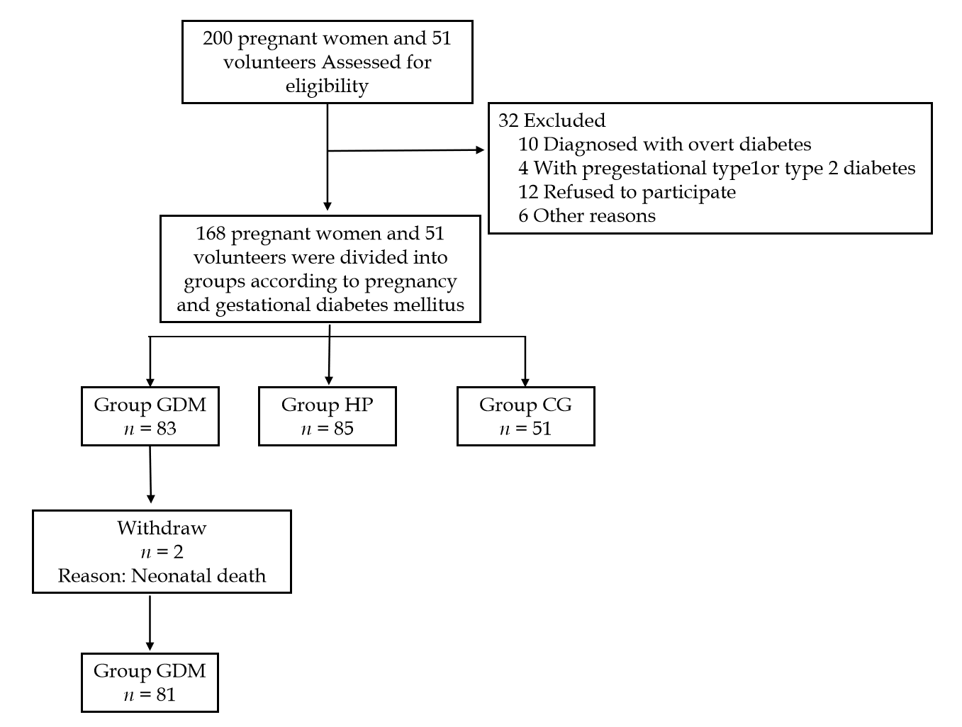
Figure 1 Patient recruitment flowchart. GDM: Gestational diabetes mellitus; HP: Healthy pregnant group; CG: Control group.
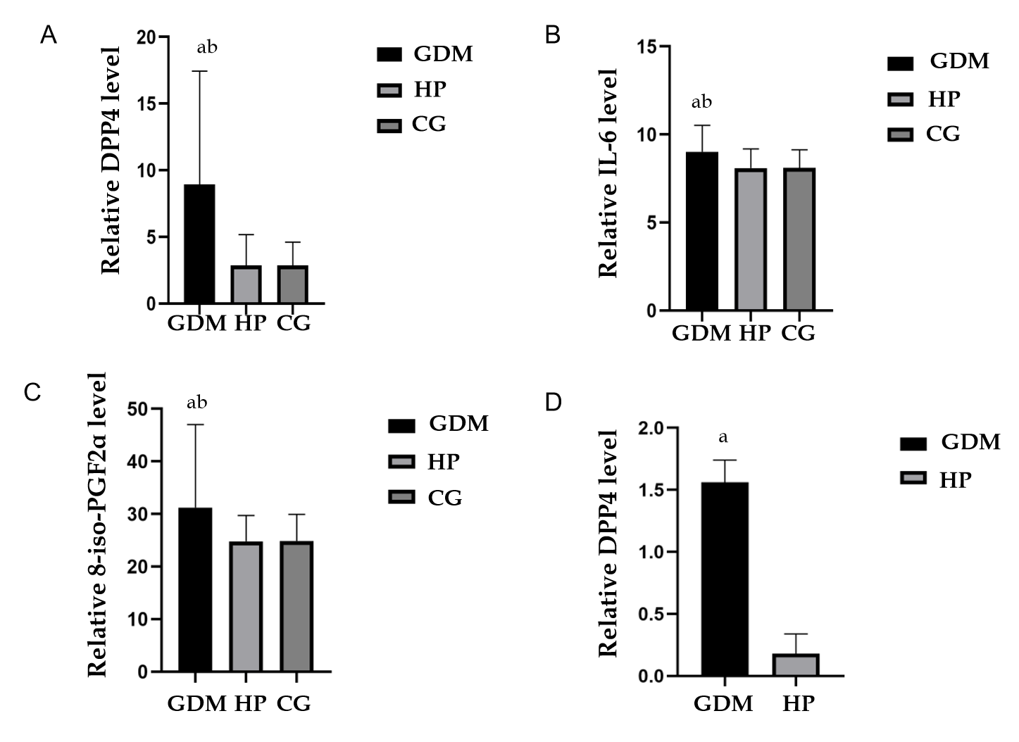
Figure 2 DPP4, IL-6 and 8-iso-PGF2α level. A–C: Concentration of DPP4, IL-6 and 8-iso-PGF2α in each group; D: Concentration of DPP4 in the umbilical cord blood of each group. Compared with the HP group, ªP < 0.05; compared with the CG, ^{b}P < 0.05. GDM: Gestational diabetes mellitus; HP: Healthy pregnant group; CG: Control group; DPP4: Dipeptidyl peptidase-4; IL-6: Interleukin-6; 8-iso-PGF2α: 8-iso-prostaglandinF2α.
Table 1 Demographic characteristics
 | GDM | HP | CG | F | P value
Sample | 81 | 85 | 51
Age (yr) | 29.40 ± 4.06 | 29.86 ± 4.39 | 29.63 ± 4.33 | 0.24 | 0.79
Height (cm) | 163.86 ± 4.79 | 164.11 ± 5.78 | 164.14 ± 5.05 | 0.06 | 0.94
Weight (kg) | 78.96 ± 11.58 | 74.35 ± 9.57 | 58.60 ± 7.42 | 68.32 | < 0.001
Glu | 4.90 ± 1.32 | 3.99 ± 0.71 | 4.83 ± 0.54 | 22.05 | < 0.001
HBA1c (%) | 5.81 ± 0.61 | 4.73 ± 0.93 |  | 5.32 | < 0.001
Education, n (%) |  |  |  | 6.95 | 0.14
Primary school | 8 (9.9) | 2 (2.4) | 1 (2.0)
High school | 22 (27.2) | 20 (23.5) | 14 (27.5)
University | 51 (63.0) | 63 (74.1) | 36 (70.6)
Data are expressed as means ± SD or number. GDM: Gestational diabetes mellitus; HP: Healthy pregnant group; CG: Control group; HbA1c: Glycated hemoglobin; Glu: Glucose.

Table 2 MoCA test scores
 | GDM | HP | CG | P value (GDM vs HP) | P value (GDM vs CG) | P value (HP vs CG)
Sample | 81 | 85 | 51
Visuospatial/executive | 4.52 ± 0.84 | 4.65 ± 0.63 | 4.94 ± 0.31 | 0.21 | 0.01 | 0.01
Naming | 3.00 ± 0.00 | 3.00 ± 0.00 | 3.00 ± 0.00 | / | / | /
Attention | 5.53 ± 0.84 | 5.58 ± 0.70 | 5.92 ± 0.27 | 0.64 | 0.001 | 0.01
Language | 2.65 ± 0.53 | 2.83 ± 0.40 | 2.96 ± 0.20 | 0.01 | < 0.001 | 0.08
Abstraction | 1.98 ± 0.16 | 1.98 ± 0.14 | 2.00 ± 0.00 | / | / | /
Orientation | 6.00 ± 0.00 | 5.99 ± 0.10 | 6.00 ± 0.00 | / | / | /
Delayed recall | 2.80 ± 1.14 | 3.61 ± 1.20 | 4.16 ± 0.92 | < 0.001 | < 0.001 | 0.01
Total | 26.99 ± 1.78 | 28.01 ± 1.80 | 29.00 ± 1.16 | < 0.001 | < 0.001 | < 0.001
MoCA ≤ 25 | 20 (24.7) | 2 (2.4) | 0 | < 0.001 | / | /
Data are expressed as mean ± SD or number. MoCA: Montreal cognitive assessment; GDM: Gestational diabetes mellitus; HP: Healthy pregnant group; CG: Control group.

Table 3 Concentration of diabetes related factors of each group
 | DPP4 | DPP4 (UCB) | BDNF | IL-6 | 8-iso-PGF2α
GDM (n = 81) | 8.94 ± 8.50 | 1.56 ± 0.18 | 29.72 ± 7.14 | 9.02 ± 1.50 | 31.24 ± 15.78
HP (n = 85) | 2.87 ± 2.31 | 0.18 ± 0.16 | 51.72 ± 15.82 | 8.10 ± 1.08 | 24.81 ± 4.90
CG (n = 51) | 2.85 ± 1.76 | / | 43.53 ± 8.93 | 8.11 ± 1.02 | 24.88 ± 5.07
P value (GDM vs HP) | < 0.001 | < 0.001 | < 0.001 | < 0.001 | < 0.001
P value (GDM vs CG) | < 0.001 | / | < 0.001 | < 0.001 | < 0.001
P value (HP vs CG) | 0.98 | / | 0.18 | 0.96 | 0.97
Data are expressed as means ± SD. UCB: Umbilical cord blood; GDM: Gestational diabetes mellitus; HP: Healthy pregnant group; CG: Control group; DPP4: Dipeptidyl peptidase-4; IL-6: Interleukin-6; 8-iso-PGF2α: 8-iso-prostaglandinF2α; BDNF: Brain-derived neurotrophic factor.
Table 4 Correlations of DPP4 and BDNF with IL-6 and 8-iso-PGF2α
 | DPP4 |  | BDNF
 | Cor | P value | Cor | P value
IL-6 | 0.617 | 0.006 | -0.749 | 0.001
8-iso-PGF2α | 0.547 | 0.019 | -0.349 | 0.029
DPP4: Dipeptidyl peptidase-4; IL-6: Interleukin-6; 8-iso-PGF2α: 8-iso-prostaglandinF2α; BDNF: Brain-derived neurotrophic factor.

