Name of Journal: World Journal of Clinical Cases
Manuscript NO: 72053
Manuscript Type: CASE REPORT

Novel mutations of the Alström syndrome 1 gene in an infant with dilated cardiomyopathy: A case report

Jiang P et al. novel ALMS1 mutations

Ping Jiang, Liang Xiao, Yuan Guo, Rong Hu, Bo-Yi Zhang, Yi He

Ping Jiang, Yuan Guo, Yi He, Department of Cardiology, Zhuzhou Central Hospital, Zhuzhou 412000, Hunan Province, China

Liang Xiao, Department of Pediatric, Zhuzhou Central Hospital, Zhuzhou 412000, Hunan Province, China

Rong Hu, Bo-Yi Zhang, Department of Medical Ultrasonics, Zhuzhou Central Hospital, Zhuzhou 410000, Hunan Province, China

Author contributions: Jiang P and He Y reviewed the literature and contributed to manuscript drafting; Hu R and Zhang YB performed follow-up work and interpreted the data; Xiao L and Guo Y analyzed and interpreted the gene sequencing; all authors approved the final version to be submitted.

Supported by Natural Science Foundation of Hunan Province, No. 2019JJ60087.

Corresponding author: Yi He, MBBS, Chief Physician, Department of Cardiology, Zhuzhou Central Hospital, No. 118 South Changjiang Road, Zhuzhou 412000, Hunan Province, China. heyicardiology@163.com

Received: October 5, 2021
Revised: November 21, 2021
Accepted: January 19, 2022
Published online:

Abstract
BACKGROUND
Alström syndrome (AS) is a rare autosomal recessive disease that is generally induced by mutations of the Alström syndrome 1 (ALMS1) gene. We report a case of AS, extend the spectrum of ALMS1 mutations and highlight the biological role of ALMS1 to explore the relationship between dilated cardiomyopathy (DCM) and mutations in ALMS1.

CASE SUMMARY
We present the case of an infant with AS mainly manifesting with DCM that was caused by a novel mutation of the ALMS1 gene. Whole-exome sequencing revealed a simultaneous large deletion and point mutation in ALMS1, leading to frameshift and missense mutations, respectively, rather than nonsense or frameshift mutations, which have been reported previously. Upon optimized anti-remodeling therapy, biohumoral exams and arrhythmic burden of the infant were alleviated at follow-up after 6 mo.

CONCLUSION
We identified novel mutations of ALMS1 and extended the spectrum of ALMS1 mutations in an infant with AS.

Key Words: Alström syndrome; Dilated cardiomyopathy; Alström syndrome 1; Missense mutation; Frameshift mutation; Case report

Jiang P, Xiao L, Guo Y, Hu R, Zhang BY, He Y. Novel mutations of the Alström syndrome 1 gene in an infant with dilated cardiomyopathy: A case report. World J Clin Cases 2022; In press

Core Tip: We present the case of an infant with dilated cardiomyopathy (DCM) who was diagnosed with Alström syndrome at the early stage of the disease. Whole-exome sequencing revealed that a large deletion and point mutation simultaneously occurred in the Alström syndrome 1 (ALMS1) gene, leading to frameshift and missense mutations, respectively, rather than nonsense or frameshift mutations, which have been reported previously. Likewise, to date, few interpretations have been made of the related mechanism of the novel ALMS1 gene mutation to induce DCM in infants.

INTRODUCTION
Alström syndrome (AS; MIM# 203800) is an unusual autosomal recessive genetic disorder that involves multiple systems and progressive dysfunction and is characterized by visual disturbance, hearing impairment, cardiomyopathy, hypertriglyceridemia, accelerated nonalcoholic fatty liver disease, and recurrent respiratory disease^{[1]}. It is caused by mutations of the Alström syndrome 1 (ALMS1) gene, which is located on chromosome 2p13. The ALMS1 gene contains 23 exons and encodes a 461.2-kDa protein of 4169 amino acids^{[2]}. To date, over 268 variants in ALMS1 have been identified^{[2]}. The ALMS1 protein localizes to centrosomes and the base of cilia^{[3]}; however, the function of the protein is not clear, and the explicit molecular pathological mechanisms of dilated cardiomyopathy (DCM) have not been fully demonstrated. Here, we present the case of a 1-month-old girl who was initially diagnosed with DCM induced by a novel mutation of the ALMS1 gene and describe the likely pathogenesis of DCM as a result of variants in ALMS1.

CASE PRESENTATION
Chief complaints
A 1-month-old girl was brought to the hospital because of cyanosis and dyspnea.

History of present illness
She had a persistent cough with recurrent choking for 4 d, and the symptoms deteriorated in the last 12 h, manifesting with cyanosis and dyspnea.

History of past illness
She had a history of recurrent respiratory infections and had nystagmus at birth.

Personal and family history
Her parents denied a family history of cardiomyopathy and genetic disease.

Physical examination
Her body weight was 4.5 kg, and her body length was 50 cm. Her heart border was enlarged to the left midaxillary line, and she had a few rales in both lower lungs.

Laboratory examinations
Clinical laboratory tests indicated a plasma triglyceride level of 3.17 mmol/L (normal < 1.7 mmol/L), high-density lipoprotein (HDL) cholesterol level of 0.99 mmol/L (normal 1.15–2.25 mmol/L), serum cardiac troponin T (cTnT) level of 0.05 µg/L (normal< 0.024 µg/L) and N-terminal pro-brain natriuretic peptide level of 23 681 pg/mL (normal < 125 pg/mL).

Imaging examinations
Twelve-lead ECG documented high voltages in the left precordial leads and diffuse T wave inversion (Figure 1A). There were two episodes of paroxysmal atrial tachycardia in 24-h Holter ECG monitoring, and the maximum heart rate was 180 beats/min, whereas ventricular arrhythmia was not recorded. Chest radiography demonstrated cardiac enlargement and pulmonary congestion (Figure 1B). Transthoracic echocardiography (TTE) indicated severe left ventricular dilatation and heart failure with reduced ejection fraction (Figure 1C).

Further diagnostic work-up
Nuclear genomic DNA was extracted from peripheral blood samples of the infant and her parents for amplification with targeted capture of the coding regions of the genome. Then, amplicons were subjected to whole-exome sequencing by a NextSeq500 sequencer (Illumina, San Diego, CA, United States). Novel genetic mutations in ALMS1 were identified, and genetic analysis showed that the ALMS1 gene (NM_015120) had two mutations on chr2: 73829360 (c.12160C>G, p.R4054G) in exon 20 and chr2: 73827805-73830431 deletion in exons 18-21 (Figure 2). The mutations were confirmed by the Sanger sequencing method, which revealed that c.12160C>G (p.R4054G) and a deletion removing the entire exons 18-21 were acquired by paternal and maternal inheritance, respectively.

FINAL DIAGNOSIS
According to diagnostic criteria for AS^{[4]}, the infant met two major criteria and one minor criterion. The mutation sites associated with clinical features were in favor of the diagnosis of AS.

TREATMENT
Both sacubitril/valsartan and dapagliflozin are strongly recommended for adult patients with heart failure with reduced ejection fraction, according to the 2021 ESC Guidelines for the diagnosis and treatment of acute and chronic heart failure^{[5]}, but not in infants, because the safety and efficacy of both have not been confirmed in infants, and further study is needed for evaluation^{[6,7]}. Therefore, drug therapies such as angiotensin-converting enzyme inhibitors, beta blockers, spironolactone, digoxin and diuretics were administered according to consensus clinical management guidelines for AS^{[1]}.

OUTCOME AND FOLLOW-UP
In follow-up at 6 mo, clinical laboratory tests indicated that the N-terminal pro-brain natriuretic peptide level decreased to 1879 pg/mL, the cTnT concentration declined to normal, and there was no arrhythmic burden in repeated 24-h Holter ECG monitoring. Further, TTE revealed that cardiac function of the infant had not deteriorated with the current medication (Figure 1D).

DISCUSSION
AS is an extremely rare autosomal recessive disease induced by a mutation of the ALMS1 gene, with an estimated incidence of 1 case per 1000000 live births^{[1]}. In the present case, the patient had mutations in ALMS1 and visual symptoms, DCM, repeated respiratory infection, and hypertriglyceridemia with low HDL levels, which conformed to the diagnostic standard for AS^{[4]}. Mutations in ALMS1 are associated with AS in the individual, and both DCM and visual symptoms are cardinal manifestations of AS^{[1]}. Consequently, the classic phenotype in infants with AS is closely related to the genotype. Mutations in exons 18-21 of ALMS1 were not identified in the mutational hotspots located in exons 8, 10 and 16. Variants in non-hotspot exons could result in classical phenotype deficiency or atypical phenotypes, such as the delayed age of obesity and diabetes onset. In contrast, most of the variants in ALMS1 in previous reports were nonsense and frameshift mutations^{[8]}, but a large deletion and point mutation simultaneously occurring in the infant caused frameshift and missense mutations, respectively, both of which are reported for the first time. Casey and colleagues^{[9]} also identified two infant siblings with DCM who were finally diagnosed with AS as a result of mutant alleles in exons 20 and 5 rather than in the mutational hotspots. Thus, an increasing number of diseases are caused by variants in the ALMS1 gene outside the recognized mutational hotspots.
To date, little is known about the mechanism by which ALMS1 gene mutation can lead to DCM in infants. In our case, the mutations that affected ALMS1 protein expression were missense and frameshift mutations in exons 20 and 18-21, respectively, which can lead to abnormal structure of the ALMS1 protein and subsequent loss of function. A previous study showed that the ALMS1 protein plays an important role in postnatal cardiomyocyte mitosis by affecting centrosomes and regulating cell cycle arrest, and ALMS1 protein deficiency can impair the terminal differentiation of cardiomyocytes^{[10]}, leading to cardiac dysfunction or progressive functional deterioration. Additionally, deficiency of the ALMS1 protein can activate β-catenin-dependent WNT signaling^{[10]}, which has been demonstrated to contribute to the inflammatory response and fibrosis in tissues and cells in animal experiments^{[11]}. The local cardiac inflammatory response and cardiac fibrosis may be important mechanisms in the process of DCM.

CONCLUSION
We identified novel mutations of the ALMS1 gene and extended the spectrum of known ALMS1 mutations. It is essential to perform ALMS1 gene sequencing in infants with DCM.

ACKNOWLEDGEMENTS
The authors are grateful to the parents of the infant for their agreement to the publication of this report and accompanying images.

REFERENCES
1 Tahani N, Maffei P, Dollfus H, Paisey R, Valverde D, Milan G, Han JC, Favaretto F, Madathil SC, Dawson C, Armstrong MJ, Warfield AT, Düzenli S, Francomano CA, Gunay-Aygun M, Dassie F, Marion V, Valenti M, Leeson-Beevers K, Chivers A, Steeds R, Barrett T, Geberhiwot T. Consensus clinical management guidelines for Alström syndrome. Orphanet J Rare Dis 2020; 15: 253 [PMID: 32958032 DOI: 10.1186/s13023-020-01468-8]
2 Dassie F, Favaretto F, Bettini S, Parolin M, Valenti M, Reschke F, Danne T, Vettor R, Milan G, Maffei P. Alström syndrome: an ultra-rare monogenic disorder as a model for insulin resistance, type 2 diabetes mellitus and obesity. Endocrine 2021; 71: 618-625 [PMID: 33566311 DOI: 10.1007/s12020-021-02643-y]
3 Sylla BS, Huberdeau D, Bourgaux-Ramoisy D, Bourgaux P. Site-specific excision of integrated polyoma DNA. Cell 1984; 37: 661-667 [PMID: 6327082 DOI: 10.1007/s00109-018-1714-x]
4 Marshall JD, Beck S, Maffei P, Naggert JK. Alström syndrome. Eur J Hum Genet 2007; 15: 1193-1202 [PMID: 17940554 DOI: 10.1038/sj.ejhg.5201933]
5 McDonagh TA, Metra M, Adamo M, Gardner RS, Baumbach A, Böhm M, Burri H, Butler J, Čelutkienė J, Chioncel O, Cleland JGF, Coats AJS, Crespo-Leiro MG, Farmakis D, Gilard M, Heymans S, Hoes AW, Jaarsma T, Jankowska EA, Lainscak M, Lam CSP, Lyon AR, McMurray JJV, Mebazaa A, Mindham R, Muneretto C, Francesco Piepoli M, Price S, Rosano GMC, Ruschitzka F, Kathrine Skibelund A; ESC Scientific Document Group. 2021 ESC Guidelines for the diagnosis and treatment of acute and chronic heart failure. Eur Heart J 2021; 42: 3599-3726 [PMID: 34447992 DOI: 10.1093/eurheartj/ehab368]
6 Das BB, Scholl F, Vandale B, Chrisant M. Sacubitril/Valsartan: potential treatment for paediatric heart failure. Cardiol Young 2018; 28: 1077-1081 [PMID: 29979147 DOI: 10.1017/S1047951118001014]
7 Tirucherai GS, LaCreta F, Ismat FA, Tang W, Boulton DW. Pharmacokinetics and pharmacodynamics of dapagliflozin in children and adolescents with type 2 diabetes mellitus. Diabetes Obes Metab 2016; 18: 678-684 [PMID: 27291448 DOI: 10.1111/dom.12638]
8 Ozantürk A, Marshall JD, Collin GB, Düzenli S, Marshall RP, Candan Ş, Tos T, Esen İ, Taşkesen M, Çayır A, Öztürk Ş, Üstün İ, Ataman E, Karaca E, Özdemir TR, Erol İ, Eroğlu FK, Torun D, Parıltay E, Yılmaz-Güleç E, Karaca E, Atabek ME, Elçioğlu N, Satman İ, Möller C, Muller J, Naggert JK, Özgül RK. The phenotypic and molecular genetic spectrum of Alström syndrome in 44 Turkish kindreds and a literature review of Alström syndrome in Turkey. J Hum Genet 2015; 60: 1-9 [PMID: 25296579 DOI: 10.1038/jhg.2014.85]
9 Casey J, McGettigan P, Brosnahan D, Curtis E, Treacy E, Ennis S, Lynch SA. Atypical Alstrom syndrome with novel ALMS1 mutations precluded by current diagnostic criteria. Eur J Med Genet 2014; 57: 55-59 [PMID: 24503146 DOI: 10.1016/j.ejmg.2014.01.007]
10 Shenje LT, Andersen P, Halushka MK, Lui C, Fernandez L, Collin GB, Amat-Alarcon N, Meschino W, Cutz E, Chang K, Yonescu R, Batista DA, Chen Y, Chelko S, Crosson JE, Scheel J, Vricella L, Craig BD, Marosy BA, Mohr DW, Hetrick KN, Romm JM, Scott AF, Valle D, Naggert JK, Kwon C, Doheny KF, Judge DP. Mutations in Alström protein impair terminal differentiation of cardiomyocytes. Nat Commun 2014; 5: 3416 [PMID: 24595103 DOI: 10.1038/ncomms4416]
11 Burgy O, Königshoff M. The WNT signaling pathways in wound healing and fibrosis. Matrix Biol 2018; 68-69: 67-80 [PMID: 29572156 DOI: 10.1016/j.matbio.2018.03.017]

Footnotes
Informed consent statement: Informed written consent was obtained from the patient for publication of this report and any accompanying images.

Conflict-of-interest statement: The authors declare that they have no conflicts of interest.

CARE Checklist (2016) statement: The authors have read the CARE Checklist (2016), and the manuscript was prepared and revised according to the CARE Checklist (2016)

Open-Access: This article is an open-access article that was selected by an in-house editor and fully peer-reviewed by external reviewers. It is distributed in accordance with the Creative Commons Attribution NonCommercial (CC BY-NC 4.0) license, which permits others to distribute, remix, adapt, build upon this work non-commercially, and license their derivative works on different terms, provided the original work is properly cited and the use is non-commercial. See: https://creativecommons.org/Licenses/by-nc/4.0/

Provenance and peer review: Unsolicited article; externally peer reviewed.
Peer-review model: Single blind

Peer-review started: October 5, 2021
First decision: November 11, 2021
Article in press:

Specialty type: Genetics and heredity
Country/Territory of origin: China
Peer-review report’s scientific quality classification
Grade A (Excellent): 0
Grade B (Very good): B
Grade C (Good): 0
Grade D (Fair): D
Grade E (Poor): 0

P-Reviewer: Barison A, Bronson SC S-Editor: Liu JH L-Editor: A P-Editor:
Figure Legends
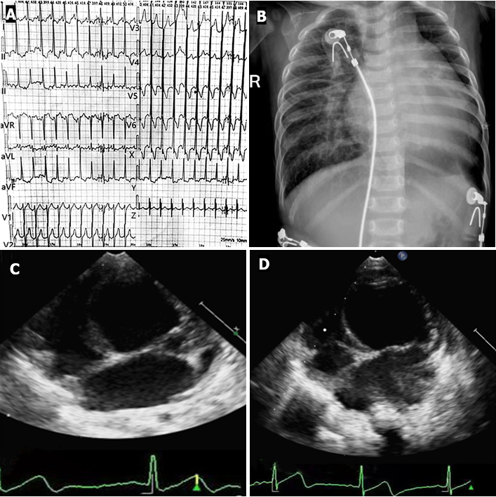
Figure 1 Electrocardiography and imaging examinations of the patient. A: Abnormal 12-lead electrocardiography indicated high voltages in the left precordial leads and diffuse T wave inversion; B: Chest radiography demonstrated cardiac enlargement and pulmonary congestion; C: Dilated left ventricle approximately 43 mm in late diastole and reduced ejection fraction approximately 26% (echocardiography at admission); D: Dilated left ventricle approximately 46 mm in late diastole, reduced ejection fraction approximately 27% (echocardiography at a follow-up of 6 mo).

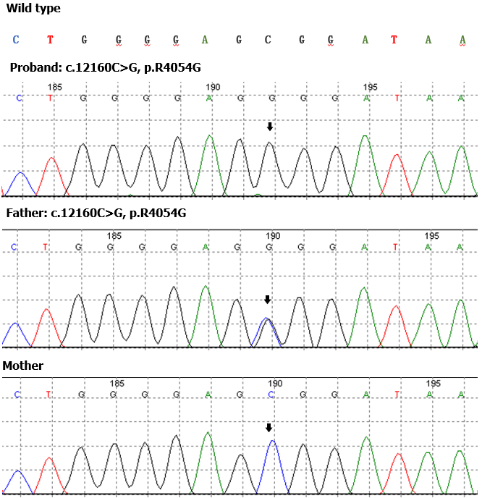
Figure 2 Sanger sequencing at the position of c.12160C>G, p.R4054G on the Alström syndrome 1 gene. The proband carried a homozygotic mutation of c.12160C>G, p.R4054G in exon 20 inherited from her father, while her mother had normal sequence in exon 20 on one chromosome and a deletion of exons 18-21 on the other chromosome.

