Name of Journal: World Journal of Clinical Cases
Manuscript NO: 77850
Manuscript Type: CASE REPORT

Brachiocephalic to left brachial vein thrombotic vasculitis accompanying mediastinal pancreatic fistula: A case report

Kokubo R et al. Thrombotic vasculitis accompanying mediastinal pancreatic fistula

Reiji Kokubo, Daisuke Yunaiyama, Yu Tajima, Natsumi Kugai, Mitsuru Okubo, Kazuhiro Saito, Takayoshi Tsuchiya, Takao Itoi

Reiji Kokubo, Daisuke Yunaiyama, Yu Tajima, Natsumi Kugai, Mitsuru Okubo, Kazuhiro Saito, Department of Radiology, Tokyo Medical University, Tokyo 160-0023, Japan

Takayoshi Tsuchiya, Takao Itoi, Department of Gastroenterology and Hepatology, Tokyo Medical University, Tokyo 160-0023, Japan

Author contributions: Kokubo R and Yunaiyama D designed the report; Kokubo R, Tajima Y, and Kugai N collected the patient’s clinical data; Kokubo R, Yunaiyama D, Tajima Y, Kugai N, Okubo M, Saito K, Tsuchiya T, and Itoi T analyzed the data and wrote the paper; and all authors have read and approved the final manuscript.

Corresponding author: Daisuke Yunaiyama, MD, PhD, Assistant Professor, Department of Radiology, Tokyo Medical University, 6-7-1 Nishishinjuku, Shinjuku-ku, Tokyo 160-0023, Japan. yuunai@tokyo-med.ac.jp

Received: May 24, 2022
Revised: August 29, 2022
Accepted: October 9, 2022
Published online:

Abstract
BACKGROUND
Pancreatitis is a severe inflammatory pancreatic disease commonly due to bile duct stones or excessive alcohol usage, with clinical manifestations of abdominal pain, nausea, fever, and fluid collections. Healthy persons with less symptomatic pancreatitis are quite rare. Herein, we report a case of a patient with an undetermined onset of pancreatitis mimicking left arm cellulitis due to thrombotic vasculitis of the brachiocephalic vein.

CASE SUMMARY
A 50-year-old woman visited our hospital for tenderness in the left arm over several recent days. She was diagnosed with cellulitis on the left arm due to left elbow tenderness. Intravenous antibiotics administration did not improve symptoms and laboratory data worsened; thus, chest and abdominal computed tomography (CT) was performed. CT demonstrated pancreatitis with pseudocyst around the pancreas extending to the mediastinum. Thrombotic vasculitis of the brachiocephalic to left brachial vein was observed, which could be the cause of left elbow pain. A pancreatic fistula was found in the head of the pancreas by endoscopic retrograde cholangiopancreatography, so a pancreatic cyst drainage tube via the duodenum was placed in the pseudocyst. Cyst content culture was positive for Escherichia coli infection. Clinical symptoms, imaging findings, and inflammatory reactions resolved gradually after starting therapeutic intervention. The mediastinal pancreatic pseudocysts shrunk, and the venous thrombi remained but shrunk.

CONCLUSION
The case of a patient with pancreatitis with an undetermined onset that mimics left arm cellulitis is reported. Deep vein thrombosis should be kept in mind when treating patients with severe inflammatory disease.

Key Words: Pancreatic fistula; Thrombotic vasculitis; Pancreatitis; Computed tomography; Case report

Kokubo R, Yunaiyama D, Tajima Y, Kugai N, Okubo M, Saito K, Tsuchiya T, Itoi T. Brachiocephalic to left brachial vein thrombotic vasculitis accompanying mediastinal pancreatic fistula: A case report. World J Clin Cases 2022; In press

Core Tip: Pancreatitis is a severe inflammatory disease commonly caused by bile duct stones or alcohol usage, with clinical manifestations of abdominal pain, nausea, fever, fluid collections, etc. Because of its severity, it is rare to experience patients with less symptomatic pancreatitis. Herein, a 50-year-old Japanese woman was referred to our hospital due to a history of cough and fatigue for 2 mo and recent left elbow tenderness. Computed tomography showed pancreatic pseudocysts in adjacent tissues and mediastinum, with thrombotic vasculitis in the brachiocephalic to left brachial vein. A history of pancreatitis might cause systemic coagulopathy, which may result in brachiocephalic vein thrombosis.

INTRODUCTION
Pancreatitis is a severe inflammatory pancreatic disease commonly due to bile duct stones or alcohol usage, with clinical manifestations of abdominal pain, nausea, fever, fluid collections, etc^{[1]}. Acute or chronic pancreatitis is at risk of pancreatic fistula to adjacent tissues, and it might extend to the mediastinum through the esophageal hiatus or aortic hiatus, which is called mediastinal pancreatic pseudocyst (MPP)^{[2,3]}. The notifying signs of MPP include chest pain, dyspnea, and systemic inflammatory changes, and diagnostic imaging modalities like computed tomography (CT) or magnetic resonance imaging (MRI) have an enormous role for its definitive diagnosis^{[4,5]}. Rare types of signs of MPP-like pancreatic panniculitis^{[6]}, multiple ascending aortic mural thrombi^{[7]}, or symmetrical peripheral gangrene^{[8]} were also reported; however, no case of MPP accompanying brachiocephalic thrombotic vasculitis has been reported. Herein, we present of a case of a patient with an undetermined onset of pancreatitis that resulted in MPP with brachiocephalic vein thrombotic vasculitis mimicking left arm cellulitis.

CASE PRESENTATION
Chief complaints
A 50-year-old Japanese woman with left elbow tenderness for several days was referred to the department of dermatology of our hospital.

History of present illness
She suffered from cough at night and exertional dyspnea for more than six months, bilateral lower extremity edema for two months, and fatigue, which worsened in recent months. Left elbow tenderness was also noted, so she was referred to the department of dermatology of our hospital.

History of past illness
The patient’s medical history included epilepsy.

Personal and family history
The patient had no family history of similar illnesses.

Physical examination
Her body temperature was 38.9 °C, with a heart rate of 150/min, blood pressure of 120/85 mmHg, respiratory rate of 20/min, and SpO₂ of 98% at room air. Tender, erythematous, and edematous left arm was observed (Figure 1).

Laboratory examinations
The following results were observed at the initial examination: White blood cell count, 14600/μL (segmented, 84.9%); red blood cell count, 322 × 10⁴/μL; hemoglobin level, 10.6 g/dL; platelet count, 53.1 × 10⁴/uL; total protein level, 4.7 g/dL; albumin level, 1.8 g/dL; total bilirubin level, 0.35 mg/dL; aspartate aminotransferase, 16 U/L; alanine aminotransferase, 10 U/L; γ-glutamyl transpeptidase, 52 IU/L; lactate dehydrogenase, 269 IU/L; alkaline phosphatase, 352 IU/L; urea nitrogen, 8.8 mg/dL; creatinine, 0.49 mg/dL; creatine kinase, 26 U/L; uremic acid, 4.2 mg/dL; Na, 133 mmol/L; K, 3.6 mmol/L; Cl, 102 mmol/L; c-reaction protein, 22.0 mg/dL; and D-dimer, 12.7 μg/mL.

Imaging examinations
The CT demonstrated pancreatitis with pseudocysts around the pancreas (Figure 2A) extending to the mediastinum (Figure 2B). Thrombotic vasculitis of the brachiocephalic to left brachial vein was also observed (Figure 2C), which was considered to be the cause of elbow pain. MPP was not seen around the brachiocephalic vein; however, it was compressed between the sternal bone and brachial artery (Figure 3). A pancreatic fistula was found in the head of the pancreas by endoscopic retrograde cholangiopancreatography (ERCP), so a pancreatic cyst drainage tube via the duodenum was placed in the pseudocyst (Figure 4).

FINAL DIAGNOSIS
During the next CT scan, the amylase concentration was 1108 U/L; therefore, a final diagnosis of brachiocephalic to left brachial vein thrombotic vasculitis with pancreatic pseudocysts in adjacent tissues of the pancreas and mediastinum was made.

TREATMENT
The pseudocyst around the head of the pancreas was drained with the tube inserted by ERCP. The culture of the cyst contents was positive for E. coli infection. MRI of MPP did not show any infection; thus, the patient was followed up with conservative treatment with antibiotics. MPP was followed up with conservative treatment with antibiotics for 32 d along with intravenous administration of heparin with 12000 U/day for 25 d and octreotide acetate for 24 d. The activated partial thromboplastin time was maintained at 38–42 s.

OUTCOME AND FOLLOW-UP
The clinical symptoms, imaging findings, and inflammatory reactions of acute pancreatitis were resolved, the MPPs shrunk, and the venous thrombi remained but shrunk. Table 1 summarizes the clinical course of the patient.

DISCUSSION
This is the first case report presenting a patient with brachiocephalic vein accompanying MPPs. MPPs are rarely found as a complication of acute pancreatitis, as first described by Clauss et al^{[9]}. Case reports about MPPs have been accumulated in recent years; however, to the best of our knowledge, there was no report on patients with a chief complaint of left arm tenderness derived from brachiocephalic to brachial vein thrombotic vasculitis. We could find a case report of a patient with multiple ascending aortic mural thrombi and acute necrotizing mediastinitis secondary to acute pancreatitis^{[7]}. The patient had acute pancreatitis with extended inflammation to the mediastinum, resulting in aortitis with thrombi. In contrast, in our case, the MPPs did not reach the brachiocephalic vein, so a direct inflammatory infiltration from the MPPs cannot be assumed.
There were case series reports of patients with splanchnic vein thrombosis and acute pancreatitis^{[10-12]}. It was reported that the coagulopathy might have an effect on forming thrombi. In addition, the compression by MPPs to adjacent veins resulted in flow deficiency and coagulation^{[13,14]}. The possible causes of thrombosis in the brachiocephalic vein, in this case, were as follows: Brachiocephalic vein stenosis due to compression of the brachiocephalic vein between the sternal body and aortic branches, resulting in systemic coagulopathy due to MPPs for an undetermined period, and edematous changes in the mediastinal tissues. Because the onset of pancreatitis in this patient is unknown, it is not clear whether systemic inflammation affected coagulopathy. Based on the presence of coagulopathy due to systemic inflammation, anatomical stenosis would be an additional cause of thrombotic vasculitis.
Panniculitis is a presenting type of pancreatic lesions derived from pancreatic enzyme migration into the systemic circulation that occur in systemic cutaneous inflammation^{[15]}. In patients with subcutaneous inflammatory changes and pancreatitis, panniculitis should be considered; however, because panniculitis usually occurs systemically, our case was suspected to have cellulitis on the left upper arm. The original symptoms of our case were associated with brachiocephalic to left brachial vein thrombosis, so the diagnosis of our case cannot be panniculitis derived from pancreatic enzyme leakage. The D-dimer level of the patient was elevated to 12.7 µg/mL. Thus, an evaluation for deep vein thrombosis might be considered, as the patient suffered from severe inflammatory disease with elevated D-dimer count.
In this case, the MPP was detected because the dermatologist who examined the patient considered the inflammatory change to be relatively worse than the severity of the left arm cellulitis. This is an instructive case demonstrating that it is essential to perform a workup study in patients with suspicious or undetermined unexplainable data.

CONCLUSION
Herein, we report a case of a patient with pancreatitis with an undetermined onset, respiratory syndrome for a few months, and thrombotic vasculitis in the brachiocephalic vein mimicking left arm cellulitis. Long-term pancreatitis might cause systemic coagulopathy that resulted in brachiocephalic vein thrombosis. Deep vein thrombosis should be kept in mind when treating patients with severe inflammatory disease.

REFERENCES
1 Rose EA, Haider M, Yang SK, Telmos AJ. Mediastinal extension of a pancreatic pseudocyst. Am J Gastroenterol 2000; 95: 3638-3639 [PMID: 11151907 DOI: 10.1111/j.1572-0241.2000.03387.x]
2 Cameron JR. Parental treatment, children's temperament, and the risk of childhood behavioral problems: 2. Initial temperament, parental attitudes, and the incidence and form of behavioral problems. Am J Orthopsychiatry 1978; 48: 140-147 [PMID: 623213 DOI: 10.1111/j.1939-0025.1978.tb01295.x]
3 Gupta R, Munoz JC, Garg P, Masri G, Nahman NS Jr, Lambiase LR. Mediastinal pancreatic pseudocyst--a case report and review of the literature. MedGenMed 2007; 9: 8 [PMID: 17955064]
4 Andrén-Sandberg A, Dervenis C. Pancreatic pseudocysts in the 21st century. Part I: classification, pathophysiology, anatomic considerations and treatment. JOP 2004; 5: 8-24 [PMID: 14730118]
5 Tajima Y, Fukuda K, Tsuneoka N, Tsutsumi R, Kuroki T, Onizuka S, Furui J, Yamanaka S, Makimoto Y, Tsuchiya R, Kanematsu T. Demonstration of a pancreaticopleural fistula with magnetic resonance cholangiopancreatography. Am J Surg 2004; 187: 741-742 [PMID: 15191868 DOI: 10.1016/j.amjsurg.2003.09.008]
6 Laureano A, Mestre T, Ricardo L, Rodrigues AM, Cardoso J. Pancreatic panniculitis - a cutaneous manifestation of acute pancreatitis. J Dermatol Case Rep 2014; 8: 35-37 [PMID: 24748910 DOI: 10.3315/jdcr.2014.1167]
7 Chong BK, Yun JK, Kim JB, Park DH. Multiple Ascending Aortic Mural Thrombi and Acute Necrotizing Mediastinitis Secondary to Acute Pancreatitis. Korean J Thorac Cardiovasc Surg 2016; 49: 401-404 [PMID: 27734004 DOI: 10.5090/kjtcs.2016.49.5.401]
8 Liao CY, Huang SC, Lin CH, Wang CC, Liu MY, Ben RJ, Kuo WH, Lee CC. Successful resolution of symmetrical peripheral gangrene after severe acute pancreatitis: a case report. J Med Case Rep 2015; 9: 213 [PMID: 26376919 DOI: 10.1186/s13256-015-0688-3]
9 Clauss RH, Wilson DW. Pancreatic pseudocyst of the mediastinum. J Thorac Surg 1958; 35: 795-801 [PMID: 13539922]
10 Nawacki Ł, Matykiewicz J, Stochmal E, Głuszek S. Splanchnic Vein Thrombosis in Acute Pancreatitis and Its Consequences. Clin Appl Thromb Hemost 2021; 27: 10760296211010260 [PMID: 33887991 DOI: 10.1177/10760296211010260]
11 Pancreas Study Group, Chinese Society of Gastroenterology, Chinese Medical Association. Practice guidance for diagnosis and treatment of pancreatitis-related splanchnic vein thrombosis (Shenyang, 2020). J Dig Dis 2021; 22: 2-8 [PMID: 33215862 DOI: 10.1111/1751-2980.12962]
12 Primignani M. Pancreatitis-related splanchnic vein thrombosis: What role, what warnings for anticoagulation therapy? J Dig Dis 2021; 22: 122-125 [PMID: 33591597 DOI: 10.1111/1751-2980.12974]
13 Ahmed SU, Rana SS, Ahluwalia J, Varma N, Sharma R, Gupta R, Kang M. Role of thrombophilia in splanchnic venous thrombosis in acute pancreatitis. Ann Gastroenterol 2018; 31: 371-378 [PMID: 29720864 DOI: 10.20524/aog.2018.0242]
14 Rebours V, Boudaoud L, Vullierme MP, Vidaud D, Condat B, Hentic O, Maire F, Hammel P, Ruszniewski P, Lévy P. Extrahepatic portal venous system thrombosis in recurrent acute and chronic alcoholic pancreatitis is caused by local inflammation and not thrombophilia. Am J Gastroenterol 2012; 107: 1579-1585 [PMID: 22825367 DOI: 10.1038/ajg.2012.231]
15 Poelman SM, Nguyen K. Pancreatic panniculitis associated with acinar cell pancreatic carcinoma. J Cutan Med Surg 2008; 12: 38-42 [PMID: 18258147 DOI: 10.2310/7750.2007.00032]

Footnotes
Informed consent statement: All study participants or their legal guardian provided informed written consent about personal and medical data collection prior to study enrolment.

Conflict-of-interest statement: All the authors report no relevant conflicts of interest for this article.

CARE Checklist (2016) statement: The authors have read the CARE Checklist (2016), and the manuscript was prepared and revised according to the CARE Checklist (2016).

Open-Access: This article is an open-access article that was selected by an in-house editor and fully peer-reviewed by external reviewers. It is distributed in accordance with the Creative Commons Attribution NonCommercial (CC BY-NC 4.0) license, which permits others to distribute, remix, adapt, build upon this work non-commercially, and license their derivative works on different terms, provided the original work is properly cited and the use is non-commercial. See: https://creativecommons.org/Licenses/by-nc/4.0/

Provenance and peer review: Unsolicited article; Externally peer reviewed.

Peer-review model: Single blind

Corresponding Author's Membership in Professional Societies: The Japanese Society of Radiology.

Peer-review started: May 24, 2022
First decision: August 21, 2022
Article in press: September 22, 2022

Specialty type: Medicine, research and experimental
Country/Territory of origin: Japan
Peer-review report’s scientific quality classification
Grade A (Excellent): A
Grade B (Very good): 0
Grade C (Good): C
Grade D (Fair): 0
Grade E (Poor): 0

P-Reviewer: Li G, China; Sade R, Turkey S-Editor: Liu GL L-Editor: A P-Editor: Liu GL
Figure Legends
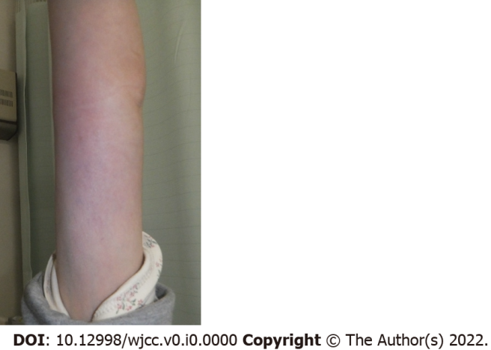
Figure 1 Swelling and redness on the patient’s left arm.

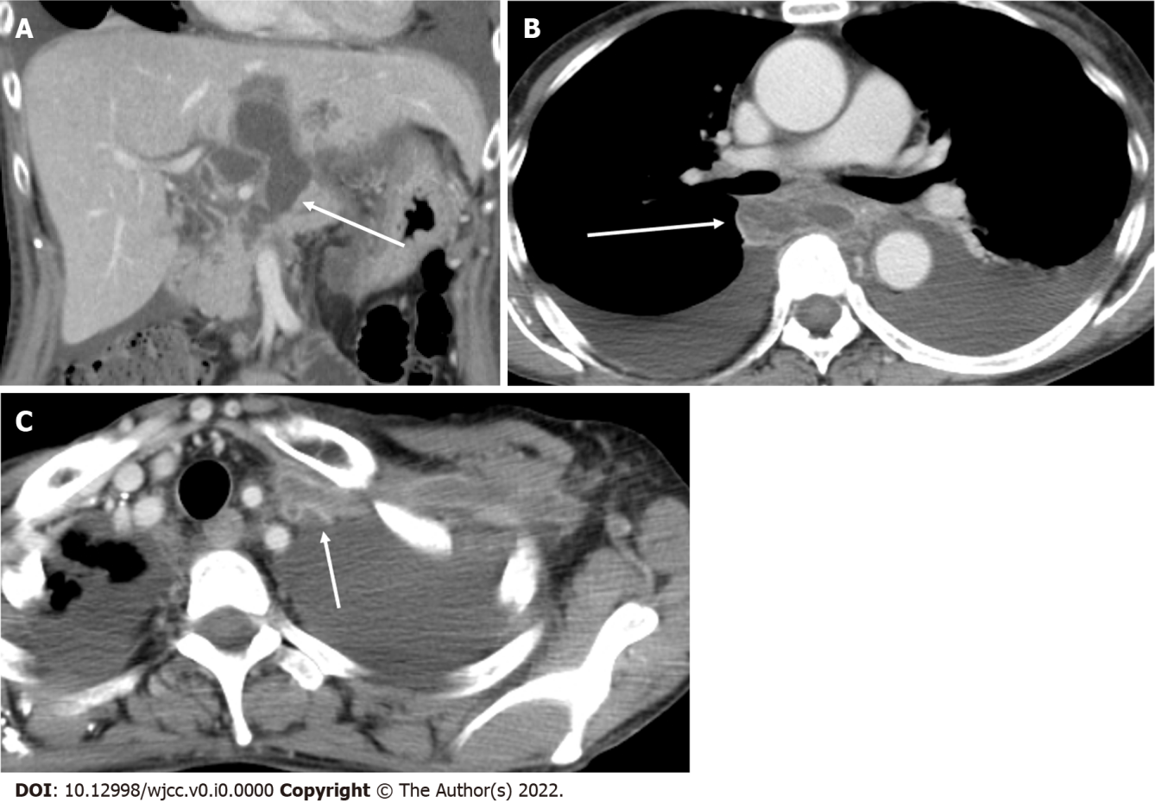
Figure 2 Contrast-enhanced computed tomography image. A: Contrast-enhanced computed tomography image at the level of fluid collection around the head of the pancreas (arrow); B: Contrast-enhanced computed tomography image at the level of the mediastinal pseudopancreatic cyst (arrow); C: Contrast-enhanced computed tomography image at the level of brachiocephalic to brachial vein thrombotic vasculitis with contrast-enhancing vessel walls, suggesting inflammatory changes (arrow).

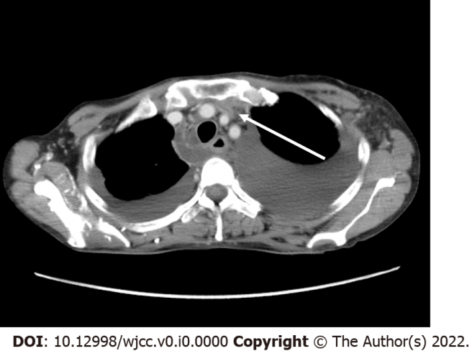
Figure 3 Contrast-enhanced axial computed tomography image showing the compressed brachiocephalic vein (arrow) with thrombosis between the sternal bone and brachial artery. No mediastinal pancreatic pseudocysts were seen around the structure.

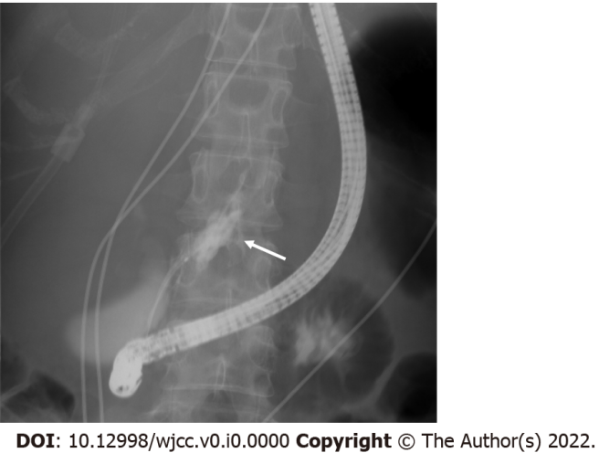
Figure 4 Endoscopic retrograde cholangiopancreatography demonstrates the pancreatic fistula (arrow).
Table 1 Summary of the clinical course of the patient
Time point | Remarks
July 24, 2017 | Redness of the bilateral auricles
July 27, 2017 | Antibiotics administration at a clinician
August 10, 2017 | Referred to our hospital
August 18, 2017 | Non–contrast-enhanced chest to abdominal CT without  significant findings
August 20, 2017 | Biopsy for auricular cartilage
August 21, 2017 | Contrast-enhanced head and neck MRI with presenting figures
 | Prednisolone administration was started
September 1, 2017 | Symptoms and laboratory abnormality improved remarkably
CT: Computed tomography; MRI: Magnetic resonance imaging.

