Name of Journal: World Journal of Gastroenterology
ESPS Manuscript NO: 28105
Manuscript Type: ORIGINAL ARTICLE

Basic Study
IRF5 regulates lung macrophages M2 polarization during severe acute pancreatitis in vitro

Sun K et al. Macrophages polarization in severe acute pancreatitis

Kang Sun, Song-Bing He, Jian-Guo Qu, Sheng-Chun Dang, Ji-Xiang Chen, Ai-Hua Gong, Rong Xie, Jian-Xin Zhang

Kang Sun, Jian-Guo Qu, Sheng-Chun Dang, Ji-Xiang Chen, Rong Xie, Jian-Xin Zhang, Department of General Surgery, The Affiliated Hospital of Jiangsu University, Zhenjiang 212001, Jiangsu Province, China

Song-Bing He, Department of General Surgery, The First Affiliated Hospital of Soochow University, Suzhou 215006, Jiangsu Province, China

Ai-Hua Gong, Medical School of Jiangsu University, Zhenjiang 212013, Jiangsu Province, China

Author contributions: Sun K and He SB contributed equally to this work; Sun K, He SB and Zhang JX designed the research; Sun K, He SB, Qu JG, Dang SC, Chen JX and Xie R performed the research; Sun K and Gong AH contributed new reagents or analytic tools; Sun K and He SB analyzed the data; Sun K and He SB wrote the paper.

Supported by Graduate Innovative Projects Foundation in Jiangsu Province, No. 1201270052; the Social Development Foundation in Zhenjiang, No. SH2013032; Six Major Talent Peak Project of Jiangsu Province of China, No. 2015-WSW-014; and the Scientific Research Foundation for the Returned Overseas Chinese Scholars, State Education Ministry, No. fiftieth batch, 2015.

Institutional review board statement: The study was reviewed and approved by Jiangsu University Institutional review board.

Institutional animal care and use committee statement: All animal protocols received prior approval from the Institutional Animal Care and Use Committee and all experiments were performed in accordance with relevant guidelines and regulations.

Conflict-of-interest statement: To the best of our knowledge, no conflict of interest exists.

Data sharing statement: No additional data are available.

Open-Access: This article is an open-access article which was selected by an in-house editor and fully peer-reviewed by external reviewers. It is distributed in accordance with the Creative Commons Attribution Non Commercial (CC BY-NC 4.0) license, which permits others to distribute, remix, adapt, build upon this work non-commercially, and license their derivative works on different terms, provided the original work is properly cited and the use is non-commercial. See: http://creativecommons.org/licenses/by-nc/4.0/

Manuscript source: Invited manuscript

Correspondence to: Jian-Xin Zhang, MD, Professor, Department of General Surgery, The Affiliated Hospital of Jiangsu University, No. 438 Jiefang Road, Zhenjiang 212001, Jiangsu Province, China. doctorsunkang@126.com
Telephone: + 86-511-85082208
Fax: + 86-511-85082208

Received: June 26, 2016
Peer-review started: June 27, 2016
First decision: July 29, 2016
Revised: August 13, 2016
Accepted: August 23, 2016
Article in press:
Published online:

Abstract
AIM: To investigate the role of interferon regulatory factor 5 (IRF5) for reversing polarization of lung macrophages during severe acute pancreatitis (SAP) in vitro.

METHODS: The SAP rat model was established by intraperitoneal (ip) injections of 20 μg/kg body weight caerulein. Pathological changes in the lung were observed by hematoxylin and eosin staining. Lung macrophages were isolated from bronchoalveolar lavage fluid. The quantity and purity of lung macrophages were detected by fluorescence-activated cell sorting and evaluated by real time polymerase chain reaction (RT-PCR). They were treated with IL-4/IRF5 siRNA to reverse their polarization and were evaluated by detecting markers expression of M1/M2 using RT-PCR.

RESULTS: SAP associated acute lung injury (ALI) was induced successfully by ip injections of caerulein, which was confirmed by histopathology. Lung macrophages expressed high levels of IRF5 as M1 phenotype during the early acute pancreatitis stages. Reduction of IRF5 expression by IRF5 siRNA reversed the action of macrophages from M1 to M2 phenotype in vitro. The decrease of the expressions of M1 markers including IRF5 (S + IRF5 siRNA vs S + PBS, 0.013 ± 0.01 vs 0.054 ± 0.047, P < 0.01), TNF-α (S + IRF5 siRNA vs S + PBS, 0.0003 ± 0.0002 vs 0.019 ± 0.018, P < 0.001), iNOS (S + IRF5 siRNA vs S + PBS, 0.0003 ± 0.0002 vs 0.026 ± 0.018, P < 0.001) and IL-12 (S + IRF5 siRNA vs S + PBS, 0.000005 ± 0.00004 vs 0.024 ± 0.016, P < 0.001) were observed. In contrast, the increase of the expressions of M2 markers including IL-10 (S + IRF5 siRNA vs S + PBS, 0.060 ± 0.055 vs 0.0230 ± 0.018, P < 0.01) and Arg-1 (S + IRF5 siRNA vs S + PBS, 0.910 ± 0.788 vs 0.0036 ± 0.0025, P < 0.001) were also occured. IRF5 siRNA can reverse the lung macrophage polarization more effectively than IL-4.

CONCLUSION: Treatment with IRF5 siRNA could reverse the pancreatitis-induced activation of lung macrophages from M1 phenotype to M2 phenotype in SAP associated with ALI.

Key words: IRF5; Severe acute pancreatitis; Macrophage polarization; SiRNA

© The Author(s) 2016. Published by Baishideng Publishing Group Inc. All rights reserved.

Core tip: We reported our first results derived from lung macrophages adopt a pro-inflammatory activation (M1 phenotype) during early phase in acute pancreatitis. Treatment with interferon regulatory factor 5 (IRF5) siRNA could reverse the pancreatitis-induced activation of lung macrophages from M1 phenotype to M2 phenotype in vitro. This study revealed the function of IRF5 in rugulating the polarization of macrophages. Reducing the expression of IRF5 may lead to a new therapeutic approach for severe acute pancreatitis associated with acute lung injury.

Sun K, He SB, Qu JG, Dang SC, Chen JX, Gong AH, Xie R, Zhang JX. IRF5 regulates lung macrophages M2 polarization during severe acute pancreatitis in vitro. World J Gastroenterol 2016; In press

INTRODUCTION
Severe acute pancreatitis (SAP) is a most serious disease especially when multiple remote organs are involved^{[1,2]}. The developing process of this disease is rapid and brings a series of complications and multiple organ dysfunction (MODS) including the lung, liver, kidney, intestine and stomach^{[3,4]}. MODS is an essential process during SAP. MODS lead to nearly half of deaths in SAP patients^{[5]}. Acute lung injury (ALI) is the most common extrapancreatic complication in SAP, which associated with the high rates of morbidity and mortality. ALI is characterized by accumulation of activated neutrophils and the development of interstitial edema^{[6,7]}.
Although accumulation of activated neutrophils in the lungs is characteristic of ALI, macrophages which reside in the pulmonary interstitium and alveoli are considered to be the most critical cell involved in development of the SAP associated with ALI^{[8-10]}. Macrophages are plastic cells displaying versatile functional phenotypes depending on microenvironments. M1 macrophages (M1, the classically activated macrophages) and M2 macrophages (M2, the alternatively activated macrophages) have been defined as the two extremes in a spectrum of macrophage functional phenotypes. M1 macrophages are critical effector cells that kill microorganisms^{[11,12]}. In contrast, M2 macrophages are involved in the resolution of inflammation^{[13]}. The pro-inflammatory response must be balanced by regulatory and inhibitory effector mechanisms to protect tissue damage from the effects of excess inflammation^{[14]}. Lung macrophages can be subdivided into alveolar, pleural, interstitial and intravascular macrophages, and alveolar macrophages (AM) considered as the most important cell of the innate immune system^{[10,15]}.
Distinct macrophage subtypes are not only characterized by their differences in cytokine release but also display differential expression of key transcription factors. Krausgruber et al^{[16]} found that transcription factor interferon regulatory factor 5 (IRF5) was a major factor in defining macrophage polarization. They found that IRF5 was the major regulator of pro-inflammatory M1 macrophage polarization. IRF5 directly induces the expression of pro-inflammatory cytokines such as IL-6, IL-12b, and IL-23a while repressing transcription of anti-inflammatory cytokines such as IL-10. Although IRF5 plays an important role in macrophage activation, it has rarely been used to track macrophages in inflammatory disease. In the present study, we used the SAP model induced by intraperitoneal (ip) injection of caerulein, and isolated murine lung macrophages from BAL fluidto to detect IRF5 expression and their polarization in vitro. In addition, we treated lung macrophages with IRF5 siRNA/IL-4 to reverse macrophage polarization from M1 phenotype to M2 phenotype and compare its effect with IL-4.

MATERIALS AND METHODS
Animals and experimental design
C57BL/6 mice, male or female, aged 8-12 wk, were obtained from the laboratory animal center of Jiangsu University, Zhenjiang, Jiangsu, China. The laboratory animal experimental protocol was approved by Institutional Animal Care and Use Committee, Jiangsu University Experimental Animal Center. All experiments followed The Laboratory Animal Care Principles. Rats were randomly divided into two groups: (1) SAP group: rats received ip injections of caerulein; and (2) control group: rats received ip injection of an equal volume of PBS. Every group has 15 rats. Plating the RAW264.7 cells (mouse macrophages, M0) in 12 wells plate as 105/mL 24h before intervention and use IFN-γ (100 U/mL) + LPS (5 µg/L) to induce M1 phenotype (M1), IL-4 (10 µg/L) to induce M2 phenotype (M2). The three types of macrophages (M0, M1, M2) were as control compared with lung macrophages.

SAP model
SAP models were prepared according to the protocol by Tang et al^{[17]}. The rats were deprived of food but allowed access to water 24 h prior to the start of the experiments. SAP was induced in C57BL/6 mice by ip injections of 20 μg/kg body weight (diluting stock solution in saline) caerulein at hourly intervals for a total of seven injections.

Histological analysis
For the histological analysis, mouse pancreatic and lung tissue samples were washed thoroughly in PBS, fixed in 10% buffered formalin, and embedded in paraffin, tissue samples were cut into sections. 5 µM sections were stained with hematoxylin and eosin (HE) using standard procedures and examined by light microscopy. Sections were examined by an experienced morphologist, who was blinded to the sample identity, for tissue injury.

Cell preparation and alveolar macrophage (AM) culture
Alveolar macrophage (AM) was purified according to the method of Small et al^{[18]}. Briefly, anesthetized mice were sacrificed, the lungs from 36 mice were lavaged with RPMI 1640 contain 10% FCS, and all bronchoalveolar lavage (BAL) were mixed in a 50 Ml tube. BAL fluids were then plated, and the AM was allowed to adhere for 2 h at 37 ℃, 5% CO₂.

The quantity and purity of the lung macrophages
BAL cells were incubated for 30 minutes at 4℃ with rat-anti-F4/80 monoclonal antibody (mAb). Then, the cells were analyzed using fluorescence-activated cell sorting (FACS). The BAL cells were seeded on plates for 2 h and then non-adherent cells were washed, the adherent cells were scraped and fixed with 4% paraformaldehyde at 4 ℃ for 30 min, and then incubated for 2 h with a 1:100 dilution of the CD11b/c antibody and F4/80 antibody (Ebioscience, San Diego, USA) labeled with Alexa Fluor 488 for flow cytometry analysis^{[19]}.

Reversion of the polarized lung macrophages in vitro by IRF5 siRNA/IL-4
Lung macrophages obtained from BAL fluid as well as rats 18 h after SAP induction. One part of polarized lung macrophages were transfected with IRF5 specific siRNA (IRF5 siRNA) using a Mouse Macrophage Nucleofector® Kit (LONZA) according to the manufacturer’s instructions. Another part of polarized lung macrophages were incubated with IL-4 (20 ng/mL) for 24 h. Macrophages were collected for further detection after incubation.

Measurement of polarization of lung macrophages
Real time polymerase chain reaction (RT-PCR) was performed with the ABI Prism 7900HT (Applied Biosystem) using the SYBR Green PCR Master Mix (Applied Biosystems, Foster City, CA) according to the protocol in our lab. The PCR primers used were as follows: GAPDH (F: GTATGACTCTACCCACGGCAAGT; R: TTCCCGTTGATGACCAGCTT), TNF-α (F: CCGATTTGCCACTTCATACCA; R: TAGGGCAAGGGCTCTTGATG), IL-10 (F: AGAAGGACCAGCTGGACAACAT; R: CAAGTAACCCTTAAAGTCCTGCAGTA), Arg-1 (F: CCGCAGCATTAAGGAAAGC ; R: CCCGTGGTCTCTCACATTG), Inos (F: CAGCCCTCAGAGTACAACGAT; R: CAGCAGGCACACGCAATGAT), IRF5 (F: GTTGCCTTTGACGGACCTA; R: 5’-GGCCCACTCCAGAACACCT-3’), IL-12 (F: 5’-AAAGGTGCGTTCCTCGTAG; R: CAACAGCATAAGGCCAAGT).

Statistical analysis
All values were expressed as mean ± SE. Independence t-test was used in the comparison of two groups. P values of < 0.05 indicate statistical significance. Analyses were performed using SPSS 17.0.

RESULTS
Histopathology and morphometry of the the lung during SAP
As shown in Figure 1, Lung tissue from control rats showed a normal structure and no histopathological changes under light microscope (Figure 1A). A typical photomicrograph of pancreatic lung injury includes lung edema, neutrophil infiltration, necrosis and hemorrhage (Figure 1B). The infiltration of neutropils, macrophages, interstitial edema and focal necrotic areas were seen in the lung tissue of sham treated rats (Figure 1C). In the IRF5 siRNA treated rats, the histological changes of lung tissue showed markedly reduced interstitial edema and inflammatory cell infiltration compared with those in the SAP and sham treatment group (Figure 1D). All the pathological pictures showed that we had established the SAP associated with ALI mouse model successfully.

Isolation of lung macrophages of SAP rats
A
C
lungs from control rat
After primary culturing 24 h, the lung alveolus macrophages were observed by microscope and examined by FACS for the purity and quantity. The purity of lung alveolus macrophages was approximately 81.7% (Figure 2).

Expression of M1 phenotype of lung alveolus macrophages during early phase of SAP
Lung alveolus macrophages were isolated from BAL fluid of the control group and SAP group by FACS. In vitro, lung macrophages from SAP group treated with PBS for 4, 8 and 16 h respectively, and macrophages from control group were treated with PBS for 4 h. The expression of major M1 markers (IRF5, TNF-α, iNOS and IL-12) and M2 markers (IL-10 and Arg-1) were detected by RT-PCR. The polarization of lung macrophages was detected by RT-PCR. As shown in Figure 3, the results showed that the mRNA levels of lung macrophages markers from SAP group were significantly higher than the control group (M0) (P < 0.01). In contrast, mRNA levels of lung macrophages markers from SAP group were similar to those in another control group (M1) (P > 0.05). The experimental data indicates that a shift to M1 polarization of lung macrophages during the initiation of SAP.

Reversion the polarization of lung macrophages from SAP group
To study whether the polarization of lung alveolus macrophages could be reversed from M1 to M2 in vitro. After treatment with PBS/IL-4/IRF5 siRNA, the levels of macrophage markers (M1: IRF5, TNF-α, iNOS, IL-12; M2: IL-12, Arg-1) expression were compared at 4 h time point. As shown in Figure 4, the results of RT-PCR showed that IL-4/IRF5 siRNA could reduce expression of M1 markers significantly. IRF5 (S + IRF5 siRNA vs S + PBS, 0.013 ± 0.01 vs 0.054 ± 0.047, P < 0.01), TNF-α (S + IRF5 siRNA vs S + PBS, 0.0003 ± 0.0002 vs 0.019 ± 0.018, P < 0.001), iNOS (S + IRF5 siRNA vs S + PBS, 0.0003 ± 0.0002 vs 0.026 ± 0.018, P < 0.001) and IL-12 (S + IRF5 siRNA vs S + PBS, 0.000005 ± 0.00004 vs 0.024 ± 0.016, P < 0.001). In contrast, M2 markers were upregulated by IL-4/IRF5 siRNA treatment. IL-10 (S + IRF5 siRNA vs S + PBS, 0.060 ± 0.055 vs 0.0230 ± 0.018, P < 0.01) and Arg-1 (S + IRF5 siRNA vs S + PBS, 0.910 ± 0.788 vs 0.0036 ± 0.0025, P < 0.001). The results suggested that the polarization of lung macrophages can be reversed by IRF5 siRNA from M1 to M2 as well as IL-4.

Comparing the ability to reverse lung macrophage polarization by IRF5 siRNA/IL-4

In order to determine the better way to alter the polarization of macrophages in vitro, we compared the expression of M1 and M2 markers after the treatment of IL-4 or IRF5 siRNA. Gene expression in primary culture macrophages from the rats with SAP was determined by real-time PCR. As shown in Figure 5, the effect of treatment with IL-4 and IRF5 siRNA were similar in IRF5 (4 h, 8 h), IL-12 (4h, 8h), iNOS (4 h, 8 h), TNF-α (4 h,16 h), IL-10 (8 h, 16 h), Arg-1 (4 h) (P > 0.05); but some groups that the level of IRF5 (16 h, 24 h), TNF-α (8 h, 24 h), iNOS (16 h, 24 h) and IL-12 (16 h, 24 h) were much lower, and Arg-1 (8 h, 16 h, 24 h), IL-10 (4 h, 24 h) were significant higher after IRF5 siRNA treatment than IL-4 treatment group (P < 0.05). These results indicated that IRF5 siRNA can reverse the lung macrophage polarization more effectively.

DISCUSSION
SAP can cause SIRS and high morbidity. In SAP, MODS in the early phase is the main reason of high mortality^{[5,20]}. In the early phase, activated macrophages can release humoral mediators which may lead to remote organ injury, including acute lung injury, acute liver injury, acute kidney injury, etc. Acute lung injury is one of the most common organ failure in SAP. It is the first cause of patients’ death during the early stage of SAP^{[21]}.
A number of investigations have indicated that the severity of SAP and pancreatitis-associated lung injury were regulated by a great deal of inflammatory factors, including inflammatory cells and cytokines^{[22-24]}. Among many inflammatory cells, macrophages are key pro-inflammatory and anti-inflammatory cells, which accumulate in the damaged organ in SAP. Plasticity and functional polarization are hallmarks of macrophages that result in the phenotypic diversity of macrophage populations^{[25,26]}. Thus, targeting selected macrophage pathways is a potential therapeutic strategy for suppressing macrophage-mediated lung injury.
Recently, transcriptional pathways were believed to play an important role in the polarization of macrophage. IRF5 was founded as a major factor in defining macrophage polarization^{[27,28]}. Modulation of IRF5 led to the conversion of one macrophage subset phenotype into the other one^{[29]}. High expression of IRF5 results in polarization of the macrophage phenotype toward M1, however, low expression of IRF5 leads to M2 polarization, which is the anti-inflammatory macrophage phenotype. This indicates a possible broad effect of therapy which targets the induction of IRF5 expression by macrophages^{[30]}.
In our study, mouse model of SAP associated with ALI was constructed successfully by ip caerulein. We found that lung macrophages were M1 polarized in the early phase of SAP. The M1 state was confirmed by the up-regulated expression of M1 phenotypes and down-regulated expression of M2 phenotypes. And the results conform to the conventional theory that macrophages can induce pro-inflammatory cytokines and amplify the degree of the inflammation during early phase of SAP^{[31,32]}.
It has been reported that macrophage polarization could be reversed from M1 phenotype to M2 phenotype^{[33]}. The development and resolution of lung injury is accompanied by alteration of macrophage polarization in the lungs. We hypothesized that lung macrophages which act as M1 phenotype could aggravate inflammation, and M2 could alleviate the inflammation if we reversed the polarization of lung macrophages in SAP by IRF5 siRNA. In the present study, we observed the lung macrophages showed M1 polarization reflected in the high expression of M1 phenotypes (IRF5, TNFα, iNOS and IL-10). This activation was expected since lung macrophages early contact with mediators released by inflammatory pancreatic tissue. Several studies had reported the plasticity of activated macrophages^{[34,35]}. Furthermore, the M2 macrophage state induced by these mediators can alleviate the inflammatory response associated with SAP. This kind of reversion may alleviated systemic inflammation and promotes tissue repair during SAP.
It is interesting to know the capacity of these pancreatitis-activated lung macrophages to be reverted to an anti-inflammatory phenotype from M1 to M2 in vitro. We isolated lung macrophages from BAL fluid of the rats with ALI and the isolated cells were treated by IRF5 siRNA or IL-4. Our data showed that both treatments can reverse macrophage polarization from M1 phenotype to M2 phenotype. After treatment with IRF5 siRNA or IL-4, lung macrophages down regulated the expression of M1 phenotypes such as IRF5, TNF-a, iNOS and IL-10, which are pro-inflammatory mediators. At the same time, macrophages expressed more M2 phenotypes such as IL-10, which is an important anti-inflammatory factor. Our result indicated that activated lung macrophages obtained from rats with SAP could be reversed to M2 state by IRF5 siRNA or IL-4 treatment.
As we know that IL-4 is known to induce the alternative M2 activation of macrophages. M2 macrophage can promote the repair phenotype and counteract the effects of pro-inflammatory cytokines^{[36]}. However, it is reported that IL-4 administration was not enough to reverse the M1 phenotype in lung macrophages therapeutically. The reason could be related with the strong proinflammatory environment generated in the lung. Because of the long half-life of IRF5 siRNA, it demonstrated their strong capability to reverse the polarization of macrophages from M1 phenotype toward the M2 phenotype. In our study, we proposed that there maybe two reasons to illustrate the results: (1) IRF5 mediates inflammatory and immune responses by controlling expression of proinflammatory cytokines downstream of MyD88-dependent Toll-like receptor signaling; and (2) IRF5 regulates the expression of inflammatory gene TNFα and IL1β directly^{[37]}.
In conclusion, treatment with IRF5 siRNA could reverse the pancreatitis-induced activation of lung macrophages from M1 phenotype to M2 phenotype in SAP associated with ALI. Nevertheless, targeting transcription factors for therapeutic aims is still an unknown area. Meanwhile, the molecular mechanism of macrophage polarization is still unknown. In our experiment, silencing the IRF5 regulated a range of inflammatory genes, and this method can reverse the lung macrophage polarization more effectively than IL-4 administration. The molecular mechanisms of IRF5 in macrophage polarization should be further researched and IRF5 is an attractive target for SAP associated with ALI therapy.

COMMENTS
Background
Severe acute pancreatitis (SAP) is a life threatening disease especially when multiple remote organs and systems are involved in the inflammation. Acute lung injury (ALI) is the most common extrapancreatic complication in SAP. Recently, several reports have demonstrated that macrophages are considered to be the most critical cell involved in development of the acute pancreatitis. M1 macrophages and M2 macrophages have been defined as the two extremes in a spectrum of macrophage functional phenotypes. Interferon regulatory factor 5 (IRF5) was a major factor in defining macrophage polarization. The expression of IRF5 in lung macrophages from SAP murine model and whether the IRF5 siRNA could reverse M1 phenotype of macrophages to M2 have not yet been elucidated.

Research frontiers
Recently, several reports have demonstrated that macrophages are considered to be the most critical cell involved in development of the acute pancreatitis. Macrophages are plastic cells displaying versatile functional phenotypes depending on microenvironments. Krausgruber et al found that transcription factor interferon regulatory factor 5 (IRF5) was a major factor in defining macrophage polarization. IRF5 was the major regulator of pro-inflammatory M1 macrophage polarization.

Innovations and breakthroughs
This is the first study deriving from lung macrophages adopt a pro-inflammatory activation (M1 phenotype) early during acute pancreatitis. Treatment with IRF5 siRNA could reverse the pancreatitis-induced activation of lung macrophages from M1 phenotype to M2 phenotype in vitro.

Applications
Lung macrophages adopt a pro-inflammatory activation (M1 phenotype) early during acute pancreatitis. Treatment with IRF5 siRNA could reverse the pancreatitis-induced activation of lung macrophages from M1 to M2 in vitro. The research revealed the function of IRF5 in regulating the polarization of lung macrophages. Reducing the expression of IRF5 may lead to a new therapeutic approach for SAP associated with ALI.

Terminology
M1 and M2 have been defined as the two extremes in a spectrum of macrophage functional phenotypes. M1 macrophages are critical effector cells that kill microorganisms. In contrast, M2 macrophages are involved in the resolution of inflammation. Distinct macrophage subtypes display differential expression of key transcription factors. IRF5 was the major regulator of pro-inflammatory M1 macrophage polarization.

Peer-review
This is a very well designed, performed and written experimental study. In this study, the authors reported the role of IRF5 in regulating lung macrophages M2 polarization during SAP in vitro. This research reveals a novel function of IRF5 in controlling the polarization of macrophages. Therefore, modification of IRF5 expression may lead to a new therapeutic approach for SAP associated with ALI.

REFERENCES
1 Gunjaca I, Zunic J, Gunjaca M, Kovac Z. Circulating cytokine levels in acute pancreatitis-model of SIRS/CARS can help in the clinical assessment of disease severity. Inflammation 2012; 35: 758-763 [PMID: 21826480 DOI: 10.1007/s10753-011-9371-z]
2 Que RS, Cao LP, Ding GP, Hu JA, Mao KJ, Wang GF. Correlation of nitric oxide and other free radicals with the severity of acute pancreatitis and complicated systemic inflammatory response syndrome. Pancreas 2010; 39: 536-540 [PMID: 20084045 DOI: 10.1097/MPA.0b013e3181c0e199]
3 Dang SC, Wang H, Zhang JX, Cui L, Jiang DL, Chen RF, Qu JG, Shen XQ, Chen M, Gu M. Are gastric mucosal macrophages responsible for gastric injury in acute pancreatitis? World J Gastroenterol 2015; 21: 2651-2657 [PMID: 25759533 DOI: 10.3748/wjg.v21.i9.2651]
4 Tony GJ, Rahul R, Ajay K, Pramod KG, Tara SR. Duration of injury correlates with necrosis in caerulein-induced experimental acute pancreatitis: implications for pathophysiology. Int J Exp Pathol 2014; 95: 199-208 [PMID: 24761825 DOI: 10.1111/iep.12081]
5 Rau BM, Krüger CM, Hasel C, Oliveira V, Rubie C, Beger HG, Schilling MK. Effects of immunosuppressive and immunostimulative treatment on pancreatic injury and mortality in severe acute experimental pancreatitis. Pancreas 2006; 33: 174-183 [PMID: 16868484 DOI: 10.1097/01.mpa.0000226895.16817.a1]
6 Akbarshahi H, Menzel M, Posaric Bauden M, Rosendahl A, Andersson R. Enrichment of murine CD68+ CCR2+ and CD68+ CD206+ lung macrophages in acute pancreatitis-associated acute lung injury. PLoS One 2012; 7: e42654 [PMID: 23110041 DOI: 10.1371/journal.pone.0042654]
7 Yang ZW, Meng XX, Xu P. Central role of neutrophil in the pathogenesis of severe acute pancreatitis. J Cell Mol Med 2015; 19: 2513-2520 [PMID: 26249268 DOI: 10.1111/jcmm.12639]
8 Xu XW, Yang XM, Bai YH, Zhao YR, Shi GS, Zhang JG, Zheng YH. Treatment with ginkgo biloba extract protects rats against acute pancreatitis-associated lung injury by modulating alveolar macrophage. Prz Gastroenterol 2014; 9: 43-48 [PMID: 24868298 DOI: 10.5114/pg.2014.40850]
9 Xue P, Guo J, Yang XN, Huang W, Xia Q. Changes of neuronal acetylcholine receptor alpha 7 of peritoneal macrophage in experimental acute pancreatitis treated by Chaiqin Chengqi Decoction (). Chin J Integr Med 2014; 20: 770-775 [PMID: 24452489 DOI: 10.1007/s11655-013-1661-x]
10 Gea-Sorlí S, Guillamat R, Serrano-Mollar A, Closa D. Activation of lung macrophage subpopulations in experimental acute pancreatitis. J Pathol 2011; 223: 417-424 [PMID: 21171087 DOI: 10.1002/path.2814]
11 Mantovani A, Biswas SK, Galdiero MR, Sica A, Locati M. Macrophage plasticity and polarization in tissue repair and remodelling. J Pathol 2013; 229: 176-185 [PMID: 23096265 DOI: 10.1002/path.4133]
12 He L, Marneros AG. Macrophages are essential for the early wound healing response and the formation of a fibrovascular scar. Am J Pathol 2013; 182: 2407-2417 [PMID: 23602833 DOI: 10.1016/j.ajpath]
13 Mosser DM, Edwards JP. Exploring the full spectrum of macrophage activation. Nat Rev Immunol 2008; 8: 958-969 [PMID: 19029990 DOI: 10.1038/nri2448]
14 Wang W, Zhou X, Yang F, Sun H, Xu D, Andersson R, Chen B, Zhou M. The effects of 5-fluorouracil on severe acute pancreatitis-inducing apoptosis of macrophages. Pancreas 2014; 43: 660-663 [PMID: 24713677]
15 Yang T, Mao YF, Liu SQ, Hou J, Cai ZY, Hu JY, Ni X, Deng XM, Zhu XY. Protective effects of the free radical scavenger edaravone on acute pancreatitis-associated lung injury. Eur J Pharmacol 2010; 630: 152-157 [PMID: 20035747 DOI: 10.1016/j.ejphar.2009.12.025]
16 Krausgruber T, Blazek K, Smallie T, Alzabin S, Lockstone H, Sahgal N, Hussell T, Feldmann M, Udalova IA. IRF5 promotes inflammatory macrophage polarization and TH1-TH17 responses. Nat Immunol 2011; 12: 231-238 [PMID: 21240265 DOI: 10.1038/ni.1990]
17 Tang Y, Han Y, Liu L, Shen W, Zhang H, Wang Y, Cui X, Wang Y, Liu G, Qi R. Protective effects and mechanisms of G5 PAMAM dendrimers against acute pancreatitis induced by caerulein in mice. Biomacromolecules 2015; 16: 174-182 [PMID: 25479110 DOI: 10.1021/bm501390d]
18 Small CL, Shaler CR, McCormick S, Jeyanathan M, Damjanovic D, Brown EG, Arck P, Jordana M, Kaushic C, Ashkar AA, Xing Z. Influenza infection leads to increased susceptibility to subsequent bacterial superinfection by impairing NK cell responses in the lung. J Immunol 2010; 184: 2048-2056 [PMID: 20083661 DOI: 10.4049/jimmunol.0902772]
19 Zhao X, Dai J, Xiao X, Wu L, Zeng J, Sheng J, Su J, Chen X, Wang G, Li K. PI3K/Akt signaling pathway modulates influenza virus induced mouse alveolar macrophage polarization to M1/M2b. PLoS One 2014; 9: e104506 [PMID: 25105760 DOI: 10.1371/journal.pone.0104506]
20 Feng YC, Wang M, Zhu F, Qin RY. Study on acute recent stage pancreatitis. World J Gastroenterol 2014; 20: 16138-16145 [PMID: 25473166 DOI: 10.3748/wjg.v20.i43.16138]
21 Zhang JX, Dang SC. Ligustrazine alleviates acute lung injury in a rat model of acute necrotizing pancreatitis. Hepatobiliary Pancreat Dis Int 2006; 5: 605-609 [PMID: 17085351]
22 Renzulli P, Jakob SM, Täuber M, Candinas D, Gloor B. Severe acute pancreatitis: case-oriented discussion of interdisciplinary management. Pancreatology 2005; 5: 145-156 [PMID: 15849485 DOI: 10.1159/000085266]
23 Elder AS, Saccone GT, Dixon DL. Lung injury in acute pancreatitis: mechanisms underlying augmented secondary injury. Pancreatology 2012; 12: 49-56 [PMID: 22487475 DOI: 10.1016/]
24 Ma P, Yu K, Yu J, Wang W, Ding Y, Chen C, Chen X, Zhao K, Zuo T, He X, Shi Q, Ren J. Effects of Nicotine and Vagus Nerve in Severe Acute Pancreatitis-Associated Lung Injury in Rats. Pancreas 2016; 45: 552-560 [PMID: 26684861]
25 Zechner D, Spitzner M, Müller-Graff T, Vollmar B. Diabetes increases pancreatitis induced systemic inflammation but has little effect on inflammation and cell death in the lung. Int J Exp Pathol 2014; 95: 411-417 [PMID: 25401425 DOI: 10.1111/iep.12103]
26 Stout RD, Jiang C, Matta B, Tietzel I, Watkins SK, Suttles J. Macrophages sequentially change their functional phenotype in response to changes in microenvironmental influences. J Immunol 2005; 175: 342-349 [PMID: 15972667]
27 Takaoka A, Yanai H, Kondo S, Duncan G, Negishi H, Mizutani T, Kano S, Honda K, Ohba Y, Mak TW, Taniguchi T. Integral role of IRF-5 in the gene induction programme activated by Toll-like receptors. Nature 2005; 434: 243-249 [PMID: 15665823 ]
28 Dideberg V, Kristjansdottir G, Milani L, Libioulle C, Sigurdsson S, Louis E, Wiman AC, Vermeire S, Rutgeerts P, Belaiche J, Franchimont D, Van Gossum A, Bours V, Syvänen AC. An insertion-deletion polymorphism in the interferon regulatory Factor 5 (IRF5) gene confers risk of inflammatory bowel diseases. Hum Mol Genet 2007; 16: 3008-3016 [PMID: 17881657]
29 Eames HL, Saliba DG, Krausgruber T, Lanfrancotti A, Ryzhakov G, Udalova IA. KAP1/TRIM28: an inhibitor of IRF5 function in inflammatory macrophages. Immunobiology 2012; 217: 1315-1324 [PMID: 22995936 DOI: 10.1016/j.imbio.2012.07.026]
30 Ding L, Gu H, Gao X, Xiong S, Zheng B. Aurora kinase a regulates m1 macrophage polarization and plays a role in experimental autoimmune encephalomyelitis. Inflammation 2015; 38: 800-811 [PMID: 25227280 DOI: 10.1007/s10753-014-9990-2]
31 Xu L, Yang F, Lin R, Han C, Liu J, Ding Z. Induction of m2 polarization in primary culture liver macrophages from rats with acute pancreatitis. PLoS One 2014; 9: e108014 [PMID: 25259888 DOI: 10.1371/journal.pone.0108014]
32 Gea-Sorlí S, Closa D. In vitro, but not in vivo, reversibility of peritoneal macrophages activation during experimental acute pancreatitis. BMC Immunol 2009; 10: 42 [PMID: 19646232 DOI: 10.1186/1471-2172-10-42]
33 Gordon S. Alternative activation of macrophages. Nat Rev Immunol 2003; 3: 23-35 [PMID: 12511873]
34 Liu YC, Zou XB, Chai YF, Yao YM. Macrophage polarization in inflammatory diseases. Int J Biol Sci 2014; 10: 520-529 [PMID: 24910531 DOI: 10.7150/ijbs.8879]
35 Alasoo K, Martinez FO, Hale C, Gordon S, Powrie F, Dougan G, Mukhopadhyay S, Gaffney DJ. Transcriptional profiling of macrophages derived from monocytes and iPS cells identifies a conserved response to LPS and novel alternative transcription. Sci Rep 2015; 5: 12524 [PMID: 26224331 DOI: 10.1038/srep12524)]
36 Zhang C, Ge CL, Guo RX, He SG. Effect of IL-4 on altered expression of complement activation regulators in rat pancreatic cells during severe acute pancreatitis. World J Gastroenterol 2005; 11: 6770-6774 [PMID: 16425382 DOI: 10.3748/wjg.v11.i43.6770]
37 Gharib SA, Johnston LK, Huizar I, Birkland TP, Hanson J, Wang Y, Parks WC, Manicone AM. MMP28 promotes macrophage polarization toward M2 cells and augments pulmonary fibrosis. J Leukoc Biol 2014; 95: 9-18 [PMID: 23964118 DOI: 10.1189/jlb.1112587]
P-Reviewer: Inal V, Peng SY, Ruiz AC S-Editor: Yu J L-Editor: E-Editor:

Specialty type: Gastroenterology and hepatology
Country of origin: China
Peer-review report classification
Grade A (Excellent): 0
Grade B (Very good): B, B, B
Grade C (Good): 0
Grade D (Fair): 0
Grade E (Poor): 0

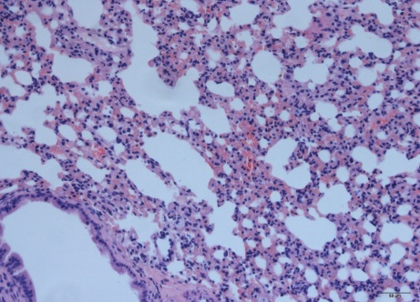
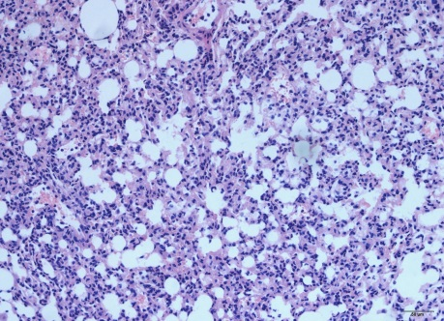
A
B

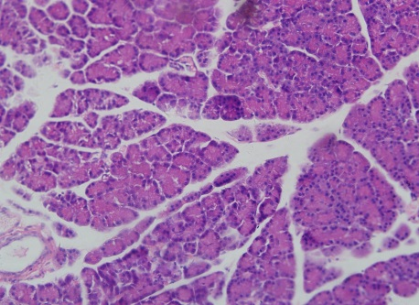
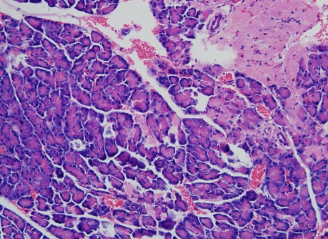
C
D

Figure 1 Histological examination of lung and pancrease stained with hematoxylin and eosin staining. A: Lung of control rats; B: Lung of acute pancreatitis (SAP) rats; C: Pancrease of control rats; D: Panceras of SAP rats. There were no remarkable pathologic changes in control rats (A, C); Significant inflammatory cell infiltration was observed in the SAP group. The typical pathological changes of SAP associated with acute lung injury which including lung edema, necrosis, hemorrhage and neutrophil infiltration were seen in SAP group (B). The histological changes of pancrease tissue such as the infiltration of neutropils, macrophages, interstitial edema, hemorrhage and focal necrotic areas were seen in the pancrease tissue of SAP group (D). Original magnification × 200 (A-D).

A
B
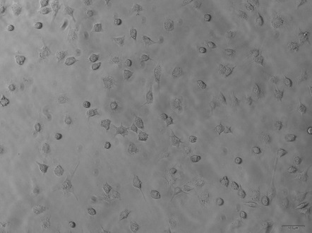

Figure 2 Identification of lung macrophages. A: Lung alveolus macrophages were identified by microscope (original magnification × 200); B: The purity of lung macrophages cells was examined by fluorescence-activated cell sorting as CD11b/c, F4/80 positive cells after primary culture for 24 h.

A
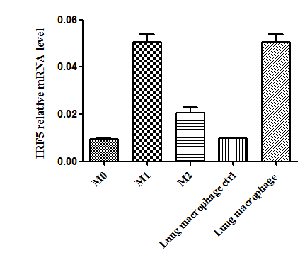
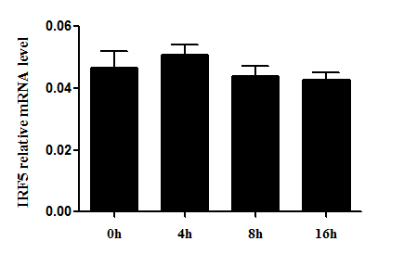
c

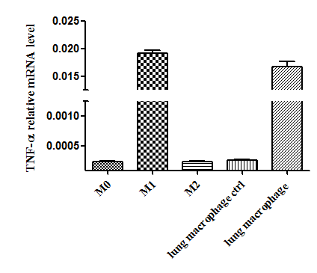
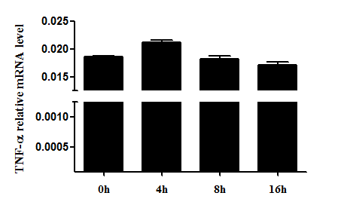
c
**

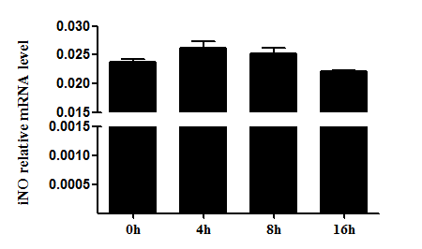
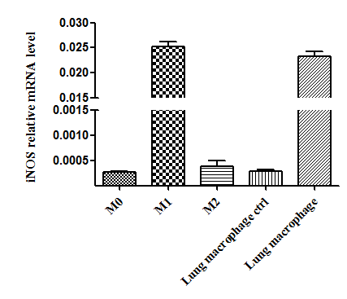
c

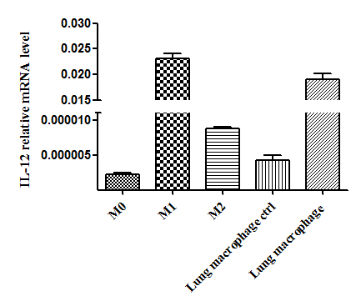
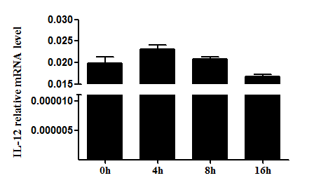
c

B
a

a

Figure 3 Expression of M1 phenotype of lung alveolus macrophages during early phase of acute pancreatitis. The expression of major M1 phenotypes [interferon regulatory factor 5 (IRF5), TNF-α, iNOS and IL-12] and M2 phenotypes (IL-10 and Arg-1) were detected by real time polymerase chain reaction (RT-PCR). The polarization of lung macrophages was detected by RT-PCR. A: mRNA levels of M1 phenotypes in the macrophages; B: mRNA levels of M2 markers in the macrophages. The significance was analyzed while comparing with the CTRL groups (M0, M1). ªP < 0.05, ^{c}P < 0.01 vs control.

A
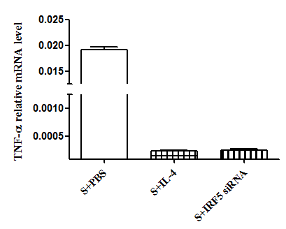
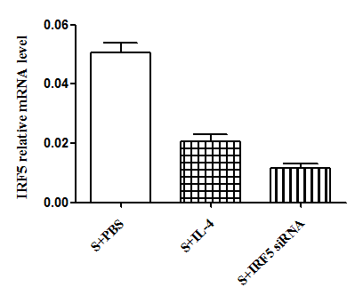
a
e
c
e

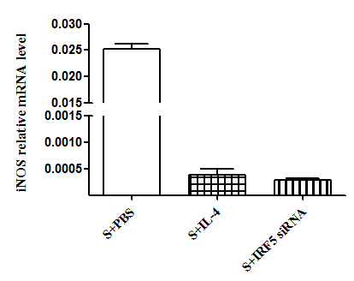
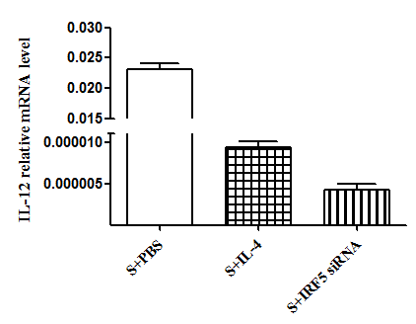

e
e
e
e

B

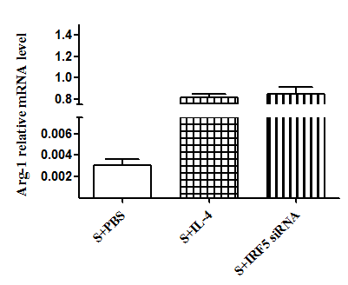
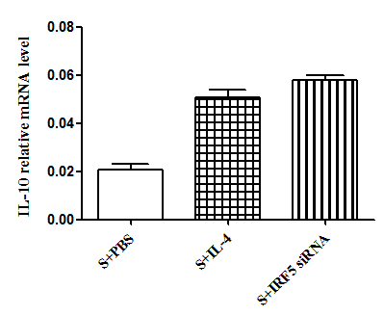
e
e
c
c

Figure 4 Reversion the polarization of lung macrophages from acute pancreatitis group. Lung alveolus macrophages were obtained 24 h after acute pancreatitis (SAP) model initiation and respectively treated with PBS, IL-4 or interferon regulatory factor 5 (IRF5) siRNA for 8 h (S + PBS, S + IL-4, S + IRF5 siRNA group). The M1/M2 phenotypes were detected by real time polymerase chain reaction. A: mRNA levels of M1 phenotypes in the macrophages; B: mRNA levels of M2 phenotypes in the macrophages. The significance was analyzed while comparing with the CTRL group (S + PBS). Error bars indicate the mean ± SE. ªP < 0.05, ^{c}P < 0.01, ^{e}P < 0.001 vs control. S: Lung alveolus macrophages from SAP rat model.

A

c
a
a
a

a
c
c
c

B
a
a
a
a

a

Figure 5 Comparing the ability to reverse lung macrophage polarization by IRF5 siRNA/IL-4. Lung macrophages were treated with interferon regulatory factor 5 (IRF5) siRNA/IL-4 for 4, 8, 16 and 24 h. The M1/M2 phenotypes were detected by real time polymerase chain reaction. A: mRNA levels of M1 phenotypes in the macrophages; B: mRNA levels of M2 phenotypes in the macrophages. The significance was analyzed while comparing the two groups in the same time point using the indifferent t-test. Error bars indicate the mean ± SE. ªP < 0.05, ^{c}P < 0.01 vs control.

