Name of Journal: World Journal of Gastroenterology
ESPS Manuscript NO: 18784
Manuscript Type: TOPIC HIGHLIGHT

2015 Advances in Gastric Cancer

Recent aspects for disseminated carcinomatosis of the bone marrow associated with gastric cancer: What has been done for the past, and what will be needed in future?

Iguchi H. Disseminated carcinomatosis of the bone marrow associated with GC

Haruo Iguchi

Haruo Iguchi, Shikoku Cancer Center, Department of Gastroenterology, Matsuyama, Ehime 791-0280, Japan

Authors contributions: Iguchi H wrote the manuscript.

Conflict-of-interest statement: The author has no conflict of interest to report.

Open-Access: This article is an open-access article which was selected by an in-house editor and fully peer-reviewed by external reviewers. It is distributed in accordance with the Creative Commons Attribution Non Commercial (CC BY-NC 4.0) license, which permits others to distribute, remix, adapt, build upon this work non-commercially, and license their derivative works on different terms, provided the original work is properly cited and the use is non-commercial. See: http://creativecommons.org/licenses/by-nc/4.0/

Correspondence to: Dr. Haruo Iguchi, Shikoku Cancer Center, Department of Gastroenterology, Minami-Umemotomachi Ko 160, Matsuyama, Ehime 791-0280, Japan. higuchi@shikoku-cc.go.jp
Telephone: +81-89-9991111
Fax: +81-89-9991128

Received: April 27, 2015
Peer-review started: May 1, 2015
First decision: June 23, 2015
Revised: July 24, 2015
Accepted: October 23, 2015
Article in press:
Published online:

Abstract
Disseminated carcinomatosis of the bone marrow is characterized by widespread bone metastasis (bone marrow infiltration) from solid tumors with hematological disorders coexisted. This disease is frequently complicated with gastric cancer among solid tumors although its incidence is very rare. In recent years, technological innovations in diagnosis and treatment for cancer have remarkably improved, which made survival rates of various cancers prolonged. Prognosis of disseminated carcinomatosis of the bone marrow associated with gastric cancer, however, is still poor (less than a year), possibly because this disease has not been given attention due to low incidence. In this review, I summarize the results obtained for the past, and propose ways to improve the prognosis of this disease.

Key words: Disseminated carcinomatosis of the bone marrow; Gastric cancer; Patogenesis; Diagnosis; Treatment

©The Author(s) 2015. Published by Baishideng Publishing Group Inc. All rights reserved.

Core tip: Disseminated carcinomatosis of the bone marrow is characterized by widespread bone metastasis from solid tumors with hematological disorders coexisted. This disease is frequently complicated with gastric cancer among solid tumors although its incidence is very rare. Technological innovations in diagnosis and treatment for cancer have remarkably improved in recent years, however, prognosis of this disease associated with gastric cancer remains still very poor. In this review, I summarize the results obtained for the past, and propose ways to improve the prognosis of this disease associated with gastric cancer.

Iguchi H. Recent aspects for disseminated carcinomatosis of the bone marrow associated with gastric cancer: What has been done for the past, and what will be needed in future? World J Gastroenterology 2015;
INTRODUCTION
Disseminated carcinomatosis of the bone marrow is characterized by widespread bone metastasis (i.e., bone marrow infiltration) from solid tumors and is associated with hematological abnormalities such as disseminated intravascular coagulation (DIC) and microangiopathic hemolytic anemia (MAHA). Although this disease is regarded as a subtype of bone metastasis, its true nature remains unclear; it is thought to be a clinical entity that may differ from bone metastasis of solid tumors. This disease is frequently complicated with gastric cancer among solid tumors^{[1]}. Its incidence seems rare, however, there has been no report about the incidence of this disease until now. Yamamura et al^{[2]} reported that bone metastasis was observed in 31 (1.4%) out of 2235 cases with gastric cancer who underwent curative surgery. Disseminated carcinomatosis of the bone marrow occupies only a small part of bone metastasis, therefore, the incidence of this disease seems quite rare although the details are still unclear. Besides some case reports, a few studies have reported disseminated carcinomatosis of the bone marrow associated with gastric cancer, but no large-scale surveys have been performed; thus, the pathogenesis of this disease remains unknown. Recent technological innovations in cancer diagnosis and treatment have improved survival rates overall. However, this has not been the case for disseminated carcinomatosis of the bone marrow associated with gastric cancer. Therefore, to improve prognosis, further research on the pathogenesis, diagnosis, and treatment is urgently needed.
Here, we review the results obtained since the concept of disseminated carcinomatosis of the bone marrow associated with gastric cancer was proposed approximately 30 years ago. In addition, we discuss ways to improve the prognosis of this disease.

MOLECULAR MECHANISM
Bone metastasis develops through the following processes: (1) cancer cells break away from the primary lesion and enter the bloodstream; (2) these cells survive and multiply in the bone marrow cavity; (3) the differentiation and activation of osteoclasts occur; and (4) the cancer cells proliferate in the bone microenvironment (Figure 1)^{[3,4]}. The main component of these processes is the osteoclasts, as they resorb the bone following differentiation and activation by cancer cells that have infiltrated the bone marrow, thereby securing a space where the cancer cells can proliferate. Various growth factors stored in the bone matrix are subsequently released into the bone marrow cavity, promoting cancer cell proliferation.
Unlike hematopoietic tumors, solid tumors, regardless of whether they are primary or metastatic tumors, generally exhibit nodularity. In contrast, disseminated carcinomatosis of the bone marrow characteristically exhibits mainly bone marrow infiltration with little tumorigenicity, although this disease is a kind of bone metastasis from solid tumors. Thus, the mode of metastasis in this disease is extremely unique among solid tumors. Disseminated carcinomatosis of the bone marrow is frequently complicated with gastric cancer^{[1]}. However, its molecular mechanism remains unknown. Some aspects of this disease differ from the more common bone metastases of solid tumors and are of considerable interest. Two important questions arise: (1) Why does gastric cancer, which usually has a low incidence of bone metastasis, rapidly and widely infiltrate the bone marrow (i.e., bone tropism)? and (2) Why does the explosive proliferation of gastric cancer cells, which results in the inhibition of normal hematopoiesis, occur?
The association between bone tropism and a chemokine (CXCR4, SDF-1) and/or integrins (α4β1, αvβ3) have been suggested in breast and/or prostate cancers^{[5-8]}. However, such a relationship has been demonstrated only in experimental models; the pathogenesis associated with bone tropism has not been clarified in cancer patients. Unlike breast and prostate cancers, gastric cancer is known to have a low incidence of bone metastasis. However, in disseminated carcinomatosis of the bone marrow associated with gastric cancer, gastric cancer cells rapidly infiltrate the bone marrow. Therefore, this disease seems ideal for studying the mechanism of bone tropism in cancer cells. The future development of in vivo models that reflect the pathogenesis of disseminated carcinomatosis of the bone marrow associated with gastric cancer will be very useful for clarifying the pathogenesis of bone tropism.
Regarding the mechanism of gastric cancer cell proliferation in the bone marrow, osteoclasts are considered to play a central role in supplying growth factors from the bone matrix. Their explosive proliferation, which may suppress normal hematopoiesis, is thought to be due to a unique mechanism that differs from that of bone metastases from solid tumors. We previously demonstrated RANKL expression in gastric cancer cells through immunostaining by using a tissue preparation from disseminated carcinomatosis of the bone marrow associated with gastric cancer (Figure 2)^{[9]}. This finding suggests the gastric cancer cells that infiltrate the bone marrow are directly involved in the differentiation and activation of osteoclasts and may result in the increased proliferation of gastric cancer cells in the bone marrow. In clinical practice, serum levels of bone resorption markers are elevated in patients with disseminated carcinomatosis of the bone marrow associated with gastric cancer^{[10-12]}, suggesting the involvement of osteoclasts in the pathogenesis of this disease (Table 1). In bone metastases from solid tumors, infiltrated cancer cells in the bone marrow produce cytokines (e.g., PTHrP, IL-8, PGE2, etc.), thereby promoting osteoclast differentiation and activation^{[13-15]}. In disseminated carcinomatosis of the bone marrow associated with gastric cancer, osteoclast differentiation and activation are also conceivably caused by cytokines secreted by gastric cancer cells. This common mechanism together with the direct action on osteoclasts through RANKL expressed in the gastric cancer cells may be associated with rapid proliferation.
Although the gastric cancer cells of disseminated carcinomatosis of the bone marrow proliferate rapidly in the bone marrow, they have little tumorigenicity. Histological types of the gastric cancer cells that cause this disease are mostly poorly differentiated adenocarcinoma or signet-ring cell carcinoma^{[16]}. In these types of cancer cells, expression levels of adhesion molecules have been shown to be reduced^{[17,18]}. Although these observations may explain the poor tumorigenicity, the precise mechanism remains to be clarified.
Disseminated carcinomatosis of the bone marrow associated with gastric cancer can occur over a long period ranging from several months to > 20 years even after patients have received curative resection of early gastric cancer^{[19,20]}. Therefore, the molecular mechanism responsible for such metachronous onset of this disease warrants attention; this information is important for formulating a postoperative follow-up strategy for patients. The concept of disseminated tumor cells (DTCs) was recently introduced to explain cancer metastasis (Figure 3)^{[21]}. The cancer cells are proposed to form a niche in the bone marrow and remain in a dormant state for a certain period until activated by an unknown trigger to form a new metastatic lesion. This mechanism might explain why disseminated carcinomatosis of the bone marrow occurs many years after curative resection of early gastric cancer. Lu et al^{[22]} showed that osteoclasts are involved in the reactivation of the cancer cell niche in the bone marrow, and bisphosphonates, which inhibit the differentiation and activation of osteoclasts, inhibit this reactivation of DTCs and exhibit anticancer activities (Figure 4). Bisphosphonates are widely used to treat bone metastasis in clinical practice. If they are proven to also inhibit DTC activation, this will lead to a new therapeutic strategy for the prevention of metastasis.

DIAGNOSIS
Characteristics features of disseminated carcinomatosis of the bone marrow associated with gastric cancer
With regard to disseminated carcinomatosis of the bone marrow associated with gastric cancer, no comprehensive articles have been published thus far, only a limited number of case reports. Therefore, we investigated the clinical characteristics of this disease in 28 cases reported in Japan during the period of 2003–2013^{[10,11,19,20,23-42]}.
Sex and age (mean ± SD; described for 28 cases): Male (n = 18): 54.4 ± 12.0 years (range: 33–78 years); Female (n = 10): 64.5 ± 11.8 years (range: 47–87 years); There were more male than female patients, and their age tended to be younger than that with gastric cancer.
Chief complaints (i.e., reasons for seeking medical attention, described for 27 cases): Pain (n = 19), hemorrhagic symptoms (n = 6), and elevation of serum ALP (n = 5) are frequently observed in order.
Laboratory examination (described for 27 cases): Among hematological abnormalities, DIC was the most frequent (n = 23), followed by anemia (n = 22). Patients with anemia included MAHA and anemia caused by gastrointestinal hemorrhage associated with DIC. Only 4 cases refer to leukoerythroblastosis, which was found in 3 of them.
- Biochemical tests showed marked elevation of ALP in all patients (4305 ± 3443 IU/L (mean ± SD), range: 739–12,600 IU/L). Mild-to-moderate elevation of LDH was also observed in most patients (706 ± 654 IU/L, mean ± SD, range: 141–2337 IU/L).
Time of onset (described for 28 cases): Disseminated carcinomatosis of the bone marrow was diagnosed synchronously with gastric cancer in 11 patients, and metachronously after gastric cancer surgery in 17 patients; in the latter group, the mean time ((mean ± SD) until diagnosis was 7.2 ± 6.7 years (range: 18 d to 23 years). The disease was observed also in patients who had received curative resection for early gastric cancers.
Macroscopic type (described for 16 cases): Among 16 cases, 10 and 6 were advanced and early gastric cancer, respectively. Regarding the macroscopic types of advanced cancer, 8 cases had type 2 or 3, and 2 cases had type 4 according to the Borrmann classification^{[43]}; there were no type 1 cases. Regarding the 6 cases of early gastric cancer, all were of type 0–II according to the classification of early gastric cancer established by the Japanese Endoscopic Society^{[43]}.
Histological type (described for 26 cases): The histological types of most cases were poorly differentiated adenocarcinoma (n = 13) and signet-ring cell carcinoma (n = 12); tubular adenocarcinoma (tub) was found in only 1 case.

Imaging diagnosis
If serum ALP and/or LDH levels are elevated in patients complaining of low back pain and/or hemorrhagic symptoms, disseminated carcinomatosis of the bone marrow should be suspected. In order to confirm the diagnosis, imaging tests such as computed tomography (CT), magnetic resonance imaging (MRI), and positron emission tomography (PET or PET/CT) should be performed first. Among these, PET/CT can detect not only primary lesions but also early bone lesions (i.e., bone marrow infiltration); therefore, it should be performed as the preferred initial imaging test. I recommend that every patient, who is suspected of disseminated carcinomatosis of the bone marrow, should have at least a PET/CT. Primary lesions of gastric cancer appear as tumor masses in the stomach and/or stomach wall thickening with ¹⁸F-deoxyglucose accumulation on PET/CT (Figure 5). When these findings are observed, histological diagnosis by upper gastrointestinal tract endoscopy should be performed. If primary lesions are not detected during screening, upper gastrointestinal tract endoscopy should be performed at the first instance, because gastric cancer is the most frequently observed cancer complicated with bone marrow carcinomatosis. Furthermore, a history of gastric cancer should always be acknowledged, because this disease can occur many years after gastric cancer surgery (Figure 6).

TREATMENT
Although the survival time of patients with disseminated carcinomatosis of the bone marrow associated with gastric cancer was 2–3 mo at the time when its concept was proposed, it has improved to some degree because of recent progress in gastric cancer chemotherapy. However, this improvement has been limited, and a survival time of a few years has not been attained; thus, the prognosis for this disease remains extremely poor. The following categories are important for treatment of this disease: (1) treatment of hematological abnormalities, especially DIC; (2) treatment of gastric cancer (chemotherapy); and (3) treatment of bone lesions [with bone-modifying agents (BMAs)]. We retrospectively analyzed the treatment methods of 28 cases of disseminated carcinomatosis of the bone marrow associated with gastric cancer reported in Japan during the period of 2003–2013.

Treatment of DIC
If a patient is diagnosed with DIC, treatment should be started promptly, because this affects prognosis. DIC coexisted in 22 of the 28 patients. Twenty-one of them received DIC treatment (gabexate mesilate + heparin) concomitantly with gastric cancer chemotherapy, and 19 fully recovered. Moreover, thrombomodulin, which was recently developed for DIC treatment, is superior to conventional treatment (i.e., heparin) for improving hemorrhagic symptoms and avoiding hemorrhage-related adverse events^{[44]}. At present, thrombomodulin is primarily used for the treatment of DIC, but its efficacy against DIC coexisting with disseminated carcinomatosis of the bone marrow associated with gastric cancer is unknown. Thrombomodulin may increase the recovery rates of DIC patients and thereby improve the treatment outcome of disseminated carcinomatosis of the bone marrow associated with gastric cancer.

Treatment of gastric cancer (chemotherapy)
Disseminated carcinomatosis of the bone marrow associated with gastric cancer is a rare disease, and its survival time is extremely short. There have been no prospective studies of the treatment for this disease to date. In 1980s, chemotherapy for gastric cancer was rarely administered because its options were limited and hematological disorders such as DIC and/or MAHA coexisted.
It was not until the 1990s that aggressive treatment with chemotherapy for this disease was started by Kobayashi et al^{[45]}. In 1992, they reported that among 10 patients with disseminated carcinomatosis of the bone marrow associated with gastric cancer complicated with DIC treated with methotrexate and 5-fluorouracil (MF therapy), 8 successively recovered from DIC^{[45]}. MF therapy was devised by Bertino et al^{[46]} as a biochemical modulation therapy. In Japan, its efficacy against gastric cancer was reported in 1989^{[47]}. Because the myelosuppression of MF therapy is mild and it showed efficacy against poorly differentiated types of gastric cancer, it was the preferred chemotherapy for this disease in the 1990s. In the 2000s, the efficacy of new chemotherapeutic anticancer drugs such as S-1, CDDP, CPT-11, and PTX against gastric cancer was reported^{[48-50]}. Furthermore, in Japan, on the basis of the results of the clinical trials (JCOG 9912 and SPIRITS), S-1 monotherapy and/or S-1 + CDDP therapy became standard therapies for gastric cancer^{[49,50]}. Since then, S-1–based chemotherapies have primarily been used to treat disseminated carcinomatosis of the bone marrow associated with gastric cancer.
In recent years, a number of different treatments have been used to treat disseminated carcinomatosis of the bone marrow associated with gastric cancer. During the period of 2003–2013, 28 cases of this disease were reported in Japan^{[10,11,19,20,23-42]}. The chemotherapy regimens (i.e., initial treatments) used in most of these cases involved MF therapy (n = 9) and S-1–based monotherapy or combination therapies (n = 14). Other chemotherapies used included GEM + CDDP, 5-FU + PTX, and 5-FU + CDDP (n = 1 each). One case was not treated with chemotherapy. Whether or not recovery from DIC is attained affects the prognosis of this disease. DIC-associated complications occurred in 22 of 28 patients; 21 of them were treated with DIC therapy (gabexate mesilate + heparin) and chemotherapy (MF therapy, n = 7; S-1–based therapy, n = 12; others, n = 2). Nineteen patients recovered from DIC. The survival time with respect to the initial treatments (although this may have been affected by the secondary treatment performed against recurrent DIC) was examined for cases for which these data were recorded. The mean (± SD) survival times of the MF (n = 7) and S-1–based (n = 11) therapy groups were 5.1 ± 3.1 and 8.1 ± 2.7 months, respectively (Figure 7); survival time tended to be longer in the S-1–based therapy group (log-rank test, p = 0.11). Kikuchi et al^{[51]} also reported a tendency for longer survival time with S-1–based therapy (n = 9) than MF therapy (n = 21), although the data used spanned the period between 1983 and 2009 when chemotherapy was not frequently administered.
Chemotherapy in addition to treatment for DIC is recommended for this disease to ensure recovery from DIC and prolonged survival. The S-1–based regimen is mainly used for gastric cancer in Japan; however, Ferrand et al^{[52]} reported a case with this disease responsive to mFOLFOX6. Regimens effective for this disease should also be investigated in a prospective study.

Treatment of bone lesions
Osteoclasts play an important role in the development of bone metastasis. The underlying, highly elaborate mechanism can be summarized as follows: the osteoclasts activated by cancer cells resorb the bone (bone destruction), securing a space for cancer cells to proliferate; concomitantly, various growth factors stored in the bone matrix are released into the bone marrow to facilitate cancer cells growth and propagation^{[3,4]}.
Disseminated carcinomatosis of the bone marrow differs from bone metastasis of solid tumors in that the cancer cells infiltrate the bone marrow but exhibit little tumorigenicity, characteristic clinical features are observed, and hematological abnormalities coexist. Although the mechanism for the development of disseminated carcinomatosis of the bone marrow is unknown, the disease is considered a subtype of bone metastasis. A mechanism similar to that of bone metastasis seems to occur during the infiltration and proliferation of cancer cells in the bone marrow. Marked elevation of serum ALP, which indicates increased bone formation, has been observed in this disease. Furthermore, bone resorption marker levels are reported to be elevated, although they have been measured in only a limited number of cases (Table 1)^{[10-12]}. These other findings suggest increased bone metabolic turnover in this disease; in other words, the increased differentiation and activation of osteoclasts lead to elevated bone resorption. This mechanism may play an important role in the development of this disease similar to that for bone metastasis.
BMAs are drugs that inhibit bone metastasis by suppressing bone resorption by osteoclasts. Among them, a bisphosphonate (zoledronate) and denosumab have become reimbursable, and are used widely in clinical practice^{[53]}. Increased bone resorption is also considered to be involved in the development of disseminated carcinomatosis of the bone marrow associated with gastric cancer; therefore, it is highly likely that BMAs are also effective for this disease. However, prospective studies are required, because there is currently no evidence for this.

PROBLEMS TO BE ADDRESSED
Pathogenesis
The pathogenesis of disseminated carcinomatosis of the bone marrow associated with gastric cancer is postulated to be similar to the conventional mechanism of bone metastasis. Although osteoclasts may play a central role in this disease, few details are known. The hematological abnormalities observed in this disease are considered to be induced by the inhibition of normal hematopoiesis due to explosive proliferation of gastric cancer cells in the bone marrow; clarification of this mechanism may contribute to treatment of the disease. In addition, the development of in vivo animal models will be required. We previously established a lung cancer cell line with high PTHrP expression and used it to create an in vivo mouse model of bone metastasis^{[13]}. This helped us elucidate the role of osteoclasts in the development of bone metastasis. In vivo models using gastric cancer cells with poorly differentiated adenocarcinoma and/or signet-ring cell carcinoma are required to clarify the pathogenesis of disseminated carcinomatosis of the bone marrow associated with gastric cancer.
This disease often occurs sometime after surgery; therefore, the mechanism of the metachronous development of the disease is also a topic of interest. The metachronous presentation of this disease may be explained by the presence of a cancer cell niche (i.e., DTCs) in the bone marrow. Osteoclasts are involved in the activation of DTCs, and bisphosphonates, which are widely used to treat bone metastasis in clinical practice, have been shown to inhibit the reactivation of DTCs^{[21,22]}. Therefore, it would be interesting to apply this drug in a clinical setting.

Gastric cancer chemotherapy
The treatment outcomes of gastric cancer following chemotherapy have improved in recent years owing to the advent of molecular-targeted drugs^{[54-56]}. On the contrary, a standard treatment for disseminated carcinomatosis of the bone marrow associated with gastric cancer has not been established. Because this disease is frequently associated with poorly differentiated adenocarcinoma and/or signet-ring cell carcinoma, regimens effective against these histological types of carcinoma are preferably administered. However, there have been no prospective studies, as the incidence rate of this disease is low. It would be beneficial to develop a system to record disease cases to allow prospective studies for the development of a treatment method specific for this disease, although conducting randomized controlled trials may prove difficult.

Treatment of bone lesions
Osteoclasts play a central role in the pathogenic mechanism of bone metastasis; therefore, drugs targeting osteoclasts (i.e., BMAs) are widely used in clinical practice. Despite circumstantial evidence such as the elevation of serum bone resorption markers, which suggests the involvement of osteoclasts in disseminated carcinomatosis of the bone marrow associated with gastric cancer, this has not been verified by scientific evidence. The hematological abnormalities of this disease are possibly triggered by the explosive proliferation of gastric cancer cells in the bone marrow; therefore, inhibiting this process may be key to the treatment of this disease. The concomitant administration of chemotherapeutic agents and BMAs that block the supply of bone-derived growth factors may effectively prevent the rapid proliferation of gastric cancer cells. Thus, I recommend that BMAs should be administered in addition to chemotherapy especially for the patients in whom serum bone resorption markers are elevated. However, its efficacy will be verified in the prospective studies of gastric cancer chemotherapy with or without BMAs.

Follow-up observations after gastric cancer surgery
Follow-up observations after gastric cancer surgery generally stop at 5 years. However, metachronous disseminated carcinomatosis of the bone marrow associated with gastric cancer can occur beyond 5 years postoperatively (Figure 6); this has raised questions about the optimum postoperative follow-up schedule. If a high-risk group of patients can be identified, guidelines could be established to follow this group for more than 5 years. This might facilitate early diagnosis and treatment of this disease, thereby improving treatment outcomes. The clinical and pathological characteristics of disseminated carcinomatosis of the bone marrow associated with gastric cancer are summerized in the section of “DIAGNOSIS”. In addition, it is necessary not only to establish criteria to identify high-risk groups, but also develop a detection method for DTCs or determine biomarkers including those for circulating tumor cells. All of these may lead to the early diagnosis of this disease.

CONCLUSION
More than 30 years have elapsed since the concept of disseminated carcinomatosis of the bone marrow was proposed. However, this disease has not been given much attention perhaps because of low incidence. Therefore, prognosis has not improved much during this time. In order to clarify the pathogenesis of this disease and improve its prognosis, the first step may be for researchers interested in this disease to collaborate on a global research system to study this disease.

REFERENCES
1 Pasquini E, Gianni L, Aitini E, Nicolini M, Fattori PP, Cavazzini G, Desiderio F, Monti F, Forghieri ME, Ravaioli A. Acute disseminated intravascular coagulation syndrome in cancer patients. Oncology 1995; 52: 505-508 [PMID: 7478440 DOI: 10.1159/000227520]
2 Yamamura Y, Kito T, Yamada E. Clinical evaluation on bone and bone marrow metastasis of gastric carcinoma. Jpn J Gastroenterol Surg 1985; 18: 2288-2293 [DOI: 10.5833/jjgs.18.2288]
3 Mundy GR. Metastasis to bone: causes, consequences and therapeutic opportunities. Nat Rev Cancer 2002; 2: 584-593 [PMID: 12154351 DOI: 10.1038/nrc867]
4 Yoneda T, Hiraga T. Crosstalk between cancer cells and bone microenvironment in bone metastasis. Biochem Biophys Res Commun 2005; 328: 679-687 [PMID: 15694401 DOI: 10.1016/j.bbrc.2004.11.070]
5 Cabioglu N, Sahin A, Doucet M, Yavuz E, Igci A, O Yildirim E, Aktas E, Bilgic S, Kiran B, Deniz G, Price JE. Chemokine receptor CXCR4 expression in breast cancer as a potential predictive marker of isolated tumor cells in bone marrow. Clin Exp Metastasis 2005; 22: 39-46 [PMID: 16132577 DOI: 10.1007/s10585-005-3222-y]
6 Conley-LaComb MK, Saliganan A, Kandagatla P, Chen YQ, Cher ML, Chinni SR. PTEN loss mediated Akt activation promotes prostate tumor growth and metastasis via CXCL12/CXCR4 signaling. Mol Cancer 2013; 12: 85 [PMID: 23902739 DOI: 10.1186/1476-4598-12-85]
7 Felding-Habermann B. Integrin adhesion receptors in tumor metastasis. Clin Exp Metastasis 2003; 20: 203-213 [PMID: 12741679 DOI: 10.1023/A: 1022983000355]
8 Leblanc R, Lee SC, David M, Bordet JC, Norman DD, Patil R, Miller D, Sahay D, Ribeiro J, Clézardin P, Tigyi GJ, Peyruchaud O. Interaction of platelet-derived autotaxin with tumor integrin αVβ3 controls metastasis of breast cancer cells to bone. Blood 2014; 124: 3141-3150 [PMID: 25277122 DOI: 10.1182/blood-2014-04-568683]
9 Kusumoto H, Haraguchi M, Nozuka Y, Oda Y, Tsuneyoshi M, Iguchi H. Characteristic features of disseminated carcinomatosis of the bone marrow due to gastric cancer: the pathogenesis of bone destruction. Oncol Rep 2006; 16: 735-740 [PMID: 16969487 DOI: 10.3892/or.16.4.735]
10 Takeda A, Kawara F, Onishi K, Higashida A, Mamori S, Ashida C, Okutani T, Yamada H, Kondo T. A very elderly case of advanced gastric cancer with disseminated carcinomatosis of bone marrow and multiple bone metastasis, diagnosed by extremely elevated serum alkaline phosphatase levels, and treated with low-dose S-1 to avoid disseminated intravascular coagulation. Nihon Shokakibyo Gakkai Zasshi 2011; 108: 1879-1885 [PMID: 22056709 DOI: 10.11405/nisshoshi.108.1879]
11 Hasuda N, Koshizuka K, Oyachi N, Takano K, Matsumoto M. A case report of disseminated carcinomatosis of the bone marrow from early gastric cancer 4 years after operation. J Jpn Surg Assoc 2008; 69: 355-359 [DOI: 10.3919/jjsa.69.355]
12 Mizuno I, Izeki O, Nakahara S, Kawamoto K, Onga T, Matsuoka H, Sugimoto T, Matsui T, Itoh H, Chihara K. [Disseminated carcinomatosis of the bone marrow occurring 11 years after subtotal gastrectomy for gastric cancer]. Rinsho Ketsueki 1998; 39: 670-675 [PMID: 9796401]
13 Iguchi H, Tanaka S, Ozawa Y, Kashiwakuma T, Kimura T, Hiraga T, Ozawa H, Kono A. An experimental model of bone metastasis by human lung cancer cells: the role of parathyroid hormone-related protein in bone metastasis. Cancer Res 1996; 56: 4040-4043 [PMID: 8752176]
14 Hiraga T, Myoui A, Choi ME, Yoshikawa H, Yoneda T. Stimulation of cyclooxygenase-2 expression by bone-derived transforming growth factor-beta enhances bone metastases in breast cancer. Cancer Res 2006; 66: 2067-2073 [PMID: 16489006 DOI: 10.1158/0008-5472.CAN-05-2012]
15 Hsu YL, Hung JY, Ko YC, Hung CH, Huang MS, Kuo PL. Phospholipase D signaling pathway is involved in lung cancer-derived IL-8 increased osteoclastogenesis. Carcinogenesis 2010; 31: 587-596 [PMID: 20106902 DOI: 10.1093/carcin/bgq030]
16 Kim HS, Yi SY, Jun HJ, Lee J, Park JO, Park YS, Jang J, Kim HJ, Ko Y, Lim HY, Kang WK. Clinical outcome of gastric cancer patients with bone marrow metastases. Oncology 2007; 73: 192-197 [PMID: 18418012 DOI: 10.1159/000127386]
17 Zhou YN, Xu CP, Han B, Li M, Qiao L, Fang DC, Yang JM. Expression of E-cadherin and beta-catenin in gastric carcinoma and its correlation with the clinicopathological features and patient survival. World J Gastroenterol 2002; 8: 987-993 [PMID: 12439911]
18 Humar B, Blair V, Charlton A, More H, Martin I, Guilford P. E-cadherin deficiency initiates gastric signet-ring cell carcinoma in mice and man. Cancer Res 2009; 69: 2050-2056 [PMID: 19223545 DOI: 10.1158/0008-5472.CAN-08-2457]
19 Sakai A, Tsuji Y, Kikuchi O, Jinno A, Tanabe W, Terashima Y, Maeda Y, Doi A, Hata T, Yamamoto N, Aoyama I, Arai O, Kiyosuke Y, Katayama S, Hirao K, Miyoshi M, Mouri H, Matsueda K, Yamamoto H. Marked effect of combination chemotherapy with tegafur-gimeracil-oteracil potassium and gemcitabine on a suspected case of pancreas cancer or gallbladder cancer metastasis to bone: further diagnosis of disseminated carcinomatosa of bone marrow recurrence after the 23 years of gastric cancer operation by autopsy findings. Gan To Kagaku Ryoho 2008; 35: 529-532 [PMID: 18347411]
20 Shiozaki M, Ishida K, Hasegawa M, Tanaka T, Ki T, Umegaki E, Takiuchi H, Hirata I, Katsu K, Kurisu Y. [Case of disseminated carcinomatosis of bone marrow with severe alkalinephosphatasia, manifested 10 years after resection of early gastric cancer]. Nihon Shokakibyo Gakkai Zasshi 2004; 101: 879-884 [PMID: 15382706 DOI: 10.11405/nisshoshi.101.879]
21 Aft R, Perez JR, Raje N, Hirsh V, Saad F. Could targeting bone delay cancer progression? Potential mechanisms of action of bisphosphonates. Crit Rev Oncol Hematol 2012; 82: 233-248 [PMID: 21683613 DOI: 10.1016/j.critrevonc.2011.05.009]
22 Lu X, Mu E, Wei Y, Riethdorf S, Yang Q, Yuan M, Yan J, Hua Y, Tiede BJ, Lu X, Haffty BG, Pantel K, Massagué J, Kang Y. VCAM-1 promotes osteolytic expansion of indolent bone micrometastasis of breast cancer by engaging α4β1-positive osteoclast progenitors. Cancer Cell 2011; 20: 701-714 [PMID: 22137794 DOI: 10.1016/j.ccr.2011.11.002]
23 Imataka H, Sato A, Hamada K, Takeda N, Nemoto H. A case of progressive gastric carcinoma accompanied by disseminated carcinomatosis of bone marrow (DCBM)due to bone metastasis, with DIC recovery by administration of S-1 and docetaxel. Gan To Kagaku Ryoho 2013; 40: 241-243 [PMID: 23411964]
24 Ninomiya K, Mannami T, Seno S, Suzuki Y, Tamura T, Kimura K, Kubo T, Masunari T, Okada T, Kiguchi T, Sezaki N, Harita S, Nakata Y, Sonobe H. A case of advanced gastric cancer with multiple bone metastases and disseminated intravascular coagulation successfully treated by combination chemotherapy of S-1 plus docetaxel. Gan To Kagaku Ryoho 2012; 39: 1719-1722 [PMID: 23152027]
25 Tsuji K, Doyama H, Yamada S, Kaneko Y, Takemura K, Tsuji S, Tominaga K, Inagaki S, Hayashi T, Ito R, Nakanishi H, Kitou Y, Takeda Y, Yamamoto M, Inaki N, Yamada T, Niwa H, Katayanagi K, Kurumaya H. A case of disseminated carcinomatosis of bone marrow treated by S-1 and cisplatin after distal gastrectomy for early gastric cancer. Gan To Kagaku Ryoho 2012; 39: 813-815 [PMID: 22584338]
26 Yamagiwa T, Maejima R, Shimada N, Dairaku N, Narisawa A, Iwahashi S. A case of gastric cancer accompanied by disseminated carcinomatosis of bone marrow with DIC, and subdural hematoma successfully treated with sequential methotrexate and 5-fluorouracil therapy. Gan To Kagaku Ryoho 2011; 38: 999-1001 [PMID: 21677495]
27 Kubo N, Takeuchi N, Nakayama A, Ogiwara H, Tsujimoto K, Ito N, Koiwai K. Successful withdrawal from disseminated intravascular coagulation caused by disseminated carcinomatosis of bone marrow originated from gastric cancer treated by sequential therapy consisting of MTX and 5-FU and palliative radiotherapy. Gan To Kagaku Ryoho 2011; 38: 693-695 [PMID: 21499008]
28 Tsukasa K, Fujimoto C, Ariyama H, Esaki T, Murakawa M, Syoji T, Baba E, Hiranuma S. A case of bone marrow carcinosis from gastric cancer that presented hypocalcemia caused by zoledronic acid during the treatment of methotrexate/5-fluorouracil sequential therapy. Gan To Kagaku Ryoho 2009; 36: 489-492 [PMID: 19295278]
29 Fujishima Y, Yoneda R, Iwai M, Fukunaga H, Miura M, Koide M, Fukuda T. A case of advanced gastric cancer with disseminated carcinomatosis of bone marrow treated by S-1 and CDDP. Gan To Kagaku Ryoho 2009; 36: 2653-2655 [PMID: 20009474]
30 Yasuda K, Kimura T, Seita M, Takahata T, Akazai Y. A case of gastric cancer accompanied by disseminated carcinomatosis of bone marrow with DIC recovered by sequential therapy consisting of MTX and 5-FU. Gan To Kagaku Ryoho 2008; 35: 1941-1943 [PMID: 19011348]
31 Katayama K, Okitsu H, Kimura S, Hara T, Ozaki K, Goto T, Yamashita M, Fujii Y. A case of disseminated bone marrow carcinosis with disseminated intravascular coagulation successfully controlled with S-1 after total gastrectomy for advanced gastric cancer. Gan To Kagaku Ryoho 2008; 35: 1201-1204 [PMID: 18633263]
32 Nishioka K, Kobayashi K, Aoki T, Hatano H, Komori T, Matsumoto T, Uemura Y. Two patients of progressive gastric cancer accompanied by disseminated carcinomatosis of bone marrow due to bone metastasis with DIC successfully controlled by combination of S-1 and CDDP. Gan To Kagaku Ryoho 2007; 34: 2135-2137 [PMID: 18219923]
33 Migita K, Watanabe A, Sakamoto C, Nakamura T, Ohyama T, Ishikawa H, Yamamoto K. A case of multiple bone metastases from gastric cancer treated with combination chemotherapy of S-1 and CDDP. Gan To Kagaku Ryoho 2007; 34: 929-931 [PMID: 17565259]
34 Satoh D, Ninomiya M, Umeoka T, Harano M, Sasaki H, Aoki H, Onoda T, Shiozaki Y, Ohno S, Higaki K, Takakura N. A case of progressive gastric carcinoma accompanied by disseminated carcinomatosis of bone marrow due to bone metastasis with DIC recovery by joint administration of 5-FU and paclitaxel. Gan To Kagaku Ryoho 2006; 33: 2079-2081 [PMID: 17197758]
35 Wakabayashi K, Hayashi S, Masuda H, Karube H, Ookame H, Aoki H, Sakamoto N, Tanaka T, Fujii M, Takayama T. A case of advanced gastric cancer with simultaneous multiple bone metastases and double occurrence of disseminated intravascular coagulation successfully controlled with combined chemotherapy. Gan To Kagaku Ryoho 2004; 31: 393-398 [PMID: 15045947]
36 Yoshioka S, Tsujinaka T, Kida H, Hirao M, Fujitani K. A patient with gastric cancer complicated with severe DIC and multiple bone metastasis showing a high response to combination of TS-1 and CDDP. Gan To Kagaku Ryoho 2003; 30: 403-406 [PMID: 12669401]
37 Miyazaki M, Shirabe K, Abe T, Miyoshi O, Kondo J, Sakurai M, Nishida K, Nagaie T. A case of disseminated carcinomatosis of the bone marrow with elevation of serum ALP from early gastric cancer 1 year and 10 months after operation. Jpn J Clin Exp Med 2009; 86: 653-656
38 Sugimoto T, Sekino T, Sago T, Futamura N, Horiya Y. A case of disseminated carcinomatosa of bone marrow from gastric carcinoma after 22 years [Abstract in English]. J Jpn Surg Assoc 2006; 67: 64-67 [DOI: 10.3919/jjsa.67.64]
39 Fujishiro R, Naruse Y, Ichinose T, Yamazaki A, Sakamoto R. A case of gastric cancer with DIC caused by multiple bone metastases treated with TS-1. Gan To Kagaku Ryoho 2006; 33: 663-665 [PMID: 16685168]
40 Mieno H, Kinoshita T, Konishi M, Nakagouri T, Takahashi S, Gotohda N. Bone and bone marrow recurrence from gastric carcinoma developed more than five years after operation: three cases. Jpn J Gastroenterol Surg 2006; 39: 1672-1677 [DOI: 10.5833/jjgs.39.1672]
41 Wakatsuki K, Yamada Y, Narikiyo M, Ueno M, Tamaki H, Miki K, Matsumoto S, Enomoto K, Nakajima Y. A case of bone metastasis from gastric carcinoma after twelve-year disease-free interval. Jpn J Gastroenterol Surg 2007; 40: 39-43 [DOI: 10.5833/jjgs.40.39]
42 Ishikawa T, Mizuno K, Togashi T, Watanabe K, Seki K, Ohta H, Yoshida T, Kamimura T. A case of advanced gastric cancer with bone metastasis and severe DIC responding to hypertensive subselective chemotherapy with pharmacokinetic modulating chemotherapy. Gan To Kagaku Ryoho 2005; 32: 523-527 [PMID: 15853221]
43 Japanese Gastric Cancer Association. Japanese Classification of Gastric Carcinoma. 2nd English Edition. Gastric Cancer 1998; 1: 10-24 [PMID: 11957040 DOI: 10.1007/s101200050051]
44 Saito H, Maruyama I, Shimazaki S, Yamamoto Y, Aikawa N, Ohno R, Hirayama A, Matsuda T, Asakura H, Nakashima M, Aoki N. Efficacy and safety of recombinant human soluble thrombomodulin (ART-123) in disseminated intravascular coagulation: results of a phase III, randomized, double-blind clinical trial. J Thromb Haemost 2007; 5: 31-41 [PMID: 17059423 DOI: 10.1111/j.1538-7836.2006.02267.x]
45 Kobayashi T, Sasaki T, Ibuka T, Imai K, Monma K, Sakaki N, Tabata I, Ishiwata J, Onozawa Y, Ohno T. Sequential MTX and 5-FU therapy of gastric cancer with systemic bone metastasis and disseminated intravascular coagulation. Gan To Kagaku Ryoho 1992; 19: 69-74 [PMID: 1309634]
46 Bertino JR, Sawicki WL, Lindquist CA, Gupta VS. Schedule-dependent antitumor effects of methotrexate and 5-fluorouracil. Cancer Res 1977; 37: 327-328 [PMID: 830420]
47 Sasaki T, Ota K, Ibayashi J, Sakata Y, Matsuoka T, Ishikawa M, Wakui A, Ogoshi K, Akazawa S, Sakai Y. Randomized multicenter trial of sequential methotrexate and 5-fluorouracil versus 5-fluorouracil alone in advanced gastric cancer. Gan To Kagaku Ryoho 1989; 16: 2545-2555 [PMID: 2673045]
48 Van Cutsem E, Moiseyenko VM, Tjulandin S, Majlis A, Constenla M, Boni C, Rodrigues A, Fodor M, Chao Y, Voznyi E, Risse ML, Ajani JA. Phase III study of docetaxel and cisplatin plus fluorouracil compared with cisplatin and fluorouracil as first-line therapy for advanced gastric cancer: a report of the V325 Study Group. J Clin Oncol 2006; 24: 4991-4997 [PMID: 17075117 DOI: 10.1200/JCO.2006.06.8429]
49 Koizumi W, Narahara H, Hara T, Takagane A, Akiya T, Takagi M, Miyashita K, Nishizaki T, Kobayashi O, Takiyama W, Toh Y, Nagaie T, Takagi S, Yamamura Y, Yanaoka K, Orita H, Takeuchi M. S-1 plus cisplatin versus S-1 alone for first-line treatment of advanced gastric cancer (SPIRITS trial): a phase III trial. Lancet Oncol 2008; 9: 215-221 [PMID: 18282805 DOI: 10.1016/S1470-2045(08)70035-4]
50 Boku N, Yamamoto S, Fukuda H, Shirao K, Doi T, Sawaki A, Koizumi W, Saito H, Yamaguchi K, Takiuchi H, Nasu J, Ohtsu A. Fluorouracil versus combination of irinotecan plus cisplatin versus S-1 in metastatic gastric cancer: a randomised phase 3 study. Lancet Oncol 2009; 10: 1063-1069 [PMID: 19818685 DOI: 10.1016/S1470-2045(09)70259-1]
51 Kikuchi Y, Matsuzaki M, Tokura N, Kanayama K, Kanayama M, Shiratori M, Shinohara M, Igarashi Y, Sumino Y, Nakano K. Disseminated carcinomatosis of the bone marrow due to Gastric cancer: Analysis of cases at Toho University and in Japan. J Med Soc Toho 2010; 57: 127-136
52 Ferrand FR, Gontier E, Guymar S, Fagot T, Ceccaldi B, Malfuson JV, de Revel T. Effectiveness and safe use of modified FOLFOX-6 for metastatic gastric cancer with signet ring cell components complicated by disseminated intravascular coagulation and diffuse bone marrow carcinomatosis. Onkologie 2012; 35: 118-120 [PMID: 22414976 DOI: 10.1159/000336971]
53 Wang Z, Qiao D, Lu Y, Curtis D, Wen X, Yao Y, Zhao H. Systematic literature review and network meta-analysis comparing bone-targeted agents for the prevention of skeletal-related events in cancer patients with bone metastasis. Oncologist 2015; 20: 440-449 [PMID: 25732263 DOI: 10.1634/theoncologist.2014-0328]
54 Bang YJ, Van Cutsem E, Feyereislova A, Chung HC, Shen L, Sawaki A, Lordick F, Ohtsu A, Omuro Y, Satoh T, Aprile G, Kulikov E, Hill J, Lehle M, Rüschoff J, Kang YK. Trastuzumab in combination with chemotherapy versus chemotherapy alone for treatment of HER2-positive advanced gastric or gastro-oesophageal junction cancer (ToGA): a phase 3, open-label, randomised controlled trial. Lancet 2010; 376: 687-697 [PMID: 20728210 DOI: 10.1016/S0140-6736(10)61121-X]
55 Kang YK, Ohtsu A, Van Cutsem E, Rha, SY, Sawaki A, Park SR, Lim HY, Wu J, Langer B, Shah MA. AVAGAST: A randomized, double-blind, placebo-controlled, phaseⅢstudy of first-line capecitabine and cisplatin plus bevacizumab or placebo in patients with advanced gastric cancer (AGC). J Clin Oncol 2010; 28 Suppl 18: abstr LBA4007
56 Lordick F, Kang YK, Chung HC, Salman P, Oh SC, Bodoky G, Kurteva G, Volovat C, Moiseyenko VM, Gorbunova V, Park JO, Sawaki A, Celik I, Götte H, Melezínková H, Moehler M. Capecitabine and cisplatin with or without cetuximab for patients with previously untreated advanced gastric cancer (EXPAND): a randomised, open-label phase 3 trial. Lancet Oncol 2013; 14: 490-499 [PMID: 23594786 DOI: 10.1016/S1470-2045(13)70102-5]
P-Reviewer: van Oudheusden TR S-Editor: Yu J L-Editor: E-Editor:

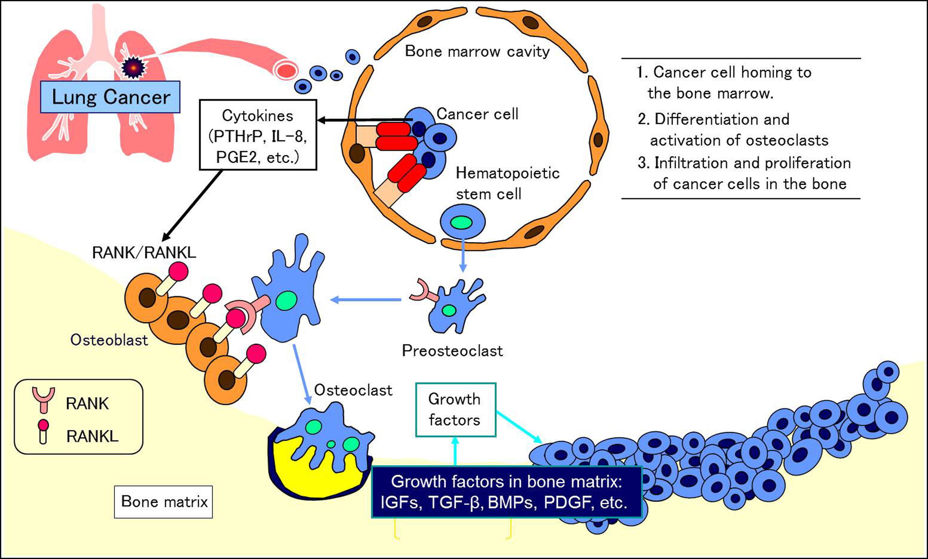

Figure 1 Molecular mechanism of osteolytic bone metastasis.
Figure 1 Molecular mechanism of osteolytic bone metastasis.
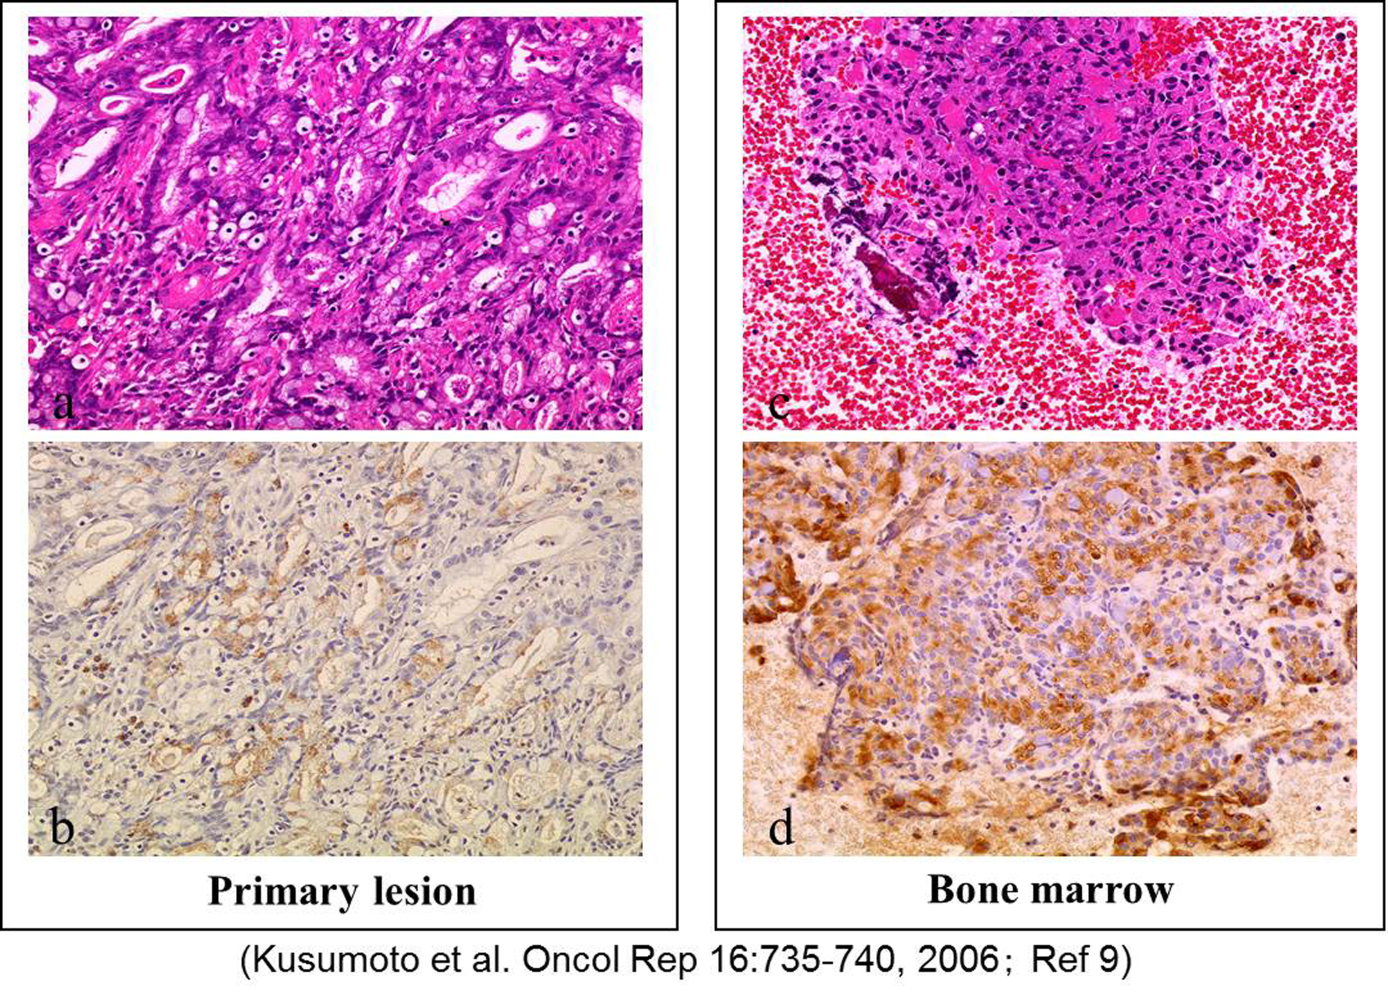

Figure 2 RANKL expression in disseminated carcinomatosis of the bone marrow associated with gastric cancer. Representative immunohistochemistry for RANKL in gastric cancer demonstrating disseminated carcinomatosis of the bone marrow. A: Hematoxylin and eosin staining of gastric cancer shows moderately differentiated adenocarcinoma (magnification × 20); B: Immunohistochemistry for RANKL in a serial section of the same specimen in (A). RANKL shows positive staining predominantly in the cytoplasm and plasma membrane of moderately differentiated adenocarcinoma cells (magnification × 20).; C: Hematoxylin and eosin staining of a bone marrow aspiration smear shows infiltration of atypical epithelial cells, indicating metastasis from known gastric cancer (magnification × 20); D: Immunohistochemistry for RANKL in a serial section of the same specimen in (C). RANKL shows positive staining predominantly in the cytoplasm and plasma membrane of metastatic gastric cancer cells as is seen in the primary lesion (B) (magnification × 20). Adapted from Kusumoto et al^{[9]}.

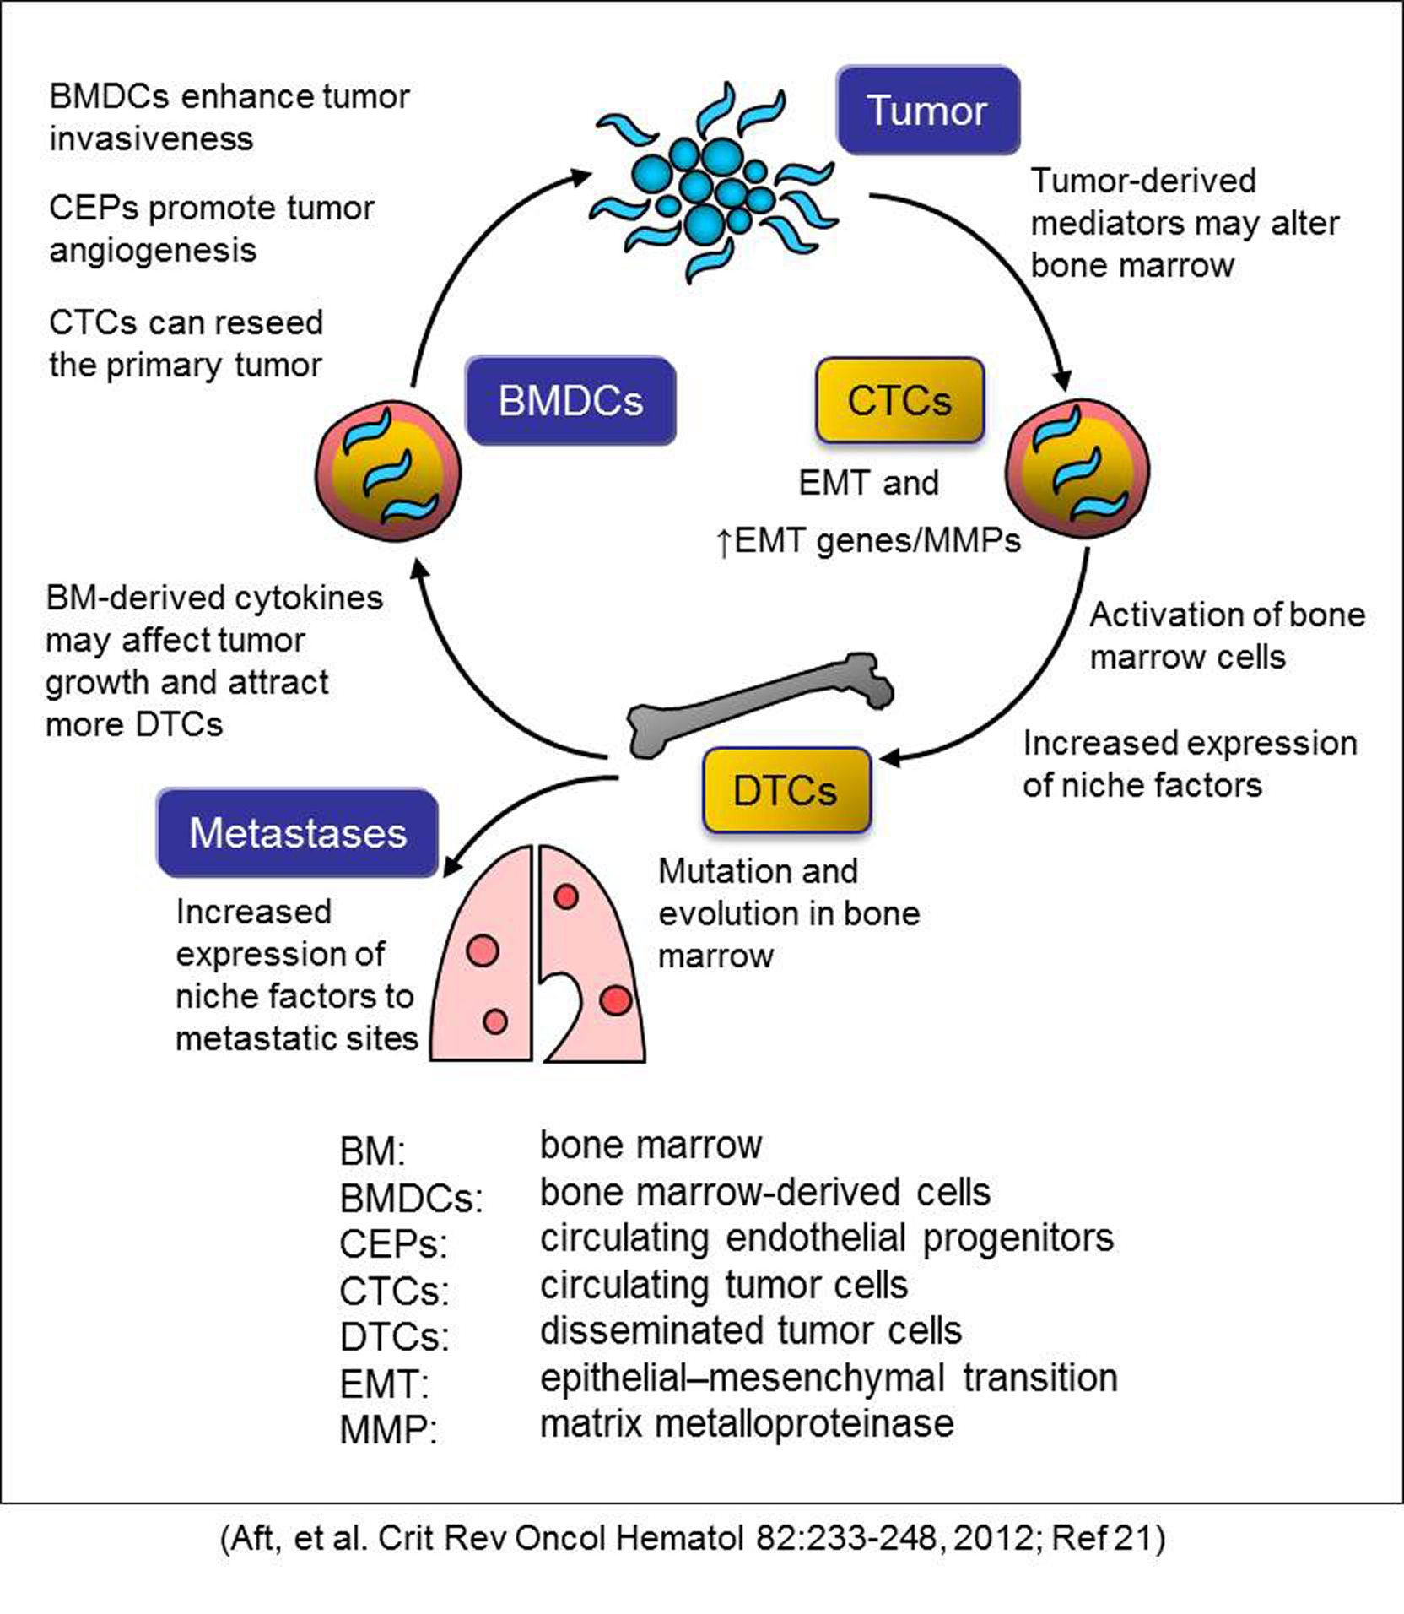

Figure 3 Association of disseminated tumor cells in the bone marrow with cancer metastasis. DTCs: Disseminated tumor cells; CTCs: Circulating tumor cells; CEPs: Circulating endothelial progenitors; MMP: Matrix metalloproteinase; BM: Bone marrow; BMDCs: BM-derived cells. Adapted from Aft et al^{[21]}.

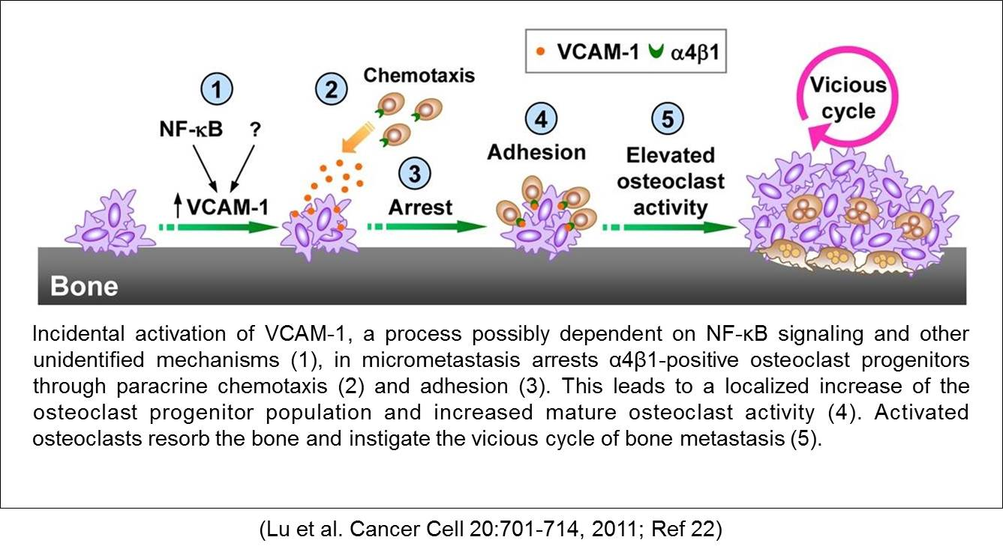
Figure 4 Reactivation of disseminated tumor cells in the bone marrow: Transition from dormant micrometastasis (i.e., DTCs) to macrometastasis. DTCs: Disseminated tumor cells. Adapted from Lu et al^{[22]}.

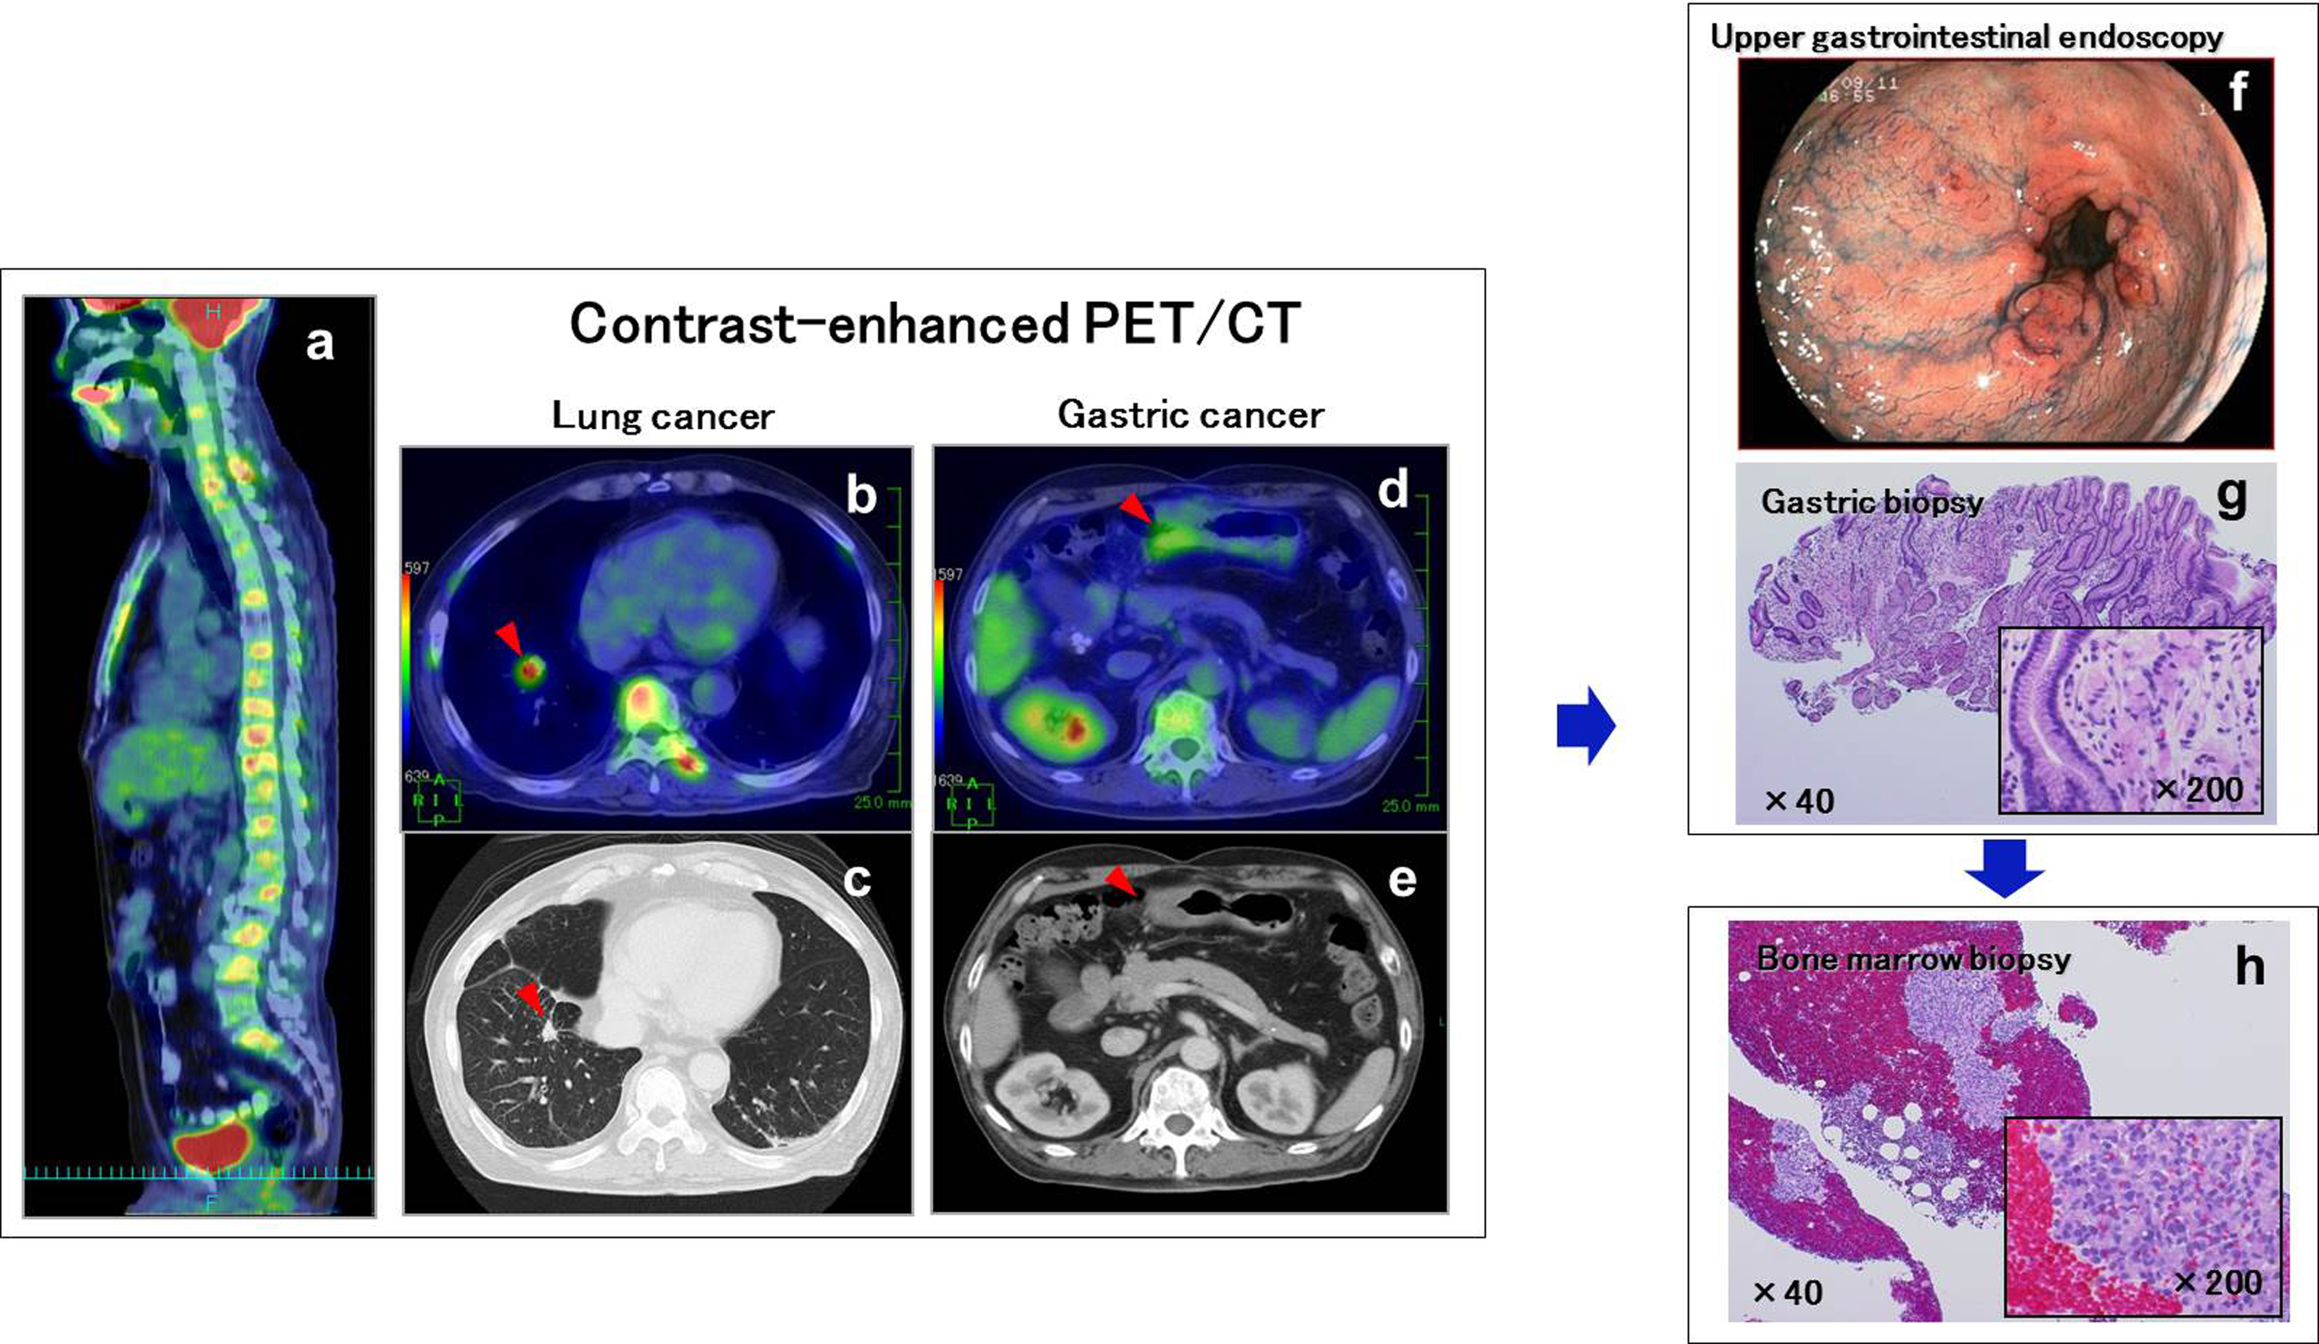

Figure 5 A case of synchronous disseminated carcinomatosis of the bone marrow associated with gastric cancer in a 60-year-old man: Findings of PET/CT imaging, endoscopic examination, and bone marrow biopsy. History: The patient visited a local doctor in August 2007 with complaints of left chest and back pain. Computed tomography (CT) and magnetic resonance imaging revealed a “lung tumor” and “bone metastasis (thoracic vertebrae)”; therefore, the patient was referred to the Shikoku Cancer Center. Laboratory findings: Marked elevation of serum ALP (2594 U/L), CRP (34.74 mg/dL), and mild elevation of serum LDH (342 U/L) were observed with hematological disorder (DIC and elevated WBC [possible leukoerythroblastosis]). Tumor marker (CA19-9 162 U/mL) and bone metabolic markers (1 CTP 8.9 ng/mL; BAP 258 μg/L) were elevated. These findings were suggestive of recurrence of gastric cancer, perhaps disseminated carcinomatosis of the bone marrow. Positron emission tomography (PET)/CT imaging: FDG accumulation was observed in all spinal vertebrae and the sternum in the sagittal view of the PET/CT fusion image (A). In the transaxial views of CT and PET/CT fusion images, a tumor mass with FDG accumulation was observed in the right lung ( ; B, C) and thickening of the wall with FDG accumulation was observed in the gastric antrum ( ;D, E). These findings on PET/CT suggested the presence of lung cancer together with gastric cancer. Endoscopic examination: Multiple erosions were observed in the gastric antrum/pyloric ring (F). In the tissue specimen obtained from the erosions, proliferation of signet-ring cell carcinoma was observed (G). Bone marrow biopsy: In order to determine the origin of the bone lesions, bone marrow biopsy was performed. Signet-ring cell carcinoma characterized by clear abundant cytoplasm and eccentrically positioned nuclei was found in the hematopoietic bone marrow (H). This histologic finding suggests the bone lesions originated from the gastric cancer.

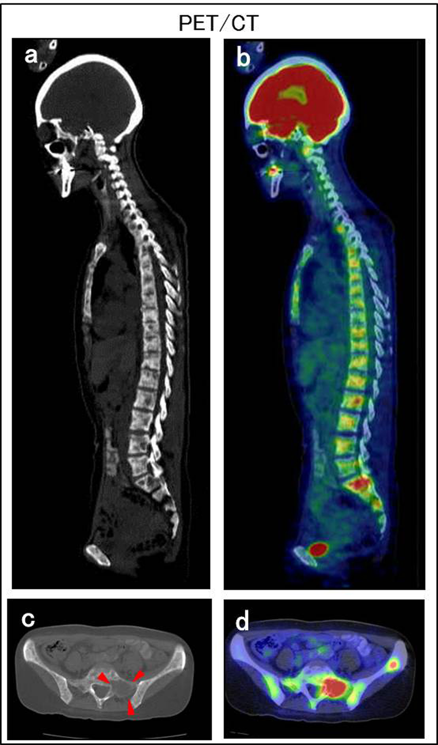

Figure 6 A case of metachronous disseminated carcinomatosis of the bone marrow associated with gastric cancer in a 47-year-old woman: Laboratory findings and PET/CT imaging. History: The patient underwent gastric cancer surgery at 36 years of age (histological diagnosis, poorly differentiated adenocarcinoma < signet-ring cell carcinoma), followed by chemotherapy with oral 5-FU (postoperative adjuvant therapy) for 3 years. Eleven years postoperatively, she visited a local orthopedist with a complaint of low back pain. Elevated serum ALP and multiple bone metastases were found on bone scintigraphy, and she was referred to the Shikoku Cancer Center. Laboratory findings: Marked elevation of serum ALP (11740 IU/L) and mild elevation of serum LDH (435 IU/L) were observed with hematological disorders (i.e., DIC and anemia: Hb 6.9 g/dL). Tumor markers (CEA 241 ng/mL; CA19-9 212 U/mL) and bone metabolic markers (1 CTP 17.7 ng/mL; Urine NTx > 300 nmol BCE/L; BAP 1260 μg/L) were elevated. These findings were suggestive of recurrence of the gastric cancer in the bone (i.e., disseminated carcinomatosis of the bone marrow). Positron emission tomography (PET)/computed tomography (CT) imaging: Osteolytic changes with FDG accumulation were observed in most vertebrae. A, B: Sagittal views of CT (A) and PET/CT fusion images (B); C, D: Transaxial views of the sacrum (S1) on CT (C; , osteolytic change) and PET/CT fusion image (D).

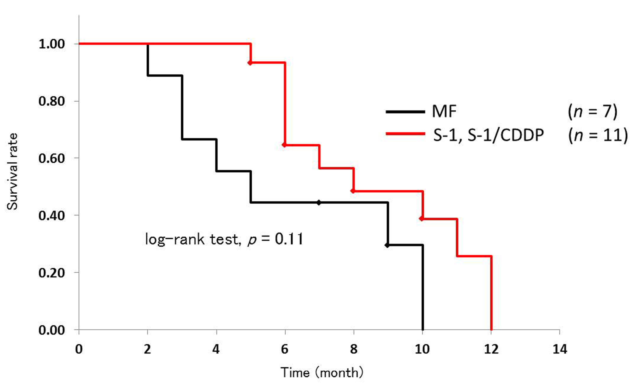

Figure 7 Kaplan–Meier survival curves of disseminated carcinomatosis of the bone marrow associated with gastric cancer according to chemotherapy regimen. Among 28 cases of disseminated carcinomatosis of the bone marrow associated with gastric cancer reported in Japan during 2003-2013, 27 cases were treated with chemotherapy. In these 27 cases, information about survival time was available for 18 cases. Using these data, Kaplan-Meier survival curves were calculated according to the chemotherapy regimen.

Table 1 Levels of serum and/or urinary bone metabolic markers in patients with disseminated carcinomatosis of the bone marrow associated with gastric cancer
 |  |  | Bone resorption markers |  |  | Bone formation markers
 | Age | Sex | 1CTP  (4.5 mg/mL)² | NTx (urine)  (< 89 nM BCE/  mM Cre)² | DPD (urine)  （< 7.6 nM BCE/  mM Cre)² | BAP  （<20.9 μg/L)² | OC  （< 13.0 ng/mL)²
Case report¹
Takeda et al^{[10]} | 87 | F | － | 14800 | 59 | 929 | 32
Hasuda et al^{[11]} | 39 | M | 19.5 | － | － | － | －
Mizuno et al^{[12]} | 44 | M | － | － | 59 | － | 37
Our cases‡
1 | 60 | M | 8.9 | － | － | 258 | －
2 | 47 | F | 17.7 | > 300 | － | 1260 | －
3 | 74 | F | 8.0 | － | － | 78 | －
4 | 54 | M | 9.7 | － | － | 55 | －
5 | 58 | M | 6.7 | － | － | 96 | －
6 | 47 | F | － | － | － | 275 | －
7 | 58 | M | 13.2 | － | － | 159 | －
8 | 78 | F | 26.5 | > 300 | － | 429 | －
9 | 67 | F | 6.7 | 175 | － | 63 | －
10 | 71 | M | 14.4 | > 300 | － | 421 | －
11 | 53 | F | 9.9 | 235 | － | 468 | －
12 | 70 | M | － | 20 | － | 62 | －
¹Our 12 cases have not been published; ²Case report. 1CTP: C-terminal telopeptide of type I collagen; NTx: N-terminal crosslinking telopeptide of type I collagen; DPD: Deoxypyridinoline; BAP: Bone-specific alkaline phosphatase; OC: Osteocalcin.

