Name of Journal: World Journal of Gastrointestinal Oncology
Manuscript NO: 45786
Manuscript Type: MINIREVIEWS

Stereotactic body radiation therapy in patients with hepatocellular carcinoma: A mini-review

Gerum S et al. SBRT in HCC

Sabine Gerum, Alexandra D Jensen, Falk Roeder

Sabine Gerum, Department of Radiation Oncology, University Hospital LMU Munich, Munich, 81377, Germany

Alexandra D Jensen, Department of Radiation Oncology, University Hospital Gießen and Marburg, Marburg, 35043, Germany

Falk Roeder, CCU Molecular Radiation Oncology, German Cancer Research Center, Heidelberg, 74626, Germany

Falk Roeder, Department of Radiotherapy and Radiation Oncology, Paracelsus Medical University, Salzburg, 5020, Austria

ORCID number: Sabine Gerum (0000-0003-3296-0404); Alexandra D Jensen (0000-0001-9863-539X); Falk Roeder (0000-0003-3787-7386).

Author contributions: Gerum S participated in drafting the manuscript, generated the figures and assisted in literature research; Jensen AD drafted the parts dealing with particle therapy and critically reviewed the manuscript, Roeder F drafted the manuscript, generated the tables and performed the literature research.

Conflict-of-interest statement: All authors declare no conflicts of interest.

Open-Access: This article is an open-access article which was selected by an in-house editor and fully peer-reviewed by external reviewers. It is distributed in accordance with the Creative Commons Attribution Non Commercial (CC BY-NC 4.0) license, which permits others to distribute, remix, adapt, build upon this work non-commercially, and license their derivative works on different terms, provided the original work is properly cited and the use is non-commercial. See: http://creativecommons.org/licenses/by-nc/4.0/

Manuscript source: Invited manuscript

Corresponding author: Falk Roeder, MD, Associate Professor, Department of Radiotherapy and Radiation Oncology, Paracelsus Medical University, Landeskrankenhaus Salzburg, Müllner Hauptstrasse 48, Salzburg, 5020, Austria. falk.roeder@t-online.de
Telephone: +43-5-725527101
Fax: +43-5-725527299

Received: January 16, 2019
Peer-review started: January 17, 2019
First decision: January 26, 2019
Revised: March 14, 2019
Accepted: March 27, 2019
Article in press: March 23, 2019
Published online: May 15, 2019

Abstract
Stereotactic body radiation therapy (SBRT) is an emerging treatment for hepatocellular carcinoma. This technique results in excellent local control rates with favorable toxicity profile despite being predominantly used in heavily pretreated patients or those unsuitable for other local therapies. SBRT may be used as a sole treatment or in combination with other local therapies as well as a bridging strategy for patient awaiting liver transplants. This brief review describes current practice of SBRT with respect to radiation technique, patient selection and treatment concepts. It summarizes available evidence from retro- and prospective studies evaluating SBRT alone, SBRT in combination with other treatments and SBRT compared to other local treatment approaches.

Key words: Hepatocellular carcinoma; Stereotactic body radiation therapy; Local-ablative treatment; Combination approaches; Mini-review

© The Author(s) 2019. Published by Baishideng Publishing Group Inc. All rights reserved.

Core tip: Stereotactic body radiation therapy (SBRT) is an emerging treatment for hepatocellular carcinoma. It may be used as a sole treatment or in combination with other local therapies as well as a bridging strategy for patient awaiting transplants and results in excellent local control rates with low toxicity. This mini-review describes current concepts of SBRT and summarizes the available evidence evaluating SBRT alone, SBRT in combination with other treatments and SBRT compared to other local treatment approaches.

Gerum S, Jensen AD, Roeder F. Stereotactic body radiation therapy in patients with hepatocellular carcinoma: A mini-review. World J Gastrointest Oncol 2019; 11(5): 367-376
URL: https://www.wjgnet.com/1948-5204/full/v11/i5/367.htm
DOI: https://dx.doi.org/10.4251/wjgo.v11.i5.367

INTRODUCTION
Hepatocellular carcinoma (HCC) is the sixth most common cancer worldwide and ranking as the third most common cause of cancer death^{[1]}. Tumour resection or liver transplantation is the main curative treatment options. However, only a minority of patients are suitable candidates for surgical treatment due to major vascular involvement, large multifocal lesions or accompanying comorbidities such as poor liver function or associated problems^{[2]}. In the past, inoperable cases have traditionally been regarded as incurable. Treatment paradigms have changed dramatically in favor of local treatments in the last decades though. Even in inoperable patients, there is now emerging evidence of survival benefit or potential cure in inoperable patients receiving local treatments^{[3,4]}. In consequence, local therapies should be considered in patients not eligible for curative surgery, or as a part of a strategy to bridge patients awaiting liver transplantation according to common guidelines^{[5]}. Local treatments are broadly classified into two categories: arterially-directed and locally ablative therapies. Arterially directed therapies include transarterial chemoembolization (TACE), transarterial chemoembolisation with drug eluting beds (DEB-TACE), and selective internal radiotherapy (SIRT)). Locally ablative techniques include radiofrequency ablation (RFA), percutaneous alcohol injection, microwave or (less invasive) Stereotactic body radiation therapy (SBRT). However, potential benefits of these treatments need to be weighed against the potential treatment-induced impairment of liver function or even liver failure especially in the presence of underlying liver disease as a primary cause of most primary hepatic malignancies^{[4]}. All of these treatments also have limitations and appropriate patient selection is crucial to achieve positive outcomes: patients with multiple comorbidities or inadequate liver function are usually poor candidates for surgical inverventions^{[4]}, patients with lesions directly adjacent to major vessels or bile ducts are not well suited for RFA^{[6]}, and patients with portal vein thrombosis rarely qualify for TACE or SIRT^{[7]}.
SBRT is an additional locally ablative treatment option for patients with HCC who are not eligible for resection or other local treatments. It can also be used to bridge waiting time in patients qualifying for transplantation or as part of multi-modality treatments with other liver- directed therapies^{[3]}. In the absence of level I evidence, SBRT is not considered a standard in many guidelines, unfortunately. This mini-review describes current SBRT techniques and summarizes published evidence regarding efficacy and toxicity as a single treatment or in combination with other liver-directed therapies.

SBRT: INDICATIONS AND TECHNIQUES
SBRT is a highly conformal technique of external beam radiation therapy (EBRT) delivering high radiation doses in a small number of fractions^{[8]}. Tumour control is achieved by high doses per fraction leading to high biological effectiveness and hence increased cell kill. Due to sharp dose gradients outside the target volume, dose to adjacent organs at risk is effectively limited maintaining adequate organ function. Stereotactic radiotherapy was initially developed for treatment of small cerebral lesions as stereotactic radiosurgery (SRS), the same principle was developed further in order to treat extracranial lesions (SBRT = stereotactic body radiation therapy). SRS and SBRT have now been widely accepted as standard of care for the treatment of limited brain or lung metastases as well as for early stage non-small-cell lung cancer. Clinical studies could show that SRS/SBRT and surgical approaches yield comparable results^{[8-10]}. Meanwhile, SBRT is increasingly used for treatment of liver, lymph node or bony lesions^{[4,11,12]}.
In liver lesions, SBRT is usually indicated in patients with 1-3 lesions with a maximum diameter of 5-6 cm^{[13]} who are not eligible for resection or other local therapies either as definitive or bridging therapy prior to transplantation^{[13]}. Preservation of adequate liver function is mandatory, which is estimated individually based on total liver volume, lesion size and number, prior treatments and current liver function^{[4,13]}. In general, patients with liver cirrhosis Child Pugh class A and early B are suitable candidates. In contrast to RFA/TACE treatment, patients with lesions located close to the liver surface, directly adjacent to large vessels, or portal vein thrombosis as well as patients presenting with extensive ascites are still candidates for SBRT. In contrast, However, patients with lesions directly adjacent to structures with low radiation tolerance like small bowel or stomach are less good candidates because dose reduction may be necessary^{[4,14,15]}.

Technically, SBRT is a form of precision external beam radiation therapy using minimal safety margins^{[8]}. In consequence, accurate target delineation and treatment planning, precise patient positioning, careful image guidance and adequate motion management strategies are mandatory. Target delineation usually includes multi-modality imaging such as multi-phase contrast-enhanced computed tomography (CT) and magnetic resonance imaging preferably with liver-specific contrast-agents (see Figure 1). Patient positioning may include supportive vacuum pillows or other immobilization devices. Treatment planning is usually performed using multi-field or rotational techniques (see Figure 2). On-board imaging usually includes at least three-dimensional cone beam CT prior to each fraction. Unfortunately, HCCs are poorly visible in native CT scans and can therefore rarely be identified by linac-based imaging, hence perilesional placement of fiducials prior to treatment planning is commonly necessary^{[4,16,17]}. Depending on respective SBRT strategy, 1-4 gold or platin markers are placed near the lesion under CT or ultrasound guidance. These markers can be easily identified with all common image-guidance procedures (especially cone beam-CT) and used for patient set-up as well as gating or tracking strategies^{[4]}. Exceptions can be made if SBRT is applied shortly following TACE and there is still adequate contrast enhancement of lipiodol or if clips from prior surgical resections are present in direct proximity to the current lesions^{[3,4]}, (see Figure 2).
Apart from implantation of fiducial markers, SBRT represents a non-invasive treatment option. Motion mitigation may be managed by either internal target volume concepts (ITV) or gating/tracking strategies. In order to define the ITV, the lesion is delineated on different respiratory phases based on a contrast-enhanced four-dimensional CT. The ITV corresponds to the resulting enveloping volume, which includes each delineated lesion position during the respiratory cycle and can be treated without breathing control or gating. In patients with large respiratory excursions, abdominal compression devices may be used to reduce motion and therefore limit resulting absolute ITVs^{[18]}. In gating strategies, lesion motion is either derived from continuous breathing detection by imaging or patient surface detection or continuously detected through electromagnetic transponders. Radiation is applied only during short phases of the breathing cycle when the specific lesion is within a specified position or corridor, tracking techniques model lesion motion with respect to the breathing cycle. Accuracy of the model is checked and corrected in real time feeding back to the treatment position. In consequence, the radiation beam moves with the target and according to the model utilizing the whole breathing cycle and thereby reducing overall treatment time as compared to gating strategies. Doses are typically prescribed to a lesion-surrounding isodose (i.e., 65% or 80%), resulting in inhomogenous dose distributions. The lesion center therefore intentionally receives significantly higher doses while doses fall off quite sharply outside of the target volume. In consequence, doses and toxicities in adjacent normal tissue are reduced (see Figure 2). A variety of dose prescription and fractionation schedules have been employed. Currently most centers use 3-6 fractions of 8-20 Gy each, depending on localization, lesion size and liver function^{[4]}. In order to preserve adequate liver function following SBRT, attention needs to be paid to specifying and sparing a threshold volume of uninvolved liver (usually 700 mL). In addition, excessive doses to luminal structures must be avoided by keeping a minimum distance (i.e. 5mm) to the high-dose area within the lesion^{[4]}. If adequately performed, acute side effects following SBRT are rare and generally mild. These include fatigue, transient elevation of liver enzymes or unspecific abdominal symptoms. Late toxicities may include radiation-induced liver disease resulting in impaired liver function, gastrointestinal side effects like ulceration or stenosis, biliary complications and rib fractures. However, high-grade toxicities were rare and usually lower than in comparable series using alternative locally-ablative techniques^{[19-21]}. Close follow-up evaluations including repeated imaging (see Figure 3) are necessary in order to evaluate resultant toxicity and to detect early local or distant progression^{[3]}. It is of note though that SBRT may induce several and characteristic types of tumor and surrounding tissue alterations over time which should not be confused with progressive disease. For example, Herfarth et al^{[22]} described three distinct types of focal reactions on multiphase contrast-enhanced CT following SBRT in their landmark paper. All of those are subject to substantial change over time and correlated to applied dose but have to be distinguished from disease recurrence. Lesions treated by SBRT may show signs of activity like hypervascularisation, wash-out or absence of regression in size up to 12 mo after treatment without residual viable tumor as reported by Mendiratta-Lala et al^{[23]}. Tétreau et al^{[24]} compared different criteria for response evaluation and found that RECIST (Response evaluation criteria in solid tumors) criteria were unsuitable for response assessment and were outperformed by EASL (European Association of Study of the liver) criteria at each point of time during available follow-up. Therefore, response assessment including decision-making for salvage treatments following SBRT should preferably be made by a multidisciplinary panel including experienced radiation oncologists.

SBRT: CLINICAL EVIDENCE
In recent years an increasing number studies have been published, including mainly small retrospective cohorts but also larger series and well-designed phase II trials, see Table 1. Comparison of published data is hampered by varying and inhomogenous inclusion criteria across these studies. In addition, most series include large numbers of patients/lesions receiving SBRT because they were not eligible for other local treatments options (anymore) and/or have been treated with other techniques multiple times before. In consequence, most SBRT series represent a negative pre-selection of patients ex ante as compared to series reporting on other local treatments mainly as the primary treatment option. Nevertheless, SBRT resulted in very encouraging local control (1-year LC 65%-100%) and overall survival rates (1-year OS 32%-94%) with low toxicity^{[14,25-39]}. In addition to dose and fractionation^{[28,30,34]}, local control appears to be determined by lesion size^{[28,34]} and number of lesions^{[1]}, while overall survival is strongly associated with general condition and liver function prior to treatment. Several groups have consistently shown clear survival benefits after SBRT in Child-Pugh class A (CP-A) patients when compared to CP-B patients^{[14,27,34,39]}. CP-B patients further suffered from significantly increased toxicity despite receiving lower SBRT doses and less aggressive fractionation schemes^{[14,27]}, thus possible benefits and risks of SBRT have to be considered carefully when selecting those patients for treatment.
Direct comparisons of SBRT with other local treatment options are limited and analyses most commonly retrospective (see Table 2). Su et al^{[40]} compared SBRT with surgery in a propensity score matched cohort. Only patients with adequate liver function (CP-A), relatively small lesions (median 3.3 cm) treated in primary situation were included in the analysis. Despite mature follow-up of these cohorts, the authors could not detect significant differences between these treatment modalities with regard to either local control or overall survival. However, they described significant differences in accompanying toxicity profiles. While surgically treated patients showed less nausea, SBRT patients suffered less often from bleeding and pain. Wahl et al^{[19]} performed a retrospective comparison of SBRT and RFA in a series of 224 patients. Except for a distinctly higher rate of prior treatments in the SBRT group, both arms seemed comparable with respect to major prognostic factors. Again, no significant difference in local control and overall survival was found between the cohorts. While both treatment were similarly efficient in lesions < 2 cm, the analysis showed significantly improved local control in patients treated with SBRT for larger lesions^{[19]}. Sapir et al^{[20]} compared SBRT with TACE in a retrospective series including 209 patients. Both groups were comparable with respect to their baseline characteristics with two exceptions: patients in the SBRT group were more heavily pre-treated, while mean lesion diameter was higher in the TACE group. Keeping those limitations in mind, SBRT resulted in significantly increased local control (1-year LC 97% vs 47%) and favourable toxicity profile although this benefit did not translate into a clear survival benefit (1-year OS 75% vs 74%)^{[20]}.
In summary, SBRT seems to result at least in similar local control and overall survival rates as compared to other local treatments while showing mainly favorable toxicity profiles based on currently available albeit limited evidence. Therefore, SBRT may represent a reasonable alternative to other local treatments and should be considered as potential treatment modality in multidisciplinary evaluations of suitable patients.

SBRT COMBINED WITH OTHER TREATMENTS
RFA/TACE
Combination of SBRT with other local therapies for treatment of either the same or different lesions may result in synergistic effects^{[3]}. In case of multifocal disease with several lesions of various sites and size, some lesions may be easily addressed by RFA while others (i.e. due to close proximity to major vessels) may profit from SBRT. When combining different approaches, invasive procedures should be scheduled first, as fiducials (which are often necessary for SBRT) can be implanted in the same session without risks of an additional intervention.
Combining TACE with SBRT in the treatment of the same lesion may offer several advantages (see Figure 1-3). Prior TACE may result in tumour response and hence smaller SBRT volume leading to potentially improved toxicity^{[4]}. Chemotherapy as a component of TACE may act as a radiosensitizer also enhancing the radiation effect of SBRT^{[4]}, although this might be counterbalanced by tumor hypoxia induced by embolization. Lipiodol deposits placed during embolization can also serve as landmarks for image guidance in SBRT, which may potentially render fiducial placement unnecessary^{[3,4]}. Indeed, small retrospective series have shown significant improvements regarding treatment response, local control, progression-free survival, and even overall survival by the addition of SBRT to TACE compared to TACE alone at least if lesion size exceeded 3 cm^{[41,42]}. Kang et al^{[28]} reported a prospective phase II trial using SBRT following TACE. Fifty patients with lesion size < 10 cm and CP-A or early CP-B cirrhosis were enrolled. Patients received SBRT in 3 fractions with 14-20 Gy per fraction. The group reported very encouraging 2-year local and overall survival rates of 95% and 69%. Toxicities of grade III or higher were observed in only 10% despite comparatively high doses. In summary, combination of TACE and SBRT seems to be a very promising approach, which is currently evaluated in several prospective trials.

Sorafenib
Although preclinical data suggested radiation-sensitizing effects of sorafenib^{[43]}, combination of Sorafenib with SBRT does not appear advisable. Prospective clinical trials reported discouraging toxicities: Brade et al^{[44]} conducted a phase I trial investigating SBRT with concurrent Sorafenib in CP-A patients unsuitable for standard local therapies. Nine out of 16 patients showed grade 3+ toxicity including 2 deaths. While 15 of 16 patients completed SBRT as planned, adherence to Sorafenib treatment was poor: only 3 out of 16 patients completed treatment for the first 12 wk without modifications. The authors concluded that concurrent use of SBRT and Sorafenib should not be recommended. Based on the preclinical data they advocated in favor of evaluating a sequential approach, which is currently under investigation within a randomized trial (RTOG 112).

SBRT AS BRIDGING TO TRANSPLANT
Many patients who were initially eligible for liver transplantation unfortunately drop off waiting lists due to tumour progression. As a result, increasing attention is paid to bridging approaches to reduce this number. Based on limited evidence from retrospective analyses, SBRT seems to be a reasonable option. For example, Katz et al^{[45]} reported 18 patients treated with SBRT as bridging approach. All patients received 50 Gy in 10 fractions. 6 patients were delisted due to various reasons while the remaining 12 finally received major surgery or transplant after a median of 6.3 months. No grade 3+ toxicities were reported. Pathologic complete response rate in explanted organs following SBRT was 20%. Local control until transplantation was achieved in all patients. With a median follow-up of 20 mo, all patients are disease-free and alive. O´Connor et al^{[46]} similarly described a series of 11 patients with median lesion size of 3.4 cm who received SBRT with 33-54 Gy in 3 fractions as bridging. Patients underwent liver transplantation after a median interval of 113 d. Again no patient experienced grade 3+ toxicity. Pathologic complete response was found in 27% and 5-year DFS and OS after transplantation were 100%. Interestingly, patients receiving 54 Gy in 3 fractions showed a distinctly higher pathologic complete response rate of 60%. Mohamed et al^{[21]} evaluated various bridging strategies including RFA, TACE, SBRT and SIRT. They found high pathologic complete response rates for all bridging treatments but noticed favorable toxicity profiles for SBRT and SIRT (no grade 3+ toxicity). Finally, Murray et al^{[4]} noted in a recent review that 63%-100% of patients treated with SBRT as bridging proceeded to transplantation with explants showing pathologic complete and partial responses in 14%-27% and 23%-64% of lesions.
In summary, SBRT seems to be another suitable option to bridge patients scheduled for liver transplant, which shows similar response rates but very modest toxicity profiles as compared to other local treatment options and should be considered in the multidisciplinary evaluation.

FUTURE DIRECTIONS
Future developments regarding SBRT mainly focus on MRI-based treatment planning followed by real-time MRI-guided radiation therapy. The implementation of daily image guidance and replanning using MR-linac technology with enhanced soft-tissue information may not only result in increased set-up accuracy. It may however, allow omission of fiducial placement prior to SBRT, thus rendering SBRT a completely non-invasive treatment option. Furthermore, particle therapy (protons or heavy ions) seems to be a promising option due to higher biological effectiveness (heavy ions) and dosimetric advantages. However, the main benefit of protons (the lack of exit dose) may be offset in liver tumors by several factors: meticulous motion mitigation techniques are crucial in order to minimize range uncertainties caused by moving air-soft-tissue or air-bony interface. Air-filled cavities in adjacent luminal organs present further challenges^{[47]}. Nevertheless, several reports describing early experiences with protons have shown high local control rates and low toxicities^{[48,49]}. The potential benefit is currently evaluated in a phase III trial (NRG-GI003) comparing photon and proton SBRT in unresectable HCC^{[47]}.

CONCLUSIONS
Evidence comparing various strategies for the treatment of HCC is limited. Based on available data, SBRT is an effective treatment option for HCC accompanied by low rates of toxicity. Outcomes seem at least comparable to other local treatment options or limited (non-transplantation) surgical approaches. Combination with other local therapies especially TACE appears to be feasible and seems to result in synergistic effects. SBRT may also be reasonably used as a bridging option in patients awaiting liver transplantation. Dose and fractionation should be prescribed individually based on liver volume, lesion size and number, prior treatments, current liver function and adjacent organs at risk and adequate patient selection is crucial.

REFERENCES
1 Ferlay J, Shin HR, Bray F, Forman D, Mathers C, Parkin DM. Estimates of worldwide burden of cancer in 2008: GLOBOCAN 2008. Int J Cancer 2010; 127: 2893-2917 [PMID: 21351269 DOI: 10.1002/ijc.25516]
2 Delis SG, Dervenis C. Selection criteria for liver resection in patients with hepatocellular carcinoma and chronic liver disease. World J Gastroenterol 2008; 14: 3452-3460 [PMID: 18567070 DOI: 10.3748/wjg.14.3452]
3 Gerum S, Heinz C, Belka C, Walter F, Paprottka P, De Toni EN, Roeder F. Stereotactic body radiation therapy (SBRT) in patients with hepatocellular carcinoma and oligometastatic liver disease. Radiat Oncol 2018; 13: 100 [PMID: 29843752 DOI: 10.1186/s13014-018-1048-4]
4 Murray LJ, Dawson LA. Advances in Stereotactic Body Radiation Therapy for Hepatocellular Carcinoma. Semin Radiat Oncol 2017; 27: 247-255 [PMID: 28577832 DOI: 10.1016/j.semradonc.2017.02.002]
5 NCCN. Clinical Practice Guidelines in Oncology – Hepatobiliary Cancers. 2018. Available from: https://www.nccn.org/patients/guidelines/hepatobiliary/
6 Kalogeridi MA, Zygogianni A, Kyrgias G, Kouvaris J, Chatziioannou S, Kelekis N, Kouloulias V. Role of radiotherapy in the management of hepatocellular carcinoma: A systematic review. World J Hepatol 2015; 7: 101-112 [PMID: 25625001 DOI: 10.4254/wjh.v7.i1.101]
7 Waller LP, Deshpande V, Pyrsopoulos N. Hepatocellular carcinoma: A comprehensive review. World J Hepatol 2015; 7: 2648-2663 [PMID: 26609342 DOI: 10.4254/wjh.v7.i26.2648]
8 Guckenberger M, Andratschke N, Alheit H, Holy R, Moustakis C, Nestle U, Sauer O; Deutschen Gesellschaft für Radioonkologie (DEGRO). Definition of stereotactic body radiotherapy: principles and practice for the treatment of stage I non-small cell lung cancer. Strahlenther Onkol 2014; 190: 26-33 [PMID: 24052011 DOI: 10.1007/s00066-013-0450-y]
9 Kocher M, Wittig A, Piroth MD, Treuer H, Seegenschmiedt H, Ruge M, Grosu AL, Guckenberger M. Stereotactic radiosurgery for treatment of brain metastases. A report of the DEGRO Working Group on Stereotactic Radiotherapy. Strahlenther Onkol 2014; 190: 521-532 [PMID: 24715242 DOI: 10.1007/s00066-014-0648-7]
10 Tanadini-Lang S, Rieber J, Filippi AR, Fode MM, Streblow J, Adebahr S, Andratschke N, Blanck O, Boda-Heggemann J, Duma M, Eble MJ, Ernst I, Flentje M, Gerum S, Hass P, Henkenberens C, Hildebrandt G, Imhoff D, Kahl H, Klass ND, Krempien R, Lohaus F, Petersen C, Schrade E, Wendt TG, Wittig A, Høyer M, Ricardi U, Sterzing F, Guckenberger M. Nomogram based overall survival prediction in stereotactic body radiotherapy for oligo-metastatic lung disease. Radiother Oncol 2017; 123: 182-188 [PMID: 28169042 DOI: 10.1016/j.radonc.2017.01.003]
11 Jereczek-Fossa BA, Ronchi S, Orecchia R. Is Stereotactic Body Radiotherapy (SBRT) in lymph node oligometastatic patients feasible and effective? Rep Pract Oncol Radiother 2015; 20: 472-483 [PMID: 26696788 DOI: 10.1016/j.rpor.2014.10.004]
12 Bhattacharya IS, Hoskin PJ. Stereotactic body radiotherapy for spinal and bone metastases. Clin Oncol (R Coll Radiol) 2015; 27: 298-306 [PMID: 25687175 DOI: 10.1016/j.clon.2015.01.030]
13 Zeng ZC, Seong J, Yoon SM, Cheng JC, Lam KO, Lee AS, Law A, Zhang JY, Hu Y. Consensus on Stereotactic Body Radiation Therapy for Small-Sized Hepatocellular Carcinoma at the 7th Asia-Pacific Primary Liver Cancer Expert Meeting. Liver Cancer 2017; 6: 264-274 [PMID: 29234630 DOI: 10.1159/000475768]
14 Lasley FD, Mannina EM, Johnson CS, Perkins SM, Althouse S, Maluccio M, Kwo P, Cárdenes H. Treatment variables related to liver toxicity in patients with hepatocellular carcinoma, Child-Pugh class A and B enrolled in a phase 1-2 trial of stereotactic body radiation therapy. Pract Radiat Oncol 2015; 5: e443-e449 [PMID: 25899219 DOI: 10.1016/j.prro.2015.02.007]
15 Yoon SM, Lim YS, Park MJ, Kim SY, Cho B, Shim JH, Kim KM, Lee HC, Chung YH, Lee YS, Lee SG, Lee YS, Park JH, Kim JH. Stereotactic body radiation therapy as an alternative treatment for small hepatocellular carcinoma. PLoS One 2013; 8: e79854 [PMID: 24255719 DOI: 10.1371/journal.pone.0079854]
16 Bibault JE, Dewas S, Vautravers-Dewas C, Hollebecque A, Jarraya H, Lacornerie T, Lartigau E, Mirabel X. Stereotactic body radiation therapy for hepatocellular carcinoma: prognostic factors of local control, overall survival, and toxicity. PLoS One 2013; 8: e77472 [PMID: 24147002 DOI: 10.1371/journal.pone.0077472]
17 Huertas A, Baumann AS, Saunier-Kubs F, Salleron J, Oldrini G, Croisé-Laurent V, Barraud H, Ayav A, Bronowicki JP, Peiffert D. Stereotactic body radiation therapy as an ablative treatment for inoperable hepatocellular carcinoma. Radiother Oncol 2015; 115: 211-216 [PMID: 26028227 DOI: 10.1016/j.radonc.2015.04.006]
18 Wunderink W, Méndez Romero A, Seppenwoolde Y, de Boer H, Levendag P, Heijmen B. Potentials and limitations of guiding liver stereotactic body radiation therapy set-up on liver-implanted fiducial markers. Int J Radiat Oncol Biol Phys 2010; 77: 1573-1583 [PMID: 20399034 DOI: 10.1016/j.ijrobp.2009.10.040]
19 Wahl DR, Stenmark MH, Tao Y, Pollom EL, Caoili EM, Lawrence TS, Schipper MJ, Feng M. Outcomes After Stereotactic Body Radiotherapy or Radiofrequency Ablation for Hepatocellular Carcinoma. J Clin Oncol 2016; 34: 452-459 [PMID: 26628466 DOI: 10.1200/JCO.2015.61.4925]
20 Sapir E, Tao Y, Schipper MJ, Bazzi L, Novelli PM, Devlin P, Owen D, Cuneo KC, Lawrence TS, Parikh ND, Feng M. Stereotactic Body Radiation Therapy as an Alternative to Transarterial Chemoembolization for Hepatocellular Carcinoma. Int J Radiat Oncol Biol Phys 2018; 100: 122-130 [PMID: 29066120 DOI: 10.1016/j.ijrobp.2017.09.001]
21 Mohamed M, Katz AW, Tejani MA, Sharma AK, Kashyap R, Noel MS, Qiu H, Hezel AF, Ramaraju GA, Dokus MK, Orloff MS. Comparison of outcomes between SBRT, yttrium-90 radioembolization, transarterial chemoembolization, and radiofrequency ablation as bridge to transplant for hepatocellular carcinoma. Adv Radiat Oncol 2015; 1: 35-42 [PMID: 28799575 DOI: 10.1016/j.adro.2015.12.003]
22 Herfarth KK, Hof H, Bahner ML, Lohr F, Höss A, van Kaick G, Wannenmacher M, Debus J. Assessment of focal liver reaction by multiphasic CT after stereotactic single-dose radiotherapy of liver tumors. Int J Radiat Oncol Biol Phys 2003; 57: 444-451 [PMID: 12957256 DOI: 10.1016/S0360-3016(03)00586-8]
23 Mendiratta-Lala M, Gu E, Owen D, Cuneo KC, Bazzi L, Lawrence TS, Hussain HK, Davenport MS. Imaging Findings Within the First 12 Months of Hepatocellular Carcinoma Treated With Stereotactic Body Radiation Therapy. Int J Radiat Oncol Biol Phys 2018; 102: 1063-1069 [PMID: 29029891 DOI: 10.1016/j.ijrobp.2017.08.022]
24 Tétreau R, Llacer C, Riou O, Deshayes E. Evaluation of response after SBRT for liver tumors. Rep Pract Oncol Radiother 2017; 22: 170-175 [PMID: 28490989 DOI: 10.1016/j.rpor.2015.12.004]
25 Méndez Romero A, Wunderink W, Hussain SM, De Pooter JA, Heijmen BJ, Nowak PC, Nuyttens JJ, Brandwijk RP, Verhoef C, Ijzermans JN, Levendag PC. Stereotactic body radiation therapy for primary and metastatic liver tumors: A single institution phase i-ii study. Acta Oncol 2006; 45: 831-837 [PMID: 16982547 DOI: 10.1080/02841860600897934]
26 Tse RV, Hawkins M, Lockwood G, Kim JJ, Cummings B, Knox J, Sherman M, Dawson LA. Phase I study of individualized stereotactic body radiotherapy for hepatocellular carcinoma and intrahepatic cholangiocarcinoma. J Clin Oncol 2008; 26: 657-664 [PMID: 18172187 DOI: 10.1200/JCO.2007.14.3529]
27 Cárdenes HR, Price TR, Perkins SM, Maluccio M, Kwo P, Breen TE, Henderson MA, Schefter TE, Tudor K, Deluca J, Johnstone PA. Phase I feasibility trial of stereotactic body radiation therapy for primary hepatocellular carcinoma. Clin Transl Oncol 2010; 12: 218-225 [PMID: 20231127 DOI: 10.1007/s12094-010-0492-x]
28 Kang JK, Kim MS, Cho CK, Yang KM, Yoo HJ, Kim JH, Bae SH, Jung DH, Kim KB, Lee DH, Han CJ, Kim J, Park SC, Kim YH. Stereotactic body radiation therapy for inoperable hepatocellular carcinoma as a local salvage treatment after incomplete transarterial chemoembolization. Cancer 2012; 118: 5424-5431 [PMID: 22570179 DOI: 10.1002/cncr.27533]
29 Price TR, Perkins SM, Sandrasegaran K, Henderson MA, Maluccio MA, Zook JE, Tector AJ, Vianna RM, Johnstone PA, Cardenes HR. Evaluation of response after stereotactic body radiotherapy for hepatocellular carcinoma. Cancer 2012; 118: 3191-3198 [PMID: 22025126 DOI: 10.1002/cncr.26404]
30 Huang WY, Jen YM, Lee MS, Chang LP, Chen CM, Ko KH, Lin KT, Lin JC, Chao HL, Lin CS, Su YF, Fan CY, Chang YW. Stereotactic body radiation therapy in recurrent hepatocellular carcinoma. Int J Radiat Oncol Biol Phys 2012; 84: 355-361 [PMID: 22342300 DOI: 10.1016/j.ijrobp.2011.11.058]
31 Bujold A, Massey CA, Kim JJ, Brierley J, Cho C, Wong RK, Dinniwell RE, Kassam Z, Ringash J, Cummings B, Sykes J, Sherman M, Knox JJ, Dawson LA. Sequential phase I and II trials of stereotactic body radiotherapy for locally advanced hepatocellular carcinoma. J Clin Oncol 2013; 31: 1631-1639 [PMID: 23547075 DOI: 10.1200/JCO.2012.44.1659]
32 Culleton S, Jiang H, Haddad CR, Kim J, Brierley J, Brade A, Ringash J, Dawson LA. Outcomes following definitive stereotactic body radiotherapy for patients with Child-Pugh B or C hepatocellular carcinoma. Radiother Oncol 2014; 111: 412-417 [PMID: 24906626 DOI: 10.1016/j.radonc.2014.05.002]
33 Sanuki N, Takeda A, Oku Y, Mizuno T, Aoki Y, Eriguchi T, Iwabuchi S, Kunieda E. Stereotactic body radiotherapy for small hepatocellular carcinoma: a retrospective outcome analysis in 185 patients. Acta Oncol 2014; 53: 399-404 [PMID: 23962244 DOI: 10.3109/0284186X.2013.820342]
34 Scorsetti M, Comito T, Cozzi L, Clerici E, Tozzi A, Franzese C, Navarria P, Fogliata A, Tomatis S, D'Agostino G, Iftode C, Mancosu P, Ceriani R, Torzilli G. The challenge of inoperable hepatocellular carcinoma (HCC): results of a single-institutional experience on stereotactic body radiation therapy (SBRT). J Cancer Res Clin Oncol 2015; 141: 1301-1309 [PMID: 25644863 DOI: 10.1007/s00432-015-1929-y]
35 Su TS, Liang P, Lu HZ, Liang J, Gao YC, Zhou Y, Huang Y, Tang MY, Liang JN. Stereotactic body radiation therapy for small primary or recurrent hepatocellular carcinoma in 132 Chinese patients. J Surg Oncol 2016; 113: 181-187 [PMID: 26799260 DOI: 10.1002/jso.24128]
36 Takeda A, Sanuki N, Tsurugai Y, Iwabuchi S, Matsunaga K, Ebinuma H, Imajo K, Aoki Y, Saito H, Kunieda E. Phase 2 study of stereotactic body radiotherapy and optional transarterial chemoembolization for solitary hepatocellular carcinoma not amenable to resection and radiofrequency ablation. Cancer 2016; 122: 2041-2049 [PMID: 27062278 DOI: 10.1002/cncr.30008]
37 Moon DH, Wang AZ, Tepper JE. A prospective study of the safety and efficacy of liver stereotactic body radiotherapy in patients with and without prior liver-directed therapy. Radiother Oncol 2018; 126: 527-533 [PMID: 29366521 DOI: 10.1016/j.radonc.2018.01.004]
38 Nabavizadeh N, Waller JG, Fain R 3rd, Chen Y, Degnin CR, Elliott DA, Mullins BT, Patel IA, Dyer BA, Fakhoury K, Naugler WE, Farsad K, Tanyi JA, Fuss M, Thomas CR Jr, Hung AY. Safety and Efficacy of Accelerated Hypofractionation and Stereotactic Body Radiation Therapy for Hepatocellular Carcinoma Patients With Varying Degrees of Hepatic Impairment. Int J Radiat Oncol Biol Phys 2018; 100: 577-585 [PMID: 29413273 DOI: 10.1016/j.ijrobp.2017.11.030]
39 Jeong Y, Jung J, Cho B, Kwak J, Jeong C, Kim JH, Park JH, Kim SY, Shim JH, Kim KM, Lim YS, Lee HC, Yoon SM. Stereotactic body radiation therapy using a respiratory-gated volumetric-modulated arc therapy technique for small hepatocellular carcinoma. BMC Cancer 2018; 18: 416 [PMID: 29653562 DOI: 10.1186/s12885-018-4340-7]
40 Su TS, Liang P, Liang J, Lu HZ, Jiang HY, Cheng T, Huang Y, Tang Y, Deng X. Long-Term Survival Analysis of Stereotactic Ablative Radiotherapy Versus Liver Resection for Small Hepatocellular Carcinoma. Int J Radiat Oncol Biol Phys 2017; 98: 639-646 [PMID: 28581406 DOI: 10.1016/j.ijrobp.2017.02.095]
41 Honda Y, Kimura T, Aikata H, Kobayashi T, Fukuhara T, Masaki K, Nakahara T, Naeshiro N, Ono A, Miyaki D, Nagaoki Y, Kawaoka T, Takaki S, Hiramatsu A, Ishikawa M, Kakizawa H, Kenjo M, Takahashi S, Awai K, Nagata Y, Chayama K. Stereotactic body radiation therapy combined with transcatheter arterial chemoembolization for small hepatocellular carcinoma. J Gastroenterol Hepatol 2013; 28: 530-536 [PMID: 23216217 DOI: 10.1111/jgh.12087]
42 Jacob R, Turley F, Redden DT, Saddekni S, Aal AK, Keene K, Yang E, Zarzour J, Bolus D, Smith JK, Gray S, White J, Eckhoff DE, DuBay DA. Adjuvant stereotactic body radiotherapy following transarterial chemoembolization in patients with non-resectable hepatocellular carcinoma tumours of ≥ 3 cm. HPB (Oxford) 2015; 17: 140-149 [PMID: 25186290 DOI: 10.1111/hpb.12331]
43 Yu W, Gu K, Yu Z, Yuan D, He M, Ma N, Lai S, Zhao J, Ren Z, Zhang X, Shao C, Jiang GL. Sorafenib potentiates irradiation effect in hepatocellular carcinoma in vitro and in vivo. Cancer Lett 2013; 329: 109-117 [PMID: 23142289 DOI: 10.1016/j.canlet.2012.10.024]
44 Brade AM, Ng S, Brierley J, Kim J, Dinniwell R, Ringash J, Wong RR, Cho C, Knox J, Dawson LA. Phase 1 Trial of Sorafenib and Stereotactic Body Radiation Therapy for Hepatocellular Carcinoma. Int J Radiat Oncol Biol Phys 2016; 94: 580-587 [PMID: 26867886 DOI: 10.1016/j.ijrobp.2015.11.048]
45 Katz AW, Chawla S, Qu Z, Kashyap R, Milano MT, Hezel AF. Stereotactic hypofractionated radiation therapy as a bridge to transplantation for hepatocellular carcinoma: clinical outcome and pathologic correlation. Int J Radiat Oncol Biol Phys 2012; 83: 895-900 [PMID: 22172906 DOI: 10.1016/j.ijrobp.2011.08.032]
46 O'Connor JK, Trotter J, Davis GL, Dempster J, Klintmalm GB, Goldstein RM. Long-term outcomes of stereotactic body radiation therapy in the treatment of hepatocellular cancer as a bridge to transplantation. Liver Transpl 2012; 18: 949-954 [PMID: 22467602 DOI: 10.1002/lt.23439]
47 Reyngold M, Koay EJ, Crane CH. Hypofractionated ablative radiation therapy for hepatocellular carcinoma: practical considerations and review of the literature. Hepatoma Res 2018; 4: 49 [DOI: 10.20517/2394-5079.2018.84]
48 Mizumoto M, Okumura T, Hashimoto T, Fukuda K, Oshiro Y, Fukumitsu N, Abei M, Kawaguchi A, Hayashi Y, Ookawa A, Hashii H, Kanemoto A, Moritake T, Tohno E, Tsuboi K, Sakae T, Sakurai H. Proton beam therapy for hepatocellular carcinoma: a comparison of three treatment protocols. Int J Radiat Oncol Biol Phys 2011; 81: 1039-1045 [PMID: 20888707 DOI: 10.1016/j.ijrobp.2010.07.015]
49 Hong TS, Wo JY, Yeap BY, Ben-Josef E, McDonnell EI, Blaszkowsky LS, Kwak EL, Allen JN, Clark JW, Goyal L, Murphy JE, Javle MM, Wolfgang JA, Drapek LC, Arellano RS, Mamon HJ, Mullen JT, Yoon SS, Tanabe KK, Ferrone CR, Ryan DP, DeLaney TF, Crane CH, Zhu AX. Multi-Institutional Phase II Study of High-Dose Hypofractionated Proton Beam Therapy in Patients With Localized, Unresectable Hepatocellular Carcinoma and Intrahepatic Cholangiocarcinoma. J Clin Oncol 2016; 34: 460-468 [PMID: 26668346 DOI: 10.1200/JCO.2015.64.2710]

P-Reviewer: Ciocalteu A, Aykan NF S-Editor: Dou Y L-Editor: A E-Editor: Wu YXJ
Specialty type: Oncology
Country of origin: Germany
Peer-review report classification
Grade A (Excellent): 0
Grade B (Very good): B
Grade C (Good): C
Grade D (Fair): 0
Grade E (Poor): 0

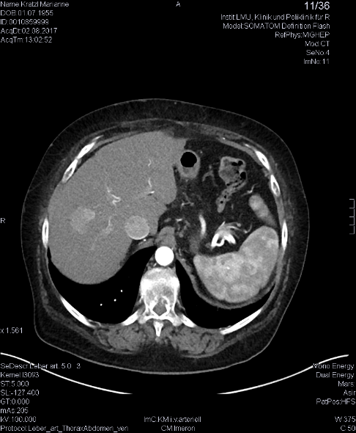
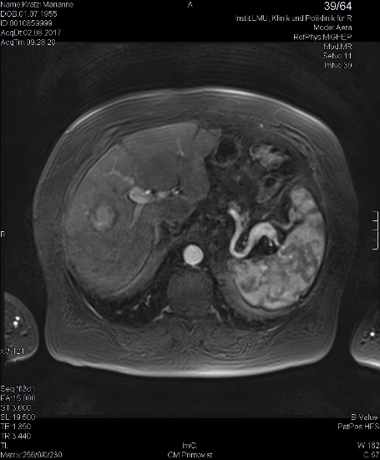
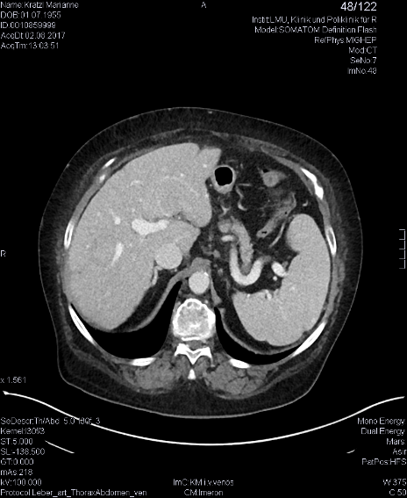

Figure 1 Hepatocellular carcinoma in segment VIII at diagnosis. A: contrast-enhanced computed tomography (CT) arterial phase; B: Contrast-enhanced CT venous phase; C: Magnetic resonance imaging with liver-specific contrast agent.

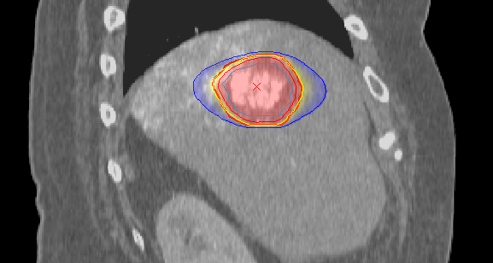
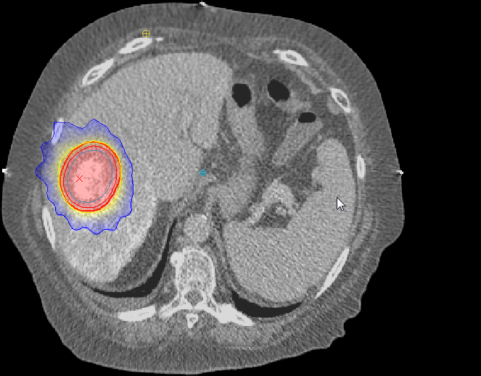
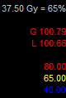
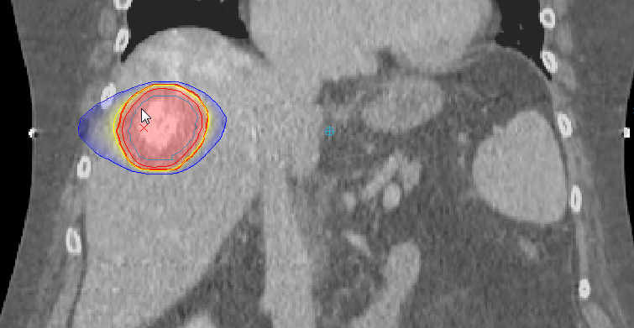

Figure 2 Treatment plan (prescription dose 3 × 12.5 Gy to 65% surrounding isodose). A: Isodose plan in axial view; B: Frontal view; C: sagittal view, broad red line: planning target volume (PTV), yellow line: PTV-surrounding 65% isodose = 37.5 Gy, light blue line: internal target volume (ITV), narrow red line: ITV-surrounding 80% isodose = 46.2 Gy, dark blue line: 40% isodose = 23.1 Gy.

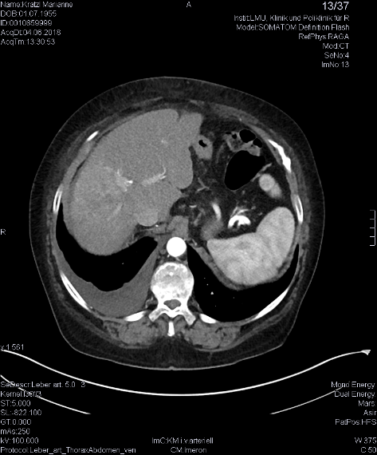
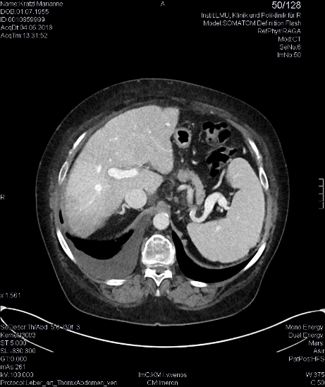
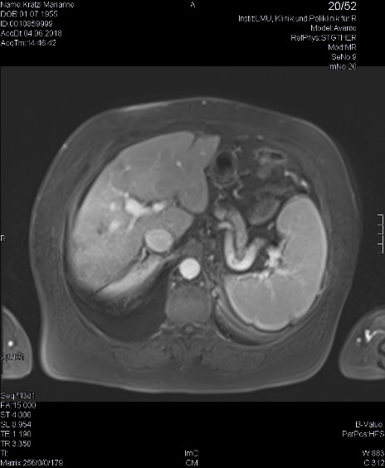

Figure 3 Complete response 9 months after transarterial chemoembolization and stereotactic body radiation therapy. A: Contrast-enhanced computed tomography (CT) arterial phase; B: Contrast-enhanced CT venous phase; C: Magnetic resonance imaging with liver-specific contrast agent.

Table 1 Prospective trials and large (> 100 patients) retrospective series evaluating stereotactic body radiation therapy in hepatocellular carcinoma
Author | Yr | Type | n | Size | VI | PVT | mf | PT | CP class | f/u | Dose | 1y-LC | 1y-OS
Méndez Romero et al^{[25]} | 2006 | phase I/II | 8 (11) | 3.5 (0.5-7) cm | 38% | 25% | 25% | nr | A:63%, B:25%, uk:12% | 13 | 25-37.5/3-5Fx | 75% | 75%
Tse et al^{[26]} | 2008 | phase I | 31 (nb) | 173 (9-1913) mL | 52% | nr | nr | 61% | A:100% | 18¹ | 24-54/6Fx | 65%¹ | 48%
Cárdenes et al^{[27]} | 2010 | phase I | 17 (25) | 34 (8-95) mL | nr | 18% | 30% | 24% | A:35%, B:65% | 24 | 36-48/3-5Fx | 100% | 75%
Kang et al^{[28]} | 2012 | phase II | 47 (56) | 15 (2-214) mL | nr | 29% | 17% | 100%² | A:87%, B:13% | 17 | 42-60/3Fx | 95%⁴ | 69%⁴
Price et al^{[29]} | 2012 | phase I/II | 26 (29) | nr (21-253) mL | nr | 12% | 12% | 27% | A:54%, B:46% | 13 | 36-48/3-5Fx | 96% | 77%
Huang et al^{[30]} | 2012 | phase II | 36 (nb) | 4.8 (1.1-12.3) cm | nr | nr | nr | nr | A:78%, B:19%, C:3% | 14 | 25-48/4-5Fx | 88% | 64%⁴
Bujold et al^{[31]} | 2013 | phase I/II | 102 (nb) | 117 (1-1913) mL | 55% | nr | 61% | 52% | A:100% | 31 | 24-54/6Fx | 87% | 55%
Culleton et al^{[32]} | 2014 | phase II | 29 (nb) | 9 (4-27) cm | nr | 76% | nr | 14% | B:97%, C:3% | nr | 21-49/5-15Fx | nr | 32%
Sanuki et al^{[33]} | 2014 | retro | 185 (185) | 8 (1.6-65) mL | nr | nr | 0% | 68%² | A:85%, B:15% | 23 | 35-40/5Fx | 99% | 95%
Lasley et al^{[14]} | 2015 | phase I/II | 59 (65) | 34 (2-107) mL | nr | nr | nr | nr | A:64%, B:36% | 33/46³ | 36-48/3-5Fx | nr | 91%/82%³
Scorsetti et al^{[34]} | 2015 | phase II | 43 (63) | 5 (1-13) cm | nr | 20% | 43% | 65% | A:53%, B:47% | 8 | 36-75/3-6Fx | 86% | 78%
Su et al^{[35]} | 2016 | retro | 132 (175) | 3 (1.1-5) cm | nr | nr | 28% | 30% | A:86%, B:14% | 21 | 42-46/3-Fx | 91% | 94%
Takeda et al^{[36]} | 2016 | phase II | 90 (90) | nr (1-4) cm | nr | nr | 0% | 64% | A:91%, B:9% | 42 | 35-40/5Fx | 96%⁵ | 67%⁵
Moon et al^{[37]} | 2018 | phase II | 11 (nb) | 23 (3-145) mL¹ | nr | nr | 13%¹ | 48%¹ | nr | 13¹ | 27.5-45/3-5Fx | 82% | 36%
Nabavizadeh et al^{[38]} | 2018 | retro | 146 (146) | nr | nr | 10% | 0% | 92% | A:46%,B41%,C:13% | 23 | 50/5Fx⁶ | 97% | nr
Jeong et al^{[39]} | 2018 | retro | 119 (139) | 1.7 (nr) cm | 0% | 0% | nr | 97% | A:91%, B:9% | 26 | 30-60/3Fx | 99% | 99%
¹: All patients (including different histologies); ²: TACE 1-2 mo prior to SBRT; ³: Reported separately for CP-A and CP-B patients; ⁴: 2-year rate; ⁵: 3-year rate; ⁶: Patients with poor liver function were treated with hypofractionated radiation therapy (45 Gy in 18 fractions).
n: Number of patients (lesions); cm: Cm diameter; mL: Milliliter volume; VI: Vascular invasion; PVT: Portal vein thrombosis; mf: Multifokal; PT: Prior treatment; CP: Child-Pugh; f/u: Median follow-up in months; dose: Total dose in Gy; Fx: Number of fractions; 1y-LC: 1-year local control rate; 1y-OS: 1-year overall survival rate; retro: Retrospective; uk: Unknown; nr: not reported.

Table 2 Studies comparing stereotactic body radiation therapy to other local treatments
Author | Yr | Type | Treat. | n | Size | mf | PT | CP class | f/u | Dose | 1y-LC | 1y-OS | tox. | Comment
Su et al^{[40]} | 2017 | pm | SBRT | 33 (45) | 3.3 (nr) cm | 36% | 0% | A:100% | 42 | 42-48/3Fx | 84%¹ | 100% | nausea⁴ | LC/OS n.s.
 |  |  | OP | 33 (45) | 3.3 (nr) cm | 30% | 0% | A:100% | 44 |  | 72%¹ | 97% | bleed./pain⁵
Wahl et al^{[19]} | 2016 | retro | SBRT | 63 (83) | 2.2 (0.1-10) cm | 29% | 2 (0-7)² | A:69%,B:29%,C:2% | 13 | 30-50/3-5Fx | 97% | 74% | grade3+:3% | LC/OS n.s.,
 |  |  | RFA | 161 (249) | 1.8 (0.6-7) cm | 32% | 0 (0-7)² | A:50%,B:42%,C:8% | 20 |  | 84% | 70% | grade3+:11% | > 2 cm LC sig↑ with SBRT
Sapir et al^{[20]} | 2018 | retro | SBRT | 125 (173) | 2.3 (0.1-20.8) cm | nr | 2 (nr)² | 6 (5-9)³ | 12 | 30-50/3-5Fx | 97% | 75% | grade3+:8% | LC sig↑ with SBRT
 |  |  | TACE | 84 (84) | 2.9 (0.7-15) cm | nr | 0 (nr)² | 6 (5-9)³ | 23 |  | 47% | 74% | grade3+:13% | Tox sig↑ with TACE
¹: Intrahepatic recurrence free survival; ²: Number of prior treatments median (range); ³: CP score median (range); ⁴: All grades, significantly increased with SBRT; ⁵: All grades, significantly increaesd with surgery.
treat.: Treatment; n: Number of patients (lesions); size: Lesion size median(range); cm: Centimeter diameter; mf: Multifokal; PT: Prior treatment; CP: Child-Pugh; f/u: Median follow-up in months; dose: Total dose in Gy; Fx: Number of fractions; 1y-LC: 1-year local control rate; 1y-OS: 1-year overall survival rate; tox: Toxicity, n.s.: Not significant; pm: Propensity score matched pair analysis; retro: Retrospective; bleed.: bleeding; sig: Significant; OP: Surgery; RFA: Radiofrequency ablation; TACE: Transarterial chemoablation; nr: Not reported.

