Name of Journal: World Journal of Clinical Cases
Manuscript NO: 85070
Manuscript Type: CASE REPORT

Tuberculosis-induced aplastic crisis and atypical lymphocyte expansion in advanced myelodysplastic syndrome: A case report and review of literature

Sun XY et al. TB-induced aplastic crisis in MDS

Xiao-Yun Sun, Xiao-Dong Yang, Jia Xu, Nuan-Nuan Xiu, Bo Ju, Xi-Chen Zhao

Xiao-Yun Sun, Xiao-Dong Yang, Jia Xu, Nuan-Nuan Xiu, Bo Ju, Xi-Chen Zhao, Department of Hematology, The Central Hospital of Qingdao West Coast New Area, Qingdao 266555, Shandong Province, China

Author contributions: Zhao XC and Sun XY developed the idea; Sun XY, Yang XD and Xu J analyzed the data and drafted the manuscript; Sun XY, Yang XD, Xu J, Xiu NN and Ju B participated in the treatment; Zhao XC revised the manuscript; all authors have read and approved the final manuscript.

Supported by The Specialized Scientific Research Fund Projects of The Medical Group of Qingdao University, No. YLJT20201002.

Corresponding author: Xi-Chen Zhao, MD, Chief Physician, Department of Hematology, The Central Hospital of Qingdao West Coast New Area, No. 9 Huangpujiang Road, Qingdao 266555, Shandong Province, China. zhaoxichen2003@163.com

Received: April 10, 2023
Revised: May 22, 2023
Accepted: May 31, 2023
Published online: July 6, 2023

Abstract
BACKGROUND
Myelodysplastic syndrome (MDS) is caused by malignant proliferation and ineffective hematopoiesis. Oncogenic somatic mutations and increased apoptosis, necroptosis and pyroptosis lead to the accumulation of earlier hematopoietic progenitors and impaired productivity of mature blood cells. An increased percentage of myeloblasts and the presence of unfavorable somatic mutations are signs of leukemic hematopoiesis and indicators of entrance into an advanced stage. Bone marrow cellularity and myeloblasts usually increase with disease progression. However, aplastic crisis occasionally occurs in advanced MDS.

CASE SUMMARY
A 72-year-old male patient was definitively diagnosed with MDS with excess blasts-1 (MDS-EB-1) based on an increase in the percentages of myeloblasts and cluster of differentiation (CD)34+ hematopoietic progenitors and the identification of myeloid neoplasm-associated somatic mutations in bone marrow samples. The patient was treated with hypomethylation therapy and was able to maintain a steady disease state for 2 years. In the treatment process, the advanced MDS patient experienced an episode of progressive pancytopenia and bone marrow aplasia. During the aplastic crisis, the bone marrow was infiltrated with sparsely distributed atypical lymphocytes. Surprisingly, the leukemic cells disappeared. Immunological analysis revealed that the atypical lymphocytes expressed a high frequency of CD3, CD5, CD8, CD16, CD56 and CD57, suggesting the activation of autoimmune cytotoxic T-lymphocytes and natural killer (NK)/NKT cells that suppressed both normal and leukemic hematopoiesis. Elevated serum levels of inflammatory cytokines, including interleukin (IL)-6, interferon-gamma (IFN-γ) and tumor necrosis factor-alpha (TNF-α), confirmed the deranged type I immune responses. This morphological and immunological signature led to the diagnosis of severe aplastic anemia secondary to large granule lymphocyte leukemia. Disseminated tuberculosis was suspected upon radiological examinations in the search for an inflammatory niche. Antituberculosis treatment led to reversion of the aplastic crisis, disappearance of the atypical lymphocytes, increased marrow cellularity and 2 mo of hematological remission, providing strong evidence that disseminated tuberculosis was responsible for the development of the aplastic crisis, the regression of leukemic cells and the activation of CD56+ atypical lymphocytes. Reinstitution of hypomethylation therapy in the following 19 mo allowed the patient to maintain a steady disease state. However, the patient transformed the disease phenotype into acute myeloid leukemia and eventually died of disease progression and an overwhelming infectious episode.

CONCLUSION
Disseminated tuberculosis can induce CD56+ lymphocyte infiltration in the bone marrow and in turn suppress both normal and leukemic hematopoiesis, resulting in the development of aplastic crisis and leukemic cell regression.

Key Words: Myelodysplastic syndrome; Aplastic crisis; Atypical lymphocyte; Leukemic cell regression; CD56+ lymphocyte expansion; Disseminated tuberculosis; Case report

©The Author(s) 2023. Published by Baishideng Publishing Group Inc. All rights reserved.

Citation: Sun XY, Yang XD, Xu J, Xiu NN, Ju B, Zhao XC. Tuberculosis-induced aplastic crisis and atypical lymphocyte expansion in advanced myelodysplastic syndrome: A case report and review of literature. World J Clin Cases 2023; 11(19): 4713-4722
URL: https://www.wjgnet.com/2307-8960/full/v11/i19/4713.htm
DOI: https://dx.doi.org/10.12998/wjcc.v11.i19.4713

Core Tip: In patients with myelodysplastic syndrome, bone marrow cellularity and myeloblasts usually increase with disease progression. An advanced myelodysplastic syndrome patient experienced an episode of aplastic crisis. During the aplastic crisis, leukemic cells regressed. The bone marrow was infiltrated with atypical lymphocytes that expressed high frequencies of cluster of differentiation (CD)3, CD5, CD8, CD16, CD56 and CD57. Antituberculosis treatment led to reversion of the aplastic crisis, disappearance of the atypical lymphocytes, increased marrow cellularity and 2 mo of hematological remission, suggesting that disseminated tuberculosis was responsible for the development of aplastic crisis, regression of leukemic cells and activation of CD56+ cells.

INTRODUCTION
Myelodysplastic syndrome (MDS) is a heterogeneous disease of hematopoietic progenitor cells (HPCs) resulting from malignant proliferation and ineffective hematopoiesis. Oncogenic somatic mutations and increased apoptosis, necroptosis and pyroptosis lead to the accumulation of earlier HPCs and impaired productivity of mature blood cells^{[1,2]}. Morphologically, MDS is characterized by one or more lineages of dysplasia, and an increased percentage of myeloblasts is the most significant dysplastic feature^{[3,4]}. The bone marrow in MDS patients is usually hyperplastic, consistent with dysregulated proliferation and differentiation. However, a fraction of MDS patients can be hypoplastic^{[5,6]}. The identification of cytogenetic abnormalities and oncogenic somatic mutations, especially unfavorable ones, is helpful in the determination of leukemic hematopoiesis^{[1,2,5-7]}. With regard to immunological signatures, patients with low-risk MDS, especially hypoplastic MDS, exhibit autoimmune-predominated responses resembling those in severe aplastic anemia (SAA), whereas patients with advanced MDS demonstrate negative regulator-predominated immune exhaustion resembling that in acute myeloid leukemia (AML)^{[1,5,6]}. An increased percentage of myeloblasts and the presence of unfavorable somatic mutations are signs of leukemic hematopoiesis and indicators of entrance into an advanced stage^{[2,3,4,6,7]}. In MDS patients, bone marrow cellularity and the percentage of myeloblasts usually increase with disease progression^{[1,3,4]}, which is generally attributed to clonal evolution or immune escape via the acquisition and accumulation of novel oncogenic mutations under chronic immune pressure^{[2,7,8]}. However, some patients, especially in the end stage, experience an episode of progressive cytopenia, usually concomitant with severe inflammatory conditions. In this situation, the bone marrow can be hypoplastic, leukemic clones are concealed, and the immunological signature changes from an exhausted phenotype to deranged autoimmune responses resembling those in autoimmune hematopoietic failure. Severe infections during aplastic crisis are generally ascribed to functional defects in the myeloid lineage and severe neutropenia^{[9-11]}.
A patient with definitively diagnosed MDS-EB-1 experienced an episode of aplastic crisis with concomitant infiltration of atypical lymphocytes and regression of leukemic cells in the bone marrow. The atypical lymphocytes expressed high frequencies of cluster of differentiation (CD)3, CD5, CD8, CD16, CD56 and CD57. Antituberculosis treatment led to not only reversion of the aplastic crisis but also disappearance of the atypical lymphocytes, increased marrow cellularity and 2 mo of hematological remission. This treatment response indicated that disseminated tuberculosis infection, especially gut involvement, was responsible for the development of the aplastic crisis, the regression of leukemic cells and the activation of CD56+ atypical lymphocytes. The reversible aplastic crisis suggested that autoimmune responses due to infectious diseases represent the major pathophysiology in patients with end-stage MDS. Leukemic cell regression during aplastic crisis and a short duration of hematopoietic remission following the resolution of infectious episodes suggest that autoimmune hematopoietic failure likely functions as an inflammatory stress-fueled antileukemic mechanism; the relapse similar to that in transient “spontaneous remission” suggests that the inflammatory stress-fueled antileukemic activity is unable to eradicate the leukemic clones; and the genetically damaged HPCs, together with the active inflammatory condition, contribute to the development of autoimmune hematopoietic failure.

CASE PRESENTATION
Chief complaints
Aggressive pancytopenia for 4 weeks.

History of present illness
Two years earlier, a 72-year-old Chinese man sought medical help for gradually worsening fatigue and cytopenia. At that time, the complete blood cell count (CBC) showed the following results: White blood cells (WBCs), 1.44 × 10⁹/L; absolute neutrophil count (ANC), 0.62 × 10⁹/L; red blood cells (RBCs), 2.74×10¹²/L; hemoglobin level (Hb), 97 g/L; platelets (Plts), 175 × 10⁹/L; and absolute reticulocyte count (Ret), 44.62 × 10⁹/L. He was diagnosed with MDS-EB-1 based on hypercellular bone marrow and an increased percentage of myeloblasts (accounting for 8.5% of all nucleated cells) on morphological evaluation, an increased percentage of CD34+CD33+ cells (6.82%) on immunotyping analysis, a normal 46,XY karyotype on cytogenetic analysis, and the identification of somatic mutations in ASXL1, RUNX1, STAG1 and N-RAS genes on molecular analysis. In the following 2 years, the patient was treated with hypomethylation therapy [a total of 14 courses of decitabine (25 mg/d × 5 d)] as a solitary antileukemic agent and was able to maintain a steady disease state. Four weeks prior to this hospitalization, the patient’s fatigue was aggravated, performance status deteriorated, and cytopenia significantly worsened. The degree of fatigue was far more severe than the degree of anemia.

History of past illness
The patient had a 6-year history of leukocytopenia prior to the diagnosis of MDS-EB-1. He denied having diseases affecting the cardiovascular, endocrine, respiratory, gastrointestinal, urogenital or musculoskeletal systems.

Personal and family history
No family history of inherited, hematological or neoplastic diseases was recorded.

Physical examination
The patient was 172 cm tall and weighed 63.5 kg. Upon admission, his vitals were as follows: Temperature, 36.4 °C; respiratory rate, 18 breaths per minute; heart rate, 88 beats per minute; and blood pressure, 114/76 mmHg. Physical examination revealed the presence of mild tenderness of the right lower abdomen. No significant signs involving the nervous, respiratory, cardiovascular, or musculoskeletal systems were present.

Laboratory examinations
Routine laboratory examinations: At hospitalization, the CBC showed the following results: WBCs, 0.93 × 10⁹/L; ANC, 0.34 × 10⁹/L; RBCs, 1.57 × 10¹²/L; Hb, 48 g/L; Plts, 16 × 10⁹/L; Ret, 18.50 × 10⁹/L; and C-reactive protein, 263.62 mg/L. The coagulation profile showed hyperfibrinogenemia (4.100 g/L), with a D-dimer level of 0.38 mg/L. Urine analysis revealed occult blood (2+) and protein (1+). Biochemical tests showed moderate hypoalbuminemia (26.1 g/L) and low serum levels of potassium (2.97 mmol/L), sodium (128 mmol/L) and chlorine (94 mmol/L), with the absence of abnormalities in markers of liver and renal function. Pathogenic cultures of blood samples were sterile. Immunological tests for hepatitis A, B, and C virus and human immunodeficiency virus were negative. Tests for Epstein-Barr virus and parvovirus B19 DNA were negative. The IFN-γ release assay yielded a positive result. The pleural effusion in aspirates was bloody, with an elevated level of adenosine deaminase. The serum levels of IL-6, IFN-γ and TNF-α were elevated, suggesting the presence of deranged type I immune responses.

Specific laboratory examinations for blood diseases: A morphological evaluation was performed. The bone marrow became aplastic, with the appearance of sparsely distributed atypical lymphocytes that accounted for 77% of all nucleated cells (Figure 1). Of the atypical lymphocytes, the chromatin was highly concentrated, the cytoplasm was excessively abundant, with eosinophilic shade on the basophilic background and most prominently adjacent to the nucleoli without visible granules, and the membrane was canthous. Basophilic substances were present in the cytoplasm of almost all erythrocytes, suggestive of dysplasia in erythropoiesis. Notably, the leukemic cells disappeared. Immunotyping analysis of bone marrow samples revealed decreases in the frequencies of CD34 (0.24%) and CD19 (14.28%) expression and increases in the frequencies of CD3 (54.15%), CD5 (47.23%), CD8 (28.49%), CD16 (28.33%), CD56 (22.16%) and CD57 (41.91%) expression. The immunological signature indicated the activation and expansion of autoimmune cytotoxic T-lymphocytes (CTLs) and NK/NKT cells, resembling that in patients with “SAA” secondary to large granular lymphocyte leukemia (LGLL)^{[12,13]}. The massively reduced frequencies of CD34 and CD19 expression indicated the exhaustion of HPCs and B lymphocytes. Next-generation sequencing analysis revealed a novel somatic mutation in the KMT2D gene in addition to the previously reported mutations. These laboratory data indicated the development of an “aplastic crisis”, in which the activated CTLs and NK/NKT cells were likely responsible for the autoimmune suppression of normal and leukemic hematopoiesis.

Imaging examinations
Computed tomography (CT) scans were performed in the search for an inflammatory niche, and the chest (Figure 2) and abdominal (Figure 3) CT features, together with the IFN-γ release assay positivity and bloody pleural effusion, suggested a diagnosis of disseminated tuberculosis involving the lungs, pleura, hilum, mediastinum, gastrointestinal tract, peritoneum and urinary tract^{[14,15]}.

FINAL DIAGNOSIS
The patient was diagnosed with SAA secondary to LGLL.

TREATMENT
The patient was tentatively treated with a combination of intravenous antibiotics [kanamycin (0.5 g/d) and levofloxacin (0.5 g/d) for 2 wk] for the inflammatory episode, antituberculotics [a combination of rifampicin (0.45 g/d), isoniazid (0.3 g/d), ethambutol (1.0 g/d), and pyrazinamide (1.0 g/d) for 2 mo and subsequently a combination of rifampicin and isoniazid for 6 mo] for the suspected tuberculosis infection, cyclosporine (100 mg bid) to repress the deranged cellular immune responses^{[16,17]}, and recombinant human granulocyte colony-stimulating factor (rhG-CSF) for the severe neutropenia. Supportive care was mandatory, without hemolysis or platelet transfusion refractoriness.

OUTCOME AND FOLLOW-UP
Three weeks of treatment led to significant improvement in the hematological parameters, disappearance of the expanded atypical lymphocytes, and an increased marrow cellularity. The patient’s inflammatory symptoms were gradually ameliorated, and his performance status was significantly improved. The patient was released, and antituberculosis treatment was continued. One month after release from our hospital, he achieved hematological remission. CBC monitoring at the peak showed the following: WBCs, 4.72 × 10⁹/L; ANC, 3.35 × 10⁹/L; RBCs, 3.64 × 10¹²/L; Hb, 137 g/L; and Plts, 281 × 10⁹/L. This treatment response indicated that disseminated tuberculosis was responsible for the aplastic crisis, leukemic cell regression and atypical lymphocyte expansion. However, the hematological response lasted for only 2 mo, and cytopenia reemerged, with an increase in bone marrow cellularity and the percentage of myeloblasts. Hypomethylation therapy was reinstituted. The patient had received 19 mo of hypomethylation therapy [a total of 3 courses of decitabine (25 mg/d × 5 d) and 10 courses of azacitidine (100 mg/d × 7 d)]. The disease phenotype transformed into AML during hypomethylation therapy. After the transformation, He denied further antileukemic treatment and eventually died of disease progression and an overwhelming infectious episode.

DISCUSSION
In this manuscript, we describe an episode of reversible aplastic crisis in a patient with advanced MDS. The patient was definitively diagnosed with MDS-EB-1 primarily based on an increase in the percentage of myeloblasts on morphological examination of bone marrow smears and slices and the identification of unfavorable somatic mutations in myeloid neoplasm-associated genes, the two most significant parameters in the diagnosis and risk stratification of MDS^{[1-4]}. Initially, the bone marrow was hypercellular. With the development of an inflammatory episode during hypomethylation therapy, the bone marrow became aplastic, with the infiltration of morphologically atypical lymphocytes. Meanwhile, the leukemic cells regressed. Immunotyping analysis of the atypical lymphocytes revealed high CD3, CD8, CD5, CD16, CD56 and CD57 expression. Disseminated tuberculosis was suspected in the search for an inflammatory niche. Tentative treatment with antituberculotics resulted in the reversion of bone marrow cellularity, disappearance of atypical lymphocytes and reappearance of leukemic clones, providing strong evidence for disseminated tuberculosis as the contributor to the phenotypic transformations. This case study revealed the following attractive points:
The first attractive point of this case study is that active tuberculosis infection can trigger bone marrow-predominated autoimmunity in patients with advanced MDS, inducing an episode of aplastic crisis. In this patient, aplastic crisis developed during an inflammatory condition, and autoimmune pathogenesis predominated in the bone marrow. Organ-specific autoimmunity suggests that the targeted antigens are located in the bone marrow. Antituberculosis treatment reversed the marrow-predominated autoimmunity, providing strong evidence that active tuberculosis was responsible for the development of the aplastic crisis. The relief of hematopoietic suppression after successful treatment of the underlying infection suggested that the autoimmune hematopoietic failure was fueled by inflammatory stresses. Tuberculosis-associated aplastic cytopenia has been reported in a few studies^{[18-22]}. Tuberculosis-associated aplastic cytopenia has even been reported in Bacillus Calmette-Guerin vaccination^{[23]}. Tuberculosis infection can trigger cellular immune responses and lead to the excessive production of proinflammatory cytokines^{[24,25]}, thereby inducing immune-mediated hematopoietic injury^{[26,27]}. Gut involvement of tuberculosis infection likely plays a more important role because tuberculosis-induced aplastic cytopenia has been reported merely in disseminated tuberculosis instead of isolated pulmonary tuberculosis. Gastrointestinal tuberculosis induces not only inflammatory lesions of its own but also gut dysbiosis, resulting in increased epithelial permeability and compromised barrier function in infected and downstream intestinal segments^{[28,29]}. The gastrointestinal tract is an organ that hosts the most abundant lymphatic tissues and microbial community and therefore can provide sufficient activated immune cells and continuously supply exogenous antigens from both pathogenic and commensal microbes to initiate and perpetuate deranged autoimmunity in the context of increased epithelial permeability and gut inflammatory conditions^{[30-33]}, leading to autoimmune hematopoietic failure^{[34-37]}. In our retrospective study to explore the inflammatory conditions of SAA patients during inflammatory flare-ups, 5 of 17 recruited patients exhibited imaging abnormalities suggestive of tuberculosis infection, all involving the gastrointestinal tract and suggesting a high frequency of tuberculosis infection in autoimmune hematopoietic failure^{[38]}. Gut inflammatory conditions in the sustenance of autoimmune responses have been demonstrated by the fact that the onset of an autoimmune disease cannot occur in a germ-free state^{[39-41]}.
The second attractive point is that active tuberculosis infection can induce CD56+ lymphocyte proliferation. The concentrated chromatin, abundant cytoplasm, canthous membrane and eosinophilic shade indicated that the lymphocytes were activated. Immunological analysis confirmed that the atypical lymphocytes were activated autoimmune CTLs and NK/NKT cells. The disappearance of atypical lymphocytes with reversion of the aplastic crisis following antituberculosis treatment provided convincing evidence that tuberculosis infection activated CTLs and CD56+ cells. It is reasonably concluded that active tuberculosis stimulated CD56+ cell expansion and in turn suppressed normal and leukemic hematopoiesis. NK and NKT cells are important effector cells in the defense against tuberculosis infection, and tuberculosis antigens can directly stimulate NK/NKT cell proliferation^{[24,25]}. Activated NK/NKT cells can suppress host hematopoiesis via secretion of excessive hematopoietic inhibitors, resulting in autoimmune hematopoietic failure^{[12,13]}. However, in patients with SAA secondary to LGLL, tuberculosis is seldom considered the original trigger. More interestingly, visible granules were absent from the activated CD56+ cells, which is distinctive from LGLL with respect to morphology.
The third attractive point is that the leukemic clones were concealed during aplastic crisis, and following antituberculosis treatment, the leukemic clones reemerged after a short duration of hematological remission. This finding suggests that tuberculosis-induced autoimmunity suppressed both normal and leukemic hematopoiesis, with preferential suppression of leukemic cells^{[42-44]}. Neoplasm-associated antigens or damage-associated molecular patterns on genetically defective HPCs likely initiate the primary inflammatory niche in the bone marrow environment and determine organ specificity^{[45-47]}. However, engagement of an exogenous stimulation is critically required in the induction of autoimmune hematopoietic failure^{[48-50]}. Inflammatory stresses due to disseminated tuberculosis fuel organ-specific autoimmunity, resulting in the development of an aplastic crisis. In this sense, autoimmune hematopoietic failure may function as an antileukemic mechanism^{[51]}, and disseminated tuberculosis may strengthen immune surveillance against malignant proliferation. However, the leukemic clones cannot be eradicated, resulting in relapse after a short duration of hematological remission following antituberculosis treatment, similar to the process of transient “spontaneous remission”^{[52,53]}. Chronic autoimmune hematopoietic failure is likely caused by inflammatory stress-fueled antileukemic activities targeting genetically damaged HPCs in the context of an active chronic inflammatory condition. We previously reported a patient with refractory SAA who progressed to a myelodysplastic/myeloproliferative neoplasm during the consecutive administration of gut-cleansing preparations (GCPs) and microbiota-modulating treatments^{[54]}, but prior intermittent GCPs achieved several cycles of hematopoietic recovery and disease relapse without evident leukemic cell expansion^{[55]}. These data indicated that inflammatory stresses rather than a specific infection fuel organ-specific autoimmunity^{[34,45,48,50,56]}.
Limitations of the case study include the lack of an etiopathological diagnosis for disseminated tuberculosis and lack of identification of proinflammatory inhibitors. In addition, the clonality of the atypical lymphocytes was not determined.

CONCLUSION
Taken together, the results of this case study show that disseminated tuberculosis infection can stimulate the activation and expansion of CD56+ cells and that activated CD56+ cells can suppress both normal and leukemic hematopoiesis, resulting in aplastic crisis and leukemic cell regression in advanced MDS. Antituberculosis treatment can reverse autoimmunity. This inflammatory stress-fueled autoimmunity may represent an antileukemic mechanism, which could be helpful in elucidating the pathogenesis of autoimmune hematopoietic failure and immunological treatments for myeloid neoplasms. Disseminated tuberculosis infection, especially gut involvement, should be given particular attention in autoimmune hematopoietic failure.

ACKNOWLEDGEMENTS
The authors thank Bin-Han Gao (Department of Radiology, The Central Hospital of Qingdao West Coast New Area) for assistance in the reassessment of the computed tomography images.

REFERENCES
1 Li H, Hu F, Gale RP, Sekeres MA, Liang Y. Myelodysplastic syndromes. Nat Rev Dis Primers 2022; 8: 74 [PMID: 36396662 DOI: 10.1038/s41572-022-00402-5]
2 Cook MR, Karp JE, Lai C. The spectrum of genetic mutations in myelodysplastic syndrome: Should we update prognostication? EJHaem 2022; 3: 301-313 [PMID: 35846202 DOI: 10.1002/jha2.317]
3 Germing U, Kobbe G, Haas R, Gattermann N. Myelodysplastic syndromes: diagnosis, prognosis, and treatment. Dtsch Arztebl Int 2013; 110: 783-790 [PMID: 24300826 DOI: 10.3238/arztebl.2013.0783]
4 Invernizzi R, Quaglia F, Porta MG. Importance of classical morphology in the diagnosis of myelodysplastic syndrome. Mediterr J Hematol Infect Dis 2015; 7: e2015035 [PMID: 25960863 DOI: 10.4084/MJHID.2015.035]
5 Votavova H, Belickova M. Hypoplastic myelodysplastic syndrome and acquired aplastic anemia: Immune-mediated bone marrow failure syndromes (Review). Int J Oncol 2022; 60 [PMID: 34958107 DOI: 10.3892/ijo.2021.5297]
6 Fattizzo B, Levati GV, Giannotta JA, Cassanello G, Cro LM, Zaninoni A, Barbieri M, Croci GA, Revelli N, Barcellini W. Low-Risk Myelodysplastic Syndrome Revisited: Morphological, Autoimmune, and Molecular Features as Predictors of Outcome in a Single Center Experience. Front Oncol 2022; 12: 795955 [PMID: 35392224 DOI: 10.3389/fonc.2022.795955]
7 Bouligny IM, Maher KR, Grant S. Mechanisms of myeloid leukemogenesis: Current perspectives and therapeutic objectives. Blood Rev 2023; 57: 100996 [PMID: 35989139 DOI: 10.1016/j.blre.2022.100996]
8 Durrani J, Groarke EM. Clonality in immune aplastic anemia: Mechanisms of immune escape or malignant transformation. Semin Hematol 2022; 59: 137-142 [PMID: 36115690 DOI: 10.1053/j.seminhematol.2022.08.001]
9 Leone G, Pagano L. Infections in Myelodysplastic Syndrome in Relation to Stage and Therapy. Mediterr J Hematol Infect Dis 2018; 10: e2018039 [PMID: 30002795 DOI: 10.4084/MJHID.2018.039]
10 Pagano L, Caira M. Risks for infection in patients with myelodysplasia and acute leukemia. Curr Opin Infect Dis 2012; 25: 612-618 [PMID: 22964946 DOI: 10.1097/QCO.0b013e328358b000]
11 Kirkizlar TA, Kirkizlar O, Demirci U, Umut A, Iflazoglu H, Umit EG, Demir AM. Incidence and predisposing factors of infection in patients treated with hypomethylating agents. Leuk Res 2023; 127: 107043 [PMID: 36801588 DOI: 10.1016/j.leukres.2023.107043]
12 Fattizzo B, Bellani V, Pasquale R, Giannotta JA, Barcellini W. Large Granular Lymphocyte Expansion in Myeloid Diseases and Bone Marrow Failure Syndromes: Whoever Seeks Finds. Front Oncol 2021; 11: 748610 [PMID: 34660312 DOI: 10.3389/fonc.2021.748610]
13 Tzankov A, Medinger M. Aplastic anemia: possible associations with lymphoproliferative neoplasms. Int J Lab Hematol 2014; 36: 382-387 [PMID: 24750685 DOI: 10.1111/ijlh.12224]
14 Deshpande SS, Joshi AR, Deshpande SS, Phajlani SA. Computed tomographic features of abdominal tuberculosis: unmask the impersonator! Abdom Radiol (NY) 2019; 44: 11-21 [PMID: 30027495 DOI: 10.1007/s00261-018-1700-3]
15 Gupta P, Kumar S, Sharma V, Mandavdhare H, Dhaka N, Sinha SK, Dutta U, Kochhar R. Common and uncommon imaging features of abdominal tuberculosis. J Med Imaging Radiat Oncol 2019; 63: 329-339 [PMID: 30932343 DOI: 10.1111/1754-9485.12874]
16 Killick SB, Bown N, Cavenagh J, Dokal I, Foukaneli T, Hill A, Hillmen P, Ireland R, Kulasekararaj A, Mufti G, Snowden JA, Samarasinghe S, Wood A, Marsh JC; British Society for Standards in Haematology. Guidelines for the diagnosis and management of adult aplastic anaemia. Br J Haematol 2016; 172: 187-207 [PMID: 26568159 DOI: 10.1111/bjh.13853]
17 Zhang L, Mao J, Lian Y, Liang Q, Li W, Zhao J, Pan H, Gao Z, Fang L, Yuan W, Chu Y, Shi J. Mass cytometry analysis identifies T cell immune signature of aplastic anemia and predicts the response to cyclosporine. Ann Hematol 2023; 102: 529-539 [PMID: 36680600 DOI: 10.1007/s00277-023-05097-6]
18 Bettelli F, Giusti D, Morselli M, Colaci E, Nasillo V, Pioli V, Gilioli A, Iotti S, Galassi L, Giubbolini R, Colasante C, Catellani H, Barozzi P, Lagreca I, Vallerini D, Maffei R, Franceschini E, Mussini C, Banchelli F, D'Amico R, Marasca R, Narni F, Potenza L, Comoli P, Luppi M, Forghieri F. Epidemiology and clinical outcomes of latent tuberculosis infection in adults affected with acute leukemia or aplastic anemia: a retrospective single-center study. Ann Hematol 2020; 99: 2201-2203 [PMID: 32699943 DOI: 10.1007/s00277-020-04191-3]
19 Dasgupta S, Mandal PK, Chakrabarti S. Etiology of Pancytopenia: An Observation from a Referral Medical Institution of Eastern Region of India. J Lab Physicians 2015; 7: 90-95 [PMID: 26417158 DOI: 10.4103/0974-2727.163136]
20 Rutovitz JJ. Miliary tuberculosis causing pancytopenia. A report of 2 cases. S Afr Med J 1986; 69: 451-452 [PMID: 3961639]
21 Demiroğlu H, Ozcebe OI, Ozdemir L, Sungur A, Dündar S. Pancytopenia with hypocellular bone marrow due to miliary tuberculosis: an unusual presentation. Acta Haematol 1994; 91: 49-51 [PMID: 8171938 DOI: 10.1159/000204246]
22 Mangion PD, Schiller KF. Disseminated tuberculosis complicated by pancytopenia. Proc R Soc Med 1971; 64: 1000 [PMID: 5114273]
23 Long HJ. Aplastic anemia, a rare complication of disseminated BCG infection: case report. Mil Med 1982; 147: 1067-1070 [PMID: 6817203]
24 Kathamuthu GR, Sridhar R, Baskaran D, Babu S. Dominant expansion of CD4+, CD8+ T and NK cells expressing Th1/Tc1/Type 1 cytokines in culture-positive lymph node tuberculosis. PLoS One 2022; 17: e0269109 [PMID: 35617254 DOI: 10.1371/journal.pone.0269109]
25 Cao X, Xin H, Zhang H, Liu J, Pan S, Du Y, Feng B, Quan Z, Guan L, Shen F, Liu Z, Wang D, Zhang B, Guan X, Yan J, Jin Q, Gao L. The Association Between Mycobacteria-Specific Antigen-Induced Cytokines and Host Response to Latent Tuberculosis Infection Treatment in a Chinese Population. Front Microbiol 2021; 12: 716900 [PMID: 34484159 DOI: 10.3389/fmicb.2021.716900]
26 Li F, Liu X, Niu H, Lv W, Han X, Zhang Y, Zhu B. Persistent stimulation with Mycobacterium tuberculosis antigen impairs the proliferation and transcriptional program of hematopoietic cells in bone marrow. Mol Immunol 2019; 112: 115-122 [PMID: 31082645 DOI: 10.1016/j.molimm.2019.05.001]
27 Li F, Ma Y, Li X, Zhang D, Han J, Tan D, Mi Y, Yang X, Wang J, Zhu B. Severe persistent mycobacteria antigen stimulation causes lymphopenia through impairing hematopoiesis. Front Cell Infect Microbiol 2023; 13: 1079774 [PMID: 36743311 DOI: 10.3389/fcimb.2023.1079774]
28 Jensen SK, Pærregaard SI, Brandum EP, Jørgensen AS, Hjortø GM, Jensen BAH. Rewiring host-microbe interactions and barrier function during gastrointestinal inflammation. Gastroenterol Rep (Oxf) 2022; 10: goac008 [PMID: 35291443 DOI: 10.1093/gastro/goac008]
29 Lu Y, Li Z, Peng X. Regulatory effects of oral microbe on intestinal microbiota and the illness. Front Cell Infect Microbiol 2023; 13: 1093967 [PMID: 36816583 DOI: 10.3389/fcimb.2023.1093967]
30 Guven-Maiorov E, Tsai CJ, Nussinov R. Structural host-microbiota interaction networks. PLoS Comput Biol 2017; 13: e1005579 [PMID: 29023448 DOI: 10.1371/journal.pcbi.1005579]
31 Kayama H, Okumura R, Takeda K. Interaction Between the Microbiota, Epithelia, and Immune Cells in the Intestine. Annu Rev Immunol 2020; 38: 23-48 [PMID: 32340570 DOI: 10.1146/annurev-immunol-070119-115104]
32 Mu Q, Kirby J, Reilly CM, Luo XM. Leaky Gut As a Danger Signal for Autoimmune Diseases. Front Immunol 2017; 8: 598 [PMID: 28588585 DOI: 10.3389/fimmu.2017.00598]
33 An J, Liu Y, Wang Y, Fan R, Hu X, Zhang F, Yang J, Chen J. The Role of Intestinal Mucosal Barrier in Autoimmune Disease: A Potential Target. Front Immunol 2022; 13: 871713 [PMID: 35844539 DOI: 10.3389/fimmu.2022.871713]
34 Zhao XC, Sun XY, Zhao L, Meng FJ. Gut inflammation in the pathogenesis of acquired aplastic anemia. Chin Med J (Engl) 2020; 133: 1878-1881 [PMID: 32568881 DOI: 10.1097/CM9.0000000000000772]
35 Naithani R, Mahapatra M, Kumar R, Rai S. Aplastic anemia and Crohn's disease - coincidence or association? Indian J Gastroenterol 2005; 24: 183 [PMID: 16204922]
36 Salmeron G, Patey N, de Latour RP, Raffoux E, Gluckman E, Brousse N, Socié G, Robin M. Coeliac disease and aplastic anaemia: a specific entity? Br J Haematol 2009; 146: 122-124 [PMID: 19438483 DOI: 10.1111/j.1365-2141.2009.07719.x]
37 Tokar B, Aydoğdu S, Paşaoğlu O, Ilhan H, Kasapoğlu E. Neutropenic enterocolitis: is it possible to break vicious circle between neutropenia and the bowel wall inflammation by surgery? Int J Colorectal Dis 2003; 18: 455-458 [PMID: 12750931 DOI: 10.1007/s00384-003-0502-3]
38 Zhao XC, Xue CJ, Song H, Gao BH, Han FS, Xiao SX. Bowel inflammatory presentations on computed tomography in adult patients with severe aplastic anemia during flared inflammatory episodes. World J Clin Cases 2023; 11: 576-597 [PMID: 36793625 DOI: 10.12998/wjcc.v11.i3.576]
39 Maeda Y, Kurakawa T, Umemoto E, Motooka D, Ito Y, Gotoh K, Hirota K, Matsushita M, Furuta Y, Narazaki M, Sakaguchi N, Kayama H, Nakamura S, Iida T, Saeki Y, Kumanogoh A, Sakaguchi S, Takeda K. Dysbiosis Contributes to Arthritis Development via Activation of Autoreactive T Cells in the Intestine. Arthritis Rheumatol 2016; 68: 2646-2661 [PMID: 27333153 DOI: 10.1002/art.39783]
40 Rehaume LM, Mondot S, Aguirre de Cárcer D, Velasco J, Benham H, Hasnain SZ, Bowman J, Ruutu M, Hansbro PM, McGuckin MA, Morrison M, Thomas R. ZAP-70 genotype disrupts the relationship between microbiota and host, leading to spondyloarthritis and ileitis in SKG mice. Arthritis Rheumatol 2014; 66: 2780-2792 [PMID: 25048686 DOI: 10.1002/art.38773]
41 Berer K, Mues M, Koutrolos M, Rasbi ZA, Boziki M, Johner C, Wekerle H, Krishnamoorthy G. Commensal microbiota and myelin autoantigen cooperate to trigger autoimmune demyelination. Nature 2011; 479: 538-541 [PMID: 22031325 DOI: 10.1038/nature10554]
42 Kiladjian JJ, Giraudier S, Cassinat B. Interferon-alpha for the therapy of myeloproliferative neoplasms: targeting the malignant clone. Leukemia 2016; 30: 776-781 [PMID: 26601783 DOI: 10.1038/leu.2015.326]
43 Malireddi RKS, Karki R, Sundaram B, Kancharana B, Lee S, Samir P, Kanneganti TD. Inflammatory Cell Death, PANoptosis, Mediated by Cytokines in Diverse Cancer Lineages Inhibits Tumor Growth. Immunohorizons 2021; 5: 568-580 [PMID: 34290111 DOI: 10.4049/immunohorizons.2100059]
44 Hashimoto H, Güngör D, Krickeberg N, Schmitt J, Doll L, Schmidt M, Schleicher S, Criado-Moronati E, Schilbach K. T(H)1 cytokines induce senescence in AML. Leuk Res 2022; 117: 106842 [PMID: 35490594 DOI: 10.1016/j.leukres.2022.106842]
45 Paracatu LC, Schuettpelz LG. Contribution of Aberrant Toll Like Receptor Signaling to the Pathogenesis of Myelodysplastic Syndromes. Front Immunol 2020; 11: 1236 [PMID: 32625214 DOI: 10.3389/fimmu.2020.01236]
46 Biavasco R, Lettera E, Giannetti K, Gilioli D, Beretta S, Conti A, Scala S, Cesana D, Gallina P, Norelli M, Basso-Ricci L, Bondanza A, Cavalli G, Ponzoni M, Dagna L, Doglioni C, Aiuti A, Merelli I, Di Micco R, Montini E. Oncogene-induced senescence in hematopoietic progenitors features myeloid restricted hematopoiesis, chronic inflammation and histiocytosis. Nat Commun 2021; 12: 4559 [PMID: 34315896 DOI: 10.1038/s41467-021-24876-1]
47 Cull AH, Rauh MJ. Success in bone marrow failure? Novel therapeutic directions based on the immune environment of myelodysplastic syndromes. J Leukoc Biol 2017; 102: 209-219 [PMID: 28596252 DOI: 10.1189/jlb.5RI0317-083R]
48 Xin J, Breslin P, Wei W, Li J, Gutierrez R, Cannova J, Ni A, Ng G, Schmidt R, Chen H, Parini V, Kuo PC, Kini AR, Stiff P, Zhu J, Zhang J. Necroptosis in spontaneously-mutated hematopoietic cells induces autoimmune bone marrow failure in mice. Haematologica 2017; 102: 295-307 [PMID: 27634200 DOI: 10.3324/haematol.2016.151514]
49 Chaturvedi CP, Tripathy NK, Minocha E, Sharma A, Rahman K, Nityanand S. Altered Expression of Hematopoiesis Regulatory Molecules in Lipopolysaccharide-Induced Bone Marrow Mesenchymal Stem Cells of Patients with Aplastic Anemia. Stem Cells Int 2018; 2018: 6901761 [PMID: 30416525 DOI: 10.1155/2018/6901761]
50 Johns JL, Macnamara KC, Walker NJ, Winslow GM, Borjesson DL. Infection with Anaplasma phagocytophilum induces multilineage alterations in hematopoietic progenitor cells and peripheral blood cells. Infect Immun 2009; 77: 4070-4080 [PMID: 19564373 DOI: 10.1128/IAI.00570-09]
51 Nissen C, Stern M. Acquired immune mediated aplastic anemia: is it antineoplastic? Autoimmun Rev 2009; 9: 11-16 [PMID: 19245859 DOI: 10.1016/j.autrev.2009.02.032]
52 Imataki O, Ishida T, Kida JI, Uemura M, Fujita H, Kadowaki N. Repeated spontaneous remission of acute myeloid leukemia in response to various infections: a case report. BMC Infect Dis 2023; 23: 215 [PMID: 37024850 DOI: 10.1186/s12879-023-08108-z]
53 Grunwald VV, Hentrich M, Schiel X, Dufour A, Schneider S, Neusser M, Subklewe M, Fiegl M, Hiddemann W, Spiekermann K, Rothenberg-Thurley M, Metzeler KH. Patients with spontaneous remission of high-risk MDS and AML show persistent preleukemic clonal hematopoiesis. Blood Adv 2019; 3: 2696-2699 [PMID: 31515231 DOI: 10.1182/bloodadvances.2019000265]
54 Zhao XC, Sun XY, Ju B, Meng FJ, Zhao HG. Acquired aplastic anemia: Is bystander insult to autologous hematopoiesis driven by immune surveillance against malignant cells? World J Stem Cells 2020; 12: 1429-1438 [PMID: 33312408 DOI: 10.4252/wjsc.v12.i11.1429]
55 Zhao XC, Zhao L, Sun XY, Xu ZS, Ju B, Meng FJ, Zhao HG. Excellent response of severe aplastic anemia to treatment of gut inflammation: A case report and review of the literature. World J Clin Cases 2020; 8: 425-435 [PMID: 32047795 DOI: 10.12998/wjcc.v8.i2.425]
56 Patel BA, Giudice V, Young NS. Immunologic effects on the haematopoietic stem cell in marrow failure. Best Pract Res Clin Haematol 2021; 34: 101276 [PMID: 34404528 DOI: 10.1016/j.beha.2021.101276]

Footnotes
Informed consent statement: Informed written consent was obtained from the patient to publish this case report and any accompanying laboratory data.

Conflict-of-interest statement: The authors have no conflicts of interest to declare that are relevant to the content of this article.

CARE Checklist (2016) statement: The authors have read the CARE Checklist (2016), and the manuscript was prepared and revised according to the CARE Checklist (2016).

Open-Access: This article is an open-access article that was selected by an in-house editor and fully peer-reviewed by external reviewers. It is distributed in accordance with the Creative Commons Attribution NonCommercial (CC BY-NC 4.0) license, which permits others to distribute, remix, adapt, build upon this work non-commercially, and license their derivative works on different terms, provided the original work is properly cited and the use is non-commercial. See: https://creativecommons.org/Licenses/by-nc/4.0/

Provenance and peer review: Unsolicited article; Externally peer reviewed.
Peer-review model: Single blind

Peer-review started: April 10, 2023
First decision: May 12, 2023
Article in press: May 31, 2023

Specialty type: Hematology
Country/Territory of origin: China
Peer-review report’s scientific quality classification
Grade A (Excellent): 0
Grade B (Very good): B, B
Grade C (Good): 0
Grade D (Fair): 0
Grade E (Poor): 0

P-Reviewer: Kupeli S, Turkey; Oley MH, Indonesia S-Editor: Ma YJ L-Editor: A P-Editor: Zhao S

Figure Legends
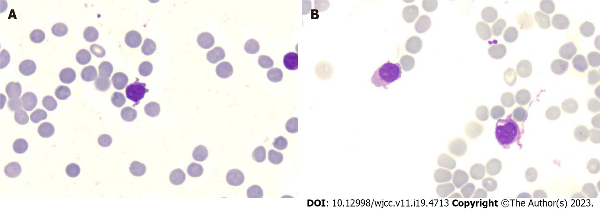
Figure 1 Morphological evaluation of bone marrow and blood smears during aplastic crisis. A: The bone marrow was aplastic, with sparsely distributed atypical lymphocytes, which accounted for 77% of all nucleated cells. The chromatin of the atypical lymphocytes was highly concentrated, the cytoplasm was excessively abundant, with eosinophilic shade on the basophilic background and most prominently adjacent to the nucleoli without visible granules, and the membrane was canthous, indicating the activation of lymphocytes. Basophilic substances were present in the cytoplasm of almost all mature erythrocytes, suggestive of dysplasia in erythropoiesis. The leukemic cells disappeared. Immunotyping analysis revealed that these atypical lymphocytes expressed a high frequency of cluster of differentiation (CD)3, CD4, CD8, CD5, CD56 and CD57, indicating the activation and expansion of autoimmune cytotoxic T-lymphocytes (CTLs) and natural killer (NK)/NKT cells that suppressed both normal and leukemic hematopoiesis; B: There were predominately atypical lymphocytes in the blood smears, and granulocytes were seldom visualized. Dyserythropoiesis can also be visualized in the blood smears.
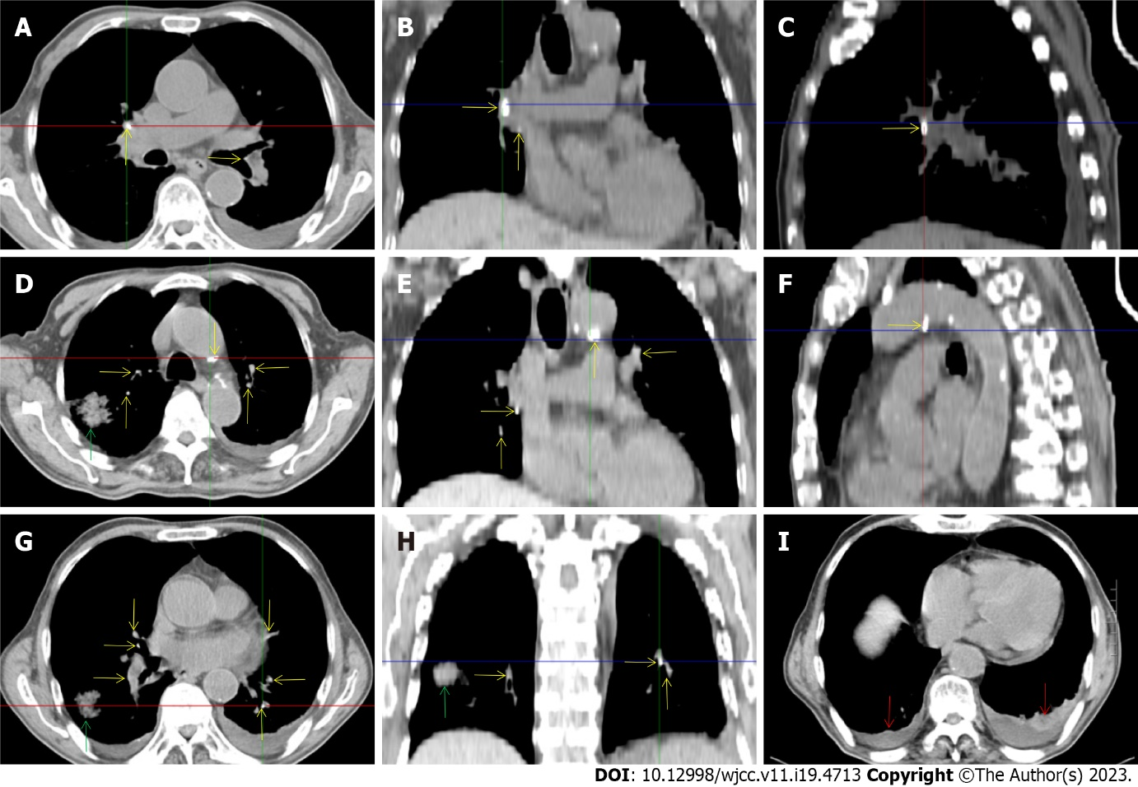
Figure 2 Chest computed tomography during aplastic crisis. A-H: Multiple calcified lesions were present in the lungs, hilum and mediastinum (yellow arrows), indicating the existence of old tuberculosis. The adjacent exudative lesions indicated reactivation of the old tuberculosis condition. A massive exudative lesion was present in the right lung (green arrows), and there was a similar exudative lesion on the pleuron adjacent to the massive exudative lesion; I: Hypertrophic lesions with pleural effusion were present in the bilateral pleura (red arrows), indicating pleural involvement of the tuberculosis infection. The pleural effusion was bloody, with an elevated level of adenosine deaminase, which was detected in aspirates and reinforced the diagnosis of tuberculosis.
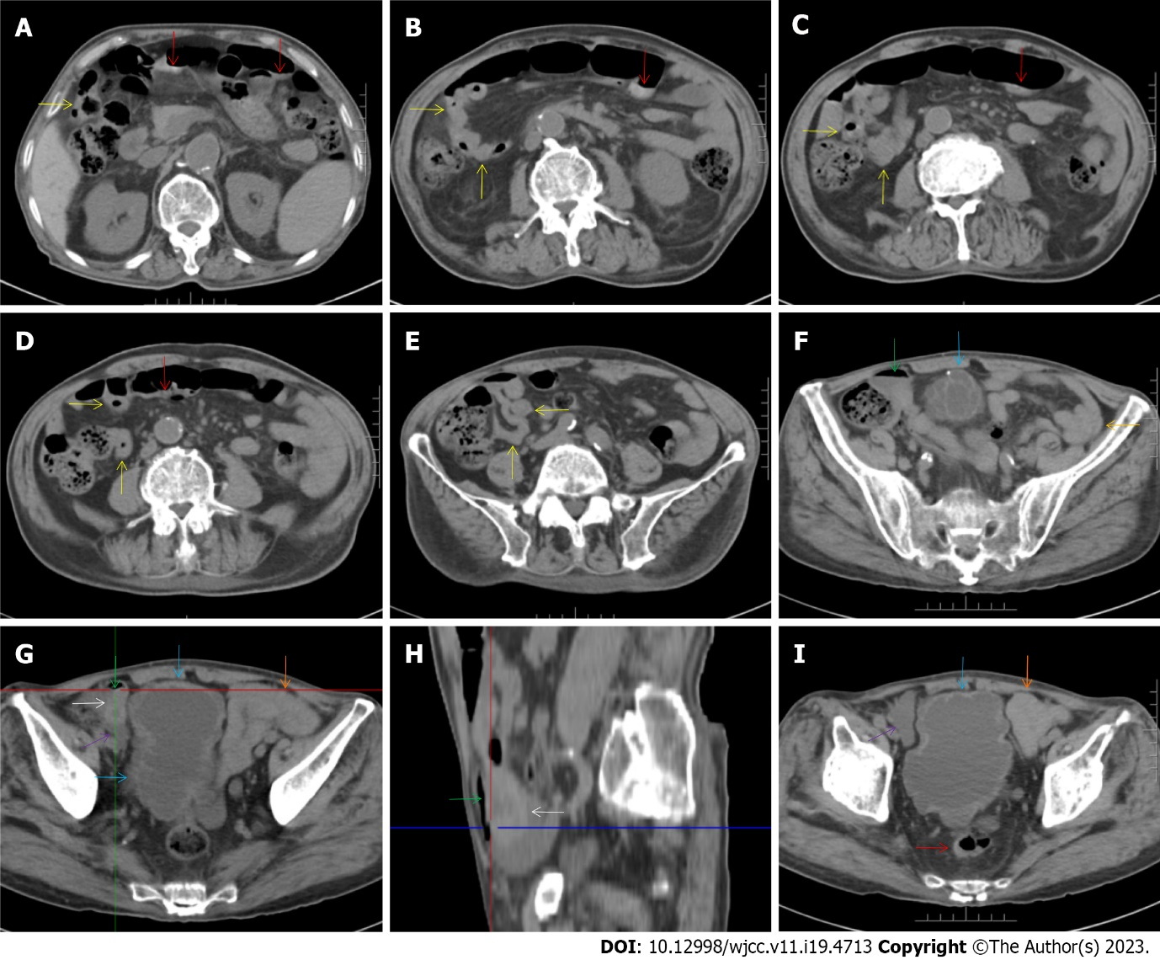
Figure 3 Abdominal computed tomography during aplastic crisis. A-E: The wall of the distal ileum was hypertrophically thickened and adhered, and the lumen of the terminal ileum was collapsed (yellow arrow). The lumen of the proximal small intestine was filled with liquid, with several gas—liquid levels. Hypertrophic lesions were also present in several segments of the colon (red arrows), and the lumen of the colon was dilated. In other segments of the colon, the wall showed fibrotic thickening. Notably, panabdominal silt-like fat proliferation led to widening of the bowel loop, forming the so-called “creeping fat sign” and indicating the presence of active chronic gut inflammatory conditions in the small intestine; F-I: In the right iliac fossa, there was an effusive lesion (purple arrow), indicative of peritoneal involvement. A gas—liquid level was present in the distal ileum (green arrows), proximal to which the ileal wall showed hypertrophic thickening (white arrows). The wall of the bladder also showed hypertrophic thickening, with an exudative lesion outside of the hypertrophic bladder wall (blue arrows). An adhered bowel loop was present in the proximal ileum (orange arrows), with the fibrotic thickening of the peritoneum forming the so-called “abdominal cocoon”. These imaging features, together with the imaging features on chest computed tomography, suggested a diagnosis of tuberculosis infection involving the gastrointestinal tract, peritoneum and urinary tract.

Published by Baishideng Publishing Group Inc
7041 Koll Center Parkway, Suite 160, Pleasanton, CA 94566, USA
Telephone: +1-925-3991568
E-mail: bpgoffice@wjgnet.com
Help Desk: https://www.f6publishing.com/helpdesk
https://www.wjgnet.com

© 2023 Baishideng Publishing Group Inc. All rights reserved.

