Name of Journal: World Journal of Radiology
ESPS Manuscript NO: 25404
Manuscript Type: Case Report

Presumptive case of sparganosis manifesting as a hepatic mass: A case report and literature review

Jo GD et al. presumptive case of hepatic sparganosis

Gyeong Deok Jo, Jae Young Lee, Sung-Tae Hong, Jung Hoon Kim, Joon Koo Han

Gyeong Deok Jo, Department of Medicine, Seoul National University School of Medicine, Jongno-gu, Seoul 03080, South Korea

Jae Young Lee, Jung Hoon Kim, Joon Koo Han, Department of Radiology, Seoul National University Hospital, Jongno-gu, Seoul 03080, South Korea

Jae Young Lee, Jung Hoon Kim, Joon Koo Han, Institute of Radiation Medicine, Seoul National University Hospital, Jongno-gu, Seoul 03080, South Korea

Sung-Tae Hong, Department of Parasitology and Tropical Medicine, Seoul National University College of Medicine, Jongno-gu, Seoul 03080, South Korea

Sung-Tae Hong, Institute of Endemic Diseases, Seoul National University College of Medicine, Jongno-gu, Seoul 03080, South Korea

Author contributions: Jo GD and Lee JY designed the research and wrote the paper; Hong S-T, Kim JH and Han JK analyzed and interpreted results.

Institutional review board statement: The study was reviewed and approved by the Seoul National University Hospital Institutional Review Board.

Informed consent statement: We were given exemption from getting informed consent by the Institutional Review Board.

Conflict-of-interest statement: The authors declare that they have no conflict of interest.

Open-Access: This article is an open-access article which was selected by an in-house editor and fully peer-reviewed by external reviewers. It is distributed in accordance with the Creative Commons Attribution Non Commercial (CC BY-NC 4.0) license, which permits others to distribute, remix, adapt, build upon this work non-commercially, and license their derivative works on different terms, provided the original work is properly cited and the use is non-commercial. See: http://creativecommons.org/licenses/by-nc/4.0/

Manuscript source: Unsolicited manuscript

Correspondence to: Jae Young Lee, MD, PhD, Department of Radiology, Seoul National University Hospital, 101 Daehak-ro, Jongno-gu, Seoul 03080, South Korea. leejy4u@snu.ac.kr
Telephone: +82-2-20723107
Fax: +82-2-7436385

Received: March 7, 2016
Peer-review started: March 9, 2016
First decision: May 19, 2016
Revised: July 26, 2016
Accepted: August 17, 2016

Article in press:
Published online:

Abstract
A 60-year-old man was admitted due to rectosigmoid colon cancer, and a hepatic mass was incidentally found during the staging work-up. The mass appeared cystic with a thick wall and contained multiple bizarre cord-like structures on ultrasound, computed tomography and magnetic resonance imaging. The differential diagnoses included organizing abscess/hematoma, foreign body granuloma and parasite infestation. Serologic study revealed anti-sparganum antibodies. Over 4-year follow up, the patient did not complain of symptoms, and no changes in the characteristics of the liver mass were observed. Hepatic sparganosis is rare; only two cases have been clinically reported, and no detailed radiologic description was available until now. This case report presents a detailed radiologic description of a hepatic mass that could most likely represent hepatic sparganosis.

Key words: Parasites; Sparganosis; Liver; Ultrasonography; X-Ray; Computed tomography; Magnetic resonance imaging

© The Author(s) 2016. Published by Baishideng Publishing Group Inc. All rights reserved.

Core tip: Hepatic sparganosis is rare; only two cases have been clinically reported, and no detailed radiologic description was available until now. This report presents radiologic findings of a presumptive case of sparganosis manifesting as a hepatic mass. This hepatic mass showed nonenhancing low attenuation mass with bizarrely arranged calcified internal cord-like structures on computed tomography, a necrotic mass with internal serpiginous tubular structures on magnetic resonance imaging, and a well-defined mixed echoic mass with multiple cord-like structures on ultrasonography. The understanding of this case will help physicians to consider the possibility of hepatic sparganosis when they encounter hepatic masses with bizarrely arranged internal serpiginous structures.

Jo GD, Lee JY, Hong S-T, Kim JH, Han JK. Presumptive case of sparganosis manifesting as a hepatic mass: A case report and literature review. World J Radiol 2016; In press

INTRODUCTION
Sparganosis refers to a parasitic infestation of plerocercoid larva of Spirometra. Humans can serve as second intermediate hosts, paratenic hosts and occasionally definitive hosts. Three routes of infection are currently known. The first is the direct ingestion of live plerocercoid larva via the consumption of raw second intermediate hosts (amphibians, reptiles, avians, mammals, etc.). The second is the consumption of water containing Cyclops species infected with procercoid larva. The third method route of infection is the use of the flesh or skin of infected frogs or snakes as a poultice. Regions of high prevalence are located in Asian countries, including China, Japan, Thailand and South Korea^{[1]}. Sparganosis frequently involves the abdominal wall, scrotum, lower extremities and thoracic wall. Less frequently involved areas include the abdominal cavity, pleural cavity, vertebral canal and orbit^{[2]}. Regarding the liver, only two cases of sparganosis have previously been reported to the best of our knowledge. Khurana et al^{[3]} reported a case of hepatic sparganosis in the English literature in 2012. The other case of hepatic sparganosis was reported in 1990 in the Korean literature^{[4]}. Unfortunately, neither of these case reports contain sufficient radiologic findings of hepatic sparganosis because they did not contain radiologic images or descriptions of computed tomography (CT) or magnetic resonance (MR) imaging findings but only included ultrasonography (US) findings.

CASE REPORT
A 60-year-old man with rectosigmoid colon cancer was referred to our hospital for preoperative staging evaluation. He was diagnosed with rectosigmoid colon cancer at a regular health checkup. During an abdominal CT study performed for the staging of the rectosigmoid colon cancer, a large low-attenuation mass was incidentally detected in the liver. This mass had internal bizarrely arranged cord-like structures, calcifications, and a few focal areas of fat (Figure 1). Our primary radiologic impression was a teratoma. Angiomyolipoma and myxoid liposarcoma were included in the differential diagnosis. Cystic metastasis of colon cancer was described as the least likely differential diagnosis.
For further evaluation, gadolinium-enhanced liver MR imaging was performed (Figure 2). Serpiginous tubular structures were clearly observed on T2-weighted images (Figure 2B). Diffusion in the mass was not restricted (Figure 2C, D). Axial in-phase T1-weighted and opposed-phase T1-weighted images showed multiple small foci with signal drops in opposed-phase image that are indicative of the presence of microscopic fat deposits. These findings indicated a fat-containing totally necrotic mass or a cystic mass with internal dead tissue. Our differential diagnosis included an organizing abscess/hematoma, a foreign body granuloma, and parasite infestation. Colon cancer metastasis was considered unlikely.
Liver US was performed to further evaluate the internal content of the liver mass. The mass was well demarcated upon US and contained echogenic material and serpiginous echogenic structures with a low echoic tubular rim (Figure 3). No vascularity was observed in the mass on color Doppler US. These findings led us to place foreign body granuloma and parasite-induced granuloma at the top of the list of differentials.
In a complete blood count including a differential cell count, no leukocytosis (white blood cell 5.02 × 10³ /μL) was observed, and the proportion of eosinophils was normal (2%). Because decreased liver excretory function was found on an indocyanine green excretion test, only an anterior resection of the rectosigmoid colon cancer without liver resection was conducted. The patient was discharged and followed up on an outpatient basis.
ELISA was performed two months after surgery to identify the parasite. The patient’s serum was tested for antibodies against Clonorchis, Paragonimus, cysticercus and sparganum. Only anti-sparganum antibodies were detected at a titer that was 1.4-fold of the cutoff value (positive and negative control sera were used to rule out the possibility of false negativity and false positivity). Although the treatment of choice for sparganosis is surgical removal, this approach was not employed due to the decreased liver excretory function. The hepatic mass was left untreated and regularly followed up.
The patient denied eating raw or undercooked snake or frog flesh and applying the skin or flesh of these animals to a wound as a poultice but admitted to drinking mountain water several times. Because he had a history of travel to the Middle East for two years, which is a crucial diagnostic clue for Echinococcosis^{[5]}, and serpiginous linear structures could also be observed in echinococcal cysts^{[6]}, an additional ELISA test was performed to differentiate between sparganosis and echinococcosis four years after surgery. At this time, the antibody titers for sparganum and Echinococcus antigen were both below the cutoff values.
He underwent CT scans every 6 mo. During four years of follow up, the mass in the liver exhibited no change in size or other aspects of appearance.

DISCUSSION
The radiologic characteristics of sparganosis in cerebral, scrotal, mammillary, and musculoskeletal areas have been described in several articles^{[7-13]}. Serpiginous tubular structures have been reported in the breast, scrotal, and musculoskeletal sparganosis^{[11-13]}. One reported scrotal sparganosis exhibited multiple serpiginous tubular echogenic structures surrounded by low echoic rims in an echogenic mass, and these findings were similar to the US findings from our case^{[11]}. According to previous reports, serpiginous echogenic tubular structures and surrounding echogenic masses are indicative of sparganum larvae and granulomatous inflammation, respectively^{[11-13]}.
The two cases of hepatic sparganosis that have been reported thus far presented with large well-defined hepatic abscesses and sparganum larvae coming out of the drains^{[3,4]}. The expelled larvae were flat, long and thread-like (35-40 cm long and 1.5-1.7 mm in width). Sparganum larvae may involve potentially all body tissues but the subcutaneous tissue is the most frequent site^{[14]}. The phenomenon is speculated by the hypothesis that the plerocercoid larvae migrate to the tissue of rather low temperature. Another reason is that subcutaneous sparganosis is more easily detectable than that in deep viscera. In any reason, hepatic sparganosis is extremely rare.
The sensitivity and specificity of the ELISA used in this case are known to be 85.7% and 95.7% for sparganosis and 91.5% and 96% for Echinococcus, respectively^{[15,16]}. The high specificity of the ELISA supports the notion that the hepatic mass resulted from sparganum. Overall, based on our imaging findings, initial ELISA test findings and the decreasing trend in the antibody titer for sparganum upon the additional ELISA, we concluded that our case involved a large organizing abscess with dead sparganum larva.
Hydatid cysts caused by Echinococcus infection can exhibit internal serpiginous structures due to the detachment of the pericysts and the collapsed membranes inside the cyst, which are collectively called the "snake sign"^{[6]}. However, these collapsed membranes exhibit low signal intensity on all MR imaging sequences, which was not observed on any of the MR images in our case. Typical imaging findings related to hydatid cysts include daughter cysts, floating membranes, internal septa, and thickened walls that represent the pericyst; none of these findings were present in our case.
Calcification on CT images is a common finding of sparganosis, particularly in cerebral sparganosis; up to 75% of all cerebral sparganosis cases have been reported to have calcification^{[17]}. Calcifications represent old lesions in late stages^{[10]}. This finding also supports our diagnosis. The reason that our case had fat foci is unclear but might be related to the process of collagen degeneration in the dead worms.
In conclusion, our case may involve the very rare condition of hepatic sparganosis manifesting as a hepatic mass with calcified serpiginous structures and detailed US, CT, and MR imaging features. The understanding of this case will encourage radiologists and physicians to consider the possibility of hepatic sparganosis when they encounter hepatic masses with bizarrely arranged internal serpiginous structures.

COMMENTS
Case characteristics
A 60-year-old man with rectosigmoid colon cancer having incidentally detected hepatic mass during cancer staging evaluation.

Differential diagnosis
Organizing abscess/hematoma, foreign body granuloma and parasite infestation.

Laboratory diagnosis
Only anti-sparganum antibodies were detected on ELISA test.

Imaging diagnosis
Computed tomography (CT) scan demonstrated a large low-attenuation mass with internal bizarrely arranged cord-like structures, calcifications, and a few focal areas of fat. Liver magnetic resonance (MR) imaging showed serpiginous tubular structures on T2-weighted images. Diffusion in the mass was not restricted on diffusion-weighted MR images. Liver ultrasonography (US) demonstrated a well-demarcated mass with echogenic material and serpiginous echogenic structures.

Experiences and lessons
This case report describes imaging features of rare hepatic sparganosis. Awareness of possibility of hepatic sparganosis can lead to proper diagnostic tests and earlier diagnosis.

Peer-review
The strength of this article is a detailed radiologic description of a presumptive case of hepatic sparganosis, including US, CT, and MR imaging findings.
REFERENCES
- Lv S, Zhang Y, Steinmann P, Zhou XN, Utzinger J. Helminth infections of the central nervous system occurring in Southeast Asia and the Far East. Adv Parasitol 2010; 72: 351-408 [PMID: 20624537 DOI: 10.1016/s0065-308x(10)72012-1]
- Cho SY, Bae JH, Seo BS. Some Aspects Of Human Sparganosis In Korea. Kisaengchunghak Chapchi 1975; 13: 60-77 [PMID: 12913468 DOI: 10.3347/kjp.1975.13.1.60]
- Khurana S, Appannanavar S, Bhatti HS, Verma S. Sparganosis of livera rare entity and review of literature. BMJ Case Rep 2012; 2012: pii: bcr2012006790 [PMID: 23220827 DOI: 10.1136/bcr-2012-006790]
- Song CS, Moon WK, Kang PJ, Lee DW, Yang WS, Huh Y, Moon HK.A case of sparganosis combined with liver abscess. Korean J Med 1990; 39: 686-690
- Byun SJ, Moon KC, Suh KS, Han JK, Chai JY. An imported case of echinococcosis of the liver in a Korean who traveled to western and central Europe. Korean J Parasitol 2010; 48: 161-165 [PMID: 20585534 DOI: 10.3347/kjp.2010.48.2.161]
- Marrone G, Crino' F, Caruso S, Mamone G, Carollo V, Milazzo M, Gruttadauria S, Luca A, Gridelli B. Multidisciplinary imaging of liver hydatidosis. World J Gastroenterol 2012; 18: 1438-1447 [PMID: 22509075 DOI: 10.3748/wjg.v18.i13.1438]
- Chang KH, Cho SY, Chi JG, Kim WS, Han MC, Kim CW, Myung H, Choi KS. Cerebral sparganosis: CT characteristics. Radiology 1987; 165: 505-510 [PMID: 3659374 DOI: 10.1148/radiology.165.2.3659374]
- Kradel J, Drolshagen LF, MacDade A. MR and CT findings in cerebral sparganosis. J Comput Assist Tomogr 1993; 17: 989-990 [PMID: 8227593 DOI: 10.1097/00004728-199311000-00028]
- Moon WK, Chang KH, Cho SY, Han MH, Cha SH, Chi JG, Han MC. Cerebral sparganosis: MR imaging versus CT features. Radiology 1993; 188: 751-757 [PMID: 8351344 DOI: 10.1148/radiology.188.3.8351344]
- Song T, Wang WS, Zhou BR, Mai WW, Li ZZ, Guo HC, Zhou F. CT and MR characteristics of cerebral sparganosis. AJNR Am J Neuroradiol 2007; 28: 1700-1705 [PMID: 17885230 DOI: 10.3174/ajnr.A0659]
- Kim YJ, Lee MW, Jeon HJ, Yi JG, Paick SH, Kim HG, Lim SD, Hwang TS. Sparganosis in the scrotum: sonographic findings. J Ultrasound Med 2007; 26: 129-131 [PMID: 17182719]
- Hong SJ, Kim YM, Seo M, Kim KS. Breast and scrotal sparganosis: sonographic findings and pathologic correlation. J Ultrasound Med 2010; 29: 1627-1633 [PMID: 20966474]
- Cho JH, Lee KB, Yong TS, Kim BS, Park HB, Ryu KN, Park JM, Lee SY, Suh JS. Subcutaneous and musculoskeletal sparganosis: imaging characteristics and pathologic correlation. Skeletal Radiol 2000; 29: 402-408 [PMID: 10963426 DOI: 10.1007/s002560000206]
- Liu Q, Li MW, Wang ZD, Zhao GH, Zhu XQ. Human sparganosis, a neglected food borne zoonosis. Lancet Infect Dis 2015; 15: 1226-1235 [PMID: 26364132 DOI: 10.1016/s1473-3099(15)00133-4]
- Kim H, Kim SI, Cho SY. Serological Diagnosis Of Human Sparganosis By Means Of Micro-ELISA. Kisaengchunghak Chapchi 1984; 22: 222-228 [PMID: 12891016 DOI: 10.3347/kjp.1984.22.2.222]
- Jin Y, Anvarov K, Khajibaev A, Hong S, Hong ST. Serodiagnosis of echinococcosis by ELISA using cystic fluid from Uzbekistan sheep. Korean J Parasitol 2013; 51: 313-317 [PMID: 23864742 DOI: 10.3347/kjp.2013.51.3.313]
- Chang KH, Chi JG, Cho SY, Han MH, Han DH, Han MC. Cerebral sparganosis: analysis of 34 cases with emphasis on CT features. Neuroradiology 1992; 34: 1-8 [PMID: 1553030 DOI: 10.1007/BF00588423]

P-Reviewer: Cerwenka H, Huang CT, Torres US S-Editor: Kong JX
L-Editor: E-Editor:

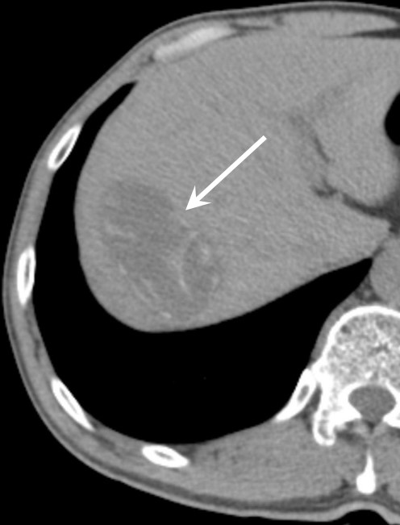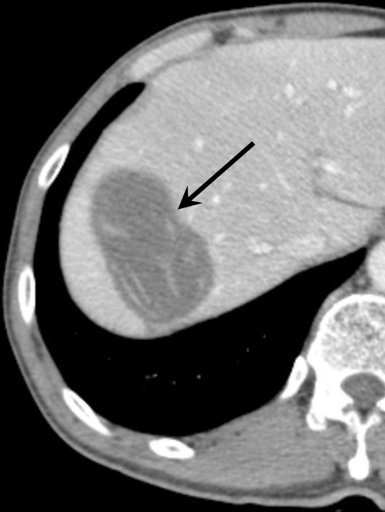
B
A
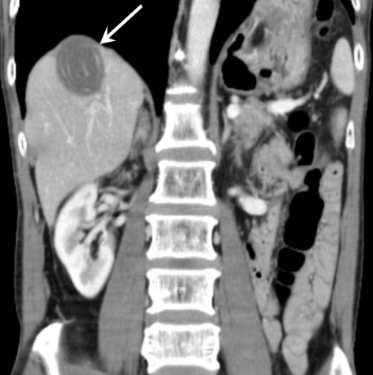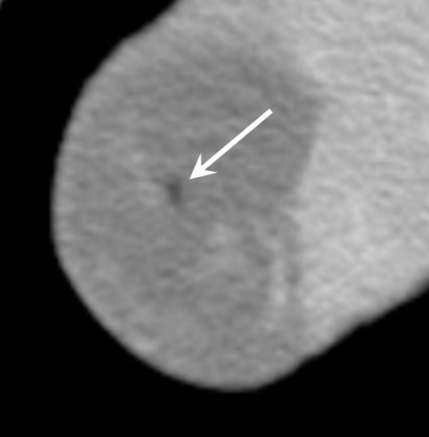
D
C
Figure 1 Liver computed tomography imaging. A: Axial noncontrast (computed tomography) CT image showing an ovoid low attenuation lesion (arrow) in the right hepatic dome. This mass has internal linear or curvilinear cord-like lesions that are most likely calcified. This mass (arrow) measured 6.3 cm × 3.5 cm. B: Axial contrast-enhanced CT image clearly showing that this ovoid lesion (arrow) does not have any enhanced portions, which suggests a totally necrotic lesion or a cystic mass. The internal cord-like structures are bizarrely arranged; C: Coronal contrast-enhanced CT image showing that the internal structures within the mass (arrow) are arranged in a whirling manner; D: Low attenuation (-22 Hounsfield units) region (arrow) in the center of the mass on a contrast-enhanced CT image, suggesting the presence of a small amount of fat.

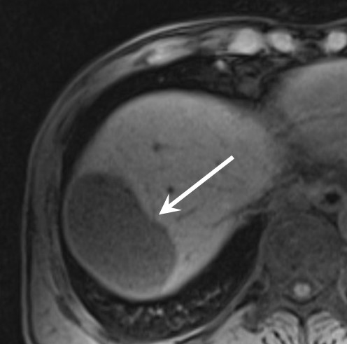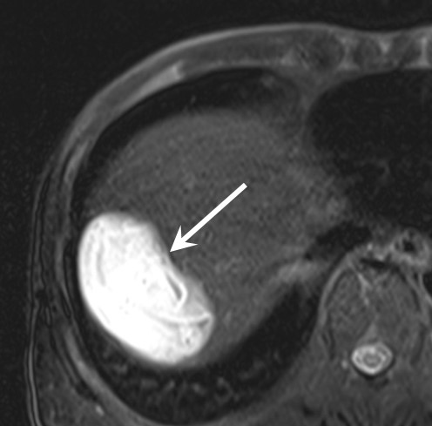
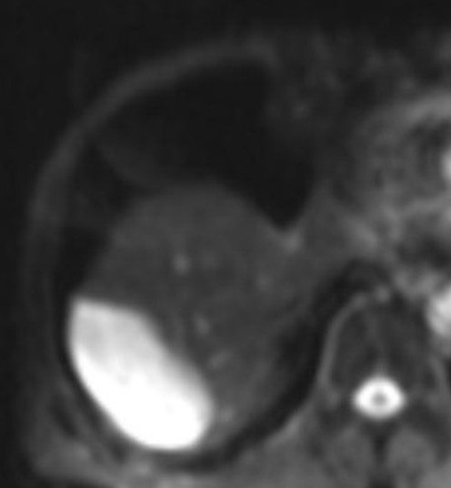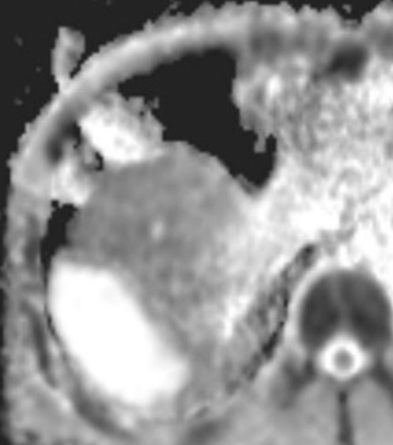
Figure 2 Liver magnetic resonance imaging. A: Axial nonenhanced T1-weighted image showing that this hepatic mass (arrow) exhibits homogeneously low signal intensity; B: Fat-saturated axial T2-weighted image showing that the mass (arrow) exhibits very high signal intensity and internal serpiginous tubular structures; C,D: Axial diffusion-weighted image (C) and apparent diffusion coefficient map (D) showing that the diffusion in the mass is not restricted.

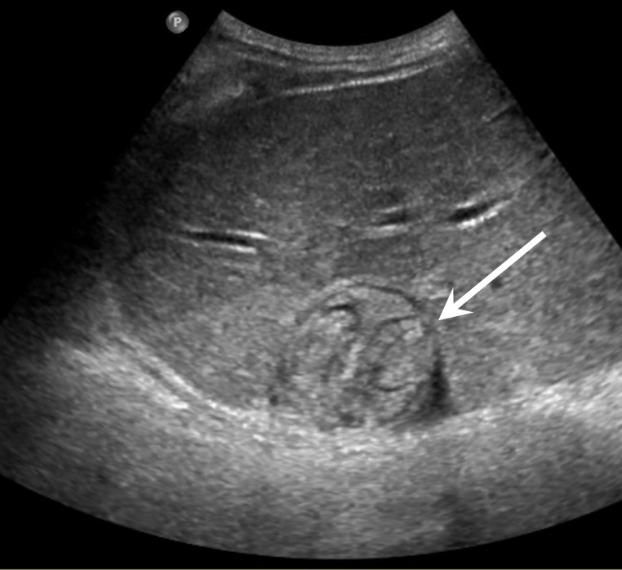
Figure 3 Liver ultrasonography showing a well-defined mixed echoic mass (arrow) in the dome of the liver. Multiple cord-like structures can be seen within the mass.

