Name of Journal: World Journal of Clinical Cases
Manuscript NO: 87170
Manuscript Type: ORIGINAL ARTICLE

Retrospective Study
Artificial intelligence technology and ultrasound-guided nerve block for analgesia in total knee arthroplasty

Tong SX et al. Ultrasound-guided nerve block for analgesia in TKA

Sheng-Xiong Tong, Ren-Song Li, Dan Wang, Xiao-Meng Xie, Yuan Ruan, Lin Huang

Sheng-Xiong Tong, Department of Pain Management, Wuhan First Hospital, Wuhan 430033, Hubei Province, China

Ren-Song Li, Department of Orthopaedics, Wuhan Wuchang Hospital, Wuhan 430063, Hubei Province, China

Dan Wang, Department of Orthopaedics, Union Hospital, Tongji Medical College, Huazhong University of Science and Technology, Wuhan 430022, Hubei Province, China

Xiao-Meng Xie, Department of Nursing, Huanggang Central Hospital, Huanggang 438000, Hubei Province, China

Yuan Ruan, Lin Huang, Department of Orthopaedics, Huanggang Central Hospital, Huanggang 438000, Hubei Province, China

Author contributions: Tong SX and Li RS contributed equally to this work; Tong SX and Huang L contributed to the conceptualization, methodology, software of the study; Tong SX and Li RS contributed to the data curation and the drafted the manuscript; Wang D, Xie XM, Li RS and Ruan Y contributed the validation of the study, and the writing, reviewing and editing of the manuscript.

Corresponding author: Lin Huang, MD, Doctor, Department of Orthopaedics, Huanggang Central Hospital, No. 6 Qi’an Avenue, Huangzhou District, Huanggang 438000, Hubei Province, China. lhuang0727@sina.com

Received: August 15, 2023
Revised: September 14, 2023
Accepted: September 22, 2023
Published online: October 16, 2023

Abstract
BACKGROUND
Knee diseases are more common in middle-aged and elderly people, so artificial knee replacement is also more used in middle-aged and elderly people. Although the patient’s pain can be reduced through surgery, often accompanied by moderate pain after surgery and neutralization, which not only increases the psychological burden of the patient, but also greatly reduces the postoperative recovery effect, and may also lead to the occurrence of postoperative adverse events in severe cases.

AIM
To investigate the analgesic effect of artificial intelligence (AI) and ultrasound-guided nerve block in total knee arthroplasty (TKA).

METHODS
A total of 92 patients with TKA admitted to our hospital from January 2021 to January 2022 were opted and divided into two groups according to the treatment regimen. The control group received combined spinal-epidural anesthesia. The research group received AI technique combined with ultrasound-guided nerve block anesthesia. The sensory block time, motor block time, visual analogue scale (VAS) at different time points and complications were contrasted between the two groups.

RESULTS
The time of sensory block onset and sensory block perfection in the research group was shorter than those in the control group, but the results had no significant difference (P > 0.05). Duration of sensory block in the research group was significantly longer than those in the control group (P < 0.05). The time of motor block onset and motor block perfection in the research group was shorter than those in the control group, but the results had no significant difference (P > 0.05). Duration of motor block in the research group was significantly longer than those in the control group. The VAS scales of the research group were significantly lower than that of the control group at different time points (P < 0.05). The postoperative hip flexion and abduction range of motion in the research group were significantly better than those in the control group at different time points (P < 0.05). The incidence of complications was significantly lower in the research group than in the control group (P = 0.049).

CONCLUSION
In TKA, the combination of AI technology and ultrasound-guided nerve block has a significantly effect, with fewer postoperative complications and significantly analgesic effect, which is worthy of application.

Key Words: Artificial intelligence technology; Ultrasound guidance; Nerve blocks; Total knee arthroplasty; Analgesia effects

©The Author(s) 2023. Published by Baishideng Publishing Group Inc. All rights reserved.

Citation: Tong SX, Li RS, Wang D, Xie XM, Ruan Y, Huang L. Artificial intelligence technology and ultrasound-guided nerve block for analgesia in total knee arthroplasty. World J Clin Cases 2023; 11(29): 7026-7033
URL: https://www.wjgnet.com/2307-8960/full/v11/i29/7026.htm
DOI: https://dx.doi.org/10.12998/wjcc.v11.i29.7026

Core Tip: Entering the century of rapid development, the phenomenon of aging population is also increasing, aging problems have received widespread social attention, middle-aged and elderly people are prone to knee joint lesions, the most important feature of knee joint lesions is its multiple, this disease affects the motor function of the elderly. This study aimed to investigate the analgesic effect of artificial intelligence (AI) and ultrasound-guided nerve block in total knee arthroplasty (TKA). The authors found that in TKA, the combination of AI technology and ultrasound-guided nerve block has a significantly effect, with fewer postoperative complications and significantly analgesic effect, which is worthy of application.
INTRODUCTION
Entering the century of rapid development, the phenomenon of aging population is also increasing, aging problems have received widespread social attention, middle-aged and elderly people are prone to knee joint lesions, the most important feature of knee joint lesions is its multiple, this disease affects the motor function of the elderly^{[1,2]}. Among the disabling chronic diseases, gonarthritis also accounts for a considerable part, and only knee replacement by surgery can minimize the patient’s pain, help the patient get rid of the disease distress as much as possible, help them establish a new outlook on life, and enhance the quality of life^{[3]}. However, surgery in the treatment of diseases at the same time, will bring a greater degree of trauma to patients, the most ideal anesthesia is perioperative analgesia. This anesthesia method is not only aimed at the surgical process, but also includes the postoperative period. If reasonable nursing is given in the perioperative period, the incidence rate of postoperative complications will be greatly reduced. This management not only includes providing a good method for the patient with labor pain, but also includes the guidance and help for the patient postoperative exercise and improving the patient’ s comfort level^{[4]}.
Knee joint diseases are mostly seen in middle-aged and elderly people, so artificial knee arthroplasty is also mostly used in middle-aged and elderly people^{[5]}. Although the pain of patients can be reduced through surgery, it is often accompanied by more than moderate pain during and after surgery, which not only aggravates the psychological burden of patients, but also greatly reduces the postoperative recovery effect, and may also lead to the occurrence of postoperative adverse events in serious cases^{[6]}. Therefore, the most important purpose of medical staff is to do a good job of preoperative as well as postoperative anesthesia and minimize the patient’s pain^{[7]}. The use of artificial intelligence (AI) technology combined with ultrasound-guided nerve block anesthesia has achieved ideal results, reducing the pain of patients while reducing the incidence of postoperative complications.

MATERIALS AND METHODS
General information
A total of 92 patients with total knee arthroplasty (TKA) who were treated in our hospital from January 2021 to January 2022 were opted, and the patients were divided into two groups according to the treatment regimen. Inclusion criteria: (1) All meet the relevant standards for TKA; (2) Clear consciousness and normal communication; (3) Normal spirit; (4) Normal blood coagulation function; and (5) All know and agree to this study. Exclusion criteria: (1) Patients with allergic reactions to anesthetics; (2) Patients with infection at the puncture site; (3) Patients with severe abnormal coagulation function; and (4) Patients with nerve damage in the bottom extremity on the operating side or abnormal skin sensation patient. Ethics approval was provided by the ethical committee of Wuhan First Hospital. Written informed consent was obtained from all participants. The research group included 31 males and 15 females, with a mean age of 74.7 ± 1.4 years and a mean weight of 64.6 ± 2.1 kg. The control group included 27 males and 19 females, with a mean age of 74.5 ± 1.3 years and a mean weight of 64.3 ± 2.0 kg. No statistically significant difference was found between the two groups.

Intervention methods
Control group: The control group was given combined spinal-epidural anesthesia, and L2-3 was used as the puncture point for puncture anesthesia. Glucose (10%, approved by Chinese medicine: H13022457, produced by CSPC) was mixed for anesthesia for the patient, and 8-10 mL of lidocaine (1.5%, approved by Chinese medicine: H35020528) was added to the epidural during the operation.

Research group: The research group performed nerve block anesthesia guided by ultrasound, and used a portable ultrasound instrument (S-NERVE, Solo Sound) to perform nerve block anesthesia on the patients. After opting a good position for the patient, let the patient flex their knees and flex their hips. After disinfection, mark points are made. The data is imported into the AI KNEE system to quickly and intelligently generate and automatically segment the three-dimensional bone anatomy of the patient’s knee joint. 5 The software automatically identifies anatomical landmarks and measures key knee parameters. After the image was obtained, 25 mL of ropivacaine (0.5%, approved by the State Drug Administration: H20113463, produced by Hebei Yipin Company) was injected into the sciatic nerve using a spinal anesthesia needle; A short-axis view was performed while 20 mL of ropivacaine was injected near the nerve using a spinal needle.

Observation indicators
Sensory block time: Observe and record the sensory block time of the two clusters of patients, including the onset time, perfection time, and duration.

Motor block time: Mainly include onset time, perfection time, and duration.

Visual analog scale: Contrasted the pain conditions of the two clusters of patients at different time points, the score is 10 points, 0 points: No pain; < 3 points: Slight pain, but tolerable; 4-6 points: Pain affects sleep, but can be tolerated; 7-10 points: Pain is intense, unbearable, affects sleep, and affects appetite.

The range of motion of hip flexion and abduction: The changes in the range of motion of hip flexion and abduction after surgery were contrasted between the two clusters.

Complications: Mainly headache, low back pain, nausea and vomiting.

Statistical analysis
The count data was expressed as n (%) and compared using the χ² test. The measurement data was expressed as mean ± SD and compared using the t-test. P < 0.05 was considered as significant differences.

RESULTS
Comparative of sensory block time between the two groups
The time of sensory block onset and sensory block perfection in the research group was shorter than those in the control group, but the results had no significant difference (P > 0.05) (Figure 1). Duration of sensory block in the research group was significantly longer than those in the control group (P < 0.05).

Comparative of motor block time between the two groups
The time of motor block onset and motor block perfection in the research group was shorter than those in the control group, but the results had no significant difference (P > 0.05) (Figure 2). Duration of motor block in the research group was significantly longer than those in the control group (P < 0.05) (Figure 2).

Comparative of visual analogue scales between the two clusters
The visual analogue scale (VAS) scales of the research group were bottom than that of the control group at different time points, and the variance was significant difference (P < 0.05) (Table 1, Figure 3).

Comparative of postoperative hip flexion and abduction range of motion
The postoperative hip flexion and abduction range of motion in the research group were better than those in the control group at different time points, and the variance was significant difference (P < 0.05) (Figure 4).

Comparative of complications between the two clusters
The number of patients with headache, back pain, nausea and vomiting in the research group were 1, 2, and 3 respectively, and the complication rate was 2.2%; while those of the control group were 0, 0, and 1, respectively, with a complication rate of 13.0%. The incidence of complications was significantly lower in the research group than in the control group (P = 0.049, Table 2).

DISCUSSION
Osteoarthritis is a common joint disease, mainly characterized by joint deformity, dysfunction and deformity^{[8-10]}. At present, TKA is mainly used to treat patients with osteoarthritis, which can relieve joint pain and restore normal function of some joints^{[11]}. However, the operation process of TKA is relatively complex, causing great harm to patients^{[12]}, which can easily lead to stress reactions in patients^{[13]}. Pain is the most common postoperative complication of TKA. Excessive pain will have a certain impact on the quality of postoperative joint training. Reasonable and effective postoperative analgesia for patients can enhance postoperative joint function training treatment, reduce the risk of complications^{[14]}.
Nerve block is to inject drugs directly into nerve trunks, nerve plexuses and other places where nerves gather, or to block nerve pathways through physical stimulation, and block the use of ultrasound-guided knee replacement surgery^{[15]}. The main function of this pump is to transfer the effective concentration of drugs are introduced into the epidural space through a catheter, so that the pain transmitted from the spinal cord is blocked in the process of being transmitted to the nervous system, increased the speed and strength of venous blood return, in this way can greatly reduce the complications of surgery^{[16,17]}.
The AI-based three-dimensional planning system for TKA surgery is used for preoperative planning^{[18,19]}. The system can accurately segment the skeletal bone fragments based on the preoperative computed tomography images of the patient, using a pixel-level segmentation network and edge smoothing technology based on a recurrent neural network In nerve block, the concentration of ropivacaine is controlled between 0.2% and 0.5%, and the total amount is less than 3 mg/kg^{[20]}. Mixing ropivacaine with lidocaine can effectively make up for the lack of slow onset 8 of ropivacaine, and can also effectively expand the area of drug diffusion and block a wider range of^{[21]}. Our results showed the time of sensory block onset and sensory block perfection in the research group was shorter than those in the control group, but the results had no significant difference^{[22]}. However, duration of sensory block in the research group was significantly longer than those in the control group^{[23]}.
With the continuous advancement of medical technology, ultrasound guidance has been widely used in anesthesia, which can effectively make up for the shortcomings of conventional nerve block anesthesia^{[24]}. Our results showed that the complications in the research group was significantly lower than those in the control group, which means that in TKA, the combination of AI technology and ultrasound-guided nerve block can significantly reduce the probability of complications in patients. The VAS scales of the research group were significantly lower than that of the control group at different time points, which indicated that the combination of AI technology and ultrasound-guided nerve block in TKA was more feasible, and the method has no obvious effect on the circulatory system of patients and is easy to be widely used^{[25]}. The most important thing is that it can significantly reduce the occurrence of various complications in the patient^{[24,25]}. Although the feasibility of ultrasound-guided nerve block is high, this study also has certain shortcomings. Therefore, in the future research process, we will conduct more in-depth research and discussion in order to confirm the accuracy of the results and provide a certain scientific basis for the development of TKA. Provide some reference for other researchers.

CONCLUSION
In TKA, the combination of AI technology and ultrasound-guided 9 nerve block has a significantly effect. The AI-based three-dimensional planning system for TKA surgery performs preoperative planning, reduces the risk of complications, and speeds up patient recovery. The analgesic effect is obvious and it is worth applying.

ARTICLE HIGHLIGHTS
Research background
Knee joint disease, as one of the common diseases of middle-aged and elderly people, has increased greatly with the aging population. Conventional total knee arthroplasty (TKA) has a high risk of postoperative pain.

Research motivation
Artificial intelligence (AI) combined with ultrasound-guided nerve block anesthesia has achieved ideal results in TKA, effectively reducing the incidence of postoperative complications.

Research objectives
This study aimed to explore the clinical analgesic effect of artificial intelligence and ultrasound-guided nerve block in TKA, and to provide expected clinical guidance for TKA.

Research methods
Patients were randomly divided into two groups: combined spinal-epidural anesthesia and AI combined with ultrasound-guided nerve block anesthesia. The different clinical effects of the two groups were compared.

Research results
Ultrasound-guided nerve block in TKA has longer duration of sensory block and longer duration of motor block in the research group, better postoperative complications and better clinical effect.

Research conclusions
The combination of AI technology and ultrasound-guided nerve block is effective in the treatment of knee lesions in the elderly, with few postoperative complications and significantly analgesic effect, which is worth popularizing and applying.

Research perspectives
The combination of AI technology and ultrasound-guided nerve block is an effective clinical practice method, which provides a certain clinical guidance for postoperative analgesia of knee diseases in middle-aged and elderly people.

REFERENCES
1 Li X, Xu Y, Lin W, Fan Y. The comparison of bone mineral density of femoral head between non-hip fracture side and hip fracture side. Sci Rep 2020; 10: 13015 [PMID: 32747650 DOI: 10.1038/s41598-020-70144-5]
2 Xin L, Wu Z, Qu Q, Wang R, Tang J, Chen L. Comparative study of CTX-II, Zn2+, and Ca2+ from the urine for knee osteoarthritis patients and healthy individuals. Medicine (Baltimore) 2017; 96: e7593 [PMID: 28796042 DOI: 10.1097/MD.0000000000007593]
3 Steinert AF, Schröder L, Sefrin L, Janßen B, Arnholdt J, Rudert M. The Impact of Total Knee Replacement with a Customized Cruciate-Retaining Implant Design on Patient-Reported and Functional Outcomes. J Pers Med 2022; 12 [PMID: 35207682 DOI: 10.3390/jpm12020194]
4 Ruppen W, Derry S, McQuay HJ, Moore RA. Incidence of epidural haematoma and neurological injury in cardiovascular patients with epidural analgesia/anaesthesia: systematic review and meta-analysis. BMC Anesthesiol 2006; 6: 10 [PMID: 16968537 DOI: 10.1186/1471-2253-6-10]
5 Dong R, Wu Y, Xu S, Zhang L, Ying J, Jin H, Wang P, Xiao L, Tong P. Is aquatic exercise more effective than land-based exercise for knee osteoarthritis? Medicine (Baltimore) 2018; 97: e13823 [PMID: 30593178 DOI: 10.1097/MD.0000000000013823]
6 Pinedo-Villanueva R, Kolovos S, Burn E, Delmestri A, Smith LK, Judge A, Kingsbury SR, Stone MH, Conaghan PG. Association between outpatient follow-up and incidence of revision after knee and hip replacements: a population-based cohort study. BMC Musculoskelet Disord 2023; 24: 106 [PMID: 36750857 DOI: 10.1186/s12891-023-06190-7]
7 Grocott MP, Pearse RM. Perioperative medicine: the future of anaesthesia? Br J Anaesth 2012; 108: 723-726 [PMID: 22499744 DOI: 10.1093/bja/aes124]
8 Cai C, Min S, Yan B, Liu W, Yang X, Li L, Wang T, Jin A. MiR-27a promotes the autophagy and apoptosis of IL-1β treated-articular chondrocytes in osteoarthritis through PI3K/AKT/mTOR signaling. Aging (Albany NY) 2019; 11: 6371-6384 [PMID: 31460867 DOI: 10.18632/aging.102194]
9 Yuan M, Wang Y, Wang H, Ding Z, Xiao Q, Zhou Z. Optimal Handling of the Patella in Tourniquet-Free Total Knee Arthroplasty: Eversion or Lateral Retraction? Orthop Surg 2020; 12: 1870-1881 [PMID: 33112025 DOI: 10.1111/os.12819]
10 Ban WR, Zhang EA, Lv LF, Dang XQ, Zhang C. Effects of periarticular injection on analgesic effects and NSAID use in total knee arthroplasty and total hip arthroplasty. Clinics (Sao Paulo) 2017; 72: 729-736 [PMID: 29319718 DOI: 10.6061/clinics/2017(12)03]
11 Thybo KH, Jakobsen JC, Hägi-Pedersen D, Pedersen NA, Dahl JB, Schrøder HM, Bülow HH, Bjørck JG, Overgaard S, Mathiesen O, Wetterslev J. PANSAID-PAracetamol and NSAID in combination: detailed statistical analysis plan for a randomised, blinded, parallel, four-group multicentre clinical trial. Trials 2017; 18: 465 [PMID: 29017585 DOI: 10.1186/s13063-017-2203-1]
12 Soulioti E, Tsaroucha A, Makris A, Koutsaki M, Sklika E, Mela A, Megaloikonomos PD, Mavrogenis AF, Fassoulaki A. Addition of 100 mg of Tramadol to 40 mL of 0.5% Ropivacaine for Interscalene Brachial Plexus Block Improves Postoperative Analgesia in Patients Undergoing Shoulder Surgeries as Compared to Ropivacaine Alone-A Randomized Controlled Study. Medicina (Kaunas) 2019; 55 [PMID: 31340565 DOI: 10.3390/medicina55070399]
13 Et T, Korkusuz M, Basaran B, Yarımoğlu R, Toprak H, Bilge A, Kumru N, Dedeli İ. Comparison of iPACK and periarticular block with adductor block alone after total knee arthroplasty: a randomized clinical trial. J Anesth 2022; 36: 276-286 [PMID: 35157136 DOI: 10.1007/s00540-022-03047-6]
14 Lynch NM, Trousdale RT, Ilstrup DM. Complications after concomitant bilateral total knee arthroplasty in elderly patients. Mayo Clin Proc 1997; 72: 799-805 [PMID: 9294525 DOI: 10.4065/72.9.799]
15 Yan SC, Fu SX, Li N, Mai L. Comparison of analgesic effects and postoperative cognitive function following total knee arthroplasty: continuous intravenous infusion of fentanyl vs. ultrasound-guided continuous femoral nerve block with ropivacaine. Am J Transl Res 2021; 13: 3174-3181 [PMID: 34017486]
16 Faiz SHR, Imani F, Rahimzadeh P, Alebouyeh MR, Entezary SR, Shafeinia A. Which Ultrasound-Guided Sciatic Nerve Block Strategy Works Faster? Prebifurcation or Separate Tibial-Peroneal Nerve Block? A Randomized Clinical Trial. Anesth Pain Med 2017; 7: e57804 [PMID: 29637044 DOI: 10.5812/aapm.57804]
17 JCS Joint Working Group. Guidelines for the diagnosis, treatment and prevention of pulmonary thromboembolism and deep vein thrombosis (JCS 2009). Circ J 2011; 75: 1258-1281 [PMID: 21441695 DOI: 10.1253/circj.cj-88-0010]
18 Li Z, Zhang X, Ding L, Du K, Yan J, Chan MTV, Wu WKK, Li S. Deep learning approach for guiding three-dimensional computed tomography reconstruction of lower limbs for robotically-assisted total knee arthroplasty. Int J Med Robot 2021; 17: e2300 [PMID: 34109730 DOI: 10.1002/rcs.2300]
19 Lee LS, Chan PK, Wen C, Fung WC, Cheung A, Chan VWK, Cheung MH, Fu H, Yan CH, Chiu KY. Artificial intelligence in diagnosis of knee osteoarthritis and prediction of arthroplasty outcomes: a review. Arthroplasty 2022; 4: 16 [PMID: 35246270 DOI: 10.1186/s42836-022-00118-7]
20 Purnomo G, Yeo SJ, Liow MHL. Artificial intelligence in arthroplasty. Arthroplasty 2021; 3: 37 [PMID: 35236494 DOI: 10.1186/s42836-021-00095-3]
21 Yang L, Chen X, Oi Lam Ung C, Zhu H, Hu H, Han S. Clinical and Economic Evaluation of Salvianolate Injection for Coronary Heart Disease: A Retrospective Study Based on National Health Insurance Data in China. Front Pharmacol 2020; 11: 887 [PMID: 32625090 DOI: 10.3389/fphar.2020.00887]
22 Kulkarni KR, Deshpande S, Namazi I, Singh SK, Kondilya K. A comparative evaluation of hyperbaric ropivacaine versus hyperbaric bupivacaine for elective surgery under spinal anesthesia. J Anaesthesiol Clin Pharmacol 2014; 30: 238-242 [PMID: 24803765 DOI: 10.4103/0970-9185.130031]
23 Laflı Tunay D, Türkeün Ilgınel M, Ünlügenç H, Tunay M, Karacaer F, Biricik E. Comparison of the effects of preoperative melatonin or vitamin C administration on postoperative analgesia. Bosn J Basic Med Sci 2020; 20: 117-124 [PMID: 31465720 DOI: 10.17305/bjbms.2019.4379]
24 Ketelaars R, Stollman JT, van Eeten E, Eikendal T, Bruhn J, van Geffen GJ. Emergency physician-performed ultrasound-guided nerve blocks in proximal femoral fractures provide safe and effective pain relief: a prospective observational study in The Netherlands. Int J Emerg Med 2018; 11: 12 [PMID: 29500558 DOI: 10.1186/s12245-018-0173-z]
25 Yamada K, Inomata S, Saito S. Minimum effective volume of ropivacaine for ultrasound-guided supra-inguinal fascia iliaca compartment block. Sci Rep 2020; 10: 21859 [PMID: 33318589 DOI: 10.1038/s41598-020-79059-7]

Footnotes
Institutional review board statement: Ethics approval was provided by the ethical committee of Wuhan First Hospital.

Informed consent statement: Written informed consent was obtained from all participants.

Conflict-of-interest statement: The authors declare that the research was conducted in the absence of any commercial or financial relationships that could be construed as a potential conflict of interest.

Data sharing statement: No additional data are available.

Open-Access: This article is an open-access article that was selected by an in-house editor and fully peer-reviewed by external reviewers. It is distributed in accordance with the Creative Commons Attribution NonCommercial (CC BY-NC 4.0) license, which permits others to distribute, remix, adapt, build upon this work non-commercially, and license their derivative works on different terms, provided the original work is properly cited and the use is non-commercial. See: https://creativecommons.org/Licenses/by-nc/4.0/

Provenance and peer review: Unsolicited article; Externally peer reviewed.
Peer-review model: Single blind

Peer-review started: August 15, 2023
First decision: August 31, 2023
Article in press: September 22, 2023

Specialty type: Orthopedics
Country/Territory of origin: China
Peer-review report’s scientific quality classification
Grade A (Excellent): 0
Grade B (Very good): 0
Grade C (Good): C, C
Grade D (Fair): 0
Grade E (Poor): 0

P-Reviewer: Han I, South Korea; Yaradilmis YU, Turkey S-Editor: Wang JL L-Editor: A P-Editor: Yuan YY
Figure Legends
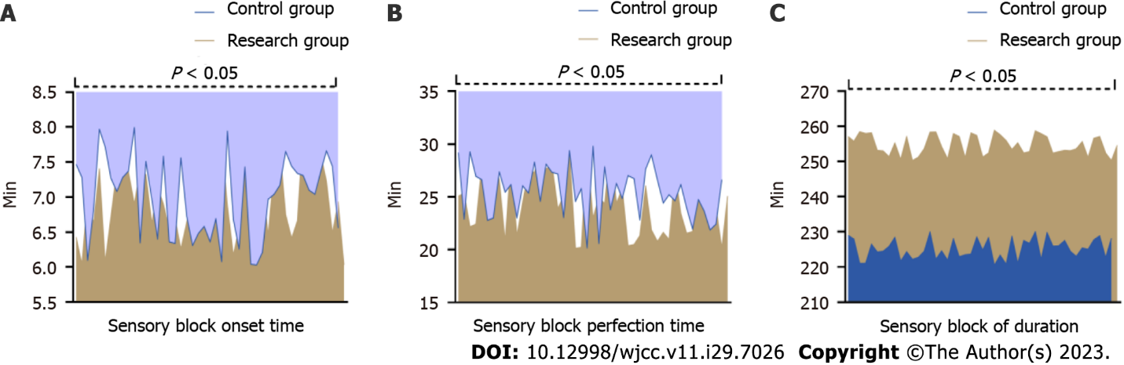
Figure 1 Comparative of sensory block time (mean ± SD). A: Sensory block onset time; B: Sensory block perfection time; C: Sensory block of duration. The duration of sensation in the research group is longer than that in the control group. P < 0.05 indicates that there is a significant difference in the duration of sensation between the control group and the research group.
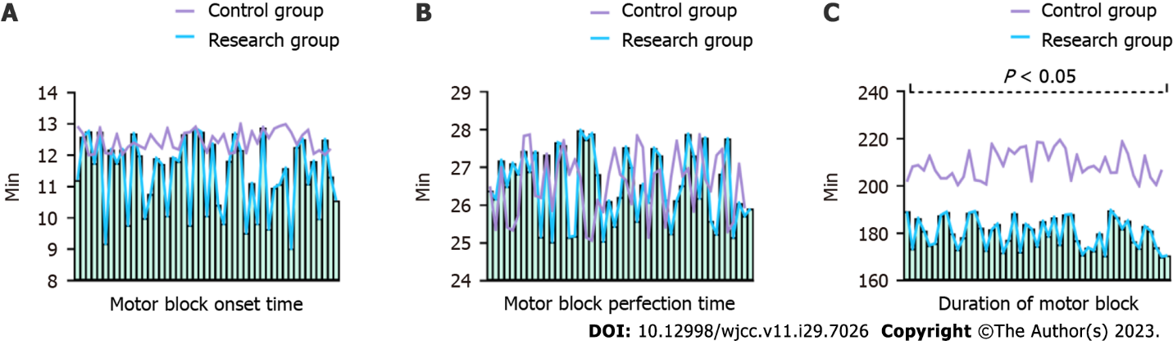
Figure 2 Comparative of motor block time (mean ± SD). A: Motor block onset time; B: Motor block perfection time; C: Duration of motor block. The exercise duration of the research group was shorter than that of the control group. P < 0.05 indicates that there was a significant difference in the exercise duration between the control group and the research group.
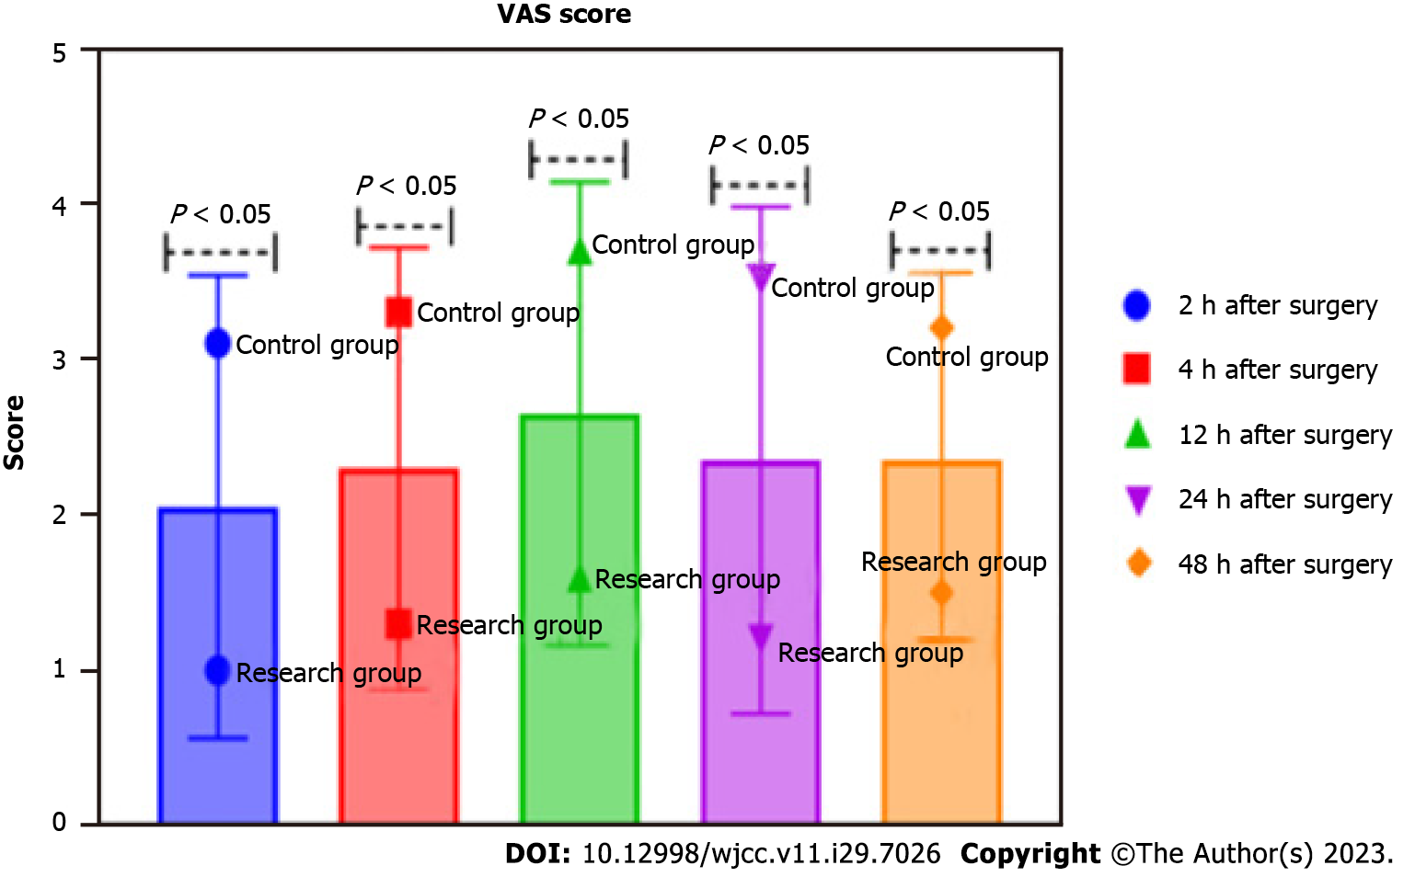
Figure 3 Comparative of visual analogue scale scores (points, mean ± SD). The visual analogue scale (VAS) score of the research group is lower than that of the control group after surgery. P < 0.05 means that the VAS score of the control group and the research group at different time points (2 h, 4 h, 12 h, 24 h, 48 h) after surgery, the variance is significant difference. VAS: Visual analogue scale.
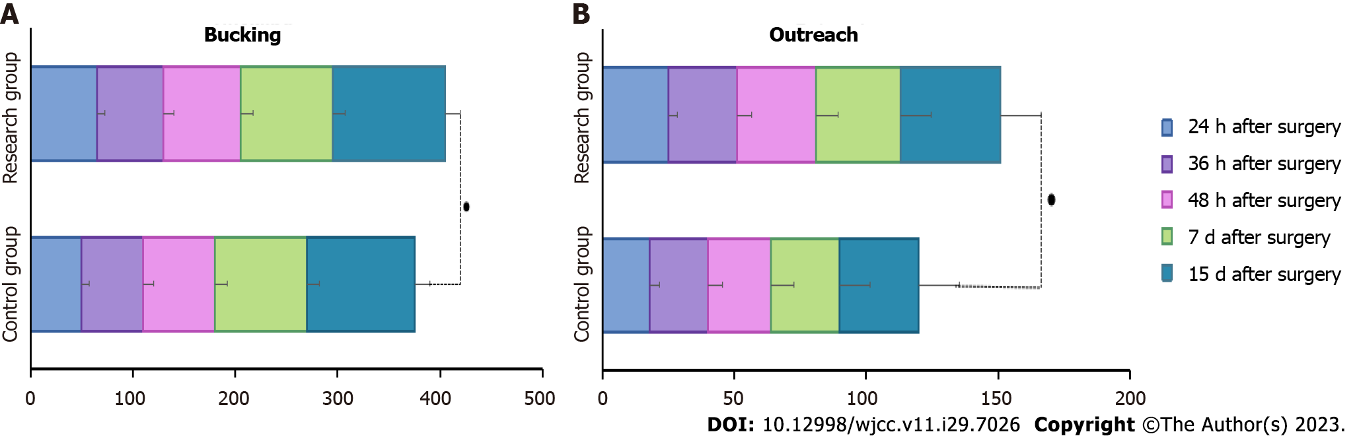
Figure 4 Comparative of hip flexion and abduction range of motion between the two groups after surgery (°, mean ± SD). A: Bucking; B: Outreach. Contrasted with the control group, the research group has greater degree of hip flexion and abduction after surgery. P < 0.05 means that the control group and the research group at different time points (24 h, 36 h, 48 h, 7 d, 15 d after the surgery) hip flexion contrasted with abduction activity, the variance was significant difference.
Table 1 Comparative of visual analogue scale scores (points, mean ± SD)
Group | 2 h post-operation | 4 h post-operation | 12 h post-operation | 24 h post-operation | 48 h post-operation
Control group (n = 46) | 3.1 ± 1.0 | 3.3 ± 0.3 | 3.7 ± 0.6 | 3.5 ± 1.0 | 3.2 ± 0.3
Research group (n = 46) | 1.0 ± 0.4 | 1.3 ± 0.4 | 1.6 ± 0.8 | 1.2 ± 0.6 | 1.5 ± 0.4
T value | 13.224 | 27.129 | 14.243 | 13.376 | 23.060
P value | < 0.05 | < 0.05 | < 0.05 | < 0.05 | < 0.05
Table 2 Comparative of complications, n (%)
Group | Headache | Back pain | Nausea and vomiting | Incidence
Control group (n = 46) | 1 (2.2) | 2 (4.3) | 3 (6.5) | 13.0%
Research group (n = 46) | 0 (0) | 0 (0) | 1 (2.2) | 2.2%
χ² value |  |  |  | 3.867
P value |  |  |  | < 0.05

Published by Baishideng Publishing Group Inc
7041 Koll Center Parkway, Suite 160, Pleasanton, CA 94566, USA
Telephone: +1-925-3991568
E-mail: bpgoffice@wjgnet.com
Help Desk: https://www.f6publishing.com/helpdesk
https://www.wjgnet.com

© 2023 Baishideng Publishing Group Inc. All rights reserved.

