Name of Journal: World Journal of Critical Care Medicine
Manuscript NO: 75274
Manuscript Type: CASE REPORT

Cardiac arrest due to massive aspiration from a broncho-esophageal fistula: A case report

Lagrotta G et al. Cardiac arrest in setting of broncho-esophageal fistula

Gustavo Lagrotta, Mina Ayad, Ifrah Butt, Mauricio Danckers

Gustavo Lagrotta, Graduate Medical Education, Pulmonary Disease, Aventura Hospital and Medical Center, Aventura, FL 33180, United States

Mina Ayad, Department of Internal Medicine, Aventura Hospital and Medical Center, Aventura, FL 33180, United States

Ifrah Butt, Department of Gastroenterology, Aventura Hospital and Medical Center, Aventura, FL 33180, United States

Mauricio Danckers, Division of Pulmonary and Critical Care Medicine, Aventura Hospital and Medical Center, Aventura, FL 331380, United States

Author contributions: Danckers M contributed conceptualization, writing original draft preparation and follow up revisions, image acquisition and editing, illustration preparation and data verification; Lagrotta G contributed writing original draft, image review and verified data; Ayad M contributed reviewing, data and image acquisition; Butt I contributed reviewing.

Corresponding author: Gustavo Lagrotta, DO, Doctor, Graduate Medical Education, Pulmonary Disease, Aventura Hospital and Medical Center, 20900 Biscayne Blvd., Aventura, FL 33180, United States. gustavo.lagrottasaavedra@hcahealthcare.com

Received: January 20, 2022
Revised: May 29, 2022
Accepted: July 31, 2022
Published online:

Abstract
BACKGROUND
Tracheo and broncho esophageal fistulas and their potential complications in adults are seldom encountered in clinical practice but carries a significant morbidity and mortality.

CASE SUMMARY
We present a case of a 39-year-old otherwise healthy man who presented to our hospital after ingestion of drain cleaner substance during a suicidal attempt. He unexpectedly suffered from cardiac arrest during his stay in the intensive care unit. The patient had developed extensive segmental trachea-broncho-esophageal fistulous tracks that led to a sudden and significant aspiration event of gastric and duodenal contents with subsequent cardiopulmonary arrest. Endoscopic evaluation of extension of fistulous track proved a slow and delayed progression of disease despite initial management with esophageal stenting for his caustic injury.

CONCLUSION
The aim of this case presentation is to share with the reader the dire natural history of trachea-broncho-esophageal fistulas and its delayed progression. We aim to illustrate pitfalls in the endoscopic examination and provide further awareness on critical care monitoring and management strategies to reduce its morbidity and mortality.

Key Words: Tracheoesophageal fistula; Broncho esophageal fistula; Caustic ingestion; Cardiopulmonary arrest; Critical care; Case report

Lagrotta G, Ayad M, Butt I, Danckers M. Cardiac arrest due to massive aspiration from a broncho-esophageal fistula: A case report. World J Crit Care Med 2022; In press

Core Tip: Trachea-esophageal and broncho-esophageal in the setting of caustic ingestion is an unusual complication associated with high morbidity and mortality. Close monitoring of the gastrointestinal tract patency and motility is critical to avoid gastric distention and large aspiration events with detrimental consequences. Although there is no general consensus on the initial approach to patients with fistula formation, our case proposes serial esophagogastroduodenoscopy and flexible bronchoscopy for at least 6 mo as well as a low threshold for surgical referral when progression of disease or new findings are encountered.
INTRODUCTION
Injuries from caustic substance ingestion are associated with varying grades of damage to the gastrointestinal and respiratory tract including esophagitis, mucosal burns, necrosis and perforation, stenosis, and rarely, trachea-esophageal (TEF), and broncho-esophageal (BEF) fistulas. Suicidal caustic ingestion strongly correlates with severity of injury and carries high morbidity and mortality^{[1]}. We present the case of a young man after suicidal caustic ingestion of drain cleaner fluid who developed a sudden massive gastric and duodenal content aspiration into his airway through acquired large TEF and BEF fistulas leading to cardiopulmonary arrest.

CASE PRESENTATION
Chief complaints
A 39-year-old man arrived at our emergency department from another institution where he had been endotracheally intubated for airway protection.

History of present illness
The patient had sought medical attention five hours after a suicidal attempt where he ingested an unknown amount of drain cleaner liquid that contained sodium hydroxide, potassium hydroxide, and carbonyl diamide.

History of past illness
The patient had a free previous medical history.

Physical examination
Upon arrival to our facility, his vital signs were stable. His physical exam revealed edematous oral mucosa and chemical injuries to the face.

Laboratory examinations
His initial laboratory data was remarkable for a white blood cell count of 12.9 × 10³/μL and a D-dimer > 5250 ng/mL DDU.

Imaging examinations
Chest computer tomography (CT) with contrast revealed thickening and submucosal edema of the esophageal and gastric wall, along with trace para-esophageal and peri-gastric stranding and fluid. No free air was reported.

FINAL DIAGNOSIS
Tracheo and broncho esophageal fistulas leading to massive aspiration and cardiac arrest.

TREATMENT
He was started on a proton pump inhibitor, intravenous fluids, and prophylactic antibiotics. A tracheostomy and jejunostomy tube were placed on hospital day 13. He was noted to have bouts of coughing during routine sedation-awakening trials and with reduction in sedatives. On hospital day 18, he became acutely hypoxic, and his oxygen saturation decreased to 50% followed by pulseless electrical arrest. Advanced cardiopulmonary resuscitation was initiated with recovery of spontaneous circulation after two 5-min rounds of cardiopulmonary resuscitation. Copious amounts of frothy, yellow-tinted secretions were noted from the tracheostomy in-line suction setup. No oral secretions were noted during oral cavity suction. A nasogastric tube was placed for gastric cavity decompression and approximately 400-500 mL of fluid were suctioned. Figure 1 demonstrates chest imaging obtained prior and post cardiopulmonary arrest highlighting the patient’s acute clinical change. On day 22, the patient underwent successful placement of a 1.8 cm in outer diameter and 12.3 cm in length fully covered esophageal stent.
The patient’s hospital course was complicated by acute respiratory distress syndrome and recurrent septic shock secondary to aspiration pneumonia. He was eventually liberated from mechanical ventilation and transitioned to a tracheostomy collar. He continued on enteral nutrition through a jejunostomy feeding tube. He left the intensive care unit on day 40 and was discharged home with home-health on day 114.

OUTCOME AND FOLLOW-UP
His endoscopy surveillance revealed progression and further extend of disease. Bronchoscopies performed on day 1 and day 8 as noted in Figure 2 demonstrate the progression of the insult. Bronchoscopy performed after 17 wk revealed new tracheoesophageal fistula with esophageal lumen opening at midway through posterior wall of the trachea (Figure 3A and B). His prior bronchoscopy at 7 wk had shown protrusion of esophageal stent through the left main broncho-esophageal fistula without any additional fistulous tracts (Figure 3C). Esophagoduodenoscopy (EGD) performed 7 mo after initial presentation visualized tracheostomy tube through a combined lumen formed by the esophagus and trachea (Figure 3D). Distal to the tracheostomy tube, a double lumen is identified with the esophagus opening at the proximal end of the stent (Figure 3E) as well as a complete obliteration of the stent in his distal end due to in-growth tissues (Figure 3F). The patient has been referred for cardiothoracic surgical evaluation where he will complete nutritional optimization prior to potential surgical intervention. Chronology of events is listed in Table 1.

DISCUSSION
Caustic ingestion remains a rare but potentially catastrophic mechanism for injury leading to significant morbidity and mortality. Specific management guidelines have yet to be defined^{[2]}. Injury severity is determined by multiple factors including type of agent, its concentration, amount consumed, and time of contact with gastrointestinal mucosa. Agents can be either acidic or alkali. Our patient ingested drain cleaner liquid, predominantly an alkali substance.
TEF is a delayed and unusual complication that occurs approximately in 3% of patients with caustic ingestion^{[2]}. BEF are not extensively described in the literature and their true incidence unknown. The rarity of BEFs is likely due to the anatomical relationship between the left mainstem bronchus and the esophagus. The thoracic esophagus extends caudally towards the diaphragmatic hiatus, passing posteriorly to the trachea, the tracheal bifurcation, and the left main stem bronchus^{[3]}. The area of contact of the posterior wall of the left main bronchus with the anterior wall of the esophagus, in contrast to that of the trachea, is significantly smaller, making left main BEFs less likely to develop than TEF.
Hemorrhage, thrombosis, and inflammation with edema occur within the first 24 h. If caustic ingestion is severe enough, transmural necrosis leads to perforation and regional fistulous tract formation. TEFs and BEFs can lead to sepsis, aspiration pneumonia, acute respiratory distress syndrome, strictures, malignancy among other systemic complications^{[2]}. In our patient, the fistulous tract was significant enough to allow for large amounts of gastric and duodenal content to reach the airway causing hypoxemia and cardiopulmonary arrest.
Medical literature on the incidence of cardiopulmonary arrest due to aspiration through a BEF is lacking, and its incidence is not defined. We infer that our patient’s aspiration leading to his arrest was due to increased output through a persistently large fistulous track in the setting of transient duodenal outlet stenosis from mucosal damage and impaired gastrointestinal motility. Our patient exhibited large amounts of bile-colored tracheal secretions in the peri-arrest period confirming a high output fistulous passage of duodenal content. Although in our case the volume we aspirated through naso-gastric suctioning was 400-500 mL, the exact volume of gastric content aspirated is unknown. However, it was large enough to infiltrate the lingula and left lower lobe.
The incidence of aspiration pneumonia related to corrosive ingestion has been estimated in up to 4.2% of cases with a mortality up to 60%^{[4]}. Due to high risk of aspiration, enteral nutrition is often restricted^{[4]}. In addition, caloric restriction and malnutrition further lead to recurrent pulmonary infections, bronchopneumonia, and sepsis^{[5]}. Alternative means of enteral nutrition through the insertion of a jejunostomy tube were sought in our patient to enhance nutritional state as well as to promote fistula healing. A high index of suspicion should be maintained for functional or anatomic gastrointestinal tract obstruction as a consequence of caustic injury and should be considered when addressing nutritional support to select the most suitable nutritional route.
Risk stratification is needed during the initial approach. Symptoms such as dysphagia, hematemesis, stridor, cough, respiratory distress, drooling, and abdominal pain have been described. A sudden bout of uncontrolled paroxysmal cough, a reported symptom associated with BEF^{[6]}, was witnessed in our patient while mechanically ventilated during daily sedation awakening trials suggesting aspiration events and persistent fistula.
There is no consensus within the medical community of the initial and emergent management of TEF/BEF after caustic ingestion. In 2015, the World Society of Emergency Surgery recommended a management algorithm which includes both endoscopy and CT imaging as part of the initial assessment^{[7]}. Our patient underwent both, esophagogastroduodenoscopy and non-contrast CT scan within the first twenty-four hours of ingestion. Figure 4 demonstrates initial esophagoduodenoscopy findings. In order to quantify the severity of the injury, we utilized the Zargar classification system which placed him in the IIIB category^{[8]}. This grading is useful for predicting systemic complications, respiratory failure, nutritional autonomy, and survival. In general, the degree of esophageal injury at endoscopy is a predictor of systemic complication and death with a 9-fold increase in morbidity and mortality for every increased injury grade^{[9]} which aligns with our case study. An important tool for the clinician about risk rather than timing.
However, risk stratification cannot accurately predict the depth of necrosis which could lead to inappropriate non-operative management and/or unnecessary surgical resection^{[2]}. In order to properly evaluate the extent of necrosis, we propose that there is a benefit for surveillance endoscopic examination through EGD and flexible bronchoscopies for early fistula detection and therapeutic interventions. This would also serve for the monitoring of long term sequelae such as airway stenosis, or such in our case, further development of fistulous tracks. The interval of bronchoscopies would be dictated by endoscopic findings. In our case, evidence of a large newly detected TEF occurred 4 mo after the initial event. Prior biweekly and monthly bronchoscopies only reported the known BEF. It is reasonable to suggest monthly endoscopic surveillance in patients with high Zargar Score for at least 4-6 mo following the initial ingestion. In patients who are able to be discharged from the hospital, surgical referral should be sought if endoscopic examination does not show a favorable course, new fistulous tracks are detected, or if the patient’s symptoms severely impair quality of life.
The treatment of TEFs and BEFs is based on previous case reports, reviews, and case series, along with experts' opinions. In our case, a multidisciplinary team agreed on the placement of an 18 mm × 123 mm fully covered esophageal wall stent. According to the World Journal of Emergency Surgery, endoscopic treatment is the gold standard for closing large esophageal defects such suspected in our patient for the exam of injury during initial endoscopic examination. Self-expandable stents have showed to have a higher success rate and lower mortality rate when compared to surgical approach^{[10]}. Our patient underwent self-expandable sent placement due to the clinical complexity and added surgical risk in the setting of a recent cardiac arrest. This case illustrates both the prolonged hospital course of a cardiac arrest survival due to delayed complications of a BEF associated with functional impairment and also the protracted progression of the disease more than 6 mo later.

CONCLUSION
In conclusion, TEF and BEF in the setting of caustic ingestion is an unusual complication associated with high morbidity and mortality. Early and frequent endoscopic evaluation of the upper gastrointestinal tract and bronchial tree, as well as maintaining a high index of clinical suspicion, are necessary for its prompt recognition. This will lead to early detection of delayed complications including new fistulous tracks, and timely institution of therapeutic interventions. We remind the reader of the importance of close monitoring of the gastrointestinal tract patency and motility to avoid gastric distention and large aspiration events with detrimental consequences. Although there is no general consensus on the initial approach to patients with fistula formation, our case proposes serial EGDs and flexible bronchoscopy for at least 6 mo as well as a low threshold for surgical referral when progression of disease or new findings are encountered.

ACKNOWLEDGEMENTS
The authors would like to acknowledgment Dr. Gonzalez H and Dr. Bethencourt-Mirabal A for the revision provided to the manuscript, and Dr. Kaplan S, Dr. Heller D and Dr. Morgan D, for their insight on the esophagoduodenoscopic and bronchoscopic findings.

REFERENCES
1 Ertekin C, Yanar H, Taviloglu K, Guloglu R, Alimoglu O. Can endoscopic injection of epinephrine prevent surgery in gastroduodenal ulcer bleeding? An analysis of 107 cases. J Laparoendosc Adv Surg Tech A 2004; 14: 147-152 [PMID: 15245666 DOI: 10.1089/1092642041255513]
2 Mircea C, Bonavina L, Kelly MD, Sarfati E, Cattan P. Caustic ingestion. Lancet 2017; 389: 2041-2052 [DOI: 10.1016/s0140-6736(16)30313-0]
3 Braden K, Urma D. Esophagus-anatomy and development. GI Motility 2006 [DOI: 10.1007/978-1-4614-3794-9_19]
4 Tseng YL, Wu MH, Lin MY, Lai WW. Outcome of acid ingestion related aspiration pneumonia. Eur J Cardiothorac Surg 2002; 21: 638-643 [DOI: 10.1016/s1010-7940(02)00045-3]
5 Argüder E, Aykun G, Karalezli A, Hasanoğlu HC. Bronchoesophageal fistula. J Bronchology Interv Pulmonol 2012; 19: 47-49 [PMID: 23207263 DOI: 10.1097/LBR.0b013e31823fc99e]
6 Aggarwal D, Mohapatra PR, Malhotra B. Acquired bronchoesophageal fistula. Lung India 2009; 26: 24-25 [PMID: 20165591 DOI: 10.4103/0970-2113.45201]
7 Bonavina L, Chirica M, Skrobic O, Kluger Y, Andreollo NA, Contini S, Simic A, Ansaloni L, Catena F, Fraga GP, Locatelli C, Chiara O, Kashuk J, Coccolini F, Macchitella Y, Mutignani M, Cutrone C, Poli MD, Valetti T, Asti E, Kelly M, Pesko P. Foregut caustic injuries: results of the world society of emergency surgery consensus conference. World J Emerg Surg 2015; 10: 44 [PMID: 26413146 DOI: 10.1186/s13017-015-0039-0]
8 Cheng HT, Cheng CL, Lin CH, Tang JH, Chu YY, Liu NJ, Chen PC. Caustic ingestion in adults: the role of endoscopic classification in predicting outcome. BMC Gastroenterol 2008; 8: 31 [PMID: 18655708 DOI: 10.1186/1471-230X-8-31]
9 Zargar SA, Kochhar R, Mehta S, Mehta SK. The role of fiberoptic endoscopy in the management of corrosive ingestion and modified endoscopic classification of burns. Gastrointest Endosc 1991; 37: 165-169 [PMID: 2032601 DOI: 10.1016/s0016-5107(91)70678-0]
10 Chirica M, Kelly MD, Siboni S, Aiolfi A, Riva CG, Asti E, Ferrari D, Leppäniemi A, Ten Broek RPG, Brichon PY, Kluger Y, Fraga GP, Frey G, Andreollo NA, Coccolini F, Frattini C, Moore EE, Chiara O, Di Saverio S, Sartelli M, Weber D, Ansaloni L, Biffl W, Corte H, Wani I, Baiocchi G, Cattan P, Catena F, Bonavina L. Esophageal emergencies: WSES guidelines. World J Emerg Surg 2019; 14: 26 [PMID: 31164915 DOI: 10.1186/s13017-019-0245-2]

Footnotes
Informed consent statement: Written consent for publication was obtained from the patient health care proxy.

Conflict-of-interest statement: All the authors report no relevant conflicts of interest for this article.

CARE Checklist (2016) statement: The authors have read the CARE Checklist (2016), and the manuscript was prepared and revised according to the CARE Checklist (2016).

Open-Access: This article is an open-access article that was selected by an in-house editor and fully peer-reviewed by external reviewers. It is distributed in accordance with the Creative Commons Attribution NonCommercial (CC BY-NC 4.0) license, which permits others to distribute, remix, adapt, build upon this work non-commercially, and license their derivative works on different terms, provided the original work is properly cited and the use is non-commercial. See: https://creativecommons.org/Licenses/by-nc/4.0/

Provenance and peer review: Unsolicited article; Externally peer reviewed.
Peer-review model: Single blind

Peer-review started: January 20, 2022
First decision: April 13, 2022
Article in press:

Specialty type: Critical care medicine
Country/Territory of origin: United States
Peer-review report’s scientific quality classification
Grade A (Excellent): 0
Grade B (Very good): 0
Grade C (Good): C
Grade D (Fair): D, D
Grade E (Poor): 0

P-Reviewer: Kumar N, India; Liu YC, China; Xu L, China S-Editor: Gao CC L-Editor: P-Editor:
Figure Legends
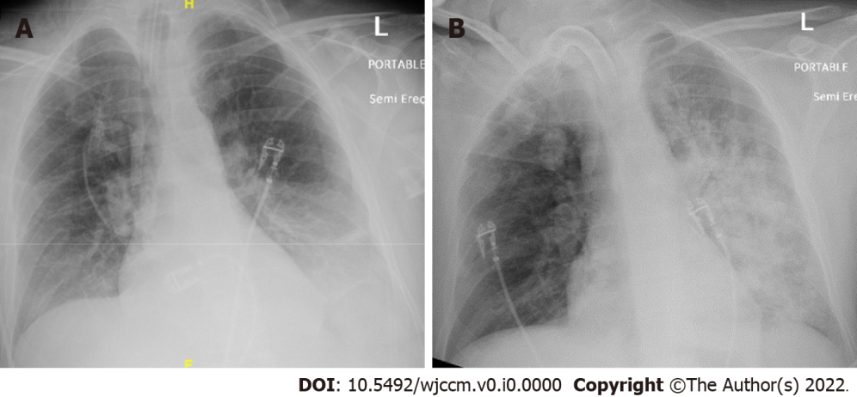
Figure 1 Chest X-ray. A: Chest X-ray on the left was obtained one day prior to cardiac arrest which shows bibasilar atelectasis; B: Chest X-ray on the right obtained following episode of cardiopulmonary arrest showing significant patchy airspace opacities occupying most of left hemithorax.

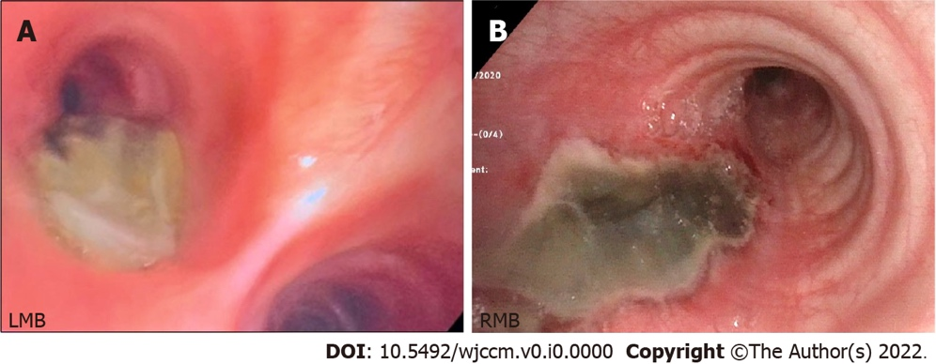
Figure 2 Flexible bronchoscopy. A: Day 1: Two-centimeter bronchoesophageal fistula (asterisk) with adjacent yellow tinged devitalized mucosa on the posterior wall of left main bronchi; B: Day 8: Further delineation of fistulous track (asterisk) with necrotic mucosa and well-defined borders. LMB: Left main bronchi; RMB: Right main bronchi.

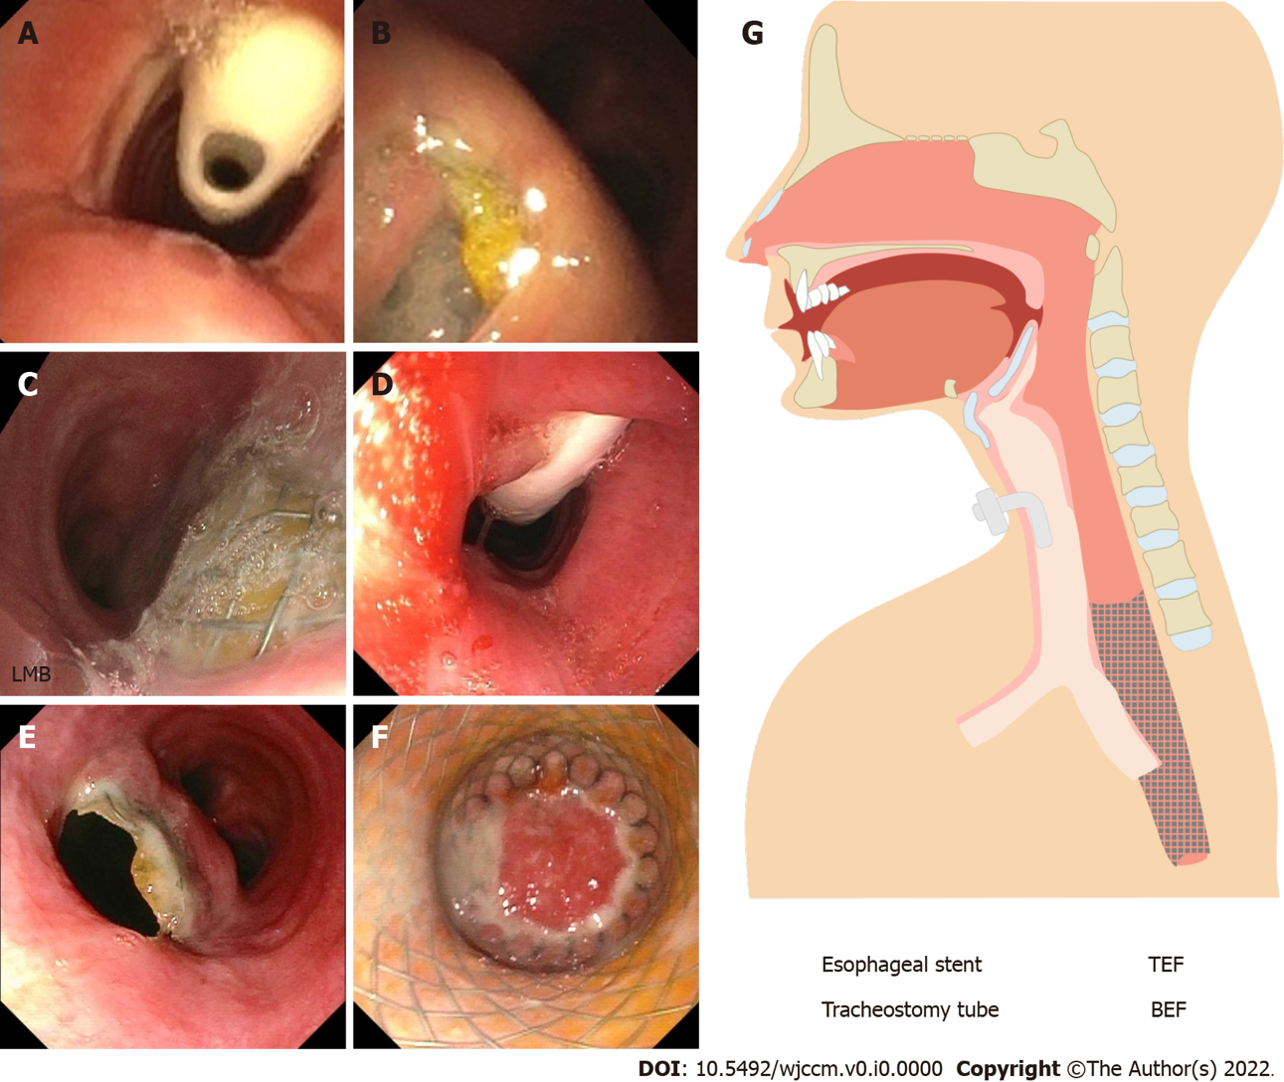
Figure 3 Flexible bronchoscopy at 17 wk. A: Visualization of tracheostomy tube (asterisk) shortly after bronchoscope is advanced through vocal cords; B: Esophageal lumen visualized at the level of mid-trachea confirming TEF. Flexible Bronchoscopy at 7 wk; C: Protruding esophageal stent through left main bronchi BEF. Esophagoduodenoscopy at 28 wk; D: Visualization of tracheostomy tube (asterisk) through a combined lumen of the esophagus and trachea at 14 cm; E: Proximal end of the esophageal stent located below the end of the tracheotomy at 23cm with a double lumen track, esophagus at 8 o’clock and trachea at 2 o’clock; F: Complete obliteration of esophageal stent due to in-growth of tissue at 35 cm (asterisk);G: Schematic diagram. LMB: Left main bronchi; TEF: Tracheoesophageal fistula; BEF: Bronchoesophageal fistula.

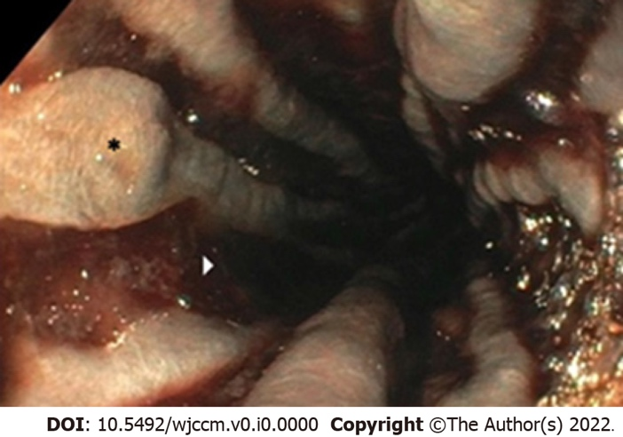
Figure 4 Esophagoduodenoscopy. Extensive esophageal esophagitis with devitalized mucosa (asterisk) and deep brownish black ulcers (arrowhead).
Table 1 Timeline of major events in chronological order
Event | Time
Admission to hospital/ICU | Day 0
EGD #1 | Day 0
Bronchoscopy #1 | Day 1
Bronchoscopy #2 | Day 8
Cardiac arrest | Day 18
Esophageal stent placement with EGD #2 | Day 22
Bronchoscopy #3 | 7 wk
Hospital discharge | 16 wk
Bronchoscopy #4 | 17 wk
EGD #3 | 28 wk
ICU: Intensive care unit; EGD: Esophagoduodenoscopy.

