Name of Journal: World Journal of Clinical Oncology
ESPS Manuscript NO: 26628
Manuscript Type: Minireviews

Granulocyte colony-stimulating factor-producing hepatocellular carcinoma with abrupt changes

Nagata H et al. Granulocyte colony-stimulating factor-producing hepatocellular carcinoma

Hiroaki Nagata, Shuhei Komatsu, Wataru Takaki, Tokunari Okayama, Yasunori Sawabe, Michiaki Ishii, Mitsuo Kishimoto, Eigo Otsuji, Hiroshi Konosu

Hiroaki Nagata, Wataru Takaki, Yasunori Sawabe, Hiroshi Konosu, Department of Surgery, Ayabe City Hospital, Kyoto 623-0011, Japan

Michiaki Ishii, Department of Gastroenterology, Ayabe City Hospital, Kyoto 623-0011, Japan

Hiroaki Nagata, Shuhei Komatsu, Eigo Otsuji, Division of Digestive Surgery, Department of Surgery, Kyoto Prefectural University of Medicine, Kyoto 602-0855, Japan

Mitsuo Kishimoto, Division of Digestive Surgery, Department of Surgical Pathology, Kyoto Prefectural University of Medicine, Kyoto 602-0855, Japan

Author contributions: All the authors contribute to the manuscript.

Conflict-of-interest statement: There is no conflict of interest associated with any of the senior author or other coauthors contributed their efforts in this manuscript.

Open-Access: This article is an open-access article which was selected by an in-house editor and fully peer-reviewed by external reviewers. It is distributed in accordance with the Creative Commons Attribution Non Commercial (CC BY-NC 4.0) license, which permits others to distribute, remix, adapt, build upon this work non-commercially, and license their derivative works on different terms, provided the original work is properly cited and the use is non-commercial. See: http://creativecommons.org/licenses/by-nc/4.0/

Manuscript source: Invited manuscript

Correspondence to: Shuhei Komatsu, MD, Division of Digestive Surgery, Department of Surgery, Kyoto Prefectural University of Medicine, 465 Kawaramachihirokoji, Kamigyo-ku, Kyoto 602-8566, Japan. skomatsu@koto.kpu-m.ac.jp
Telephone: +81-75-2515527
Fax: +81-75-2515522

Received: April 20, 2016
Peer-review started: April 22, 2016
First decision: June 12, 2016
Revised: August 17, 2016
Accepted: August 30, 2016
Article in press:
Published online:

Abstract
Granulocyte colony-stimulating factor (G-CSF)-producing tumor is one of the rare types of cancer clinically characterized by an elevated fever and white blood cell (WBC) increment. Although G-CSF producing tumors have been reported in several types of cancer including those of the lungs, cervix and bladder, G-CSF producing hepatocellular carcinoma is extremely rare. Here, we report the case of a rapidly growing and poorly differentiated hepatocellular carcinoma producing G-CSF. The patient showed symptoms of continuous high fever, stomach pain and cough, and high serum WBC counts, C-reactive protein (CRP) and G-CSF levels were found in laboratory tests. After a radical hepatectomy, the patient completely recovered from the above symptoms and inflammatory state. The serum levels of G-CSF were reduced to normal levels after radical surgery. An immunohistochemical analysis revealed the overexpression of G-CSF in the cytoplasm of certain hepatocellular carcinoma cell (HCC). The patient’s serum WBC, CRP and G-CSF levels remained within normal levels in the six months after surgery without recurrence. This is the 9th case report of G-CSF producing hepatocellular carcinoma in English literature. We review the clinical characteristics of the G-CSF producing HCC and discuss a possible treatment strategy.

Key words: Granulocyte colony stimulating factor; Granulocyte colony-stimulating factor producing tumor; Hepatocellular carcinoma; Sarcomatous changes; Immunohistochemistry

© The Author(s) 2016. Published by Baishideng Publishing Group Inc. All rights reserved.

Core tip: Granulocyte colony-stimulating factor (G-CSF)-producing tumor is one of the rare types of cancer clinically characterized by an elevated fever and white blood cell increment. Although G-CSF producing tumors have been reported in several types of cancer including those of the lungs, cervix and bladder, G-CSF producing hepatocellular carcinoma (HCC) is extremely rare. This is the 9th case report of G-CSF producing HCC in English literature. We report our case and review reported literatures with special reference to the clinical characteristics of the G-CSF producing HCC and a possible treatment strategy.

Nagata H, Komatsu S, Takaki W, Okayama T, Sawabe Y, Ishii M, Kishimoto M, Otsuji E, Konosu H. Granulocyte colony-stimulating factor-producing hepatocellular carcinoma with abrupt changes. World J Clin Oncol 2016; In press

INTRODUCTION
Granulocyte colony-stimulating factor (G-CSF) is a naturally produced glycoprotein that is synthesized by stromal cells in bone marrow. G-CSF stimulates progenitor cells to differentiate and enhances the functions of neutrophils. The G-CSF producing tumor is characterized by leukocytosis without infection and high serum G-CSF levels. In 1977, the G-CSF producing tumor was first reported in lung cancer^{[1]}. After that, several G-CSF producing tumor cases were reported for cancers of the bladder^{[2,3]}, lung^{[4]}, thyroid^{[5]}, gallbladder^{[6]} and uterine cervix^{[7]}. Among them, the G-CSF producing hepatocellular carcinoma (HCC) is extremely rare and is generally reported as having a poor prognosis because of its dramatic tumor progression. Liver cancer including hepatocellular carcinoma (HCC) is the second cause of cancer death worldwide^{[8]}. It is common that HCC develops in the patient with chronic hepatitis caused by viruses, especially hepatitis B virus (HBV). The development of the HCC is driven by the genetic factor, epigenetic factor, environmental factor and viruses. Although, the novel factors such as hematopoietic stem cells and non-coding RNA are reported in the recent researches to be involved in hepatocarcinogenesis^{[9-11]} , the mechanisms of the carcinogenesis of G-CSF producing HCC remains unclear.
We report a G-CSF producing HCC that was radically resected and diagnosed by pathological and serological findings. We review previous reports regarding the clinical behaviors of the G-CSF producing HCC, including our case.

CASE REPORT
A 79-year-old man was admitted to our hospital with a continuous fever, cough and high degree of serum C-reactive protein (CRP). A physical examination revealed a hard, fixed mass palpable on the right upper quadrant of the abdomen. Laboratory tests showed an increased degree of serum CRP (17.3 mg/dL) and white blood cell (WBC) counts, and a worsening of anemia compared with the patient’s initial examination. In addition, a higher level of serum G-CSF (42 pg/mL) was detected. A preoperative computed tomography (CT) examination revealed an irregular mass in segment IV of the liver, approximately 60 mm in diameter with peripheral enhancement (Figure 1A). Tumor markers, such as the absence of protein-induced vitamin K or antagonist (PIVKA)-II level, α-foetoprotein (AFP) level, carcinoembryonic antigen (CEA) level and carbohydrate antigen 19-9 (CA19-9) levels, were within the normal range. Further evaluations of the liver mass were performed.
Detailed CT examination during arterial portography (CTAP), computed tomography during hepatic arteriography (CTHA), magnetic resonance cholangiopancreatography (MRCP), and gadoxetic acid-enhanced MRI (Gd-EOB-MRI) revealed that the liver mass was a poorly differentiated carcinoma, rather than a liver abscess. The tumor partially occupied segment IV of the liver and protruded toward the abdominal cavity (Figure 1A and B).
Four days after admission, the patient continued to have an intermittent fever (Figure 2A) and the tumor size became drastically enlarged within a short period; therefore, we decided to perform surgery. The surgery was a complete resection with a segment IV partial hepatectomy. There was ascites around the tumor in the abdominal cavity, but a cytological analysis revealed that was no malignant cells in it.
After the radical hepatectomy, the patient’s fever gradually dropped to a normal temperature and the other symptoms, such as cough and abdominal pain, ceased (Figure 2A). The laboratory data, such as WBC count and neutrophil percentage returned to the normal range by postoperative day 5 (from 13020/μl to 6180/μl, 88.3% to 68.5%, respectively). The serum CRP level dropped gradually from 28.7 mg/dl to 1.5 mg/dl by postoperative day 12. The patient had an uneventful postoperative recovery and was discharged on postoperative day 12. Afterward, serum WBC counts, CRP and G-CSF returned to normal levels (Figure 2B and C).
The pathological findings of the resected specimen showed that the tumor size was 12.0 cm × 10.0 cm × 10.0 cm, and the gallbladder and partial greater curvature were also resected with the main tumor (Figure 1C). The cut surface of the tumor was white with an irregular margin and vast necrotic tissue was observed inside the tumor (Figure 1D). Microscopic findings revealed that the tumor was mainly composed of poorly differentiated hepatocellular carcinoma (Figure 3A) and partially sarcomatous spindle-shaped malignant cells (Figure 3B) were detected. Moreover, a drastic neutrophil infiltration within the hepatocellular carcinoma cells was noted (Figure 3A and B). Immunohistochemistry showed the ordinary HCC cells to be positive for CAM5.2 (Figure 3C) and the sarcomatous area was positive for vimentin. The HCC cells were positive for G-CSF. These findings were supportive for the diagnosis of G-CSF producing HCC (Figure 3).

MINIREVIEW
G-CSF
G-CSF is a glycoprotein (19.6 kDa) that stimulates cell proliferation and differentiation of precursor cells in the bone marrow. G-CSF is major extracellular regulator of hemopoiesis and the immune system, first named in the 1980s^{[12,13]}. It not only changes mature precursor cells into fully differentiated neutrophils, but also enhances their functional activity^{[14]}. These mechanisms have been exploited to produce a drug to increase neutrophils in patients with chemotherapy-induced neutropenia. Granulocyte colony-stimulating factor receptor (G-CSF R) is also member of the cytokine receptor family and functions in some cell surface adhesion or recognition process. This protein is essential for granulocytic maturation and plays a crucial role in the proliferation, differentiation and survival of cells along the neutrophilic lineage. Furthermore, there are reports on the relationship between G-CSF and cancers^{[15-17]}.

Clinical behavior of G-CSF producing tumor
Some cancers have been reported to produce certain humoral factors including cytokines, such as G-CSF, granulocyte macrophage colony-stimulating factor (GM-CSF), erythropoietin or parathyroid hormone, which cause paraneoplastic syndrome^{[18-21]}. Paraneoplastic syndrome presents as various clinical disorders, such as anemia, hypercalcemia, erythrocytosis, granulocytosis and thrombocytosis, and is often reported in lung cancer^{[20,22]}. Asano et al^{[1]} first reported G-CSF producing lung cancer in 1997. After this report, various cases were reported with G-CSF producing tumors in lung, bladder, sarcoma, cervical and gallbladder cancers^{[3,6,7,20,22]}. The G-CSF producing tumor has been described as having (1) a drastic WBC increase; (2) an elevation of G-CSF activity; (3) WBC decrease after tumor resection and (4) evidence of G-CSF production in the tumor tissue^{[1]}. In our case, high WBC counts and fever elevation were present without a bacterial infection preoperatively. Also, a contrast enhanced CT image revealed a non-typical and poorly differentiated HCC tumor. After radical hepatectomy, the serum WBC level and G-CSF activity were decreased to normal levels. Finally, immunohistochemical staining showed G-CSF production in the tissue inside the tumor. These findings fit the above definition and strongly suggested that our case was a G-CSF producing HCC^{[27-31]}.

Previous reports of G-CSF producing hepatocellular carcinoma, including our case
G-CSF producing HCC is extremely rare and only eight cases have been documented in the English literature (Table 1). G-CSF producing tumors, including HCC, generally grow rapidly and have a poor prognosis. G-CSF is reported to be linked to tumor cell growth and progression^{[31,32]}. Also, there might be a relationship between the secretion of G-CSF and the degree of cell differentiation^{[23]}. Wang et al^{[33]} compared the production of G-CSF between well- and poorly differentiated HCC using cell lines and concluded that only poorly differentiated HCC tends to produce G-CSF. As shown in Table 1, of nine reports including our case, six cases 76% (6/9) were pathologically diagnosed as poorly differentiated HCCs and two cases were moderate to poorly differentiated HCCs.
Tachibana et al^{[3]} reported that the G-CSF production and G-CSF receptor expression exhibited by cancer cells both play crucial roles in mediating the malignant progression of nonhematopoietic cancer cells. Baba et al^{[34]} and Segawa et al^{[35]} both reported G-CSF as an autocrine growth factor considered to be necessary for tumor proliferation and metastasis^{[3,7,34,36]}. As these reports demonstrate, the prognosis of patients with G-CSF producing HCCs is indeed very poor^{[26-28]}. Specifically, in more than one-half of the cases, the patients died within approximately within six months after diagnosis. Therefore, some authors have suggested that surgical resection is not an effective strategy considering the poor outcome of this G-CSF producing HCC^{[26]} because most patients were diagnosed in a far-advanced stage. Whereas, our case was diagnosed as a curatively resectable stage, such as a stage-II (T2N0M0 UICC 7th), and the preoperative serum WBC counts and G-CSF levels were relatively lower than in previous reports (Table 1). Therefore, in our case, radical tumor resection was effective.
The serum levels of G-CSF are positively correlated with WBC counts^{[20,37]}. Also, in our case, serum WBC counts, CRP and G-CSF levels were shifting in parallel during the treatment course and the trend seemed to be correlated with the growth of the liver tumor (Figure 2B and C). To date, these marker levels are being maintained at normal levels and will continue to be monitored, and the patient has had no recurrence in the six months following surgery.

G-CSF producing HCC as one of the differential diagnosis of fever of unknown origin (FUO)
FUO remains to be of considerable clinical importance. Classical FUO was defined by Petersdorf and Beeson in 1961^{[38]}. In recent study about FUO, Bleeker-Rovers et al^{[39]} showed that infection was the cause of FUO in 16% of the patients, cancer in 7% and non-infectious inflammatory diseases in 22%. Their report showed that in over 50% of the cases, the cause of fever was not found. Not only hematological malignancies, but also varieties of solid neoplastic diseases have been reported as occasionally associated with FUO without any associated infection^{[40]}. Therefore, more physicians should include G-CSF producing tumors in the differential diagnosis of FUO.

CONCLUSION
Although G-CSF producing tumors are extremely rare, clinicians should consider this diagnosis for a patient with a continuous high fever of unknown origin and leukocytosis without evidence of infection. Early laboratory and imaging examinations should also be performed for an early diagnosis, effective treatment and improved prognosis. Radical resection in the early stage of a G-CSF producing HCC might provide a more favorable outcome. Nevertheless, further studies and the accumulation of clinical cases are required to establish appropriate treatment strategies for patients with G-CSF producing HCCs.

ACKNOWLEDGMENTS
The authors thank Tadanori Yamaguchi (Chief Cytotechnologist, Ayabe City Hospital) for the technical assistance.

REFERENCES
1 Asano S, Urabe A, Okabe T, Sato N, Kondo Y. Demonstration of granulopoietic factor(s) in the plasma of nude mice transplanted with a human lung cancer and in the tumor tissue. Blood 1977; 49: 845-852 [PMID: 300638]
2 Ito N, Matsuda T, Kakehi Y, Takeuchi E, Takahashi T, Yoshida O. Bladder cancer producing granulocyte colony-stimulating factor. N Engl J Med 1990; 323: 1709-1710 [PMID: 1700300 DOI: 10.1056/NEJM199012133232418]
3 Tachibana M, Miyakawa A, Tazaki H, Nakamura K, Kubo A, Hata J, Nishi T, Amano Y. Autocrine growth of transitional cell carcinoma of the bladder induced by granulocyte-colony stimulating factor. Cancer Res 1995; 55: 3438-3443 [PMID: 7542171]
4 Kaira K, Ishizuka T, Tanaka H, Tanaka Y, Yanagitani N, Sunaga N, Hisada T, Ishizuka T, Mori M. Lung cancer producing granulocyte colony-stimulating factor and rapid spreading to peritoneal cavity. J Thorac Oncol 2008; 3: 1054-1055 [PMID: 18758311 DOI: 10.1097/JTO.0b013e3181834f7b]
5 Iwasa K, Noguchi M, Mori K, Ohta N, Miyazaki I, Nonomura A, Mizukami Y, Nakamura S, Michigishi T. Anaplastic thyroid carcinoma producing the granulocyte colony stimulating factor (G-CSF): report of a case. Surg Today 1995; 25: 158-160 [PMID: 7539648 DOI: 10.1007/BF00311090]
6 Furihata M, Sonobe H, Ohtsuki Y, Enzan H, Tokuoka H, Nakanuma Y. An immunohistochemical study on a case of granulocyte-colony stimulating factor-producing gall-bladder carcinoma. Pathol Int 1999; 49: 1010-1013 [PMID: 10594849 DOI: 10.1046/j.1440-1827.1999.00970.x]
7 Kyo S, Kanaya T, Takakura M, Inoue M. A case of cervical cancer with aggressive tumor growth: possible autocrine growth stimulation by G-CSF and Il-6. Gynecol Oncol 2000; 78: 383-387 [PMID: 10985899 DOI: 10.1006/gyno.2000.5904]
8 Cancer IARC. Globocan. Estimated cancer incidence, mortality and prevalence worldwide. World Health Organization, 2012: 9
9 Facciorusso A, Antonino M, Del Prete V, Neve V, Scavo MP, Barone M. Are hematopoietic stem cells involved in hepatocarcinogenesis? Hepatobiliary Surg Nutr 2014; 3: 199-206 [PMID: 25202697]
10 Levrero M, Zucman-Rossi J. Mechanisms of HBV-induced hepatocellular carcinoma. J Hepatol 2016; 64: S84-S101 [PMID: 27084040 DOI: 10.1016/j.jhep.2016.02.021]
11 Facciorusso A, Villani R, Bellanti F, Mitarotonda D, Vendemiale G, Serviddio G. Mitochondrial Signaling and Hepatocellular Carcinoma: Molecular Mechanisms and Therapeutic Implications. Curr Pharm Des 2016; 22: 2689-2696 [PMID: 26861645 DOI: 10.2174/1381612822666160209153624]
12 Burgess AW, Metcalf D. The nature and action of granulocyte-macrophage colony stimulating factors. Blood 1980; 56: 947-958 [PMID: 7002232]
13 Nicola NA, Metcalf D, Matsumoto M, Johnson GR. Purification of a factor inducing differentiation in murine myelomonocytic leukemia cells. Identification as granulocyte colony-stimulating factor. J Biol Chem 1983; 258: 9017-9023 [PMID: 6190815]
14 Lieschke GJ, Burgess AW. Granulocyte colony-stimulating factor and granulocyte-macrophage colony-stimulating factor (1). N Engl J Med 1992; 327: 28-35 [PMID: 1375975 DOI: 10.1056/NEJM199207023270106]
15 Beekman R, Touw IP. G-CSF and its receptor in myeloid malignancy. Blood 2010; 115: 5131-5136 [PMID: 20237318 DOI: 10.1182/blood-2010-01-234120]
16 Demetri GD, Griffin JD. Granulocyte colony-stimulating factor and its receptor. Blood 1991; 78: 2791-2808 [PMID: 1720034]
17 Avalos BR. Molecular analysis of the granulocyte colony-stimulating factor receptor. Blood 1996; 88: 761-777 [PMID: 8704229]
18 Ueno M, Seferynska I, Beckman B, Brookins J, Nakashima J, Fisher JW. Enhanced erythropoietin secretion in hepatoblastoma cells in response to hypoxia. Am J Physiol 1989; 257: C743-C749 [PMID: 2552819]
19 Tani K, Ozawa K, Ogura H, Shimane M, Shirafuji N, Tsuruta T, Yokota J, Nagata S, Ueyama Y, Takaku F. Expression of granulocyte and granulocyte-macrophage colony-stimulating factors by human non-hematopoietic tumor cells. Growth Factors 1990; 3: 325-331 [PMID: 1701653 DOI: 10.3109/08977199009003675]
20 Shimasaki AK, Hirata K, Kawamura T, Kunibe N, Hirai K, Yoshimoto K, Hashimoto H, Nakahara Y, Mochizuki Y. The level of serum granulocyte colony-stimulating factor in cancer patients with leukocytosis. Intern Med 1992; 31: 861-865 [PMID: 1280490 DOI: 10.2169/internalmedicine.31.861]
21 Asahi Y, Kubonishi I, Imamura J, Kamioka M, Matsushita H, Furihata M, Ohtsuki Y, Miyoshi I. Establishment of a clonal cell line producing granulocyte colony-stimulating factor and parathyroid hormone-related protein from a lung cancer patient with leukocytosis and hypercalcemia. Jpn J Cancer Res 1996; 87: 451-458 [PMID: 8641981 DOI: 10.1111/j.1349-7006.1996.tb00245.x]
22 Shijubo N, Inoue Y, Hirasawa M, Igarashi T, Mori M, Matsuura A, Uede T, Suzuki A. Granulocyte colony-stimulating factor-producing large cell undifferentiated carcinoma of the lung. Intern Med 1992; 31: 277-280 [PMID: 1376180 DOI: 10.2169/internalmedicine.31.277]
23 Yamamoto S, Takashima S, Ogawa H, Kuroda T, Yamamoto M, Takeda A, Nakmaura H. Granulocyte-colony-stimulating-factor-producing hepatocellular carcinoma. J Gastroenterol 1999; 34: 640-644 [PMID: 10535496 DOI: 10.1007/s005350050387]
24 Amano H, Itamoto T, Emoto K, Hino H, Asahara T, Shimamoto F. Granulocyte colony-stimulating factor-producing combined hepatocellular/cholangiocellular carcinoma with sarcomatous change. J Gastroenterol 2005; 40: 1158-1159 [PMID: 16378181 DOI: 10.1007/s00535-005-1715-8]
25 Aita K, Seki K. Carcinosarcoma of the liver producing granulocyte-colony stimulating factor. Pathol Int 2006; 56: 413-419 [PMID: 16792552 DOI: 10.1111/j.1440-1827.2006.01979.x]
26 Araki K, Kishihara F, Takahashi K, Matsumata T, Shimura T, Suehiro T, Kuwano H. Hepatocellular carcinoma producing a granulocyte colony-stimulating factor: report of a resected case with a literature review. Liver Int 2007; 27: 716-721 [PMID: 17498259 DOI: 10.1111/j.1478-3231.2007.01468.x]
27 Joshita S, Nakazawa K, Koike S, Kamijo A, Matsubayashi K, Miyabayashi H, Furuta K, Kitano K, Yoshizawa K, Tanaka E. A case of granulocyte-colony stimulating factor-producing hepatocellular carcinoma confirmed by immunohistochemistry. J Korean Med Sci 2010; 25: 476-480 [PMID: 20191051 DOI: 10.3346/jkms.2010.25.3.476]
28 Kohno M, Shirabe K, Mano Y, Muto J, Motomura T, Takeishi K, Toshima T, Yoshimatsu M, Ijichi H, Harada N, Aishima S, Uchiyama H, Yoshizumi T, Taketomi A, Maehara Y. Granulocyte colony-stimulating-factor-producing hepatocellular carcinoma with extensive sarcomatous changes: report of a case. Surg Today 2013; 43: 439-445 [PMID: 22638568 DOI: 10.1007/s00595-012-0202-0]
29 Snyder RA, Liu E, Merchant NB. Granulocyte colony stimulating factor secreting hepatocellular carcinoma. Am Surg 2012; 78: 821-822 [PMID: 22748547]
30 Ito T, Okubo K, Shiomi M, Narita M, Morita K, Takeuchi A, Kanazawa H, Shimizu J, Takeyama T, Hashizume K, Shibahara H, Nishimura D, Katada N, Katano Y, Goto H. [A case of successful treatment of granulocyte colony-stimulating factor producing hepatocellular carcinoma accompanying type B hepatitis with tegafur-uracil]. Nihon Shokakibyo Gakkai Zasshi 2012; 109: 2088-2096 [PMID: 23221058]
31 Berdel WE, Danhauser-Riedl S, Steinhauser G, Winton EF. Various human hematopoietic growth factors (interleukin-3, GM-CSF, G-CSF) stimulate clonal growth of nonhematopoietic tumor cells. Blood 1989; 73: 80-83 [PMID: 2462944]
32 Noda I, Fujieda S, Ohtsubo T, Tsuzuki H, Tanaka N, Sunaga H, Saito H. Granulocyte-colony-stimulating factor enhances invasive potential of human head-and-neck-carcinoma cell lines. Int J Cancer 1999; 80: 78-84 [PMID: 9935235 DOI: 10.1002/(SICI)1097-0215(19990105)80: 1<78: : AID-IJC16>3.0.CO; 2-S]
33 Wang SY, Chen LY, Tsai TF, Su TS, Choo KB, Ho CK. Constitutive production of colony-stimulating factors by human hepatoma cell lines: possible correlation with cell differentiation. Exp Hematol 1996; 24: 437-444 [PMID: 8599973]
34 Baba M, Hasegawa H, Nakayabu M, Shimizu N, Suzuki S, Kamada N, Tani K. Establishment and characteristics of a gastric cancer cell line (HuGC-OOHIRA) producing high levels of G-CSF, GM-CSF, and IL-6: the presence of autocrine growth control by G-CSF. Am J Hematol 1995; 49: 207-215 [PMID: 7541602 DOI: 10.1002/ajh.2830490306]
35 Segawa K, Ueno Y, Kataoka T. In vivo tumor growth enhancement by granulocyte colony-stimulating factor. Jpn J Cancer Res 1991; 82: 440-447 [PMID: 1710615 DOI: 10.1016/S0002-9440(10)65472-7]
36 Mueller MM, Herold-Mende CC, Riede D, Lange M, Steiner HH, Fusenig NE. Autocrine growth regulation by granulocyte colony-stimulating factor and granulocyte macrophage colony-stimulating factor in human gliomas with tumor progression. Am J Pathol 1999; 155: 1557-1567 [PMID: 10550313 DOI: 10.1016/S0002-9440(10)65472-7]
37 Nagata S, Tsuchiya M, Asano S, Kaziro Y, Yamazaki T, Yamamoto O, Hirata Y, Kubota N, Oheda M, Nomura H. Molecular cloning and expression of cDNA for human granulocyte colony-stimulating factor. Nature 1986; 319: 415-418 [PMID: 3484805 DOI: 10.1038/319415a0]
38 Petersdorf RG, Beeson PB. Fever of unexplained origin: report on 100 cases. Medicine (Baltimore) 1961; 40: 1-30 [PMID: 13734791 DOI: 10.1097/00005792-196102000-00001]
39 Bleeker-Rovers CP, Vos FJ, de Kleijn EM, Mudde AH, Dofferhoff TS, Richter C, Smilde TJ, Krabbe PF, Oyen WJ, van der Meer JW. A prospective multicenter study on fever of unknown origin: the yield of a structured diagnostic protocol. Medicine (Baltimore) 2007; 86: 26-38 [PMID: 17220753 DOI: 10.1097/MD.0b013e31802fe858]
40 Loizidou A, Aoun M, Klastersky J. Fever of unknown origin in cancer patients. Crit Rev Oncol Hematol 2016; 101: 125-130 [PMID: 26995082 DOI: 10.1016/j.critrevonc.2016.02.015]

P-Reviewer: Facciorusso A, Senousy MA, Sergi CM, Tomizawa M
S-Editor: Qiu S L-Editor: E-Editor:

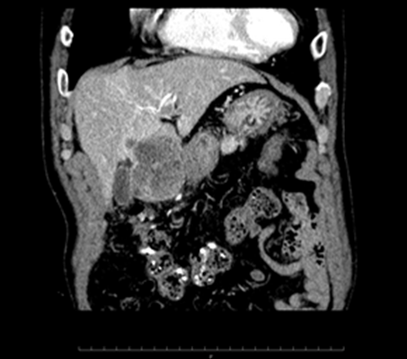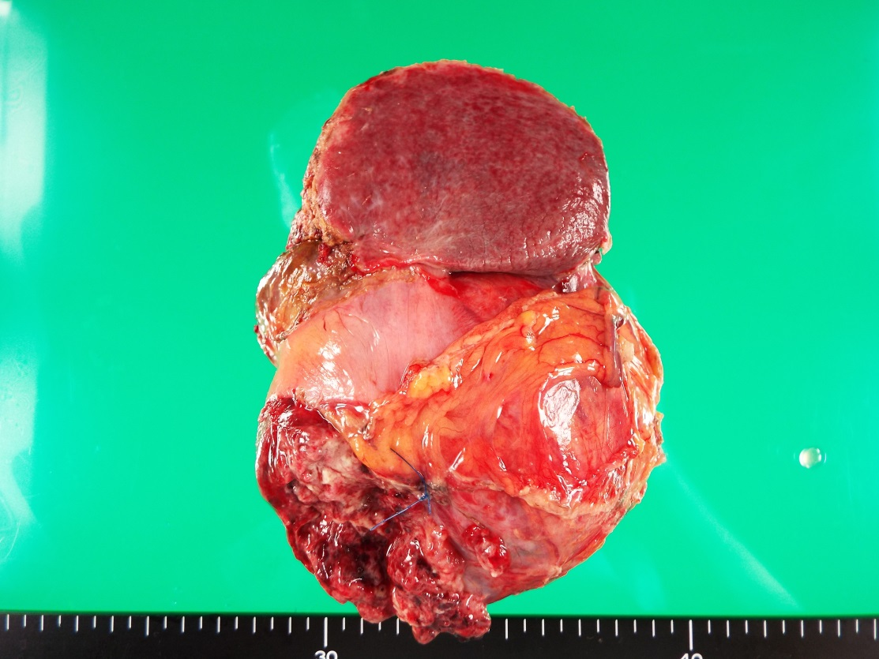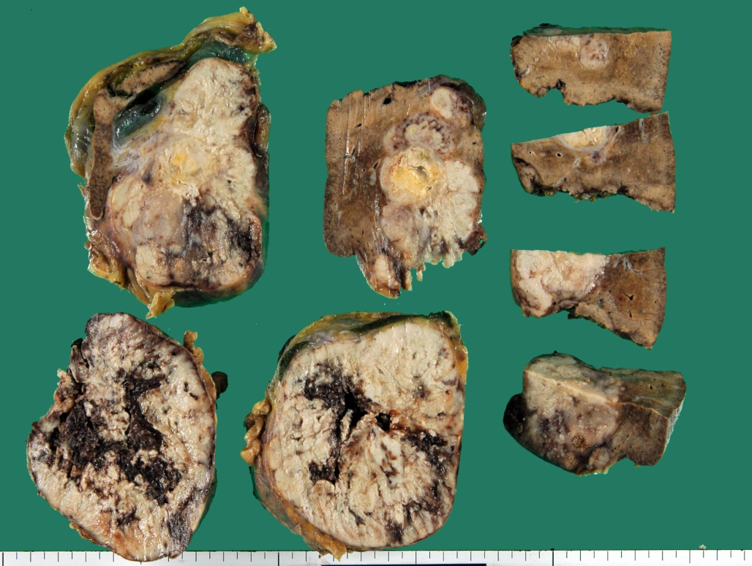
Figure 1 Imaging and macroscopic findings of Granulocyte colony-stimulating factor producing hepatocellular carcinoma. A: CT scan one month before operation showed an irregular liver mass located in segment IV, approximately 60 mm in diameter with peripheral enhancement (white arrow heads); B: T2-WI MRI one week before operation showed the rapidly growing liver mass with a 100 mm diameter (black arrow heads); C: Macroscopic examination showed a large tumor (100 × 100 mm) that protruded through segment IV of the liver to the greater omentum (white double arrow heads); D: The irregular liver tumor in segment IV showed a central necrosis (black double arrow heads).
A
B
C
D

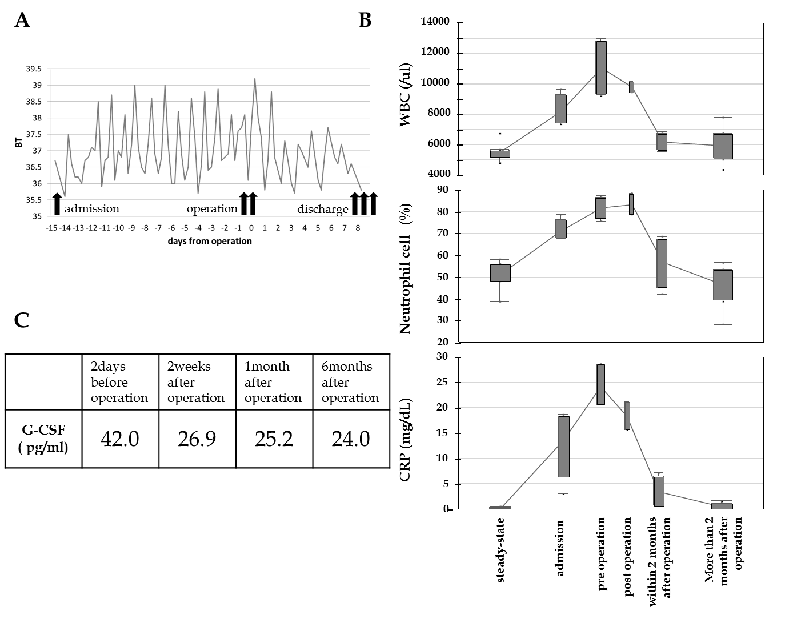
Figure 2 Physiological and laboratory changes during the treatment. A: Changes in body temperature during the treatment; B: Laboratory changes during the treatment. White blood cell count, neutrophil proportion and C-reactive protein were collected at various treatment points including “steady-state” (more than six months before admission), “before admission” (within six months of admission), “pre-operation” (from admission until operation), “post-operation” (from operation until discharge), “within two months of surgery” and “more than two months after operation”.

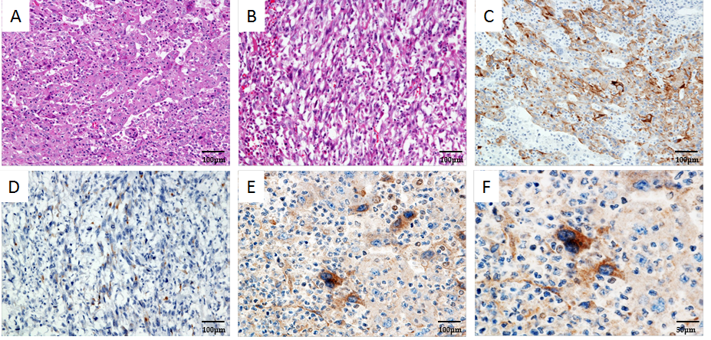
Figure 3 Histopathologic findings. Microscopic findings showed atypical poorly differentiated cells with a sheet structure (A); HCC tumor was also composed of sarcomatous spindle-shaped cells (B); in both samples, a drastic infiltration of the neutrophils was found (H and E, × 20). Immunohistochemical findings showed CAM5.2 positive in the moderately to poorly differentiated HCC lesion (C) and negative in the spindle-shaped cell lesion (D) (CAM5.2, × 20). Immunohistochemical examination showed that G-CSF was positive in the moderately to poorly differentiated HCC lesion (E, F) (G-CSF, × 20 and × 40). G-CSF: Granulocyte colony-stimulating factor; HCC: Hepatocellular carcinoma cell.

Table 1 Previous reported cases of Granulocyte colony-stimulating factor producing hepatocellular carcinoma
Case | Ref. | Year | Age | Sex | WBC¹ (/μL) | G-CSF² (pg/mL) | HCV | HBV | Pathology | Sarcomatous change | Treatment | IHC | Prognosis³
1 | Yamamoto et al^{[19]} | 1999 | 67 | M | 234000 | 251 | + | - | Poorly dif. HCC | - | TAE + Chemotherapy | + | 5 mo | Dead
2 | Amano et al^{[20]} | 2005 | 70 | M | 26400 | 308 | - | - | Poorly dif. HCC/CCC | + | Palliative surgery | + | 1 mo | Dead
3 | Aita et al^{[21]} | 2006 | 74 | M | 71700 | 286 | - | - | Poorly carcinosarcoma | + | TAE | + | 2 mo | Dead
4 | Araki et al^{[22]} | 2007 | 66 | M | 45200 | 178 | - | - | Poorly dif. HCC | + | Radical surgery + TAE | + | 4 mo | Dead
5 | Joshita et al^{[23]} | 2010 | 66 | M | 25450 | 62 | - | - | Moderately dif. HCC | - | Radial surgery | + | 4 yr | Dead
6 | Kohno et al^{[24]} | 2012 | 46 | M | 51670 | 195 | - | + | Moderately to poorly dif. HCC | + | Radical surgery + TAE + Chemotherapy | + | 7 mo | Dead
7 | Snyder et al^{[25]} | 2012 | 47 | F | 40000 | 58.2 | - | - | Poorly dif. HCC | unknown | Radical surgery | unknown | 1 mo | Dead
8 | Ito et al^{[26]} | 2012 | 37 | M | 51600 | 342 | - | + | Moderately to poorly dif. HCC | - | Radical surgery + Chemotherapy | + | 2 yr | Alive
9 | Our case | 2016 | 79 | M | 13020 | 42 | - | - | Poorly dif. HCC | + | Radical surgery | + | 6 mo | Alive
¹White blood cell count (normal value: 4000-8000/μL); ²granulocyte-colony stimulating factor (normal value: < 39 pg/mL); ³prognosis after diagnosis. HBV: Hepatitis B virus; HCV: Hepatitis C virus; WBC: White blood cell; G-CSF: Granulocyte-colony stimulating factor; HCC: Hepatocellular carcinoma; CCC: Cholangiocellular carcinoma; TAE: Transcatheter arterial embolization.

