Name of journal: World Journal of Gastroenterology
ESPS Manuscript NO: 8438
Columns: REVIEW

Predictive proteomic biomarkers for inflammatory bowel disease-associated cancer: Where are we now in era of the next generation proteomics?

Park JM et al. Proteomic biomarker for colitis-associated cancer

Jong-Min Park, Na Young Han, Young-Min Han, Mi Kyung Chung, Hoo Keun Lee, Kwang Hyun Ko, Eun-Hee Kim, Ki Baik Hahm
----------------------------------------------------------------------------------------------------------------
Jong-Min Park, Young-Min Han, Mi Kyung Chung, Eun-Hee Kim, Ki Baik Hahm, CHA Cancer Prevention Research Center, CHA University, Seoul 135-081, South Korea

Na Young Han, Hoo Keun Lee, Gachon University College of Pharmacy, Incheon 406-799, South Korea

Kwang Hyun Ko, Ki Baik Hahm, Digestive Disease Center, CHA University Bundang Medical Center, Seongnam 463-838, South Korea

Author contributions: Park JM and Han NY contributed equally to this manuscript; Park JM and Han NY performed the majority of experiments; Han YM, Chung MK and Ko KH contributed new reagents or analytic tools for this work; Lee HK, Kim EH, and Hahm KB designed the study; Park JM and Hahm KB analyzed the data and wrote the manuscript.

Supported by Grant from the Ministry of Education and Science Technology, 2010-0002052, Korea and JSPS Asian CORE Program, Japan

Correspondence to: Ki Baik Hahm, MD, PhD, Professor, CHA Cancer Prevention Research Center, CHA University, 605 Yeoksam 1-dong, Gangnam-gu, Seoul 135-081, South Korea. hahmkb@cha.ac.kr

Telephone: +82-2-34682869 Fax: +82-2-34682868
Received: December 27, 2013 Revised: March 10, 2014
Accepted: June 14, 2014

Published online:

Abstract
Recent advances in genomic medicine have allowed for the possibility of an era of tailored medicine that may eventually replace traditional “one-size-fits all” approaches to the treatment of inflammatory bowel disease (IBD). In addition to exploring the interactions between hosts and microbes referred to as the microbiome, a variety of strategies that can be tailored to an individual in the coming era of personalized medicine in the treatment of IBD are being researched and include prompt genomic screening of patients at risk of developing IBD, the utility of molecular discrimination of IBD subtypes among patients diagnosed with IBD, and the discovery of proteome biomarkers to diagnose or predict cancer risks. Host genetic factors influence the etiology of IBD, as do microbial ecosystems in the human bowel, which are not uniform, but instead represent many different microhabitats which can be influenced by diet and impact processes essential in bowel metabolism. Further advances in basic research regarding intestinal inflammation may reveal new insights into the role of the inflammatory mediators referred to as the inflammasome, the macromolecular complex of the metabolites formed by intestinal bacteria. Collectively, knowledge of the inflammasome and metagenomics bring about to the development of biomarkers for IBD that can be imply into control in order to targeting specific pathogenic mechanisms that is able to alter the spontaneous progress of IBD. In this review article, our recent results regarding the discovery of potential proteomic biomarkers using a label-free quantification technique will be introduced and on-going projects contributing to either the discrimination of IBD subtypes or to the prediction of cancer risks will be accompanied by updated information from IBD biomarker research.

© 2014 Baishideng Publishing Group Inc. All rights reserved.

Key words: Inflammatory bowel disease; Biomarker; Proteomics; Tailored medicine; Colitic cancer

Core tip: Our recent achievements in discovering biomarkers to predict cancer risk are introduced. Ultimately, models based on combinations of genotype and gene expression data referenced with clinical, biochemical, and serological data may permit the development of tools for individualized risk stratification and efficient treatment selection as well as complete rescue from complications including colitis-associated cancer in the near future.

Park JM, Han NY, Han YM, Chung MK, Lee HK, Ko KH, Kim EH, Hahm KB. Predictive proteomic biomarkers for inflammatory bowel disease-associated cancer: Where are we now in era of the next generation proteomics? World J Gastroenterol 2014; In press

INTRODUCTION
Inflammatory bowel disease (IBD) is chronic inflammatory diseases that cause to injury of the gastrointestinal (GI) tract and are accompanied by clinical characteristics of remission and relapse. The two common type of IBD are ulcerative colitis (UC) and Crohn's (CD). Although many molecular methods for the investigation of protein and gene sequences have contributed to diagnostic methodologies, the diagnosis of IBD is primarily based on clinical, endoscopic, radiologic, and characteristic histologic criteria. Unfortunately, there has been little to no change in this traditional approach to diagnosis despite modern advances in genomics and proteomics. However, progress in treatment strategies involving the incorporation of marketed biologics and molecular targeted therapeutics has lead to the development of the beneficial concept of “deep remission” or “mucosal healing” in the treatment of IBD^{[1,2]}. Furthermore, there are two major of the diagnostic methods including the advance of more complicated endoscopic and non-invasive imaging methods. These techniques used to improve quality of life (QOL) of patient, predict complications, and contribute to prevention or surveillance of cancer associated with IBD such as colitis-associated cancer (CAC)^{[3]}.
Recent developments of the molecular pathogenesis of IBD have highlighted three aspects. First, IBD is caused by complex disorders influenced by susceptibility genes and is characterized by disturbed epithelial barrier function and abnormal innate and adaptive immunity. Second, the compositions of gut microflora were changed or disorganized of epithelial barrier function cause to response from the immune system. Thirdly, a murine model has been very helpful in unraveling the pathogenesis/mucosal immunopathology of IBD^{[4]} by suggesting that the abnormal immune reaction to normal microbiota result from dysregulation of the mucosal immune system^{[5]}. For example, the composition of microbe in the gastrointestinal tract may impair cause to lifestyle in developed countries and the infection of pathogen with immune system in the gastrointestinal tract is a significant function in modulation of immune system. These data may explain why developing and some Asian countries are confronting steep increases in the incidence of IBD. Developments in gene-sequencing technologies such as next generation sequencing, as well as the the several of bioinformatic tools led to discover of novel insights of microbe balance in the human gastrointestinal tract and the effect of microbe on human physiology and pathology^{[6]}.
Additional innovative technologies such as mass spectrometry (MS)-based proteomics, also referred to as next generation proteomics, have allowed for the discovery of new classes of proteomic biomarkers that can be used to explore the accurate and comprehensive molecular characterization of IBD genes and proteomes. These advances are expected to lead to more reliable identification of IBD diagnostic- or progression-specific targets and enable molecular diagnosis as well as provide guidance regarding the selection of treatment options and the risk of cancer development in cases with longstanding remission and relapse^{[7]}. A more robust molecular definition of IBD subtypes is likely to be based on specific molecular pathways that determine not only disease susceptibility, but also disease characteristics such as location, natural history, and therapeutic response. Furthermore, such advances could be applicable in defining “deep remission”, which have not been feasible with either currently used scoring systems or endoscopic evaluations. Discovering biomarkers in IBD may allow for objective measurements of disease activity and severity while also serving as prognostic indicators regarding therapeutic outcomes^{[8]}. Furthermore, the discovery of one or more biomarkers predictive of the risk of IBD-associated cancers such as CAC, combined with advanced therapeutics may lead to tremendous improvements in patient QOL in the near future.
In this review article, our recent achievements in discovering biomarkers to predict cancer risk are introduced. Ultimately, models based on combinations of genotype and gene expression data referenced with clinical, biochemical, and serological data may permit the development of tools for individualized risk stratification and efficient treatment selection as well as complete rescue from complications including CAC in the near future^{[9]}.

Molecular pathogenesis of colorectal cancer and CAC
Chronic inflammatory diseases are associated with cancer incidence and depended on their duration as well as severity of diseases. As examples, Barrett’s esophagus is relevant to esophageal cancer, chronic Helicobacter pylori-associated chronic atrophic gastritis is relevant to gastric cancer, and UC or CD are relevant to CAC. These are well-acknowledged examples that support a connection between gut inflammation and cancer. In fact, it has been reported that patients with IBD are at enhanced risk of colorectal cancer (CRC), as approximately 15% of CRC patients have related IBD etiology^{[10]}. Though general carcinogenesis is a multi-factorial progress that combines accumulation of genetic mutation, post modification, and cell-matrix reciprocal action, inflammation-prone carcinogenesis is somewhat different^{[11]}. Since the utility of biomarkers for CAC can be extended to facilitate earlier detection of dysplasia, the targeted manipulation of biomarkers may afford good chance for the advance of cancer therapies and cancer preventions and may verify effective in reducing the development of CAC with clinical interventions such as use of blocking agents or endoscopic treatments. Regarding molecular aspects, the mechanism of CAC in IBD differ from CRC which is well-known adenoma-to-carcinoma sequence while CAC appears to take place from either flat dysplastic tissue or dysplasia-associated lesions or masses^{[12]}. The major pathway of sporadic CRC and CAC compose of chromosomal instability, hypermethylation, and microsatellite instability, but CAC demonstrates of the inflamed colonic mucosa before histological changes of dysplasia or cancer. Patients with IBD show high risk to CAC following diagnosis and patients have common symptom such as coliits^{[13]}. The risk for CAC is increase in disease onset of younger patients, more extensive colitis, concomitant primary sclerosing cholangitis, and a famiry history of CRC^{[14]}. Most of cancers are no high risk related with proctitis but increased in pancolitis, thus, left-sided colitis carries an intermediate cancer risk^{[15]}. Patients with CD and UD has the same risk of CRC and the prevalence in the US is greater than 200 cases per 100000, representing a total of between 1 and 1.5 million patients with IBD. Fortunately, these incidences of CAC are lower than United States and other western countries^{[16]}. A biological background for the high risk of CRC in IBD give an one-side interpretation, patients have high levels of inflammatory mediators production may progress development of CAC. The key signaling of IBD-induced carcinogenesis is inflammation cytokines induced by mucosal and immune cells in the gut. The key molecules of inflammation, including nuclear factor kappaB (NF-κB) and cyclooxygenase-2 (COX-2), are important role to link between inflammation and cancer. Recently, other factors, such as tumor necrosis factor-α (TNF-α) and interleukin-6 (IL-6)-induced signaling, have been proven to induce cancer development in animal experiments of CAC^{[17]}. Based on these molecular carcinogeneses, we have tried to apply biologics such as infliximab to neutralize TNF-α, a proton pump inhibitor based on mechanisms including the inhibition of NF-κB as well as attenuation of oxidative stress, and aspirin/celecoxib to inhibit cancer-prone COX enzymes. As expected, all of these efforts to block inflammation-promoted carcinogenesis efficiently prevented CAC in our mouse model experiments^{[18,19]}. The recent descriptions of epigenetic alterations, in particular alterations in DNA methylation, that have been observed during inflammation and inflammation-associated carcinogenesis led us to explore nutritional interventions as a means of targeting and correcting epigenetic oncogenic abnormalities as a form of CAC prevention^{[20]}.

Biomarker for CAC prediction
Patients with long-standing UC and CD are at increased risk for developing CRC and patients with small intestinal CD have a high risk for developing small bowel adenocarcinoma. Unlike the sporadic CRC that can develop in those with IBD, CAC development is intimately associated with IBD. In those with IBD, CAC results from a process which is believed to begin with mutagenic benign inflammation developing to indeterminate, low-grade, high-grade dysplasia and eventually to carcinoma. Regarding the risk factors predisposing to carcinoma in IBD, the risk is increased depending on duration, severity of colitis, presence of sclerosing cholangitis, degree of inflammation, and family history of CRC. Evidence-based medicine advises patients with colitis should keep under surveillance colonoscopy after diagnosis at 8 to 10 years. As surveillance guidelines for early detection of CAC, the general approach of periodic endoscopic examinations and systematic random biopsies of involved mucosa is generally recommended^{[21]}. Recently, advance colonoscopic techniques including narrow band imaging, chromoendoscopy, and confocal microendoscopy, were used to identity abnormal areas, but definitely, one will be potential biomarkers highlighting these adoptions of high resolution endoscopes^{[22]}. Though medications such as aminosalicylates, folic acid, and ursodeoxycholic acid seem to be chemopreventive, potent preventive therapeutics as well as surveillance of high risk patients through the use of potential biomarkers would seem to be ideal^{[23]}.

CURRENT STATUS OF BIOLOGICAL MARKERS FOR IBD
The serologic markers of IBD are rapidly developing. However, there are two antibodies such as anti-Saccharomyces cerevisiae antibodies (ASCA) and atypical perinuclear antineutrophil cytoplasmic antibodies (P-ANCA) which is the most studied while their limited sensitivity. Thus, the relationship between serologic markers of disease pattern and phenotype may be of greater value than the use of serologic markers as diagnostic tools. As examples, Patient with CD who have various serologic makers at high titers is more serious small intestine disease, than those with low titers of antibodies^{[24]}. On the genetic level, application of the genome wide association study design in CD has provided new insights regarding to the immunopathogenesis of CD that link to genes of the innate and adaptive immune system^{[25]}. Only patient with CD was associated with gene mutation of NOD2 and ATG16L1 autophagy gene, both of genes which affect the intracellular mechanism of bacteria. In addition, genetic variation of IL-23 receptor, STAT3 and NKX2-3 genes, which were associated with CD and UC in Asian patients. Although comparative analyses of gene associations between CD and UD can disclose and unique mechanisms of immunopathogenesis of IBD, such results have limited applicability in real-world clinical settings due to ethnic, racial, and environmental differences in the samples studied. Since the formulation of the concept of proteomics, a plethora of proteomic technologies have been developed in order to study proteomes. In IBD, several studies have used proteomics in attempts to better understand the disease and discover molecules that could serve as therapeutic targets. The advance of proteomic technologies will suggest important effect on the development of new biomarkers for IBD^{[26]}. Further advances in proteomic technologies has allowed us to use label-free quantification for detecting biomarkers in various IBD patients for the first time. Results are expected to provide additional insights in to the molecular biomarkers of IBD that may be used in predicting responses to treatment^{[27]}.

Classic serological and fecal markers in IBD
Currently diagnosis and treatment of IBD from blood and stool of patient, give reliable and quantitative tools to clinicians^{[28]}. C-reactive protein (CRP) and fecal-based leukocyte markers, calprotectin (Cal) or lactoferin (Lf), can help clinicians in assessing disease activity and in distinguishing IBD from other non-inflammatory diarrhea and simple colitis. Both of serologic tests including ASCA and P-ANCA can use to know the current status and risk of IBD^{[29]}. The progression of IBD and inflammatory processes are assessed by the tests for CRP and erythrocyte sedimentation rate (ESR). In addition, clinicians may be measured levels of drug metabolites and antibodies against therapeutic agents which aim to determine why patients do not respond to treatment and to select alternative therapy. Advantages of using the fecal markers including Cal or Lf, are easy to detect and use inexpensive ELISA technique as well as their stability in feces for long time^{[30]}. However, several limitations have been associated with these classical serological and fecal markers in IBD. The advantages of ESR technique such as easy to determine, easy to available, and inexpensive, but it has several disadvantages such as a concentration that depends on age, several confounders, and the use of certain drugs^{[31]}. Several factors can be affect the CRP utility including long half life and prolonged latency period after changes in chronic IBD. Determination of fecal Cal or Lf markers is very helpful in diagnosis of chronic IBD, while, GI diseases, including chronic IBD, ischemic colitis, and non-steroidal anti-inflammatory drug-associated intestinal damage also show greater leukocyte elimination in feces^{[32]}. In spite of 80%-100% diagnostic accuracy levels, fecal markers are not specific for IBD and may be elevated in a range of organic conditions. In order to compensate for these limitations, Langhorst et al^{[33]} evaluated fecal levels of PMN-elastase (PMN-e) in addition to the aforementioned markers and concluded IBD and IBS can be discriminated by the fecal markers Cal, Lf, and PMN-e. However, these fecal markers have shown similar capacity to indicate endoscopic pathology, however, these markers have been shown more efficient to diagnose than CRP. Therefore, the combination diagnosis of fecal markers and CRP with disease-specific activity index will be very useful to advance the diagnosis ability when assessing endoscopic inflammation in UC. It should be noted that these fecal markers were proven to be very efficient in diagnosing IBD as well as in predicting impending clinical relapse in pediatric patients with IBD^{[34]}. Despite the benefits that can be derived from these serum and fecal biomarkers, there remain considerable room for improvement regarding disease prediction and prognosis assessment, as none can be applied to predict future risk of CAC development in IBD.

Proteomic biomarkers in IBD
Matrix-assisted laser desorption/ionization time-of-flight (MALDI-TOF) mass spectrometry (MS) and surface-enhanced laser desorption/ ionization (SELDI)-TOF MS, have recently become popular methods for the analysis of macromolecules of biological origin such as tissues, serum, or plasma^{[35]}. MALDI-TOF MS is used in clinical medicine to discover disease markers in combination with classic protein gel analysis (1-D) and two dimensional gel electrophoresis separation accomplished through either peptide mass fingerprinting or peptide sequence tag (2-D) analysis followed by a data base search using proteome blot analysis software^{[36]}. Using these applications, evaluation of samples by MALDI-TOF MS can give novel data regarding peptides present in high molecular mass and may therefore be valuable for assessment of potential disease markers of IBD. For example, Nanni et al^{[37]} determined serum proteins of 22 healthy subjects and 41 patients with IBD (15 CD, 26 UC) extracted with reversed-phase (C18) and subsequently performed MALDI-TOF MS . Then the results reported in the highest prognosis capability (96.9%) of identifiable protein biomarkers involved in IBD discrimination. Similarly, Liu et al^{[38]} study, serum proteins from 74 CRC samples compared with 48 healthy samples were applied SELDI-TOF MS by using ProteinChip reader. The diagnostic pattern can distinguish samples according to status of CRC from normal samples with sensitivity and specificity of 95% by independent analysis of samples. These two studies demonstrated the high potential for biomarker discovery in patients with IBD or CRC in clinical settings and further clinical validation in large patient cohorts is expected to promote the use of novel biomarkers into clinical practice^{[39]}. In addition to protein identification, difference gel electrophoresis coming 2-D electrophoresis is another method. However, isobaric tags for relative and absolute quantification (iTRAQ) and stable isotope labeling by amino acids (SILAC) are the best methods until now. Sample preparation step is important to the success or failure of such analysis and subcellular fractionation can be used to give more specific protein localization analysis than total cellular proteins^{[40-42]}. In our recent study^{[43]}, we applied advanced technologies such as iTRAQ and SILAC for label-free quantification in samples obtained from a mouse model for UC and CAC to identify potential biomarkers for cancer-prone inflammation in IBD and evaluate empirical therapeutics.

PROTEOMIC BIOMARKER DISCOVERY FOR CAC: A CLASSICAL PROTEOMIC APPROACH
Multiple chemical and biological systems including the intestinal tissue itself, its associated immune system, the gut microbiota, xenobiotics, and their metabolites meet and interact to form a tightly regulated state of tissue homeostasis. Disturbance that affect this state of homeostasis can cause IBD as well as CAC through intercalated multi-factorial mechanisms. Many strong pathological and mechanistic correlates exist between mouse models of CAC and the clinically-relevant situation in humans, allowing for the use of approaches adopting systems biology^{[44]}. Furthermore, the close proximity of colonic tumors to the myriad of intestinal microbes as well as the instrumental implication of microbiota in IBD introduces microbes as new factors capable of triggering inflammation and possibly promoting CAC, necessitating high throughput metabolomic approaches^{[45]}. Additionally, a detailed understanding of these interactions may also provide a means of preventing CAC^{[46]}. In a small study, Watanabe et al^{[47]} performed a low density array analysis of 149 genes implicated in CAC and identified 20 genes showing differential expression between UC- and non-UC-associated CAC, including cancer-related genes such as CYP27B1, runt-related transcription factor 3, sterile alpha motif domain-containing protein 1, EGF-like repeats and discoidin I-like domain 3, nucleolar protein 3, CXCL9, integrin beta2, and LYN. Colliver et al^{[48]} demonstrated that 392 transcripts showed differential expression in progression from UC to CAC. Both of dysplasia and CAC showed 224 transcripts common and it was concluded that some genes showed same modification both in dysplasia and CAC, signifying that they can be related with tumor initiation and progression. Following these studies, a host of potential biomarkers have been reported in literature including cytokeratin 7/20^{[49]}, a-methylacyl-CoA-racemase^{[50]}, transgelin, a frame shift mutation in the TGF-β type II receptor^{[51,52]}, HSP47^{[53]}, methylation of the estrogen receptor^{[54]}, association with certain HLA class II alleles^{[55]}, DNA methyltransferase-1^{[56]}, 8-nitroguanine or 8-oxo-deoxyguanine^{[57-59]}, CCL20^{[60]}, and activation-induced cytidine deaminase^{[61]}. Using our experimental animal model for colitic cancer, which was provoked with repeated bouts of UC, and additional proteomic method based on 2-D electrophoresis and MALDI-TOF MS to analyze proteins related in CAC. In detail, 38 proteins were differentially showed in CAC and healthy sample using comparative 2-D electrophoresis analysis. Through validation studies, 27 proteins which included enolase, GRP94, HSC70 prohibitin, and transgelin were identified. Among these identified proteomes, the down-regulation of transgelin protein in mouse colitic cancer was supported by western blot and immunohistochemistry. Moreover, transgelin was significantly decreased in colon tumor as compared to non-tumorous regions in human and concluded that reduction of transgelin could be a good biomarker for CAC^{[62]}.

BIOMARKER DISCOVERY FOR CAC: THE NEXT GENERATION OF PROTEOMICS
Currently, knowledge of proteomics is important and provide researches with complicated label and label-free technique. This next generation of proteomics may provide effective perspectives in the diagnosis and treatment of gastrointestinal disease and allow for translation of proteomics from the bench to the bedside. Currently, proteomic studies focus not only identification of proteins in sample but also quantification of them. Various protein expression profiles are importantly examined because it gives useful information, especially in clinical proteomics, involving molecular targets related to specific diseases. The technology for proteomics study is continuously developing, and both of methods have their several advantages. Currently, label-free and isotope-label techniques are used to study quantitative of protein. Label-free approach with spectral and signal quantitation for identified amino acids provides accurate relative protein expression data and is easy way to determine quantitative information. However, these strategies have errors from variation in protein preparation that may be reduced when various stable isotopes are inserted in the specimens to make protein isotopomers which have different spectrum according to their different masses. Therefore, several metabolic labeling strategies that apply stable isotopes to minimize error have been improved recently and have been applied in animal models.

Biomarkers to predict CAC risk discovered via label-free quantification analyses A comparative label-free quantification analysis was conducted in 8 patients with UC, 8 patients with CD, and 8 patients with irritable bowel syndrome (IBS). Colonic tissue biopsies were obtained during colonoscopy after written consent and stored in deep freeze until the assay. Using an Agilent HPLC-Chip 6520 Q-TOF MS system and a label-free quantitative technique (IDEAL-Q v1.0.6.3), signal pathway analysis regarding carcinogenesis was conducted in order to discover potential biomarkers in CAC (Figure 1). The analysis was conducted according to the degree of intestinal inflammation, type of IBD, and extent of inflammation. To compare against the analysis from IBS samples, the proteomes implying CAC risk were isolated (Figure 2A and 2B). As seen in Figure 2A, 22 significant proteomes were found to be potential biomarkers predicting CAC risk in patients with UC and Figure 2B shows the 19 proteomes found to be potential biomarkers for CAC risk in patients with CD. Further analysis yielded 4 important proteome biomarkers including proteoglycan 2 (PRG2), S100A6 (calcyclin), ribosomal protein L18 (RPL18), UDP-glucose dehydrogenase (UGDH) as potential target proteomes and predictive biomarkers for CAC risk in IBD (Figure 3). PRG is a major component of the animal extracellular matrix and has been shown to be involved in the differentiation process across the epithelial-mesenchymal axis. It is one of potential biomarker inferred principally through their ability to bind growth factors and modulate their downstream signaling since malignant tumors have their individual characteristic PRG profiles closely associated with their differentiation and biological behavior. PRG2 has further been implicated as a biomarker for neuropathic pain attributable to advanced pancreatic cancer^{[63]}, animal model of CAC^{[27]}, inflammation related gene of several cancers including prostate, lung, and CRC^{[64]}, pancreatic cancer^{[65]}. S100 calcium binding protein A6 (S100A6), an S100 calcium-binding protein whose expression is up-regulated in proliferating and differentiating cells^{[66]}, has been reported to be a possible biomarker for hepatocellular carcinoma^{[67,68]}, pancreatic cancer^{[69]}, acute lymphoblastic leukemia^{[70]}, CRC^{[71]}, and breast cancer^{[72]}. RPL18 as gene encoding ribosomal protein, especially 60S, expressed in stem cell factor^{[73]}, adipogenesis^{[74]}, and UGDH as biomarker for cancer metabolism. The oxidation of UDP-glucose is catalyzed by UDP-glucose dehydrogenase (UGDH) to generate UDP-glucuronic acid (UDP-GlcA), a precursor of glycosaminoglycans (GAGs). Wang et al^{[75]} showed decreases in the expression of UGDH, UDP-GlcA and GAG expression after treated a UGDH-siRNA to HCT-8 colon cancer cells and concluded that UGDH can be a new target for CRC clinical treatment^{[76]}. Additionally, UGDH has been identified as a potential biomarker for prostate cancer^{[77,78]}, hepatocellular carcinoma^{[79]}, and breast cancer^{[80]}.

Biomarkers to predict CAC risk discovered via label-based protein quantification analyses
Proteomic techniques with blood and biopsy provide reliable and accurate tools which leading to support clinicians for diagnosis and treatment of IBD. For example, clinically meaningful biomarkers may be used in the differential diagnosis of CD and UC or as predictors of treatment responses. Tandem mass spectrometry (MS/MS) is mainly used proteomic analysis. But, various workflows are possible for peptide analysis prior to MS/MS as well as bioinformatics to identify peptides, for which 2-D electrophoresis and following MS, liquid chromatography-MS, difference gel electrophoresis subsequent 2-D electrophoresis, and iTRAQ are under development. In our previous publication^{[43]}, the present status and perspectives regarding these developed proteomic methods were showed, with descriptions of examples of new biomarkers for the diagnosis, treatment, and prognosis of IBD and CAC in mouse models and human. In detail, we have showed the new concepts and technologies of proteomics, such as protein identification and proteome coverage, determined with iTRAQ with different shot-gun proteomic methods in samples from an animal model of CAC that uses repeated oral administration of dextran sulfate sodium (DSS) to induce CAC. As previously reported, iTRAQ protein quantification analysis identified fibrinogen beta, prohibitin, transgelin, Hsc-70-interacting protein, suppression of tumorigenesity 13 (ST13), a TKL kinase of the MLK famil, dual leucine zipper kinase (MKL1), actin, beta, protein-coding gene (ACTB), ubiquitin carboxyl-term, esterase L3 (UCHL3), coronin, actin binding protein, 1A (CORO1A), hypoxanthin-guanine phosphoribosyltransferase (HPRT), glutathione peroxidase 1 (GPX1), estrogen receptor 1 (ESR1), transcriptional repressor protein 1 (YY1), transcription activator1, ATP-depedent helicase SMARCA4 (BRG1), brahma gene (BRM), and ornithine aminotransferase (OAT) as potential biomarkers for CAC in the DSS-induced colitic cancer model^{[43]}.

CONCLUSION
MALDI imaging mass spectrometry (IMS) is a new technology for analysis of small peptides in the various sample and novel tool for molecular mechanism study of biological tissue. Recent study has demonstrated considerable diagnostic and prognostic value which should be applicable to clinical settings in the near future^{[81,82]}. However, one challenge associated with the use of MALDI-IMS in the identification of potential biomarkers involves the systematic identification of peptides introduced in the MALDI matrix with association of top-down and bottom-up analysis^{[83]}. IMS will be investigated without target-specific reagents and permitted finding of the new markers for diagnosis, treatment, and prognosis of CAC as well as the determination of effective therapies. In the near future, an era of tailored medicine will provide for diagnostic algorithms that include molecular parameters for the detection of early disease and treatment algorithms guided by predicting the individual course of disease. However, more trials focused on discovering proteomic biomarkers will be necessary to guide the treatment of IBD with more advanced levels of biologics or molecular targeted therapeutics for inflammation. Using label-free quantification methods on biopsied tissue from patients with IBD, four potential biomarkers, PRG2, S100A6 (calcyclin), RPL18, and UGDH, have been discovered (Figure 3). Further validation of these potential biomarkers will be necessary to ascertain their clinical value.

REFERENCES
1 Vucelic B. Inflammatory bowel diseases: controversies in the use of diagnostic procedures. Dig Dis 2009; 27: 269-277 [PMID: 19786751 DOI: 10.1159/000228560]
2 Nikolaus S, Schreiber S. Diagnostics of inflammatory bowel disease. Gastroenterology 2007; 133: 1670-1689 [PMID: 17983810 DOI: 10.1053/j.gastro.2007.09.001]
3 Graham DB, Xavier RJ. From genetics of inflammatory bowel disease towards mechanistic insights. Trends Immunol 2013; 34: 371-378 [PMID: 23639549 DOI: 10.1016/j.it.2013.04.001]
4 Xavier RJ, Podolsky DK. Unravelling the pathogenesis of inflammatory bowel disease. Nature 2007; 448: 427-434 [PMID: 17653185 DOI: 10.1038/nature06005]
5 Strober W, Fuss I, Mannon P. The fundamental basis of inflammatory bowel disease. J Clin Invest 2007; 117: 514-521 [PMID: 17332878 DOI: 10.1172/JCI30587]
6 Manichanh C, Borruel N, Casellas F, Guarner F. The gut microbiota in IBD. Nat Rev Gastroenterol Hepatol 2012; 9: 599-608 [PMID: 22907164 DOI: 10.1038/nrgastro.2012.152]
7 Fassan M, Baffa R, Kiss A. Advanced precancerous lesions within the GI tract: the molecular background. Best Pract Res Clin Gastroenterol 2013; 27: 159-169 [PMID: 23809238 DOI: 10.1016/j.bpg.2013.03.009]
8 Mendoza JL, Abreu MT. Biological markers in inflammatory bowel disease: practical consideration for clinicians. Gastroenterol Clin Biol 2009; 33 Suppl 3: S158-S173 [PMID: 20117339 DOI: 10.1016/S0399-8320(09)73151-3]
9 Gerich ME, McGovern DP. Towards personalized care in IBD. Nat Rev Gastroenterol Hepatol 2014; 11: 287-299 [PMID: 24345887 DOI: 10.1038/nrgastro.2013.242]
10 Goel GA, Kandiel A, Achkar JP, Lashner B. Molecular pathways underlying IBD-associated colorectal neoplasia: therapeutic implications. Am J Gastroenterol 2011; 106: 719-730 [PMID: 21386829 DOI: 10.1038/ajg.2011.51]
11 Ullman TA, Itzkowitz SH. Intestinal inflammation and cancer. Gastroenterology 2011; 140: 1807-1816 [PMID: 21530747 DOI: 10.1053/j.gastro.2011.01.057]
12 Itzkowitz SH, Yio X. Inflammation and cancer IV. Colorectal cancer in inflammatory bowel disease: the role of inflammation. Am J Physiol Gastrointest Liver Physiol 2004; 287: G7-17 [PMID: 15194558 DOI: 10.1152/ajpgi.00079.2004]
13 Herszenyi L, Miheller P, Tulassay Z. Carcinogenesis in inflammatory bowel disease. Dig Dis 2007; 25: 267-269 [PMID: 17827953 DOI: 10.1159/000103898]
14 Viennot S, Deleporte A, Moussata D, Nancey S, Flourié B, Reimund JM. Colon cancer in inflammatory bowel disease: recent trends, questions and answers. Gastroenterol Clin Biol 2009; 33 Suppl 3: S190-S201 [PMID: 20117342 DOI: 10.1016/S0399-8320(09)73154-9]
15 Jawad N, Direkze N, Leedham SJ. Inflammatory bowel disease and colon cancer. Recent Results Cancer Res 2011; 185: 99-115 [PMID: 21822822 DOI: 10.1007/978-3-642-03503-6_6]
16 Rubin DC, Shaker A, Levin MS. Chronic intestinal inflammation: inflammatory bowel disease and colitis-associated colon cancer. Front Immunol 2012; 3: 107 [PMID: 22586430 DOI: 10.3389/fimmu.2012.00107]
17 Kraus S, Arber N. Inflammation and colorectal cancer. Curr Opin Pharmacol 2009; 9: 405-410 [PMID: 19589728 DOI: 10.1016/j.coph.2009.06.006]
18 Kim YJ, Hong KS, Chung JW, Kim JH, Hahm KB. Prevention of colitis-associated carcinogenesis with infliximab. Cancer Prev Res (Phila) 2010; 3: 1314-1333 [PMID: 20736334 DOI: 10.1158/1940-6207.CAPR-09-0272]
19 Kim YJ, Lee JS, Hong KS, Chung JW, Kim JH, Hahm KB. Novel application of proton pump inhibitor for the prevention of colitis-induced colorectal carcinogenesis beyond acid suppression. Cancer Prev Res (Phila) 2010; 3: 963-974 [PMID: 20628001 DOI: 10.1158/1940-6207.CAPR-10-0033]
20 Hartnett L, Egan LJ. Inflammation, DNA methylation and colitis-associated cancer. Carcinogenesis 2012; 33: 723-731 [PMID: 22235026 DOI: 10.1093/carcin/bgs006]
21 Rubin DT, Ulitsky A, Poston J, Day R, Huo D. What is the most effective way to communicate results after endoscopy? Gastrointest Endosc 2007; 66: 108-112 [PMID: 17591482 DOI: 10.1016/j.gie.2006.12.056]
22 Dyson JK, Rutter MD. Colorectal cancer in inflammatory bowel disease: what is the real magnitude of the risk? World J Gastroenterol 2012; 18: 3839-3848 [PMID: 22876036 DOI: 10.3748/wjg.v18.i29.3839]
23 Ahmadi A, Polyak S, Draganov PV. Colorectal cancer surveillance in inflammatory bowel disease: the search continues. World J Gastroenterol 2009; 15: 61-66 [PMID: 19115469]
24 Papp M, Norman GL, Altorjay I, Lakatos PL. Utility of serological markers in inflammatory bowel diseases: gadget or magic? World J Gastroenterol 2007; 13: 2028-2036 [PMID: 17465443]
25 Cho JH. The genetics and immunopathogenesis of inflammatory bowel disease. Nat Rev Immunol 2008; 8: 458-466 [PMID: 18500230 DOI: 10.1038/nri2340]
26 Alex P, Zachos NC, Nguyen T, Gonzales L, Chen TE, Conklin LS, Centola M, Li X. Distinct cytokine patterns identified from multiplex profiles of murine DSS and TNBS-induced colitis. Inflamm Bowel Dis 2009; 15: 341-352 [PMID: 18942757 DOI: 10.1002/ibd.20753]
27 Han NY, Choi W, Park JM, Kim EH, Lee H, Hahm KB. Label-free quantification for discovering novel biomarkers in the diagnosis and assessment of disease activity in inflammatory bowel disease. J Dig Dis 2013; 14: 166-174 [PMID: 23320753 DOI: 10.1111/1751-2980.12035]
28 Lewis JD. The utility of biomarkers in the diagnosis and therapy of inflammatory bowel disease. Gastroenterology 2011; 140: 1817-1826.e2 [PMID: 21530748 DOI: 10.1053/j.gastro.2010.11.058]
29 Iskandar HN, Ciorba MA. Biomarkers in inflammatory bowel disease: current practices and recent advances. Transl Res 2012; 159: 313-325 [PMID: 22424434 DOI: 10.1016/j.trsl.2012.01.001]
30 Abraham BP, Kane S. Fecal markers: calprotectin and lactoferrin. Gastroenterol Clin North Am 2012; 41: 483-495 [PMID: 22500530 DOI: 10.1016/j.gtc.2012.01.007]
31 Gisbert JP, González-Lama Y, Maté J. [Role of biological markers in inflammatory bowel disease]. Gastroenterol Hepatol 2007; 30: 117-129 [PMID: 17374324]
32 Langhorst J, Boone J. Fecal lactoferrin as a noninvasive biomarker in inflammatory bowel diseases. Drugs Today (Barc) 2012; 48: 149-161 [PMID: 22384454 DOI: 10.1358/dot.2012.48.2.1732555]
33 Langhorst J, Elsenbruch S, Koelzer J, Rueffer A, Michalsen A, Dobos GJ. Noninvasive markers in the assessment of intestinal inflammation in inflammatory bowel diseases: performance of fecal lactoferrin, calprotectin, and PMN-elastase, CRP, and clinical indices. Am J Gastroenterol 2008; 103: 162-169 [PMID: 17916108 DOI: 10.1111/j.1572-0241.2007.01556.x]
34 Walkiewicz D, Werlin SL, Fish D, Scanlon M, Hanaway P, Kugathasan S. Fecal calprotectin is useful in predicting disease relapse in pediatric inflammatory bowel disease. Inflamm Bowel Dis 2008; 14: 669-673 [PMID: 18240279 DOI: 10.1002/ibd.20376]
35 Marvin LF, Roberts MA, Fay LB. Matrix-assisted laser desorption/ionization time-of-flight mass spectrometry in clinical chemistry. Clin Chim Acta 2003; 337: 11-21 [PMID: 14568176]
36 Hortin GL. The MALDI-TOF mass spectrometric view of the plasma proteome and peptidome. Clin Chem 2006; 52: 1223-1237 [PMID: 16644871 DOI: 10.1373/clinchem.2006.069252]
37 Nanni P, Parisi D, Roda G, Casale M, Belluzzi A, Roda E, Mayer L, Roda A. Serum protein profiling in patients with inflammatory bowel diseases using selective solid-phase bulk extraction, matrix-assisted laser desorption/ionization time-of-flight mass spectrometry and chemometric data analysis. Rapid Commun Mass Spectrom 2007; 21: 4142-4148 [PMID: 18022963 DOI: 10.1002/rcm.3323]
38 Liu XP, Shen J, Li ZF, Yan L, Gu J. A serum proteomic pattern for the detection of colorectal adenocarcinoma using surface enhanced laser desorption and ionization mass spectrometry. Cancer Invest 2006; 24: 747-753 [PMID: 17162557 DOI: 10.1080/07357900601063873]
39 Gemoll T, Roblick UJ, Auer G, Jörnvall H, Habermann JK. SELDI-TOF serum proteomics and colorectal cancer: a current overview. Arch Physiol Biochem 2010; 116: 188-196 [PMID: 20615064 DOI: 10.3109/13813455.2010.495130]
40 Alex P, Gucek M, Li X. Applications of proteomics in the study of inflammatory bowel diseases: Current status and future directions with available technologies. Inflamm Bowel Dis 2009; 15: 616-629 [PMID: 18844215 DOI: 10.1002/ibd.20652]
41 Brewis IA, Brennan P. Proteomics technologies for the global identification and quantification of proteins. Adv Protein Chem Struct Biol 2010; 80: 1-44 [PMID: 21109216 DOI: 10.1016/B978-0-12-381264-3.00001-1]
42 Vaiopoulou A, Gazouli M, Theodoropoulos G, Zografos G. Current advantages in the application of proteomics in inflammatory bowel disease. Dig Dis Sci 2012; 57: 2755-2764 [PMID: 22740064 DOI: 10.1007/s10620-012-2291-4]
43 Han NY, Kim EH, Choi J, Lee H, Hahm KB. Quantitative proteomic approaches in biomarker discovery of inflammatory bowel disease. J Dig Dis 2012; 13: 497-503 [PMID: 22988922 DOI: 10.1111/j.1751-2980.2012.00625.x]
44 Mangerich A, Dedon PC, Fox JG, Tannenbaum SR, Wogan GN. Chemistry meets biology in colitis-associated carcinogenesis. Free Radic Res 2013; 47: 958-986 [PMID: 23926919 DOI: 10.3109/10715762.2013.832239]
45 Grivennikov SI. Inflammation and colorectal cancer: colitis-associated neoplasia. Semin Immunopathol 2013; 35: 229-244 [PMID: 23161445 DOI: 10.1007/s00281-012-0352-6]
46 Feagins LA, Souza RF, Spechler SJ. Carcinogenesis in IBD: potential targets for the prevention of colorectal cancer. Nat Rev Gastroenterol Hepatol 2009; 6: 297-305 [PMID: 19404270 DOI: 10.1038/nrgastro.2009.44]
47 Watanabe T, Kobunai T, Yamamoto Y, Ikeuchi H, Matsuda K, Ishihara S, Nozawa K, Iinuma H, Kanazawa T, Tanaka T, Yokoyama T, Konishi T, Eshima K, Ajioka Y, Hibi T, Watanabe M, Muto T, Nagawa H. Predicting ulcerative colitis-associated colorectal cancer using reverse-transcription polymerase chain reaction analysis. Clin Colorectal Cancer 2011; 10: 134-141 [PMID: 21859567 DOI: 10.1016/j.clcc.2011.03.011]
48 Colliver DW, Crawford NP, Eichenberger MR, Zacharius W, Petras RE, Stromberg AJ, Galandiuk S. Molecular profiling of ulcerative colitis-associated neoplastic progression. Exp Mol Pathol 2006; 80: 1-10 [PMID: 16277983 DOI: 10.1016/j.yexmp.2005.09.008]
49 Tatsumi N, Kushima R, Vieth M, Mukaisho K, Kakinoki R, Okabe H, Borchard F, Stolte M, Okanoue T, Hattori T. Cytokeratin 7/20 and mucin core protein expression in ulcerative colitis-associated colorectal neoplasms. Virchows Arch 2006; 448: 756-762 [PMID: 16609910 DOI: 10.1007/s00428-006-0188-3]
50 Thorsteinsdottir S, Gudjonsson T, Nielsen OH, Vainer B, Seidelin JB. Pathogenesis and biomarkers of carcinogenesis in ulcerative colitis. Nat Rev Gastroenterol Hepatol 2011; 8: 395-404 [PMID: 21647200 DOI: 10.1038/nrgastro.2011.96]
51 Yoo SH, Jung HS, Sohn WS, Kim BH, Ku BH, Kim YS, Park SW, Hahm KB. Volatile sulfur compounds as a predictor for esophagogastroduodenal mucosal injury. Gut Liver 2008; 2: 113-118 [PMID: 20485620 DOI: 10.5009/gnl.2008.2.2.113]
52 Fujiwara I, Yashiro M, Kubo N, Maeda K, Hirakawa K. Ulcerative colitis-associated colorectal cancer is frequently associated with the microsatellite instability pathway. Dis Colon Rectum 2008; 51: 1387-1394 [PMID: 18546042 DOI: 10.1007/s10350-008-9212-9]
53 Araki K, Mikami T, Yoshida T, Kikuchi M, Sato Y, Oh-ishi M, Kodera Y, Maeda T, Okayasu I. High expression of HSP47 in ulcerative colitis-associated carcinomas: proteomic approach. Br J Cancer 2009; 101: 492-497 [PMID: 19603022 DOI: 10.1038/sj.bjc.6605163]
54 Fujii S, Tominaga K, Kitajima K, Takeda J, Kusaka T, Fujita M, Ichikawa K, Tomita S, Ohkura Y, Ono Y, Imura J, Chiba T, Fujimori T. Methylation of the oestrogen receptor gene in non-neoplastic epithelium as a marker of colorectal neoplasia risk in longstanding and extensive ulcerative colitis. Gut 2005; 54: 1287-1292 [PMID: 15870230 DOI: 10.1136/gut.2004.062059]
55 Garrity-Park MM, Loftus EV, Sandborn WJ, Bryant SC, Smyrk TC. MHC Class II alleles in ulcerative colitis-associated colorectal cancer. Gut 2009; 58: 1226-1233 [PMID: 19251712 DOI: 10.1136/gut.2008.166686]
56 Fujii S, Katake Y, Tanaka H. Increased expression of DNA methyltransferase-1 in non-neoplastic epithelium helps predict colorectal neoplasia risk in ulcerative colitis. Digestion 2010; 82: 179-186 [PMID: 20588031 DOI: 10.1159/000311064]
57 Saigusa S, Araki T, Tanaka K, Hashimoto K, Okita Y, Fujikawa H, Okugawa Y, Toiyama Y, Inoue Y, Uchida K, Mohri Y, Kusunoki M. Identification of patients with developing ulcerative colitis-associated neoplasia by nitrative DNA damage marker 8-nitroguanin expression in rectal mucosa. J Clin Gastroenterol 2013; 47: e80-e86 [PMID: 23632356 DOI: 10.1097/MCG.0b013e31828f51e1]
58 Ock CY, Kim EH, Choi DJ, Lee HJ, Hahm KB, Chung MH. 8-Hydroxydeoxyguanosine: not mere biomarker for oxidative stress, but remedy for oxidative stress-implicated gastrointestinal diseases. World J Gastroenterol 2012; 18: 302-308 [PMID: 22294836 DOI: 10.3748/wjg.v18.i4.302]
59 Gushima M, Hirahashi M, Matsumoto T, Fujita K, Fujisawa R, Mizumoto K, Nakabeppu Y, Iida M, Yao T, Tsuneyoshi M. Altered expression of MUTYH and an increase in 8-hydroxydeoxyguanosine are early events in ulcerative colitis-associated carcinogenesis. J Pathol 2009; 219: 77-86 [PMID: 19479711 DOI: 10.1002/path.2570]
60 Hashimoto K, Saigusa S, Araki T, Tanaka K, Okita Y, Fujikawa H, Kawamura M, Okugawa Y, Toiyama Y, Inoue Y, Uchida K, Mohri Y, Kusunoki M. Correlation of CCL20 expression in rectal mucosa with the development of ulcerative colitis-associated neoplasia. Oncol Lett 2013; 6: 1271-1276 [PMID: 24179507 DOI: 10.3892/ol.2013.1528]
61 Gushima M, Hirahashi M, Matsumoto T, Fujita K, Ohuchida K, Oda Y, Yao T, Iida M, Tsuneyoshi M. Expression of activation-induced cytidine deaminase in ulcerative colitis-associated carcinogenesis. Histopathology 2011; 59: 460-469 [PMID: 22034886 DOI: 10.1111/j.1365-2559.2011.03965.x]
62 Yeo M, Kim DK, Park HJ, Oh TY, Kim JH, Cho SW, Paik YK, Hahm KB. Loss of transgelin in repeated bouts of ulcerative colitis-induced colon carcinogenesis. Proteomics 2006; 6: 1158-1165 [PMID: 16402363 DOI: 10.1002/pmic.200500390]
63 Demir IE, Schorn S, Schremmer-Danninger E, Wang K, Kehl T, Giese NA, Algül H, Friess H, Ceyhan GO. Perineural mast cells are specifically enriched in pancreatic neuritis and neuropathic pain in pancreatic cancer and chronic pancreatitis. PLoS One 2013; 8: e60529 [PMID: 23555989 DOI: 10.1371/journal.pone.0060529]
64 Meyer TE, Chu LW, Li Q, Yu K, Rosenberg PS, Menashe I, Chokkalingam AP, Quraishi SM, Huang WY, Weiss JM, Kaaks R, Hayes RB, Chanock SJ, Hsing AW. The association between inflammation-related genes and serum androgen levels in men: the prostate, lung, colorectal, and ovarian study. Prostate 2012; 72: 65-71 [PMID: 21520164 DOI: 10.1002/pros.21407]
65 Hagihara A, Miyamoto K, Furuta J, Hiraoka N, Wakazono K, Seki S, Fukushima S, Tsao MS, Sugimura T, Ushijima T. Identification of 27 5' CpG islands aberrantly methylated and 13 genes silenced in human pancreatic cancers. Oncogene 2004; 23: 8705-8710 [PMID: 15467763 DOI: 10.1038/sj.onc.1207783]
66 Nowotny M, Bhattacharya S, Filipek A, Krezel AM, Chazin W, Kuznicki J. Characterization of the interaction of calcyclin (S100A6) and calcyclin-binding protein. J Biol Chem 2000; 275: 31178-31182 [PMID: 10884380 DOI: 10.1074/jbc.M001622200]
67 Li Z, Tang M, Ling B, Liu S, Zheng Y, Nie C, Yuan Z, Zhou L, Guo G, Tong A, Wei Y. Increased expression of S100A6 promotes cell proliferation and migration in human hepatocellular carcinoma. J Mol Med (Berl) 2014; 92: 291-303 [PMID: 24281831 DOI: 10.1007/s00109-013-1104-3]
68 Hua Z, Chen J, Sun B, Zhao G, Zhang Y, Fong Y, Jia Z, Yao L. Specific expression of osteopontin and S100A6 in hepatocellular carcinoma. Surgery 2011; 149: 783-791 [PMID: 21310450 DOI: 10.1016/j.surg.2010.12.007]
69 Zihao G, Jie Z, Yan L, Jing Z, Jing C, Xue L, Jing Z, Heng LW, Ru G, Jianyu H. Analyzing S100A6 expression in endoscopic ultrasonography-guided fine-needle aspiration specimens: a promising diagnostic method of pancreatic cancer. J Clin Gastroenterol 2013; 47: 69-75 [PMID: 22914344 DOI: 10.1097/MCG.0b013e3182601752]
70 Tamai H, Miyake K, Yamaguchi H, Takatori M, Dan K, Inokuchi K, Shimada T. Resistance of MLL-AFF1-positive acute lymphoblastic leukemia to tumor necrosis factor-alpha is mediated by S100A6 upregulation. Blood Cancer J 2011; 1: e38 [PMID: 22829076 DOI: 10.1038/bcj.2011.37]
71 Kilańczyk E, Graczyk A, Ostrowska H, Kasacka I, Leśniak W, Filipek A. S100A6 is transcriptionally regulated by β-catenin and interacts with a novel target, lamin A/C, in colorectal cancer cells. Cell Calcium 2012; 51: 470-477 [PMID: 22560296 DOI: 10.1016/j.ceca.2012.04.005]
72 McKiernan E, McDermott EW, Evoy D, Crown J, Duffy MJ. The role of S100 genes in breast cancer progression. Tumour Biol 2011; 32: 441-450 [PMID: 21153724 DOI: 10.1007/s13277-010-0137-2]
73 Chooi WH, Zhou R, Yeo SS, Zhang F, Wang DA. Determination and validation of reference gene stability for qPCR analysis in polysaccharide hydrogel-based 3D chondrocytes and mesenchymal stem cell cultural models. Mol Biotechnol 2013; 54: 623-633 [PMID: 23054629 DOI: 10.1007/s12033-012-9604-x]
74 Fromm-Dornieden C, von der Heyde S, Lytovchenko O, Salinas-Riester G, Brenig B, Beissbarth T, Baumgartner BG. Novel polysome messages and changes in translational activity appear after induction of adipogenesis in 3T3-L1 cells. BMC Mol Biol 2012; 13: 9 [PMID: 22436005 DOI: 10.1186/1471-2199-13-9]
75 Wang TP, Pan YR, Fu CY, Chang HY. Down-regulation of UDP-glucose dehydrogenase affects glycosaminoglycans synthesis and motility in HCT-8 colorectal carcinoma cells. Exp Cell Res 2010; 316: 2893-2902 [PMID: 20691680 DOI: 10.1016/j.yexcr.2010.07.017]
76 Egger S, Chaikuad A, Kavanagh KL, Oppermann U, Nidetzky B. UDP-glucose dehydrogenase: structure and function of a potential drug target. Biochem Soc Trans 2010; 38: 1378-1385 [PMID: 20863317 DOI: 10.1042/BST0381378]
77 Huang D, Casale GP, Tian J, Lele SM, Pisarev VM, Simpson MA, Hemstreet GP. Udp-glucose dehydrogenase as a novel field-specific candidate biomarker of prostate cancer. Int J Cancer 2010; 126: 315-327 [PMID: 19676054 DOI: 10.1002/ijc.24820]
78 Wei Q, Galbenus R, Raza A, Cerny RL, Simpson MA. Androgen-stimulated UDP-glucose dehydrogenase expression limits prostate androgen availability without impacting hyaluronan levels. Cancer Res 2009; 69: 2332-2339 [PMID: 19244115 DOI: 10.1158/0008-5472.CAN-08-3083]
79 Fan HZ, Liu H, Zhang C, Gao DM, Xue Q, Chen J, Sun RX, Liu YK, Yang PY. Comparative proteomics and molecular mechanical analysis in CDA-II induced therapy of LCI-D20 hepatocellular carcinoma model. J Cancer Res Clin Oncol 2009; 135: 591-602 [PMID: 18853186 DOI: 10.1007/s00432-008-0493-0]
80 Huh JW, Choi MM, Yang SJ, Yoon SY, Choi SY, Cho SW. Inhibition of human UDP-glucose dehydrogenase expression using siRNA expression vector in breast cancer cells. Biotechnol Lett 2005; 27: 1229-1232 [PMID: 16158268 DOI: 10.1007/s10529-005-0022-z]
81 Maier SK, Hahne H, Gholami AM, Balluff B, Meding S, Schoene C, Walch AK, Kuster B. Comprehensive identification of proteins from MALDI imaging. Mol Cell Proteomics 2013; 12: 2901-2910 [PMID: 23782541 DOI: 10.1074/mcp.M113.027599]
82 Ko KH, Kwon CI, Park SH, Han NY, Lee HK, Kim EH, Hahm KB. Application of Matrix-Assisted Laser Desorption/Ionization Time-of-Flight Imaging Mass Spectrometry (MALDI-TOF IMS) for Premalignant Gastrointestinal Lesions. Clin Endosc 2013; 46: 611-619 [PMID: 24340253 DOI: 10.5946/ce.2013.46.6.611]
83 Schwamborn K, Caprioli RM. Molecular imaging by mass spectrometry--looking beyond classical histology. Nat Rev Cancer 2010; 10: 639-646 [PMID: 20720571 DOI: 10.1038/nrc2917]

P-Reviewers: Prasad KK, van Langenberg DR, Vynios D, Voortman J
S-Editor: Gou SX L-Editor: E-Editor:

Figure 1.
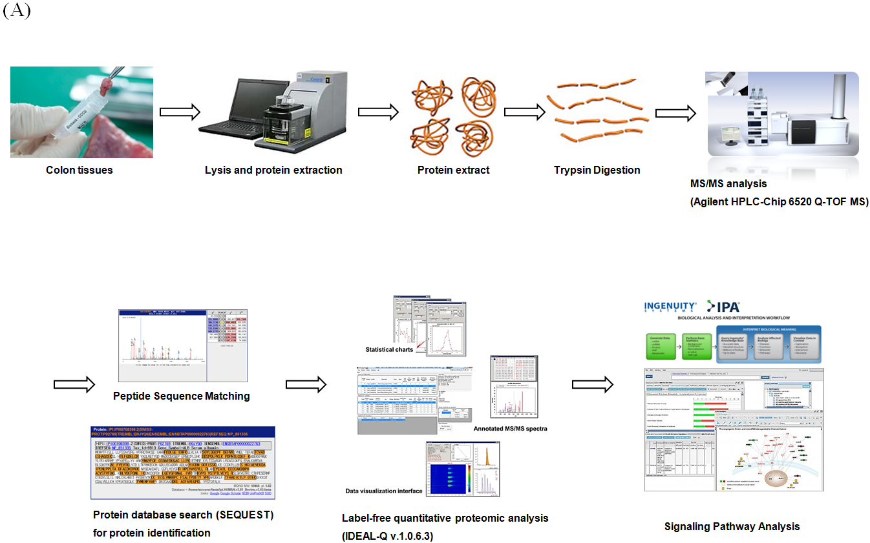
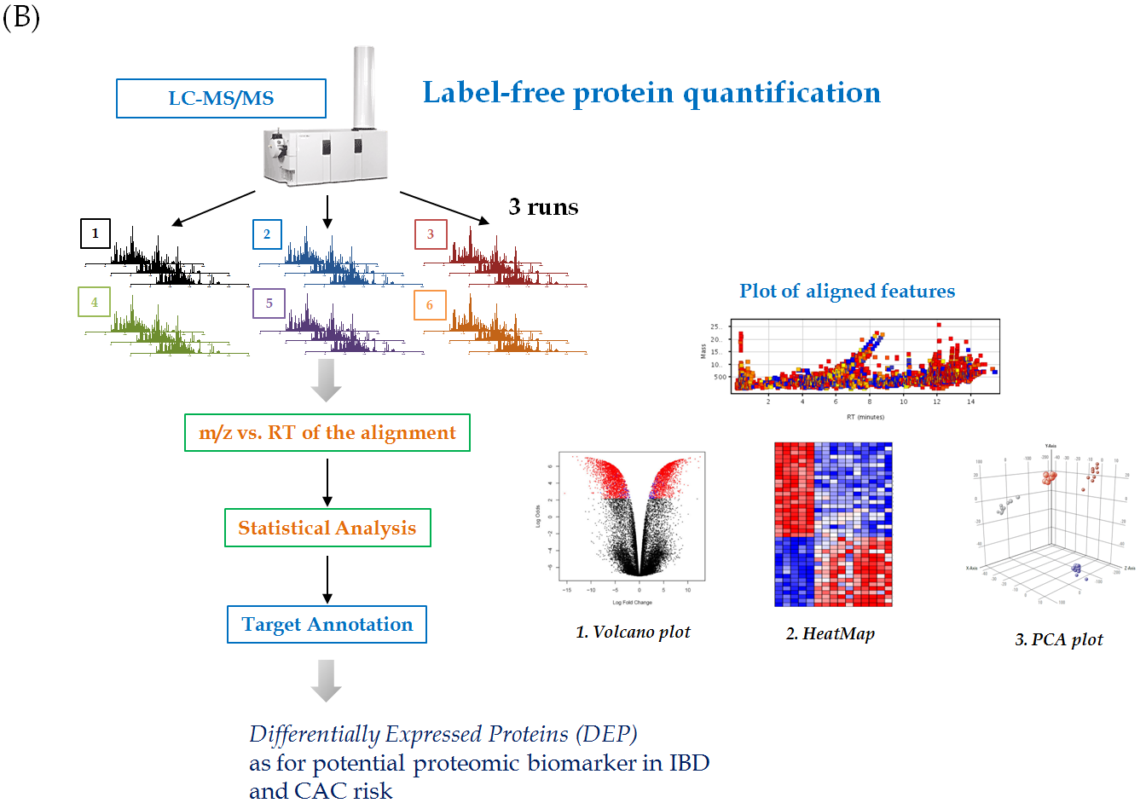

Figure 1 Schematic presentation showing proteome analysis to discover potential biomarker and label free quantification analysis in inflammatory bowel disease. A: Applying label free quantification method to discover proteomic biomarkers in patients with different type and different stage of inflammatory bowel disease (IBD) patients, comparative analysis was done in 8 patients with ulcerative colitis (UC), 8 patients with Crohn’s disease (CD), and 8 patients with irritable bowel syndrome (IBS). Colon biopsied tissues were obtained during colonoscopy after written consent, stored in deep freezer until the assay. Using Agilent HPLC-Chip 6520 Q- time-of-flight mass spectrometry (TOF MS) and label free quantitative proteome analysis (IDEAL-Q v1.0.6.3), significant signal pathway analysis was done. In the current review article, the analysis done according to the degree of intestinal inflammation, type of IBD, and extent of inflammation from 24 patients, 8 from non-IBD normal patients, that is, IBS patients, 8 from patients with UC, 8 from patients with CD were displayed; B: Label-free protein quantification scheme for potential biomarker for colitis-associated cancer (CAC) risks in 16 patients with IBD.

Figure 2
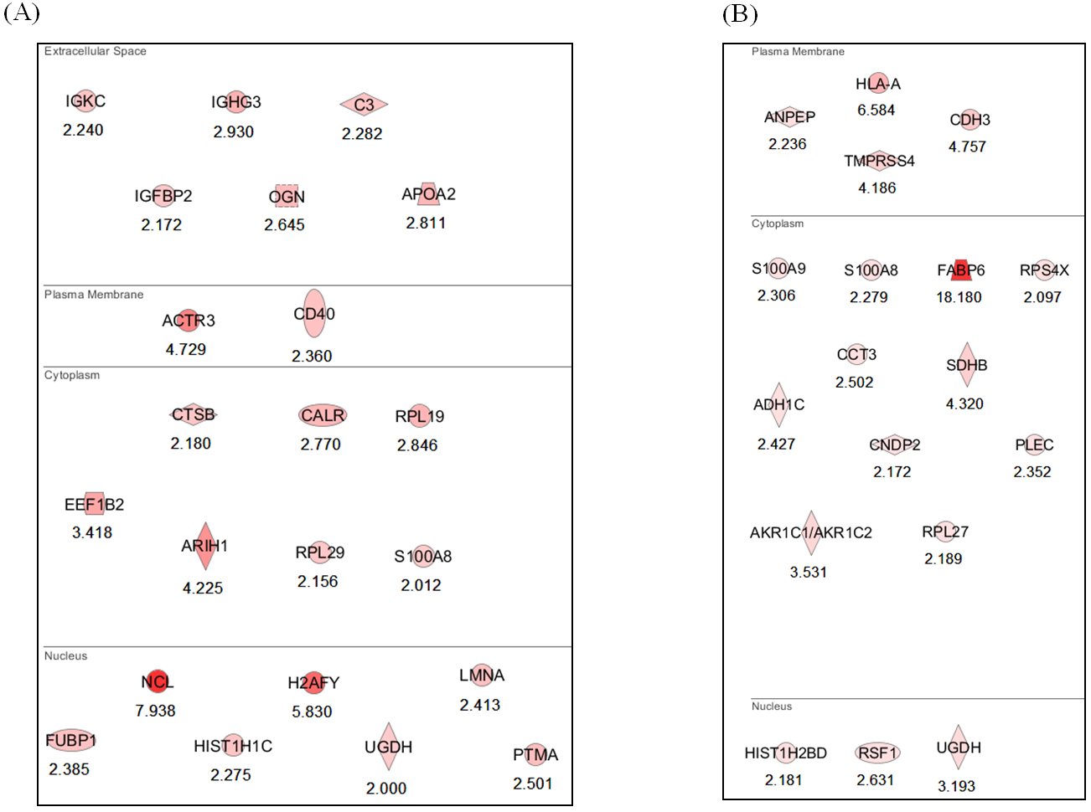

Figure 2 Potential proteomic markers signifying the colitis-associated cancer risks in inflammatory bowel disease. A: Proteomic marker for colitis-associated cancer (CAC) risk in patients with ulcerative colitis (UC) The analysis was done according to the degree of intestinal inflammation, type of inflammatory bowel disease, and extent of inflammation. Comparative with the analysis from CAC, 22 significant proteomes were obtained from patients as potential biomarker of CAC risk in patients with UC, 6 proteomes existing at extracellular space, 2 biomarkers at plasma membrane, 7 proteomes from cytoplasm, and 7 from nucleus proteins; B: Proteomic marker for CAC risk in patients with Crohn’s disease (CD) 19 proteomes were identified as potential biomarkers to tell the risk of CAC in patients with CD, 4 from plasma membrane, 11 from cytoplasm, and 3 from nucleus.

Figure 3
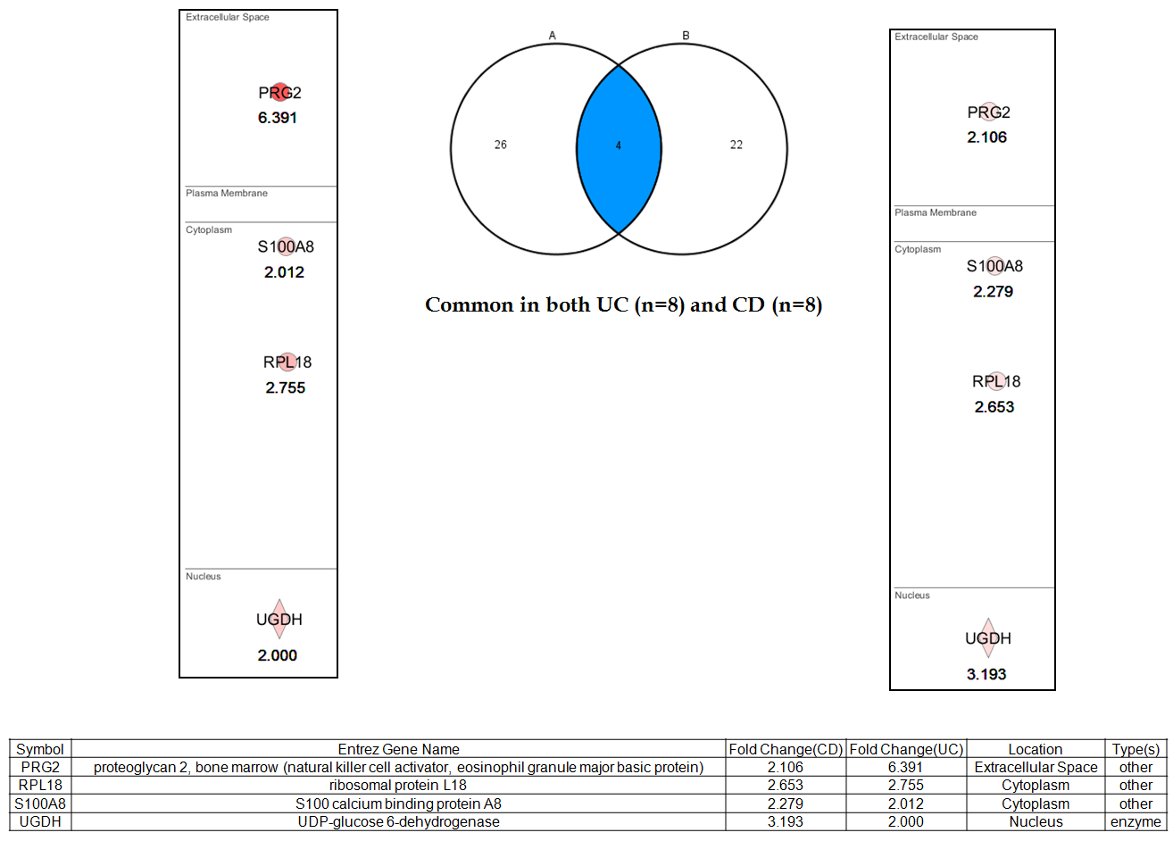
Figure 3 Proteomic marker for colitis-associated cancer risk in patients with both ulcerative colitis and Crohn’s disease. After analyzing signaling pathways from label–free quantitative analysis, four important proteome biomarkers were pulled out, including proteoglycan 2 (PRG2), S100A6 (calcyclin), ribosomal protein L18 (RPL18), UDP-glucose dehydrogenase (UGDH) with higher fold changes. Validation is ongoing to highlight these biomarkers for predicting colitis-associated cancer risk in patients with inflammatory bowel disease. UC: Ulcerative colitis; CD: Crohn’s disease.

