Name of journal: World Journal of Anesthesiology
ESPS Manuscript No: 8050
Columns: Minireview

Intraoperative magnetic resonance imaging in neurosurgery and anesthetic considerations

Gupta N et al. Anesthesia for iMRI

Nidhi Gupta, Girija Prasad Rath

Nidhi Gupta, Unit of Neuroanaesthesia, Fortis Memorial Research Institute, Gurgaon, Haryana 122002, India

Girija Prasad Rath, Department of Neuroanaesthesiology, Neurosciences Centre, A.I.I.M.S., New Delhi 110029, India

Author contributions: Both authors contributed equally to this work.

Correspondence to: Dr. Girija Prasad Rath, MD, DM, Additional Professor, Department of Neuroanaesthesiology, Neurosciences Centre, A.I.I.M.S., Ansari Nagar East, AIIMS Campus, Gautam Nagar, New Delhi 110029, India. girijarath@yahoo.co.in

Telephone: +91-98-68398204 Fax: +91-11-26588238
Received: October 25, 2013 Revised: April 2, 2014
Accepted: May 8, 2014

Published online:

Abstract
Currently, magnetic resonance imaging (MRI) is the only imaging modality available which is capable of acquiring intra-operative images frequently with acceptable spatial and contrast resolution. However, the incorporation of MRI technology into the operating room requires special anesthetic considerations. It may include various aspects such as transport, remote location anesthesia, strong electromagnetic field, use of approved items, equipment counts, possible emergencies, and surgery in awake patients. The patient safety may be compromised by health-related, equipment-related, and procedure-related risks. Direct patient observation may be compromised by acoustic noise, darkened environment, obstructed line of sight, and distractions along with difficult access to the patient for airway management. Most often, the patient’s head will be 180° away from the anesthesiologist during the procedure. Several monitors exist that are designed for conditional use in a MR environment. The general design criterion in these monitors is to eliminate conductors that carry electrical signals for monitoring physiologic parameters of the patient. General anesthesia requires an extended anesthetic circuit for ventilation maintenance and drug administration because the patient is located farther from the anesthesia machine than in traditional operating room settings. Dead space creates a time delay before the volatile anesthetic and drugs are administered and when expected effects can be observed. Therefore, the attending anaesthesiologists must understand the above aspects for safe conduct of neurosurgical procedures by minimizing MRI associated accidents while assuring optimal patient vigilance.

© 2014 Baishideng Publishing Group Inc. All rights reserved.

Key words: Intraoperative magnetic resonance imaging; Electromagnetic field; Safety; Anesthesia; Neurosurgery

Core tip: Intraoperative MRI (iMRI) has been used for the identification of eloquent brain areas. However, the incorporation of MRI technology into the operating room requires special anesthetic and procedural considerations. This review article focussed on these aspects.

Gupta N, Rath GP. Intraoperative magnetic resonance imaging in neurosurgery and anesthetic considerations. World J of Anesthesiol 2014; In Press

Introduction
Successful neurosurgical procedures rely on the accurate targeting of regions of interest along with preservation of eloquent cortex such as motor, speech, and visual areas during the procedure. This helps the neusurgeons achieving maximal resection of the lesion with minimal untoward neurologic sequelae. The development of magnetic resonance imaging (MRI)-guided navigation systems represents a significant improvement in the surgical treatment of various intracranial lesions. At present, MRI is the only imaging modality available which is capable of acquiring intra-operative images frequently with acceptable spatial and contrast resolution.

Benefits and use of intra-operative MRI in neurosurgery
Intraoperative MRI (iMRI) has been used for the identification of eloquent brain areas. It is also known as functional MRI (fMRI) during intraoperative period, thus help in reducing postoperative morbidity after excision of lesions in eloquent areas of brain^{[1]}. Intracranial anatomy undergoes dynamic changes after the opening of the dura (known as “brain shift”), thereby compromising the localization of neural structures in space relative to their preoperative location on imaging. The brain shift occurs up to one centimeter in most of the cranial neurosurgeries due to drainage of cerebrospinal fluid (CSF), brain edema, and tumor resection^{[2-4]}. This is most likely to occur in patients with large tumors (> 3 cm diameter) or tumors adjacent to the ventricles^{[5]}. Only serial intraoperative imaging with high spatial resolution allows the distinction of deformation patterns and reveals brain compartments with differing reactions to surgical manipulations^{[2]}.
Among intracranial tumors, gliomas pose technical challenges to the neurosurgeon as many of these tumors (particularly low-grade gliomas) do not possess distinct capsules, thus causing an uncertainty as to where the border of the lesion ends and viable brain begins.This may lead to either inadequate resection if surgeon limits the resection within the boundaries of abnormal tissue (to avoid neurologic damage). Abundant evidence indicates that a more complete resection under the guidance of iMRI directly impacts the survival time and quality of life of patients with low-grade gliomas and glioblastoma multiforme^{[6-8]}.
During trans-sphenoidal microsurgical resection of pituitary adenomas, the extent of resection may be difficult to assess, especially when extensive suprasellar and parasellar growth has occurred. iMRI is particularly useful in guiding resection safely, aiding in clinical decision making, allowing identification and preservation of the pituitary stalk and normal pituitary gland with good postoperative outcomes^{[9,10]}. Temporal lobe resection or selective amygdalo-hippocampectomy to remove an epileptogenic focus can be performed much more accurately under iMRI^{[11]}. Its application in spine surgeries, particularly those involving critical regions like cervical and craniocervical junctions may increase the surgical accuracy and safety^{[12,13]}.
Subthalamic nucleus deep brain stimulator (DBS) placement using high-field interventional magnetic resonance imaging and a skull-mounted aiming device simplifies DBS implantation by eliminating the use of the traditional stereotactic frame and the subsequent requirement for registration of the brain in stereotactic space^{[14]}.
In case of an intraoperative complication, global status of the brain can be checked such as intracerebral hemorrhage, diffuse cerebral edema, hydrocephalus, etc. Auxillary adjuncts of iMRI such as diffusion-weighted images, MR-angiography and MR-venography could clearly demonstrate vascular complications like ischemia^{[15]}. It also helps to reduce the need for further surgeries, as scans done after the process can help doctors identify and remove any residual tumor that may have been missed^{[16]}. It also avoids the transfer of the critically ill patient to another suite should urgent imaging be needed be needed during or after operation.

Origin of iMRI
It has been almost three decades since the introduction of iMRI into the field of neurosurgery. Collaboration between the Brigham and Women’s Hospital and General Electric resulted in the world’s first iMRI system in 1994 at Brigham and Women’s Hospital in Boston, Massachusetts^{[17]}. Since then, several types of iMRI units have been developed that can be classified as low or high-field systems based on the magnetic field strength ranging from 0.12 and 3 Tesla (T) ^{[18]}. Low-field magnets (0.15–0.2 T) have the advantage of providing good surgical access to the patient; however, they have the disadvantage of lower resolution. High-field magnets (1.5–3 T) have the advantage of providing better resolution but may limit access to the patient during imaging. The recent high field iMRI system, constructed by the cooperation of Siemens and Brain Lab (Brain Suite), consists of a standard 1.5T magnet scanner, implemented in a dedicated operating room (OR) with a computer-assisted neuronavigation system, and digitized image transfer and projection system to form a comprehensive unit (Figure 1).

Design of the iMRI suite
The incorporation of MRI technology into the OR requires special considerations. In this setting, the respective role and communication among team members (e.g., surgeons, radiologists, MR technologists, nurses, anesthesiologists, computer scientists, and engineers) is of paramount importance. The design of the OR must allow adequate anesthesia monitoring and care. Room size must be significantly larger than a standard operating room to allow enough space to install an MRI machine, to move the patient into and out of the MRI core. The monitoring equipment has to be MR safe as well as MR conditional. MR Safe indicates an item that poses no known hazards in all MRI environments and is non-conducting, non-metallic, and non-magnetic. MR Conditional indicates an item that has been demonstrated to pose no known hazards in a specified MR environment with specified conditions of use. An example of this would be an MRI conditional anesthesia machine (Datex-Ohmeda Aestiva; GE Healthcare, Waukesha, WI, United States) that is conditional to 100 Gauss (G) in a 1.5T magnet. MR unsafe indicates an item that is known to pose hazards in all MRI environments^{[19]}.
Another important consideration is to assure adequate distance between equipment with ferromagnetic properties and the location where the magnetic field is the strongest. A red line (inner) represents the region where the magnetic field is 50 G and higher, and the yellow line (outer) demarcates the region beyond which the magnetic field strength is less than 5 G. Any ferromagnetic object within 5 G line can be attracted to the magnet and act as a missile with devastating consequences. Since the areas for imaging and surgery are separate in many clinical circumstances using iMRI, either the patient is transferred to the MRI, or the MRI is brought to the patient.
Brain suite has 180◦ rotating dedicated table (modified Angio DIAGNOST 5 Syncra Tilt Patient Support, Philips Medical Systems) and the surgery is carried out under standard operating environment, with conventional ferromagnetic instruments and microscope as patient is placed outside 5 G line (Figure 2). This area is equipped with a ceiling-mounted navigation system (BrainLab Vector Vision), which allows conventional neuronavigation with preoperative and updated navigation with intraoperatively acquired images. For intraoperative imaging, the patient is transferred from the primary microneurosurgical operating site to the scanner (imaging site) using the rotating table, which is returned to the MR- axis, connected, and the patient is transferred into the magnet. For this transfer, every ferromagnetic item is removed and the surgical field is covered with additional sterile drapes. MRI images are obtained and loaded into the navigation system while the patient is transferred back to the surgical area. If residual tumor is identified, resection is continued, using the updated image data for continued neuronavigation. Biopsies can be performed outside the 5 G line, using standard frame-based or frameless systems. Both of these methods employ standard neurosurgical techniques and equipments.

Anesthetic Challenges in iMRI
Introducing the MRI technology into the OR-setting presents unique challenge in a trans-disciplinary environment^{[20]}. The American College of Radiologists has developed practice guidelines for personnel working in an MRI environment^{[21]}. These guidelines extend to nurses, surgeons, and anesthesia providers in an iMRI setting.
Anesthetic considerations in the iMRI may include various aspects such as transport, remote location anesthesia, strong electromagnetic field, use of approved items, equipment counts, MRI periods, possible emergencies, and surgery in awake patients^{[22]}. The anesthesiologist mediates safe conduct of neurosurgical procedure by minimizing or eliminating iMRI associated accidents, while assuring optimal patient vigilance. Patient safety may be compromised by health-related, equipment-related, and procedure-related risks.
Preoperative evaluation is aimed for identifying functional limitations and patient risks associated with the iMRI technology. This examination should include history of implanted metallic devices, such as cardiac defibrillators or pacemakers, cerebrovascular clips, cochlear implants, vagal nerve stimulators, deep brain stimulators, other steel metallic implants, intravascular wires, stents, bullets, extensive tattoos, or permanent eye make-up. These devices may be ferromagnetic and lead to dislodgment^{[23]}. Patients who have braces or dentures may generate artifacts that may significantly degrade iMRI images. The heating of metallic implants can lead to severe burns. The function of pacemakers, cardiac catheters and insulin pumps can be altered with exposure to the magnetic field.
Direct patient observation may be compromised by acoustic noise, darkened environment, obstructed line of sight, and distractions along with difficult access to the patient for airway management. Most often, the patient’s head will be 180° away from the anesthesiologist during the procedure. The actual distance may be 10-15 feet from the anesthesia workstation, limiting access to the patient. A magnetic field is constantly present and extends beyond the magnet. This source of the electromagnetic force attracts any ferromagnetic object or instrument, such as glasses, pens, stethoscopes, scissors, intravenous (IV) stands, gas cylinders, laryngoscopes, and anesthesia machines. This ferromagnetic attraction poses potential injury to patients or staff in the OR. In general, no metallic object should be allowed in the OR.
Several monitors exist that are designed for conditional use in a MR environment. The general design criterion in these monitors is to eliminate conductors that carry electrical signals for monitoring physiologic parameters of the patient. These conductors can function as receiving antenna on which the pulsating electrical and magnetic energy can induce spurious electric noise (EN) that distorts and corrupts the physiologic waveforms displayed on the monitor. The two general approaches currently used to achieve this criterion are the use of fiberoptics and wireless technology. When metal objects and electronic monitors are introduced into the MR environment, they may interact with the images produced by the MRI scanner by reflecting or generating radiofrequency (RF) waves. These may result in distorted MR images that are unreliable for diagnostic purposes.
There is negligible ferromagnetic material in vaporizers and mechanical ventilators, and with the exception of desflurane, these devices behave properly when introduced into MR environments^{[24]}. Isoflurane and sevoflurane vaporizers are MR safe and cleared for use in the low- and high-field MR environments. The desflurane vaporizer is not MR safe. MRI compatible anesthesia machines and ventilators are also available.
The RF signal and the magnetic gradients of an iMRI system are pulsed during a scan at a frequency dependent on the specific imaging pulse sequence type and the parameters used. The sequences used for iMRI typically apply gradient and RF pulses at rates less than 100 Hz^{[25]}. These high-energy pulsations can generate a significant second EN component in the frequency bandwidth of most monitored physiologic signals. The most vulnerable signal is the electrocardiogram (ECG), with masking of virtually all details of the ECG waveform. Specialized equipment compatible with MRI is currently available for monitoring of ECG, non-invasive blood pressure, oxygen saturation (SpO₂), end-tidal CO₂, invasive blood pressure and central venous pressure, and Doppler. Both audio and visual alarms are necessary because the loud noise generated by the scanner may mask the sound of the audio alarms. Necessary monitoring equipments that do not have MRI conditional counterparts include defibrillators, fluid-warming devices, forced air warming devices, peripheral nerve stimulators, and temperature probes. The MRI unsafe monitoring can be used during the non-imaging portions of the case, with the equipment tethered to the wall of the MRI suite with the help of cables to prevent them from ever being inadvertently moved within the 5 G line. Before transferring the patient to the imaging area, a checklist is used to assure all MRI unsafe items are counted and moved beyond the 5 G line.
Most monitors have ECG filters that can be adjusted to minimize the noise while maintaining as much of the rhythm information as possible. The ECG electrodes and cables should be MR safe and contain minimal metal components. Cables should be well padded to avoid direct contact with the skin.
Standard blood pressure monitoring techniques may be used with minimal adaptations. A mercury manometer, sphygmomanometer, or automated oscillometric blood pressure recording device may still be used as long as they are kept away from the scanner^{[24]}. For major craniotomies invasive blood pressure monitoring is done. MRI compatible anesthesia monitors with invasive monitoring are now available.
Cold temperature is required in the room to keep the magnet super cooled with liquid helium or nitrogen in an effort to maintain a pristine magnetic field, which may decrease body temperature. Active heating with forced hot air warmers is essential in maintaining proper patient temperature during the non-imaging phases of the procedure. Covering the patient with impermeable sterile drapes during the imaging phase prevents most radiant heat loss by the patient. Again, perioperative hypothermia is of greater concern in pediatric patients than adults^{[26]}, given the relatively cool iMRI environment. However, studies have shown that RF waves emitted from the magnet may produce heat and increase body temperature in pediatric patients, despite minimal efforts to reduce passive heat loss under sedation and without the use of warming devices^{[27,28]}.
Heating of devices used in the OR, such as pulse oximeters and temperature probes, may cause local burn injuries. MR safe pulse oximeters are available for use in MR environments to measure SpO₂. Anesthesiologists may benefit by using an end-tidal CO₂ monitor with elongated sampling tube in anesthetized patients.
Another safety consideration for high-field MR environments is the acoustic noise generated from the MR machine during a scan, which can exceed 100 dB^{[29]}. Exposure to high noise levels can lead to hearing loss, making hearing protection essential^{[30]}. An effective barrier against patient and operator injury from this sound is the use of foam earplugs. It is important that the use of earplugs by iMRI staff does not interfere with the ability to hear physician commands or respond to emergencies.
General anesthesia requires an extended anesthetic circuit for ventilation maintenance and drug administration because the patient is located farther from the anesthesia machine than in traditional OR settings. Dead space creates a time delay before the volatile anesthetic and drugs are administered and when expected effects can be observed. A combination of IV anesthetic with volatile agents is preferred. The intravenous extension lines must be long, properly arranged, color-coded, and positioned along the patient’s body to extend caudally.

Awake craniotomy in High-Field Intraoperative MRI
Combination of brain tumor surgery under local anesthesia with iMRI is a demanding procedure mostly because of procedural limitations in the form of prolonged duration and subsequent patient exhaustion. The patients should be carefully selected with regard to neurological status, cognitive, and mental resilience. However, the procedure seems to be tolerable and reasonable for most patients from a psychological point of view^{[31]}. Standard draping protocols in high-field iMRI units make awake craniotomies challenging due to issues with both patient comfort (claustrophobia for alert patients) and safety (airway protection for sedated patients). Nabavi et al^{[32]} suggest uncovering the patient’s face and Weingarten et al^{[33]} described trimming drapes hanging below the operating table. During the procedure, the patient is transferred between operating and imaging area with a rotating table. The scanning procedure adds extra 45-60 min to the surgery time. Earplugs are placed during the scans and sedation may be increased to help tolerate immobility and noise.
Gadolinium-based contrast agents are approved by the United States Food and Drug Administration (FDA) for use in MRI. There is a finite risk of moderate-to-severe acute adverse reaction to IV gadolinium chelates (0.01%)^{[34]}, but until recently there was no evidence for late adverse reaction to MR contrast agents. However, gadolinium chelate is now the suspected trigger for development of a rare debilitating syndrome termed as nephrogenic systemic fibrosis (NSF). This syndrome occurs in patients with renal insufficiency. To date, NSF has not been reported in patients with normal renal function.

Conclusion
The incorporation of MRI technology into the operating room requires special anesthetic considerations. The patient safety may be compromised by health, equipment and/or procedure-related risks. In this context, the role of anesthesiologists in mediating the safe conduct of neurosurgical procedures by minimizing MRI associated accidents, while assuring optimal patient vigilance, may not be overemphasized.

Reference
1 Gasser T, Ganslandt O, Sandalcioglu E, Stolke D, Fahlbusch R, Nimsky C. Intraoperative functional MRI: implementation and preliminary experience. Neuroimage 2005; 26: 685-693 [PMID: 15955478 DOI: 10.1016/j.neuroimage.2005.02.022]
2 Nabavi A, Black PM, Gering DT, Westin CF, Mehta V, Pergolizzi RS, Ferrant M, Warfield SK, Hata N, Schwartz RB, Wells WM, Kikinis R, Jolesz FA. Serial intraoperative magnetic resonance imaging of brain shift. Neurosurgery 2001; 48: 787-97; discussion 797-8 [PMID: 11322439]
3 Nimsky C, Ganslandt O, Hastreiter P, Fahlbusch R. Intraoperative compensation for brain shift. Surg Neurol 2001; 56: 357-64; discussion 364-5 [PMID: 11755962 DOI: 10.1016/S0090-3019(01)00628-0]
4 Hata N, Nabavi A, Wells WM, Warfield SK, Kikinis R, Black PM, Jolesz FA. Three-dimensional optical flow method for measurement of volumetric brain deformation from intraoperative MR images. J Comput Assist Tomogr 2000; 24: 531-538 [PMID: 10966182 DOI: 10.1097/00004728-200007000-00004]
5 Benveniste RJ, Germano IM. Correlation of factors predicting intraoperative brain shift with successful resection of malignant brain tumors using image-guided techniques. Surg Neurol 2005; 63: 542-58; discussion 542-58; [PMID: 15936381 DOI: 10.1016/j.surneu.2004.11.025]
6 Claus EB, Horlacher A, Hsu L, Schwartz RB, Dello-Iacono D, Talos F, Jolesz FA, Black PM. Survival rates in patients with low-grade glioma after intraoperative magnetic resonance image guidance. Cancer 2005; 103: 1227-1233 [PMID: 15690327 DOI: 10.1002/cncr.20867]
7 Senft C, Bink A, Franz K, Vatter H, Gasser T, Seifert V. Intraoperative MRI guidance and extent of resection in glioma surgery: a randomised, controlled trial. Lancet Oncol 2011; 12: 997-1003 [PMID: 21868284 DOI: 10.1016/S1470-2045(11)70196-6]
8 Kubben PL, ter Meulen KJ, Schijns OE, ter Laak-Poort MP, van Overbeeke JJ, van Santbrink H. Intraoperative MRI-guided resection of glioblastoma multiforme: a systematic review. Lancet Oncol 2011; 12: 1062-1070 [PMID: 21868286 DOI: 10.1016/S1470-2045(11)70130-9]
9 Szerlip NJ, Zhang YC, Placantonakis DG, Goldman M, Colevas KB, Rubin DG, Kobylarz EJ, Karimi S, Girotra M, Tabar V. Transsphenoidal resection of sellar tumors using high-field intraoperative magnetic resonance imaging. Skull Base 2011; 21: 223-232 [PMID: 22470265 DOI: 10.1055/s-0031-1277262]
10 Ramm-Pettersen J, Berg-Johnsen J, Hol PK, Roy S, Bollerslev J, Schreiner T, Helseth E. Intra-operative MRI facilitates tumour resection during trans-sphenoidal surgery for pituitary adenomas. Acta Neurochir (Wien) 2011; 153: 1367-1373 [PMID: 21523361 DOI: 10.1007/s00701-011-1004-7]
11 Schwartz TH, Marks D, Pak J, Hill J, Mandelbaum DE, Holodny AI, Schulder M. Standardization of amygdalohippocampectomy with intraoperative magnetic resonance imaging: preliminary experience. Epilepsia 2002; 43: 430-436 [PMID: 11952775 DOI: 10.1046/j.1528-1157.2002.39101.x]
12 Kaibara T, Hurlbert RJ, Sutherland GR. Intraoperative magnetic resonance imaging-augmented transoral resection of axial disease. Neurosurg Focus 2001; 10: E4 [PMID: 16749751]
13 Kaibara T, Hurlbert RJ, Sutherland GR. Transoral resection of axial lesions augmented by intraoperative magnetic resonance imaging. Report of three cases. J Neurosurg 2001; 95: 239-242 [PMID: 11599844]
14 Starr PA, Martin AJ, Ostrem JL, Talke P, Levesque N, Larson PS. Subthalamic nucleus deep brain stimulator placement using high-field interventional magnetic resonance imaging and a skull-mounted aiming device: technique and application accuracy. J Neurosurg 2010; 112: 479-490 [PMID: 19681683 DOI: 10.3171/2009.6.JNS081161]
15 Hall WA, Liu H, Martin AJ, Truwit CL. Intraoperative magnetic resonance imaging. Top Magn Reson Imaging 2000; 11: 203-212 [PMID: 11145212 DOI: 10.1097/00002142-200006000-00006]
16 Shah MN, Leonard JR, Inder G, Gao F, Geske M, Haydon DH, Omodon ME, Evans J, Morales D, Dacey RG, Smyth MD, Chicoine MR, Limbrick DD. Intraoperative magnetic resonance imaging to reduce the rate of early reoperation for lesion resection in pediatric neurosurgery. J Neurosurg Pediatr 2012; 9: 259-264 [PMID: 22380953 DOI: 10.3171/2011.12.PEDS11227]
17 Black PM, Moriarty T, Alexander E, Stieg P, Woodard EJ, Gleason PL, Martin CH, Kikinis R, Schwartz RB, Jolesz FA. Development and implementation of intraoperative magnetic resonance imaging and its neurosurgical applications. Neurosurgery 1997; 41: 831-42; discussion 842-5 [PMID: 9316044 DOI: 10.1097/00006123-199710000-00013]
18 Mislow JM, Golby AJ, Black PM. Origins of intraoperative MRI. Neurosurg Clin N Am 2009; 20: 137-146 [PMID: 19555875 DOI: 10.1016/j.nec.2009.04.002]
19 Shellock FG, Woods TO, Crues JV. MR labeling information for implants and devices: explanation of terminology. Radiology 2009; 253: 26-30 [PMID: 19789253 DOI: 10.1148/radiol.2531091030]
20 Tan TK, Goh J. The anaesthetist's role in the setting up of an intraoperative MR imaging facility. Singapore Med J 2009; 50: 4-10 [PMID: 19224077]
21 Kanal E, Borgstede JP, Barkovich AJ, Bell C, Bradley WG, Felmlee JP, Froelich JW, Kaminski EM, Keeler EK, Lester JW, Scoumis EA, Zaremba LA, Zinninger MD. American College of Radiology White Paper on MR Safety. AJR Am J Roentgenol 2002; 178: 1335-1347 [PMID: 12034593 DOI: 10.2214/ajr.178.6.1781335]
22 Henrichs B, Walsh RP. Intraoperative magnetic resonance imaging for neurosurgical procedures: anesthetic implications. AANA J 2011; 79: 71-77 [PMID: 21473229]
23 Johnston T, Moser R, Moeller K, Moriarty TM. Intraoperative MRI: safety. Neurosurg Clin N Am 2009; 20: 147-153 [PMID: 19555876 DOI: 10.1016/j.nec.2009.04.007]
24 Longnecker DE, Tinker JH, Morgan GE. Anaesthesia for non surgical procedures. In: Longnecker DE, Tinker JH, Morgan GE, editors. Principles and Practice of Anesthesiology, 2nd ed. St. Louis: Mosby, Inc. 1998: 2287–94
25 Magnetic Resonance Imaging (MRI), Low-Field. CIGNA Healthcare Coverage Position [Coverage Position Number: 0444]. CIGNA, 2008: 1–17
26 Archer DP, McTaggart Cowan RA, Falkenstein RJ, Sutherland GR. Intraoperative mobile magnetic resonance imaging for craniotomy lengthens the procedure but does not increase morbidity. Can J Anaesth 2002; 49: 420-426 [PMID: 11927485 DOI: 10.1007/BF03017334]
27 Bryan YF, Templeton TW, Nick TG, Szafran M, Tung A. Brain magnetic resonance imaging increases core body temperature in sedated children. Anesth Analg 2006; 102: 1674-1679 [PMID: 16717307 DOI: 10.1213/01.ane.0000216292.82271.bc]
28 Machata AM, Willschke H, Kabon B, Prayer D, Marhofer P. Effect of brain magnetic resonance imaging on body core temperature in sedated infants and children. Br J Anaesth 2009; 102: 385-389 [PMID: 19174372 DOI: 10.1093/bja/aen388]
29 Shellock FG. Reference manual for magnetic resonance safety. Salt Lake City: Amirsys, 2003
30 Kanal E, Shellock FG, Talagala L. Safety considerations in MR imaging. Radiology 1990; 176: 593-606 [PMID: 2202008]
31 Goebel S, Nabavi A, Schubert S, Mehdorn HM. Patient perception of combined awake brain tumor surgery and intraoperative 1.5-T magnetic resonance imaging: the Kiel experience. Neurosurgery 2010; 67: 594-600; discussion 600 [PMID: 20647971 DOI: 10.1227/01.NEU.0000374870.46963.BB]
32 Nabavi A, Goebel S, Doerner L, Warneke N, Ulmer S, Mehdorn M. Awake craniotomy and intraoperative magnetic resonance imaging: patient selection, preparation, and technique. Top Magn Reson Imaging 2009; 19: 191-196 [PMID: 19148035 DOI: 10.1097/RMR.0b013e3181963b46]
33 Weingarten DM, Asthagiri AR, Butman JA, Sato S, Wiggs EA, Damaska B, Heiss JD. Cortical mapping and frameless stereotactic navigation in the high-field intraoperative magnetic resonance imaging suite. J Neurosurg 2009; 111: 1185-1190 [PMID: 19499978 DOI: 10.3171/2009.5.JNS09164]
34 De Ridder F, De Maeseneer M, Stadnik T, Luypaert R, Osteaux M. Severe adverse reactions with contrast agents for magnetic resonance: clinical experience in 30,000 MR examinations. JBR-BTR 2001; 84: 150-152 [PMID: 11688727]

P-Reviewers: Abdallah C, Fassoulaki A, Luchetti M S-Editor: Ma YJ L-Editor: E-Editor:

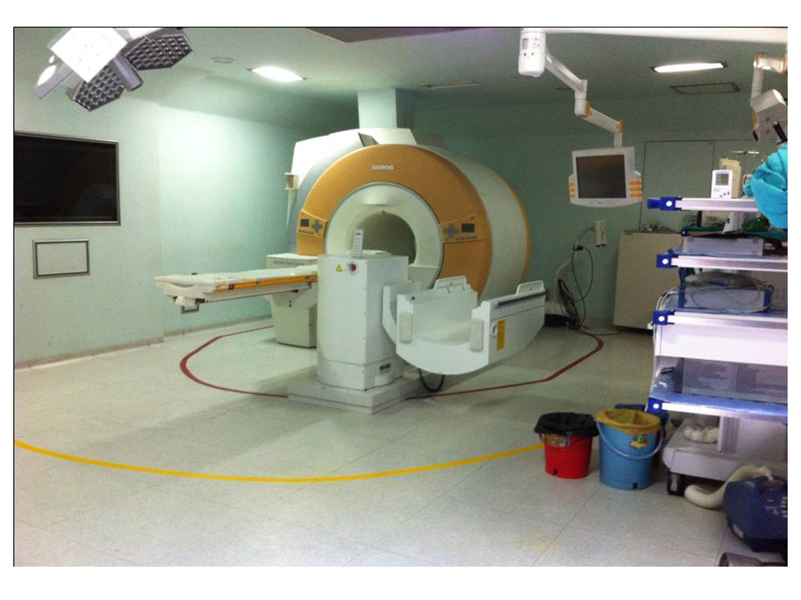
Figure 1 Brain suite with magnet scanner and computer-assisted, ceiling-mounted navigation system.

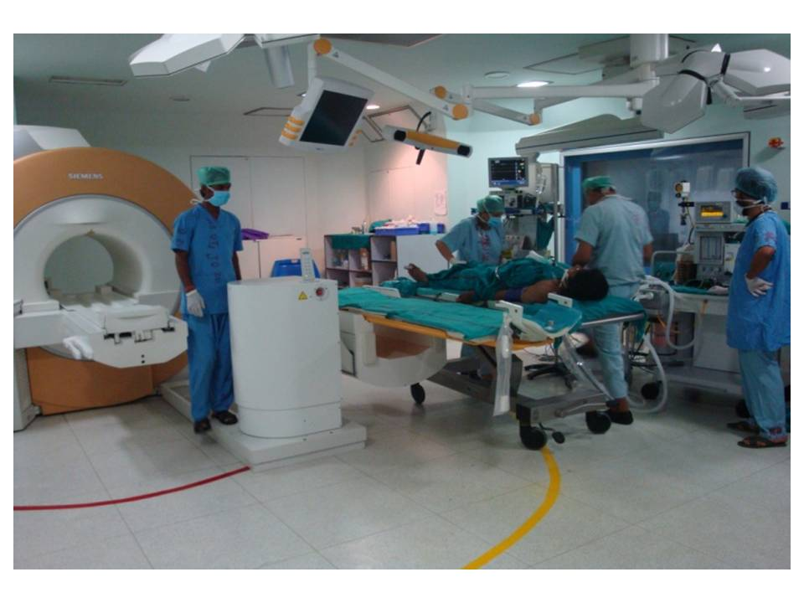
Figure 2 Procedure are being performed outside the 5-Gauss line in the brain suite.

