Name of Journal: World Journal of Clinical Cases
Manuscript NO: 58416
Manuscript Type: CASE REPORT

Dynamic biomechanical effect of lower body positive pressure treadmill training for hemiplegic gait rehabilitation after stroke: A case report

Tang HF et al. Dynamic LBPP effect on hemiplegic gait

Hui-Fang Tang, Bing Yang, Qiang Lin, Jun-Jie Liang, Zhi-Wei Mou

Hui-Fang Tang, Zhi-Wei Mou, Department of Rehabilitation Medicine, The First Affiliated Hospital of Jinan University, Guangzhou 510630, Guangdong Province, China

Bing Yang, Department of Neurology, The First Affiliated Hospital of Jinan University, Guangzhou 510630, Guangdong Province, China

Qiang Lin, Jun-Jie Liang, Department of Rehabilitation Medicine, The Fifth Affiliated Hospital of Guangzhou Medical University, Guangzhou 510070, Guangdong Province, China

Author contributions: Tang HF reviewed the literature and contributed to data analysis and manuscript drafting; Yang B interpreted the study findings; Lin Q and Liang JJ were the patient’s rehabilitation physicians and contributed to data collection; Mou ZW drafted the manuscript and was responsible for the revision of the manuscript; all authors issued final approval for the version to be submitted.

Supported by National Natural Science Foundation for Young Scientists of China, No. 81902281; Guangdong Medical Science and Technology Research Foundation of China, No. A2019120 and No. A2020362; and Special Project of Chinese Government for Science and Technology of Guangdong Province, No. 2019SKJ003.

Corresponding author: Zhi-Wei Mou, MD, PhD, Associate Chief Physician, Department of Rehabilitation Medicine, The First Affiliated Hospital of Jinan University, No. 613 West Huangpu Avenue, Guangzhou 510630, Guangdong Province, China. mouzhiwei@jnu.edu.cn

Received: July 21, 2020
Revised: November 18, 2020
Accepted: November 29, 2020
Published online:

Abstract
BACKGROUND
Lower body positive pressure (LBPP) treadmill has potential applications for improving the gait of patients after stroke, but the related mechanism remains unclear.

CASE SUMMARY
A 62-year-old male patient suffered from ischemic stroke with hemiplegic gait. He was referred to our hospital because of a complaint of left limb weakness for 2 years. The LBPP training was performed one session per day and six times per week for 2 wk. The dynamic plantar pressure analysis was taken every 2 d. Meanwhile, three-digital gait analysis and synchronous electromyography as well as clinical assessments were taken before and after LBPP intervention and at the 4-wk follow-up. During LBPP training, our patient not only improved his lower limb muscle strength and walking speed, but more importantly, the symmetry index of various biomechanical indicators improved. Moreover, the patient’s planter pressure transferring from the heel area to toe area among the LBPP training process and the symmetry of lower body biomechanical parameters improved.

CONCLUSION
In this study, we documented a dynamic improvement of gait performance in a stroke patient under LBPP training, which included lower limb muscle strength, walking speed, and symmetry of lower limb biomechanics. Our study provides some crucial clues about the potential dynamic mechanism for LBPP training on gait and balance improvement, which is related to rebuilding foot pressure distribution and remodeling symmetry of biomechanics of the lower limb.

Key Words: Lower body positive pressure treadmill; Dynamic plantar pressure; Stroke; Gait analysis; Electromyography; Case report; Rehabilitation

Tang HF, Yang B, Lin Q, Liang JJ, Mou ZW. Dynamic biomechanical effect of lower body positive pressure treadmill training for hemiplegic gait rehabilitation after stroke: A case report. World J Clin Cases 2020; In press

Core Tip: Lower body positive pressure (LBPP) treadmill has potential applications for improving the gait of patients after a stroke, although the related mechanism remains unclear. To the best of our knowledge, our case report is the first study for the dynamic observation on hemiplegic gait rehabilitation using plantar pressure analysis, which presents with every detail of the changes in gait. Meanwhile, we also presented the macroscopic longitudinal changes using the clinical assessments and three-digital gait analysis before and after LBPP intervention and at a follow-up. The critical clues were found for the potential dynamic mechanism for LBPP training on the gait and balance improvement, which is related to rebuilding foot pressure distribution and remodeling symmetry of biomechanics of the lower limb.
INTRODUCTION
Recovery of locomotor function and community mobility is the primary goal of individuals post-stroke and is prioritized during physical rehabilitation^{[1]}. Lower body positive pressure (LBPP) treadmill is one of emerging body weight-supported training technology, and has been used in musculoskeletal and neurological disease rehabilitation^{[2-4]}, but the potential mechanism is still unclear and requires further study. The distribution of foot pressure (especially the toe area) has important effects on walking characteristics (velocity and pace), lower limb muscle activation, and joint stability^{[5,6]}. Therefore, this study investigated dynamic plantar pressure distribution changes by plantar pressure analysis and gait pattern, as well as lower limb muscle activity changes by three-dimensional (3D) gait analysis and synchronous electromyography (EMG) during walking to explore the effect of LBPP training on locomotor function rehabilitation in a stroke patient. To our knowledge, no studies have evaluated the effect of LBPP training for stroke patients by dynamic plantar pressure analysis.

CASE PRESENTATION
Chief complaints
A 62-year-old male patient was referred to the rehabilitation department because of a 2-year history of left limb weakness. He suffered from the first right hemorrhagic stroke 27 mo prior. He lived independently in the community and was ambulatory. However, there was residual motor and gait impairment due to his stroke.

History of present illness
He had a history of hypertension for 10 years, and his systolic blood pressure was up to 190 mmHg. Upon presentation, he took oral antihypertensive drugs to control blood pressure (Baixintong, Goteling, Dyvan, and Furosemide), and the blood pressure was controlled at 130-140/80-90 mmHg.

History of past illness
He had a history of smoking for more than 30 years.

Personal and family history
The patient denied any family history of hypertension, coronary heart disease, or stroke.

Laboratory examinations
The blood biochemistry and urine analysis were normal.

Imaging examinations
Laboratory findings, including routine blood, coagulation function, kidney function, and liver function tests, were within normal ranges. Magnetic resonance imaging (MRI) findings on December 12, 2018 revealed chronic infarction in the right part of the pons (Figure 1).

Clinical assessments
The clinical assessments, including lower extremity subscale of the Fugl-Meyer Assessment (FMA-LE)^{[7]}, Berg Balance Scale (BBS)^{[8]}, and Timed Up and Go test (TUG)^{[9]}, were performed at day 1 (baseline/pretreatment), day 14 (posttreatment), and day 28 (4-wk follow-up) by a trained physical therapist.

Further biomechanical and electrophysiological examinations
Further examinations included plantar pressure analysis (FreeStep, Italy) and 3D gait analysis with synchronized EMG (BTS SMART, Italy)^{[10]}. The patient underwent the plantar pressure analysis on days 1, 4, 7, 11, 14, and 28 to detect the dynamic changes of plantar pressure distribution on the affected side and unaffected side during walking. Moreover, the patient underwent 3D gait analysis with EMG on days 1, 14, and 28 to detect gait spatial-temporal parameters (mean velocity and cadence) and muscle activities of the lower limb [root-mean-square of EMG (RMS EMG)], which included the tibialis anterior (TA), gastrocnemius lateralis (GL), and gastrocnemius medialis (GM). The symmetric index (SI) of gait parameters (cadence and stride length) and mean RMS parameters were computed over the stance phase and swing phase. The formula for calculating the symmetry index is as follows^{[11]}: SI = [(V_{affected} - V_{unaffected})/0.5(V_{affected} + V_{unaffected})] × 100%, where V represents the parameters put into the formula. The lower the value of SI, the lesser the difference between the affected side and the unaffected side.

FINAL DIAGNOSIS
Light side hemiparesis, hemorrhages in chronic phase, hypertension, and lumbar disc herniation.

TREATMENT
The patient provided informed consent, and all procedures were approved by the Medical Ethics Association of the Fifth Affiliated Hospital of Guangzhou Medical University. This study has been registered at the China Clinical Trial Registration Center (No. ChiCTR1800020253). The timeline of this study is shown in Figure 2.
The patient performed one session of LBPP treadmill walking training per day (provided using AlterG M320 Antigravity Treadmill, California, United States), 6 d per week, for 2 wk [LBPP parameter setting: 70% bodyweight (BW); 1.2 mph peak speed; and 0° incline]. Each session lasted approximately 30 min, including 5 min warmup on the treadmill and 5 min cooling down period. Meanwhile, the patient also undertook a 60-min conventional physical therapy program based on the Guidelines for Adult Stroke Rehabilitation and Recovery from the American Heart Association/American Stroke Association^{[12]} and medication for secondary prevention of stroke. The patient did not show any discomfort after interventions.

OUTCOME AND FOLLOW-UP
The clinical assessments (FMA-LE, BBS, and TUG) are reported in Table 1. Scores on the BBS improved from pretreatment (baseline) to posttreatment (2 wk of training) and the 4-wk follow-up, whereas the scores on the FMA-LE were not changed. The timing on TUG varied slightly from posttreatment to the 4-wk follow-up, but still improved compared with pretreatment.
The dynamic plantar pressure distributions on days 1 (baseline/pretreatment), 4, 7, 11, 14 (posttreatment), and 28 (follow-up) on the affected side and unaffected side are shown in Table 2 and Figure 3. The dynamic plantar pressure distributions in four foot areas (including toes, metatarsal, midfoot, and heel area) on the unaffected side presented only slight variation over the six measurements, whereas the plantar pressure distribution in the toes area on the affected side showed 0 values (unloading) on days 1 and 4, and then gradually increased to normal range compared with the unaffected side. The plantar pressure distribution in the heel area on the affected side was gradually decreased over the whole training process, except a slight variation at the follow-up, and was obviously greater than the unaffected side (affected side range from 48.59%-76.1% vs unaffected side range from 28.52%-42.46%). The plantar pressure distribution in the midfoot area and metatarsal area on the affected side showed only slight variation over the whole process, and the values were smaller than those of the unaffected side.
The 3D gait analysis results showed that the mean velocity was gradually increased from pretreatment to posttreatment and even at the follow-up. Meanwhile, the SI of stride length (%height) and SI of cadence increased from pretreatment to posttreatment, which indicated a lesser difference between the affected side and unaffected side at posttreatment (Table 3).
The mean RMS values (microvolt, μV) of the lower limb muscles (including the tibialis anterior, gastrocnemius lateralis, and gastrocnemius medialis) and their SI values over the gait cycle are shown in Table 4 and Figure 4. The values of mean RMS on the affected side gradually increased from pretreatment to follow-up but remained lower than those of the unaffected side. During both the stance phase and swing phase, the posttreatment SI values of the muscle activities were lower than the pretreatment values. The symmetry of gastrocnemius medialis activities varied slightly from posttreatment to follow-up.

DISCUSSION
The LBPP treadmill has potential applications for improving the gait of patients after stroke, but the related mechanism remains unclear^{[13]}. Here we present the rehabilitation effect of LBPP training on gait performance in a stroke patient mainly by plantar pressure analysis and 3D gait analysis with synchronous EMG. During LBPP training, our patient not only improved his lower limb muscle strength and walking speed, but more importantly, the symmetry index of various biomechanical indicators improved. Correspondingly, the scores of clinical balance assessment scales of BBS and TUGT improved, although his score of lower limb function scale FMA did not change. This might be related to one of the functional mechanisms of the LBPP treadmill setting, which is a pressure chamber with air inflation designed to increase support for the patient’s lower limb to restore the patient’s normal gait pattern^{[14]}. Intensive training in constant normal gait mode might be a great help to the recovery of the patient’s balance. Also, through dynamic foot pressure observation, this case report presents the patient’s plantar pressure transferring from the heel area to the toe area during the LBPP training process, and the symmetry of lower body biomechanical parameters improved. Other studies also found that the toe area pressure could affect gait and balance^{[6,15]}.
Although this case study reports the details of the LBPP training program and evaluation, and obtained some potential theoretical clues, more cases are required to be included in future studies to further verify the mechanism of LBPP for gait and balance improvement after stroke.

CONCLUSION
We have documented a dynamic improvement of gait performance in a stroke patient under LBPP training, which includes lower limb muscle strength, walking speed, and symmetry of lower limb biomechanics. Our study provides some clues about the potential mechanism for LBPP training on gait and balance improvement, which is related to rebuilding foot pressure distribution and remodeling symmetry of biomechanics of the lower limb.

REFERENCES
1 Schröder J, Truijen S, Van Criekinge T, Saeys W. Feasibility and effectiveness of repetitive gait training early after stroke: A systematic review and meta-analysis. J Rehabil Med 2019; 51: 78-88 [PMID: 30516821 DOI: 10.2340/16501977-2505]
2 Liang J, Guo Y, Zheng Y, Lang S, Chen H, You Y, O'Young B, Ou H, Lin Q. The Lower Body Positive Pressure Treadmill for Knee Osteoarthritis Rehabilitation. J Vis Exp 2019 [PMID: 31380828 DOI: 10.3791/59829]
3 Grabowski AM. Metabolic and biomechanical effects of velocity and weight support using a lower-body positive pressure device during walking. Arch Phys Med Rehabil 2010; 91: 951-957 [PMID: 20510989 DOI: 10.1016/j.apmr.2010.02.007]
4 Kristiansen M, Odderskær N, Kristensen DH. Effect of body weight support on muscle activation during walking on a lower body positive pressure treadmill. J Electromyogr Kinesiol 2019; 48: 9-16 [PMID: 31176846 DOI: 10.1016/j.jelekin.2019.05.021]
5 Lee KS, Ko E, Lee SY. Immediate Effect of the Toe Spreader on Tibialis Anterior and Peroneus Longus Muscle Activities: a Pilot Study. J Phys Ther Sci 2013; 25: 293-295 [DOI: 10.1589/jpts.25.293]
6 Lee KB, Kim BR, Lee KS. Effects of toe spreader on plantar pressure and gait in chronic stroke patients. Technol Health Care 2018; 26: 957-962 [PMID: 29966214 DOI: 10.3233/THC-181316]
7 Sanford J, Moreland J, Swanson LR, Stratford PW, Gowland C. Reliability of the Fugl-Meyer assessment for testing motor performance in patients following stroke. Phys Ther 1993; 73: 447-454 [PMID: 8316578 DOI: 10.1093/ptj/73.7.447]
8 Berg KO, Wood-Dauphinee SL, Williams JI, Maki B. Measuring balance in the elderly: validation of an instrument. Can J Public Health 1992; 83 Suppl 2: S7-11 [PMID: 1468055]
9 Ng SS, Hui-Chan CW. The timed up & go test: its reliability and association with lower-limb impairments and locomotor capacities in people with chronic stroke. Arch Phys Med Rehabil 2005; 86: 1641-1647 [PMID: 16084820 DOI: 10.1016/j.apmr.2005.01.011]
10 Temporiti F, Zanotti G, Furone R, Molinari S, Zago M, Loppini M, Galli M, Grappiolo G, Gatti R. Gait analysis in patients after bilateral versus unilateral total hip arthroplasty. Gait Posture 2019; 72: 46-50 [PMID: 31136942 DOI: 10.1016/j.gaitpost.2019.05.026]
11 Patterson KK, Gage WH, Brooks D, Black SE, McIlroy WE. Evaluation of gait symmetry after stroke: a comparison of current methods and recommendations for standardization. Gait Posture 2010; 31: 241-246 [PMID: 19932621 DOI: 10.1016/j.gaitpost.2009.10.014]
12 Winstein CJ, Stein J, Arena R, Bates B, Cherney LR, Cramer SC, Deruyter F, Eng JJ, Fisher B, Harvey RL, Lang CE, MacKay-Lyons M, Ottenbacher KJ, Pugh S, Reeves MJ, Richards LG, Stiers W, Zorowitz RD; American Heart Association Stroke Council, Council on Cardiovascular and Stroke Nursing, Council on Clinical Cardiology, and Council on Quality of Care and Outcomes Research. Guidelines for Adult Stroke Rehabilitation and Recovery: A Guideline for Healthcare Professionals From the American Heart Association/American Stroke Association. Stroke 2016; 47: e98-e169 [PMID: 27145936 DOI: 10.1161/STR.0000000000000098]
13 Masumoto K, Joerger J, Mercer JA. Influence of stride frequency manipulation on muscle activity during running with body weight support. Gait Posture 2018; 61: 473-478 [PMID: 29494820 DOI: 10.1016/j.gaitpost.2018.02.010]
14 Hoffman MD, Donaghe HE. Physiological responses to body weight--supported treadmill exercise in healthy adults. Arch Phys Med Rehabil 2011; 92: 960-966 [PMID: 21621673 DOI: 10.1016/j.apmr.2010.12.035]
15 Bonanno DR, Zhang CY, Farrugia RC, Bull MG, Raspovic AM, Bird AR, Landorf KB. The effect of different depths of medial heel skive on plantar pressures. J Foot Ankle Res 2012; 5: 20 [PMID: 22889267 DOI: 10.1186/1757-1146-5-20]

Footnotes
Informed consent statement: The patient provided informed written consent prior to study enrollment.

Conflict-of-interest statement: Nothing to disclose.

CARE Checklist (2016) statement: The authors have read the CARE Checklist (2016), and the manuscript was prepared and revised according to the CARE Checklist (2016).

Open-Access: This article is an open-access article that was selected by an in-house editor and fully peer-reviewed by external reviewers. It is distributed in accordance with the Creative Commons Attribution NonCommercial (CC BY-NC 4.0) license, which permits others to distribute, remix, adapt, build upon this work non-commercially, and license their derivative works on different terms, provided the original work is properly cited and the use is non-commercial. See: http://creativecommons.org/Licenses/by-nc/4.0/

Manuscript source: Unsolicited manuscript

Peer-review started: July 21, 2020
First decision: November 3, 2020
Article in press:

Specialty type: Medicine, research and experimental
Country/Territory of origin: China
Peer-review report’s scientific quality classification
Grade A (Excellent): 0
Grade B (Very good): B, B
Grade C (Good): 0
Grade D (Fair): 0
Grade E (Poor): 0

P-Reviewer: Radenovic L S-Editor: Gao CC L-Editor: Wang TQ P-Editor:

Figure Legends
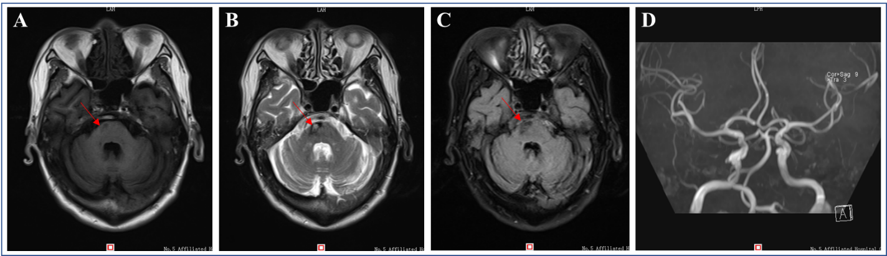
Figure 1 Brain magnetic resonance imaging obtained 27 mo after stroke showed abnormal signals in the right part of the pons. A-C: The signals are hypointense on T1-weighted imaging (T1WI) (A, red arrow) as well as fluid-attenuated inversion recovery (C, red arrow) and hyperintense on T2-weighted imaging (T2WI) (B, right arrow); D: Magnetic resonance angiography revealed arteriosclerosis in bilateral siphon arteries.
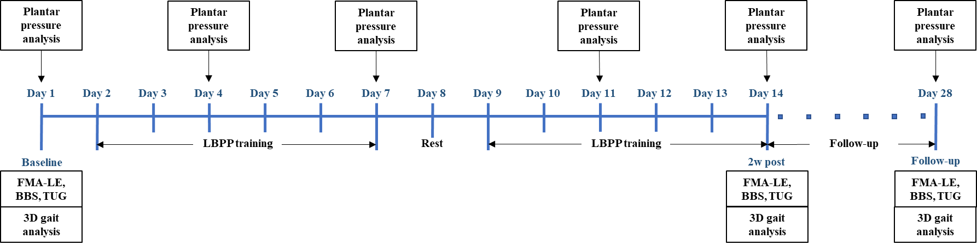
Figure 2 Timeline for the whole evaluation and intervention process. The lower body positive pressure training was performed one session per day and six times per week for 2 wk. The plantar pressure analysis was performed on days 1 (baseline/pre-treatment), 4, 7, 11, 14 (post-treatment), and 28 (follow-up). Lower extremity subscale of the Fugl–Meyer Assessment, Berg Balance Scale, Timed Up and Go test, and three-dimensional gait analysis were assessed on days 1 (pre-treatment), 14 (post-treatment), and 28 (follow-up). FMA-LE: Lower extremity subscale of the Fugl–Meyer Assessment; BBS: Berg Balance Scale; TUG: Timed Up and Go test; 3D: Three-dimensional.
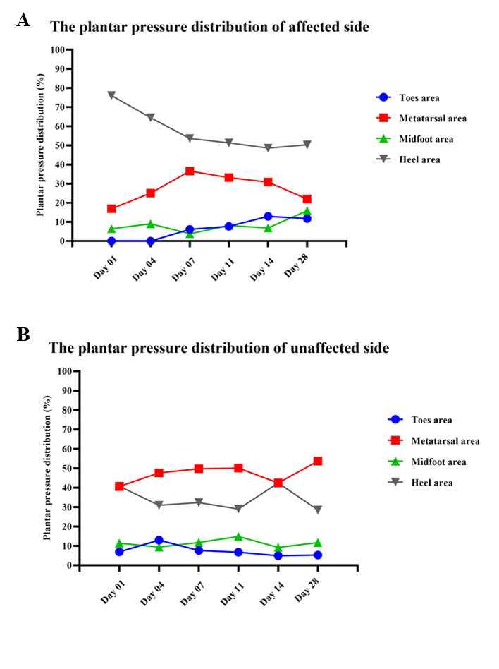
Figure 3 Plantar pressure distributions measured on days 1 (baseline/pretreatment), 4, 7, 11, 14 (posttreatment), and 28 (follow-up) on the affected side and unaffected side. A: Affected side; B: Unaffected side.
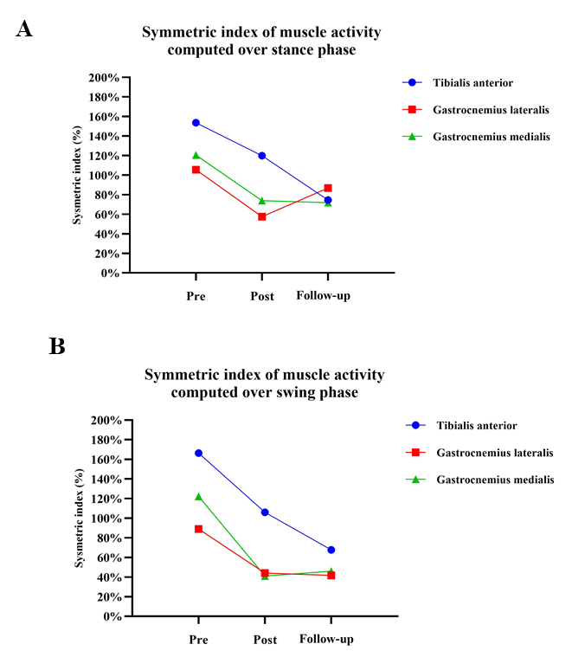
Figure 4 Symmetric index of mean muscle activity computed during stance phase and swing phase. The lower the value of the symmetric index, the lesser the difference between the affected side and the unaffected side. During both the stance phase and swing phase, the symmetry of muscle activities (including the tibialis anterior, gastrocnemius lateralis, and gastrocnemius medialis) were better posttreatment than pretreatment. The symmetry of gastrocnemius medialis activities were slightly worse at follow-up. A: Stance phase; B: Swing phase.

Table 1 Scores of clinical assessments before and after intervention and at 4-wk follow-up
 | FMA-LE (total score) | BBS (total score) | TUGT (s)
Pre-treatment | 18 (34) | 39 (56) | 34.1
Post-treatment | 18 (34) | 43 (56) | 27.1
Follow-up | 18 (34) | 45 (56) | 27.5
FMA-LE: Fugl-Meyer Assessment of Lower extremity; BBS: Berg Balance Scale; TUGT: Timed Up and Go Test.
Table 2 Plantar pressure distributions in percentage measured on days 1 (baseline/pretreatment), 4, 7, 11, 14 (posttreatment), and 28 (follow-up) on the affected side and unaffected side
 | Toes area |  | Metatarsal area |  | Midfoot area |  | Heel area
 | Affected | Unaffected | Affected | Unaffected | Affected | Unaffected | Affected | Unaffected
Day 01 | 0 | 6.92 | 16.93 | 40.63 | 6.47 | 11.43 | 76.1 | 40.77
Day 04 | 0 | 12.98 | 25.06 | 47.62 | 9.04 | 9.42 | 64.48 | 30.96
Day 07 | 6.15 | 7.67 | 36.55 | 49.74 | 3.82 | 11.76 | 53.66 | 32.35
Day 11 | 7.71 | 6.75 | 33.17 | 50.13 | 8.15 | 14.84 | 51.32 | 29.02
Day 14 | 12.9 | 4.92 | 30.8 | 42.43 | 6.87 | 9.23 | 48.59 | 42.46
Day 28 | 11.75 | 5.27 | 22.02 | 53.72 | 15.9 | 11.71 | 50.32 | 28.52
Affected: affected side; Unaffected: unaffected side.
Table 3 Gait spatial-temporal parameters and symmetric index before and after intervention and at 4-wk follow-up
 | Mean velocity (%height/s) | Cadence (steps/min) | Symmetric index (SI, %)
 |  |  | SI _{Stride (%height)} | SI _{Cadence}
Pre-treatment | 16.95 | 73.60 | 125.12 | 193.31
Post-treatment | 18.21 | 81.20 | 126.74 | 193.85
Follow-up | 18.39 | 76.40 | 122.40 | 193.69
SI: Symmetric index.
Table 4 Mean root-mean-square values (μv) over the gait cycle computed for the tibialis anterior, gastrocnemius lateralis, and gastrocnemius medialis of the affected and unaffected lower limbs before and after intervention and at 4-wk
 | TA |  | GL |  | GM |  | Symmetric index (SI, %)
 | Affected | Unaffected | Affected | Unaffected | Affected | Unaffected | SI_{TA} | SI_{GL} | SI_{GM}
Stance phase
Pre-treatment | 9.95 | 75.78 | 22.53 | 72.83 | 11.96 | 48.20 | 153.58 | 105.49 | 120.48
Post-treatment | 19.46 | 77.74 | 25.95 | 46.85 | 19.00 | 41.24 | 119.92 | 57.42 | 73.84
Follow-up | 25.54 | 55.85 | 23.05 | 58.38 | 20.41 | 43.24 | 74.48 | 86.77 | 71.74
Swing phase
Pre-treatment | 8.11 | 88.40 | 20.27 | 52.73 | 9.93 | 41.19 | 166.39 | 88.93 | 122.30
Post-treatment | 20.73 | 67.43 | 22.12 | 34.60 | 17.96 | 27.23 | 105.94 | 44.01 | 41.03
Follow-up | 36.38 | 73.66 | 21.74 | 33.18 | 18.97 | 30.26 | 67.76 | 41.66 | 45.87
RMS: Root-mean-square; TA: Tibialis anterior; GL: Gastrocnemius lateralis; GM: Gastrocnemius medialis; μv: Microvolt.

