Name of journal: World Journal of Clinical Cases
ESPS Manuscript No: 6567
Columns: Case Report

Atrium of stone: A case of confined left atrial calcification without hemodynamic compromise

Jones C et al. Atrium of Stone

Christopher Jones, Aadil Mubeen Lodhi, Arjun Kumar Chagarlamudi, Long Bao Cao, Assad Movahed

______________________________________________________________________________
Christopher Jones, Aadil Mubeen Lodhi, Long-Bao Cao, Arjun Kumar Chagarlamudi, Assad Movahed, Department of Cardiovascular Sciences, East Carolina Heart Institute, Brody School of Medicine, East Carolina University, Greenville, NC 27858, United States

Author contributions: Jones C, Lodhi AM, Cao LB, Chagarlamudi AK and Movahed A contributed to the manuscript writing and revision.

Supported by the “East Carolina Heart Institute”

Correspondence to: Assad Movahed, MD, Department of Cardiovascular Sciences, East Carolina Heart Institute, Brody School of Medicine, East Carolina University, 115 Heart Drive, Mail Stop 651, Greenville, NC 27858, United States. movaheda@ecu.edu

Telephone: +1-832-3731447 Fax: +1-252-7447724
Received: October 23, 2013 Revised: March 4, 2014
Accepted: April 25, 2014

Published online:

Abstract
Dystrophic cardiac calcification is often associated with conditions causing systemic inflammation and when present, is usually extensive, often encompassing multiple cardiac chambers and valves. We present an unusual case of dystrophic left atrial calcification in the setting of end stage renal disease on hemodialysis diagnosed by echocardiography and computed tomography (CT). Calcium deposition is significantly confined within the walls of the left atrium with no involvement of the mitral valve or untoward effects on hemodynamics.

© 2014 Baishideng Publishing Group Co., Limited. All rights reserved.

Key words: Left atrium calcification; Heart of stone; Atrial calcification; Dystrophic cardiac calcification; Renal failure

Core tip: Dystrophic cardiac calcification can often lead to complicated valular stenosis, cardiac arrhythmias, cardiac block and abnormal cardiac hemodynamics by effecting systolic and diastolic cardiac function, thus awareness, early detection and treatment of the underlying cause, and resulting complications is key to patient outcome.

Jones C, Lodhi AM, Cao LB, Chagarlamudi AK, Movahed A. Atrium of stone: A case of confined left atrial calcification without hemodynamic compromise.
Available from:
DOI:

INTRODUCTION
Dystrophic cardiac calcification is often diffuse and occurs primarily in patients with chronic inflammatory diseases. Long term advancement of dystrophic calcification often lead to complicated valular stenosis, cardiac arrhythmias, cardiac block and abnormal cardiac hemodynamic by effecting systolic and diastolic cardiac function, thus awareness, early detection and treatment of the underlying cause, and resulting complications is key to patient outcome.

CASE REPORT
A 55-year-old African-American woman with past medical history of hypertension, endstage renal failure on dialysis with failure of previous renal transplant presented for cardiac risk stratification prior to renal transplant surgery. Previous work up for renal transplant had been unremarkable except for elevated intact parathyroid hormone of 1346 pg/mL. Electrocardiogram (EKG) showed normal sinus rhythm. By Teichholtz equation, transthoracic echocardiography showed a left ventricular ejection fraction (LVEF) of 75%. In the parasternal long axis view, the interventricular septal diameter (IVSd) was 1 cm, the left ventricular posterior wall diameter (LVPwd) was 1.1 cm, the left ventricular end diastolic diameter (LVeDd) was 4 cm, and the left ventricular mass index was greater than 86 grams/m². There was concentric remodeling by relative wall thickness (RWT) calculation. Grade 2 diastolic dysfunction with pseudonormalization mitral inflow pattern was observed. The E:A was 1.4, lateral e’ of 8.68 cm/s, medial e’ of 6.14 cm/s, and a deceleration time of 200 ms. The left atrial size and volume was in the upper limits of normal. (Normal left atrial size by index is < 29 cm/m²)^{[1]}. The left atrial wall, however, showed diffuse hyper-echogenicity not observed in the left ventricular walls. This hyper-echogenicity did not restrict the movement of the mitral valve leaflets (Figure 1). Tricuspid annular plane systolic excursion was 2.1 cm/s. A transesophageal echocardiogram was not performed in this case. However, in order to confirm our suspicion and diagnosis, the patient underwent a non-enhanced computed tomography (CT) of the chest which noted increased attenuation of the left atrial wall, consistent with calcification of majority of the left atrium and mild calcification of the ascending aorta (Figure 2). The CT unfortunately did not show the aorto-mitral continuity well. The Calcium-phosphorous product at time of evaluation was within normal limits, and patient had no history of tuberculosis or a positive PPD.

Discussion
Calcification seen in patients is typically either a product of metastatic calcification or dystrophic calcification. Metastatic calcification is typically seen in patients with a disturbance of Calcium and Phosphorus metabolism, often due to renal dysfunction. In our patient, although the intact parathyroid hormone level was elevated on previous workup for renal transplant, the pattern of calcification was that of a dense, finely speckled pattern. This indicates that the calcification in the left atrium is a product of dystrophic calcification and not that of metastatic calcification.
Dystrophic myocardial calcification which is increased intracellular calcium deposition driven by high serum calcium, is a well described process associated with conditions that cause systemic inflammation such as renal failure, rheumatic disease or cardiac surgery^{[2-5]}. Calcium deposition often involves the left atrial appendage, free wall and septal wall, and mitral valve as well. In severe cases the entire atrium is involved with significant mitral valve stenos is or malcoaptation^{[6]}. In cases where an entire atrium is involved, it is often referred to as a “coconut” ^{[7]} or “porcelain atrium”^{[8]}. Although calcification of parts or the whole left atrium have been well documented, calcium deposition confined to the left atrial walls without valular involvement is a unique variant.
There are several genes that have been linked to dystrophic cardiac calcification, including but not limited to the ATP-binding cassette transporter subtype 6 (Abcc6) gene which was recently found to mediate myocardial necrosis and calcification^{[9-11]}, the Adiponectin (Adipoq) gene which was linked to calcification of the aortic median^{[12,13]}, the alpha2-HS-glycoprotein/fetuin (Ahsg) gene which has been linked to calcification of coronary artery plaques in patients with type II diabetes^{[14,15]}, the ectonucleotide pyrophosphatase/phosphodiesterase1 (Enpp1) gene which has been linked to increased aortic arch calcifications in patients with type II diabetes and higher coronary calcification scores in patients with End Stage Renal Disease^{[16-20]}, and the Osteoprotegerin (Opg) gene which has been linked to increased risk for coronary artery disease^{[21-25]}.
Women in their fifth and sixth decades are most often affected^{[6]} and can be classified into one of three types which are associated with prior mitral valve dysfunction^{[26]}. Type A is caused by mitral stenos is with calcification confined to the left atrial appendage causing an increased occurrence of thrombi within the appendage. Type B is the result of advanced mitral stenos is with calcification confined to the left atrial free wall and the mitral valve. Type C is the confined calcification of the posterior wall of the left atrium. This particular pattern of left atrial calcium deposition is known as MacCallum’s patch and is often the result of a regurgitant mitral jet^{[26]}. The structure that is most often spared is the interatrial septum. When the septal wall is calcified as well, the term coconut atrium is used to describe the hyperdense white appearance of the complete left atrial calcification on imaging^{[6]}. Multiple imaging techniques can be used to diagnose and assess the extent of calcification. On anterior-posterior chest radiograph mural calcification presents as a thin C shaped curvilinear density outlining the left atrium partially or completely with the opening of the C anterior to mitral annulus. Hyper-echogenicity within the walls of the left atrium, Restriction in atrial wall motion and mitral valve abnormalities can be well visualized with transthoracic and transesophageal echocardiography, however, CT is superior to all other imaging modalities for determining extent of calcification^{[20,27]}.
Dystrophic calcification of the left atrium can cause significant complications which can lead to hemodynamic compromise or even collapse. A common complication is the occurrence of mitral stenos is as the mitral leaflets become restricted due to calcification^{[20]}. In cases of significant calcium deposition Arrhythmias can present especially if calcification occurs outside the left atrium involving the SA node, AV node or other points along the cardiac conduction system. Over time increased left atrial pressure can develop due to decreased compliance of the left atrial walls and can be transmitted through pulmonary veins resulting in derangements in right heart hemodynamics (Figure 3)^{[7,28]}.
The accepted surgical treatment for left atrial calcification is endoatrioectomy with mitral valve replacement as the calcification usually does not extend beyond the endocardium^{[25]}. Total endoatrioectomy of a calcified left atrium has been shown to be a technique with limited morbidity, however, not much follow up of atrial compliance has been done in patients who undergo this procedure in order to quantify improvement^{[29]}. The two major contraindications to endoatrioectomy are calcification of the left atrial septal wall and mitral annulus. Septal calcification makes repair difficult and increases mortality due to the septum serving as a cleavage plane during surgery which helps prevent hemorrhage and embolization if thrombus is present. Caseous necrosis is known to cause mitral calcification, usually occurring along the posterior annulus^{[28,30]}.
Our case presentation is unique in that all of the walls of the left atrium are heavily calcified including the septal wall and left atrial appendage with minimal presence in the ascending aorta, however, there is no calcification of the mitral valve and no resultant mitral stenos is, mitral regurgitation, arrhythmias or hemodynamic compromise.

Comments
Case characteristics
In a preoperative evaluation for renal transplant of an asymptomatic patient with a prior history of ESRD and HTN, there were no significant clinical or exam findings.

Clinical diagnosis
However, upon routine echocardiogram and chest x-ray, findings of dystrophic calcification was seen in the heart.

Differential diagnosis
Findings of dystrophic calcification lead to further concerns of tuberculosis, sarcoidosis, and other rare systemic inflammatory diseases.

Laboratory diagnosis
Calcium-phosphorous product at time of evaluation was within normal limits, and patient had no history of tuberculosis or a positive PPD.

Imaging diagnosis
Further evaluation by CT imaging confirmed a calcified left atrium and made sarcoidosis, and other more rare inflammatory disease less likely.

Pathological diagnosis
No further pathological studies were done, but the additional imaging studies confirmed dystrophic calcification in an individual with ESRD, a systemic inflammatory disease equivalent.

Treatment
The patient is at risk for complicated valvular stenosis, cardiac arrhythmias, cardiac block and abnormal cardiac hemodynamics due to this dystrophic calcification; thus close follow-up, and early treatment of these resulting complications are the key to the patient’s outcome.

Term explanation
An “atrium of stone,” thus refers to this dystrophic calcification almost isolated to the left atrium.

Experiences and lessons
ESRD patients often carry a higher mortality and morbidity than previous thought, which may not always be present on initial clinical and exam assessment.

Peer review
The authors present an unusual case of dystrophic left atrial calcification in the setting of end stage renal disease on hemodialysis diagnosed by echocardiography and computed tomography. Calcium deposition is significantly confined within the walls of the left atrium with no involvement of the mitral valve or untoward effects on hemodynamics. This is an interesting case report for the clinical practice.
REFERENCES
1 Lang RM, Bierig M, Devereux RB, Flachskampf FA, Foster E, Pellikka PA, Picard MH, Roman MJ, Seward J, Shanewise JS, Solomon SD, Spencer KT, Sutton MS, Stewart WJ. Recommendations for chamber quantification: a report from the American Society of Echocardiography's Guidelines and Standards Committee and the Chamber Quantification Writing Group, developed in conjunction with the European Association of Echocardiography, a branch of the European Society of Cardiology. J Am Soc Echocardiogr 2005; 18: 1440-1463 [PMID: 16376782]
2 Kuzela DC, Huffer WE, Conger JD, Winter SD, Hammond WS. Soft tissue calcification in chronic dialysis patients. Am J Pathol 1977; 86: 403-424 [PMID: 836675]
3 Lee CJ, Ramirez C, Thomson LE. A stone heart: fatal cardiac microcalcification. Eur Heart J 2007; 28: 2312 [PMID: 17483106 DOI: 10.1093/eurheartj/ehm100]
4 Tom CW, Talreja DR. Heart of stone. Mayo Clin Proc 2006; 81: 335 [PMID: 16529137 DOI: 10.4065/81.3.335]
5 Lee HU, Youn HJ, Shim BJ, Lee SJ, Park MY, Jeong JU, Gu GM, Jeon HK, Lee JE, Kwon BJ. Porcelain heart: rapid progression of cardiac calcification in a patient with hemodialysis. J Cardiovasc Ultrasound 2012; 20: 193-196 [PMID: 23346289 DOI: 10.4250/jcu.2012.20.4.193]
6 Leacock K, Duerinckx AJ, Davis B. Porcelain atrium: a case report with literature review. Case Rep Radiol 2011; 2011: 501396 [PMID: 22606546 DOI: 10.1155/2011/501396]
7 Del Campo C, Weinstein P, Kunnelis C, DiStefano P, Ebers GM. Coconut atrium: transmural calcification of the entire left atrium. Tex Heart Inst J 2000; 27: 49-51 [PMID: 10830629]
8 Edwards JM, Chisholm RJ. Porcelain atrium: rheumatic heart disease. Can J Cardiol 2006; 22: 267 [PMID: 16520861]
9 Ivandic BT, Qiao JH, Machleder D, Liao F, Drake TA, Lusis AJ. A locus on chromosome 7 determines myocardial cell necrosis and calcification (dystrophic cardiac calcinosis) in mice. Proc Natl Acad Sci USA 1996; 93: 5483-5488 [PMID: 8643601]
10 Meng H, Vera I, Che N, Wang X, Wang SS, Ingram-Drake L, Schadt EE, Drake TA, Lusis AJ. Identification of Abcc6 as the major causal gene for dystrophic cardiac calcification in mice through integrative genomics. Proc Natl Acad Sci USA 2007; 104: 4530-4535 [PMID: 17360558]
11 Aherrahrou Z, Doehring LC, Ehlers EM, Liptau H, Depping R, Linsel-Nitschke P, Kaczmarek PM, Erdmann J, Schunkert H. An alternative splice variant in Abcc6, the gene causing dystrophic calcification, leads to protein deficiency in C3H/He mice. J Biol Chem 2008; 283: 7608-7615 [PMID: 18201967]
12 Luo XH, Zhao LL, Yuan LQ, Wang M, Xie H, Liao EY. Development of arterial calcification in adiponectin-deficient mice: adiponectin regulates arterial calcification. J Bone Miner Res 2009; 24: 1461-1468 [PMID: 19257834]
13 Wassel CL, Pankow JS, Rasmussen-Torvik LJ, Li N, Taylor KD, Guo X, Goodarzi MO, Palmas WR, Post WS. Associations of SNPs in ADIPOQ and subclinical cardiovascular disease in the multi-ethnic study of atherosclerosis (MESA). Obesity (Silver Spring) 2011; 19: 840-847 [PMID: 20930713]
14 Lehtinen AB, Burdon KP, Lewis JP, Langefeld CD, Ziegler JT, Rich SS, Register TC, Carr JJ, Freedman BI, Bowden DW. Association of alpha2-Heremans-Schmid glycoprotein polymorphisms with subclinical atherosclerosis. J Clin Endocrinol Metab 2007; 92: 345-352 [PMID: 17062776]
15 Jahnen-Dechent W, Schinke T, Trindl A, Müller-Esterl W, Sablitzky F, Kaiser S, Blessing M. Cloning and targeted deletion of the mouse fetuin gene. J Biol Chem 1997; 272: 31496-31503 [PMID: 9395485]
16 Rutsch F, Ruf N, Vaingankar S, Toliat MR, Suk A, Höhne W, Schauer G, Lehmann M, Roscioli T, Schnabel D, Epplen JT, Knisely A, Superti-Furga A, McGill J, Filippone M, Sinaiko AR, Vallance H, Hinrichs B, Smith W, Ferre M, Terkeltaub R, Nürnberg P. Mutations in ENPP1 are associated with 'idiopathic' infantile arterial calcification. Nat Genet 2003; 34: 379-381 [PMID: 12881724]
17 Hosoda Y, Yoshimura Y, Higaki S. A new breed of mouse showing multiple osteochondral lesions--twy mouse. Ryumachi 1981; 21 Suppl: 157-164 [PMID: 7344126]
18 Lorenz-Depiereux B, Schnabel D, Tiosano D, Häusler G, Strom TM. Loss-of-function ENPP1 mutations cause both generalized arterial calcification of infancy and autosomal-recessive hypophosphatemic rickets. Am J Hum Genet 2010; 86: 267-272 [PMID: 20137773]
19 Lee JE, Choi YK, Seo HA, Jeon JH, Jeong JY, Moon SS, Kim JG, Kim BW, Kim SW, Min Yoo JY, Lee IK. Impact of ENPP1 and MMP3 gene polymorphisms on aortic calcification in patients with type 2 diabetes in a Korean population. Diabetes Res Clin Pract 2010; 88: 87-96 [PMID: 20092902]
20 Gedgaudas E, Kieffer SA, Erickson C. Left atrial calcification. Am J Roentgenol Radium Ther Nucl Med 1968; 102: 293-296 [PMID: 5635682 DOI: 10.2214/ajr.102.2.293]
21 Bucay N, Sarosi I, Dunstan CR, Morony S, Tarpley J, Capparelli C, Scully S, Tan HL, Xu W, Lacey DL, Boyle WJ, Simonet WS. osteoprotegerin-deficient mice develop early onset osteoporosis and arterial calcification. Genes Dev 1998; 12: 1260-1268 [PMID: 9573043]
22 Mizuno A, Amizuka N, Irie K, Murakami A, Fujise N, Kanno T, Sato Y, Nakagawa N, Yasuda H, Mochizuki S, Gomibuchi T, Yano K, Shima N, Washida N, Tsuda E, Morinaga T, Higashio K, Ozawa H. Severe osteoporosis in mice lacking osteoclastogenesis inhibitory factor/osteoprotegerin. Biochem Biophys Res Commun 1998; 247: 610-615 [PMID: 9647741]
23 Orita Y, Yamamoto H, Kohno N, Sugihara M, Honda H, Kawamata S, Mito S, Soe NN, Yoshizumi M. Role of osteoprotegerin in arterial calcification: development of new animal model. Arterioscler Thromb Vasc Biol 2007; 27: 2058-2064 [PMID: 17615383]
24 Soufi M, Schoppet M, Sattler AM, Herzum M, Maisch B, Hofbauer LC, Schaefer JR. Osteoprotegerin gene polymorphisms in men with coronary artery disease. J Clin Endocrinol Metab 2004; 89: 3764-3768 [PMID: 15292302]
25 Lee WJ, Son CW, Yoon JC, Jo HS, Son JW, Park KH, Lee SH, Shin DG, Hong GR, Park JS, Kim YJ. Massive left atrial calcification associated with mitral valve replacement. J Cardiovasc Ultrasound 2010; 18: 151-153 [PMID: 21253366 DOI: 10.4250/jcu.2010.18.4.151]
26 Shaw DR, Chen JT, Lester RG. X-ray appearance and clinical significance of left atrial wall calcification. Invest Radiol 1976; 11: 501-507 [PMID: 1002404 DOI: 10.1097/00004424-197611000-00001]
27 Seltzer RA, Harthorne JW, Austen WG. The appearance and significance of left atrial calcification. Am J Roentgenol Radium Ther Nucl Med 1967; 100: 307-311 [PMID: 6025199 DOI: 10.2214/ajr.100.2.307]
28 Montes L, Rodriguez JE, Carnero M. Giant right atrial dilation and left atrial calcification. Ann Thorac Surg 2011; 91: e80 [PMID: 21524439 DOI: 10.1016/j.athoracsur.2011.02.085]
29 Vallejo JL, Merino C, González-Santos JM, Bastida E, Albertos J, Riesgo MJ, González de Diego F. Massive calcification of the left atrium: surgical implications. Ann Thorac Surg 1995; 60: 1226-1229 [PMID: 8526604]
30 Harthorne JW, Seltzer RA, Austen WG. Left atrial calcification. Review of literature and proposed management. Circulation 1966; 34: 198-210 [PMID: 5969353 DOI: 10.1161/01.CIR.34.2.198]

P-Reviewers: Letsas K, Martí-Carvajal A, Sakabe K, Trohman R S-Editor: Ma YJ L-Editor: E-Editor:

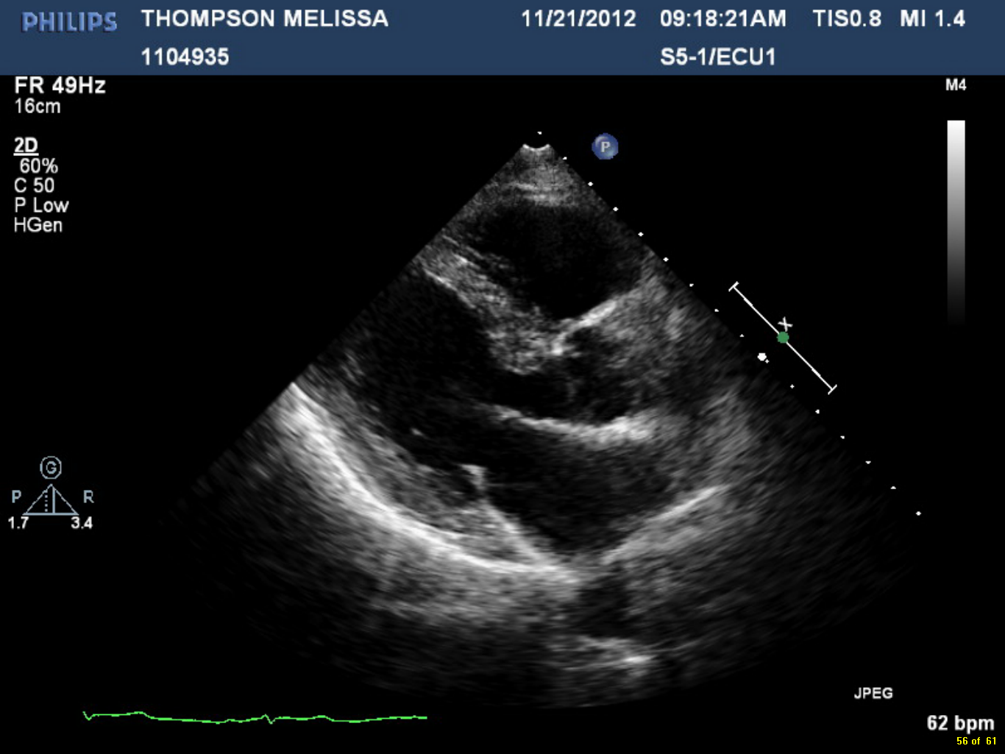
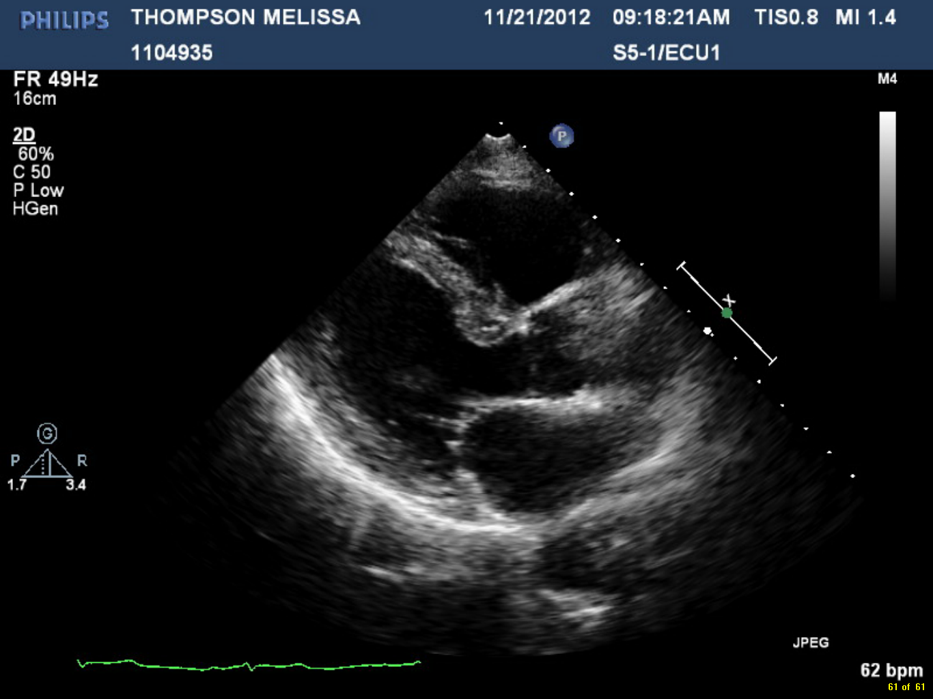
B
A
LA
LA
RVOT
RVOT
LV
LV

AO
AO

MV
MV

Figure 1 Transthoracic 2D parasternal long axis. A: systole shows diffuse echo dense signal significantly confined to the walls of the left atrium (LA) indicated by arrow. No mitral valve (MV) or mitral annulus involvement. Valve closes normally during systole; B: diastole shows adequate mitral valve opening.

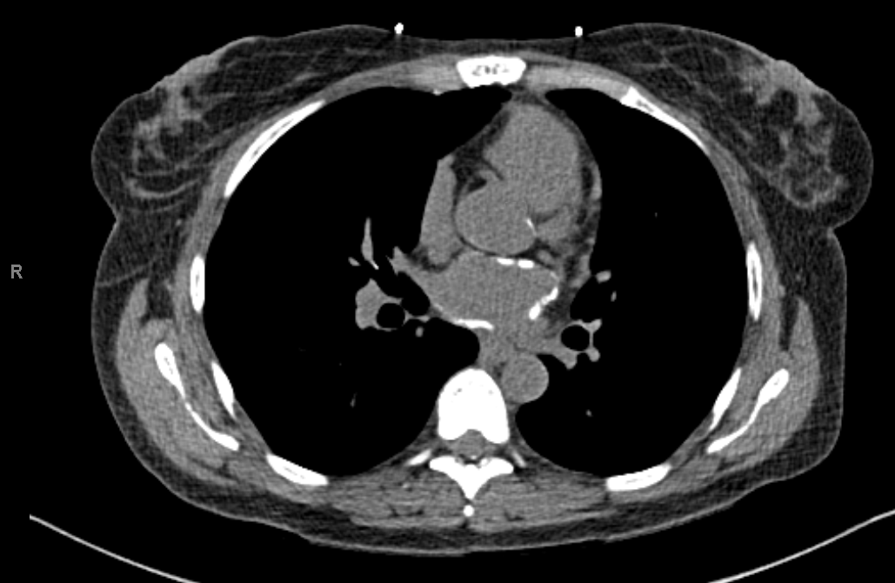
LA
AO

Figure 2 Cardiac computed tomography indicating calcium within the walls of the left atrium and mild calcification of the aortic root.

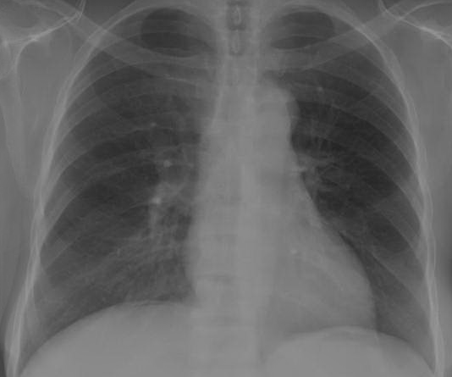

Figure 3 CXR shows a small amount of what appears to be pneumoperitoneum beneath the right hemi- diaphragm that was present prior, otherwise, no change.

