Name of journal: World Journal of Gastroenterology
Manuscript NO: 38118
Manuscript type: ORIGINAL ARTICLE

Retrospective Study
Prognostic significance of combined preoperative fibrinogen and CA199 in gallbladder cancer patients

Xu WY et al. prognostic biomarker and gallbladder cancer

Wei-Yu Xu, Hao-hai Zhang, Xiao-bo Yang, Yi Bai, Jian-Zhen Lin, Jun-Yu Long, Jian-Ping Xiong, Jun-Wei Zhang, Xin-Ting Sang, Hai-Tao Zhao

Wei-Yu Xu, Hao-hai Zhang, Xiao-bo Yang, Yi Bai, Jian-Zhen Lin, Jun-Yu Long, Jian-Ping Xiong, Jun-Wei Zhang, Xin-Ting Sang, Hai-Tao Zhao, Department of Liver Surgery, Peking Union Medical College Hospital, Chinese Academy of Medical Sciences and Peking Union Medical College, Beijing 100730, China

ORCID number: Wei-yu Xu (0000-0002-2101-4829); Hao-hai Zhang (0000-0002-5292-6505); Xiao-bo Yang (0000-0003-1929-8866); Yi Bai (0000-0002-1179-3734); Jian-Zhen Lin (0000-0002-4767-8834); Jun-Yu Long (0000-0001-5745-7165); Jian-Ping Xiong (0000-0002-6163-2621); Jun-Wei Zhang (0000-0002-2833-0090); Xin-Ting Sang (0000-0003-1952-0527); Hai-Tao Zhao (0000-0002-3444-8044).

Author contributions: Xu WY, Zhang HH and Yang XB contributed equally to this work. Xu WY conceived, designed and wrote the manuscript that led to the submission; Xu WY, Zhang JW, Bai Y and Yang XB collected the clinical data and followed up the patients; Lin JZ, Long JY and Xiong JP helped to analyze the data, Bai Y revised then manuscript, Sang XT and Zhao HT provided financial support for this work; Sang XT and Zhao HT are co-corresponding authors, and they contributed equally to this work; All authors read and approved the final manuscript.

Supported by National key project research and development projects, No. S2016G9012; International Science and Technology Cooperation Projects, No. 2015DFA30650; and The Capital Special Research Project for Clinical Application, No. Z151100004015170.

Institutional review board statement: The publication of this manuscript has been reviewed and approved by the PUMCH institutional review board.

Informed consent statement: All patients and their families signed informed consent statements before surgery, and the type of surgical procedure was performed according to the approved guidelines.

Conflict-of-interest statement: We declare that the authors have no conflict of interest.

Data sharing statement: No additional data are available.

Open-Access: This article is an open-access article which was selected by an in-house editor and fully peer-reviewed by external reviewers. It is distributed in accordance with the Creative Commons Attribution Non Commercial (CC BY-NC 4.0) license, which permits others to distribute, remix, adapt, build upon this work non-commercially, and license their derivative works on different terms, provided the original work is properly cited and the use is non-commercial. See: http://creativecommons.org/licenses/by-nc/4.0/

Manuscript source: Unsolicited manuscript

Correspondence to: Hai-tao Zhao, MD, Professor, Department of Liver Surgery, Peking Union Medical College Hospital, Chinese Academy of Medical Sciences and Peking Union Medical College, 1 Shuaifuyuan, Wangfujing, Beijing 100730, China. zhaoht@pumch.cn
Telephone: +86-10-69156042
Fax: +86-10-69156042

Received: January 26, 2018
Peer-review started: January 26, 2018
First decision: February 10, 2018
Revised: March 7, 2018
Accepted: March 10, 2018
Article in press:
Published online:

Abstract
AIM
To investigate the prognostic value of the combination of preoperative plasma fibrinogen and CA199 in patients with gallbladder carcinoma (GBC).

METHODS
The clinicopathological data of 154 GBC patients after surgery were retrospectively reviewed. A receiver operating characteristic (ROC) curve was plotted to verify the optimum cutoff values for plasma fibrinogen and CA199. Univariate and multivariate survival analyses were performed to identify the factors associated with GBC prognosis. Based on the HRs calculated via multivariate survival analyses, patients with elevated plasma fibrinogen and CA199 levels were allocated a score of 2.1; those with an elevated plasma fibrinogen level alone were allocated a score of 1, those with an elevated CA199 level alone were allocated a score of 1.1, and those with neither of these abnormalities were allocated a score of 0.

RESULTS
ROC curve analysis showed that the optimum cut-off values for preoperative plasma fibrinogen and CA199 were 3.47 g/L and 25.45 U/ml, respectively. Multivariate analysis indicated that elevated preoperative plasma fibrinogen and CA199 levels were significantly correlated with worse overall survival (OS) (HR = 1.711, 95%CI: 1.114-2.627, P = 0.014, and HR = 1.842, 95%CI: 1.111-3.056, P = 0.018). When we combined these two parameters, the area under the ROC curve increased from 0.735 (for preoperative plasma fibrinogen only) and 0.729 (for preoperative CA199 only) to 0.765. When this combined variable was added to the multivariate analysis, the combination of plasma fibrinogen and CA199 (P < 0.001), resection margin (P < 0.001) and TNM stage (P = 0.010) were independent prognostic factors for GBC.

CONCLUSION
The combination of plasma fibrinogen and CA199 may serve as a more efficient independent prognostic biomarker for postoperative GBC patients than either parameter alone.

Key words: Prognostic factor; Plasma fibrinogen; CA199; Survival; Gallbladder cancer

© The Author (s) 2018. Published by Baishideng Publishing Group Inc. All rights reserved.

Core tip: Elevated plasma fibrinogen and CA199 levels are associated with a poor prognosis of gallbladder carcinoma (GBC). The prognostic value of the combination of plasma fibrinogen and CA199 for GBC has not been reported. The most important finding in this study was that the combination of preoperative plasma fibrinogen and CA199 levels was a better independent prognostic indicator for GBC than either parameter alone.

Xu WY, Zhang HH, Bai Y, Yang XB, Lin JZ, Long JY, Xiong JP, Zhang JW, Sang XT, Zhao HT. Prognostic significance of combined preoperative fibrinogen and CA199 in gallbladder cancer patients. World J Gastroenterol 2018; In press

INTRODUCTION
Primary gallbladder carcinoma (GBC) is relatively rare worldwide but is the most common malignancy of the biliary tract system^{[1]}. GBC is the seventh most common gastrointestinal cancer^{[2]} and is attributable to approximately 1% of all cancer cases in China^{[3]}. The incidence of this malignancy has been recently reported to be approximately 2.5 per 100000 persons^{[4]}. The prognosis of this malignancy is still typically poor because of nonspecific symptoms, late diagnosis, lack of treatment options, and absence of effective prognostic markers. According to epidemiological studies, the overall survival (OS) of GBC patients is 6 mo, with a 5­year survival rate of less than 10%^{[1,5-7]}. Therefore, investigations of the prognostic factors for GBC are especially important.
The association between hemostasis and cancer and the influence of hemostatic factors on cancer development, growth, and metastasis are evident^{[8,9]}. Fibrinogen is a 340-kDa plasma glycoprotein that is upregulated during systemic inflammation and tissue injury. Fibrinogen is synthesized in the liver and transformed into fibrin through the activity of activated thrombin, which is a key coagulation factor in platelet aggregation, clot formation, wound healing, and coagulation^{[10-12]}. A number of studies have shown that plasma fibrinogen levels are upregulated in various cancer types, such as respiratory system tumors^{[13,14]}, digestive system tumors^{[15-18]}, gynecological tumors^{[19-22]}, head and neck cancer^{[23,24]} and genitourinary tumors^{[25,26]}, and may indicate cancer progression, metastasis and recurrence^{[17,22,27-29]}. However, to our knowledge, studies on the prognostic value of plasma fibrinogen levels for GBC are very rare^{[30]}.
Meanwhile, CA199 has been traditionally used for the diagnosis and prognosis of GBC^{[31]}; however, the reported results on its prognostic value for GBC patients are inconsistent and controversial^{[30,32,33]}. Therefore, we hypothesized that the combination of plasma fibrinogen and CA199 levels may avoid inconsistent results and increase the prognostic accuracy for GBC.
Hence, the aim of the current study was to investigate the prognostic value of the combination of plasma fibrinogen and CA199 levels in patients with GBC. Additionally, we aimed to determine whether the combination of plasma fibrinogen and CA199 levels can serve as a more efficient predictive factor than either parameter alone for patients with GBC.

MATERIALS AND METHODS
Study population
From January 2005 to May 2017, a retrospective analysis was conducted on 154 GBC patients after surgery in the Department of Liver Surgery at the Peking Union Medical College Hospital of the Chinese Academy of Medical Sciences and Peking Union Medical College (CAMS & PUMC). The patients included in the analysis met the following criteria: (1) GBC diagnosis confirmed by histopathology and cancer stage determined in accordance with the American Joint Committee on Cancer staging system, 8th Edition (AJCC-8), and the histopathologic postoperative pathologic tumor-node-metastasis (pTNM) categorization system (International Union against Cancer Staging Manual, 7th Edition; UICC-7); and (2) no adjuvant chemotherapy and/or radiotherapy before gallbladder resection surgery. Patients with the following characteristics were excluded: (1) other tumors; (2) inflammatory conditions, including infections, collagen diseases, anemia, other diseases concerning the hematological system, and absolute cardiovascular and cerebrovascular disorders; and (3) liver disease; (4) oral administration of anticoagulants or acetylsalicylic acids within 3 mo before the operation; (5) lack of adequate clinical data or loss to follow-up. This study was approved by the Medical Ethics Committee of the Peking Union Medical College Hospital of the CAMS & PUMC, and all participants signed written informed consent forms.

Data collection
Patient characteristics were collected via a retrospective medical record review using a standardized data collection form. Based on the medical records, the following data were collected for each patient: age, gender, plasma fibrinogen concentration, CA199 level, tumor size (defined as the longest diameter of the general postoperative pathological specimens), gallstone history, jaundice, comorbidity (diabetes), resection margin, tumor differentiation (categorized into poorly differentiated, moderately differentiated and well differentiated), T stage, N stage, M stage, pTNM stage (as defined by AJCC-8), pathological type and other miscellaneous characteristics.

Plasma fibrinogen concentration and CA199 level
The plasma fibrinogen concentration and CA199 level were measured within 3 days before surgery as part of a routine workup in these patients. The fibrinogen concentration was measured based on the Clauss method as previously described^{[34]}, and the CA199 level was determined via electrochemiluminescence immunoassay at the Department of Liver Surgery of the Peking Union Medical Hospital affiliated to Peking Union Medical College, Beijing, China. According to the assay protocols, the normal reference values were as follows: serum fibrinogen concentration ≤ 4.0 g/L and CA199 level ≤ 39 U/mL.

Clinical treatment and follow-up assessments
All patients were treated by modified radical cholecystectomy or radical cholecystectomy and received systemic therapy in the adjuvant setting. All patients were followed via telephone interviews. The patients were followed carefully at 3-mo intervals for the first 2 years after surgery, at a 6-mo interval during the third year, and at 1-year intervals thereafter. The date of surgery marked the beginning of the follow-up period, which ended at the last follow-up visit (December 2017) or death.

Statistical analysis
Continuous variables are expressed as means ± standard deviation for normally distributed variables (Kolmogorov-Smirnov test, P > 0.05) or as medians (range) for non-normally distributed variables, and categorical variables were expressed as frequencies and percentages. OS was defined as the time from surgery to death from any cause or the last follow-up. A receiver operating characteristic (ROC) curve for OS prediction was constructed to estimate the optimal cutoff value for plasma fibrinogen, which allowed us to treat this parameter as a binary variable. The optimal cutoff value was determined as the point on the ROC curve that maximizes the Youden index. The area under the ROC curve (AUC) was used to calculate discrimination ability. The associations between clinicopathological variables and pretreatment plasma fibrinogen levels were assessed using either the chi-square test or the trend version of chi-square test, as appropriate. Survival curves were generated by means of the Kaplan–Meier method, and the log-rank test was used to evaluate survival differences between groups. A univariate analysis using the log-rank test was performed to screen variables that could potentially predict prognosis. Then, the statistically significantly predictive variables were included in a multivariate Cox regression model to determine the independent prognostic risk factors. Statistical analysis of the data was performed using Statistical Package for the Social Sciences (SPSS®, version 24.0; IBM Corp., Armonk, NY, United States). Statistical significance was defined as a two-sided P < 0.05.

RESULTS
Patient characteristics
The detailed baseline clinicopathological characteristics of the 154 GBC patients are displayed in Table 1. There were 91 (59.1%) women and 63 (40.9%) men, and 98 (63.6%) of the patients were > 60 years old. The median age at diagnosis was 64 years (range: 29-85 years). There were 75 (48.7%) patients with a history of gallstones before the surgery. Thirty-eight (24.7%) patients had diabetes before the surgery. The entire cohort comprised 150 (97.4%) adenocarcinoma carcinoma patients, 3 (1.9%) adenosquamous carcinoma patients and 1 (0.6%) papillary carcinoma patient. The majority of the patients had moderately or well differentiated cancer [94 (61.0%) patients with moderately or well differentiated cancer, 60 (39.0%) patients with poorly differentiated cancer]. Fifty-eight (37.7%) patients had a positive resection margin. Tumor invasion depths of Tis-T1a, T1b-T2b, T3, and T4 were observed in 10 (6.5%), 29 (18.8%), 103 (66.9%), and 12 (7.8%) patients, respectively. In terms of lymph node metastasis, 98 (63.6%) patients were N0, 47 (30.5%) patients were N1 (1-3 positive lymph nodes), and 9 (5.8%) patients were N2 (≥ 4 positive lymph nodes). The majority [142 (92.2%)] of the patients did not have distant metastasis. Of all 154 patients, 16 (10.4%) had stage 0-I disease, 16 (10.4%) had stage IIA-IIB, 92 (59.7%) had stage IIIA-IIIB, and 30 (19.5%) had stage IVA-IVB.

Association of plasma fibrinogen levels with patient clinicopathological characteristics
The median plasma fibrinogen concentration in all patients was 3.54 g/L (range: 1.71–7.47 g/L). The optimum cutoff value for plasma fibrinogen according to the ROC curve was 3.47 g/L, with a sensitivity of 0.709 and a specificity of 0.721 (Figure 1A); the AUC was 0.735 (95%CI: 0.654-0.816). The entire cohort was stratified into 2 groups for further analysis: group A, with a plasma fibrinogen concentration > 3.47 g/L, included 79 patients (51.3%); group B, with a plasma fibrinogen concentration ≤ 3.47 g/L, included 75 patients (48.7%) (Table 1). As shown in Table 2, an elevated plasma fibrinogen level was significantly correlated with resection margin (P = 0.003), degree of differentiation (P = 0.048), jaundice (P = 0.003), T stage (P < 0.001), CA199 level (P = 0.003) and TNM stage (P = 0.011), while it was not significantly correlated with gender, age, gallstone history, comorbidity (diabetes), pathological type, N stage, distant metastasis, ABO blood group, or tumor size (P > 0.05).

Association of CA199 levels with patient clinicopathological characteristics
The median CA199 level in all patients was 69.3 U/ml (range: 0.6-10524 U/ml). The optimum cutoff value for CA199 according to the ROC curve was 25.45 U/ml, with a sensitivity of 0.791 and a specificity of 0.574 (Figure 1B); the AUC was 0.729 (95%CI: 0.650-0.808). The entire cohort was stratified into 2 groups for further analysis: group A, with a CA199 level > 25.45 U/ml, included 97 patients (63.0%); group B, with a CA199 level ≤ 25.45 U/ml, included 57 patients (37.0%) (Table1). As shown in Table 3, an elevated CA199 level was significantly correlated with resection margin (P = 0.001), jaundice (P = 0.022), T stage (P < 0.001), plasma fibrinogen concentration (P = 0.003) and TNM stage (P < 0.001) but was not significantly correlated with other factors (P > 0.05).

Analysis of factors influencing prognosis
The median follow-up time was 17 mo. There were 103 patients who died during the follow-up period, with an estimated median OS duration of 14.5 mo (range: 0.5-153.0 mo). The 1-year and 2-year survival rates were 55.8% and 35.7% respectively.
A Cox univariate analysis for OS showed that resection margin (HR: 3.683, 95%CI: 2.468-5.496, P < 0.001), distant metastasis (HR = 2.550, 95%CI: 1.388-4.684, P = 0.003), jaundice (HR = 2.598, 95%CI: 1.644-4.106, P < 0.001), CA199 level (HR = 3.570, 95%CI: 2.213-5.760, P < 0.001), lymph node metastasis (P < 0.001), degree of differentiation (HR = 1.527, 95%CI: 1.031-2.261, P = 0.035), T stage (P < 0.001), TNM stage (P < 0.001), and plasma fibrinogen level (HR: 2.795, 95%CI: 1.853-4.214, P < 0.001) were significantly associated with unfavorable OS (Table 4). The OS curve stratified by plasma fibrinogen level showed that GBC patients with a plasma fibrinogen level ≤ 3.47 g/L had longer OS durations than those with a plasma fibrinogen level > 3.47 g/L (Figure 2A). In addition, the OS curve stratified by CA199 showed that GBC patients with a CA199 level ≤ 25.45 U/ml had longer OS durations than those with a CA199 level > 25.45 U/ml (Figure 2B). Next, we selected the risk factors identified by the univariate analysis described above for multivariate Cox regression analysis of survival. Resection margin (HR = 1.971, 95%CI: 1.288-3.017, P = 0.002), TNM stage (P = 0.003), CA199 level (HR = 1.842, 95%CI: 1.111-3.056, P = 0.018) and plasma fibrinogen level (HR = 1.711, 95%CI: 1.114-2.627, P = 0.014) were identified as independent prognostic factors for GBC patient survival (Table 5).

Prognostic significance of the combination of plasma fibrinogen and CA199 in predicting the long-term survival of GBC patients
As we showed from the above results of multivariate analysis, plasma fibrinogen and CA199 were independent prognostic biomarkers in GBC patients, but whether the combination of plasma fibrinogen and CA199 had the same efficacy remained unclear. Because the HR for CA199/the HR for plasma fibrinogen = 1.842/1.711 ≈ 1.10, patients with elevated plasma fibrinogen and CA199 levels were allocated a score of 2.1, those with an elevated plasma fibrinogen level alone were allocated a score of 1, those with an elevated CA199 level alone were allocated a score of 1.1, and those with neither of these abnormalities were allocated a score of 0. Then, we used the Kaplan–Meier method and a Cox regression model to investigate the prognostic significance of the combination of plasma fibrinogen and CA199 in our GBC patients.
Both the univariate and multivariate Cox regression analyses of survival revealed that the combination of plasma fibrinogen and CA199 was an independent prognostic factor for survival in postoperative GBC patients (Table 6). The results of the OS curve are presented in Figure 3. Finally, a ROC curve was generated to assess the prognostic accuracy of the combination of plasma fibrinogen and CA199. The results showed that for OS, the AUC of the combination of plasma fibrinogen and CA199 was 0.765 (95%CI: 0.688-0.841) (Figure 4), which was higher than that of plasma fibrinogen (0.735, 95%CI: 0.654-0.816) (Figure 1A) and that of CA199 (0.729, 95%CI: 0.650-0.808) (Figure 1B). These results implied that the combination of plasma fibrinogen and CA199 may serve as a significant prognostic biomarker that is superior to either plasma fibrinogen or CA199 alone.
DISCUSSION
The incidence of GBC appears to be increasing worldwide, creating an enormous public health and economic burden. Due to a lack of effective prognostic biomarkers, the prognosis of GBC is typically poor. In our present study, we investigated the correlations among biomarkers, clinicopathological characteristics, and survival in patients with GBC undergoing surgical resection. Our results showed that plasma fibrinogen, CA199, resection margin and TNM stage were independent prognostic factors associated with OS in patients with GBC. Elevated plasma fibrinogen and CA199 levels were significantly correlated with worse OS. Moreover, to the best of our knowledge, our current study indicated for the first time that the combination of plasma fibrinogen and CA199 was more efficient than plasma fibrinogen or CA199 alone in predicting the prognosis of GBC patients who have undergone surgical resection.
Due to the low incidence of GBC, few studies have examined the correlations between inflammation-related factors and GBC prognosis. The inflammation-related factors explored in previous studies include platelet count (PLR)^{[35]}, platelet to lymphocyte ratio (PLR)^{[32,33]}, neutrophil to lymphocyte ratio (NLR)^{[36,37]}and plasma fibrinogen level^{[30]}.
Wang et al^{[35]} showed that a PLT > 178 × 109/L was significantly correlated with worse prognosis of GBC (HR = 1.541, 95%CI: 1.038-2.287, P = 0.032) and identified 178 × 109/L as the optimal cutoff value (AUC = 0.798, 95%CI: 0.737-0.858, sensitivity: 0.746, specificity: 0.722). The prognostic accuracy of PLT for GBC was higher than that of plasma fibrinogen in our study (AUC = 0.735, 95%CI: 0.654-0.816, sensitivity: 0.709, specificity: 0.721). However, Pang et al^{[32]} and Zhang et al^{[33]} indicated that PLT was not associated with the prognosis of GBC (HR = 1.013, 95%CI: 0.647-1.594, P = 0.956, and HR = 1.172, 95%CI: 0.794-1.731, P = 0.423). These results may be related to the different cutoff values chosen (300 × 10⁹/L and 200 × 10⁹/L) and different sample sizes (316 patients and 145 patients). Therefore, the prognostic significance of PLT in GBC patients requires further validation.
Zhang et al^{[33]} and Zhang et al^{[36]} demonstrated that NLR was significantly associated with an unfavorable prognosis of GBC (HR = 2.059, 95%CI: 1.253-3.384, P = 0.004, and HR = 1.65, P < 0.001), but the prognostic accuracy of NLR for GBC according to Lingqiang Zhang et al^{[36]} (AUC = 0.637, 95%CI: 0.556-0.718, sensitivity: 0.713, specificity: 0.565) was not higher than that of plasma fibrinogen in our study (AUC = 0.735, 95%CI: 0.654-0.816, sensitivity: 0.709, specificity: 0.721).
Pang et al^{[32]} showed that PLR was a negative prognostic factor for GBC patients (HR = 2.02, 95%CI: 1.24-3.28, P < 0.001), although the prognostic accuracy of PLR for GBC (AUC = 0.620, 95%CI: 0.542-0.698, P = 0.040, sensitivity: 0.736, specificity: 0.532) was not superior to that of plasma fibrinogen in our study (AUC = 0.735, 95%CI: 0.654-0.816, sensitivity: 0.709, specificity: 0.721). However, Zhang et al^{[33]} showed that PLR was not associated with the prognosis of patients with GBC. Therefore, the prognostic significance of PLR in GBC patients requires further validation.
To date, the only study that explored the prognostic significance of plasma fibrinogen in GBC patients was conducted by Shu et al^{[30]}. Consistent with the results of our study, their results indicated that an elevated preoperative plasma fibrinogen level, poorer margin status and higher TNM stage were independently associated with worse OS. They also showed that lymphatic metastasis was a negative prognostic factor for GBC, but in our study, lymphatic metastasis was not identified as a prognostic factor. This difference may be related to the TNM stage classification standard that we used. The newly published AJCC-8 indicated that the number of positive lymph nodes rather than the location of lymph node metastasis is closely related to the prognosis of GBC. The new N stage defined 1-3 positive lymph nodes as N1, 4 or more positive lymph nodes as N2, and no positive lymph nodes as N0.
The prognostic significance of plasma fibrinogen in the study^{[30]} conducted by Yi-Jun Shu et al (AUR = 0.751, 95%CI: 0.653-0.848) was slightly superior to that observed in our study (AUC = 0.735, 95%CI: 0.654-0.816, sensitivity: 0.709, specificity: 0.721) and had a positive predictive value of 92.73%. This difference may be related to the different optimal cutoff values between the two studies (4.02 g/L and 3.47 g/L) and the different methods used to determine the optimal cutoff values. In their study, the dichotomous variable that were used to determine the optimal cutoff value on the ROC curve was TNM stage, whereas the dichotomous variable used in our study was OS. Our method is more accepted by most researchers. Nonetheless, the results of their study support the conclusion reached in our study that the prognostic accuracy of the combination of plasma fibrinogen and CA199 (AUC = 0.765, 95%CI: 0.688-0.841) is higher than that of plasma fibrinogen alone (AUR = 0.751, 95%CI: 0.653-0.848).
Many recent studies have demonstrated that an elevated plasma fibrinogen level, as a marker of coagulation and fibrinolytic activation, is a strong predictor of poor prognosis for various malignant tumors^{[13,15,19,23,25]}. Additionally, it has been found that fibrinogen synthesis is significantly upregulated by inflammation^{[38]}. However, the molecular mechanisms underlying the association between plasma fibrinogen and cancer prognosis is still uncertain. Through an in vitro study, Shu et al^{[30]} found that plasma fibrinogen at a high concentration induced epithelial-mesenchymal transition (EMT), thus increasing the migration, invasion, and metastatic capacity of co-cultured GBC cells by increasing the expression of vimentin (a mesenchymal marker) and reducing the expression of E-cadherin (an epithelial marker). EMT is known to confer migration, invasion, and metastatic capacity and multidrug resistance to cells^{[38,39]}. However, this explanation needs to be verified through basic research in the future.
One of the methodological innovations of our study is that we assigned different scores to patients according to the HR for elevated plasma fibrinogen levels and elevated CA199 levels, instead of assigning all patients a score of 1 as in the previous scoring system. This new scoring method further distinguished the difference in prognostic efficiency between plasma fibrinogen and CA199, rather than simply assigning a score of 1 to each parameter, considering that the HRs for the two parameters are not the same (CA199: 1.842, plasma fibrinogen: 1.711). From the OS curve (Figure 3) and ROC curve (Figure 4), we observed that the new scoring system effectively improved the prognostic accuracy of the biomarkers.
This study is the first to investigate the prognostic significance of the combination of plasma fibrinogen and CA199 in GBC patients. Inevitably, our study has some limitations that should be acknowledged. First, this study was performed using a retrospective design. Second, although this new scoring method distinguished the prognostic value of different biomarkers and improved prognostic accuracy, the validity and predictive value of this scoring method still require further verification. Third, the data were obtained from a single institution and the sample size was relatively small, which may have influenced the final conclusions. Fourth, to obtain more data, we did not distinguish between patients who underwent radical surgery and those who received palliative cholecystectomy or extended resection. Therefore, our results should be validated by prospective, multicenter studies with a large sample size.
In conclusion, elevated preoperative levels of both plasma fibrinogen and CA199 are independent prognostic factors for GBC. Additionally, the combination of plasma fibrinogen and CA199 showed superior prognostic accuracy to either parameter alone. Therefore, the combination of plasma fibrinogen and CA199 can facilitate the identification of GBC patients with poorer survival prognosis before surgery. We hypothesize that the combination of plasma fibrinogen and CA199 could be used as an inexpensive, simple, reliable and reproducible method to determine GBC prognosis in clinical practice.

Article Highlights
Research background
Gallbladder cancer is a rare hepatobiliary tumor with a relatively low incidence. Due to lack of significant specific symptoms at early stage, the prognosis of gallbladder cancer is fatal and poor. Therefore, determining a convenient and cost-effective prognostic biomarker is urgent and necessary for patients with gallbladder cancer. Elevated fibrinogen has been demonstrated to be associated with the poor prognosis of multiple malignancies, while CA199 is considered as a widely accepted diagnostic and prognostic marker of gallbladder cancer in tradition. There have been very few studies on the role of fibrinogen in the prognosis of patients with gallbladder cancer. The study regarding on combined use of fibrinogen and CA199 to predict the prognosis of patients with gallbladder cancer has not been found so far. Combined use of fibrinogen and CA199 avoids inconsistencies caused by the use of a single indicator and enhances predictive efficacy.

Research motivation
The main topic of this study is to validate and identify a convenient and not expensive combined biomarker with a higher prognostic value for patients with gallbladder cancer. From the conclusion of our research, we found the combination of preoperative plasma fibrinogen and ca199 is a more efficient prognostic factor than either parameter alone in patients with gallbladder cancer. With this finding, we can screen the potential high-risk candidates for gallbladder cancer and provide prognostic guidance for the surgical patients with gallbladder cancer. Meanwhile, this also provides the clinical evidence and preconditions for the future study of how fibrinogen promotes the proliferation and metastasis of malignant tumor cells.

Research objectives
The main objective of this study was to find a convenient and more efficient prognostic biomarker for gallbladder cancer patients. Through this study, we found that both elevated fibrinogen and elevated CA199 were independent risk factors for gallbladder cancer patients. Furthermore, the combination of preoperative plasma fibrinogen and ca199 is a more efficient prognostic factor than either parameter alone in patients with gallbladder cancer. Through these findings, they not only provide a further example to prove the relationship between hemostasis and tumor, but also provide powerful clinical evidence for the related basic research in the future.

Research methods
We used the computer excel table to collect and organize research-related clinical data, and imported these variables into SPSS 24.0 statistical software. We then made the appropriate assignment for different types of variables. We determined the optimal cut-off values for fibrinogen and CA199 by plotting ROC curves, and then determined the association of fibrinogen and CA199 with other clinicopathological variables using the R × C table. Finally, univariate and multivariate analyzes were performed to determine the independent prognostic factors in patients with gallbladder cancer.
Given the different HR of the two parameters (CA199: 1.842, plasma fibrinogen: 1.711), one methodological innovations of we study was that we assigned different scores to elevated plasma fibrinogen level and elevated CA199 levels, instead of assigning the same score to them as in the previous scoring system. this scoring approach further differentiates the difference in the prognostic efficiency between plasma fibrinogen and CA199, rather than simply assigning each parameter Specify 1 point. Based on the overall survival curve (Figure 3) and the ROC curve (Figure 4) in the manuscript text, we observed that the new scoring system effectively improved the prognostic accuracy of biomarkers.

Research results
Our study demonstrated that the best cut-off values of pretreatment fibrinogen and CA199 were 3.47 g/L and 25.45 U/mL respectively for patients with gallbladder cancer. After single factor and multivariate analysis, it showed that elevated pretreatment fibrinogen, elevated pretreatment CA199, resection margin and TNM stage were independent risk factors for gallbladder cancer patients. When the elevated pretreatment fibrinogen and elevated pretreatment CA199 were combined with different assigned scores according to their different HRs, the prognostic accuracy and power was significantly improved (the AUROC increased to 0.765, this was a relatively very high value). The research findings provided an illustration which confirm the relationship between hemostatic factors and cancer in the field of gallbladder cancer. Fibrinogen, as a hemostatic factor, how did it influence the development, growth, and metastasis of the gallbladder cancer cells? The real underlying mechanism was remaining unknown. In the future, we needed more basic tests to explore and verify it.

Research conclusions
In our study, we found that the combination of preoperative plasma fibrinogen and ca199 is a more efficient prognostic factor than either parameter alone in patients with gallbladder cancer. We proposed that the combination of hemostatic factor and specific oncology markers can better predict the prognosis of gallbladder cancer, because hemostatic and oncology markers can make up for each other's inconsistency in predicting tumor prognosis and eventually enhance overall prognostic efficacy. Fibrinogen was associated with the development, growth, metastasis of the cancer cells, CA199 was a product of tumor cell growth and metabolism, but, from the finding of our study, we found they had different prognostic efficacy (because they had different HRs showed by our study) for gallbladder cancer patients, so we assigned different scores to them which differed from the previous traditional score systems. Through this new method, the prognostic efficacy of the combination of these two prognostic biomarkers was significantly improved, and we could utilize the combined prognostic biomarkers to screen the potential high-risk gallbladder cancer candidates, identify the appropriate surgical patients, and make the best follow-up strategy.

Research perspectives
From this study, we learnt that combined hemostatic factor and oncology factor could make up for each other's inconsistency in predicting tumor prognosis and improve the overall prognostic efficacy, and the combination of them was More Efficient than Either Parameter Alone in prediction of the prognosis of gallbladder cancer patients. It’s a cheap, easy-to-use and high accuracy prognostic factor for gallbladder cancer patients. In the future, we need more large-scale, well-designed and prospective studies to further verify the findings and conclusions gained in our study.

REFERENCES
1 Hundal R, Shaffer EA. Gallbladder cancer: epidemiology and outcome. Clin Epidemiol 2014; 6: 99-109 [PMID: 24634588 DOI: 10.2147/CLEP.S37357]
2 Wu XS, Shi LB, Li ML, Ding Q, Weng H, Wu WG, Cao Y, Bao RF, Shu YJ, Ding QC, Mu JS, Gu J, Dong P, Liu YB. Evaluation of two inflammation-based prognostic scores in patients with resectable gallbladder carcinoma. Ann Surg Oncol 2014; 21: 449-457 [PMID: 24081806 DOI: 10.1245/s10434-013-3292-z]
3 Liu YB, He XW, Wang JW, Li JT, Li KQ, Liu FB, Xue JF, Zhu JH, Li B, Peng SY. [Establishment of liver metastasis model of human gallbladder cancer and isolation of the subpopulation with high metastatic potential]. Zhonghua Yi Xue Za Zhi 2006; 86: 2117-2121 [PMID: 17064616]
4 Boutros C, Gary M, Baldwin K, Somasundar P. Gallbladder cancer: past, present and an uncertain future. Surg Oncol 2012; 21: e183-e191 [PMID: 23025910 DOI: 10.1016/j.suronc.2012.08.002]
5 Srivastava K, Srivastava A, Mittal B. Potential biomarkers in gallbladder cancer: present status and future directions. Biomarkers 2013; 18: 1-9 [PMID: 22931385 DOI: 10.3109/1354750X.2012.717105]
6 Choi SB, Han HJ, Kim CY, Kim WB, Song TJ, Suh SO, Kim YC, Choi SY. Fourteen year surgical experience of gallbladder cancer: validity of curative resection affecting survival. Hepatogastroenterology 2012; 59: 36-41 [PMID: 22251521 DOI: 10.5754/hge10297]
7 Wang RT, Xu XS, Liu J, Liu C. Gallbladder carcinoma: analysis of prognostic factors in 132 cases. Asian Pac J Cancer Prev 2012; 13: 2511-2514 [PMID: 22938413]
8 Balkwill F, Mantovani A. Inflammation and cancer: back to Virchow? Lancet 2001; 357: 539-545 [PMID: 11229684 DOI: 10.1016/S0140-6736 (00)04046-0]
9 Wang X, Wang E, Kavanagh JJ, Freedman RS. Ovarian cancer, the coagulation pathway, and inflammation. J Transl Med 2005; 3: 25 [PMID: 15969748 DOI: 10.1186/1479-5876-3-25]
10 Lawrence SO, Simpson-Haidaris PJ. Regulated de novo biosynthesis of fibrinogen in extrahepatic epithelial cells in response to inflammation. Thromb Haemost 2004; 92: 234-243 [PMID: 15269818 DOI: 10.1160/TH04-01-0024]
11 Collen D, Tytgat GN, Claeys H, Piessens R. Metabolism and distribution of fibrinogen. I. Fibrinogen turnover in physiological conditions in humans. Br J Haematol 1972; 22: 681-700 [PMID: 5064500]
12 Koenig W. Fibrin (ogen) in cardiovascular disease: an update. Thromb Haemost 2003; 89: 601-609 [PMID: 12669113]
13 Kim KH, Park TY, Lee JY, Lee SM, Yim JJ, Yoo CG, Kim YW, Han SK, Yang SC. Prognostic significance of initial platelet counts and fibrinogen level in advanced non-small cell lung cancer. J Korean Med Sci 2014; 29: 507-511 [PMID: 24753697 DOI: 10.3346/jkms.2014.29.4.507]
14 Ghanim B, Hoda MA, Klikovits T, Winter MP, Alimohammadi A, Grusch M, Dome B, Arns M, Schenk P, Jakopovic M, Samarzija M, Brcic L, Filipits M, Laszlo V, Klepetko W, Berger W, Hegedus B. Circulating fibrinogen is a prognostic and predictive biomarker in malignant pleural mesothelioma. Br J Cancer 2014; 110: 984-990 [PMID: 24434429 DOI: 10.1038/bjc.2013.815]
15 Zhang SS, Lei YY, Cai XL, Yang H, Xia X, Luo KJ, Su CH, Zou JY, Zeng B, Hu Y, Luo HH. Preoperative serum fibrinogen is an independent prognostic factor in operable esophageal cancer. Oncotarget 2016; 7: 25461-25469 [PMID: 27009857 DOI: 10.18632/oncotarget.8171]
16 Wang GY, Jiang N, Yi HM, Wang GS, Zhang JW, Li H, Zhang J, Zhang Q, Yang Y, Chen GH. Pretransplant Elevated Plasma Fibrinogen Level is a Novel Prognostic Predictor for Hepatocellular Carcinoma Recurrence and Patient Survival Following Liver Transplantation. Ann Transplant 2016; 21: 125-130 [PMID: 26903139]
17 Yamamoto M, Kurokawa Y, Miyazaki Y, Makino T, Takahashi T, Yamasaki M, Nakajima K, Takiguchi S, Mori M, Doki Y. Usefulness of Preoperative Plasma Fibrinogen Versus Other Prognostic Markers for Predicting Gastric Cancer Recurrence. World J Surg 2016; 40: 1904-1909 [PMID: 26969673 DOI: 10.1007/s00268-016-3474-5]
18 Hong T, Shen D, Chen X, Wu X, Hua D. Preoperative plasma fibrinogen, but not D-dimer might represent a prognostic factor in non-metastatic colorectal cancer: A prospective cohort study. Cancer Biomark 2017; 19: 103-111 [PMID: 28269756 DOI: 10.3233/CBM-160510]
19 Zhao K, Deng H, Qin Y, Liao W, Liang W. Prognostic significance of pretreatment plasma fibrinogen and platelet levels in patients with early-stage cervical cancer. Gynecol Obstet Invest 2015; 79: 25-33 [PMID: 25278089 DOI: 10.1159/000365477]
20 Seebacher V, Polterauer S, Grimm C, Husslein H, Leipold H, Hefler-Frischmuth K, Tempfer C, Reinthaller A, Hefler L. The prognostic value of plasma fibrinogen levels in patients with endometrial cancer: a multi-centre trial. Br J Cancer 2010; 102: 952-956 [PMID: 20160724 DOI: 10.1038/sj.bjc.6605547]
21 Bekos C, Grimm C, Brodowicz T, Petru E, Hefler L, Reimer D, Koch H, Reinthaller A, Polterauer S, Polterauer M. Prognostic role of plasma fibrinogen in patients with uterine leiomyosarcoma - a multicenter study. Sci Rep 2017; 7: 14474 [PMID: 29101329 DOI: 10.1038/s41598-017-13934-8]
22 Mei Y, Zhao S, Lu X, Liu H, Li X, Ma R. Clinical and Prognostic Significance of Preoperative Plasma Fibrinogen Levels in Patients with Operable Breast Cancer. PLoS One 2016; 11: e0146233 [PMID: 26799214 DOI: 10.1371/journal.pone.0146233]
23 Selzer E, Grah A, Heiduschka G, Kornek G, Thurnher D. Pre-therapeutic fibrinogen levels are of prognostic significance in locally advanced head and neck cancer. Wien Klin Wochenschr 2016; 128: 320-328 [PMID: 26919854 DOI: 10.1007/s00508-016-0963-3]
24 Holzinger D, Danilovic I, Seemann R, Kornek G, Engelmann J, Pillerstorff R, Holawe S, Psyrri A, Erovic BM, Farwell G, Perisanidis C. Prognostic Impact of Pretreatment Plasma Fibrinogen in Patients with Locally Advanced Oral and Oropharyngeal Cancer. PLoS One 2016; 11: e0158697 [PMID: 27362659 DOI: 10.1371/journal.pone.0158697]
25 Zhang B, Song Y, Jin J, Zhou LQ, He ZS, Shen C, He Q, Li J, Liu LB, Wang C, Chen XY, Fan Y, Hu S, Zhang L, Yu W, Han WK. Preoperative Plasma Fibrinogen Level Represents an Independent Prognostic Factor in a Chinese Cohort of Patients with Upper Tract Urothelial Carcinoma. PLoS One 2016; 11: e0150193 [PMID: 26930207 DOI: 10.1371/journal.pone.0150193]
26 Ma C, Zhou Y, Zhou S, Zhao K, Lu B, Sun E. Preoperative peripheral plasma fibrinogen level is an independent prognostic marker in penile cancer. Oncotarget 2017; 8: 12355-12363 [PMID: 27738342 DOI: 10.18632/oncotarget.12563]
27 Troppan KT, Melchardt T, Wenzl K, Schlick K, Deutsch A, Bullock MD, Reitz D, Beham-Schmid C, Weiss L, Neureiter D, Tränkenschuh W, Greil R, Neumeister P, Egle A, Pichler M. The clinical significance of fibrinogen plasma levels in patients with diffuse large B cell lymphoma. J Clin Pathol 2016; 69: 326-330 [PMID: 26644520 DOI: 10.1136/jclinpath-2015-203356]
28 Zhang D, Zhou X, Bao W, Chen Y, Cheng L, Qiu G, Sheng L, Ji Y, Du X. Plasma fibrinogen levels are correlated with postoperative distant metastasis and prognosis in esophageal squamous cell carcinoma. Oncotarget 2015; 6: 38410-38420 [PMID: 26334098 DOI: 10.18632/oncotarget.4800]
29 Zhu LR, Li J, Chen P, Jiang Q, Tang XP. Clinical significance of plasma fibrinogen and D-dimer in predicting the chemotherapy efficacy and prognosis for small cell lung cancer patients. Clin Transl Oncol 2016; 18: 178-188 [PMID: 26184726 DOI: 10.1007/s12094-015-1350-7]
30 Shu YJ, Weng H, Bao RF, Wu XS, Ding Q, Cao Y, Wang XA, Zhang F, Xiang SS, Li HF, Li ML, Mu JS, Wu WG, Liu YB. Clinical and prognostic significance of preoperative plasma hyperfibrinogenemia in gallbladder cancer patients following surgical resection: a retrospective and in vitro study. BMC Cancer 2014; 14: 566 [PMID: 25096189 DOI: 10.1186/1471-2407-14-566]
31 Wang YF, Feng FL, Zhao XH, Ye ZX, Zeng HP, Li Z, Jiang XQ, Peng ZH. Combined detection tumor markers for diagnosis and prognosis of gallbladder cancer. World J Gastroenterol 2014; 20: 4085-4092 [PMID: 24744600 DOI: 10.3748/wjg.v20.i14.4085]
32 Pang Q, Zhang LQ, Wang RT, Bi JB, Zhang JY, Qu K, Liu SS, Song SD, Xu XS, Wang ZX, Liu C. Platelet to lymphocyte ratio as a novel prognostic tool for gallbladder carcinoma. World J Gastroenterol 2015; 21: 6675-6683 [PMID: 26074706 DOI: 10.3748/wjg.v21.i21.6675]
33 Zhang Y, Jiang C, Li J, Sun J, Qu X. Prognostic significance of preoperative neutrophil/lymphocyte ratio and platelet/lymphocyte ratio in patients with gallbladder carcinoma. Clin Transl Oncol 2015; 17: 810-818 [PMID: 26077119 DOI: 10.1007/s12094-015-1310-2]
34 Clauss A. [Rapid physiological coagulation method in determination of fibrinogen]. Acta Haematol 1957; 17: 237-246 [PMID: 13434757]
35 Wang RT, Zhang LQ, Mu YP, Li JB, Xu XS, Pang Q, Sun LK, Zhang X, Dong SB, Wang L, Liu C. Prognostic significance of preoperative platelet count in patients with gallbladder cancer. World J Gastroenterol 2015; 21: 5303-5310 [PMID: 25954104 DOI: 10.3748/wjg.v21.i17.5303]
36 Zhang L, Wang R, Chen W, Xu X, Dong S, Fan H, Liu C. Prognostic significance of neutrophil to lymphocyte ratio in patients with gallbladder carcinoma. HPB (Oxford) 2016; 18: 600-607 [PMID: 27346141 DOI: 10.1016/j.hpb.2016.03.608]
37 Whelton SP, Narla V, Blaha MJ, Nasir K, Blumenthal RS, Jenny NS, Al-Mallah MH, Michos ED. Association between resting heart rate and inflammatory biomarkers (high-sensitivity C-reactive protein, interleukin-6, and fibrinogen) (from the Multi-Ethnic Study of Atherosclerosis). Am J Cardiol 2014; 113: 644-649 [PMID: 24393259 DOI: 10.1016/j.amjcard.2013.11.009]
38 Romano S, Staibano S, Greco A, Brunetti A, Nappo G, Ilardi G, Martinelli R, Sorrentino A, Di Pace A, Mascolo M, Bisogni R, Scalvenzi M, Alfano B, Romano MF. FK506 binding protein 51 positively regulates melanoma stemness and metastatic potential. Cell Death Dis 2013; 4: e578 [PMID: 23559012 DOI: 10.1038/cddis.2013.109]
39 He L, Zhou X, Qu C, Hu L, Tang Y, Zhang Q, Liang M, Hong J. Musashi2 predicts poor prognosis and invasion in hepatocellular carcinoma by driving epithelial-mesenchymal transition. J Cell Mol Med 2014; 18: 49-58 [PMID: 24305552 DOI: 10.1111/jcmm.12158]
P-Reviewer: Armellini E, Osuga T, Tokunaga Y S-Editor: Gong ZM
L-Editor: E-Editor:
Specialty type: Gastroenterology and hepatology
Country of origin: China
Peer-review report classification
Grade A (Excellent): A
Grade B (Very good): B, B
Grade C (Good): 0
Grade D (Fair): 0
Grade E (Poor): 0

A B
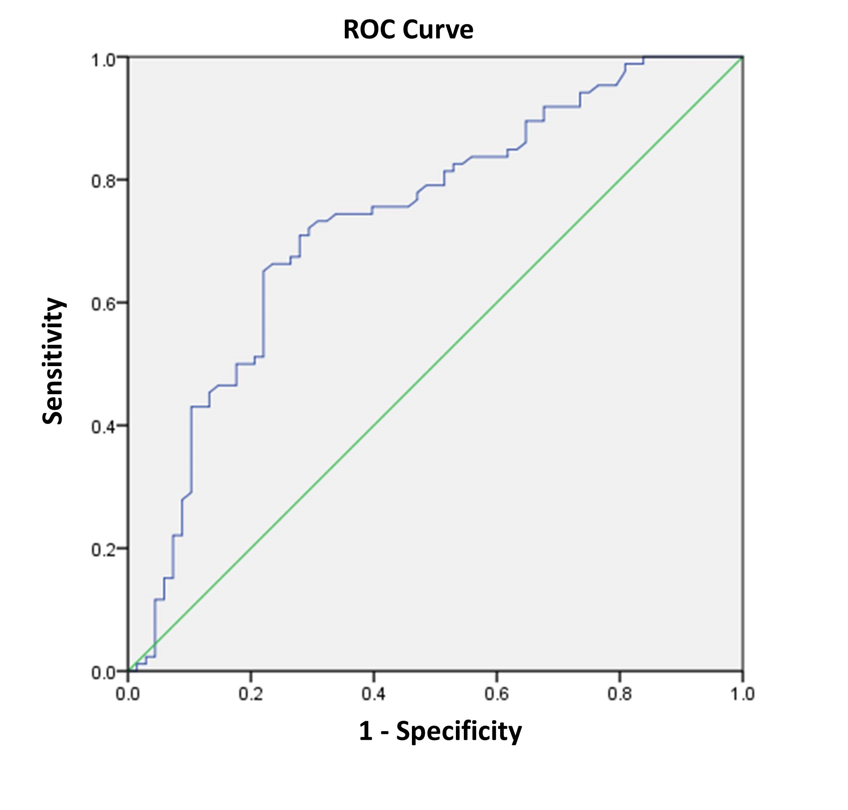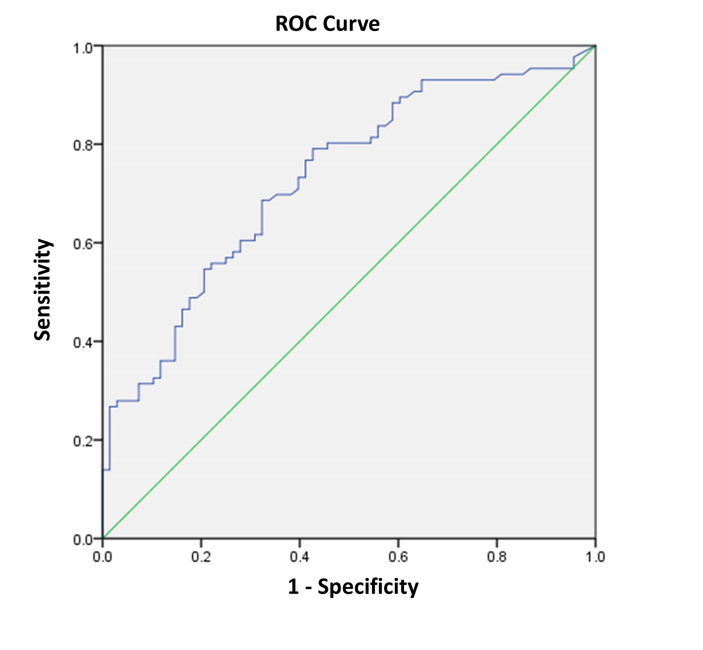
Figure 1 Receiver operating characteristics curve analysis based on fibrinogen for overall survival. A: The area under the ROC curve (AUC) indicates the diagnostic power of preoperative plasma fibrinogen concentration. In this model, the optimum cut-off point for fibrinogen concentration was 3.47 g/L, AUC was 0.735 (95%CI: 0.654-0.816), with a sensitivity of 0.709 and a specificity of 0.721 by the Youden index. B: AUC indicates the diagnostic power of preoperative CA199 level. In this model, the optimum cut-off point for CA199 level was 25.45 U/mL, AUC was 0.729 (95%CI: 0.650–0.808), with a sensitivity of 0.791 and a specificity of 0.574 by the Youden index. AUC: area under curve. ROC: Receiver operating characteristics curve.

A
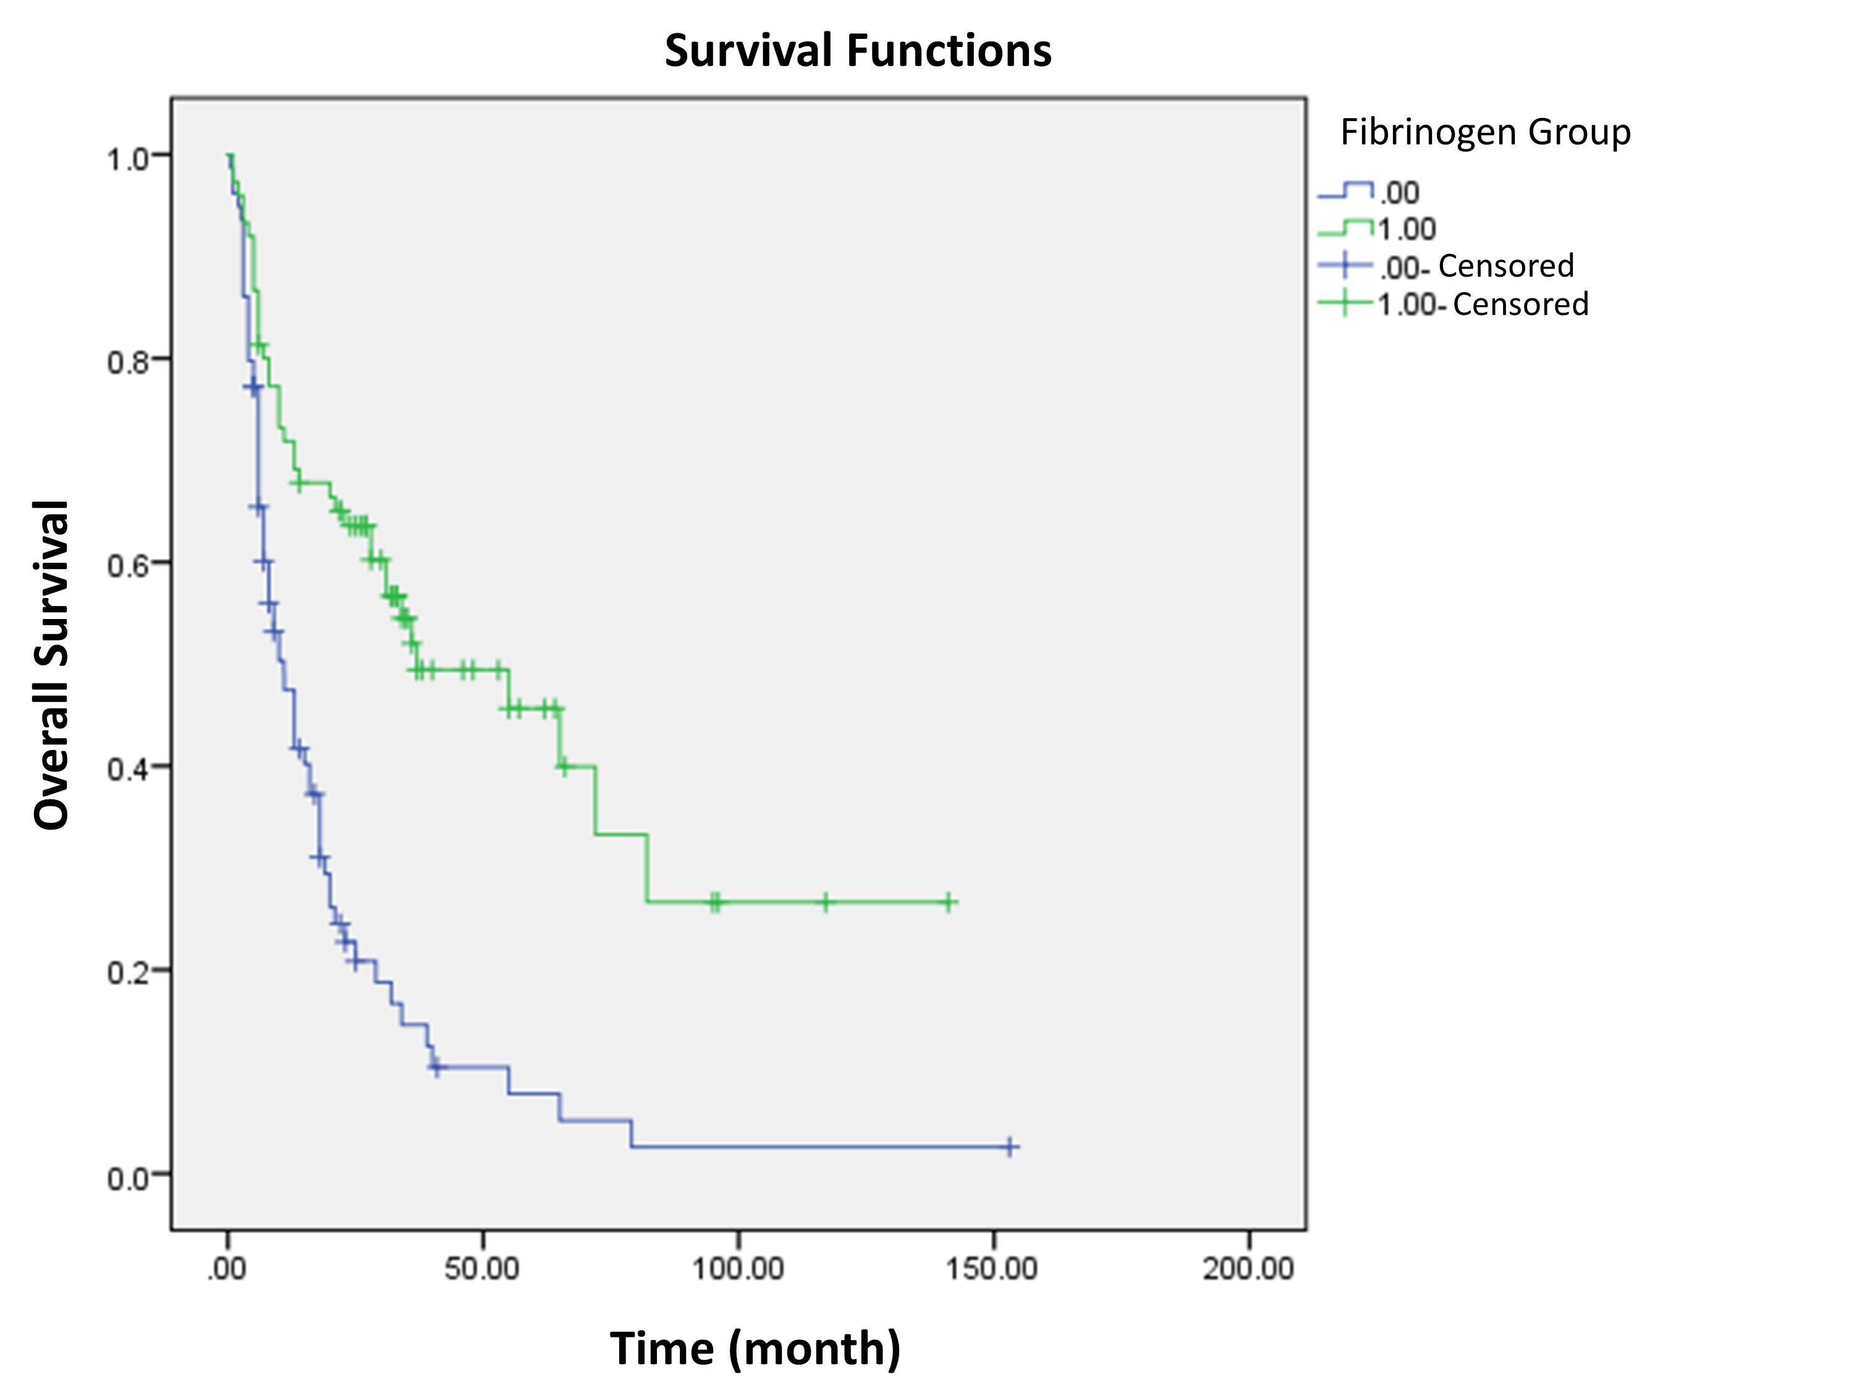
B
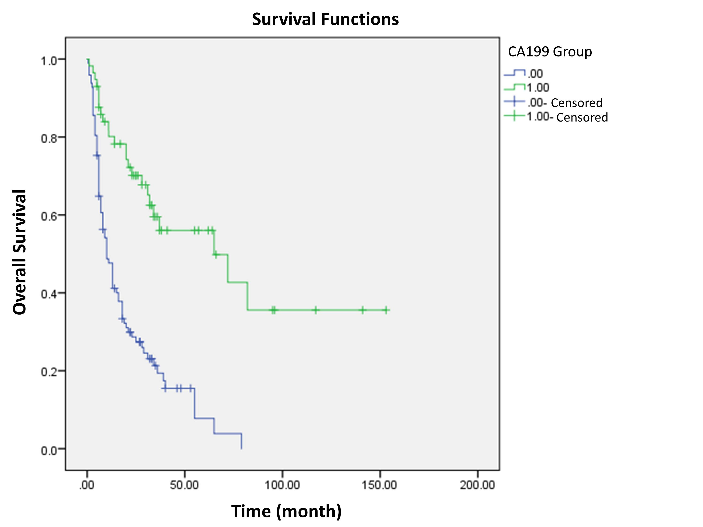
Figure 2 Survival curve according to the presence of preoperative fibrinogen concentration (A) and CA199 level (B). A: Data compares fibrinogen concentration > 3.47 g/L vs ≤ 3.47 g/L group (P < 0.05). The number 1 for ≤ 3.47 g/L group, number 2 for > 3.47 g/L group. B: Data compares CA199 level > 25.45 U/ml vs ≤ 25.45 U/ml (P < 0.05). The number 1 for ≤ 25.45 U/ml group, number 2 for > 25.45 U/ml group.

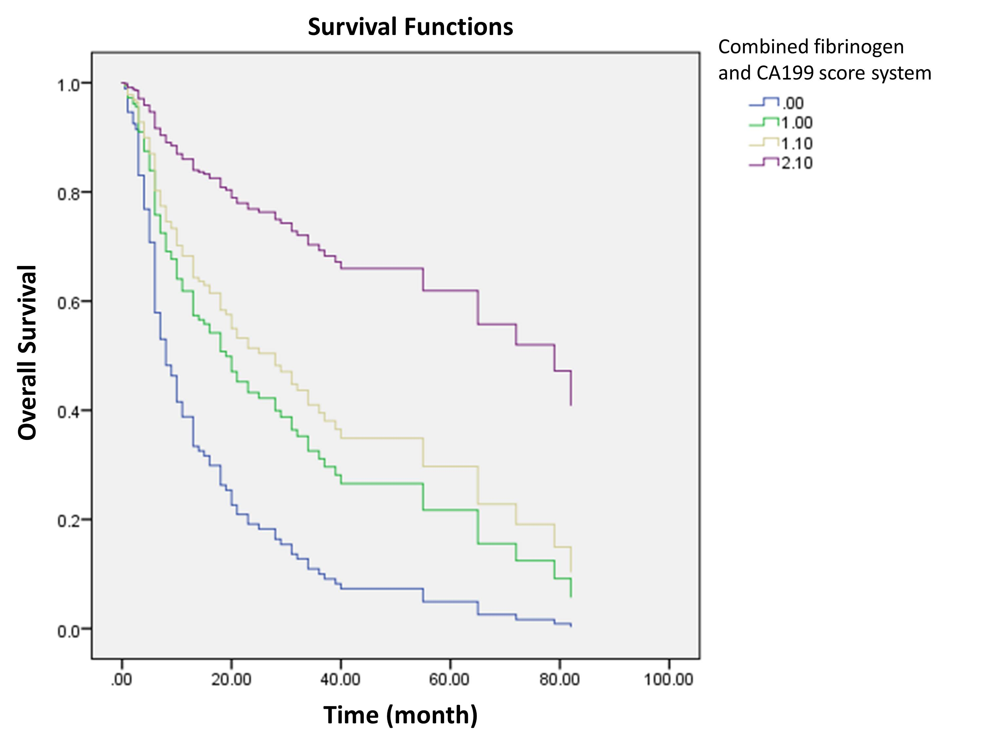
Figure 3 Survival curve according to the combined fibrinogen and CA199 score system. Data compares between fibrinogen concentration > 3.47 g/L with CA199 level > 25.45 U/mA group, fibrinogen concentration > 3.47 g/L with CA199 level ≤ 25.45 U/ml group, fibrinogen concentration ≤ 3.47 g/L with CA199 level > 25.45 U/ml group and fibrinogen concentration ≤ 3.47 g/L with CA199 level ≤ 25.45 U/ml group. The number 0 for fibrinogen concentration > 3.47 g/L with CA199 level > 25.45 U/ml group, number 1 for fibrinogen concentration > 3.47g/L with CA199 level ≤ 25.45 U/ml group, number 1.1 for fibrinogen concentration ≤ 3.47 g/L with CA199 level > 25.45 U/ml group, number 2.1 for fibrinogen concentration ≤ 3.47 g/L with CA199 level ≤ 25.45 U/ml group.

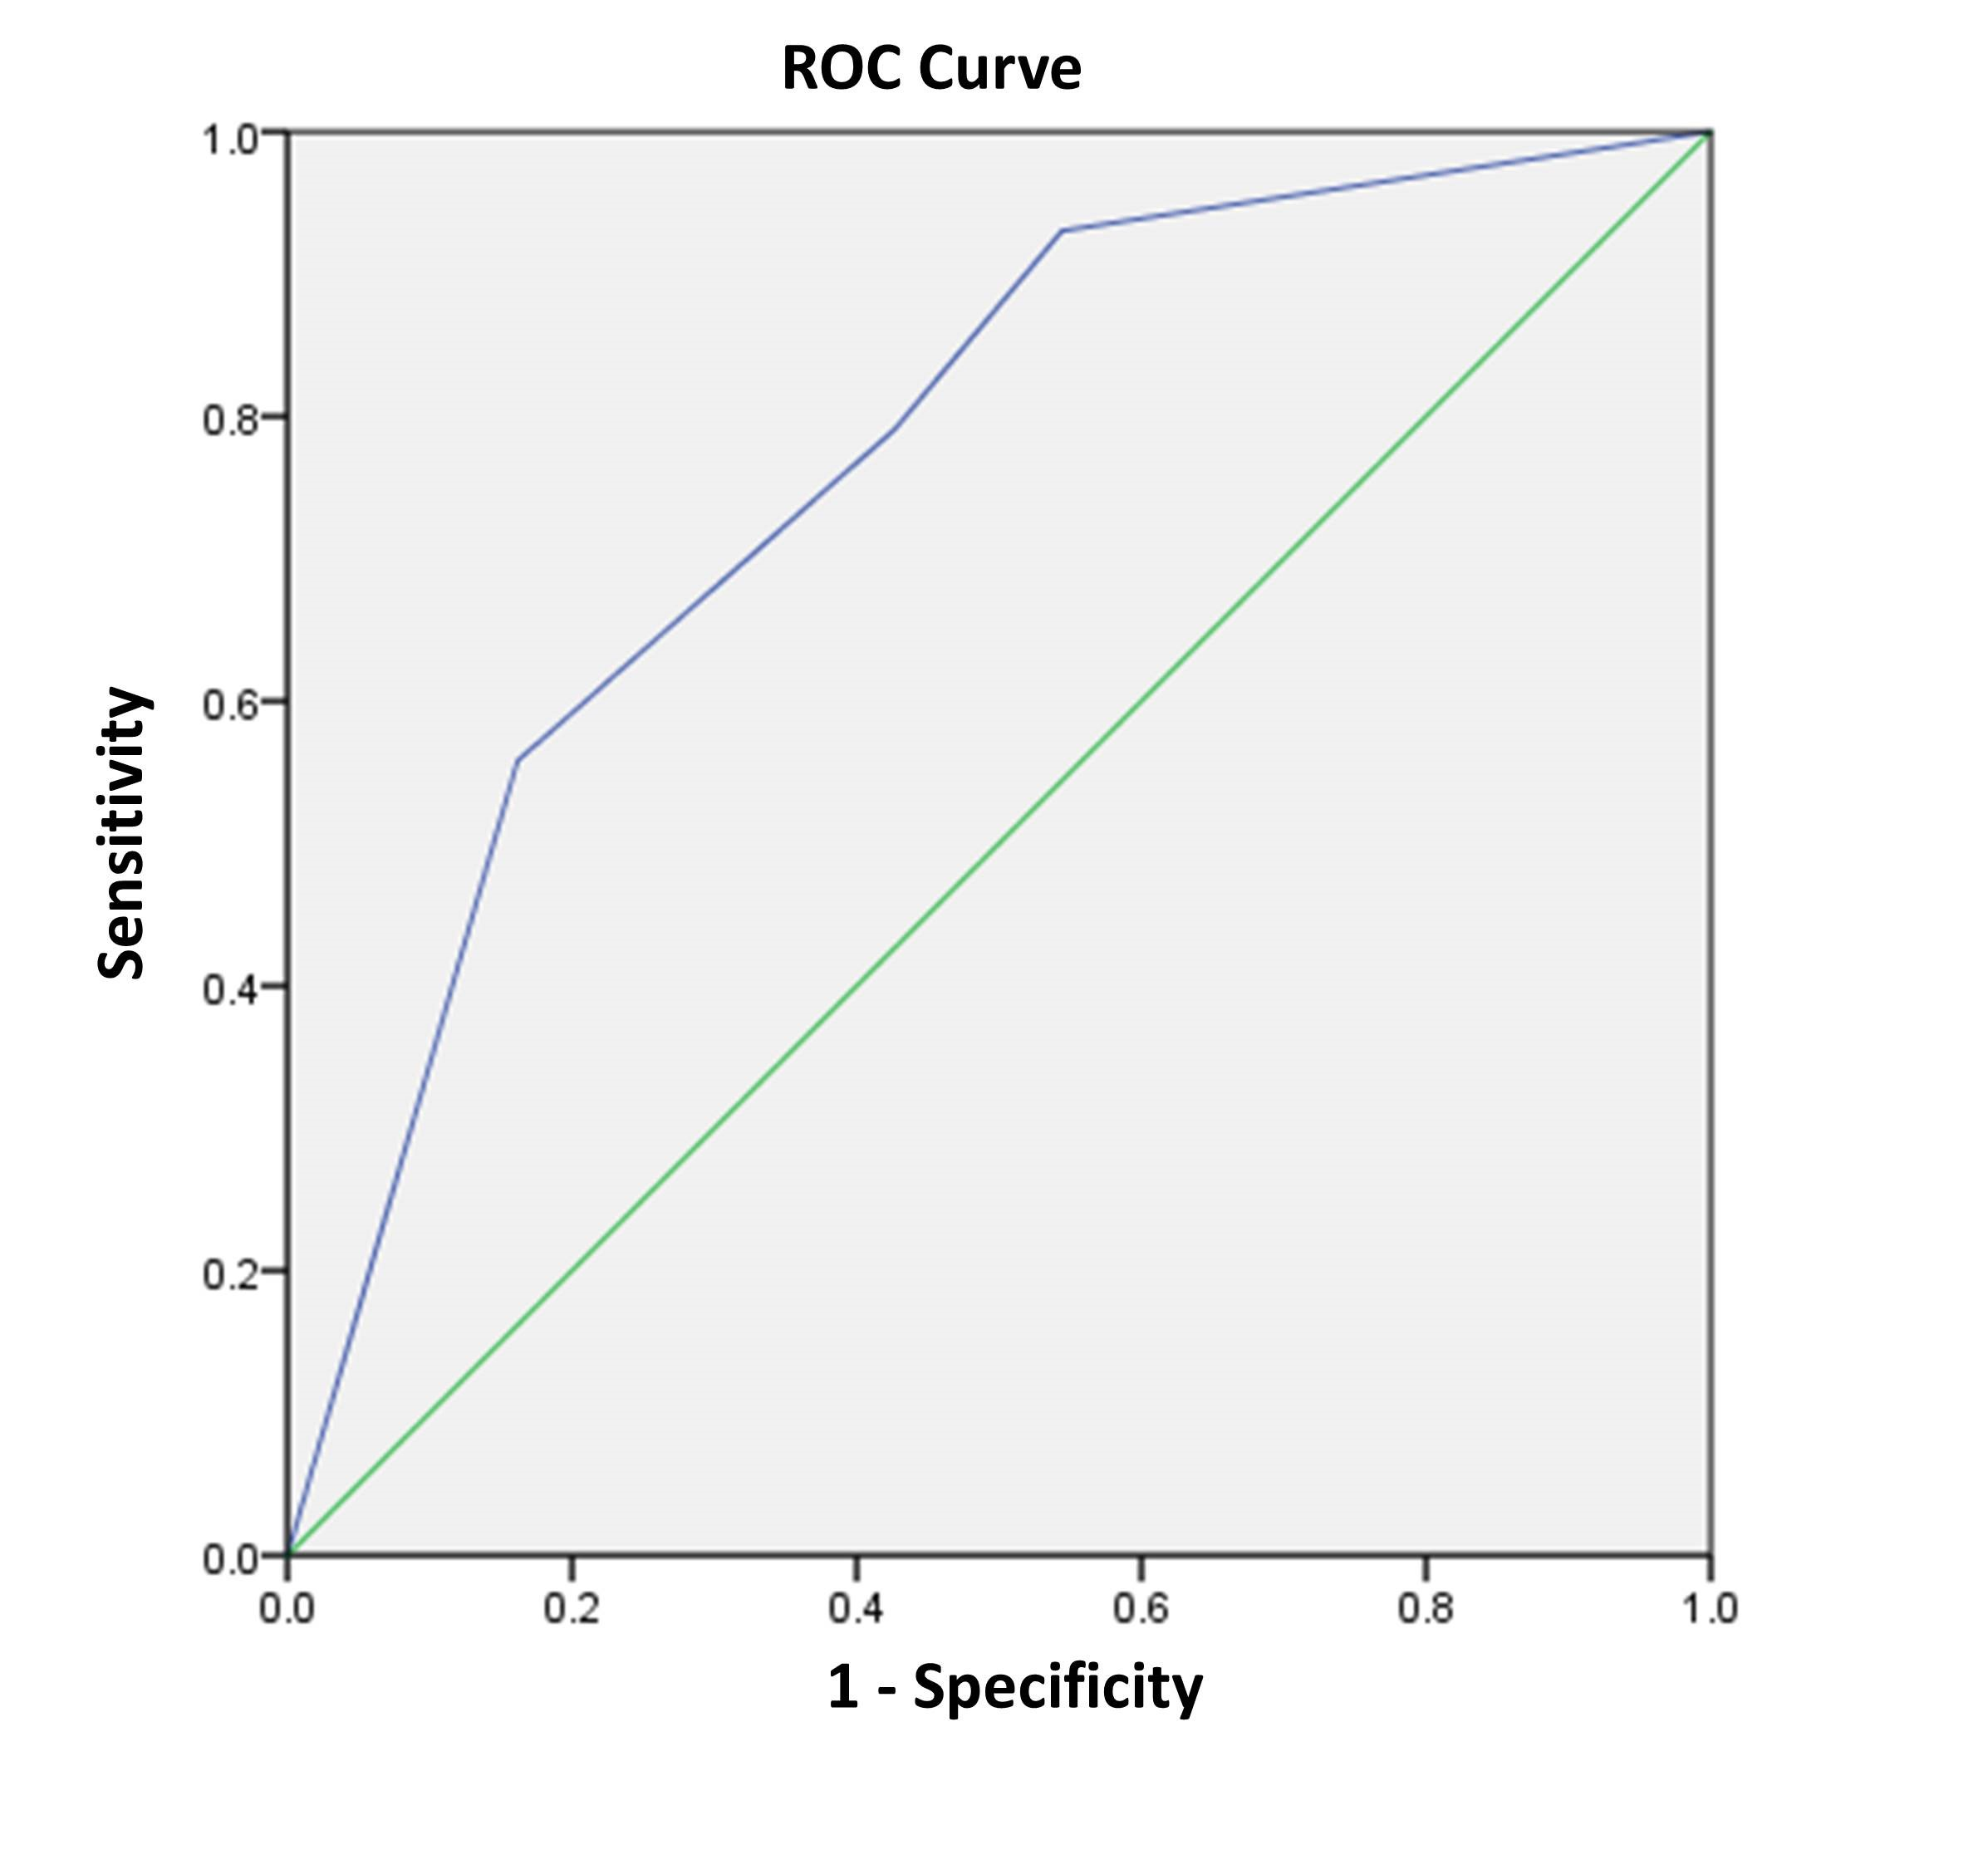
Figure 4 Receiver operating characteristics curve analysis based on the combination of fibrinogen and CA199 for overall survival. AUC indicates the diagnostic power of the combination of fibrinogen and CA199. In this model, AUC was 0.765 (95%CI: 0.688-0.841). AUC: area under curve.

Table 1 Baseline characteristics of 154 patients who underwent potential curative cholecystectomy n (%)
Characteristic | Patients (n = 154)
Age (yr) | 64 (29-85)
≤ 60 | 56 (36.4)
> 60 | 98 (63.6)
Sex
Male | 63 (40.9)
Female | 91 (59.1)
Cholecystolithiasis
Absent | 79 (51.3)
Present | 75 (48.7)
Diabetes
Absent | 116 (75.3)
Present | 38 (24.7)
Jaundice
Absent | 129 (83.8)
Present | 25 (8.9)
Blood groups
A | 43 (27.9)
B | 56 (36.4)
AB | 9 (5.8)
O | 46 (29.9)
Pathological types
Adenosquamous carcinoma | 3 (1.9)
Adenocarcinoma | 150 (97.4)
Papillocarcinoma | 1 (0.6)
Degree of differentiation
Poor | 60 (39.0)
Moderate-well | 94 (61.0)
Resection margin status
Negative | 96 (62.3)
Positive | 58 (37.7)
Maximum tumor diameter (cm) | 3 (0.2-13)
≤ 2.45 | 68 (44.2)
> 2.45 | 86 (55.8)
T stage
Tis-T1a | 10 (6.5)
T1b-T2b | 29 (18.8)
T3 | 103 (66.9)
T4 | 12 (7.8)
N stage
0 | 98 (63.6)
1 | 47 (30.5)
2 | 9 (5.8)
Distant metastasis
Absent | 142 (92.2)
Present | 12 (7.8)
TNM stage
0-I stage | 16 (10.4)
IIA-IIB stage | 16 (10.4)
IIIA-IIIB stage | 92 (59.7)
IVA-IVB stage | 30 (19.5)
CA199 (U/ml) | 69.3 (0.6-10524)
≤ 25.45 | 57 (37.0)
> 25.45 | 97 (63.0)
Fibrinogen concentration (g/L) | 3.54 (1.71-7.47)
≤ 3.47 | 75 (48.7)
> 3.47 | 79 (51.3)

Table 2 Correlation between fibrinogen concentration and clinicopathological characteristics in gallbladder carcinoma patients n (%)
Characteristics | Fibrinogen concentration |  | P value
 | ≤ 3.47 g/L (n = 75) | > 3.47 g/L (n = 79)
Age (yr)
≤ 60 | 31 (20.1) | 25 (16.2) | 0.243
> 60 | 44 (28.6) | 54 (35.1)
Sex
Male | 33 (21.4) | 30 (19.5) | 0.513
Female | 42 (27.3) | 49 (31.8)
Cholecystolithiasis
Absent | 38 (24.7) | 41 (26.6) | 0.878
Present | 37 (24.0) | 38 (24.7)
Diabetes
Absent | 57 (37.0) | 59 (38.3) | 0.850
Present | 18 (11.7) | 20 (13.0)
Jaundice
Absent | 68 (44.2) | 61 (39.6) | 0.029
Present | 7 (4.5) | 18 (11.7)
Blood groups
A | 19 (12.3) | 24 (15.6) | 0.145
B | 33 (21.4) | 23 (14.9)
AB | 2 (1.3) | 7 (4.5)
O | 21 (13.6) | 25 (16.2)
Pathological types
Adenosquamous carcinoma | 0 (0) | 3 (1.9) | 0.142
Adenocarcinoma | 75 (48.7) | 75 (48.7)
Papillocarcinoma | 0 (0) | 1 (0.6)
Degree of differentiation
Poor | 23 (14.9) | 37 (24.0) | 0.048
Moderate-well | 52 (33.8) | 42 (27.3)
Resection margin status
Negative | 56 (36.4) | 40 (26.4) | 0.003
Positive | 19 (12.3) | 39 (25.3)
Maximum tumor diameter (cm)
≤ 2.45 | 34 (22.1) | 34 (22.1) | 0.871
> 2.45 | 41 (26.6) | 45 (29.2)
T stage
Tis-T1a | 8 (5.2) | 2 (1.3) | ＜0.001
T1b-T2b | 22 (14.3) | 7 (4.5)
T3 | 43 (27.9) | 60 (39.0)
T4 | 2 (1.3) | 10 (6.5)
N stage
N0 | 50 (32.5) | 48 (31.2) | 0.748
N1 | 21 (13.6) | 26 (16.9)
N2 | 4 (2.6) | 5 (3.2)
Distant metastasis
Absent | 69 (44.8) | 73 (47.4) | 0.925
Present | 6 (3.9) | 6 (3.9)
TNM stage
0-I stage | 12 (7.8) | 4 (2.6) | 0.011
IIA-IIB stage | 12 (7.8) | 4 (2.6)
IIIA-IIIB stage | 39 (25.3) | 53 (34.4)
IVA-IVB stage | 12 (7.8) | 18 (11.7)
CA199 (U/ml)
≤ 25.45 | 37 (24.0) | 20 (13.0) | 0.003
> 25.45 | 38 (24.7) | 59 (38.3)

Table 3 Correlation between CA199 level and clinicopathological characteristics in gallbladder carcinoma patients n (%)
Characteristics | CA199 level |  | P value
 | ≤ 25.45 U/ml (n = 57) | > 25.45 U/ml (n = 97)
Age (yr)
≤ 60 | 24 (15.6) | 32 (20.8) | 0.299
> 60 | 33 (21.4) | 65 (42.2)
Sex
Male | 23 (14.9) | 40 (26.0) | 0.914
Female | 34 (21.1) | 57 (37.0)
Cholecystolithiasis
Absent | 32 (20.8) | 47 (30.5) | 0.406
Present | 25 (16.2) | 50 (32.5)
Diabetes
Absent | 45 (29.2) | 71 (46.1) | 0.447
Present | 12 (7.8) | 26 (16.9)
Jaundice
Absent | 53 (34.4) | 76 (49.4) | 0.022
Present | 4 (2.6) | 21 (13.6)
Blood groups
A | 19 (12.3) | 24 (15.6) | 0.303
B | 21 (13.6) | 35 (22.7)
AB | 1 (0.6) | 8 (5.2)
O | 16 (10.4) | 30 (19.5)
Pathological types
Adenosquamous carcinoma | 0 (0) | 3 (1.9) | 0.299
Adenocarcinoma | 57 (37.0) | 93 (60.4)
Papillocarcinoma | 0 (0) | 1 (0.6)
Degree of differentiation
Poor | 33 (21.4) | 61 (39.6) | 0.069
Moderate-well | 24 (15.6) | 36 (23.4)
Resection margin status
Negative | 45 (29.2) | 51 (33.1) | 0.001
Positive | 12 (7.8) | 46 (29.9)
Maximum tumor diameter (cm)
≤ 2.45 | 30 (19.5) | 38 (24.7) | 0.131
> 2.45 | 27 (17.5) | 59 (38.3)
T stage
Tis-T1a | 7 (4.5) | 3 (1.9) | < 0.001
T1b-T2b | 18 (11.7) | 11 (7.1)
T3 | 32 (20.8) | 71 (46.1))
T4 | 0 (0.0) | 12 (7.8)
N stage
N0 | 43 (27.9) | 55 (35.7) | 0.056
N1 | 11 (7.1) | 36 (23.4)
N2 | 3 (1.9) | 6 (3.9)
Distant metastasis
Absent | 53 (34.4) | 89 (57.8) | 0.783
Present | 4 (2.6) | 8 (5.2)
TNM stage
0-I stage | 11 (7.1) | 5 (3.2) | < 0.001
IIA-IIB stage | 12 (7.8) | 4 (2.6))
IIIA-IIIB stage | 27 (17.5) | 65 (42.2)
IVA-IVB stage | 7 (4.5) | 23 (14.9)
Fibrinogen concentration (g/L)
≤ 3.47 | 37 (24.0) | 38 (24.7) | 0.003
> 3.47 | 20 (13.0) | 59 (38.3)

Table 4 Univariate analysis of overall survival in gallbladder cancer patients
Characteristics | HR (95%CI) | P value
Age (yr) | 1.473 (0.973-2.230) | 0.067
≤ 60
> 60
Sex | 0.995 (0.670-1.477) | 0.981
Male
Female
Cholecystolithiasis | 1.198 (0.814-1.764) | 0.360
Absent
Present
Diabetes | 1.028 (0.651-1.623) | 0.906
Absent
Present
Jaundice | 2.598 (1.644-4.106) | < 0.001
Absent
Present
Blood groups | —— —— | 0.113
A
B
AB
O
Pathological types | —— —— | 0.165
Adenosquamous carcinoma
Adenocarcinoma
Papillocarcinoma
Degree of differentiation | 1.527 (1.031-2.261) | 0.035
Poor
Moderate-well
Resection margin status | 3.683 (2.468-5.496) | < 0.001
Negative
Positive
Maximum tumor diameter (cm) | 1.101 (0.744-1.630) | 0.631
≤ 2.45
> 2.45
T stage | —— —— | < 0.001
Tis-T1a
T1b-T2b
T3
T4
N stage | —— —— | < 0.001
N0
N1
N2
Distant metastasis | 2.550 (1.388-4.684) | ＜0.003
Absent
Present
TNM stage | —— —— | ＜0.001
0-I stage
IIA-IIB stage
IIIA-IIIB stage
IVA-IVB stage
CA199 (U/ml) | 3.570 (2.213-5.760) | < 0.001
≤ 25.45
> 25.45
Fibrinogen concentration (g/L) | 2.79 (1.853-4.214) | < 0.001
≤ 3.47
> 3.47

Table 5 Multivariate analysis for overall survival in gallbladder cancer patients
Characteristics | HR (95%CI) | Wald | p value
Resection margin status | 1.971 (1.288-3.017) |  | 0.002
Negative
Positive
TNM stage |  | 11.299 | 0.003
IIA-IIB stage/0-1stage | 1.336 (0.317-5.627) | 0.156 | 0.693
IIIA-IIIB stage/0-1 stage | 3.831 (1.167-12.571) | 4.907 | 0.027
IVA -IVB stage/0-1 stage | 5.204 (1.497-18.093) | 6.730 | 0.009
Fibrinogen concentration (g/L) | 1.711 (1.114-2.627) |  | 0.014
≤ 3.47
> 3.47
CA199 (U/ml) | 1.842 (1.111-3.056) |  | 0.018
≤ 25.45
> 25.45

Table 6 Univariate and multivariate analysis of overall survival in gallbladder cancer patients according the combination of fibrinogen and CA199
Characteristics | HR (95%CI) | Wald | P value
Univariate analysis
Combined fibrinogen and CA199 | --------- |  | < 0.001
0
1
1.1
2.1
Multivariate analysis
Resection margin status | 1.973 (1.289-3.020) |  | 0.002
Negative
Positive
TNM stage | 11.299 |  | 0.011
IIA-IIB stage/0-1stage | 1.342 (0.318-5.659) | 0.160 | 0.689
IIIA-IIIB stage/0-1 stage | 3.812 (1.158-12.545) | 4.848 | 0.028
IVA -IVB stage/0-1 stage | 5.189 (1.491-18.055) | 6.699 | 0.010
Combined fibrinogen and CA199 | 14.218 |  | 0.003
1/0 | 1.784 (0.775-4.104) | 1.854 | 0.173
1.1/0 | 1.895 (0.943-3.806) | 3.222 | 0.073
2.1/0 | 3.195 (1.676-6.090) | 12.454 | 0.000
The number 0 for fibrinogen concentration > 3.47g/L with CA199 level > 25.45 U/ml group, number 1 for fibrinogen concentration > 3.47 g/L with CA199 level ≤ 25.45 U/ml group, number 1.1 for fibrinogen concentration ≤ 3.47g/L with CA199 level > 25.45 U/ml group, number 2.1 for fibrinogen concentration ≤ 3.47 g/L with CA199 level ≤ 25.45 U/ml group.

