Name of journal: World Journal of Transplantation

ESPS Manuscript NO: 2085

Columns: CASE REPORT

Residual renal function in peritoneal dialysis with failed allograft and minimum immunosuppression

Elmahi N et al. Peritoneal dialysis in failed renal transplant

Nadear Elmahi, Éva Csongrádi, Kenneth Kokko, Jamie Davison, Jack R Lewin, Tibor Fülöp

Nadear Elmahi, Éva Csongrádi, Kenneth Kokko, Jamie Davison, Tibor Fülöp, Division of Nephrology, Department of Medicine, University of Mississippi Medical Center, Jackson, MS 39216, United States

Éva Csongrádi, Department of Medicine, Medical and Health Science Center, University of Debrecen, 4032 Debrecen, Hungary

Jack R Lewin, Department of Pathology, University of Mississippi Medical Center, Jackson, MS 39216, United States

Author contributions: Elmhi N collected the data, reviewed the patient chart, wrote the initial draft of the paper, performed the literature review, submitted the paper and will be the correspondent; Csongrádi É revised the manuscript and checked the clinical relevance of the case; Lewin JR reviewed and presented the tissue pathology and histology slides; Kokko K performed critical manuscript revision; Davison J collected data and performed clinical case review; Fülöp T the senior author of the case, wrote the abstract, helped with the manuscript development and coordinated the manuscript revisions.

Correspondence to: Nadear Elmahi, MD, MPH, Division of Nephrology, Department of Medicine, University of Mississippi Medical Center, 2500 North State Street, Jackson, MS 39216, United States. nxhelma@gmail.com

Telephone: +1-601-9845670 Fax: +1-601-9845765
Received: January 25, 2013 Revised: March 29, 2013
Accepted: April 10, 2013

Published online:

Abstract
Immunosuppression (IS) is often withdrawn in patients with end stage renal disease secondary to a failed renal allograft, and this can lead to an accelerated loss of residual renal function (RRF). As maintenance of RRF appears to provide a survival benefit to peritoneal dialysis (PD) patients, it is not clear whether this benefit of maintaining RRF in failed allograft patients returning to PD outweigh the risks of maintaining immunosuppression. A 49 year-old Caucasian male developed progressive allograft failure nine years after living-donor renal transplantation. Hemodialysis was initiated via tunneled dialysis catheter (TDC) and IS was gradually withdrawn. Two weeks after IS withdrawal he developed a febrile illness, which necessitate removal of the TDC and conversion to PD. He was maintained on small dose of tacrolimus (1 mg daily) and prednisone (5 mg daily). Currently (1 year later) he is doing exceedingly well on cycler-assisted PD. Residual urine output ranges between 600-1200 mL/d. Total weekly Kt/V achieved 1.82. RRF remained well preserved in this patient with failed renal allograft with minimal immunosuppressive therapy. This strategy will need further study in well-defined cohorts of PD patients with failed allografts and residual RRF to determine efficacy and safety.

© 2013 Baishideng. All rights reserved.

Key words: Immunosuppression; Kidney transplantation; Nephrectomy; Peritoneal dialysis; Renal function reserve

Core tip: Making decision regarding the optimal management of immunosuppresion is one the most challenging decisions following allograft failure. The use of low dose immunosuppressive medications is the most reasonable approach. Many patients with failed allograft require renal replacement therapy. Peritoneal dialysis remains underused modality in failed renal allograft, especially in patients with residual renal function. Our patient failed renal transplant and was initiated on peritoneal dialysis and maintained on minimal immunosuppression. Interestingly, his residual renal function remained well preserved. We recommend further study in well-defined cohorts of peritoneal dialysis patients with failed allografts and residual renal function to determine efficacy and safety.

Elmahi N, Csongrádi E, Kokko K, Davison J, Lewin JR, Fülöp T. Residual renal function in peritoneal dialysis with failed allograft and minimum immunosuppression.
World J Transplant 2013;
Available from: URL: http://www.wjgnet.com/esps/
DOI: http://dx.doi.org/10.3748/wjg.v19.i0.0000

INTRODUCTION
Data from the United States Renal Data System revealed that the number of patients with a failed transplanted kidney in the United States has increased over the past few years^{[1]}. The management of those patients with a failed transplant involves two major decisions: optimal management of immunosuppression and whether or not to perform graft nephrectomy. While there might be a survival advantage in maintaining dialysis patients on long-term immunosuppressive therapy after allograft failure^{[2]}, immunotherapy comes with its own risks, which include increased susceptibility to infections and cancers^{[3,4]}. This case report and review of the literature illustrates the fact that not all dialysis patients with allograft dysfunction are created equally and that different cohorts deserve further study regarding the benefits of maintenance of low dose immunosuppression after declared allograft failure.

CASE REPORT
A 49-year-old Caucasian male with past medical history of hypertension was diagnosed with end stage renal disease (ESRD) and was started on peritoneal dialysis in 2001. One year later he had living-donor renal transplantation, after which he maintained fair allograft function with new baseline creatinine around 1.8–2.2 mg/dL. His initial immunosuppressive therapy included tacrolimus, mycophenolate mofetil (MMF) and prednisone. His medications were adjusted over the next few months and he was maintained on tacrolimus 3 mg twice daily, MMF 500 mg twice daily, and prednisone 5 mg daily. Three months after his transplant, he had a biopsy-proven type IIA acute rejection, which responded well to treatment with steroids.
He presented to the transplant clinic on September 13, 2010 for a routine visit with elevated serum creatinine of 3.2 mg/dL compared to creatinine of 1.8 mg/dL one year prior to that. Further testing revealed nephrotic range proteinuria of around 3 g by a spot urine analysis. The patient has been compliant with his immunosuppressive medications and has no major change in his medical, surgical, and social history. The patient was admitted to the hospital and underwent a diagnostic percutaneous ultrasound guided renal biopsy (Figure 1). Histopathologic examination of the tissue confirm the presence of focal segmental glomerulosclerosis as evidenced by involvement of approximately 50% of the glomeruli with segmental lesions and some of the glomeruli had total global glomerulosclerosis. There was also associated interstitial fibrosis and tubular atrophy. Immunofluorescence studies were consistent with a diagnosis of focal segmental glomerulosclerosis with 2+ staining for IgG and a segmental distribution, 2+ staining of IgM and a segmental distribution, negative staining for IgA and 2+ staining for kappa and lambda light chains. The patient had one area of questionable crescent formation on a single glomerulus but the biopsy was unrevealing otherwise for any other disease process. There was no evidence of transplant rejection or antibody mediated rejection as the patient had a negative C4d immunofluorescence. His medications were adjusted where his prednisone dose was increased to 60 mg daily and lisinopril was resumed to reduce proteinuria.
His creatinine worsened gradually over the next five months. He was readmitted to the hospital in February 2011 with herpes zoster involving his eye and was treated with ganciclovir and local erythromycin ointment. The serum creatinine was 5.02 mg/dL at the time of admission and 5.42 mg/dL at the time of discharge. It was clear that the patient was experiencing progressive renal allograf failure and the options of dialysis were explained to the patient.
Few days after his discharge, he was readmitted to the hospital for evaluation of pneumonia and was treated with antibiotics. During that hospitalization his renal function continues to worsen with associated oliguria and clinical uremia that required initiation of dialysis. Tunneled dialysis catheter (TDC) was placed and the patient was discharged in stable condition. He remained oliguric with minimal urine output and he continued hemodialysis via TDC. In the interim, he also had a peritoneal dialysis (PD) catheter placed. MMF was discontinued but he was maintained on low dose of tacrolimus (1 mg twice daily). Two months later he was re-admitted to the hospital with suspected sepsis and associated TDC infection. He was treated with antibiotics, stress dose steroids and removal of the hemodialysis catheter. During the hospitalization he had increased urine output up to 1-1.5 L per 24 h. However, he continued to be dialysis dependent with elevated creatinine around 7-8 mg/dL. At that point of time, peritoneal dialysis was initiated and we opted to continue his tacrolimus at 1 mg daily (serum levels not measurable) and prednisone 5 mg daily. Currently (1 year later) he is doing exceedingly well on cycler-assisted PD regimens of 10 L exchanged over 8 h. Residual urine output ranges between 600-1200 mL/d. Total weekly Kt/V achieved 1.82 (dialysate: 1.30; endogenous: 0.51) and global creatinine clearance 64.8 L/wk/1.73 m² (dialysate: 39.3; endogenous: 25.4). A renal scan confirmed that all endogenous renal function is originating from the partially functioning renal allograft. Furthermore, his albumin remained stable at 4 g/dL and hemoglobin well controlled (11.6 g/dL) on darbopotein-alfa 12.5 mg weekly. He is currently awaiting another renal transplant and has an arteriovenous fistula in place.

DISCUSSION

Management of immunosuppression after graft failure
Approximately 20% of all renal patients on the transplant waiting list in the United States have had a previously failed allograft^{[5]}. Initiating dialysis on those patients with failed renal transplant usually prompts the clinician to withdraw immunotherapy to reduce the risk of infection. Gregoor et al^{[4]} showed that patients with allograft failure who were maintained in low-dose immunosuppression suffered from high infectious complications, in addition to higher cardiovascular-related death. Those findings were supported by more recent study done by Johnson et al^{[3]}, who studied more than 5000 patients who initiated dialysis after failed renal transplant. Their study revealed overall sepsis rate of 12 per 100 patient years and the sepsis rates were higher in the first 76 mo after transplant failure. Along the same line, Smak et al^{[6]} argued against the value of using low dose immunosuppressive medications based on the perceived morbidity and mortality associated with immunosuppressive medications. His group analyzed data from patients’ files, with renal failure after at least 3 mo graft function. The authors found that continuation of immunosuppressive medication did not lead to fewer rejections. They revealed an increase in morbidity and mortality in the group with low immunosuppressive medications^{[6]}. Closer scrutiny of this study, however, revealed that many of the conclusions might not be applicable to the current era where the majority of the transplant occurred in the pre-cyclosporine era with a large variation of maintenance prednisone doses and about one-third of the patients were on significant doses of azathioprine^{[6]}. It is also unclear, how many of them have been placed upfront on PD to reduce the risk of infection and sepsis typically caused by infection of TDC.
There has been no consensus on the optimal management of immunosuppression in patients with a failed transplant. Nonetheless, the decision to continue low-dose immunosuppression vs immunosuppression withdrawal must be individualized as both options have their inherent advantages and disadvantages. Immunosuppressive withdrawals’ protocols vary among transplant centers with most centers discontinue anti-metabolites abruptly and taper calcineurin inhibitors over several weeks and prednisone over a 3 to 6-mo period. Certain adverse effects should be considered in the process of withdrawing immunosuppression that include precipitation of rejection, the potential need for transplant nephrectomy, secondary adrenal insufficiency, and loss of RRF^{[2,7]}.

The role of nephrectomy after graft failure
Nephrectomy of the failed allograft remains a controversial issue. Failed allograft with no symptoms may not require an immediate intervention. However, some centers routinely refer these patients for nephrectomy in the absence of symptomatic rejection to prevent potential future complications^{[8,9]}. Recent retrospective study by Ayus et al^{[10]} suggested that patients who undergo allograft nephrectomy after graft failure might experience superior outcomes to those who did not. The limitations of this study include its retrospective nature and the unclear reasons for nephrectomy. Madore et al^{[11]} revealed that the need for late allograft nephrectomy was correlated with the number of previous episodes of acute rejection. The authors suggested more gradual tapering of immunosuppression or continuation of low-dose immunosuppression indefinitely to reduce the need for nephrectomy.
It is more acceptable practice to perform post allograft failure nephrectomy when patients develop symptoms attributed to the failed renal allograft^{[11]}. The surgical risk, rising number of circulating antibodies, reduced erythropoietin, and preserved urine output are among the arguments for observing or supporting a failed allograft^{[12,13]}. On the other hand, chronic inflammation, potential for malignancy and infections has been raised as arguments for surgical intervention^{[13,14]}.

Need for dialysis and the choice of dialysis modality
Among transplant-native, those treated with PD enjoy an early survival advantage compared with those treated with hemodialysis (HD) but this advantage is not sustained over time. However, it is not clear if this advantage persist in post allograft failure in patients treated with PD. On the other hand, survival of patients initiating PD after graft loss may be equivalent to that seen in transplant-naïve patients on PD^{[15-18]}. The outcome of the dialysis modality (PD or HD) can be affected by the use of immunosuppressive medications and the need for transplant nephrectomy^{[19]}. However, no survival benefit was found when using PD versus HD. Perl et al^{[20]} studied 2110 adult patients who initiated dialysis after renal transplant failure and after adjustment, the authors found no difference in overall survival between HD-treated and PD treated patients with similar results seen for both early and late survival.
Nevertheless, PD remains underused modality in patients with failed renal allograft as suggested by many researchers^{[18,21]}. Davies^{[21]} revealed that PD would appear to be a good option for patients with failing allograft. His study also demonstrated that the earlier loss of residual Kt/V in those patients might be prevented by continuing immunosuppression after commencement of dialysis.
In summary, the management of patients with a failed transplant involves two major decisions: optimal management of immunosuppression and whether or not to perform graft nephrectomy. The use of low dose immunosuppressive medications in failed renal allograft is the most reasonable approach. Transplant nephrectomy is not routinely indicated but might be required in certain group of patients with morbidities related to transplant. Many patients with failed allograft require a period of renal dialysis while re-listed for new renal transplant. There is no clear evidence to support the superiority of hemodialysis or peritoneal dialysis in the treatment of patients with failed allograft. However, peritoneal dialysis remains underused modality in failed renal allograft, especially in patients with residual renal function. Our patient failed renal transplant and was declared ESRD. Peritoneal dialysis was initiated and he was maintained on minimal immunosuppressive regimen with tacrolimus 1 mg daily. Interestingly, his residual renal function remained very well preserved. We recommend further study in well-defined cohorts of PD patients with failed allografts and residual renal function to determine efficacy and safety.

REFERENCES
1 Collins AJ, Kasiske B, Herzog C, Chavers B, Foley R, Gilbertson D, Grimm R, Liu J, Louis T, Manning W, Matas A, McBean M, Murray A, St Peter W, Xue J, Fan Q, Guo H, Li S, Li S, Roberts T, Snyder J, Solid C, Wang C, Weinhandl E, Arko C, Chen SC, Dalleska F, Daniels F, Dunning S, Ebben J, Frazier E, Johnson R, Sheets D, Forrest B, Berrini D, Constantini E, Everson S, Frederick P, Eggers P, Agodoa L. Excerpts from the United States Renal Data System 2004 annual data report: atlas of end-stage renal disease in the United States. Am J Kidney Dis 2005; 45: A5-7, S1-280 [PMID: 15640975]
2 Jassal SV, Lok CE, Walele A, Bargman JM. Continued transplant immunosuppression may prolong survival after return to peritoneal dialysis: results of a decision analysis. Am J Kidney Dis 2002; 40: 178-183 [PMID: 12087576 DOI: 10.1053/ajkd.2002.33927]
3 Johnston O, Zalunardo N, Rose C, Gill JS. Prevention of sepsis during the transition to dialysis may improve the survival of transplant failure patients. J Am Soc Nephrol 2007; 18: 1331-1337 [PMID: 17314323 DOI: 10.1681/asn.2006091017]
4 Gregoor PJ, Kramer P, Weimar W, van Saase JL. Infections after renal allograft failure in patients with or without low-dose maintenance immunosuppression. Transplantation 1997; 63: 1528-1530 [PMID: 9175823]
5 Schold JD, Gregg JA, Harman JS, Hall AG, Patton PR, Meier-Kriesche HU. Barriers to evaluation and wait listing for kidney transplantation. Clin J Am Soc Nephrol 2011; 6: 1760-1767 [PMID: 21597030 DOI: 10.2215/cjn.08620910]
6 Smak Gregoor PJ, Zietse R, van Saase JL, op de Hoek CT, IJzermans JN, Lavrijssen AT, de Jong GM, Kramer P, Weimar W. Immunosuppression should be stopped in patients with renal allograft failure. Clin Transplant 2001; 15: 397-401 [PMID: 11737116]
7 Verresen L, Vanrenterghem Y, Waer M, Hauglustaine D, Michielsen P. Corticosteroid withdrawal syndrome in dialysis patients. Nephrol Dial Transplant 1988; 3: 476-477 [PMID: 3140138]
8 Roberts CS, LaFond J, Fitts CT, Rajagopalan PR, Baliga P, Cofer JB, Bromberg JS. New patterns of transplant nephrectomy in the cyclosporine era. J Am Coll Surg 1994; 178: 59-64 [PMID: 8156119]
9 O'Sullivan DC, Murphy DM, McLean P, Donovan MG. Transplant nephrectomy over 20 years: factors involved in associated morbidity and mortality. J Urol 1994; 151: 855-858 [PMID: 8126809]
10 Ayus JC, Achinger SG, Lee S, Sayegh MH, Go AS. Transplant nephrectomy improves survival following a failed renal allograft. J Am Soc Nephrol 2010; 21: 374-380 [PMID: 19875809 DOI: 10.1681/asn.2009050480]
11 Madore F, Hébert MJ, Leblanc M, Girard R, Bastien E, Morin M, Beaudry C, Boucher A, Dandavino R. Determinants of late allograft nephrectomy. Clin Nephrol 1995; 44: 284-289 [PMID: 8605707]
12 Langone AJ, Chuang P. The management of the failed renal allograft: an enigma with potential consequences. Semin Dial 2005; 18: 185-187 [PMID: 15934959 DOI: 10.1111/j.1525-139X.2005.18305.x]
13 López-Gómez JM, Pérez-Flores I, Jofré R, Carretero D, Rodríguez-Benitez P, Villaverde M, Pérez-García R, Nassar GM, Niembro E, Ayus JC. Presence of a failed kidney transplant in patients who are on hemodialysis is associated with chronic inflammatory state and erythropoietin resistance. J Am Soc Nephrol 2004; 15: 2494-2501 [PMID: 15340000 DOI: 10.1097/01.asn.0000137879.97445.6e]
14 Schleicher C, Wolters H, Kebschull L, Anthoni C, Suwelack B, Senninger N, Palmes D. Impact of failed allograft nephrectomy on initial function and graft survival after kidney retransplantation. Transpl Int 2011; 24: 284-291 [PMID: 21155899 DOI: 10.1111/j.1432-2277.2010.01197.x]
15 de Jonge H, Bammens B, Lemahieu W, Maes BD, Vanrenterghem Y. Comparison of peritoneal dialysis and haemodialysis after renal transplant failure. Nephrol Dial Transplant 2006; 21: 1669-1674 [PMID: 16469763 DOI: 10.1093/ndt/gfl010]
16 Duman S, Aşçi G, Töz H, Ozkahya M, Ertilav M, Seziş M, Ok E. Patients with failed renal transplant may be suitable for peritoneal dialysis. Int Urol Nephrol 2004; 36: 249-252 [PMID: 15368705]
17 Badve SV, Hawley CM, McDonald SP, Mudge DW, Rosman JB, Brown FG, Johnson DW. Effect of previously failed kidney transplantation on peritoneal dialysis outcomes in the Australian and New Zealand patient populations. Nephrol Dial Transplant 2006; 21: 776-783 [PMID: 16280374 DOI: 10.1093/ndt/gfi248]
18 Mujais S, Story K. Patient and technique survival on peritoneal dialysis in patients with failed renal allograft: a case-control study. Kidney Int Suppl 2006; : S133-S137 [PMID: 17080105 DOI: 10.1038/sj.ki.5001930]
19 Ayus JC, Achinger SG. At the peril of dialysis patients: ignoring the failed transplant. Semin Dial 2005; 18: 180-184 [PMID: 15934958 DOI: 10.1111/j.1525-139X.2005.18304.x]
20 Perl J, Hasan O, Bargman JM, Jiang D, Na Y, Gill JS, Jassal SV. Impact of dialysis modality on survival after kidney transplant failure. Clin J Am Soc Nephrol 2011; 6: 582-590 [PMID: 21233457 DOI: 10.2215/cjn.06640810]
21 Davies SJ. Peritoneal dialysis in the patient with a failing renal allograft. Perit Dial Int 2001; 21 Suppl 3: S280-S284 [PMID: 11887836]

P-Reviewer Holan V S-Editor Gou SX L-Editor E-Editor

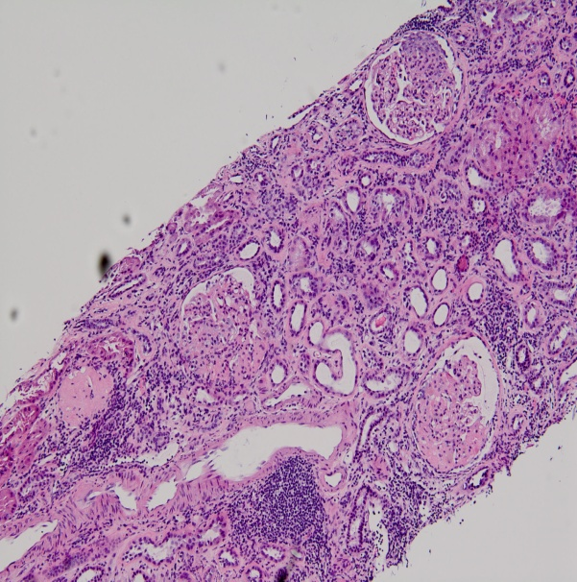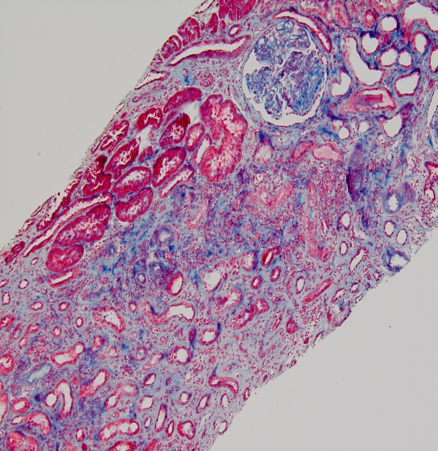
A B

Figure 1 Patient was admitted to the hospital and underwent a diagnostic percutaneous ultrasound guided renal biopsy. Hematoxylin and eosin (A) and periodic acid–Schiff stains of the kidney biopsy specimens (light microscopy) (B) showing the histopathology examination of the kidney, which tissue confirm the presence of focal segmental glomerulosclerosis as evidenced by involvement of approximately 50% of the glomeruli with segmental lesions and some of the glomeruli had total global glomerulosclerosis. There was also associated interstitial fibrosis and tubular atrophy.

