Name of Journal: World Journal of Clinical Cases
Manuscript NO: 76648
Manuscript Type: MINIREVIEWS

Complication of lengthening and the role of post-operative care, physical and psychological rehabilitation among fibula hemimelia

Salimi M et al. Complication of lengthening and physiotherapy

Maryam Salimi, Rojin Sarallah, Salar Javanshir, Seyed Peyman Mirghaderi, Amirhossein Salimi, Shokoufeh Khanzadeh

Maryam Salimi, Department of Orthopaedic Surgery, Shiraz University of Medical Sciences, Shiraz 71936-13311, Iran

Rojin Sarallah, Salar Javanshir, Department of Medicine, Islamic Azad University Medical Branch of Tehran, Tehran 713843809, Iran

Seyed Peyman Mirghaderi, Students' Scientific Research Center, Tehran University of Medical Sciences, Tehran 7138433608, Iran

Amirhossein Salimi, Department of Medicine, Shahid Sadoughi University of Medical Sciences, Yazd 7156893040, Iran

Shokoufeh Khanzadeh, Student Research Committee, Tabriz Sadoughi University of Medical Sciences, Tabriz 716534908, Iran

Author contributions: Salimi M performed the majority of the writing; Mirghaderi SP prepared the figures; Salimi A performed data accusation and writing; Sarallah R and Khanzadeh S provided the input in writing the paper; Javanshir S designed the outline and coordinated the writing of the paper.

Corresponding author: Maryam Salimi, MD, Doctor, Research Assistant, Department of Orthopaedic Surgery, Shiraz University of Medical Sciences, Karim Khan Z and Boulevard, Shiraz 71936-13311, Iran. salimimaryam7496@gmail.com

Received: March 23, 2022
Revised: April 27, 2022
Accepted: July 25, 2022
Published online: August 26, 2022

Abstract
There is a clear clinical need for efficient physiotherapy and rehabilitation programs during and after bone lengthening and reconstruction for gaining the optimal effect and also prevention or treatment of lengthening side effects. Pin tract infection is the most prevalent side effect during lengthening which could be prevented and treated initially via proper wound care. Muscle contractures are typically a consequence of the generated tension on the distracted muscle. It can be managed by physiotherapy initially and surgically in later severe stages. Furthermore, it is essential to avoid muscle contracture development, which is the demonstration of the imbalanced muscle appeals on the joint to inhibit the following subluxation. The knee is the furthermost affected joint by the aforementioned problem due to the inherent lack of ligamentous and bony stability. Joint stiffness is the other possible unfavorable effect of lengthening. It happens because of extensive muscle contractures or may possibly be attributed to rigidity of the joint following the amplified pressure on the joint surface during the process of lengthening. Physiotherapy and occupational therapy including endurance and strength exercise as well as stretching play an important role during the rehabilitation periods for the prevention and also the treatment of muscle contracture and the following deformity and also joint stiffness. Likewise, the effect of mental and physical rehabilitation programs should not be overlooked.

Key Words: Fibular hemimelia; Rehabilitation; Reconstruction; Lengthening

©The Author(s) 2022. Published by Baishideng Publishing Group Inc. All rights reserved.

Citation: Salimi M, Sarallah R, Javanshir S, Mirghaderi SP, Salimi A, Khanzadeh S. Complication of lengthening and the role of post-operative care, physical and psychological rehabilitation among fibula hemimelia. World J Clin Cases 2022; 10(24): 8482-8489
URL: https://www.wjgnet.com/2307-8960/full/v10/i24/8482.htm
DOI: https://dx.doi.org/10.12998/wjcc.v10.i24.8482

Core Tip: Difficulties that occur during limb lengthening are not avoidable. Pin tract infections are considered the most common adverse effect of lengthening which should be prevented through prophylaxis and treated as soon as possible when occurred. Muscle contractures are usually a result of the tension generated on the muscle due to distraction. It can be managed by physiotherapy initially and surgically in later severe stages. Subluxation or dislocation during lengthening may have been attributed to the preexisting joint instability or imbalanced muscle tension that developed during lengthening. It often happens in the knee joint posteriorly.

INTRODUCTION
Fibular hemimelia (FH) is considered the most common long bones deficiency and includes an extensive spectrum of anomalies, from a slight partial fibular shortening to a whole lack of fibula, and associated defects of the foot, and ankle, tibia, femur, and even hand abnormality^{[1]}.
With respect to the numerous deformities among fibular insufficiency as well as its relationship with postaxial hypoplasia, decision-making and strategies of treatment must be personalized^{[2]}. Treatment choices consist of non-surgical management with shoe lift and orthotic devices; limb preservation, which includes limb elongation strategies; or amputation followed by lifetime prosthetic use. The aforementioned recommended managements are principally hooked on the harshness of the amount of limb length discrepancy, the foot deformity and deficiency, and the potential for achieving the functional and plantigrade foot^{[3]}. The optimal treatment of FH has been controversial for a long time. Amputation along with prosthetic fitting has been recommended as an effective method in the management of FH in early studies and they also use to believe that patients may be more satisfied with amputation and prosthesis with no need for multiple surgeries to correct the deformities and then lengthen the usual major limb length discrepancies^{[4]}.
Unfavorable side effects have inundated limb-lengthening procedures since the first introduction for lengthening of the lower limb in 1905^{[5]}. High obstacle rates, mostly bone-healing related, turn into the hallmark of the conservatively accepted aforementioned technique^{[6]}. Along with the introduction of physiological-based approaches to elongation established by Ilizarov^{[7]} in 1988 and according to the biology and physiology of soft tissue as well as bone regeneration under the tension and stretching condition, bone healing problems and complications have developed substantially less and the treatment goals are mostly achieved^{[8]}.
It did not take long before the great revolution of Ilizarov's principles of external fixation, became the main pillar of reconstruction and lengthening. This improved the results of limb preservation and reconstruction presenting an attractive alternative to amputation^{[9]}. Over time and as surgeons become more interested in limb preservation, lengthening, and reconstruction, several studies have been conducted on the effects of post-operative care and rehabilitation on the final outcome of reconstructive surgical approaches^{[10,11]}. Since the Ilizarov technique is slow and gradual through daily physiologic changes in the soft tissues and bone, many potential difficulties develop during the distraction as well as fixation periods. Some of the aforementioned difficulties could be solved during the lengthening procedure^{[6]}. In this perusal, we reviewed the literature to find the current post-operative care and rehabilitation programs during and after limb lengthening and reconstruction.

PIN TRACT INFECTION
Pin tract infections are considered the most common adverse effect of lengthening or even an almost inevitable obstacle in using external apparatus with various rates of 5% to 100% which is the result of pin tract insertion^{[12,13]} (Figure 1). It happens because the natural barrier, the skin, and residues open, providing a communication, vehiculated through the pins, between the bone and the surroundings. It can ultimately cause osteomyelitis, loosening, and fixation loss^{[14]}. Moreover, rehabilitation may lead to motion at the pin-skin interface, aggregating the risk for pin tract infection^{[15]}.
Treatment and prophylaxis of pin track infection are influenced by different parameters^{[14]}. Pins and holes care includes gentle softening and massage of the crust by moistening it with saline, following the use of alcohol, and the application of an antiseptic which usually consists of chlorhexidine or povidone-iodine^{[16,17]}. Some other authors have also used tribromophenate, paraffin ointment, bismuth, silver sulfadiazine, polyhexamethylene biguanide, or hydrogen peroxide^{[18-21]}. Protection with dry gauze finalizes the care^{[14]}. Dry nailing makes the environment of the pining site unfavorable for germs to grow. The frequency of the aforementioned care is usually every two days, even though it varies between once a week and twice a day^{[14]}.
It has been suggested that the prophylactic prudence including the release of the skin tension at the pin-site as well as cautious pin-site overhaul and care by the parents will help in the prevention and control of the infections and their development to a complication^{[3,22-26]}. Likewise, including the knee in the Ilizarov frame prevent moving the proximal ring to the cutaneous or subcutaneous tissue of the posterior thigh or popliteal fossa and further wound infections^{[27]}.

MUSCLE CONTRACTURE
Muscle contracture is frequently a consequence of the over tension on the muscle following distraction^{[28]}. They often have a tendency to happen in the over-powering muscle group. It goes back to the strength difference between extensors and flexors^{[29]}. Knee flexion and ankle plantarflexion contracture during the lengthening of the tibia, the most common site of lengthening among fibula hemimelia, occurs because of the triceps surae muscle’s resistance to lengthening because of their large muscle mass and strength^{[30]}. In some cases, who have a simultaneous proximal focal deficiency, which is accompanied by fibular hemimelia in 50% to 80%, the second stage of lengthening from femoral bone is desirable^{[31]}. In these cases, the hamstrings are the bulkiest and largest muscle group. The hamstring contracture leads to the moving back of the leg (hip extension) and the knee to bend (knee flexion)^{[32]}.
The muscles that cross two joints are frequently involved in contractures because they contain fibers of numerous extents as opposed to muscles crossing a single joint and have fibers of the same extent^{[33]} (Figure 2). The aforementioned statement would cause tension deviations in similar muscles. Muscle tension is a mechanism of stimulating regeneration in muscle during the lengthening procedure. Muscles that pass through two joints may contain a variance proportion of histogenesis in comparison to muscles crossing a single joint^{[34]}. Moreover, it may be attributed to the differences in the maximum histogenesis rate and potential between bone and muscle^{[35]}.
The other etiologic concern is the muscles or tendons' transfixion by the pins of the apparatus^{[36]}. It would be amplified via transfixed pins, the longitudinal clump of numerous pins in the single plane as well as the thick pins’ diameter. Transfixed fascia and tendons lead to joint motion restriction more than transfixed muscles^{[36]}.
Therefore, muscle contracture prevention is an inevitable portion of the elongation process. The initial preventive methods include fixation across joints, splinting, and physiotherapy^{[37]}. Physiotherapy has been expected to motivate passive stretching movements for the most involved muscles. Moreover, it is not enough to stretch the muscle only at one end, due to the fact the aforementioned muscle typically crosses two joints. For instance, regarding the triceps surae, while the knee is flexed, the foot should be motivated to dorsiflex maximally. Afterward, the knee would be extended passively, as the ankle is dorsiflexed^{[38,39]}. The patient must be instructed and motivated to repeat the aforementioned movements during the day^{[40]}. Electrical stimulation, as well as active exercises, are approved to improve muscle regeneration^{[41]}. There are several reports which have shown the positive role of continuous passive motions (CPM). Many studies have demonstrated the encouraging effect of passive motion in improving the knee flexion contracture^{[42,43]}. CPM has also some proven hopeful effects in plantar flexion contracture of the ankle which is frequently seen following tibia lengthening^{[44]}.
The principles of contracture prevention would work if they have been maintained for at least six hours each day. It is far from the mind that most cases would exercise their muscles that much^{[45,46]}.
Trigger point dry needling is suggestive management that would reduce the pain during the physiotherapy and stretching process. This hypothesis has been supported by several investigations demonstrating that muscle damage identified by magnetic resonance imaging after the application of dry needling over the spasmed muscle was associated with post-needling induced pain^{[42]}. They have associated the presence of post-needling with the number of local twitch responses elicited during the needling therapy. Moreover, Gattie et al^{[47]} conducted an interesting meta-analysis that displayed low to moderate evidence suggesting that dry needling, when applied by physical therapists, is superior to each treatment solely. This may reduce the pain and so fascinate the stretching progression.

SUBLUXATION/ DISLOCATION
Dislocation or subluxation of the adjacent joint frequently occurs during lengthening^{[48]}. It may have been attributed to the preexisting joint instability. For example, the anterior cruciate ligament deficiency almost always occurs in the fibula hemimelia state due to femoral notch narrowing^{[49,50]}. The imbalanced muscle pressure that developed during elongation might conduce subluxation, even in the lack of preoperative instability; this particularly happens in the knee^{[51,52]}. Therefore, it is fundamental to avoid muscle contracture presentation.
The knee is the most frequently affected joint because of the inherent deficiency of bony and ligamentous stability^{[28]}. It also should be mentioned that if there is a body segment with a hypomobility (deficit of movement), the nearest segment (joint) will assume that deficit creates hypermobility (increased movement, and therefore the possibility of subluxation) thus creating a compensatory mechanism automatically and involuntarily by the patient.
The subluxated joint may be improved using stretching physiotherapy of the distorting muscle force. It is worth mentioning that physiotherapy would help in the early stages and among milder cases. Traction is another way of management^{[53]}. For the cases of complete dislocation as well as the more severe and persistent subluxation, the apparatus should be extended across the joint to distract and then relocate it gradually or immediately. Moreover, tendon or capsular releases or reapplication of the Ilizarov may be needed^{[54]}.

JOINT STIFFNESS
Joint rigidity is usually known as a late-onset complication^{[55]}. This happens because of long-term muscle contractures or can be attributed to rigidity of the joint following the amplified pressure on the joint surface during the elongation process^{[56]}. If a joint is being assumed at the risk of residual rigidity while the elongation device was still on, it should be extended across the joint, and the joint can be distracted afterward. Following that the device can be used to mobilize the joint prior to its removal^{[57]}. The severity of adverse effects can be different according to the created functional limitation. Apparently, 15° loss of ankle dorsiflexion or knee extension is much more significant in comparison to the same motion limitation in ankle plantar flexion and knee flexion^{[58]}.

PSYCHOLOGICAL AND MENTAL REHABILITATION
Many experienced pediatric orthopaedics have stated that quality of life will increase as the child grows up^{[22,59]}. The higher quality of life in adults may be attributed to psychological reasons and musculoskeletal development^{[60]}. To describe more precisely, children and their parents are generally under the impression that surgery will make their appearance, daily function, and other physical aspects normal and like healthy individuals^{[61]}. They sometimes confuse this defect with a simple bone fracture and expect it to be completely repaired with surgery. But as these patients age, they will become more realistic about their malformation and learn to adjust their lives to their disease^{[22]}. Therefore, more involved in routine daily activity and report a higher quality of life when being surveyed. Through much literature review, we have come to the conclusion that educating parents about the fact that FH has a range of problems and that the patients who choose any management method will never be as skeletal as their peers are ultimately effective in their satisfaction^{[61]}.

CONCLUSION
Limb salvage and lengthening is a speedily growing approach to orthopaedic surgery among bone deficient cases. There are some unavoidable adverse effects. Pin Tract Infection could be extensively prevented via post-operative wound care and cleaning. Muscle contracture could be prevented and managed by physiotherapy in the early stages and surgically in later severe stages. Subluxation/dislocation would be treated by stretching the deforming muscle force during the physiotherapy procedure. Moreover, if a joint is being assumed at the risk of residual rigidity while the elongation device was still on, it should be extended across the joint, and the joint can be distracted afterward. Following that the device can be used to mobilize the joint prior to its removal. Therefore, the aforementioned issues during or after lengthening could be prevented extensively through proper physiotherapy and occupational therapy including endurance and strength exercise as well as stretching programs. Psychological Rehabilitation would also improve the long-term quality of life and patients' satisfaction.

REFERENCES
1 Hootnick DR, Vargesson N. The syndrome of proximal femur, fibula, and midline metatarsal long bone deficiencies. Birth Defects Res 2018; 110: 1188-1193 [PMID: 30152124 DOI: 10.1002/bdr2.1349]
2 Fraga CEC, Souza GJF, Martins JS, Souto MVML, Pinto RA de CC, Chaves TRT. The SUPERankle procedure in the treatment of foot and ankle deformities in fibular hemimelia. J Foot Ankle 2021; 15: 217-222 [DOI: 10.30795/jfootankle.2021.v15.1555]
3 McCarthy JJ, Glancy GL, Chnag FM, Eilert RE. Fibular hemimelia: comparison of outcome measurments after amputation and lengthening. J Bone Joint Surg Am 2000; 82: 1732-1735 [PMID: 11130646 DOI: 10.2106/00004623-200012000-00006]
4 Fuller CB, Shannon CE, Paley D. Lengthening Reconstruction Surgery for Fibular Hemimelia: A Review. Children (Basel) 2021; 8 [PMID: 34199455 DOI: 10.3390/children8060467]
5 Codivilla A. On the means of lengthening, in the lower limbs, the muscles and tissues which are shortened through deformity. 1904. Clin Orthop Relat Res 1994: 4-9 [PMID: 8156694 DOI: 10.1097/00003086-199404000-00002]
6 Hosny GA. Limb lengthening history, evolution, complications and current concepts. J Orthop Traumatol 2020; 21: 3 [PMID: 32140790 DOI: 10.1186/s10195-019-0541-3]
7 Ilizarov GA. The principles of the Ilizarov method. Bull Hosp Jt Dis Orthop Inst 1988; 48: 1-11 [PMID: 2840141]
8 Krajbich JI, Pinzuir MS, Potter BK, Stevens PM. Atlas of Amputations & Limb Deficiencies. 4thed. United States: American Academy of Orthopaedic Surgeons, 2018.
9 Paley D. The Ilizarov technology revolution: History of the discovery, dissemination, and technology transfer of the Ilizarov method. J Limb Lengthen Reconstr 2018; 4: 115-128 [DOI: 10.4103/2455-3719.253395]
10 Sharafat Vaziri A, Aghaghazvini L, Jahangiri S, Tahami M, Borazjani R, Tahmasebi MN, Rabie H, Mamaghani HJ, Vosoughi F, Salimi M. Determination of Normal Reference Values for Meniscal Extrusion Using Ultrasonography During the Different Range of Motion: A Pilot, Feasibility Study. J Ultrasound Med 2022 [PMID: 35137975 DOI: 10.1002/jum.15955]
11 Hajivandi S, Dachek A, Salimi A, Mamaghani HJ, Mirghaderi SP, Dehghani J, Borazjani R, Babaniamansour A, Sarallah R, Javanshir S, Salimi M. Comparison of the Separate and Combined Effects of Physiotherapy Treatment and Corticosteroid Injection on the Range of Motion and Pain in Nontraumatic Rotator Cuff Tear: A Randomized Controlled Trial. Adv Orthop 2021; 2021: 6789453 [PMID: 34733561 DOI: 10.1155/2021/6789453]
12 Rogers LC, Bevilacqua NJ, Frykberg RG, Armstrong DG. Predictors of postoperative complications of Ilizarov external ring fixators in the foot and ankle. J Foot Ankle Surg 2007; 46: 372-375 [PMID: 17761322 DOI: 10.1053/j.jfas.2007.06.004]
13 Ceroni D, Grumetz C, Desvachez O, Pusateri S, Dunand P, Samara E. From prevention of pin-tract infection to treatment of osteomyelitis during paediatric external fixation. J Child Orthop 2016; 10: 605-612 [PMID: 27848193 DOI: 10.1007/s11832-016-0787-8]
14 Guerado E, Cano JR, Fernandez-Sanchez F. Pin tract infection prophylaxis and treatment. Injury 2019; 50 Suppl 1: S45-S49 [PMID: 31003703 DOI: 10.1016/j.injury.2019.03.044]
15 Quattlebaum DG, Loker KM, Stoneback IW. External Fixation in Orthopaedic Trauma and Limb Reconstruction. JBJS J Orthop Physician Assist 2021; 9: e21.00013 [DOI: 10.2106/JBJS.JOPA.21.00013]
16 Patterson MM. Multicenter pin care study. Orthop Nurs 2005; 24: 349-360 [PMID: 16272914 DOI: 10.1097/00006416-200509000-00011]
17 W-Dahl A, Toksvig-Larsen S, Lindstrand A. No difference between daily and weekly pin site care: a randomized study of 50 patients with external fixation. Acta Orthop Scand 2003; 74: 704-708 [PMID: 14763702 DOI: 10.1080/00016470310018234]
18 Grant S, Kerr D, Wallis M, Pitchford D. Comparison of povidone-iodine solution and soft white paraffin ointment in the management of skeletal pin-sites: A pilot study. J Orthop Nur 2005; 9: 218-225 [DOI: 10.1016/j.joon.2005.09.005]
19 Egol KA, Paksima N, Puopolo S, Klugman J, Hiebert R, Koval KJ. Treatment of external fixation pins about the wrist: a prospective, randomized trial. J Bone Joint Surg Am 2006; 88: 349-354 [PMID: 16452747 DOI: 10.2106/JBJS.E.00011]
20 Yuenyongviwat V, Tangtrakulwanich B. Prevalence of pin-site infection: the comparison between silver sulfadiazine and dry dressing among open tibial fracture patients. J Med Assoc Thai 2011; 94: 566-569 [PMID: 21675445]
21 Lee CK, Chua YP, Saw A. Antimicrobial gauze as a dressing reduces pin site infection: a randomized controlled trial. Clin Orthop Relat Res 2012; 470: 610-615 [PMID: 21842299 DOI: 10.1007/s11999-011-1990-z]
22 Birch JG, Paley D, Herzenberg JE, Morton A, Ward S, Riddle R, Specht S, Cummings D, Tulchin-Francis K. Amputation Versus Staged Reconstruction for Severe Fibular Hemimelia: Assessment of Psychosocial and Quality-of-Life Status and Physical Functioning in Childhood. JB JS Open Access 2019; 4: e0053 [PMID: 31334463 DOI: 10.2106/JBJS.OA.18.00053]
23 Choi IH, Kumar SJ, Bowen JR. Amputation or limb-lengthening for partial or total absence of the fibula. J Bone Joint Surg Am 1990; 72: 1391-1399 [PMID: 2229119 DOI: 10.2106/00004623-199072090-00019]
24 Naudie D, Hamdy RC, Fassier F, Morin B, Duhaime M. Management of fibular hemimelia: amputation or limb lengthening. J Bone Joint Surg Br 1997; 79: 58-65 [PMID: 9020446 DOI: 10.1302/0301-620x.79b1.6602]
25 Tomás-Gil J, Valverde Belda D, Chismol-Abad J, Valverde-Mordt C. Complete fibular hemimelia: a long-term review of four cases. Acta Orthop Belg 2002; 68: 265-271 [PMID: 12152374]
26 Walker JL, Knapp D, Minter C, Boakes JL, Salazar JC, Sanders JO, Lubicky JP, Drvaric DM, Davids JR. Adult outcomes following amputation or lengthening for fibular deficiency. J Bone Joint Surg Am 2009; 91: 797-804 [PMID: 19339563 DOI: 10.2106/JBJS.G.01297]
27 Liu K, Abulaiti A, Liu Y, Cai F, Ren P, Yusufu A. Risk factors of pin tract infection during bone transport using unilateral external fixator in the treatment of bone defects. BMC Surg 2021; 21: 377 [PMID: 34702235 DOI: 10.1186/s12893-021-01384-z]
28 Calder PR, Faimali M, Goodier WD. The role of external fixation in paediatric limb lengthening and deformity correction. Injury 2019; 50 Suppl 1: S18-S23 [PMID: 30987743 DOI: 10.1016/j.injury.2019.03.049]
29 Uysal M. The Treatment of Complications in Ilizarov Technique. In: Çakmak M, Şen C, Eralp L, Balci H, Civan M. Basic Techniques for Extremity Reconstruction. Cham: Springer, 2018: 691-699
30 Miraj F, Nugroho A, Dalitan IM, Setyarani M. The efficacy of ilizarov method for management of long tibial bone and soft tissue defect. Ann Med Surg (Lond) 2021; 68: 102645 [PMID: 34401130 DOI: 10.1016/j.amsu.2021.102645]
31 Hosny GA, Bilgili F, and Balci HI. Congenital Lower Limb Deformities. In: Çakmak M, Şen C, Eralp L, Balci H, Civan M. Basic Techniques for Extremity Reconstruction. Cham: Springer, 2018: 493-539
32 Bakhshi AS, Kumar S, Singh J, Sood M, Jain KA. Complications of ilizarov ring fixator and their management. Int J Orthop 2019; 5: 839-844 [DOI: 10.22271/ortho.2019.v5.i4o.1781]
33 Maas H, Finni T. Mechanical Coupling Between Muscle-Tendon Units Reduces Peak Stresses. Exerc Sport Sci Rev 2018; 46: 26-33 [PMID: 28857890 DOI: 10.1249/JES.0000000000000132]
34 Carpenter C. Paediatric Disorders. In: Agarwal S. Current Orthopaedic Practice. Cham: Springer, 2022: 425-479
35 Kong LC, Li HA, Kang QL, Li G. An update to the advances in understanding distraction histogenesis: From biological mechanisms to novel clinical applications. J Orthop Transl 2020; 25: 3-10 [DOI: 10.1016/j.jot.2020.09.003]
36 Palazzolo A, Rosso F, Bonasia DE, Saccia F, Rossi R; Knee Committee SIGASCOT . Uncommon Complications after Anterior Cruciate Ligament Reconstruction. Joints 2018; 6: 188-203 [PMID: 30582108 DOI: 10.1055/s-0038-1675799]
37 DePamphilis MA, Cauley RP, Sadeq F, Lydon M, Sheridan RL, Winograd JM, Driscoll DN. Reconstruction of the Upper Extremity High-Voltage Electrical Injury: A Pediatric Burn Hospital's 13-Year Experience. J Burn Care Res 2022; 43: 696-703 [PMID: 34534315 DOI: 10.1093/jbcr/irab177]
38 Green SA, Dahl MT. Postoperative Management Considerations. In: Green SA, Dahl MT. Intramedullary Limb Lengthening. Cham: Springer, 2018: 125-136
39 Jahangiri S, Mousavi SH, Hatamnejad MR, Salimi M, Bazrafshan H. Prevalence of non-steroidal anti-inflammatory drugs (NSAIDs) use in patients with hypertensive crisis. Health Sci Rep 2022; 5: e483 [PMID: 35036580 DOI: 10.1002/hsr2.483]
40 Iliadis AD, Palloni V, Wright J, Goodier D, Calder P. Pediatric Lower Limb Lengthening Using the PRECICE Nail: Our Experience With 50 Cases. J Pediatr Orthop 2021; 41: e44-e49 [PMID: 32947442 DOI: 10.1097/BPO.0000000000001672]
41 Iyer KM. The Principles of the Ilizarov apparatus. In: Iyer K, Khan W. General Principles of Orthopedics and Trauma. Cham: Springer, 2019: 607-617
42 Fernández-de-Las-Peñas C, Nijs J. Trigger point dry needling for the treatment of myofascial pain syndrome: current perspectives within a pain neuroscience paradigm. J Pain Res 2019; 12: 1899-1911 [PMID: 31354339 DOI: 10.2147/JPR.S154728]
43 Knapik DM, Harris JD, Pangrazzi G, Griesser MJ, Siston RA, Agarwal S, Flanigan DC. The basic science of continuous passive motion in promoting knee health: a systematic review of studies in a rabbit model. Arthroscopy 2013; 29: 1722-1731 [PMID: 23890952 DOI: 10.1016/j.arthro.2013.05.028]
44 Linan E, O'Dell MW, Pierce JM. Continuous passive motion in the management of heterotopic ossification in a brain injured patient. Am J Phys Med Rehabil 2001; 80: 614-617 [PMID: 11475483 DOI: 10.1097/00002060-200108000-00013]
45 Zhai J, Weng X, Zhang B, Peng H, Bian Y. Management of knee flexion contracture in haemophilia with the Ilizarov technique. Knee 2019; 26: 201-206 [PMID: 30415971 DOI: 10.1016/j.knee.2018.08.006]
46 Salimi M, Dehghani J, Gerami MH. Efficacy of Elastic Intramedullary Nails in Treating Axially Unstable Femur Fracture in Children. Pak J Med Health Sci 2021; 15: 572-576
47 Gattie E, Cleland JA, Snodgrass S. The Effectiveness of Trigger Point Dry Needling for Musculoskeletal Conditions by Physical Therapists: A Systematic Review and Meta-analysis. J Orthop Sports Phys Ther 2017; 47: 133-149 [PMID: 28158962 DOI: 10.2519/jospt.2017.7096]
48 Green SA, Dahl MT. Preventing Complications During Limb Lengthening. In: Green SA, Dahl MT. Intramedullary Limb Lengthening. Cham: Springer, 2018: 93-124
49 Beran MC, Samora WP, Klingele KE, Parikh SN. Congenital Absence of the Anterior Cruciate Ligament. In: Parikh S. The Pediatric Anterior Cruciate Ligament. Cham: Springer, 2018: 241-249
50 Akrami M, Izadpanah P, Bazrafshan M, Hatamipour U, Nouraein N, Drissi HB, Manafi A. Effects of colchicine on major adverse cardiac events in next 6-month period after acute coronary syndrome occurrence; a randomized placebo-control trial. BMC Cardiovasc Disord 2021; 21: 583 [PMID: 34876021 DOI: 10.1186/s12872-021-02393-9]
51 Shivji F, Kurien T, Robinson K, Ali F. Lower Limb Clinical Cases. In: Ali F, Harris N. Orthopaedic Examination Techniques: A Practical Guide. Cambridge: Cambridge University Press, 2022: 300-315
52 Leite CBG, Grangeiro PM, Munhoz DU, Giglio PN, Camanho GL, Gobbi RG. The knee in congenital femoral deficiency and its implication in limb lengthening: a systematic review. EFORT Open Rev 2021; 6: 565-571 [PMID: 34377548 DOI: 10.1302/2058-5241.6.200075]
53 Shende G, Deshmukh MP, Jain DK, Phansopkar P. Efficacy of Stretching vs Muscle Energy Technique in Postoperative Elbow Stiffness: A Research Protocol. Indian J Forensic Med Toxicol 2021; 15: 136-138 [DOI: 10.37506/ijfmt.v15i2.14291]
54 Fragomen AT, Falls TD, Suh J, Khabyeh-Hasbani N, Rozbruch S R. Tibial lengthening evolution: Classic ilizarov, lengthening and then nailing, motorized internal lengthening nail. J Limb Lengthen Reconstr 2020; 6: 13-19 [DOI: 10.4103/jllr.jllr_3_20]
55 Angelini A, Baracco R, Dolci A, Vigo M, Mavrogenis AF, Ruggieri P. Limb lengthening for deformities in Ollier's disease: a systematic review. Eur J Orthop Surg Traumatol 2020; 30: 1325-1332 [PMID: 32500348 DOI: 10.1007/s00590-020-02692-5]
56 Vogt B, Gosheger G, Wirth T, Horn J, Rödl R. Leg Length Discrepancy- Treatment Indications and Strategies. Dtsch Arztebl Int 2020; 117: 405-411 [PMID: 32865491 DOI: 10.3238/arztebl.2020.0405]
57 Luo S, Kong L, Wang J, Nie H, Luan B, Li G. Development of modified Ilizarov hip reconstruction surgery for hip dysfunction treatment in adolescent and young adults. J Orthop Translat 2021; 27: 90-95 [PMID: 33437641 DOI: 10.1016/j.jot.2020.11.002]
58 Maior AS, Lobo E, Braz M, Campos JC Jr, Leporace G. Comparison of ankle range of motion and functional performance between practitioners of resistance exercise with free-weight vs. Machine. MOJ Sports Med 2020; 4: 81-85 [DOI: 10.15406/mojsm.2020.04.00099]
59 Tieland M, Trouwborst I, Clark BC. Skeletal muscle performance and ageing. J Cachexia Sarcopenia Muscle 2018; 9: 3-19 [PMID: 29151281 DOI: 10.1002/jcsm.12238]
60 Ng JS, Chin KY. Potential mechanisms linking psychological stress to bone health. Int J Med Sci 2021; 18: 604-614 [PMID: 33437195 DOI: 10.7150/ijms.50680]
61 Cox CL, Zhu L, Kaste SC, Srivastava K, Barnes L, Nathan PC, Wells RJ, Ness KK. Modifying bone mineral density, physical function, and quality of life in children with acute lymphoblastic leukemia. Pediatr Blood Cancer 2018; 65 [PMID: 29286560 DOI: 10.1002/pbc.26929]

Footnotes
Conflict-of-interest statement: There is no conflict of interest associated with any of the senior author or other coauthors contributed their efforts in this manuscript.

Open-Access: This article is an open-access article that was selected by an in-house editor and fully peer-reviewed by external reviewers. It is distributed in accordance with the Creative Commons Attribution NonCommercial (CC BY-NC 4.0) license, which permits others to distribute, remix, adapt, build upon this work non-commercially, and license their derivative works on different terms, provided the original work is properly cited and the use is non-commercial. See: https://creativecommons.org/Licenses/by-nc/4.0/

Provenance and peer review: Invited article; Externally peer reviewed.
Peer-review model: Single blind

Peer-review started: March 23, 2022
First decision: April 13, 2022
Article in press: July 25, 2022

Specialty type: Orthopedics
Country/Territory of origin: Iran
Peer-review report’s scientific quality classification
Grade A (Excellent): 0
Grade B (Very good): B, B
Grade C (Good): 0
Grade D (Fair): 0
Grade E (Poor): 0

P-Reviewer: Byeon H, South Korea; Velázquez-Saornil J, Spain S-Editor: Yan JP L-Editor: A P-Editor: Yan JP

Figure Legends
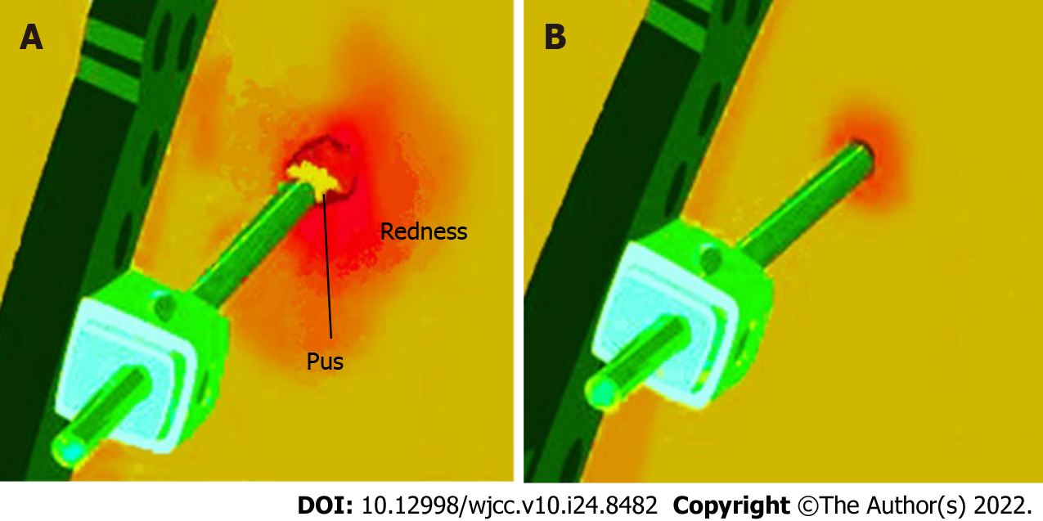
Figure 1 Pin tract infection. A: Healthy healing of pin tract site; B: Infection of pin tract site.

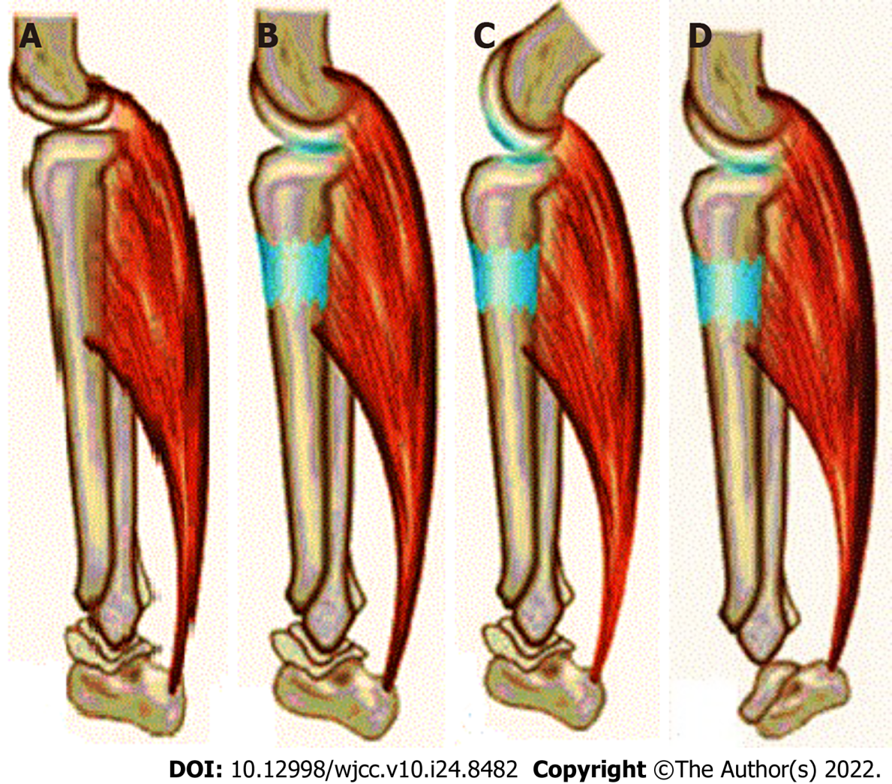
Figure 2 Lateral view of the tibia and associated muscles. A: Before lengthening. Gastrosoleus muscles and Achilles tendon; B: After lengthening of tibia. Ideally the muscle should lengthen to the same extent as the bone; C: Knee flexion contracture. This occurs when knee extension is not maintained throughout lengthening. A relative shortening of the muscle to the new bone length has been produced; D: Equinus contracture of ankle. This occurs when ankle dorsiflexion is not maintained during lengthening.

Published by Baishideng Publishing Group Inc
7041 Koll Center Parkway, Suite 160, Pleasanton, CA 94566, USA
Telephone: +1-925-3991568
E-mail: bpgoffice@wjgnet.com
Help Desk: https://www.f6publishing.com/helpdesk
https://www.wjgnet.com

© 2022 Baishideng Publishing Group Inc. All rights reserved.

