Name of Journal: World Journal of Clinical Cases
Manuscript NO: 77982
Manuscript Type: CASE REPORT

Case mistaken for leukemia after mRNA COVID-19 vaccine administration: A case report

Lee SB et al. Coronavirus disease vaccine induced leukemoid reaction

Seul Bi Lee, Chi Young Park, Sang-Gon Park, Hee Jeong Lee

Seul Bi Lee, Chi Young Park, Sang-Gon Park, Hee Jeong Lee, Department of Internal Medicine, Hemato-oncology, Chosun University Hospital, Gwangju 501-717, South Korea

Author contributions: Lee SB contributed mainly to the writing of the manuscript; Park SG and Park CY advised on manuscript drafting; Lee HJ proofread and revised the manuscript as a corresponding author; all authors have approved this version for publication.

Supported by Chosun University, 2020.

Corresponding author: Hee Jeong Lee, PhD, Professor, Department of Internal Medicine, Hemato-oncology, Chosun University Hospital, 365 Pilmun-daero, Dong-gu, Gwangju 501-717, South Korea. hjangel21c@hanmail.net

Received: June 9, 2022
Revised: September 6, 2022
Accepted: October 20, 2022
Published online:

Abstract
BACKGROUND
Following the global outbreak of coronavirus disease 2019 (COVID-19), unlike other vaccines, COVID-19 vaccines were developed and commercialized in a relatively short period of time. The large-scale administration of this vaccine in a short time-period led to various unexpected side effects, including severe cytopenia and thrombosis with thrombocytopenia syndrome. Despite many reports on adverse reactions, vaccination was necessary to prevent the spread of COVID-19; thus, it is essential to understand and discuss various cases of adverse reactions after vaccination.

CASE SUMMARY
A 77-year-old woman was administered the second dose of Pfizer mRNA COVID-19 vaccine. After vaccination she experienced fever, myalgia, and weakness. Antibiotics were subsequently administered for several days, but there was no improvement in the symptoms. The patient showed severe thrombocytopenia and leukocytosis. Thoracic and abdominopelvic computed tomography showed no infection related findings, but splenomegaly and cirrhotic liver features were observed. A large number of immature cells were observed in the peripheral blood smear; thus, bone marrow examination was performed for acute leukemia. However, there were no abnormalities. The patient recovered after administration of hepatotoxins and transfusion treatment for cytopenia and was diagnosed with an adverse reaction to COVID-19 vaccination.

CONCLUSION
Adverse reactions of vaccination could be mistaken for hematologic malignancies including leukemia. We report a patient with leukocytosis following COVID-19 vaccination.

Key Words: COVID-19; Vaccine; mRNA; Leukocytosis; Adverse reaction; Case report

Lee SB, Park CY, Park SG, Lee HJ. Case mistaken for leukemia after mRNA COVID-19 vaccine administration: A case report. World J Clin Cases 2022; In press

Core Tip: Cases of cytopenia or thrombosis with thrombocytopenia syndrome after coronavirus disease vaccination have been reported. We report a case of suspected hematologic malignancy, i.e., leukemia after vaccination in a female patient. Adverse reactions of vaccination could be mistaken for hematologic malignancies.

INTRODUCTION
Since the coronavirus disease 2019 (COVID-19) outbreak at the end of 2019, there have been more than 200 million infections and over 4.5 million deaths worldwide. Several people suffer from COVID-19 complications following recovery. Autoimmune hematologic disorders such as immune thrombocytopenia (ITP) and autoimmune hemolytic anemia (AIHA), leukocytosis, thrombocytopenia, and eosinopenia have been reported as hematologic complications of COVID-19^{[1-5]}. COVID-19 vaccination campaigns are conducted worldwide. Most adverse reactions after vaccination were mild and the vaccines are effective in the prevention of COVID-19. Severe adverse events include anaphylaxis, pericarditis, neurologic diseases such as Guillain-Barre syndrome, and hematologic diseases [hemolytic anemia, thrombosis with thrombocytopenic syndrome (TTS) such as cerebral sinus venous thrombosis, splanchnic vein thrombosis, and ITP]^{[6-12]}. Considering hematologic disorders, most cases are those of ITP or hemolysis in patients with underlying hematologic diseases^{[13-16]}. Cases of blood-related adverse reactions have been reported even among individuals without underlying hematologic disease, and most of these cases were related to cytopenia^{[17-21]}.
Leukemoid reaction is a rare clinical condition defined as leukocytosis. This term was initially used by Krumbhaar^{[22]} in 1926. Since then, it has been used to refer to reactive leukocytosis above 50 × 10⁹/L with neutrophilia and a marked left shift (presence of immature neutrophilic forms) with non-hematologic malignancies^{[23]}.
We report a case with an adverse reaction that was mistaken for a hematologic malignancy due to an increased proportion of immature cells along with severe leukocytosis after COVID-19 vaccination.

CASE PRESENTATION
Chief complaints
A healthy 77-year-old woman with no known comorbidities and no medication use was transferred to the emergency room due to severe thrombocytopenia.

History of present illness
After the second dose of the BNT162b2 (Pfizer-BioNTech) vaccine, the patient visited a local clinic complaining of fever, myalgia, and weakness. The patient had no history of overseas travel, outdoor activity, or contact with wild animals. She was treated with antibiotics for a week due to elevated infection marker levels and fever. Despite continuous antibiotic administration, the patient's symptoms did not improve; this was followed by the occurrence of dyspnea along with thrombocytopenia. The patient was referred to our clinic for further evaluation of newly diagnosed thrombocytopenia and dyspnea.

History of past illness
Prior to vaccination, the patient had no history of disease, including malignancy, and there was no medication administration. There was no history of any infectious disease, including COVID-19.

Personal and family history
The patient is a housewife and has never been exposed to certain occupational risks. She denied tobacco smoking, alcohol drinking, and drug abuse. There was also no confirmed family history.

Physical examination
Except for fever, the patient's vital signs were stable. Despite dyspnea, there was no oxygen demand. Physical examination revealed splenomegaly of three-finger width.

Laboratory examinations
The complete blood count results were as follows (normal ranges are shown in parentheses): White blood cells, 11590 × 10³/μL (4.0-10.0 × 10³/μL); hemoglobin, 8.6 g/dL (12-16 g/dL); platelets, 38 × 10³/μL (150-400 × 10³/μL). The blood biochemistry results were as follows: Total bilirubin, 6.5 mg/dL (0.2-1.1 mg/dL); aspartate aminotransferase (AST), 242 U/L (5-40 U/L); alanine aminotransferase (ALT), 74 U/L (5-40 U/L); albumin, 2.06 g/dL (3.5-5.2 g/dL); blood urea nitrogen, 23.0 mg/dL (8-20 mg/dL); creatinine, 1.27 mg/dL (0.5-1.3 mg/dL); C-reactive protein (CRP), > 16 mg/dL (0-0.3 mg/dL). The coagulation profile results were as follows: Prothrombin time, 20.5 s (9.4-12.5 s); activated partial thromboplastin time, 41.3 s (28.0-44.0 s), fibrinogen 350 mg/dL (200-400 mg/dL), D-dimer 5830 (0-255 ng/mL) (Table 1). The real-time reverse transcription-polymerase chain reaction results were negative for COVID-19. The results were also negative for Hantavirus, Letospira, Rickettsia, and Scrub typhus. Further virological laboratory tests for human immunodeficiency virus and hepatitis B, C, and A were negative. Urine and blood cultures showed no bacterial growth (Table 2).

Imaging examinations
Thoracic and abdominopelvic computed tomography (CT) was performed to check for infection focus and the cause of dyspnea. Thoracic CT revealed mild pleural effusion, but no findings indicated infection, such as pneumonia or bronchitis (Figure 1). On abdominopelvic CT, liver cirrhosis was suspected with splenomegaly (16.5 cm) and moderate ascites (Figure 1).

Further diagnostic work-up
Most infectious diseases were not considered to be the cause of the patient’s symptoms; thus, the causes of cirrhosis and splenomegaly were evaluated. All tests for autoimmune hepatitis were negative (Table 3). Although no evidence of infectious disease was found, ceftriaxone administration was continued due to leukocytosis, CRP elevation, and persistent febrile symptoms. On day 2 of hospitalization, continuous renal replacement treatment (CCRT) was started due to decreased urine output accompanied by metabolic acidosis, and CCRT was stopped due to recovery of kidney function on day 5 of hospitalization. On day 4, the white blood cell count was elevated to 50790 × 10³/μL (Figure 2) and immature cells were observed in the peripheral blood smear. To rule out acute leukemia, we performed bone marrow biopsy, but there were no abnormalities (Figure 3). On day 5 of hospitalization, the total bilirubin increased to 10.0 mg/dL and the LDH level also increased to 1053 mg/dL, with a low haptoglobin level. In the peripheral blood smear, schistocytes were observed in trace amounts, but both direct and indirect Coombs’ test results were negative.

FINAL DIAGNOSIS
The patient was diagnosed with an adverse reaction to COVID-19 vaccination and not with a hematologic malignancy such as acute leukemia.

TREATMENT
Hepatotoxins, platelets and fresh-frozen plasma transfusion, and intravascular fluid were only administered due to liver cirrhosis, splenomegaly, changes in blood count, and CRP elevation observed at the time of hospitalization.

OUTCOME AND FOLLOW-UP
AST, ALT, and bilirubin levels decreased from day 7 of hospitalization, and the coagulation panel also started to improve. From day 5 of hospitalization, the leukocyte count started decreasing and recovered to the normal level on day 10; the platelet count also recovered to > 100000 showing a normal blood cell count profile from day 11. On day 13 of hospitalization, we performed abdomino-pelvic CT again and it was confirmed that the ascites had decreased and splenomegaly had improved. The patient was discharged in good condition on day 16 of hospitalization and is currently undergoing regular follow-up as an outpatient.

DISCUSSION
Various adverse events of COVID-19 vaccines like those of many other vaccines have been reported. There are mild adverse events such as fever, fatigue, headache, myalgia, and arthralgia, and more severe events such as anaphylactic shock, myocarditis, and TTS. Although one case of TTS related to mRNA-based vaccine has been reported, TTS is mainly reported in relation to adenoviral vector vaccines^{[17-20]}. ITP and hemolytic anemia mainly occur in relation to mRNA-based vaccines^{[24-28]}.
Cases of ITP and one case of AIHA related to the mRNA-1273 (Moderna) vaccine have been reported^{[24]}. One case of ITP was reported in a patient with Evans syndrome, and AIHA was observed in a healthy elderly man^{[13]}. Adverse events related to the Pfizer-BionTech vaccine included several cases of ITP, one case of AIHA, and four cases of severe hemolysis in paroxysmal nocturnal hemoglobinuria (Table 4)^{[25-27]}. Although the specific vaccine type is unknown, one case of hemolytic crisis in a patient with primary cold agglutinin disease and AIHA in a patient with clinically insignificant cryoglobulinemia have been reported^{[15]}. However, to the best of our knowledge, there are no reports of severe leukocytosis. Cases of leukemoid reaction with COVID-19 have been reported, but there are no reports of similar cases related to vaccination^{[4,5]}. The major causes of leukemoid reaction are severe infection, malignancies, intoxication, or hemorrhage. There were no findings that indicated malignancy or infection on CT performed at the time of admission when the patient was evaluated for all possible infectious diseases at the Department of Infectious Diseases; however, this was not confirmed. The patient showed negative real-time polymerase chain reaction test results for severe acute respiratory syndrome coronavirus 2, eliminating the possibility of COVID-19. With findings including thrombocytopenia, fever, dyspnea, and pleural effusion, a disease such as dengue fever can also be suspected. However, South Korea is not an endemic area of dengue fever and its residents have no history of travel to a country where the disease occurs; thus, this disease was excluded.
Our findings suggested the occurrence of cirrhosis from the early stage of hospitalization; all possible causes were evaluated, but the exact cause was not identified. There were no risk factors such as alcohol drinking history, drug abuse, or stick injury. The patient was transferred from the Department of Infectious Diseases to the Department of Hematology due to leukocytosis with immature cells that persisted without evidence of infection. Bone marrow examination was performed to differentiate malignant diseases such as acute leukemia; no abnormal cells including blasts were identified, and the Department of Laboratory Medicine reported that it was a reactive bone marrow according to the patient’s disease state. The patient’s condition improved with only supportive treatment, such as fluid therapy and blood transfusion, without any special treatment except for antibiotic administration. The detailed pathogenesis of leukocytosis and splenomegaly is unknown. The diagnosis of liver cirrhosis was presumed from initial CT findings such as splenomegaly with ascites; however, liver biopsy was not performed to rule out liver cirrhosis. Autoimmune hepatitis developing after COVID-19 vaccination has been reported. This report postulated that autoinflammatory dysregulation was the cause of tissue damage^{[29]}. In our case, organ damage such as liver cirrhosis was observed by a similar mechanism. Further studies on the pathogenesis and confirmation in more cases are needed.
No case of severe leukocytosis after COVID-19 vaccination has been reported so far. There have been reports of leukocytosis after pneumococcal polysaccharide vaccine administration wherein it was hypothesized that the leukocytosis was the result of an inflammatory response due to increased cytokines in the body after vaccination. However, further studies on the pathogenesis have not yet been conducted^{[30]}. An excessive inflammatory response can also be assumed in the present case, which could have been caused by increased cytokines after vaccination; however, additional research is needed regarding this.

CONCLUSION
The patient was suspected to have infection due to fever, leukocytosis and CRP elevation. All infectious agents were excluded and immature cells were observed in the peripheral blood smear with leukocytosis; thus, other causes of leukemoid reaction were also investigated, but all results were negative. The patient had a history of COVID-19 vaccination prior to symptom onset, no specific underlying disease or medication history, and no special findings in the overall evaluation including bone marrow examination. The patient’s symptoms were considered to be adverse events due to vaccination, and this is the first report of a leukemoid-like reaction that occurred after COVID-19 vaccination.

REFERENCES
1 Bhattacharjee S, Banerjee M. Immune Thrombocytopenia Secondary to COVID-19: a Systematic Review. SN Compr Clin Med 2020; 2: 2048-2058 [PMID: 32984764 DOI: 10.1007/s42399-020-00521-8]
2 Mahévas M, Moulis G, Andres E, Riviere E, Garzaro M, Crickx E, Guillotin V, Malphettes M, Galicier L, Noel N, Darnige L, Terriou L, Guerveno C, Sanchis-Borja M, Moulinet T, Meunier B, Ebbo M, Michel M, Godeau B. Clinical characteristics, management and outcome of COVID-19-associated immune thrombocytopenia: a French multicentre series. Br J Haematol 2020; 190: e224-e229 [PMID: 32678953 DOI: 10.1111/bjh.17024]
3 Algassim AA, Elghazaly AA, Alnahdi AS, Mohammed-Rahim OM, Alanazi AG, Aldhuwayhi NA, Alanazi MM, Almutairi MF, Aldeailej IM, Kamli NA, Aljurf MD. Prognostic significance of hemoglobin level and autoimmune hemolytic anemia in SARS-CoV-2 infection. Ann Hematol 2021; 100: 37-43 [PMID: 32918594 DOI: 10.1007/s00277-020-04256-3]
4 Tarekegn K, Colon Ramos A, Sequeira Gross HG, Yu M, Fulger I. Leukemoid Reaction in a Patient With Severe COVID-19 Infection. Cureus 2021; 13: e13598 [PMID: 33815998 DOI: 10.7759/cureus.13598]
5 Tabassum S, Bibi T, Tariq F, Tariq S, Raza S, Hafeez M, Rana M. Unusual leukemoid reaction in a COVID-19 patient: a case report. Biol Clin Sci Res J 2020 [DOI: 10.54112/bcsrj.v2020i1.34]
6 Rosenberg HF, Foster PS. Eosinophils and COVID-19: diagnosis, prognosis, and vaccination strategies. Semin Immunopathol 2021; 43: 383-392 [PMID: 33728484 DOI: 10.1007/s00281-021-00850-3]
7 Lee DS, Kim JW, Lee KL, Jung YJ, Kang HW. Adverse events following COVID-19 vaccination in South Korea between February 28 and August 21, 2021: A nationwide observational study. Int J Infect Dis 2022; 118: 173-182 [PMID: 35276381 DOI: 10.1016/j.ijid.2022.03.007]
8 Voysey M, Clemens SAC, Madhi SA, Weckx LY, Folegatti PM, Aley PK, Angus B, Baillie VL, Barnabas SL, Bhorat QE, Bibi S, Briner C, Cicconi P, Collins AM, Colin-Jones R, Cutland CL, Darton TC, Dheda K, Duncan CJA, Emary KRW, Ewer KJ, Fairlie L, Faust SN, Feng S, Ferreira DM, Finn A, Goodman AL, Green CM, Green CA, Heath PT, Hill C, Hill H, Hirsch I, Hodgson SHC, Izu A, Jackson S, Jenkin D, Joe CCD, Kerridge S, Koen A, Kwatra G, Lazarus R, Lawrie AM, Lelliott A, Libri V, Lillie PJ, Mallory R, Mendes AVA, Milan EP, Minassian AM, McGregor A, Morrison H, Mujadidi YF, Nana A, O'Reilly PJ, Padayachee SD, Pittella A, Plested E, Pollock KM, Ramasamy MN, Rhead S, Schwarzbold AV, Singh N, Smith A, Song R, Snape MD, Sprinz E, Sutherland RK, Tarrant R, Thomson EC, Török ME, Toshner M, Turner DPJ, Vekemans J, Villafana TL, Watson MEE, Williams CJ, Douglas AD, Hill AVS, Lambe T, Gilbert SC, Pollard AJ; Oxford COVID Vaccine Trial Group. Safety and efficacy of the ChAdOx1 nCoV-19 vaccine (AZD1222) against SARS-CoV-2: an interim analysis of four randomised controlled trials in Brazil, South Africa, and the UK. Lancet 2021; 397: 99-111 [PMID: 33306989 DOI: 10.1016/S0140-6736(20)32661-1]
9 Polack FP, Thomas SJ, Kitchin N, Absalon J, Gurtman A, Lockhart S, Perez JL, Pérez Marc G, Moreira ED, Zerbini C, Bailey R, Swanson KA, Roychoudhury S, Koury K, Li P, Kalina WV, Cooper D, Frenck RW Jr, Hammitt LL, Türeci Ö, Nell H, Schaefer A, Ünal S, Tresnan DB, Mather S, Dormitzer PR, Şahin U, Jansen KU, Gruber WC; C4591001 Clinical Trial Group. Safety and Efficacy of the BNT162b2 mRNA Covid-19 Vaccine. N Engl J Med 2020; 383: 2603-2615 [PMID: 33301246 DOI: 10.1056/NEJMoa2034577]
10 Sadoff J, Gray G, Vandebosch A, Cárdenas V, Shukarev G, Grinsztejn B, Goepfert PA, Truyers C, Fennema H, Spiessens B, Offergeld K, Scheper G, Taylor KL, Robb ML, Treanor J, Barouch DH, Stoddard J, Ryser MF, Marovich MA, Neuzil KM, Corey L, Cauwenberghs N, Tanner T, Hardt K, Ruiz-Guiñazú J, Le Gars M, Schuitemaker H, Van Hoof J, Struyf F, Douoguih M; ENSEMBLE Study Group. Safety and Efficacy of Single-Dose Ad26.COV2.S Vaccine against Covid-19. N Engl J Med 2021; 384: 2187-2201 [PMID: 33882225 DOI: 10.1056/NEJMoa2101544]
11 Baden LR, El Sahly HM, Essink B, Kotloff K, Frey S, Novak R, Diemert D, Spector SA, Rouphael N, Creech CB, McGettigan J, Khetan S, Segall N, Solis J, Brosz A, Fierro C, Schwartz H, Neuzil K, Corey L, Gilbert P, Janes H, Follmann D, Marovich M, Mascola J, Polakowski L, Ledgerwood J, Graham BS, Bennett H, Pajon R, Knightly C, Leav B, Deng W, Zhou H, Han S, Ivarsson M, Miller J, Zaks T; COVE Study Group. Efficacy and Safety of the mRNA-1273 SARS-CoV-2 Vaccine. N Engl J Med 2021; 384: 403-416 [PMID: 33378609 DOI: 10.1056/NEJMoa2035389]
12 Shimabukuro TT, Cole M, Su JR. Reports of Anaphylaxis After Receipt of mRNA COVID-19 Vaccines in the US-December 14, 2020-January 18, 2021. JAMA 2021; 325: 1101-1102 [PMID: 33576785 DOI: 10.1001/jama.2021.1967]
13 Gaignard ME, Lieberherr S, Schoenenberger A, Benz R. Autoimmune Hematologic Disorders in Two Patients After mRNA COVID-19 Vaccine. Hemasphere 2021; 5: e618 [PMID: 34263143 DOI: 10.1097/HS9.0000000000000618]
14 Gerber GF, Yuan X, Yu J, Cher BAY, Braunstein EM, Chaturvedi S, Brodsky RA. COVID-19 vaccines induce severe hemolysis in paroxysmal nocturnal hemoglobinuria. Blood 2021; 137: 3670-3673 [PMID: 33945618 DOI: 10.1182/blood.2021011548]
15 Pérez-Lamas L, Moreno-Jiménez G, Tenorio-Núñez MC, Velázquez-Kennedy K, Jiménez-Chillón C, Astibia-Mahillo B, Núñez-Torrón C, García-Gutiérrez V, Jiménez-Martín A, Vallés-Carboneras A, López-Jiménez JF. Hemolytic crisis due to Covid-19 vaccination in a woman with cold agglutinin disease. Am J Hematol 2021; 96: E288-E291 [PMID: 33939851 DOI: 10.1002/ajh.26214]
16 Murdych TM. A case of severe autoimmune hemolytic anemia after a receipt of a first dose of SARS-CoV-2 vaccine. Int J Lab Hematol 2022; 44: e10-e12 [PMID: 34258873 DOI: 10.1111/ijlh.13653]
17 Greinacher A, Thiele T, Warkentin TE, Weisser K, Kyrle PA, Eichinger S. Thrombotic Thrombocytopenia after ChAdOx1 nCov-19 Vaccination. N Engl J Med 2021; 384: 2092-2101 [PMID: 33835769 DOI: 10.1056/NEJMoa2104840]
18 Muir KL, Kallam A, Koepsell SA, Gundabolu K. Thrombotic Thrombocytopenia after Ad26.COV2.S Vaccination. N Engl J Med 2021; 384: 1964-1965 [PMID: 33852795 DOI: 10.1056/NEJMc2105869]
19 Bang SM, Na SH, Kim JH, Kim SR, Kim SR, Jang S. Platelet count as an important prognostic factor for vaccine-induced immune thrombotic thrombocytopenia. Blood Res 2021; 56: 129-133 [PMID: 34349044 DOI: 10.5045/br.2021.2021126]
20 Sangli S, Virani A, Cheronis N, Vannatter B, Minich C, Noronha S, Bhagavatula R, Speredelozzi D, Sareen M, Kaplan RB. Thrombosis With Thrombocytopenia After the Messenger RNA-1273 Vaccine. Ann Intern Med 2021; 174: 1480-1482 [PMID: 34181446 DOI: 10.7326/L21-0244]
21 Shimabukuro T, Nair N. Allergic Reactions Including Anaphylaxis After Receipt of the First Dose of Pfizer-BioNTech COVID-19 Vaccine. JAMA 2021; 325: 780-781 [PMID: 33475702 DOI: 10.1001/jama.2021.0600]
22 Krumbhaar EB. Leukemoid blood pictures in various clinical conditions. Am J Med Sci 1926; 172: 519-532 [DOI: 10.1097/00000441-192610000-00005]
23 Portich JP, Faulhaber GAM. Leukemoid reaction: A 21st-century cohort study. Int J Lab Hematol 2020; 42: 134-139 [PMID: 31765058 DOI: 10.1111/ijlh.13127]
24 Brito S, Ferreira N, Mateus S, Bernardo M, Pinto B, Lourenço A, Grenho F. A Case of Autoimmune Hemolytic Anemia Following COVID-19 Messenger Ribonucleic Acid Vaccination. Cureus 2021; 13: e15035 [PMID: 34150386 DOI: 10.7759/cureus.15035]
25 Ganzel C, Ben-Chetrit E. Immune Thrombocytopenia Following the Pfizer-BioNTech BNT162b2 mRNA COVID-19 Vaccine. Isr Med Assoc J 2021; 23: 341 [PMID: 34155844]
26 Lee EJ, Cines DB, Gernsheimer T, Kessler C, Michel M, Tarantino MD, Semple JW, Arnold DM, Godeau B, Lambert MP, Bussel JB. Thrombocytopenia following Pfizer and Moderna SARS-CoV-2 vaccination. Am J Hematol 2021; 96: 534-537 [PMID: 33606296 DOI: 10.1002/ajh.26132]
27 Shah SRA, Dolkar S, Mathew J, Vishnu P. COVID-19 vaccination associated severe immune thrombocytopenia. Exp Hematol Oncol 2021; 10: 42 [PMID: 34266487 DOI: 10.1186/s40164-021-00235-0]
28 Paulsen FO, Schaefers C, Langer F, Frenzel C, Wenzel U, Hengel FE, Bokemeyer C, Seidel C. Immune thrombocytopenic purpura after vaccination with COVID-19 vaccine (ChAdOx1 nCov-19). Blood 2021; 138: 996-999 [PMID: 34297792 DOI: 10.1182/blood.2021012790]
29 Bril F, Al Diffalha S, Dean M, Fettig DM. Autoimmune hepatitis developing after coronavirus disease 2019 (COVID-19) vaccine: Causality or casualty? J Hepatol 2021; 75: 222-224 [PMID: 33862041 DOI: 10.1016/j.jhep.2021.04.003]
30 von Elten KA, Duran LL, Banks TA, Banks TA, Collins LC, Collins LC. Systemic inflammatory reaction after pneumococcal vaccine: a case series. Hum Vaccin Immunother 2014; 10: 1767-1770 [PMID: 24642659 DOI: 10.4161/hv.28559]
31 Tarawneh O, Tarawneh H. Immune thrombocytopenia in a 22-year-old post Covid-19 vaccine. Am J Hematol 2021; 96: E133-E134 [PMID: 33476455 DOI: 10.1002/ajh.26106]
32 Toom S, Wolf B, Avula A, Peeke S, Becker K. Familial thrombocytopenia flare-up following the first dose of mRNA-1273 Covid-19 vaccine. Am J Hematol 2021; 96: E134-E135 [PMID: 33580970 DOI: 10.1002/ajh.26128]
33 Ghosh AK, Bhushan S, Lopez LDR, Sampat D, Salah Z, Hatoum CA. BNT162b2 COVID-19 Vaccine Induced Immune Thrombocytopenic Purpura. Case Rep Med 2022; 2022: 5603919 [PMID: 35464782 DOI: 10.1155/2022/5603919]

Footnotes
Informed consent statement: A written informed consent was obtained from the patient for publication of this case report.

Conflict-of-interest statement: The authors declare that they have no conflict of interest to disclose.

CARE Checklist (2016) statement: The authors have read the CARE Checklist (2016), and the manuscript was prepared and revised according to the CARE Checklist (2016).

Open-Access: This article is an open-access article that was selected by an in-house editor and fully peer-reviewed by external reviewers. It is distributed in accordance with the Creative Commons Attribution NonCommercial (CC BY-NC 4.0) license, which permits others to distribute, remix, adapt, build upon this work non-commercially, and license their derivative works on different terms, provided the original work is properly cited and the use is non-commercial. See: https://creativecommons.org/Licenses/by-nc/4.0/

Provenance and peer review: Unsolicited article; Externally peer reviewed.
Peer-review model: Single blind

Peer-review started: June 9, 2022
First decision: July 29, 2022
Article in press:

Specialty type: Hematology
Country/Territory of origin: South Korea
Peer-review report’s scientific quality classification
Grade A (Excellent): 0
Grade B (Very good): 0
Grade C (Good): C
Grade D (Fair): D
Grade E (Poor): 0

P-Reviewer: Salim J, Indonesia; Zhang JX, China S-Editor: Wang DM L-Editor: Webster JR P-Editor: Wang DM
Figure Legends
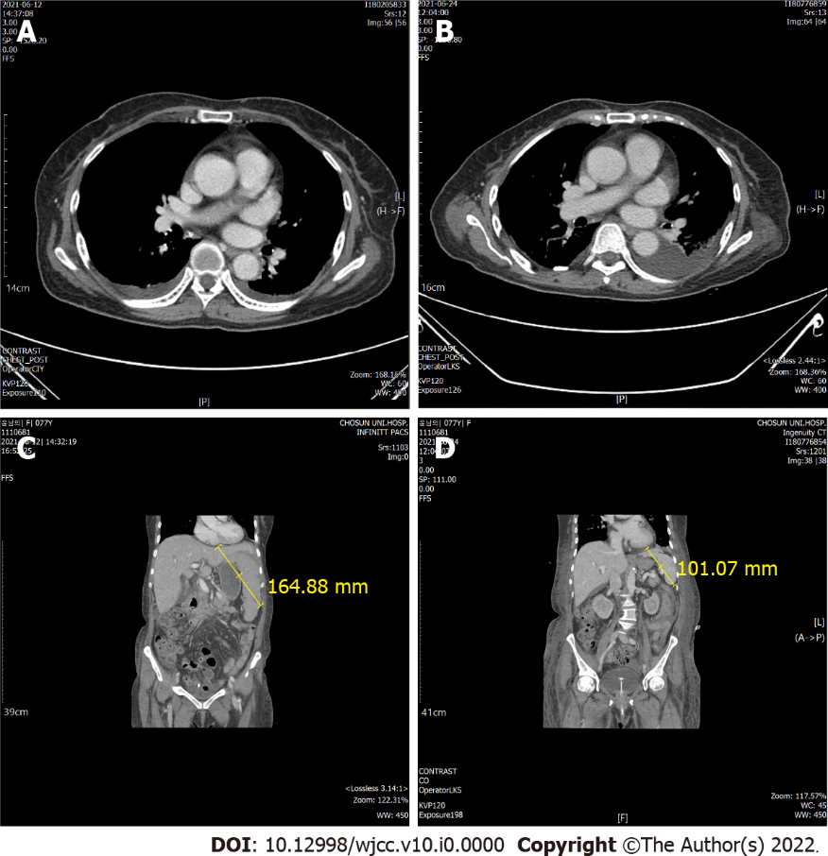
Figure 1 Computed tomography imaging. A: Initial thorax imaging; B: Day 13 thorax imaging; C: Initial hospitalization; D: Day 13 of hospitalization. Thorax computed tomography showed no findings indicating infection, but splenomegaly and liver cirrhosis were confirmed on abdomino-pelvic computed tomography. Splenomegaly improved on day 13 of hospitalization.
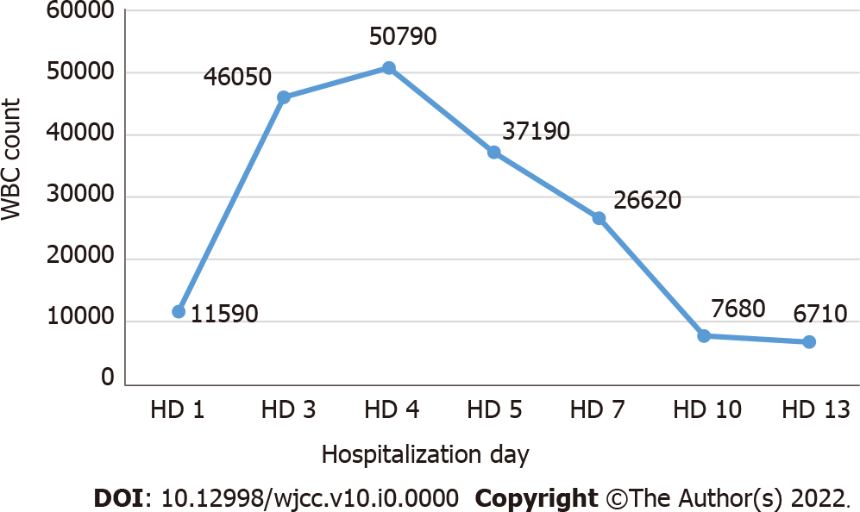
Figure 2 White blood cell count during hospitalization. WBC: White blood cell; HD: Hospitalization day.
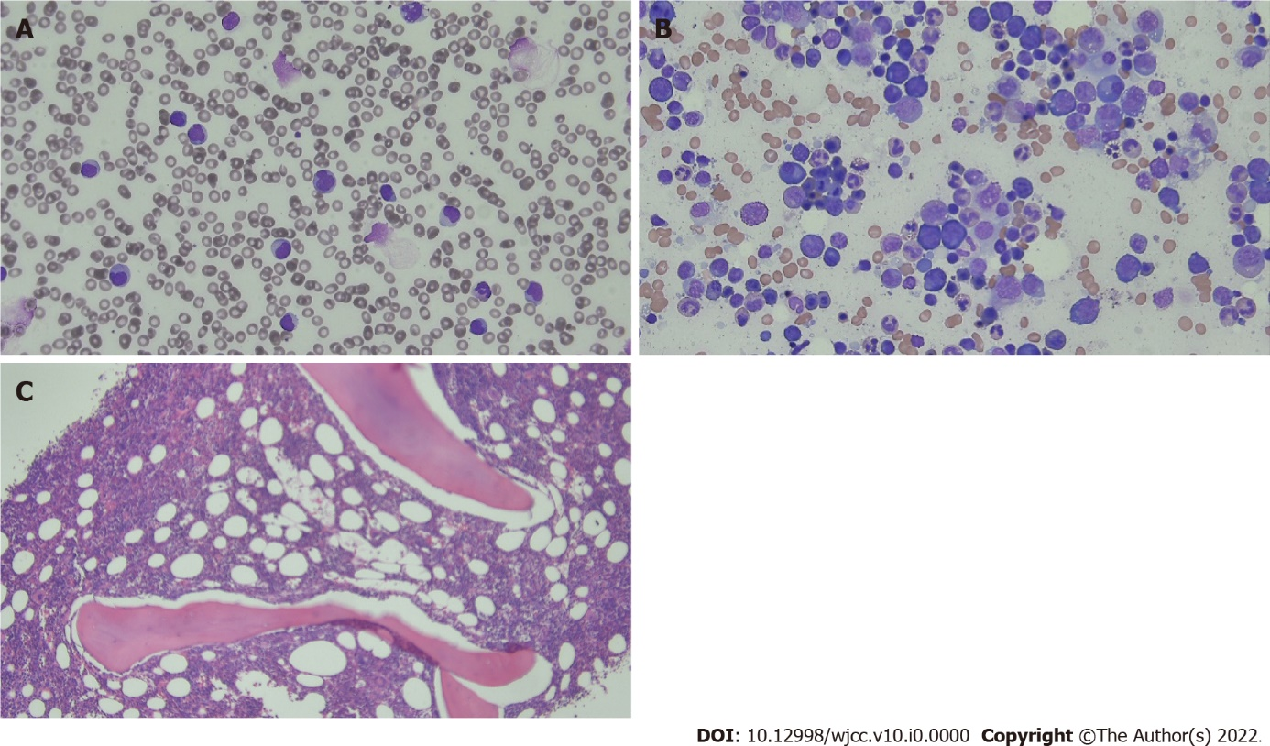
Figure 3 Peripheral blood smear and bone marrow examination. A: Peripheral blood smear; B: Bone marrow aspiration; C: Bone marrow biopsy. Peripheral blood smear showed leukocytosis with neutrophils and immature cells. Bone marrow aspiration and biopsy sample revealed reactive marrow.
Table 1 Laboratory data at admission
Laboratory parameter | Result | Normal range
WBC (/μL) | 11590 | 4000-10000
Neutrophil (%) | 58.7 | 40-80
Lymphocyte (%) | 31.2 | 25-50
Monocyte (%) | 9.8 | 0-9
Eosinophil (%) | 0.1 | 0-7
Basophil (%) | 0.2 | 0-1.8
Platelet (/μL) | 38000 | 150000-400000
AST (U/L) | 242 | 5-40
ALT (U/L) | 73.5 | 5-40
Total bilirubin (mg/dL) | 6.5 | 0.2-1.2
CRP (mg/dL) | > 16 | 0.0-0.3
WBC: White blood cell; AST: Aspartate aminotransferase; ALT: Alanine aminotransferase; CRP: C-reactive protein.
Table 2 Infectious disease diagnostic test results
Diseases | Result
COVID-19 | Negative
Ebstein-Barr virus | Negative
Cytomegalovirus | Negative
Hepatitis A | Negative
Hepatitis B | Negative
Hepatitis C | Negative
Hantavirus | Negative
HIV | Negative
Rickettsia tsutsugamushi | Negative
Leptospira | Negative
Blood bacterial culture | Negative
Urine bacterial culture | Negative
COVID-19: Coronavirus disease 2019; HIV: Human immunodeficiency virus.
Table 3 Evaluation of autoimmune hepatitis
Laboratory parameter | Results | Normal range
Anti LKM-1 Ab | Negative | Negative
Anti-mitochondria Ab | Negative | Negative
ANA (titer) | Centromere 1:1280
Anti dsDNA antibody (IU/mL) | Negative < 10 | 10-15
p-ANCA (IU/mL) | Negative < 0.1 | 0-3.5
Anti LKM-1 Ab: Anti liver kidney microsomal antibody; ANA: Antinuclear antibody; ANCA: Anti neutrophil cytoplasmic antibody.

Table 4 Hematologic adverse events except for thrombocytopenic syndrome
Types of hematologic adverse events | Patient No. and Ref. | Age, yr | Sex | Symptom onset  (No. of days after vaccination) | Symptoms | Underlying diseases | Type of vaccine | Outcome
ITP | 1, Tarawneh and Tarawneh^{[31]} | 22 | M | 3 | Petechia, gum bleeding | None | Pfizer | Recovery
 | 2-9, Lee et al^{[26]} | NA | NA | NA | NA | NA | Pfizer | NA
 | 10-20, Lee et al^{[26]} | NA | NA | NA | NA | NA | Moderna | NA
 | 21, Shah et al^{[27]} | 53 | M | 8 | Petechia rash, myalgia | Crohn’s disease | Pfizer | Recovery
 | 22, Shah et al^{[27]} | 67 | M | 2 | Melena | Chronic ITP | Pfizer | Recovery
 | 23, Shah et al^{[27]} | 59 | F | 2 | Bloody diarrhea | SLE, chronic ITP | J&J | Recovery
 | 24, Ganzel and Ben-Chetrit^{[25]} | 53 | M | 14 | Epistaxis | DM, HTN, otitis | Pfizer | Recovery
 | 25, Toom et al^{[32]} | 36 | F | 14 | Petechia, bruising, gum bleeding, headache | ITP | Moderna | Recovery
 | 26, Paulsen et al^{[28]} | 72 | M | 11 | Petechia, epistaxis, headache | Autoimmune thyroiditis | AZD1222 | NA
 | 27 Paulsen et al^{[28]} | 71 | F | 11 | Petechia, hyposphagma | Latent hyperthyroidism, breast cancer, stroke | AZD1222 | NA
 | 28 Paulsen et al^{[28]} | 66 | M | 2 | Petechia | HTN, mild thrombocytopenia | AZD1222 | NA
 | 29 Paulsen et al^{[28]} | 64 | F | 15 | None | HTN, COPD, steatosis hepatitis | AZD1222 | NA
 | 30, Ghosh et al^{[33]} | 63 | F | 2 | Bruise | COPD, Type 2 DM | Pfizer | Recovery
AIHA | 30, Gaignard et al^{[13]} | 56 | M | 3 | Painless petechia | Evans syndrome | Moderna | Recovery
 | 31, Gaignard et al^{[13]} | 77 | M | 5 | Weakness, fatigue, shortness of breath | none | Moderna | Recovery
 | 32, Murdych^{[16]} | 84 | M | 19 | Urinary frequency, dizziness | Prostate & colon cancer, CAD, HTN, trace cryoglobulinemia, emphysema, mild chronic anemia, major depression and/or anxiety | Pfizer | Recovery
 | 33, Brito et al^{[24]} | 88 | F | 2 | Asthenia, jaundice | Insomnia | mRNA vaccine | Recovery
Hemolytic crisis | 35, Pérez-Lamas et al^{[15]} | 57 | F | 2 | Chills, weakness, exertional dyspnea, jaundice, mild hemoglobinurina | Cold agglutinin disease | mRNA vaccine | Recovery
Hemolysis | 36, Gerber et al^{[14]} | 25 | M | 5 | Abdominal pain | PNH | Pfizer | NA
 | 37, Gerber et al^{[14]} | 45 | M | 0 | Fever, headache, myalgia, fatigue, hemoglobinuria | PNH | Pfizer | NA
 | 37, Gerber et al^{[14]} | 32 | F | 0 | Fever, rigor | PNH | Moderna | NA
 | 38, Gerber et al^{[14]} | 63 | M | 0 | Fatigue, darkening urine | PNH | Moderna | NA
ITP: Immune thrombocytopenia; AIHA: Autoimmune hemolytic anemia; M: Male; NA: Not available; F: Female; SLE: Systemic lupus erythematosus; DM: Diabetes mellitus; HTN: Hypertension; COPD: Chronic obstructive pulmonary disease; CAD: Coronary artery disease; PNH: Paroxysmal nocturnal hemoglobinuria.

