Name of Journal: World Journal of Clinical Cases
Manuscript NO: 77644
Manuscript Type: CASE REPORT

Treatment of primary tracheal schwannoma with endoscopic resection: A case report

Shen YS et al. Endoscopic resection of primary tracheal schwannoma

Yong-Shuai Shen, Xiang-Dong Tian, Yi Pan, Hua Li

Yong-Shuai Shen, Department of Endoscopy, Tianjin Cancer Hospital Airport Hospital, Tianjin 300000, China

Xiang-Dong Tian, Department of Endoscopy, Tianjin Medical University Cancer Institute and Hospital, Tianjin 300060, China

Yi Pan, Department of Pathology, Tianjin Medical University Cancer Institute and Hospital, National Clinical Research Center for Cancer, Key Laboratory of Cancer Prevention and Therapy, Tianjin’s Clinical Research Center for Cancer, Tianjin 300060, China

Hua Li, Department of Endoscopy, Tianjin Medical University Cancer Institute and Hospital, National Clinical Research Center for Cancer, Key Laboratory of Cancer Prevention and Therapy, Tianjin’s Clinical Research Center for Cancer, Tianjin 300060, China

Author contributions: Li H and Shen YS designed the report and wrote the manuscript; Tian XD provided manuscript recommendations; Pan Y collaborated with pathologists at our hospital to determine the pathological diagnosis; Manuscript was read and approved by all authors.

Corresponding author: Hua Li, MD, Doctor, Department of Endoscopy, Tianjin Medical University Cancer Institute and Hospital, National Clinical Research Center for Cancer, Key Laboratory of Cancer Prevention and Therapy, Tianjin’s Clinical Research Center for Cancer, North Huanhu West Road, Sports Institute, Hexi District, Tianjin 300060, China. lihuatjmuch@163.com

Received: May 15, 2022
Revised: June 21, 2022
Accepted: August 25, 2022
Published online: October 6, 2022

Abstract
BACKGROUND
Schwannoma is a benign tumor originating from the peripheral nerve sheath. The clinical symptoms of tracheal schwannoma depend on the location of the tumor, and the most common clinical symptoms are cough and hemoptysis. The most effective treatment for benign tumors is complete resection of the primary lesion at an early stage. Our experience has demonstrated that primary tracheal schwannoma can be safely excised with a high-frequency electric knife in a minimally invasive manner.

CASE SUMMARY
We report a 61-year-old asymptomatic woman who underwent chest computed tomography (CT), which accidentally found an intraluminal tracheal mass without enlarged lymph nodes. Then, the patient underwent bronchoscopy, which found that the tracheal mass originated from the left wall of the upper trachea, was less than 1.5 cm in size, immovable, smooth and 4 cm away from the vocal cord, resulting in partial upper respiratory tract obstruction. Treatment was performed using an endoscopic resection for en bloc removal of the tracheal mass. The diagnosis was primary tracheal schwannoma. A follow-up was performed after endoscopic surgery, and bronchoscopy and thoracic CT were used to monitor whether there was a recurrence. At present, there is no evidence of recurrence, and the patient had a good quality of life. Endoscopic resection may be effective and safe in the treatment of primary tracheal schwannoma.

CONCLUSION
Primary tracheal schwannoma is a very rare benign tumor. In this case, we cured it by complete endoscopic resection.

Key Words: Schwannoma; Tracheal tumor; Endoscopic therapy; High-frequency electric knife; En bloc; Case report

©The Author(s) 2022. Published by Baishideng Publishing Group Inc. All rights reserved.

Citation: Shen YS, Tian XD, Pan Y, Li H. Treatment of primary tracheal schwannoma with endoscopic resection: A case report. World J Clin Cases 2022; 10(28): 10279-10285
URL: https://www.wjgnet.com/2307-8960/full/v10/i28/10279.htm
DOI: https://dx.doi.org/10.12998/wjcc.v10.i28.10279

Core Tip: We report a case diagnosed with primary tracheal schwannoma using endoscopic resection. Primary tracheal schwannoma is an extremely rare benign tumor of trachea. To the best of our knowledge, only a few cases have previously been reported. Cough and hemoptysis are common in this disease, but many patients are misdiagnosed as having asthma. Our experience shows that primary tracheal schwannoma can be safely and completely resected by a high-frequency electric knife in a minimally invasive manner.

INTRODUCTION
Primary tracheal tumors are uncommon^{[1,2]}. It is estimated that approximately 0.2% of the entire respiratory system is occupied by primary tracheal tumors in the United States, and most of them are malignant^{[3]}. Among them, primary tracheal schwannoma accounts for less than 0.5% of primary tracheal tumors^{[4,5]}. There are two distinct types of primary tracheal schwannomas, schwannomas and neurofibromas, which arise from nerves located inside the trachea. As an extremely rare tumor with nonspecific symptoms and is sometimes misdiagnosed as asthma^{[6,7]}. Less invasive endoscopic procedures can now be used to resect tumors that previously required surgery^{[8,9]}. We herein present a rare case of a primary tracheal schwannoma with a high-frequency electric knife in a minimally invasive manner. In addition, we retrieved related literature found four primary tracheal schwannoma cases treated by endoscopic therapy that are reported in the literature in Table 1^{[7,9-11]}.

CASE PRESENTATION
Chief complaints
There were no complaints from the patient.

History of present illness
A 61-year-old woman with no history of chronic pulmonary disease was referred from the department of chest surgery for diagnosis and treatment of an accidental pulmonary nodule. She was a nonsmoker. No abnormal results were found in physical examinations or biochemical tests.

History of past illness
There was no relevant medical history for the patient.

Personal and family history
The patient has no noteworthy family history. There was no family history of cancer in the patient's family. The patient's family members had no smoking history.

Physical examination
A physical examination revealed no clinically significant changes.

Laboratory examinations
No abnormalities were noted on laboratory examinations.

Imaging examinations
A bronchoscopy was performed, which confirmed that the lesion originated from the left wall of the upper trachea. The mass was less than 1.5 centimeters in size, immobile, smooth and 4 centimeters distal to the vocal cords, leading to partial upper airway obstruction (Figure 1A-C). A computed tomography (CT) scan of the chest revealed an intraluminal tracheal mass without enlarged lymph nodes (Figure 1D and E). Chest CT was performed and suggested the existence of a nodule on the left wall of the trachea at the entrance to the thoracic cavity, considering benign lesions.

FINAL DIAGNOSIS
Pathological examination confirmed a spindle cell neoplasm with schwannoma features (Figure 2).

TREATMENT
The patient underwent endoscopic excision within 25 min. A BF TYPE 1T260 bronchoscope (Olympus, Tokyo, Japan) was used for the operation, and VIO200D (ERBE, Germany) was selected as the electrosurgical generator, with cutting set to the endo-cut mode (effect 3, duration 1, interval 5) and electrocoagulation set to the forced-coagulation mode (effect 3, 30 W).
The patient was positioned in a supine posture under intravenous anesthesia (propofol and fentanyl). Based on the measurement of blood oxygen saturation, intermittent mask oxygen inhalation was administered with an oxygen flow rate of 0-10 L/min, and the density of oxygen was controlled within a safe range. The mass was approximately 1.0 cm in diameter and involved the left side of the tracheal wall. Incision, stripping and hemostasis through the basal part of the tumor was conducted with a disposable high-frequency cutting tool (Olympus, KD-650U) rather than an endoloop. No obvious hemorrhage or edema existed (Figure 3).

OUTCOME AND FOLLOW-UP
Bronchoscopy and CT were reviewed two months later, and a scar had formed without recurrence (Figure 4). The patient has recovered well and remains free of disease.

DISCUSSION
Tracheal schwannoma was first reported in 1951 and originates from Schwann cells of the intraluminal sheath; it commonly occurs in the distal trachea with a female sex predilection and excellent prognosis^{[4]}. There are no pathogenic factors known to cause primary tracheal schwannoma, and how it develops is unclear. Fortunately, a previous study on the genomic landscape of schwannoma showed that the common genomic aberrations in sporadic schwannoma are NF2, ARID1A, ARID1B, and DDR1. The fusion expression of SH3PXD2A-HTRA1 leads to an increase in phosphorylated ERK, increasing proliferation, invasion, and tumorigenesis in vivo^{[12]}. This study could provide a potential therapeutic strategy for the treatment of schwannoma.
The clinical presentation of schwannoma is determined by the site of tumor origin, disease extent, degree of airway obstruction, and lung function damage. Patients with this disease can be asymptomatic, with the disease being diagnosed by chance after a routine medical examination. Cough and hemoptysis are often observed in the disease^{[13]}. Unfortunately, many patients are misdiagnosed as having asthma^{[7]}.
Chest CT or magnetic resonance imaging (MRI) plays an important role in the accurate diagnosis of tracheal tumors^{[5]}. On radiographic examination, the lesion often shows well-defined boundaries, and the tumor surface is usually smooth, without surrounding structure invasion^{[14]}. Flexible bronchoscopy is employed not only for direct tumor visualization but also for biopsy and resection^{[2]}. Immunohistochemical analysis reveals positivity for S-100 protein and Vimentin, confirming the diagnosis of schwannoma^{[13,15]}.
Complete resection of a tracheal schwannoma is the gold standard of treatment. There are a variety of treatment methods, including tracheal resection and minimally invasive treatment^{[13,16]}. In the present case, considering the sessile tumor without extraluminal lesions and the low risk of tracheal fistula, we preferred endoscopic excision. A high-frequency electric knife is commonly used in the treatment of early esophageal and gastroenteric tumors in endoscopic resection^{[17]}; however, there are no available data regarding its use, or its effectiveness and safety in the management of tracheal masses. In our case, we first reported a novel method of en bloc removal of a tracheal mass, complying with oncological requirements. This method is safe since the two major security elements of the resection are under control, including the density of oxygen and the operation depth. In addition, shorter operation time and less bleeding volume are two other advantages compared with traditional primary tracheal resection. Potential complications of tracheal resection would be avoided, thus benefitting the clinical outcome.
However, this study has some limitations. One limitation is the short follow-up time. Although no significant difference exists in the quality of life pre- and postoperation, local recurrence in endoscopic excision has been previously reported, suggesting that bronchoscopic surveillance is necessary^{[11]}. Another limitation is the limited number of cases. As a result, the long-term effects require further patient follow-up.

CONCLUSION
Primary tracheal schwannoma is an extremely rare benign tumor that can be cured with complete endoscopic excision.

REFERENCES
1 Urdaneta AI, Yu JB, Wilson LD. Population based cancer registry analysis of primary tracheal carcinoma. Am J Clin Oncol 2011; 34: 32-37 [PMID: 20087156 DOI: 10.1097/COC.0b013e3181cae8ab]
2 Hao ZR, Yao ZH, Zhao JQ, Li DZ, Wan YY, Kang YM, Lin DJ. Clinical efficacy of treatment for primary tracheal tumors by flexible bronchoscopy: Airway stenosis recanalization and quality of life. Exp Ther Med 2020; 20: 2099-2105 [PMID: 32782522 DOI: 10.3892/etm.2020.8900]
3 Gaissert HA, Mark EJ. Tracheobronchial gland tumors. Cancer Control 2006; 13: 286-294 [PMID: 17075566 DOI: 10.1177/107327480601300406]
4 Righini CA, Lequeux T, Laverierre MH, Reyt E. Primary tracheal schwannoma: one case report and a literature review. Eur Arch Otorhinolaryngol 2005; 262: 157-160 [PMID: 15060831 DOI: 10.1007/s00405-004-0778-0]
5 Hamdan AL, Moukarbel RV, Tawil A, El-Khatib M, Hadi U. Tracheal schwannoma: a misleading entity. Middle East J Anaesthesiol 2010; 20: 611-613 [PMID: 20394267]
6 Afsin E, Yaksi O, Önal A, Bacaksiz E. Tracheal schwannoma mimicking asthma. Int J Neurosci 2022: 1-5 [PMID: 35924590 DOI: 10.1080/00207454.2022.2110494]
7 Ge X, Han F, Guan W, Sun J, Guo X. Optimal treatment for primary benign intratracheal schwannoma: A case report and review of the literature. Oncol Lett 2015; 10: 2273-2276 [PMID: 26622833 DOI: 10.3892/ol.2015.3521]
8 Xia C, Liu M, Niu X, Li X, Chen J. Molecular Features of a Primary Transmural Tracheal Schwannoma: Clinical Experience and Review of the Literature. Cancer Manag Res 2022; 14: 1125-1129 [PMID: 35308086 DOI: 10.2147/CMAR.S353146]
9 Sharma PV, Jobanputra YB, Perdomo Miquel T, Schroeder JR, Wellikoff A. Primary intratracheal schwannoma resected during bronchoscopy using argon plasma coagulation. BMJ Case Rep 2018; 2018 [PMID: 30232068 DOI: 10.1136/bcr-2018-225140]
10 Gibb AP, Sivaraman B. A second case of foul smelling urine in a boy caused by Aerococcus urinae. Pediatr Infect Dis J 2013; 32: 1300-1301 [PMID: 24141805 DOI: 10.1097/INF.0b013e3182a64054]
11 Horovitz AG, Khalil KG, Verani RR, Guthrie AM, Cowan DF. Primary intratracheal neurilemoma. J Thorac Cardiovasc Surg 1983; 85: 313-317 [PMID: 6823150 DOI: 10.1016/S0022-5223(19)38890-7]
12 Agnihotri S, Jalali S, Wilson MR, Danesh A, Li M, Klironomos G, Krieger JR, Mansouri A, Khan O, Mamatjan Y, Landon-Brace N, Tung T, Dowar M, Li T, Bruce JP, Burrell KE, Tonge PD, Alamsahebpour A, Krischek B, Agarwalla PK, Bi WL, Dunn IF, Beroukhim R, Fehlings MG, Bril V, Pagnotta SM, Iavarone A, Pugh TJ, Aldape KD, Zadeh G. The genomic landscape of schwannoma. Nat Genet 2016; 48: 1339-1348 [PMID: 27723760 DOI: 10.1038/ng.3688]
13 Han DP, Xiang J, Ye ZQ, He DN, Fei XC, Wang CF, Che JM, Hang JB, Li HC. Primary tracheal schwannoma treated by surgical resection: a case report. J Thorac Dis 2017; 9: E249-E252 [PMID: 28449512 DOI: 10.21037/jtd.2017.02.85]
14 Parsons RB, Milestone BN, Adler LP. Radiographic assessment of airway tumors. Chest Surg Clin N Am 2003; 13: 63-77, v-vi [PMID: 12698638 DOI: 10.1016/S1052-3359(02)00039-X]
15 Jung YY, Hong ME, Han J, Kim TS, Kim J, Shim YM, Kim H. Bronchial schwannomas: clinicopathologic analysis of 7 cases. Korean J Pathol 2013; 47: 326-331 [PMID: 24009627 DOI: 10.4132/KoreanJPathol.2013.47.4.326]
16 Hamouri S, Novotny NM. Primary tracheal schwannoma a review of a rare entity: current understanding of management and followup. J Cardiothorac Surg 2017; 12: 105 [PMID: 29183345 DOI: 10.1186/s13019-017-0677-2]
17 Gambitta P, Iannuzzi F, Ballerini A, D'Alessandro A, Vertemati M, Bareggi E, Pallotta S, Fontana P, Aseni P. Endoscopic submucosal dissection versus endoscopic mucosal resection for type 0-II superficial gastric lesions larger than 20 mm. Ann Gastroenterol 2018; 31: 338-343 [PMID: 29720859 DOI: 10.20524/aog.2018.0237]
Footnotes
Informed consent statement: Informed written consent was obtained from the patient for publication of this report and any accompanying images.

Conflict-of-interest statement: The authors declare that they have no conflict of interest.

CARE Checklist (2016) statement: The authors have read the CARE Checklist (2016), and the manuscript was prepared and revised according to the CARE Checklist (2016).

Open-Access: This article is an open-access article that was selected by an in-house editor and fully peer-reviewed by external reviewers. It is distributed in accordance with the Creative Commons Attribution NonCommercial (CC BY-NC 4.0) license, which permits others to distribute, remix, adapt, build upon this work non-commercially, and license their derivative works on different terms, provided the original work is properly cited and the use is non-commercial. See: https://creativecommons.org/Licenses/by-nc/4.0/

Provenance and peer review: Unsolicited article; Externally peer reviewed.
Peer-review model: Single blind

Peer-review started: May 15, 2022
First decision: June 8, 2022
Article in press: August 25, 2022

Specialty type: Oncology
Country/Territory of origin: China
Peer-review report’s scientific quality classification
Grade A (Excellent): 0
Grade B (Very good): B
Grade C (Good): C, C
Grade D (Fair): D
Grade E (Poor): 0

P-Reviewer: Faraji N, Iran; Li Y, China; Vyshka G, Albania; Yeh CY, Taiwan S-Editor: Zhang H L-Editor: A P-Editor: Zhang H

Figure Legends
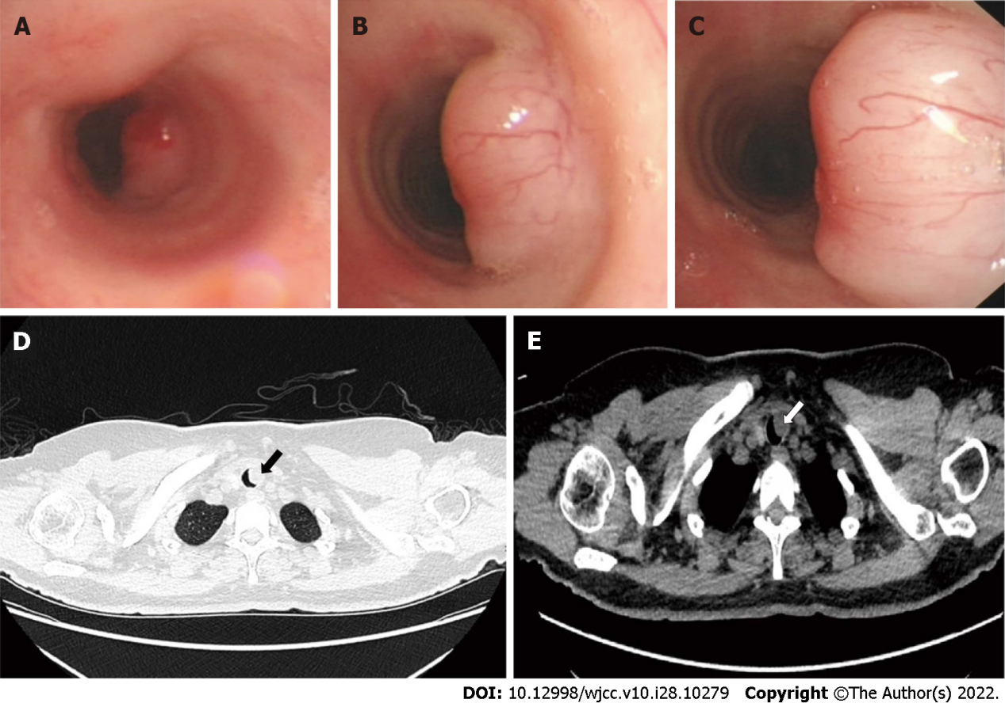
Figure 1 Bronchoscopic view and computed tomography scan of the chest showing the tracheal tumor. A-C: Three different observation positions were observed during bronchoscopy: Distant (A), middle (B), near (C); D: Computed tomography (CT) scan, lung window; E: CT scan, mediastinal window.
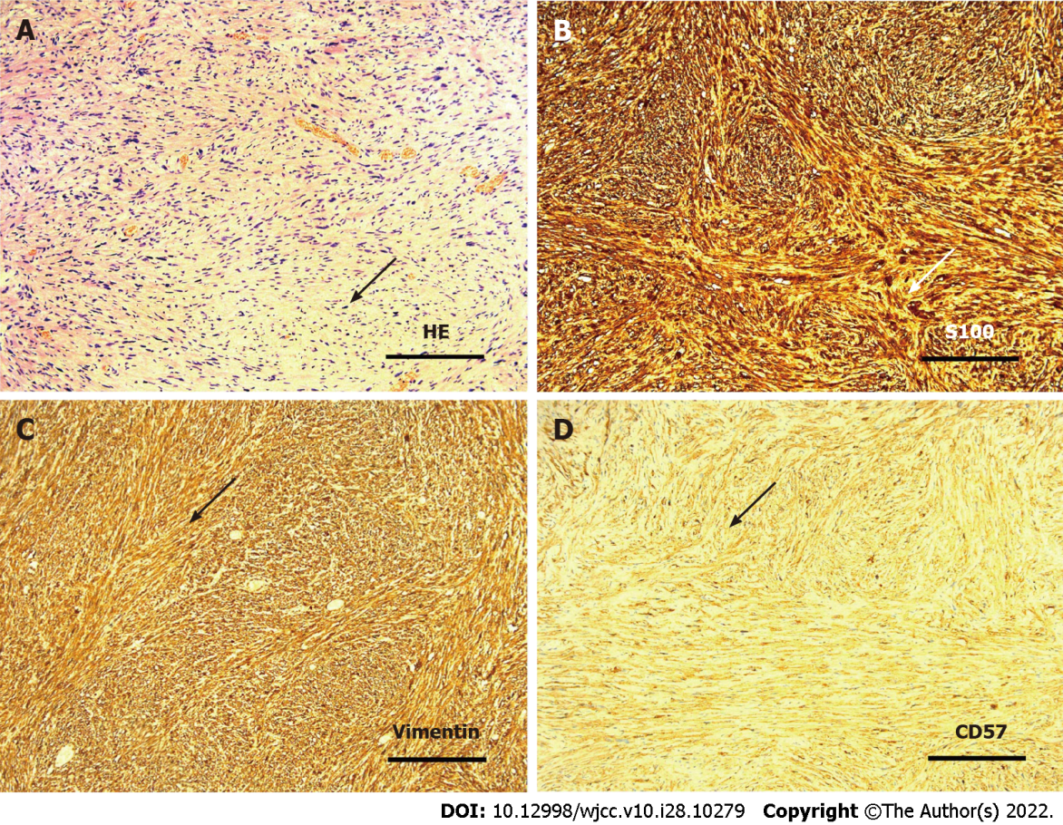
Figure 2 Results of hematoxylin and eosin staining and immunohistochemistry of tumors. A: Photomicrograph of hematoxylin and eosin staining; B: Photomicrograph of S100 staining; C: Photomicrograph of Vimentin staining; D: Photomicrograph of CD57 staining.
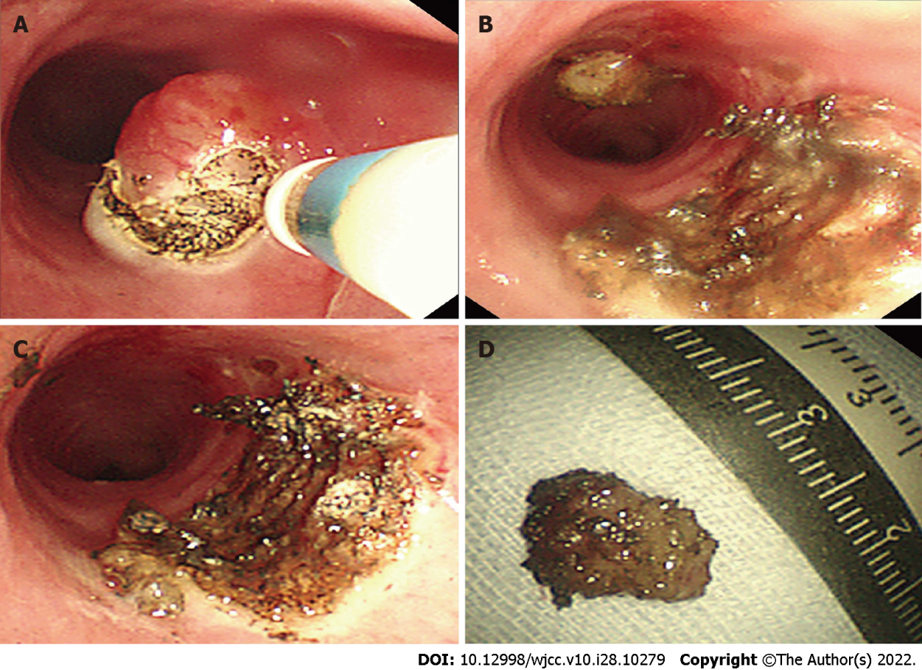
Figure 3 The process of tumor resection with a high-frequency electric knife. A-C: Diagram of surgery; D: Resected tumor specimen.
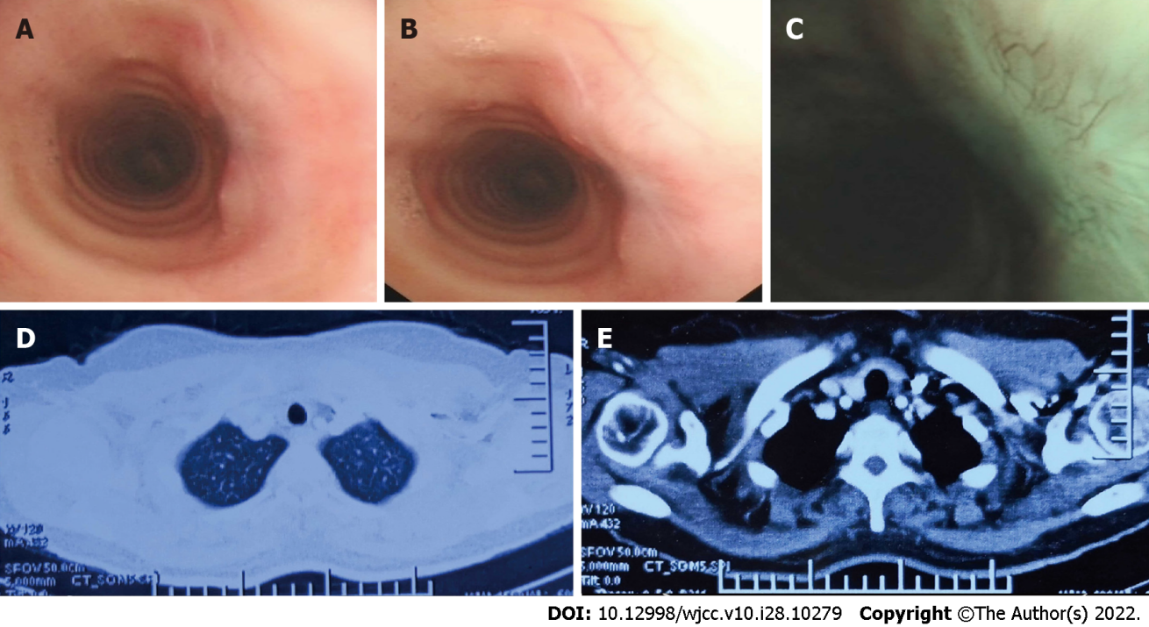
Figure 4 Postoperative re-examination. A-C: Bronchoscopic view; D and E: Computed tomography scan of the chest.
Table 1 Four primary tracheal schwannoma cases treated by endoscopic therapy are reported in the literature
Characters | Ge et al^{[7]} | Gibb et al^{[10]} | Sharma et al^{[9]} | Horovitz et al^{[11]}
Population | China | China | United States | NA
Age | 53 | 16 | 63 | 38
Sex | M | F | M | F
Clinical presentation | Cough, expectoration | Cough, asthma | Dyspnea | NA
Location | Distal trachea | Distal trachea | Proximal trachea | NA
Size | 2.0 cm | NA | 2.0 cm | NA
Treatment | APC/electrocautery | APC/electrocautery | APC/electrocautery | Endoscopic excision
Prognosis | Recurrence, 2 wk after endoscopic resection | Uneventful for 18 mo | Uneventful for 8 mo | Recurrence, 12 yr after endoscopic resection
F: Female; M: Male; APC: Argon plasma coagulation; NA: Not applicable.

Published by Baishideng Publishing Group Inc
7041 Koll Center Parkway, Suite 160, Pleasanton, CA 94566, USA
Telephone: +1-925-3991568
E-mail: bpgoffice@wjgnet.com
Help Desk: https://www.f6publishing.com/helpdesk
https://www.wjgnet.com

© 2022 Baishideng Publishing Group Inc. All rights reserved.

