Name of Journal: World Journal of Gastroenterology
ESPS Manuscript NO: 24812
Manuscript Type: META-ANALYSIS

Hepatitis C virus genotype 3: Meta-analysis on sustained virologic response rates with currently available treatment options

Ampuero J et al. Treatment of HCV genotype 3

Javier Ampuero, K Rajender Reddy, Manuel Romero-Gómez

Javier Ampuero, Manuel Romero-Gomez, Inter-Centre Unit of Digestive Diseases and CIBERehd, Virgen Macarena, Virgen del Rocío University Hospitals, University of Sevilla, 41018 Sevilla, Spain

Javier Ampuero, Manuel Romero-Gomez, Instituto de Biomedicina de Sevilla, 41018 Sevilla, Spain

K Rajender Reddy, Division of Gastroenterology and Hepatology, Department of Medicine, University of Pennsylvania, Philadelphia, PA 19107, United States

Author contributions: Romero-Gómez M guarantor of article; Ampuero J, Reddy KR and Romero-Gómez M Writing the paper; Ampuero J, Reddy KR and Romero-Gómez M contributing to the design of the review.

Conflict-of-interest statement: No potential conflicts of interest relevant to this article were reported.

Data sharing statement: No additional data are available.

Open-Access: This article is an open-access article which was selected by an in-house editor and fully peer-reviewed by external reviewers. It is distributed in accordance with the Creative Commons Attribution Non Commercial (CC BY-NC 4.0) license, which permits others to distribute, remix, adapt, build upon this work non-commercially, and license their derivative works on different terms, provided the original work is properly cited and the use is non-commercial. See: http://creativecommons.org/licenses/by-nc/4.0/

Correspondence to: Manuel Romero-Gómez, Full Professor, Head of Inter-Centre Unit of Digestive Diseases, Virgen Macarena, Virgen del Rocío University Hospitals, Av. Manuel Siurot, s/n, 41013 Sevilla, Spain. mromerogomez@us.es
Telephone: +34-955-012568
Fax: +34-955-015899

Received: February 10, 2016
Peer-review started: February 10, 2016
First decision: March 21, 2016
Revised: April 10, 2016
Accepted: May 4, 2016
Article in press:
Published online:

Abstract
AIM: To address the therapeutic efficacy of various treatment regimens in genotype 3 selecting randomized clinical trials and prospective National Cohort Studies.

METHODS: (1) PEG-INF-based therapy including sofosbuvir (SOF) + RBV for 12 wk vs SOF+RBV 24w; (2) SOF+RBV therapy 12 w/16w vs 24w; and (3) the role of RBV in SOF + daclatasvir (DCV) and SOF + ledipasvir (LDV) combinations. This meta-analysis provides robust information with the intention of addressing treatment strategy for hepatitis C virus genotype 3.

RESULTS: A combination treatment including SOF+RBV+PEG-IFN for 12 wk notes better SVR than with only SOF + RBV for 12 wk, although its association with more frequent adverse effects may be a limiting factor. Longer duration therapy with SOF + RBV (24 wk) has achieved higher SVR rates than shorter durations (12 or 16 wk). SOF+LDV are not an ideal treatment for genotype 3.

CONCLUSION: Lastly, SOF+DCV combination is probably the best oral therapy option and the addition of RBV does not appear to be needed to increase SVR rates substantially.

Key words: Hepatitis C; Genotype 3; Sofosbuvir; Daclatasvir; Ledipasvir

© The Author(s) 2016. Published by Baishideng Publishing Group Inc. All rights reserved.

Core tip: The landscape of therapy for hepatitis C virus infection is changing rapidly. In genotype 3, the improvement in SVR rates has not been hugely spectacular, being considered the most difficult genotype to treat and representing a major challenge. The advent of direct acting antivirals has not solved all questions about the treatment, while challenges remain such as the use of RBV, the duration of PEG-IFN-free treatment and whether PEG-IFN still plays an important role. These questions are difficult to elucidate with the current data because of the small number of patients included in clinical trials (particularly, those with cirrhosis) and their different designs.

Ampuero J, Reddy KR, Romero-Gómez M. Hepatitis C virus genotype 3: Meta-analysis on sustained virologic response rates with currently available treatment options. World J Gastroenterol 2016; In press

INTRODUCTION
The landscape of therapy for hepatitis C virus (HCV) infection is changing rapidly^{[1]}. Ideally, new drugs should be all-oral regimen (once-daily, single pill) with pangenotypic activity, and have short treatment course (no more than 12 wk), and with high sustained virological response (at least 90%-95%). A multitude of direct acting antivirals (DAAs) have been developed with or without pegylated interferon (PEG-IFN) and ribavirin (RBV)^{[2]}, and others are being tested in promising clinical trials^{[3]}. In genotype 3, the improvement in SVR rates has not relatively suboptimal and is being considered the most difficult genotype to treat and thus representing a major challenge^{[4]}. Unique clinical features of genotype 3 and possible reasons for suboptimal response are: (1) a close relationship with insulin resistance and disturbances in lipid metabolism^{[5]}; and (2) fibrosis progression^{[6]} and higher incidence of hepatocellular carcinoma^{[7]}.
The advent of DAAs has not solved all questions regarding the treatment in genotype 3, and with emerging new challenges such as RBV use^{[8]}, duration of PEG-IFN-free treatment and whether PEG-IFN still plays an important role^{[9]}. These questions are difficult to elucidate with the current data because of the small number of patients included in clinical trials (particularly, those with cirrhosis) and their different designs. In fact, more valuable data have been derived from prospective observational studies (clinical practice), and beyond randomized clinical trials. In this study, we aimed to address key questions on treatment outcomes through a meta-analysis.

MATERIAL AND METHODS
Data sources and search
The search strategy was in accordance with the recommendations of meta-analysis of clinical trials and observational studies. We searched in MEDLINE, EMBASE and Cochrane Library databases (to November 2015), as well as abstracts published and presented at EASL and AASLD (to November 2015) to identify potentially relevant publications in English language. We included FDA-approved DAA therapies that included SVR as a primary end point. Search terms were: “hepatitis C”, “genotype 3”, “HCV treatment”, “sofosbuvir”, “ledipasvir”, “daclatasvir”, “ribavirin”, “interferon”. The preceding terms were combined with appropriate Boolean logic. Manual search of cited bibliographies was also performed. Duplicated publications were deleted. Two researchers independently performed the literature search and data abstraction with regard to the inclusion and exclusion criteria by reading titles and abstracts. When reading titles and abstracts did not allow identification of eligible studies, articles were read in full. Relevant reviews and letters to the editor were excluded from the analysis, but read in full to identify potential relevant original studies. Disagreements between two observers were resolved by discussion.

Study selection criteria and data extraction
We selected randomized clinical trials (preferably) and prospective National Cohort Studies in which therapies were administrated in different arms. Therefore, studies including only a combination testing different doses or being administrated to different subset of patients were excluded. Inclusion and exclusion criteria (studies involving genotypes other than 3) were defined prior to initiation of the literature search. Twelve studies were included and classified according to the aims (Figure 1). The following data were extracted: (1) Study: year of publication, number of patients, location, design; (2) Patients: stage of liver disease (cirrhosis or chronic hepatitis), previous HCV treatment (naïve or treatment-experienced); (3) HCV treatment regimen and duration; and (4) SVR rates.

Objectives
We aimed to address the therapeutic efficacy of various treatment regimens in genotype 3. Firstly, we compared a PEG-INF-based therapy including sofosbuvir (SOF) + RBV during 12 wk with SOF + RBV 24 w. Secondly, we assessed the importance of extending the course of SOF+RBV therapy (12 w/16 w vs 24w). Thirdly, we analyzed the role of RBV in SOF + daclatasvir (DCV) and SOF + ledipasvir (LDV) combinations.

Statistical analysis
Statistical analysis was performed using the Meta-Disc software 1.4^{[10]}, considering: (1) a summary of data from individual studies; (2) an investigation of the studies homogeneity, graphically and statistically; (3) calculation of clustered indexes; and (4) exploration of heterogeneity. Our assumption of heterogeneity was tested for each planned analysis using the Cochran-Q heterogeneity and I² statistics (low, moderate, and high heterogeneity according to I² values of 25%, 50%, and 75%, respectively)^{[11]}. Random effects model using Der Simonian and Laird method and fixed effects model were used according to the presence of heterogeneity. To check for publication bias, we used the Begg and Egger tests. Only two-sided tests with a significance level of 0.05 were used. Confidence intervals (CIs) of individual studies were determined or approximated from the available data. Further, we assessed the quality of the studies using the ‘‘Quality Assessment of Diagnostic Accuracy Studies” (QUADAS) tool for observational studies (≥ 10 were considered as high-quality studies^{[12]}) and Jadad scale for randomized clinical trials (≥ 3 were considered as high-quality ones^{[13]}).

RESULTS
Comparison between INF-based and IFN-free regimens
We evaluated four studies that met the selection criteria and that were identified using the search strategy described. Studies characteristics are shown in Table 1. Pooled data included 807 patients. The meta-analysis demonstrated that triple therapy including SOF+RBV+PEG-IFN was able to achieve higher SVR rates (92.5%; 236/255) than SOF+RBV (75.2%; 415/552), using fixed effects model [OR = 3.51 (95%CI: 2.08–5.92)] (Figure 2A). We found neither heterogeneity between these studies [(Cochran-Q = 0.94; df = 3, P = 0.8157); inconsistency I² = 0%, and τ² = 0.0000)] nor publication bias [(Begg test: Kendall’s tau 1.70, P = 0.1); (Egger test: -1.14, P = 0.37)].

Course of SOF+RBV treatment
We included four studies involving 850 patients. The meta-analysis demonstrated that a 24w-course of SOF+RBV (85.5%; 501/586) combination was better than 12w-16w (70%; 185/264) in terms of SVR rates, using random effects model [OR = 3.51 (95%CI: 1.59–7.70)] (Figure 2B). We found a moderate heterogeneity between these studies [(Cochran-Q = 7.77, df = 3, P = 0.0511); inconsistency I² = 61%, and τ² = 0.3718], but no publication bias [(Begg test: Kendall’s tau 0.34, P = 0.73); (Egger test: 0.81, P = 0.50)]. Three of these studies evaluated SVR rates according to the presence of cirrhosis. In non-cirrhotic patients, longer therapy of SOF+RBV (89.7%; 218/243) achieved higher SVR rates than shorter one (78.2%; 144/184) using random effects model (OR 2.44 (95%CI: 1.41–4.23)). We did find a moderate heterogeneity between these studies [(Cochran-Q = 4.42; df = 2, P = 0.11); inconsistency I² = 55%, and τ² = 0.3987], with no publication bias. Similarly, this effect was observed in cirrhotic population (78.5%; 73/93 vs 55%; 38/69) using the random effects model [OR = 2.79 (95%CI: 1.34–5.78)].

Role of RBV in SOF+DCV and SOF+LDV combinations
Additionally, we assessed the role of adding RBV in IFN-free regimens. Four studies have evaluated this point regarding the combination treatment of SOF+DCV. Pooled data included 502 patients. The meta-analysis demonstrated that adding RBV was not essential to achieve optimal SVR rates (83%; 173/209 vs 86.3%; 253/293), using fixed effects model [OR = 1.09 (95%CI: 0.35–3.40)] (Figure 2C). We did not find heterogeneity between these studies [(Cochran-Q = 2.38; df = 3, P = 0.4981); inconsistency I² = 0%, and τ² = 0.0000], and did not seem to have publication bias. On the other hand, two studies have evaluated the role of adding RBV in SOF+LDV combination. Pooled data included 169 patients. The meta-analysis demonstrated that adding RBV was important to achieve better SVR rates (81%; 111/137 vs 62.5%; 20/32), using fixed effects model [OR = 3.30 (95%CI: 1.35–8.04)] (Figure 2D). We did not find heterogeneity between these studies [(Cochran-Q = 0.61, df = 1, P = 0.4335); inconsistency I² = 0%, and τ² = 0.0000], and no publication bias was found [(Begg test: Kendall’s tau 0.01, P = 0.99)].

DISCUSSION
New challenges have emerged in the evolving era of HCV therapy, particularly with genotype 3, and these include the ongoing role of PEG-IFN, the addition of RBV and the adequate duration of the therapy^{[13]}. The rapid development and use of DAAs in several heterogeneous studies including small number of patients has made robust guideline development and recommendation rather challenging. Thus, a meta-analysis is needed pooling all patients to address these questions.
In this new era, PEG-IFN is being abandoned as part of standard HCV therapy because of the association with serious adverse effects (and the parenteral administration) ^{[14]}. From now on, PEG-IFN will not be used for genotypes 1, 2 or 4 anymore. For genotype 3, there are only two DAAs (SOF and DCV) with a significant inhibitory activity in vitro^{[15]}. In this context, PEG-IFN could potentially play a role in HCV treatment and could be the last such indication for its use. We demonstrated that the addition of PEG-IFN to SOF+RBV 12w was superior to only SOF+RBV combination (92% vs 75%; OR = 3.51). BOSON study represents the main study evaluating this comparison, and it included nearly two hundred patients per arm^{[16]}. Additionally, DCV has been evaluated in combination with PEG-IFN+RBV, although SVR rates were not higher than those patients treated with dual standard therapy (65% vs 59%)^{[17]}. Both EASL and AASLD recommend SOF+RBV+PEG-IFN as a good alternative in non-cirrhotic and compensated-cirrhotic patients^{[18]}. On the other hand, no data is available evaluating SOF+RBV+PEG-IFN vs SOF+DCV.
We analyzed the combination of SOF+RBV, in terms of duration of therapy. To date, this combination has been evaluated for 12, 16 and 24 wk duration. We compared SOF+RBV 12w/16w vs SOF+RBV 24w, and the latter achieved higher SVR rates (89% vs 70%, OR = 3.51). Furthermore, SOF+RBV 12w (56%) was associated with poorer SVR rates than dual standard therapy with PEG-IFN+RBV 24w (63%) in FISSION study^{[19]}, and showing similar results than POSITRON study (61%)^{[20]}. Both studies demonstrated that SOF+RBV combination 12w was suboptimal, especially in the cirrhotic population. In FISSION study, a longer course of therapy (16w) with SOF + RBV showed better results than a shorter one (62% vs 30%)^{[21]}. Overall SVR rates with SOF + RBV 12/16w were about 60%, which is considered suboptimal in the evolving era of hepatitis C therapy where response rates far below 90% are considered suboptimal. We included four studies that evaluated the course of 24 wk of SOf+RBV and noted an overall SVR rate around 90%. In addition, PHOTON study confirmed the extrapolation of these results in HIV-coinfected patients^{[22]}. Taking into account all of these results, EASL and AASLD guidelines recommend extending SOF+RBV treatment to 24 wk (especially indicated in non-cirrhotic population).
In this meta-analysis, we demonstrated that SOF+LDV combination needs the addition of RBV to achieve optimal SVR rates in patients with genotype 3 (81% vs 62%, OR = 3.30). In contrast, RBV did not play any role in the combination of SOF+DCV because it did not improve SVR rates. DCV and LDV are HCV NS5A inhibitors^{[23]}, although DCV shows a pangenotypic activity^{[24]} while LDV has a low activity in genotypes 2 and 3^{[25]}. Currently, SOF+DCV combination is the first option to treat patients with genotype 3 in EASL guidelines, 12 wk in non-cirrhotic and 24 weeks (with RBV) in cirrhotic patients. This recommendation is mainly based on ALLY-3 study in which SOF+DCV 12w achieved 97% and only 58% SVR in non-cirrhotic and cirrhotic population respectively^{[26]}. The UK Early Access Program did not show any impact of adding RBV to SOF+DCV 24w in cirrhotic patients (70% vs 71%)^{[27]}, as well as the European Compassionate Use Program in patients at high risk of hepatic decompensation or death within 12 mo (100% vs 85%; P = NS) ^{[28]}. In a relatively small study, ELECTRON-2 trial, SOF+LDV for 12w achieved suboptimal SVR rates while the addition of RBV substantially increased it (100% in non-cirrhotic naïve patients, and 89% in non-cirrhotic and 73% in cirrhotic treatment-experienced patients)^{[29]}. However, this trial should be interpreted with caution because it has very limited data from a phase II single-center study and comprising a homogenous population which could limit the generalizability of the results. This, together with the high EC50 of LDV for genotype 3^{[30]}, has lead EASL and AASLD to not recommend SOF+LDV±RBV combination for genotype 3.
Recommendations made by EASL and AASLD guidelines were based on few data derived from randomized clinical trials and, due to the rapid and wide use in clinical practice, modified by prospective national cohorts. This meta-analysis provides solid and robust information to address several important questions, regarding the treatment of HCV genotype 3. First, combination including SOF+RBV+PEG-IFN shows better results than only SOF+RBV, although its association with adverse effects may limit the use (i.e., cirrhotic population). Second, longer therapies including SOF+RBV (24 wk) have higher SVR rates than shorter ones (12 or 16 wk). Therefore, SOF+RBV for 24 wk are ideal. Third, SOF+LDV should not be used in genotype 3 and, if so, necessarily with RBV. Lastly, SOF+DCV combination is probably the best option and the addition of RBV does not appear to be needed to increase substantially the SVR rates.

COMMENTS
Background
The advent of direct acting antivirals (DAAs) has not solved all questions of successfully and effectively treating all hepatitis C virus (HCV) genotypes. Genotype 3, a common genotype globally, remains the last challenge. It remains unclear if Peg-IFN and RBV are still required to treat HCV genotype 3 effectively.

Research frontiers
The current data are inadequate to strongly take a position on the duration of therapy with DAAs, the role of ribavirin and PEG-IFN particularly given the heterogeneity of the HCV population that includes prior treatment experience with or without cirrhosis, and the small number of patients in the various clinical trials.

Innovations and breakthroughs
The authors demonstrated that SOF+LDV combination needs the addition of RBV to achieve optimal SVR rates in patients with genotype 3 (81% vs 62%, OR = 3.30).

Peer-review
The meta-analysis HCV genotype 3: Meta-analysis with available treatment options is an important topic and of high scientific significance. The results were interesting and valuable to communicate. This study will help future work in the treatment of HCV. statistical analysis reported in this manuscript are well done.

REFERENCES
1 Kohli A, Shaffer A, Sherman A, Kottilil S. Treatment of hepatitis C: a systematic review. JAMA 2014; 312: 631-640 [PMID: 25117132 DOI: 10.1001/jama.2014.7085]
2 Buti M, Esteban R. Hepatitis C virus genotype 3: a genotype that is not 'easy-to-treat'. Expert Rev Gastroenterol Hepatol 2015; 9: 375-385 [PMID: 25222289 DOI: 10.1586/17474124.2015.960396]
3 Vizuete J, Hubbard H, Lawitz E. Next-Generation Regimens: The Future of Hepatitis C Virus Therapy. Clin Liver Dis 2015; 19: 707-716, vii [PMID: 26466657 DOI: 10.1016/j.cld.2015.06.009]
4 Ampuero J, Romero-Gómez M, Reddy KR. Review article: HCV genotype 3 – the new treatment challenge. Aliment Pharmacol Ther 2014; 39: 686-698 [PMID: 24612116]
5 Duseja A, Dhiman RK, Chawla Y, Thumburu KK, Kumar A, Das A, Bhadada S, Bhansali A. Insulin resistance is common in patients with predominantly genotype 3 chronic hepatitis C. Dig Dis Sci 2009; 54: 1778-1782 [PMID: 19513842 DOI: 10.1007/s10620-009-0844-y]
6 Probst A, Dang T, Bochud M, Egger M, Negro F, Bochud PY. Role of hepatitis C virus genotype 3 in liver fibrosis progression--a systematic review and meta-analysis. J Viral Hepat 2011; 18: 745-759 [PMID: 21992794 DOI: 10.1111/j.1365-2893.2011.01481]
7 Kanwal F, Kramer JR, Ilyas J, Duan Z, El-Serag HB. HCV genotype 3 is associated with an increased risk of cirrhosis and hepatocellular cancer in a national sample of U.S. Veterans with HCV. Hepatology 2014; 60: 98-105 [PMID: 24615981 DOI: 10.1002/hep.27095]
8 Hézode C, Bronowicki JP. Ideal oral combinations to eradicate HCV: The role of ribavirin. J Hepatol 2016; 64: 215-225 [PMID: 26409316 DOI: 10.1016/j.jhep.2015.09.009]
9 Zoulim F, Liang TJ, Gerbes AL, Aghemo A, Deuffic-Burban S, Dusheiko G, Fried MW, Pol S, Rockstroh JK, Terrault NA, Wiktor S. Hepatitis C virus treatment in the real world: optimising treatment and access to therapies. Gut 2015; 64: 1824-1833 [PMID: 26449729 DOI: 10.1136/gutjnl-2015-310421]
10 Zamora J, Abraira V, Muriel A, Khan K, Coomarasamy A. Meta-DiSc: a software for meta-analysis of test accuracy data. BMC Med Res Methodol 2006; 6: 31 [PMID: 16836745]
11 Higgins JP, Thompson SG, Deeks JJ, Altman DG. Measuring inconsistency in meta-analyses. BMJ 2003; 327: 557-560 [PMID: 12958120]
12 Whiting P, Rutjes AW, Reitsma JB, Bossuyt PM, Kleijnen J. The development of QUADAS: a tool for the quality assessment of studies of diagnostic accuracy included in systematic reviews. BMC Med Res Methodol 2003; 3: 25 [PMID: 14606960]
13 Jadad AR, Moore RA, Carroll D, Jenkinson C, Reynolds DJ, Gavaghan DJ, McQuay HJ. Assessing the quality of reports of randomized clinical trials: is blinding necessary? Control Clin Trials 1996; 17: 1-12 [PMID: 8721797]
14 Ampuero J, Romero-Gómez M. Hepatitis C Virus: Current and Evolving Treatments for Genotypes 2 and 3. Gastroenterol Clin North Am 2015; 44: 845-857 [PMID: 26600223 DOI: 10.1016/j.gtc.2015.07.009]
15 Evon DM, Esserman DE, Howell MA, Ruffin RA. Pegylated interferon pharmacokinetics and self-reported depressive symptoms during antiviral treatment for chronic hepatitis C. Pharmacopsychiatry 2014; 47: 195-201 [PMID: 25121993 DOI: 10.1055/s-0034-1385929]
16 Nakamoto S, Kanda T, Wu S, Shirasawa H, Yokosuka O. Hepatitis C virus NS5A inhibitors and drug resistance mutations. World J Gastroenterol 2014; 20: 2902-2912 [PMID: 24659881 DOI: 10.3748/wjg.v20.i11.2902]
17 Foster GR, Pianko S, Brown A, Forton D, Nahass RG, George J, Barnes E, Brainard DM, Massetto B, Lin M, Han B, McHutchison JG, Subramanian GM, Cooper C, Agarwal K. Efficacy of sofosbuvir plus ribavirin with or without peginterferon-alfa in patients with hepatitis C virus genotype 3 infection and treatment-experienced patients with cirrhosis and hepatitis C virus genotype 2 infection. Gastroenterology 2015; 149: 1462-1470 [PMID: 26248087 DOI: 10.1053/j.gastro.2015.07.043]
18 Dore GJ, Lawitz E, Hézode C, Shafran SD, Ramji A, Tatum HA, Taliani G, Tran A, Brunetto MR, Zaltron S, Strasser SI, Weis N, Ghesquiere W, Lee SS, Larrey D, Pol S, Harley H, George J, Fung SK, de Lédinghen V, Hagens P, McPhee F, Hernandez D, Cohen D, Cooney E, Noviello S, Hughes EA. Daclatasvir plus peginterferon and ribavirin is noninferior to peginterferon and ribavirin alone, and reduces the duration of treatment for HCV genotype 2 or 3 infection. Gastroenterology 2015; 148: 355-366.e1 [PMID: 25311593 DOI: 10.1053/j.gastro.2014.10.007]
19 European Association for the Study of the Liver. EASL recommendations on treatment of hepatitis C 2014. J Hepatol 2014; 61: 373-395 [PMID: 24818984 DOI: 10.1016/j.jhep.2014.05.001]
20 Lawitz E, Mangia A, Wyles D, Rodriguez-Torres M, Hassanein T, Gordon SC, Schultz M, Davis MN, Kayali Z, Reddy KR, Jacobson IM, Kowdley KV, Nyberg L, Subramanian GM, Hyland RH, Arterburn S, Jiang D, McNally J, Brainard D, Symonds WT, McHutchison JG, Sheikh AM, Younossi Z, Gane EJ. Sofosbuvir for previously untreated chronic hepatitis C infection. N Engl J Med 2013; 368: 1878-1887 [PMID: 23607594 DOI: 10.1056/NEJMoa1214853]
21 Jacobson IM, Gordon SC, Kowdley KV, Yoshida EM, Rodriguez-Torres M, Sulkowski MS, Shiffman ML, Lawitz E, Everson G, Bennett M, Schiff E, Al-Assi MT, Subramanian GM, An D, Lin M, McNally J, Brainard D, Symonds WT, McHutchison JG, Patel K, Feld J, Pianko S, Nelson DR. Sofosbuvir for hepatitis C genotype 2 or 3 in patients without treatment options. N Engl J Med 2013; 368: 1867-1877 [PMID: 23607593 DOI: 10.1056/NEJMoa1214854]
22 Sulkowski MS, Naggie S, Lalezari J, Fessel WJ, Mounzer K, Shuhart M, Luetkemeyer AF, Asmuth D, Gaggar A, Ni L, Svarovskaia E, Brainard DM, Symonds WT, Subramanian GM, McHutchison JG, Rodriguez-Torres M, Dieterich D. Sofosbuvir and ribavirin for hepatitis C in patients with HIV coinfection. JAMA 2014; 312: 353-361 [PMID: 25038354 DOI: 10.1001/jama.2014.7734]
23 Herbst DA, Reddy KR. NS5A inhibitor, daclatasvir, for the treatment of chronic hepatitis C virus infection. Expert Opin Investig Drugs 2013; 22: 1337-1346 [PMID: 23931586 DOI: 10.1517/13543784.2013.826189]
24 Bunchorntavakul C, Reddy KR. Review article: the efficacy and safety of daclatasvir in the treatment of chronic hepatitis C virus infection. Aliment Pharmacol Ther 2015; 42: 258-272 [PMID: 26014906 DOI: 10.1111/apt.13264]
25 Laccourreye H, Bonfils P, Brasnu D, Ménard M, Fabre A, Janot F, Bassot V. [Chemotherapy and partial surgery in epithelioma of the pharyngo-larynx]. Ann Otolaryngol Chir Cervicofac 1988; 105: 409-414 [PMID: 2462398 DOI: 10.2147/IDR.S36247]
26 Nelson DR, Cooper JN, Lalezari JP, Lawitz E, Pockros PJ, Gitlin N, Freilich BF, Younes ZH, Harlan W, Ghalib R, Oguchi G, Thuluvath PJ, Ortiz-Lasanta G, Rabinovitz M, Bernstein D, Bennett M, Hawkins T, Ravendhran N, Sheikh AM, Varunok P, Kowdley KV, Hennicken D, McPhee F, Rana K, Hughes EA. All-oral 12-week treatment with daclatasvir plus sofosbuvir in patients with hepatitis C virus genotype 3 infection: ALLY-3 phase III study. Hepatology 2015; 61: 1127-1135 [PMID: 25614962 DOI: 10.1002/hep.27726]
27 Foster GR, McLauchlan J, Irving W, Cheung M, Hudson B, Verma S, Agarwal K, HCV Research UK EAP Group. Treatment of decompensated HCV cirrhosis in patients with diverse genotypes: 12 weeks sofosbuvir and NS5A inhibitors with/without ribavirin is effective in HCV genotypes 1 and 3. J Hepatol 2015; 62: S190-S191
28 Welzel TM, Herzer K, Ferenci P, Petersen J, Gschwantler M, Cornberg M, et al. Daclatasvir plus sofosbuvir with or without ribavirin for the treatment of HCV in patients with severe liver disease: Interim results of a multicenter compassionate use program. J Hepatol 2015; 62: S620
29 Gane EJ, Hyland RH, An D, Svarovskaia E, Pang PS, Brainard D, Stedman CA. Efficacy of ledipasvir and sofosbuvir, with or without ribavirin, for 12 weeks in patients with HCV genotype 3 or 6 infection. Gastroenterology 2015; 149: 1454-1461.e1 [PMID: 26261007 DOI: 10.1053/j.gastro.2015.07.063]
30 Wong KA, Worth A, Martin R, Svarovskaia E, Brainard DM, Lawitz E, Miller MD, Mo H. Characterization of Hepatitis C virus resistance from a multiple-dose clinical trial of the novel NS5A inhibitor GS-5885. Antimicrob Agents Chemother 2013; 57: 6333-6340 [PMID: 23877691 DOI: 10.1128/AAC.02193-12]
31 Alqahtani S, Zeuzem S, Manns M, Kuo A, Di Bisceglie AM, Reddy R, Mailliard M, O’Leary J, Pockros P, Kwo PY, Lim JK, Vargas HE, Fried MW, Nelson D, Sulkowski MS. Safety and effectiveness of sofosbuvir-based regimens for the treatment of hepatitis C genotype 3 and 4 infections: Interim analysis of a prospective, observational study. J Hepatol 2015; 62: S652
32 Chulanov V, Zhdanov K, Kersey K, Zhu Y, Massetto B, Zhuravel S. Sofosbuvir plus ribavirin for the treatment of Russian patients with chronic HCV genotype 1 or 3 infection. Hepatology 2014; 1: 676A
33 Dalgard O, Weis N, Noraberg G, Isaksen K, Oevrehus A, Skalshoj Skjar M, Weiland O. Sofosbuvir containing regimes to patients with HCV genotype 3 infection. A scandinavian real-life experience. J Hepatol 2015; 62: S287
34 Hezode C, Ledinghen V, Fontaine H, Zoulim F, Lebray P, Boyer N, Larrey D, Silvain C, Botta-Fridlund D, Leroy V, Bourliere M, D’Alteroche L, Hubert-Fouchard I, Guyader D, Rosa I, Nguyen-Khac E, Di Martino V, Carrat F, Fedchuk L, Akremi R, Bennai Y, Bronowicki JP. Daclatasvir plus sofosbuvir with or without ribavirin in genotype 3 patients from a large French multicenter compassionate use program. Hepatology 2015; 62: 314A
35 Ingiliz P, Christensen S, Hueppe D, Lutz T, Schewe K, Boesecke C, Simon KG, Schmutz G, Baumgarten A, Busch H, Maussemail S. German multicenter cohort on sofosbuvir-based treatments in HCV mono- and HIV/HCV co-infected patients (GECOSO). J Hepatol 2015; 62: S650
36 Sulkowski MS, Gardiner DF, Rodriguez-Torres M, Reddy KR, Hassanein T, Jacobson I, Lawitz E, Lok AS, Hinestrosa F, Thuluvath PJ, Schwartz H, Nelson DR, Everson GT, Eley T, Wind-Rotolo M, Huang SP, Gao M, Hernandez D, McPhee F, Sherman D, Hindes R, Symonds W, Pasquinelli C, Grasela DM. Daclatasvir plus sofosbuvir for previously treated or untreated chronic HCV infection. N Engl J Med 2014; 370: 211-221 [PMID: 24428467 DOI: 10.1056/NEJMoa1306218]
37 Zeuzem S, Dusheiko GM, Salupere R, Mangia A, Flisiak R, Hyland RH, Illeperuma A, Svarovskaia E, Brainard DM, Symonds WT, Subramanian GM, McHutchison JG, Weiland O, Reesink HW, Ferenci P, Hézode C, Esteban R. Sofosbuvir and ribavirin in HCV genotypes 2 and 3. N Engl J Med 2014; 370: 1993-2001 [PMID: 24795201 DOI: 10.1056/NEJMoa1316145]

P-Reviewer: Abd El-Wahab EW S-Editor: Qi Y L-Editor: E-Editor:

Table 1 Overall characteristics of studies included in meta-analysis
Ref. | Year | Patients characteristics | Study design | Outcome (SVR %)
Alqahtani et al^{[31]} | 2015 | -HCV mono-infected patients.  -TARGET cohort.  -Randomized by cirrhosis and previous treatment.  -50% Treatment naïve.  -51% Cirrhosis. | a) SOF + RBV + PEG-IFN (n = 18)  b) SOF + RBV (n = 133) | a) 89%  b) 65%
Chulanov et al^{[32]} | 2014 | -HCV mono-infected patients.  -Russian multicenter cohort.  -Randomized by cirrhosis.  -100% Treatment naïve.  -18% Cirrhosis. | a) SOF + RBV 16 w (n = 30)  b) SOF + RBV 24 w (n = 31) | a) 87%  b) 90%
Dalgard et al^{[33]} | 2015 | -HCV mono-infected patients.  -Scandinavian cohort study.  -51% Treatment naïve.  -82% Cirrhosis. | a) SOF + RBV + PEG-IFN 12 w (n = 25)  b) SOF + RBV 24 w (n = 33) | a) 92%  b) 79%
Foster et al^{[17]}  (BOSON) | 2015 | -HCV mono-infected patients.  -Randomized study.  -51% Treatment naïve.  -31% Cirrhosis. | a) SOF + RBV + PEG-IFN 12 w (n = 181)  b) SOF + RBV 16 w (n = 181)  c) SOF + RBV 24 w (n = 182) | a) 93%  b) 71%  c) 84%
Foster et al^{[27]} | 2015 | -HCV mono-infected patients.  -NHS England Early Access Program.  -100% Decompensated Cirrhosis. | a) SOF + DCV 12 w (n = 7)  b) SOF + DCV + RBV 12 w (n = 113)  c) SOF + LDV 12 w (n = 7)  d) SOF + LDV + RBV 12 w (n = 61) | a) 71%  b) 81%  c) 57%  d) 72%
Gane et al^{[29]} (ELECTRON-2) | 2015 | -HCV mono-infected patients.  -Randomized study.  -50% Treatment naïve.  -32% Cirrhosis. | a) SOF + LDV 12 w (n = 25)  b) SOF + LDV + RBV 12 w (n = 26)  c) SOF + LDV + RBV 12 w (n = 50) | a) 64%  b) 100%  c) 82%
Hezode et al^{[34]} | 2015 | -HCV mono-infected patients.  -French Compassionate Use Program.  -27% Treatment naïve.  -94% Cirrhosis. | a) SOF + DCV 12 w (n = 26)  b) SOF + DCV + RBV 12 w (n = 4)  c) SOF + DCV 24 w (n = 35)  d) SOF + DCV + RBV 24 w (n = 13) | a) 85%  b) 100%  c) 91%  d) 92%
Ingiliz et al^{[35]} | 2015 | -HCV-HIV co-infected patients.  -German multicenter cohort study  -50% Treatment naïve.  -38% Cirrhosis. | a) SOF + RBV + PEG-IFN 12 w (n = 31)  b) SOF + RBV 24 w (n = 23) | a) 94%  b) 91%
Sulkowski et al^{[22]}  (PHOTON) | 2014 | -HCV-HIV co-infected patients.  -International multicenter cohort.  -25% Treatment naïve. | a) SOF + RBV 12 w (n = 42)  b) SOF + RBV 24 w (n = 123) | a) 67%  b) 89%
Sulkowski et al^{[36]} | 2014 | -HCV mono-infected patients.  -Randomized study.  -100% Treatment naïve.  -14% Cirrhosis. | a) SOF + DCV 24 w (n = 13)  b) SOF + DCV + RBV 24 w (n = 5) | a) 92%  b) 80%
Welzel et al^{[28]} | 2015 | -HCV mono-infected patients.  -European Compassionate Use Program.  -72% Cirrhosis. | a) SOF + DCV 24 w (n = 11)  b) SOF + DCV + RBV 24 w (n = 13) | a) 100%  b) 85%
Zeuzem et al^{[37]} (VALENCE) | 2014 | -HCV mono-infected patients.  -Randomized study.  -41% Treatment naïve.  -24% Cirrhosis. | a) SOF + RBV 12 w (n = 11)  b) SOF + RBV 24 w n = 250) | a) 27%  b) 84%
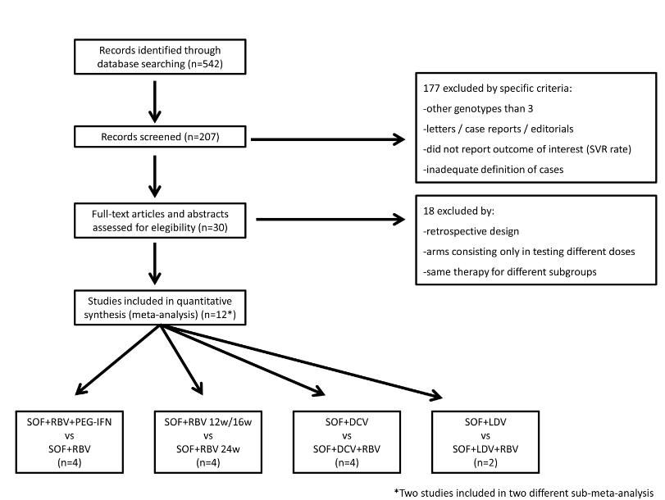 Figure 1 Flow chart of studies screened and included in meta-analysis.

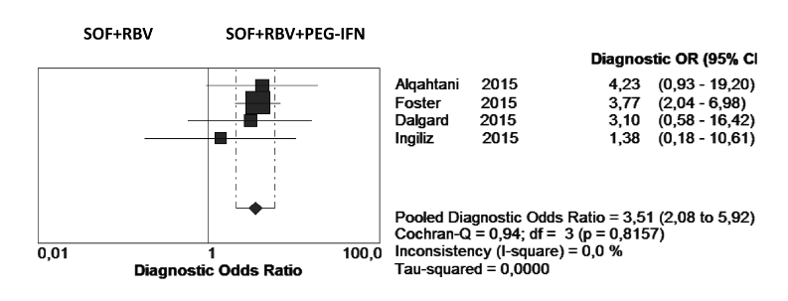
A
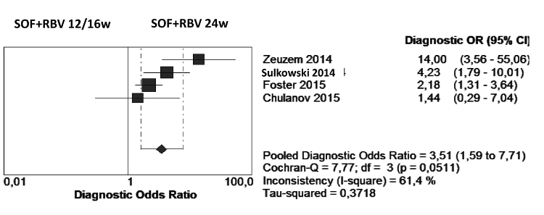
B
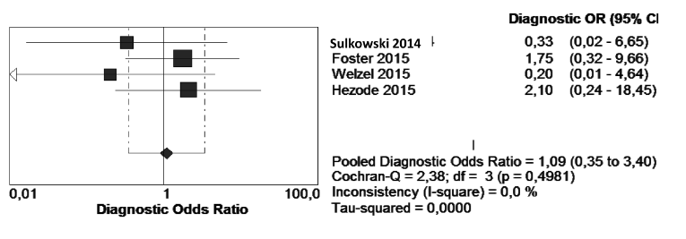
C
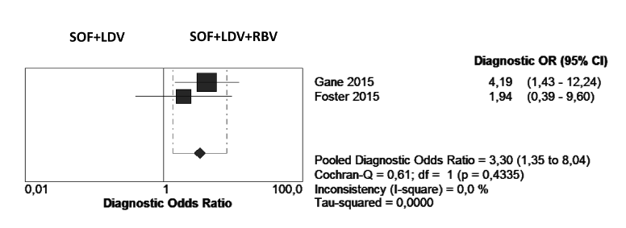
D
Figure 2 Odds ratio (95%CI) and Forest plot for SVR rates. A: SOF+RBV+PEG-IFN vs SOF+RBV combinations; B: SOF+RBV 12w/16w vs SOF+RBV 24w combinations; C: SOF+RBV 12w/16w vs SOF+RBV 24w combinations; D: SOF+LDV vs. SOF+LDV+RBV combinations.

